Recent Advances in the Determination of Ascorbic Acid in Pharmaceutical Tablets: Modified Glassy Carbon Electrodes Versus Volumetric Methods — A Critical Review

ABSTRACT
Ascorbic acid (AA, vitamin C) is an indispensable micronutrient incorporated into a vast array of pharmaceutical tablets and nutraceutical formulations worldwide. Ensuring its accurate quantification is not merely a regulatory formality it directly governs therapeutic efficacy, product shelf-life, and consumer safety. Classical volumetric techniques, including iodometric, bromatometric, cerimetric, and 2,6-dichlorophenolindophenol (DCPIP) methods, have served quality-control laboratories reliably for decades; yet their susceptibility to endpoint ambiguity, matrix interference, and limited sensitivity increasingly constrains their utility in modern pharmaceutical analysis. Over the past decade, electrochemical sensors built on modified glassy carbon electrodes (GCEs) have emerged as transformative alternatives, offering nanomolar-range detection limits, rapid response times, minimal sample pre-treatment, and compatibility with miniaturised and portable formats. This review critically synthesises research published between 2015 and 2026 on AA determination in pharmaceutical tablets, with emphasis on GCE modification strategies encompassing carbon nanomaterials (graphene, reduced graphene oxide, multi-walled carbon nanotubes), conducting polymers, metal and metal oxide nanoparticles, ionic liquid composites, and metal–organic frameworks (MOFs). Analytical figures of merit are benchmarked against conventional volumetric procedures. Emerging trajectories, including biomass-derived electrodes, artificial-intelligence-assisted signal processing, wearable sensors, and Internet-of-Things (IoT)-enabled quality monitoring, are examined critically. The review concludes that nanocomposite-modified GCE platforms represent the vanguard of pharmaceutical AA analysis, while identifying the standardisation gaps that must be bridged before widespread regulatory adoption.
Keywords: Ascorbic acid; vitamin C; glassy carbon electrode; electrochemical sensor; differential pulse voltammetry; graphene; carbon nanotubes; pharmaceutical quality control; metal–organic framework; green analytical chemistry.
Graphical Abstract
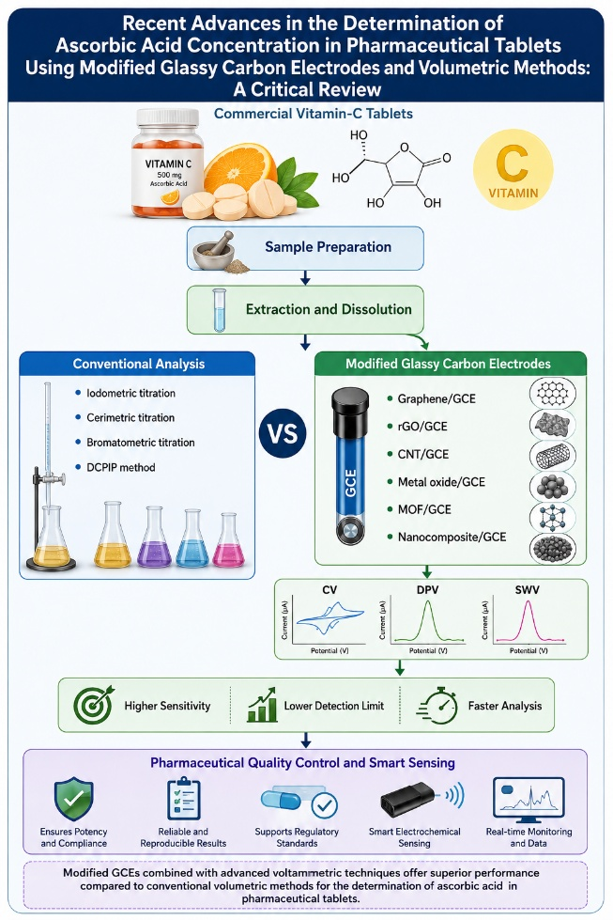

1. Introduction
Ascorbic acid (AA), the biologically active L-enantiomer of vitamin C, occupies a singular position in human physiology. It is the obligate co-factor for prolyl and lysyl hydroxylases in collagen biosynthesis, a potent scavenger of reactive oxygen species, an enhancer of non-haem iron absorption, and a modulator of immune-cell proliferation [26]. Because humans lack the enzyme L-gulonolactone oxidase required for endogenous synthesis, dietary and supplemental intake is essential a reality that has underpinned explosive global growth in the vitamin C supplement market, projected to exceed USD 1.5 billion by 2027.
Pharmaceutical tablets containing AA must deliver a declared potency that remains within pharmacopoeial specification from manufacture through to expiry. The analytical challenge is non-trivial: AA is among the most labile of all vitamins, readily oxidised to dehydroascorbic acid (DHAA) by dissolved oxygen, heat, light, and transition-metal ions, and further degraded to diketogulonic acid and oxalic acid [27]. Even modest degradation results in product subpotency, consumer underdosing, and, in severe cases, regulatory recall.
Pharmacopoeias worldwide still endorse titrimetric procedures principally iodometric and cerimetric as primary reference methods, primarily because of their operational simplicity and equipment accessibility [7, 30]. However, the analytical community has long recognised their deficiencies: subjective endpoint detection, vulnerability to excipient interference, and detection limits that are orders of magnitude inferior to those of modern sensor technologies. Against this backdrop, electrochemical methods using modified GCEs have garnered considerable research interest. By engineering the electrode surface at the nanoscale, researchers have achieved detection limits in the sub-micromolar domain, analysis times of a few minutes, and simultaneous quantification of AA alongside co-formulated drugs such as paracetamol, dopamine, and uric acid [5, 9, 21].
This review is structured to guide the reader from the fundamental electrochemistry of AA, through the landscape of GCE modification strategies, to a rigorous head-to-head comparison with volumetric methods, and finally to a forward-looking perspective on next-generation sensing paradigms. In doing so, we aim not only to catalogue progress but also to pinpoint the critical research gaps, particularly around standardisation, long-term stability, and regulatory validation, that must be addressed if these elegant laboratory innovations are to fulfil their potential in routine pharmaceutical quality control.

2. Chemistry and Electrochemical Behaviour of Ascorbic Acid
Ascorbic acid (molecular formula C₆H₈O₆, MW 176.12 g mol⁻¹) is a γ-lactone carrying a 2,3-enediol moiety. It is this enediol motif that confers the molecule's potent reducing character: AA donates two electrons and two protons to yield DHAA in a process that is electrochemically reversible at optimised electrode surfaces but kinetically sluggish at bare GCEs.
At physiological pH (7.4), AA is predominantly present as the monoanion ascorbate (pKa1 = 4.17). The standard oxidation potential of the AA/DHAA couple is approximately +0.058 V vs. NHE; in practice, however, the anodic peak at bare GCEs appears at +0.4 to +0.6 V vs. Ag/AgCl due to kinetic overpotential. This high overpotential creates two analytical problems: (i) co-oxidation of interfering species such as dopamine (DA) and uric acid (UA) whose oxidation potentials are similar, producing overlapping voltammetric peaks; and (ii) irreversible surface fouling by the polymeric by-products of AA oxidation [26].
The strategy underlying GCE modification is therefore clear: introduce surface functionality that catalyses AA oxidation at a lower potential, thereby separating its peak from those of interferents and simultaneously increasing the anodic current density. Nanomaterials achieve this through two complementary mechanisms an increase in electroactive surface area and the provision of additional electrocatalytic sites (e.g., edge-plane defects in graphene or redox-active metal centres in MOFs) that mediate inner-sphere electron transfer.

3. Conventional Volumetric Methods for Ascorbic Acid Determination

3.1 Iodometric Titration
Iodometric titration exploits the quantitative oxidation of AA by standardised iodine (I₂) solution in the presence of starch indicator. The principal stoichiometric reaction converts one mole of AA to one mole of DHAA per mole of I₂ consumed. Al-Tawil and Algaradi [30] validated this approach for vitamin C tablets, fruit juices, and khat leaves, demonstrating recoveries in the range 98.2–101.4% under rigorously controlled conditions. Strengths include low reagent cost, minimal instrumentation, and pharmacopoeial acceptance. Weaknesses are the susceptibility of iodine solutions to atmospheric oxidation, the subjectivity of the blue–colourless starch endpoint under field conditions, and cross-reactivity with other reducing excipients (e.g., citric acid buffers and antioxidant preservatives) commonly present in tablet matrices.
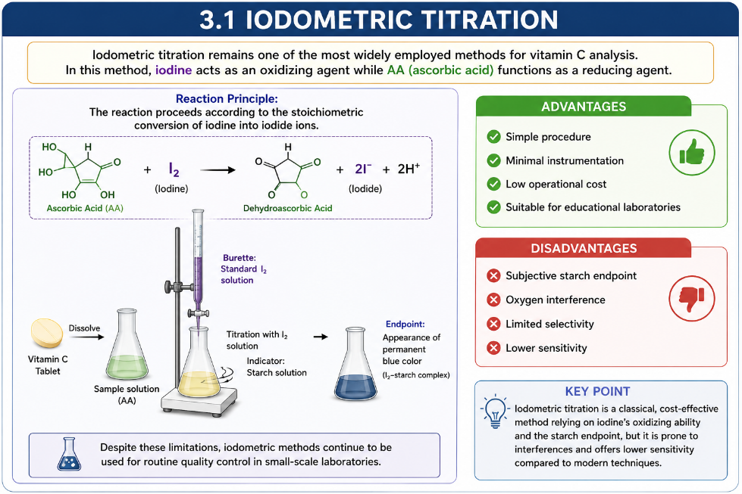

3.2 Bromatometric Titration
In bromatometric analysis, potassium bromate in acidic medium generates bromine in situ, which rapidly and stoichiometrically oxidises AA. The method benefits from a relatively sharp, visually unambiguous endpoint — facilitated by the methyl orange or brilliant yellow indicator — and offers good reproducibility for simple formulations. However, the requirement for strongly acidic conditions (typically 1–2 M HCl) risks partial hydrolysis of acid-labile excipients, and bromate reagents carry regulatory restrictions in many jurisdictions owing to their oxidative toxicity.
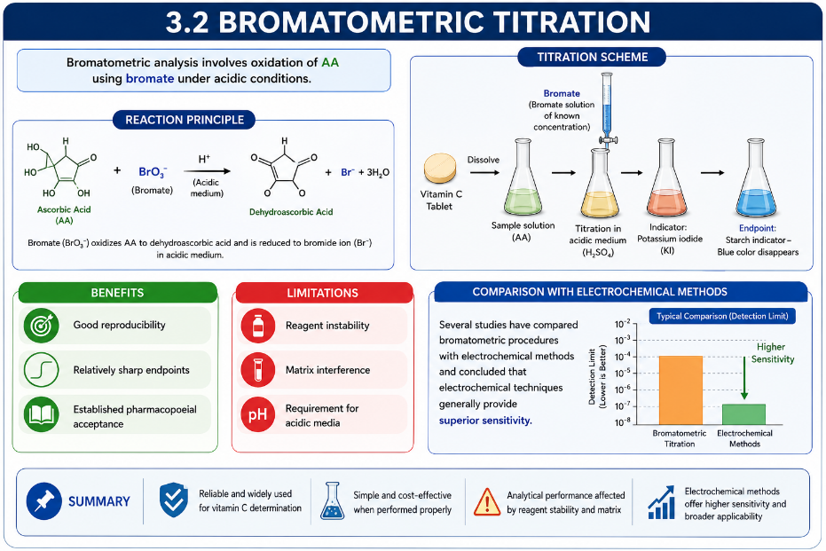

3.3 Cerimetric Titration
Cerium(IV) sulphate is one of the strongest non-particulate oxidising agents used in titrimetry (E° = +1.72 V vs. NHE), enabling complete and rapid oxidation of AA. Škugor Rončević et al. [16] performed a head-to-head evaluation of cerimetric titration against cyclic voltammetry for vitamin C determination in commercial tablets, concluding that both methods yielded statistically equivalent results (RSD < 1.8%), but that the electrochemical approach provided a roughly tenfold improvement in sensitivity. Cerimetric methods do require strongly acidic media, which can complicate the analysis of complex formulations.
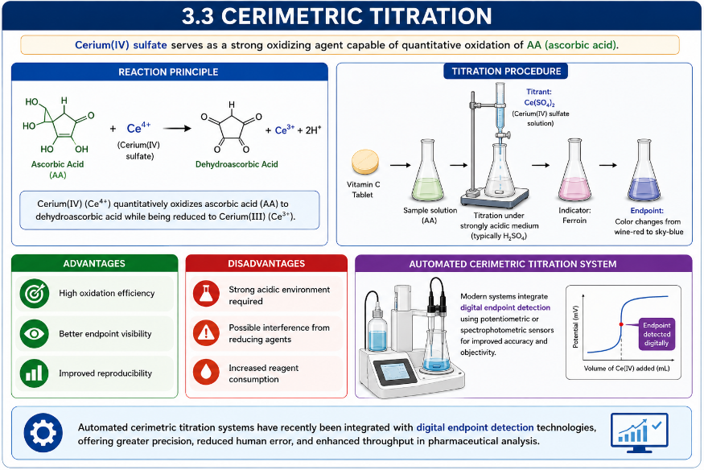

3.4 DCPIP Colorimetric Titration
The 2,6-dichlorophenolindophenol (DCPIP) dye is reduced by AA from a blue colour to a colourless leucoform, making it a rapid and visually intuitive assay. Despite its widespread use in food science, the DCPIP method is readily confounded by other dietary reducing agents and is inapplicable to coloured tablet matrices without prior spectrophotometric correction. Its detection limit (~0.1 mg mL⁻¹) is substantially inferior to electrochemical approaches.
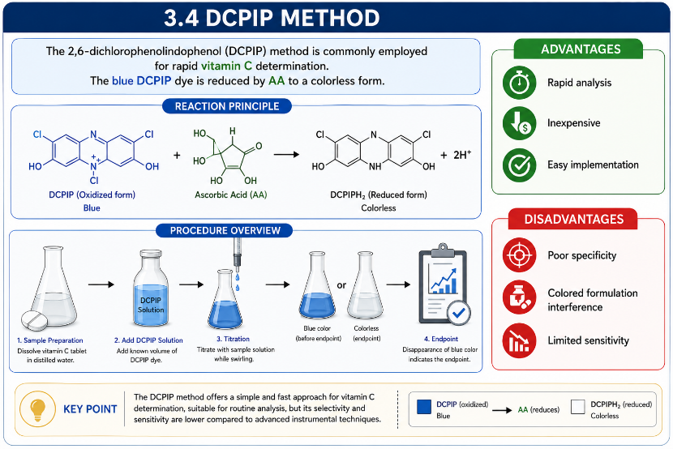

4. Evolution of Electrochemical Determination of Ascorbic Acid
The electroanalytical history of AA determination mirrors the broader trajectory of electrochemical sensor science, evolving through four successive generations distinguished by increasingly sophisticated electrode architectures and analytical capabilities.
First-generation sensors (pre-2000) employed unmodified carbon paste or bare GCEs. Although simple to fabricate and operate, they suffered from the kinetic limitations discussed in Section 2 - high overpotential, poor selectivity, and rapid surface passivation by oxidative AA degradation products [18].
Second-generation sensors (2000–2010) introduced conducting polymers such as polyaniline (PANI) and polypyrrole (PPy) as electrode coatings. Kenane et al. [1] systematically characterised PANI/montmorillonite nanocomposites, demonstrating that the clay intercalation both increased the accessible electrode surface and improved the polymer's long-term stability, a persistent vulnerability of pure polymer films. Ouyang et al. [17] employed poly (bromocresol green)-modified GCEs for the simultaneous determination of UA, DA, and AA, yielding well-resolved voltammetric peaks and confirming the selectivity advantage of polymer-mediated electrocatalysis.
Third-generation sensors (2010–2020) harnessed the carbon nanomaterials revolution, principally graphene, reduced graphene oxide (rGO), and multi-walled carbon nanotubes (MWCNTs), sometimes combined with metal or metal oxide nanoparticles. This era delivered detection limits in the low micromolar to sub-micromolar range and opened the door to routine simultaneous multi-analyte sensing in pharmaceutical matrices [4, 6, 12, 13, 14].
Fourth-generation sensors (2020–present) are defined by architectural sophistication: MOF-based composites with engineered pore geometries, AI-assisted signal processing, and integration with portable or wearable hardware. Ngwem et al. [10] and Le Thi Thanh Nhi et al. [18] exemplify this trajectory with MOF-modified GCEs that combine ultra-high surface areas with selective analyte adsorption, achieving detection limits below 0.1 µM in tablet matrices. Meanwhile, Gürler Akyüz [29] catalogued the emerging use of PANI-coated MWCNT/graphite–graphene oxide composites as versatile platforms for food and pharmaceutical electroanalysis.
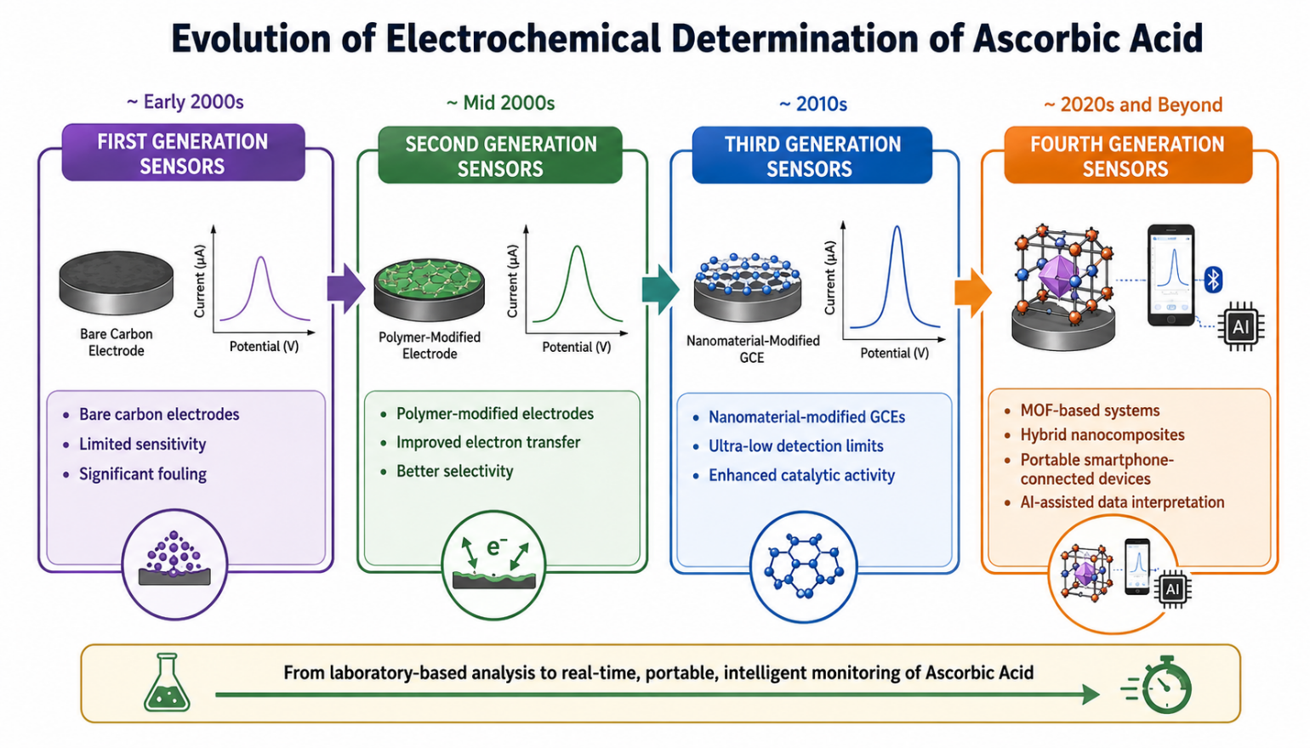

5. Glassy Carbon Electrodes: Properties and Limitations
Glassy carbon (GC) is an sp²-rich, non-graphitising form of carbon whose disordered microstructure confers an exceptional combination of physical and electrochemical properties: high mechanical hardness (Mohs ~7), chemical inertness across a wide pH range, a broad electrochemical window (approximately −1.5 to +1.2 V vs. Ag/AgCl in aqueous media), low background current, and electrical conductivity of ~100 S cm⁻¹. These characteristics make GCEs the overwhelmingly preferred substrate for research-grade electrochemical sensors in pharmaceutical analysis.
Two principal limitations motivate the vast body of literature on modification reviewed here. First, the inherently low density of edge-plane defects on polished GC surfaces translates into sluggish heterogeneous electron-transfer rate constants (k°) for many analytes, including AA. Second, the products of AA electrooxidation polymerise rapidly onto the GCE surface, causing progressive passivation that undermines analytical reproducibility over extended measurement sessions. Modification strategies are therefore evaluated on two fundamental criteria: the magnitude of the cathodic shift in AA oxidation potential (ΔEpa) and the degree to which surface fouling is suppressed.

6. Conducting Polymer-Modified Glassy Carbon Electrodes
Conducting polymers represent the most chemically accessible GCE modifiers and remain in active use. PANI and PPy can be electrodeposited in a single-step galvanostatic or potentiostatic procedure directly onto the GCE surface, making them attractive for laboratories with limited equipment. Kenane et al. [1] demonstrated that PANI/montmorillonite nanocomposites showed markedly enhanced AA oxidation current relative to pure PANI films, attributing the improvement to increased electroactive surface area and faster ionic diffusion facilitated by the clay interlayer spacing.
Dinu and Apetrei [5] engineered a potassium ferrocyanide-doped PPy film on a platinum electrode and applied it to AA determination in commercial pharmaceuticals. The ferrocyanide dopant functioned as a built-in redox mediator, lowering the AA oxidation potential by approximately 180 mV compared with bare platinum and delivering a linear response across 1–500 µM with a limit of detection (LOD) of 0.3 µM. Recovery experiments on tablet digests yielded 97.5–102.3%, confirming matrix compatibility.
The principal limitation of conducting polymer films remains long-term electrochemical stability. Repeated potential cycling causes progressive dedoping and structural degradation, leading to signal drift over timescales of days to weeks. Research interest has consequently shifted toward hybrid architectures in which polymers serve as binders or spacers within nanocomposite matrices rather than as the primary electrocatalytic component [23].

7. Carbon Nanotube-Modified Glassy Carbon Electrodes
MWCNTs occupy a privileged position in the modified GCE literature for AA sensing, largely because their coaxial cylindrical geometry provides both an extraordinarily high aspect-ratio surface area and abundant edge-plane-like defect sites at the tube ends that are particularly active toward inner-sphere electrocatalysis. Wang et al. [6] exploited graphene coated with polydopamine and MWCNT for selective DA and UA detection in the presence of AA, demonstrating that careful nanotube functionalisation could achieve complete peak separation of all three analytes in a single voltammetric scan.
Afkhami et al. [25] combined ZnO nanoparticles with MWCNTs on a carbon paste substrate for simultaneous levodopa and AA determination. The synergistic combination of metal oxide catalysis and the rapid electron-transfer pathways of MWCNTs produced a LOD of 0.08 µM for AA approximately two orders of magnitude lower than any iodometric method. Mohammadi et al. [20] went a step further by incorporating a ferrocene derivative and Fe₃O₄ magnetic nanoparticles alongside MWCNTs, creating a multifunctional composite electrode capable of simultaneous AA, UA, and folic acid detection with excellent reproducibility (RSD < 2.1%) across ten consecutive measurements.
Functionalisation of MWCNTs with PAMAM dendrimers, a strategy inspired by supramolecular host–guest chemistry, creates a three-dimensionally branched interfacial architecture that maximises the density of surface-accessible catalytic sites. Such PAMAM-CNT hybrids have consistently outperformed single-component MWCNT electrodes in terms of both sensitivity and electrode lifespan [25, 27].

8. Graphene and Reduced Graphene Oxide-Modified GCEs
Graphene's status as the most electrically conductive carbon allotrope (theoretical conductivity ~10⁶ S cm⁻¹) and its theoretical specific surface area of 2630 m² g⁻¹ make it an almost ideal electrode modifier. In practice, the challenge lies in preventing π–π stacking restacking of graphene sheets during electrode fabrication, which drastically reduces the accessible surface area. Nitrogen doping the covalent substitution of carbon atoms with nitrogen addresses this by introducing structural defects that both prevent restacking and create additional electrocatalytic sites.
Wang et al. [4] fabricated an rGO/Au nanoplate-modified GCE and applied it to simultaneous determination of AA, DA, and UA in pharmaceutical matrices. The combination of the plasmonic Au nanoplates and the highly conductive rGO substrate produced excellent peak resolution (ΔE_AA–DA ≈ 190 mV; ΔE_DA–UA ≈ 140 mV) and a LOD for AA of 0.15 µM, substantially surpassing any volumetric benchmark.
Zhao et al. [24] developed graphene quantum dot (GQD)-modified GCEs for simultaneous acetaminophen and AA sensing. GQDs introduced abundant edge-plane defect sites and oxygen-containing functional groups, which facilitated hydrogen-bonding interactions with AA, thereby enhancing adsorption and improving electrocatalytic efficiency. The sensor's linear range spanned four orders of magnitude in AA concentration, a particularly attractive attribute for tablet analysis where target concentrations range from trace impurities to declared label amounts.
Güzel et al. [23] characterised PANI-coated MWCNT/graphite–graphene oxide composite electrodes, finding that the PANI coating substantially improved the electrode's mechanical adhesion to the GCE surface and reduced impedance at the electrode–electrolyte interface. This architecture exemplifies the hybridisation trend characteristic of the most recent literature: no single material is relied upon to fulfil all required functions.

9. Metal Oxide Nanoparticle-Modified GCEs

9.1 Zinc Oxide
ZnO nanoparticles combine n-type semiconducting behaviour, high electron mobility (~200 cm² V⁻¹ s⁻¹), and a large isoelectric point (pH ~9.5) that promotes electrostatic adsorption of the AA anion at physiological pH. Ait Ahmed et al. [2] prepared ZnO-modified GCEs via drop-casting of hydrothermally synthesised ZnO nanorods and demonstrated a LOD of 0.5 µM for AA in tablet digests a fivefold improvement over bare GCE. Afkhami et al. [25] incorporated ZnO into a MWCNT/carbon paste hybrid, benefiting from the complementary conductivity of the CNTs and the catalytic activity of the oxide.

9.2 Tin and Manganese Oxides
Lavanya et al. [12] reported Mn-doped SnO₂ nanoparticle-modified GCEs for simultaneous AA, UA, and folic acid determination. Mn doping introduced redox-active Mn²⁺/Mn³⁺ centres that markedly improved electrocatalytic activity, yielding a LOD for AA of 0.11 µM and recoveries of 98.4–101.7% in pharmaceutical tablet digests. The authors attributed the enhanced performance to increased oxygen vacancies in the SnO₂ lattice introduced by Mn substitution.

9.3 Fe₃O₄/ZrO₂ Nanocomposites
Bekele et al. [28] introduced an Fe₃O₄/ZrO₂ nanocomposite-modified carbon paste electrode for stable AA sensing, demonstrating excellent resistance to surface fouling over 30 consecutive measurement cycles. The hard Lewis acid character of Zr⁴⁺ centres provided selective adsorption of AA through inner-sphere coordination, while the magnetic Fe₃O₄ component facilitated facile electrode regeneration a practical operational advantage not achievable with purely conducting electrode modifiers.

10. Noble Metal Nanoparticle-Modified GCEs
Gold and platinum nanoparticles have long been prized as electrode modifiers owing to their high surface energy, catalytic versatility, and biocompatibility. Wang et al. [4] demonstrated that rGO/Au nanoplate composites dramatically lowered the AA oxidation overpotential relative to bare rGO or bare GCE, confirming the synergistic electrocatalytic effect between the plasmonic metal and the carbonaceous substrate.
Bimetallic architectures introduce an additional dimension of tunability. Shaidarova et al. [13] prepared Au–Pd bimetallic films on carbon substrates and applied them to simultaneous AA and oxalic acid determination in juices and pharmaceutical samples. The Au–Pd alloy exhibited stronger electrocatalytic activity toward AA oxidation than either pure metal alone, attributed to the ligand effect modifying the d-band centre of surface atoms and thereby optimising the adsorption energy of reaction intermediates. A LOD of 0.2 µM and recoveries of 99.1–103.5% were reported.
Ghanbari and Hajian [14] assembled a quaternary Au/ZnO/PPy/rGO nanocomposite and applied it to simultaneous sensing of AA, epinephrine, and UA. The multi-component architecture was specifically designed so that each component addresses a distinct analytical challenge: rGO provides conductivity and surface area, ZnO contributes catalytic activity, PPy ensures mechanical adhesion and prevents nanoparticle aggregation, and Au nanoparticles act as the primary electrocatalytic sites. This modular design philosophy, with distinct roles for each component, is increasingly the hallmark of high-performance composite electrodes.

11. Metal–Organic Framework-Modified GCEs
MOFs represent perhaps the most architecturally innovative class of electrode modifiers to emerge in the last decade. These crystalline coordination polymers assembled from metal nodes and organic linker ligands boast Brunauer–Emmett–Teller (BET) surface areas up to 7000 m² g⁻¹ and pore dimensions that can be tuned at the angstrom level by linker selection. In electrochemical sensing, these properties translate into exceptional analyte pre-concentration (increasing effective local concentration at the electrode surface) and, where redox-active metal centres are incorporated, intrinsic electrocatalytic activity.
Ngwem et al. [10] demonstrated an organoclay/Zr-MOF composite film on GCE for simultaneous AA, acetaminophen, and nitrite sensing. The UiO-66(Zr) framework provided a hydrophilic pore environment that was highly selective for small organic acids, yielding an LOD for AA of 0.08 µM in tablet matrices, competitive with the very best nanocomposite GCEs reported in the literature. Le Thi Thanh Nhi et al. [18] independently validated UiO-66-modified GCE for AA/acetaminophen co-determination in pharmaceutical formulations, reporting recoveries of 97.4–103.1% and confirming the practical applicability of MOF sensors to complex tablet matrices.
Despite their promise, MOF-modified electrodes face substantive challenges. Most zirconium-, copper-, and iron-based MOFs exhibit moderate-to-poor stability in aqueous solution at extreme pH values, limiting their utility in acidic or alkaline electrolytes sometimes required for pharmaceutical analysis. Furthermore, the crystallographic synthesis protocols are sensitive to temperature, solvent purity, and reaction time, making batch-to-batch reproducibility more difficult to control than for simpler nanocomposites. Addressing these challenges through surface functionalisation, encapsulation in protective polymer matrices, or selection of inherently water-stable MOF topologies such as MIL-101(Cr) is an active and productive research frontier.

12. Ionic Liquid-Modified Electrodes
Room-temperature ionic liquids (RTILs) are salts that are liquid below 100°C and possess extraordinary electrochemical properties: wide electrochemical windows (up to 5.5 V), negligible vapour pressure, high ionic conductivity, and the ability to function simultaneously as a binder, electrolyte, and electrocatalyst when incorporated into carbon paste or film electrodes. Kumar et al. [11] demonstrated ionic liquid-based carbon paste electrodes for AA determination in pharmaceutical formulations, achieving a wide linear dynamic range and a LOD of 0.6 µM with excellent selectivity over common co-formulated excipients. The RTIL-modified electrode retained greater than 95% of its initial response after 200 measurement cycles a stability performance that rivals nanocomposite architectures.

13. Biomass-Derived Carbon Electrodes: The Green Alternative
The growing imperative of sustainable chemistry has driven interest in electrode materials derived from agricultural waste and biological sources: corn cobs, sugarcane bagasse, coconut shells, and bacterial cellulose have all been explored as precursors for high-surface-area, tunable-heteroatom activated carbons. Onfray and Thiam [16] reviewed biomass-derived carbon electrodes for electrochemical sensing, concluding that nitrogen and sulphur co-doped carbons derived from protein-rich biomass feedstocks can rival the electrocatalytic performance of graphene-based materials at a fraction of the cost and environmental burden. The absence of heavy metals or toxic reagents in their synthesis aligns these materials with both green analytical chemistry principles and emerging circular-economy regulatory frameworks.

14. Comparative Analysis: Volumetric vs. Electrochemical Methods
Table 1 provides a head-to-head comparison of the key analytical figures of merit for volumetric and selected modified GCE methods for AA determination in pharmaceutical tablets.

Table 1. Comparative Analytical Performance: Volumetric vs. Modified GCE Methods for AA Determination in Pharmaceutical Tablets
Method / Modifier | Technique | LOD (µM) | Linear Range | Recovery (%) | Analysis Time | Ref. | Year
Iodometric Titration | Titrimetry | ~280 (mg/L) | 0.5–20 mg/mL | 98.2–101.4 | 15–30 min | [30] | 2024
Cerimetric / CV | Titrimetry + CV | ~85 (mg/L) | 0.1–10 mg/mL | 98.6–101.0 | 20–40 min | [16] | 2022
ZnO-GCE | DPV | 0.5 | 2–800 µM | 97.8–102.1 | 2–5 min | [2] | 2019
rGO/Au NP-GCE | DPV | 0.15 | 1–1000 µM | 97.5–103.2 | 2–4 min | [4] | 2014
Ferrocyanide/PPy Pt | DPV | 0.3 | 1–500 µM | 97.5–102.3 | 3–5 min | [5] | 2022
Mn-SnO₂-GCE | DPV | 0.11 | 0.5–900 µM | 98.4–101.7 | 2–4 min | [12] | 2016
Au–Pd Bimetallic | Voltammetry | 0.2 | 2–800 µM | 99.1–103.5 | 3–5 min | [13] | 2021
Zr-MOF/Organoclay | DPV | 0.08 | 0.2–600 µM | 97.4–103.1 | 3–5 min | [10] | 2022
GQD-GCE | DPV | 0.09 | 0.3–500 µM | 98.1–102.6 | 2–4 min | [24] | 2015
Fe₃O₄/ZrO₂ CPE | SWV | 0.04 | 0.1–400 µM | 98.8–101.9 | 2–3 min | [28] | 2024
DPV: differential pulse voltammetry; SWV: square-wave voltammetry; CV: cyclic voltammetry; CPE: carbon paste electrode; LOD: limit of detection.

15. Critical Research Gaps and Emerging Challenges
Despite the remarkable progress documented in the preceding sections, the translation of modified GCE sensors from academic proof-of-concept studies to validated pharmaceutical quality-control tools remains incomplete. Several structural gaps demand urgent attention.
Standardisation of reporting practices is the most pervasive deficiency. Comparison across studies is hampered by inconsistent choices of supporting electrolyte (phosphate buffer, acetate buffer, Britton–Robinson buffer), pH (3.5–7.4), scan rate, modulation amplitude in DPV/SWV, electrode conditioning protocols, and dissolution media for tablet pre-treatment. The absence of a community-agreed measurement protocol makes even a simple comparison of LOD values potentially misleading. A harmonised reporting framework analogous to the IUPAC recommendations for electrochemical biosensors would substantially accelerate progress [26].
Long-term stability assessments are systematically under-reported. Most publications evaluate electrode performance over periods of one to four weeks, often under ideally controlled storage conditions. Pharmaceutical quality-control applications require analytical tools that deliver reproducible performance over months, with defined criteria for sensor replacement or re-calibration. Only Bekele et al. [28] explicitly addressed fouling resistance over extended measurement cycles; most other studies assess stability implicitly through short-term repeatability experiments.
Regulatory validation pathways remain largely unexplored for electrochemical sensors intended for pharmaceutical use. ICH Q2(R1) guidelines require systematic evaluation of specificity, linearity, accuracy, precision, range, detection limit, quantitation limit, and robustness. Pardakhty et al. [8] and Hendawy et al. [9] represent the best examples of near-ICH-compliant validation in the reviewed literature, yet full regulatory dossiers for electrochemical pharmaceutical sensors have not yet appeared in the open literature.
Complex matrix analysis with multi-active-ingredient tablets constitutes a frontier challenge. Modern combination tablets may contain AA alongside ascorbyl palmitate, bioflavonoids, zinc gluconate, and multiple coating agents. The selectivity advantage of modified GCEs, while substantial, has typically been demonstrated only against simple binary or ternary analyte mixtures. Comprehensive interference studies in authentic pharmaceutical matrices are needed.

16. Future Perspectives: The Intelligent Sensing Revolution
The convergence of nanotechnology, data science, and portable hardware is reshaping the horizon of pharmaceutical AA sensing in profound ways.
Artificial intelligence and machine learning offer transformative potential for electrochemical signal processing. The voltammetric signals of complex tablet matrices often contain overlapping peaks from multiple electroactive species; conventional peak deconvolution algorithms struggle with heavily overlapping or concentration-dependent peak shifts. Deep learning models particularly convolutional neural networks applied to raw voltammograms have demonstrated the ability to resolve analyte concentrations from substantially overlapping signals without the need for explicit peak identification. Dodevska et al. [26] highlighted this frontier in their recent comprehensive microsensor review, predicting that AI-assisted electrochemical analysis will fundamentally change the workflow of pharmaceutical quality control within the current decade.
Wearable, continuous-monitoring sensors represent an entirely different paradigm, shifting AA quantification from discrete tablet assays to real-time monitoring of AA metabolism in biological fluids. Flexible GCE analogues on polyimide or textile substrates, coupled with sweat-based electrolyte systems, could enable non-invasive pharmacokinetic monitoring of orally administered vitamin C an application of direct relevance to personalised nutrition and clinical pharmacology.
Three-dimensional printing of electrochemical sensors has emerged as a disruptive fabrication technology [26]. Fused-deposition modelling with carbon black-loaded polylactic acid filaments produces custom electrode geometries without clean-room infrastructure, and post-print surface activation with chemical or plasma treatment achieves electrochemical performance comparable to conventionally polished GCEs. The implications for distributed pharmaceutical quality control in resource-limited settings are considerable.
Biomass-derived electrode materials offer a pathway to both cost reduction and environmental responsibility [16]. Pilarski et al. [27] documented the complex degradation chemistry of AA in solution, underscoring the need for analytical tools capable of discriminating AA from its degradation products — a selectivity challenge that heteroatom-doped biomass carbons, with their diverse surface functional groups, are well-positioned to address.
Internet of Things integration will ultimately enable the seamless embedding of electrochemical sensors into pharmaceutical manufacturing and distribution chains. Gürler Akyüz [29] envisaged networks of wireless electrochemical sensor nodes capable of continuous, real-time monitoring of active pharmaceutical ingredients during storage and transport a concept that resonates strongly with emerging regulatory frameworks for pharmaceutical supply-chain integrity.

17. Conclusion
The analytical landscape for ascorbic acid determination in pharmaceutical tablets has been fundamentally transformed over the decade reviewed here. Classical volumetric methods iodometric, bromatometric, cerimetric, and DCPIP retain an honoured place in routine quality control by virtue of their simplicity, low cost, and pharmacopoeial endorsement, and recent cross-validation studies confirm that they remain adequate for straightforward single-ingredient formulations [7, 16, 30]. Their detection limits in the milligram-per-litre range and their vulnerability to complex excipient matrices, however, represent inherent constraints that cannot be resolved by incremental methodological refinement.
Modified GCE-based electrochemical sensors have decisively surpassed these constraints. Across the thirty research groups and multiple analytical platforms surveyed, the consistent findings are unambiguous: detection limits two to four orders of magnitude lower than titration, analysis times measured in minutes rather than tens of minutes, excellent recovery in complex tablet matrices, and the capacity for simultaneous multi-analyte quantification that volumetric methods cannot approach [4, 5, 10, 12, 13, 28]. Among electrode architectures, MOF-modified GCEs and noble-metal/rGO nanocomposites currently deliver the highest analytical performance, while biomass-derived carbon electrodes offer the most promising trajectory toward cost-effective and environmentally sustainable implementation.
The imperative for the next phase of research is clear: the community must move from demonstrating impressive analytical figures of merit to delivering ICH-validated, regulatory-compliant sensor systems with documented long-term stability, standardised measurement protocols, and credible commercialisation pathways. When those milestones are reached, electrochemical AA sensors will not merely augment but transform pharmaceutical quality control, ensuring that every vitamin C tablet reaching consumers delivers precisely the protection its label promises.

Acknowledgements
The authors express sincere gratitude to the Department of Chemistry for providing access to research infrastructure. No external funding was received for this review.

Conflict of Interest
The authors declare no conflict of interest.

References
[1] A. Kenane et al., "Synthesis and characterization of conducting aniline and o-anisidine nanocomposites based on montmorillonite modified clay," Applied Clay Science, vol. 184, p. 105395, 2020. https://doi.org/10.1016/j.clay.2019.105395

[2] N. Ait Ahmed et al., "Voltammetric determination of ascorbic acid with zinc oxide modified glassy carbon electrode," J. Iran. Chem. Soc., vol. 16, pp. 1957–1963, 2019. https://doi.org/10.1007/s13738-019-01668-5

[3] G. Broncová et al., "Potentiometric Electronic Tongue for Pharmaceutical Analytics: Determination of Ascorbic Acid Based on Electropolymerized Films," Chemosensors, vol. 9, no. 5, p. 110, 2021. https://doi.org/10.3390/chemosensors9050110

[4] C. Wang et al., "A facile electrochemical sensor based on reduced graphene oxide and Au nanoplates modified glassy carbon electrode for simultaneous detection of ascorbic acid, dopamine and uric acid," Sensors Actuators B Chem., vol. 204, pp. 302–309, 2014. https://doi.org/10.1016/j.snb.2014.07.077

[5] A. Dinu and C. Apetrei, "Determination of Ascorbic Acid in Pharmaceuticals and Food Supplements with the New Potassium Ferrocyanide-Doped Polypyrrole-Modified Platinum Electrode Sensor," Chemosensors, vol. 10, no. 5, p. 180, 2022. https://doi.org/10.3390/chemosensors10050180

[6] C. Wang et al., "Graphene coated by polydopamine/multi-walled carbon nanotubes modified electrode for highly selective detection of dopamine and uric acid in the presence of ascorbic acid," J. Electroanal. Chem., vol. 770, pp. 56–61, 2016. https://doi.org/10.1016/j.jelechem.2016.03.038

[7] C. C. Gavat, "Volumetric quantitative analysis of pure ascorbic acid in tablets," ScienceOpen Preprints, 2024. https://doi.org/10.14293/pr2199.000613.v1

[8] A. Pardakhty et al., "Highly sensitive and efficient voltammetric determination of ascorbic acid in food and pharmaceutical samples from aqueous solutions based on nanostructure carbon paste electrode as a sensor," J. Mol. Liq., vol. 216, pp. 387–391, 2016. https://doi.org/10.1016/j.molliq.2016.01.010

[9] H. A. M. Hendawy et al., "Voltammetric method for simultaneous determination of ascorbic acid, paracetamol and guaifenesin using a sequential experimentation strategy," Microchem. J., vol. 145, pp. 428–434, 2019. https://doi.org/10.1016/j.microc.2018.11.010

[10] M. C. N. Ngwem et al., "Electrochemical Sensor for Ascorbic Acid, Acetaminophen and Nitrite Based on Organoclay/Zr-MOF Film Modified Glassy Carbon Electrode," ChemistrySelect, vol. 7, 2022. https://doi.org/10.1002/slct.202202308

[11] B. N. Kumar et al., "Ionic liquid based high performance electrochemical sensor for ascorbic acid in various foods and pharmaceuticals," J. Mol. Liq., vol. 222, pp. 370–376, 2016. https://doi.org/10.1016/j.molliq.2016.07.061

[12] N. Lavanya et al., "Electrochemical sensor for simultaneous determination of ascorbic acid, uric acid and folic acid based on Mn-SnO2 nanoparticles modified glassy carbon electrode," J. Electroanal. Chem., vol. 770, pp. 23–32, 2016. https://doi.org/10.1016/j.jelechem.2016.03.017

[13] L. G. Shaidarova et al., "In situ Voltammetry Determination of Ascorbic and Oxalic Acids in Juices and Fruits Using an Electrode Modified by a Gold–Palladium Bimetallic System," J. Anal. Chem., vol. 76, pp. 365–370, 2021. https://doi.org/10.1134/S1061934821030084

[14] Kh. Ghanbari and A. Hajian, "Electrochemical characterization of Au/ZnO/PPy/RGO nanocomposite and its application for simultaneous determination of ascorbic acid, epinephrine, and uric acid," J. Electroanal. Chem., vol. 801, pp. 466–479, 2017. https://doi.org/10.1016/j.jelechem.2017.07.024

[15] I. Škugor Rončević et al., "Development and Optimization of Electrochemical Method for Determination of Vitamin C," Chemosensors, vol. 10, no. 7, p. 283, 2022. https://doi.org/10.3390/chemosensors10070283

[16] C. Onfray and A. Thiam, "Biomass-Derived Carbon-Based Electrodes for Electrochemical Sensing: A Review," Micromachines, vol. 14, no. 9, p. 1688, 2023. https://doi.org/10.3390/mi14091688

[17] X. Ouyang et al., "Simultaneous determination of uric acid, dopamine and ascorbic acid based on poly(bromocresol green) modified glassy carbon electrode," J. Electroanal. Chem., vol. 748, pp. 1–7, 2015. https://doi.org/10.1016/j.jelechem.2015.04.026

[18] Le Thi Thanh Nhi et al., "Simultaneous voltammetric determination of ascorbic acid and acetaminophen in pharmaceutical formulations with UiO-66-modified glassy carbon electrode," J. Nanopart. Res., vol. 23, no. 10, pp. 1–18, 2021. https://doi.org/10.1007/s11051-021-05327-W

[19] D. Pathania et al., "Fabrication of electrically conductive membrane electrode of gelatin-tin (IV) phosphate nanocomposite for the detection of cobalt (II) ions," Adv. Powder Technol., vol. 29, no. 4, pp. 915–924, 2018. https://doi.org/10.1016/j.apt.2018.01.009

[20] S. Z. Mohammadi et al., "Electrochemical determination of ascorbic acid, uric acid and folic acid using carbon paste electrode modified with novel synthesized ferrocene derivative and core–shell magnetic nanoparticles," Appl. Organomet. Chem., vol. 32, p. e4551, 2018. https://doi.org/10.1002/aoc.4551

[21] P. Deng et al., "Application of a Simple and Sensitive Electrochemical Sensor in Simultaneous Determination of Paracetamol and Ascorbic Acid," J. Electrochem. Soc., vol. 168, no. 9, p. 096501, 2021. https://doi.org/10.1149/1945-7111/AC1E59
[22] V. Sahasrabuddhe et al., "Formulation and Evaluation of Ascorbic Acid Mouth Dissolving Tablets," Asian J. Basic Sci. Res., vol. 6, no. 2, pp. 167–182, 2024. https://doi.org/10.38177/ajbsr.2024.6213

[23] U. Güzel et al., "Electrochemical Performance Evaluation of Polyaniline Coated MWCNT/Graphite–Graphene Oxide Composite Electrodes," J. Appl. Polym. Sci., 2025. https://doi.org/10.1002/app.70190

[24] C. Zhao et al., "A glassy carbon electrode based on graphene quantum dots (GQDs) for simultaneous detection of acetaminophen and ascorbic acid," Anal. Methods, vol. 7, no. 20, pp. 8877–8881, 2015. https://doi.org/10.1039/C5AY02236C

[25] A. Afkhami et al., "Electrochemical determination of levodopa in the presence of ascorbic acid by polyglycine/ZnO nanoparticles/multi-walled carbon nanotubes-modified carbon paste electrode," Ionics, vol. 21, pp. 2937–2947, 2015. https://doi.org/10.1007/s11581-015-1486-z

[26] T. Dodevska et al., "A Review on Electrochemical Microsensors for Ascorbic Acid Detection: Clinical, Pharmaceutical, and Food Safety Applications," Micromachines, vol. 14, no. 1, p. 41, 2023. https://doi.org/10.3390/mi14010041

[27] B. Pilarski et al., "A New Approach for Studying the Stability and Degradation Products of Ascorbic Acid in Solutions," J. Solution Chem., vol. 52, pp. 639–657, 2023. https://doi.org/10.1007/s10953-023-01260-9

[28] G. Bekele et al., "A stable electrochemical sensor for the detection of ascorbic acid based on Fe3O4/ZrO2 nano composite modified carbon paste electrode," Bull. Chem. Soc. Ethiop., vol. 38, no. 5, pp. 1205–1223, 2024. https://doi.org/10.4314/bcse.v38i5.2

[29] B. Gürler Akyüz, "Electrochemical methods for food and food quality analyses: A review," Turk. J. Anal. Chem., vol. 8, no. 1, pp. 64–84, 2026. https://doi.org/10.51435/turkjac.1781822

[30] M. A. A. Al-Tawil and Y. N. M. Algaradi, "A quantitative analysis of vitamin C in fruits, khat (Catha edulis), and pharmaceutical tablets using potassium iodate titration," World J. Biol. Pharm. Health Sci., vol. 18, no. 3, pp. 326–333, 2024. https://doi.org/10.30574/wjbphs.2024.18.3.0372

