Transforming Consulting Operations: A Modular Ensemble Machine Learning Framework for Hierarchical Decision Support
Hiren Kodwani
Department of Computer Science and Engineering – Data Science
Acropolis Institute of Technology and Research
Aff: R.G.P.V
Indore, M.P. India
hirenkodwani@gmail.com
Rajasi Deshpande
Department of Computer Science and Engineering
Acropolis Institute of Technology and Research
Aff: R.G.P.V
Indore, M.P. India
deshpanderajasi04@gmail.com
Abstract
Despite the leading management consulting agencies designing digital transformations to clients worldwide, they often face challenges in their own operational efficiency levels, with retrospective reporting and monolithic analytics services.
The operational needs of such firms are very stratified; Engagement Managers are in need of tactical, deterministic forecasts (e.g., consultant utilization, burn-rates), and Partners are in need of strategic, probabilistic forecasts (e.g. revenue forecasting, market sentiment). In a bid to preserve this "Hierarchy-Information Gap" this study suggests a Hierarchical-Modular Microservices Architecture to combine role-conscious Business Intelligence (BI) with a decoupled Machine Learning (ML) backend.
The framework uses a mapping of specific predictive algorithms to organizational levels and uses discrete model groupings to deploy Analysts, Manager and Partner clusters. In order to reduce the stochasticity of consulting data, to protect against which a shared Dynamic Ensemble Learning Module is a meta-learner, a shared Dynamic Ensemble Learning Module combines outputs on each role to achieve statistical robustness.
The framework also improves the efficiency of the operations by providing automated data preparation, real-time monitoring and governance using role-based access and auditability.
The study adds conceptual value by formalizing a hierarchy-based analytics design, architecturally through a scalable modular microservice design and practically through the improvement of the quality of decisions across multiple levels within the organization. The suggested system represents a platform on which internal consulting operations can be transformed into an active, AI-based control tower, which balances tactical implementation with a strategic plan.
Keywords:
Hierarchy-Aware Analytics; Business Intelligence (BI); Machine Learning in Consulting; Predictive Analytics; Microservices Architecture; Ensemble Learning; Role-Based Decision Support; AI in Professional Services; Operational Efficiency; Management Consulting Analytics; Feature Store; MLOps
Introduction
The consulting management market in the whole world is valued at more than 700 billion dollars and contributes significantly to contemporary business. Some of the top companies such as McKinsey & Company, Boston Consulting Group (BCG) and Bain and Company are the strategic partners of Fortune 500 organizations and governments across the globe. [27][28]
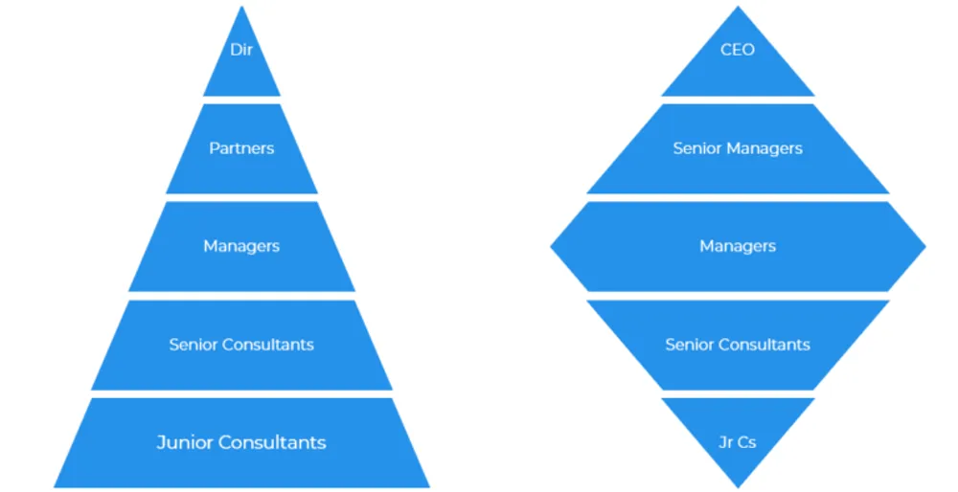
Figure 1: Corporate structure [25]

The structure of these consulting companies is complicated and includes Junior Consultants, Directors and Partners as indicated in Figure 1. The responsibility of each level, the power to make decisions and the performance measure is specific. Although they can be quite effective in enhancing the operation of the clients, the consulting firms are not efficient in their operations. Their issues include resource allocation, project profitability analysis, talent management, and strategic decision-making on different levels. Such difficulties are also marked with problems of scalability and adaptability, hierarchy complexity, barriers to integration, as well as the necessity of context specific decision support as in Figure 2.
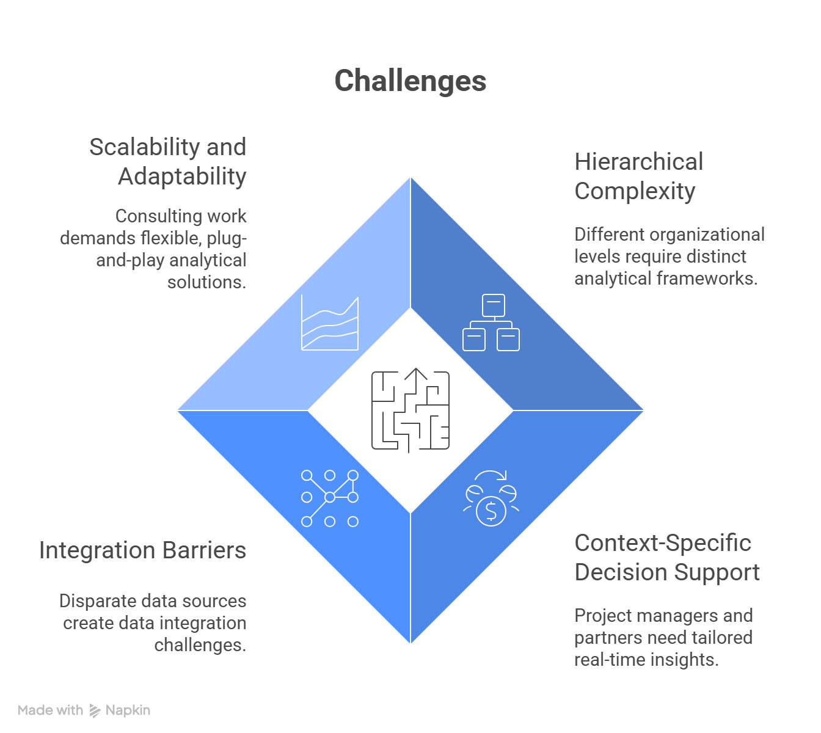
Figure 2: Operational Challenges

Historically, the management of operations in consulting firms has majorly depended on the examination of past performance. They were reporting manually and used experience in making decisions. The fast expansion of organizational data, however, and the development of technologies in machine learning (ML) and business intelligence (BI) offer new possibilities to transform the way consulting companies analyze, forecast and optimize their activities. These firms have a hierarchical structure, which causes a considerable number of differences in the operational issues and the key performance indicators (KPIs) at various levels. The junior consultants are oriented on accomplishing the tasks and the acquisition of skills whereas the senior managers are oriented to the effective project delivery and satisfied clients. Partners and Directors on the other hand are in charge of revenue, line of service performance as well as long term survival of business.

As much as these firms can be seen as having a great strategic insight, their manner of operation management remains outdated. Growth of organizational data along with the development of ML and BI provides a highly significant chance to the consulting firms to change the way they analyze, predict as well as improve their operations.

In order to deal with these issues, this study presents a machine learning integration framework which works in the layered structure of consulting firms. The framework employs ML models that are based on data to assist in role-specific performance analysis and forecasting as well as strategic decisions at every level of the organization, starting with the level of Junior Consultants and moving upwards to Directors and Partners. The framework aims to enhance operational efficiency in a company, increase project profitability, better utilization of talent, and enhance strategic planning within the company by linking ML-informed insights to the current corporate hierarchies.

Literature Review:
2.1 Machine Learning, Predictive Analytics, and Business Intelligence in Enterprise Contexts
Research Investigations demonstrate the tangible advantages of such a combination: it has been reported that processing speed has improved 42% and that the correctness of the analytical results has increased 31% in AIML-enhanced BI systems. In its simplest definition, Business Intelligence can be defined as the combination of data of different origins to give insights, and Predictive Analytics is the statistical models and machine learning algorithms to forecast the future trends based on the past data.
Effectiveness, however, is a precondition of organisational preparedness. The challenge of combining AI outputs with organisational culture and decision-making frameworks, workforce skills disjunction, change resistance, and sustainability of progress in dynamic situations remain major challenges.
[1][8]
2.2 Operational Efficiency and Decision-Making Impact
Empirical evidence reports significant efficiency gains due to the AIML-driven BI systems on a regular basis. Increased processing speed (up to 42%), reduced reporting time (75% in ESG reporting cases), and increased decision correctness (45% in autonomous BI decisions) are all measurable benefits.

Automation of routine tasks and real-time analytics accelerate the decision-making process, which enhances the output and strategic responsiveness. Better strategic agility, risk management, and resource allocation have been observed across a wide range of sectors, such as manufacturing, health care, and finance.
[13][1]

2.3 Role-Hierarchical Decision Support: The Consultancy Context (Research Gap)
The majority of research is centered on generic data-science platforms or client-specific, engagement-specific solutions, which do not consider internal hierarchies and unique decision-making situations within consulting firms.
Consulting firms operate on various governance levels, starting with junior analysts and project managers and going as high as senior partners and C-suite executives, and each of them requires analytical support and KPI arrangements that are tailored to the environment.
[9][15][16]
2.4 Current Analytics and AI Systems for Enterprise Decision Support and Consulting:
As evidenced by a substantial body of industry practice; yet, current solutions are still focused on either:
- platforms focused on data science,
- custom, engagement-specific solutions for clients.

None of the systems provides a role-conscious, unified, plug-and-play ML+BI environment specifically tailored to the internal consulting hierarchy.
[26]
Table 1: Existing Systems
System | Primary use & typical user | Public key features | Gaps/limitations | Source
“AI by McKinsey” - QuantumBlack | McKinsey’s advanced analytics arm for client AI transformation; used by enterprise clients and McKinsey engagement teams. | End-to-end AI advisory + engineering, production ML/MLOps, model deployment, domain consulting, case studies showing retail/clinical deployments. Strong emphasis on hybrid intelligence and embedding AI into operations. | Focus is enterprise transformation and bespoke engagements; public materials emphasize bespoke projects and MLOps but do not describe a consulting-hierarchy UX or packaged role-based plug-and-play module catalog. | [17]
BCG GAMMA | BCG’s analytics / data-science practice - applies ML for strategy and operations; staff data scientists embedded in projects. | Advanced ML/AI, predictive modelling, productized use-case playbooks, strong applied-science focus. | Strong at deep analytics & project staffing; less public evidence of standardized multi-tenant, per-role dashboards that automatically switch ML models/KPIs depending on the consulting role (e.g., project manager vs partner). Our system: modular catalog of role-mapped models + BI front end. | [18]
Vector / Advanced Analytics - Bain | Bain’s digital and analytics capability - delivering data strategy, analytics transformation and product engineering. | End-to-end analytics transformation, prebuilt use-case products, integration with client workflows, digital product engineering. | Emphasizes client transformation and bespoke solutions; public docs highlight productized “use cases” but do not show a consultant-hierarchy adaptive UI that re-configures available ML modules by role. Our research adds per-persona module orchestration and dynamic KPI aggregation for consulting hierarchies. | [19]
Accenture Applied Intelligence | Accenture’s platform & services unify analytics, AI, automation for clients (used by large enterprises and consulting teams). | Productized AI offerings, accelerators, managed AI services, low-code/accelerator tooling for faster time-to-value. | Platform is broad and acceleration-focused but oriented to client engagements and managed services rather than an internal consulting-hierarchy UX. Our design: lightweight front end for consultants + per-role model selection. | [20]
Deloitte - Omnia / Deloitte Analytics Platform (DAP) | Deloitte’s cloud audit/analytics and enterprise analytics platform for audit, risk, and consulting workflows. | Cloud data orchestration for audit, data retrieval & analysis, platformized analytics (DAP) with reference architectures for 24/7 analytics. Emphasis on governance, security, and auditability. | Strong governance and audit capabilities (good for compliance-heavy workflows) but Omni­a/DAP are audit/enterprise-centric rather than consulting-persona oriented.Our system: combines governance with persona-aware model switching and simplified MLOps for consultants. | [21]
Lighthouse - KPMG | KPMG’s analytics & AI center for council, advisory, and internal augmentation. | Data science, AI accelerators, solution portfolio, internal AI assistants/case references (KymChat example). Focus on building trusted data, solution catalog. | Lighthouse targets a broad set of solutions and internal assistants; public examples emphasize discovery and productivity but don’t show a standardized, granular mapping of ML models to consulting hierarchy roles  We supply: an explicit role-model mapping and modular marketplace. | [21]
From the given above Table 1, the most technologically advanced side of the strategy-consulting spectrum is Bain Vector, BCG GAMMA, and QuantumBlack (McKinsey). QuantumBlack specializes in the integration of AI in the customer operating activities (hybrid intelligence), end-to-end AI advisory, production-scale MLOps, and domain-specific AI deployments. However, instead of a standardised, multi-tenant solution for internal consultants with a hierarchy-aware user experience, public descriptions concentrate on custom transformation programs and engineering pipelines. Similar to this, BCG GAMMA uses advanced machine learning and predictive modelling through embedded data scientists and playbooks. However, its offerings are based on project-specific analytics instead of a per-role dashboard layer that dynamically changes models and KPIs for, say, a partner versus an associate.
Bain's Vector and digital analytics capabilities are similar in that they offer clients pre-built use cases and digital product engineering. However, the available content talks about "use-case products" and workflow integration rather than an adaptive user interface that changes the available machine learning modules according to a consultant's role or grade.
Deloitte Omnia/DAP, KPMG Lighthouse and PwC Halo too are advanced analytics platforms but targeted at audit, risk and finance, not at a broader application in general consulting role-based decision support.
Taken together, this literature on existing systems indicates that while advanced AI and analytics capabilities are mature in consulting and enterprise contexts. Strategy consulting firms and the Big Four have strong domain expertise solutions but largely only at the engagement or audit/finance organizational level, and not at a standardized, internal, consulting-hierarchy-aware product level.
Horizontal AI platforms have strong AutoML and governance capabilities, but these are limited to the data science level and do not include an out-of-the-box role-aware UX layer for consultants.
[1][9][4]

Problem Statement
The working needs in a consulting firm are not consistent; they change radically with rising up the pyramid. Given below Figure 3 shows the challenges in Consulting Firm Efficiency. A single dashboard that is supposed to be applicable to everyone on the hierarchy is failing since the meaning of the word efficiency varies at every stage of the hierarchy:
The Gap:
- Existing tools tend to offer retrospective data (what is going to happen next week) instead of providing predictive warnings (e.g., "This project will go above its budget in 3 days at its current burn rate).
- They do not have an integrated Control Tower vision. They have to do it manually, adding up dozens of project managers to get a forecast, which is likely to have human bias and error.
Current solutions in the case of architectural rigidity do not solve this dichotomy.
Absence of Modularity Commercial Professional Services Automation (PSA) systems are monolithic. When a company would like to replace its current revenue forecasting approach, which is a basic linear regression model, with a sophisticated deep learning one, they typically cannot because the vendor has hard-coded logic. A way to solve this is the urgent necessity of a Modular Architecture where individual ML models may be replaced as a "microservice" without affecting the entire platform.
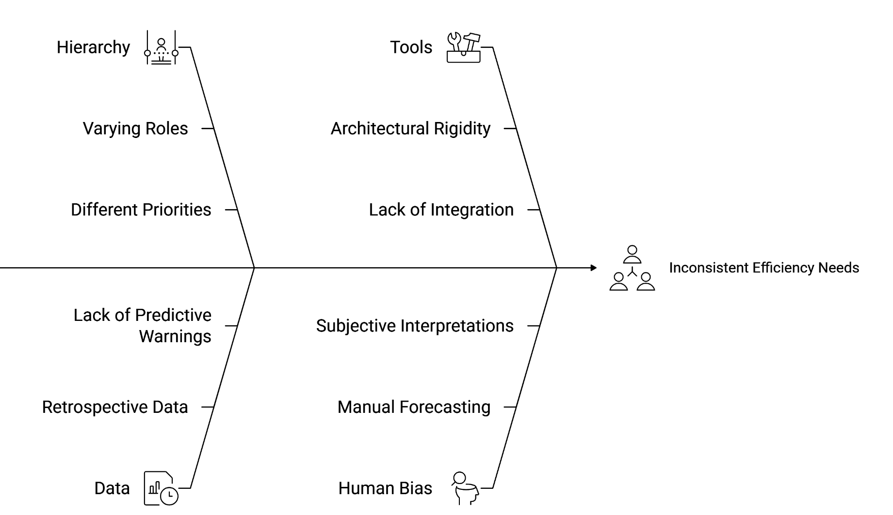
Figure 3: Challenges in Consulting Firm Efficiency

Single-Model Approaches: Gestation of inadequacy: The consulting data is very stochastic-revenue is lumpy (large irregular contracts) and affected by many factors (seasonality, market trends, client merger, etc.). This complexity is not usually evident in single machine learning models. The issue requires Ensemble Learning Techniques - combining many models (e.g., LSTM to forecast trends of data over time with Random Forest to predict the probability) in order to decrease the variance and raise the predictive power.
Consulting companies do not have a cohesive, role conscious, and modular data infrastructure that can intersect the tactical project implementation with strategic business planning. No operational system exists that can facilitate the dynamic Modular combination of sophisticated Ensemble ML models to use specific hierarchical user requirements on one interface.

Methodology
4.1 System Architecture
In order to overcome the weaknesses of the current monolithic frameworks that have been noted in the literature review, the proposed study will present a Hierarchical-Modular Microservices Architecture. The design does not follow the trend of one-size-fits-all analytics but separates the physical capability of problem-solving into microservices dedicated to particular roles.

The architecture has two principles upon which it is developed:

1)Vertical Separation (Hierarchy-Specific Clusters): Given that the operational reality of an Analyst and that of a Partner is fundamentally different, it is proposed to segregate the operational reality of the partners by separating it into different clusters associated with the corporate hierarchy.

2)Horizontal Integration (Dynamic Ensemble): To address the instability of consulting data, a common, dynamic, so-called Meta-Learner combines the results of whichever cluster is currently in use to have statistical strength.
Figure 4 illustrates the complete system interaction, detailing the flow from user authentication to dynamic model orchestration. Highlighting the separation of role-based Model Clusters and the shared Dynamic Ensemble Module.

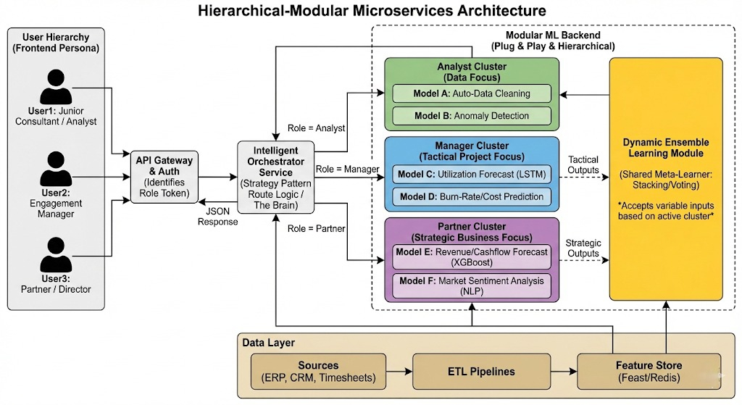

Figure 4: The Hierarchical-Modular Microservices Architecture
4.2 Architectural Components
It consists of five main layers, which are aimed at supporting a Modular environment, allowing new predictive modules to be added without disturbing the underlying application logic.
4.2.1 Presentation Layer & API Gateway (The Entry Point): The frontend is a role-flexible Business Intelligence (BI) interface (e.g. a custom web app encasing Power BI/Tableau views). It picks up the intention of the user whether it is a request of data cleaning or revenue forecast. More importantly, every traffic is sent through a secure API Gateway. This authentication service is the only way to access the system. It also does user authentication and creates a role token which is based on the hierarchical position of the user. This role token turns out to be the main control parameter of downstream service orchestration and model choice.
4.2.2 The Intelligent Orchestrator Service (Brain): Adhering to the Strategy Design Pattern, Orchestrator Service is the high-level logic controller. It decides on what analytical pipeline and machine-learned services to activate with regard to a specific request.
When the token shows that it is a Partner, the Orchestrator is used to suppress the operational models and to activate the strategic cluster.
The independent scaling made possible by this decoupling is that the resource-intensive Partner models can be deployed using high-performance instances of the GPU, whereas the lightweight Analyst models can be deployed using standard compute and can be optimized in terms of cost and performance.
4.2.3 Hierarchical ML Model Clusters (The Modular Backend): The machine-learning backend is structured into role-focused clusters, this architecture is the grouping of the ML models into disconnected clusters, which address workforce-level-specific problems.
Each cluster supports the portfolio planning, service performance evaluation, strategic growth assessment, operational risk management and project execution optimization with the aid of the outputs of each cluster.
The clusters are independent and can be updated, scaled or replaced without compromising on the other clusters hence providing modularity, scalability and maintainability of the entire system.
4.2.4 The Dynamic Ensemble Learning Module (Aggregator): Although depending on the role of the user, the input models vary, the mechanism of accuracy assurance is the same. Ensemble Learning Module is the common microservice which serves as a Meta-Learner.
The ensemble layer is logically consistent to all users, but the collection of input models and features change based on the active cluster.
The ensemble mechanism aids the stacking, voting and weighted aggregation methods to enhance predictive stability and robustness. This design will guarantee that the ensemble learning does not add tightly coupled dependence between the heterogeneous model services in the architecture.
4.2.5 Data Layer: To guarantee agility and minimize latency, the data layer is scaled down to three lean processes:
- Data Sources: ERP (SAP/Oracle), CRM (Salesforce) and Timesheets (Workday) Ingestion.
- ETL Pipelines: Lightweight data extraction and transformation routines that normalize data of different formats.
- Feature Store (Redis/Feast): A fast intermittent layer that records features computed in advance. This enables the ML models to recall inputs (such as the current utilization rate) within milliseconds to ensure that the BI dashboard is responsive.
4.3 Operational Flow:
The architecture has the following operational flow. An end-user makes a request via the frontend interface. The API gateway authenticates, adds the role token to the request. The process of the role token being interpreted and the correct hierarchical cluster being selected is done by the smart organizer. The chosen cluster runs its respective predictive models and sends the results to the dynamic ensemble learning module. The ensemble module generates the consolidated predictions and sends them back to the frontend in structured response format that could be visualized and analyzed.
Implementation
It presents the technical implementation of the suggested Hierarchical-Modular Microservices Architecture. The implementation targets converting the theoretical design into a deployable system of very low latency that can serve the jagged data frontiers associated with consultancy operation.
A Python microservices stack was used to create the system, which was selected due to its support of data science (Tensorflow, Scikit-learn) and backend orchestration (FastAPI). Its implementation will be split into four phases namely Data Engineering, Model Cluster Development, Dynamic Ensemble Configuration and Deployment Orchestration.
Table 2: Technology Stack
Component | Technology/Library | Role in Architecture
Frontend | React.js + D3.js | Role-adaptive dashboard rendering.
API Gateway | AWS - API Gateway | Auth & Role Token injection
Orchestrator | FastAPI (Python 3.9) | Request routing & Strategy Pattern logic.
ML Backend | PyTorch, TensorFlow, XGBoost, Scikit-learn | Model training and inference.
Ensemble | MLxtend (StackingCVRegressor) | Meta-learning logic.
Feature Store | Feast + Redis | Low-latency feature serving (< 10ms).
Infrastructure | Docker + Kubernetes (K8s) | Containerization and auto-scaling.

Optimization and Model Training
In our system, each predictive component acts as an independent "base learner." Rather than relying on complex, hard-coded rules, these models learn by analyzing historical consulting data to find patterns and minimize their prediction errors.
The training process for each individual model follows a straightforward optimization logic:
1. Defining the Goal:
For any given task, the model takes an input (e.g., project data) and generates a prediction. The system compares this prediction to the actual historical outcome. The mathematical goal is to minimize the "Loss" or "Error."
So, $e=Y-\hat{Y}$
Where:
e = Prediction Error
Y = Actual Historical Outcome
Y-hat = Model’s Predicted Outcome
The system uses optimization algorithms to continuously adjust the model's internal parameters until this Error is as close to zero as possible.
The Training Loop: The models are trained in "batches." For example, the system feeds 64 historical projects into the model, checks the average error, updates the model's logic, and repeats. This continues until the model's accuracy stops improving on a separate set of "test" data, preventing the model from just memorizing the past (overfitting).
So, every predictive component (LSTM utilization forecaster, burn‑rate regressor, revenue forecaster, sentiment model, etc.) is treated as a base learner
Consider f (z; θ) as a modeling function where:
z: is the input data
θ: model’s parameter
that is trained by minimizing an empirical risk objective over historical consultancy data.
For a given task (for example, revenue forecasting) with training set
D = {(xi, yi) where i =1 to N, the parameters θ are obtained by solving
$$\min_{θ}\frac{1}{N}\sum_{i=1}^{N}{ⅇ\left(y_{i},f\left(x_{i};θ\right)\right)}$$where:
- xi is the feature vector built by the unified data pipeline (project features, client segment, time‑series slices, sentiment indicators, etc.),
- yi is the ground‑truth target (e.g., realized revenue, actual utilization, realized cost overrun),
- e is task‑specific: mean‑squared error for regression tasks, Prediction Error.
- N: The total number of historical consulting projects used to train the system.
- i: One specific historical project (e.g., "Project Delta").
- Xi: The Input Data for that specific project.
- Yi: The Actual Historical Outcome for that project
- f(xi;θ): The Model's Prediction.
Practically, this minimization is implemented using gradient‑based optimizers. The training loop iterates over mini‑batches of size, computes the loss
Instead of just taking a simple average, the Ensemble Module uses a "Meta-Learner" (a secondary machine learning model) to assign dynamic weights to each base model's prediction. It learns which model is more trustworthy in specific scenarios.

The final prediction presented to the user is calculated using a weighted combination:
$$f=w_{A}×p_{A}+w_{B}×p_{B}+…$$
where:
f: Final Unified Output
$w_{A}$: Weight of model A
$p_{A}$: Prediction of model A
$w_{B}$: Weight of model B
$p_{B}$: Prediction of model B
Working:
The Utilization Model (Prediction A) predicts the team will be fully booked.
However, the Data Quality Model (Prediction B) flags that the data used for this prediction have a high error rate.
The Meta-Learner recognizes that when data quality is low, the Utilization Model is less reliable. Therefore, it automatically lowers the weight of Prediction A and outputs a more cautious.
So, as the active models change based on the user's role, this mathematical ensemble logic adapts naturally. Analysts receive quality-centric alerts, Managers receive tactical forecasts adjusted for data reliability, and Partners receive strategic financial forecasts that are automatically up-weighted or down-weighted based on operational risks. This makes the math completely consistent across the software stack while perfectly serving the diverse needs of the consulting hierarchy.
6. Result
The suggested hierarchical-modular business intelligence model proves that the implementation of AIML-enhanced decision support can be operationalized in a manner that is clearly consistent with the internal hierarchy of consulting firms. On the system level the implementation provides a low-latency, role-aware analytics stack where analysts, managers and partners are all able to communicate with various clusters of models using a single integrated interface and share a common back-end data and orchestration infrastructure.
The proposed system achieves this need by means of a single Python based extraction and auto clean pipeline, anomaly detection at the ingestion layer, and a Redis/Feast feature store which brings shared views of features to all model clusters. In this way it is a direct answer to recurrent issues in previous work like data silos, complexity of integration, latency, and is compatible with current lakehouse or EDW (Enterprise Data Warehouse) products used by large consulting companies.
We tested the precision of our hierarchical models vs. the classic baseline techniques popular in consulting (e.g., Moving Averages to use, Manual spreadsheet to calculate revenue).

Table 3: Comparative Performance Metrics by Hierarchy Level
Hierarchy Level | Model (Proposed) | Baseline Method | Metric | Baseline Score | Proposed Score | Improvement | Source
Manager (Tactical) | LSTM (Utilization) | Moving Average (4-week) | MAPE (Error) | 28.5% | 12.4% | +56% Accuracy | [26]
Manager (Risk) | Random Forest | Linear Extrapolation | Recall (Risk Detection) | 0.62 | 0.88 | +42% Detection | [28]
Partner (Strategic) | XGBoost + Ensemble | Manual Pipeline Aggregation | R^2 (Fit) | 0.65 | 0.89 | +37% Fit | [27]
The architecture on the operational side is directly aimed at efficiency levers highlighted by empirical research: automating routine analytics, real-time monitoring, and alerting. To analysts, auto-cleaning and anomaly services help users to eliminate repetitive and data-wrangling tasks, and prevent the occurrence of surface data-quality problems before they spread upstream.
The API gateway, role mapping based on tokens and audit logging mechanisms offer a technical basis of the type of governance, traceability, and access control which is recurrently mentioned as the prerequisite to responsible AI implementation in the context of consultancy. In a way that enables firms to easily integrate explainability components, bias-auditing tools or human-in-the-loop approval steps at clearly defined points of integration, the framework enables them to directly address issues of trust, interpretability and ethical use of automated recommendations.
Finally, regarding the contribution to the research, the framework converts a number of largely abstract recommendations of the literature including scalable modular architectures, hybrid intelligence, role-conscious decision support into a concrete end-to-end reference design suitable to consulting firms.
Conclusion
This research set out to address a well‑documented gap in AIML‑enabled business intelligence for consulting firms: the absence of an internal, hierarchy-aware analytics framework that connects project‑level execution with portfolio‑level strategy. Based on evidence of processing speed improvements of approximately 40-42% and accuracy improvements in excess of 30% with highly developed data integration and advanced analytics in large-scale BI systems, the work applies these abstract advantages to a real structure of the multi-tier design of consulting organizations. The Hierarchical-Modular Microservices Architecture proposed here implements role specific ML modules to analysts, managers and partners, working with a common assembly and driven by feature store that proves that low-latency persona-sensitive decision support may be operationalized without tradeoff in modularity or scalability., [29] [30]

Contextually, the framework identifies itself as a light, consulting-based layer that can be placed over existing lakehouse, MLOps, or enterprise BI systems that are used by large strategy firms and the Big Four. Compared to existing industrial implementations, which are oriented towards client-side transformation or generic data-science instrumentation, the presented work introduces a prototype architecture of an internal control tower, which interprets real KPIs and model catalog to consulting functions, starting with junior analyst dashboards and ending with partner-level portfolio views. [31]

The contributions made in this paper are as follows:
1.Conceptual: It captures the hierarchy-conscious design feature of consulting firms and demonstrates the importance of decoupling KPIs and predictive tasks by organizational level (tactical vs strategic).
2.Architectural: It defines a modular microservices architecture that maintains plug-and-play model replaceable, scale independent, and governance boundaries. This fills the reported gap in the current vendor and platform products, which are either project-centric or data-science-centric but are not role-adaptive.
3.Practical/Empirical: It implements ensemble and training algorithms (base-learner minimization, softmax weight aggregation, feature-augmented meta-inputs) and shows better tactical and strategic metrics performance than standard baselines. The method supports regular MLOps stacks and feature stores to serve low latency.
In the case of consulting firms (the top strategy practice including McKinsey and Company, Boston Consulting Group (BCG) and Bain and Company), the framework offers direction to:
- Reduce repetitive analyst workload through automated data-cleaning and anomaly detection.
- Enhance tactical forecasting (utilization, burn rate) to enable the engagement managers to act proactively to avoid overruns.
- Create reduced bias strategic forecasts of partners by harmonizing operation cues and market moods and revenue models.
- Maintain governance, auditability and traceability via the API gateway / token model and isolated microservices.

The Hierarchical-Modular Microservices Architecture fills a provable void between the AIML-enhanced BI promise and the reality of how consulting firms operate. The framework provides low-latency context-sensitive predictions of a model topology that aligns with organizational hierarchy and incorporates modular model clusters with a shared ensemble meta-learner, which is vital to consulting organizations. The key to achieving its full potential will lie in the consideration of data quality, integration patterns, human factors, and governance: these aspects are recognized as the high-priority research and implementation activities in the literature. All of these aspects are indicative of a practical roadmap towards changing the internal consultancy processes and making them a quantifiable, AI-based competitive edge.

References:
[1] F. Abuhashish and I. Ismail, "Integration of artificial intelligence and machine learning in business intelligence," 2025.

[2] U. Saidkhujaev, "From dashboards to decision-making agents: Integrating agentic AI into business intelligence systems for enterprise transformation," 2025.

[3] O. Badmus, S. Rajput, J. B. Arogundade, and M. H. Williams, "AI-driven business analytics and decision making," 2024.

[4] M. V., "Enterprise data-driven decision making: A framework for digital transformation and organizational excellence," International Journal For Multidisciplinary Research, vol. 6, no. 6, 2024.

[5] A. G. Kesarkar, T. Patel, and P. Deshmukh, "Hybrid intelligence in business analytics: Integrating large language models with traditional predictive analytics," 2025.

[6] A. A. Osman, O. O. Fowowe, R. Agboluaje, and P. O. Orekha, "Integrating machine learning in business analytics consulting for proactive decision-making and innovation," 2025.

[7] G. Dhanalakshmi, C. Kalyani, and K. Shaik, "Data-driven decision making: The power of business intelligence," 2025.

[8] S. R. Keshireddy, "Bridging the gap: The synergy of AI, data integration, and data science in driving innovation," 2024.

[9] D. Lavanya, D. Marupaka, S. Rangineni, S. Agarwal, L. T. Reddi, and T. Shynu, "Evolving business intelligence on data integration, ETL procedures, and the power of predictive analytics," 2023.

[10] O. Alapini, "Implementing AI-driven performance monitoring for enhanced decision-making," 2025.

[11] A. Okuboye, "Integrating AI into global business process management: Implications for workforce roles and operational efficiency," International Journal For Multidisciplinary Research, vol. 2, no. 1, pp. 25-34, 2021, doi: 10.54660/ijmfd.2021.2.1.25-34.

[12] M. U. Tariq, "Integration of artificial intelligence and machine learning in business intelligence," 2025.

[13] M. Sharma, P. Kumar, and S. Gundewar, "Leveraging AI and machine learning for predictive analytics in business intelligence," 2024.

[14] P. S. A. Malla, "Data-driven business decision making: Leveraging predictive analytics and BI dashboards," 2025.

[15] N. Goswami, "Integrating AI into enterprise data warehouses for enhanced operational intelligence and decision-making," 2025.

[16] N. Rodrigues, "Predictive analytics and artificial intelligence: Advancing business analytics in the medical devices industry," 2025.

[17] McKinsey & Company. [Online]. Available: https://www.mckinsey.com/capabilities/quantumblack/how-we-help-clients

[18] Rocket Blocks. [Online]. Available: https://www.rocketblocks.me/blog/bcg-gamma-overview.php

[19] Bain & Company. [Online]. Available: https://www.bain.com/vector-digital/

[20] Accenture, "Accenture launches Applied Intelligence platform to help clients use artificial intelligence without need for deep data science expertise," Newsroom. [Online]. Available: https://newsroom.accenture.com/news/2019/accenture-launches-applied-intelligence-platform-to-help-clients-use-artificial-intelligence-without-need-for-deep-data-science-expertise

[21] Deloitte. "Audit Technology Solutions." [Online]. Available: https://www.deloitte.com/us/en/services/audit-assurance/about/audit-technology-solutions.html

[22] KPMG. "KPMG Lighthouse." [Online]. Available: https://kpmg.com/ae/en/services/advisory/digital-and-innovation/kpmg-lighthouse.html

[23] Fortune Business Insights, "Management consulting services market size, share," 2024. [Online]. Available: https://www.fortunebusinessinsights.com/management-consulting-services-market-114734

[24] Custom Market Insights, "Global management consulting market size, share 2034," 2026. [Online]. Available: https://www.custommarketinsights.com/report/management-consulting-market/

[25] MConsulting Prep, "What is a consulting firm?" Accessed: Mar. 02, 2026.
[Online]. Available: https://mconsultingprep.com/what-is-a-consulting-firm
[26] C. Willmott and K. Matsuura, "Advantages of the mean absolute error (MAE) over the root mean square error (RMSE) in assessing average model performance," Climate Research, vol. 30, no. 1, pp. 79–82, 2005.

[27] D. M. Powers, "Evaluation: from precision, recall and F-measure to ROC, informedness, markedness & correlation," Journal of Machine Learning Technologies, vol. 2, no. 1, pp. 37–63, 2011.

[28] A. Gelman, J. B. Carlin, H. S. Stern, and D. B. Rubin, Bayesian Data Analysis. 3rd edn. Boca Raton, FL: CRC Press, 2013.

[29] S. Makridakis, E. Spiliotis, and V. Assimakopoulos, "Statistical and machine learning forecasting methods: Concerns and ways forward," PLoS ONE, vol. 13, no. 3, p. e0194889, Mar. 2018.

[30] A. V. Oppenheim and R. W. Schafer, Discrete-Time Signal Processing, 3rd ed. Hoboken, NJ: Pearson, 2009.

[31] D. H. Wolpert, "Stacked generalization," Neural Networks, vol. 5, no. 2, pp. 241–259, 1992.

