A COMPUTER VISION-BASED PLASTIC BOTTLE CLASSIFICATION AND RECYCLING MANAGEMENT SYSTEM USING ENHANCED YOLOV8N WITH SE BLOCK AND CBAM

ABSTRACT

This study developed a Prototype CV-Based Plastic Bottle Classification and Recycling Management System using YOLOv8n model integrated with SE Block and CBAM is designed to improve waste segregation and recycling practices within the Mindanao State University – Sultan Naga Dimaporo (MSU-SND) campus. The system utilized a Raspberry Pi 4, Raspberry Pi Camera Module, servo motor, LCD display, and the YOLOv8n object detection model for real-time bottle detection and sorting. The study adopted the Software Development Life Cycle (SDLC) using the Spiral Model, which involved iterative phases of planning, risk analysis, design, development, testing, and evaluation to ensure continuous system improvement. A dataset composed of plastic and non-plastic bottle images underwent preprocessing and augmentation techniques to improve detection accuracy and model robustness. The dataset was divided into training, validation, and testing subsets using a 70:20:10 ratio to ensure reliable model evaluation. Furthermore, the YOLOv8n model, enhanced with Squeeze-and-Excitation (SE) Block and Convolutional Block Attention Module (CBAM), was trained to improve feature extraction and detection performance under varying lighting conditions, object positions, and orientations. The trained model achieved a mAP@0.5 score of 0.97 demonstrating high object detection and classification performance during validation and testing. During operation, the system identified whether the inserted item was plastic or non-plastic and automatically directed it into the appropriate bin using a servo-controlled diverter mechanism while displaying corresponding feedback through the LCD module. The developed system demonstrated effective real-time detection, classification, and automated sorting performance, showing its potential in supporting sustainable waste management and promoting environmental responsibility within the campus community.

Keywords: Computer Vision, Plastic Bottle Classification, Recycling System, YOLOv8n, Waste Segregation

INTRODUCTION

Plastic pollution remains one of the most significant environmental challenges worldwide, posing serious threats to ecosystems, biodiversity, and sustainable development. According to the United Nations Environment Programme (UNEP, 2021), plastic constitutes a major portion of marine litter and continues to accumulate in terrestrial and aquatic environments due to improper disposal and inadequate waste management practices. The growing volume of plastic waste, coupled with ineffective segregation methods, reduces recycling efficiency and contributes to environmental degradation. As a result, there is an increasing need for innovative and sustainable solutions that can improve waste segregation and support recycling initiatives.
In the Philippines, improper waste disposal and insufficient segregation of recyclable materials remain persistent concerns in both communities and educational institutions. Recyclable plastic bottles are often mixed with non-recyclable waste, resulting in contamination that limits material recovery and increases the burden of manual sorting. Similar challenges are observed at Mindanao State University – Sultan Naga Dimaporo (MSU-SND), where plastic bottles are frequently disposed of together with non-plastic materials, reducing the effectiveness of recycling efforts and waste management practices within the campus.
Recent advancements in artificial intelligence and computer vision have shown significant potential in addressing waste management challenges. Deep learning-based object detection systems have demonstrated high accuracy in identifying and classifying recyclable materials, thereby improving waste segregation and recycling efficiency (Choi et al., 2023). Among these technologies, the YOLO (You Only Look Once) family of object detection models has gained widespread recognition for its ability to perform accurate real-time object detection (Redmon et al., 2016). The latest YOLOv8 architecture further enhances detection performance and computational efficiency, making it suitable for deployment on embedded systems such as Raspberry Pi (Jocher et al., 2023). Moreover, attention mechanisms such as Squeeze-and-Excitation (SE) Block (Hu et al., 2018) and Convolutional Block Attention Module (CBAM) (Woo et al., 2018) have been shown to improve feature extraction and object recognition performance by enabling deep learning models to focus on the most relevant image features.
In response to these challenges, this study proposes a Computer Vision-Based Plastic Bottle Classification and Recycling Management System using an enhanced YOLOv8n model integrated with SE Block and CBAM. The system utilizes a Raspberry Pi 4 Model B, Raspberry Pi Camera Module V2, LCD display, and high-torque servo motor to perform real-time identification of plastic bottles and distinguish them from non-plastic materials. Unlike conventional waste segregation methods that rely heavily on manual inspection, the proposed system automates the classification process to improve efficiency, reduce contamination of recyclable materials, and support effective recycling management practices. By leveraging computer vision, deep learning, and embedded system technologies, the study contributes to the development of intelligent waste management solutions that promote environmental sustainability within the university community.
Furthermore, this study supports the achievement of the United Nations Sustainable Development Goals (SDGs), particularly SDG 9 (Industry, Innovation and Infrastructure), SDG 11 (Sustainable Cities and Communities), SDG 12 (Responsible Consumption and Production), and SDG 13 (Climate Action), by promoting the adoption of innovative technologies for sustainable waste management and environmental conservation.

Statement of the Problem

Plastic bottle waste is one of the significant environmental challenges on the MSU-SND campus due to the lack of proper designation and an innovative, effective system that supports modern recycling practices. The existing waste management approach does not provide a structured method for responsible disposal, making it difficult for the university to maintain a clean, sustainable, and environmentally responsible campus. Specifically, this study sought to address the improper disposal of plastic bottles and other waste materials, as well as the contamination of recyclable plastics, which reduces their usability.

Objectives of the Study

This study aimed to develop a computer vision-based plastic bottle classification and recycling management system integrated into a prototype reverse vending machine to support proper waste disposal and enhance recycling practices within the MSU-SND campus. Specifically, it sought to design and implement an enhanced YOLOv8n model, improved using SE blocks and CBAM, for accurate identification and classification of plastic bottles, particularly PET and HDPE, while rejecting non-plastic waste. Furthermore, the system aimed to improve the quality and reliability of collected recyclable materials by minimizing contamination from non-recyclable items, thereby addressing inefficiencies in manual waste segregation and promoting a more effective recycling process.

Conceptual Framework

The Input–Process–Output (IPO) model illustrates the overall operation of the Computer Vision-Based Plastic Bottle Classification and Recycling Management System using Enhanced YOLOv8n with Squeeze-and-Excitation (SE) Block and Convolutional Block Attention Module (CBAM). The input stage consists of the primary hardware components, which include the Raspberry Pi 4 Model B, Raspberry Pi Camera V2, 16x2 LCD display, servo motor, power supply, and buck converter, all integrated into a single functional unit. It also includes the curated plastic bottle dataset and the real-time image acquisition process. These inputs serve as the foundational data and physical resources required to initialize and support system operation.
The process stage involves a structured pipeline consisting of dataset preparation, model training, and system deployment. It begins with image annotation using Roboflow to ensure accurate labeling of plastic and non-plastic bottle classes. This is followed by model training in Google Colab, where the deep learning model is developed using YOLOv8n as the base architecture. To enhance detection performance, the model is improved using the Squeeze-and-Excitation (SE) block and the Convolutional Block Attention Module (CBAM), which strengthen feature extraction by improving both channel and spatial attention mechanisms. The trained model is then deployed on the Raspberry Pi, where local control scripts enable real-time image processing, classification, and system response for automated recycling management operations.
The output stage represents the final system implementation and operational results. This includes a fully functional computer vision-based recycling management prototype capable of real-time classification of plastic bottles. The system accurately identifies plastic and non-plastic items and supports effective segregation within the recycling process. Ultimately, it provides an intelligent and automated recycling management solution that improves sorting efficiency, reduces waste contamination, and promotes sustainable waste management practices within the operational environment.
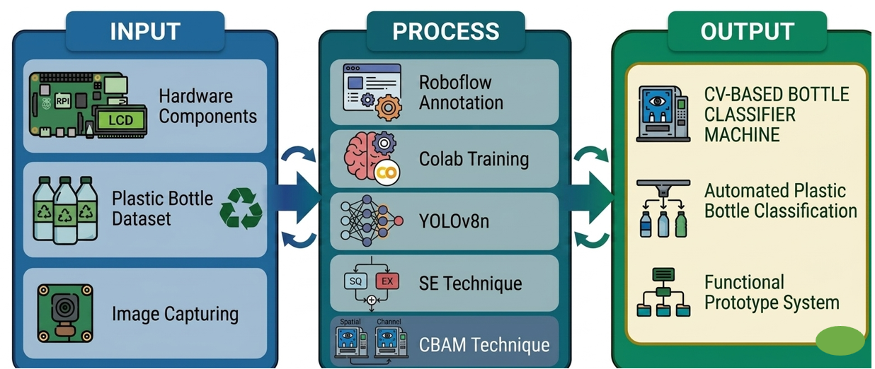

Figure 1. Conceptual Framework

METHODOLOGY

The study adopted the Software Development Life Cycle (SDLC) using the Spiral Model, an iterative and risk-driven approach consisting of planning, risk analysis, design and development, and evaluation. This framework enabled continuous refinement across development cycles to ensure accurate integration and reliable performance of both hardware and computer vision components.
The system was built using a Raspberry Pi 4 Model B as the central processing unit, a Raspberry Pi Camera V2 for image capture, a high-torque servo motor for mechanical sorting, an LCD 16x2 for real-time user feedback, a buck converter for voltage regulation, and a stable power supply. The Raspberry Pi executed AI-based image processing and controlled hardware operations, while the camera captured bottle images for classification. Software development utilized Python, with dataset management and annotation via Roboflow, model training in Google Colab, and deployment through Thonny IDE. The system enabled real-time detection and automated classification of PET and HDPE plastics with precise actuator control.
System design was further supported by Use Case, Flowchart, and Circuit Diagrams to illustrate workflow, hardware integration, and data processing architecture, forming the basis of an efficient automated plastic bottle sorting and recycling system.

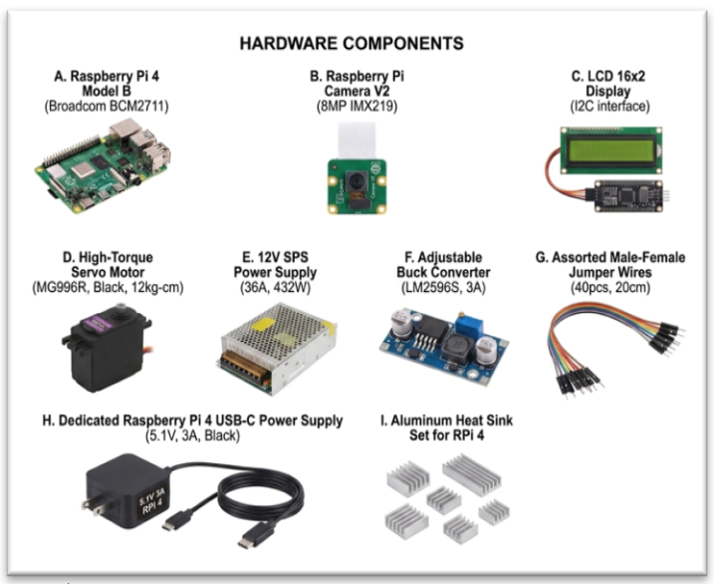

Figure 2. Hardware Components

Collection and Preprocessing

The dataset used in this study was developed for a computer vision-based plastic bottle classification and recycling management system utilizing the YOLOv8n object detection model. It consisted of 2,440 annotated images, equally divided into 1,220 plastic bottle images and 1,220 non-plastic bottle images. Annotation and preprocessing were performed using Roboflow.
The dataset was divided using a 70:20:10 ratio, resulting in 1,708 training images, 488 validation images, and 244 testing images. A stratified splitting approach was applied to maintain balanced class distribution across all subsets, ensuring fair representation of both plastic and non-plastic categories.
All images underwent auto-orientation correction and were resized to 416 × 416 pixels to ensure uniform input dimensions during model training. To enhance generalization capability and reduce overfitting, data augmentation techniques were applied exclusively to the training set. These included horizontal and vertical flipping, 90-degree rotations, slight rotations ranging from -5° to +5°, and adjustments in brightness, saturation, and exposure.
The system utilized the YOLOv8n architecture enhanced with Squeeze-and-Excitation (SE) blocks and the Convolutional Block Attention Module (CBAM) to improve feature representation and strengthen the model’s ability to distinguish plastic bottles under varying lighting conditions, occlusions, and complex backgrounds. This enhancement supports the classification component of the proposed recycling management system by improving detection reliability in real-world waste segregation scenarios.
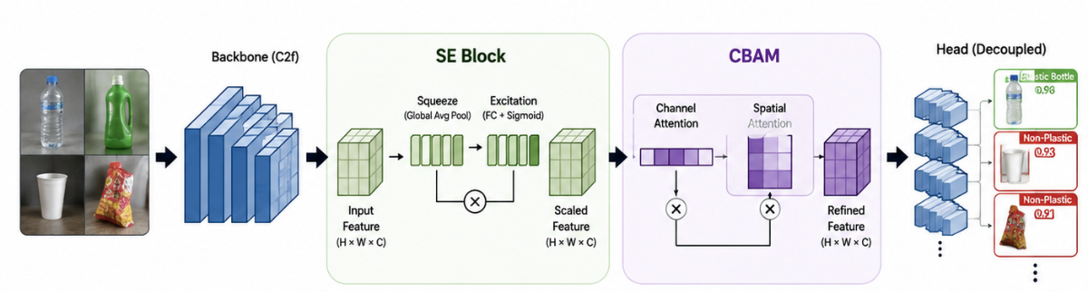

Figure 3. YOLOv8n Architecture

The model was trained using Google Colab with an input resolution of 416 × 416, a batch size of 16, and 100 epochs. Training employed the default Adam-based optimizer integrated within YOLOv8, while early stopping with a patience mechanism was implemented to prevent overfitting and ensure optimal model performance.
YOLOv8n is a single-stage, anchor-free object detector composed of a CSPDarknet backbone for feature extraction, a PAN-FPN neck for multi-scale feature fusion, and a decoupled detection head for simultaneous object localization and classification. Unlike earlier anchor-based YOLO versions, YOLOv8n directly predicts bounding box coordinates and optimizes detection using Distribution Focal Loss (DFL) and Complete Intersection over Union (CIoU) Loss.
Each detected object is assigned an objectness score and class probability, enabling accurate classification between plastic and non-plastic bottles. The enhanced YOLOv8n-SE-CBAM model achieved 97% mAP@0.5, demonstrating strong performance and suitability for integration into the proposed plastic bottle classification and recycling management system, supporting real-time waste identification and segregation processes.

System Design

The system design serves as the foundation of the proposed Computer Vision-Based Plastic Bottle Classification and Recycling Management System, presenting the overall structure and organization of the system components to ensure efficient, reliable, and automated plastic bottle detection, classification, and recycling management operations.

Use Case Diagram

The use case diagram illustrates the interaction between the user and the Computer Vision-Based Plastic Bottle Classification and Recycling Management System. The process begins when the user submits or places a bottle for analysis, which activates the system’s main function. The system then applies computer vision techniques to detect and classify the object, followed by a validation process to determine whether it is a plastic or non-plastic bottle. Based on the classification result, the system records and directs the item into its appropriate category within the recycling management process. The diagram also emphasizes that detection and validation are integrated subprocesses within the main operation, ensuring a structured, accurate, and automated classification workflow for effective recycling management.
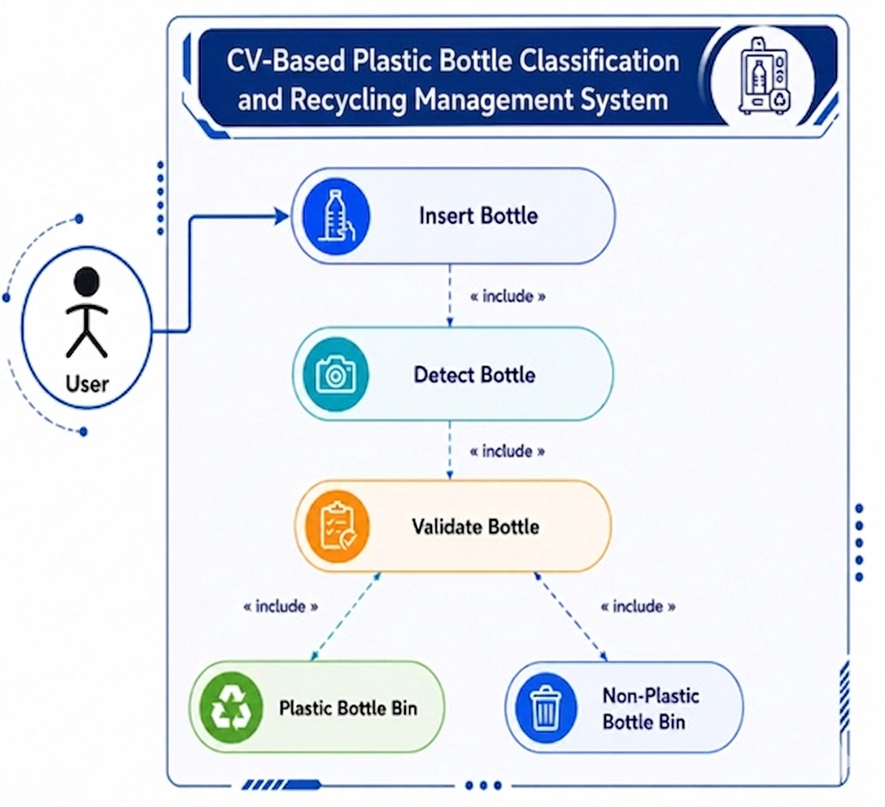

Figure 4. Use Case Diagram

System Architecture Diagram

The System Architecture Diagram illustrates the overall structure and operation of the Computer Vision-Based Plastic Bottle Classification and Recycling Management System using Enhanced YOLOv8n with SE Block and CBAM. The system is composed of four major layers: Input, Processing, Control, and Output.
In the Input Layer, the Raspberry Pi Camera Module v2 captures images of the object submitted by the user for analysis. These images are then transmitted to the Processing Layer, where the Raspberry Pi 4 executes a Python-based Enhanced YOLOv8n model integrated with SE blocks and CBAM to detect and classify whether the object is a plastic bottle or a non-plastic item.
The classification output is then passed to the Control Layer, where decision-making logic is applied to determine the appropriate action based on the detected class. If the object is classified as a plastic bottle, it is recorded and routed to the designated plastic category within the recycling management system. Otherwise, it is categorized as non-plastic and handled accordingly.
In the Output Layer, the system provides real-time feedback through a 16x2 LCD display, showing system statuses such as “Scanning,” “Plastic Bottle Detected,” or “Non-Plastic Item Identified.” Overall, the system integrates computer vision, deep learning, and embedded hardware technologies to support automated plastic bottle classification and improve recycling management efficiency.
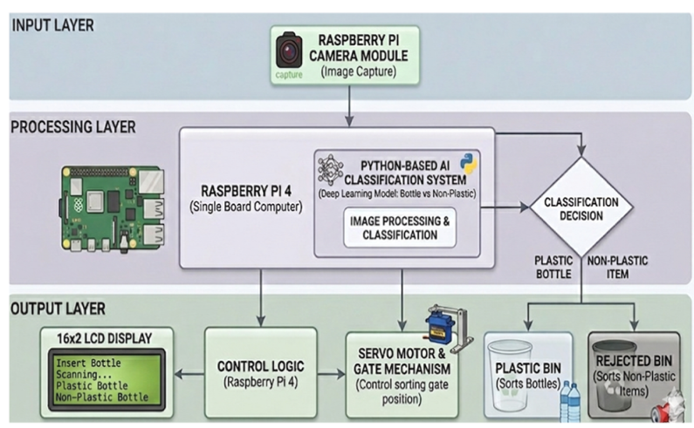

Figure 5. System Architecture Diagram

Flowchart

The flowchart illustrates the operational process of the Computer Vision-Based Plastic Bottle Classification and Recycling Management System using Enhanced YOLOv8n with SE Block and CBAM. The process begins when a user inserts a bottle into the slot. The Raspberry Pi camera captures an image of the item, and the computer vision detection module analyzes it to determine whether it is a plastic bottle. If the item is identified as a valid plastic bottle, the servo motor directs it to the accepted bin. Otherwise, the item is diverted to the rejected bin. After sorting, the servo returns to its neutral position, and the system goes back to idle mode, ready to process the next item. This cycle enables continuous and automated bottle sorting.
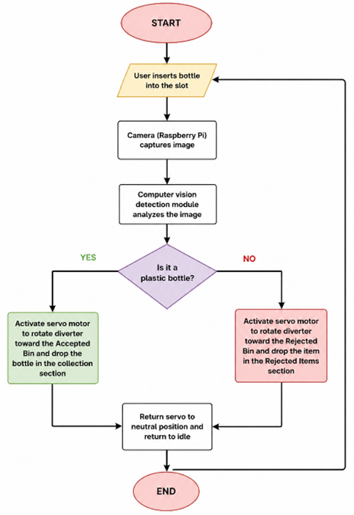

Figure 6. System Flowchart

Circuit Diagram

A circuit diagram is a visual representation of an electrical system that shows how components are connected, how power is distributed, and how signals flow between devices. In this study, the circuit diagram illustrates the complete wiring of the Computer Vision-Based Plastic Bottle Classification and Recycling Management System using Enhanced YOLOv8n with SE Block and CBAM, with the Raspberry Pi 4 Model B serving as the main controller. The system is powered using a 5V 3A USB-C supply for the Raspberry Pi and a 12V 5A switching power supply for external components, which is stepped down to 5V through a buck converter to power the servo motor and other peripherals. The servo motor, responsible for the sorting mechanism, is controlled via GPIO 19 (PWM) with a shared ground connection across all components to ensure stable operation. The Raspberry Pi Camera Module is connected through the CSI interface for real-time image capture, while a 16x2 I2C LCD displays system status and is connected via GPIO 2 (SDA) and GPIO 3 (SCL). The overall design separates power lines for stability while maintaining a common ground, ensuring efficient and reliable operation of the real-time detection and automated sorting system.
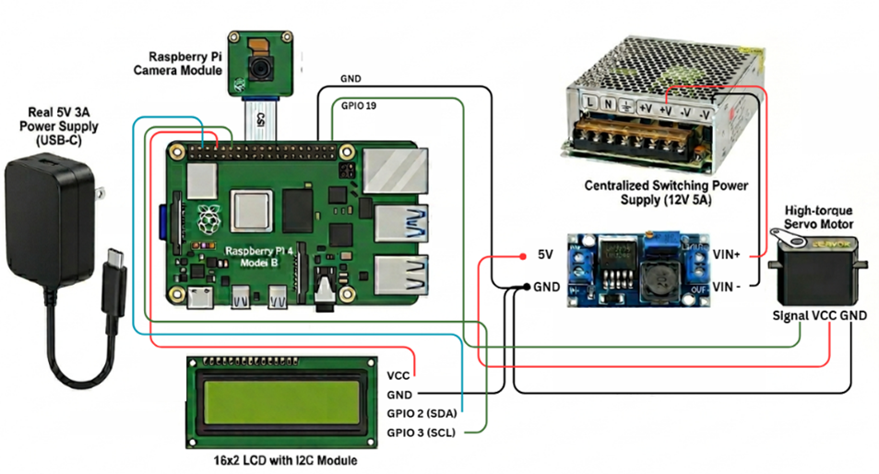

Figure 7. Circuit Diagram

Testing Method

The testing methods included Black Box Testing to evaluate system functionality, input-output behavior, and mechanical sorting reliability from the user's perspective without considering the internal code structure. This was complemented by White Box Testing to rigorously examine the internal logic, data flows, and software execution across individual system modules, including the YOLO model accuracy, camera frame loops, and GPIO control. These testing procedures ensured that all hardware-software components operated seamlessly as intended before the prototype was moved into the user evaluation phase.

Population and Sample of the Study

The participants of the study consisted of 35 students from Mindanao State University – Sultan Naga Dimaporo, who served as the primary end-users of the system. Purposive sampling was utilized to select respondents who directly interacted with the developed prototype during the testing and evaluation process. The sample size of 35 participants was considered sufficient for this quantitative study, as it provided adequate data to evaluate the functionality, usability, and performance of the system while remaining manageable within the scope and time constraints of the research. The respondents were specifically chosen based on their relevance, availability, and ability to provide reliable feedback regarding the developed system.

Instrument Use

The researchers utilized a structured survey questionnaire as the primary data-gathering instrument to gather the information necessary to address the objectives of the study. The questionnaire employed a 5-point Likert scale and was developed by merging and adapting validated indicators from three established evaluation instruments to ensure reliability and comprehensiveness. These included the Questionnaire for User Interface Satisfaction (QUIS) by John Chin, Virginia Diehl, and Kent Norman (1988), which focused on screen clarity and learning; the Technology Acceptance Model (TAM) questionnaire developed by Fred Davis (1989), which measured perceived usefulness and perceived ease of use; and the Computer System Usability Questionnaire (CSUQ) developed by James R. Lewis (1995), which assessed system usefulness and interface quality. By integrating these standardized instruments, the researchers were able to comprehensively evaluate the usability, functionality, user satisfaction, usefulness, and ease of operation of the Computer Vision-Based Plastic Bottle Classification and Recycling Management System using Enhanced YOLOv8n with SE Block and CBAM based on actual user experience. The collected data were analyzed using the weighted mean to summarize respondents’ ratings and determine the overall effectiveness, usability, and acceptability of the developed system.

RESULTS AND DISCUSSION

Figure 8 presents the training and validation performance of the YOLO model across 100 epochs. The results show a consistent decrease in box loss, classification loss, and distribution focal loss (DFL) for both training and validation, indicating continuous learning improvement and good generalization without significant overfitting. The model effectively improved its object localization and classification capabilities throughout the training process.
Performance metrics also demonstrated strong detection accuracy. Precision increased and stabilized at approximately 97%, while recall reached about 94%, indicating that the model accurately identified most objects with minimal false detections and missed objects. Furthermore, the model achieved an mAP50 score of approximately 97% and an mAP50-95 score of about 86%, demonstrating excellent object detection and localization performance even under stricter IoU thresholds. Overall, the results confirm that the developed YOLO model is highly effective and reliable in detecting and classifying Plastic Bottle and NON_PLASTIC objects.
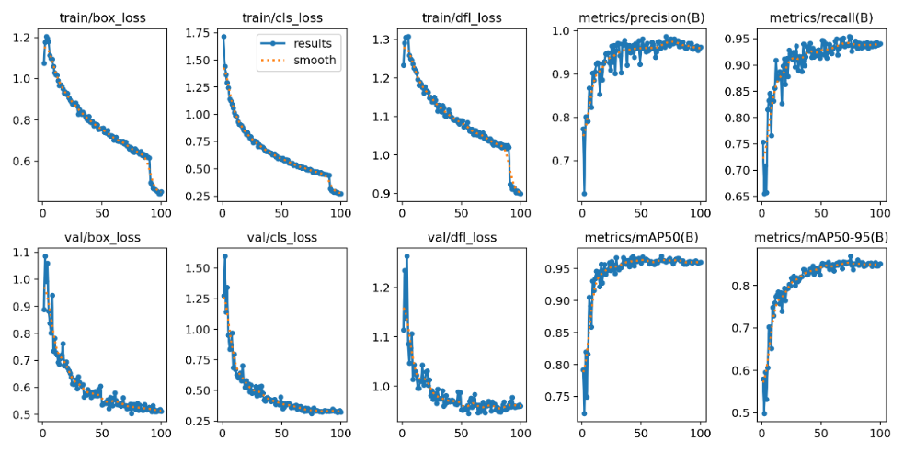

Figure 8. Training and Validation Curves

Figure 9 presents the normalized confusion matrix of the YOLO model for detecting and classifying NON_PLASTIC and Plastic_Bottle objects. The results show that the model achieved high classification accuracy, correctly identifying approximately 98% of NON_PLASTIC objects and 94% of Plastic_Bottle objects. The low misclassification rates indicate that the model can effectively distinguish between the two classes with minimal prediction errors.
The confusion matrix also demonstrates that only a small percentage of objects were incorrectly classified or detected as background, confirming the reliability and robustness of the trained model. Overall, the results validate the effectiveness of the YOLO model in accurately recognizing and classifying waste objects for the Automated Vending Machine for Plastic Bottles.

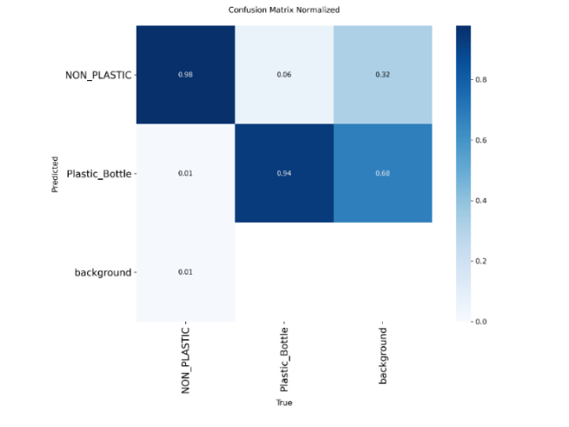

Figure 9. Normalized Confusion Matrix

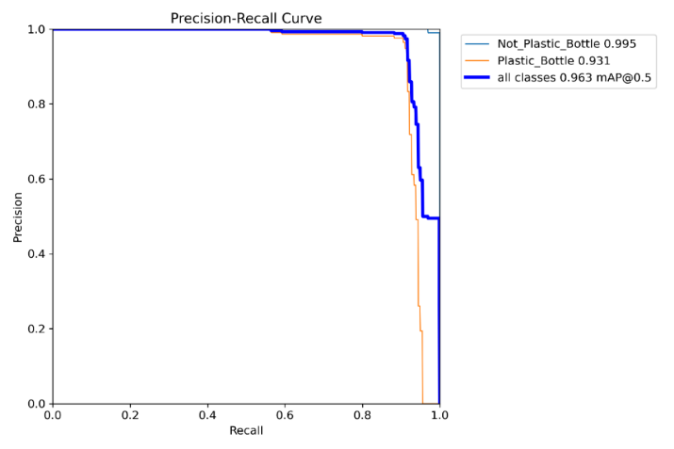
Figure 10 presents the Precision-Recall Curve of the YOLO model for detecting NON_PLASTIC and Plastic_Bottle objects. The results show high detection performance, with an overall mAP@0.5 score of approximately 96.3%. The NON_PLASTIC class achieved a performance score of 99.5%, while the Plastic_Bottle class obtained 93.1%. These results indicate that the model can accurately detect and classify both object classes with high precision and recall, demonstrating strong object recognition capability and minimal detection errors.

Figure 10. Precision-Recall Curve

Figure 11 illustrates the F1-Confidence Curve of the YOLO model, showing the relationship between confidence thresholds and the balance of precision and recall. The model achieved its highest overall F1-score of approximately 0.97 at a confidence threshold of 0.654, indicating an optimal balance between accurate detections and reduced false predictions. The consistently high F1-scores across both classes confirm the robustness, reliability, and effectiveness of the model in detecting Plastic_Bottle and NON_PLASTIC objects for the Automated Vending Machine for Plastic Bottles.
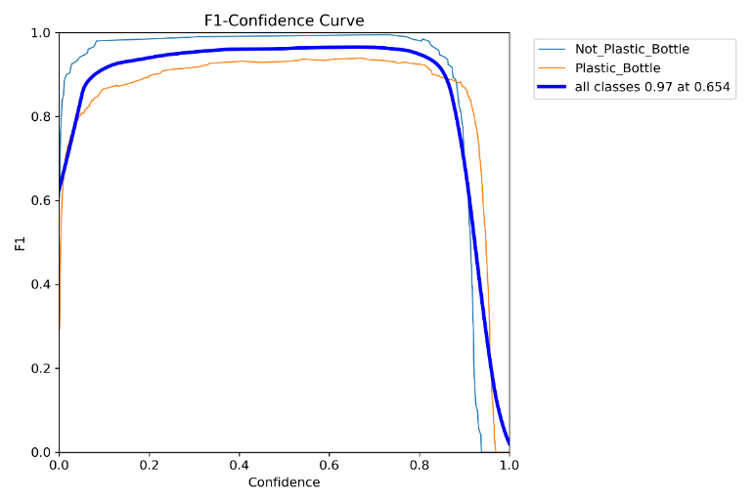

Figure 11. F1 Confidence Curve

Figure 12 shows the physical hardware implementation and structural layout of the Computer Vision-Based Plastic Bottle Classification and Recycling Management System using Enhanced YOLOv8n with Squeeze-and-Excitation (SE) Block and Convolutional Block Attention Module (CBAM). The system serves as a localized automated recycling and classification platform where users can deposit recyclable items and receive real-time feedback directly through the physical interface, without the need for external web-based platforms or internet connectivity.
At the upper part of the machine’s exterior interface is the 16x2 LCD Display Module, which shows system status and provides step-by-step guidance throughout the recycling and classification process. The system is designed with a user-friendly layout to ensure ease of use, particularly for community users with limited familiarity with electronic systems.
In the middle section is the input slot, which serves as the designated opening where users place plastic bottles or other waste items for analysis. This entry point leads directly into the internal detection chamber, where the classification process is performed.
Inside the enclosed chamber, the Raspberry Pi Camera Module V2 is securely mounted at a fixed position to capture consistent and high-quality image data. An integrated LED lighting system provides controlled illumination to reduce the effects of external lighting variations, ensuring more stable and accurate image acquisition for the Enhanced YOLOv8n model during real-time classification.
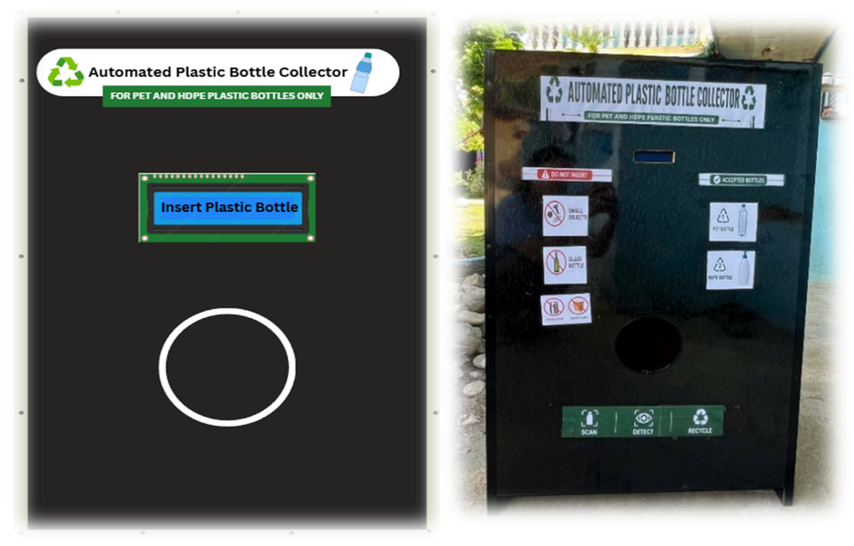

Figure 12. Hardware Prototype

Figure 13 presents the overall evaluation results of the Computer Vision-Based Plastic Bottle Classification and Recycling Management System based on six evaluation criteria: Screen, Learning, Perceived Usefulness, Perceived Ease of Use, System Usefulness, and Interface Quality. The graph indicates that all criteria obtained high average weighted means ranging from 4.54 to 4.89, all verbally interpreted as “Strongly Agree.” These findings suggest that the respondents positively evaluated the system in terms of usability, functionality, ease of operation, and overall user satisfaction.
Among the evaluated criteria, Screen obtained the highest average weighted mean of 4.89. This result implies that respondents found the LCD instructions and display messages clear, readable, and easy to understand. The respondents strongly agreed that the information presented on the screen effectively guided them in using the system and identifying whether an inserted bottle was accepted or rejected.
The Learning category obtained an average weighted mean of 4.81, indicating that respondents found the system easy to learn and operate. The high rating suggests that users were able to quickly understand the machine's layout and identify the proper location for bottle insertion with minimal difficulty.
Perceived Usefulness obtained an average weighted mean of 4.74. Respondents strongly agreed that the system accurately detects and classifies plastic bottles, promotes proper waste disposal practices, and saves time and effort compared to traditional disposal methods. These findings suggest that the system serves as an effective tool for supporting recycling initiatives within the campus.
The Interface Quality category obtained an average weighted mean of 4.57, indicating that respondents felt confident using the system without assistance. Similarly, System Usefulness obtained an average weighted mean of 4.56, reflecting positive perceptions regarding the system's reliability, responsiveness, efficiency, and overall performance.
On the other hand, Perceived Ease of Use obtained the lowest average weighted mean of 4.54. Despite being the lowest among the evaluated criteria, it was still verbally interpreted as “Strongly Agree.” This result indicates that respondents generally found the system easy to use and requiring minimal effort, although some users may have needed a short period of familiarization before becoming fully comfortable with its operation.
Overall, the graph demonstrates that the Plastic Bottle Classification and Recycling Management System a high level of user acceptance across all evaluation criteria. The consistently high ratings confirm that the developed system is functional, user-friendly, reliable, and effective in supporting proper plastic bottle disposal. The findings further indicate that the system has the potential to contribute to improved waste management practices within the university campus.
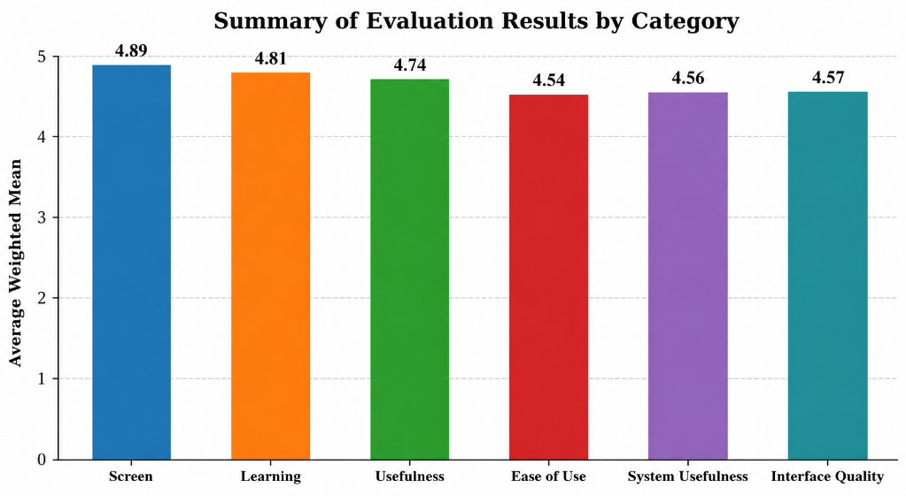

Figure 13. Overall Evaluation Result

Table 1 presents the reviewed studies, which share a common objective of improving real-time object detection through computer vision and YOLO-based architectures, particularly in embedded systems and waste management applications. Most studies focused on balancing detection accuracy and processing speed while addressing hardware limitations and real-world deployment challenges. Similarities can also be observed in their use of AI-driven detection systems, embedded platforms, and optimization techniques for automated recognition and classification tasks.
However, the studies differ in terms of model architecture, application focus, hardware requirements, and evaluation environments. Earlier studies primarily utilized YOLOv4 and lightweight YOLO variants for general object detection and embedded applications, while more recent studies adopted advanced YOLO-based models for waste classification, including plastic bottle detection. Some studies were limited to controlled laboratory environments, whereas others explored real-world deployment in unconstrained settings, revealing challenges such as environmental variability, latency, and computational limitations.
The strengths of previous studies include high detection accuracy, optimized real-time performance, and effective application of deep learning in waste classification and embedded vision systems. Nevertheless, several limitations remain evident, including dependence on high-end GPUs, reduced performance under real-world conditions, limited processing capability of embedded devices, and inherent trade-offs between speed and accuracy. These limitations highlight the need for a more practical, cost-efficient, and real-time automated system capable of operating effectively in actual recycling and waste management environments.This study builds upon existing works by integrating computer vision-based plastic bottle classification and recycling management into a unified intelligent system using an enhanced YOLOv8n model with Squeeze-and-Excitation (SE) and Convolutional Block Attention Module (CBAM). Unlike prior studies that primarily focused on detection alone, this research emphasizes real-world classification, system integration, user interaction, and sustainable recycling management through an embedded, cost-effective, and automated solution.

Table 1. Comparative Analysis
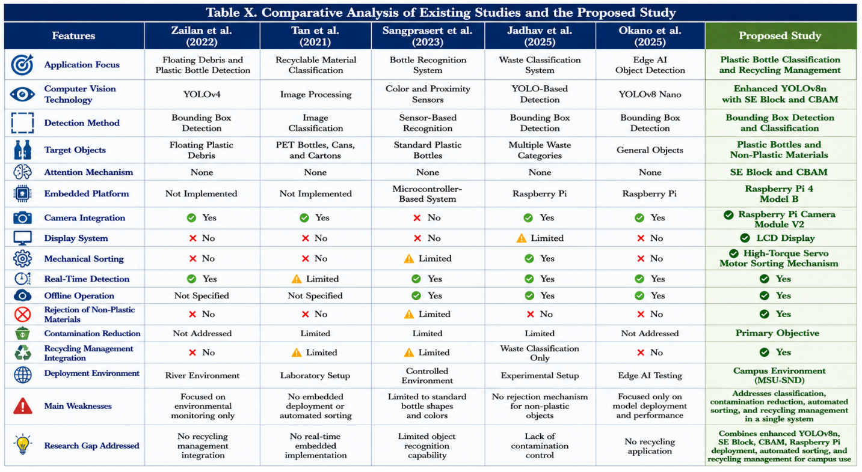

CONCLUSIONS AND RECOMMENDATIONS

The study successfully developed a Computer Vision-Based Plastic Bottle Classification and Recycling Management System using Enhanced YOLOv8n with Squeeze-and-Excitation (SE) and Convolutional Block Attention Module (CBAM) to improve feature extraction and detection performance. The system effectively classified plastic and non-plastic bottles through the integration of a camera module, embedded processing unit, and display interface. Testing and evaluation results demonstrated that the system performed efficiently in terms of object detection, classification accuracy, processing response, and user interaction. The model achieved a high detection performance of 97% mAP@0.5 and 86% mAP@0.5:0.95, indicating strong capability in accurately identifying and localizing objects.
User evaluation also showed that the system is useful, reliable, and beneficial in supporting proper plastic waste identification and promoting environmental awareness. However, limitations were observed in detecting certain object types such as glass bottles and small-sized items, despite the integration of SE and CBAM attention mechanisms. These limitations were attributed to hardware constraints, limited computational resources, camera resolution, and varying environmental conditions during real-time operation.
Overall, the study demonstrates that computer vision and embedded systems can be effectively applied in automated recycling management applications and can significantly contribute to improved waste classification and environmental sustainability.
Based on the findings of the study, several recommendations are proposed to further enhance the system’s performance and functionality. Future researchers may improve detection accuracy by expanding the dataset, retraining the YOLOv8n model, and including additional object classes such as glass bottles and other recyclable materials. Upgrading hardware components, such as using a more powerful microprocessor and higher-resolution camera, may also improve processing speed, image quality, and real-time performance.
Future implementations may consider integrating renewable energy sources, such as solar power, to promote energy efficiency and sustainable operation. In addition, incorporating a reward-based incentive system (e.g., digital credits or vouchers) may increase user participation in recycling activities. Furthermore, future studies may integrate Internet of Things (IoT) technology for remote monitoring and expand system capabilities with features such as weight sensing and multi-object detection to improve scalability, robustness, and overall effectiveness in smart waste management systems.

REFERENCES

- Afifah, V., & Erniwati, S. (2025). YOLOv8 for object detection: A comprehensive review of advances, techniques, and applications. International Journal of Advanced Computing and Informatics, 2(1), 53–61. https://doi.org/10.71129/ijaci.v2i1.pp53-61
- Ahn, H., Chen, T., Alnaasan, N., Shafi, A., Abduljabbar, M., Subramoni, H., & Panda, D. K. (2023). Performance characterization of using quantization for DNN inference on edge devices: Extended version. arXiv. https://doi.org/10.48550/arXiv.2303.05016
- Akpan, V. A., Agbogun, J. B., & Olatunji, D. A. (2022). The development of an integrated wireless security surveillance system based on Internet-of-Things technologies. International Journal of Internet of Things, 10(1), 1–21. https://doi.org/10.5923/j.ijit.20221001.01
- AlQaraleh, L., et al. (2024). Multi-criteria sustainability assessment of solid waste management systems incorporating Material Recovery Facilities (MRFs). Science of the Total Environment / Waste Management (Elsevier).
- Alzubaidi, L., Zhang, J., Humaidi, A. J., et al. (2021). Review of deep learning: Concepts, CNN architectures, challenges, applications, and future directions. Journal of Big Data, 8, Article 53. https://doi.org/10.1186/s40537-021-00444-8
- Baballe, M. A., Bello, M. I., & Umar, A. A. (2022). A look at the different types of servo motors and their applications. Zenodo, 1(2), 4–9. https://doi.org/10.5281/zenodo.6529859
- Baribad, J. A. B., Cabauatan, T. C., Guingab, E. M., & Tarun, I. M. (2024). Plastic2Fantastic: Reverse vending machine for plastic bottles. Isabela State University Linker: Journal of Engineering, Computing and Technology, 1(1), 33–49.
- Bacea, D. S., & Oniga, F. (2025). Lightweight YOLO-based object detection improvements for edge devices. https://doi.org/10.1109/WACV61041.2025.00161
- Benyathiar, P., Kumar, P., Carpenter, G., Brace, J., & Mishra, D. K. (2022). Polyethylene terephthalate (PET) bottle-to-bottle recycling for the beverage industry: A review. Polymers, 14(12), 2366. https://doi.org/10.3390/polym14122366
- Bochkovskiy, A., Wang, C.-Y., & Liao, H.-Y. M. (2020). YOLOv4: Optimal speed and accuracy of object detection. arXiv. https://doi.org/10.48550/arXiv.2004.10934
- Brahma, R., & Ray, S. (2022). A comprehensive review on the recent advances in the valorization of jackfruit waste for the development of value-added products. Journal of Food Technology Research, 9(2), 120–134.
- Cai, Z., Yang, J., Fang, H., Ji, T., Hu, Y., & Wang, X. (2022). Research on waste plastics classification method based on multi-scale feature fusion. Sensors, 22(20), 7974.
- Cakanlar, A., Hunter, M., & Nenkov, G. Y. (2024). Recycle right: How to decrease recycling contamination with informational point-of-disposal signage. Journal of the Academy of Marketing Science, 53, 781–803. https://doi.org/10.1007/s11747-024-01058-1
- Chaichana, K., Netinant, P., & Pukdesree, S. (2023). Design and implementation of an IoT-based surveillance system using Raspberry Pi, camera, and motion sensor. In Proceedings of ICEEG ’23 (pp. 195–202). ACM. https://doi.org/10.1145/3599609.3599638
- Chen, B. (2024). Research overview of YOLO series object detection algorithms based on deep learning. Journal of Computing and Electronic Information Management, 15(3), 84–92. https://doi.org/10.54097/p81rtv77
- Chin, J. P., Diehl, V. A., & Norman, K. L. (1988). Development of an instrument measuring user satisfaction of the human-computer interface. In Proceedings of the SIGCHI Conference on Human Factors in Computing Systems (CHI ’88) (pp. 213–218). Association for Computing Machinery. https://doi.org/10.1145/57167.57203
- Choi, J., Lim, B., & Yoo, Y. (2023). Advancing plastic waste classification and recycling efficiency: Integrating image sensors and deep learning algorithms. Applied Sciences, 13(18), 10224. https://doi.org/10.3390/app131810224
- Conniff, M. (2022, April 29). High-density polyethylene (HDPE): Definition, properties, and uses. Xometry. https://www.xometry.com/resources/materials/high-density-polyethylene-hdpe/
- Davis, F. D. (1989). Perceived usefulness, perceived ease of use, and user acceptance of information technology. MIS Quarterly, 13(3), 319–340. https://doi.org/10.2307/249008
- Department of Environment and Natural Resources. (2022). Solid waste management updates and campaigns. https://denr.gov.ph/news-events/sampulna-solid-waste-segregation-remains-a-major-challenge-in-ph/
- Department of Environment and Natural Resources. (2024). Solid waste management program and implementation of Republic Act 9003. https://denr.gov.ph/priority-program/solid-waste-management-program/
- DENR-EMB. (2024). Roadmap for the management of plastic waste and reduction of non-recyclable single-use plastics in the Philippines. Department of Environment and Natural Resources.
- Dhaka, V., Singh, S., Anil, A. G., Naik, T. S. S. K., Garg, S., Samuel, J., Kumar, M., Ramamurthy, P. C., & Singh, J. (2022). Occurrence, toxicity and remediation of polyethylene terephthalate plastics: A review. Environmental Chemistry Letters, 20(3), 1777–1800.
- Hausherr, D. P., & Berben, D. (2023). (All-in-One) power supply system for Raspberry Pi-based IoT applications. Hardware, 1(1), 54–69. https://doi.org/10.3390/hardware1010005
- Hosny, K. M., Magdi, A., Salah, A., El-Komy, O., & Lashin, N. A. (2023). Internet of Things applications using Raspberry Pi: A survey. International Journal of Electrical and Computer Engineering, 13(1), 902–910.
- Hu, J., Shen, L., & Sun, G. (2018). Squeeze-and-Excitation Networks. Proceedings of the IEEE/CVF Conference on Computer Vision and Pattern Recognition, 7132–7141. https://doi.org/10.1109/CVPR.2018.00745
- Jadhav, V., Cardoso, N., & Patel, D. (2025). Waste classification using YOLO on Raspberry Pi. International Journal of Engineering Research & Technology (IJERT), 14(08). https://doi.org/10.17577/IJERTV14IS080104
- Jocher, G., Chaurasia, A., & Qiu, J. (2023). Ultralytics YOLOv8. GitHub Repository. https://github.com/ultralytics/ultralytics
- Kazmi, M., Hafeez, B., Khan, H. R., & Qazi, S. A. (2022). Machine vision based plastic bottle inspection for quality assurance. Engineering Proceedings, 20(1), 9.
- Kaur, J., & Singh, D. (2021). Design and implementation of power management system for IoT-based embedded devices. International Journal of Electrical and Computer Engineering, 11(3), 2450–2458.
- Kirana, N. L., Kurnianingtyas, D., & Indriati. (2024). A deep learning approach to plastic bottle waste detection on the water surface using YOLOv6 and YOLOv7. Engineering, Technology & Applied Science Research, 14(6), 18623–18630.
- Kirvan, P. (2023). What is a prototype? TechTarget.
- La Mantia, F. P., & Castellani, B. (2022). Special Issue “Feature Papers in Recycling 2021”. Recycling, 7(4), 56. https://doi.org/10.3390/recycling7040056
- Lewis, J. R. (1995). IBM computer usability satisfaction questionnaires: Psychometric evaluation and instructions for use. International Journal of Human–Computer Interaction, 7(1), 57–78. https://doi.org/10.1080/10447319509526110
- Li, W., Hu, D., & Yang, L. (2023). Actuation mechanisms and applications for soft robots: A comprehensive review. Applied Sciences, 13(16), 9255.
- Maragatham, T., Balasubramanie, P., & Vivekanandhan, M. (2021). IoT based home automation system using Raspberry Pi 4. IOP Conference Series: Materials Science and Engineering, 1055(1), 012081.
- Munro, A. (2025). Python—computer language. Encyclopaedia Britannica.

- Okano, M. T., Lopes, W. A. C., & Ruggero, S. M. (2026). Efficient edge AI for manufacturing: A comparative study of YOLOv8 models on the Raspberry Pi 500. In 2026 IEEE 16th Annual Computing Conference (CCWC). IEEE.
- Okano, M. T., Lopes, W. A. C., Ruggero, S. M., Vendrametto, O., & Fernandes, J. C. L. (2025). Edge AI for industrial visual inspection: YOLOv8-based visual conformity detection using Raspberry Pi. Algorithms.
- Pal, K. K., Pal, S. K., Srivastava, S., et al. (2025). Object detection using OpenCV. ICSBPIM 2025 Proceedings, 1018–1027.
- Pan, S., Yamada, Y., Shimoe, D., & Yoshida, K. (2024). Aerial image segmentation using YOLOv8 and SAM pipeline. IEEE SILCON 2024. https://doi.org/10.1109/SILCON63976.2024.10910484
- Rao, V. S., et al. (2025). A smart reverse vending machine for plastic bottles. International Journal of Scientific Research and Engineering Trends, 11(2), 2485–2489.
- Redmon, J., Divvala, S., Girshick, R., & Farhadi, A. (2016). You Only Look Once: Unified, real-time object detection. Proceedings of the IEEE Conference on Computer Vision and Pattern Recognition, 779–788. https://doi.org/10.1109/CVPR.2016.91
- Ren, Y., Li, Y., & Gao, X. (2024). An MRS-YOLO model for high-precision waste detection and classification. Sensors, 24(13), 4339. https://doi.org/10.3390/s24134339
- Republic of the Philippines. (2000). Republic Act No. 9003: Ecological Solid Waste Management Act. Official Gazette.
- Roedan. (2025). Future trends in embedded systems.
- Sangprasert, N., Inthavisas, K., Wattanakul, K., & Noorit, N. (2023). Development of a low-cost reverse vending machine for clear plastic bottles and aluminum cans. Science, Engineering and Health Studies, 17, 23040001. https://doi.org/10.69598/sehs.17.23040001
- Santos, R., Silva, M. C., & Rabelo, R. A. (2024). Real-time object detection performance analysis using YOLOv7 on edge devices. IEEE Latin America Transactions, 22(10), 799–805. https://doi.org/10.1109/TLA.2024.10705971
- Sari, R., et al. (2022). Systematic literature review of spiral development model. International Journal of Research and Applied Technology, 2(2), 154–171.
- Sawtell Rickson, J. (2025). What is computer vision? Bui.
- Shafiee, M. J., Chywl, B., Li, F., & Wong, A. (2017). Fast YOLO: A fast you only look once system for real-time embedded object detection in video. arXiv. https://doi.org/10.48550/arXiv.1709.05943
- Singh, P., & Krishnamurthi, R. (2024). IoT-based real-time object detection system for crop protection and agriculture field security. Journal of Real-Time Image Processing, 21, 106. https://doi.org/10.1007/s11554-024-01488-8
- Sliusar, N., et al. (2022). Drone technology in municipal solid waste management. Waste Management, 153, 1–17.
- Sontakke, S. R., et al. (2024). Automated waste sorting system. IJRASET.
- Tan, H. Y., & Mohd Azam, S. N. (2021). Recyclable beverage containers for reverse vending machine sorting mechanism using image processing technique. International Journal of Electrical Engineering and Applied Sciences.
- Uddin, S., & Lu, H. (2024). Dataset meta-level and statistical features affect machine learning performance. Scientific Reports, 14, 1670. https://doi.org/10.1038/s41598-024-51825-x
- Ultralytics. (2023). YOLOv8 documentation. https://docs.ultralytics.com
- United Nations. (2015). Transforming our world: The 2030 Agenda for Sustainable Development.
- United Nations. (2023). Sustainable Development Goals Report. https://sdgs.un.org/goals
- United Nations Environment Programme. (2021). From pollution to solution: A global assessment of marine litter and plastic pollution. https://www.unep.org/resources/pollution-solution-global-assessment-marine-litter-and-plastic-pollution
- Woo, S., Park, J., Lee, J. Y., & Kweon, I. S. (2018). CBAM: Convolutional Block Attention Module. Proceedings of the European Conference on Computer Vision, 3–19. https://doi.org/10.1007/978-3-030-01234-2_1
- World Bank. (2018). What a waste 2.0: A global snapshot of solid waste management to 2050.
- World Bank. (2024). Reducing plastic waste in the Philippines.
- Wu, C.-Y., & Huang, K.-H. (2020). A framework for off-line operation of IoT services. Sensors, 20(20), 5864.
- Yasiri, J. R., Prathivi, R., & Susanto. (2025). Detection of plastic bottle waste using YOLO version 5 algorithm. Sinkron, 9(1). https://doi.org/10.33395/sinkron.v9i1.14242
- Zailan, N. A., Azizan, M. M., Hasikin, K., Khairuddin, A. S. M., & Khairuddin, U. (2022). An automated solid waste detection using the optimized YOLO model for riverine management. Frontiers in Public Health, 10, 907280. https://doi.org/10.3389/fpubh.2022.907280

