Performance Evaluation of Concrete Using GGBS and Silica Fume as Partial Cement Replacements

Vakati RadhaKrishna¹, D Pavan Kumar², P. Revanth³, SK. Shakeer Basha⁴, P. Narendra⁵
Department of Civil Engineering, Geethanjali Institute of Science and Technology, SPSR Nellore, India

ABSTRACT
The escalating cost of cement poses significant barriers to affordable construction, limiting access for individuals and smaller entities beyond governments and affluent sectors. This study explores sustainable alternatives by investigating the compressive strength properties of high-performance M50 grade concrete incorporating Ground granulated blast furnace slag (GGBS) and silica fume (SF) as partial cement replacements. Three distinct concrete mixtures were developed with GGBS replacement levels of 0%, 10%, and 15% by weight of cement, combined with SF additions of 0%, 15%, and 20%. Concrete cubes were cast, compacted, and cured in a controlled tank environment for 3, 7, and 28 days. Post-curing, specimens underwent density determination followed by compressive strength testing at each interval to evaluate early-age and long-term performance. Incorporating these pozzolanic materials reduces cement demand by up to 35%, lowering production costs, minimizing CO₂ emissions, and promoting resource efficiency. This approach fosters sustainability in the construction industry, enabling economic viability for broader infrastructure development while maintaining structural integrity. Future work could extend to flexural, tensile, and durability assessments under varied exposure conditions.
Keywords: Durability, GGBS, High performance Concrete, Silica Fume/Micro Silica, Density, water absorption.

INTRODUCTION
Concrete is the most widely used construction material in the world due to its versatility, durability, and cost-effectiveness. However, the production of Ordinary Portland Cement (OPC) is energy-intensive and contributes significantly to global carbon dioxide (CO₂) emissions. According to the International Energy Agency, cement manufacturing accounts for a considerable percentage of global industrial CO₂ emissions, raising serious environmental concerns. Therefore, the incorporation of supplementary cementitious materials (SCMs) as partial replacements for cement has gained significant attention in sustainable construction practices. Ground Granulated Blast Furnace Slag (GGBS), a by-product of the iron and steel industry, and silica fume, a by-product of silicon and ferrosilicon alloy production, are two widely used SCMs known for their pozzolanic and latent hydraulic properties. The utilization of GGBS enhances workability, reduces heat of hydration, improves long-term strength, and increases resistance to sulfate and chloride attacks. Similarly, silica fume, owing to its ultrafine particle size and high amorphous silica content, significantly improves concrete density, reduces permeability, and enhances compressive strength and durability characteristics. The combined use of GGBS and silica fume in concrete has shown synergistic effects. GGBS contributes to long-term strength development and durability, while silica fume enhances early-age strength and microstructural refinement through the formation of additional calcium silicate hydrate (C–S–H) gel. The improved particle packing and pore refinement reduce capillary porosity and enhance resistance to aggressive environmental conditions. Such blended systems not only improve mechanical and durability performance but also contribute to sustainability by reducing cement consumption and industrial waste disposal issues. In recent years, extensive research has focused on optimizing replacement levels of GGBS and silica fume to achieve enhanced performance without compromising workability and economic feasibility. However, the combined influence of these materials on fresh properties, mechanical strength, and durability characteristics under varying replacement proportions requires further systematic investigation. Therefore, this study aims to evaluate the performance of concrete incorporating GGBS and silica fume as partial cement replacements. The research focuses on assessing workability, compressive strength, split tensile strength, flexural strength, and durability characteristics to determine the optimal replacement combination for sustainable and high-performance concrete applications.

LITERATURE REVIEW

The growing environmental concerns associated with Ordinary Portland Cement (OPC) production have led researchers to explore supplementary cementitious materials (SCMs) as sustainable alternatives. Reports by the International Energy Agency highlight that cement production significantly contributes to global CO₂ emissions, necessitating eco-friendly solutions in concrete technology. Among various SCMs, Ground Granulated Blast Furnace Slag (GGBS) and silica fume have been extensively investigated due to their favorable mechanical and durability performance.

2.1 Ground Granulated Blast Furnace Slag (GGBS)

GGBS is a by-product of the iron manufacturing industry and exhibits latent hydraulic properties. Previous studies [1–3] have reported that partial replacement of cement with GGBS improves workability due to its smooth and glassy particle texture. Additionally, GGBS reduces the heat of hydration, making it suitable for mass concrete applications. Research indicates that replacement levels ranging from 30% to 50% significantly enhance long-term compressive strength [4]. The pozzolanic reaction between slag and calcium hydroxide (Ca(OH)₂) forms additional calcium silicate hydrate (C–S–H) gel, leading to improved microstructural densification [5]. Furthermore, several authors [6,7] have reported enhanced resistance to sulfate attack, chloride penetration, and alkali-silica reaction in slag-blended concretes. However, higher replacement levels (>60%) may reduce early-age strength due to slower hydration kinetics [8], indicating the need for optimization depending on structural requirements.

2.2 Silica Fume

Silica fume is an ultrafine material with high amorphous silicon dioxide (SiO₂) content. Due to its extremely fine particle size (approximately 100 times smaller than cement particles), it acts both as a pozzolanic material and microfiller. Studies [9–11] demonstrate that silica fume significantly enhances early-age strength and reduces permeability by refining pore structure. The pozzolanic reaction of silica fume consumes calcium hydroxide and produces additional C–S–H gel, resulting in increased compressive strength and improved interfacial transition zone (ITZ) characteristics [12]. Replacement levels between 5% and 15% are generally reported as optimal for achieving enhanced mechanical properties [13]. Durability studies [14,15] have shown substantial reductions in chloride ion penetration and water absorption when silica fume is incorporated. However, higher percentages may adversely affect workability due to increased water demand unless superplasticizers are used [16].

2.3 Combined Use of GGBS and Silica Fume

Recent investigations have focused on the combined use of GGBS and silica fume to achieve synergistic performance improvements. While GGBS contributes to long-term strength and durability, silica fume enhances early strength and microstructural refinement. Studies [17–19] indicate that ternary blended systems (cement–GGBS–silica fume) exhibit superior compressive strength and reduced porosity compared to binary blends. Microstructural analyses using SEM and XRD techniques [20] confirm improved particle packing and reduced capillary pores in ternary systems. The combined pozzolanic and latent hydraulic reactions lead to enhanced formation of secondary hydration products, contributing to strength gain and durability enhancement. Moreover, research findings [21,22] suggest that optimal performance is typically achieved with GGBS replacement levels of 30–40% combined with 5–10% silica fume. These combinations provide balanced fresh properties, mechanical strength, and durability performance.

MATERIALS AND METHODOLOGY

Materials

Cement

Portland Pozzolana Cement (PPC) conforming to Bureau of Indian Standards specifications (IS 1489 Part 1) was used in this study. PPC contains fly ash as a pozzolanic material, which enhances long-term strength and durability. The cement used had a specific gravity of 3.10 and standard consistency, initial setting time, and fineness within permissible limits as per relevant Indian Standards.

GGBS

GGBS, obtained from a reputed steel manufacturing plant, was used as a partial replacement of cement. It is a latent hydraulic material rich in calcium silicates and aluminosilicates. The specific gravity of GGBS was 2.85. Its fine particle size contributes to improved workability and long-term strength development.

Silica Fume

Silica Fume was procured from a commercial supplier. It contained more than 90% amorphous silicon dioxide with ultra-fine particle size (<1 µm) and specific gravity of 2.20. Due to its high pozzolanic reactivity and micro-filler effect, silica fume enhances early-age strength and reduces permeability by refining pore structure.

Fine Aggregate

Locally available river sand conforming to Zone II as per IS 383:2016 was used. The fine aggregate had a specific gravity of 2.65 and fineness modulus of 2.70.

Coarse Aggregate

Crushed granite aggregates of maximum size 20 mm conforming to IS 383:2016 were used. The specific gravity was 2.70 with water absorption within permissible limits.

Water

The dosage was adjusted (0.8–1.5% by weight of binder) to maintain the desired slump without altering the water-binder ratio. Potable water free from harmful impurities was used for mixing and curing as per IS 456:2000.

Super Plasticizer

A polycarboxylate ether (PCE)-based superplasticizer was used to achieve the required workability for high-strength M50 concrete.

Mix Proportioning
Concrete of M50 grade was designed as per IS 10262:2019 guidelines. A target mean compressive strength was calculated considering standard deviation and quality control measures. The water-binder ratio was maintained at 0.35–0.38 to achieve high strength and durability. Cement was partially replaced with GGBS and silica fume at varying proportions. The total binder content remained constant while varying replacement percentages.
Table 1. Mix Proportion of M50 Grade (m³/Kg)
Mix ID | Cement | GGBS | Silica Fume | Water | FA | CA | SP
CM | 500 | 0 | 0 | 175 | 650 | 1200 | 6
M1 | 375 | 50 | 75 | 175 | 650 | 1200 | 6
M2 | 325 | 75 | 100 | 175 | 650 | 1200 | 6
- EXPERIMENTAL INVESTIGATION
The experimental investigation was carried out to evaluate the fresh, mechanical, and durability properties of M50 grade concrete incorporating Ground Granulated Blast Furnace Slag (GGBS) and silica fume as partial replacements of cement. Three different concrete mixes were prepared: Control Mix (CM), Mix 1 (10% GGBS + 15% Silica Fume), and Mix 2 (15% GGBS + 20% Silica Fume). The total binder content and water–binder ratio were kept constant throughout the study to ensure uniform comparison.
  - Fresh Concrete Properties
    - Slump Test
Workability of fresh concrete was determined using the slump cone apparatus in accordance with IS 1199:2018. The test was conducted immediately after mixing to assess consistency and ease of placement. The slump values were recorded for each mix to evaluate the influence of GGBS and silica fume on workability.
Due to the high fineness of silica fume, a reduction in slump was expected with increasing replacement levels. A polycarboxylate ether-based superplasticizer was used to maintain the desired workability for high-strength concrete.
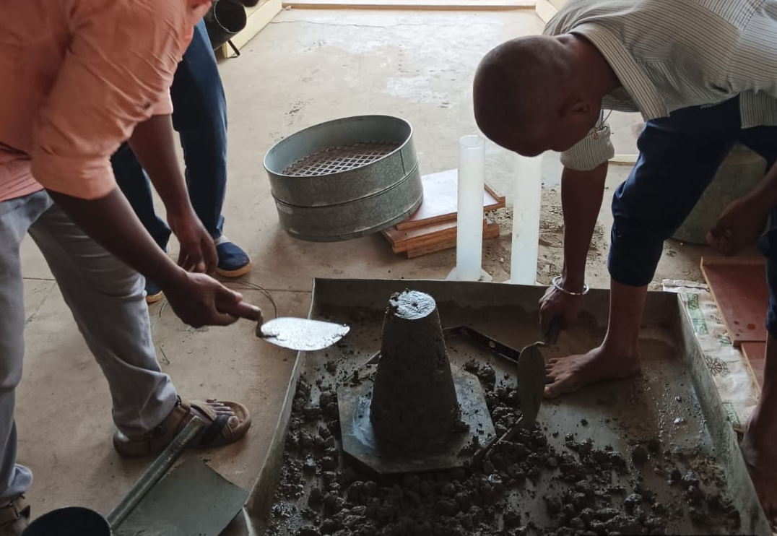
Figure 1. Slump test
  - Mechanical Properties
    - Compressive Strength Test
Compressive strength was determined using 150 mm × 150 mm × 150 mm cube specimens as per IS 516:2018. Specimens were tested at curing ages of 7, 28, and 56 days using a calibrated Compression Testing Machine (CTM). The average of three specimens was considered as the representative compressive strength for each mix.

    - Split Tensile Strength Test
Split tensile strength was evaluated using cylindrical specimens of 150 mm diameter and 300 mm height as per IS 5816:1999. The test was conducted at 28 days of curing. The split tensile strength was calculated using:
    - Flexural Strength Test
Flexural strength was determined using prism specimens (100 mm × 100 mm × 500 mm) under two-point loading as per IS 516:2018. The modulus of rupture was calculated based on the maximum load at failure.
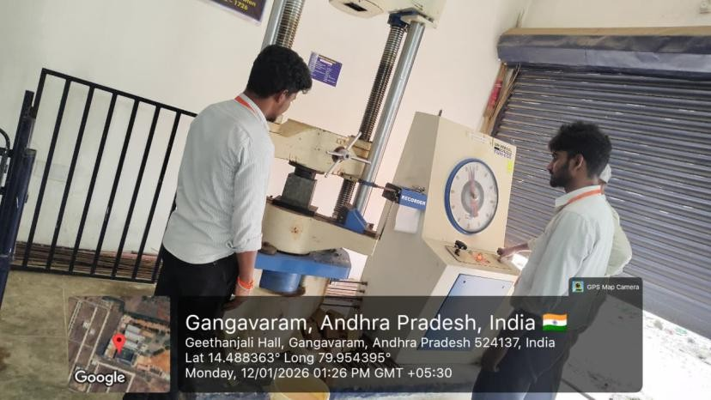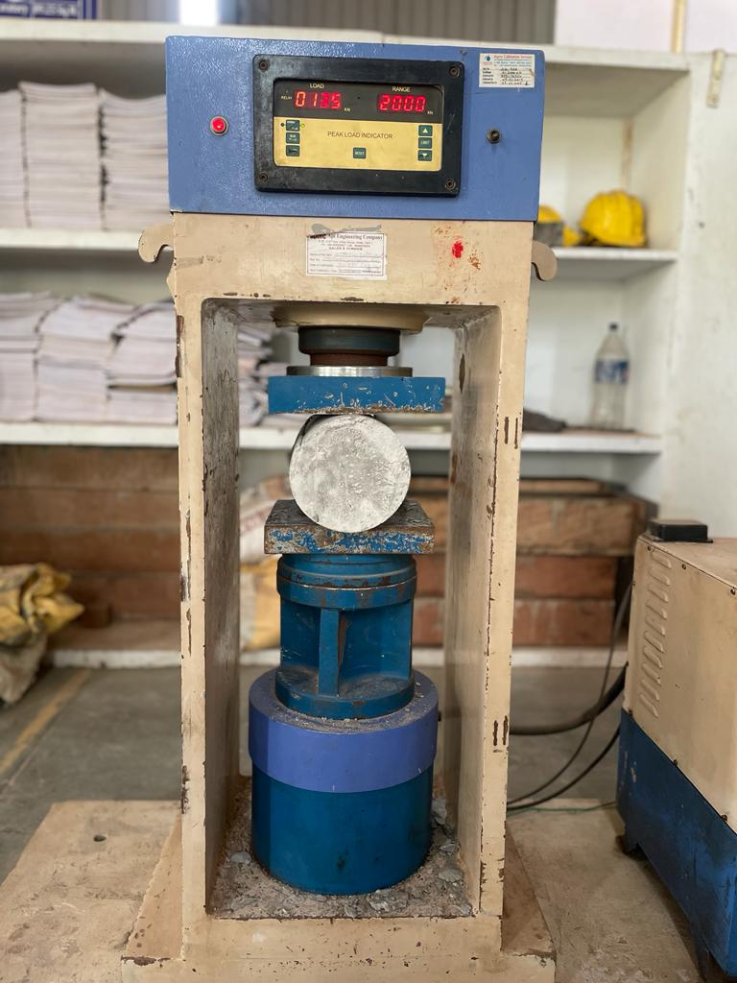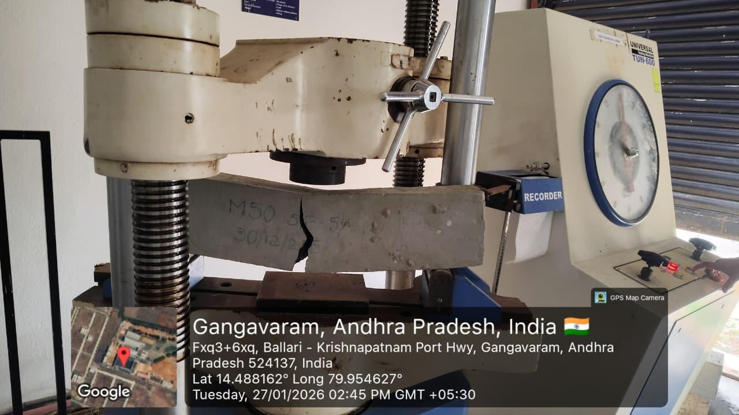Figure 2. Mechanical Properties
  - Durability Tests
    - Water Absorption Test
Water absorption was measured to assess the permeability characteristics of hardened concrete. Oven-dried specimens were immersed in water for 24 hours
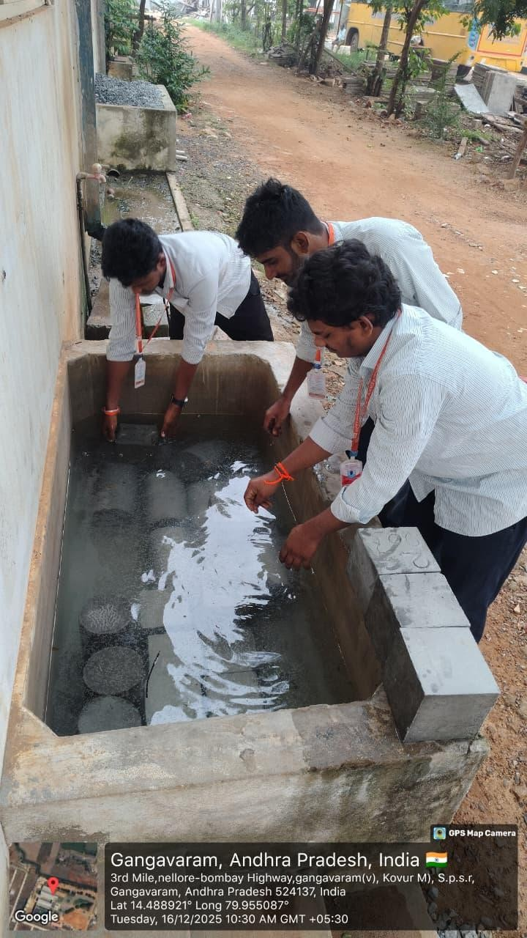
Figure 3. Water absorption test
- RESULTS AND DISCUSSION

The performance of M50 grade concrete incorporating GGBS and silica fume was evaluated in terms of fresh properties, mechanical strength, and durability characteristics. The results obtained are presented in tabular form and discussed with reference to material behavior.

  - Workability (Slump Test)

Figure 4. Graph plotted for slump values for mixes

The slump value decreased with increasing silica fume content. Mix M2 exhibited the lowest slump (80 mm), representing a 27% reduction compared to the control mix. This reduction is attributed to the extremely fine particle size and high surface area of silica fume, which increases water demand. Although GGBS improves workability due to its smooth texture, the dominant effect of silica fume reduced overall consistency.

  - Compressive Strength

At 28 days, Mix M1 achieved the highest compressive strength of 60.4 MPa, showing an increase of approximately 8.2% compared to the control mix. The improvement is due to:
- Pozzolanic reaction of silica fume producing additional C–S–H gel.
- Latent hydraulic reaction of GGBS enhancing long-term strength.
- Improved particle packing and reduced porosity.
Although M2 contained higher replacement levels, excessive silica fume (20%) slightly reduced strength compared to M1, possibly due to dilution of cementitious content beyond the optimum level.
At 56 days, all modified mixes showed continued strength gain due to ongoing secondary hydration reactions, especially from GGBS.

Figure 5. Graph plotted for Compressive strength for mixes of 7, 28 and 56 Days

  - Split Tensile Strength

Figure 6. Graph plotted for 28 days Split tensile strength for mixes

Mix M1 showed a 10.9% increase in tensile strength over the control mix. The enhancement is attributed to microstructural densification and improved interfacial transition zone (ITZ) due to silica fume. M2 exhibited slightly lower tensile strength than M1, likely due to higher cement replacement affecting bonding efficiency.
  - Flexure Strength
Flexural strength followed a similar trend to compressive and tensile strength. Mix M1 showed approximately 10.3% improvement over the control mix. The improved matrix density and reduced microcracks due to silica fume contributed to enhanced flexural performance

Figure 7. Graph plotted for 28 days Flexure strength for mixes

  - Water absorption test

Figure 8. Graph plotted for water absorption test for mixes

Water absorption decreased significantly with the inclusion of GGBS and silica fume. Mix M2 showed the lowest absorption (1.95%), indicating improved durability. The ultrafine silica fume particles filled microvoids, while GGBS contributed to long-term pore refinement, resulting in a denser microstructure.

CONCLUSION
The experimental investigation on M50 grade concrete incorporating Ground Granulated Blast Furnace Slag (GGBS) and silica fume as partial cement replacements demonstrates that blended binder systems significantly enhance overall concrete performance. Workability decreased with increasing silica fume content due to its ultrafine nature and higher surface area; however, the use of a polycarboxylate-based superplasticizer ensured adequate consistency for practical applications. Compressive strength improved notably at 28 and 56 days for blended mixes compared to the control mix, with the combination of 10% GGBS and 15% silica fume exhibiting the highest strength gain, indicating an optimal balance between early pozzolanic reactivity and long-term latent hydraulic action. Split tensile and flexural strengths also showed improvement due to refinement of the interfacial transition zone and enhanced microstructural densification. Furthermore, water absorption values decreased with higher replacement levels, confirming improved pore refinement and reduced permeability, with the 15% GGBS and 20% silica fume mix demonstrating superior durability performance. Overall, partial replacement of cement with GGBS and silica fume proves effective for producing sustainable, high-performance concrete.

REFERENCES

  - Mehta, P.K., 1986. Concrete: Structure, Properties and Materials. Prentice-Hall, New Jersey.
  - Neville, A.M., 2011. Properties of Concrete, 5th ed. Pearson Education Limited, London.
  - ACI Committee 233, 2017. Ground Granulated Blast-Furnace Slag as a Cementitious Constituent in Concrete (ACI 233R-17). American Concrete Institute, Farmington Hills, MI.
  - Hogan, F.J., Meusel, J.W., 1981. Evaluation for durability and strength development of a ground granulated blast furnace slag. Cement, Concrete and Aggregates, 3(1), pp.40–52. DOI: 10.1520/CCA10353J
  - Escalante-García, J.I., Sharp, J.H., 2001. The microstructure and mechanical properties of blended cements hydrated at various temperatures. Cement and Concrete Research, 31(5), pp.695–702. DOI: 10.1016/S0008-8846(01)00486-9
  - Song, H.W., Saraswathy, V., 2006. Studies on the corrosion resistance of reinforced steel in concrete with ground granulated blast-furnace slag—An overview. Journal of Hazardous Materials, 138(2), pp.226–233. DOI: 10.1016/j.jhazmat.2006.05.101
  - Shi, C., Qian, J., 2000. High performance cementing materials from industrial slags — A review. Resources, Conservation and Recycling, 29(3), pp.195–207. DOI: 10.1016/S0921-3449(99)00060-5
  - Atiş, C.D., 2003. High-volume fly ash concrete with high strength and low drying shrinkage. Journal of Materials in Civil Engineering, 15(2), pp.153–156. DOI: 10.1061/(ASCE)0899-1561(2003)15:2(153)
  - ACI Committee 234, 2012. Guide for the Use of Silica Fume in Concrete (ACI 234R-06). American Concrete Institute, Farmington Hills, MI.
  - Bhanja, S., Sengupta, B., 2005. Influence of silica fume on the tensile strength of concrete. Cement and Concrete Research, 35(4), pp.743–747. DOI: 10.1016/j.cemconres.2004.06.009Mazloom, M., Ramezanianpour, A.A., Brooks, J.J., 2004. Effect of silica fume on mechanical properties of high-strength
  - concrete. Cement and Concrete Composites, 26(4), pp.347–357. DOI: 10.1016/S0958-9465(03)00046-5
  - Bentz, D.P., 2000. Influence of silica fume on diffusion in cement-based materials. Cement and Concrete Composites, 22(5), pp.327–336. DOI: 10.1016/S0958-9465(00)00028-8\
  - Toutanji, H.A., El-Korchi, T., 1995. The influence of silica fume on the compressive strength of cement paste and mortar. Cement and Concrete Research, 25(7), pp.1591–1602. DOI: 10.1016/0008-8846(95)00067-O
  - Khatri, R.P., Sirivivatnanon, V., 1995. Effect of different supplementary cementitious materials on mechanical properties of high performance concrete. Cement and Concrete Research, 25(1), pp.209–220. DOI: 10.1016/0008-8846(94)00166-U
  - Berke, N.S., Hicks, M.C., 1994. Predicting chloride profiles in concrete. Corrosion, 50(3), pp.234–239. DOI: 10.5006/1.3292920
  - Aïtcin, P.C., 2000. High Performance Concrete. E & FN Spon, London.
  - Thomas, M.D.A., Bamforth, P.B., 1999. Modelling chloride diffusion in concrete: Effect of fly ash and slag. Cement and Concrete Research, 29(4), pp.487–495. DOI: 10.1016/S0008-8846(98)00212-9 Langan, B.W., Weng, K., Ward, M.A., 2002. Effect of silica fume and fly ash on heat of hydration of Portland cement.
  - Cement and Concrete Research, 32(7), pp.1045–1051. DOI: 10.1016/S0008-8846(02)00728-8
  - Yazici, H., 2008. The effect of silica fume and high-volume Class C fly ash on mechanical properties, chloride penetration and freeze–thaw resistance of self-compacting concrete. Construction and Building Materials, 22(4), pp.456–462. DOI: 10.1016/j.conbuildmat.2006.08.009
  - Gonen, T., Yazıcıoğlu, S., 2007. The influence of compaction pores on sorptivity and carbonation of concrete. Construction and Building Materials, 21(5), pp.1040–1045. DOI: 10.1016/j.conbuildmat.2006.04.010
  - Dinakar, P., Sethy, K.P., Sahoo, U.C., 2013. Design of self-compacting concrete with ground granulated blast furnace slag. Materials & Design, 43, pp.161–169. DOI: 10.1016/j.matdes.2012.06.018
  - Siddique, R., Khan, M.I., 2011. Supplementary Cementing Materials. Springer-Verlag, Berlin. DOI: 10.1007/978-3-642-17372-8

