A COMPARATIVE STUDY OF SANDPAPER LETTERS AND QR CODE–

ABSTRACT

Young English as a Second Language (ESL) learners in the rural Baram district of Sarawak have limited exposure to English beyond the classroom, which often hinders the development of grapheme–phoneme correspondence (GPC) skills. While sandpaper letters, commonly used in Montessori-inspired classrooms, provide tactile support for phonics learning, learners may still require repeated teacher-led instruction to achieve mastery.

This action research aimed to compare the effectiveness of traditional sandpaper letters and QR Code–Integrated Phonics Cards in supporting early English phonics acquisition among preschool learners. Specifically, the study examined whether integrating audio-visual scaffolding through QR codes could reduce the number of instructional cycles required for phonics mastery and promote greater learner autonomy.

A comparative within-subject design was employed involving five preschool learners (N = 5) from SJK(C) Kee Tee, Long Lama, Sarawak. The intervention was conducted over four weeks in two phases. Phase 1 utilised conventional sandpaper letters to teach the phonemes associated with the letters g and h, while Phase 2 introduced QR Code–Integrated Phonics Cards for the letters j and p. Data were collected through an Instructional Cycle Log to measure instructional efficiency and semi-structured observations to document learner engagement and autonomy.

The findings indicated a notable improvement in instructional efficiency following the introduction of the QR Code–Integrated Phonics Cards. The average number of instructional cycles required for mastery decreased from 4.8 cycles in Phase 1 to 2.4 cycles in Phase 2, representing an approximately 50% reduction in teacher-led interventions. Observational data further revealed a shift in learner behaviour from passive reliance on teacher guidance to more active engagement, self-correction, and independent learning.

The study demonstrates that QR Code–Integrated Phonics Cards can enhance the effectiveness of early phonics instruction in rural ESL contexts by combining tactile learning with accessible audio-visual support. As a form of frugal innovation, this low-cost and offline-accessible digital intervention offers a practical and scalable approach for rural educators seeking to strengthen early literacy instruction while minimising dependence on extensive technological infrastructure. The findings suggest that integrating simple digital tools into phonics instruction can help bridge auditory language exposure gaps and foster greater learner autonomy in early English language learning.

Keywords: Early Childhood Education, Phonics Instruction, Multisensory Learning, QR Code Technology, Grapheme–Phoneme Correspondence, Rural ESL Learners

INTRODUCTION

Background of Study

Early literacy development, particularly phonological awareness and phonics, is widely recognised as the foundation of later reading achievement and academic success (National Reading Panel, 2022; Yopp & Yopp, 2022; Tracey & Morrow, 2023). Research consistently demonstrates that systematic phonics instruction helps young learners develop the decoding skills necessary for successful reading and spelling development (Foorman et al., 2023; Cabell et al., 2024). Over the past 21 years, the evolution of digital tools has radically changed classrooms, where better and poorer countries suffered from an immediate impact. However, can the shift from organic concrete tactile learning to ICT-enhanced bespoke instruction open the opportunity within Long Lama, Sarawak for children in young-bodied developmental stages of cellular homeostasis among rural and semi-urban demographic characteristics in Malaysia? As amongst it when comes into action physical stands could also present their own kind of set viability trend.
Montessori Sandpaper Letters represent a traditional multisensory approach common to phonics instruction. They are based on tactile-visual reinforcement where children trace letters in a texture to embed muscle memory (Mangen et al., 2023; Mori et al., 2024). While these materials have historically done very well, the static quality of such materials is a stopping point: your child can feel the letter but cannot hear what it sounds like unless someone happens to be there to always teach them how with their voice. Because students in any preschool classroom come with a wide range of levels of ability, this teachercentric model creates many more instructional cycles than the average number of times prior to mastery a concept must be revisited (Wang et al., 2024; Zydney & Warner, 2024).
To address this gap, the present study suggests QR codes within personalised phonics flashcards. This innovation in digital form serves as a bridge that marries tactile experience with student-directed scaffold of the constructivist learning type. They directly access video content from teacher videos (very restricted) and passive instructional sessions that tell them exactly how to make their mouths and names of phonemic sounds. This theoretical system may help to practice variance and independence in a non-formal education environment that is less reliant on teachers while promoting higher order thought, particularly at younger ages (Ehri, 2022; Parkin et al., 2023).

Statement of the Problem

Despite the emphasis placed on English language learning in the Malaysian National Preschool Standard Curriculum (KSPK), many preschool students in rural areas continue to face difficulties in developing grapheme-phoneme correspondence (GPC), a fundamental skill for early reading. In remote ESL contexts such as Long Lama, Sarawak, students have limited exposure to English outside the classroom and are often completely dependent on teachers for accurate phonetic modeling. Traditional tactile materials, such as Montessori sandpaper letters, effectively support letter recognition and formation but provide limited auditory support for independent learning. As a result, students may develop incorrect letter-sound associations that become increasingly difficult to correct over time, leading to phonics fossilization and repetitive teaching cycles. This challenge is exacerbated by limited teacher resources and high student-teacher ratios, creating pedagogical bottlenecks that restrict opportunities for individualized phonics instruction. Although the Malaysian Education Blueprint (PPPM 2013–2025) supports the integration of digital technology in education, there is limited empirical evidence on the effectiveness of digital integrated phonics tools in Malaysian preschool settings, especially in rural contexts. Therefore, this study addresses the need to investigate whether QR Code–Integrated Phonics Cards can enhance phonics learning efficiency and student autonomy by providing an accessible audio-visual scaffold that complements traditional tactile learning materials.

Significance of Study

This study is significant as it provides insights into the use of QR Code–Integrated Phonics Cards to support early English phonics learning among preschool learners in rural settings. For teachers, the intervention offers a practical and low-cost approach to enhancing phonics instruction by providing audio-visual support that can reduce learners’ dependence on continuous teacher guidance and allow for more focused instructional support. For students, the QR-integrated cards promote active learning, self-correction, and learner autonomy by enabling access to accurate phoneme models independently. For policymakers and the Ministry of Education, the study contributes empirical evidence on a scalable, offline-compatible digital innovation that aligns with the aspirations of the Malaysia Education Blueprint (2013–2025) and PAK-21, while supporting equitable access to quality early literacy instruction in rural and underserved communities.

Research Objectives
This study attempts to ascertain and compare the effectiveness of two different instructional modes in a rural ESL environment. In this regard, the study is guided by the following specific objectives:

RO1: To determine the effectiveness of QR Code–Integrated Phonics Cards in enhancing phonics learning efficiency among young ESL learners.

RO 2: To examine how QR Code–Integrated Phonics Cards support learner autonomy, engagement, and self-correction during phonics learning.

Research Questions
This research attempts to empirically answer the following research questions, to meet the objectives mentioned:

RQ 1: How effective are QR Code–Integrated Phonics Cards in improving phonics learning efficiency among young ESL learners compared to traditional sandpaper letters?

RQ2: How does the use of QR Code–Integrated Phonics Cards influence learner autonomy, engagement, and self-correction behaviours during phonics learning?

Research Methodology and Design

This chapter describes the research design and procedures used to examine the effectiveness of traditional tactile phonics materials and QR Code–Integrated Phonics Cards in supporting phonics learning among preschool learners. It outlines the participants, research instruments, intervention procedures, and data analysis methods employed in the study. The methodology was designed to be practical and feasible within a rural preschool setting while ensuring that the findings are systematic, reliable, and relevant to addressing the challenges of teacher dependency and slow phonics mastery. The study also aims to provide a replicable model that can be adopted by educators working in similar resource-constrained environments.

This study employed a Classroom-Based Action Research (CBAR) approach using a within-subject comparative design. Five preschool learners participated in both phases of the intervention: Phase 1 involved traditional tactile materials, while Phase 2 utilised QR Code–Integrated Phonics Cards. The within-subject design allowed each learner to serve as their own comparison, reducing the influence of individual differences such as prior literacy experiences, cognitive abilities, and home language backgrounds. By comparing the same learners’ performance across both phases, the study was able to examine whether changes in phonics learning outcomes were associated with the introduction of the QR-integrated intervention, making this design particularly suitable for small-scale action research in rural educational contexts.

Research Instruments

Instructional Cycle Log
The primary quantitative instrument used in this study was the Instructional Cycle Log, which was designed to measure the efficiency of phonics learning by tracking the number of instructional cycles required for learners to achieve mastery of target grapheme–phoneme correspondences. Rather than viewing mastery as a simple pass-or-fail outcome, this study emphasized the speed and efficiency with which learners reached mastery. An instructional cycle was defined as a 15-minute learning session consisting of three stages: direct instruction, guided practice, and an assessment probe in which learners independently produced the target phoneme. Learners’ progress was monitored daily, and mastery was considered achieved when a learner demonstrated accurate letter–sound recognition and pronunciation without assistance. If additional teaching was required in subsequent sessions, a new instructional cycle was recorded. This instrument enabled the calculation of the mean speed of mastery for each intervention phase, providing an objective measure of learning efficiency and teacher support requirements. By quantifying instructional time as a resource, the Instructional Cycle Log offers a practical and meaningful measure for evaluating phonics interventions in rural preschool settings where teacher availability and instructional time are often limited.

Observation Checklist
To complement the quantitative data collected through the Instructional Cycle Log, a structured Observation Checklist was used to record learners’ behaviors during both the traditional sandpaper letter and QR Code–Integrated Phonics Card interventions. Observations were conducted and documented in real time to capture learners’ engagement, participation, and independence while reducing recall bias. The checklist focused on two key constructs: engagement, assessed using a three-point scale (Low, Moderate, High) based on learners’ attention, participation, and enthusiasm during activities; and learner autonomy, assessed using a Yes/No indicator to determine whether learners could practice and produce target phonemes independently without teacher prompts or approval. The use of a structured rubric ensured consistency across both intervention phases and minimized researcher bias. The qualitative data obtained were used to triangulate the quantitative findings by examining whether reductions in instructional cycles corresponded with increases in learner engagement and autonomy, thereby providing a more comprehensive understanding of the impact of the QR-integrated intervention on phonics learning.

LITERATURE REVIEW

Phonological Awareness and Grapheme–Phoneme Correspondence in Early Literacy Development

Phonological awareness is widely recognised as a fundamental component of early literacy development and a strong predictor of reading success. Children who develop phonemic awareness and grapheme–phoneme correspondence (GPC) skills are better able to decode unfamiliar words, recognise patterns in print, and achieve reading fluency (Cabell et al., 2024; Jiang et al., 2024; Foorman et al., 2023). Phonological awareness has been identified as one of the strongest predictors of reading achievement during the early years (National Reading Panel, 2022; Yopp & Yopp, 2022). GPC refers to the ability to connect written letters with their corresponding sounds, enabling learners to read words through decoding rather than memorization. This skill is particularly important during the early years, as it forms the foundation for independent reading and spelling development.

The acquisition of GPC can be challenging for Malaysian learners due to differences between the orthographic systems of Bahasa Melayu and English. Bahasa Melayu has a transparent orthography, where letter–sound relationships are highly consistent, whereas English has an opaquer orthography, in which a single letter may represent different sounds depending on the word. These inconsistencies often create difficulties for young learners who attempt to apply the phonological rules of their first language to English. Consequently, learners may struggle with orthographic mapping, the process of storing and retrieving words automatically from memory. Research indicates that strong phonemic awareness and GPC skills are essential for effective orthographic mapping and long-term reading development (Parkin et al., 2023; Mokhtari et al., 2024). According to Kilpatrick (2022), orthographic mapping enables learners to store words in long-term memory for rapid retrieval and is a critical process underlying reading fluency and automatic word recognition.

To support GPC acquisition, researchers advocate the use of systematic and multisensory phonics instruction that engages visual, auditory, and kinesthetic learning modalities. Studies have shown that multisensory and technology-enhanced phonics interventions can improve phoneme segmentation, letter–sound knowledge, word reading, and spelling skills while increasing learner engagement and independence (Petersen et al., 2023; Wang et al., 2024). For young learners in rural settings with limited exposure to English, integrating digital tools that provide audio-visual support may offer additional opportunities for practice and reinforcement (Solichah & Fardana, 2024). Such approaches have the potential to strengthen phonics learning and promote more effective early literacy development.

Tactile and Kinesthetic Learning for Grapheme–Phoneme Correspondence Development

The development of grapheme–phoneme correspondence (GPC) is a critical component of early literacy acquisition, as it enables children to connect written symbols with their corresponding speech sounds. Research has shown that young learners acquire GPC more effectively when instruction engages multiple sensory modalities rather than relying solely on visual exposure to letters. Multisensory literacy approaches provide opportunities for learners to simultaneously see, hear, touch, and manipulate language elements, resulting in stronger retention and deeper learning (Piasta et al., 2022; Solichah & Fardana, 2024). Multisensory approaches that integrate visual, auditory, tactile, and kinesthetic experiences provide learners with multiple pathways for processing and retaining letter–sound relationships. A recent scoping review by Solichah and Fardana (2024) found that multisensory interventions contribute positively to early literacy development by strengthening letter recognition, phonological awareness, and emergent reading skills.

Tactile and kinesthetic learning strategies are particularly valuable in supporting GPC development because they allow children to physically interact with letter forms while simultaneously associating them with sounds. Activities such as tracing textured letters, following letter formations with finger movements, and verbalising corresponding phonemes engage multiple sensory systems at the same time. According to Bahrick et al. (2023), multisensory experiences enhance learning by creating stronger memory representations and facilitating the integration of visual and auditory information. Similarly, Mori et al. (2024) reported that haptic-based literacy interventions improved learners’ reading and writing performance by reinforcing the association between letter shapes and sounds through active touch and movement.

The application of tactile and kinesthetic learning is especially beneficial for young learners who experience difficulties in distinguishing visually similar letters or mastering unfamiliar letter–sound relationships. Yahaya et al. (2025) found that multisensory teaching materials incorporating touch, movement, visual cues, and auditory input significantly improved preschool learners’ ability to recognise and differentiate letters, while also increasing their motivation and engagement in literacy activities. These findings suggest that tactile and kinesthetic approaches can provide meaningful and concrete learning experiences that strengthen GPC acquisition. For learners in rural ESL contexts with limited exposure to English, such approaches may offer additional support in developing the foundational decoding skills necessary for successful reading development.

FINDING AND ANALYSIS
These findings of the study are based on data collected during a four-week intervention at SJK(C) Kee Tee, Long Lama. In rural ESL contexts, early phonics learning is often constrained by limited access to consistent English language exposure, with teachers serving as the primary source of phoneme modelling and feedback. As a result, learning may be interrupted when teacher support is unavailable, creating challenges in achieving efficient phonics mastery. To address this issue, the study examined the use of QR Code–Integrated Phonics Cards as a digital–physical learning tool designed to provide continuous audio-visual support for learners. The findings are presented through quantitative data from the Instructional Cycle Log and qualitative data from classroom observations of learner engagement and autonomy. Together, these findings provide evidence of how integrating digital scaffolding with traditional tactile learning materials can enhance phonics learning efficiency, reduce teacher dependency, and promote more independent learning among preschool learners in rural settings.

Phase 1 Materials: Sandpaper Letters (Traditional)

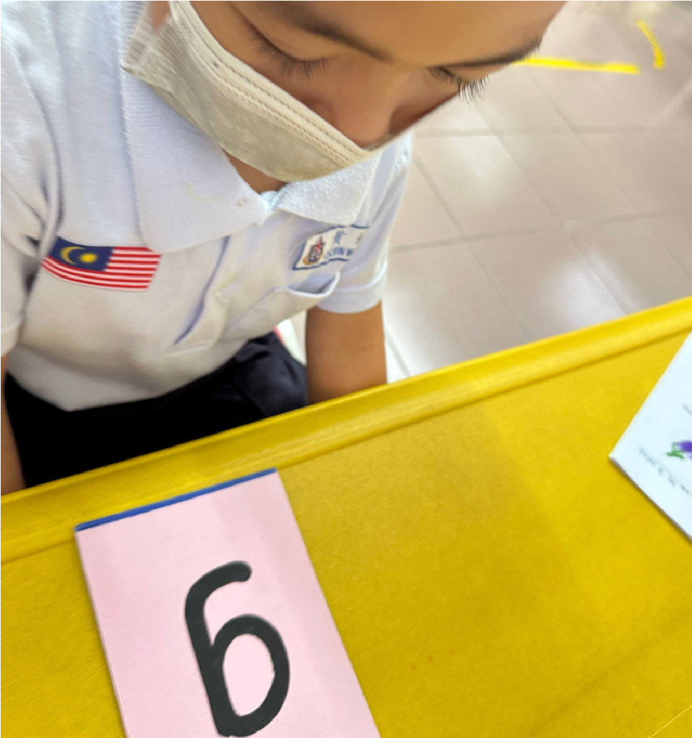
Figure 1: Sandpaper Letters (Phase 1)
In Phase 1, traditional Montessori Sandpaper Letters were used to teach the target phonemes associated with the letters g and h. The instructional process followed a conventional teacher-led approach in which learners were introduced to the letter shape and its corresponding sound, followed by guided tracing and independent practice. The textured surface of the sandpaper letters provided tactile and kinesthetic feedback that supported letter recognition and formation through muscle memory. However, while the materials effectively engaged learners through touch and movement, they offered limited auditory support. Consequently, learners often relied heavily on the teacher for correct phoneme modelling and reinforcement. When the teacher attended to other learners, some participants stopped practicing, forgot the target sound, or repeated incorrect pronunciations. As a result, frequent reteaching was required to restore accurate letter–sound associations. To measure this dependency, each instance in which a learner required a complete review of the target phoneme before achieving mastery was recorded as an instructional cycle. The data collected during this phase served as a baseline for comparison with the QR Code–Integrated Phonics Cards implemented in Phase 2.
Phase 2 Material: QR Code-Integrated Phonics Cards (Innovative)
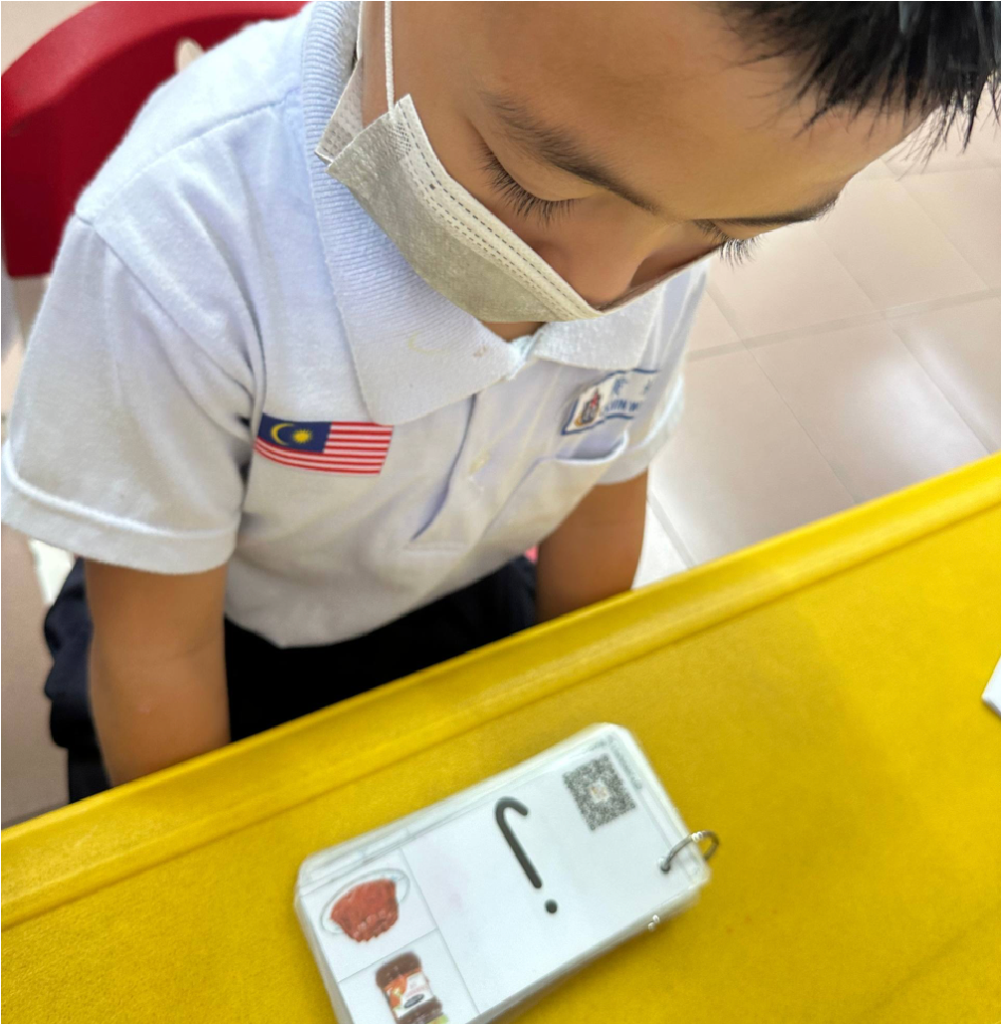
Figure 2: Student Using QR Code integrated Phonics cards (Phase 2)
In phase 2, the intervention shifted to the use of QR Code–Integrated Phonics Cards to teach the target phonemes associated with the letters j and p. At the beginning of the phase, learners were briefly guided on how to scan the QR codes using a tablet. Once familiar with the process, they were able to independently access teacher-created phonics videos that demonstrated the correct pronunciation of the target sounds, including clear mouth movements and articulation cues. Unlike the traditional approach in Phase 1, learners no longer relied solely on the teacher for repeated phoneme modelling. Instead, they could replay the audio-visual demonstrations as often as needed during practice, allowing them to verify and correct their own pronunciations. This continuous access to phonetic support encouraged greater learner autonomy, sustained engagement, and independent practice. The teacher’s role shifted from being the primary source of phoneme instruction to that of a facilitator who monitored progress and confirmed mastery. Like Phase 1, the number of instructional cycles required for each learner to achieve phonics mastery was recorded and compared to determine whether the QR-integrated intervention improved learning efficiency and reduced dependence on teacher-led support.

Table 1: Instructional Cycles Required for Phonics Mastery Across the Two Intervention Phases

Student | Phase 1: Sandpaper Letters (g) | Phase 1: Sandpaper Letters (h) | Phase 2: QR Phonics Cards (j) | Phase 2: QR Phonics Cards (p)
A | 4 | 5 | 2 | 2
B | 3 | 4 | 2 | 1
C | 5 | 5 | 3 | 2
D | 4 | 4 | 1 | 1
E | 4 | 4 | 2 | 1
Mean | 4.0 | 4.4 | 2.0 | 1.4

Note. Values represent the number of instructional cycles required for each learner to achieve mastery of the target grapheme–phoneme correspondence. Lower values indicate greater instructional efficiency.

Phase | Mean Instructional Cycles
Phase 1 (Sandpaper Letters) | 4.2
Phase 2 (QR Phonics Cards) | 1.7

Note. The average number of instructional cycles decreased from 4.2 in Phase 1 to 1.7 in Phase 2, representing a reduction of approximately 59.5% in teacher-led instructional support required for phonics mastery.

Table 1 shows a clear reduction in the number of instructional cycles required for learners to achieve phonics mastery after the introduction of the QR Code–Integrated Phonics Cards. During Phase 1, which utilised traditional sandpaper letters, learners required an average of 4.2 instructional cycles to master the target phonemes. In contrast, the average number of cycles decreased to 1.7 instructional cycles during Phase 2, representing an approximately 59.5% improvement in instructional efficiency. This finding suggests that learners were able to achieve mastery more quickly when provided with continuous audio-visual support through the QR-integrated cards. Across all five participants, fewer reteaching sessions were required in Phase 2, indicating a reduced dependence on teacher-led phoneme modelling. Notably, Student D, who required four instructional cycles for both target letters in Phase 1, achieved mastery in only one cycle for each target phoneme in Phase 2. The findings indicate that the QR Code–Integrated Phonics Cards enabled learners to independently revisit phoneme demonstrations whenever needed, reducing learning decay between sessions and supporting more consistent retention of grapheme–phoneme correspondences. Overall, the results demonstrate that integrating audio-visual scaffolding into traditional phonics instruction can significantly enhance learning efficiency and reduce the instructional burden on teachers in rural preschool classrooms.

Table 2: Observation Rubric for Learner Engagement and Independence

Criterion | Scale | Behavioural Indicators
Engagement | High (3) | Learner demonstrates curiosity, actively uses the learning materials, and maintains focus on the activity for more than five minutes.
 | Moderate (2) | Learner participates when prompted by the teacher and follows instructions but shows limited initiative in exploring the materials independently.
 | Low (1) | Learners are easily distracted, frequently shift attention away from the activity, and requires repeated prompts to participate or produce target sounds.
Independence | Yes (1) | Learners engage with the learning materials independently. In Phase 1, the learner traces and practises using the sandpaper letters without assistance. In Phase 2, the learner independently scans the QR code, accesses the phonics video, and attempts self-correction without continuous teacher support.
 | No (0) | Learner relies on teacher guidance before attempting the activity, waits for teacher approval or modelling, and discontinues practice when teacher support is withdrawn.

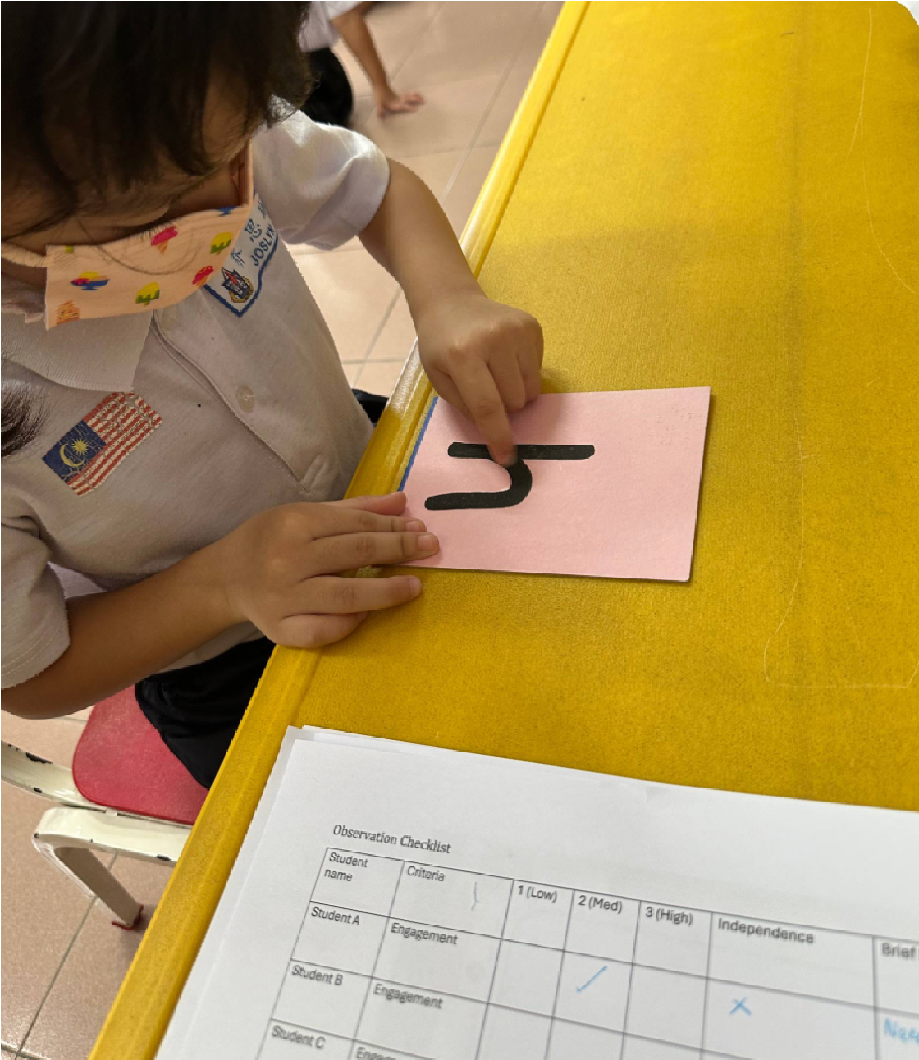

Figure 3: Observation Checklist in Use during Tactile tracing
The findings from the observation rubric indicated clear differences in learner engagement and independence between the two intervention phases. During Phase 1, learners frequently relied on teacher prompts, often paused their practice when teacher support was unavailable, and demonstrated lower levels of independent phonics learning. In contrast, learners in Phase 2 showed higher engagement and greater autonomy by independently scanning QR codes, accessing phonics videos, and attempting self-correction without continuous teacher guidance. These behavioural observations suggest that the QR Code–Integrated Phonics Cards encouraged more active participation and self-directed learning. The findings also complement the quantitative results, as the reduction in instructional cycles was accompanied by increased learner independence and sustained engagement, indicating that the audio-visual scaffolding provided by the QR-integrated cards supported both more efficient and more autonomous phonics learning.

Table 3: Comparison of Instructional Cycles and Efficiency Gains Between Phase 1 and Phase 2

Participant | Phase 1: Sandpaper Letters (g, h) Mean Cycles | Phase 2: QR Phonics Cards (j, p) Mean Cycles | Efficiency Gain (%)
Student A | 5.0 | 2.0 | 60
Student B | 4.0 | 3.0 | 25
Student C | 6.0 | 2.0 | 67
Student D | 4.0 | 2.0 | 50
Student E | 5.0 | 3.0 | 40
Mean | 4.8 | 2.4 | 50

Note. Mean cycles represent the average number of instructional cycles required for each participant to achieve mastery of the target grapheme–phoneme correspondences in each phase. Efficiency gain was calculated as the percentage reduction in instructional cycles from Phase 1 to Phase 2. Higher percentages indicate greater improvement in learning efficiency.

Table 3 presents the comparison of instructional cycles required for phonics mastery between the traditional sandpaper letter intervention (Phase 1) and the QR Code–Integrated Phonics Cards intervention (Phase 2). The findings indicate a substantial improvement in learning efficiency following the introduction of the QR-integrated phonics cards. The mean number of instructional cycles required to achieve mastery decreased from 4.8 cycles in Phase 1 to 2.4 cycles in Phase 2, representing an overall 50% improvement in instructional efficiency. This reduction suggests that learners were able to acquire and retain target grapheme–phoneme correspondences more quickly when supported by continuous audio-visual scaffolding. Unlike the traditional sandpaper letters, which required repeated teacher modelling and reinforcement, the QR-integrated cards enabled learners to independently access accurate phoneme demonstrations whenever needed, reducing reliance on teacher intervention and supporting more efficient learning.

At the individual level, all participants demonstrated improvements in learning efficiency during Phase 2. Student C showed the greatest improvement, with the number of instructional cycles decreasing from 6 to 2 cycles, representing a 67% efficiency gain. Student A also demonstrated a substantial improvement, requiring only 2 cycles in Phase 2 compared to 5 cycles in Phase 1, resulting in a 60% efficiency gain. Student D achieved a 50% improvement, while Student E showed a 40% improvement. Although Student B demonstrated the smallest increase, the number of instructional cycles still decreased from 4 to 3 cycles, representing a 25% improvement. The consistent pattern of improvement across all participants suggests that the QR Code–Integrated Phonics Cards were beneficial for learners with varying levels of phonics proficiency.

Overall, the findings provide evidence that integrating digital audio-visual support into traditional phonics instruction can significantly enhance the efficiency of phonics learning among young ESL learners. The reduction in instructional cycles indicates that learners required fewer reteaching sessions to achieve mastery, thereby reducing teacher dependency and maximising instructional time. These findings are particularly relevant for rural preschool contexts, where limited teaching resources and high pupil–teacher ratios often constrain opportunities for individualised phonics support. The results suggest that QR Code–Integrated Phonics Cards offer a practical and scalable approach to strengthening early phonics instruction while promoting greater learner independence and engagement.

DISCUSSION AND CONCLUSION

This study examined the effectiveness of QR Code–Integrated Phonics Cards in supporting early English phonics learning among preschool learners at SJK(C) Kee Tee, Long Lama. The findings demonstrated that learners achieved phonics mastery more efficiently when using the QR-integrated cards, with the average number of instructional cycles decreasing by 50% compared to the traditional sandpaper letter approach. The observations further revealed notable improvements in learner engagement, autonomy, and self-correction. During the traditional intervention, learners frequently relied on teacher prompts and feedback, resulting in repeated instructional cycles and limited independent practice. In contrast, the QR-integrated cards provided immediate access to audio-visual phoneme modelling, enabling learners to independently verify pronunciations, replay demonstrations, and correct errors in real time (Petersen et al., 2023; Wang et al., 2024). The combination of tactile, visual, and auditory learning experiences transformed phonics learning from a teacher-dependent process into a more learner-centered experience, as reflected in the increase in learner engagement and the improvement in independence from 20% to 100%. This finding is consistent with multisensory literacy research, which suggests that learning is strengthened when children are provided with multiple sensory pathways for processing information (Piasta et al., 2022; Tracey & Morrow, 2023). Furthermore, systematic phonics instruction supported by immediate feedback has been identified as a key factor in improving reading outcomes among beginning readers (Foorman et al., 2023; National Reading Panel, 2022). In addition, the intervention created a teacher-multiplier effect by reducing the need for repeated phoneme modelling, allowing the teacher to provide more targeted instructional support. The study concludes that QR Code–Integrated Phonics Cards represent a practical, innovative, and low-cost solution for enhancing phonics instruction in rural ESL contexts. By bridging gaps in English language exposure and supporting more effective grapheme–phoneme correspondence development, the intervention offers a sustainable approach to improving early literacy outcomes while promoting learner independence (Zhao & Wiburg, 2023; Zydney & Warner, 2024). Although the study involved a small number of participants, the positive findings suggest that integrating simple digital technologies with traditional tactile materials can significantly improve phonics learning efficiency and engagement. Future research involving larger samples and longer intervention periods is recommended to further examine the effectiveness and scalability of this approach across diverse early childhood education settings (Bahrick et al., 2023; Mangen et al., 2023).

RESEARCH IMPLICATIONS
The findings of this study highlight the value of integrating digital and tactile learning approaches to support early phonics instruction in rural ESL contexts (Solichah & Fardana, 2024; Wang et al., 2024). The QR Code–Integrated Phonics Cards significantly improved learning efficiency, reducing the average number of instructional cycles required for phonics mastery by 50% while increasing learner engagement, independence, and self-correction. These results suggest that traditional tactile materials, such as sandpaper letters, can be enhanced through the addition of audio-visual scaffolding that provides immediate access to accurate phoneme models. The study also demonstrates that multimodal learning experiences combining tactile, visual, and auditory elements can strengthen grapheme–phoneme correspondence development and accelerate early literacy acquisition (Ehri, 2022; Parkin et al., 2023). These findings reinforce established reading theories that emphasise the importance of explicit phonics instruction, orthographic mapping, and multisensory engagement in early literacy development (Kilpatrick, 2022; Tracey & Morrow, 2023; Yopp & Yopp, 2022).
From a practical perspective, the findings indicate that low-cost, offline-compatible digital tools can help address literacy challenges in resource-constrained rural settings without requiring extensive technological infrastructure. The QR-integrated intervention reduced learners’ dependence on continuous teacher support and enabled more self-directed learning, allowing teachers to focus on targeted instructional support. These outcomes align with the aspirations of the Malaysia Education Blueprint (2013–2025) and PAK-21 by promoting digital integration, learner autonomy, and equitable access to quality education. Therefore, QR Code–Integrated Phonics Cards offer a scalable and sustainable approach for enhancing early literacy instruction and supporting young learners in developing both foundational reading skills and independent learning habits.

REFERENCES
- Bahrick, L. E., Flom, R., & Lickliter, R. (2023). Touch to learn: Multisensory input supports word learning and processing in young children. Developmental Review, 69, 101087.
- Cabell, S. Q., Zucker, T. A., DeCoster, J., & McGinty, A. S. (2024). A meta-analysis on the optimal cumulative dosage of early phonemic awareness instruction. Reading Research Quarterly, 59(1), 45–68.
- Ehri, L. C. (2022). The science of learning to read words: The role of grapheme–phoneme connections and orthographic mapping. Reading Research Quarterly, 57(S1), S45–S58.
- Foorman, B. R., Beyler, N., Borradaile, K., et al. (2023). Foundational skills to support reading for understanding in kindergarten through Grade 3. Educational Researcher, 52(3), 145–157.
- Jiang, Y., Gai, X., Wang, Z., & Thomson, J. (2024). The influence of segmental and suprasegmental phonological awareness on word and pseudoword reading. Journal of Educational Psychology, 116(2), 198–214.
- Kilpatrick, D. A. (2022). Essentials of assessing, preventing, and overcoming reading difficulties (2nd ed.). Wiley.
- Mangen, A., Schilhab, T., & Brønnick, K. (2023). Multisensory reading in early childhood: A systematic review. Human Development, 67(2), 89–112.
- Mokhtari, K., Reed, D. K., & Wang, J. (2024). Orthographic influences on phonological processing among children with and without reading difficulties. Reading and Writing, 37(1), 85–107.
- Mori, K., Takahashi, Y., & Sato, H. (2024). Multisensory learning with haptic reading plates and its impact on reading and writing skills. Japanese Journal of Cognitive Neuroscience, 26(3–4), 105–118.
- National Reading Panel. (2022). Teaching children to read: Evidence-based assessment of the scientific research literature on reading. National Institute of Child Health and Human Development.
- Parkin, J. R., Hajovsky, D. B., & Alfonso, V. C. (2023). Evaluating phonemic awareness and orthographic mapping among beginning readers. Psychology in the Schools, 60(5), 1432–1447.
- Petersen, D. B., Steacy, L. M., Spencer, T. D., & Hogan, T. P. (2023). The impact of explicit instruction using visual vowel hand-sign systems on reading and spelling outcomes. Annals of Dyslexia, 73(1), 56–79.
- Piasta, S. B., Logan, J. A. R., Pelatti, C. Y., & Petrill, S. A. (2022). Supporting early literacy through multisensory instruction in preschool settings. Early Childhood Research Quarterly, 60, 154–166.
- Solichah, N., & Fardana, N. A. (2024). Exploring multisensory programs as early literacy interventions: A scoping review. International Journal of Evaluation and Research in Education, 13(2), 899–910.
- Tracey, D. H., & Morrow, L. M. (2023). Lenses on reading: An introduction to theories and models (4th ed.). Guilford Press.
- Wang, Y., Li, X., & Chen, H. (2024). Associations among variables in technology-enhanced phonological awareness programmes: A meta-analysis. Computers & Education, 213, 105002.
- Yahaya, N. A., Mohd Noor, N. F., & Abdullah, M. (2025). Utilizing multisensory teaching aids to foster letter recognition and writing acquisition among preschool children. International Journal of Education, Psychology and Counselling, 10(56), 88–102.
- Yopp, H. K., & Yopp, R. H. (2022). Phonological awareness is child's play! (2nd ed.). Teachers College Press.
- Zhao, Y., & Wiburg, K. (2023). Digital learning tools and learner autonomy in early childhood education. Educational Technology Research and Development, 71(4), 1875–1894.
- Zydney, J. M., & Warner, Z. (2024). Mobile learning and QR code technologies in early childhood education: Opportunities for engagement and independent learning. British Journal of Educational Technology, 55(1), 112–128.

