LOCAL PERSPECTIVES ON THE IMPACTS OF DROUGHT ON MEDICINAL PLANTS IN RAMOKGOPA VILLAGE, LIMPOPO PROVINCE, SOUTH AFRICA.

ABSTRACT
Medicinal plants are crucial for maintaining traditional healing practices in different communities. However, the survival of these plant species is threatened due to environmental stresses such as drought. The study aimed to explore the local perceptions of the impacts of droughts on medicinal plant species in Ramokgopa village, Limpopo province, South Africa. A sample of 10 participants were purposively selected to participate in the study. Semi-structured face-to-face interviews were adopted as a method of data collection. The study findings show that drought has a severe impact on the growth, availability, and accessibility of medicinal plants. The participants indicated that medicinal plants showed signs of drought stress, such as stunted growth, drying, and extinction. This resulted in community members and traditional health practitioners traveling long distances to obtain traditional medicine. The study revealed that limited access to these plant species affects the health and well-being of Ramokgopa residents since there is inadequate healthcare facilities in the area. The scarcity of medicinal plants also affects the ability of traditional healers to deliver treatment services to patients. As a result, indigenous strategies such as water storage, the use of humus to retain soil moisture, drying of medicinal plants, and sustainable harvesting practices were reported to be commonly used to adapt and mitigate the effects of drought on medicinal plants. It was imperative to conduct this study as it adds valuable knowledge to local communities that depend on medicinal plants for primary healthcare, with effective strategies to save and protect medicinal plant species during drought seasons.
Keywords: Drought, Medicinal plants, Local perspectives, Limpopo Province, South Africa

INTRODUCTION
Regardless of the vital importance of medicinal plants as a primary healthcare resource in Ramokgopa village, recurrent drought is decimating medicinal plant species, thereby jeopardizing local healthcare systems, leaving local communities vulnerable to diseases, and compromising traditional local knowledge. Drought threatens the survival of medicinal plants, as it restricts plants’ growth, development, and overall production. Khalid, Zakir, Khan, Irum, Sabir, Zafar, Ahmad, Abbas, Ahmed, and Hussain (2023) reported that approximately 60% of crops, along with medicinal plants, are affected by water deficit. Water deficit results in physiological malfunctions such as biochemical variation, reduced transpiration and photosynthesis, and metabolite alteration. This affects the well-being of people who are overly reliant on medicinal plants for traditional medicine.
Drought is globally one of the attributes that stresses the environment, as it hinders the growth of plants and their organic state (Seleiman, AI-Suhaibani, Ali, Akmal, Alotaibi, Refay, Dindaroglu, Abdul-Wajid & Battaglia, 2021). This is observable in medicinal plant species consumed by communities, especially in rural areas where resources and financial means are limited. Medicinal plants have been used for centuries due to their nutritional value and medicinal properties. However, as a result of drought, medicinal plant species are predisposed to extinction, as some plants are not drought-tolerant. Drought refers to a long period of lack of rain, little moisture, and dryness (Lloyd-Hughes, 2014). The impacts of drought are usually noticeable on agriculture and water resources, which influence the ecosystems, livelihoods and health (Walker, Oliveira, Cavalcante, Kchouk, Neto, Melson, Femandes, Mitroi, Gondim, Martins & Van Oel, 2024). In Africa, drought has resulted in much devastation, including failed harvests, animal fatalities and human losses in various locations. An estimation of about 450 000 of deaths was reported in Ethiopia and Sudan, more than 325 000 deaths in the Sahel, and 100 000 deaths in Zimbabwe as a result of drought. Notably, drought is caused by climate fluctuations as well as anthropogenic effects, such as deforestation, growing water demands, climate change, global warming, and land degradation (Haile, Tang, Sun, Huang, Zhang & Liu, 2019).
Drought has severe effects on medicinal plants as it reduces their availability, restricts plants growth, reproduction and increases plant mortality. These plant species are significant for healthcare and hold significant economic importance. These impacts are particularly pronounced in places that are excessively dependent on traditional medicine, posing threats to the health of people and local economies. A key characteristic of medicinal plants is their richness in secondary metabolites which have therapeutic properties. These properties are less prevalent or not present in other plants. Drought stress diminishes the biomass of medicinal plant species, which is remarkably vital in these plants as it impacts the accessibility of raw materials to produce drugs. Moreover, drought affects medicinal plants by changing their physiological and biochemical processes, which restricts proper growth and development of the plants (Tan & Gören, 2024).
Medicinal plants consist of secondary metabolites which exhibit pharmacological properties such as anti-inflammatory effects, antibacterial activity, antiviral abilities, neuroprotection and antitumor actions. Drought stress can alter the quality of these secondary metabolites, moreover, drought can intensify disease incidence among these medicinal plants further affecting the yield and the quality. When the quality of the secondary metabolites is altered it significantly influence the development of drugs (Guo, He, Zhong, Yang & Xu, 2025).
Farooq, Wahid, Kobayashi, Fujita and Basra (2009) concur that the biomass of medicinal plants is continuously depleting due to stress resulting from drought, which influences the availability of natural resources for health maintenance. Hence, Gaur, Chauhan, Singh, Usman and Kanta (2024) allude that drought changes the functions and the compounds essential for the life of medicinal plants by reducing growth and production of medicinal plants. Drought also affects the therapeutic properties of medicinal plant species (Nazari, Ghasemi-Soloklui, Kordrostami & Latef, 2023; Azad, Rezayian, Hassanpour, Niknam & Ebrahimzadeh, 2021). Drought affects the therapeutic properties of medicinal plants by altering the bioactive compounds, reducing the plant biomass, reducing the nutrient uptake and influencing the oil yield of medicinal plants. When these properties are affected, the effectiveness, potency and quality of medicinal plants also reduce, therefore preventing some medicinal plants from fulfilling their remedial purposes (Özyazıcı & Valizadeh, 2025).
Medicinal plants are plants utilised to treat diseases; these plants are used in different ways in both traditional and allopathic healthcare systems globally (Smith-Hall, Larsen & Pouliot, 2012). Medicinal plants play a significant role in the livelihoods of communities (Guar et al., 2024). Medicinal plants play a significant role in numerous communities by providing accessible and affordable treatment in areas where is limited healthcare facilities (Karunamoorthi, Jegajeenvanram, Vijayalakshmi & Mengistie, 2013). The role of medicinal plants is beyond healthcare; they also play a significant role in the economy of local communities. This is supported by Hamilton (2004) that medicinal plants are also a significant source of income to many rural communities, traditional healers, and local traders, who gain income from selling and utilising medicinal plants (Hamilton, 2004). A great demand of these medicinal plants, combined with a number of environmental stresses such as drought, has led to a drastic diminution of medicinal plants worldwide (AI-Hamed, Shiyab & AI-Bakri, 2022).
In South Africa, droughts are frequent, and it is anticipated that this country will proceed to experience droughts due to climate change (Ncube & Largardien, 2015). Indigenous communities are utilising adaptation and mitigation strategies to cope with the effects of drought on medicinal plants. Indigenous adaptation strategies and mitigation strategies include mulching to keep soil moisture, utilising water storages, seeding early before drought, removing trees that require an excessive amount of water, planting early and planting drought-resistant crops and modifying cropping patterns (Aliabadi, Ataei & Gholamrazai, 2022; Shikwambana, Malaza, Ncube, 2022).
Ramokgopa village lacks resources such as healthcare facilities and reliant on medicinal plants for primary healthcare. Medicinal plant species in this area are severely impacted by frequent drought experienced in the area. The ecological vulnerability and dependence on medicinal plants in this area explains why this area was chosen in this study. The motivation behind conducting this study stems from the need to understand how drought affects medicinal plant species in Ramokgopa village and the repercussions of these effects on the healthcare systems, the livelihood of people depending on these plants and the conservation of biodiversity. In Ramokgopa village, people still practice traditional healthcare and utilise medicinal plants for traditional medicine, however the study area is prone to recurrent drought, therefore limiting the access to different plant species for treating certain ailments. Conducting this research can add knowledge on the sustainable use of medicinal plants and conservation for easy access in the area under investigation as well as other communities.

METHODOLOGY

A qualitative study was conducted with a sample of 10 participants. The study consisted of 10 (100%) women who were purposively selected to participate in this study. In-depth semi-structured interviews were conducted to gather the local perspectives on the impacts of drought on medicinal plants in Ramokgopa village. Data was collected within a period of 3 months, and each interview took about 30-35 minutes. Field notes, voice recording, and pictures were utilised to capture data. A thematic content analysis method was adopted to analyse data. Verbal data from the recordings was transcribed, and themes and sub-themes were extracted from the data. Credibility, dependability, confirmability, and transferability were ensured through identifying indigenous knowledge holders, including traditional healers, member checking, respectively. Confirmability was ensured by keeping all interview records and transcripts to serve as proof that the research findings are not manipulated by the researcher. Transferability was also ensured by explaining all the research procedures that were used to collect and analyse data so that it becomes applicable to other people. Ethical considerations such as permission to conduct the study, informed consent, voluntary participation, anonymity and confidentiality and no harm to the participants were adhered to when conducting this study.
RESULTS
Participants have emphasised that drought severely impact the growth, availability and accessibility of medicinal plant species in Ramokgopa village.
The growth of medicinal plants
The Participants reported that plants do not grow under drought conditions. They have emphasised that these plant species need adequate water for proper growth. If there is enough water, the plants growth improves. Participants also indicated that the physical structure of the plants usually changes under drought conditions, which includes stunted growth and the leaves drying up, leaving only the roots.
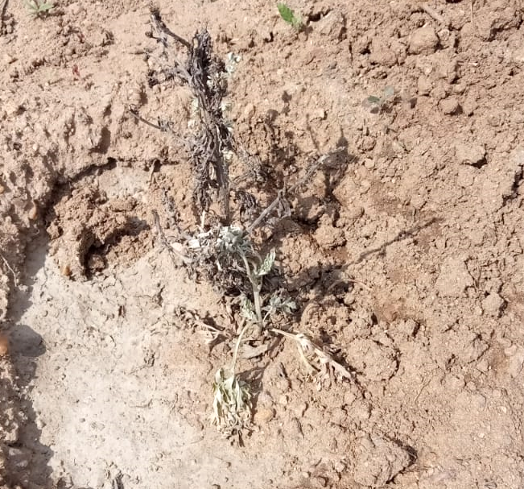
Figure 1: Lengana (Artemisia Afra) during drought in Ramokgopa
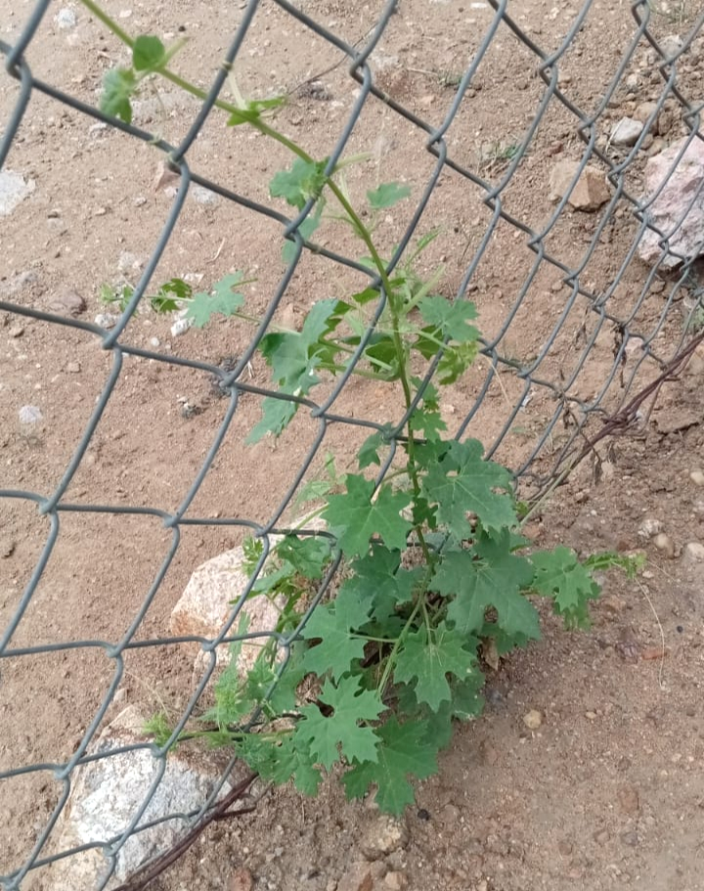
Figure 2: Stunted growth of Tharane (momordica balsamina) in Ramokgopa
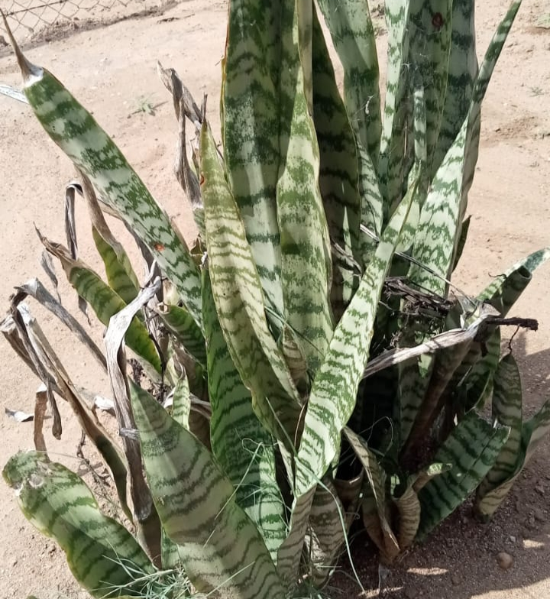
Figure 3: Mohlakwana (Sansevieria)
Participant 1 reported that:
“Plants cannot grow without rain. They do not grow as well as they did when rainfall was sufficient. When there is insufficient rain, the leaves are green in colour. If there is drought, plants are hard to be found. These plants are important since we utilise them for healing certain diseases. They make us live longer. Without medicine, people will die.”
Participant 5 reported that:
“When there is no water, plants are not happy, they do not grow during drought periods.”
Drought conditions were reported to negatively affect the growth of medicinal plant species. Participants stressed the negative impacts of drought on the growth of medicinal plants. They have highlighted the significant role of adequate water in the growth of medicinal plants.
The availability of medicinal plants
Participants reported that the impacts of drought on medicinal plants reduce their availability in Ramokgopa village. They have explained that some medicinal plants become scarce while others dry up. They have highlighted the significance of adequate water to plants. The extended periods of water deficit slowly leads to drying of medicinal plants leaves and roots and this results plant mortality, therefore reducing their availability in the village.
Participant 3 reported that:
“Plants disappear during drought; this makes it difficult for us to treat diseases. It not only affects us but also health professionals because some modern drugs are made from medicinal plants.”
Participant 6 reported that:
“We do not usually find medicinal plants during drought; their leaves dry up and only the roots remain”
Participant one concurred that:
“When there is no rain, the leaves of medicinal plants tend to dry out and fall off. Many of them are unavailable during drought periods”
Participants viewed drought as one of the environmental stressors that diminish the diversity of medicinal plants in their area. Participants expressed how drought significantly reduced the availability of medicinal plants. The unavailability of these plant species reduces the accessibility of traditional remedies. The reduced availability of medicinal plants poses challenges on the people and healthcare systems that depend on them.

The accessibility of medicinal plants
Participants reported that the unavailability of medicinal plants reduces the accessibility of traditional medicine. Participants expressed the difficulties they come across when trying to access medicinal plants. This difficult access of medicinal plants in Ramokgopa makes them travel long distances to buy traditional medicine
Participant 5 reported that:
“It is very difficult to access medicinal plants during drought periods. This negatively impacts us, as these plants are important because they heal us. Sometimes you will find that medicinal plants have dried up due to water deficit, it makes it challenging to identify them if they are dry.”
Participant 1 reported that:
“We use medicinal plants for treating different diseases, when these plants are not accessible, how are we going to treat certain diseases. It is very difficult to find medicinal plants nowadays, but for myself, I can travel to Gauteng to buy them”
Participants expressed how the lack of accessibility of medicinal plants during drought affects their health and interrupts traditional healthcare systems. They have showed concerns on how various diseases are going to be treated since it is not easy to access these plant species in their area
DISCUSSION

When participants were asked about the impacts of drought on medicinal plants, they have reported that medicinal plants do not grow well under drought conditions. This perspective is supported by Swann (2018) that the extended periods of drought conditions exacerbate plants stress, leading to the damage of plant tissues. This may result in increased mortality rates of plant species. A study conducted by Al-Tawaha, Turk, Abu-Zaitoon, Aladaileh, Al-Rawashdeh, Alnaimat, Al-Tawaha, Alu’Datt and Wedyan (2017) also shows that water deficit is the greatest environmental issue that severely affect plant growth and restricts plants production over any other environmental issue. These scholars further articulated that drought affects three key aspects of medicinal plants, which are, the plant growth and physiology, yield and quality.
Participants made it clear that these effects of drought on medicinal plants reduce their availability in the community. The reduced availability of these plant species was reported to have negative impacts on the well-being and health of community members since they are unable to treat certain diseases using traditional remedies. It was also reported by participants that they believe some modern drugs or medications are made from medicinal plant species. These findings are supported by Sen and Samanta (2014) that medicinal plants are the source of many drugs utilised in modern medicine. Examples are drugs including digitalis, quinine, ergotamine and salicytes.
During the interviews, participants also reported that medicinal plant species can also be used to generate income. In addition to that, participants indicated that these plant species play a significant role in cultural practices in their area. These findings are supported by Schippmann, Leaman and Cunningham (2002) that people collect plant and animal resources for their needs. Examples include edible nuts, herbs, fruits, fodder and plant or animal products for medicinal, cosmetic and cultural uses. These scholars further reported that this is still practiced today, many people, mostly in developing countries depend on plant and animal products for food and generating income. Gathering valuable products such as medicinal plants also continues in developed countries for cultural and economic purposes.
CONCLUSION
The study explored the effects of drought on medicinal plant species in Ramokgopa village, Limpopo province, South Africa. From the findings of the study, it can be deduced that extended drought conditions impact the survival of medicinal plants in the area. Insufficient rainfall reduces the availability of these plant species, resulting in limited access, it also impacts the health of Ramokgopa village residents as well as cultural practices that involve the use of medicinal plant species. Indigenous strategies need to be executed to conserve, mitigate, and adapt to the impacts of drought on medicinal plants.

AKNOWLEDGEMENTS
First, the researcher would love to thank the Ramokgopa tribal authority for permitting the study to be conducted and the participants from Ramokgopa village for participating in this study.

REFERENCES
  - Al-hamed, T., Shiyab, S.M. & Al-Bakri, J. (2022). Morpho-physiological Effects of Drought on Medicinal Plants and the Potential Use of Remote Sensing-A Review. Jordan Journal of Earth and Environmental Sciences, 13(2), 105-113.
  - Aliabadi, V., Ataei, P. & Gholamrezai, S. (2022). Farmers’ strategies for drought adaptation based on the indigenous knowledge system: The case of Iran. Weather, Climate, and Society, 14(2), 561-568.
  - Al-Tawaha, A.R., Turk, M.A., Abu-Zaitoon, Y.M., Aladaileh, S.H., Al-Rawashdeh, I.M., Alnaimat, S., Al-Tawaha, A.R.M., Alu’datt, M.H. & Wedyan, M. (2017). Plants adaptation to drought environment. Bulgarian Journal of Agricultural Science, 23(3), 381-388.
  - Azad, N., Rezayian, M., Hassanpour, H., Niknam, V. & Ebrahimzadeh, H. (2021). Physiological mechanism of salicylic acid in Mentha pulegium L. under salinity and drought stress. Brazilian Journal of Botany, 44, 359-369.
  - Farooq, M., Wahid, A., Kobayashi, N.S.M.A., Fujita, D.B.S.M.A. & Basra, S.M. (2009). Plant drought stress: effects, mechanisms and management. Agronomy for sustainable development, 29(1), 185-212.
  - Gaur, R., Chauhan, A., Singh, A.K., Usman, M. & Kanta, C. (2024), "Assessing the Impact of Climate Change on Medicinal Plants: Strategies for Sustainable Management", African Journal of Biomedical Research, 2381.
  - Guo, Z., He, S., Zhong, X., Yang, N. & Xu, D. (2025). "Optimizing Plant Alkaloid Biosynthesis under Drought Stress: Regulatory Mechanisms and Biotechnological Strategies", Journal of Plant Physiology, vol. 311,154545.
  - Haile, G.G., Tang, Q., Sun, S., Huang, Z., Zhang, X. and Liu, X. (2019). Droughts in East Africa: Causes, impacts and resilience. Earth-science reviews, 193,146-161.
  - Hamilton, A.C. (2004). Medicinal plants, conservation and livelihoods. Biodiversity & Conservation, 13(8), 1477-1517.
  - Karunamoorthi, K., Jegajeevanram, K., Vijayalakshmi, J. & Mengistie, E. (2013). Traditional medicinal plants: a source of phytotherapeutic modality in resource-constrained health care settings. Journal of Evidence-Based Complementary & Alternative Medicine, 18(1), 67-74.
  - Khalid, M.F., Zakir, I., Khan, R.I., Irum, S., Sabir, S., Zafar, N., Ahmad, S., Abbas, M., Ahmed, T. & Hussain, S. (2023). Effect of water stress (drought and waterlogging) on medicinal plants. In Medicinal plants: Their response to abiotic stress, 169-182. Singapore: Springer Nature Singapore.
  - Lloyd-Hughes, B. (2014). The impracticality of a universal drought definition. Theoretical and applied climatology, 117, 607-611.
  - Nazari, M., Ghasemi-Soloklui, A.A., Kordrostami, M. & Abdel Latef, A.A.H. (2023). "Deciphering the response of medicinal plants to abiotic stressors: A focus on drought and salinity", Plant Stress, vol. 10,100255.
  - Ncube, B. & Lagardien, A. (2015). Insights into indigenous coping strategies to drought for adaptation in agriculture: A Karoo scenario. Water Research Commission Report, 2084(1),15.
  - Özyazıcı, G. & Valizadeh, N. (2025). Impact of drought stress on the medicinal and aromatic plants’ biochemistry. Medicinal and Aromatic Plants: Pharmaceutical, Food, and Cosmetic Applications, 199.
  - Schippmann, U., Leaman, D.J. & Cunningham, A.B. (2002). Impact of cultivation and gathering of medicinal plants on biodiversity: global trends and issues. Biodiversity and the ecosystem approach in agriculture, forestry and fisheries.
  - Seleiman, M.F., Al-Suhaibani, N., Ali, N., Akmal, M., Alotaibi, M., Refay, Y., Dindaroglu, T., Abdul-Wajid, H.H. & Battaglia, M.L. (2021). Drought stress impacts on plants and different approaches to alleviate its adverse effects. Plants, 10(2), 259.
  - Sen, T. & Samanta, S.K. (2014). Medicinal plants, human health and biodiversity: a broad review. Biotechnological applications of biodiversity, 59-110.
  - Shikwambana, S., Malaza, N. & Ncube, B. (2022). Enhancing the resilience and adaptive capacity of smallholder farmers to drought in the Limpopo Province, South Africa. Conservation, 2(3).
  - Smith-Hall, C., Larsen, H.O. & Pouliot, M. (2012). People, plants and health: a conceptual framework for assessing changes in medicinal plant consumption. Journal of ethnobiology and ethnomedicine, 8, 1-11.
  - Swann, A.L. (2018). Plants and drought in a changing climate. Current Climate Change Reports, 4(2), 192-201.
  - Tan, U. & Gören, H.K. (2024). Comprehensive evaluation of drought stress on medicinal plants: a meta-analysis. PeerJ, 12, 17801.
  - Walker, D.W., Oliveira, J.L., Cavalcante, L., Kchouk, S., Neto, G.R., Melsen, L.A., Fernandes, F.B.P., Mitroi, V., Gondim, R.S., Martins, E.S.P.R. and Van Oel, P.R. (2024). It's not all about drought: What “drought impacts” monitoring can reveal. International Journal of Disaster Risk Reduction, 103, 104338.

