“Systematic Review of the Toy Industry in India: Trends, Challenges, and Global Integration"

Abstract
Purpose: This study examines the intellectual evolution of the toy industry through a domain-based Systematic Literature Review (SLR). The review is guided by four research questions: (RQ1) What are the publication trends in toy-related research? (RQ2) What thematic clusters define the intellectual structure of the toy domain? (RQ3) How do policy and economic developments influence the evolution of the toy industry? and (RQ4) What future research directions emerge from existing literature?
Research Design: The review follows PRISMA 2020 guidelines and the SPAR-4-SLR protocol. Peer-reviewed articles were systematically retrieved from the Scopus database to capture historical developments and structural shifts within the toy industry. Bibliometric techniques were applied using Biblioshiny (R) and VOSviewer, including descriptive analysis, keyword co-occurrence mapping, cluster analysis, and factorial analysis (PCA).
Key Findings: The findings reveal a steady Compound Annual Growth Rate (CAGR) of 6.65% in toy-related research. The literature is organized into ten thematic clusters, which merged together as three core areas such as; core toys, smart and digital toys and toy production & design, . Keywords related to data-driven technologies, such as deep learning, machine learning, and IoT, appear prominently, reflecting the growing integration of digital and analytical tools within toy research. Recent studies increasingly focus on wooden toys, smart toys, and technology-enabled play products.
Originality and Implications: To the best of the authors’ knowledge, this is the first domain-wide bibliometric review of the toy industry. The study offers a structured understanding of research trends and thematic evolution, providing useful insights for scholars, industry practitioners, and policymakers. The findings support evidence-based decision-making for innovation, policy formulation, and future academic inquiry in the toy sector. The findings will also help governments, startups to identify the core changes of the toy industry in recent years, which will help the government to make a policy framework; practitioners to identify new trends and clusters.
Keywords: Toy Industry; Toy Manufacturing; Bibliometric Analysis; Toy Innovation; Data Analytics
Paper Type: Systematic Literature Review

Introduction:
The toy industry represents a distinctive intersection of culture, manufacturing, innovation, and childhood development. Historically, toys have not only served as objects of play but have also reflected the cultural values, craftsmanship, and social contexts of their regions. In the Indian context, archaeological and historical accounts trace the presence of toys back to the Indus Valley civilization, highlighting a long-standing tradition of indigenous toy-making (About Indian Toys). Toys enable play and imagination in children. Gurudev Rabindranath Tagore noted that incomplete toys encourage creativity, but he also observed how attractive foreign-made toys can shift attention from imaginative play to the object itself (Modi, 2020). Despite this rich heritage, the contemporary Indian toy industry remains economically underrepresented, with Indian firms accounting for a marginal share of the global toy market and domestic manufacturers meeting only a limited proportion of internal demand (ASSOCHAM, 2021; The Indian Toy Industry Fighting for Its Survival, 2021).
Scholarly research on toys has evolved across multiple disciplinary lenses. Early studies primarily examined conventional toys and their material and functional characteristics (Jayan, 2018), while subsequent research expanded into consumer behavior and purchasing patterns associated with toys (Ellen, 2006; Bhuwandee, 2016; Sian, 2020). Other studies explored psychological and developmental dimensions, including personality traits and learning outcomes associated with toy use (Goldberg, 2000; Yi Lin, 2010; Anette Sandberg, 2008). Collectively, these works established toys as meaningful products influencing child development, family interaction, and consumption behavior.
Further streams of literature investigated social and contextual dimensions of toy use. Studies focusing on gender-based toy preferences (Luisi, 2019; Davis & Hines, 2020) and family interactions with toys (Wood, 2002; Dawson, 2008; Goldbart et al., 2010) highlighted the role of toys in shaping socialization and relational dynamics. Parallel research addressed entrepreneurship and production aspects, including women-led soft toy enterprises (Kumar, 2009), design innovation, creativity, and sustainability in toy manufacturing (Pereira, 2017). Health-related studies examined the impact of games and toys on children’s physical and psychological well-being (Johnson, 2011; Maureira, 2019; Yadav, 2020; Sajjadi, 2022), further broadening the scope of toy-related scholarship.
In recent years, the toy industry has also attracted attention from a policy and economic perspective. Toy industry has identified as one of the most potential industry which is supposed to reach $179.4 billion by 2032 (IANS, 2025). Comparative trade studies, particularly those examining India–China dynamics, have highlighted structural weaknesses in domestic manufacturing and competitiveness (ASSOCHAM, 2021). Recognizing this potential, the Government of India has identified the toy industry as a strategic sector for economic growth and employment generation. Policy initiatives such as quality control orders, manufacturing incentives, and the National Action Plan to Accelerate India’s Toy Sector have aimed to promote indigenous production and reduce import dependency (National Action Plan, 2021; Modi, 2020). Institutional efforts, including the organization of the National Toy Fair by the Department for Promotion of Industry and Internal Trade (DPIIT), further signal growing policy emphasis on revitalizing the sector.
Alongside these developments, recent academic publications increasingly reference data-driven and technology-oriented concepts within toy-related research. Keywords such as artificial intelligence, machine learning, and IoT appear with greater frequency, reflecting broader trends in smart manufacturing, product innovation, and digital play experiences. However, these technological themes have largely emerged in a fragmented manner and have not been systematically mapped within the broader toy industry literature.
Despite the richness and diversity of existing studies, the literature on the toy industry remains dispersed across disciplines, methodologies, and thematic areas. Prior reviews have typically focused on specific aspects, such as gender preferences or developmental outcomes, without offering a comprehensive overview of the domain’s intellectual structure (Davis & Hines, 2020). Consequently, there is limited clarity regarding publication trends, dominant research clusters, policy linkages, and emerging themes within toy-related scholarship as a whole.
The primary objective of this study is to systematically examine the existing body of literature on the toy industry and to map its intellectual structure using bibliometric analysis. Specifically, the study aims to:
(i) analyse publication trends in the toy research domain;
(ii) identify and interpret major thematic clusters shaping the literature;
(iii) examine the influence of policy and economic developments on the evolution of toy-related research; and
(iv) propose future research directions based on identified gaps. To address these objectives, the study is guided by the following research questions:
RQ1: What are the prevailing publication trends in toy-industry research?
RQ2: What thematic clusters define the intellectual structure of the toy domain?
RQ3: How do policy and economic developments influence the evolution of the toy industry literature?
RQ4: What future research opportunities emerge from existing studies?
Against this backdrop, a domain-based Systematic Literature Review is both timely and necessary. Bibliometric analysis provides a robust methodological approach to synthesizing large volumes of literature, enabling the identification of publication patterns, thematic clusters, and conceptual relationships (Paul, 2020; Rana, 2016). Accordingly, the purpose of this study is to conduct a systematic and bibliometric review of the toy industry, mapping its intellectual evolution, examining the influence of policy and economic developments, and identifying future research opportunities. By doing so, the study offers a cohesive understanding of the toy research landscape and contributes meaningful insights for scholars, industry practitioners, and policymakers.

2. Research Methodology
2.1 Review Design
The present study conducts a Systematic Literature Review (SLR) on the Toy Industry of India, drawing insights from global perspectives. In alignment with the research methodology, the literature review aims to "contribute significantly to the conceptual, methodological, and thematic development of different domains" (Palmateir, 2018). The researcher adopts the scientific steps of SLR, involving organization and purification of dataset and, finally, analysis and future roadmap development, departing from the traditional form of literature review described as the "process of assembling, arranging, and assessing existing literature in the research domain" (Justin Paul, 2021). Purification refers to removing the irrelevant data from the study through coding, inclusion and exclusion criteria. The main aim of SLR to provide deep insights from the domain and to provide value from the current literature of the toy domain by providing future research aspects. (Khanra Sayantan A. D., 2021) . There are various phases of a systematic Literature review. Khanra et.al. (2021) have conducted a literature review in three phases: scanning, curating, and reporting, which include the selection of appropriate studies by appropriate keywords; curating refers to refining the results from the scanning phase; and the last step followed as reporting of data (Khanra et.al., 2021). The initial step in the Systematic Literature Review entails identifying definitions and keywords. The researcher establishes criteria for the appearance of keywords in either the abstract or the full-text manuscript. Subsequent steps involve searching for papers across various databases, reading abstracts, and selecting titles, followed by the selection of full papers. The final step involves the analysis of extracted papers from the
2.2 SPAR-4-SLR & PRISMA Protocol
Researchers have adapted SPAR-4-SLR & PRISMA (Matthew, 2021); sequential phases of Khanra et.al. (2021). These all protocols stand for systematic literature review (Paul et.al 2021; Khanra et.al, 2021). SPAR-4-SLR protocols describe the entire procedure of systematic literature review, which includes the 3 stages of SLR and 6 subtopics. On the basis of protocols, researchers have conducted the review. Inclusion and exclusion criteria for the research is one of the important parts of the review study, which help in deselecting the irrelevant research articles (Plessen, 2020). The authors have followed the mixed-methodology approach outlined by Khanra (2021) and Justine Paul (2021) (Khanra et al., 2021; Paul et al. 2021). The sequential phases of SLR has adopted from Khanra et.al 2021. The process of Systematic Literature Review is mentioned in table 1.

Table 1: Process of Systematic Literature Review
Sr.No. | Phase (Paul,2021) | Sequential Phases, Khanra et.al. (2021)
1 | Definition and Key word identification | Scanning Phase
2 | Searching the papers from various databases | Scanning Phase
3 | Abstract and title selection | Curating Phase
4 | Identifying full research paper | Curating Phase
5 | Analysis of the papers | Analysis Phase
Source: Three decades of export competitiveness literature: systematic review, synthesis and future research agenda (Justin paul R. D., 2021); Servitization research: A review and bibliometric analysis of past achievements and future promises (Khanra et al. 2021).
To describe the process of SLR, the Inclusion-Exclusion process was followed in Phase 1:
Scanning Phase
The initial inclusion process. Authors have used search strings as follows: The primary database has been taken from two sources, first, the SCOPUS database as the primary data source, and second, government reports on toys. The reason behind selecting government reports was to study the developments in the toy domain concerning quality, infrastructure development, and educational uses. To identify relevant literature for this study, a comprehensive search was conducted using the Scopus database. The search string included the keywords TITLE-ABS-KEY ( "Toys" OR "Toy Startups" OR "Toy Ecosystem" OR "Khilone” ) AND ( LIMIT-O ( AFFILCOUNTRY, "India" ) ) AND (LIMIT TO ((LANGUAGE, “English”)). "Toy", "Toys", OR "Khilone" to capture both English and vernacular references to toys. The search was restricted to publications from 1993 to 2026 (i.e., PUBYEAR > 1993 AND PUBYEAR < 2026). Additionally, only English-language publications with at least one author affiliated with an institution in India were included in the final dataset.
Curating Phase
The study has considered the keyword as “Toy.” A total of 291 research papers were identified from the Scopus database, and 24 government reports were identified for review. Papers where keywords have appeared in the abstract or in the full text were selected; after the careful review of 291 papers, 151 research papers were excluded from the final consideration in the review process; Total number 140 research papers were selected for further analysis, and of these 140 papers 24 government reports were identified for further analysis. Due to non-applicable key terms. The exclusion and inclusion criteria is given below - The researchers have used the PRISMA protocol to show the exclusion-inclusion process it as shown in Figure 1.

Figure 1: Inclusion-Exclusion Process
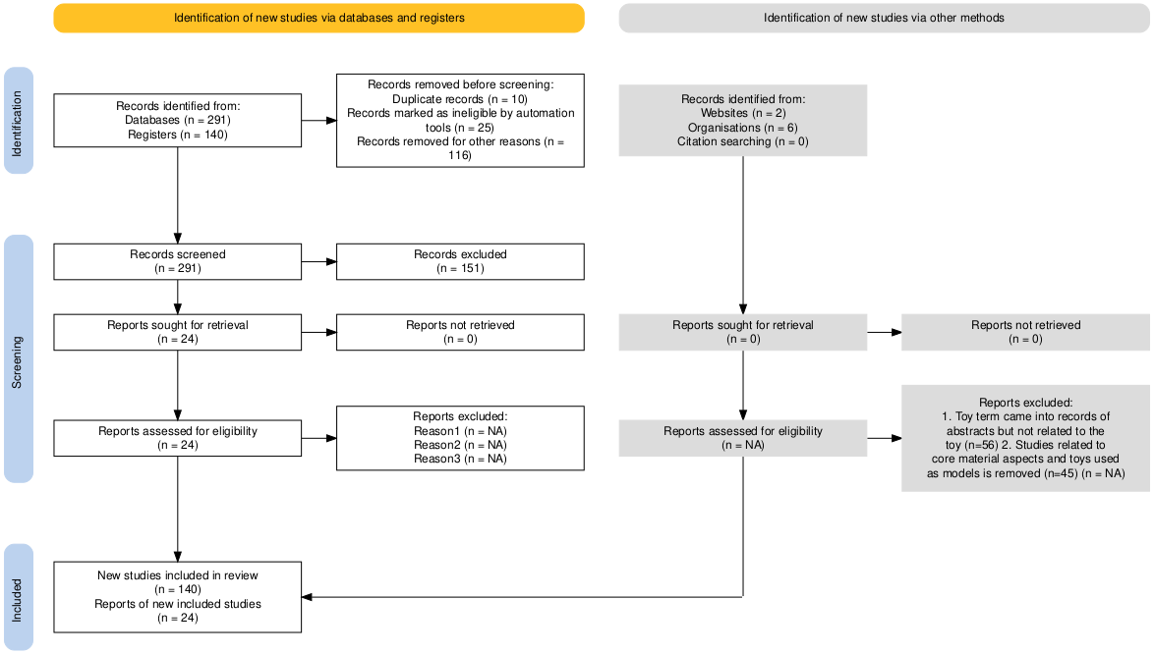
Source: Haddaway, N. R., Page, M. J., Pritchard, C. C., & McGuinness, L. A. (2022). PRISMA2020: An R package and Shiny app for producing PRISMA 2020.
2.3 Research Questions – Researchers have examined four questions in their review paper next part of the paper will discuss the research questions and the statistics used (Table 2) for the same
RQ 1: What are the recent publications and trends in the toy domain?
RQ 2: What are the various clusters in the toy domain literature?
RQ 3: What are the policy initiatives to improve the domain in recent years?
RQ 4: What are the future research aspects in the domain

Table 2: Statistics Used in Research Questions
Sr. No. | Research Question | Statistics Used
1 | What are the recent publication trends in the toy domain? | Annual Scientific Production, Most relevant sources, Most relevant authors, Author’s production over time.
2 | What are the various clusters in the toy domain literature? | Cluster Analysis and Thematic Analysis
3 | What are the policy initiatives to improve the domain in recent years? | Government Initiative analysis
4 | What are the future research aspects in the domain | The author’s analysis based on various statistics
Source: author’s own implication
RQ 1: What are the major publications trends in the toy domain
To examine this question, researchers have used the Scopus database; the range of data appears in the study is from 2000 to 2025, the first paper that came into review was from the year 2000, with a Compound Annual Growth Rate (CAGR) of 6.65%. A compound annual growth rate (CAGR) of 6.65% in the toy industry points to a healthy and consistent rise in the sector over the selected time period. This upward trend highlights the growing interest of parents and caregivers in toys that support learning, creativity, and overall child development. It also reflects improving purchasing power, changing lifestyle preferences, and the wider availability of both Indian and global toy brands in the market. Overall, this level of growth indicates increasing confidence in the toy sector and underlines its potential as an attractive area for business investment and innovation. Total number of 72 articles were published in 2021-2025 presented in graph 1 with CAGR of 6.65%, smart innovation, systems and Technologies (6 ) articles was found to lead toy literature, followed by Exergaming Intervention For Children, Adolescents, And Elderly People (5) and Lecture Notes In Mechanical Engineering (4) presented in table 3. Das S was found most influential author in toy domain, followed by Patil, Sharma, Bhat. The list of top 10 most influential authors in the domain was summarized in table 4

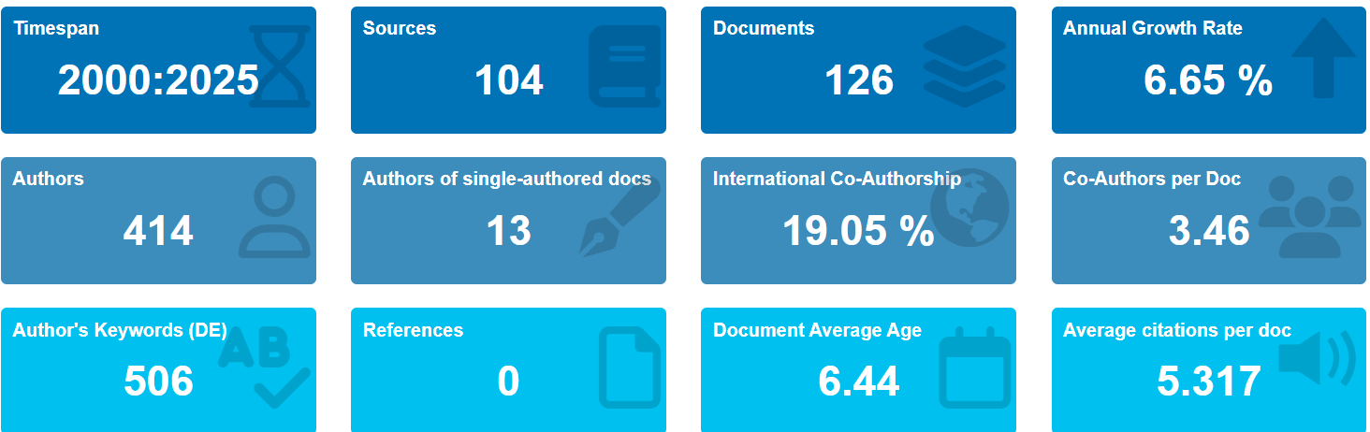
Source: R-Suite Biblioshiny author’s data
Graph 1: Years of Article Publication

Source: Author’s Own Compilation

Table 3: Most Influential Journals
Sr.No. | Journal Name | Published Articles
1 | Smart Innovation, Systems And Technologies | 6
2 | Exergaming Intervention For Children, Adolescents, And Elderly People | 5
3 | Lecture Notes In Mechanical Engineering | 4
4 | Lecture Notes In Networks And Systems | 3
5 | Materials Today: Proceedings | 3
6 | Acm International Conference Proceeding Series | 2
7 | Acm/Ieee International Conference On Human-Robot Interaction | 2
8 | Bioplastics For Sustainability: Manufacture, Technologies, And Environment | 2
9 | Emerald Emerging Markets Case Studies | 2
10 |  | 2
  Journal Of Molecular Liquids
Source: Author’s Own Compilation
Table 4: Top 10 author’s based on number of publication
Sr. No. | Author’s Name | Author’s Affiliation | Article
1 | DAS S | Department of Design IIT, Guwahati | 3
2 | PATIL K | Department of Design, Department of Humanities and Social Sciences, Indian Institute of Technology Kanpur, Kanpur, UP, India | 3
3 | SHARMA S | Faculty of Information Technology and Communication Sciences, Tampere University, Finland | 3
4 | BHAT JS | Manipal Academy of Higher Education, Manipal, India | 2
5 | INDIA G | Microsoft Research, Bangalore, India | 2
6 | JOHRY A | IDC School of Design, IIT Bombay | 2
7 | JOSEPH CV | National Institute of Design, Gandhinagar, India | 2
8 | KHANEJA S | School of Business, World University of Design, Haryana, Sonipat, India | 2
9 | KUMAR P | Department of Design, Shiv Nadar University, Uttar Pradesh | 2
10 | KUMAR S | Amity Business School, Amity University, Noida, India | 2
Source: Author’s Own Compilation
Authors from the top-most institute of the country have contributed in toy research domain, notably 50% of the authors belong to the design department, which indicates the product design part and material importance in the toy domain. Material refers to raw material and components used in the toy design and production.
Analysis
RQ 2: What are the various clusters in the toy domain literature?

To track the trends, clusters, and networks, researchers have Vosviewer and R-Suite Biblioshiny for identifying the emerging field of a domain. The VOSviewer overlay visualization in the image provides a clear picture of research trends by mapping out the connections between different keywords. Each node (keyword) represents a frequently used term in the dataset, while the links between them show how often these terms appear together in research papers. The size of the nodes reflects the frequency of keyword usage, and the colors indicate different clusters of related topics. Additionally, the color gradient (2019-2022) helps track the evolution of research focus.
At the heart of the visualization lies the keyword “toys,” which acts as the central anchor for the entire research landscape. Its strong connections with terms such as toy manufacture, toy design, design, and sustainable development (Smith et al., 2020) suggest that earlier studies largely concentrated on production methods, material choices, and design considerations. These themes represent the foundational phase of toy research, where attention was primarily directed toward improving manufacturing processes and aligning product design with sustainability concerns.
A noticeable cluster on the left side of the network highlights design-oriented research, including keywords like product design, design and development, wooden toys, and toy manufacture. This grouping reflects sustained academic interest in traditional craftsmanship, eco-friendly materials, and responsible production practices (Gupta & Sharma, 2021). The association of these themes with sustainable development indicates that environmental considerations gradually became an integral part of toy design research rather than a peripheral concern.
In contrast, the right side of the visualization shows a stronger focus on the end user, with keywords such as child, children, children’s toys, human, and India. The relatively recent appearance of these terms suggests a shift in research priorities toward understanding children’s needs, play behavior, and socio-cultural contexts. The inclusion of India points to growing scholarly attention in developing economies, where policy support, demographic trends, and domestic manufacturing initiatives are reshaping the toy sector.
The lower portion of the network reveals emerging themes linked to technological advancement, including artificial intelligence, Internet of Things, and learning-related concepts (Kumar & Jain, 2022). These keywords, which appear in warmer shades, indicate newer research directions that combine digital technologies with toys aimed at enhancing learning and cognitive development. Their connections with children and cognitive development highlight a transition toward smart and interactive toys designed to support educational outcomes.
Overall, the overlay visualization captures a clear progression in toy-related research. The field has moved from a strong emphasis on manufacturing and design toward a more interdisciplinary approach that incorporates child development, technology, and innovation. This shift reflects broader changes in consumer expectations and technological capabilities, suggesting that future research in the toy domain is likely to continue blending design, sustainability, and intelligent systems with a strong focus on child-centric value creation.

Diagram 1: Overlay Visualisation
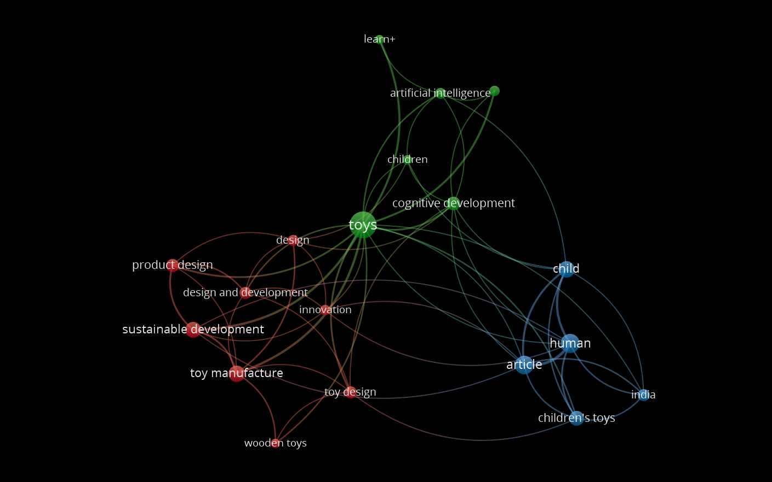

Source: VoS Viewer, overlay visualization
Diagram 2: Coword Network Analysis

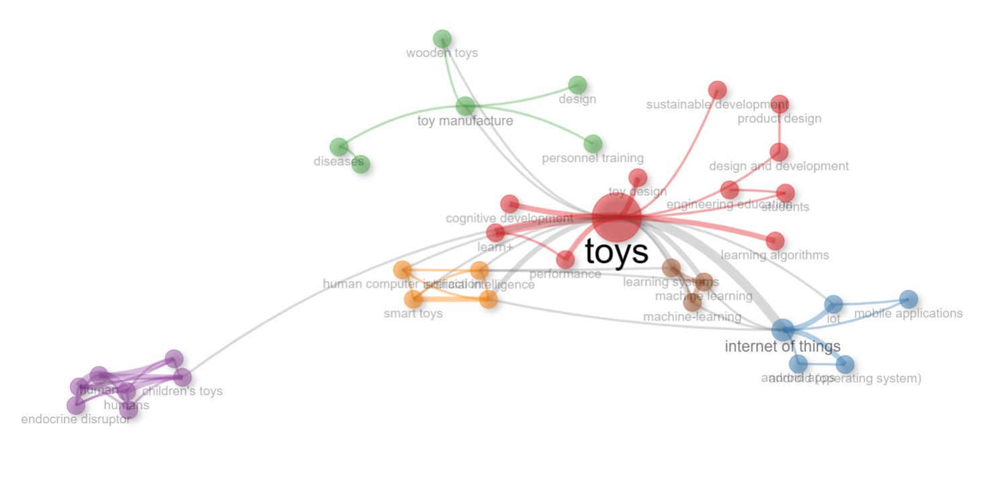
Source: R-Biblioshiny Result on Coword Net
Coword network analysis clearly exhibited a few key words in focus, which combined other key terms in the network, such as reinforcement learning, which has a strong network with learning toys, decision making through toys (red network); whereas other networks indicated key terms such as human, articles, and female-oriented toys.
Table 5: Cluster Analysis
Cluster | Callon Centrality | Callon Density | Rank Centrality | Rank Density | Cluster Frequency
Toys | 6.914 | 97.517 | 4 | 7 | 15
Internet Of Things | 3.953 | 133.6 | 7 | 5 | 37
toy manufacture | 4.803 | 76.681 | 9 | 8 | 366
children's toys | 7.076 | 174.044 | 8 | 9 | 455
design and development | 2.632 | 82.083 | 5 | 2.5 | 9
computational thinkings | 0.167 | 83.333 | 6 | 6 | 15
learning algorithms | 0.889 | 48.148 | 1.5 | 2.5 | 2
developing countries | 0 | 50 | 3 | 2.5 | 2
nanocomposites | 0.25 | 50 | 1.5 | 2.5 | 2
supply chain management | 0 | 50
  1.21989817
  2.58582254
Source: Author’s Own Compilation
The dataset provides an insightful overview of various research themes by evaluating their significance and development within the academic landscape. The Callon Centrality metric highlights how interconnected a topic is with other research areas. The “children’s toys” cluster shows high centrality (7.076) and very high density (174.044), indicating that it is both well-developed and highly influential within the overall research network. Its high frequency further confirms that this theme acts as a core driver of scholarly discussions, linking developmental, educational, and product-oriented studies in the toy domain kids (Chugh, 2020), (Lydia, et al., 2024). Similarly, the “toys” cluster demonstrates strong internal development with a high density (97.517) and moderate centrality, suggesting that it represents a foundational theme. While internally cohesive, its slightly lower centrality implies that it supports the field rather than driving cross-thematic integration.
The “Internet of Things” cluster exhibits moderate centrality (3.953) but high density (133.6), indicating a specialized yet mature niche theme. This reflects focused research on smart toys and connected play technologies that are conceptually advanced but still limited in broader integration across the field (Pujari S. Sachin, 2017). The “toy manufacture” and “design and development” clusters display moderate density and centrality, positioning them as basic and transversal themes. Their high frequency, particularly for toy manufacture, highlights their practical relevance, although their moderate centrality suggests room for stronger theoretical integration with emerging digital and cognitive themes.
Clusters such as “computational thinking,” “learning algorithms,” “nanocomposites,” and “developing countries” show low centrality values, indicating that they are emerging or peripheral themes. Despite some internal coherence, their limited connectivity suggests that these topics are still in early stages of conceptual integration within the toy research landscape. Lastly, “supply chain management” presents low centrality and moderate density, suggesting a specialized but under-explored theme, particularly relevant in the context of manufacturing resilience and global production networks.
For tracking the various dimensions in the toy industry, Factor Analysis was conducted. In factor analysis, Principal Component Analysis has been performed through cluster analysis, which is used to reduce the dimensions. Values of factor analysis are shown in Table 6.
Table 6: Factor Analysis, Principal Component Analysis (PCA)
word | Dim1 | Dim2 | cluster
toys | 0 | -0.34 | 1
internet of things | 0.35 | -1.96 | 1
toy manufacture | 0.22 | 0.39 | 1
children | 0.2 | 0.27 | 1
children's toys | -1.64 | 0.14 | 1
artificial intelligence | 0.21 | -0.6 | 1
design | 0.24 | 0.43 | 1
design and development | 0.15 | 0.23 | 1
human | -3.39 | -0.05 | 1
learn+ | 0.33 | -0.15 | 1
toy design | 0.18 | 0.34 | 1
wooden toys | 0.14 | 0.41 | 1
article | -3.98 | -0.17 | 1
child | -1.1 | 0.33 | 1
cognitive development | 0.14 | 0.02 | 1
Source: Data result analysis author’s own compilation R-Studio, biblioshiny
The data provides important insights into how concepts from technology, artificial intelligence, and human-centered research interconnect. Words related to advanced systems — such as "reinforcement learning" (0.73, -0.31), "deep learning" (0.76, -1.04), and "robotics" (0.79, -1.27) — cluster with positive Dim1 values, reflecting a focus on automation and intelligent systems. In contrast, terms like "child" (-1.92, 0.05), "health care policy" (-1.62, 0.05), and "controlled study" (-2.35, 0.06) show negative Dim1 values, indicating a strong association with healthcare, psychology, and human behavior. This split suggests a broader theme where technology and humanity coexist, likely in research on intelligent systems impacting societal aspects.
The second dimension further refines this perspective. Words that represent structured research processes and decision-making, such as "Markov decision processes" (0.78, 2.37) and "behavioral research" (0.65, 1.99), have high Dim2 values. In contrast, more practical or application-based technology terms, like "robots" (0.66, -1.38) and "intelligent robots" (0.47, -0.9), lean towards negative Dim2 values. This division could reflect a difference between theoretical frameworks and real-world implementations. Despite these variations, the fact that all words fall under Cluster 1 suggests they are part of a cohesive research domain where human behavior, decision-making, and technological systems intersect.

Table 7: Summary of Factor Analysis (PCA) Themes and Data

Theme | Examples (Dim1, Dim2) | Trend (Dim1 / Dim2)
Technology & AI | Reinforcement learning (0.73, -0.31),  Robotics (0.79, -1.27) | Positive / Negative
Human & Social Sciences | Child (-1.92, 0.05),  Health care policy (-1.62, 0.05) | Negative / Slightly Positive
Decision-Making Processes | Markov processes (0.78, 2.37),  Decision making (-0.13, 1.32) | Slightly Positive / Strongly Positive
Robotics & Automation | Intelligent robots (0.47, -0.9),  Robot programming (0.59, 1.31) | Positive / Negative or Positive
Healthcare & Policy | Major clinical study (-2, -0.06),  Environmental exposure (-1.33, -0.26) | Strongly Negative / Slightly Negative
Source: Author’s Own Compilation

Content Analysis of Clusters
Prior studies on cluster analysis have ten clusters, which are further clubbed into three core clusters. Clusters can be merged together if they are similar in nature and if they together give better results (Booth et al. 2013). Three cluster areas were clubbed according to the similarities in studies. Three clusters were named as, Core Toy Domain which includes studies related to the toys, children toys (Pandey, 2021; Ravichandran et.al. 2022) second cluster has emerged as Smart and Innovative Toys which includes research on latest toy innovations, AI toys, Toys with machine learning (Gesu et.al, 2020, Joshi et.al. 2017); third, toy production and design system which includes studies related to design and development of toys with new materials, sustainable toys, indigenous toy design ((Rangaswami, 2018, Chattopadhyay, 2015). To analyze the thematic area, we have included Table 8 & Table 9
Table 8: Core cluster identification
Cluster Number | Cluster Component | Core Cluster
1 | Toys, Children’s Toy | Core Toy Domain
2 | IoT-based toys, Computational Thinking toys, Machine Learning, Robotics-based toys | Smart and Digital Toys
3 | Toy Production, toy manufacture, design and design development, sustainable toys | Toy production and design system
Source: Author’s Own Implication
Table 9: Analysis of Core Thematic Area  Thematic Area | Prior Literature | Research Gap
Core Toy Domain | Using sustainable materials for the development of toys (Pandey et.al, 2021) | Market Acceptance of those products is not studied
 | A study on Fragrance Chemicals in Children’s products was analyzed in the context of various toys (Ravichandran et.al. 2022) | Consumer behavior and parental perspectives are not discussed
 | Use of sustainable materials to build environmentally friendly toys (Rebello et.al. 2021) | Safety norms and consumer acceptance of sustainable toys were not addressed
 | The study discussed children’s health by examining buyers’ attitudes and purchase intentions toward green toys in India (Saini et al. 2024) | The study has discussed limited stakeholders sus as buyers. Study has not discussed other stakeholders like, like manufacturers, suppliers or designer’s perspective
 | A comprehensive empirical investigation of phthalate contamination in children’s toys available in the Indian market was discussed. | Parental awareness regarding phthalates in Indian toys and consumer attitudes were not discussed

Smart and Digital Toys | Study on toy design specifically for computational Thinking, for school students through learning toys/play-based learning tools. (Gesu,at.al, 2020) | Play-based physical programming toys with a digital approach are not defined
Smart and Digital Toys | A study based on the smart cradle baby toy with an operating system of Android was discussed and analyzed (Joshi et.al. 2017) | Consumer acceptance and parents' perception of using this type of toy were not analyzed
Smart and Digital Toys | The study discussed remotely controlled smart robot toys as a medium of communication between parents and children. | The user experience of parents was not discussed
Smart and Digital Toys | IoT based smart toy car has been discussed. The study analyzed multiple features of the Smart toy car, such as automated obstacle detection, indicator activation, and bloototh enabled voice system | Educational and development impact has not been discussed in the study.
Smart and Digital Toys | The study discussed the use of robot toys in imparting education and improving the level of understanding of STEM subjects. This integrated fun and IoT together, and their drawbacks and challenges were discussed (Gupta & Jain, 2021) | Third, the study does not address affordability, and accessibility—especially in low-resource settings—are also not addressed. Additionally, the paper does not examine the environmental or sustainability implications of deploying robotic systems in education.
Toy Production & Design System | Composite materials, from ancient applications to modern high-performance composites used in toys, were discussed | Sustainable fibers in toy manufacturing are not discussed
Toy Production & Design System | Life cycle assessment results show that Channapatna wooden toys made from Wrightia tinctoria have lower toxicity, reduced energy demand, and smaller environmental impacts than PVC toys. Their localized production also supports traditional craftsmanship and sustainable small-scale manufacturing, making them an environmentally preferable option for children’s products (Rangaswami, 2018) | Market option barriers, consumer perception is not discussed, cost–benefit assessment or life cycle costing (LCC) are absent.
Toy Production & Design System | The study demonstrates the potential of jute as a sustainable material for value-added products, including soft toys. Natural dyeing of jute fabric using plant-based dyes and double pre-mordanting significantly improved color yield, fastness properties, UV protection, and antimicrobial performance, reinforcing jute’s suitability for eco-friendly textile applications (Chattopadhyay, 2015) | The study doesn’t examine the scalability, cost implications, or industrial feasibility of the dyeing and mordanting processes.
Toy Production & Design System | It highlights key entrepreneurial attributes, including resilience, innovation, and strategic decision-making, while emphasizing the role of product design, upskilling, and market-oriented innovation in sustaining traditional crafts (Kumar, 2023) | It lacks an assessment of consumer perception, market demand analytics, and competitive benchmarking. Additionally, issues related to digital marketing adoption, supply chain scalability, sustainability metrics, and policy-level support mechanisms

Source: Author’s Own Implication
Thematic Analysis
The thematic cluster analysis reveals a structured yet evolving research landscape within the toy-related literature. Themes positioned with high density and centrality highlight areas that are both conceptually mature and strongly integrated into the broader knowledge network, while clusters with lower connectivity signal emerging or specialized research directions. Thematic clusters connect with four broad themes such as basic themes, emerging or declining themes, niche themes, and motor themes. The dominance of children’s toys reflects the sustained scholarly focus on child-centric perspectives, encompassing play behavior, learning outcomes, safety, and developmental benefits. Its strong internal cohesion and connectivity suggest that this theme acts as a central anchor, linking multiple strands such as education, design, and technology.
Similarly, the toys cluster represents a foundational research base, reinforcing the centrality of traditional toy studies while supporting adjacent themes rather than driving methodological or technological expansion. Technology-oriented clusters, particularly Internet of Things, demonstrate high conceptual maturity but moderate integration across the network. This positioning suggests that smart toys and connected play systems are well developed within their niche but remain partially isolated from mainstream toy research (Crisman, 1996). As digitalization of play accelerates, this gap indicates an opportunity for stronger interdisciplinary integration. Themes related to toy manufacture and design and development occupy an intermediate position, reflecting their operational importance and consistent research presence. Despite high publication frequency, their moderate centrality suggests that these themes are often addressed from applied or industry-specific perspectives, with limited theoretical cross-linkages to cognitive, technological, or sustainability-driven discussions. Clusters such as computational thinking, learning algorithms, and nanocomposites appear as specialized or emerging areas. Their relatively low connectivity indicates that these themes are still consolidating their role within toy research, often appearing in experimental or exploratory studies. The developing countries cluster similarly reflects limited integration, highlighting a contextual research gap despite its relevance for inclusive innovation and market expansion (Arvinder, 2000); Finally, supply chain management emerges as a marginal yet internally coherent theme, underscoring its relevance in production and logistics while revealing limited engagement with broader toy innovation and policy discussions. Collectively, the findings suggest a field anchored in child-focused and product-based research, with growing but still fragmented contributions from digital, material, and systemic perspectives.
The evolving research landscape offers valuable insights into how priorities have shifted over time. The changes in uses of toys has been found differently at different places. Early on, there was a clear focus on competitiveness of toys between Indian toys and chines toys (Arvinder, 2000); Robotic toy hands (Crisman, 1996); Transformation of indigenous kondapalli toys to global level toys handcrafted material was discussed by Girija Kumari, 2004 (Girija Kuamri, 2004) environmental concerns, particularly in 2019-2020, reflecting a global push for sustainability. By 2021, attention began to pivot toward market-driven studies, emphasizing consumer behavior and economic factors. More recently, in 2022, the spotlight has shifted toward advanced technology applications, highlighting the growing influence of tech-driven solutions in business, sustainability, and social sciences. This evolution reflects a broader global trend where innovation and technology are increasingly seen as key drivers for addressing complex societal challenges. For researchers, policymakers, and businesses, understanding these shifts is crucial for identifying emerging opportunities, fostering collaborations, and developing innovative solutions tailored to real-world needs.

Image 1: Thematic Analysis
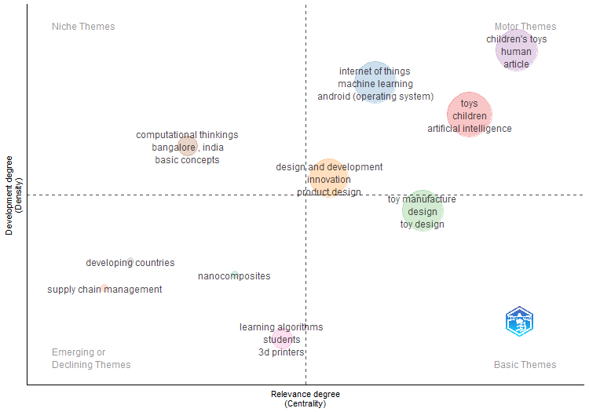
Source: Thematic Analysis, Biblioshiny
RQ 3: Government policy initiatives
In this section, researchers attempt to list the various factors that have been frequently studied in various toy research. It can be seen that the majority of practitioners have studied factors such as safety regulations, government policies for the development of the toy industry in India, Chinese imports and the threat to the Indian toy industry, indigenous toys and heritage, Indian domestic market opportunities, and technology advancement. Recent policy initiatives have positioned the Indian toy sector as a strategic industry within the country’s broader agenda of self-reliant and innovation-driven growth. Programmes such as, Toycathon, the National Action Plan for Toys, and targeted measures under the self-reliance framework have been designed to strengthen domestic manufacturing capacity, promote design-led innovation, and reduce dependence on imports. Policy support has also focused on sustainability through the promotion of eco-friendly toys, collaborative industry platforms such as national toy fairs, and tariff interventions to encourage indigenous production. Together, these initiatives reflect a coordinated policy effort to nurture entrepreneurship, enhance skill development, and build a competitive manufacturing ecosystem supported by institutional and regulatory frameworks (Government of India, 2023; Ministry of Education India, 2022). Table 10 exhibits various factors studied by previous researchers.

Table 10: Factors studied in Indian Toy Industry
Sr. No. | Factor for consideration | Authors
1. | Safety Regulations, Quality Control | The gazette of India, Quality Control in Toys DPIIT, Suresh Gupta and Prateek Gupta
2. | Government Policies for development of toy industry | Savills, Leaping forward, Favorable government policies to make in India a toy manufacturing hub
3. | Chinese Imports, threat to Indian toy industry, high import duty on toy making raw materials | ASSOCHAM, 2013; ASSOCHAM, 2016; NSIC, 2015, Sridhar Krishna, 2000; Sunny, K P, Sund Rajesh, 2014; Bhatia madhur, 2016, Sadiya Siddiqui & Asma farooque
4. | Indigenous Toys, Culture, and heritage | DPIIT, 2020; Sunanda Yadav, 2020; Ministry of Tourism, Sudarshan Khanna, 1987; Natasha Rego, 2021; Bhagwan Nagpal, Lalana Bhatina & Supradip Das, 2019; Sunny & Sund, 2014, (F, 2016)
5. | Indian domestic market opportunities | KPMG, 2021, Khyati Malhotra, 2021; Uma Shankar yadav & Ravindra Tripathi. 2022
6. | Technology Advancement, Productivity and Competitiveness of Toy Manufacturing Sector In India | UN Industrial Development Organization Industrial Promotion and Technology Branch, 2004; Economic Services Group National Productivity Council, 2017
Source: Author’s own Compilation
3.1 Safety Regulations- The safety of toys is a critical public health and consumer protection concern, particularly in a country like India, where toys are used by children across diverse age groups and socio-economic settings. In this context, the Bureau of Indian Standards (BIS) has established key regulatory benchmarks—most notably IS 9873 and IS 15644—to ensure that toys available in the market meet essential safety requirements. IS 9873, which is aligned with international toy safety frameworks, focuses on mechanical, physical, and chemical safety aspects such as choking hazards, sharp edges, small detachable components, flammability, and the presence of harmful substances (BIS, 2020). These provisions are especially important for protecting younger children, who are more vulnerable to injuries arising from unsafe toy design or poor material quality. Complementing this, IS 15644 specifically addresses the safety of electric and battery-operated toys, setting standards related to insulation, overheating, short circuits, and protection against electric shock. With the increasing penetration of electronic, smart, and interactive toys in the Indian market, this standard has gained renewed relevance. Together, IS 9873 and IS 15644 form a comprehensive safety framework that balances innovation in toy design with child welfare considerations (Nanda, 2020). Beyond minimizing physical and electrical risks, these standards also promote responsible manufacturing practices, quality control, and material transparency. Their enforcement has broader implications, including strengthening parental trust, enhancing consumer confidence, and improving the credibility of Indian toy manufacturers in domestic and export markets. Moreover, in the context of sustainable and eco-friendly toys, BIS standards provide a foundational safety baseline against which alternative materials and green design innovations can be evaluated. Thus, these standards play a pivotal role not only in ensuring toy safety but also in supporting the long-term development of a safe, competitive, and responsible toy ecosystem in India. Safety regulations and quality control in Indian toys are recognized as a prime concern by researchers. Safety and toxicity have been studied in various research reports and by practitioners. The Bureau of Indian Standards (BIS), an Indian regulatory agency, has specified toy safety regulations in IS 9873 (Part 1 to Part 4, 7, and 9) and IS 15644:2006 (Nanda, 2020). The Indian safety standard is detailed in Table 11

Table 11: Safety Standard for Indian Toys
Good of Articles | Indian Standard | Title of Indian Standard
1 | 2 | 3
TOYS | IS 9873 (Part 1): 2018 | Safety of Toys part 1: Safety aspects related to mechanical and physical properties
TOYS | IS 9873(Part 2): 2017 | Safety of toys Part 2: Flammability
TOYS | IS 9873(Part 3): 2017 | Safety requirements for toys, Part 3: Migration of certain elements
TOYS | IS 9873(Part 4): 2017 | Safety of toys part 4 swings, slides and similar activity toys for indoor and outdoor family domestic use
TOYS | IS 9873(Part 7): 2017 | Safety of toys part 7 requirements and test methods for finger paints.
TOYS | IS 9873(Part 9): 2017 | Safety of toys part 9 certain phthalate esters in toys and children’s products
TOYS | IS 15644: 2006 | Safety of electric toys.
Source: Adopted from The Gazette of India, G-DL-E 26022020-216415, Ministry of Commerce and Industry DPIIT, 25-02-2020
Previous researchers have examined the levels of metal content in toys and their effects on children's health. Elevated levels of lead (Pb), zinc (Zn), and toxicity have been linked to adverse effects, including serious medical issues such as cancer (Somsiri Decharat, 2013). The levels of cadmium (Cd), nickel (Ni), and arsenic (As) in PVC toys have been discussed by Rangaswami et al. (Jananee Rangaswami, 2018; Abhay Kumar, 2007). Johnson et al. studied the presence of phthalates in 24 toys and childcare items from China, India, Taiwan, and other countries. Results showed a higher concentration of phthalates in soft toys compared to hard toys. Children under 3 years old, who are more likely to suck or chew soft toys, may be directly affected regarding their health (Sapana Johnson, 2011). The impact of toys in packaged foods on obesity was discussed by Dario et al. in 2014; the study found no clear link between toys and food consumption (Dario Gregori, 2014).
3.2 Government Policies for the Development of the Indian Toy Industry - Over the past few years, the Indian toy sector has emerged as a priority area within the government’s broader vision of innovation-led and self-reliant industrial growth. Initiatives such as Toycathon and the Aatma Nirbhar Bharat programme reflect a deliberate effort to reposition toy manufacturing from an import-dependent activity to a domestically driven and innovation-oriented sector. Toycathon, in particular, has played a catalytic role by encouraging students, designers, and young entrepreneurs to engage in theme-based toy development, thereby strengthening design capabilities and fostering startup culture within the industry; its long-term effectiveness depends on commercialization pathways, funding continuity, and integration with manufacturing clusters. Atma Nirbhar Bharat seeks to reduce import dependence through tariff reforms, localization incentives, and manufacturing support, which may enhance domestic production competitiveness but can also create short-term adjustment pressures for small firms lacking technological capability. Complementing this, national-level policy frameworks such as the National Action Plan for Toys provide structured direction through targeted objectives aimed at strengthening manufacturing capacity, skill development, and market access. These policies should be interpreted not merely as promotional initiatives but as institutional mechanisms shaping industrial restructuring, innovation diffusion, and entrepreneurial capacity within the evolving toy ecosystem. Table 12 presents an overview of these key initiatives and policy measures that collectively shape the evolving toy ecosystem in India (Yadav et al., 2022; Day & Gupta, 2021).”

Table 12: Toy Initiatives and Government Support-
S.No. | Initiative/Scheme | Objective | State Government/Central Government/Ministry
1. | Toycathon 2021-2022 | To come up with new toy startups in various themes under the Toycathon. Theme based toy development, by students, faculties, and professionals | Institution’s Innovation Council, MHRD, MoE
2. | National Action Plan for Toys | To formulate action plan for development of toys in the country, 21 point agenda for toy development. | Central Government
3. | Identifying as key sector under Aatma Nirbhar Bharat | Development of Toy sector as self-resilient sector, to build toys from the local resources, | Atma Nirbar Bharat
4. | Eco-friendly toys | To make India hub for eco-friendly toys | Atma Nirbar Bharat
5. | India’s First Toy Fair | To come up with all memebrs of toy community manufacturers, suppliers, entrepreneurs, startups, MEMEs initiatives | Central Government
6. | Increase in Import duty on toys | To motivate Indian toy manufactures to create indigenous toys | Budget Announcement, 2023 (Govt hikes import duty on toys to 70% , 2023)
Source: Toy Initiatives by Government of India, Budget Announcement, 2023, Institution’s Innovation Council, MHRD, MoE
The above-mentioned initiatives outlined in Table 12 demonstrate a coordinated approach toward building a resilient and sustainable toy industry. Policies promoting eco-friendly toys and the strategic increase in import duties have encouraged manufacturers to explore locally sourced materials, traditional craftsmanship, and environmentally responsible production methods. At the same time, platforms such as India’s Toy Fair have facilitated collaboration among manufacturers, suppliers, MSMEs, and startups, creating opportunities for knowledge exchange and market expansion. These interventions go beyond short-term protectionist measures and instead support long-term innovation, sustainability, and localization. By aligning creativity, policy support, and indigenous manufacturing, the government’s initiatives are gradually transforming the toy sector into a competitive, socially responsible, and globally relevant industry rooted in local innovation.
RQ 4: Findings concerning Research Questions for the analysis of the research
4.1 Findings, Discussions, and Future Scope
4.1.1 Historical Evolution of Toy Research
The intellectual development of toy-related research reflects a gradual yet distinct transformation in scholarly priorities. Early academic work primarily concentrated on production processes, material innovation, and competitive industrial dynamics. Researchers focused on manufacturing techniques, mechanical toy design, and the transformation of traditional handcrafted toys into standardized commercial products. This period largely treated toys as physical commodities, emphasizing functionality, durability, and cost efficiency rather than their developmental or social significance.
By the late 2010s, the research focus began shifting toward environmental sustainability and product safety. Growing global awareness of ecological risks and regulatory requirements encouraged studies on eco-friendly materials, non-toxic components, and sustainable manufacturing processes. Scholars increasingly examined biodegradable plastics, composite materials, and life-cycle assessment of toy production, reflecting broader concerns about environmental responsibility and consumer safety (Browne et al., 2011; Steenis et al., 2017). Around 2021, the research landscape expanded further to incorporate market-oriented and human-centered perspectives. Studies began to explore consumer preferences, educational value, and the developmental implications of play.
More recently, technological integration has emerged as a defining research frontier. Contemporary studies examine artificial intelligence, smart toys, robotics, and digitally mediated play environments. These developments signal a conceptual shift toward interactive and adaptive play systems that merge entertainment, education, and digital connectivity (Nambisan et al., 2019). Overall, the historical evolution of toy research demonstrates a clear progression from production-centered analysis to human-centered and technology-driven inquiry.
4.1.2 Clustered Themes in Toy Research
Thematic clustering reveals a structured yet evolving intellectual architecture within toy research. Highly central and dense clusters represent mature knowledge domains with strong conceptual integration, whereas peripheral clusters reflect emerging or specialized research areas with limited connectivity.
At the core of the research landscape lies the children’s toys cluster, which consistently anchors scholarly attention. This domain emphasizes developmental outcomes, learning processes, emotional engagement, and child well-being. Its prominence reflects the recognition that toys function not merely as commodities but as instruments of cognitive and social development (Goldstein, 2012).
Supporting this central domain is the broader toys cluster, representing traditional product-based research focused on design characteristics, materials, and usability. While foundational, this cluster is increasingly complemented by technology-oriented themes. Among these, the Internet of Things (IoT) forms a specialized yet conceptually advanced cluster centered on connected play environments, data-enabled interaction, and intelligent feedback systems (Marsh et al., 2018).
Intermediate clusters, such as toy manufacture and design and development, represent applied research domains that bridge production and innovation. These areas address engineering optimization, product testing, and design methodologies. Meanwhile, emerging themes—including computational thinking, learning algorithms, and nanocomposite materials—remain relatively fragmented, indicating early-stage exploration with limited cross-domain integration. Supply chain management appears as a marginal but internally coherent area, highlighting logistics, production resilience, and distribution efficiency as underexplored dimensions of the field.
Collectively, these clusters reveal a research domain anchored in child-centered and product-oriented inquiry, while gradually expanding toward digital integration and systemic analysis.
4.1.3 Emerging Research Trends
Temporal analysis indicates notable shifts in thematic emphasis over time. Earlier research was dominated by environmental and material concerns, particularly the impact of plastics, chemical safety, and sustainability in toy production (Steenis et al., 2017). These studies reflected growing public awareness of environmental risk and regulatory oversight.
Subsequent research increasingly examined market behavior and developmental outcomes, reflecting rising interest in educational value, consumer decision-making, and play-based learning. Scholars explored how toys influence cognitive development, creativity, and social interaction, positioning play as a structured learning process rather than a purely recreational activity (Goldstein, 2012). The most recent wave of research is strongly technology-driven. Smart toys equipped with sensors, artificial intelligence, and adaptive interfaces now represent a major emerging research frontier. These technologies enable personalized interaction, real-time feedback, and immersive digital engagement, illustrating the convergence of play, education, and technological innovation (Nambisan et al., 2019).This temporal progression reflects a broader transition from material and environmental concerns toward intelligent and interactive toy ecosystems.
4.1.4 Broader Conceptual Patterns: Principal Component Analysis
To identify higher-order relationships among thematic domains, Principal Component Analysis (PCA) was employed. The results reveal two dominant conceptual orientations shaping contemporary toy research. The first dimension captures technological advancement, encompassing artificial intelligence, robotic toys, and automated toy-human interaction. This dimension reflects the growing importance of digital capability and technological sophistication in toy design and functionality.
The second dimension represents human and social outcomes, including learning, behavioral development, health, and emotional engagement. This orientation emphasizes the role of toys in shaping developmental processes and social interaction.
Together, these dimensions indicate that toy research is structured around the interaction between technological innovation and human-centered outcomes. Rather than replacing traditional developmental concerns, digital advancements coexist with educational and social objectives. This dual structure reflects a hybrid research paradigm in which technological capability and developmental value are mutually reinforcing.
4.1.5 The Indian Context
These global research patterns are increasingly reflected within the toy industry of India. Traditional priorities—such as safety, cultural relevance, and artisanal craftsmanship—remain central to the sector. However, policy-driven initiatives are reshaping industry structure by promoting domestic manufacturing, startup participation, and technological innovation.
Government programs supporting indigenous production, innovation clusters, and entrepreneurship are fostering new growth opportunities. Higher levels of institutional support and industry collaboration are strengthening the transition from traditional craft-based production toward organized manufacturing systems (KPMG, 2022).
Simultaneously, growing emphasis on digital integration and global competitiveness is transforming the sector’s strategic orientation. The convergence of policy support, innovation ecosystems, and domestic production capacity indicates a structural shift toward a knowledge-driven and technologically integrated toy industry.
4.1.6 Multi-layer Toy Framework
The findings of this study suggest that the toy sector can no longer be understood simply as a manufacturing industry focused on product creation. Instead, it is better viewed as a dynamic system shaped by the interaction of technology, child development, sustainability concerns, and industrial structures. Over time, research attention has gradually shifted from production and materials toward human experience, digital innovation, and policy-driven transformation. This evolution reflects a broader movement from viewing toys as physical objects to understanding them as interactive tools that influence learning, behaviour, and social development.
Layer 1: Toy Development
At the Micro level of this framework lies the cognitive development and human-centric role of toys. Research consistently highlights their importance in shaping cognitive skills, emotional engagement, and social interaction among children (piaget, 2013). This human-centred dimension remains the foundation of toy research, even as new technologies transform the way toys function and interact with users.
Layer 2: Educational Skill Enhancement

Layer 3: Technology Integration
Alongside developmental perspectives, technological innovation has become increasingly central. The growing presence of smart and connected toys indicates that play is becoming digitally mediated. Sensors, artificial intelligence, and interactive features are reshaping how children engage with toys, making them more responsive and personalized. This technological shift is not replacing traditional developmental concerns but expanding them, creating new forms of learning and interaction.
Layer 4: Sustainable Industrial Production
Industrial and supply chain structures provide the operational foundation that supports innovation. Manufacturing systems, logistics networks, and production efficiency influence how new ideas are implemented and scaled. At the same time, policy support and entrepreneurial ecosystems shape the broader environment in which the industry operates. Government initiatives, startup culture, and institutional support mechanisms play a key role in enabling innovation and strengthening domestic production capacity. Sustainability forms another important layer of the framework. Rising awareness of environmental impact and material safety has pushed manufacturers and researchers to focus on eco-friendly design, safe materials, and responsible production. Sustainability is therefore no longer a peripheral issue; it is becoming integral to product development and industry strategy.
Layer 5: Entrepreneurial Ecosystem
Taken together, these elements form an interconnected system in which technological capability, developmental value, environmental responsibility, and industrial organization evolve together. Toy research is therefore best understood as a socio-technical field where human needs and technological possibilities continuously influence one another. For understanding the industry at various levels, a Multi-Layered Toy framework is given in Figure 2.

Figure 2: Multi-layered Toy Framework
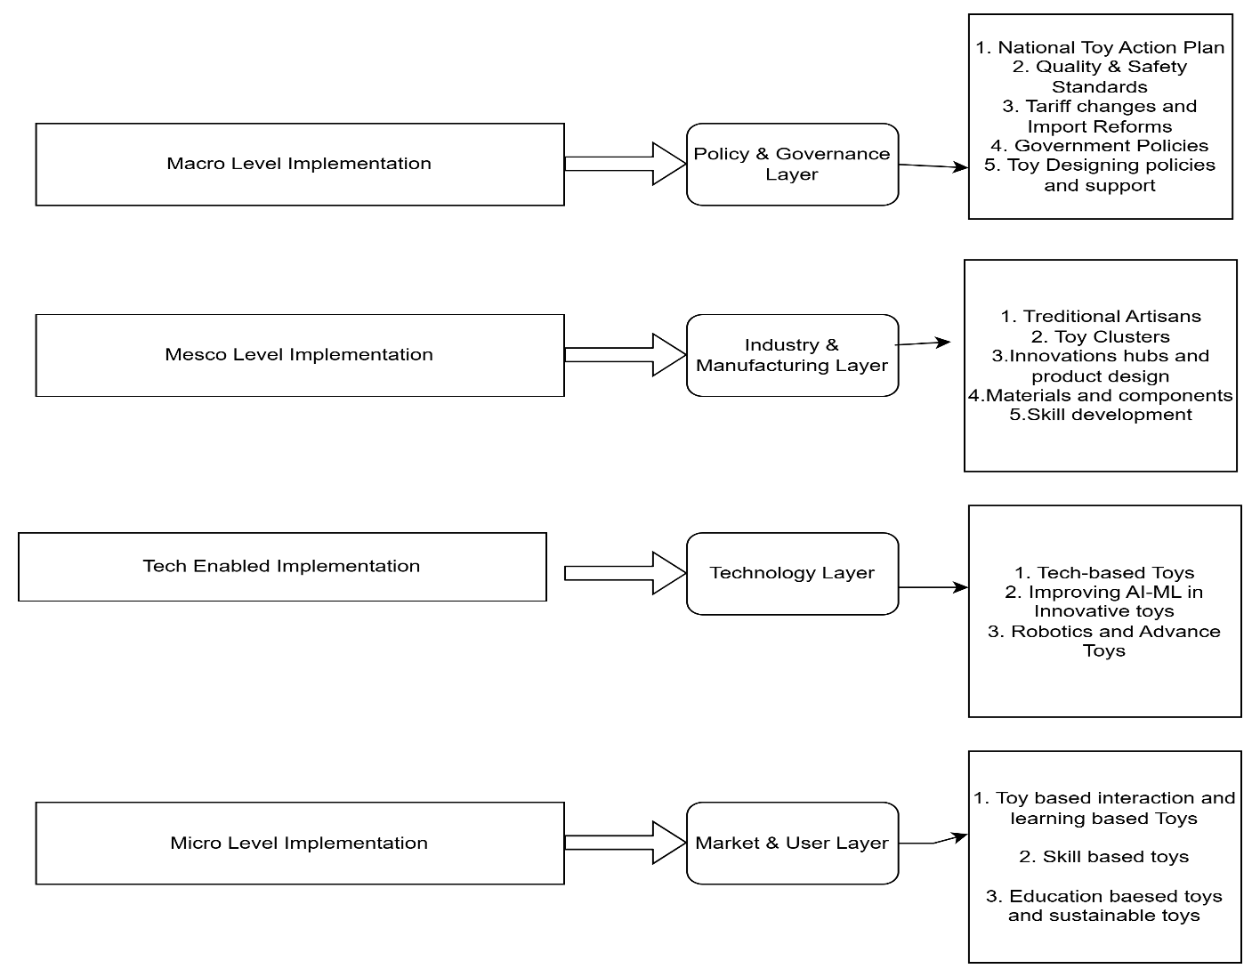
Source: Author’s Own Compilation
4.1.7 Implications for Future Research
The evolving research landscape points to several important directions for future inquiry. First, emerging technological domains remain fragmented and require stronger interdisciplinary integration with developmental psychology, education, and behavioural science. Second, production systems and supply chain dynamics remain underexplored despite their strategic importance for scalability and resilience.
Third, developing country contexts require deeper investigation to understand inclusive innovation, market expansion, and policy effectiveness. Comparative and longitudinal studies would provide valuable insight into how regional ecosystems shape industry transformation.
Future research should therefore prioritize the integration of technological innovation with developmental outcomes, examine entrepreneurial and institutional support systems, and explore sustainability within scalable production frameworks. Such efforts will contribute to a more comprehensive understanding of the evolving toy industry and its broader socio-economic significance.
In the context of the Indian toy industry, this broader evolution is mirrored in several pivotal dimensions. Toy safety, consumer perceptions, and cultural significance remain foundational concerns, but there is also a growing emphasis on increasing the global visibility of Indian toys and positioning India as a thriving hub in the global toy market. Government support has played a significant role in this transformation, fostering entrepreneurship and encouraging startups to venture into the toy sector. Exploring how entrepreneurial perceptions and attitudes shape these ventures offers valuable insights into the dynamics of a rapidly growing industry. With startups at the heart of this ecosystem, innovation is poised to drive sustained growth and create new opportunities for businesses and consumers alike.

Conclusion
Looking ahead, the future of research in the Indian toy industry holds immense promise. Beyond refining toy design, safety standards, and cultural representation, there is an urgent need to delve deeper into the entrepreneurial landscape — understanding the motivations, challenges, and opportunities faced by startups. Additionally, the integration of advanced technology, such as smart toys and sustainable materials, is expected to redefine how toys are designed, manufactured, and marketed. As the industry continues to evolve, future research should also explore the socio-economic impact of these changes, examining how innovation can support local communities and preserve cultural heritage. Ultimately, the Indian toy industry stands at the intersection of tradition and modernity, offering a vibrant space where creativity, entrepreneurship, and technology can come together to shape a dynamic and globally competitive future
The toy industry is no longer just about play—it’s become a serious area of study. Researchers are exploring how toys can help children learn, how they can be environmentally friendly, and how to use the latest tech like AI. There’s a clear shift from traditional toys to smart, educational, and inclusive toys, opening exciting new paths for educators, developers, and policymakers.

Statements & Declarations
Declaration of generative AI and AI-assisted technologies in the writing process
During the preparation of this work the author(s) used [Chat GPT, Google Gemini] to refine the language of the article. After using this tool/service, the author(s) reviewed and edited the content as needed and take(s) full responsibility for the content of the publication

“The authors have no relevant financial or non-financial interests to disclose.”
Author’s Contribution
“All authors contributed to the study conception and design. Material preparation, data collection and analysis were performed by [A.J], Expert review was done by Dr. P.C. The first draft of the manuscript was written by [A.J] and all authors commented on previous versions of the manuscript. All authors read and approved the final manuscript.”

2. Financial Statement
“The authors declare that no funds, grants, or other support were received during the preparation of this manuscript.”
Responses to Editor Decision Minor- Review Date 08/07/2025
- DATA AVAILABILITY STATEMENT-
The datasets generated during and/or analysed during the current study are available in the DATAVERSE repository, https://doi.org/10.7910/DVN/M3O97Q, Harvard Dataverse, V1, UNF:6:tpaBjJgqN8p9W3fKyzVn3g== [fileUNF]. This data set include 291 research papers from SCOPUS database, I have uploaded the final data used for the study.

- ETHICAL APPROVAL

"This article does not contain any studies with human participants performed by any of the authors"

- INFORMED CONSENT "This article does not contain any studies with human participants performed by any of the authors."
Arvinder, S. (2000). China and the global economic slowdown. China Report, 38(3). https://doi.org/10.1177/000944550203800303
Bhatiya, M. (2016). Dragon vs. elephant: A comparative study of competitiveness of the toy industry of China and India. ZENITH International Journal of Business Economics & Research, 5(11).
Bhuwandee, R. S. (2016). Indian toy industry: Market analysis and recommendations. IIMB Management Review.
Directorate General of Foreign Trade, Ministry of Commerce and Industry. (2017). Amendment in policy condition No. 2 (iii) to chapter 95 of ITC (HS) 2017 Schedule 1 (Import policy). Government of India.
Economic Services Group, National Productivity Council. (2017). A research study on productivity and competitiveness of the toy manufacturing sector in India. National Productivity Council.
Hirshfelder, P. F. A. (1999). Toys with Indian imagery. In American stereotypes in the world of children (2nd ed., pp. 139–154). Scarecrow Press.
India Brand Equity Foundation. (n.d.). About Indian toys. Retrieved May 15, 2022, from https://www.ibef.org/indian-toys
ILO Consulting. (2021, May 30). An overview of Indian toy industry. https://www.iloconsulting.in/knowledge-center/an-overview-of-indian-toys-industry
Kumar, A. (2007). Lead and cadmium in soft plastic toys. Current Science, 93(6), 818–822.
Sandberg, A., & [Author initials needed], V. T. (2008). Dimensions of childhood play and toys. Asia-Pacific Journal of Teacher Education.
S. J. (2020). Parents’ responses to toys representing physical impairment. Equality, Diversity and Inclusion, 949–966. ⚠ Verify authors.
India Education Diary. (2021, February 22). Big on toys: Rajasthan government plans for the India Toy Fair. https://indiaeducationdiary.in/big-on-toys-rajasthan-government-plans-for-the-india-toy-fair/
Brandl, M. (2011). Children’s play and military toys today. Psychological Science and Education, (2), 26–29.
Bulsara, H. K., & [Author surname needed], S. G. (2009). Women entrepreneurship in India: A case study of Phoenix Soft Toys Creation. IIMA Institutional Repository, 111–120.
ASSOCHAM. (2013, August 8). Chinese toys trigger attrition in Indian SMEs: The Indian toy industry fighting for its survival. http://www.assocham.org/newsdetail.php?id=4125
ASSOCHAM. (2021, May 30). Chinese toys trigger attrition in Indian SMEs: The Indian toy industry fighting for its survival.
Crisman, J. D. (1996). Graspar: A flexible, easily controllable robotic hand. IEEE Robotics and Automation Magazine, 32–38.
Kwong, C. W., & [Author surname needed], S. M. (2021). Evaluation of the tactics for small- and medium-sized toy factories in China to deal with European and US toy safety requirements. International Journal of Engineering Business Management.
Gregori, D., et al. (2014). Food packaged with toys: An investigation of potential obesogenic effects in Indian children. Indian Journal of Pediatrics, 81(1), 30–38.
Merriam-Webster. (n.d.). Toy. In Merriam-Webster dictionary. https://www.merriam-webster.com/dictionary/toy
Teik, D. O. L., & [Author initials needed], K. K. (2014). An exploratory study of the factors influencing Generation Y’s purchasing intention within the toy industry in Malaysia. Academy of World Business, Marketing and Management Development Conference Proceedings, 6(1), 176–188.
Dhar, S. (2020, September 2). India’s toy industry can’t meet domestic demand expectation. The Times of India. https://timesofindia.indiatimes.com/india/indias-toy-industry-cant-meet-domestic-demand-expectation/articleshow/77884539.cms
Business Standard. (2016, August 19). Differential duty structure a big challenge for toy industry: ASSOCHAM. https://www.business-standard.com/article/news-cm/differential-duty-structure-a-big-challenge-for-toy-industry-assocham-116081800234_1.html
Department for Promotion of Industry and Internal Trade. (2020). DPIIT organises virtual conference on the National Action Plan for Toys (Newsletter No. 16).
Wood, E., Desmarais, S., & Gugula, S. (2002). The impact of parenting experience on gender stereotyped toy play of children. Sex Roles, 47(1–2), 39–49.
Singh, F. (2016). Wooden toys of Varanasi: Weakly developed isolated sector and shortages of income and employment opportunities. Arts and Social Sciences Journal, 7(3), 1–3.
The Economic Times. (2021, February 26). Foxconn of toy world to set up India’s first toy cluster in Karnataka. https://economictimes.indiatimes.com/news/politics-and-nation/foxconn-of-toy-world-to-set-up-indias-first-toy-cluster-in-karnataka/articleshow/81230592.cms
Gálvez Martín, M. E. (1997). How to teach social science with toys. National Council for the Social Studies, Ohio State University.
George, A. (2013). The study of consumer behavior in the toys market of Kerala (Doctoral dissertation).
Dawson, G., & Galpert, L. (2008). Mothers’ use of imitative play for facilitating social responsiveness and toy play in young autistic children. Development and Psychopathology, 20(2).
Kumari, G., & Jayasree, K. (2004). Design development from Kondapalli toys. Textile Trends, 46(10), 23–27.
The Economic Times. (2023, February 1). Government hikes import duty on toys to 70%.
Ministry of Commerce and Industry. (2024). Government creates conducive manufacturing ecosystem for toy industry. https://pib.gov.in/PressReleasePage.aspx?PRID=2002099
Todd, B. K., Barry, J. A., & Thommessen, S. A. O. (2020). How large are gender differences in toy preferences? A systematic review and meta-analysis. Archives of Sexual Behavior.
India Brand Equity Foundation. (2020). India’s toy story. https://www.ibef.org
Jain, P., & Singh, T. (2023). Teaching toy car to self-drive in a game environment using reinforcement learning. In Proceedings of the 5th International Conference on Advances in Computing, Communication Control and Networking (pp. 948–956). IEEE. https://doi.org/10.1109/GCAT59970.2023.10353463
Rangaswami, J., Kumar, T., & [Author surname needed], K. (2018). A comparative life cycle assessment of locally oriented small-scale toy industries: Traditional Channapatna toys vs. low-cost PVC toys made in China. Procedia CIRP, 487–492.
Gogan, J., & O’Leary, M. (2010). Aiming at a moving target: IT alignment in toy companies. In Proceedings of the 18th European Conference on Information Systems (pp. 1–13).
Jayan, A. P. (2018). A theoretical paper on research studies about the conventional toy industry. Research Journal of Management Sciences, 7(2), 6–9.
Goldbart, J., & Marshall, S. (2010). Play and toys in West Bengal: Self-reports of parents of children with cerebral palsy. International Journal of Disability, Development and Education, 47(4), 337–353.
Plessen, C. F. (2020). Humor styles and personality: A systematic review and meta-analysis on the relations between humor styles and the Big Five personality traits. Personality and Individual Differences, 154.
Reddy, S. (2021). Leaping forward: Favourable government policies to make India a toy manufacturing hub. Savills.
Rego, N. (2021, April 16). Clusters have wonderful and rare skills, says toy designer Natasha Khanna. .
Palmatier, R. W., Houston, M. B., & Hulland, J. (2018). Review articles: Purpose, process, and structure. Journal of the Academy of Marketing Science, 1–5.
The Hindu. (2021, January 29). A look at the Indian toy industry as the National Toy Fair is set to begin next month.
Johnson, S., Nair, S., & Rao, S. (2011). Phthalates in toys available in Indian market. Bulletin of Environmental Contamination and Toxicology.
Siddiqui, S., & Farooque, A. (2019). Study of Indo-China trade with special reference to Chinese toys in Indian market. International Journal of Research and Analytical Reviews, 6(1), i51–i58.
Seiter, E. (2006). Toys are us: Marketing to children and parents. Cultural Studies. ⚠ Add volume/pages.
Shaheen, S. (2015). Cost optimization in electronic toys manufacturing and marketing: A viable alternative for women entrepreneurship (Doctoral thesis). Aligarh Muslim University.
Decharat, S. (2013). Assessment of lead in some children plastic toys. KKU Research Journal, 18(6).
Rana, S., & Sharma, K. (2016). A review on the state of methodological trends in international marketing literature. Journal of Global Business Advancement, 9(1), 90–107.
Misra, S., & Gupta, P. (2015). Toys and safety regulations. Consumer Education Monograph Series, 18.
Inc42. (2018, March 15). The 26 Rajasthan-based startups to look out for. https://inc42.com/features/the-26-rajasthan-based-startups-to-look-out-for/
The India Toy Fair. (2021). https://theindiatoyfair.in/
Ministry of Tourism. (2020). Toy story: Promotion of indigenous toys of India.
Toycathon. (2021). https://toycathon.mic.gov.in/
Dey, V., & Gupta, Y. (2021). Toyathon: Steps towards creating innovative Indian toy industry ecosystem. Indian Journal of Economics and Business, 20(3), 1505–1512.
Department for Promotion of Industry and Internal Trade. (2020). Virtual conference on the action plan for toys.
Yadav, C. S. (2020). Incredible handmade in India toys on the brink of extinction. International Journal of Disaster Recovery and Business Continuity, 11(1), 561–571.

Conflict of Interest

There is no conflict of interest in the current research paper in any form of financial, personal, academics. There are two beneficial organizations in the paper
      - Author’s scholar institute
      - Author’s Academic institute

Financial Statement

Author has not received any financial funding from any agency.

