Weld Formation Investigations of FSW of Al 6061-T6 Lapped Workpieces Using Dual Shoulders Tool

Vijaykumar Natvarlal Modi ^{1, 2}, Anishkumar H. Gandhi ^{3,} *, Vishvesh J. Badheka⁴, Kishan Fuse⁴
¹ Research Scholar, Gujarat Technological University, Gujarat, India
² Mechanical Engineering Department, Government Engineering College, Gandhinagar, Gujarat, India
³Proprietor, IPsecuR Services, Surat, Gujarat, India.
⁴ Department of Mechanical Engineering, School of Technology, Pandit Deendayal Energy University, Gandhinagar, India

* Corresponding author: anishgandhi2002@yahoo.co.in
ABSTRACT
In present paper, dual shoulders friction stir welding (FSW) tools also named as bobbin tools or self-reacting tools were used for lap welding of Al 6061-T6 workpieces (152 mm X 102 mm) having thickness of 3 mm in lap configuration in open air-cooling conditions by the varying tool rotational speed (w) and tool feed (v). Total 17 experiments were performed with seven differently designed dual shoulders tools with two different fixtures on two vertical milling machines to investigate effect of tool parameters on weld formations having variation in processing parameters. With some of the tools, results indicate less effective material flow due to less amount of frictional heat generation and insufficient tool stirring action to push material towards horizontal interface of workpiece and intermix of workpieces material at the horizontal interface in lap configuration. Based on investigation of weld formations, dual shoulders FSW tool redesigned and resulted in improved frictional heat generation, enhanced plasticized material flow and material intermixing at weld interface and generated good weldments. Series of experiments finally resulted the weldments from the unwelded to good welded category, although with very few hole/porosity defects at the advanced side of the weld nugget zone. Investigation of experiments results lead to dual shoulders FSW tool redesigns with features for defect free FSW of lapped workpieces.
Keywords: lap welding; bobbin tool; frictional heat generation; advancing side; retreating side
INTRODUCTION
Al 6061 alloys, known for their high strength-to-weight ratio, are extensively used in various engineering applications. There is a growing demand for "green welding" techniques in different joining situations, with friction stir welding (FSW) being at the forefront. Modern applications such as military/defense industries, high-speed ground and aviation mobility [1] require such materials to be welded precisely and efficiently in different joint configurations like butt, lap, fillet, or corner edge joints, depending on the structure, assembly, or component needs. The innovation of FSW lies in its ability to join a wide range of materials, whether similar [2–4] or dissimilar [4-8] with the same or different thicknesses [9]. These materials include aluminum and its alloys, copper and its alloys [10], magnesium alloys [5], [11-13], titanium [6], [14-19] steel [19-20], metal composites [21-24], polymers [8], [25-28], and even wood-plastics [28]. Since its invention by TWI [29], FSW has evolved from conventional tool friction stir welding (CTFSW) to more advanced techniques such as floating bobbin tool friction stir welding (FBTFSW) and differential rotation bobbin tool friction stir welding (DRBTFSW), among others.
Conventional tool FSW (CTFSW)
In FSW, the workpiece materials are mixed by the rotation and string action of the shoulder and pin. The areas where the material is stirred include the shoulder, the interface between the materials, and the pin interface, as shown in Figure 1. The movement of the tool causes a horizontal flow of material. There is very little vertical movement of the material because of the pressure applied by the shoulder and the design of the tool. Compared to the lap configuration, which has a horizontal interface between the base materials, the limited material flow in the butt configuration is less of a problem due to the presence of a vertical interface between the base materials. This is because the lap configuration requires both vertical and horizontal material flow, whereas the butt configuration only requires horizontal material flow as a result of the vertical separation surfaces of the workpieces. Because of this, FSW in the lap configuration is more difficult than in the butt configuration [30-32]. The horizontal interface in lap welding, as opposed to the vertical interface in butt welding, which is associated with the “hooking” effect, inevitably results in the formation of crack-like unbonded regions at the mating surface of the workpieces [33]. The hooking effect occurs on both sides of the weld and is referred to as hooking at the advancing side (AS) and termed as “cold lap” at the retreating side (RS) of the weld. This contributes to the occurrence of plate thinning or thickening in welded lap joints.
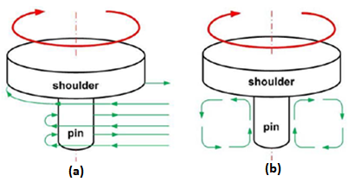
Figure 1: (a) horizontal material flow, (b) vertical material Flow in FSW [20]
Dual shoulders FSW (DSFSW)
To address and reduce the issues caused by CTFSW, TWI had developed a variant of FSW, called dual shoulders friction stir welding (DSFSW) which is also termed as bobbin tool friction stir welding (BTFSW) or self-reaction friction stir welding (SRFSW) [34]. This technique provides multiple advantages, such as eliminating root defects, reducing under welding problems, avoiding weld roots, removing the requirement for a back plate, and lowering Z forces [35] because it uses a double-sided friction stir tool with more interfacing with workpiece material and effective control of frictional heat generation.
Kissing bond, joint line defect, and residual oxide defect (ROD), and cold lap are additional issues associated with the FSLW. In lap welding, residual oxide defects (ROD) occur when oxide layers from the bottom surface of the top plate and the top surface of the bottom plate become trapped between the two surfaces that are joined. These defects contribute to increased stress concentration and are primarily responsible for the failure of lap joints [9], [30-37].
It is interesting to examine the effect on weldments in DSFSLW, by changing tool dimensions and features and synchronizing tool speed and feed with the identical workpiece materials. It is highly valuable to determine the dimensions and features of dual shoulders FSW tool that can generate good quality lap weldments by synchronized process parameters as tool speed (w) and feed (v). This paper presents the results of several experiments conducted to achieve these main objectives.
MATERIALS AND METHODS
The workpiece materials, 3 mm thick rolled Aluminum alloy 6061-T6 plates of 152 mm X 102 mm, were used for investigation of dual shoulders friction stir lap welding configuration (DSFSLW). Table 1 shows the chemical compositions and mechanical properties of used base metal (BM). Differently designed seven, dual shoulders FSW tools were experimented for DSFSLW shown in Table 2. As a tool material, hardened H13 tool steel was used in all dual shoulders FSW tools. Variations in design of dual shoulders FSW tool includes, (i) change in diameter of shoulders, (ii) change in shoulders height, (iii) change in pin diameter, (iv) change in primary feature of shoulders, (v) change in secondary features of shoulders, (vi) change in pin shape (vii) change in primary feature of pin (viii) change in secondary features and profiles which all are shown in subsequent figures in 2D sketch and actual images of dual shoulders FSW tool. In all experiments, DSFSLW performed along the longitudinal direction of the workpiece plates and perpendicular to rolling direction of workpiece plates. Oxide layers on the top and bottom surfaces of the workpieces are removed with light rubbing and acetone to overcome ROD defect. Components involved in DSFSLW are shown in Figure 2, indicated all components are jointly responsible for quality of weldments. Figure 3 shows experiment flow diagram and concepts applied in DSFSLW. Control of generated frictional heat is also important as important as generation of frictional heat in FSW and fixture play a major role in this direction, considering this fact, specially designed and fabricated two types of fixtures were used for FSW lap joint as shown in Figure 4. Figure 5 shows schematic sketch of workpiece sheets overlaps. A large overlap of 72 mm was used in all experiments. Experiment set-up for DSFSLW with SS fixture is shown in Figure 6. Experiments were performed with differently designed dual shoulders FSW tools with different tool rotation speed (RPM) and tool feed (mm/min) as shown in table 2.
Table 1: Chemical composition and mechanical properties of base metal
Chemical Composition (wt %) |  |  |  |  |  |  |  | Mechanical Properties
Si | Fe | Cu | Mn | Mg | Cr | Zn | Al | UTS | Elongation | Hardness
 |  |  |  |  |  |  |  | (MPa) | (%) | (HV)
0.457 | 0.553 | 0.173 | 0.106 | 0.937 | 0.266 | 0.01 | Bal | 282 | 21 | 80-90

Table 2: Chemical composition and mechanical properties of base metal
Experiment |  | Process parameters |  | Tool Variant | Weld formation | Remarks
Sr. | Code | Tool rotation speed (RPM) | Tool feed (mm/min) | Tool Variant | Weld formation | Remarks
1 | TA | - | - | 1 | Not Started | Tool Failed
2 | TB | - | - | 2 | Not Started | Tool Failed
3 | TC | - | - | 3 | Not Started | Tool Failed
4 | T0 | 445 | 26 | 4 | Very poor | Not acceptable
5 | T1 | 445 | 33 | 4 | Too poor | Not acceptable
6 | T2 | 445 | 26 | 4 | Very poor | Experiment repeated-T0
 |  |  |  |  |  | Not acceptable
7 | T3 | 640 | 26 | 4 | Too poor | Not acceptable
8 | T4 | 515 | 31 | 4 | Too poor | Not acceptable
9 | T5 | 445 | 31 | 5 | No | Not acceptable
10 | T6 | 445 | 31 | 6 | Very poor | Not acceptable
11 | T7 | 445 | 16, 65 | 6 | Too poor | Not acceptable
12 | T8 | 350 | 16 | 7 | Good | Acceptable
13 | T9 | 445 | 16 | 7 | Very Good | Acceptable
14 | T10 | 280 | 16 | 7 | Very Good | Acceptable
15 | T11 | 350 | 33 | 7 | Very Good | Acceptable
16 | T12 | 350 | 54 | 7 | Good | Acceptable
17 | T13 | 350 | 43 | 7 | Good | Acceptable
shown in table 2. From the investigated all weldments, good weldments samples were cut in transverse direction of the weld specimen with help of wire EDM after DSFSLW for the metallographic study and mechanical testing. Metallographic study and mechanical testing of weldments samples are beyond the scope of present paper.
Schematic diagram of workpieces sheet overlap placement is shown in Figure 6. Sheets overlap was kept 72 mm and 30 mm width kept for holding purpose in both the top and bottom workpiece plates. Two types of vertical milling machines were used DSFSLW, experiment 1 to 3 were performed on computer controlled VMC and other all experiments were performed on heavy duty vertical milling machine – Sigma model, Geeta Machine Tools, Rajkot, Gujarat, India.
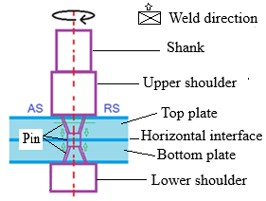
Figure 2: BTFSLW components

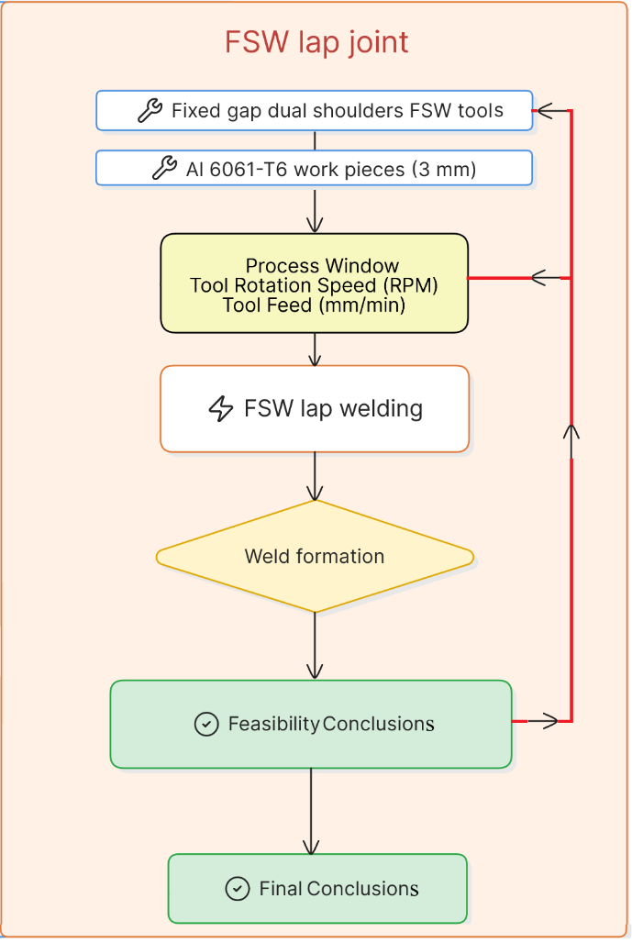
Figure 3: BTFSLW flow diagram
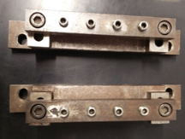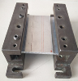
Figure 4: Fixtures, SS fixture (left), MS fixture with sheet overlap placement (right)
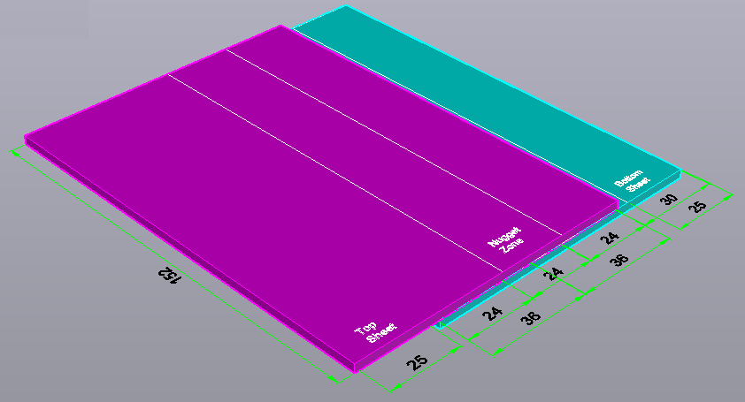
Figure 5: Schematic sketch of workpiece overlaps
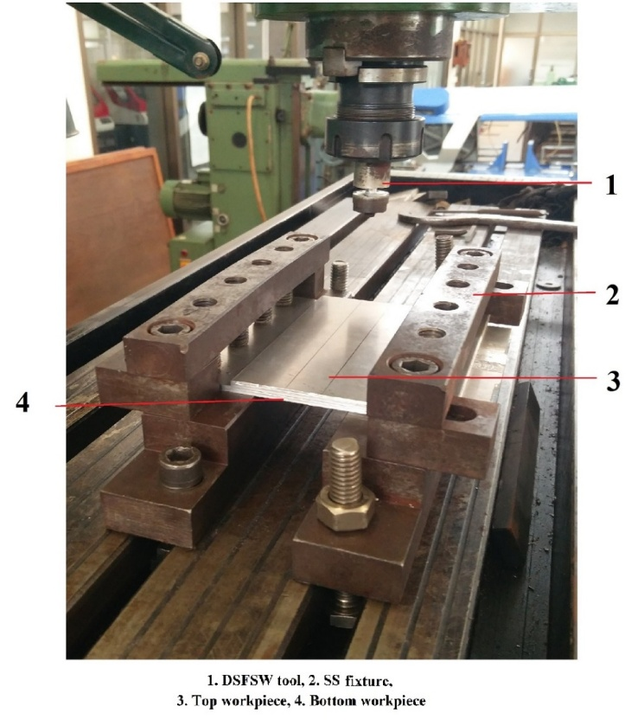
Figure 6: Experiment setup for DSFSLW
Weld formations were visually checked after each experiment, and based on the investigations, modifications in dual shoulder tool dimensions and features and value change in process parameters as tool speed and tool feed were applied accordingly for successive experiments.
Dual shoulders FSW tools
Total seven different dual shoulders FSW tools were used in the DSFSLW experiments, which are shown in following figures in 2D sketch and/or 3d sketch and actual images.
Initial experiment was performed with the tool-1 which is shown in Figure 7. Figure 7 (a) shows 2D sketch of the tool and Figure (c) shows actual tool used in experiment. As shown in Figure 7 (a), diameter of the both the shoulders was equal and 18 mm with different heights 20 mm and 15 mm for upper shoulder and lower shoulder, respectively. Dumbbell or hour glass shaped pin with maximum diameter of 12 mm towards shoulders and minimum diameter of 9 mm towards the center of pin was used. As shown in Figure 7, LH threads on conical shape of upper pin part and RH threads on conical shape of bottom pin part were used as secondary features of tool pin to force material towards the common interface of both the lapped workpieces (as shown in Figure 2).
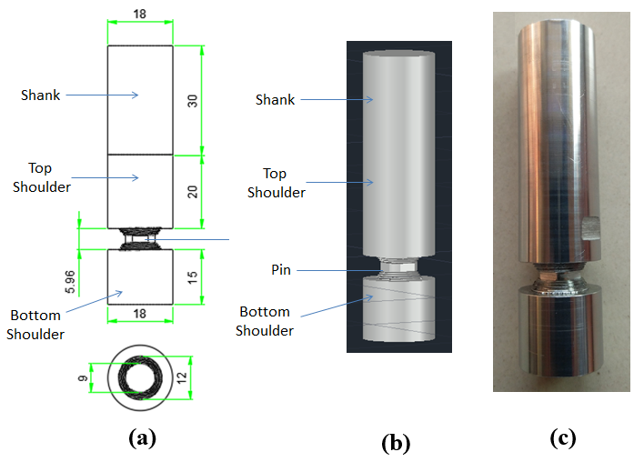
Figure 7: Tool-1, (a) 2D sketch, (b) 3D sketch, (c) actual

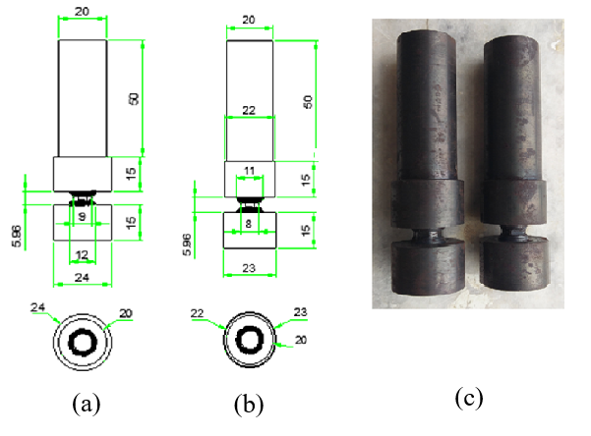
Figure 8: Tool-2 and 3, (a) Tool 2, 2D sketch, (b) Tool 3, 2D sketch, (c) Actual
Figures 8 shows, 2D sketches and actual images of the tool-2 and 3, which were used in second and third experiments. As shown in Figure 8 (a), diameter of both the shoulders was increased from 18 mm to 24 mm with same 15 mm heights. For tool-2, dumbbell or hour glass shaped pin with maximum diameter of 12 mm towards shoulders and minimum diameter of 9 mm towards the center of pin was used and for the tool-3, maximum diameter of 11 mm towards shoulders and minimum diameter of 8 mm towards the center of pin was used. As shown in Figure 8, LH threads and RH threads were used as described before. Due to these tool modifications, frictional volume of the workpiece material was increased to enhance frictional heat generation and embodies string action.
Figures 9 shows, 2D sketches and actual images of the tool-4, which was used in experiments 4 to 8. As shown in Figure 9 (a), diameter of both the shoulders was kept 24 mm with different heights of 20 mm and 15 mm for upper and lower shoulder respectively. As shown in figure 9, flat surface as primary feature and three spirals on flat surface were used as secondary feature of both the shoulders to enhance plasticized material flow and to reduce flash formation. Two opposite flats/flutes as secondary feature pin cylinder and cylindrical shape with 8 mm diameter as primary feature were used as pin design. Pin flats/flutes improves material shearing and mixing at weldment region.
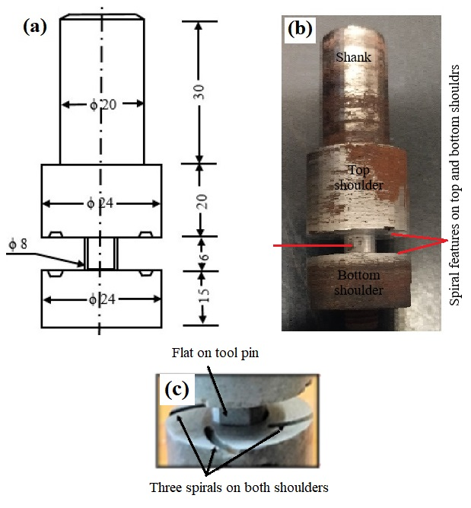
Figure 9: Tool-4, (a) 2D sketch, (b) Actual, (c) Spirals on shoulders
For the experiment-9, tool-5 was used as shown in Figure 10 (a) and Figure 11 (a). As shown in figure 10 (a), hour glass shaped and threaded pin was used in tool. Other parts dimensions are shown in Figure 10 (a). As per previous tool-4, flat surface as primary feature and four spirals on flat surface towards pin, as secondary feature on both the shoulders were used in tool-5 also as shown in Figure 12. Three flats/flutes as secondary feature on pin profile with maximum 10 and minimum 8 mm diameter on tapered pin were used as pin design.
As shown in Figure 10 (b) and Figure 11 (b), tool-6 was used for the experiment-10 to 11. As shown in figure 10 (b) and Figure 11 (b), a cylindrical pin with two flats/flutes and 2° concave shoulders were used in tool. Other dimensions of the tool parts are shown in Figure 10 (b). Concave shape of shoulders works as plasticized material reservoir during welding and reduces flash and tool marks on weld surface.
Tool-7 with 2° concave shoulders and hour glass shaped pi profile without threads was used for the experiment-12 to 17, as shown in Figure 10 (c) and 11 (c). Figure 10 (c) shows, other parts dimensions in 3D sketch. Tool pin maximum and minimum diameter was kept as 10 mm and 8 mm respectively as used before in tool-5. Experiment 1 to 3 were performed on computer controlled vertical milling machine shown in Figure 13 and Figure 14, and all other experiments were performed on heavy duty milling machine as shown in Figure 15.
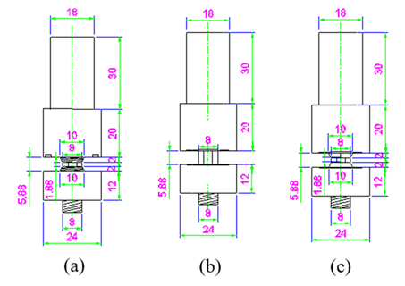
Figure 10: 2D sketch, (a) Tool 5, (b) Tool 6, (c) Tool 7

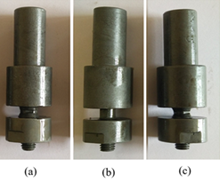
Figure 11: Actual images, (a) Tool 5, (b) Tool 6, (c) Tool 7

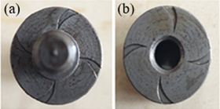
Figure 12: Tool-5, (a) Spirals on pin faced top shoulder, (b) Spirals on pin faced bottom shoulder
RESULTS AND DISCUSSION
To decide appropriate dual shoulders FSW tool dimensions; primary, secondary and tertiary features, and process parameters (tool speed, tool feed) window by investigating of weld formations formed by the applications of modified and upgraded dual shoulders FSW tools and change in processing parameters in similar DSFSLW of the Al6061-T6 workpiece material with 3 mm thickness, was the major objective of the present work.
As mentioned in Table 2, minimum ‘w’ was 280 RPM and maximum ‘w’ was 640 RPM. Minimum ‘v’ was 16 mm/min and maximum ‘v’ was 54 mm/min. Total seven tools, 1 to 7 as mentioned in table 2, were used for the investigation purpose on the same tool materials with same thickness of 3 mm in lapped configuration. Due to large variations in these parameters, various weldments are formed which are discussed in this section.
In experiment 1, tool speed (RPM) was varied from 350 to 1550 in various steps to soften weld area during dwelling (in several trials) but weld formation could not start and tool failed as shown in Figure 13. Following observations took with experience of experiment 1!
- Plate material was softened and material flow observed due to frictional heat generation.
- Material flow in horizontal as well in vertical direction towards mating surface of the plate was observed according to tool pin design.
- Less amount of frictional heat generation due to un sufficient tool shoulder peripheral frictional area. (although tool is designed based on literature reviews).
- Due to high thermal conductivity of aluminum alloy, generated heat is transferred to fixture. (temperature of fixture was higher than plates temperature).
- Tool vibrated at some time, due to little long shoulder length and lower shank length. (longer length of shank leads to more rigid holding).
- Pin length was proper according to plate thickness. Sufficient piercing of shoulder in to plate material was observed.
- Fixture held the plates very rigidly. Sliding/movement of plates was not observed.
- Tool was broken at pin portion (at minimum diameter) due to high thermal stress in tool with tool rotational speed of 1550 RPM.
Following modifications were identified based on the observations of experiment 1.
- Tool shoulder (upper and bottom) diameter should be increased and pin diameter should be decreased to increase frictional peripheral area. (decrease in pin diameter reduces tool strength and may break at the stressed area).
- Sufficient provision should be made in between Aluminum plates and fixture to prevent large amount of heat dissipation.
- Tool shank diameter should be increased to dissipate more amount of heat.
- Tool shank length should be increased to increase griping force in collate.
- Upper shoulder length should be decreased to reduced effective tool length to reduce tool vibrations.
In experiment 2 and 3, modified dual shoulders FSW tool-2 and 3 were designed and used in experiment 2 and 3. Due to insufficient load bearing capacity of computer controlled vertical mailing machine, tool failed as shown in Figure 14. Following modifications were needed based on the observations of experiment 2 and 3.
- Total tool length should be decreased to reduce tool vibrations.
- Tool should be designed in two parts for secondary features on tool shoulders and easy machining.
- Number of flutes should be optimized to provide pin strength and material stirring action as a greater number of flutes with increase stirring action but reduces tool strength due to reduction in cross section area.
- Heat treated hardened tool should be used to reduce failures.
- Sufficient provision should be made in between Aluminum plates and fixture to prevent large amount of heat dissipation.
- Heavy duty milling machine should be used to eliminate vibrations.

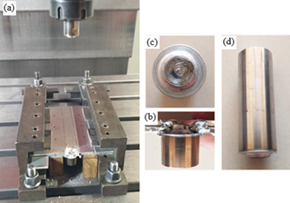
Figure 13: Experiment-1, after tool-1 broken, (a) experiment setup, (b) view of bottom shoulder, (c) Top view of bottom shoulder, (d) Top shoulder with shank

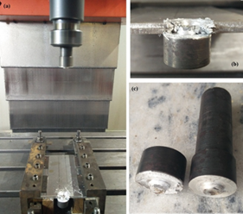

Figure 14: Experiment-2, after tool-2 broken, (a) experiment setup, (b) view of bottom shoulder, (c) view of broken tool-2.
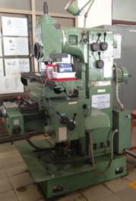
Figure 15: Heavy duty vertical milling machine used for FSW
The evaluation of weld formation on both the top and bottom surfaces was conducted through a detailed visual inspection. The assessment included weld surface appearance, flash formation, surface cracking, visible porosity, cold welding/galling defects, and other surface irregularities. In the case of dual shoulders friction stir lap welding (DSFSLW), particular attention was given to the geometry and integrity of the entry hole and exit tail regions, as these features significantly influence weld quality and process stability.
During the friction stir welding (FSW) process, the rotating tool initially interacts with the relatively cold material on the advancing side (AS) of the workpiece. The frictional heat generated by the tool shoulder and pin softens and plasticizes the material, which is subsequently transported by the rotational motion of the tool from the AS toward the retreating side (RS) [38-40]. The displaced plasticized material is deposited on the RS, leading to the characteristic formation of flash in this region. As illustrated in Figure 16 (a) (left), noticeable flash formation is observed on the RS of the top weld surface in experiment-4 in which tool-4 was used as shown in Figure-9. Distinct tool marks are also evident on the top surface, indicating effective material flow and tool engagement. Figure 16 (b) (left) presents the bottom surface of the weld, where surface markings resulting from the welding process can be observed. Furthermore, inadequate tool pin height or an inappropriate shoulder gap may contribute to excessive material expulsion, thereby promoting flash formation during welding.
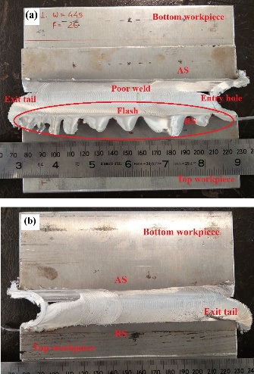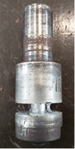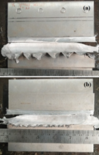
Figure 16: Weld formation, experiment-4 (left), (a) Top surface, (b) bottom surface; Tool view after performing experiment-4 (middle); Weld formation, experiment-5 (right), (a) Top surface, (b) bottom surface
Furthermore, the welds displayed a distinct entry hole, an extended unwelded region along the lap interface, and a noticeable exit tail, as illustrated in Figure 16 (left). These defects can be attributed to insufficient frictional heat generation and inadequate material mixing during the welding process. Figure 16 (middle) shows, condition of the welding tool after experiment finished that revealed adhesion of workpiece material to the tool pin and adjacent shoulder surfaces, indicating poor material flow behavior and increased sticking tendency. Nearby unbonded poor weld formation and defect patterns were observed in experiment-5 in which ‘v’ was increased to 33 mm/min, as shown in Figure 16 (right), confirming the poor intermixing of workpiece materials towards common interface by the application of tool-4 as shown in Figure-9
Figures 17 (a) (left) and 17 (b) (left) illustrate the weld morphology observed on the top and bottom surfaces of the weld specimen, respectively, produced at a tool rotational speed of 445 rpm and a welding feed rate of 26 mm/min in experiment-6 as repeated experiment-4 and repeated tool-4. The weld exhibited negligible lap joint formation, with joint quality nearby same that was obtained in the experiments-4. This deterioration in weld integrity can be attributed to the increased tool feed rate, which reduced the interaction time between the tool and workpiece, thereby limiting heat generation and material mixing. As a result, the plasticized material was transported away from the weld zone without adequate intermixing at the faying interface, leading to material tearing and insufficient metallurgical bonding between the overlapping sheets.
Figures 17 (a) (middle) and 13(b) (middle) present the weld morphology on the top and bottom surfaces, respectively, of the specimen produced at a tool rotational speed of 640 rpm and a welding feed rate of 26 mm/min in experiment-7 by application of tool-4. Compared with the previous experimental condition, a slight improvement in joint formation was observed. The increase in tool rotational speed enhanced frictional heat generation, resulting in greater softening of the material and a reduction in the viscosity of the plasticized zone. Consequently, material flow around the rotating tool was improved, promoting better mixing at the weld interface.
However, the selected feed rate was not adequately balanced with the increased rotational speed. The relatively high traverse rate tended to drag the plasticized material along the welding direction, limiting its effective deposition and consolidation at the lap interface. As a result, the weld quality remained unsatisfactory, and the joint was classified within the unacceptable category due to insufficient bonding and poor lap joint formation.
Figures 17 (a) (right) and 17 (b) (right) depict the weld morphology observed on the top and bottom surfaces, respectively, of the specimen welded at a tool rotational speed of 515 rpm and a welding feed rate of 31 mm/min in experiment-8 and application of tool-4. Under these processing conditions, no effective lap joint formation was achieved. The absence of bonding can be attributed to inadequate frictional heat generation resulting from the relatively low tool rotational speed, combined with the comparatively high traverse rate. These conditions limited material softening and plasticization, thereby restricting material flow and intermixing at the faying interface. Consequently, insufficient consolidation occurred between the overlapping sheets, leading to the failure of joint formation.
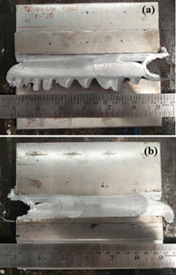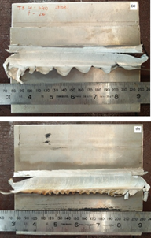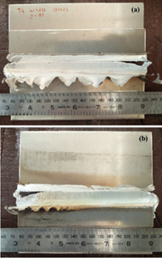
Figure 17: Weld formation, experiment-6 (left), (a) Top surface, (b) bottom surface; Weld formation, experiment-7 (middle), (a) Top surface, Weld formation, experiment-8 (right), (a) Top surface, (b) bottom surface
Figures 18 (a) (left) and 18 (b) (left) illustrate the weld morphology on the top and bottom surfaces, respectively, of the specimen produced during an experiment conducted at a tool rotational speed of 445 rpm and a welding feed rate of 31 mm/min in experiment-9 and application of tool-5 as shown in Figure 10 (a). Compared with the previous trial performed under identical processing conditions and different tool, unwelded formation was observed. This variation may be attributed to the complex thermo-mechanical nature of the friction stir welding process, as well as tool features not suitable for lapped workpieces.
Figures 18 (a) (middle) and 18 (b) (middle) illustrate the weld morphology on the top and bottom surfaces, respectively, of the specimen produced during an experiment conducted at a tool rotational speed of 445 rpm and a welding feed rate of 31 mm/min in experiment-10 and application of tool-6, as shown in Figure 10 (b). Compared with the previous experiment performed under identical processing conditions, a slight improvement in joint formation was observed but under non acceptable category.
Figures 18 (a) (right) and 18 (b) (right) illustrate the weld morphology on the top and bottom surfaces, respectively, of the specimen produced during an experiment conducted at a tool rotational speed of 445 rpm and a welding feed rate of 16 mm/min initially and changed 65 mm/min in experiment-11 with application of tool-6, as shown in Figure 10 (b). Compared with the previous experiment performed under identical processing conditions, decrement in joint formation was observed as non-acceptable.
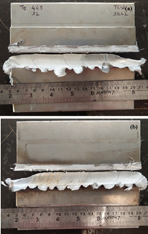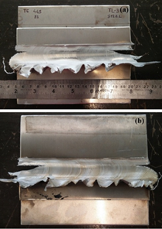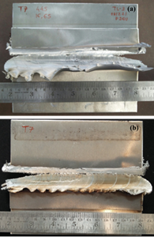
Figure 18: Weld formation, experiment-9 (left), (a) Top surface, (b) bottom surface; Weld formation, experiment-10 (middle), (a) Top surface, Weld formation, experiment-11 (right), (a) Top surface, (b) bottom surface

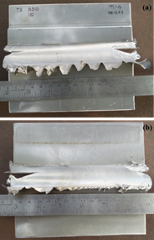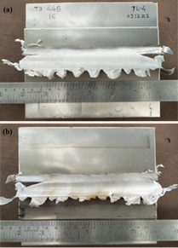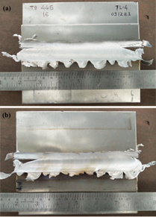
Figure 19: Weld formation, experiment-12 (left), (a) Top surface, (b) bottom surface; Weld formation, experiment-13 (middle), (a) Top surface, Weld formation, experiment-14 (right), (a) Top surface, (b) bottom surface
As presented in Table 2, experiments corresponding to serial numbers 4–11 exhibited poor weld formation in all DSFSLW trials due to lack of needed features in tool for efficient frictional heat generation and intermixing of heated embodies and non-synchronized process parameters as tool rotation speed and tool feed value for lapped workpieces. All weldments were characterized by significant flash formation on the retreating side (RS) of the top surface, pronounced tool marks on the bottom surface, and inadequate lap joint integrity. The excessive flash indicates insufficient confinement between the tool shoulder and substrate, which limited the effective transport of frictionally softened material toward the faying interface of the overlapping sheets. Consequently, inadequate material flow and bonding occurred at the weld interface.
Tool-7 as shown in Figure 10 (c) was applied in experiments 12 to 17 with tool rotation speed of 280, 350 and 445 RPM; and tool feed of 16, 43 and 45 mm/min as shown in Table-2, serial number 12 to 16. Figure 19 represents good and very good weld formations on top and bottom surfaces achieved in experiments 12 to 14. Figure 20 shows good and very good weldments on top and bottom surfaces generated in experiments 15 to 17.
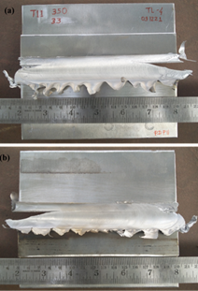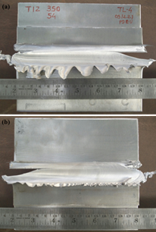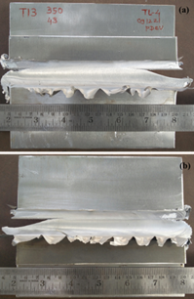
Figure 20: Weld formation, experiment-15 (left), (a) Top surface, (b) bottom surface; Weld formation, experiment-16 (middle), (a) Top surface, Weld formation, experiment-17 (right), (a) Top surface, (b) bottom surface
These weld formation variations may be attributed to the complex thermo-mechanical nature of the friction stir welding process, as well as reduced heat dissipation through the machine structure and fixture system due to heat restricted material plates were placed at the mating surfaces of workpiece plates and abutting fixture surfaces during subsequent welding runs. These resulting in enhanced thermal input and likely enhanced material plasticization and dynamic material flow at the weld interface.
Very good weldments generated with tool-7 and tool rotation feed of 280, 350 and 445 RPM and tool feed of 16 mm/min. Another combination was tool rotation speed of 350 RPM and 33 mm/min with the same tool-7. No defects were visible from the surface investigations of the weldments either on top surface or bottom surface and acceptable as per visible weld formations. These investigations proved the needed features of dual shoulders FSW tool for lapped workpieces.
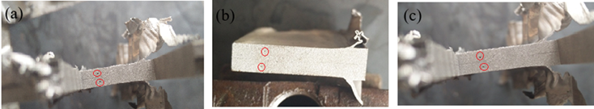
Figure 21: Cross section of weldments, (a) experiment-12 (T8), (b) experiment-13 (T9), (c) experiment-14 (T10)
Nevertheless, the improvement was not so sufficient to achieve acceptable weld quality, and the joint remained within the non-acceptable category due hole defects observed in cross sections of weldments 12 to 17. Figure 21 shows holes or porosity defects in cross section of weldments at AS, extremely undesired as these defects work as stress booster. Figure 21 (a), (b) and (c) shows hole defects in experiment 12, 13 and 14 respectively. Such defects can be removed by slightly modifying design of dual shoulders FSW tool and synchronized tool rotation speed and tool feed with controlled net effective frictional heat accumulated in workpiece at moving tool volume and intermixing of workpiece materials embodies towards mating interface.
CONCLUSION
After investigations of weld formations in DSFSLW on Al 6061-T6 workpieces material by application different of dual shoulders FSW tools, and varying the processing parameters as tool rotation speed (ROM) and tool feed (mm/min), following conclusions can be revealed.
In DSFSLW, very poor weld formation was generated in initial 4 to 8 experiments with the application of dual shoulders FSW tool with cylindrical and fluted pin. In one case, even weld formation was not generated in lap configuration. Cylindrical fluted pin is successful in DSFSW in butt configuration but not effective in lap configuration.
Very good lap weld quality was achieved at lower welding speed of 16 mm/min with designed bobbin tool mentioned earlier.
Higher rotational speed and welding speed resulted poor quality of lap weld.
Low tool rotational speed (RPM) required due to heat flow restriction applied in experiment setup.
Weld joint quality and strength was increased with increase in tool rotational speed from 280 to 445 RPM.
Good weld formations were observed in the investigation in which experiments were performed with the dual shoulders FSW tool with 2° concave shoulders surface towards pin and hour glass shaped pin without threads and 3 flutes in mid of pin.
Characteristics of weld formation of lapped workpieces is different that the butted workpieces due to horizontal separation surfaces, demand for tool features described as above which cumulatively forge intermixed and stirred workpiece material towards mating interface of lapped workpieces.
AUTHOR’S CONTRIBUTION
Conceptualization: Modi Vijaykumar Natwarlal,
Methodology: Modi Vijaykumar Natwarlal, Kishan Fuse
Investigation: Modi Vijaykumar Natwarlal, Kishan Fuse
Discussion of results: Modi Vijaykumar Natwarlal, Kishan Fuse
Writing – Original Draft: Modi Vijaykumar Natwarlal
Writing – Review and Editing: Modi Vijaykumar Natwarlal, Anishkumar H. Gandhi, Vishvesh J. Badheka
Resources: Vishvesh J. Badheka. Kishan Fuse
Supervision: Anishkumar H. Gandhi, Vishvesh J. Badheka
Approval of the final text: Anishkumar H. Gandhi
ACKNOWLEDGMENTS
The author would like to thank Pandit Deendayal Energy University (PDEU), Gandhinagar, Gujarat, India for providing necessary support, equipment’s and infrastructure to carry out this research work. Experiments were performed on heavy duty vertical milling machine - Sigma, Geeta Machine Tools, Rajkot and weld samples were cut on wire EDM facilitated by machining center of department of Mechanical engineering, PDEU, Gandhinagar, Gujarat, India.
REFERENCES
- L. Dubourg, A. Merati, and M. Jahazi, “Process optimisation and mechanical properties of friction stir lap welds of 7075-T6 stringers on 2024-T3 skin,” Materials & Design, vol. 31, no. 7, pp. 3324–3330, 2010. [Crossref]
- A. Devaraju, “Influence of Post-weld Rapid cooling on Grain size and Mechanical properties of Friction Stir Welded AA 2014,” Materials Today: Proceedings, vol. 4, no. 2, Part A, pp. 3722–3727, 2017. [Crossref]
- Z. Li, Y. Yue, S. Ji, P. Chai, and Z. Zhou, “Joint features and mechanical properties of friction stir lap welded alclad 2024 aluminum alloy assisted by external stationary shoulder,” Materials & Design, vol. 90, pp. 238–247, 2016. [Crossref]
- M. I. Costa, D. Verdera, C. Leitão, and D. M. Rodrigues, “Dissimilar friction stir lap welding of AA 5754-H22/AA 6082-T6 aluminium alloys: Influence of material properties and tool geometry on weld strength,” Materials & Design, vol. 87, pp. 721–731, 2015. [Crossref]
- V. Paradiso, F. Rubino, P. Carlone, and G. S. Palazzo, “Magnesium and Aluminium alloys Dissimilar Joining by Friction Stir Welding,” Procedia Engineering, vol. 183, pp. 239–244, 2017. [Crossref]
- Y. C. Chen and K. Nakata, “Microstructural characterization and mechanical properties in friction stir welding of aluminum and titanium dissimilar alloys,” Materials & Design, vol. 30, no. 3, pp. 469–474, Mar. 2009. [Crossref]
- Y. Gao, K. Nakata, K. Nagatsuka, T. Matsuyama, Y. Shibata, and M. Amano, “Microstructures and mechanical properties of friction stir welded brass/steel dissimilar lap joints at various welding speeds,” Materials & Design, vol. 90, pp. 1018–1025, 2016. [Crossref]
- K. Nagatsuka, S. Yoshida, A. Tsuchiya, and K. Nakata, “Direct joining of carbon-fiber–reinforced plastic to an aluminum alloy using friction lap joining,” Composites Part B: Engineering, vol. 73, pp. 82–88, 2015. [Crossref]
- Y. Zhang, Y. Huang, X. Meng, J. Li, Y. Xie, and Q. Fan, “Friction stir lap welding of AA2024-T4 with drastically different thickness,” The International Journal of Advanced Manufacturing Technology, vol. 106, no. 9, pp. 3683–3691, Feb. 2020. [Crossref]
- N. Panaskar and R. Terkar, “A Review on Recent Advances in Friction Stir Lap Welding of Aluminium and Copper,” Materials Today: Proceedings, vol. 4, no. 8, pp. 8387–8393, 2017. [Crossref]
- C. Yang et al., “A comparative research on bobbin tool and conventional friction stir welding of Al-Mg-Si alloy plates,” Materials Characterization, vol. 145, pp. 20–28, Nov. 2018. [Crossref]
- S. Ji, Z. Li, L. Zhang, Z. Zhou, and P. Chai, “Effect of lap configuration on magnesium to aluminum friction stir lap welding assisted by external stationary shoulder,” Materials & Design, vol. 103, pp. 160–170, 2016. [Crossref]
- H. H. Jadav, V. Badheka, D. K. Sharma, and G. Upadhyay, “Effect of pin diameter and different cooling media on friction stir welding of dissimilar Al-Mg alloys,” Materials Today: Proceedings, vol. 42, pp. 362–369, 2021. [Crossref]
- S. H. C. Park, Y. S. Sato, H. Kokawa, K. Okamoto, S. Hirano, and M. Inagaki, “Rapid formation of the sigma phase in 304 stainless steel during friction stir welding,” Scripta Materialia, vol. 49, no. 12, pp. 1175–1180, Dec. 2003. [Crossref]
- B. Li, Y. Shen, L. Luo, and W. Hu, “Effects of processing variables and heat treatments on Al/Ti-6Al-4V interface microstructure of bimetal clad-plate fabricated via a novel route employing friction stir lap welding,” Journal of Alloys and Compounds, vol. 658, pp. 904–913, 2016. [Crossref]
- S. Ji, Z. Li, Y. Wang, and L. Ma, “Joint formation and mechanical properties of back heating assisted friction stir welded Ti–6Al–4V alloy,” Materials & Design, vol. 113, pp. 37–46, 2017. [Crossref]
- S. Ji, Z. Li, Y. Wang, and L. Ma, “Joint formation and mechanical properties of back heating assisted friction stir welded Ti–6Al–4V alloy,” Materials & Design, vol. 113, pp. 37–46, 2017. [Crossref]
- K. Gangwar and M. Ramulu, “Friction stir welding of titanium alloys: A review,” Materials & Design, vol. 141, pp. 230–255, 2018. [Crossref]
- Y. Gao, K. Nakata, K. Nagatsuka, F. C. Liu, and J. Liao, “Interface microstructural control by probe length adjustment in friction stir welding of titanium and steel lap joint,” Materials & Design (1980-2015), vol. 65, pp. 17–23, 2015. [Crossref]
- S. S. Emamian, M. Awang, F. Yusof, M. Sheikholeslam, and M. Mehrpouya, “Improving the friction stir welding tool life for joining the metal matrix composites,” The International Journal of Advanced Manufacturing Technology, vol. 106, no. 7, pp. 3217–3227, Feb. 2020. [Crossref]
- M. M. Z. Ahmed, K. Touileb, M. M. El-Sayed Seleman, I. Albaijan, and M. I. A. Habba, “Bobbin Tool Friction Stir Welding of Aluminum: Parameters Optimization Using Taguchi Experimental Design,” 2022. [Crossref]
- O. S. Salih, H. Ou, X. Wei, and W. Sun, “Microstructure and mechanical properties of friction stir welded AA6092/SiC metal matrix composite,” Materials Science and Engineering: A, vol. 742, pp. 78–88, Jan. 2019. [Crossref]
- D. Baffari, G. Buffa, D. Campanella, E. Lo Valvo, and L. Fratini, “Experimental and numerical investigation on a new FSW based metal to composite joining technique,” Journal of Manufacturing Processes, vol. 34, pp. 758–764, Aug. 2018. [Crossref]
- A. K. P, D. Yadav, C. S. Perugu, and S. V. Kailas, “Influence of particulate reinforcement on microstructure evolution and tensile properties of in-situ polymer derived MMC by friction stir processing,” Materials & Design, vol. 113, pp. 99–108, 2017. [Crossref]
- S. Eslami, T. Ramos, P. J. Tavares, and P. M. G. P. Moreira, “Effect of Friction Stir Welding Parameters with Newly Developed Tool for Lap Joint of Dissimilar Polymers,” Procedia Engineering, vol. 114, pp. 199–207, 2015. [Crossref]
- S. Eslami, T. Ramos, P. J. Tavares, and P. M. G. P. Moreira, “Shoulder design developments for FSW lap joints of dissimilar polymers,” Journal of Manufacturing Processes, vol. 20, pp. 15–23, 2015. [Crossref]
- F. Lambiase, A. Paoletti, V. Grossi, and S. Genna, “Improving energy efficiency in friction assisted joining of metals and polymers,” Journal of Materials Processing Technology, vol. 250, pp. 379–389, 2017. [Crossref]
- P. S. De and R. S. Mishra, “Friction stir welding of precipitation strengthened aluminium alloys: Scope and challenges,” Science and Technology of Welding and Joining, vol. 16, no. 4, pp. 343–347, May 2011. [Crossref]
- “W.M. Thomas, E.D. Nicholas, J.C. Needham, M.G. Church, P. Templesmith, C. Dawes. Friction stir welding, GB Patent 9, 125, 978, 9, Sept 1991” [Google patent]
- G. Buffa, G. Campanile, L. Fratini, and A. Prisco, “Friction stir welding of lap joints: Influence of process parameters on the metallurgical and mechanical properties,” Materials Science and Engineering: A, vol. 519, no. 1–2, pp. 19–26, Aug. 2009. [Crossref]
- R. Chandran, S. Ramaiyan, A. G. Shanbhag, and S. K. V. Santhanam, “Optimization of Welding Parameters for Friction Stir Lap Welding of AA6061-T6 Alloy,” MME, vol. 08, no. 01, pp. 31–41, 2018. [Crossref]
- T. Medhi, A. Das, P. Pankaj, S. Kapil, and P. Biswas, “Multi-Pass Friction Stir Lap Welding of AA 6061-T6: Implication of Tool Pin Overlapping on Microstructure and Mechanical Properties of Joints,” Soldag. insp., vol. 27, p. e2708, 2022. [Crossref]
- X. Xu, X. Yang, G. Zhou, and J. Tong, “Microstructures and fatigue properties of friction stir lap welds in aluminum alloy AA6061-T6,” Materials & Design, vol. 35, pp. 175–183, Mar. 2012. [Crossref]
- K. Fuse and V. Badheka, “Bobbin tool friction stir welding: a review,” Science and Technology of Welding and Joining, vol. 24, no. 4, pp. 277–304, May 2019. [Crossref]
- P. L. Threadgill, M. M. Z. Ahmed, J. P. Martin, J. G. Perrett, and B. P. Wynne, “The Use of Bobbin Tools for Friction Stir Welding of Aluminium Alloys,” MSF, vol. 638–642, pp. 1179–1184, Jan. 2010. [Crossref]
- M. Pecanac et al., “Influence of Tool and Welding Parameters on the Risk of Wormhole Defect in Aluminum Magnesium Alloy Welded by Bobbin Tool FSW,” Metals, vol. 12, no. 6, p. 969, Jun. 2022. [Crossref]
- A. Astarita, F. Tucci, A. T. Silvestri, M. Perrella, L. Boccarusso, and P. Carlone, “Dissimilar friction stir lap welding of AA2198 and AA7075 sheets: forces, microstructure and mechanical properties,” The International Journal of Advanced Manufacturing Technology, vol. 117, no. 3, pp. 1045–1059, Nov. 2021. [Crossref]
- K. Fuse and V. Badheka, “Hybrid Self-Reacting Friction Stir Welding of AA 6061-T6 Aluminium Alloy with Cooling Assisted Approach,” Metals, vol. 11, no. 1, p. 16, Dec. 2020. [Crossref]
- K. Fuse, V. Badheka, V. Patel, and J. Andersson, “Dual sided composite formation in Al 6061/B4C using novel bobbin tool friction stir processing,” Journal of Materials Research and Technology, vol. 13, pp. 1709–1721, Jul. 2021. [Crossref]
- K. Fuse and V. Badheka, “Effect of shoulder diameter on bobbin tool friction stir welding of AA 6061-T6 alloy,” Materials Today: Proceedings, vol. 42, pp. 810–815, 2021. [Crossref]
Appendix -1 (Abbreviations and full term)
Abbreviations | Full Term
FSW | Friction Stir Welding
CTFSW | Conventional Tool Friction Stir Welding
w | Tool Rotational Speed (RPM)
v | Tool Traveling Speed/Feed (mm/min)
FSLW | Friction Stir Lap Welding
BTFSW | Bobbin Tool Friction Stir Welding
DSFSW | Dual Shoulders Friction Stir Welding
SRFSW | Self-Reacting Friction Stir Welding
DSFSLW | Dual Shoulders Friction Stir Lap Welding
BTFSLW | Bobbin Tool Friction Stir Lap Welding
SRFSLW | Self-Reacting Friction Stir Lap Welding
LH | Left Hand
RH | Right Hand
BM | Base Material
AS | Advancing Side
RS | Retreating Side
ROD | Residual Oxide Defect
UTS | Ultimate Tensile Strength

