Transformation of IR4.0 Technology Literacy in Empowering Asnaf Students of STEM Secondary Schools in Perlis, Malaysia
Norziana Yahya¹, Nur Rasyidah Saini¹, Mohd Azahani Md Taib²

¹ Faculty of Computer and Mathematical Sciences, Universiti Teknologi MARA (UiTM), Perlis, Malaysia

²Masari Holdings Sdn Bhd, Selangor, Malaysia.

*Corresponding Author: Norziana Yahya

Abstract
The Fourth Industrial Revolution (IR4.0) has significantly transformed the global landscape, reshaping industries and redefining educational priorities. This study examined the development and implementation of an IR4.0 Technology Literacy Program aimed at empowering asnaf students in STEM-focused secondary schools in Perlis, Malaysia. A total of 80 asnaf students were selected from 20 schools, with four students nominated by each school to participate in the program. The participants underwent structured training modules covering Artificial Intelligence (AI), the Internet of Things (IoT), and immersive technologies such as Virtual/Augmented Reality and holograms. The methodology included the design of tailored training modules, delivery of intensive workshops, pre- and post-test assessments, and subsequent peer mentoring where trained asnaf students guided their school peers. Findings revealed that the program effectively enhanced students' knowledge, confidence, and literacy in IR4.0 technologies, enabling them not only to bridge their own digital knowledge gaps but also to mentor others, thereby amplifying the program's impact.
Keywords: IR4.0, STEM, asnaf students, artificial intelligence, immersive technology
Introduction
The Fourth Industrial Revolution (IR4.0) has brought profound transformations across multiple sectors, including education, through the introduction of advanced technologies such as Artificial Intelligence (AI), the Internet of Things (IoT), Big Data analytics, Augmented Reality (AR), and Mixed Reality (Saari et al., 2021). These technologies not only create new economic opportunities but also require changes in educational approaches to ensure that learners are prepared to meet the demands of the future (Idris & Bacotang, 2023), (Hanafi et al., 2023).
In the context of education, IR4.0 technologies are closely integrated with STEM education (Science, Technology, Engineering, and Mathematics), and together they play a critical role in equipping students for technology-driven and innovation-oriented careers. For students from asnaf backgrounds, exposure to IR4.0 through structured STEM education can help overcome persistent skill gaps and offer greater pathways into high-technology sectors (Xia et al., 2022).
Integrating IR4.0 into learning does not only build technical literacy but also empowers students to become agents of change within their communities. At Universiti Teknologi MARA (UiTM) Perlis, introducing asnaf students to IR4.0 is part of a broader initiative to equip them with relevant skills and knowledge, which can in turn be shared with secondary school students pursuing STEM fields (Idris & Bacotang, 2023).
LITERATURE
This section reviews IR4.0, STEM, digital equity, and prior interventions, highlighting gaps in technology access for asnaf students.
IR4.0 and Educational Transformation
The IR4.0 has fundamentally transformed global education systems, necessitating a shift toward technology-driven learning to prepare students for an increasingly digital economy. Scholars such as Saari et al. (2021) have highlighted how emerging technologies including AI, the IoT, AR, and Big Data analytics are reshaping pedagogical approaches. Within this context, research emphasizes the importance of hands-on, experiential learning to bridge the gap between theoretical knowledge and practical application (Idris & Bacotang, 2023). Additionally, the role of teacher upskilling has been identified as a critical factor in effectively delivering content related to these advanced technologies (Hanafi et al., 2023). In Malaysia, national policies such as the Pelan Pembangunan Pendidikan Malaysia (PPPM) and the STEM Education Policy explicitly advocate for the integration of IR4.0 technologies into school curricula to foster innovation and future-ready skills among students.
STEM Education and Digital Equity
STEM education serves as a key enabler of IR4.0 readiness, yet significant disparities persist in access and participation. Studies reveal a pronounced urban-rural divide, where students in less developed regions often lack access to advanced technological infrastructure (Kormos & Wisdom, 2021). Compounding this issue, students from socio-economically disadvantaged groups face additional barriers that restrict their engagement in technology-focused programs (Bhandari, 2023).
In the Malaysian context, one such vulnerable group is the asnaf community. The term asnaf, derived from Islamic zakat (almsgiving) principles, refers to individuals or households eligible to receive zakat assistance due to poverty or other socio-economic disadvantages (Hanafi et al., 2023). Asnaf students are therefore those from low-income families who often face constraints such as limited financial resources, lack of access to digital devices, and restricted exposure to advanced educational opportunities.
Addressing the educational needs of asnaf students is critical, as they represent a segment of society at risk of being left behind in the transition toward IR4.0-driven economies. Improving their access to STEM and technology literacy not only promotes educational equity but also aligns with broader national goals of reducing socio-economic disparities through education.
Prior Interventions in Technology Literacy
Existing programs in other regions demonstrate the potential of structured IR4.0 training to improve educational outcomes. For instance, AI and IoT workshops conducted in rural Indonesian schools resulted in a 40 percent increase in student competency (Wahyudi et al., 2025). Likewise, AR-based STEM modules implemented in Thailand, supported by a review of 42 SSCI-indexed studies demonstrated AR's growing role in boosting both student engagement and knowledge retention (Sırakaya & Alsancak Sırakaya, 2020). However, a recurring challenge identified in these studies is the sustainability of such interventions without robust institutional support, such as partnerships with government agencies or higher education institutions.
Gaps and Justification for This Study
Despite the growing body of research on IR4.0 in education, several gaps remain unaddressed. Few studies specifically examine the unique barriers faced by asnaf students, including financial constraints and limited exposure to technology. Additionally, there is limited exploration of peer-led knowledge transfer as a scalable solution to bridge these gaps. This study seeks to address these shortcomings by evaluating an intervention model that combines workshops with student-led technology literacy programs in Perlis, Malaysia. The collaboration between UiTM and the Sektor Sumber Teknologi Pendidikan (SSTP) ensures a structured approach to systemic impact.
METHODOLOGY
This project followed a multi-phase approach to equip asnaf students in selected Perlis secondary schools with IR4.0 technology literacy and prepare them as peer mentors.
Development of the IR4.0 Technology Learning Module
A tailored learning module was developed around three IR4.0 pillars: AI, IoT, and immersive technologies. AI covered concepts such as machine learning, chatbots, and recommendation systems, alongside ethical considerations. IoT introduced device interconnectivity, sensor operations, and data exchange through hands-on kits and simulations. Immersive technologies (VR, AR, holograms) offered guided demonstrations of applications in sectors like education and healthcare. The module integrated theory, practice, and ethics to create a comprehensive, multimodal learning experience.
Selection and Registration of Asnaf Students
The target group of participants consisted of asnaf students, defined in the Malaysian context as students from low-income families eligible for zakat assistance. A total of 20 secondary schools across Perlis were invited to participate. Each school was required to nominate four asnaf students, resulting in 80 students being selected overall. The nomination process was conducted by school administrators and teachers, who considered factors such as students' interest and aptitude in STEM subjects, commitment to participate in post-training peer mentoring, and representation across different geographic areas of Perlis. Academic records and personal profiles were reviewed to ensure transparency and to identify students most likely to benefit from the program and act as effective peer mentors.
Delivery of the Training Program
The IR4.0 module was delivered through blended workshops combining expert lectures, demonstrations, hands-on projects, and group discussions. Students engaged in activities such as building IoT circuits, creating simple AR applications, and exploring VR simulations. Each module concluded with reflection and structured feedback to reinforce learning. Training sessions were conducted at designated facilities to ensure both accessibility and consistent delivery quality.
Mentoring by Asnaf Students
Upon completing the training, the 80 certified students were further coached to strengthen both their technical competencies and their communication skills as peer mentors. Resource kits containing simplified guides, activity templates, and lesson aids were provided to support their mentoring role. Each student was required to conduct at least five peer sessions in their respective schools, which included workshops, study circles, or live demonstrations. This peer-led model not only expanded the program's reach but also fostered leadership and confidence among the asnaf students themselves.
Evaluation of Program Effectiveness
A mixed-methods evaluation design was employed to measure outcomes. Pre- and post-tests assessed knowledge, practical tasks measured skills acquisition, and self-assessments gauged confidence and readiness. Trainers also observed student engagement using structured observation protocols. Anonymous student feedback was collected to evaluate content relevance, delivery quality, and overall learning experience. Finally, the effectiveness of peer mentoring was assessed through interviews with both mentors and their peers, along with documentation of the number and quality of peer sessions conducted.
Strategic Collaboration and Program Participation
The project was implemented in collaboration with the Perlis Educational Technology Resources Sector (SSTP), which coordinated school participation and logistical support. In total, 20 secondary schools and 80 asnaf students participated. Through the peer mentoring model, each trained student mentored at least five peers in their respective schools, thereby extending the reach of the program to approximately 400 additional students while simultaneously promoting IR4.0 technology literacy and leadership skills across the wider student population.
RESULTS AND DISCUSSIONS
The evaluation of the IR4.0 Technology Literacy Workshop at SSTP revealed significant improvements in participants' knowledge, skills, and attitudes. The mixed-methods assessment demonstrated the program's effectiveness in enhancing digital literacy for both students and teachers across Perlis.
Ice-Breaking Session Analysis
The ice-breaking session on the first day of the workshop served as an introductory activity to create a friendly and open learning environment while gauging participants' initial feelings and expectations for the upcoming activities. Survey results showed that more than 80% of students felt "Very Excited" or "Excited" about attending the workshop, demonstrating strong enthusiasm for learning IR4.0 technologies. When asked what they would like to learn, 85% expressed interest in AR and 72% chose the IoT, indicating a high level of interest and positive expectations toward the workshop's focus areas.
Reflection Session Analysis
The reflection session was conducted at the beginning of each new module as part of a self-directed learning approach, enabling participants to reassess their experiences and understanding of the previous module. It also provided a space for participants to express their feelings, reflect on their comprehension, and share feedback on the content and delivery methods used by the facilitators.
Module 1: Immersive Technology
At the start of the following session, students were asked several reflection questions to identify the most challenging and the most enjoyable activities in Module 1: Immersive Technology. The analysis as shown in Figure 1, revealed that the most challenging activity, cited by 59.7% of students, was editing videos using the CapCut application. This task required creativity, technical understanding, and perseverance. Despite the challenge, many participants viewed it as an opportunity to acquire new skills.
Conversely, the most enjoyable activity (see Figure 2), mentioned by almost all participants, was successfully displaying a hologram object using a prism box. The experience of seeing tangible 3D visuals generated a strong sense of amazement and excitement, motivating students to explore holographic technology further.
Figure 1. The most challenging activity
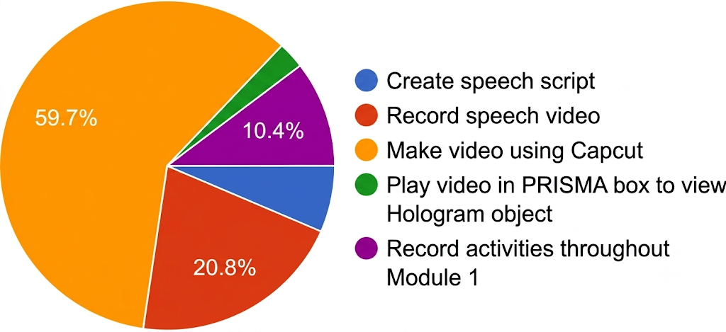

Figure 2. The most enjoyable activity
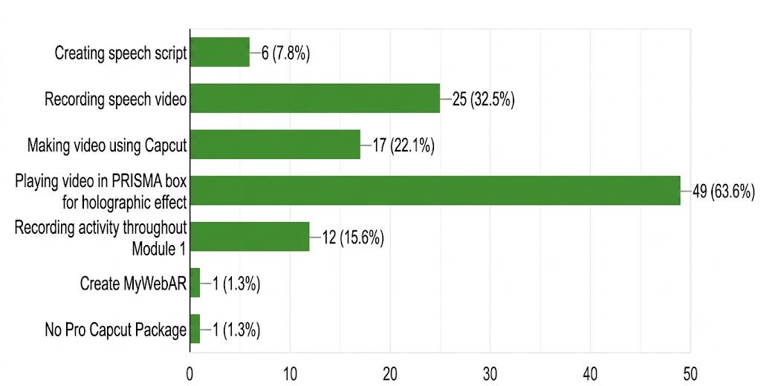
This demonstrates that Module 1 successfully introduced immersive technology through experiential learning, which not only enhanced understanding but also made the learning process more meaningful, enjoyable, and relevant to 21st-century skills. Overall, Module 1 succeeded in attracting students' interest and offering a balanced learning experience that integrated both cognitive and emotional elements.
Module 2: Augmented Reality - MyWebAR
In Module 2, students reflected on the most challenging and enjoyable activities involving MyWebAR. The pie chart analysis (see Figure 3) showed that the most challenging task was adding "Actions" to each object (28.9%), followed by registering on the application (25%) and inserting multiple object types into the canvas (22.4%). Only 15.8% reported difficulty in adjusting object position and size, while using the "Properties" panel posed the least challenge (7.9%). These findings indicate that students encountered greater difficulty understanding interactive elements compared to basic technical operations.
Figure 3. The most challenging activity
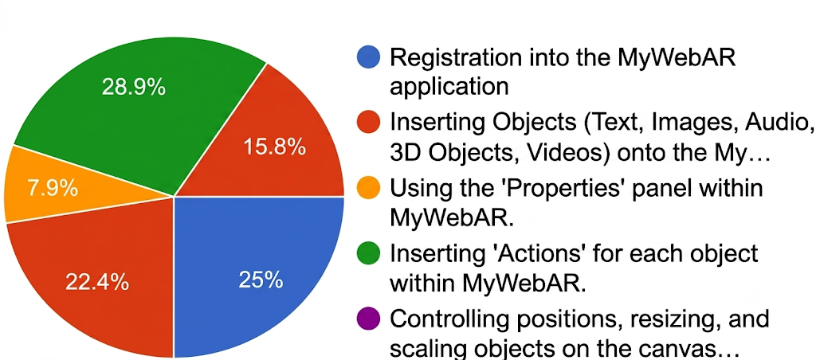
On the other hand, nearly all participants found the activities enjoyable (see Figure 4), particularly creating and visualising 3D and AR objects on their smartphones. This generated excitement and curiosity to explore augmented reality technologies further. This confirms that Module 2 effectively introduced AR technology through a hands-on learning approach.

Figure 4. The most enjoyable activity
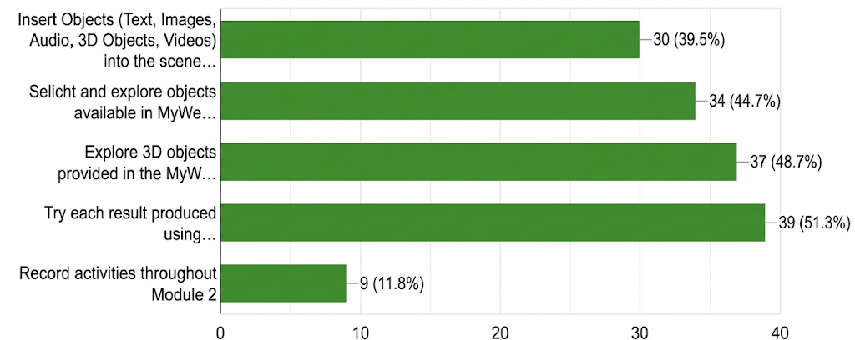
Module 3: AI Applications
In Module 3, which covered Prezi.AI and InVideo, the pie chart analysis (see Figure 5) indicated that the most challenging activity was preparing STEM content for Prezi.AI slides (36.1%), followed by preparing or modifying prompt scripts (33.3%). This suggests that students found it more difficult to generate appropriate content to guide AI applications.
Figure 5. The most challenging activity
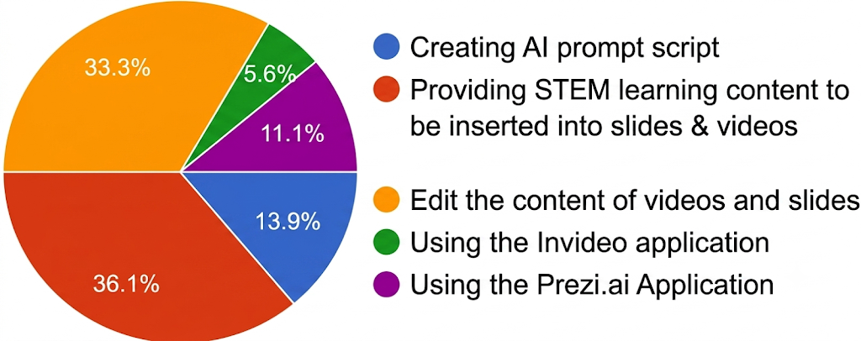
Nevertheless, almost half of the participants identified using both AI applications as the most enjoyable activity (see Figure 6). The process of writing prompt scripts, sourcing STEM materials, and witnessing the AI generate creative outputs independently sparked a sense of amazement and enthusiasm, encouraging further exploration of AI tools. This demonstrates that Module 3 successfully introduced AI-powered applications through hands-on learning.
Figure 6. The most enjoyable activity
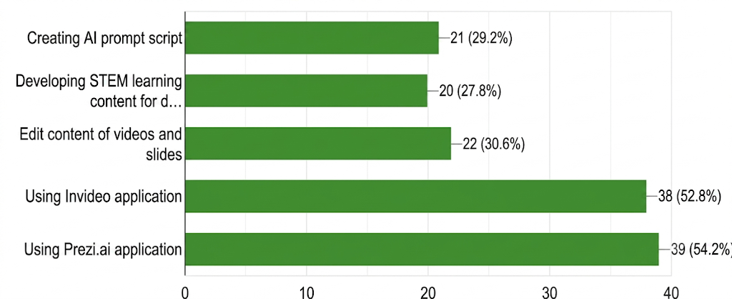
Module 4: Introduction to IoT
In Module 4, students reflected on their experiences with IoT tools. The analysis (see Figure 7) showed that the most challenging activity was uploading code to the NodeMCU (46.3%), followed by difficulties in displaying live data accurately using the Blynk application (29.9%).
Figure 7. The most challenging activity
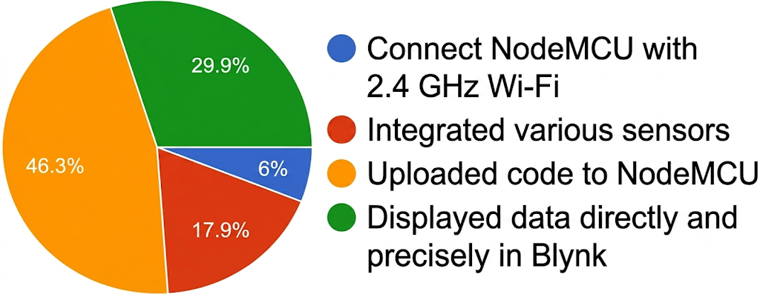
Despite these challenges, students found the introduction to IoT devices highly enjoyable, especially activities involving wiring connections and reading sensor data (see Figure 8). These experiences generated excitement and inspired students to explore further IoT innovations. This indicates that Module 4 effectively introduced IoT technology using a hands-on approach.
Figure 8. The most enjoyable activity
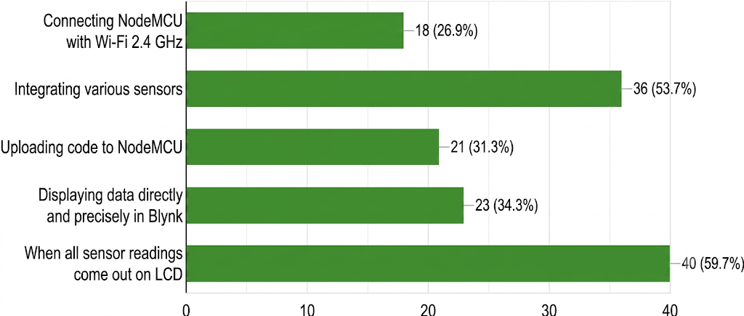
Module 5: IoT Control
In the final module, students reflected on their experiences with IoT control systems. The analysis revealed that the most challenging task was configuring connections between Google Assistant, IFTTT, and Adafruit IO (see Figure 9). This difficulty arose partly from differences in participants' computer hardware and smartphone models.

Figure 9. The most challenging activity
Nonetheless, all groups managed to complete the tasks successfully, and the activities ran smoothly. Students particularly enjoyed activities involving LED control, which provided a sense of achievement and practical application of IoT concepts (see Figure 10). This confirms that Module 5 successfully introduced IoT control systems through hands-on learning.
Figure 10. The most enjoyable activity
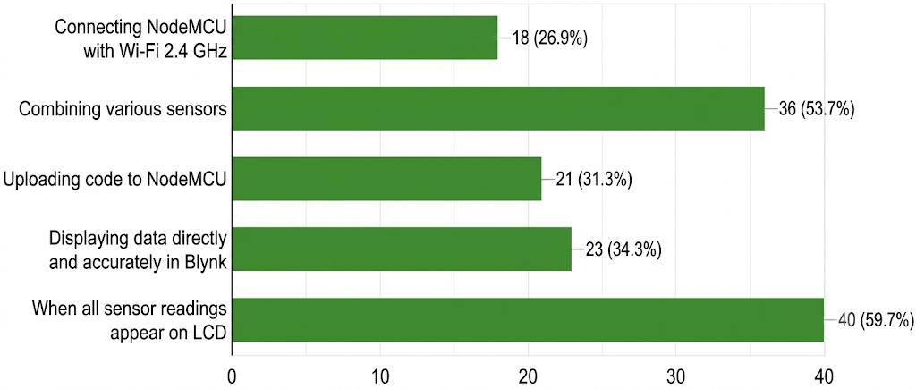
Analysis of the Pre-Post Study Session
This session aimed to evaluate participants' levels of knowledge, understanding, and confidence before and after attending the IR4.0 Technology Literacy Workshop. The questionnaire included items covering key topics such as AI, AR, and the IoT, as well as participants' ability to apply these technologies in real-life contexts. The collected data was analysed to identify improvements in knowledge and skills related to IR4.0 technologies among participants.
The pre-post analysis provided the basis for assessing the effectiveness of the training modules and delivery methods used during the workshop. Workshop participants comprised 80 secondary school students and 20 accompanying teachers, with 50.6% coming from urban schools (see Figure 11). While the programme was initially designed for students from STEM streams, there were limitations in securing full participation from this group. Nevertheless, 54.4% of participants were from STEM streams (see Figure 12), meeting the intended target.

Figure 11. Participants of Workshop (Students’ stream)
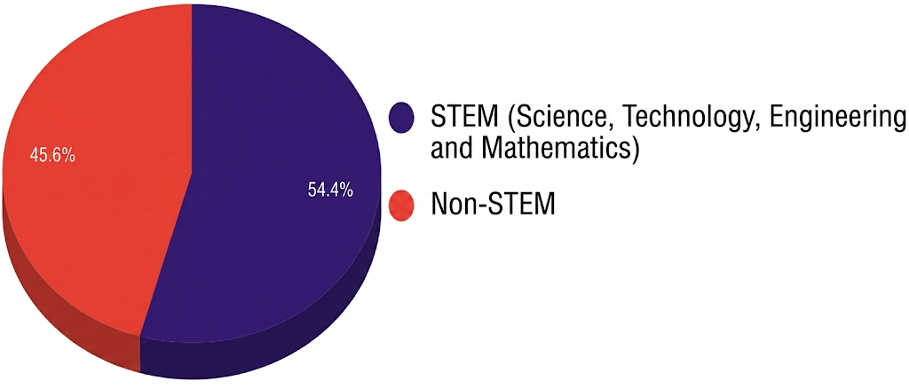

Figure 12. Participants of Workshop (School type)
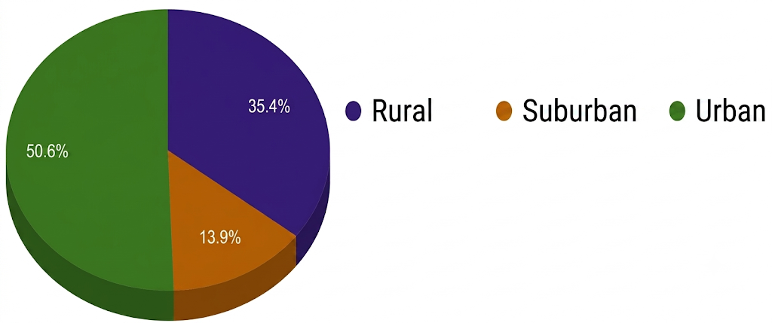
The findings revealed that the most frequently cited challenge in practicing IR4.0 technologies was a lack of knowledge (70.5%), followed by limited access to equipment, insufficient guidance, and lack of exposure (see Figure 13). These results indicate that before the workshop, students faced barriers from multiple angles, particularly in foundational areas such as knowledge and access to physical resources. Therefore, the implementation of a hands-on, structured training approach was deemed highly relevant in addressing these challenges.
Figure 13. The most frequently cited challenge in practicing IR4.0 technologies
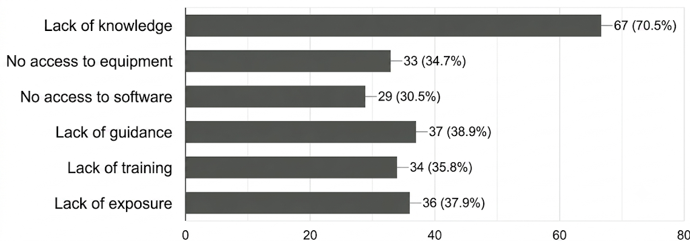

Analysis of Participants' Knowledge Assessment
Table 1 presents the list of questionnaire items along with their corresponding question numbers, designed to assess participants' baseline knowledge prior to the workshop. The questions cover a range of topics related to Industrial Revolution 4.0 (IR4.0) technologies, including holography, Augmented Reality (AR), Virtual Reality (VR), Artificial Intelligence (AI), immersive applications in STEM, and the Internet of Things (IoT). These items were intended to gauge participants' understanding of fundamental concepts, key components, and real-world applications before the commencement of the training sessions.
Table 1. Knowledge Assessment Questionnaire
No | Description
1 | I can distinguish between Hologram, AR, and VR.
2 | I understand how holographic technology works.
3 | I can explain how AR adds digital elements to the real world.
4 | I understand the applications of immersive technology in STEM and IR4.0.
5 | I understand the role of AI in producing digital learning materials.
6 | I understand the basic concept of the Internet of Things (IoT).
7 | I know the basic components of an IoT system (sensor, connectivity, processor).
8 | I can give examples of real-world IoT applications.
9 | I understand how IR4.0 technologies facilitate daily tasks.
The graphs in Figure 14 illustrate participants' self-assessment of their knowledge levels before and after the workshop. The analysis shows a significant and positive increase. Before the workshop, the majority rated their knowledge at the lower end of the scale, levels 1 (very low) and 2 (low), for almost all items.
Figure 14. Participants' self-assessment of their knowledge levels before and after the workshop
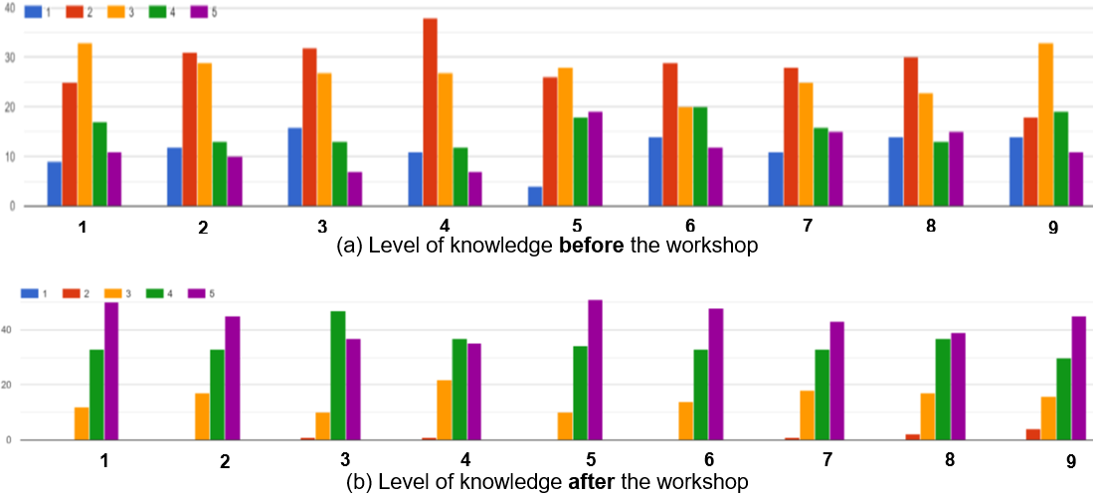
This demonstrates that participants initially had very limited understanding of topics such as holograms, Augmented Reality (AR), Virtual Reality (VR), applications of immersive technology in STEM and IR4.0, the role of AI in digital learning, as well as the basic concepts and components of IoT.
After the workshop, there was a remarkable improvement, with most participants rating their knowledge at level 4 (high) and level 5 (very high). No participants recorded low scores (levels 1 or 2) after the workshop, confirming that the intended learning objectives had been successfully achieved.
Analysis of Participants' Skills Assessment
Table 2 presents the list of questionnaire items for assessing participants' practical skills relevant to IR4.0 technologies. The items evaluate the ability to create holographic videos, develop interactive Augmented Reality (AR) content, utilise various AI-powered tools for content creation, integrate narratives with visual elements in educational media, and implement Internet of Things (IoT) applications. This section was designed to measure participants' applied competencies in combining creativity, technology, and problem-solving for innovative solutions.
Table 2. Skills Assessment Questionnaire
No | Description
1 | I am able to create a hologram video using the CapCut application.
2 | I can use the PRISMA technique and produce a hologram object.
3 | I am able to create interactive STEM content using AR elements.
4 | I know how to use the MyWebAR application.
5 | I can combine visual creativity and technology to produce an AR application.
6 | I can use Prezi AI to produce interactive presentations.
7 | I know how to write a script and generate automated videos using InVideo AI.
8 | I can integrate narrative and visuals effectively in an educational video.
9 | I can connect sensors to a controller and read data from it.
10 | I can design an IoT project idea that can solve problems.
11 | I can produce an innovation that integrates IR4.0 technologies.
The graphs in Figure 15 present participants' self-assessment of their skills before and after the workshop. Initially, most participants rated their skills as low, levels 1 (not skilled) and 2 (less skilled), particularly in areas such as creating hologram videos, using applications like CapCut, MyWebAR, Prezi AI, and InVideo AI, and implementing basic IoT projects.
Figure 15. Participants' self-assessment of their skills levels before and after the workshop
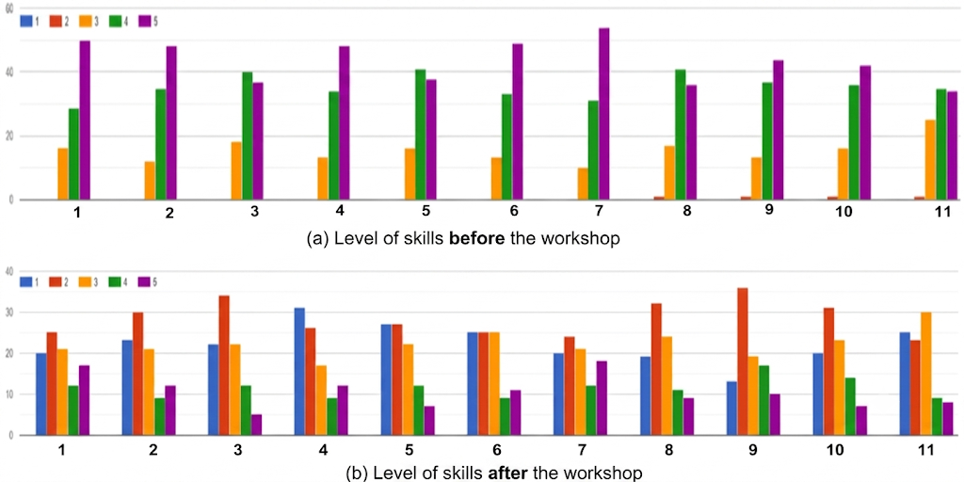
Following the workshop, self-assessments revealed a substantial positive shift, with the majority rating their skills at level 4 (skilled) and level 5 (highly skilled). This reflects the workshop's effectiveness in developing participants' practical competencies through hands-on and project-based learning activities.
CONCLUSION AND RECOMMENDATIONS
The "Transformation of IR4.0 Technology Literacy" program significantly empowered asnaf students from UiTM and STEM secondary schools in Perlis by enhancing their knowledge, practical skills, and confidence in key technologies such as AR, IoT, AI, VR, and holograms through a structured, hands-on learning approach. The marked improvements in participants' self-assessments highlight the program's effectiveness in fostering both understanding and creative application of IR4.0 technologies. For future implementation, the program should be expanded to reach more students, strengthened through institutional partnerships, enriched with advanced modules, and supported with efforts to address infrastructure gaps in rural schools, ensuring sustainability and alignment with national education goals.
ACKNOWLEDGMENT
This study was funded by Universiti Teknologi MARA (UiTM) Cawangan Perlis under the Geran Inovatif Zakat (GIZA) 2024 (Grant No.: 600-UiTMPs (PJ/UPP-GIZA6 2024)). The author gratefully acknowledges the support provided by MASARI Holdings Sdn. Bhd., SSTP JPN Perlis, and all individuals who contributed to this research.
REFERENCES
- Saari, M. S. Rasul, R. M. Yasin, R. A. A. Rauf, Z. H. M. Ashari, and D. Pranita (2021). "Skills Sets for Workforce in the 4th Industrial Revolution: Expectation from Authorities and Industrial Players," Journal of Technical Education and Training, vol. 13, no. 2, pp. 1–9, Jan. 2021, Available: https://publisher.uthm.edu.my/ojs/index.php/JTET/article/view/7830
- R. Idris and J. Bacotang (2023). "Exploring STEM Education Trends in Malaysia: Building a Talent Pool for Industrial Revolution 4.0 and Society 5.0," International Journal of Academic Research in Progressive Education and Development, vol. 12, no. 2, Apr. 2023, doi: https://doi.org/10.6007/ijarped/v12-i2/16825.
- Hanafi, A. G., Ahmad, H. H., Mansor, M. F., & Mustafa, W. A. (2023). "An Integrated Approach in Empowering Technical and Vocational Education and Training (TVET) for Malaysian Asnaf in the IR4.0 Era," Journal of Advanced Research in Applied Sciences and Engineering Technology, 30(2), 255–271. https://doi.org/10.37934/araset.30.2.255271
- Q. Xia, T. K. F. Chiu, M. Lee, I. T. Sanusi, Y. Dai, and C. S. Chai (2022). "A self-determination Theory (SDT) Design Approach for Inclusive and Diverse Artificial Intelligence (AI) Education," Computers & Education, vol. 189, no. 104582, p. 104582, Nov. 2022, doi: https://doi.org/10.1016/j.compedu.2022.104582.
- E. Kormos and K. Wisdom (2021). "Rural Schools and the Digital Divide," Theory & Practice in Rural Education, vol. 11, no. 1, pp. 25–39, Jun. 2021, doi: https://doi.org/10.3776/tpre.2021.v11n1p25-39.
- R. Bhandari (2023). "Bridging the skills gap: Fuelling careers and the economy in Malaysia," Economist.com, 2023. https://impact.economist.com/new-globalisation/bridging-skills-gap-fuelling-careers-and-economy-malaysia
- M. N. A. Wahyudi, C. W. Budiyanto, I. Widiastuti, P. Hatta, and Mohd. S. bin Bakar (2025). "Exploring Students’ Perception of Virtual Laboratory Adoption on an IoT Course," TEM Journal, pp. 1531–1547, May 2025, doi: https://doi.org/10.18421/tem142-52.
- M. Sirakaya and D. Alsancak Sirakaya (2020). "Augmented reality in STEM education: a systematic review," Interactive Learning Environments, vol. 30, no. 8, pp. 1–14, Feb. 2020, doi: https://doi.org/10.1080/10494820.2020.1722713.

