PROCUREEASE: A DIGITAL PROCUREMENT AND MONITORING SYSTEM

Background of the Study
Statement of the Problems
Objective of the Study
Significance of the Study
Scope and Delimitation
Definition of Terms
CHAPTER II REVIEW OF RELATED LITERATURE AND STUDIES
Related Literature ( Foreign&Local)
Related Studies ( Foreign&Local)
CHAPTER III METHODS OF RESEARCH AND PROCEDURES
Research Methodology
Research Design
Data Gathering
Statistical Treatment
CHAPTER IV SUMMARY OF FINDINGS, CONCLUSSIONS AND RECOMMENDATIONS
Summary of Findings
Conclusions
Recommendations
BIBLIOGRAPHY
APPENDICES
DFD Diagram
Context Diagram
Exploded Diagram
Program Flowchart
VTOC Diagram
IPO Diagram
Sample Screen Output
Program Listing
Users Manual
Evaluation Result
T-Test
Cost Benefit Analysis
CURRICULUM VITAE

CHAPTER I
PROBLEM AND ITS BACKGROUND
Background of the Study

Most people have already experienced delays and confusion in the procurement process, especially when it is done manually. According to Komakech (2015), the continuous development of technology has a significant influence on the education sector, particularly in improving processes and the overall experience within educational institutions. However, many local procurement systems still rely on traditional methods, such as manual processing of requests and verbal communication with administrators. According to Maturi (2013), this manual process often results in delays and misunderstandings, which can affect the quality of service and the satisfaction of requesters.

Established in 1986, St. Clare College of Caloocan is part of the St. Clare Group of Schools. It started as a small institution focused only on basic education, but later expanded its programs to include senior high school and various college courses. Its main goal is to provide quality and affordable education to students from Caloocan and nearby areas (St. Clare College, n.d.). Along with the institution’s growth, the need for proper management of school equipment, facilities, and other properties also expanded. Because of this, a custodian property management system was gradually developed, aiming to monitor, record, and safeguard school equipment. In its early stages, this was carried out through manual recording and coordination between teachers and administration.

At St. Clare College, the procurement process remains traditional. Each request for the purchase of supplies is recorded using purchase request forms prepared by each department. These forms are submitted to the property custodian for review and approval. Once the purchase request is approved by the custodian, it is forwarded to the accounting office to prepare the purchase order and allocate the necessary budget for acquiring academic supplies. Requesters only become aware of the status of their purchase requests when they personally inquire or visit the office. They do not receive any form of notification, such as letters or email updates, even when the items are about to be delivered. As a result, there is a lack of communication and transparency throughout the procurement process.

However, due to the lack of a digital and centralized procurement system, various problems arise such as delays in the process, loss of documents, difficulty in tracking requests, slow processing, a cumbersome procedure, and unaddressed requests. Users find it difficult to monitor their requests, which may result in an unorganized workflow in the office or institution, delays in projects and operations, a decline in the quality of service for students or clients, and confusion and errors due to missing documents (Field Observation, 2026).

To address these issues, the project entitled ProcureEase: A Digital Procurement and Monitoring System for St. Clare College was developed. The system aims to automate and centralize the institution’s procurement process. Through features such as purchase request submission, digital approval processes, and real-time tracking, the system is designed to reduce manual procedures, enhance transparency, and ensure the timely delivery of required supplies.

This system is expected to benefit not only the procurement office by making operations more efficient and accurate, but also teachers and staff by providing more reliable access to essential educational and office supplies. In addition, it may serve as a model for other educational institutions that wish to transition from traditional systems to digital processes, contributing to the broader goal of modernization and transparency.

Statement of the Problem

The proponents aimed to know what the problem in their existing process was in order to identify possible improvements and develop more efficient solutions.the proponents conduct an interview with custodian property management of st.clare college of caloocan,they told us the problems they usually encountered a.) lack of real-time tracking affect delays, confusion, and the lack of clear information in purchase requests. b.) manual documentation and approval affect the loss of documents, occurrence of errors, and longer processing time in the procurement system. c.) limited communication and transparency affect the verification of request status. d.) inaccurate procurement record-keeping affect reporting and decision-making. e.) automated system for submission, approval, and monitoring help address current procurement issues.

Objective of the Study
This study was conducted with the focus on fulfilling the general and specific objective.

General Objective
The general objective of the study is to develop and evaluate a ProcureEase: A Digital Procurement and Monitoring System for St.Clare College that will serve as an aid or tool for fast and efficient work result.
Specific Objective
- To develop a system that will allow departments to submit their purchase requests.
- To develop a system that will digitalize the procurement process.
- To develop a system that simplifies procurement process and helps reduce delays and inefficiencies caused by manual procedures.
- To develop a system that will provide fast and efficient service through an automated process that will reduce the time required for processing requests..
- To develop a system that will enhance communication between departments and the procurement office,ensuring that the entire purchase request process can be monitored through a digital platform.
- To develop a system that will improved transparency,accuracy and user satisfaction through real-time tracking of purchase request that will assist in the approval process.
- To evaluate the software according to the following criteria.

a) Functionality – Assesses whether the system can perform all required procurement tasks, such as submission, approval, and tracking of requests within a digital environment.

b) Accuracy – Ensures that the system provides correct and reliable data for every transaction, which is essential for proper decision-making and record-keeping.

c) Usability – Evaluates how easy and user-friendly the system is for users, including employees and procurement staff, to effectively perform their tasks.

d) Reliability – Determines whether the system operates consistently and without failure, especially in processing and monitoring purchase requests.

e) Maintainability – Assesses how easy it is to update, modify, and maintain the system to ensure its continued effectiveness in digital procurement and monitoring.

Significance of the Study
This study is important because it helps address the problems in the current paper-based procurement process at St. Clare College. Through the development of a centralized and automated digital procurement and monitoring system, this research aims to improve the speed and facilitate the process of requesting, approving, and tracking academic supplies. The implementation of this system is expected to bring significant benefits to various stakeholders within the school community and beyond.
- St. Clare College - This study is highly important to St. Clare College because it directly addresses the deficiencies and problems of the current paper-based procurement process. Through the implementation of a centralized and automated digital procurement and monitoring system, it is expected that the processing of purchase requests in the academic institution will become faster, more efficient, and more transparent.
- Departments - This study is important for all departments at St. Clare College because it simplifies and speeds up the process of requesting academic supplies. Through ProcureEase, each department can easily submit their purchase requests and monitor their status in real time. This reduces delays, minimizes confusion, and improves communication with the procurement office, allowing departments to focus more on their core responsibilities rather than administrative follow-ups.

- Property Management Custodian - This study is helpful because the digital system simplifies the process of reviewing and approving purchase requests, reducing reliance on manual and paper-based procedures. It is important for them as it allows easier tracking of school supplies and equipment with proper organization and management.It also results in faster inventory updates, improved coordination with the procurement office, higher accuracy and accountability, and quicker decision-making in handling purchase requests, ensuring that all processes are accurate and completed on time.

- Accounting Office - For the accounting office, this system is very beneficial because it simplifies the processing, monitoring, and validation of all financial transactions related to procurement. Through the automation of budget allocation and the creation of purchase orders, record-keeping becomes more accurate and errors are reduced. It improves financial management and audit readiness, which supports better decision-making and proper allocation of funds.

- 5. Student - The proponents are the biggest beneficiaries of this study because it ensures that academic supplies in the school are always available. It helps create a better learning environment and supports the continuous delivery of educational services that directly benefit the students.
- Proponents - This study benefit greatly as they gain actual experience in analyzing real problems within an organization and developing a practical solution through a centralized and automated procurement system. In this study, they are able to apply their knowledge of systems analysis, database management, and software development in a meaningful context. It also enhances their skills in problem-solving, critical thinking, and system design.
- Future Proponents - Benefit from this study because it serves as a reference and foundation for their own research on digital systems and automation in educational institutions. It provides insights into the challenges and solutions in procurement, encouraging further innovation and improvement of digital solutions in the future.

Overall The ProcureEase system is expected not only to improve the operational efficiency of St. Clare College but also to serve as a model for other institutions that aim to modernize their procurement practices, promoting transparency, accountability, and user satisfaction.

Scope and Delimitation
Scope
- Safe keeping of the custodian procurement database - The system ensures the safe keeping of the custodian procurement database at St. Clare College of Caloocan through controlled access, secure login, data encryption, audit logs, and regular backups.
- Web Application Purchase Request - The Web Application Purchase Request at St. Clare College of Caloocan enables users to submit and track requests with basic approval and monitoring features.
- Creating Request for Procurement easily - The custodian property department can easily create a procurement request through a simplified digital form such as input and submit.
- Sending Request procurement for accounting easily - The system allows procurement request to be easily sent to the accounting department through a streamlined digital workflow, limited to basic routing and submission features only.
- Accounting Processing Module - Approved requests are transmitted to the accounting office for budget allocation and preparation of purchase orders.
- Real-Time Request Tracking - The system provides users with the ability to monitor the status of their requests in real time. This improves transparency and eliminates the need for manual follow-ups or physical inquiries.
- Generating Printed Layout for Purchase Request - The system has a capability to produce a printable format for purchase requests, constrained to simple formatting and printing functions
- Login Users - Secure St. Clare College to authorized sign ups of unauthorized personnel by approving or dis-approving account of the user.

Delimitaion
Institutional Limitation - The system is designed exclusively for St. Clare College and is not intended for implementation in other institutions.
Scope of Functionality - The system focuses only on procurement processes and does not include inventory management, supplier/vendor management, stock monitoring features.
Financial Transactions Limitation - Payment processing and financial disbursement are not included in the system.
Platform Limitation - The system is developed as a web-based application only and does not support mobile application functionality.
Implementation Limitation - The study is limited to system development, testing, and initial deployment, and does not cover full-scale institutional integration.
Evaluation Limitation - System evaluation is limited to selected users within the institution and may not represent all possible user experiences.

Definition of Terms
Procurement System — A computerized or automated process designed to manage, speed up, and monitor the entire process of acquiring goods, services, or materials within an academic institution. It includes tasks such as request creation and management, supplier selection, purchase order creation, and tracking of purchase requests. It may also include an approval workflow to ensure transparency, efficiency, and compliance with school policies.
Purchase Request (PR) — A formal document or electronic request submitted by a department to request the purchase of school supplies. It specifies item details, quantity, and purpose, and serves as the first step in the procurement process.
Purchase Order (PO) — An official and legal document issued by the buyer to the supplier as confirmation of the purchase of specific supplies or services based on agreed terms such as price, quantity, and delivery date.
Automation — The use of technology, especially software applications, to perform tasks with minimal human intervention. In a procurement system, it helps reduce errors and speed up processes.
Database — An organized collection of data containing information related to procurement, such as supplier details, purchase records, and inventory levels. It provides a fast and efficient way to access and manage data within the system.
User Interface (UI) — The part of the procurement system that allows users to interact with the software. It includes dashboards, forms, and menus used for data entry and viewing.
Approval Workflow — A sequence of steps or authorizations required to approve a purchase request or purchase order within an organization. It defines the roles of each user and ensures accountability and compliance with school policies.
CHAPTER II
RELATED LITERATURE AND STUDIES

Foreign Literature
2.1.2 Mary Girsch-Bock (2026)

Through the work of Mary Girsch-Bock (2026) discusses how traditional procurement systems in educational institutions are often inefficient due to their reliance on manual, paper-based processes These outdated practices result in wasted time, lack of budget visibility, slow approvals, and increased risk of errors and non-compliance. Educational institutions face additional challenges such as managing limited budgets, maintaining transparency, and ensuring proper allocation of resources, which become difficult without a structured digital system.

The article explains that digital transformation in procurement, particularly through e-procurement systems, can address these issues by automating the entire procurement workflow—from requisition to payment. These systems enable real-time budget tracking, faster processing, and improved accuracy by reducing manual intervention. Additionally, technologies such as automation and artificial intelligence enhance decision-making, streamline operations, and improve overall efficiency. As a result, institutions can optimize resource management, strengthen compliance, and support better organizational performance through a more transparent and efficient procurement system.

2.1.2 E&I Cooperative Services (2023)

E&I Cooperative Services (2023) explains that educational institutions allocate a significant portion of their budgets to procurement activities, making it essential to implement efficient and structured purchasing systems. Traditional procurement methods are often time-consuming and inefficient due to manual processes, lack of centralized data, and limited visibility into transactions. These challenges can result in delays, poor decision-making, and difficulty in managing supplier relationships and procurement records.

The article discusses that e-procurement systems provide a digital solution that automates and streamlines the entire procurement lifecycle, from vendor registration to payment processing. Through centralized platforms, institutions can manage requisitions, quotations, approvals, purchase orders, and invoicing in a more organized and efficient manner. Additionally, e-procurement systems offer benefits such as cost savings, shorter procurement cycles, improved transparency, and better tracking of procurement activities through audit trails and reporting tools. These features enable educational institutions to enhance efficiency, ensure accountability, and support data-driven decision-making in procurement management.

2.1.3 E Concept (2026)

EConcept (2026) describes how procurement processes in educational institutions are frequently affected by inefficiencies, lack of coordination, and limited transparency, and poor coordination among departments. Many schools still rely on traditional procurement practices such as manual documentation, email-based requests, and fragmented systems, which result in delays, errors, and difficulty in tracking procurement activities. These issues make it challenging for institutions to manage purchasing effectively and ensure accountability in resource allocation.

The article explains that implementing digital procurement systems can address these challenges by streamlining workflows and improving overall process visibility. Through automation and centralized platforms, schools can efficiently manage requisitions, approvals, and supplier interactions in a more organized manner. Digital systems also enhance real-time monitoring, allowing institutions to track procurement activities, control budgets, and ensure compliance with policies. As a result, adopting digital procurement solutions leads to improved efficiency, better decision-making, and increased transparency in school operations.

2.1.4 Hallikas, Immonen, and Brax (2021)

Hallikas, Immonen, and Brax (2021) emphasize that one of the major challenges in procurement is the limited ability of traditional systems to effectively utilize data, which hinders operational efficiency and informed decision-making. In conventional procurement processes, organizations often rely on manual procedures and fragmented systems, making it difficult to analyze data, monitor performance, and improve overall operations. This limitation can lead to inefficiencies, delays, and reduced effectiveness in supply chain management.

The authors argue that digital procurement systems, when integrated with data analytics capabilities, can address these challenges by enabling organizations to process and analyze procurement data more efficiently. Their study found that digital procurement capabilities significantly improve supply chain performance by supporting data-driven decisions and enhancing operational processes. The findings highlight the importance of adopting digital technologies in procurement systems to achieve better efficiency, transparency, and overall organizational performance.

Local Literature
2.1.5 (Digital Procurement in the Philippines) (n.d.)

The document on digital procurement in the Philippines (n.d.) presents how traditional procurement processes in government and institutions are often inefficient, lack of transparency, and delays due to manual and paper-based systems. These challenges make it difficult for organizations to ensure accountability, proper monitoring, and efficient allocation of resources.

The document explains that the implementation of digital procurement systems, such as electronic platforms, can improve procurement efficiency by automating processes, enhancing transparency, and enabling better tracking of transactions. It highlights that digital procurement supports faster processing, reduces errors, and promotes accountability in procurement operations. The discussion underscores the importance of adopting digital systems to modernize procurement practices and improve overall organizational performance in the Philippines

2.1.6 Bicol University (2022)

Bicol University (2022) outlines how procurement in educational institutions follows structured processes to ensure transparency and accountability, and efficient use of resources. The university implements procurement activities through its Bids and Awards Committee (BAC), which manages the acquisition of goods, services, and infrastructure while ensuring compliance with government regulations.

In traditional procurement systems, institutions rely on formal procedures such as bidding, documentation, and approval workflows, which may involve multiple steps and coordination among departments. These processes, while ensuring transparency, can also lead to delays and inefficiencies if not supported by digital systems. The university’s procurement practices highlight the importance of organized workflows, proper documentation, and monitoring to maintain accountability and effective resource management.

Foreign studies
2.1.7 Chiang and Chuang (2024)

Chiang and Chuang (2024) examined the role of sustainable supply chain practices in procurement performance is the integration of sustainable supply chain management practices, which influence environmental and operational outcomes. In traditional procurement systems, organizations often focus only on cost and efficiency, overlooking environmental sustainability and resource optimization, which can lead to long-term inefficiencies and negative environmental impacts.

The authors explain that adopting sustainable supply chain management in procurement can improve environmental performance by promoting more responsible resource utilization and better procurement decision-making. Their study highlights that integrating sustainability principles into procurement processes enhances overall efficiency, supports environmental goals, and improves organizational performance through more structured and responsible procurement practices.

2.1.8 Pala (2014)

Pala (2014) analyzed the role of information systems in improving decision-making processes in organizations, The study highlights that traditional manual systems often result in inefficiencies, delays, and difficulties in managing large volumes of data, which can negatively affect operational performance and decision quality.
The author explains that the implementation of electronic and digital information systems can improve data management, enhance accessibility of information, and support more accurate and timely decision-making. The study found that integrating information systems into organizational processes leads to improved efficiency, better data organization, and enhanced operational performance. The findings underscore the value of adopting digital systems to support effective and data-driven decision-making in organizations.

2.1.9 Alabdali and Salam (2022)
Alabdali and Salam (2022) conducted an empirical study on digital transformation and its impact on procurement performance and enhancing organizational competitive advantage. The study highlights that traditional procurement systems often face challenges such as inefficiency, lack of transparency, and limited data utilization, which negatively affect overall performance and decision-making.

The authors explain that adopting digital procurement systems can address these issues by automating procurement processes, improving data management, and enabling better coordination among stakeholders. Their empirical study found that digital transformation significantly improves supply chain procurement performance and contributes to achieving competitive advantage. The results further show that procurement acts as a mediating factor between digital transformation and competitive advantage, highlighting its importance in organizational success.

2.1.10 Susanto, Martono, Wardani, Sangka, and Wahyono (2025)
Susanto et al. (2025) investigated factors influencing the continued use of e-procurement systems in educational institutions is ensuring continuous user acceptance and effective system utilization. In many cases, users may resist adopting digital procurement systems due to lack of familiarity, insufficient digital skills, and limited institutional support, which can hinder system effectiveness.

The authors explain that factors such as system quality, usability, and digital readiness significantly influence users’ perceptions of usefulness and ease of use. Their study, conducted among 3,110 schools using a Technology Acceptance Model (TAM), found that these factors directly affect the continued use of e-procurement systems. The findings highlight that strong digital leadership and adequate technological infrastructure are essential in ensuring successful adoption and sustainability of digital procurement systems in educational settings.

Local Studies
2.2.1 Bacalso, Pleto, Fernandez, and Jain (2024)

Bacalso et al. (2024) developed a web-based procurement management system integrated with monitoring and tracking features, which often results in delays, inefficiencies, and lack of transparency. In traditional procurement systems, organizations struggle with identifying the status of procurement requests and managing documents effectively, leading to poor coordination among users.

The authors developed a web-based procurement management system with process monitoring and tracking features to address these issues. Their study found that the system enables real-time monitoring of procurement activities, improves document management, and enhances process visibility. The results highlight that integrating digital systems in procurement significantly improves efficiency, transparency, and decision-making in organizational operations.

2.2.2 Almacen and Cabaluna (2021)
Almacen and Cabaluna (2021) examined that one of the major challenges in organizations, particularly in the healthcare sector, is the reliance on traditional paper-based documentation, which leads to inefficiencies, data loss, and difficulty in managing records. In conventional systems, documents are manually stored and maintained, making them vulnerable to damage, loss, and slow retrieval, which affects the overall efficiency of operations and decision-making.

The authors argue that implementing an Electronic Document Management System (EDMS) can address these challenges by digitizing records and enabling faster access, improved organization, and better data security. Their study found that EDMS improves efficiency, enhances information accessibility, and supports better decision-making through timely and accurate data management. The findings highlight the importance of adopting digital document management systems to improve operational performance, reduce errors, and support digital transformation in organizations.

2.2.3 (Belmonte and peralta) (2026)

Belmonte and Peralta (2026) investigated the impact of digital systems on information management and organizational processes by enhancing efficiency, accuracy, and accessibility of data. Traditional manual systems often result in delays, errors, and difficulties in tracking information, which can negatively affect decision-making and operational performance.

The authors explain that adopting digital systems can help address these challenges by automating processes, improving data organization, and enabling faster access to information. The study found that digitalization significantly improves operational efficiency, reduces processing time, and enhances overall system performance. The findings highlight the importance of implementing digital solutions to support more efficient and reliable organizational processes.

CHAPTER III
METHODS OF RESEARCH AND PROCEDURES
3.1 Research Methodology
This chapter presents the research methodology used in the development and evaluation of the system entitled “ProcureEase: A Digital Procurement and Monitoring System for St. Clare College.” It includes the research design, data gathering procedures, data analysis, and statistical treatment used in the study.

3.2 RESEARCH DESIGN
The study employed a mixed-methods research design, combining quantitative and qualitative approaches in the development and evaluation of the ProcureEase: A Digital Procurement and Monitoring System for St. Clare College.
A mixed-methods design was used because the study involves both measurable system performance and user experiences. The quantitative data provides numerical evaluation of the system, while qualitative data explains user insights and actual problems encountered in the procurement process.
First, the study requires measurable data such as system usability, accuracy, and user satisfaction, which are best obtained through quantitative methods. However, numerical data alone cannot fully explain the challenges experienced in the existing manual procurement system.
Second, the study also requires understanding of user experiences, particularly from the property custodian personnel. These insights are best obtained through qualitative methods such as interviews, which provide deeper explanations of the problems and system needs.
The interview focused on gathering information about the current procurement process and its issues. The following are the sample guide questions used during the interview:

* What is the current workflow of the procurement process?
* Can you describe the step-by-step process of a procurement transaction?
* What problems do you usually encounter in the manual procurement system?
* Are there delays or difficulties in tracking requests?
* What improvements would you like to see if a digital system is implemented?
* What problems do you think will be solved by using a digital procurement system?

These questions helped the researchers understand the real situation of the procurement process and identify the system requirements.
Third, the use of mixed-methods allows for data triangulation, where the results from the survey can be supported and validated by interview responses. This ensures that the findings of the study are both reliable and comprehensive.
Thus, the mixed-methods design was used to ensure that the evaluation of the system is based on both measurable results and actual user experiences.

3.2.1 Quantitative Component
The quantitative component focuses on measurable data collected through a survey questionnaire distributed via Google Forms using a QR code.
It evaluates the system based on the following criteria:
Functionality – Determines if the system can perform procurement tasks such as request submission, approval, and tracking.
Accuracy – Measures if the system provides correct and reliable procurement data.
Usability – Evaluates how easy the system is to use for employees and staff.
Reliability – Assesses if the system operates consistently without errors or delays.
Maintainability – Determines how easy it is to update and manage the system over time.
The collected data were analyzed using descriptive statistics such as frequency, percentage, and weighted mean to determine the overall performance and acceptability of the system.

3.2.2 Qualitative Component
The qualitative component focuses on understanding the existing problems in the manual procurement process and gathering user insights.
Data were collected through semi-structured interviews with selected personnel from the property custodian department. The interview focused on:

• Challenges in the current procurement process
• Issues in tracking and monitoring requests
• Suggestions for system improvement

3.2.3 Integration of Methods
The quantitative and qualitative data were integrated during the analysis phase.
Survey results were compared with interview responses to determine consistency between numerical evaluation and actual user experiences. This integration ensures that the conclusions of the study are supported by both statistical data and real-world insights.

3.3 Respondents of the Study
The respondents of this study were selected personnel from departments involved in procurement activities at St. Clare College of Caloocan, including the Accounting Department,, and Property Custodian Management.
A total of fourteen respondents participated in the survey, which was conducted using Google Forms and distributed through a QR code. Although the researchers initially aimed to gather a larger number of respondents, only fourteen were able to complete the survey due to time constraints.
In addition, two respondents from the Property Custodian Department were selected for the interview. These participants were chosen because of their direct involvement in the procurement process and their knowledge of the current manual system.
The study utilized purposive sampling, as the respondents were specifically selected based on their roles and relevance to procurement-related activities within the institution.

3.4 Research Instruments
The study utilized the following research instruments to collect and analyze data for the evaluation of the ProcureEase system:

3.4.1 System Prototype
A web-based procurement and monitoring system named ProcureEase was developed as the main output of this study. The system includes the following features:

• Purchase request submission
• Digital approval process
• Real-time tracking of requests
• Monitoring of procurement status
The system prototype served as the primary tool for evaluating system performance, usability, and overall effectiveness.

3.4.2 Survey Questionnaire
A structured survey questionnaire was developed using Google Forms and distributed through a QR code to selected respondents.
The questionnaire consists of four (4) parts:

Part I: Respondent Profile
This section identifies the profile of the respondents in terms of their department, including Accounting, Clinic, and Property Custodian Management.

Part II: Problems Encountered in Procurement
This section evaluates the common problems experienced in the current manual procurement system, such as delays, missing or hard-to-find documents, slow approval procedures, coordination challenges between departments, and difficulty in tracking requests. The section uses a 5-point Likert scale, where 5 – Always, 4 – Sometimes, 3 – Often, 2 – Seldom, and 1 – Never.

The indicators include:

• Procurement Delays (e.g., delays in processing requests)
• Document Management Issues (e.g., missing or hard-to-find documents)
• Approval Process Efficiency (e.g., slow approval procedures)
• Coordination Challenges (e.g., difficulty communicating with departments)
• Tracking Difficulties (e.g., lack of real-time status updates)

Part III: Proposed System Features
This section assesses the respondents’ perceptions of the proposed ProcureEase system in terms of system efficiency, real-time tracking capability, ease of use, reduction of errors, user adaptability, and overall improvement of procurement operations. The section uses a 5-point Likert scale, where 5 – Strongly Agree, 4 – Agree, 3 – Neutral, 2 – Disagree, and 1 – Strongly Disagree.

It includes questions related to:

• Speed of procurement process
• Real-time tracking
• Ease of submitting requests
• Reduction of errors
• Improvement of overall operations

Part IV: Overall Feedback
This section gathers general feedback from the respondents regarding the usefulness of the system, the need for training, and their willingness to recommend its implementation. The responses are measured using percentage-based options such as Yes, Maybe, and No.

It includes questions such as:
• Whether the system will improve services
• Need for user training
• Willingness to recommend the system

3.4.3 Interview Guide
A semi-structured interview guide was used to collect qualitative data from selected personnel in the Property Custodian Department.
The interview focused on the following areas:
• Current procurement workflow
• Step-by-step process of transactions
• Common problems encountered in the manual system
• Challenges in tracking and communication
• Suggested improvements for a digital system
Responses were recorded through note-taking and analyzed to identify recurring issues and system requirements.

System Development Process
The study followed the Waterfall Model in developing the ProcureEase system. This model follows a structured and sequential approach suitable for projects with clearly defined requirements.

1. Requirements Analysis
The researchers gathered data through interviews and surveys to identify the current procurement process and its existing problems, such as delays, lack of tracking, and manual documentation.
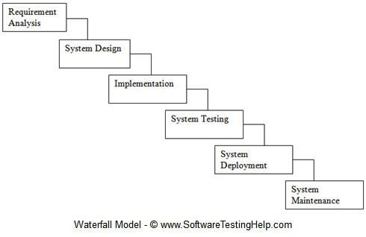

2. System Design
Based on the identified requirements, the system design was created, including database structure, system flow, and user interface layout.
3. System Development (Implementation)
In this phase, the ProcureEase system was developed as a web-based application with features such as request submission, approval process, and tracking system.
4. System Testing (Internal Testing)
The system underwent initial testing conducted by the researchers to check for errors, bugs, and functionality issues. Necessary corrections were made to improve system performance.
5. System Validation
The system was not fully deployed but was validated based on the gathered data from surveys and interviews. The responses of participants were used to support the need and effectiveness of the proposed system.
6. Maintenance
Future improvements and system updates are recommended to enhance performance and usability once the system is fully implemented.

3.5 Data Gathering Procedure
The data gathering process of the study was conducted in several phases to ensure systematic collection of both quantitative and qualitative data.

Phase 1: Permission and Coordination
The researchers first sought permission from St. Clare College of Caloocan to conduct the study. Coordination with the Property Custodian Department and other involved offices was done to explain the purpose of the study and request participation.

Phase 2: Initial Interview
The researchers conducted interviews with selected personnel from the Property Custodian Department to understand the current procurement process. This phase aimed to identify the workflow, common problems, and challenges encountered in the manual procurement system.

Phase 3: System Development
Based on the gathered information, the researchers designed and developed the ProcureEase system. The system was created as a web-based application to address issues such as delays, lack of tracking, and manual processing.

Phase 4: Survey Distribution
A structured survey questionnaire was distributed to selected respondents through Google Forms using a QR code. The survey aimed to gather data regarding the problems in the current system and the respondents’ perceptions of the proposed digital system.

Phase 5: Data Collection
The researchers collected the completed survey responses from fourteen (14) respondents and recorded the interview responses from two (2) participants. All data were organized and prepared for analysis, the following data were gathered from the respondents and system evaluation process:

• Completed survey questionnaires from selected respondents in the Accounting, Clinic, and Property Custodian Management departments
• Interview responses from selected Property Custodian personnel regarding the manual procurement process and system requirements
• Observation checklist entries recorded by the researchers during the procurement process evaluation
• System logs, including request timestamps and status updates, used for analyzing processing time and workflow efficiency
Phase 6: Data Organization and Analysis Preparation
All collected data were reviewed, encoded, and organized for statistical analysis and interpretation. The data were then used to evaluate the effectiveness of the ProcureEase system.
.
3.6 Statistical Treatment
The data gathered in this study were analyzed and interpreted using appropriate statistical tools to ensure accurate and systematic presentation of results from the survey and evaluation of the proposed system.
3.6.1 Frequency and Percentage Distribution
Frequency and percentage were used to describe the distribution of respondents in terms of department and to present the number of responses per survey item. This helps identify how many respondents selected each option and express it in percentage form for clearer interpretation.
Percentage Formula:
Percentage = (f / N) × 100

Where:
f = frequency of responses
N = total number of respondents

3.6.2 Weighted Mean
Weighted mean was used to determine the average response of the participants for each indicator in the survey, particularly in assessing problems encountered in procurement and evaluating the proposed ProcureEase system. This provides a general interpretation of the respondents’ overall perception.

Weighted Mean Formula:
Weighted Mean = Σ (W × X) / N

Where:
W = weight assigned to each response (1–5 scale)
X = frequency of responses
N = total number of respondents

3.6.3 Likert Scale Interpretation
The 5-point Likert scale was used to interpret the responses of the participants. For Part II, the scale ranges from 5 – Always to 1 – Never, while for Part III, it ranges from 5 – Strongly Agree to 1 – Strongly Disagree. The computed weighted mean was interpreted to determine the level of agreement or frequency of the respondents answers.
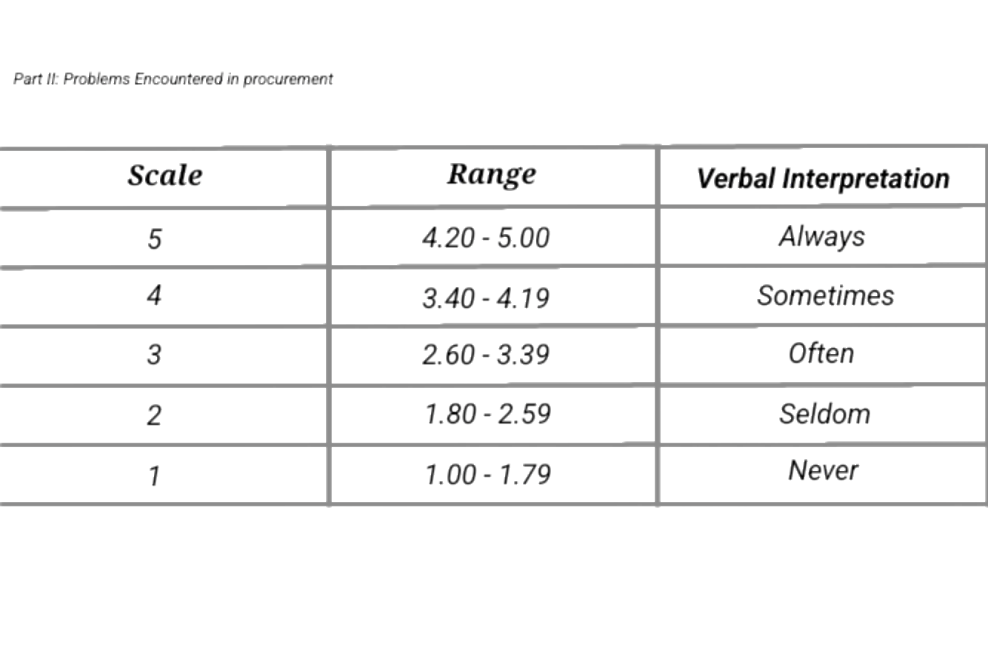
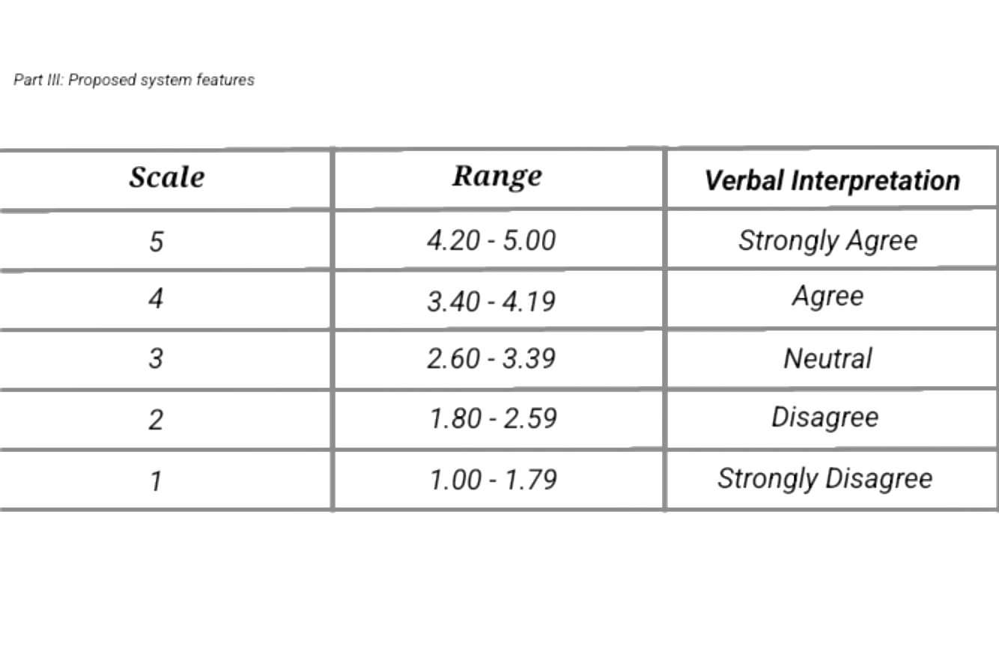
3.6.4 Mean and Standard Deviation
Mean was used to determine the overall average response for each survey indicator, while standard deviation was used to measure the consistency of the respondents’ answers. A low standard deviation indicates similar responses among participants, while a high standard deviation indicates varied opinions regarding the procurement process and the proposed system.

3.6.5 Thematic Analysis (Qualitative Data)
Qualitative data gathered from interviews were analyzed using thematic analysis. The process involved organizing and interpreting responses to identify common patterns and themes related to the procurement process.

The steps include:
• Reviewing all interview responses to understand the content
• Identifying and coding recurring ideas or statements
• Grouping codes into themes such as procurement delays, document issues, and communication problems
• Interpreting the themes to support the findings of the quantitative data
Thematic analysis was used to provide deeper understanding of user experiences and to complement the numerical results of the survey.

CHAPTER IV
SUMMARY OF FINDINGS, CONCLUSSIONS
AND RECOMMENDATION

This chapter presents the summary and conclusions of the study, which aims to examine the impact of ProcureEase: a digital procurement and monitoring system for St. Clare College, as a digital system for improving efficiency, transparency, and accuracy in the acquisition of equipment and supplies in an academic institution. It also provides recommendations for administrators and staff to further enhance the implementation of the system.

The study was conducted at St. Clare College of Caloocan. The respondent was the property management custodian, who was selected due to their direct experience in the procurement process.

Summary of Findings
Based on the observations and interviews conducted prior to the development of the system, the existing manual process of acquiring supplies for the academic institution at St. Clare College showed the following effects on service efficiency and the satisfaction of staff and departments that rely on the timely delivery of equipment and supplies.

a.) lack of real-time tracking for purchase requests.

The lack of real-time tracking in the procurement process causes serious effects on the operations of the institution. One of its main problems is the delayed updating of purchase request statuses, which results in confusion among users regarding where their requests currently are in the process. Because of this, staff are often forced to follow up repeatedly, leading to additional workload and inefficiency.

In some cases, the absence of real-time updates causes delays, confusion, and a lack of clear information regarding purchase requests. It also becomes a barrier to proper coordination between departments because there is no immediate access to updated information about the status of each request.

Furthermore, it results in a lack of transparency in the process, where requesters are not immediately informed whether their requests have been approved, put on hold, or rejected. This situation may lead to a loss of trust in the system and lower user satisfaction.

By introducing a digital system such as ProcureEase, these problems are expected to be addressed through real-time monitoring and automated updates. As a result, the procurement process becomes more organized, faster, and more transparent, leading to improved institutional operations and more efficient use of time and resources.

b.) Manual documentation for purchase request and approval

Manual documentation in procurement is one of the main causes of inefficiency in the former system. Because it relies on manual and paper-based processes, there is a high possibility of human error such as lost documents, the occurrence of mistakes, and incomplete information in purchase requests. In addition, the physical handling and transfer of documents from one office to another result in longer processing times in the procurement system.

This type of system also leads to poor record organization, making it difficult to locate and verify old documents when needed. In some cases, documents may be misplaced, damaged, or completely lost, causing significant inconvenience in following up and auditing procurement transactions.

Furthermore, the manual process causes delays in the approval workflow because each document still needs to be physically signed and forwarded to different offices. This results in a slower operational flow and reduced overall efficiency of the procurement system.

Because of this, it is clear that manual documentation is no longer suitable for the fast-paced and organized needs of modern institutions. A digital and automated system is therefore necessary to improve the accuracy, speed, and reliability of the procurement process.

c.) limited communication and transparency

Limited communication and transparency in the procurement process lead to misunderstandings between requesters and approvers, resulting in an unorganized flow of information throughout the process. Because there is no centralized system, details and updates are often passed through manual methods such as personal follow-ups and phone calls, which are not always received or updated promptly.

This kind of system can cause miscommunication, delayed responses, and unclear interpretation of request statuses, all of which negatively affect the efficiency of the procurement workflow. In some cases, it also leads to delays in important transactions due to the lack of real-time updates and a single reliable source of information.

Furthermore, the lack of transparency results in a lack of accountability, making it difficult to determine where delays occurred or who is responsible for a particular step in the process. This may lead to a loss of trust in the system and lower overall satisfaction with procurement services.

Because of this, there is a clear need for a centralized and digital system that provides better communication, real-time updates, and a higher level of transparency throughout the procurement process.

d.) Inaccurate recording of procurement records

Inaccurate recording of procurement records has a significant impact on the administrative and financial management of an institution. When there are errors in data entry or when records are not updated, incorrect information arises that can affect proper budget allocation, procurement planning, and the reporting process. This type of problem causes confusion in the data used as a basis for management decision-making.

In addition, poor record-keeping may also result in order duplication, where the same item or service is requested more than once due to a lack of updated information. It also leads to the misinterpretation of inventory status, which may result in overstocking or shortages of necessary supplies.

From a broader perspective, these issues affect the overall efficiency and accountability of the procurement system, as it becomes difficult to track the history of transactions and validate past requests. It can also cause delays in the audit process and increase the administrative burden on staff.

Because of this, the system automatically records and updates every transaction in a real-time database. As a result, procurement data becomes more accurate, consistent, and reliable, allowing for better reporting and more informed decision-making by management. It also helps reduce administrative errors and improves the efficiency of record management.

e.) Lack of an automated system for submission, approval, and monitoring

The lack of an automated system results in a slow and inefficient procurement workflow within the institution. In a traditional system, each step from submission, evaluation, approval, to monitoring is done manually, resulting in lengthy processes, redundant work, and a high administrative burden on employees. Due to these successive manual tasks, the system also becomes more prone to human error, document delays, and an uncoordinated flow of information between processes.

As a result, the process becomes inconsistent and experiences delays that affect the overall efficiency of the institution’s operations. The lack of proper integration between steps also causes confusion regarding the status of requests and slows down the response of those responsible for the approval process. In a broader perspective, this situation also affects the productivity of staff and the quality of service provided by the procurement office.

With the implementation of ProcureEase, the entire process became automated and integrated into a centralized platform. The system follows a standardized workflow that organizes each step to make the process faster, more systematic, and more transparent. As a result, processing time was reduced, staff productivity increased, and monitoring of all procurement activities became more organized and available in real-time.

Ultimately, automation helped ensure that each request follows the proper process with clear tracking and accountability. Because of this, the procurement system of the institution became more reliable, transparent, and efficient, significantly improving the overall operational performance of procurement management.

Conclusions

Based on the summary of findings, the following conclusions are drawn:

- The current manual procurement system of the institution is inefficient due to the lack of real-time tracking of purchase requests. This limitation results in delays, confusion, and difficulty in monitoring the actual status of requests. Consequently, users are required to make repeated follow-ups, which increases their workload and reduces overall productivity and operational efficiency within the institution.
- The use of manual documentation and paper-based processes significantly contributes to inefficiency in procurement operations. This traditional approach increases the likelihood of human errors such as incorrect data entry, incomplete information, and loss or damage of documents. Furthermore, the physical handling and transfer of documents between offices lead to delays in processing and approval, making the system less reliable and time-consuming.
- Limited communication and the absence of a centralized platform negatively affect coordination between requesters and approvers. Without a unified system, updates are communicated through informal and manual means, resulting in miscommunication, delayed responses, and unclear request status. This lack of transparency also reduces accountability and makes it difficult to track responsibilities and identify the source of delays.
- Inaccurate recording and inconsistent documentation of procurement data create serious challenges in administrative and financial management. These issues may lead to poor decision-making, incorrect budget allocation, duplication of requests, and misinterpretation of inventory levels. As a result, the institution may experience shortages or overstocking of supplies, affecting overall resource management.
- The lack of an automated system for submission, approval, and monitoring significantly slows down the procurement workflow and increases repetitive and manual tasks for employees. However, the implementation of ProcureEase demonstrates that automation and centralization can greatly enhance the efficiency, transparency, and accuracy of procurement processes. It also improves monitoring, streamlines workflows, and supports better decision-making, resulting in a more organized and effective procurement management system for the institution.

Recommendations

Based on the findings and conclusions, the following recommendations are presented for St. Clare College, other academic institutions, future researchers, and for the improvement of the system itself.

Recommendations for St. Clare College

- Implement the ProcureEase system as a permanent part of St. Clare College’s operations to make its procurement process digital and centralized. Through this, the efficiency and speed of processing requests will be improved, paper usage will be reduced, and the workflow within the institution will become more organized.
- provide adequate training and orientation for the staff of St. Clare College to ensure the proper and effective use of the system.
- It is important to establish a local server that will serve as the main infrastructure of the system to ensure the continuous, reliable, and secure operation of ProcureEase. Through this, the system can continue to function even without an internet connection, which is essential for the fast and critical procurement processes at St. Clare College.
- Regular system maintenance and updates are also recommended to maintain its security and optimal performance.

Recommendations for other academic institutions

- important for other academic institutions to have a digital procurement and monitoring system because it enables a faster, more organized, and more transparent process of acquiring and managing necessary equipment and services. Through this system, manual processes are reduced, which often cause delays, documentation errors, and a lack of proper tracking of requests.
- Ensure the readiness of users by providing adequate training, guidance, and hands-on experience before the full implementation of the system. It is also important to make sure that they understand their roles and the proper use of the system in order to avoid errors and delays in the process. Orientation and simulation activities may also be conducted to further strengthen their confidence and efficiency in using the system.
- Assess the specific needs of your school before implementation to ensure that the system to be deployed is appropriate and effective for its existing processes. This step is important in identifying which features, functions, and workflows need to be adapted based on the institution’s size, number of users, and current procurement procedures.

Recommendations for future researchers

- For future researchers, conduct a deeper and more comprehensive study about the ProcureEase system to understand how the system was developed and to gain a broader understanding of similar systems.
- Conduct a thorough study on user satisfaction, usability, and system efficiency to measure the overall performance of ProcureEase. This is an important step to determine how effective the system is in actual use and how it can still be improved based on the experiences of end-users.
- Collect and analyze feedback from end-users such as procurement staff and approvers in order to identify bugs, limitations, and other areas for improvement. A continuous feedback loop will help make the system more responsive and user-centered in its development.
- Expand further studies and encourage future researchers to conduct and publish research in the Philippines about ProcureEase systems in order to strengthen knowledge in this field.

Recommendations for system improvement

- Integrate an automated notification system such as email or in-app alerts to immediately inform users of any updates regarding their requests. This will help keep all users updated and prevent delays caused by lack of information.

- Improve the user interface (UI) and user experience (UX) to make the system simpler, more intuitive, and easier to use. The layout should be more organized, navigation should be clear, and access to main features should be faster to ensure more efficient use of the ProcureEase system for all users.

- Implement role-based access control to ensure that each user has appropriate access only to system functions based on their responsibilities. This will strengthen system security and prevent unauthorized access or misuse of data.

- Conduct regular system maintenance, updates, and security patching to avoid system vulnerabilities and ensure the smooth performance of ProcureEase. Continuous maintenance helps prevent bugs and system downtime.

- Develop an automated backup system to prevent data loss in case of technical failures or unforeseen events. This ensures that all procurement data remains secure and can be recovered at any time.

- Add a help desk or support feature so that users can easily seek assistance whenever they encounter problems or have questions about the system. This may include chat support, a ticketing system, or an FAQ section to speed up issue resolution.

Bibliography
https://www.academia.edu/95531725/DEVELOPMENT_OF_PROCUREMENT_FOR_PUBLIC_SCHOOLS
https://link.springer.com/chapter/10.1007/978-3-030-69415-9_154
Girsch-Bock, M. (2026). Digital transformation and e-procurement in education. Planergy. https://planergy.com/blog/digital-transformation-in-education-procurement/

E&I Cooperative Services. (2023). How does education e-procurement work? https://www.eandi.org/resources/ei-blog/how-does-education-eprocurement-work/

E Concept. (n.d.). School procurement management. https://econceptme.com/resources/guides/procurement-challenges-in-schools-and-how-digital-systems-help.

Hallikas, J., Immonen, M., & Brax, S. (2021).Digitalizing procurement.Supply Chain Management Journal.https://link.springer.com/chapter/10.1007/978-981-97-3879-3_15](https://link.springer.com/chapter/10.1007/978-981-97- 3879-3_15

Digital Procurement in the Philippines. (n.d.). Scribd.
https://www.scribd.com/document/895476151/Digital-Procurement-in-the-Philippines

Bicol University. (2022.). Procurement system. Official Website.
Source: Bicol University Official Website https://share.google/WDdZruInVgKOZTeIM

Chiang, C., & Chuang, M. (2024). Sustainable supply chain procurement. Sustainability
https://www.mdpi.com/2071-1050/16/2/586](https://www.mdpi.com/2071-1050/16/2/586

Pala, I. (2014). Information systems in decision-making. BMC Journal
https://link.springer.com/article/10.1186/s12913-021-07065-0](https://link.springer.com/article/10.1186/s12913-021-07065- 0

Alabdali, M., & Salam, M. (2022). Digital transformation and procurement. Sustainability
https://www.mdpi.com/2071-1050/14/19/12269](https://www.mdpi.com/2071-1050/14/19/12269

Susanto, H., et al. (2025). E-procurement adoption in education. Taylor & Francis
https://ideas.repec.org/a/taf/titdxx/v31y2025i4p1723-1744.html

Bacalso, E., et al. (2024). Web-based procurement system. ISU Journal
https://www.isujournals.ph/index.php/ject/article/view/53](https://www.isujournals.ph/index.php/ject/ article/view/53

Almacen, A., & Cabaluna, A. (2021). EDMS implementation. Journal Study.
https://www.neliti.com/publications/589784/electronic-document-management-system-edmsimplementationimplications-for-the-f](https://www.neliti.com/publications/589784/electronic-document- management-system-edmsimplementation-implications-for-the-f

Belmonte, & Peralta. (2026). Digital systems study. IJSAIR
https://ijsair.com/index.php/ijsair/article/view/335

Appendices
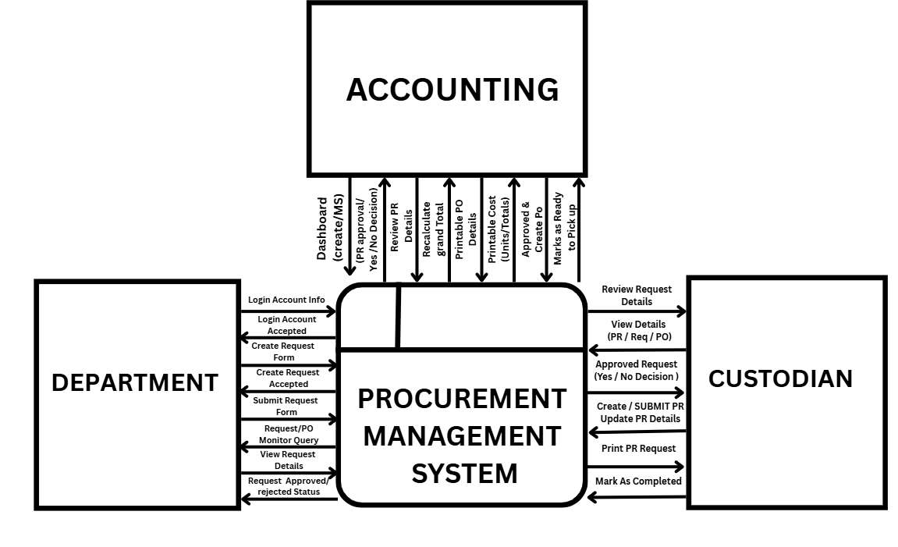
Context Diagram

DFD Diagram
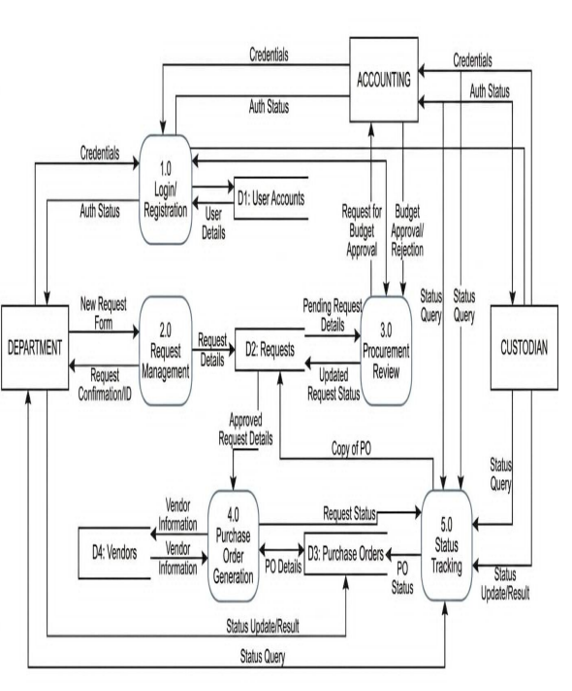

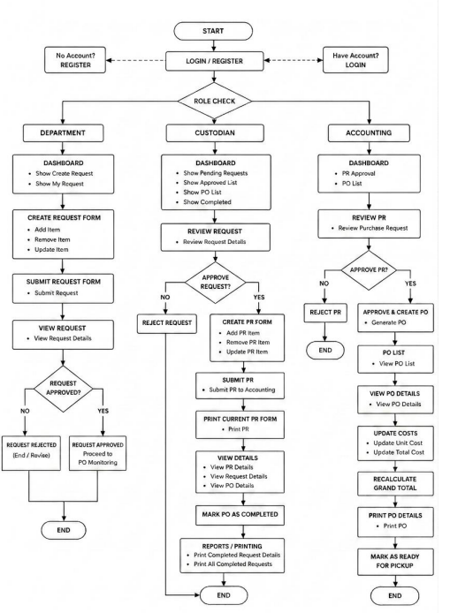
Program Flowchart

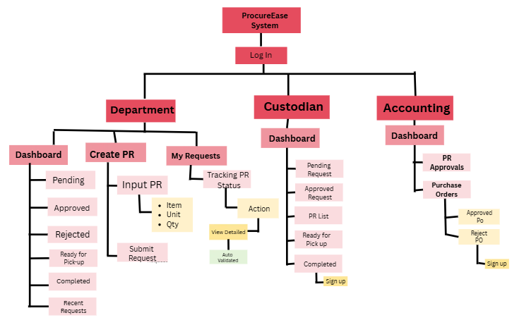
VTOC Diagram

IPO Diagram
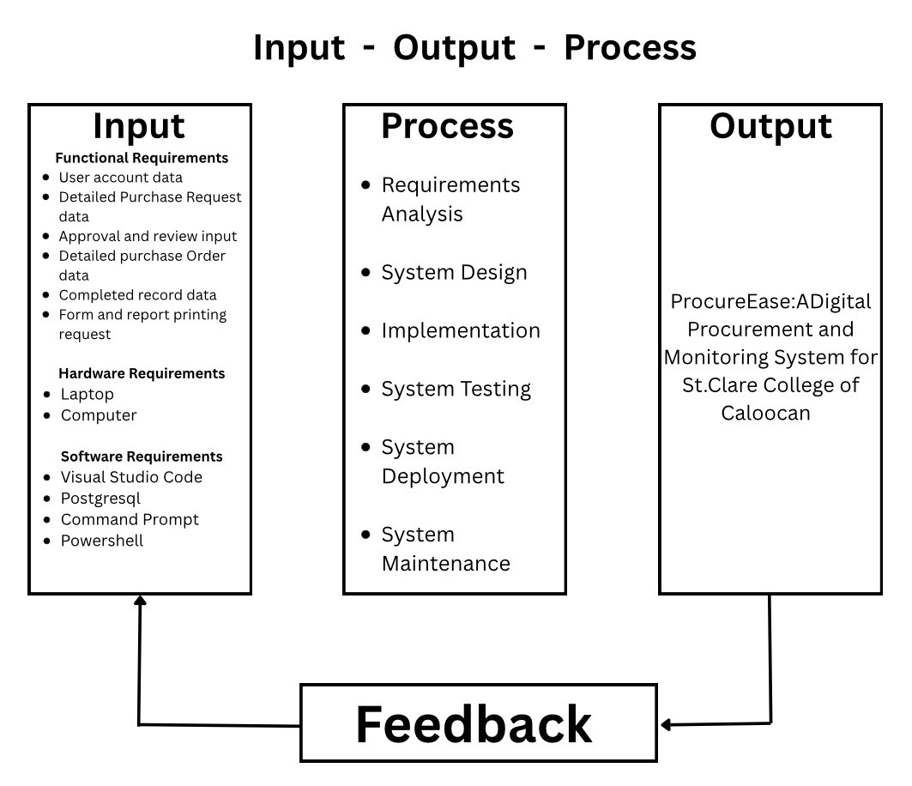
Sample Screen Output
The login page allows departments, custodians, property personnel, and accounting staff to access their respective accounts by entering their information, including their username and password. If the entered data is correct, they will be redirected to the appropriate dashboard for the department, custodian, property, or accounting staff. If you do not yet have your own account, especially for departments, they can use the “create account” option to be granted access to the system
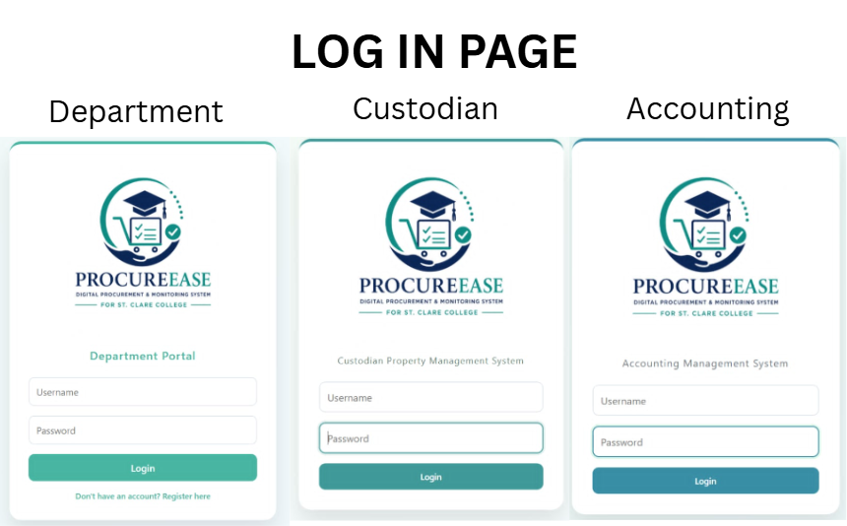
Displays the user's request statistics (Pending, Approved, Ready for Pick-up, Completed, Rejected) and a list of recent requests with their current status. It allows the department user to track their purchase requests and view detailed information about each request.
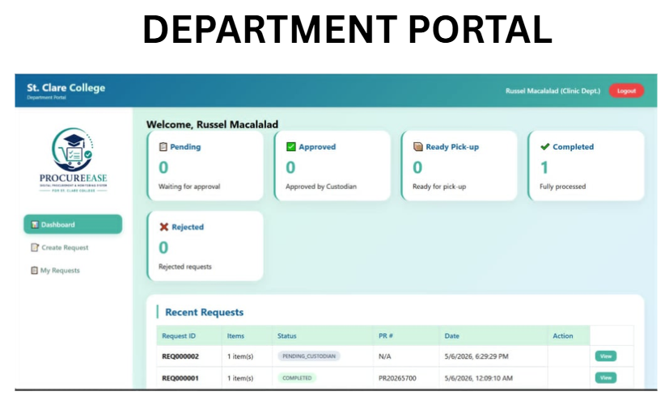
Shows five summary cards: Pending Requests (needs review), Approved Requests (ready for PR creation), PR Created (sent to accounting), Ready for Pick-up (POs ready), and Completed (finished transactions). Clicking each card directs the user to the corresponding list for action.
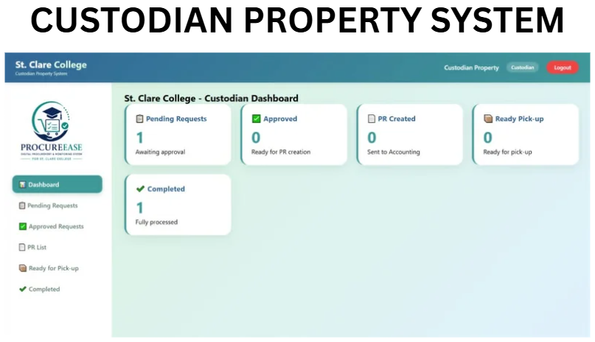
Provides two key metrics: Pending PR Approvals (PRs waiting to be reviewed) and Total Purchase Orders (all POs created). This helps the accounting team prioritize which PRs need to be converted into Purchase Orders to keep the procurement process moving.
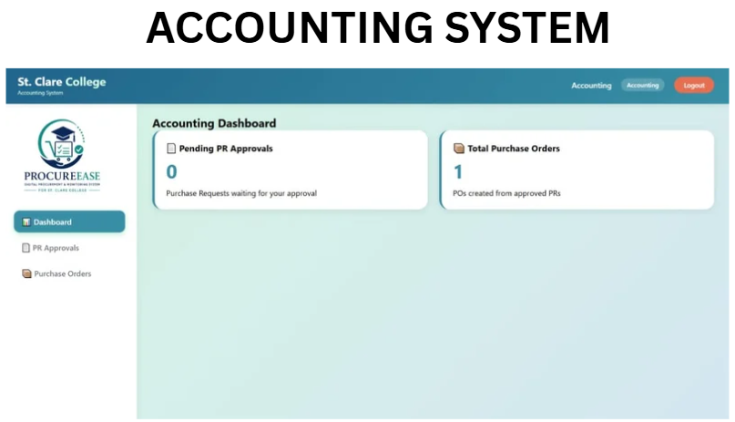
Users Manual
The system has three portals. The Department Portal is for staff who need supplies. They register first, then log in to create purchase requests by adding items, purpose, and urgency. They can track their requests under "My Requests" and view the status, which can be Pending, Approved, PR Created, Ready for Pick-up, Completed, or Rejected. The Custodian Portal is for the property officer. They review pending requests, approve or reject them with reasons, and create PRs by adding estimated costs. They also mark requests as Completed once items are picked up. The Accounting Portal is for the finance team. They review PRs, edit unit costs, create Purchase Orders (POs) with supplier details, print POs, and mark them as "Ready for Pick-up" to notify the custodian. The full workflow is: Department creates request → Custodian approves and creates PR→ Accounting creates PO and marks ready → Custodian picks up and completes →Department views final status. Users should always logout, save credentials, check status regularly, and print POs for records. For help, contact the Custodian Office for requests and the Accounting Office for payment concerns. ProcureEase makes procurement fast, easy, and transparent for St. Clare College.

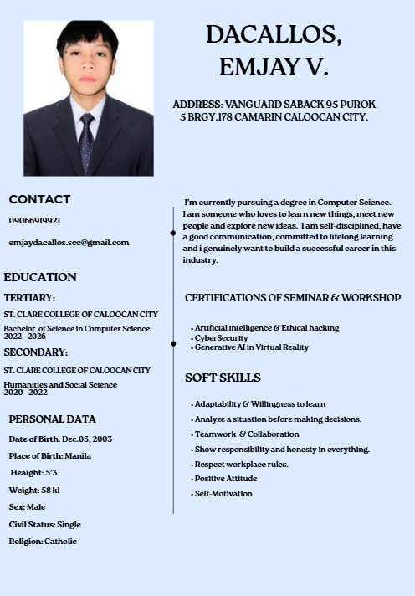
Curriculum Vitae

