Entrepreneurial Strengthening Mindset through Entrepreneurship Seminar , Innovation , and Community Empowerment in Cultivating the Entrepreneurial Spirit of Prospective Teachers at Universiti Tun Hussein Onn Malaysia

Ratih Eka Sakti, Endrik Andika, Yusrawati
University of PGRI Silampari, University of Mulawarman, Almuslimin University of Bireuen Aceh
ratih91212@gmail.com

ABSTRACT
The transformation of 21st century education demands that prospective teachers not only have pedagogical competence , but also... entrepreneurial mindset which can foster creativity, innovation, leadership, and problem-solving skills in the learning process. However, entrepreneurship education in higher education still tends to be business-oriented, so that the strengthening of the entrepreneurial spirit in prospective teachers is not optimal. This community service activity aims to strengthen entrepreneurial mindset prospective teachers through an international seminar on the theme " Entrepreneurship , Innovation , and Community Empowerment " with subthemes " Entrepreneurial" Mindset " . The activity was carried out at Universiti Tun Hussein Onn Malaysia (UTHM) through a collaboration between Jakarta State University (UNJ), Universiti Tun Hussein Onn Malaysia (UTHM), and the Indonesian Multidisciplinary Lecturer Community (KDMI). The implementation method used the approach Participatory Learning and Action (PLA) combined with Experiential Learning , through preparation, material delivery, case study-based discussions, reflection, and evaluation. The material was delivered interactively by three speakers with a focus on strengthening entrepreneurial character, learning innovation, and the implementation of entrepreneurship in the teaching profession. The results of the activity showed that participants showed high enthusiasm during the seminar, demonstrated through active participation in discussions, the ability to identify opportunities for learning innovation, and an increased understanding of the importance of entrepreneurial mindset as an essential competency for prospective teachers. This activity contributed to broadening participants' insights into the role of teachers as innovators, agents of change, and developers of creative learning. Furthermore, this seminar strengthened international academic collaboration in developing entrepreneurship education for prospective teachers. Therefore, strengthening entrepreneurial mindset needs to be integrated sustainably into teacher education as a strategy to produce educators who are adaptive, innovative, and able to foster an entrepreneurial spirit in students.
Keywords: entrepreneurial mindset ; prospective teachers; teacher education ; entrepreneurship education; learning innovation.

INTRODUCTION
The transformation of 21st-century education has shifted the learning paradigm from mere knowledge transfer to competency development oriented toward creativity, innovation, collaboration, communication, and problem-solving skills. The development of digital technology, artificial intelligence ( AI) , and the development of AI have significantly impacted the learning process. Intelligence ), and the knowledge-based economy require educational institutions to prepare graduates who not only possess academic competence but are also able to adapt to change, create opportunities, and provide solutions to various social and economic problems (OECD, 2023; UNESCO, 2021). In this context, the development of entrepreneurial mindset is one of the main competencies that prospective teachers must have in order to be able to form students who are innovative, adaptive, and globally competitive ( Neck et et al. , 2021).
Entrepreneurship education today is no longer seen as learning that is oriented towards the formation of business actors alone, but rather as a process of forming a mindset that encourages individuals to have the courage to take the initiative, think creatively, be able to identify opportunities, innovate, and create value . creation ) for society (Bell, 2020; Shane, 2020). Ribeiro et al. (2023) explains that entrepreneurial mindset Entrepreneurship is a combination of opportunity recognition, creativity, innovation, risk-taking, and adaptability to change, which are the primary foundations for developing entrepreneurial character. Therefore, entrepreneurship education needs to be directed not only at producing new entrepreneurs but also at developing individuals with innovative character across various professional fields.
Various previous studies have shown that the effectiveness of entrepreneurship education is greatly influenced by the learning approach used. Experiential learning is a learning ), project-based learning , problem- based Learning , collaboration with the community, and integration of digital technology have been proven to increase creativity, critical thinking skills, communication, collaboration, self-confidence, and students' decision-making abilities ( Lackéus , 2020; Rahmi et al. al. , 2025; Ratten & Jones, 2021). In addition to improving academic competency, this approach can also build the entrepreneurial character needed to face the increasingly complex dynamics of the workplace and social change .
For prospective teachers, mastery entrepreneurial mindset has a broader meaning than the ability to build a business. Future teachers are expected to be learning leader which is able to inspire students to think innovatively, develop creativity, utilize technology responsibly, and build collaboration with various stakeholders ( Kuratko , 2020; Kuratko et al. , 2021). Teachers also play a role as change agent which is able to connect learning with the needs of society so as to produce graduates who not only have pedagogical competence , but also the ability to create innovation and solve various real problems.
Despite this, various studies still show a gap between entrepreneurship education in higher education and its implementation in learning practices. Most students, especially prospective teachers, still view entrepreneurship as merely an economic or business activity and therefore do not understand that entrepreneurial mindset is a professional competency that every educator must possess (Rauf & Jones, 2025; Syafitri, 2025). Furthermore, the integration of learning innovation, digital literacy , and entrepreneurial character development in teacher education still faces various challenges, both in terms of curriculum and learning strategies (Arifin, 2022; Ministry of Education , Culture, Research, and Technology , 2022).
As an effort to answer this challenge, community service activities were carried out in the form of an international seminar with the theme " Entrepreneurship , Innovation , and Community Empowerment " with subthemes " Entrepreneurial" Mindset " and the topic "How Teachers Cultivate an Entrepreneurial Spirit" . This activity presents speakers Dr. Endrik Andika, S.AB., M.AB., Ratih Eka Sakti, SE, MM, and Yusrawati, SE, MM The seminar was held through collaboration between Jakarta State University (UNJ), Universiti Tun Hussein Onn Malaysia (UTHM), the Indonesian Multidisciplinary Lecturer Community (KDMI), and other institutional partners as part of strengthening international academic networks in the development of entrepreneurship education.
The seminar is designed to be interactive, encompassing presentations, discussions, case studies, reflections, and group presentations. The material emphasizes not only basic entrepreneurial concepts but also integrates learning innovation, educational leadership, digital technology utilization, and implementation strategies. entrepreneurial mindset in 21st century learning. This approach is in line with the concept experiential learning which places participants as active subjects in the learning process so that they are able to build understanding contextually ( Lackéus , 2020; Rahmi et et al. , 2025)
This activity has novelty compared to previous community service programs because it integrates entrepreneurship , innovation , and teacher education within a single framework for developing prospective teacher competencies through international collaboration. This integration is expected to strengthen prospective teachers' capacity in developing innovative learning oriented toward building students' entrepreneurial character. Thus, the goal of this activity is to increase prospective teachers' understanding of the importance of entrepreneurial mindset , strengthening their ability to integrate entrepreneurial values into the learning process, and producing teacher competency development models that are relevant to the needs of 21st-century education and support the achievement of the Sustainable Development Goals , especially in the aspects of quality education, decent work, economic growth, and global partnerships (OECD, 2023; UNESCO, 2021).
Based on this description, the aim of this community service activity is to increase participants' understanding and awareness of the importance of entrepreneurship. mindset for the teaching profession, strengthening teachers' ability to integrate entrepreneurial values into the learning process, and encouraging educational innovations that impact community empowerment. The results of this activity are expected to become a model for developing prospective teachers' competencies through an entrepreneurial education approach that is relevant to the needs of the 21st-century education world and supports the achievement of the Sustainable Development Goals , particularly in the aspects of quality education, decent work, economic growth, and global partnerships.

IMPLEMENTATION METHOD
Community service activities were carried out in the form of an international seminar with the theme " Entrepreneurship , Innovation , and Community Empowerment ", subtheme " Entrepreneurial Mindset ", and the topic "Growing the Entrepreneurial Spirit of Prospective Teachers". This activity is the result of collaboration between Jakarta State University (UNJ), Universiti Tun Hussein Onn Malaysia (UTHM), and the Indonesian Multidisciplinary Lecturer Community (KDMI) as an effort to strengthen the competence of prospective teachers in facing the challenges of 21st-century education.
The program targets students at Universiti Tun Hussein Onn Malaysia (UTHM) preparing to become future teachers. The selection of these students is based on the importance of developing entrepreneurial character during higher education, ensuring that prospective teachers not only possess pedagogical competence but also become innovative, creative, and adaptive educators, fostering entrepreneurial character in their students.
Implementation of community service using a participatory approach Learning and Action (PLA) combined with Experiential Learning . This approach provides participants with the opportunity to actively engage through a process of sharing experiences, discussion, reflection, and solving real-world problems related to the implementation of entrepreneurship education in schools.

Implementation Stages
The implementation of the activity consists of four stages, namely:

1. Preparation Stage
The initial stage involved coordination between the community service team and partners at UTHM regarding participant needs, developing seminar materials, assigning resource persons, and developing activity evaluation instruments. This stage also identified prospective teachers' entrepreneurial competency needs based on the challenges of education in the digital era.

2. Seminar Implementation Stage
The core activities are carried out through interactive seminars that focus on strengthening entrepreneurial mindset as a basic competency for prospective teachers.
The seminar material was delivered by three speakers with the following division.
Dr. Endrik Andika, S.AB., M.AB.
Material on the importance of entrepreneurship mindset for the teaching profession, characteristics of teachers with an entrepreneurial spirit, and changes in the educational paradigm from teacher centered towards innovation centered learning . The resource person emphasized that future teachers must be able to become opportunity creators . creator ), not just a transmitter of information.
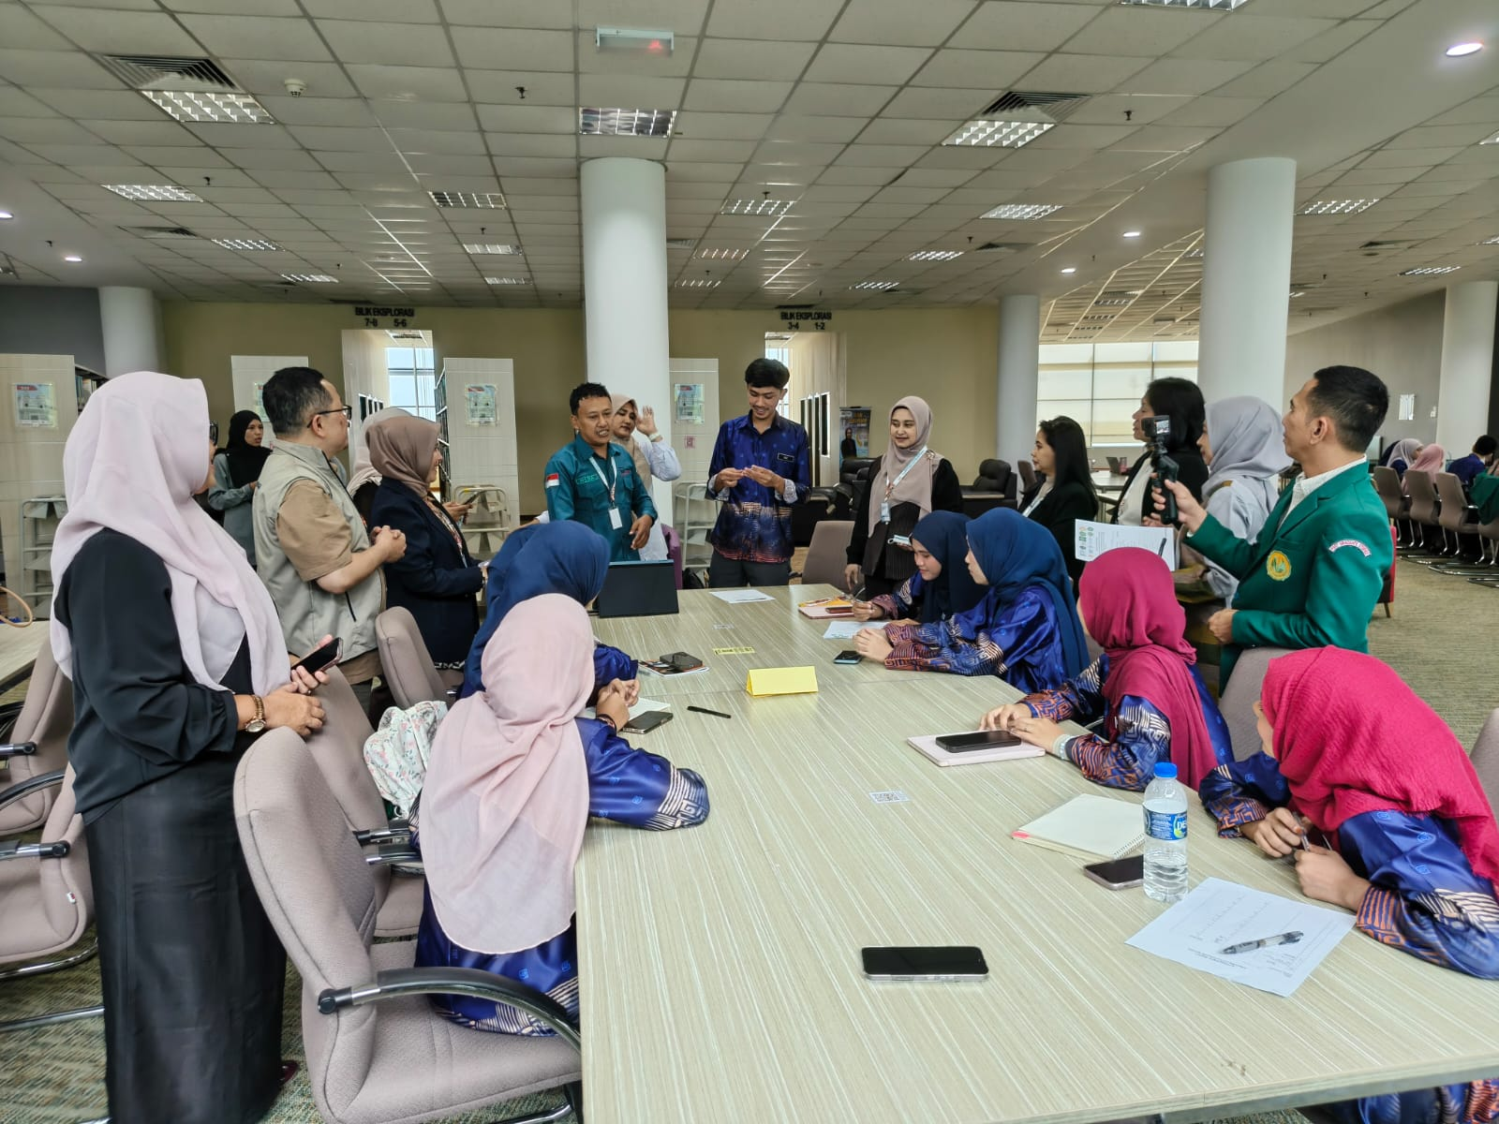
Ratih Eka Sakti, SE, MM
Material on strategies to foster the entrepreneurial spirit of prospective teachers through creative, project-based learning problem - based learning learning , and the development of critical thinking, creativity, communication, collaboration, and leadership skills. In this session, participants are encouraged to understand that entrepreneurship is a mindset that can be applied in every learning process, not just in entrepreneurship subjects.
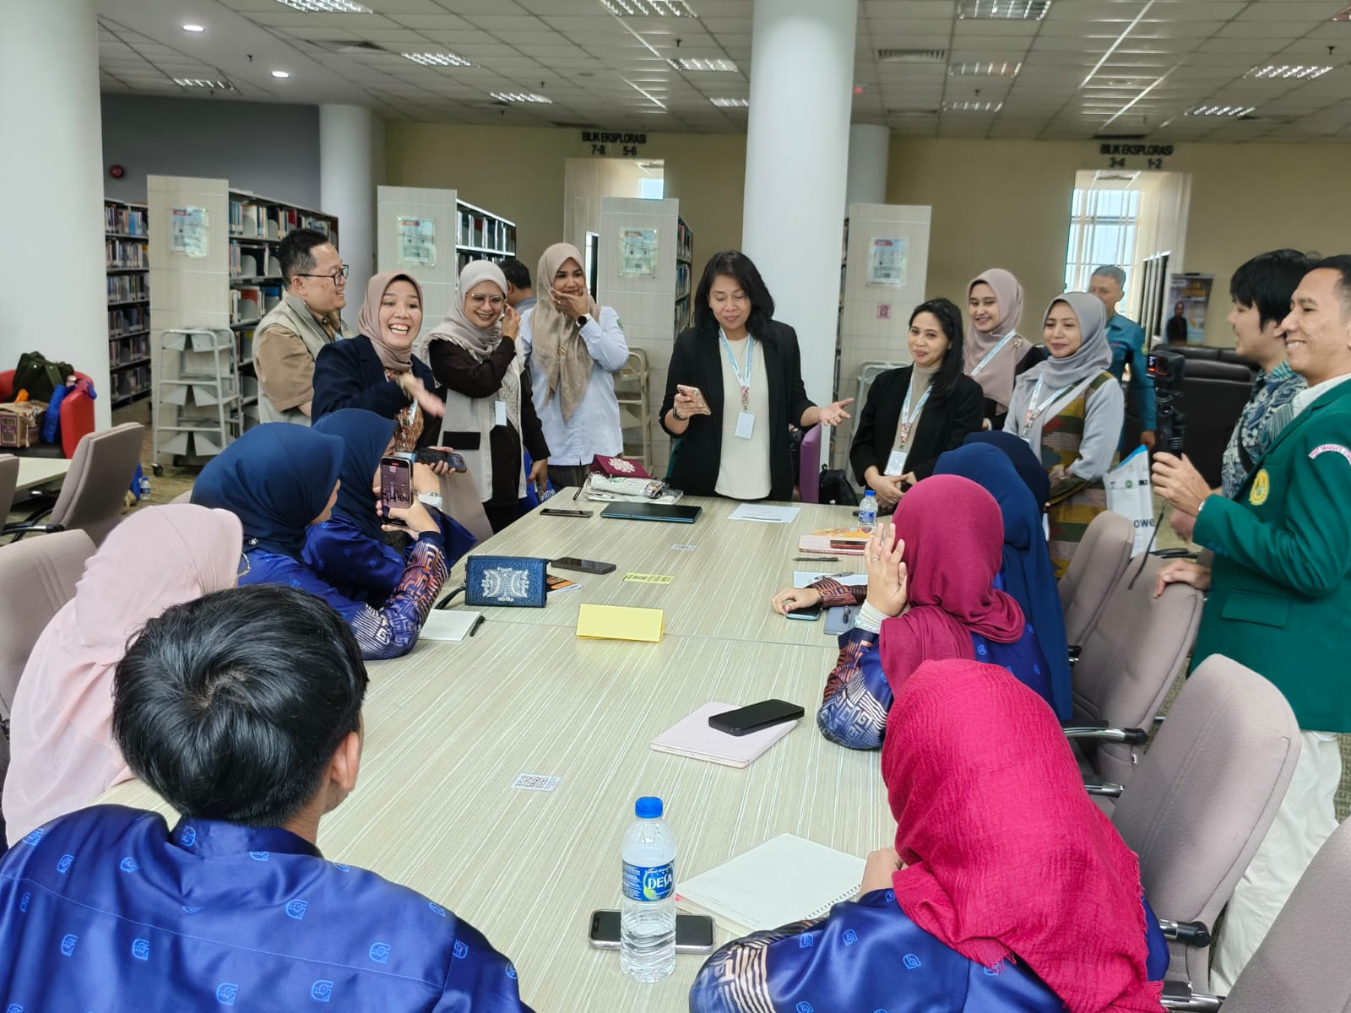
Yusrawati, SE, MM
Material on educational innovation and implementation of social entrepreneurship ( social entrepreneurship) entrepreneurship ) in learning. Participants were given examples of good practices on how teachers can build a culture of innovation, empower the school environment, and develop learning projects that benefit the community.
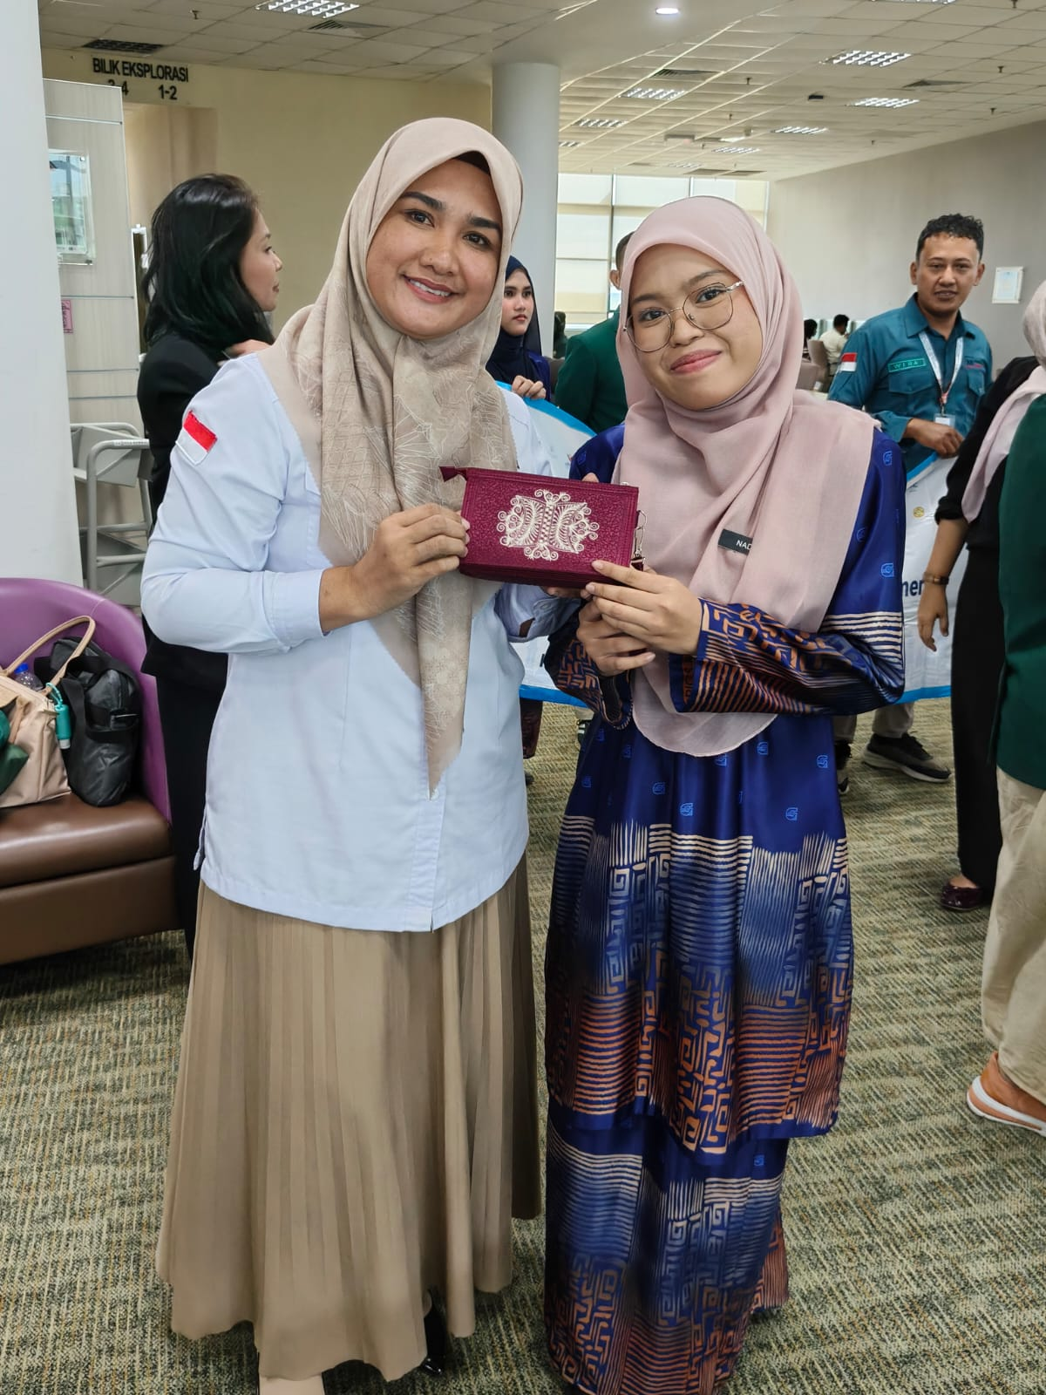

3. Discussion and Reflection Stage
After the presentation of the material, participants took part in an interactive discussion using the case-based method. Discussion . Each group was given a case study on the challenges teachers face in fostering an entrepreneurial spirit in students in the digital age.
Participants were asked to identify:
- teacher characteristics needed in the 21st century;
- learning strategies that can foster student creativity;
- ethical use of digital technology in learning;
- forms of innovation that can be applied in the school environment.
The results of the discussion were then presented and feedback was obtained from the resource persons so that a joint reflection process took place regarding the implementation of entrepreneurialism. mindset in the teaching profession.
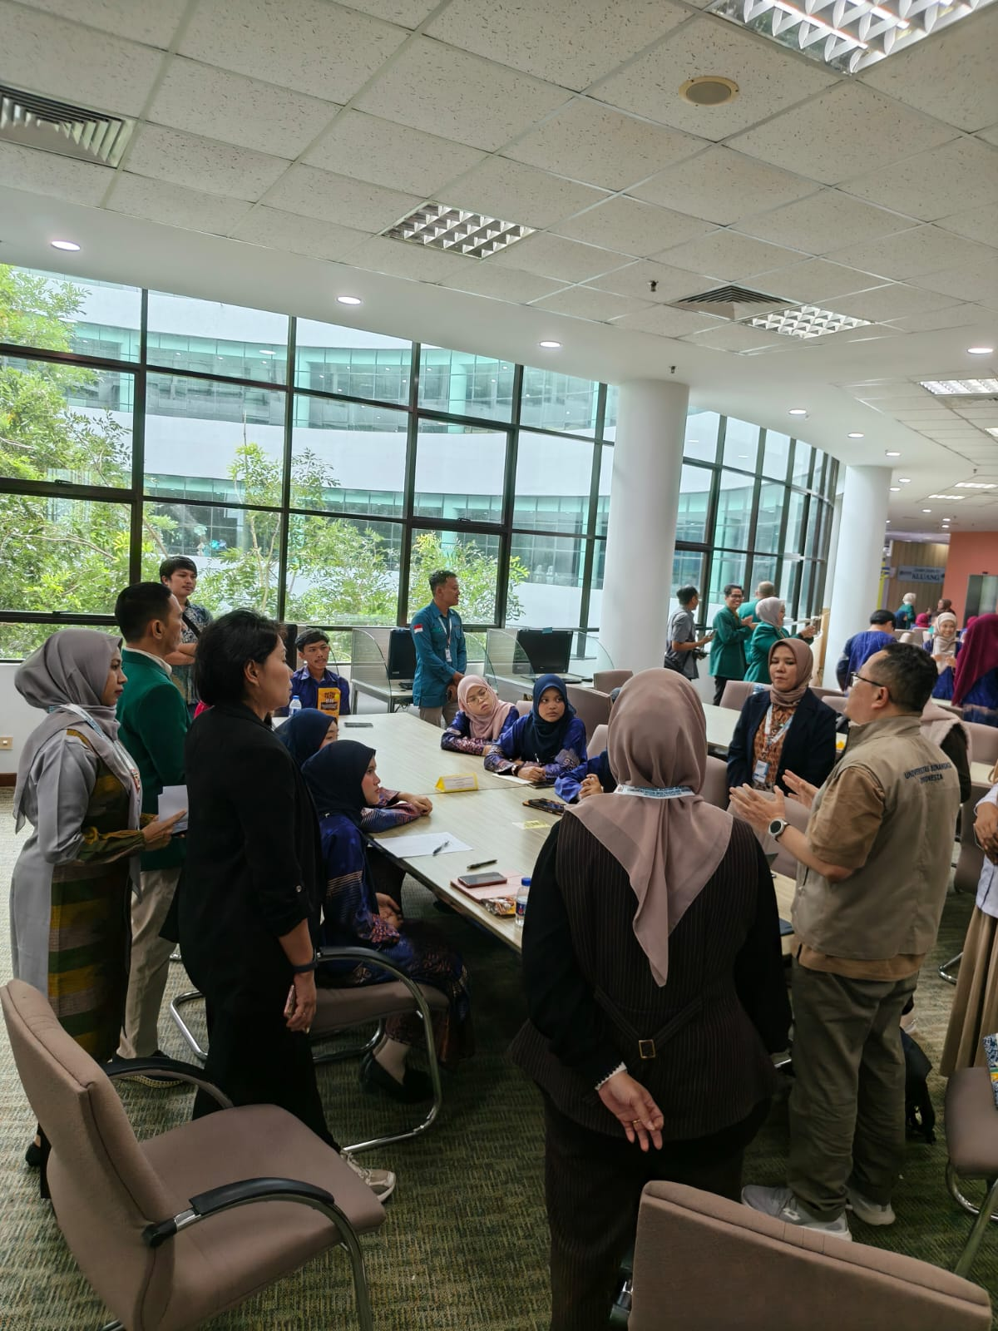

4. Evaluation Stage
The evaluation was conducted formatively through participant observation during the seminar, discussions, and question-and-answer sessions. Additionally, participants completed an evaluation form to determine their level of understanding of the material presented and their perceptions of the importance of entrepreneurship. mindset for prospective teachers.
The evaluation focuses on four aspects, namely:
- understanding the concept of entrepreneurship mindset ;
- ability to identify innovation opportunities in learning;
- readiness to integrate entrepreneurial values in the learning process; and
- commitment to being an innovative and adaptive teacher to technological developments.
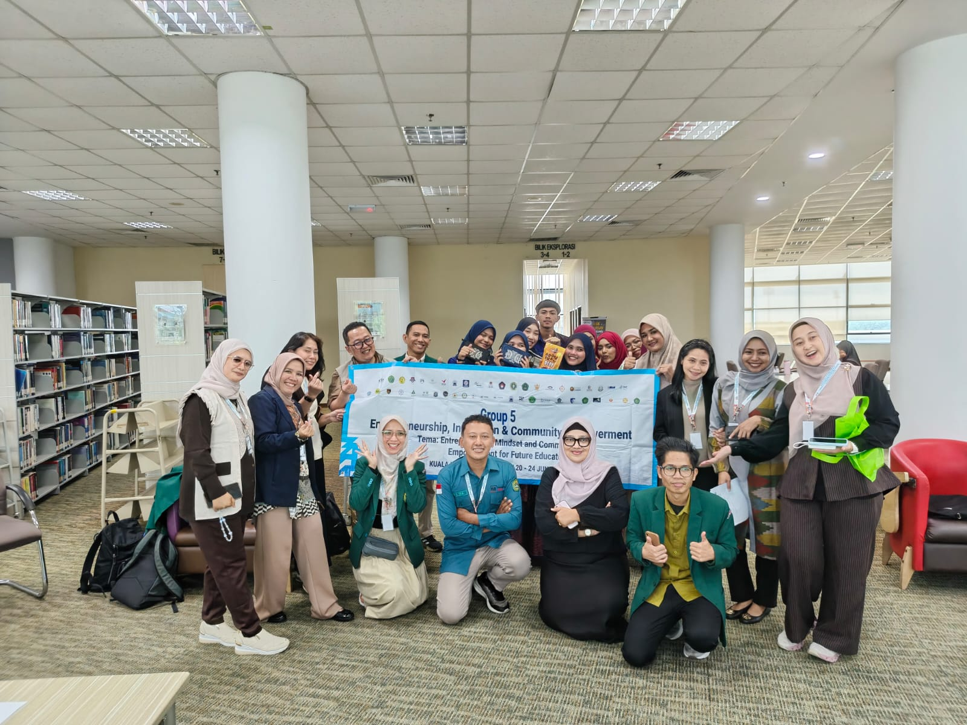

Learning methods
To increase the effectiveness of activities, the seminar applies several complementary learning methods, namely:
- Interactive Lecture , to provide a conceptual foundation regarding entrepreneurship education.
- Case-Based Learning , to train analytical skills on real problems in the world of education.
- Group Discussion , to develop collaboration and communication skills.
- Reflective Learning , to help participants evaluate their readiness as prospective teachers who have an entrepreneurial spirit.

Success Indicators
The success of the activity is measured based on the following indicators.
- Increased participant understanding of entrepreneurial concepts mindset as the main competency of prospective teachers.
- Increased participant awareness of the importance of innovation in the learning process.
- Increasing participants' ability to design learning that encourages creativity, independence, and problem-solving skills.
- The participants' commitment to becoming teachers who are able to foster entrepreneurial character in students through innovative learning is built.
Community Service Implementation Flow

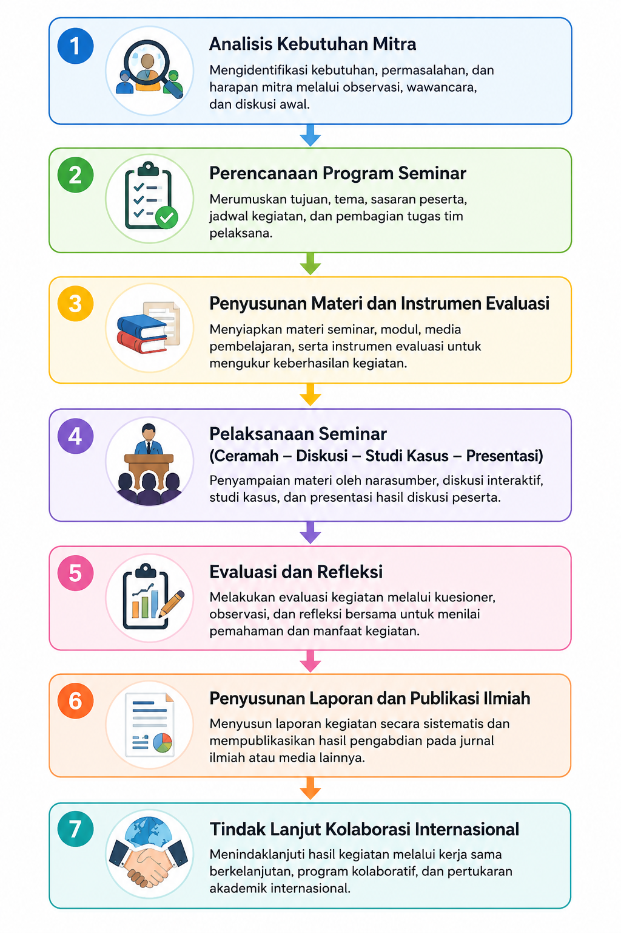
This implementation method is designed to not only provide knowledge transfer but also encourage participatory , reflective, and applied learning. Thus, community service activities are expected to strengthen entrepreneurial mindset prospective teachers, increasing their capacity in developing learning innovations, and expanding international collaboration networks in developing entrepreneurship education.

RESULTS AND DISCUSSION

Results of Activity Implementation
Community service activities were carried out in the form of an international seminar with the theme " Entrepreneurship , Innovation , and Community Empowerment " with the subtheme " Entrepreneurial Mindset " and the topic "Growing the Entrepreneurial Spirit of Prospective Teachers". The activity was held through a collaboration between Jakarta State University (UNJ), Universiti Tun Hussein Onn Malaysia (UTHM), and the Indonesian Multidisciplinary Lecturer Community (KDMI). The target of the activity is students of Universiti Tun Hussein Onn Malaysia as prospective teachers who are prepared to face the challenges of education in the era of digital transformation.
The seminar proceeded according to the planned stages, starting with the presentation of material by the resource person, followed by an interactive discussion, case studies, group presentations, and a reflection session. The entire series of activities was aimed at developing participants' understanding that entrepreneurship is not only about the ability to build a business, but also about a mindset ( entrepreneurial). mindset ) that every prospective teacher needs to have in carrying out the learning process.
The first material delivered by Dr. Endrik Andika, S.AB., M.AB. emphasized the importance of entrepreneurship. Mindset as a basic competency for 21st-century teachers. Participants gained an understanding that teachers no longer merely serve as conveyors of information, but rather as learning facilitators, innovators, and agents of change capable of creating a creative learning environment and encouraging students to find solutions to various problems.
The second topic, presented by Ratih Eka Sakti, SE, MM, focused on strategies for integrating entrepreneurial values into the learning process. The discussion included the application of project-based learning. problem - based learning learning , and experiential learning learning ) as an approach that is able to develop creativity, critical thinking skills, communication, collaboration, and the courage to take initiatives.
Next, Yusrawati, SE, MM delivered material regarding the importance of innovation in education and the implementation of social entrepreneurship ( social entrepreneurship). entrepreneurship ) through learning activities. Participants are encouraged to understand that teachers have a strategic role in building a culture of innovation in the school environment and developing learning that benefits the community.
In addition to the presentation of the material, the activity continued with a group discussion using a case study on the challenges teachers face in fostering students' entrepreneurial spirit in the digital age. Participants discussed various alternative learning strategies that can be implemented to develop creativity, leadership, problem-solving skills, and decision-making skills. The results of the discussion were then presented and received feedback from the speakers, fostering reflection and strengthening understanding.
Based on observations during the event, participants demonstrated high levels of enthusiasm for the seminar. This was evident in their active participation in the discussion sessions, the numerous questions asked, and their ability to relate the material to their experiences and the educational context in their respective environments. This demonstrates that the topics raised are relevant to the needs of prospective teachers facing the changing educational paradigm.

Discussion
The implementation of the seminar showed that strengthening entrepreneurial Mindset development is an important strategy for improving the professional competence of prospective teachers. The entrepreneurial spirit developed in this activity is not understood solely as the ability to run a business, but as the ability to think creatively, innovatively, adaptively, boldly take initiative, and recognize opportunities to solve various educational problems.
This finding is in line with research by Wardana et al. (2020) stated that entrepreneurship education plays a crucial role in shaping an entrepreneurial mindset by enhancing creativity, innovation, and the ability to identify opportunities. Similarly, Lackéus (2020) emphasized that entrepreneurship education has a broader impact than business education because it contributes to the development of character, leadership, and problem-solving skills.
During the activity, participants not only receive theoretical material but also engage in participatory learning through discussions and case studies. This approach provides participants with the opportunity to construct knowledge based on real-world experiences and situations encountered in education. This approach aligns with the Experiential Theory. Learning states that the learning process will be more meaningful when participants are actively involved in experiencing, reflecting, conceptualizing, and implementing learning experiences.
Material about project-based learning and problem- based Project-based learning received high attention from participants because it was considered relevant to the implementation of 21st-century learning. Through these two approaches, teachers can create a learning environment that encourages students to think critically, collaborate, generate creative ideas, and develop problem-solving skills. Various studies have shown that project-based learning can increase creativity, self-confidence, and entrepreneurial skills in college and university students.
Discussions on the use of digital technology were also an important part of the seminar. Participants recognized that technological developments, including artificial intelligence ( AI), are rapidly evolving. Intelligence (ICT ) offers a significant opportunity to improve the quality of learning when used ethically and responsibly. Teachers are required to possess strong digital literacy to utilize technology as a learning tool without neglecting humanitarian values and professional ethics.
This activity also demonstrated that developing prospective teachers' entrepreneurial spirit cannot be achieved through mere theoretical presentations but requires contextual, collaborative, and reflective learning experiences. Therefore, international seminars, which bring together participants from diverse backgrounds, provide added value in the form of exchanging experiences, cross-cultural insights, and strengthening international academic networks.
entrepreneurial values into the learning process. The mindset is expected to be able to produce teachers who are not only pedagogically competent , but also have the ability to be innovators, learning leaders, and agents of change who are able to foster entrepreneurial character in students.
Overall, the results of the activity showed that this international seminar was an effective medium in broadening participants' insight regarding the importance of entrepreneurship. The collaboration between Indonesian and Malaysian universities also strengthens a shared commitment to developing innovative, adaptive education that is oriented toward developing globally competitive human resources.

CONCLUSION
Community service activities carried out through an international seminar with the theme " Entrepreneurship , Innovation , and Community Empowerment " with the subtheme " Entrepreneurial Mindset " has made a positive contribution in increasing the understanding of prospective teachers regarding the importance of entrepreneurial spirit as one of the essential competencies of educators in the 21st century. Through the delivery of materials, interactive discussions, case studies, and reflections, participants gained insight that entrepreneurship is not only interpreted as the ability to build a business, but also as a mindset that encourages creativity, innovation, problem-solving skills, leadership, courage to take initiatives, and the ability to adapt to change.
The implementation of the seminar showed that strengthening entrepreneurial Entrepreneurial mindset is a relevant strategy in preparing prospective teachers to create more innovative, contextual, and student-centered learning processes. Teachers with an entrepreneurial spirit will be better prepared to develop project-based learning, encourage creativity and collaboration, utilize digital technology ethically , and build a learning environment that encourages students to think critically and create solutions to various societal problems.
This activity also strengthens international academic collaboration between Jakarta State University (UNJ), Universiti Tun Hussein Onn Malaysia (UTHM), and the Indonesian Multidisciplinary Lecturers Community (KDMI) in developing entrepreneurship education for prospective teachers. This synergy is expected to be the initial step for implementing sustainable collaborative programs, such as seminars, training, joint research, and community service focused on strengthening teacher competencies in the era of digital transformation.
As a follow-up, it is suggested that entrepreneurial development mindset is not only carried out through seminars, but is also systematically integrated into the teacher education curriculum through project-based learning ( Project- Based Learning). Learning ), problem-based learning ( Problem- Based Learning ), social entrepreneurship activities ( social entrepreneurship ), as well as community service programs. Thus, prospective teachers are expected to be able to become agents of change ( change agents ) who not only transfer knowledge, but also inspire the birth of a creative, innovative, independent generation with an entrepreneurial spirit to face global challenges.

BIBLIOGRAPHY
Arifin, Z. (2022). Entrepreneurship education in building student character in the digital era. Indonesian Journal of Entrepreneurship Education, 5 (2), 112–124.
Bell, R. (2020). Developing the next generation of entrepreneurs : Giving students the opportunity to gain experience and thrive . The International Journal of Management Education , 18 (3), 100409. https://doi.org/10.1016/j.ijme.2020.100409
Directorate General of Higher Education. (2020). Independent Learning Guide–Independent Campus . Ministry of Education, Culture, Research, and Technology.
Hisrich , R.D., Peters, M.P., & Shepherd , D.A. (2020). Entrepreneurship (11th ed.). McGraw -Hill Education .
Ministry of Education, Culture, Research, and Technology. (2022). Guide to Implementing the Independent Curriculum . Ministry of Education , Culture, Research, and Technology .
Kuratko , DF (2020). Entrepreneurship : Theory , Process , Practice (11th ed.). Cengage Learning .
Lackéus , M. (2020). Comparing the impact of three different experiential approaches to entrepreneurship education . International Journal of Entrepreneurial Behavior & Research , 26 (5), 937–971. https://doi.org/10.1108/IJEBR-04-2018-0236
Neck , H.M., Neck , C.P., & Murray , E.L. (2021). Entrepreneurship : The Practice and Mindset (3rd ed.). Sage Publications.
Nugroho, R., & Wahyuni, S. (2023). Strengthening entrepreneurial mindset for prospective teachers through project-based learning. Indonesian Journal of Community Service, 4 (3), 215–224.
Organization for Economic Cooperation and Development. (2021). The State of School Education : One Year into the COVID Pandemic . OECD Publishing .
Organization for Economic Cooperation and Development. (2023). Education at a Glance 2023: OECD Indicators . OECD Publishing .
Prasetyo, PE, & Kistanti , NR (2020). Human capital , institutional economics , and entrepreneurship as a driver for quality and sustainable economic growth . Entrepreneurship and Sustainability Issues , 7 (4), 2575–2589.
Rahmi, E., Darmansyah, Yulastri , A., & Handrianto , C. (2025). Bridging entrepreneurship education and digital transformation : A novel experiential learning model for entrepreneurial mindset development . International Journal of Learning , Teaching and Educational Research , 24 (4), 640–660.
Ratten , V. (2021). Entrepreneurship and the COVID-19 pandemic : Innovation , resilience and the future of education . Journal of Entrepreneurship in Emerging Economies , 13 (4), 747–761.
Ratten , V., & Jones, P. (2021). Entrepreneurship and management education : Exploring trends and gaps . The International Journal of Management Education , 19 (1), 100431.
Ribeiro , ATVB, Uechi , J.N., & Plonski , G.A. (2023). Entrepreneurial mindset : A systematic literature review . Journal of Entrepreneurship Education , 26 (2), 1–18.
Rauf, R., & Jones, E. A. (2025). Entrepreneurship education , entrepreneurship intentions , and pedagogical approaches : A systematic literature review . Journal of Economic Education , 14 (2), 181–195.
Scarborough , N. M. , & Cornwall , J. R. (2019). Essentials of Entrepreneurship and Small Business Management (9th ed.). Pearson.
Shane, S. (2020). Entrepreneurship and Innovation . Edward Elgar Publishing .
Syafitri, D. (2025). The innovative role of entrepreneurship courses in shaping Generation Z entrepreneurial mindset . Society , 5(1), 45–60.
Suryana. (2022). Entrepreneurship: Tips and Processes for Success (Revised edition). Salemba Empat.
UNESCO. (2021). Reimagining Our Futures Together : A New Social Contract for Education . UNESCO Publishing .
World Economic Forum. (2023). The Future of Jobs Report 2023 . World Economic Forum.

