APPLICATION OF NOVEL GEMINI SURFACTANT IN TEXTILE INDUSTRY
NeeluKambo^{a*}, Shubham Joshi^{b}, Saurabh Dubey^{c}
ªProfessor, Uttar Pradesh Textile Technology Institute, Kanpur, 208001, India
^{b}Assistant Professor, Bannari Amman Institute of Technology, Erode, 638401, India
^{c}RS Formulation and Consultant, Pune, India
*Communication author: Neelu_kambo@rediffmail.com
Abstract
Surfactants with superior performance are in constant demand, and novel surfactants have been developed for specific applications. In the coming years, new surfactants, such as Gemini, will become more accessible and affordable. Surfactants grant textiles interfacial and bulk properties. Surfactants are employed as textile additives due to their interfacial and bulk characteristics. Surfactants enhance the dyeing process by increasing solubility, stabilising dispersion, and promoting uniform dye distribution throughout the material. In response to the rising demand for high-performance surfactants, novel surfactants have been developed and produced. Surfactants with novel structures, such as Gemini surfactants, have been studied to increase their convenience and decrease their cost. This article explores the numerous types of Gemini surfactants and their current and potential textile industry applications. This article provides a brief summary of the potential and theoretical applications of Gemini surfactants in the global textile industry.
Keywords- Gemini surfactant, critical micellarconcentration, dye-surfactant interaction, textile process
Introduction
Although water is an eco-friendly solvent for reaction medium, due to the solubility problem of the organic substrate, researchers have selected aggregated surfactant media which have two different parts: one is hydrophobic which easily solubilise the organic moieties and another is hydrophilic to solubilise inorganic substrates with ease^{1–3}. Aggregated surfactant medium composed of different nano aggregates, such as, micelle, vesicle, large uni-lamellar vesicle, etc. above its critical micelle concentration (CMC) in aqueous medium. Surfactants are one of the most useful chemical products, which are consumed in a large amount and have several applications in various areas. Surface chemistry is immensely affected by the presence of surface-active substances i.e., the surfactantshave a significant impact on the surface chemistry of a material.Surfactants are amphillic compounds, which include two or more groups that, in pure form, are insoluble with one another^{4,5}. These groups consist of oil, water, silicone compounds, and fluoro chemicals. It has a hydrophilic head and a hydrophobic tail. Surfactants reduce surface tension and give wetting, emulsification, foaming, and detergent properties. Surfactants are utilised as catalysts in different reactions worldwide^{6–9}. Their presence on a liquid interface changes its physicochemical features as surface tension, viscosity, and solvent nature. Despite the fact that water is an environmentally friendly solvent for reaction medium, researchers have chosen aggregated surfactant media that have two different parts: one is hydrophobic which easily solubilizes organic moieties and another is hydrophilic to easily solubilize inorganic substrates. Surfactants are one of the most useful chemical products. They are used in many different ways and are used in large quantities. The conventional types of surfactants each consist of one head and one tail. Sodium lauryl sulphate is a conventional surfactant. Gemini or dimeric surfactants are a new family of surfactants comprised of two identical or distinct amphiphilic moieties linked by a spacer group^{10–13}. The spacer might be hydrophobic (aliphatic or aromatic) or hydrophilic (polyether), short (two methylene groups) or long (up to 20 methylene groups or more), hard (stilbene) or flexible (poly methylene chain).Sodium lauryl sulphate is a conventional surfactant.
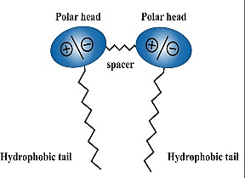 | 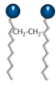 | 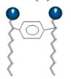 |  | 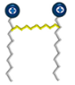 | 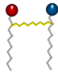
Polar spacer | Flexible spacer | rigid spacer | short chain spacer | cationic | two non-identical hydrophilic heads
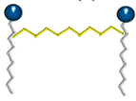 | 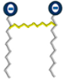 | 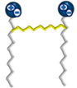 | 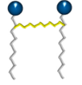 | 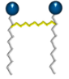 | 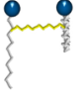
long-chain spacer | anionic | zwitterionic | non-ionic | two identical hydrophilic heads and hydrophobic chains | two non-identical hydrophobic chains

Figure 1: Schematic representation of physical structure of Gemini surfactants [1]
Gemini surfactant has two hydrophilic groups, it is more water soluble and hard-water tolerant. Also, because a Gemini surfactant has two hydrophobic groups, it will more readily self-associate into micelles, as compared with a conventional surfactant¹⁴. The nature and structure of a spacer between the two head groups is critical to the properties of the Gemini surfactant, because the spacer can be used to manipulate the hydrophobic interaction as well as constrain the electrostatic repulsion between hydrophilic ionic groups¹⁵. Several reasons can be given for the present interest in Gemini surfactants. First their critical micellization concentration (CMC) is generally at least one order of magnitude lower than that of the corresponding conventional (monomeric) surfactants. Second, they are 10–100 times more efficient at reducing the surface tension of water and the interfacial tension of the oil-water interface than conventional surfactants. Third, the aqueous solutions of some dimeric surfactants with a short spacer can have extremely interesting rheological properties (viscoelasticity, shear thickening).
Gemini surfactants, sometimes called dimeric surfactants, have two hydrophilic head groups and two hydrophobic groups in the molecules, in contrast to conventional surfactants that generally have a single hydrophilic head group and a single hydrophobic group in the molecule. Gemini surfactants can be ten to a thousand times more surface active than conventional surfactants with similar but single hydrophilic and hydrophobic groups in the molecules. Gemini surfactants are considerably more surface-active than conventional surfactants ^{16–19}. Gemini surfactants have remarkably low CMC values compared to the corresponding conventional surfactants of equivalent chain length.
Gemini surfactants have good commercial utilization potential. Therefore, their preparation should be cost-effective. As lower amounts of Gemini surfactants are needed for a particular performance, cost-effectiveness may not stand in the way⁴. Surfactants, which are surface-active chemicals, have a significant impact on the textile surface chemistry. Their presence on the surface of a liquid changes not only its physical and chemical properties, such as surface tension and viscosity, but also serves as a solvent and catalyst for chemical reactions. Surfactants are utilised as catalysts in several chemical reactions throughout the world. Since organic substrates are difficult to dissolve in water, researchers have adopted two-component aggregated surfactant media. One component is hydrophobic, facilitating the dissolution of organic molecules, while the other is hydrophilic, facilitating the dissolution of inorganic substrates. Aggregated surfactant media is an aqueous medium containing micelle, vesicles, large uni-lamellar vesicles, and other nanoaggregates at a concentration greater than its required micelle concentration (CMC)⁷.
Surfactants are among the most beneficial types of chemicals due to their versatility and abundance of applications.Gemini surfactants have two hydrophobic chains and two polar head groups that are covalently linked to each other and are connected by a spacer (Figure 1)⁸. Gemini surfactants are anticipated to have an excellent cost-to-performance ratio in a variety of surfactant applications, including soil cleansing, oil extraction, and the production of industrial detergents. A lot of study has been done on Gemini surfactants over past decades. The majority of the research has been on their remarkable surface and bulk features, including as high surface activity, low critical micelle concentration (CMC), improved wetting properties, peculiar viscosity behaviour, and complex aggregation structures. Menger and Zana studied the different forms of Gemini surfactants^{8–13} and concluded that these surfactants have distinct characteristics. They are effective as emulsifiers, bacteria killers, dispersants, anti-foaming agents, detergents, and other similar applications. They can also be employed to dissolve dyes and pigments in the textile sector, as well as in gene therapy^{14–16}.
The surfactant molecules contain at least two molecules, hydrophobic and hydrophilic. Hydrophilic moiety is often a polar or ionic group, whereas hydrophobic moiety is typically a straight or branching 8–18-carbon hydrocarbon or fluorocarbon chain. Hydrophilic-lipophilic balance (HLB) is accountable for the unique features of amphiphilic chemicals in fluids, including surface and interface adsorption and self-assembly aggregates. Amphiphile adsorption is driven by the decrease in the phase boundary's free energy, which reduces surface and interface stress.This essential characteristic of amphiphiles serves as the foundation for their wide range of practical applications. They are used in detergents ²⁰, in personal care products²¹, as additives for paints, in coatings²², as dyestuffs^{23,24}, as biocides ^{25–28}, in material science ²⁰, in organic synthesis²⁹, in pharmacies ³⁰, in textiles and leather ^{20,31,32}, in agrochemicals, in plastics ^{33–35}, in food processing³⁶, and in the petroleum industry for enhanced and tertiary oil refinery^{37–41}.Surfactants are increasingly employed to replace traditional solvents, reducing risk and environmental effect ⁴².
Structure of Gemini Surfactant
All Gemini surfactants contain a minimum of two hydrophobic chains and two anionic or mixed polar heads (Figure 5). The spacer group that covalently binds these two segments of surfactants can range from a short chain of two methylene groups to a long chain of twelve methylene groups; from a rigid stilbene to a non-rigid flexible methylene chain form; from polar polyether to non-polar aliphatic type; and also, from aliphatic methylene to aromatic type.It is possible to synthesise Geminis with more than three or more hydrophobic chains.Ionic Gemini surfactants can be classified into many groups based on different physicochemical characteristics of the hydrophobic tail and spacer group.
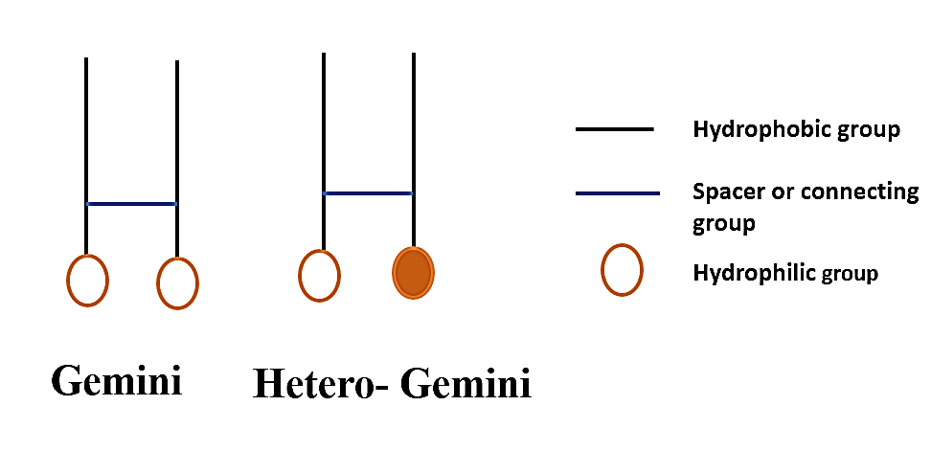
Figure 2: Chemical structure of Gemini surfactant
The length of the surfactant tail reduces CMC while increasing surface tension at CMC ^{43,44}. Nonetheless, an increase in surfactant tail contributes to reduced water solubility⁴⁵. The spacer group is possibly the most important feature of Gemini amphiphile solution properties ⁴⁶. Spacers can be short (C2) or long (C16), rigid (double bond or benzene ring), flexible (methylene units), lipophilic (hydrocarbon) or hydrophilic (ether bond). The length of the spacer has a significant impact on the size, shape, and morphology of the micelle, dictating its physicochemical properties⁴⁶. These surfactants generate polymeric surfactants with a relative molecular mass greater than 10,000 as well as a surface-active component. Natural, modified natural, and synthetic forms obtained from natural sources can be distinguished ⁴⁰. Polymer surfactants can be used as gelling agents, thickeners, emulsifiers, fluidity enhancers, antistatic agents, and dispersants. It was recognised as a critical surfactant component (Figure 4) ^{47,48}.
Classification of surfactants
- Anionic surfactants:In a neutral or alkaline aqueous solution, anionic surfactants liquefy and form a surface-active community⁴⁹. Based on the form of anionic surfactant, hydrophilic groups can be classified into five types of peptide condensates: phosphate ester, fatty acid salt type, sulphate salt type, sulfonate, and carboxylic acid salt type. In many surfactants, anionic surfactants are the original, most developed, and leading class. They are frequently utilised in biochemical process as foaming agents, antistatic agents, dispersants, detergents, emulsifiers, and stabilisers ⁵⁰. The structure of an anionic surfactant is depicted in (Figure 3)⁵¹.
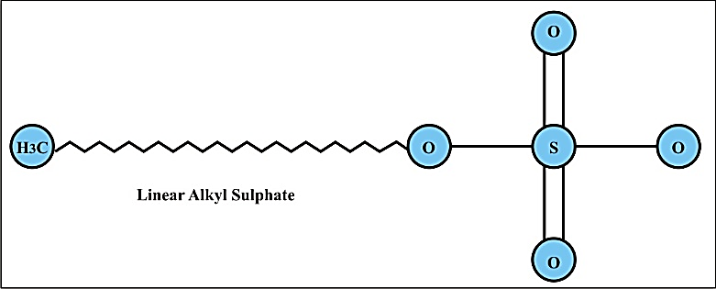
Figure 3: Linear alkyl sulphate (Anionic surfactant)

- Cationic surfactants: Cationic surfactants are liquefied in water containing positively charged surface-active ions. They have great superficial action in an acidic medium and are supposed to demonstrate rapid action in an alkaline medium. Cationic surfactants are divided into three categories based on their chain structure: open-chain cationic surfactants, heterocyclic group cationic surfactants, and bound cationic surfactants. Several studiesshow that Gemini cationic surfactants (GS) consist of two alkylammonium monomeric salts that are joined by a spacer and have considerable surface, aggregation, and antimicrobial properties. Cationic surfactants are typically employed for corrosion, rusting, cracking, mineral flotation, and sterilising⁵². Figure 3 illustrates the common form of surfactant ⁵³.
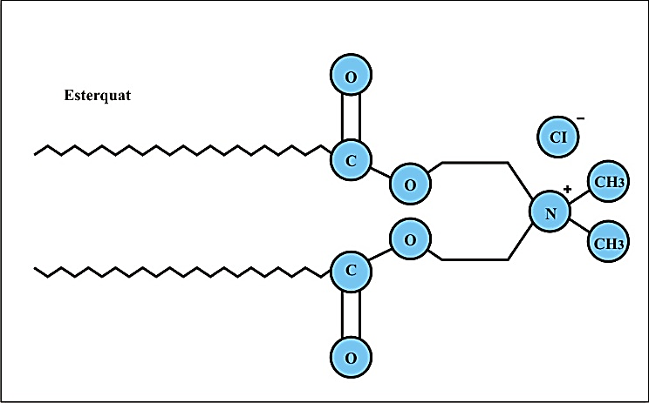
Figure 4: Cationic surfactant
- Non-ionic surfactants:In an aqueous medium, non-ionic surfactants are not ionised into ions, and form a significant number of oxygen-containing hydrophilic groups, resulting in a hydrogen-bonding suspension. The aqueous solubility of non-ionic surfactants diminishes as the temperature rises. Physiochemically, non-ionic surfactants differ from ionic surfactants due to their fundamental properties. Hydrophilic groups are categorised into four categories, including polyhydric alcohols, type polyethylene glycol, type glycosidic and type polyether. Non-ionic surfactants are widely used in paper, clothing, fruit, fabric, plastic, glass, medicines, dyes, pesticides and many other products. They show excellent performance against ionic surfactants; generated in higher amounts after anionic surfactants (Figure 5)⁵⁴.
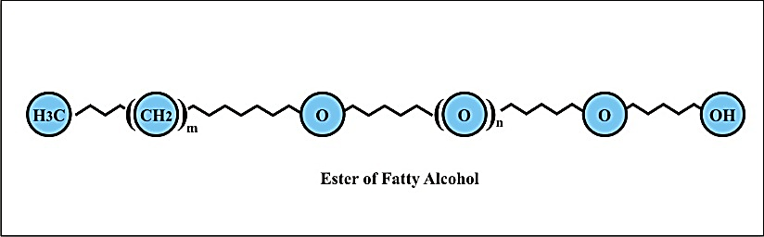
Figure 5: Ester of fatty alcohol (Non-ionic surfactant)
- Amphoteric surfactants:Amphoteric surfactants are composed of both positive and negative ions. By anion type, amphoteric surfactants can be classified as lecithin, betaine, imidazoline, or amino acid. Surfactants that are amphoteric have minimal toxicity. It is skin-friendly and possesses exceptional biodegradability. Amphoteric surfactants have numerous uses in personal defence products, such as shower gel, shampoo, cosmetics, etc., as well as in industrial softeners and antistatic agents.
- Speciality surfactants: A variety of distinct qualities distinguish specialty surfactants from regular surfactants. In addition to being a good conventional surfactant, fluorocarbon surfactant possesses remarkable thermal stability, high chemical stability, and excellent surface behaviour in a wide range of variations. Carbon black is widely used in the textile, fire, mineral processing, paper, pesticide, leather, and chemical industries, in addition to the textile, fire, mineral processing, paper, and leather industries. Tin (Sn), Thallium (Ti), and Germanium (Ge) elements are also used to improve surfactant molecules ¹².
- Macromolecule surfactants: These surfactants produce polymeric surfactants with a relative molecular mass greater than 10,000 and a surface-active part. They can be separated into natural, modified natural and synthetic forms derived from natural sources. As gelling agents, thickeners, emulsifiers, fluidity-enhancing agents, antistatic agents, and dispersants, polymer surfactants can be utilised. It was acknowledged as an important surfactant component. Figure 4 depicts the general composition of non-ionic surfactants¹².
Surface properties of Gemini Surfactant
- Critical Micelle Concentration:
Gemini surfactants are characterized by CMC’s that are one to two orders of magnitude lower than for the corresponding conventional (monomeric) surfactants. For instance, Figure 6 shows that the CMC of the dimeric surfactant 12–2–12 [dimethylene-1,2- bis(dodecyl-di-methyl-ammonium-bromide)] is about 0.055 weight %, where as that of the corresponding monomeric surfactant DTAB (dodecyl-di-methyl-ammonium-bromide) is 0.50 weight %. Thus, the “dimerization” of DTAB results in a surfactant of much lower CMC.The plots show the large difference in the values of CMC (indicated by long arrows) and of the concentration C20^{1,4,7,49}. Several Gemini surfactants linked by a spacer were discovered to exhibit significant surface, aggregation, and antibacterial characteristics ⁵⁵.
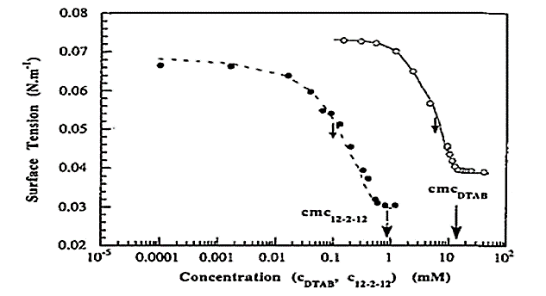 | 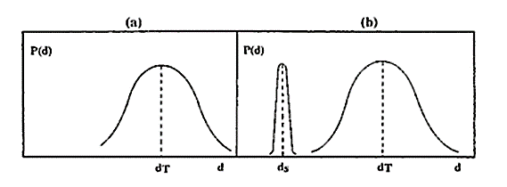
Figure 6(A) Variation of the surface tension with thesurfactant concentration; (B) Schematic representation of the distribution of distances between head group in micelles of B(a) conventional surfactant and B(b) Gemini surfactant[64]
CMC is defined as a particular concentration of a surfactant which dictates the start of aggregation of surfactants to micelle, vesicle, large uni-lamellar vesicle, (Figure 7) etc. in a particular state of reaction condition. As already discussed, all types of surfactants are amphiphiles with both hydrophilic and hydrophobic moieties. Diverse functional properties of Gemini surfactants, such as emulsification, foaming, wetting, cleansing, surface activity, phase separation and reduction in viscosity of crude oil, makes it some of the most versatile processed chemicals ^{37,53}. The activities of surfactants depend on their concentration until the critical micelle concentration (CMC) is obtained. The CMC is usually used to measure surfactant efficiency. More efficient surfactants have lower CMC, i.e., less amount of surfactant is needed to decrease the surface tension ⁵⁴.To acquire the information on different physicochemical properties of surfactants like micelle formation and structure, surface activity, adsorption, solubilisation, foaming property, wetting, phase behaviour etc. a chemist must investigate a few experiments like light scattering, spectrophotometry, conductometry, calorimetry, NMR, ESR spectroscopy and many other associated experiments for characterization. However, critical micelle concentration CMC (γCMC)is like finger print evidence, always trusted as the pivotal character of a particular micelle in every surface research that includes micellization. Surfactant molecules abruptly forms aggregation called a micelle^{40,42,56,57}. Previously it has been reported that surfactants often adsorb at interfaces and theirdual-chemical nature reduces surface tension.Gemini surfactants reduce surface tension better than monomeric ones. DTAB's pC20 (C20 = 5.25 mM) is 2.3, while 12-2-12's is 3.78. (0.16 mM)^{58–60}. Gemini surfactants have lower CMC values than QAC due to their hydrophilic groups. Critical micelle concentrations are higher in monomeric quaternary ammonium compounds. The link between positive nitrogen atoms and CMC is depicted in Figure 8[69]. Micelles are produced from monomeric and dimeric surfactants (figure 7).

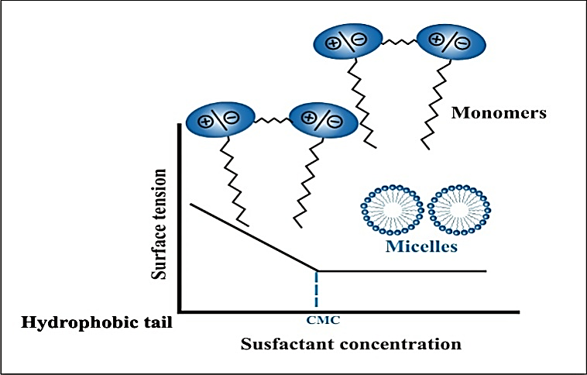
Figure 7: The variation of surface tension with surfactant concentration
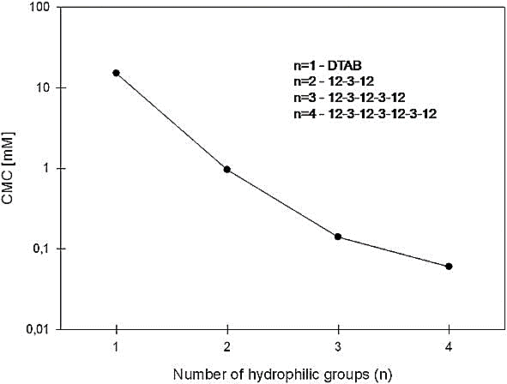
Figure 8: The correlation between number of hydrophilic groups and critical micelle concentration⁶¹
In spacers, the polar oxygen group enhances CMC. The CMC of Gemini 12-5-12 is 1.03 mM ³² and 1.35 mM ^{62,63} with an oxygen-containing spacer. The CMC is increased by multiplying oxygen units in spacers. Gemini surfactant 16-CH2CH2OCH2CH2-16 has a CMC of 0.004 mM compared to 0.02 mM for 16-CH2(CH2OCH2)3CH2-16 ⁶⁴. Rigid spacers (unsaturated bond, benzene ring) can elevate CMC ^{57,61,62,65}. The CMC structure is shown here.
12 CH₂CH₂CH₂CH 12
Unlike the spacer, the hydrophilicity of the substituent decreases the CMC. The CMC value for Gemini surfactants modified by adding ethoxyl groups are shown in figure 7. Furthermore, various Gemini surfactants with changed spacer groups are antibacterial and antifungal, as seen in Table 1. ³⁷.As Table 1 demonstrates, Gemini surfactant's antibacterial and antifungal properties offer a superior solution for the textiles industry.
Table 1: MIC values (mM) for 3-oxa-1,5-pentane-bis(N-alkyl-N,N-dimethylammonium bromides³⁷
Gemini Surfactant | MIC(mM)
Gemini Surfactant | S. aureus | E. Coli | C. albicans | A. niger | P. chysogenum
4-O-4 | >3.75 | >3.75 | >3.75 | >3.75 | >3.75
6-O-6 | 1.875 | 1.875 | >3.75 | >3.75 | >3.75
8-O-8 | 0.234 | 0.469 | 0.937 | 3.75 | 1.875
10-O-10 | 0.0293 | 0.058 | 0.117 | 0.469 | 0.117
12-O-12 | 0.0037 | 0.0073 | 0.0146 | 0.117 | 0.058
14-O-14 | 0.0073 | 0.0293 | 0.117 | 0.234 | 0.117
16-O-16 | 0.0293 | 0.058 | 0.234 | 0.234 | 0.234
18-O-18 | 0.469 | 0.937 | >3.75 | 0.469 | 0.469
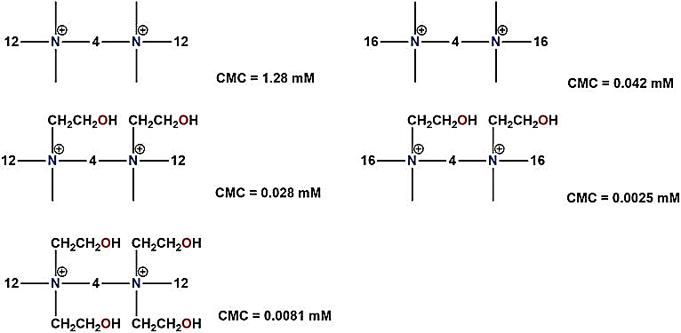
Figure 7: CMC values for ethoxyl-modified Gemini surfactants
Wetting Power
Contact angle measurements are commonly used to evaluate the degree of spreading/wettability of a liquid on a surface ⁶⁶. Wetting agents that lower the surface tension of the liquid, allow easier spreading or penetration into the solid if it is porous^{67–69} (Figure 9) shows that a small contact angle (h) is noticed when the liquid spreads on the surface, while a large contact angle is noticed when the liquid beads on the surface. When the contact angle of the pure water is smaller than 90⁰, the solid surface is considered to be hydrophilic; when the contact angle of the pure water is greater than 90⁰, the solid surface is hydrophobic ^{70–76}.
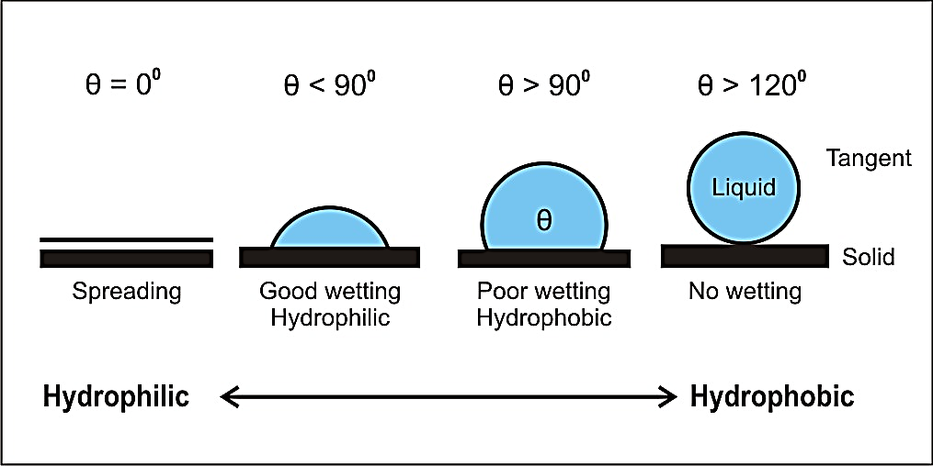
Figure 9: Contact angles formed by sessile drop on a smooth solid surface
Applications of Gemini surfactants in Textile Processes
Surfactants are extensively utilized in many textile processing techniques such as desizing, scouring, bleaching, dying, printing, and functional finishing. Surfactants are the active ingredient in finishing products for softening, crease resistance, water repellency, and so on. Gemini surfactants are better than traditional ones. They have a lower CMC/C20 required to reduce water surface tension by 20 mN/m and a lower Krafft temperature^{77,78}.In certain applications, a modest amount of Gemini surfactant can have tremendous results.Surface activity of a finishing compound has major influence on the finished textiles. Long-chain fatty and oily materials are usually applied to the surface of the fibres to make a fabric water resistant or soft in handle. Adding a solubilizing group to the fatty molecule is one effective method for depositing and attaching fatty acid chain molecules to a fibre surface. The resultant product may be applied in precise amounts in an aqueous media and is water-dispersible. Some solubilizing groups may even give substantivity, making it easier and better for the finish to stick to the fabric.Surfactants have been incorporated to textile auxiliaries primarily because to their fascinating surface and bulk characteristics. The textile sector utilises more surfactants than any other industry as a result^{79–82}. Surfactants are frequently employed as wetting, dispersing, and levelling agents to enhance the dyeing process by making the dye more soluble, stabilising the dispersed condition, and facilitating the color's equal distribution throughout the cloth. Gemini surfactants are particularly effective in dissolving substances^{83–85}. Polycyclic aromatic hydrocarbons (PAHs), which are organic contaminants and include anthracene, naphthalene, fluorene, and pyrene ^{86,87}, are easily extracted from aqueous solutions employing Gemini surfactants.Gemini surfactants are more effective in dissolving polycyclic aromatic hydrocarbons (PAH) than their monomeric equivalents ^{88,89}.
Effect on wetting properties
Few researchers have reported the exceptional surface qualities of silicone surfactants, particularly the wetting and spreading abilities^{90–92}. To attain the target throughput, they examined the application of silicone surfactants in conjunction with traditional surfactants. Gemini surfactants RN[(C₂H₄O)_{x}H]-C(O)₂CH₂CH₂, where R=2-ethylhexyl, and C_{2–4}CH₃C(OH)CC(OH) CCH₃C_{2–4}have been discovered to have strong hydrophobic characteristics and may be employed as soil wetting and rewetting agents.The disodium phosphate Gemini {CmH_{2m+1}OCH₂CH(CH₂)[OP(O)(O⁻Na⁺)(OH)]}₂Y,where Y=O(CH₂CH₂O)_{x}, has good foaming properties^{93,94}. Alkylated di-phenyloxi-dedi-sulfonates (ADPODS) is utilized in textile processing ^{95,96}.Several researchers reported the blends containing Geminis such as 10–4–10–SDeSO₄, C₁₀DADS–C₁₄DMAO, or C₁₀DADS-C₁₂EO₃ have superior wetting action and better solubilization^{97,98}. Silicon-based surfactants have excellent wetting capabilities due to their unique structure, low liquid-air surface tension, rapid adsorption kinetics and solid-liquid interfaces, and suitable structural orientation to adsorb molecules(table 2) ^{2,99–102}. Air must be immediately and completely evacuated from between the fibres or filaments of the textiles since they are submerged in aqueous solutions throughout the treatment process. The success of this procedure is determined by a number of factors, including:
  - The wettability of various fibres varies due to their varied chemical structures. Polyester filaments are challenging to wet due to the lack of polar groups, in contrast to cotton fibres, which are simple to wet.
  - The wettability of a material is determined by the structural arrangement of the fibres in yarn and fabric.
  - The presence of pollutants (wax, soil) has an effect on the wettability of fabrics. Surfactants utilised in technical textile processing (sizing, dying, printing) are Alkyl aryl ethoxylates and phosphoric esters.
Table 2: Spreading properties of various surfactants in water²
Material | Surface tension (mN/M) | Spreading factor
Water | 72.8 | 1.0
Non-ionic silicon surfactant 1 | 20.5 | 8.6
Non-ionic silicon surfactant 1 | 23.5 | 2.3
Fluorocarbon Surfactant FSAª | 16.2 | 2.0
Fluorocarbon Surfactant FSB^{b} | 16.8 | 1.8
Non-ionicsurfactantTergitol NP-10^{c} | 31.1 | 1.7
Fluorocarbon Surfactant FSN^{b} | 23.4 | 1.4
Sodium dodecyl  sulfate | 44.3 | 1.2
Here:
ªSurfactantconcentration 0.1%; ^{b} obtained from DuPont; ^{c}Obtained from Carbide Corporation

Effect on softening properties
According to previous research, conventional surfactant, Gemini surfactant, and a polymeric non-ionic soil release agent may be combined in surfactant additives, detergents, and fabric softeners.The increased reflectivity of samples of fabric treated with Gemini surfactant resembles the cleanliness of the fabric^{103,104}. Therefore, Softeners are particularly essential in textile manufacturing, and customers are increasingly choosing materials with soft handling characteristics.The use of surfactants in textile finishing processes improves processability and wearability. Most long-chain quaternary ammonium salts avoid damaging cellulosic fabrics. Softeners can be composed of cationic, anionic, or non-ionic surfactants. Non-ionicGemini surfactants can reduce the free ionic surfactant concentration in anionic-non-ionic or cationic- non-ionic combinations.Anionic surfactants may cause toxicity and skin irritations.Similarly, Amphoteric Gemini surfactants are also effective mild multifunctional surfactants³². Liu et al. 2020 identified Gemini ester surfactant for fabric softening. Cationic surfactants containing esters are important hydrolysable and biodegradable substances. According to the study, at 25 °C, its aqueous solution's critical micelle concentration and surface tension are ~3.09×10⁻⁵ M and 38.4 mN/m, respectively. Due to its more efficient adsorption onto the fabric surface, it softens cotton better than monomeric surfactants while preserving its whiteness and surface hydrophilicity (Figure 10)¹⁰⁵.
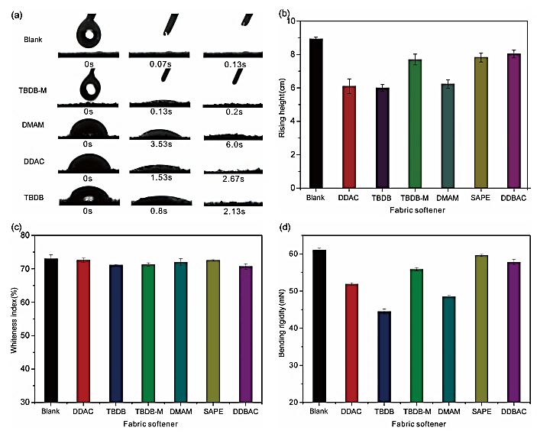
Figure 10: Effect of different surfactant emulsions on various fabric properties (a) wetting (~5 μL) (b) Wicking (cm), (c) Whiteness index (d) bending rigidity¹⁰⁶
Dye-surfactant interaction
Several researchersclaimed the effectiveness of Gemini surfactants as a dye solubilizers ¹⁰⁵. The dispersion, emulsification, and solubilization abilities of surfactants affect dye bath stability, levelness of dyeing, dyeing rate, and dye uptake.Dye–surfactant interactions are useful for industrial applications because surfactants are used to wet and level or disperse low-soluble dyes. Their interactions with dyes help level dyeing by wetting textiles and controlling dye absorption.Surfactant and dye interactions have been the subject of extensive study ^{107–109}. Structures of the dye and surfactant are crucial in dye–surfactant interactions. Dye-surfactant interactions are complex. Chemical structure of compounds determines these interactions.Cationic surfactants increase dye adsorption to negatively charged textile fibres ^{110,111}. The solubilization power of Gemini surfactants rises with alkyl chain and spacer length, leading to bigger micelles.Surfactant-dye interactions are important in dyeing and dye separation processes like cloud point extraction and micellar enhanced ultrafiltration. Potentiometry, conductometry, ion selective electrodes, and spectrophotometry were used to evaluate dye-surfactant interactions.The absorption rate of various dyes can arise in the presence of surfactant was evaluated by electronic absorption spectra, and confirmed the stronger the mutual interaction between dye and surfactant (figure11)^{112–117}.
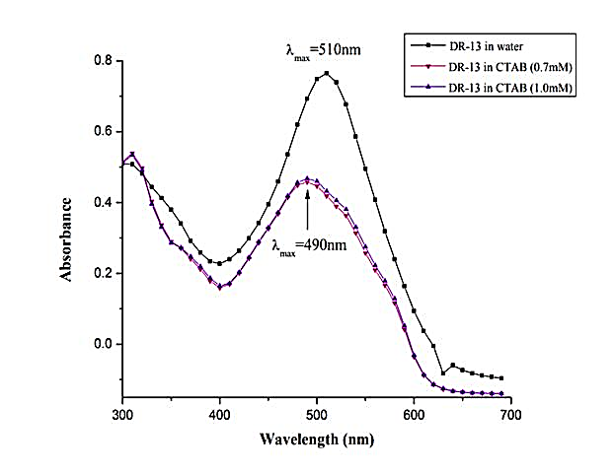
Figure 11: Absorbance of DR-13 in presence and absence of CTAB¹¹⁸
A change in the equilibrium state of surfactant and dye monomers and other complex compounds causes visible dye absorption spectra to change. The polarity of the solvent influence’s surfactant-dye interactions. Predicting the behaviour of dye-surfactant mixtures in aqueous and mixed solvent systems can be made easier with an understanding of these interactions¹¹⁸.
Few researchers have studied dye–surfactant interactions and reported direct improvements in dyeing quality⁵⁶, which is one of the goals of textile dyeing and finishing. According to Barni et al. 1991, dye and surfactant structures affect dye–surfactant interactions and surfactant levelling abilities in ionic dyes¹¹⁰. Many studies stated the importance of electrical force in the processing of anionic dyes with cationic surfactants. It allows ions to attach via Vander-Waal force ^{65,89,92,110,119}.Barni et al. 1991 also studied the interactions between modified Gemini surfactant and direct dyes on the structure of cotton fabrics. According to their research, the physicochemical properties of modified anionic Gemini surfactants enhanced the rate of orange dyeing. They also observed the reverse effect in the case of blue dye with a changed surface due to the creation of complex structures¹¹⁰.
levelling agents in dyeing
The interaction of several Ionic and anionic dyes with two cationic Gemini surfactants with different spacer lengthshas been studies by several researchers ^{120–122}. The disperse dyeing of nylon-6 and polyester with 1,4-diaminoanthraquinone (1,4-DAA) in the presence of the cationic Geminis 12–3–12 and 12–6–12 and compared the results with those for the corresponding conventionalsurfactant dodecyltri-methylammonium bromide(DTAB).According to their findings the Gemini surfactant with the shorter spacer interacted with dye more strongly than DTAB and the Gemini with the longer spacer.The hydrophilic dye—surfactant complexes increased the solubility of the disperse dyes, resulting in a slower dyeing rate in the presence of surfactants.From figure 12 it has been stated that dye molecules are absorbed into the micellar (or vesicle) surface rather than its interior. Cationic micelles also include aromatic compounds with sulphonate groups. They reported that at surfactant concentration above the CMC, K increased in the order DTAB<12–6–12< 12–3–12<<water. The relativity of the K depends on the solubilization capacity of the surfactants. It has been discovered that dyeing kinetics and dye uptake in disperse dyeing of polyester or Nylon-6 are controlled by the Gemini surfactants^{123,124}.
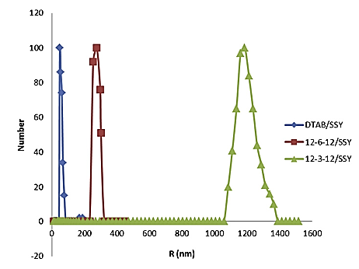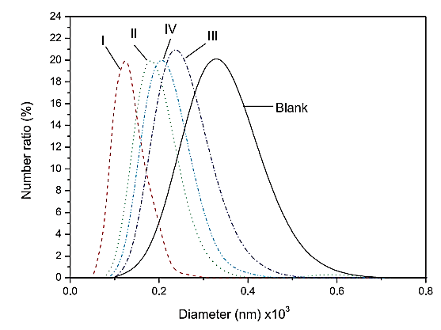
Figure12: Particle size distribution and diameter difference of different dye-surfactant systems in micellar region¹²³
Several researchers reported the solubilization dye molecules. Most dispersion dyes are hydrophobic in nature [55]. Hydrophobic non-covalent bonds cause clumping and precipitation, rendering the chemical difficult to dissolve in water. The addition of dispersants, primarily anionic surfactants, to dye baths prevents particles from clumping and sticking together. In disperse dyeing, solubilization, particle size distribution, and dispersion stability are crucial ^{125,126}. Compared to commercial disperse dyes used at a higher temperature, the dispersing capabilities and particle size of modified Gemini surfactants are superior when polyester is coloured. The existence of dye-surfactant complexes was demonstrated by spectrophotometry. Surfactants reduced the rate at which polyester fabrics changed colour as a result of interactions between hydrophilic dyes and surfactants that evened out the colour.In the exhaustion dyeing process, levelling agents enhance consistent dye dispersion in the material, ensuring a uniform hue and depth of colour. According to prior researches, levelling agents decrease the rate of dyeing, increase dye migration, and improve colour compatibility.Use of levelling retarders are common in dyeing of polyacrylonitrile fibres using cationic. Several cationic surfactants (12–18 C–C chain based quaternary ammonium salts) are recommended by the researchers in the application of cationic dyes for anionic dye sites. Table 3 despite the commonlevelling agents.
Table 3: Various levelling agents for textile fibres¹²⁵
S.no. | Fibre type | Dye type | Levelling agent type
1. | Cellulose ﬁbres | Vat and direct dyes | Polyglycol ether  Phosphoric esters  Alkyl aryl sulphonate
2. | Wool fibres | Acid dyes | Alkyl amine polyglycol ether sulphate
3. | Polyamide ﬁbres | Anionic dyes | Fatty amine polyglycol ether
4. | Polyacrylonitrile ﬁbres | Cationic dyes | Quaternary ammonium compound  Quaternary fatty acid amine

Water-repellent ﬁnishes
Gemini surfactants comprise two monomeric molecules connected at their head groups. They have hydrophilic and hydrophobic properties. Gemini surfactants possess a greater surface activity and a lower CMC^{103,104,125}. Water repellency refers to the liquid repellency of the fabric with an application of aqueous solution in the presence of heat, a water-soluble, long-chain chemical can be made into a water-repellent finish on fabric. Additionally, long-chain compounds may be water-soluble due to the presence of cationic, anionic, or non-ionizing solubilizing groups. Surface-active chemicals that make materials water-repellent include:
  - Cationic surfactants
  - Methyl-ol-stearamides
  - Ethylene bis stearamide
  - Lauryl pyridinium chloride
Carbohydrate fatty acids are non-ionic oil in water O/W emulsifiers for cosmetics. A surfactant must have excellent surface activity and low surface tension to operate as an emulsifier. Thus, it must migrate to the air–water contact rather than remain dissolved ^{126,127}.Several researchers reported that a decrease in the alkyl chain length resulted in an increase in the emulsifying ability in the average initial droplet diameter.
Conclusion
This article summarises the findings of several investigations that intended to improve fundamental understanding of Gemini surfactants used as dyeing auxiliaries with direct dyes, as well as their interactions with direct dyes and dyeing properties. Gemini surfactants can be used for softening finishes, lubricating agents in warp sizing, sewage sludge detergency, and particle dirt detergency. Surfactants are now used in a variety of fabric finishing methods, in addition to pre-treatment. Surfactants with an anionic or non-ionic nature are more commonly utilised in the production of technical fabrics.In addition, the employment of surfactants as levelling, emulsifying, dispersing, solubilizing, foaming, and detergent cleaning/scouring agents is crucial.The most typical applications for anionic and non-ionic surfactants in textile processing include dyeing, finishing, and post-finishing.The application of surfactants as antimicrobial agent is also crucial in textile industry. With the aid of these surfactants, countless innovative challenges can be conquered. The Possible applications of Gemini surfactants include softening, lubrication, antistatic, antimicrobial, and water/oil repellent properties.As a result, this novel Gemini surfactant appears to have enormous potential for textile industry applications.
Acknowledgement
The authors are thankful to the Uttar Pradesh textile Technology Institute, Kanpur, Bannari Amman Institute of Technology, Sathymangalam and RS formulation and consultancy for providing all facilities and fundings.
References
1 Zana R, Dimeric and oligomeric surfactants. Behavior at interfaces and in aqueous solution: a review, Adv Colloid Interface Sci, 97 (1–3) 2002 205–253.
2 Rosen MJ & Tracy DJ, Gemini surfactants, J Surfactants Deterg, 1 (4) 1998 547–554.
3 Texter J, Reactions and synthesis in surfactant systems, Surfactant science series, 100 2001.
4 Zana R, Dimeric (Gemini) Surfactants: Effect of the Spacer Group on the Association Behavior in Aqueous Solution, J Colloid Interface Sci, 248 (2) 2002 203–220.
5 Bunton CA, Robinson LB, Schaak J, & Stam MF, Catalysis of nucleophilic substitutions by micelles of dicationic detergents, J Org Chem, 36 (16) 1971 2346–2350.
6 Devínsky F, Lacko I, Bittererová F, &Tomečková L, Relationship between structure, surface activity, and micelle formation of some new bisquaternary isosteres of 1,5-pentanediammonium dibromides, J Colloid Interface Sci, 114 (2) 1986 314–322.
7 Menger FM &Littau CA, Gemini-surfactants: synthesis and properties, J Am Chem Soc, 113 (4) 1991 1451–1452.
8 Gautam A, Kambo N, Upadhyay SK, & Singh RP, Anionic gemini surfactant viz. sodium salt of bis(1-dodecenylsuccinamic acid); synthesis, surface properties and micellar effect on oxidation of reducing sugars by hexacyanoferrate(III), Colloids Surf A PhysicochemEng Asp, 312 (2–3) 2008 195–202.
9 Kambo N & Upadhyay SK, Antagonism in (conventional anionic-gemini anionic) mixed micelle catalyzed oxidation of D-fructose by alkaline chloramine-T: A kinetic study, Int J Chem Kinet, 41 (2) 2009 123–132.
10 Menger FM &Littau CA, Gemini surfactants: a new class of self-assembling molecules, J Am Chem Soc, 115 (22) 1993 10083–10090.
11 Zana Raoul, Dynamics of Surfactant Self-Assemblies, (edited by Zana R), (CRC Press), 2005.
12 Menger FM & Keiper JS, Gemini Surfactants, AngewandteChemie International Edition, 39 (11) 2000 1906–1920.
13 Menger FM &Mbadugha BNA, Gemini Surfactants with a Disaccharide Spacer, J Am Chem Soc, 123 (5) 2001 875–885.
14 Idouhar M &Tazerouti A, Spectrophotometric Determination of Cationic Surfactants Using Patent Blue V: Application to the Wastewater Industry in Algiers, J Surfactants Deterg, 11 (4) 2008 263–267.
15 Alami E, Beinert G, Marie P, & Zana R, Alkanediyl-.alpha.,.omega.-bis(dimethylalkylammonium bromide) surfactants. 3. Behavior at the air-water interface, Langmuir, 9 (6) 1993 1465–1467.
16 Myers D, Surfactant Science and technology, 4th ed., (edited by Myers D), (Wiley), 2020.
17 Karsa DR, Surfactants in Polymers, Coatings, Inks and Adhesives, (edited by Karsa DR), (Blackwell), 2020.
18 Schramm LL, Stasiuk EN, & Marangoni DG, 2 Surfactants and their applications, Annu Rep Prog Chem, Sect C: Phys Chem, 99 2003 3–48.
19 Tehrani-Bagha A & Holmberg K, Solubilization of Hydrophobic Dyes in Surfactant Solutions, Materials, 6 (2) 2013 580–608.
20 Siedenbiedel F & Tiller JC, Antimicrobial Polymers in Solution and on Surfaces: Overview and Functional Principles, Polymers (Basel), 4 (1) 2012 46–71.
21 Rahman PKSM & Randhawa KKS, Editorial: Microbiotechnology Based Surfactants and Their Applications, Front Microbiol, 6 2015.
22 Russell H, Index, In: Russell, Hugo &Ayliffe’s, (Wiley-Blackwell, Oxford, UK), 2012, 589–606.
23 Zhou C, Wang F, Chen H, Li M, Qiao F, et al., Selective Antimicrobial Activities and Action Mechanism of Micelles Self-Assembled by Cationic Oligomeric Surfactants, ACS Appl Mater Interfaces, 8 (6) 2016 4242–4249.
24 John VT, Simmons B, McPherson GL, & Bose A, Recent developments in materials synthesis in surfactant systems, CurrOpin Colloid Interface Sci, 7 (5–6) 2002 288–295.
25 Shinde P v, Kategaonkar AH, Shingate BB, &Shingare MS, Surfactant catalyzed convenient and greener synthesis of tetrahydrobenzo[a ]xanthene-11-ones at ambient temperature, Beilstein Journal of Organic Chemistry, 7 2011 53–58.
26 Javed Raymond Akbar, Pharmaceutical Applications of Gemini Surfactants, (University of Waterloo), 2010.
27 Sivaramakrishnan CN, The use of surfactants in the finishing of technical textiles, In: Advances in the Dyeing and Finishing of Technical Textiles, (Elsevier), 2013, 199–235.
28 le Marechal AM, Krianec B, Vajnhandl S, &Volmajer J, Textile Finishing Industry as an Important Source of Organic Pollutants, In: Organic Pollutants Ten Years After the Stockholm Convention - Environmental and Analytical Update, (InTech), 2012.
29 Shen AQ, Gleason B, McKinley GH, & Stone HA, Fiber coating with surfactant solutions, Physics of Fluids, 14 (11) 2002 4055–4068.
30 Ma J, Tang J, Cheng Q, Zhang H, Shinya N, et al., Effects of surfactants on spinning carbon nanotube fibers by an electrophoretic method, Sci Technol Adv Mater, 11 (6) 2010 065005.
31 Lin Y, Qiao Y, Cheng X, Yan Y, Li Z, et al., Hydrotropic salt promotes anionic surfactant self-assembly into vesicles and ultralong fibers, J Colloid Interface Sci, 369 (1) 2012 238–244.
32 Pritchard G, Additives are essential, In: 1998, 3–10.
33 Raffa P, Broekhuis AA, &Picchioni F, Polymeric surfactants for enhanced oil recovery: A review, J Pet Sci Eng, 145 2016 723–733.
34 Maithufi MN, Joubert DJ, &Klumperman B, Application of Gemini Surfactants as Diesel Fuel Wax Dispersants, Energy & Fuels, 25 (1) 2011 162–171.
35 Kumar N & Tyagi R, Industrial Applications of Dimeric Surfactants: A Review, J Dispers Sci Technol, 35 (2) 2014 205–214.
36 Athas JC, Jun K, McCafferty C, Owoseni O, John VT, et al., An Effective Dispersant for Oil Spills Based on Food-Grade Amphiphiles, Langmuir, 30 (31) 2014 9285–9294.
37 Song D, Development of High Efficient and Low Toxic Oil Spill Dispersants based on Sorbitol DerivantsNonionic Surfactants and Glycolipid Biosurfactants, J Environ Prot (Irvine, Calif), 04 (01) 2013 16–22.
38 Lopes LRB, Soares VLP, Barcellos MTC, & Mansur CRE, Desenvolvimento de surfatantes para aplicaçãonaindústria de explosivos, Polímeros, 24 (4) 2014 474–477.
39 Tornero V & Hanke G, Chemical contaminants entering the marine environment from sea-based sources: A review with a focus on European seas, Mar Pollut Bull, 112 (1–2) 2016 17–38.
40 Brown P, Butts CP, &Eastoe J, Stimuli-responsive surfactants, Soft Matter, 9 (8) 2013 2365.
41 Helenius A, McCaslin DR, Fries E, &Tanford C, [63] Properties of detergents, In: 1979, 734–749.
42 Zhang W, Dai X, Zhao Y, Lu X, & Gao P, Comparison of the Different Types of Surfactants for the Effect on Activity and Structure of Soybean Peroxidase, Langmuir, 25 (4) 2009 2363–2368.
43 Zhou M, Zhang Z, Xu D, Hou L, Zhao W, et al., Synthesis of three gemini betaine surfactants and their surface active properties, J Taiwan Inst Chem Eng, 74 2017 7–13.
44 AkramMohd, Anwar S, Bhat IA, & Kabir-ud-Din, In vitro evaluation of the non-covalent interactions of hemoglobin with distinctively modified gemini surfactants: Effect of structural variation, Colloids Surf APhysicochemEng Asp, 527 2017 145–157.
45 Zhou L, Jiang X, Li Y, Chen Z, & Hu X, Synthesis and Properties of a Novel Class of Gemini Pyridinium Surfactants, Langmuir, 23 (23) 2007 11404–11408.
46 Shakil Hussain SM, Animashaun MA, Kamal MS, Ullah N, Hussein IA, et al., Synthesis, Characterization and Surface Properties of Amidosulfobetaine Surfactants Bearing Odd-Number Hydrophobic Tail, J Surfactants Deterg, 19 (2) 2016 413–420.
47 Brycki B &Szulc A, Gemini surfactants as corrosion inhibitors. A review, J Mol Liq, 344 2021 117686.
48 Bhadani A, Kataria H, & Singh S, Synthesis, characterization and comparative evaluation of phenoxy ring containing long chain gemini imidazolium and pyridinium amphiphiles, J Colloid Interface Sci, 361 (1) 2011 33–41.
49 Li F & Rosen MJ, Adsorption of Gemini and Conventional Cationic Surfactants onto Montmorillonite and the Removal of Some Pollutants by the Clay, J Colloid Interface Sci, 224 (2) 2000 265–271.
50 Zhang T, Cao X, Wang X, & Song C, Synthesis, surface activity and thermodynamic properties of cationic gemini surfactants with diester and rigid spacers, J Mol Liq, 230 2017 505–510.
51 Ao M, Huang P, Xu G, Yang X, & Wang Y, Aggregation and thermodynamic properties of ionic liquid-type gemini imidazolium surfactants with different spacer length, Colloid Polym Sci, 287 (4) 2009 395–402.
52 Taleb K, Pillin I, Grohens Y, &Saidi-Besbes S, Gemini surfactant modified clays: Effect of surfactant loading and spacer length, Appl Clay Sci, 161 2018 48–56.
53 Wang X, Wang J, Wang Y, Yan H, Li P, et al., Effect of the Nature of the Spacer on the Aggregation Properties of Gemini Surfactants in an Aqueous Solution, Langmuir, 20 (1) 2004 53–56.
54 Mondal MH, Roy A, Malik S, Ghosh A, &Saha B, Review on chemically bonded geminis with cationic heads: second-generation interfactants, Research on Chemical Intermediates, 42 (3) 2016 1913–1928.
55 Malik S, Ghosh A, Mukherjee K, &Saha B, Combination of Best Promoter and Micellar Catalyst for Cr(VI) Oxidation of Lactose to Lactobionic Acid in Aqueous Medium at Room Temperature, Tenside Surfactants Detergents, 51 (4) 2014 325–332.
56 Hill RM, Superspreading, CurrOpin Colloid Interface Sci, 3 (3) 1998 247–254.
57 Zhang X, Shi F, Niu J, Jiang Y, & Wang Z, Superhydrophobic surfaces: from structural control to functional application, J Mater Chem, 18 (6) 2008 621–633.
58 Bronner F &Peterlik M, PREFACE, In: Calcium and Phosphate Transport Across Biomembranes, (Elsevier), 1981, xix–xx.
59 McEvoy J & Giger W, Accumulation of linear alkylbenzenesulphonate surfactants in sewage sludges, Naturwissenschaften, 72 (8) 1985 429–431.
60 Henau H de, Mathijs E, & Hopping WD, Linear Alkylbenzene Sulfonates (LAS) in Sewage Sludges, Soils and Sediments: Analytical Determination and Environmental Safety Considerations, Int J Environ Anal Chem, 26 (3–4) 1986 279–293.
61 Abdul AS & Ang CC, In Situ Surfactant Washing of Polychlorinated Biphenyls and Oils from a Contaminated Field Site: Phase II Pilot Study, Ground Water, 32 (5) 1994 727–734.
62 Khan ZA & Al-Bogami AS, Dye-Surfactant Interaction: Role of Solvent, Asian Journal of Chemistry, 25 (18) 2013 10499–10503.
63 Sarkar M & Poddar S, Spectral studies of methyl violet in aqueous solutions of different surfactants in supermicellar concentration region, Spectrochim Acta A Mol BiomolSpectrosc, 55 (9) 1999 1737–1742.
64 Kumar Mandal A &Kanta Pal M, Spectral analysis of complexes of the dye, 3,3′-diethyl thiacyanine and the anionic surfactant, SDS by the principal component analysis method, Spectrochim Acta A Mol BiomolSpectrosc, 55 (7–8) 1999 1347–1358.
65 Sarkar M & Poddar S, Studies on the Interaction of Surfactants with Cationic Dye by Absorption Spectroscopy, J Colloid Interface Sci, 221(2) 2000 181–185.
66 Dutta RK & Bhat SN, Association of neutral red with micelles and its effect on the p K_{a}, Can J Chem, 71 (11) 1993 1785–1791.
67 Minch MJ & Shah SS, Spectroscopic studies of hydrophobic association. Merocyanine dyes in cationic and anionic micelles, J Org Chem, 44 (18) 1979 3252–3255.
68 Moulik SP, Ghosh S, & Das AR, Interaction of acridine orange monohydrochloride dye with sodiumdodecylsulfate, (SDS) cetyltrimethylammoniumbromide (CTAB) and p-tert-octylphenoxypolyoxy ethanol (Triton X 100) surfactants, Colloid Polym Sci, 257 (6) 1979 645–655.
69 Karukstis KK, Savin DA, Loftus CT, & D’Angelo ND, Spectroscopic Studies of the Interaction of Methyl Orange with Cationic Alkyltrimethylammonium Bromide Surfactants, J Colloid Interface Sci, 203 (1) 1998 157–163.
70 Shah SS, Khan MS, Ullah H, & Awan MA, Solubilization of Amphiphilic Hemicyanine Dyes by a Cationic Surfactant, Cetyltrimethylammonium Bromide, J Colloid Interface Sci, 186 (2) 1997 382–386.
71 Elvers B, Ullmann’s encyclopedia of industrial chemistry. , (edited by Elvers Barbara), Volume 17, (Hoboken NJ: Verlag Chemie), 1991.
72 El-Zawahry MM &Mashaly HM, Acid dyeing of linen fabrics using gemini cationic surfactants, Journal of the Textile Institute, 101 (7) 2010 645–652.
73 Brac̆ko S &Špan J, Anionic dye–cationic surfactant interactions in water–ethanol mixed solvent, Dyes and Pigments, 50 (1) 2001 77–84.
74 Oakes J & Gratton P, Solubilisation of dyes by surfactant micelles. Part 1; Molecular interactions of azo dyes with nonionic and anionic surfactants, Coloration Technology, 119 (2) 2003 91–99.
75 Oakes J & Gratton P, Solubilisation of dyes by surfactant micelles. Part 2; Molecular interactions of azo dyes with cationic and zwitterionic surfactants, Coloration Technology, 119 (2) 2003 100–107.
76 Sivaramakrishnan CN, The use of surfactants in the finishing of technical textiles, In: Advances in the Dyeing and Finishing of Technical Textiles, (Elsevier), 2013, 199–235.
77 Zana R & Xia J, Applications of Gemini Surfactants, In: 2003.
78 Yoshimura T, Ishihara K, &Esumi K, Sugar-Based Gemini Surfactants with Peptide Bonds─Synthesis, Adsorption, Micellization, and Biodegradability, Langmuir, 21 (23) 2005 10409–10415.
79 Shang Y, Liu H, Xia J, & Xu Z, Fabrication and Characterization of Flower‐Like ZnO by Gemini Surfactant‐Assisted Hydrothermal Process, J Dispers Sci Technol, 26 (5) 2005 525–530.
80 Sivaramakrishnan CN, The use of surfactants in the finishing of technical textiles, In: Advances in the Dyeing and Finishing of Technical Textiles, (Elsevier), 2013, 199–235.
81 Gulrajani ML, Advances in the dyeing and finishing of technical textiles, (Woodhead Publishing Limited), 2013.
82 Waddad AY, Abbad S, Yu F, Munyendo WLL, Wang J, et al., Formulation, characterization and pharmacokinetics of Morin hydrate niosomes prepared from various non-ionic surfactants, Int J Pharm, 456 (2) 2013 446–458.
83 Lam Y-L, Kan C-W, & Yuen C-WM, Developments in functional finishing of cotton fibres – wrinkle-resistant, flame-retardant and antimicrobial treatments, Textile Progress, 44 (3–4) 2012 175–249.
84 Ibrahim NA, Eid BM, & Sharaf SM, Functional Finishes for Cotton‐Based Textiles: Current Situation and Future Trends, In: Textiles and Clothing, (Wiley), 2019, 131–190.
85 Zhang Y, Shahid-ul-Islam, Rather LJ, & Li Q, Recent advances in the surface modification strategies to improve functional finishing of cotton with natural colourants - A review, J Clean Prod, 335 2022 130313.
86 Nadi A, Boukhriss A, Bentis A, Jabrane E, &Gmouh S, Evolution in the surface modification of textiles: a review, Textile Progress, 50 (2) 2018 67–108.
87 Amzad Hossain M &Salehuddin SM, Polycyclic aromatic hydrocarbons (PAHs) in edible oils by gas chromatography coupled with mass spectroscopy, Arabian Journal of Chemistry, 5 (3) 2012 391–396.
88 Boving TB & Zhang W, Removal of aqueous-phase polynuclear aromatic hydrocarbons using aspen wood fibers, Chemosphere, 54 (7) 2004 831–839.
89 Fatma N, Panda M, Ansari WH, & Kabir-ud-Din, Solubility enhancement of anthracene and pyrene in the mixtures of a cleavable cationic gemini surfactant with conventional surfactants of different polarities, Colloids Surf APhysicochemEng Asp, 467 2015 9–17.
90 Wei W, Ran Z, He H, Zhou K, Huangfu Z, et al., Desorption process and morphological analysis of real polycyclic aromatic hydrocarbons contaminated soil by the heterogemini surfactant and its mixed systems, Chemosphere, 254 2020 126854.
91 Patel U, Parekh P, Sastry NV, Aswal VK, & Bahadur P, Surface activity, micellization and solubilization of cationic gemini surfactant-conventional surfactants mixed systems, J Mol Liq, 225 2017 888–896.
92 Pukale DD, Bansode AS, Jadhav NL, Pinjari D v., & Kulkarni RR, Review on Silicone Surfactants: Silicone-based Gemini Surfactants, Physicochemical Properties and Applications, Tenside Surfactants Detergents, 56 (4) 2019 268–278.
93 Bao Y, Guo J, Ma J, Li M, & Li X, Physicochemical and antimicrobial activities of cationic gemini surfactants with polyether siloxane linked group, J Mol Liq, 242 2017 8–15.
94 Floyd DT, Silicone Surfactants, In: Silicone Surfactants, (Routledge), 2019, 181–208.
95 Chowdhury S, Rakshit A, Acharjee A, &Saha B, Novel Amphiphiles and Their Applications for Different Purposes with Special Emphasis on Polymeric Surfactants, ChemistrySelect, 4 (23) 2019 6978–6995.
96 Myers D, Surfactant Science and Technology, (Wiley), 2020.
97 Tongcumpou C, Acosta EJ, Quencer LB, Joseph AF, Scamehorn JF, et al., Microemulsion formation and detergency with oily soils: II. Detergency formulation and performance, J Surfactants Deterg, 6 (3) 2003 205–214.
98 Ananthapadmanabhan KP, Goddard ED, &Chandar P, A study of the solution, interfacial and wetting properties of silicone surfactants, Colloids and Surfaces, 44 1990 281–297.
99 Goddard ED &Ananthapadmanabhan KP, Applications of Polymer-Surfactant Systems, In: Polymer-Surfactant Systems, (CRC Press), 2020, 21–64.
100 Lee HJ, Paul S, Atalla N, Thomas PE, Lin X, et al., Gemini Vitamin D Analogues Inhibit Estrogen Receptor–Positive and Estrogen Receptor–Negative Mammary Tumorigenesis without Hypercalcemic Toxicity, Cancer Prevention Research, 1 (6) 2008 476–484.
101 Pukale DD, Bansode AS, Jadhav NL, Pinjari D v., & Kulkarni RR, Review on Silicone Surfactants: Silicone-based Gemini Surfactants, Physicochemical Properties and Applications, Tenside Surfactants Detergents, 56 (4) 2019 268–278.
102 Han F & Zhang G, Synthesis and characterization of glucosamide-based trisiloxanegemini surfactants, J Surfactants Deterg, 7 (2) 2004 175–180.
103 Tyagi P & Tyagi R, Synthesis, Structural Properties and Applications of Gemini Surfactants: A Review, Tenside Surfactants Detergents, 46 (6) 2009 373–382.
104 Liu D, Yang X, Liu P, Mao T, Shang X, et al., Synthesis and characterization of gemini ester surfactant and its application in efficient fabric softening, J Mol Liq, 299 2020 112236.
105 Garcia MED & Sanz-Medel A, Dye-surfactant interactions: a review, Talanta, 33 (3) 1986 255–264.
106 Simončič B &Špan J, A study of dye–surfactant interactions. Part 3. Thermodynamics of the association of C.I. Acid Orange 7 and cetylpyridinium chloride in aqueous solutions, Dyes and Pigments, 46 (1) 2000 1–8.
107 Forte-Tavčer P, Interactions between some anionic dyes and cationic surfactants with different alkyl chain length studied by the method of continuous variations, Dyes and Pigments, 63 (2) 2004 181–189.
108 Barni E, Savarino P, &Viscardi G, Dye-surfactant interactions and their applications, Acc Chem Res, 24 (4) 1991 98–103.
109 Tehrani Bagha AR, Bahrami H, Movassagh B, Arami M, &Menger FM, Interactions of gemini cationic surfactants with anionic azo dyes and their inhibited effects on dyeability of cotton fabric, Dyes and Pigments, 72 (3) 2007 331–338.
110 Ajaz M, Shakeel S, & Rehman A, Microbial use for azo dye degradation—a strategy for dye bioremediation, International Microbiology, 23 (2) 2020 149–159.
111 Rahman MYA, Sulaiman AS, & Umar AA, Dye-sensitized Solar Cell utilizing Gold Doped Reduced Graphene Oxide Films Counter Electrode, Journal of New Materials for Electrochemical Systems, 21 (2) 2018 113–117.
112 Rahman MYA, Sulaiman AS, Umar AA, & Salleh MM, Dye-sensitized solar cell (DSSC) utilizing reduced graphene oxide (RGO) films counter electrode: effect of graphene oxide (GO) content, Journal of Materials Science: Materials in Electronics, 28 (2) 2017 1674–1678.
113 Sharma R, Kamal A, & Mahajan RK, A quantitative appraisal of the binding interactions between an anionic dye, Alizarin Red S, and alkyloxypyridinium surfactants: a detailed micellization, spectroscopic and electrochemical study, Soft Matter, 12 (6) 2016 1736–1749.
114 AkramMohd, Lal H, Shakya S, Varshney R, & Kabir-ud-Din, Molecular engineering of complexation between RNA and biodegradable cationic gemini surfactants: role of the hydrophobic chain length, Mol Syst Des Eng, 7 (5) 2022 487–506.
115 Irshad S, Sultana H, Usman M, Saeed M, Akram N, et al., Solubilization of direct dyes in single and mixed surfactant system: A comparative study, J Mol Liq, 321 2021 114201.
116 Rehman A, Usman M, Bokhari TH, Rahman HMAU, Mansha A, et al., Effects of nonionic surfactant (TX-100) on solubilizing power of cationic surfactants (CTAB and CPC) for Direct Red 13, Colloids Surf APhysicochemEng Asp, 586 2020 124241.
117 Khan ZA & Al-Bogami AS, Dye-Surfactant Interaction: Role of Solvent, Asian Journal of Chemistry, 25 (18) 2013 10499–10503.
118 Shahid M, Shahid-ul-Islam, & Mohammad F, Recent advancements in natural dye applications: a review, J Clean Prod, 53 2013 310–331.
119 Padasala S, Kuperkar K, & Bahadur P, Solubilisation study of water‐insoluble dye in cationic single/dimeric surfactant micelles: effect of headgroup, non‐polar tail, and spacer chain in aqueous and salt solution, Coloration Technology, 132 (3) 2016 217–221.
120 Fazeli S, Sohrabi B, & Tehrani-Bagha AR, The study of Sunset Yellow anionic dye interaction with gemini and conventional cationic surfactants in aqueous solution, Dyes and Pigments, 95 (3) 2012 768–775.
121 Lai C-C & Chen K-M, Preparation and surface activity of polyoxyethylene-carboxylated modified Gemini surfactants, Colloids Surf APhysicochemEng Asp, 320 (1–3) 2008 6–10.
122 Choi T-S, Shimizu Y, Shirai H, & Hamada K, Solubilization of disperse dyes in cationic gemini surfactant micelles, Dyes and Pigments, 45 (2) 2000 145–152.
123 Choi T-S, Shimizu Y, Shirai H, & Hamada K, Disperse dyeing of polyester fiber using gemini surfactants containing ammonium cations as auxiliaries, Dyes and Pigments, 50 (1) 2001 55–65.
124 Mallinson P, Application of Surfactants in the Textile Industry, In: Industrial Applications of Surfactants IV, (Elsevier), 1999, 272–278.
125 Tehrani-Bagha AR & Holmberg K, Cationic Ester-Containing Gemini Surfactants: Physical−Chemical Properties, Langmuir, 26 (12) 2010 9276–9282.
126 Lin L-H & Chou Y-S, Surface activity and emulsification properties of hydrophobically modified dextrins, Colloids Surf APhysicochemEng Asp, 364 (1–3) 2010 55–60.

