Extraction and Applications of Rosmarinus
Prof .Yasir .A.Mohamed¹, Dr.Elrafie A. A.Allah¹, Shimaa A. M.Mohamed²
^{1.1}Department of Chemical Engineering, Faculty of Engineering, University
of ElImam ElMahdi, Kosti, Sudan
Yasir13000@yahoo.com,rafieah@gmail.com,shimaalhag2021@gmail.com
Abstract
The aim of this research is to evaluate the antioxidant, cytotoxic, and antimicrobial effects, identify the constituent compounds, calculate the extraction rate, and conduct phytochemical analysis of rosemary.
Rosemary, also known as Rosmarinus officinalis, is native to the Mediterranean region. It belongs to the mint family and is an evergreen shrub related to basil and marjoram. Some rosemary plants can reach a height of one meter or more. Its small, grayish-green leaves resemble pine needles and have a sweet, slightly bitter aroma similar to lemon. Its flowers range in color from white to light and dark blue and bloom in the spring.
A sample of rosemary was taken, dried, ground, weighed, and placed in a Soxhlet extraction apparatus. After exiting the apparatus, it was weighed, the extraction rate was calculated, and the components present in the rosemary were identified and collected by conducting phytochemical analysis using potassium hydroxide, ferric chloride, copper acetate, acetic anhydride, and concentrated sulfuric acid.
Chemical laboratory experiments were carried out, revealing some substances such as flavonoids (yellow), tannins (dark green), terpenes (blue-green), and saponins. Foam was observed, but anthraquinone glycosides were not detected. Furthermore, its toxicity to stromal cells was tested using shrimp. Six samples of the extract were taken at different concentrations, and the shrimp were monitored for a full day.
It was found that the lower the concentration, the greater the number of stromal cells killed. we recommend using rosemary to treat certain diseases such as Alzheimer's, depression, diabetes, and cancer.
It has antimicrobial and anti-inflammatory properties, and it also possesses cosmetic properties that improve hair growth. Furthermore, it has nutritional benefits as an antioxidant. We will explore how to use it as a healthy food or dietary supplement, and we will study the genetic variations in the rosemary plant and their impact on its biological properties and chemical composition.
Keywords: Extraction,Rosmarinus,Applications, antioxidant, cytotoxic, antimicrobial

1. Introduction:
Rosemary (botanical name Rosmarinus officinalis), also known as Garden Rosemary, is native to the Mediterranean area. A member of the mint family, it is an evergreen shrub also related to basil, marjoram, and oregano. It is usually found growing by the ocean, and its latin name equates to "dew of the sea . Some rosemary plants grow up to 6 feet tall or more, but standard varieties are usually around 3 feet and bushy. The small, gray-green leaves look similar to small pine needles and have a bittersweet, lemony, slightly piney flavor,Small flowers range from white to pale blue to dark blue, usually flowering in late spring. Usage of rosemary dates back to 500 b.c. when it was used as a culinary and medicinal herb by the ancient Greeks and Romans. It is still a popular medicinal herb today. Most commercially used, dried rosemary comes to us from Spain, France, and Morocco. However, it is easy to grow your own in temperate climates. In 1987, researchers at Rutgers University in New Jersey patented a food preservative derived from rosemary.
The chemical called rosmaridiphenol, is a very stable antioxidant useful in cosmetics and plastic food packaging, Rosemary is indeed a versatile, aromatic rosmarinus officinalis is common household plant grown in many part of the word.
It grow wildly along the north and south coasts of the Mediterranean sea, and also in sub-Himalayan areas.Rosemary extract has mainly component of different phytochemical classes several phenol acids, Flavonoids, Diterpenoids namely, carnosol, carnosic acids Several volatiles are responsible for flavour and odour,
Tannins, Polyphenols, Polysaccharide, Triterpinic acid, Phenol Diterpenes, as well as some protein matter and lipophelic substances, residual organic material such as protein, lipids, resins, waxes, carbohydrates, and inorganic substituent.Both fresh and dried leaves of rosemary have been used for their characteristic aroma in food cooking or consumed in small amount as herbal tea, while rosemary extracts are routinely employed as natural antioxidant to improve the shelf life of perishable foods(Garcia, Ladeiras and Reis, 2018),also it is used traditionally as flavouring agent and antispasmodic in renal colic and dysmenorrhoea, in relieving respiratory disorders and to stimulate growth of hair.
Is one of medicinal plant which is has different pharmacological activity such as antimicrobial effect on mono- and polymicrobial bio films, cytotoxicity, anti-inflammatory capacity, and genotoxicity.
There are several types of extraction, including liquid-liquid, liquid-solid, and solid-liquid extraction, depending on the state of the materials used in the separation process.
Depending on the nature of the materials used:
-Liquid-liquid extraction: Used to separate liquid components from a liquid mixture using another immiscible solvent’distribution equations describe how a solute is distributed between two immiscible liquid phases (usually aqueous and organic) based on the distribution constant (Kd) and the distribution coefficient (D),It is key to determining the efficiency of the separation process and designing the process, and it relies on the principle of chemical equilibrium. The substance seeks to reach a state of stability between the two phases, and this is referred to as the Extraction Equation and the Equilibrium Phase Equations, which describe the amount of solute in each phase.
There are two types of solvents: single solvents, which consist of a single substance, and mixed solvents, which consist of more than one substance. Mixed solvents are used to impart specific properties, such as increasing the salinity or extracting more than one substance simultaneously.
2- Materials and Methods:
2.1 Materials:
2.1.1 Plant Materials
Rosmarinus officinalis Leaves was obtained from local market in Sudan (Alarbi market) .
2.1.2 Chemicals and Reagents:
Petroleum ether (SDFCL, sd fine- chem. limited /INDIA ) methanol((SDFCL, sd fine- chem. limited /INDIA ), prepared sea water, brine shrimp egg, nutrient agar, potassium hydroxide solution, ferric chloride reagent, chloroform, Cupric acetate, Acetic Anhydride, concentrated , distilled water, ethanol,
2.1.2 Equipment and Apparatus:
Test tube , filter paper , conical flasks, micro pipette, measuring cylinder, soxhlet apparatus Adevice invented by (Hendel, N., 2 Larous, L and et.al,2016), , Sensitive balance., rotary evaporator.
- Boiling flask:A glass container at the bottom containing the solvent, which is heated to evaporate it.
- Extraction tube/ Soxhlet extractor:Located above the heating flask and contains a sample holder.
- Paper thimbles/Sample holders:A tube made of thick filter paper into which the plant material (rosemary) is placed for extraction.
- Coil condenser:Assembled at the top of the extraction device, the evaporated solvent is passed through it to be cooled, condensed, and returned to the sample holder.
- Siphon arm:A side arm that allows the solvent loaded with the extracted compound to be discharged from the s0ample holder into the heating flask
2.2 Methods:
2.2.1 Extraction:
The Soxhlet apparatus for rosemary extraction consists of a heating flask, t.he main extraction device (extraction unit), a condenser, and a paper sample holder or cassette containing the rosemary powder, as well as a suitable solvent such as methanol to dissolve the desired compounds.
2.2.2 Device Operation Steps
Place the solid material from which the compounds are to be extracted inside a tube made of thick filter paper or grease-free paper.
Install the sample tube in the device's extraction chamber, then place the entire device over a beaker containing the appropriate solvent, and connect the condenser at the top and the solvent is heated in the beaker, where it evaporates and rises through distillation arm to reach the condenser at the top.
The condenser cools the solvent vapor and condenses it into a liquid. This liquid then drips onto the sample inside the extraction chamber.the chamber is filled with hot solvent, causing a portion of the desired substance to dissolve in the solvent.
- Batch Evacuation: When the liquid level reaches the side siphon arm, suction occurs, allowing the dissolved solvent and the desired compound to flow back into the distillation flask.
This cycle is repeated continuously, as the solvent evaporates, condenses, and then flows over the sample, ensuring thorough and efficient extraction of the desired compounds. After the extraction process is complete, the solvent is removed from the flask, usually using a rotary evaporator, to obtain the extracted compound about 75 gram of Coarsely powder was extracted by petroleum ether,and the extraction was done by using soxhlet apparatus which is compose of heat source, distillation tube, siphon tube, and condenser the extraction process was done in 8 hour until the colour in siphon tube became colourless after that the solvent was evaporated under reduce pressure by using rotary evaporator apparatus. extract allowed to complete dryness, and the yield percent was calculated.
The mark was reback by methanol and the yield percent was calculated, about 75 gram of plant leaves (Rosmarinus officinalis) was extracted by methanol. And the yield percent was calculated. Finally measure the weight of the sample and the final product.

2.2.3 Phytochemical screening of Rosemary:
Firstly about 0.5 gram of Rosmarinus officinalis extract was taken and then 30 ml of ethanol was added as solvent in conical flask, after that the mixture was filtrated, then the filtrate was divided into many test tubes to do different phytochemical screening tests.
Six samples of Rosmarinus officinalis extract were prepared with different agents range . Samples from the extracts solutions were collected and tested for Flavonoids, Tannin, terpenoid, ditepenes. Anthraquinone glycoside, and Saponin .
4- Results and Discussion:
4.1 The Yields percentage of extraction:
The percentage of extracts were calculated as followed :
( weight of extract /weight of crude plant material )×100%
Table (1) yield of extracts of Rosmarinus
Extract | Initial weight(g) | Final weight (g) | Yields%
Petroleum ether extract | 75 | 3.2 | 4.267%
Methanol extract | 75 | 14 | 18.67%

Difference between extractions yields demonstrated in Table (1) showed that the highest yield in extractions was achieved by the methanol and the lowest yield percentage in extraction was showed by petroleum ether,the different in yields according to the solvent which was use and these may be related to the polarity of the solvent plant consist of some polar component .

4.2 The result of phytochemical test:
The results of Phytochemical screening for methanolic extract of Rosmarinus officinalis was monitoring in table (2).
Photo (1) : show the phytochemical results :
Test | Result | Picture
Flavonoids | (+)ve ,Dark yellow colour | 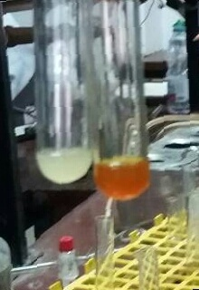
Tannin | (+)ve ,Dark green . | 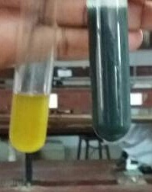
Terpenoid  1-diterpenoid | (+)ve ,greenish blue | 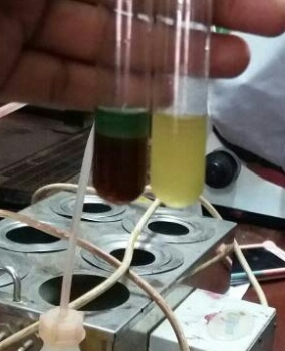
2-Triterpenoid | (+)ve , brown color | 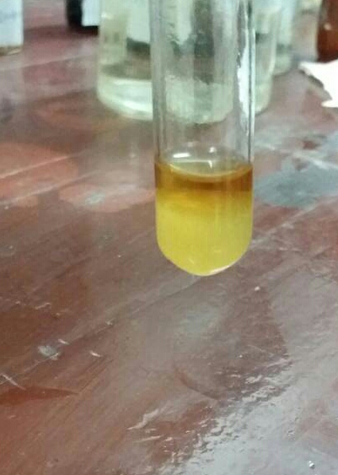
3-Anthraquinone glycoside | (-)ve result | 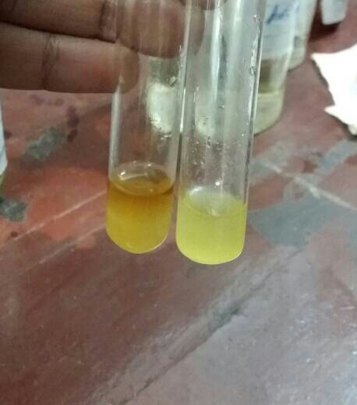
Saponin | (+)ve  . | 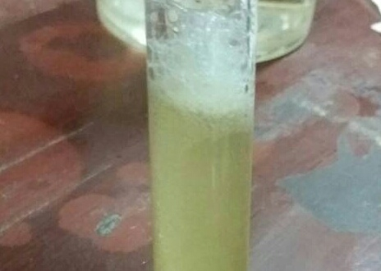

(+)ve = presence of phytochemical group, (-)ve=absence of phytochemical group
Photo (1) show the phytochemical results of the rosemary extract consist of several phytochemical classes The appearance of the Dark yellow color confirms the presence of flavonoids., The appearance of the Dark green color confirms the presence of tannin., The appearance of the greenish blue color confirms the presence of diterpenoid. The appearance of the brown color confirms the presence of diterpenes, The absence of apinkish-red color confirms the absence of Anthraquinone glycoside and After adding the solvent foam appears Saponin.

4.3 cytotoxic result:
Cytotoxic activity of the studied plant using brine shrimp assay was shown in tables (2).
Table (2) cytotoxic effect of Rosmarinus officinalis methanolic extract on brine shrimp nauplii:
Concentration(ppm) | 1hr | 3 hr | 6 hr | 12 hr | 24 hr | lethal%
1000 | 3 | 5 | 13 | 15 | 20 | 66.66%
100 | 8 | 18 | 23 | 24 | 27 | 90%
10 | 9 | 24 | 27 | 28 | 29 | 96.66%

Triplicate samples of each extract were tested initially at concentrations of 10, 100 and 1000 ppm (µg/mL) in test tube containing 5 mL of brine solution and shrimp the Rosemary studied extracts revel cytotoxic effect when it tested against brine shrimp .
The lethal percentage effect of Methanolic extract is highest cytotoxic activity and this appear with the lower concentration and this may be due to remove of fat increase activity. The three samples are monitored every hour and the results are recorded within 24 hours. It becomes clear that rosemary contains compounds that are safe for cells as shown in the diagram.

Figure 1: showed the cytotoxic Effect of Rosmarinus officinalis methanolic extract on brine shrimp nauplii.

Conclusion
Phytochemical screening of the Leaves of Rosmarinus officinalis showed presence of flavonoids, tannins, terpenes and it is very rich of Saponin, and the yields percentage of petroleum ether, methanolic and crude methanolic was found 4.267%, 16.4%and 18.67% respectively.The tested extracts of Rosmarinus officinalis were exhibited antioxidant, cytotoxic and antimicrobial activity. These results confirm the folkloric use of rosemary as antibiotic , hair protective and antioxidant agent.It is highly recommended that The petroleum ether extract of Rosemary revealed highly effect as antimicrobial and antioxidant and need further studies to identify , isolate and purify there constituent.
The studies plant is rich with Saponin that permit it to be formulated as antifungal dosage form (shampoo). Further studies needed for isolation and purification of active constituent of tested plant. The remarkable antioxidant results of studied plant enable to use it for treatment of cancer after the cell line study. Confirmatory studies needed for other traditional use.
References:
[1]Hendel, N., 2 Larous, L. and 1 Belbey, L. (2016) ‘Antioxidant activity of rosemary ( Rosmarinus officinalis and its in vitro inhibitory effect on Penicillium digitatum’, 23(4), pp. 1725–1732.
[2]Garcia, C., Ladeiras, D. and Reis, C. P. (2018) ‘Rosmarinus officinalis L .: an update review of its phytochemistry and biological activity’, 4.
[3]Gezici, S. and Sekeroglu, N. (2017) ‘In vitro Anticancer Activity and Antioxidant Properties of Essential Oils from Populus alba L . and Rosmarinus officinalis L . from South Eastern Anatolia of Turkey’, (September). doi: 10.5530/ijper.51.3s.74.
[4]Habtemariam, S. (2016) ‘The Therapeutic Potential of Rosemary ( Rosmarinus officinalis ) Diterpenes for Alzheimer ’ s Disease’, 2016.
[5]Hamidpour, R., Hamidpour, S. and Elias, G. (2017) ‘Rosmarinus Officinalis ( Rosemary ): A Novel Therapeutic Agent for Antioxidant , Antimicrobial , Anticancer , Inflammatory , and Anti-Obesity Treatment’, pp. 1–6. doi: 10.26717/BJSTR.2017.01.000371.
[6]Hejmadi, M. (2010) . Introduction to Cancer Biology 2nd edition, ISBN 978-87-7681-478-6
[7]Kabubii, Z. N. (2015) ‘Phytochemical Composition, Cytotoxicity and Toxicological Studies of Rosmarinus Officinalis, Catharanthus Roseus and Myrsine Africana Crude Extracts’.
[8]Karchesy, Y. M. et al. (2016) ‘Biological screening of selected Pacific Northwest forest plants using the brine shrimp ( Artemia salina ) toxicity bioassay’, SpringerPlus. Springer International Publishing, pp. 1–9. doi: 10.1186/s40064-016-2145-1.
[9]M R AI-Sereiti’, K. M. A.-A. & P. S. . (2020) ‘Pharmacology of rosemary ( Rosmarinus oificinalis Linn .) and its therapeutic potentials’, 37(February), pp. 124–130.

