PALM SAP (Arenga pinnata Merr.) AS A FUNCTIONAL FOOD AND FERMENTED PRODUCT: A BIBLIOMETRIC REVIEW

Wikashita Woherli, Fauzan Azima*, Tuty Anggraini

Departemen of Food Technology and Agricultural Product, Faculty of Agricultural Technology, Andalas University
*Corresponding Author

ABSTRACT
Arenga pinnata Merr., commonly recognized as the sugar palm, represents a multifunctional tropical plant whose sap (nira) holds substantial potential as both a functional food ingredient and a fermentation substrate. Despite the growing body of research surrounding this plant, no systematic bibliometric study has been conducted specifically addressing palm sap in the context of functional food and fermentation. This study aims to map global research trajectories concerning Arenga pinnata Merr. sap over the period 2006–2026 using bibliometric analysis. Literature data were sourced from the ScienceDirect database with keywords "Arenga pinnata Merr.", "palm sap", and "sugar palm sap", resulting in 48 publications from diverse contributing journals. Data visualization and keyword co-occurrence network analysis were performed using VOSviewer software. The results reveal a progressive increase in research output, particularly after 2019, reflecting intensified scientific attention toward palm sap utilization in fermentation, bioethanol production, and functional food development. Keyword mapping identified dominant research themes including fermentation, ethanol, sugar composition, antioxidant activity, and health benefits, while emerging topics such as biocontrol, secondary metabolites, and anti-inflammatory properties signal future directions in this field. The Journal of Materials Research and Technology, Food Chemistry, and the International Journal of Biological Macromolecules emerged as the three most prolific contributing publishers. This bibliometric review provides a structured framework for understanding the evolution of Arenga pinnata Merr. sap research and establishes a foundation for future scientific investigations in food biotechnology and sustainable agro-industry.

Keywords: Arenga pinnata Merr.; palm sap; bibliometric analysis; fermentation; functional food; VOSviewer

INTRODUCTION

The use of tropical plants as a source of functional food and bioindustrial raw materials has become a global concern in recent decades. One of the plants that has high strategic value is palm (Arenga pinnata Merr.), a member of the Arecaceae family that thrives in the tropics of Southeast Asia, including Indonesia. Almost all parts of this plant can be used, ranging from stems, leaves, to sap liquid obtained from tapping flower bunches. Palm sap contains a fairly high sugar content, ranging from 13.9–14.9%, consisting of sucrose, glucose, and fructose, making it a very potential raw material for various processed food and industrial products (Anggraini, Azima, Anwar, Hervani, & Suhendra, 2025).

In addition to its sugar content, palm sap is also known to contain a number of important minerals such as iron (Fe), zinc (Zn), copper (Cu), and manganese (Mn), and has antioxidant activity that can be measured by the ferric reducing antioxidant power (FRAP) method (Maryani et al., 2020). The existence of this bioactive compound encourages the interest of researchers to explore the potential of palm sap as a functional food that not only provides caloric value, but also health benefits for consumers. The palm sap fermentation process involving certain microorganisms is known to produce high-value products such as bioethanol, lactic acid, and traditional fermented beverages that have distinctive functional characteristics.
The development of research in the field of functional food and fermented biotechnology based on local natural resources shows an increasing trend in line with increasing public awareness of the importance of healthy and environmentally friendly food consumption. Palm sap as a natural raw material with rich nutritional content is becoming an increasingly relevant research focus, especially in the context of the development of conventional sugar substitution products and the exploration of plant-based fermentation products (Maspeke, 2025). However, a comprehensive study of research trends and developments in this field has never been systematically carried out through a bibliometric approach.

Bibliometric analysis is a quantitative method used to evaluate and map scientific developments through scientific publication data, including citation patterns, author collaboration, and the simultaneous occurrence of keywords. This approach has been widely used in various fields of science to identify research trends, determine topics that have not been explored much, and provide strategic guidance for future research. The use of software such as VOSviewer allows for an interactive and informative visualization of bibliometric networks, making it easier to interpret research patterns at scale.

Based on the background that has been presented, the formulation of the problem in this study is: how is the development of global research trends regarding palm sap (Arenga pinnata Merr.) as a functional food and fermented product during the period 2006–2026, as well as what topics dominate and that still need to be further developed. This study aims to: (1) map the trend of scientific publications regarding Arenga pinnata Merr. as a functional food and fermentation substrate in the period 2006–2026; (2) identify the journals that contribute the most to this research topic; and (3) visualize a network of keywords to illustrate the linkages between research topics and identify emerging research directions. The results of this study are expected to provide a comprehensive overview of the dynamics of research related to palm sap globally, so that it can be a reference for researchers, academics, and industry stakeholders in determining future research priorities. In addition, this study is also expected to encourage the development of innovative palm sap-based products with high added value, especially in the functional food and sustainable biotechnology sectors.

MATERIALS AND METHOD

Data Sources

Literature data collection in this study was carried out through a search on the ScienceDirect database. The database was chosen because of its broad and comprehensive scope in providing scientific publications in the fields of food science, biotechnology, and agriculture. Keywords used in the search process include "Arenga pinnata Merr." OR "palm sap" OR "sugar palm sap". Literature search is limited to English-language research articles published in the last 20-year period, i.e. from 2006 to 2026. The latest research data is collected and stored on April 12, 2026. From the search process, as many as 48 relevant literature sources were obtained and came from various international scientific journal publishers.

Data Extraction and Analysis

The process of data extraction and analysis is carried out by collecting information from relevant scientific literature, including article titles, abstracts, keywords, and year of publication. After the extraction process is completed, all the collected literature is stored in a ". RIS" and further exported into the VOSviewer software version 1.6.19 for further bibliometric analysis (Rismunandar, Farsy, Prahesti, & Nabila, 2025). The parameters used in the analysis include annual publication trends, the most contributing journals, the network co-occurrence keywords, as well as visualizations Overlay which describes the temporal development of the research topic.

Term Map

VOSviewer is a software designed to analyze and visualize bibliometric data in the form of a visual map (bubble map). Each bubble in the map represents the keywords that appear in the title, abstract, or keyword from the literature analyzed. The size of the bubble reflects the frequency with which the keyword appears in the literature set, while the color of the bubble indicates the average year of publication which represents the temporal development of research trends. The distance between bubbles describes the degree of interconnectedness or frequency of co-occurrence between two keywords in the literature.

RESULTS AND DISCUSSION

Publication Trends

The most recent research data was collected and stored as of April 12, 2026 from the ScienceDirect database. A total of 48 sources of published literature related to Arenga pinnata Merr., palm sap, and sugar palm sap were successfully collected from various international scientific journal publishers. Figure 1 presents the publication trends during the observation period covering the years 2006 to 2026.

Based on the data shown in Figure 1, it can be observed that the number of scientific publications on Arenga pinnata Merr. fluctuated in the early period (2006–2018), with some years showing a very low number, even no publications at all in certain years. However, since 2019, there has been a significant and sustainable increase. The number of publications continues to grow until it reaches the highest number in 2025, with a total of 9 articles. This pattern of improvement indicates a real growth in scientific interest in Arenga pinnata Merr. as a natural resource with great potential in various sustainable applications.

The increase in the number of publications that occurred after 2019 is suspected to be closely related to the increasing exploration of the use of palm sap, especially in the fermentation process to produce bioethanol, lactic acid, and various other value-added compounds. The growing global interest in renewable energy sources and nature-based functional foods has also encouraged researchers to examine the potential of palm sap in this context more deeply (Sarkar, Mukherjee, Roy, & Chakraborty, 2023). This condition is in line with the development pattern of research on medicinal plants and other functional foods, where the increase in publications often occurs in line with increasing industrial demand and consumer awareness of natural products.

Fig. 1. Publication trends of Arenga pinnata Merr. as functional food and fermented products (2006–2026)
(Figure 1 shows a bar chart of the number of publications per year from 2006 to 2026, with the distribution: 2006=1, 2007=2, 2008=2, 2009=0, 2010=4, 2011=0, 2012=1, 2013=5, 2014=1, 2015=4, 2016=2, 2017=1, 2018=0, 2019=4, 2020=5, 2021=2, 2022=3, 2023=5, 2024=7, 2025=9, 2026=2)

Analysis of Top Contributing Publishers

An analysis of the contribution of journal publishers in the research topics of Arenga pinnata Merr. and palm sap shows that there are at least three major journals that publish the most related articles in the ScienceDirect database. The following table 1 presents a list of the top three publishers along with the number of publications each.

Table 1. The top three contributing publishers in the research topic of Arenga pinnata Merr.

Yes | Publisher | Publication
1 | Journal of Materials Research and Technology | 4
2 | Food Chemistry | 3
3 | International Journal of Biological Macromolecules | 3

Based on the data in Table 1, Journal of Materials Research and Technology took first place with 4 articles, followed by Food Chemistry and International Journal of Biological Macromolecules each with 3 articles. Dominance Journal of Materials Research and Technology This topic reflects the orientation of most research on the material aspects and physicochemical properties of palm derivative products, such as bacterial cellulose, natural fibers, and composite materials based on Arenga pinnata Merr. Meanwhile, Food Chemistry which focuses on the chemical composition of food reflects a strong interest in uncovering the nutritional profile and bioactive compounds of palm sap (Widyasari, Argo, Lastriyanto, & Wijana, 2025). The International Journal of Biological Macromolecules reflects the in-depth study of the biological macromolecules contained in Arenga pinnata Merr., including polysaccharides and cellulose. Knowledge of the most productive journals in a research topic is very useful for researchers to determine the right publication targets and browse the literature with high citation impact in the field of functional food and biotechnology (Maliza, 2021). The three journals are consistently the main reference in studies related to the cross-disciplinary use of palm sap.

Keyword Co-occurrence Network
The results of keyword co-occurrence analysis using VOSviewer produced a network of keywords that describe the relationship between various research topics related to Arenga pinnata Merr. Figure 2 presents a visualization of the keyword co-occurrence network from the entire literature analyzed.
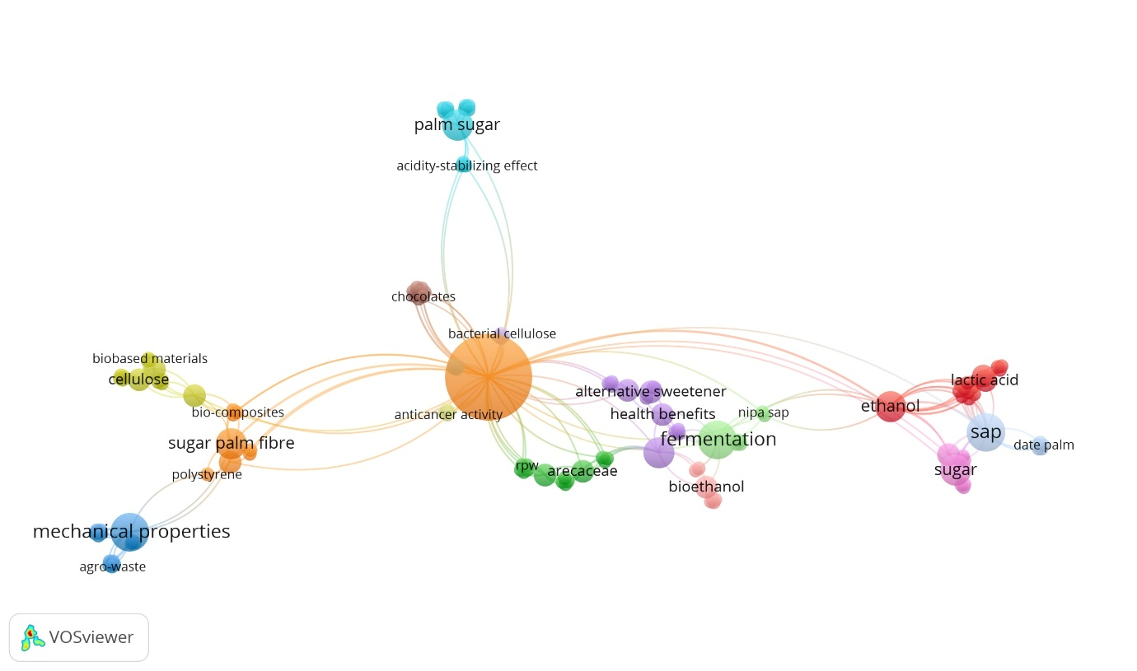
Fig. 2. Visualization of keyword co-occurrence network research by Arenga pinnata Merr.
(Figure 2 shows a VOSviewer bubble map with the main keywords: palm sap, fermentation, ethanol, sap, sugar, health benefits, alternative sweetener, cellulose, bacterial cellulose, biobased materials, sugar palm fibre, mechanical properties, agrowaste, anti-inflammatory, secondary metabolites, biocontrol, arecaceae, neera, lactic acid, date palm, nipa sap, sago palm, coconut sugar, palm sugar, banana powder, anticancer activity, plethora)

Based on the visualization in Figure 2, it can be observed that Palm Sap and Fermentation is the keyword with the largest bubble, which indicates that they are the most frequently researched topics and have the most extensive association with other topics. Keywords Palm Sap serves as a central node (central node) which connects research clusters in the field of sugar production with health and materials research clusters. Strong link between Fermentation and Ethanol Reflecting the conventional research path of NIRA as a raw material for renewable energy (Sarkar, Mukherjee, Roy, & Chakraborty, 2023).

In addition, the emergence of connections between Sugar Composition with antioxidant activity and Health Benefits illustrates a new integration in scientific research that explores the health benefits of sap beyond its role as a mere source of calories. Keywords such as Alternative Sweetener, Coconut Sugar, and Palm Sugar reflects the relevance of palm sap in the natural sweetener industry, while Bacterial cellulose and Sugar Palm Fiber Indicates the utilization of Arenga pinnata Merr. in the application of biomass-based materials. The linkage between these keywords is in line with bibliometric findings on other functional plants that show a pattern of research diversification from basic aspects to innovative applications (Kurnia, Wiyono, Fawwazy, Putra, & Hafizhan, 2024).

Keyword Co-occurrence Overlay
In addition to network visualization, overlay analysis was performed to illustrate the temporal development of research topics based on the average year of publication of each keyword. Figure 3 presents the results of the keyword overlay visualization that shows the evolution of research trends over time.
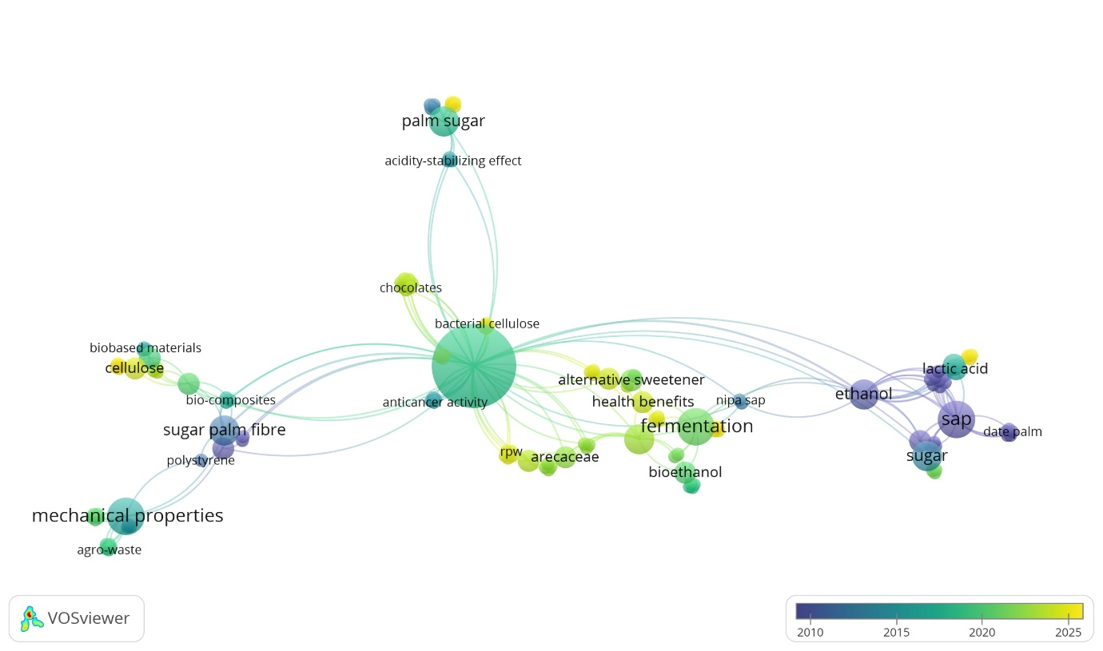
Fig. 3. Visualization of keyword co-occurrence overlay research on Arenga pinnata Merr.
(Figure 3 shows a map of the VOSviewer bubbles with a color scale from dark blue (2010) to yellow (2025), showing the temporal development of the research topic)

Based on the visualization in Figure 3, the development of palm sap research trends can be divided into three main periods based on the colors displayed. The dark blue and purple bubbles (circa 2010–2015) cover topics such as Palm Sugar, Banana Powder, and Ethanol, which indicates that research on these topics has been going on for a relatively long period of time and is the main foundation of the study Arenga pinnata Merr. Topics Ethanol and Sugar This period reflects the dominance of early research that focused on the conversion of sap into fermentation and energy products. The green bubble (around 2018–2020) represents topics that are in the transition phase, including Palm Sap, Fermentation, Health Benefits, and Alternative Sweetener. This group of topics reflects a shift in research orientation from simply exploring the technical aspects of fermentation to a more holistic understanding of the functional benefits of palm sap for human health (Tee, 2023).

Meanwhile, the yellow bubble (around 2023–2025) represents relatively new topics and are in an active growth phase, including Biocontrol, Secondary Metabolites, Anti-inflammatory, neera, and Lactic acid. The emergence of these topics suggests an expansion of the scope of research towards the exploration of specific bioactive compounds and the more in-depth functional mechanisms of palm sap, in line with the increasing demand for functional food products based on local natural resources (Rismunandar, Farsy, Prahesti, & Nabila, 2025). This pattern of development is consistent with trends observed in other bibliometric studies of medicinal plants, where research progresses gradually from basic characterization to applied innovation.

CONCLUSION
This bibliometric study succeeded in mapping the development of global research on palm sap (Arenga pinnata Merr.) as a functional food and fermented product during the period 2006–2026 based on 48 scientific literature sourced from the ScienceDirect database. Publication trends show a significant increase especially after 2019, reflecting the increasing interest of researchers in the potential of palm sap in various sustainable applications. The Journal of Materials Research and Technology is the publisher with the largest contribution (4 articles), followed by Food Chemistry and the International Journal of Biological Macromolecules (3 articles each). The keyword network analysis identified palm sap and fermentation as the central topics connecting the various research clusters, while the overlay visualization revealed that topics such as biocontrol, secondary metabolites, and anti-inflammatory are new research areas that are rapidly developing in the 2023–2025 period.

Suggestions
Based on the findings of this bibliometric study, it is suggested that future research focus more attention on the exploration of secondary metabolite compounds and the biological activity of palm sap, including its anti-inflammatory and biocontrol potential. In addition, research on optimizing the fermentation process to produce high-value-added products such as lactic acid and other bioactive compounds needs to be continuously developed. A comprehensive study of the metabolomic profile of palm sap is also recommended to strengthen the scientific basis for its use as a functional food. In terms of methodology, further research is recommended to expand the scope of databases, for example by integrating Scopus or Web of Science, as well as extending the observation time span to produce more representative bibliometric maps.

REFERENCES
- Anggraini, T., Azima, F., Anwar, A., Hervani, D., & Suhendra, D. (2025). Characteristics of Sugar Palm Sap Powder ( Arenga pinnata Merr .) Produced using the Foam-mat Drying Method with Various Encapsulant Agents. 1–7. https://doi.org/10.18805/ajdfr.DRF-490.Submitted
- Kurnia, D., Wiyono, N., Fawwazy, M., Putra, E., & Hafizhan, M. (2024). Heliyon Research productivity in catamenial epilepsy : A bibliometric analysis of worldwide scientific literature ( 1956 – 2022 ). Heliyon, 10(10), e31474. https://doi.org/10.1016/j.heliyon.2024.e31474
- Maliza. (2021). Isolation and characterization of acetic acid bacteria from palm sap (Arenga pinnata Merr.) for a starter culture in the production of Java plum (Syzigium cumini L.) vinegar. https://doi.org/10.1088/1755-1315/667/1/012004
- Maspeke. (2025). Potential application of ohmic heating in sugar palm (Arenga pinnata) sap processing. https://doi.org/10.1088/1755-1315/1471/1/012064
- Rismunandar, A., Farsy, R. Al, Prahesti, G. A., & Nabila, F. (2025). Optimization And Development Of Packaging In The Production Of Aren Sugar (Arenga pinnata Merr.) As A Superior Product Of Kemang Village. 23(2), 660–668.
- Sarkar, T., Mukherjee, M., Roy, S., & Chakraborty, R. (2023). Heliyon Palm sap sugar an unconventional source of sugar exploration for bioactive compounds and its role on functional food development. Heliyon, 9(4), e14788. https://doi.org/10.1016/j.heliyon.2023.e14788
- Tee, E. S. (2023). Review of recommended energy and nutrient intake values in Southeast Asian countries.
- Widyasari, R., Argo, B. D., Lastriyanto, A., & Wijana, S. (2025). Changes in Volatile Components and Sugar Content of Arenga Sap ( Arenga pinnata Sap ) during the Ohmic Heating Process. 13(3), 280–287. https://doi.org/10.13189/fst.2025.130305

