A STUDY ON PREVALENCE, CAUSES, STRESS AND ITS IMPACT ON ACADEMIC PERFORMANCE AND WELL BEING FOR HIGHER EDUCATION STUDENTS
Authors: Keerthana M, V Divya Jyothi
Bengaluru North University
Master of Business Administration (MBA)
Patel Institute of Science & Management (PISM)
Bengaluru, India
ABSTRACT

Higher education is important for students. They have to do in college and also take care of themselves and their personal lives. A lot of students in higher education have to deal with many problems that affect how well they do in college and how happy they are. This study is trying to figure out how many students have these problems what is causing them and how they affect student’s college work and mental health.

The study is looking at the things that affect how well students do in college. Things like stress from work much to do not managing time well money problems, what their family wants them to do what their friends think and how much help they get from their college. It also looks at how not being motivated, not studying well and not being emotionally stable can lead to not doing in college and not being happy. This study is using a way of researching that involves asking students questions and talking to them to get the information it needs.

The study is going to show that how well students do in college is closely related to how they're feeling mentally and emotionally. When students are really stressed, anxious and have problems they often have a hard time focusing feel bad about themselves do poorly in college and behave in negative ways.
Keywords: Nervousness, cognitive overload, emotional exhaustion, constant multitasking, chronic stress.

INTRODUCTION
Higher education is important for students and society. The time students spend in college and university is a part of their life. This is where they learn things and grow as a person. They become smarter make friends and figure out who they are as a person. This time can also be very tough and stressful for higher education students. Many higher education students struggle with feeling overwhelmed worried and pressured to do in college. Lots of education students around the world are dealing with these kinds of problems. It is hard for higher education students to balance college work, their personal life and what their friends and family expect from them. Things like exams, competition and money problems can make higher education students feel sick and unhappy. Not having advice and not taking care of themselves can also be a big problem for higher education students. These problems do not just affect how higher education students feel they also make it harder for higher education students to focus, learn and do well in college. We need to understand why these problems are happening so we can help education students. If we know what is causing these problems, colleges, teachers and parents can do things to make college a healthier place for education students. We also need to see how these problems affect how higher education students do in college so we can come up with plans to help higher education students succeed and be happy.
So this study is going to look at how common these problems what is causing them and how they affect higher education students. The study wants to show what the big challenges are for education students and suggest ways to make higher education students feel better be healthier and do better in college. Higher education students need our help to deal with the pressures of education and to have a better life. Higher education is very important, for education students.
LITERATURE REVIEW
Fauzi et al. (2021). Examined health issues among undergraduate students. They found that many students had anxiety (85.1%) stress (65%) and depression (51.4%).The study showed that academic workload, poor sleep, physical fatigue and frequent headaches caused a lot of distress. Students in programs had more stress. This suggests that the expectations from college and how courses are structured can affect student’s mental health. The authors also noted that these factors play a role in shaping students’ mental well-being and that academic workload poor sleep quality, physical fatigue and frequent headaches are major factors contributing to psychological distress, among undergraduate students.
Islam et al. (2020). The study looked at students who were in their year of university and checked how many of them had depression and anxiety when they started university. What the study found out was that a lot of these students had depression, sixty nine point five per cent and anxiety about sixty one per cent. The people who did the study said that students had a time adjusting to university life and things like moving to a new place using the internet too much not exercising and not sleeping well made it harder for them to deal with mental health issues. This shows that when students first start university it is a tough time for them and they are more likely to have problems with their mental health. The university life is a change, for first-year university students and it can cause a lot of stress.
Wagner et al. (2022). The connection between feeling depressed and how well students do in college was looked at. This study used numbers to figure out what is going on. It found that students who are really struggling with depression are more likely to fall in college. When students are feeling down they have a time focusing. They do not want to do their work. They do not do as well in college.All of these studies together show that a lot of university students are dealing with health issues and that college and lifestyle are factors. This affects how well students can do their work in college. Depression is a problem for students. It affects how well students can do in college. University students, with depression need help.
SCOPE OF THE STUDY
➢ The analysis focuses on collegians and university students are degree seeking in higher education institutions to get academic training. These education students are the people that the study is looking at to get an education.
➢ This thing looks at how many students have stress and anxiety. It also looks at pressure and how students deal with big changes, in their lives. The main goal is to focus on mental health issues and the student’s well behaviour.
OBJECTIVES OF THE STUDY
❖ To understand the prevalence of mental health issues among the higher education students.
❖ To analyse the relation between biological, social and psychological factors among the students.
HYPOTHESIS OF THE STUDY
H1: There is a significance of different factors. It includes the level of stress, level of anxiety, level of depression, emotional breakdown, sleep quality, overall well-being, education performance, family expectations, and peer competition significantly. It will lead to stress among the higher education students.
H0: The other idea is that things like stress, anxiety, depression, emotional breakdowns, sleep quality, well-being, academic performance, family expectations, peer competition, academic work load, time management, financial problems and institutional support do not really matter when it comes to how well students do in school and how good they feel. This idea says that these things are not important for students who're, in college or university.
RESEARCH METHODOLOGY
This paper provides insight into students who are with psychological disorders. The study used a questionnaire with five points to measure stress, anxiety and depression. It also looked at things like what students do every day how they sleep and the pressure they feel to do in college. The study asked 106 students to take part and they were chosen because it was easy to get to them and they wanted to take part. The students filled out the questionnaire on Google Forms. The way the study was done was simple and easy to manage so the people doing the study could understand what the students were going through. This way of doing the study helped the people doing it looks closely at health issues among university students. The study found out how many students have stress, anxiety and depression and how it affects their college work and how they feel overall. The study looked at health issues, among university students and it looked at how these issues affect university students.

DATA ANALYSIS AND INTERPRETATION

The data says how students feel about the psychological help or support and study related anxiety can make a transform in their mind wellness. Students believe that awareness programs and better support from friends are also very important. This means that colleges need to have both help and support from friends. Almost all the students open up to their friends and family about their study related anxiety, which indicates how significant it is to have people you trust when you are stressed. Not many students have asked teachers or counsellors for help and some students do not talk to anyone about their problems. This could be because they are scared do not know where to go or worried about what others will think. The data says that academic pressure and not knowing what the future holds can really hurt student’s mental health.
FIGURE 1: Have you ever spoken to someone about your mental health concerns.
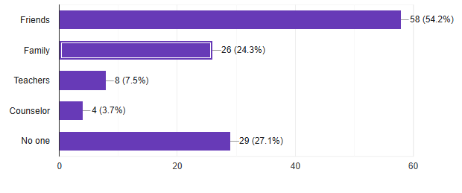
Almost students have opened up about their mental wellness and mostly with their mates (54.2%) and not preferred to the college counsellors.
FIGURE 2: How often do you feel stressed due to academic pressure.
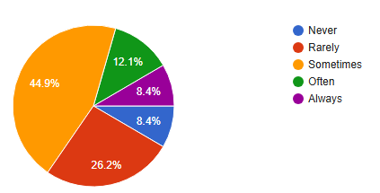
Students feel more stressed due to academic pressure sometimes (44.9%) and rarely (26.2%) the least following them is always and never as the same percentage (8.4%).
FIGURE 3: What are the main sources of stress in your student life.
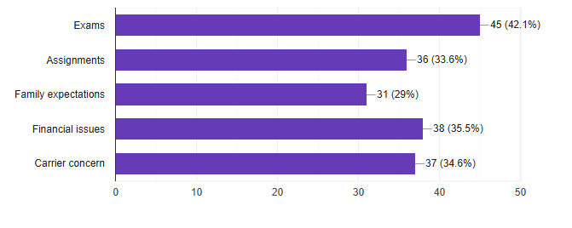
The main source of stress where every student faces in their academics is regarding the exams and the assignments and many other factors.
FIGURE 4: Have you experienced anxiety, sadness or emotional distress during your studies.
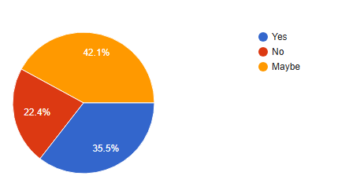

The students have experienced anxiety, sadness or emotional distress where most of the students have responded (42.1%) as maybe.
FIGURE 5: How does stress affects your academic performance.
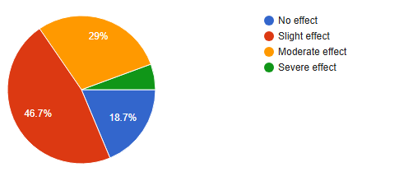

The side effects of stress may lead to downfall from the pressure of academics. where most of the students have said that there is a slight effect.
FINDINGS

- Students are, under a lot of pressure. They feel stressed, anxious and depressed. A big reason is their college work. They also worry about what’s next.

- It is really important to have programs that teach students, about these things and to have friends who can support them when they are feeling down.

- Usually students talk to their friends and family members about what's bothering them.

- Not many students talk to their teachers or counsellors about their problems and some students do not talk to anyone all because they are scared or do not know who to turn to.

- The things that stress students out the most are exams, homework what their families want them to do. What they want to do with their lives. Some students also worry about financial problems. How they will pay for things.
SUGGESTIONS
- We need to make arrangement to students easily get counselling support when they need it.

- One way to do, students are not overwhelmed with much work at once.

- This can be done by balancing assignments and deadlines.

- Colleges should also have programs that teach each student’s about health.

- Creating groups where students can talk to each other about their feelings can help to each other. This way students feel safe sharing their thoughts.

- Teachers and staff must be trained enough to identify when students are stressed.

- We should talk openly about health so that students may aware and comfortable to discussing it without fear of being judged. Mental health is just as important, as health.
CONCLUSION
- The study shows that many university students have health problems like stress, anxiety and depression. University students have these problems because of their college work the way they live and worrying about what's going to happen in the future.

- Things like exams, homework what their family thinks and what they want to do for a job make university students stressed. Some university students also have money problems.

- Not many university students talk to their teachers or people who can help them with their problems.

- This is because university students are embarrassed doing not know where to go or afraid of what others will think.

- The study also found that university students think that talking to someone who can help them learning more about health getting help from other students and not having as much college work would make them feel better.

- This means that universities need to make a place where university students can get help from people who know what they are doing and also get help from their friends.

- If universities can get university students to talk about their problems and teach the teachers to see when university students are stressed then university students can deal with their problems better. Do better in college.

- Overall universities need to do something about health because it is important for university students to be happy and do well in college.

- If universities can provide proactive students services and teaching them about holistic wellness initiatives and by not giving much curriculum streamline and fostering a positive inclusive and safe environment.
REFERENCES
- Fauzi, M. F., Anuar, T. S., Teh, L. K., Lim, W. F., James, R. J., Ahmad, R., Mohamed, M., Abu Bakar, S. H., Mohd Yusof, F. Z., & Salleh, M. Z. (2021). Stress, anxiety and depression among a cohort of health sciences undergraduate students: The prevalence and risk factors, 18(6), 3269. https://doi.org/10.3390/ijerph18063269.

- Islam, S., Akter, R., Sikder, T., & Griffiths, M. D. (2020). Prevalence and factors associated with depression and anxiety among first-year university students in Bangladesh: A cross-sectional study, 20, 1289–1302. https://doi.org/10.1007/s11469-020-00242-y.

- Wagner, F.,Wagner, R. G., Kolanisi, U., Makuapane, L. P., Masango, M., & Gómez-Olivé, F. X. (2022). The relationship between depression symptoms and academic performance among first-year undergraduate students at a South African university: A cross-sectional study. BMC Public Health, 22, 2067. https://doi.org/10.1186/s12889-022-14517-7.

