Category – Case Report
Title:
“From Gut to Gonads: A Rare Journey of Jejunal Neuroendocrine tumor to the Testis”

Name of Authors: Dr. Shakuntala S Aramani ¹, Dr. Susmitha S², Dr. Jeenu J Jayan ³, Dr. Basavaraj P Bommanahalli ⁴.
¹Associate Professor, ² Assistant Professor, ³ Postgraduate Resident, ⁴Professor & Head of the Department
Department of Pathology, K H Patil Institute of Medical Sciences (Formerly called as Gadag Institute of Medical Sciences), Gadag, Karnataka

Corresponding author -
Dr. Shakuntala S Aramani
Associate Professor
Department of Pathology,
K H Patil institute of medical sciences (Formerly called as Gadag Institute of medical sciences), Mallasamudhra, Gadag, Karnataka, India
Email - shakkuaramani@gmail.com
Ph - 9663935998

Abstract:
Neuroendocrine tumors (NETs) are uncommon epithelial neoplasms originating from neuroendocrine cells, within the gastrointestinal tract—particularly the jejunum and ileum, being the most frequent primary sites. While NETs account for approximately 0.5% of all malignancies, metastatic spread occurs in about 30% of cases, most commonly to the liver. Testicular metastasis from NETs is extremely rare, representing less than 1% of testicular tumors. We report a rare case of 65-year-old male who presented with a painless right scrotal swelling. Imaging revealed a well-defined hypervascular testicular mass and a similar lesion in the mid-jejunum with mesenteric involvement. The patient underwent segmental jejunal resection and right high inguinal orchidectomy. Histopathology and immunohistochemistry confirmed the diagnosis of a well-differentiated - Grade I -jejunal NET with testicular metastasis.
Key words: Neuroendocrine tumor (NET), Jejunum, Testis, Metastasis, Orchidectomy

Introduction
Neuroendocrine tumors (NETs) represent a heterogeneous group of neoplasms originating from neuroendocrine cells, and they display a wide range of clinical behaviour and hormone-secreting capacity ¹. Although uncommon, they comprise about 0.5% of all cancers and are categorized based on their degree of differentiation and proliferative activity, as outlined by the WHO classification ².
Neuroendocrine tumors (NETs) are epithelial neoplasms with predominant neuroendocrine differentiation, most commonly arising in the gastrointestinal tract, particularly in the Jejunum and ileum.
Approximately 30% of neuroendocrine tumor cases develop metastases ³, with the liver being the most commonly affected site—reported in up to 82% of cases. Additional frequent metastatic locations include the bones, adrenal glands, lungs, brain, and peritoneum ^{4,5}.
Testicular NETs account for less than 1% of all testicular tumors, with metastasis from other primary sites to the testis being rare; approximately 16% of patients present with symptoms of neuroendocrine tumor syndrome.
We present a rare case of a gastrointestinal neuroendocrine tumor metastasizing to the testis, presenting with features that closely resembled a primary testicular neoplasm. This atypical manifestation necessitated comprehensive workup including radiological, histopathological and immunohistochemical analysis to establish a definitive diagnosis.
This case emphasizes the importance of including metastatic disease in the differential diagnosis of testicular masses, particularly in patients with a known history of NETs. It also highlights the diagnostic value of specific immunomarkers such as chromogranin A, synaptophysin, and the Ki-67 proliferation index in distinguishing primary testicular tumors from metastatic lesions ².
Recognizing such uncommon patterns of spread enhances our understanding of NET metastasis and helps prevent misdiagnosis in clinical practice.

Case Details
A 65-year-old male presented with a 4-month history of swelling in the right scrotum. Scrotal ultrasound revealed a well-defined, oval, hyperechoic and hypervascularized mass measuring 7 × 5 cm in the right testis. The left testis appeared normal. CECT abdomen revealed similar lesion in the mid jejunum with attached mesentery. He underwent segmental resection of the jejunal mass with right high inguinal orchidectomy.
Gross findings:
Two labelled containers were received. One having a resected segment of jejunum with attached mesentery, and the other having a high right inguinal orchidectomy specimen. On mesenteric border of the jejunum, a solid, well circumscribed tumor measuring 7.5x3.5x3.5 cm was identified. On cut section, the tumor appeared solid, homogenous, grey-yellow. (Fig: 1a)
Testicular specimen was measuring 7.5 × 5.5 × 5 cm. A similar lesion was observed involving the entire testis and extending beyond the tunica. (Fig: 1b) No adjacent normal testicular parenchyma was identified.
Histopathological examination:
Histopathology showed a neuroendocrine tumor of grade I differentiation confined to the jejunal submucosa sparing mucosa which is arranged predominantly in an organoid pattern separated by fibrocollagenous septa. Individual cells are monomorphic, round to oval in shape with moderate eosinophilic cytoplasm and round nuclei containing stippled chromatin. Mitotic activity was 1–2 per 10 high-power fields (HPF). (Fig: 2a)
Section studied from testicular mass shows similar tumor with above described morphology. (Fig: 2b)
Immunohistochemistry performed on the testicular specimen showed positivity for synaptophysin (Fig: 3a) and chromogranin (Fig: 3b) confirming neuroendocrine differentiation. Ki-67 index was low (≤2%). (Fig: 3c) CDX2 shows positivity confirming intestinal origin. (Fig: 3d)

Discussion:
Neuroendocrine tumors (NETs) of the jejunum are slow-growing neoplasms that can exhibit distant metastasis despite their indolent nature. Testicular metastasis from a jejunal NET is extremely uncommon, with few reported cases in the literature ⁶. The pathway of metastasis may involve retrograde spread via lymphatics or hematogenous dissemination, emphasizing the unpredictable behaviour of NETs even at a low grade ⁷. Histopathological evaluation and immunohistochemical markers such as chromogranin A and synaptophysin aid in confirming the neuroendocrine origin, while Ki-67 assists in grading the tumor.
NETs often remain asymptomatic until they reach an advanced stage or metastasize, making early diagnosis challenging ⁸. Testicular metastasis, although rare, may present as a painless testicular mass and mimic primary testicular malignancies, which highlights the importance of a thorough clinical history and systemic evaluation ⁹. The presence of neuroendocrine markers in testicular lesions should prompt consideration of secondary involvement, especially in patients with known NETs elsewhere in the body ¹⁰. Recognizing such atypical metastatic presentations is crucial for guiding appropriate management and avoiding overtreatment or misdiagnosis ¹.

Conclusion:
This case highlights an unusual metastatic pattern of a jejunal neuroendocrine tumor to the testis, emphasizing the importance of thorough systemic evaluation in patients presenting with testicular mass, especially in older adults. Early identification and surgical intervention are essential for accurate diagnosis, staging, and management. Recognizing such rare presentations is critical for ensuring appropriate diagnosis and optimal treatment planning.
Acknowledgement:
Nil
Conflict of Interest:
Nil

Figures:
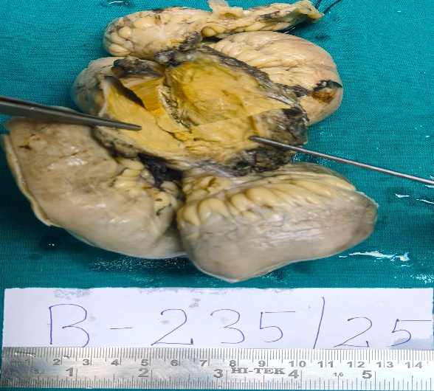 Fia 1a:– Cut section of Jejunal mass
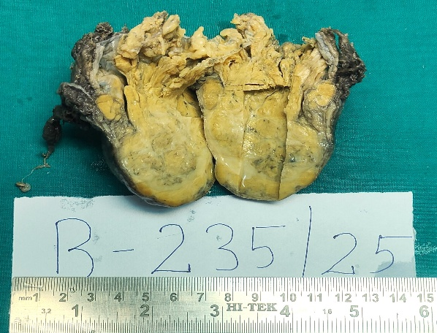 Fig 1b – Cut section of the testicular mass
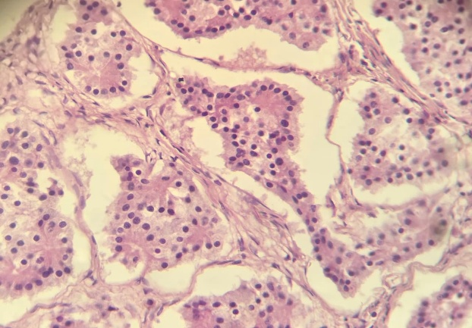Fig 2a - 40x – H & E -Jejunal mass - Nucleus shows stippled chromatin
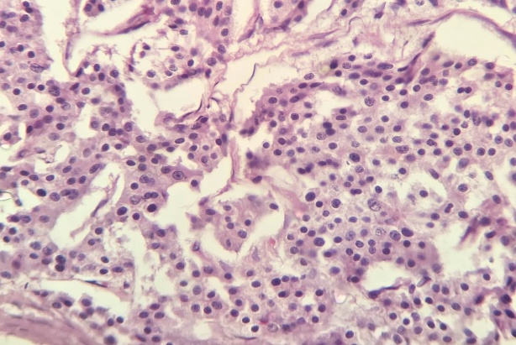 Fig 2b – 40x - H & E - Testicular mass
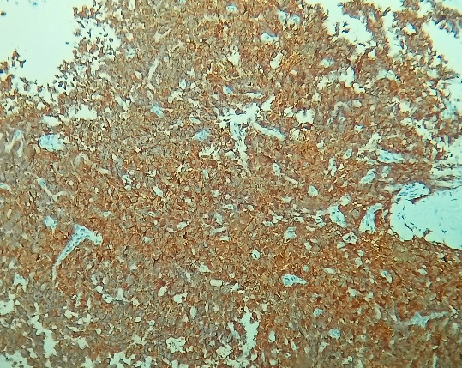 Fig 3a – Testis - Synaptophysin – showing diffuse cytoplasmic positivity
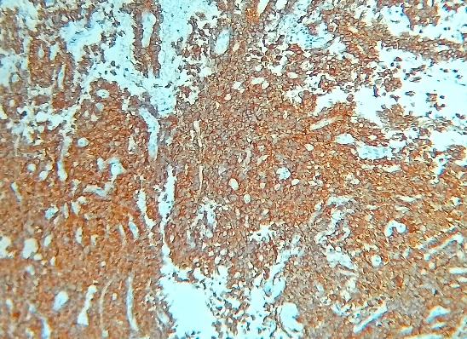 Fig 3b – Testis – Chromogranin - showing diffuse cytoplasmic positivity
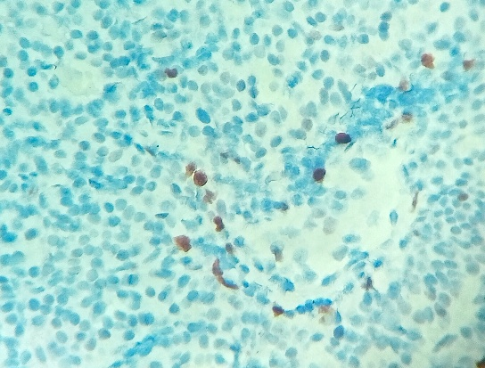 Fig 3c – Testis – Ki 67 – Strong nuclear expression for <2% of cells
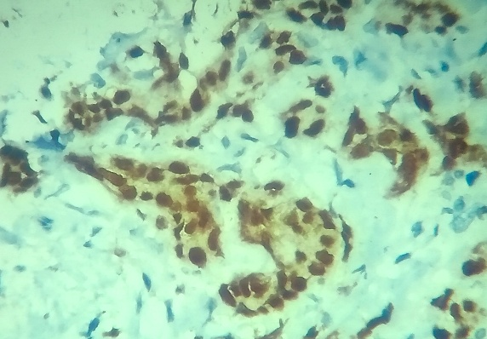 Fig 3d – Testis – CDX2 – Showing intestinal differentiation

References:
- Klimstra DS, Klöppel G, La Rosa S, Rindi GW. Classification of neuroendocrine neoplasms of the digestive system. WHO Classification of tumours, 5th Edition. Digestive system tumours. 2019 Sep 1:16-9. doi: 10.1111/his.13975.
- Lloyd RV, Osamura RY, Klöppel G, Rosai J. WHO Classification of Tumours of Endocrine Organs, 4th ed., IARC: Lyon, 2017. doi: 10.1007/s00401-017-1769-8.
- Modlin IM, Sandor A. An analysis of 8305 cases of carcinoid tumors. Cancer. 1997 Feb 15;79(4):813-29. doi:10.1002/(SICI)1097-0142(19970215)79:4<813::AID-CNCR19>3.0.CO;2-2.
- Akbar SA, Sayyed TA, Jafri SZ, Hasteh F, Neill JS. Multimodality imaging of paratesticular neoplasms and their rare mimics. Radiographics. 2003 Nov;23(6):1461-76. doi: 10.1148/rg.236025174.
- Eichhorn JH, Young RH. Neuroendocrine tumors of the genital tract. Pathology Patterns Reviews. 2001 Jun 1;115(suppl_1):S94-112. doi: 10.1309/64CW-WKGK-49EF-BYD1.
- Yao JC, Hassan M, Phan A, Dagohoy C, Leary C, Mares JE, Abdalla EK, Fleming JB, Vauthey JN, Rashid A, Evans DB. One hundred years after “carcinoid”: epidemiology of and prognostic factors for neuroendocrine tumors in 35,825 cases in the United States. Journal of clinical oncology. 2008 Jun 20;26(18):3063-72. doi: 10.1200/JCO.2007.15.4377.
- Strosberg J. Neuroendocrine tumours of the small intestine. Best practice & research Clinical gastroenterology. 2012 Dec 1;26(6):755-73. doi: 10.1016/j.bpg.2012.12.002.
- Oronsky B, Ma PC, Morgensztern D, Carter CA. Nothing but NET: a review of neuroendocrine tumors and carcinomas. Neoplasia. 2017 Dec 1;19(12):991-1002. doi: 10.1016/j.neo.2017.09.002.
- Parghane RV, Basu S. Testicular Metastasis From Neuroendocrine Tumors: Imaging and Theranostics Through: 68: Ga-DOTATATE PET/CT and: 177: Lu-DOTATATE–Based Peptide Receptor Radionuclide Therapy. Clinical Nuclear Medicine. 2023 Dec 1;48(12):1051-2. doi: 10.1097/RLU.0000000000004846.
- Amine MM, Mohamed B, Mourad H, Majed H, Slim C, Mehdi B, Hela M, Nouri R, Rim K, Tahya B, Nabil MM. Neuroendocrine testicular tumors: a systematic review and meta-analysis. Current Urology. 2017 Mar 30;10(1):15-25. doi: 10.1159/000447146.

