AI-Based Quality Control using Vision System: A Review

Miss. PATWADKAR SHREYA
Electronics & Telecommunications VPKBIET, Baramati shreyapatwadkar@gmail.com
Miss. HARSHADA SHETE
Electronics & Telecommunications VPKBIET, Baramati harshadashete13@gmail.com

Mr. RANJIT CHAVAN
Electronics &Telecommunications VPKBIET, Baramati ranjitchavan3112@gmail.com
Dr. BALASAHEB PATIL
Electronics and Telecommunication VPKBIET, Baramati balasaheb.patil@vpkbiet.org

Abstract — In today’s highly competitive manufacturing environment, ensuring consistent product quality is a key factor for customer satisfaction and cost reduction. Traditional quality inspection methods rely heavily on human operators, which can lead to fatigue, subjective judgment, and low efficiency. To overcome these challenges, this project proposes an AI-Based Quality Control System using a Vision System that automates the defect detection process with high precision and reliability.The system utilizes a camera or vision sensor to capture images of products on the production line. These images are analyzed using Computer Vision and Artificial Intelligence (AI) techniques, particularly Deep Learning algorithms such as Convolutional Neural Networks (CNNs), to identify defects such as scratches, color variations, shape deformities, and missing components. The AI model is trained with a dataset of defective and non-defective samples to enable accurate classification and real-time decision-making.
This intelligent inspection system provides fast and consistent results, minimizes human intervention, and significantly reduces production losses. The integration of AI with vision technology ensures higher productivity, improved quality assurance, and efficient process
monitoring. The proposed system demonstrates a step toward Industry 4.0, where smart automation enhances manufacturing accuracy and efficiency.

I.INTRODUCTION
In modern manufacturing industries, maintaining consistent product quality is one of the most critical challenges. Traditional methods of quality inspection rely heavily on human operators, which often lead to errors due to fatigue, subjectivity, and environmental factors. As production rates increase, manual inspection becomes inefficient and costly. To address these limitations, industries are increasingly adopting automated quality control systems that utilize Artificial Intelligence (AI) and computer vision to detect and classify defects with high accuracy and speed [1]. AI-based vision systems can analyze visual data in real- time, recognize patterns, and make intelligent decisions, enabling precise defect detection across various industrial applications [2].
This project proposes an AI-based quality control system using a vision system that integrates machine learning algorithms with image processing techniques. The system captures images of products through high- resolution cameras and processes them using deep learning models to identify defects such as scratches, cracks, or surface

irregularities. The integration of AI allows the system to continuously learn from new data, improving its accuracy and adaptability over time [3]. This approach not only minimizes human intervention but also ensures uniformity, reliability, and scalability in inspection processes.
The rest of this report is organized as follows: Section II discusses the literature review and existing methods related to AI and vision-based inspection systems. Section III explains the methodology, including the architecture of the proposed system, hardware setup, and software algorithms used. Section IV presents the experimental results and performance analysis, highlighting accuracy and efficiency metrics. Finally, Section V concludes the report and provides future scope, suggesting possible improvements and real-world industrial applications.
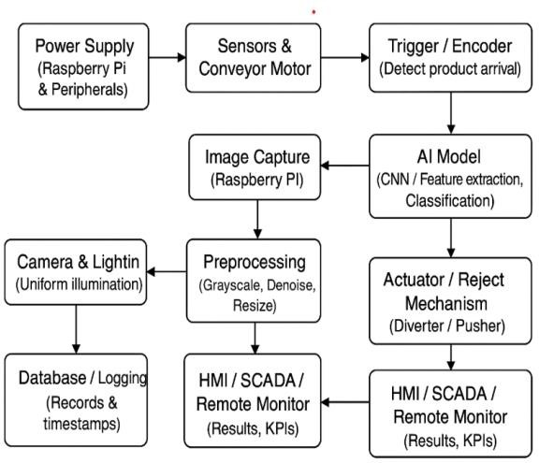

Fig.No 1:Block Diagram of System

- Power Supply
Provides electrical power to all components, including sensors, motors, Raspberry Pi, camera, and actuators.

Sensors & Conveyor Motor
Detects product movement on the conveyor belt and ensures continuous motion of products for inspection.

Trigger / Encoder (Detect Product Arrival)
Sends a signal when a product arrives at the inspection point, triggering the camera to capture an image.
- Image Capture (Raspberry Pi) Captures images of the product using a connected camera. Raspberry Pi acts as the processing unit to handle image acquisition.

AI Model (CNN / Feature Extraction, Classification)
Processes captured images using a Convolutional Neural Network (CNN) or feature extraction technique to classify products as good or defective.

Actuator / Reject Mechanism (Diverter
/ Pusher)
Mechanically removes defective products from the conveyor belt using diverters or pushers, based on AI model results.

HMI / SCADA / Remote Monitor (Results, KPIs)
Displays system results, performance metrics, and real-time monitoring data for operators to review.

Preprocessing (Grayscale, Denoise, Resize)
Performs image enhancement tasks like converting to grayscale, removing noise, and resizing to prepare for AI analysis.

Camera & Lighting (Uniform Illumination)
Ensures consistent lighting and image quality, minimizing shadows and reflections for accurate inspection.

Database / Logging (Records & Timestamps)
Stores inspection data, including images, results, timestamps, and performance logs for traceability and analysis.

II.ALGORITHM

Step 1 – Start:
Power on Raspberry Pi, camera, sensors, lighting, and conveyor motor.

Step 2 – Initialization:
Set up camera, sensors, communication, and load the AI defect detection model.

Step 3 – Object Detection:
Sensor detects product and triggers image capture.

Step 4 – Image Acquisition:
Camera captures image under uniform light and stores it temporarily.

Step 5 – Preprocessing:
Convert to grayscale, reduce noise, enhance edges, and normalize image.

Step 6 – Classification:
AI model analyzes features and classifies product as Defective or Non-defective.

Step 7 – Decision & Control:
Move good products forward; reject or divert defective ones; log results.

Step 8 – Display & Monitoring:
Show inspection results and system status on HMI or SCADA.

Step 9 – Repeat:
Repeat the process for each product.

Step 10 – Stop:
Stop conveyor and safely power down the system.

Step4:PROCESS
Raspberry Pi analyses features(e.g., cap, fill level).

Step5:DECIDE
Determine if bottle is Acceptor Reject.

Step6:ACTUATE
Send Accept/Reject command to the Actuator.

Step7:SORT
Actuator performs the physical sorting action.

Step8:LOOP
Wait for the next bottle(ReturntoStep2).

III. FLOWCHART

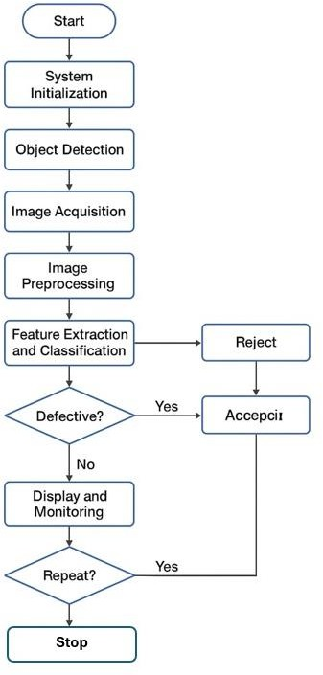
Fig 2: Flowchart of the System

V. CONCLUSION
The automated inspection system using Raspberry Pi, camera, sensors, and AI-based image processing offers an efficient and cost- effective solution for real-time defect detection in industrial production. By integrating machine learning models with hardware components, the system ensures accurate, consistent, and high- speed inspection, reducing human error and improving product quality. The review highlights that such systems can be easily customized for various applications, supporting smart manufacturing and Industry 4.0 objectives. Future advancements in deep learning and embedded computing will further enhance accuracy, speed, and adaptability of automated.

I. REFERENCES
1] G. Bhavanasi et al., ”Enhanced vision- based quality inspection: A multi-view artificial intelligence framework for defect detection,” Sensors, vol. 25,no. 6, p. 1703, Mar. 2025, doi: 10.3390/s25061703.
- ”AI-driven toolbox for efficient and transferable visual quality inspection in
produc tion,” SN Comput. Sci., vol. 6, no.4, Article 481, Apr. 2025, doi:
10.1007/s42979-025 03988-1.
- ”Generative AI in industrial machine vision: A review,” J. Intell.
Manuf., Apr. 11, 2025, doi: 10.1007/s10845-
025-02604-6. 4. M.R.Islametal.,
”Deeplearning and computer vision techniques for enhanced quality con-
trol in manufacturing processes,” IEEE Access, pp. 1–1, Jun. 2024, doi:
10.1109/AC CESS.2024.3453664.
- ”Leveraging AI for automated quality control in manufacturing,” J.
Deep Learn. Ge nomic Data Anal., Oct. 2024. [Online]. Available:
- C. B. Kolanur, J. Bali, S. Tanvashi, and
A. Giriyapur, ”An overview of ma-chine vision based quality control strategies for smart manufacturing,” AIP Conf. Proc., vol. 2788, no. 1, p. 110005, Mar. 2023, doi:10.1063/5.0148661.
- Enhanced Vision-Based Quality Inspection: A Multiview Artificial Intelli- gence Framework for Defect Detection by Geethika Bhavanasi ORCID,DavyNeven ORCID,Manuel Arteaga ORCID,Sina Ditzel ORCID,Sam Dehaeck O-RCID andAbdellatif Bey-Temsamani.
- AI-Driven Toolbox for Efficient and Transferable Visual Quality Inspection
in Production.Patrick Trampert, Sven Mantowsky, Felix Schmidt, Tobias
Masiak Georg Schneider ,Published: 10 March 2025.
- Generative AI in industrial machine vision: a review. Hans Aoyang Zhou,Dominik Wolfschl¨ager, Constantinos Florides, Jonas Werheid, HannesBehnen,
Jan-Henrik Woltersmann, Tiago C. Pinto, Marco Kemmerling,Anas Abdelrazeq Robert H.
Schmitt
- Deep Learning and Computer Vision Techniques for Enhanced Quality
Control in Manufacturing Processes MDRAISUL ISLAM1, MD ZAKIR
HOSSAIN ZAMIL2, MDESHMAMRAYED 3,MDMOHSINKABIR 4, M.
F. MRIDHA 3,(Senior Member, IEEE), SATOSHI NISHIMURA 5,(Mem-
ber, IEEE), AND JUNGPIL SHIN 5,(Senior
Member, IEEE) 1School of
Engineering and Technology, Western Illinois University, Macomb, IL 61
- ” Machine Vision Intelligent Detection System Based on Faster R-CNN”,Xueting Wang,Weizhao Song,
DOI: 10.1109/ICDSCA63855.2024.10859896,
Publisher: IEEE,22-24 November 2024.

.

