Understanding AEC Stakeholder Perceptions: A Mixed-Methods Approach Integrating Thematic Analysis and Computational Text Analytics

ABSTRACT
This study adopts a mixed-methods approach to examine stakeholder perceptions of the ASEAN Economic Community (AEC), integrating qualitative thematic analysis with quantitative data analytics techniques. Drawing on 480 valid open-ended survey responses from diverse stakeholder groups across ASEAN member states and regional partners, thematic analysis was employed to identify six major themes: Economic Growth and Trade, Regional Integration and Connectivity, Business Development and Market Opportunities, Stakeholder Benefits and Quality of Life, Cooperation and ASEAN Solidarity, and Limited Awareness and Visibility Gap. Complementing this, chi-square tests reveal statistically significant associations between theme distribution and both stakeholder group and country of origin. Sentiment analysis further indicates an overwhelmingly positive tone across responses (49.8% positive, 47.5% neutral, 2.7% negative), with notable variation by theme. Word frequency analysis identifies dominant keywords within each theme, providing additional granularity to stakeholder narratives. The findings suggest that while stakeholders broadly perceive the AEC as beneficial, their perceptions are significantly shaped by national context and stakeholder type. This study contributes methodologically by demonstrating how computational text analytics can enrich qualitative regional integration research, and substantively by providing a more nuanced, multi-dimensional understanding of AEC stakeholder engagement.
Keywords: ASEAN Economic Community; Mixed Methods; Thematic Analysis; Sentiment Analysis; Chi-Square Test; Stakeholder Perceptions; Text Analytics; Regional Integration

I. INTRODUCTION
Regional economic integration has long been a central concern in the social sciences, examined through the intersecting lenses of political economy, international relations, sociology, and governance studies. Within Southeast Asia, the ASEAN Economic Community (AEC), formally established in 2015, represents one of the most ambitious institutional undertakings in the region's post-colonial history. Conceived as a mechanism to create a single market and production base, the AEC aims to facilitate the free flow of goods, services, investment, skilled labor, and capital across the ten-member states (ASEAN Secretariat, 2015). However, as scholars of regional integration have long observed, the institutional architecture of economic communities does not operate in a social vacuum. The success of such initiatives depends not merely on policy design and formal compliance, but on how ordinary citizens, civil society actors, businesses, and governments understand, interpret, and assign meaning to the integration process (Hurd, 1999; Acharya, 2023). In this sense, stakeholder perceptions constitute a critical, yet frequently underexplored, dimension of regional governance.
The study of stakeholder perceptions in the context of regional economic integration is fundamentally a social science problem. It concerns how individuals and groups cognitively and emotionally process institutional change, how lived experiences of economic transformation are narrated and communicated, and how divergent social positions, defined by nationality, occupational sector, gender, and institutional affiliation, produce differential readings of the same regional project. Previous research has addressed aspects of this problem through survey-based attitudinal studies, elite interviews, and qualitative content analysis. However, the methodological repertoire of such studies has largely remained confined to either conventional quantitative instruments that measure pre-defined variables, or qualitative approaches that privilege interpretive depth over systematic pattern detection. What has been comparatively rare in the AEC literature is a research design that genuinely integrates both, one that begins with stakeholder voices and narrative data, but then subjects those narratives to rigorous computational and statistical analysis to uncover patterns invisible to the unaided interpretive eye.
This study addresses that methodological gap by extending a prior thematic analysis of 480 open-ended survey responses on stakeholder perceptions of the AEC into a fully integrated mixed-methods inquiry. The first objective is to identify and describe the dominant thematic content of stakeholder responses using the reflexive thematic analysis framework of Braun and Clarke (2006, 2019), thereby grounding the analysis in stakeholder voices and interpretive categories. The second objective is to apply chi-square tests of independence to examine whether the distribution of themes varies significantly across stakeholder groups, countries of origin, and gender. The third objective is to employ VADER sentiment analysis to assess the emotional orientation of stakeholder narratives at both the aggregate and thematic levels. Taken together, these objectives reflect a conviction that understanding stakeholder perceptions of the AEC requires not a single methodological lens but a layered, pluralistic analytical strategy.
The research gap that motivates this study is both substantive and methodological. Substantively, while the economic outcomes of the AEC have been extensively documented (Petri, Plummer, & Zhai, 2012; ASEAN Secretariat, 2023), the social and perceptual dimensions of integration remain comparatively under-theorized. Methodologically, the gap lies in the underutilization of computational text analytics within regional integration research. Disciplines such as political science, communication studies, and computational social science have increasingly demonstrated the analytical value of sentiment analysis, word frequency modeling, and text-as-data approaches for examining large bodies of qualitative material (Grimmer & Stewart, 2013; Liu, 2012). However, these tools remain largely absent from the ASEAN governance literature. This study seeks to make a dual contribution by advancing both the empirical literature on AEC perceptions and the methodological literature on mixed-methods approaches to regional governance research.

II. LITERATURE REVIEW
A. ASEAN Economic Community and Regional Integration
The theoretical foundations of regional economic integration draw on a diverse intellectual tradition spanning neofunctionalism, intergovernmentalism, and constructivism. Haas (1958) argued that economic cooperation generates spillover effects that gradually draw political and social life into a regional orbit. While the ASEAN experience has often been contrasted with the European model, notably in its emphasis on non-interference and consensus-based decision-making, the AEC nonetheless reflects a broadly neofunctionalist logic (Severino, 2006; Jetschke, 2021).
The AEC, launched in 2015 following the 2007 ASEAN Charter, seeks to establish a single market and production base characterized by the free flow of goods, services, investment, capital, and skilled labor (ASEAN Secretariat, 2015). Baldwin (2006) argues that preferential trade agreements reduce transaction costs and generate efficiency gains. Petri, Plummer, and Zhai (2012) estimated significant welfare gains from AEC integration, while more recent assessments by the ASEAN Secretariat (2023) and the Asian Development Bank (2024) highlight the AEC's contribution to supply chain resilience and post-pandemic economic recovery.
However, a growing body of critical scholarship has called attention to the uneven distribution of integration benefits. Menon (2013) argues that development disparities within ASEAN risk entrenching structural inequalities. Jones (2015) further contends that ASEAN's state-centric, elite-driven mode of regionalism has consistently marginalized civil society voices, women, migrant workers, and informal sector actors. These critiques are directly relevant to the present study, which foregrounds diverse stakeholder perceptions as a corrective to institutionally focused accounts of AEC performance.

B. Stakeholder Theory and Regional Governance
Stakeholder theory, originally developed within strategic management, has been progressively extended to the analysis of public institutions and governance regimes. Freeman's (1984) foundational account established that any individual or group capable of affecting or being affected by an organization's objectives qualifies as a stakeholder and has a legitimate interest in institutional decision-making. Applied to the AEC, this implies that stakeholder perceptions become a primary criterion of institutional effectiveness.
Donaldson and Preston (1995) refined stakeholder theory by distinguishing its descriptive, instrumental, and normative dimensions, suggesting that stakeholder perceptions simultaneously mirror institutional performance, resource strategic communication, and matter as a question of democratic legitimacy. Mitchell, Agle, and Wood (1997) introduce the concept of stakeholder salience, defined by power, legitimacy, and urgency, predicting that groups with higher salience are more likely to have their perceptions reflected in institutional behavior. Fung (2006) and Gerard (2014) extend this framework to encompass questions of voice and deliberation, emphasizing the substantive inclusion of diverse stakeholder voices in regional governance.

C. Public Perception, Legitimacy, and Regional Identity
Hurd (1999) identifies legitimacy as a primary source of institutional authority, arguing that actors comply with rules because they regard them as rightful. For regional institutions like the AEC, legitimacy is therefore a socially constructed and continuously negotiated achievement. Gilardi (2012) demonstrates that the diffusion of institutional norms is mediated by social learning and normative persuasion and is fundamentally dependent on how stakeholders perceive the value and appropriateness of those models.
Constructivist scholars have argued that ASEAN regionalism is not merely a functional arrangement but a project of identity formation aimed at cultivating a sense of shared community (Acharya, 2001). However, empirical research has consistently found limited awareness of ASEAN institutions, particularly among younger and lower-income populations (Narine, 2008; Stubbs, 2019). This awareness gap, which emerges as a distinct theme in the present study, represents a critical challenge for the AEC's social legitimacy and long-term governance effectiveness.

D. The Digital Turn in Social Science Research
The past two decades have witnessed a profound transformation in the methodological landscape of the social sciences, driven by the exponential growth of digitally available textual data and computational tools capable of analyzing it at scale (Lazer et al., 2009). Text-as-data approaches offer social scientists a means of processing large volumes of textual material with systematicity and replicability that traditional qualitative methods cannot achieve, while retaining sensitivity to semantic content (Grimmer & Stewart, 2013).
Sentiment analysis, the computational identification and quantification of emotional orientation within textual data (Liu, 2012), has been applied across social science domains, including political communication (Young & Soroka, 2012), public health discourse (Guntuku et al., 2017), and international relations (Ceron, Curini, & Iacus, 2016). The VADER model (Hutto & Gilbert, 2014), due to its rule-based design accounting for capitalization, punctuation, and degree modifiers, is particularly robust for short-form text responses. Word frequency analysis complements sentiment modeling by revealing the conceptual vocabulary through which stakeholders frame their experiences (Krippendorff, 2018). The application of these digital methods to ASEAN stakeholder perceptions represents a novel contribution to the regional integration literature.

III. METHODOLOGY
A. Research Design
This study employs an explanatory sequential mixed-methods design (Creswell, 2014), in which qualitative thematic analysis is conducted first to identify dominant themes, followed by quantitative data analytics to test statistical associations, assess sentiment, and examine linguistic patterns. This sequencing allows the quantitative phase to extend and enrich the qualitative findings.

B. Data Collection and Sample
The dataset comprises 480 valid open-ended survey responses collected during a public consultation on the AEC Post-2025 Agenda, conducted under the auspices of the ASEAN Secretariat in collaboration with ERIA and GIZ. Following data screening and exclusion of incomplete or irrelevant responses, 480 valid responses were retained for analysis. The profile of respondents is presented in Table 1.

Characteristic | Category | n | %
Country | Philippines | 213 | 44.4
Country | Indonesia | 171 | 35.6
Country | Malaysia | 40 | 8.3
Country | Singapore | 27 | 5.6
Country | Others | 29 | 6.0
Gender | Female | 281 | 58.5
Gender | Male | 186 | 38.8
Gender | Prefer not to say | 13 | 2.7
Stakeholder Group | Individual | 291 | 60.6
Stakeholder Group | Academe/Research/Think Tank | 121 | 25.2
Stakeholder Group | Business (incl. MSMEs) | 29 | 6.0
Stakeholder Group | Civil Society Organization | 13 | 2.7
 | Government | 10 | 2.1
 | International Organisation | 6 | 1.3
 | Marginalised Individual | 10 | 2.1
Table 1: Profile of Respondents (N = 480)

C. Analytical Procedures
Phase 1 — Thematic Analysis
Thematic analysis was conducted following the six-phase framework of Braun and Clarke (2006, 2019): familiarisation, initial coding, theme development, theme review, theme definition, and reporting. Six themes were identified: T1 Economic Growth and Trade, T2 Regional Integration and Connectivity, T3 Business Development and Market Opportunities, T4 Stakeholder Benefits and Quality of Life, T5 Cooperation and ASEAN Solidarity, and T6 Limited Awareness and Visibility Gap.
Phase 2 — Chi-Square Tests of Independence
Chi-square tests of independence were conducted to examine whether the distribution of themes differed significantly across stakeholder groups, countries of origin, and gender. Contingency tables were constructed for each grouping variable by theme, and Pearson chi-square statistics were calculated using Python's SciPy library. Statistical significance was set at p < 0.05.
Phase 3 — Sentiment Analysis
Sentiment analysis was performed using the VADER (Valence Aware Dictionary and Sentiment Reasoner) model (Hutto & Gilbert, 2014), which assigns compound sentiment scores ranging from -1 (most negative) to +1 (most positive). Responses were classified as Positive (compound ≥ 0.05), Neutral (-0.05 < compound < 0.05), or Negative (compound ≤ -0.05). Sentiment distributions were examined both overall and by theme.
Phase 4 — Word Frequency Analysis
Word frequency analysis was conducted for each theme using Python's NLTK library. Standard English stopwords were supplemented with domain-specific terms (e.g., 'asean', 'aec', 'community') to ensure that theme-distinctive vocabulary was captured. The top 12 most frequent content words per theme were visualized using horizontal bar charts and word clouds.

IV. RESULTS
A. Thematic Analysis
The thematic analysis identified six major themes characterizing stakeholder perceptions of the AEC. Table 2 presents the frequency distribution across themes.

Theme | Frequency (n) | Percentage (%)
T1: Economic Growth and Trade | 93 | 19.4
T2: Regional Integration and Connectivity | 68 | 14.2
T3: Business Development and Market Opportunities | 55 | 11.5
T4: Stakeholder Benefits and Quality of Life | 165 | 34.4
T5: Cooperation and ASEAN Solidarity | 80 | 16.7
T6: Limited Awareness and Visibility Gap | 19 | 4.0
Total | 480 | 100.0
Table 2: Theme Frequency Distribution (N = 480)
Stakeholder Benefits and Quality of Life (T4) emerged as the dominant theme (34.4%), followed by Economic Growth and Trade (T1, 19.4%) and Cooperation and ASEAN Solidarity (T5, 16.7%). The Limited Awareness and Visibility Gap (T6) was the least frequent theme (4.0%), but its presence signals an important governance challenge.

B. Chi-Square Test Results
Chi-square tests of independence were conducted to examine whether the distribution of themes differed significantly across stakeholder characteristics. Table 3 summarises the results.

Grouping Variable | χ² | df | p-value | Significance
Stakeholder Group vs Theme | 44.17 | 30 | 0.046 | * Significant
Country vs Theme | 119.80 | 55 | < 0.001 | *** Highly Significant
Gender vs Theme | 16.41 | 10 | 0.088 | Not Significant
Table 3: Chi-Square Test Results
The results indicate statistically significant associations between theme distribution and both stakeholder group (χ² = 44.17, df = 30, p = 0.046) and country of origin (χ² = 119.80, df = 55, p < 0.001). Gender did not produce a statistically significant association (p = 0.088). Notable cross-tabulation patterns include: Business respondents showed the highest proportion of T3 (Business Development) responses (31.0%), while CSO respondents were most strongly associated with T4 (Stakeholder Benefits, 53.8%). International Organization respondents skewed toward T1 (Economic Growth, 33.3%), consistent with an institutional-macroeconomic perspective. These patterns suggest that stakeholders engage with the AEC through the lens of their own sectoral roles and institutional mandates. Figure 1 visualizes these distributions across all stakeholder groups and countries, enabling a comparative reading of how national and sectoral context simultaneously shapes thematic orientation. The country-level variation is considerably more pronounced than stakeholder-group variation, consistent with the much larger chi-square statistic for country (χ² = 119.80) relative to stakeholder group (χ² = 44.17). The gender panel confirms the non-significant chi-square result for that variable.
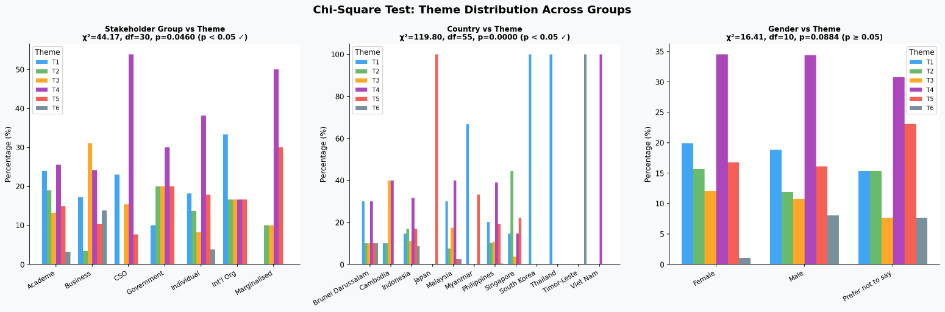
Figure 1: Chi-Square Test — Theme Distribution Across Groups

Taken together, the chi-square results and Figure 1 establish that stakeholder perceptions of the AEC are systematically patterned by national belonging and sectoral affiliation, two dimensions of social position that shape how individuals experience and evaluate regional integration. This finding has direct implications for the design of differentiated AEC communication and engagement strategies.

C. Sentiment Analysis
Sentiment analysis using the VADER model revealed a predominantly positive overall tone across the 480 responses. Table 4 presents the overall sentiment distribution, while Figure 2 shows sentiment breakdown by theme.

Sentiment | Frequency (n) | Percentage (%)
Positive | 239 | 49.8
Neutral | 228 | 47.5
Negative | 13 | 2.7
Total | 480 | 100.0
Table 4: Overall Sentiment Distribution (N = 480)
Theme-level sentiment analysis revealed notable variation. T1 (Economic Growth and Trade) exhibited the highest proportion of positive responses. T6 (Limited Awareness and Visibility Gap) was characterized entirely by neutral sentiment, with zero positive responses, reflecting the uncertainty and unfamiliarity respondents in this category expressed. T4 (Stakeholder Benefits and Quality of Life) contained the majority of negative responses (n = 11), suggesting that some stakeholders feel that AEC benefits have not yet translated into tangible improvements in their quality of life. These theme-level patterns are visualized in Figure 2, which presents three complementary panels: an overall sentiment pie chart, a stacked bar chart of sentiment distribution by theme, and a horizontal bar chart of mean VADER compound scores per theme. The pie chart confirms the dataset's strongly positive overall orientation. The stacked bar chart makes visible the distinctive flatness of T6, entirely neutral, with no positive bar, in sharp contrast to the positivity-dominated profiles of T1, T2, T3, and T5. The rightmost panel quantifies this contrast precisely: T1 has the highest mean score, while T6 has the lowest, approaching zero.
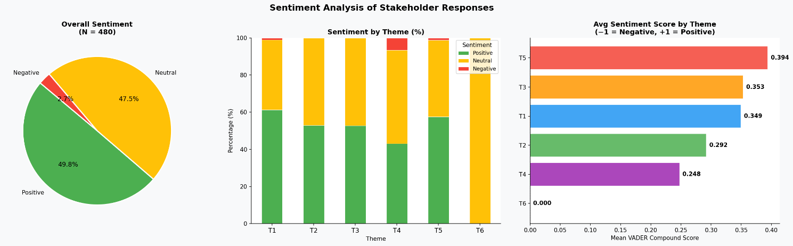

Figure 2: Sentiment Analysis Results

D. Word Frequency Analysis
Word frequency analysis identified the most prominent keywords within each theme. Across all themes, terms such as 'growth', 'trade', 'integration', 'opportunities', 'benefits', and 'cooperation' were among the most frequently appearing content words. Theme-specific patterns include the dominance of 'investment' and 'development' in T1, 'market' and 'connectivity' in T2, 'business' and 'entrepreneurs' in T3, 'opportunities' and 'quality' in T4, 'together' and 'solidarity' in T5, and notably shorter word lists with lower frequency in T6, reflecting the limited vocabulary of respondents unfamiliar with the AEC. Figure 3 presents these findings as a horizontal bar chart with six panels, showing the top 12 content words per theme. The word 'opportunities' appears frequently across T1, T3, T4, and T5, suggesting a broadly aspirational framing of the AEC. By contrast, terms associated with institutional processes, 'policy', 'framework', and 'governance', are largely absent, confirming that stakeholders narrate the AEC in terms of lived outcomes. The contrast between T5's solidarity-oriented vocabulary ('together', 'unity', 'solidarity') and T6's knowledge-deficit vocabulary ('aware', 'know', 'information') maps directly onto the sentiment profiles identified above.

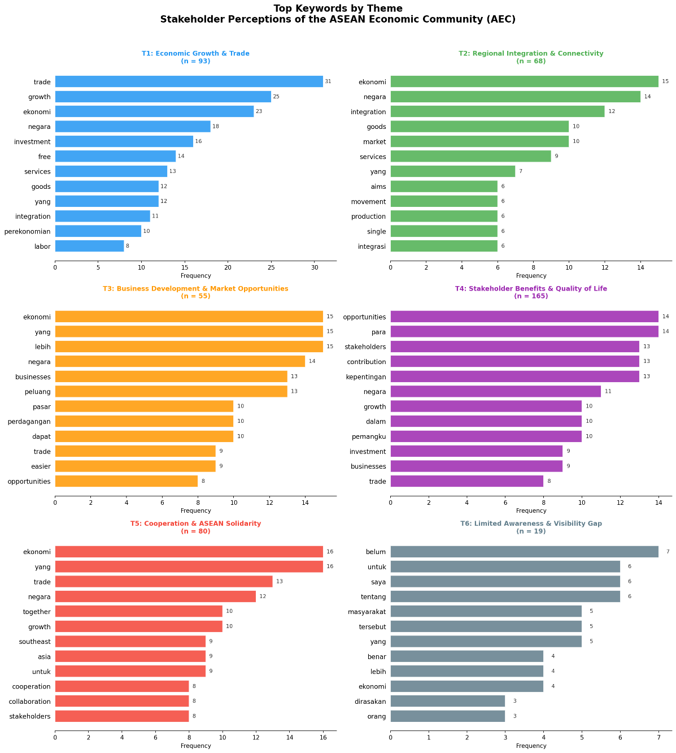
Figure 3: Word Frequency by Theme

Taken together, Figures 1, 2, and 3 constitute a mutually reinforcing set of visual evidence. Figure 1 reveals the structural patterning of thematic perceptions across social groups; Figure 2 adds the affective dimension; and Figure 3 anchors both in the actual vocabulary stakeholders use. The consistency across these three analytical layers, for example, T6 appearing as statistically distinct (Figure 1), affectively flat (Figure 2), and lexically sparse (Figure 3), strengthens confidence in the validity of the overall findings.
Note: A word cloud visualization of theme keywords and a cross-tabulation heatmap of stakeholder groups by theme are provided in Appendices A and B, respectively, for supplementary reference.
V. DISCUSSION
A. Tangible Benefits Drive Stakeholder Perceptions
The dominance of T4 (Stakeholder Benefits and Quality of Life, 34.4%) across the dataset, combined with an overall positive sentiment (49.8%), supports the argument that stakeholders evaluate the AEC primarily through its perceived impact on everyday socioeconomic welfare rather than through institutional or policy achievements. This is consistent with Freeman's (1984) stakeholder theory, which emphasizes that institutional legitimacy is grounded in the creation of tangible value for stakeholders. The high proportion of positive sentiment in T1 further suggests that economic growth narratives resonate strongly with respondents.

B. National Context Shapes Perceptions
The highly significant chi-square result for country versus theme (χ² = 119.80, p < 0.001) indicates that national context is a powerful determinant of AEC perceptions. This finding is consistent with Menon's (2013) observation that development disparities across ASEAN member states generate uneven experiences of regional integration. The dominance of Filipino and Indonesian respondents (80% combined) further suggests that future research should aim for a more balanced geographic representation.

C. Stakeholder Type Influences Thematic Orientation
The significant association between stakeholder group and theme distribution (χ² = 44.17, p = 0.046) aligns with Mitchell, Agle, and Wood's (1997) concept of stakeholder salience. Business respondents' strong orientation toward T3 reflects sector-specific interests in market access and entrepreneurial opportunities. CSO respondents' concentration in T4 reflects their mandate to advocate for societal welfare. These findings suggest that AEC communication strategies should be tailored to the distinct interests and priorities of different stakeholder segments.

D. The Awareness Gap as a Governance Challenge
The entirely neutral sentiment profile of T6 responses, with zero positive responses, suggests that respondents unfamiliar with the AEC are not merely uninformed; they are also disengaged from the positive narratives surrounding regional integration. This finding supports Jetschke's (2021) argument that ASEAN's long-term relevance depends on its ability to communicate tangible value to citizens, and Acharya's (2023) call for broader societal recognition of ASEAN regionalism.

E. Methodological Contribution
This study demonstrates that integrating thematic analysis with chi-square tests, sentiment analysis, and word frequency analysis produces a richer analytical picture than any single method alone. The chi-square results provide statistical validation of patterns identified qualitatively; sentiment analysis adds an emotional dimension absent from coding-based approaches; and word frequency analysis anchors thematic interpretations in respondents' actual linguistic choices. This mixed-methods approach is transferable to other regional integration and governance research contexts.

VI. CONCLUSION
This study adopts a mixed-methods approach to examine stakeholder perceptions of the ASEAN Economic Community, combining qualitative thematic analysis with chi-square tests, sentiment analysis, and word frequency analysis. The findings reveal that stakeholders predominantly associate the AEC with tangible socioeconomic benefits, that national context and stakeholder type significantly shape the distributions of themes, and that overall sentiment is strongly positive. The persistence of an awareness and visibility gap, particularly characterized by entirely neutral sentiment, highlights a critical challenge for AEC governance and communication.
The findings carry several implications for AEC policymakers. First, communication strategies should emphasize tangible quality-of-life outcomes, as these resonate most strongly with stakeholders. Second, engagement efforts should be differentiated by stakeholder group, given the significant variation in thematic orientations across sectors. Third, targeted awareness campaigns are needed to address the visibility gap, particularly among segments of the population that remain unfamiliar with AEC initiatives.
This study has several limitations. The sample is geographically skewed toward the Philippines (44.4%) and Indonesia (35.6%), limiting the generalisability of findings across all ASEAN member states. The age group is entirely within the 15–24 bracket, which may not represent broader adult stakeholder populations. Future research should seek more representative sampling across ASEAN countries and age groups, and may consider longitudinal designs to track how perceptions evolve in relation to AEC policy developments. Additionally, multilingual sentiment analysis tools could be applied to capture non-English responses more accurately.
REFERENCES
Acharya, A. (2001). Constructing a security community in Southeast Asia: ASEAN and the problem of regional order. Routledge.
Acharya, A. (2023). ASEAN and the future of regional order. Asian Affairs, 54(1), 1–20.
ASEAN Secretariat. (2015). ASEAN Economic Community Blueprint 2025. ASEAN Secretariat.
ASEAN Secretariat. (2023). ASEAN Integration Report 2023. ASEAN Secretariat.
Asian Development Bank. (2024). Asian Development Outlook 2024. ADB.
Baldwin, R. (2006). Managing the noodle bowl: The fragility of East Asian regionalism. Singapore Economic Review, 53(3), 449–478.
Braun, V., & Clarke, V. (2006). Using thematic analysis in psychology. Qualitative Research in Psychology, 3(2), 77–101.
Braun, V., & Clarke, V. (2019). Reflecting on reflexive thematic analysis. Qualitative Research in Sport, Exercise and Health, 11(4), 589–597.
Ceron, A., Curini, L., & Iacus, S. M. (2016). iSA: A fast, scalable and accurate algorithm for sentiment analysis of social media content. Information Sciences, 367–368, 105–124.
Creswell, J. W. (2014). Research design: Qualitative, quantitative, and mixed methods approaches (4th ed.). SAGE.
Donaldson, T., & Preston, L. E. (1995). The stakeholder theory of the corporation. Academy of Management Review, 20(1), 65–91.
Freeman, R. E. (1984). Strategic management: A stakeholder approach. Pitman.
Fung, A. (2006). Varieties of participation in complex governance. Public Administration Review, 66(S1), 66–75.
Gerard, K. (2014). ASEAN's engagement of civil society: Regulating dissent and engendering conformity. Pacific Affairs, 87(2), 255–274.
Gilardi, F. (2012). Transnational diffusion: Norms, ideas, and policies. Handbook of International Relations, 2, 453–477.
Grimmer, J., & Stewart, B. M. (2013). Text as data: The promise and pitfalls of automatic content analysis methods for political texts. Political Analysis, 21(3), 267–297.
Guntuku, S. C., Yaden, D. B., Kern, M. L., Ungar, L. H., & Eichstaedt, J. C. (2017). Detecting depression and mental illness on social media: An integrative review. Current Opinion in Behavioral Sciences, 18, 43–49.
Haas, E. B. (1958). The uniting of Europe: Political, social, and economic forces, 1950–1957. Stanford University Press.
Hurd, I. (1999). Legitimacy and authority in international politics. International Organization, 53(2), 379–408.
Hutto, C. J., & Gilbert, E. (2014). VADER: A parsimonious rule-based model for sentiment analysis of social media text. Proceedings of the 8th International AAAI Conference on Weblogs and Social Media.
Jetschke, A. (2021). ASEAN and the future of Southeast Asian regionalism. The Pacific Review, 34(3), 345–365.
Jetschke, A., & Murray, P. (2012). Diffusing regional integration: The EU and Southeast Asia. West European Politics, 35(1), 174–191.
Jones, D. S. (2015). ASEAN and the management of regional security. Pacific Affairs, 88(1), 95–115.
Kimura, F. (2006). International production and distribution networks in East Asia. Asian Economic Policy Review, 1(2), 348–364.
Krippendorff, K. (2018). Content analysis: An introduction to its methodology (4th ed.). SAGE.
Lazer, D., Pentland, A., Adamic, L., Aral, S., Barabasi, A. L., Brewer, D., ... & Van Alstyne, M. (2009). Computational social science. Science, 323(5915), 721–723.
Liu, B. (2012). Sentiment analysis and opinion mining. Synthesis Lectures on Human Language Technologies, 5(1), 1–167.
McNaught, C., & Lam, P. (2010). Using Wordle as a supplementary research tool. The Qualitative Report, 15(3), 630–643.
Menon, J. (2013). Narrowing the development divide in ASEAN. Asian-Pacific Economic Literature, 27(2), 1–27.
Mitchell, R. K., Agle, B. R., & Wood, D. J. (1997). Toward a theory of stakeholder identification and salience. Academy of Management Review, 22(4), 853–886.
Narine, S. (2008). Forty years of ASEAN: A historical review. The Pacific Review, 21(4), 411–429.
Petri, P. A., Plummer, M. G., & Zhai, F. (2012). ASEAN economic community: A general equilibrium analysis. Asian Economic Journal, 26(2), 93–118.
Plummer, M. G., & Chia, S. Y. (Eds.). (2009). Realizing the ASEAN Economic Community. ISEAS Publishing.
Severino, R. C. (2006). Southeast Asia in search of an ASEAN community. ISEAS Publishing.
Stubbs, R. (2019). ASEAN sceptics versus ASEAN proponents: Evaluating ASEAN. The Pacific Review, 32(6), 923–939.
Wiedemann, G. (2013). Opening up to big data: Computer-assisted analysis of textual data in social sciences. Forum: Qualitative Social Research, 14(2).
Young, L., & Soroka, S. (2012). Affective news: Automated sentiment coding in political texts. Political Communication, 29(2), 205–231.
APPENDIX
Appendix A — Word Cloud by Theme
Figure A1 presents word clouds generated from stakeholder responses within each of the six identified themes. Word size is proportional to term frequency within the respective theme. The visualization complements the word-frequency bar charts shown in Figure 3 of the main text and provides an intuitive overview of the dominant vocabulary for each thematic category.
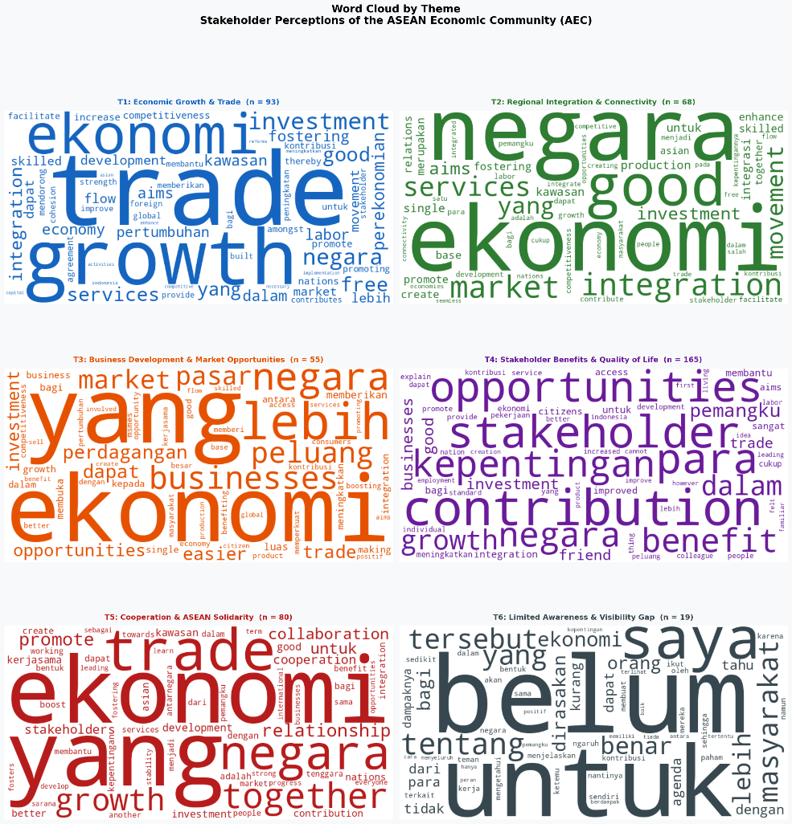

Figure A1: Word Cloud by Theme

Appendix B — Cross-Tabulation Heatmap: Theme by Stakeholder Group
Figure B1 presents a cross-tabulation heatmap showing the percentage distribution of themes across stakeholder groups. Darker cells indicate higher proportions. This visualization supplements Table 3 and the chi-square bar chart (Figure 1) in the main text by providing a more granular view of theme distribution patterns across individual stakeholder categories.

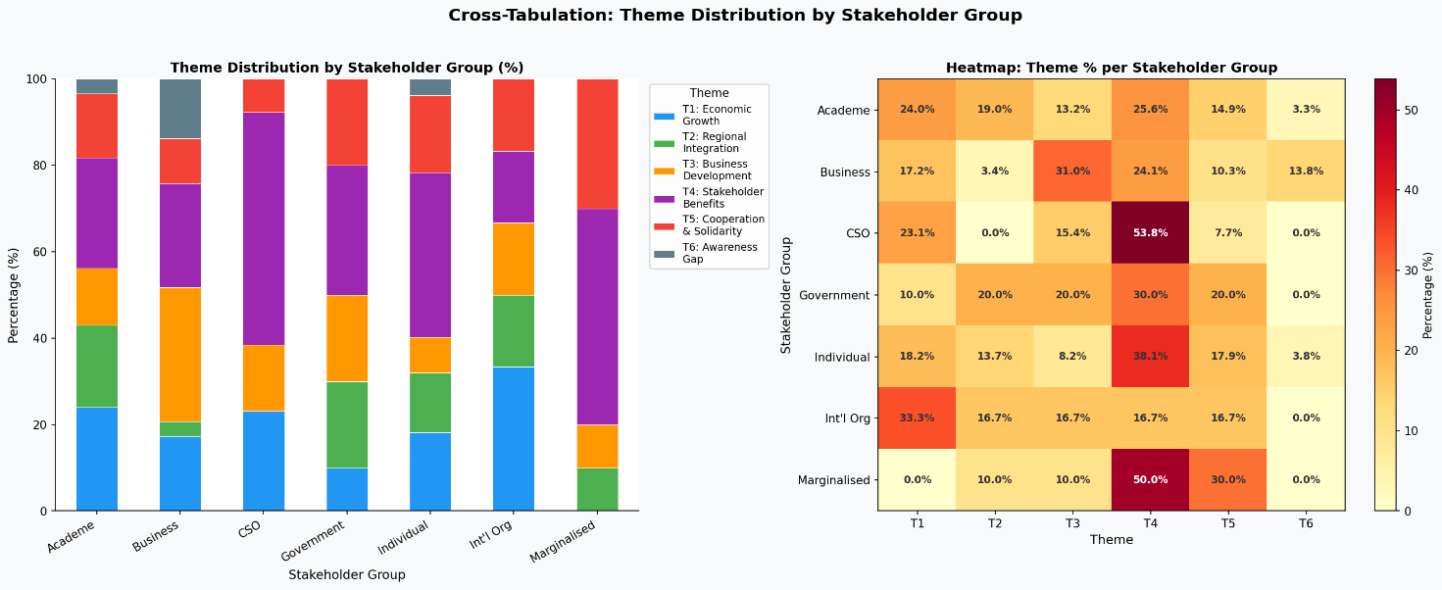

Figure B1: Cross-Tabulation Heatmap — Theme by Stakeholder Group

