Practical Approach for Developing Frosting Map for Air Sourced Heat Pumps Operating In Low Ambient Temperature Conditions

Abstract. Performance of Air Sourced Heat Pumps (ASHPs) highly depends on outside ambient temperature conditions. Relative humidity in air plays a very crucial role in phenomenon of frosting. Ice formation and its Deposition on the surface of the evaporator coil impacts the performance of ASHPs lowering the heat transfer to ambient air and reducing the COP levels. Developing a Frost map become crucial to under the occurrence of frosting in such systems. The most practical approach of developing a frosting map for air-source Heat pumps (ASHPs) using Saturation suction temperature as a reference value instead of the wall temperature of the evaporator is being analyzed in this paper. This would facilitate quick and easy understanding of frosting conditions when ASHPs are operating in very low ambient conditions, allowing for the selection of an appropriate defrosting method to improve the overall performance of ASHPs. Lab and factory tests were conducted to verify the results obtained through theoretical parametric Analysis.
Introduction to Space Heating
Space heating is a critical component of global energy consumption, accounting for a significant share of the total energy demand. According to the International Energy Agency (IEA), nearly 60% of the world's energy is used for heating-related applications, highlighting the importance of efficient and sustainable heating solutions. In regions with extremely low ambient temperatures, such as parts of Asia, Europe, and North America, space heating is not just a necessity but a major factor influencing energy efficiency and environmental sustainability. Recent technological advancements have shifted focus towards sustainable and energy-efficient systems, including Low Ex systems that utilize low-quality energy sources for heating and cooling applications [1].
Traditional space heating systems, such as central heating and space heaters, often rely on fossil fuels or electricity. While effective, these systems suffer from inefficiencies and high greenhouse gas emissions, making them less suitable for modern sustainability goals. In contrast, innovative technologies like heat pumps and radiant floor heating offer improved efficiency by leveraging low-temperature heat sources and renewable energy. Radiant floor heating, for instance, has the lowest exergy demand but requires careful design to minimize energy losses [2] [3].
Central heating systems are widely used for their ability to provide uniform temperature control across multiple rooms. They typically use boilers, furnaces, or heat pumps to generate heat, which is distributed through radiators, underfloor heating pipes, or ducted air systems. However, they require careful design to avoid energy losses and are often more expensive to install compared to localized heating solutions [2] [6]. Localized heating systems, such as space heaters and wood stoves, are less efficient but offer flexibility and lower installation costs, making them suitable for smaller spaces or as supplementary heating solutions [6].
Recent studies highlight the importance of exergy analysis in optimizing space heating systems. Exergy analysis accounts for the quality of energy supply and demand, enabling the design of systems that minimize waste. Radiant heating systems, particularly when integrated with heat pumps, enhance system performance by leveraging available energy in ambient air, ground heat, or water [5] [7]. Additionally, integrating renewable energy technologies, such as solar-assisted heating systems and biomass boilers, is gaining popularity for reducing carbon emissions. However, challenges like high initial costs and regional availability of renewable resources remain significant barriers to widespread adoption [4] [8].

S.No | Feature | Local Heating Systems | Centralized Heating Systems | District Heating Systems
1. | Examples | Electric heaters, Wood, and pellet stoves | Boilers, Heat pumps, Radiant floor heating | Cogeneration plants, Geothermal heat pumps, Large solar heating systems
2. | Efficiency  (COP/SPF) | 75-90 % (Pellet stoves), 100% (Electric heaters) | 3.0-4.5 (Heat Pumps), >90% (Modern boilers) | 3.5-4.5 (GSHP- powered systems), 80-90% (CHP systems)
3. | Energy Source | Wood, Pellets, Electricity | Natural gas, Biomass, Heat pumps, Solar thermal | Waste heat, Geothermal, Solar thermal
4. | Distribution Method | Direct heat to a localized area | Hydronic pipes, Radiators, Air ducts | Insulated underground pipes distributing hot water or steam
5. | Environmental Impact | Moderate to high emissions (e.g., wood stove emits PM, CO, VOCs) | Low to moderate emissions (depends on fuel type) | Low emissions with centralized pollution control
6. | Operational Cost | High (electric heaters); Low (wood stoves) | Moderate | Low
7. | Installation Cost | Low | Moderate | High
8. | Suitability | Small spaces, Intermittent use | Residential and commercial spaces with consistent heating needs | Urban areas with high heat density and dense population
9. | Challenges | High emissions, Limited coverage, Manual operation | High initial setup cost, Regular maintenance | High infrastructure cost, Inefficient in low-density areas
10. | Advantages | Simple installation, Low upfront cost, Portable option | Uniform temperature, High efficiency, Renewable integration | Highly efficient for large-scale applications, Low per-unit energy cost, and Renewable integration

Table 1: Comparison of Local, centralized, and district heating systems
Introduction to Heat Pumps
According to the thermodynamic principle, heat from any heat source is always transferred from a high-temperature level heat source to a low-temperature level of the heat sink. However, when the available heat source temperature is equal to or lower than the required desired temperature at heat sink, heat cannot be transferred directly. The concept of a refrigeration system enables the thermal energy (heat) to be transferred from a low-temperature heat source to the desired available high-temperature heat sink, which is done by connecting the heat source and heat sink through the compressor and expansion valve, as illustrated in Figure 1. This is achieved by using the thermodynamic relationship between temperature and pressure of the working fluid(refrigerant). Heat pump, as a concept, has been known for many years. However, it has received greater traction owing to its potential to reduce emissions. Heat pumps transfers heat more efficiently and environmentally friendly compared to the process of combustion. Efficiency is the most significant advantage heat pumps provide. The electricity required to run a heat pump typically represents only 1/4 to 1/3 of the total heat output—and almost all of that electricity is eventually converted into useful heat.
Figure 1: Basic Refrigeration Cycle
Refrigerants with a lower boiling point at atmospheric pressure are used as working fluid in this system. The low-pressure refrigerant with a temperature lower than the heat source absorbs the heat from the heat source. After this absorption, the pressure of the refrigerant is increased by external energy supply (compressor energy input) to the point at which the saturation temperature of the refrigerant would be higher than the available heat sink temperature, so that heat can be transferred from the refrigerant to the heat sink. After heat rejection to the heat sink, the expansion process reduces the refrigerant pressure to a level where the saturation temperature of the refrigerant would be lower than the available heat source temperature to repeats this cyclic operation continuously with the same working fluid. This process is called the “vapour compression refrigeration cycle”. In this way, refrigerant is used as a mediator to transfer the heat from low- low-temperature to high-temperature levels by changing working pressure. The heat pump is working on the same principle as the refrigeration cycle, with primary control on the heat sink side (condenser side).

Types of Heat Pump Systems
Heat Pumps are generally classified based on the source of heat they utilize and the mode of operation. Each type serves specific applications and climatic conditions, making them suitable for various residential, commercial, and industrial applications.
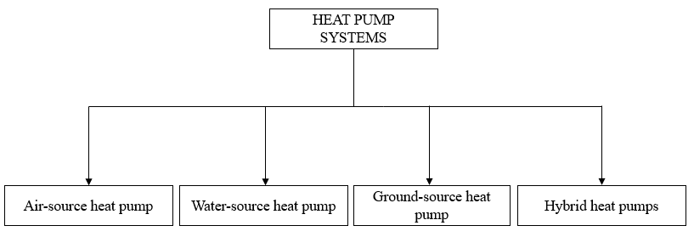
Figure 2: Classification of heat pumps
Air Source Heat Pumps (ASHPs) extract heat from ambient air and are widely used due to their cost-effectiveness and ease of installation, with modern designs performing efficiently even in colder climates. In Ground Source Heat Pumps (GSHPs), the heat is extracted from underground, which gives a stable temperature that provides higher efficiency in heating and cooling, but they involve a higher installation cost.
Water Source Heat Pumps (WSHPs) utilize bodies of water like lakes or wells for heat exchange, providing excellent efficiency but requiring specific site conditions. Hybrid Heat Pumps combine multiple heat sources, such as air and ground or air and gas, to optimize performance under varying conditions. Solar-Assisted Heat Pumps (SAHPs) utilizes solar thermal energy to further enhance efficiency and sustainability, making them ideal for domestic applications.

S.  No | Feature | Air Source Heat Pump (ASHP) | Ground Source Heat Pump (GSHP) | Water Source Heat Pump (WSHP) | Hybrid Heat Pump  (Solar-Assisted)
1. | Heat Source | Ambient air | Ground (geothermal energy) | Bodies of water (e.g., lakes, wells) | Solar thermal energy
2. | Efficiency  (COP) | 2.5-4.0 | 3.5-4.5 | 3.0-4.0 | 3.5-3.8
3. | Installation Cost | Low to Moderate | High (requires boreholes or ground loops) | Moderate to high (site-specific) | High (solar thermal integration)
4. | Environmental Impact | Low | Low | Low | Very low
5. | Suitability | Residential and commercial spaces; moderate climates | Areas with stable geothermal conditions, cold climates | Proximity to water bodies; moderate to cold climates | Domestic applications; sunny regions with moderate heating needs
6. | Advantages | Cost-effective, easy installation, works in various climates | Stable efficiency, high performance in extreme temperatures | Efficient and site-specific, good for areas with water access | High sustainability, reduced dependency on grid electricity
7. | Challenges | Performance drops in extreme cold, and defrosting issues. | High upfront cost, requires specific geological conditions. | Dependent on water source availability and quality | High installation cost, reliance on solar energy availability
Table 2: Comparison of Various categories of heat pumps
Principle of Air-Source Heat Pump
ASHPs work on the principle of transferring heat from the outside air to provide heating, cooling, or hot water for indoor spaces. Unlike conventional heating systems that generate heat through combustion or electrical resistance, ASHPs utilize a refrigeration cycle to move thermal energy from one location to another, making them significantly more energy efficient. This is governed by refrigeration cycle involving the principles of thermodynamics, which involves evaporation, compression, condensation, and expansion of a refrigerant.
The operation begins with the evaporator, where a low-pressure refrigerant absorbs heat from the outdoor air. Even in cold climates, the air contains sufficient thermal energy for this process. The refrigerant, now in a gaseous state, is compressed by a compressor, which raises its temperature and pressure. The high-temperature gas then flows into the condenser, where it releases the absorbed heat into the indoor environment, typically through a heat exchanger connected to a radiator or underfloor heating system. Finally, the refrigerant passes through an expansion valve, reducing its pressure and temperature before re-entering the evaporator to repeat the cycle.
ASHPs are designed to work efficiently even at sub-zero temperatures, although their performance may decline in extreme cold conditions. Modern systems incorporate advanced technologies such as variable-speed compressors, enhanced evaporator designs, and defrosting mechanisms to minimize losses in harsh conditions. By leveraging ambient air, a renewable and widely available energy source, ASHPs operates at high coefficients of performance (COP), typically ranging from 2.5 to 4.0, meaning they can deliver 2.5 times to 4 times more energy than the electricity they consume. This makes ASHPs a environmentally friendly and economic alternative to traditional heating and cooling systems. [10]
The benefits of ASHPs extend beyond their applications. One of the most significant advantages is their energy efficiency. ASHPs achieve a high coefficient of performance (COP), often between 2.5 and 4.0. This efficiency translates into lower operating costs, making ASHPs a cost-effective solution for long-term energy management. Furthermore, ASHPs contribute to environmental sustainability by utilizing ambient air, a renewable energy source, and reducing reliance on fossil fuels. Modern ASHPs also employ low-global-warming-potential (GWP) refrigerants, minimizing their environmental impact. [11]
Another key advantage of ASHPs is their adaptability. They can be easily integrated with renewable energy sources such as solar photovoltaic systems, further reducing energy bills and carbon emissions. Moreover, innovative smart technology advancements have enabled ASHPs to incorporate intelligent controls, allowing users to monitor and optimize system performance remotely. This feature is particularly beneficial for ensuring energy savings and enhancing user convenience in both residential and commercial settings. [12]
Heat pumps can be monitored and controlled manually and automatically, which can save power consumption and increase performance based on the environmental conditions. [13] In colder climates, where the performance of ASHPs was traditionally a concern, recent technological developments have addressed efficiency challenges. For example, systems equipped with variable-speed compressors and enhanced defrosting mechanisms maintain performance even at sub-zero temperatures. These innovations have expanded the applicability of ASHPs to wider band width regions earlier considered as not a right application for air source heat pump technology. [14]
Challenges in ASHPs
There will be an increase in demand on electricity grids during peak hours. As the adoption of ASHPs grows, particularly in regions transitioning from natural gas-based heating, the added electrical load can strain existing grid infrastructure. This often necessitates the use of backup power sources, which are frequently fossil fuel based, leading to higher electricity production costs and higher greenhouse gas (GHG) emissions. Moreover, many grids lack sufficient capacity to accommodate the increased peak demand without substantial investments in grid expansion and modernization, which can limit the number of heat pumps that can be effectively installed in a region.
Another limitation of ASHPs is their reduced capacity and performance during extreme temperature conditions. On very cold or hot days, the compressor operates under higher pressure ratios to maintain heat transfer, causing a significant drop in efficiency and heating or cooling capacity. In cold climates, when ambient temperatures fall below the ASHP’s minimum operating range, the system may rely on auxiliary heating sources, such as fossil-fuel-based or less efficient electrical heaters, increasing operational costs and emissions.
Additionally, during cold weather, frost accumulation on the outdoor heat exchanger requires frequent defrosting, which temporarily halts heating and may increase energy consumption. Common defrost mechanisms, such as reversing the cycle or using electrical coils, can further diminish the system’s overall efficiency.
Selection of Refrigerants for Low Temperature Applications
In extreme cold climates, particularly at ambient temperatures (-30°C), conventional refrigerants struggle to maintain efficient heat transfer and system stability. Heat pumps operating under such conditions require refrigerants with exceptionally low boiling points to facilitate phase change and heat absorption, ensuring optimal system performance. Low-temperature refrigeration is widely used in applications such as cryogenics, ultra-low temperature freezers, cold storage, and space heating in frigid environments. The selection of a suitable refrigerant is critical to achieving energy efficiency, reliability, and environmental sustainability, making it a key focus of ongoing research and development efforts.
The selection of refrigerants for low-temperature applications is governed by several thermodynamic and environmental considerations. A refrigerant’s boiling point, critical temperature, and pressure significantly influence the efficiency and feasibility of a refrigeration or heat pump system. Refrigerants with low boiling points are particularly suitable for sub-zero applications as they allow for efficient evaporation and heat absorption even in extremely cold conditions. Additionally, the critical temperature of a refrigerant determines its capacity to remain in a gaseous phase under high-pressure conditions, affecting system performance and stability. Beyond thermodynamic properties, environmental impact is another crucial factor, as global regulations increasingly limit the use of high global warming potential (GWP) and ozone-depleting substances. Selecting a refrigerant that balances performance, safety, and environmental sustainability is essential for the long-term viability of low-temperature heat pump technologies.
Refrigerant | Chemical Formula | Boiling Point (°C) | Critical Temperature (°C) | Critical Pressure  (MPa) | Ozone Depletion Potential (ODP) | Global Warming Potential (GWP)
R- 23 | CHF₃ | -82.1 | 25.9 | 4.84 | 0 | 14,800
R- 170 | C₂H₆ | -88.6 | 32.2 | 4.88 | 0 | 5
R- 1150 | C₂H₄ | -103.7 | 9.2 | 5.12 | 0 | 3
R- 508B | CHF₃/C₂F₆(46/54 wt%) | -87.4 | 14.1 | 3.90 | 0 | 13,396
R- 32 | CH₂F₂ | -51.7 | 78.1 | 5.78 | 0 | 675
R- 134a | C₂H₂F₄ | -26.3 | 101.1 | 4.06 | 0 | 1,430
R- 469A | CO₂/CH₂F₂/C₂HF₅ | -78.5 to -61.5 |  |  | 0 | 1,357
R- 13 | CCLF₃ | -81.4 | 28.9 | 3.90 | 1 | 13,900
R- 14 | CF₄ | -128.0 | -45.7 | 3.74 | 6630 | 0
R- 1234yf | C₃H₂F₄ | -29.4 | 94.7 | 3.38 | 0 | <1
Table 3: Comparison of Refrigerant Properties
Significance of Frost Maps
The development of frosting maps is a vital tool in cold climatic regions, where frosting poses a significant challenge to the efficient operation of ASHPs and to deploying suitable defrosting techniques. Most of the work done in these directions mainly focused on developing the frosting map based on the wall temperature of the coil and the relative humidity of the air. Measurement of wall temperature poses a lot of practical challenges in measurement and emphasizes experimental verification of the frosting map every time while designing ASHPs for these climatic conditions.
Another practical way for developing the frosting map is based on saturated suction temperature (SST) and RH%. The advantage of using SST lies in the fact that physical measurement of SST is not required, as this value gets fixed by suction pressure, which is monitored continuously on ASHPs for control operation of compressors. This method doesn’t assume a constant flow rate of air through the evaporator. Most of the evaporator’s fans are incorporated with VFD to modulate the flow rate through the evaporator. This proposed approach of developing the frosting map considers varying flow of air through the evaporator. So, this model would reflect a simulation very close to the real-time running scenario of ASHPs.
Materials and Methods
The frosting map is developed for an air source heat pump system based on the relative humidity (RH) and ambient air temperature.
- Development of a frosting map for an air-source heat pump system By theoretical method:

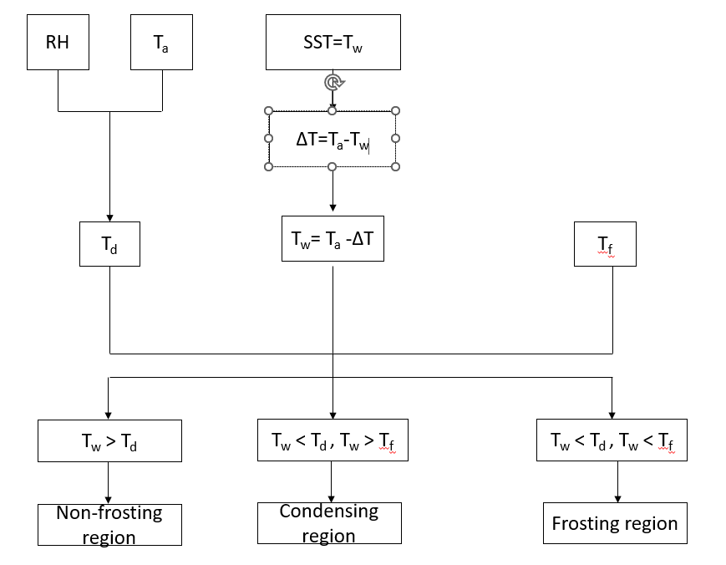Flow chart for developing the new frosting map

RH- Relative Humidity, %.
T_{a} – Temperature of ambient air, °C.
SST – Saturated suction temperature, °C.
T_{d} – Dew point temperature of air, °C.
T_{w} – Surface temperature of the evaporator coil, °C.
T_{f} – Freezing point temperature of water, °C.
From the weather data collected for the Leh Ladakh region ambient temperature and relative humidity of the air is given as input.
$T_{w}=T_{a}-∆T$ (1)
- Steps to calculate ΔT:
$∆T=k_{1}+k_{2}*T_{a}$ (2)
Initially, evaporator SST (SST is taken from the cfm calculation) is considered as surface temperature of evaporator coil. And using that a polynomial equation is created with the relation of Ambient temperature and Surface temperature.
$$T_{w}=T_{a}-k_{1}-(k_{2}*T_{a})$$
To find the constant values k1 and k2 the polynomial equation is solved in the form of matrices.
$$A=B*C$$
A matrix represents DeltaT i.e SST – Ambient Temperature.
B matrix represents Ambient temperature &
C matrix represents Constant.
$A=\left[\begin{matrix}{SST}_{1}-{T_{a}}_{1} \\ {SST}_{2}-T_{a_{2}} \\ {SST}_{3}-{T_{a}}_{3} \\ . \\ . \\ {SST}_{n}-{T_{a}}_{n}\end{matrix}\right]$ $B=\left[\begin{aligned}{1 T}_{1} \\ 1 T_{2} \\ 1 T_{3} \\ . . \\ . . \\ 1 T_{n}\end{aligned}\right]$ $C=\left[\begin{aligned}k_{1} \\ k_{2}\end{aligned}\right]$
$$A*B^{-1}=C$$
By solving this matrix using matlab, values of k₁ and k₂ are calculated. And substituting those values in equation (2) to get the Temperature difference in the heat exchanger.
- Steps to calculate saturation pressure:
$$p_{sat}=0.611*e^{\frac{17.27*T_{w}}{237.3+T_{w}}}$$
The above equation is Tetens empirical relation to calculate the saturation pressure of air. Using this relation pressure at various conditions are calculated. In this case the wall surface temperature of air is considered.
- Steps to calculate partial pressure:
Using the Tetens empirical relation considering the outlet temperature of air from the evaporator the partial pressure is calculated. In this case outlet temperature of air from the evaporator is considered.
$$p_{v}=0.611*e^{\frac{17.27*T_{o}}{237.3+T_{o}}}$$

- Estimation of Relative Humidity:
$$RH=\frac{p_{v}}{P_{sat}}$$

For various conditions RH can be estimated using the above formula.

2.Experimental procedure:
1. To Validate the frosting map the data required are:
- Ambient air Temperature (Evaporator inlet)
- Air Relative Humidity
- Evaporator SST (Calculated based on suction pressure which is measured)
- Outlet air Temperature
- The Temperature of the Cold room test temperature is maintained initially at a temperature of 15ºC.
- Test ASHP system (60 kW) is placed inside the cold room. After starting the system, the ambient temperature will gradually decrease.
- Both the outlet air temperature ( temperature of air at the outlet of evaporator coil) and relative humidity are measured and monitored continuously.
- Suction Pressure is measured using pressure transmitter and based on the data SST can be calculated.
- By measuring the relative humidity and outlet air temperature, Dew point Temperature of air can be calculated using below given formulas.
$$P_{sat}=P_{Tetens}=0.61078* e^{\frac{17.27*T_{i}}{T_{i}+237.3}}$$
$$P_{v}=P_{sat}*RH$$
$$DPT=\frac{237.3*\ln\left(\frac{P_{v}}{0.611}\right)}{17.27-\ln\left(\frac{P_{v}}{0.611}\right)}$$
- Then the calculated DPT is compared with SST.
  - If DPT is greater than SST then frost is formed.
  - If DPT is lower than SST then frost is not formed.
- Visual inspection is to be done on the evaporator to check the formation of frost on its surface. The point of frost formation over the evaporator is to be noted.
- By changing the temperature and relative humidity, we can find out when frosting happens. That point is called the Critical point.
- Using those critical points Frosting map is developed for the experimental test, and it is checked for the deviation with the theoretically developed map.
Results and Discussion
The frosting map developed based on the theoretical parametric equation has been revalidated experimentally. Several trails and iterations were conducted during the experimental phase. The analysis shows that the experimental results achieved when compared to theoretical methods follow the same pattern giving a clear indication on frost formation above certain RH values, with a variation of +/- 5 to +/-10%. So, this practical approach of developing frosting maps using SST is an easy approach for the selection of suitable defrosting techniques in ASHPs. Further variable flow rate of air through the evaporator is being taken into consideration as well while developing the frosting maps, making it the most effective approach in handling the issues of frosting in ASHPs.
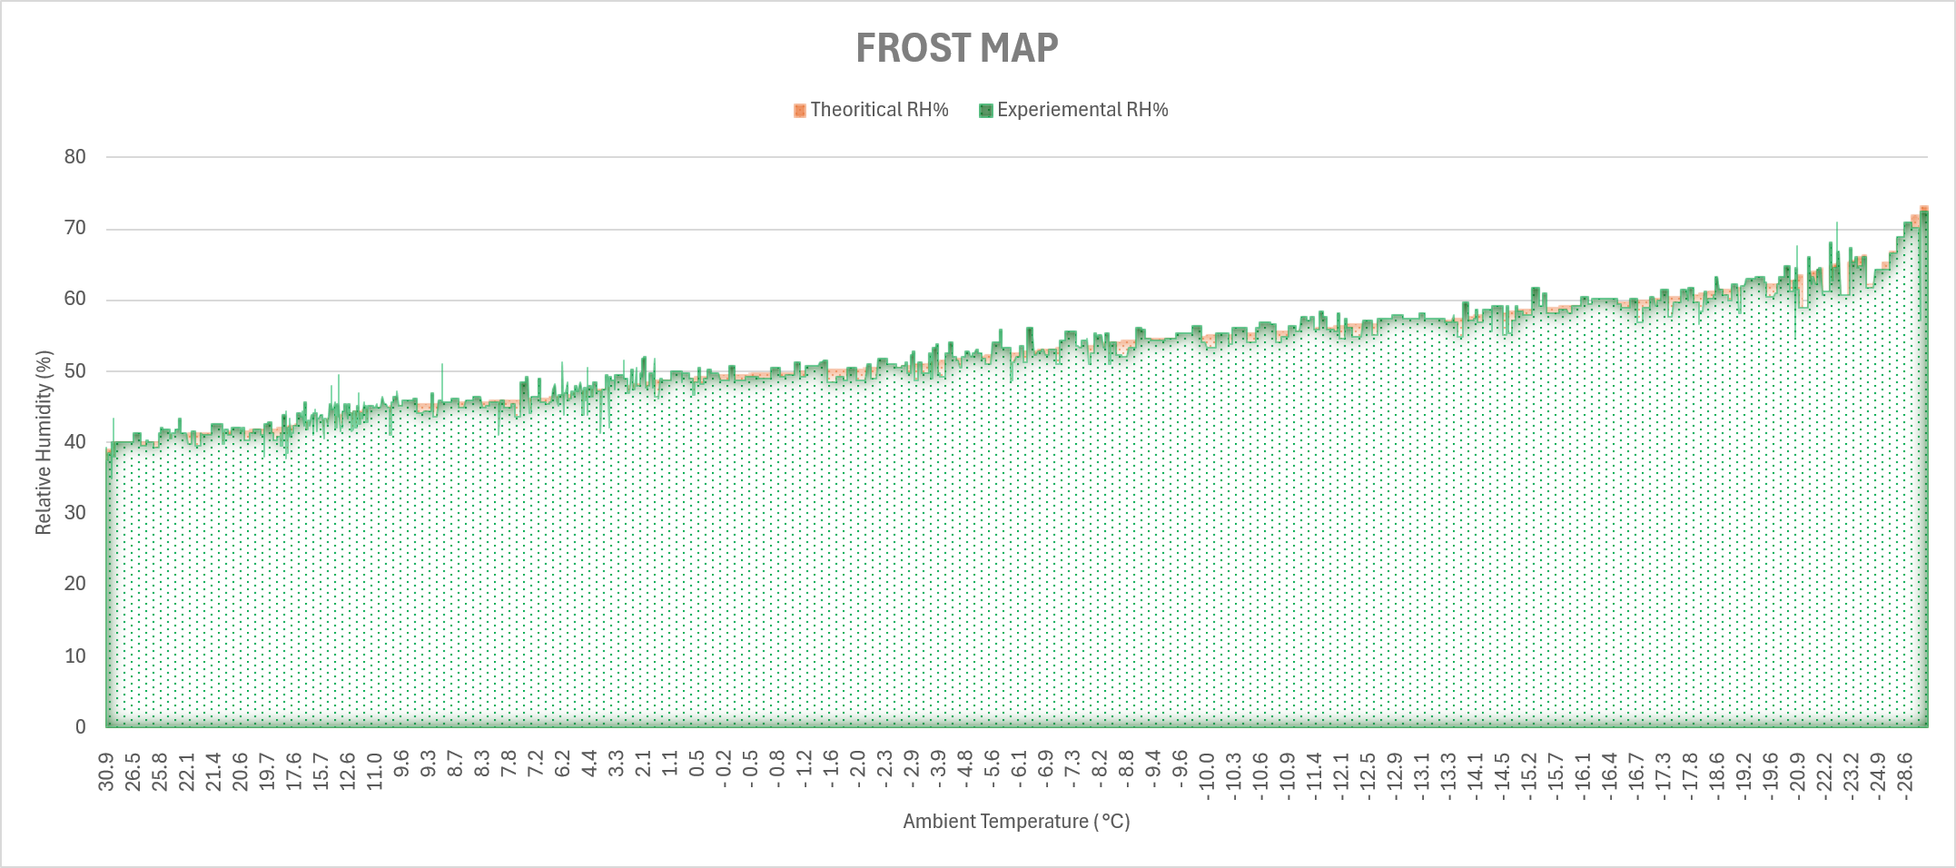
Conclusion
ASHP technology represents a crucial step toward achieving sustainable and low-carbon space heating solutions. While challenges remain, ongoing research and technological advancements continue to enhance their feasibility and performance in ultra-low-temperature applications. The integration of intelligent controls improved refrigerant cycles, and renewable energy sources will be key in optimizing ASHPs for widespread adoption, ultimately contributing to global energy efficiency and carbon reduction goals. Frosting Maps developed using SST values provide an effective, practical approach for optimizing the performance of ASHPs. The paper also provides further scope for improving the frosting maps developed so far further categorization of zones based on the extent of frosting.
References
[1] Arif Hepbasli, Low exergy (LowEx) heating and cooling systems for sustainable buildings and societies, Renewable and Sustainable Energy Reviews, (2012) 73-104.
[2] Ongun B. Kanzanci, Masanori Shukuya, Biarne W. Olesen, Exergy performance of different space heating systems: A theoretical study, Building and Environment, (2016) 119-129.
[3] Abdhullah Yildiz, Ali Gungor, Energy and exergy analyses of space heating in buildings, Applied Energy, (2009) 1939-1948.
[4] Yan Zhou, Guanhcai Gong, Exergy analysis of the building heating and cooling system from the power plant to the building envelope with hourly variable reference state, (2013) 94-99.
[5] Forrest Meggers, Volker Ritter, Philippe Goffin, Marc Baetschmann, Hansjurg Leinbundgut, Low exergy building systems implementation, Energy, (2012) 48-55.
[6] Dietrich Schmidt, Benchmarking of low ‘exergy’ buildings, International Journal of Exergy, (2012).
[7] Tolga Balta, Ibrahim Dincer, Arif Hepbasli, Performance and sustainability assessment of energy options for building HVAC applications, Energy and Buildings, (2010) 1320-1328.
[8] Arif Hepbasli, A key review on exergetic analysis and assessment of renewable energy resources for a sustainable future, Renewable and Sustainable Energy Reviews, (2008) 593-661.
[9] Janet Rudge, Coal fires, fresh air and the hardy British: A historical view of domestic energy efficiency and thermal comfort in Britain, Energy Policy, (2012) 6-11.
[10] Yaning Zhang, Qin Ma, Bingxi Li, Xinmeng Fan, Zhongbin Fu, “Application of an air source heat pump (ASHP) for heating in Harbin, the coldest provincial capital of China”, Energy Science and Engineering, (2016).
[11] Sanaz Akbarzadeh, Zahra Sefidgar, Mohammad Sadegh Valipour, Brian Elmegaard, Ahmad Arabkoohsar, “A comprehensive review of research and applied studies on bifunctional heat pumps supplying heating and cooling”, Applied Thermal Engineering, (2024), 257; 124280.
[12] Chua K.J., Chou S.K., Yang W.M. “Advances in heat pump systems: A review”, Applied Energy, (2010) 3611-3624.
[13] Heat Pumping Technologies Magazine, “Control and Monitoring of Heat Pump Systems”, (2022) Vol 40 NO 2/2022
[14] Cristina Baglivo, Domenico Mazzeo, Nicoletta Matera, Paolo Maria Congedo, Air-source heat pump under very climate change scenarios: a numerical analysis, Journal of Sustainable Development of Energy, Water and Environmental Systems, (2023), Vol:11, 1110458.
[15] Wang X, Xia L, Bales C, Zhang X, Copertaro B, Pan S, Wu J, A systematic review of recent air source heat pump (ASHP) systems assisted by solar thermal, photovoltaic, and photovoltaic/thermal sources. Renewable Energy, (2021), 2472–2487.
[16] Pham, A. T., Kinzer, B., Jain, R., Bala Chandran, R., & Craig, M. T. (2024). Assessing the Value of Coupling Thermal Energy Storage with Air-Source Heat Pumps for Residential Space Heating in the U.S. (2024).
[17] Weidner, T., & Guillén-Gosálbez, G., Planetary boundaries assessment of deep decarbonisation options for building heating in the European Union. Energy Conversion and Management, (2023).
[18] Kaufman, N., & Duke, R., Decarbonizing Space Heating with Air Source Heat Pumps. Center on Global Energy Policy, Columbia University (2020).
[19] Arash Bastani, Justin Tamasauskas, Air Source Heat Pump with integrated latent heat storage for residential buildings, Concept Development and Design Evaluation, (2023).
[20] Xin Jin, Siqian Zheng, Gongsheg Huang, Alvin CK Lai, “Energy and economic performance of the heat pump integrated with latent heat thermal energy storage for peak demand shifting”, Applied Thermal Engineering, (2023) Vol: 218, 119337.

