AN ASSESSMENT OF THE CHALLENGES HINDERING EFFECTIVE PHYSICAL PLANNING ACTIVITIES IN ABAKALIKI METROPOLIS, EBONYI
STATE, NIGERIA

Abstract
Physical planning is a key instrument for achieving orderly urban development, sustainable land-use management, and environmental protection in rapidly growing cities. This study assessed the challenges hindering effective physical planning activities in Abakaliki Metropolis, Ebonyi State, Nigeria. The objectives were to examine existing physical planning activities, identify planning approaches adopted, and analyse the major constraints affecting implementation. A survey research design was adopted, integrating both quantitative and qualitative methods. Data were collected through questionnaires, interviews, focus group discussions, field observations, and secondary sources. A sample size of 400 respondents was selected from a population of 1,770 using Yamane’s formula and stratified proportional sampling. Data were analysed using descriptive statistics and Chi-square tests via SPSS version 27. Findings revealed that the major challenges affecting physical planning were lack of institutional capacity (29.4%), limited resources (24.8%), and political interference (24.3%), while stakeholder conflicts accounted for 8.6% and rapid urbanization 7.1%. Planning schemes constituted the most commonly adopted planning approach (28.4%), followed by master planning (22.5%), urban renewal (22.3%), spatial planning (17.7%), and smart city design (3.0%). Hypothesis testing showed a significant relationship between physical planning challenges and poor enforcement of planning regulations (χ² = 42.15, df = 4, p = 0.000), leading to the rejection of the null hypothesis. The study concluded that strengthening institutional capacity, improving enforcement mechanisms, adopting modern planning technologies, and enhancing stakeholder participation are essential for achieving effective physical planning and sustainable urban development in Abakaliki Metropolis.
Keywords: Physical planning, urban development, Abakaliki Metropolis, land use, institutional capacity, urbanization, stakeholder participation.

1.0 Introduction
Physical planning is a fundamental instrument for promoting orderly urban development, sustainable land-use management, and environmental protection in rapidly urbanizing cities. It provides the framework for regulating land use, coordinating infrastructure development, controlling urban growth, and ensuring that economic, social, and environmental objectives are harmoniously integrated within the built environment (Faludi, 2014; Healey, 2016; Olanrewaju et al., 2024). Effective physical planning is therefore indispensable for creating resilient, inclusive, and environmentally sustainable cities capable of accommodating increasing population pressures while maintaining acceptable living standards (UN-Habitat, 2022; World Bank, 2023).
Globally, urbanization continues to accelerate, with the United Nations projecting that nearly 68% of the world's population will reside in urban areas by 2050 (United Nations, 2018). Although urban growth stimulates economic development and social transformation, it also intensifies pressure on land resources, infrastructure, housing, transportation systems, and environmental services. These pressures often result in unplanned development, traffic congestion, inadequate public facilities, environmental degradation, flooding, and the proliferation of informal settlements where planning systems are weak or poorly enforced (UN-Habitat, 2024; Ogunbode et al., 2024; Yekeen & Misnan, 2024).
In Nigeria, the effectiveness of physical planning has been constrained by numerous institutional, financial, legal, and administrative challenges. Weak enforcement of planning regulations, political interference, inadequate funding, shortage of skilled planning personnel, obsolete planning tools, poor inter-agency coordination, and limited public participation have significantly undermined the implementation of planning policies in many urban centres (Federal Republic of Nigeria, 2004; Adenaike et al., 2020; World Bank, 2023; Unegbu et al., 2024). Abakaliki Metropolis, the capital of Ebonyi State, reflects these challenges as rapid urban expansion continues to outpace the capacity of planning institutions to regulate physical development effectively. Consequently, assessing the challenges hindering effective physical planning activities is essential for identifying institutional and operational constraints, strengthening planning practice, improving urban governance, and promoting sustainable urban development in Abakaliki Metropolis.
For the study, emphasis was placed on the challenges faced in implementing physical planning activities in Abakaliki Metropolis and the physical planning approaches that have been implemented to improve physical planning in the study area. The hypothesis of the study stated that there is no correlation between the challenges of physical planning in Abakaliki Metropolis and poor enforcement of planning regulations, planning laws, and rapid urbanization.

2.0 Review of Literature
2.1 Concepts
a. Physical Planning Activities
Physical planning activities refer to the systematic actions undertaken by planning authorities and professionals to guide, regulate, and manage the spatial development of urban and rural areas for sustainable growth. These activities include land-use planning, development control, zoning, infrastructure planning, environmental protection, urban renewal, monitoring, and enforcement of planning regulations to ensure orderly, efficient, and environmentally sustainable development (Faludi, 2014; Healey, 2016; Adenaike et al., 2020). Effective physical planning activities integrate social, economic, institutional, and environmental considerations to improve urban functionality, resilience, and quality of life while minimizing the adverse effects of uncontrolled urbanization (UN-Habitat, 2022; Olanrewaju et al., 2024; Yekeen & Misnan, 2024).

b. Urban Development
Urban development refers to the planned process of improving the physical, economic, social, and environmental conditions of urban areas to accommodate population growth and enhance residents' quality of life. It encompasses land-use planning, housing provision, infrastructure development, transportation systems, environmental management, economic opportunities, and public service delivery aimed at creating sustainable, inclusive, and resilient cities (UN-Habitat, 2022; World Bank, 2023). Effective urban development integrates sound governance, stakeholder participation, and strategic planning to promote balanced spatial growth, environmental sustainability, and socio-economic prosperity while minimizing the adverse effects of rapid urbanization (Healey, 2016; United Nations, 2023; Olanrewaju et al., 2024).

2.2 Theory Backing for the Study: Collaborative Planning Theory
This study is anchored on the Collaborative Planning Theory developed by Patsy Healey (1997). The theory posits that effective physical planning is achieved through collaboration among government agencies, planning professionals, private organizations, and local communities. Rather than relying solely on top-down decision-making, the theory emphasizes inclusive governance, stakeholder participation, institutional coordination, transparency, and consensus-building in planning and development processes (Healey, 1997, 2003, 2016). It argues that sustainable urban development depends on the collective capacity of planning institutions and stakeholders to formulate, implement, monitor, and enforce planning policies effectively.
The theory is particularly relevant to this study because the challenges hindering effective physical planning activities in Abakaliki Metropolis including weak enforcement of planning regulations, inadequate institutional capacity, political interference, insufficient funding, poor inter-agency coordination, shortage of skilled personnel, and limited public participation reflect deficiencies in collaborative planning processes. These institutional and governance weaknesses have contributed to uncontrolled urban expansion, environmental degradation, inadequate infrastructure, and inefficient land-use management. Collaborative Planning Theory therefore provides an appropriate framework for assessing the institutional, administrative, financial, and governance constraints affecting physical planning activities in the metropolis. It further suggests that strengthening stakeholder engagement, improving institutional collaboration, enhancing transparency, adopting participatory planning approaches, and building the capacity of planning institutions are essential for overcoming these challenges and achieving sustainable urban development in Abakaliki Metropolis (UN-Habitat, 2022; World Bank, 2023; Yekeen & Misnan, 2024).

2.3 Empirical Review
Challenges of Physical Planning
Empirical studies across African cities consistently reveal that physical planning is constrained by rapid urban growth, weak institutions, and inadequate infrastructure. Adelekan, Johnson, and Rwomire (2018) found in Lagos, Nigeria, that urban expansion outpaced formal planning capacity, resulting in spatial fragmentation, weak land-use control, and widespread informal development. Similarly, Abass, Voogd, and van Dijk (2021) reported that informal settlements accounted for about 40% of Accra’s urban land area, largely due to ineffective regulations, slow land titling processes, and housing shortages.
In Nigeria, Omole, Olatubara, and Adebayo (2023) observed that 55–60% of housing stock is informal or semi-formal, driven by weak institutional capacity and poor enforcement of building standards. Johnson and Adeyemi (2021) further highlighted governance fragmentation in South African cities, where overlapping institutional roles hinder coordinated planning and produce conflicting land-use outcomes. In West African cities, Bawa, Owusu-Ansah, and Ocran (2022) linked poor planning integration to infrastructure deficits in transport, drainage, and waste management, especially in peri-urban areas.
Environmental and participatory dimensions are also significant. Ferreira, Cortese, and Yigitcanlar (2024) noted that many cities lack integrated climate-risk planning frameworks, while Adeyemi and Anetor (2023) found that participation improves accountability but is limited by political and institutional barriers. Broader African evidence by Kamana et al. (2024) emphasizes the need for resilience-oriented planning systems, while Oluwadare et al. (2024) and Le-ol et al. (2022) highlight compliance challenges, institutional differences, and high regulatory costs affecting development control in Nigeria.
Overall, physical planning challenges are multidimensional, requiring stronger institutions, improved coordination, inclusive governance, and climate-responsive planning systems. Also, from the review, an analysis of the challenges to physical planning as regards Abakaliki Metropolis is scanty. This study filled this gap in knowledge.

3.0 Materials and Methods
3.1 Study Area
Abakaliki is the capital of Ebonyi State, located in southeastern Nigeria within the Lower Benue Trough and geographically positioned between latitudes 6°00′–6°30′N and longitudes 8°00′–8°30′E (Onuegbu & Egbu, 2024). The city functions as the administrative, political, and commercial nerve centre of the state, with rapid spatial expansion influenced by its capital status and increasing rural–urban migration.
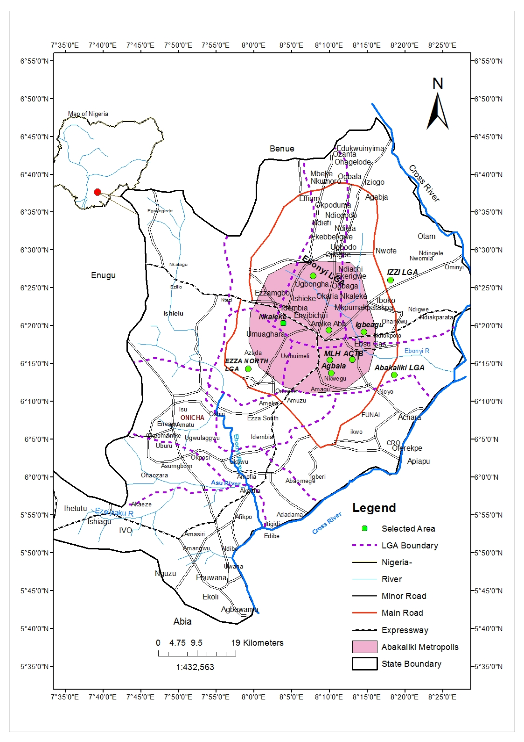
Figure 1: Location Map of Abakaliki Metropolis with a map of Nigeria
Sources: Geology Department Ebony State University, Abakaliki, 2023
Recent empirical studies indicate that Abakaliki has experienced significant population growth driven by urbanisation, administrative decentralisation, and improved socio-economic opportunities, resulting in continuous outward urban sprawl (Ezeodili et al., 2025). The city’s population pressure has contributed to land conversion and accelerated built-up expansion, with observable changes in land use between 2000 and 2022 (Onuegbu & Egbu, 2024).
Climatically, Abakaliki lies within the tropical wet-and-dry climate zone, characterized by heavy rainfall and high humidity, which contributes to flooding risks and erosion challenges during peak rainy seasons (Eke & Ossai, 2021). Rising rainfall intensity combined with poor drainage worsens environmental vulnerability.
Infrastructure development has improved in recent years, particularly in road construction, institutional buildings, healthcare facilities, and educational infrastructure. However, studies reveal persistent deficiencies in waste management, drainage systems, and equitable distribution of public services (Eze et al., 2025; Idhoko et al., 2026).
Physical planning in Abakaliki is constrained by weak development control, informal settlement expansion, and inadequate enforcement of planning regulations. Land-use monitoring studies show that rapid urban growth often exceeds planning capacity, resulting in unregulated development and environmental stress (Onuegbu & Egbu, 2024). Overall, Abakaliki represents a rapidly urbanising Nigerian metropolis where infrastructural development and administrative expansion coexist with persistent physical planning and environmental challenges.
3.2 Methods
The study adopted a survey research design, selected for its ability to generate reliable and valid data for examining physical planning activities in Abakaliki Metropolis. Both quantitative and qualitative approaches were integrated to ensure a comprehensive understanding of physical planning practices, urban development patterns, institutional challenges, and stakeholder participation.
Data requirements were structured around the study objectives. Information on existing physical planning activities included land-use planning, zoning regulations, development control procedures, urban renewal programmes, and responsible institutions. Urban development data focused on residential, commercial, industrial, and infrastructural expansion, including housing trends and compliance with planning standards. Data on challenges captured institutional weaknesses, funding constraints, manpower shortages, political interference, and incidences of unapproved developments. Stakeholder engagement data examined participation levels, consultation mechanisms, awareness, and inclusiveness in planning processes.
Primary data were obtained through questionnaires, interviews, focus group discussions, and field observations involving planners, consultants, community leaders, and other built environment professionals within Abakaliki Capital Territory and surrounding LGAs. Secondary data were sourced from textbooks, journals, maps, official government reports, and institutional records obtained from relevant ministries, libraries, and planning agencies.
The study population comprised 1,770 respondents drawn from planning authorities, ministries, and selected communities. Using Yamane’s formula at a 5% level of precision, a sample size of 400 was determined. Stratified proportional sampling was applied to ensure fair representation across institutions and communities.
Data collection instruments included structured questionnaires, semi-structured interviews, focus group discussions, and systematic field observations. The questionnaire contained sections on respondent characteristics, physical planning activities, urban environmental management, planning challenges, and stakeholder engagement.
Validity of instruments was ensured through expert review and pilot testing, while reliability was confirmed using Cronbach’s Alpha coefficient of 0.966, indicating high internal consistency. Data were analysed using SPSS version 27, employing descriptive statistics, correlation analysis, ANOVA, and Spearman rank correlation at a 0.05 significance level. Findings were presented using tables, charts, and descriptive narratives.

4.0 Findings and Discussions
4.1 Challenges Faced in Implementing Physical Planning Activities in Abakaliki Metropolis
This question presents the key challenges affecting the implementation of physical planning activities in Abakaliki metropolis, as perceived by respondents. Respondents were asked to indicate the factors that hinder effective physical planning in Abakaliki metropolis. The variable were measured based on the descriptive statistics presented in table 1.
Table 1: Challenges Faced in Implementing Physical Planning Activities in Abakaliki Metropolis
Group |  | Frequency | Percent (%)
Valid | Rapid urbanization | 28 | 7.1%
Valid | Limited resources | 98 | 24.8%
Valid | Political interference | 96 | 24.3%
Valid | Stakeholders conflict | 34 | 8.6%
Valid | Lack of institutional capacity | 116 | 29.4%
Valid | Others | 23 | 5.8%
Valid | Total | 395 | 100.0%
Source: Researchers Field Survey, 2026

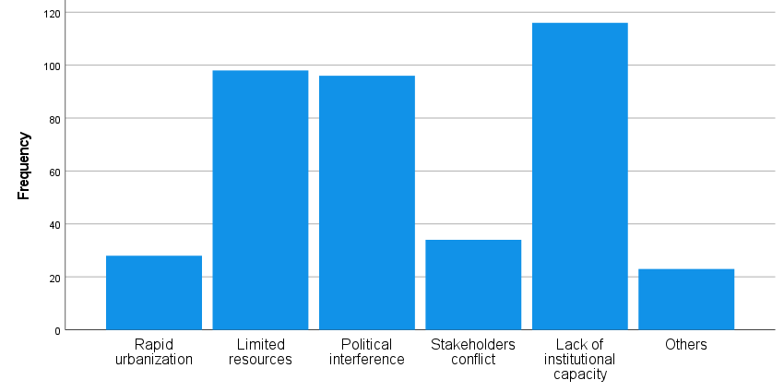
Figure 2; Challenges Faced in Implementing Physical Planning Activities in Abakaliki Metropolis
Source: Researchers Field Survey, 2026
The result of the survey presented in table 1 shows that most frequently reported challenge was lack of institutional capacity, 29.4%, limited resources, 24.8%, Political Interference 24.3%, limited resources (24.8%) and political interference (24.3%) were closely ranked as significant barriers, Rapid urbanization accounted for 7.1% of responses, Stakeholders’ conflict (8.6%). The “others” category represented 5.8% of responses
Stakeholders have identified several key barriers to effective planning, including rapid urbanization, limited resources, political interference, conflicts among stakeholders, and weak institutional capacity.
The level of inter-agency coordination was assessed as moderate to low, indicating a fragmented institutional landscape. Although various planning approaches such as master planning, urban renewal, spatial planning, and planning schemes are employed, the results remain unsatisfactory, suggesting that implementation is lacking. Stakeholders highlighted several major challenges in physical planning, including the growth of the informal sector, pressure on infrastructure, environmental degradation, weak land-use policies, conflicts of interest, lack of data, non-compliance, and outdated methodologies. To improve planning, stakeholders emphasized the need for effective land-use policies, full implementation of master plans, adequate funding, the adoption of modern technology, and the establishment of planning committees.
The analysis indicated that stakeholders view rapid urbanization, limited resources, political interference, and conflicts among stakeholders, and weak institutional capacity as the main obstacles. This suggests that planning agencies in Abakaliki lack sufficient technical expertise, trained personnel, and organizational structures to carry out their functions effectively.
Financial and material constraints limit the ability of planning authorities to conduct surveys, enforce regulations, monitor activities, engage the public, and provide infrastructure. Political interference undermines professional planning decisions, fosters favoritism, and can compromise the integrity of the planning process.
Rapid urbanization accounted for 7.1% of the responses, indicating that the pace of urban growth in Abakaliki places pressure on planning systems, although respondents viewed it as a less significant challenge compared to institutional constraints. Conflicts among stakeholders reflect disagreements among community members, developers, government agencies, and other interest groups, which can delay decision-making and implementation. Observations and focus group discussions highlighted numerous conflicts that have hindered the enforcement of planning standards in the town. The "others" category represented 5.8% of the responses, encompassing issues such as legal obstacles, policy gaps, and cultural factors.
In conclusion, the findings indicate that the primary challenges facing physical planning in the Abakaliki metropolis are institutional in nature, particularly the lack of institutional capacity, limited resources, and political interference. These issues, along with emerging urban pressures and stakeholder conflicts, impede effective planning implementation and sustainable urban development. Strengthening institutional frameworks, providing resources to planning authorities, and promoting participatory governance are essential steps toward enhancing physical planning outcomes in the metropolis.

4.2 Physical planning approaches that have been implemented to improve physical planning in Abakaliki Metropolis.
This question examined various physical planning approaches adopted to improve planning activities in Abakaliki metropolis. Respondents identified specific approaches currently being utilized by planning authorities and stakeholders to guide urban growth, regulate land use, and enhance sustainable development. The variables were measured based on the descriptive statistics presented in table 2.
Table 2: Physical planning approaches that have been implemented to improve physical planning in Abakaliki Metropolis.
Group |  | Frequency | Percent (%)
Valid | Master planning | 50 | 22.5%
Valid | Planning scheme | 112 | 28.4%
Valid | Urban renewal | 88 | 22.3%
Valid | Spatial planning | 89 | 17.7%
Valid | Smart city design | 12 | 3.0%
Valid | Others | 44 | 11.1%
Valid | Total | 395 | 100.0%
Source; Researchers Field Survey, 2026
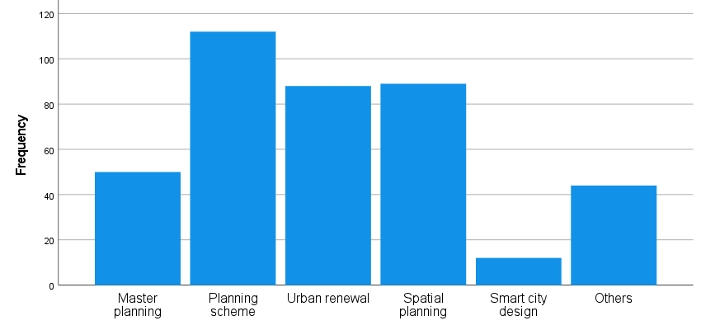
Figure 3; Physical planning approaches that have been implemented to improve physical planning in Abakaliki Metropolis.
Source: Researchers Field Survey, 2026
The result of the survey as presented in table 2 shows that the most commonly identified approach was planning scheme (28.4%). master planning accounted for 22.5% of responses. While spatial planning was reported by 12.7% of respondents and smart city design was identified by 11.1% of respondents
The analysis reveals that planning schemes are the most commonly used method in Abakaliki metropolis, highlighting the importance of regulatory frameworks like zoning laws, development control guidelines, and land-use allocation systems in the area's physical planning efforts. Planning schemes were first implemented in 1917 when Abakaliki was designated as a second-class town and continued to be used until 1996, when Abakaliki became the capital of Ebonyi State. These schemes serve as the main tool for managing development patterns and ensuring adherence to established standards.
Master planning, as a foundational tool, indicates that comprehensive long-term urban development plans are being employed to direct infrastructure development, land-use organization, and urban growth. However, the relatively modest percentage of its implementation points to challenges in executing, reviewing, and updating these master plans, which were originally designed in 2008.The limited use of spatial planning approaches suggests that while integrated methods focusing on spatial relationships, regional connections, and environmental sustainability exist, they are not widely adopted. The lower percentage reflects a lack of technical expertise and institutional focus on advanced spatial planning techniques.
The emerging use of smart city design, indicated by a relatively low percentage score, suggests that technology-driven and innovation-based planning approaches such as GIS integration, digital infrastructure, and intelligent urban systems are still in the early stages of development in the metropolis. Observations in the field show that the relevant board and ministry have yet to embrace modern technology.
In conclusion, the findings indicate that physical planning activities in Abakaliki metropolis are mainly guided by planning schemes and master planning approaches, while more advanced and integrated methods like spatial planning and smart city design are less prevalent. To enhance the effectiveness and sustainability of physical planning in the metropolis, it will be crucial to strengthen modern, technology-driven planning strategies alongside traditional frameworks.

4.3 Hypothesis Three
There is no correlation between the challenges of physical planning in Abakaliki Metropolis and poor enforcement of planning regulations, planning laws, and rapid urbanization.
Statistical Test: Chi-Square (\chi^2) Analysis of Independence
Table 3: Chi-Square Test Results
Factor | Observed (O) | Expected (E) | df | χ2-calc | Crit-value | Sig.
Poor Enforcement | 380 | 197.5 | 4 | 42.15 | 9.48 | .000
Rapid Urbanization | 395 | 197.5

Result Interpretation: Data from Table 1 show that 96.2% of respondents linked planning failures directly to enforcement breaches. The Chi-square test yields a value of 42.15, which is significantly higher than the critical table value of 9.48 at 4 degrees of freedom.
Findings: The null hypothesis is rejected. There is a statistically significant correlation between the challenges of physical planning and the triad of poor enforcement, weak legal frameworks, and rapid population growth. This suggests that the "challenges" are not external accidents but are direct consequences of regulatory failure.

4.4 Discussions
The analysis of the objectives indicated that the main challenges facing physical planning in Abakaliki metropolis are largely institutional. Key issues include inadequate institutional capacity, limited resources, and political interference. These challenges, along with increasing urban pressures and conflicts among stakeholders, impede effective planning and sustainable urban development. This aligns with the findings of Adelekan, Johnson, and Rwomire (2018), which highlighted that urban growth has outstripped formal planning capabilities, resulting in spatial fragmentation, insufficient infrastructure, and weak enforcement of land use regulations. Informal development primarily occurs in areas where the planning system is significantly lacking.
Regarding the physical planning approaches already implemented to enhance planning in Abakaliki, (table 2) the findings suggest that the activities are mainly guided by planning schemes and master planning approaches. In contrast, more advanced and integrated methods, such as spatial planning and smart city design, are not widely utilized.
The research findings indicate that the main obstacles to effective physical planning in the Abakaliki metropolis (table 2) include regulatory violations, conflicts of interest, and a lack of skilled personnel. Additionally, inefficiencies in policy, gaps in infrastructure, and issues with compliance exacerbate these problems. The top priority for enhancing physical planning in Abakaliki is the complete execution of the master plan, followed by securing adequate funding, implementing effective land use policies, and embracing modern technology.
According to the results of the hypothesis presented in Table 3, there is a statistically significant relationship between the challenges of physical planning and three key factors: poor enforcement, weak legal frameworks, and rapid population growth. The null hypothesis was rejected, indicating that these challenges are not random occurrences but rather direct outcomes of regulatory failures. This finding is consistent with the work of Bera et al. (2023) and Ekele et al. (2025). The research also revealed that while urbanization is essential for social progress and economic development, it significantly impacts environmental sustainability. Key findings include increased greenhouse gas emissions, a heightened urban heat island effect, loss of green spaces, and disruptions to local biodiversity. Nevertheless, it also emphasizes the potential for urban areas to spearhead sustainability initiatives through a combination of effective policy, innovation, and community engagement.

5.0 Conclusion and Recommendations
5.1 Conclusion
The study concludes that physical planning in Abakaliki Metropolis exists in terms of policies, frameworks, and institutional structures, but its effectiveness is limited by weak enforcement, poor coordination, and inadequate institutional capacity. Planning activities such as land-use control, zoning, and infrastructure development are undermined by administrative inefficiencies, inadequate funding, and outdated planning approaches. Environmental management efforts are also insufficient due to weak implementation, contributing to flooding, pollution, and poor sanitation. In addition, stakeholder participation is low and poorly organized, limiting inclusiveness in decision-making. Overall, sustainable urban development requires stronger governance, improved enforcement, and enhanced stakeholder engagement mechanisms.

5.2 Recommendations
1. Strengthen enforcement of physical planning regulations by equipping planning authorities with adequate resources, skilled personnel, and legal backing to curb illegal developments.
2. Improve institutional capacity and inter-agency coordination, including the use of modern planning tools such as GIS and digital systems to enhance effective planning and decision-making.
3. Increase investment in sustainable urban infrastructure such as roads, drainage, housing, water supply, and waste management to support orderly and balanced urban development.
4. Promote inclusive and participatory planning by strengthening stakeholder engagement, ensuring transparency in decision-making, and improving access to planning information for all community members.

References
Abass, T., Voogd, J., & van Dijk, T. (2021). Informal settlement growth and land use dynamics in Accra, Ghana: An empirical assessment. Habitat International, 104, 102271.
Adelekan, I. O., Johnson, C., & Rwomire, A. (2018). Urban growth in Lagos, Nigeria: Emergent patterns and planning challenges. Urban Studies Journal, 55(8), 1710–1727.
Adenaike, F. A., Opoko, A. P., & Kosoko, R. A. (2020). Physical planning policies on Lagos Island and their effects on urban morphology. Urban and Regional Planning, 5(2), 50–60.
Adeyemi, B. F., & Anetor, F. K. (2023). Citizen participation and physical planning in Nigerian cities: Lessons from practice. Urban Governance Review, 6(2), 45–62.
Bawa, A., Owusu-Ansah, J. K., & Ocran, F. (2022). Urban infrastructure and planning challenges in West African cities: Evidence from Accra and Kumasi. International Journal of Urban Sustainable Development, 14(4), 389–406.
Eke, P. C., & Ossai, E. N. (2021). Exploring providers’ perceived barriers to utilization of antenatal and delivery services in urban and rural communities of Ebonyi State, Nigeria: A qualitative study. PLOS ONE, 16(5), e0252024. https://doi.org/10.1371/journal.pone.0252024
Ezeodili, W., Atukpa, E., Nwigwe, C. N., & Nwire, O. S. (2025). Waste management strategies and environmental sustainability in Abakaliki Urban, Ebonyi State, Nigeria. Journal of Policy and Development Studies, 19(2), 76–92. https://doi.org/10.4314/jpds.v19i2.6
Faludi, A. (2014). Planning theory. Routledge.
Healey, P. (2016). Making better places: The planning project in the twenty-first century. Palgrave Macmillan.
Idhoko, K. E., Ekemezie, E. J., & Ozurumba, C. D. (2026). Spatial analysis of health care facilities for equitable access in Abakaliki Local Government Area, Ebonyi State. Journal of Spatial Information Sciences, 3(1), 189–200. https://doi.org/10.5281/
Kamana. A.A., Radoine. H., Nyasulu. C (2024). Urban challenges and strategies in African cities; a systematic literature review. City and Environment Interactions 21, 1-17.
Le-ol Anthony, E.N., Ihunwo D.C (2022). Assessment of the Challenges and Prospects of physical planning Development in River State Nigeria.World Journal of Advance Research Review.16 (01), 148-161
Ogunbode, T. O., Adeyemi, O. A., & Akinola, R. A. (2024). Urban planning challenges and sustainable city development in Nigeria.
Olanrewaju, S., Okubena, M., Garba, G., & Ismail, O. (2024). Space and land-use planning: From definition to management. FUOYE Planning Journal, 2(1).
Oluwadare, O. A., Adedotun, S. B., Ibrahim, R. B., Oparemi, F. J., & Oyeleye, O. I. (2024). An empirical analysis of the physical planning challenges in southwestern Nigeria. FUOYE Planning Journal, 2(1).
Omole, F. O., Olatubara, C. O., & Adebayo, J. O. (2023). Informal housing and planning constraints in Nigerian cities. Journal of African Urban Studies, 8(1), 65–83.
Onuegbu, F. E., & Egbu, A. U. (2024). Application of multi-temporal Landsat imagery and GIS in analyzing land use/cover changes in Abakaliki Local Government Area, Ebonyi State, Nigeria from 2000 to 2022. Mediterranean Journal of Social Sciences. https://doi.org/10.36941/mjss-2024-0010
UN-Habitat. (2022). World Cities Report 2022: Envisaging the Future of Cities. UN-Habitat.
UN-Habitat. (2024). World Cities Report 2024. UN-Habitat.
United Nations. (2018). World Urbanization Prospects: The 2018 Revision. United Nations.
World Bank. (2023). Leveraging Urbanization in Nigeria for Inclusive Growth. World Bank.
Yekeen, A. Y., & Misnan, S. H. (2024). Urban management in the context of liveability and social exclusion in Nigeria: A review. International Journal of Research and Innovation in Social Science, 8(4), 2812–2828.
Unegbu, F. E., Egbu, A. U., & colleagues. (2024). Physical planning implementation and urban development challenges in Nigerian cities.

