Caregiver Employees of People with Disabilities:A Systematic Literature Review on Caregiver Burden, Work–Family Conflict, and Organizational Support

Abstract
The employment experiences of caregiver employees of people with disabilities have received increasing attention due to the challenges associated with balancing paid work and caregiving responsibilities. Caregiver employees often experience substantial physical, emotional, financial, and psychological demands that may negatively affect their work performance, job satisfaction, and overall well-being. This study aims to systematically review existing literature on caregiver employees of people with disabilities, with particular emphasis on caregiver burden, work–family conflict, and organizational support.
A systematic literature review (SLR) approach guided by the Preferred Reporting Items for Systematic Reviews and Meta-Analyses (PRISMA) framework was employed. Literature was identified through Google Scholar, Wiley Online Library, and SpringerLink databases. An initial search yielded approximately 16,900 records. Following a rigorous screening process involving title review, abstract screening, and full-text assessment, 27 studies were retained for final synthesis.
The findings reveal that caregiver burden is the most dominant factor influencing the employment experiences of caregivers, primarily through emotional strain, time constraints, financial pressure, and reduced quality of life. Work–family conflict emerged as the central mechanism through which caregiving demands affect job satisfaction, work engagement, employment sustainability, and overall work outcomes. Conversely, organizational support, including flexible work arrangements, supervisor support, caregiver-friendly human resource practices, and supportive workplace culture, was consistently identified as a protective factor that mitigates the negative effects of caregiving responsibilities.
This review contributes to the human resource management and disability inclusion literature by integrating fragmented findings into a comprehensive conceptual framework linking caregiver burden, work–family conflict, organizational support, and employment outcomes. The findings support Sustainable Development Goal 8 (Decent Work and Economic Growth) and provide practical implications for organizations seeking to develop inclusive, supportive, and sustainable workplaces for caregiver employees.
Keywords : Caregiver Employees; People with Disabilities; Caregiver Burden; Work–Family Conflict; Organizational Support
BACKGROUND OF THE STUDY
The increasing participation of employees who simultaneously perform caregiving responsibilities has become an important workforce issue globally. Among these individuals, caregiver employees of people with disabilities (PWDs) face unique challenges as they balance employment obligations with the long-term care needs of family members with physical, intellectual, developmental, or multiple disabilities. Unlike temporary caregiving situations, caring for a person with a disability often requires continuous emotional, financial, and physical commitment, creating significant pressure on caregivers and potentially affecting their employment outcomes.
The growing prevalence of disability worldwide has increased the demand for informal caregiving provided by family members. According to the World Health Organization (WHO), more than one billion people worldwide live with some form of disability, many of whom rely on family members for daily support and assistance. As a result, a substantial number of employees undertake dual roles as both workers and caregivers. While caregiving can provide personal fulfillment and strengthen family relationships, it is frequently associated with increased stress, emotional exhaustion, financial burden, and reduced work-life balance.
Existing research suggests that caregiver employees often experience caregiver burden, which refers to the physical, emotional, social, and financial strain resulting from caregiving responsibilities [6, 14, 24]. High levels of caregiver burden may negatively affect caregivers’ psychological well-being, job performance, and career progression. In many cases, caregivers are required to adjust their working hours, reduce career aspirations, or even leave the workforce entirely to meet caregiving demands. Consequently, caregiver burden has become a significant concern for both employees and employers.
Another important challenge faced by caregiver employees is work–family conflict [3, 18, 21] occurs when demands from work and family roles become incompatible, making participation in one role more difficult because of responsibilities associated with the other. For caregiver employees of people with disabilities, caregiving responsibilities often extend beyond normal family obligations due to the continuous support required by care recipients. This situation may lead to increased absenteeism, reduced productivity, emotional stress, and lower job satisfaction. Previous studies have identified work–family conflict as a key mechanism through which caregiving responsibilities influence employment outcomes and employee well-being.
Organizational support has emerged as a critical factor in helping caregiver employees manage competing work and family demands [10, 11, 20]. Supportive workplace practices such as flexible working arrangements, family-friendly policies, supervisor support, employee assistance programmes, and inclusive organizational cultures can help reduce the negative effects of caregiving responsibilities. Research indicates that employees who perceive higher levels of organizational support are more likely to experience greater job satisfaction, stronger work engagement, lower turnover intention, and improved psychological well-being. Therefore, organizations play a vital role in promoting sustainable employment among caregiver employees.
Although previous studies have examined caregiver burden, work–family conflict, and organizational support independently, research focusing specifically on caregiver employees of people with disabilities remains fragmented. Existing literature is dispersed across multiple disciplines, including healthcare, psychology, social work, disability studies, and human resource management. As a result, there is limited integration of findings regarding how these factors interact to influence employment outcomes among caregiver employees of people with disabilities.
Furthermore, most studies focus primarily on caregivers’ health outcomes, caregiving experiences, or family-related challenges, with less attention given to employment-related consequences and organizational interventions. The absence of a comprehensive synthesis of existing evidence limits the ability of researchers, policymakers, and organizations to develop effective strategies that support caregiver employees in the workplace.
Therefore, this study adopts a Systematic Literature Review (SLR) approach to synthesize existing knowledge on caregiver burden, work–family conflict, and organizational support among caregiver employees of people with disabilities. By integrating findings from previous studies, this review aims to identify key themes, highlight research gaps, and propose a conceptual framework that explains the relationships among these factors. The findings are expected to contribute to human resource management literature and provide practical recommendations for organizations seeking to create more supportive and sustainable workplaces for caregiver employees while contributing to Sustainable Development Goal 8 (Decent Work and Economic Growth).
METHODS
This study adopted a Systematic Literature Review (SLR) approach to synthesize existing knowledge on caregiver employees of people with disabilities, with a particular focus on caregiver burden, work–family conflict, and organizational support. The review was conducted using the Preferred Reporting Items for Systematic Reviews and Meta-Analyses (PRISMA) framework to ensure a transparent, rigorous, and replicable review process.
A comprehensive literature search was conducted using three electronic databases: Google Scholar, Wiley Online Library, and SpringerLink. These databases were selected due to their extensive coverage of multidisciplinary research related to human resource management, organizational behavior, disability studies, healthcare, and social sciences. The search process utilized combinations of keywords including “caregiver employee,” “family caregiver,” “people with disabilities,” “caregiver burden,” “work–family conflict,” “organizational support,” “job satisfaction,” and “employment outcomes.” Boolean operators such as AND and OR were applied to refine the search and improve the relevance of retrieved studies.
Studies were included if they met the following criteria: (1) published in English; (2) published between 2017 and 2025; (3) focused on caregivers of people with disabilities; (4) examined employment-related issues such as caregiver burden, work–family conflict, organizational support, job satisfaction, work engagement, or employment outcomes; and (5) were published in peer-reviewed journals or recognized academic sources. Studies were excluded if they focused solely on medical or clinical outcomes, lacked an employment-related perspective, focused exclusively on care recipients rather than caregivers, or were duplicate records and non-academic publications.
The study selection process followed four stages. First, duplicate and irrelevant records were removed. Second, titles and abstracts were screened according to the inclusion criteria. Third, full-text articles were assessed for eligibility. Finally, studies that met all selection criteria were retained for review. The initial search yielded approximately 16,900 records. After the screening and eligibility assessment process, 27 studies were included in the final synthesis.
To ensure the quality and relevance of the selected studies, each article was evaluated based on methodological rigor, relevance to caregiver employment, contribution to the review objectives, and publication quality. Data extraction focused on author information, publication year, research design, sample characteristics, key findings, and relevance to the review themes.
A thematic analysis approach was employed to synthesize the findings. The selected studies were coded and categorized according to recurring themes. Three dominant themes emerged from the analysis: caregiver burden, work–family conflict, and organizational support. These themes formed the basis for developing a conceptual framework that explains the employment experiences and outcomes of caregiver employees of people with disabilities.

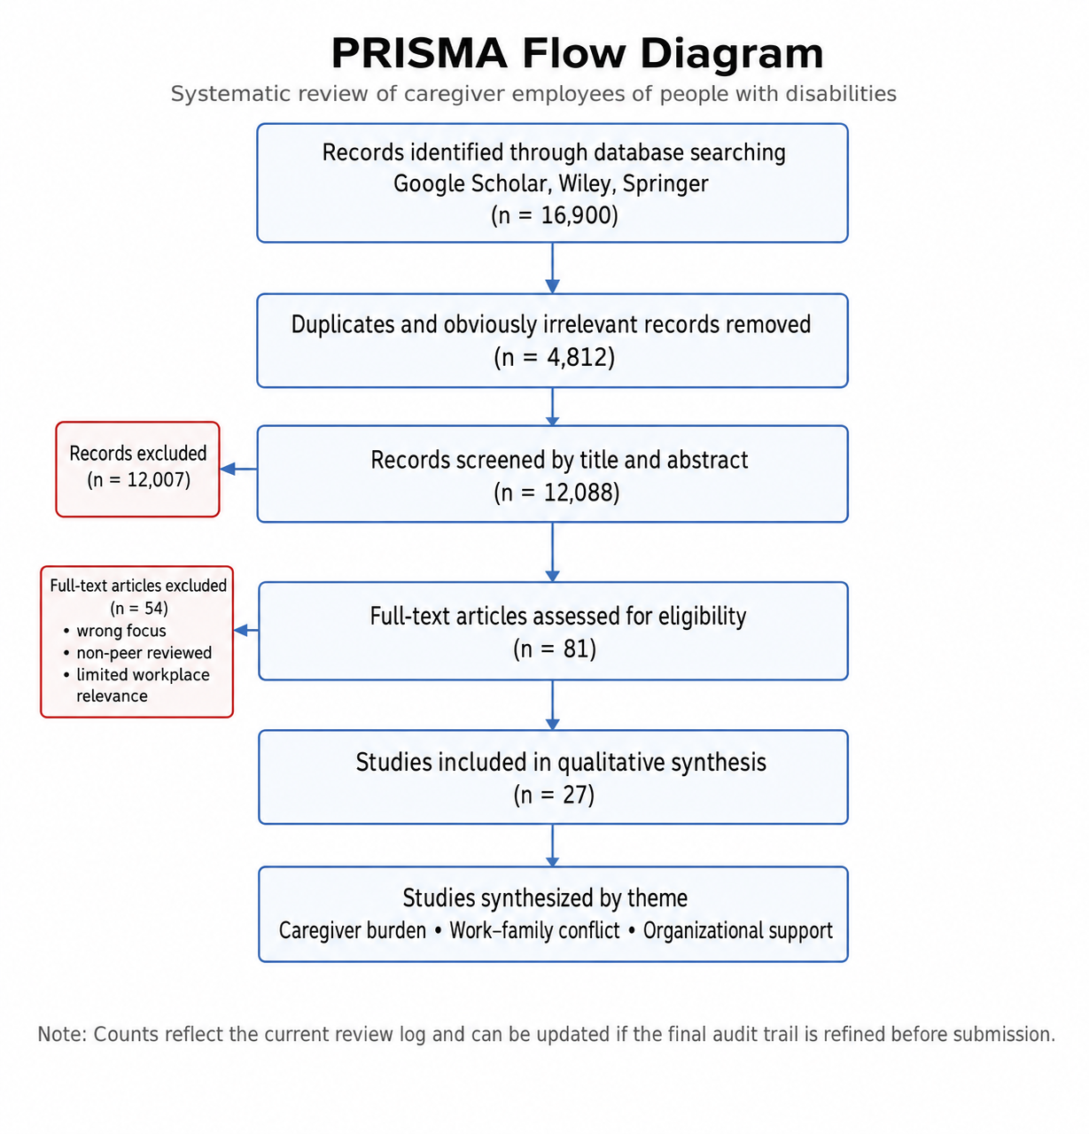
Figure 1. PRISMA flow diagram for the review process.

RESULTS AND DISCUSSION
The systematic review identified 27 studies that examined various aspects of caregiver employees of people with disabilities. The selected studies consisted of quantitative, qualitative, review, and conceptual research designs conducted across different countries and employment settings. Three dominant themes emerged from the analysis: caregiver burden, work–family conflict, and organizational support. These themes collectively explain the employment experiences and work-related outcomes of caregiver employees.
To provide an overview of the evidence base included in this review, Table 1 summarises the key characteristics, methodologies, and contributions of the selected studies. The table demonstrates the diversity of research designs and contexts represented in the literature while highlighting the recurring themes of caregiver burden, work–family conflict, and organizational support.
Table 1. Summary of reviewed studies
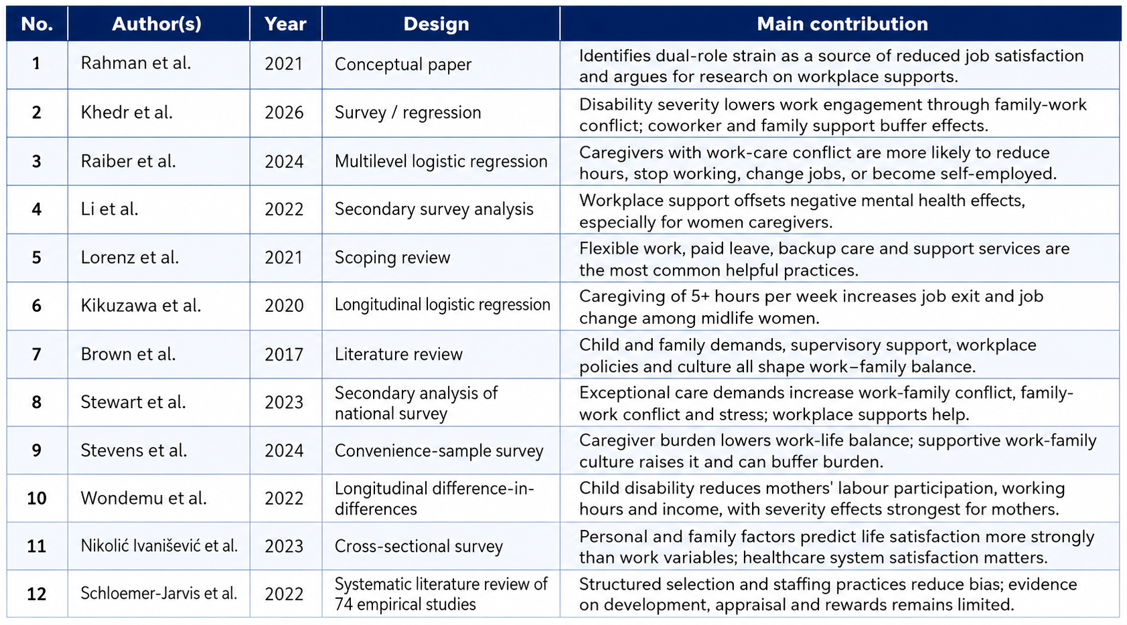
A. Caregiver Burden
These findings are consistent with previous studies which reported that caregivers frequently experience emotional exhaustion, psychological distress, financial strain, and reduced quality of life due to caregiving responsibilities [6, 14, 16, 24, 25].
Caregiver burden emerged as the most frequently discussed theme across the reviewed studies. The findings indicate that caregiver employees experience substantial emotional, physical, financial, and psychological demands resulting from their caregiving responsibilities. Caregivers often provide continuous support, supervision, transportation, healthcare management, and daily living assistance to people with disabilities, which requires significant time and energy commitments.
The reviewed studies consistently reported that prolonged caregiving responsibilities contribute to increased stress, emotional exhaustion, fatigue, and reduced psychological well-being. Financial burden was also identified as a significant concern, particularly among caregivers who face additional healthcare expenses or reduced earning opportunities due to caregiving obligations. These findings suggest that caregiver burden directly influences employees' ability to maintain work performance and sustain long-term career development.
The findings are consistent with the caregiving literature, which emphasizes that prolonged caregiving demands may negatively affect both personal well-being and employment outcomes. Employees experiencing high levels of caregiver burden are more likely to encounter difficulties balancing work and family responsibilities, resulting in decreased job satisfaction and increased intentions to reduce working hours or leave employment. Similar findings were reported by Ghazawy et al. [6], Niu et al. [16], and Uhm et al. [24], who found that increasing caregiving demands were associated with poorer mental health, reduced well-being, and lower employment sustainability.
B. Work–Family Conflict
Work–family conflict was identified as a central mechanism through which caregiving responsibilities influence employment outcomes. The reviewed studies indicate that caregiver employees frequently experience competing demands between workplace obligations and caregiving responsibilities. This conflict often occurs when caregiving activities interfere with work schedules, job performance, or career advancement opportunities. Previous studies have consistently identified work–family conflict as a major challenge among employed caregivers, particularly those caring for children or family members with disabilities [3, 18, 21, 22].
Several studies reported that caregiver employees experience increased absenteeism, presenteeism, reduced productivity, and higher levels of occupational stress. Work–family conflict was also associated with lower job satisfaction, reduced work engagement, and increased turnover intentions. Employees often face difficulties attending work-related meetings, training programmes, or career development opportunities due to caregiving commitments. These outcomes are consistent with the findings of Brown and Clark [3], Stewart et al. [22], and Stevens et al. [21], who reported significant associations between caregiving responsibilities, work–family conflict, and adverse employment outcomes.
The findings support previous research suggesting that work–family conflict acts as an intermediary factor linking caregiver burden to negative employment outcomes. As caregiving responsibilities increase, employees are more likely to experience role conflict, resulting in adverse effects on both organizational performance and individual well-being.
C. Organizational Support
Organizational support emerged as a critical protective factor that helps caregiver employees manage caregiving and employment responsibilities. The reviewed studies consistently highlighted the importance of flexible work arrangements, supportive supervisors, family-friendly workplace policies, employee assistance programmes, and positive organizational cultures. Organizational support has been widely recognized as an effective mechanism for reducing work–family conflict and improving employee well-being among caregiver employees [10, 11, 20].
Employees who perceived higher levels of organizational support reported lower levels of work–family conflict, greater job satisfaction, stronger work engagement, and improved psychological well-being. Flexible working hours, remote working arrangements, caregiving leave, and understanding supervisors were identified as effective mechanisms for reducing the pressures associated with caregiving responsibilities. Similar findings were reported by Li et al. [10] and Lorenz et al. [11], who found that workplace flexibility, supportive supervisors, and caregiver-friendly policies contributed to better mental health and work outcomes among employed caregivers
From an organizational perspective, supportive workplace practices contribute not only to employee well-being but also to employee retention, productivity, and organizational commitment. These findings suggest that organizations play a significant role in creating sustainable employment environments for caregiver employees.
D. Synthesis of Findings and Proposed Conceptual Model
The findings from the reviewed studies indicate that caregiver burden, work–family conflict, and organizational support are closely interconnected in shaping the employment experiences of caregiver employees of people with disabilities. Caregiver burden emerged as the primary antecedent influencing employees’ psychological well-being, work performance, and career sustainability. As caregiving demands increase, employees are more likely to experience work–family conflict due to competing responsibilities between work and caregiving roles.The relationships identified in this review are supported by previous studies examining caregiver burden, work–family conflict, and workplace support among caregiver employees [3, 10, 11, 18, 21].
The review further demonstrates that work–family conflict acts as a mediating mechanism through which caregiver burden affects employment outcomes, including job satisfaction, work engagement, absenteeism, turnover intention, and overall well-being. Employees experiencing high levels of work–family conflict often report greater stress, lower productivity, and reduced career progression opportunities.
Organizational support was consistently identified as a protective factor that helps mitigate the negative effects of caregiver burden and work–family conflict. Supportive workplace practices such as flexible work arrangements, supervisor support, employee assistance programmes, and caregiver-friendly human resource policies enable employees to better balance caregiving and work responsibilities.
Based on the synthesis of the reviewed studies, a conceptual model is proposed to illustrate the relationships among caregiver burden, work–family conflict, organizational support, and employment outcomes among caregiver employees of people with disabilities.
The synthesis of the reviewed studies suggests that caregiver burden should not be viewed solely as an individual or family issue but also as a workplace and organizational concern. Organizations that recognize the challenges faced by caregiver employees and implement supportive policies are more likely to enhance employee well-being, retention, and productivity. Consequently, caregiver-supportive practices represent an important component of sustainable human resource management and inclusive workplace development.

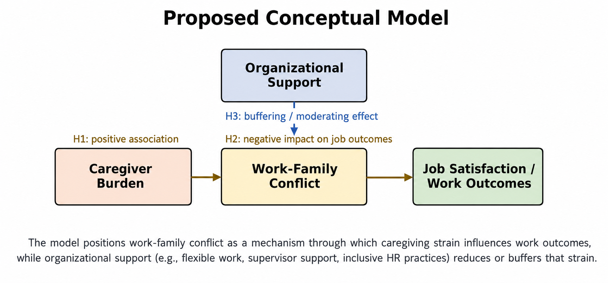
Figure 2. Proposed conceptual model derived from the review synthesis.

CONCLUSION
This systematic literature review examined the employment experiences of caregiver employees of people with disabilities by synthesizing evidence relating to caregiver burden, work–family conflict, and organizational support. The review identified caregiver burden as the most dominant challenge faced by caregiver employees, affecting their emotional well-being, financial stability, work performance, and overall quality of life. The findings further revealed that work–family conflict serves as the primary mechanism through which caregiving responsibilities influence employment outcomes, including job satisfaction, work engagement, and employment sustainability.
The review also demonstrated that organizational support plays a critical role in mitigating the negative effects of caregiving responsibilities. Supportive workplace practices such as flexible work arrangements, family-friendly policies, supervisor support, and inclusive organizational cultures were consistently associated with improved employee well-being and positive work outcomes. These findings highlight the importance of developing caregiver-supportive workplaces that enable employees to balance caregiving responsibilities while maintaining productive and sustainable careers.
The proposed conceptual framework contributes to the human resource management and disability inclusion literature by integrating caregiver burden, work–family conflict, and organizational support within a single explanatory model. The framework provides a foundation for future empirical research examining the relationships among these constructs and their impact on employment outcomes.
From a practical perspective, organizations should view caregiver-friendly workplace initiatives as strategic investments rather than discretionary accommodations. Such initiatives can enhance employee retention, engagement, productivity, and organizational commitment while supporting workforce sustainability. Furthermore, the findings contribute to Sustainable Development Goal 8 (Decent Work and Economic Growth) by emphasizing the need for inclusive employment practices that support caregiver employees.
Future research should adopt longitudinal and mixed-method approaches to examine the evolving nature of caregiving responsibilities and explore how organizational support mechanisms operate across different industries, cultural contexts, and labour market environments. Such efforts will contribute to a deeper understanding of caregiver employees and inform the development of more effective workplace policies and interventions.
ACKNOWLEDGEMENT
The authors would like to acknowledge the support provided by INTI International University and UNITAR International University in facilitating this research.
ETHICAL CONSIDERATION
This study adopted a Systematic Literature Review (SLR) approach and utilized secondary data obtained from publicly available published literature. The study did not involve human participants, animals, personal data, interviews, surveys, or experimental procedures. Therefore, ethical approval was not required. All sources used in this review were appropriately acknowledged and cited to ensure academic integrity and compliance with ethical research practices.
CONFLICT OF INTEREST
The authors declare that there is no conflict of interest regarding the publication of this paper.
DATA AVAILABILITY STATEMENT
The data supporting the findings of this study are available from the corresponding author upon reasonable request. All sources included in this review are publicly available through the respective databases and publishers.

REFERENCES
[1] Alemu, N. E., Adeagbo, M. J., & Eshete, B. M. (2023). The risk of interpersonal violence against women with disabilities in low- and middle-income countries: A systematic literature review. International Journal of Africa Nursing Sciences, 18, 100554.
[2] Bahador, R. S., Farokhzadian, J., Nasab, F. R. S., & Abbasi, M. (2023). Experiences of family caregivers of people with intellectual disabilities from rural areas in southeastern Iran: A qualitative study. BMC Psychiatry, 23, 613.
[3] Brown, T. J., & Clark, C. (2017). Employed parents of children with disabilities and work-family life balance: A literature review. Child and Youth Care Forum, 46, 857–876.
[4] Calderwood, C., Breaux, R., ten Brummelhuis, L. L., Mitropoulos, T., & Swanson, C. S. (2022). When daily challenges become too much during COVID-19: Implications of family and work demands for work-life balance among parents of children with special needs. Journal of Occupational Health Psychology.
[5] Gardiner, C., Robinson, J., Connolly, M., Hulme, C., Kang, K., Rowland, C., Larkin, P., Meads, D., Morgan, T., & Gott, M. (2020). Equity and the financial costs of informal caregiving in palliative care: A critical debate. BMC Palliative Care, 19, 71.
[6] Ghazawy, E. R., Mohammed, E. S., Mahfouz, E. M., & Abdelrehim, M. G. (2020). Determinants of caregiver burden of persons with disabilities in a rural district in Egypt. BMC Public Health, 20, 1156.
[7] Kehinde, P. T., Adigun, O. T., Obosu, G. K., & Mngomezulu, T. P. (2023). Determinants of state of mental health among caregivers of children with disabilities. International Journal of Mental Health Promotion, 25.
[8] Khedr, W. M. (2026). Work engagement of employees who are parents/caregivers for a disabled family member. Journal of Alexandria University for Administrative Sciences, 63(2), 325–369.
[9] Kikuzawa, S., & Uemura, R. (2020). Parental caregiving and employment among midlife women in Japan. Journal of Aging and Health.
[10] Li, L., Lee, Y., & Lai, D. W. L. (2022). Mental health of employed family caregivers in Canada: A gender-based analysis on the role of workplace support. The International Journal of Aging and Human Development, 95(4), 470–492.
[11] Lorenz, F., Whittaker, L., Tazzeo, J., & Williams, A. (2021). Availability of caregiver-friendly workplace policies: An international scoping review follow-up study. International Journal of Workplace Health Management, 14(4), 459–476.
[12] Marsack-Topolewski, C. N. (2020). A snapshot of social support networks among parental caregivers of adults with autism. Journal of Autism and Developmental Disorders, 50, 1111–1122.
[13] Marsack-Topolewski, C. N., & Samuel, P. S. (2025). Experiences of parental caregivers of adults with autism in navigating the world of employment. Journal of Autism and Developmental Disorders, 55, 2733–2743.
[14] Masefield, S. C., Prady, S. L., Sheldon, T. A., Small, N., Jarvis, S., & Pickett, K. E. (2020). The caregiver health effects of caring for young children with developmental disabilities: A meta-analysis. Maternal and Child Health Journal, 24, 561–574.
[15] Nikolić Ivanišević, M., Slišković, A., Ombla, J., Tokić, A., & Brown, T. (2023). Life satisfaction in employed mothers of children with disabilities: The importance of personal, family, work, and society characteristics. Societies, 13, 177.
[16] Niu, S., Ding, S., Wu, S., Ma, J., & Shi, Y. (2023). Correlations between caregiver competence, burden and health-related quality of life among Chinese family caregivers of elderly adults with disabilities. BMJ Open, 13, e067296.
[17] Palagyi, A., Sengupta, A., Moorthy, M., Malik, C., Barratt, J., Devuyst, O., Ulasi, I. I., Gale, D. P., Wang, S., Angell, B., Jha, V., & Jan, S. (2025). Systematic scoping review of socioeconomic burden and associated psychosocial impact in patients with rare kidney diseases and their caregivers. Kidney International Reports, 10, 838–854.
[18] Rahman, S. Y. A., Wahat, N. W. A., Rasdi, R. M., Rahim, N. A. A., Sabri, M. F., & Abu Samah, B. (2021). Caregivers of people with disability at the workplace and how job satisfaction is affected? International Journal of Academic Research in Business and Social Sciences, 11(11).
[19] Raiber, K., Visser, M., & Verbakel, E. (2024). Strategies of informal caregivers to adapt paid work. European Societies, 26(1), 63–90.
[20] Schloemer-Jarvis, A., Bader, B., & Böhm, S. A. (2022). The role of human resource practices for including persons with disabilities in the workforce: A systematic literature review. The International Journal of Human Resource Management, 33(1), 45–98.
[21] Stevens, E. K., Aziz, S., Wuensch, K. L., & Walcott, C. (2024). Caregivers of children with special healthcare needs: A quantitative examination of work-family culture, caregiver burden, and work-life balance. Journal of Child and Family Studies, 33, 1365–1377.
[22] Stewart, L. M., Sellmaier, C., Brannan, A. M., & Brennan, E. M. (2023). Employed parents of children with typical and exceptional care responsibilities: Family demands and workplace supports. Journal of Child and Family Studies, 32, 1048–1064.
[23] Tokić, A., Slišković, A., & Nikolić Ivanišević, M. (2023). Well-being of parents of children with disabilities—Does employment status matter? Social Sciences, 12, 463.
[24] Uhm, K. E., Jung, H., Woo, M. W., Kwon, H. E., Oh-Park, M., Lee, B. R., Kim, E. J., Kim, J. H., Lee, S. A., & Lee, J. (2023). Influence of preparedness on caregiver burden, depression, and quality of life in caregivers of people with disabilities. Frontiers in Public Health, 11, 1153588.
[25] Vadivelan, K., Sekar, P., Shri Sruthi, S., & Gopichandran, V. (2020). Burden of caregivers of children with cerebral palsy: An intersectional analysis of gender, poverty, stigma, and public policy. BMC Public Health, 20, 645.
[26] Vasudevan, A., Salim, I., Mohammad, S. I., Wenchang, C., Krishnasamy, H. N., Parahakaran, S., & Alshurideh, M. T. (2025). Sustainable leadership and employee performance: The role of organizational culture in Malaysia’s information science sector. Applied Mathematics, 19(1), 101–113.
[27] Wagle, S., Yang, S., Osei, E. A., Katare, B., & Lalani, N. (2024). Caregiving intensity, duration, and subjective financial well-being among rural informal caregivers of older adults with chronic illnesses or disabilities. Healthcare, 12, 2260.
[28] Wondemu, M. Y., Joranger, P., Hermansen, Å., & Brekke, I. (2022). Impact of child disability on parental employment and labour income: A quasi-experimental study of parents of children with disabilities in Norway. BMC Public Health, 22, 1813.

