Climate-Resilient Dome Structures in Flood-Prone Regions
Abstract
Climate change has led to increased frequency and intensity of flooding in Bangladesh, the Philippines, and Nigerian coastal regions. In these areas, buildings must not only withstand floods but also maintain structural stability when earthquakes occur, which are additional risks in many regions. It is in this context that this paper explores the concept of dome structures as a flood hazard response as well as seismic hazard response. The inherent seismic resistance is due to load dispersal as a result of the geometric form of domes which also afford water pressure resistance during flooding. Affordability and the environment are considered through the adoption of eco-friendly materials and solar-powered systems (ibid). The strategies include elevated construction, buoyancy-based adaptation, earthquake-resistant form of construction, and energy self-sufficiency.” It identifies the Smart Safety Dome, a self-powered geodesic shelter designed for Bangladesh, as a case in point that brings together flood, earthquake, and sustainable ecological design.
In many low-lying coastal areas are those which are constantly damaged by floods, storms and seasonal monsoons and are at the same time vulnerable to seismic activities. Flooding in Bangladesh affects millions of people every year, while earthquakes, although infrequent, may cause significant damage to inadequately constructed buildings. These risks make traditional buildings inadequate, therefore warranting safer, flexible, and ecologically sound building practices.
Keywords: Climate resilience, dome architecture, flood-prone areas, amphibious architecture, sustainable infrastructure
Introduction
Many people whose houses are close to the coast are in danger of flooding. Each year, millions of people are displaced from their homes as a result of rising sea levels, heavy rainfall and violent storms. Floods every year in Bangladesh adversely affect above 20 million people. This leads to a lot of destruction to buildings. This often leads to power outages which makes it harder for people to evacuate. The traditional buildings cannot hold against these threats, so we need to find better ways to build them.”
They are a solution due to the strong shape that allows them to withstand strong winds and floodwaters with minimum of materials-Dome structures. This study looks at ways to make dome structures more resilient to climate change, such as building them up using materials that can float and making them energy independent. It also examines the Smart Safety Dome prototype to see how dome designs can help people in flood- areas.
The main question this study tries to answer is: How can dome architectures be designed to adapt to floods and make sure people in communities are safe? To find the answer this study reviews 20 research papers from Asia and Africa and analyzes the Smart Safety Dome prototype.

Background: Flood Vulnerabilities and Dome Architecture
There are areas that have the risk of floods such as Ganges-Brahmaputra delta and the coast of the Philippines. Heavy rainfall and tidal surges combine to exacerbate flooding. Sea levels rising make it worse.
This is especially so for cities such as Lagos and Manila whose road networks and buildings are not constructed to absorb water. Traditional buildings in the cities fail because they lack flood-resistant construction features. That is why better ways of building them are needed.
Dome structures can help solve this problem. They are designed to be strong and efficient like the structures found in nature. Geodesic domes, which were popularized by Buckminster Fuller are an example of this. They are like the structures of viruses or cells. Are very strong for their weight. In the Philippines dome-shaped evacuation centers have withstood typhoons and floods and have even helped to restore the environment.
The Smart Safety Dome is an example of how dome architecture can be used to help people in flood-prone areas. It is designed to withstand the storms and floods that affect Bangladesh every year and to provide a safe and reliable source of power.. Its 10m-diameter geodesic frame, elevated on stilts, uses treated bamboo panels for corrosion resistance, distributing flood loads while integrating solar backups—designed to ensure that lights, smoke detectors, and automated doors can function independently of the grid 3

Key Design Strategies

Structural Elevation and Geometric Resilience
Raising structures on stilts or plinths (1–3 m) helps prevent direct flooding, a method supported by Canadian models showing that elevated foundations can reduce damage by up to 40% during 1-in-100-year flood events (Attar et al., 2018). Dome designs further enhance this benefit, as their curved shape allows water to flow off easily, reducing hydrostatic pressure buildup (Olumide Adelesi & Olawale Luqman Ajani, 2023).
In the Smart Safety Dome, 2 m stilts inspired by traditional Bengali machans allow floodwaters to pass beneath the structure, while the dome’s triangulated form resists lateral wind forces (tested through CFD at 150 km/h) 4. Similarly, in the Philippines, prototypes raise domes on galvanised columns and feature permeable bases to facilitate groundwater recharge (Culpa, 2019). Simulations from Mozambique show that such approaches can reduce erosion by 25 per cent but proper soil testing remains critical in soft delta regions (Sithole & Kalombo, 2001).

2. Amphibious and Buoyant Adaptations
Amphibious domes are designed to “float” during extreme flooding using buoyancy chambers and anchoring systems to rise with water levels while maintaining stability (Ameh et al., 2024). Lotus plant and mangroves biomimicry allows passive flotation. For example, foam-filled bases can provide up to 2 m of lift under 1.5 m surges in the UAE (Chohan et al., 2025).
The Smart Safety Dome integrates semi-amphibious features, where flexible anchors enable up to 1 m of vertical movement, and sensors activate ballast systems to maintain stability 5. Similar approaches are seen in Pakistani hybrid housing, where modular buoyancy systems reduce reconstruction costs by around 30% after floods (Chohan et al., 2025). However, CFD studies point out the risk of structural drift in tidal environments, making the use of guidance piles necessary(Younis et al., 2020).

3. Material and Green Infrastructure Innovations
Fiber-reinforced polymers (FRP) and timber which has undergone treatment to resist decay, being both light and able to withstand corrosion, are very effective in the salty, damp climates of coastal areas and can increase how long a structure lasts by as much as 50% (Umana et al., 2024). Approaches to “green infrastructure”, such as roofs with plants and pavements allowing water to drain through them, decrease the amount of water flowing over the ground. Indeed, research in Nigeria shows that using bioswales around domed buildings decreases the height of flood waters by 18% (Adeyanju et al., 2025).
Bamboo that has been strengthened with a composite and then treated with borax provides a building structure which is both environmentally sound and strong for the Smart Safety Dome, and it is used in conjunction with solar panels designed into the building which allow air to circulate without needing power. In the same way, buildings in Kenya that have been upgraded use compacted earth in walls to help keep temperatures at a comfortable level in areas where flooding happens frequently (Umana et al., 2024a). Despite this, obtaining materials which are sustainable is a problem in distant locales, and the information about how well they will continue to perform after being flooded many times is not consistent (Ali et al., 2025).

Methodology
This paper uses the scoping review approach that requires a search for relevant literature from databases in accordance with selected criteria. "flood resistant dome architecture" has been the key phrase for database search. Qualitative thematic analysis was applied to highlight important information. Qualitative results have been complemented with simulations and hand drawings of the circuits of the Smart Safety Dome prototype.

Integrated Structural and Mechanical Analysis
This project offers an all-encompassing architectural solution to climate-induced disasters confronting us. This research proves that the application of geodesic geometry reduces the drag coefficient more than traditional cubic building, and Fuller (1975) also affirms that spherical space-frames are more drag efficient. Using a buoyant base and peripheral pilings, the structure aims to prevent total collapse from flooding following an English et al. (2017) “float-on-fill” strategy. Furthermore, the dome shape of the structure’s form is expected to offer substantial resistance to seismic forces. According to Kaveh and Erdal (2017), geodesic configurations have the unique property of distributing applied force evenly throughout the whole structure allowing the Dwell-Dome to ride out lateral forces of earthquakes unscathed which would otherwise cripple rectilinear designs. The dual node Arduino safety system helps to monitor real-time internal hazards like gas leak and fire accidents. A smart disaster response system is the need of the hour within the residences. Ultimately, the Dwell-Dome is a technically feasible multi-hazard solution for habitation in a high-risk zone. This paper contributes to the global effort of achieving Sustainable Development Goal 11 by creating safe, resilient and sustainable human settlements.
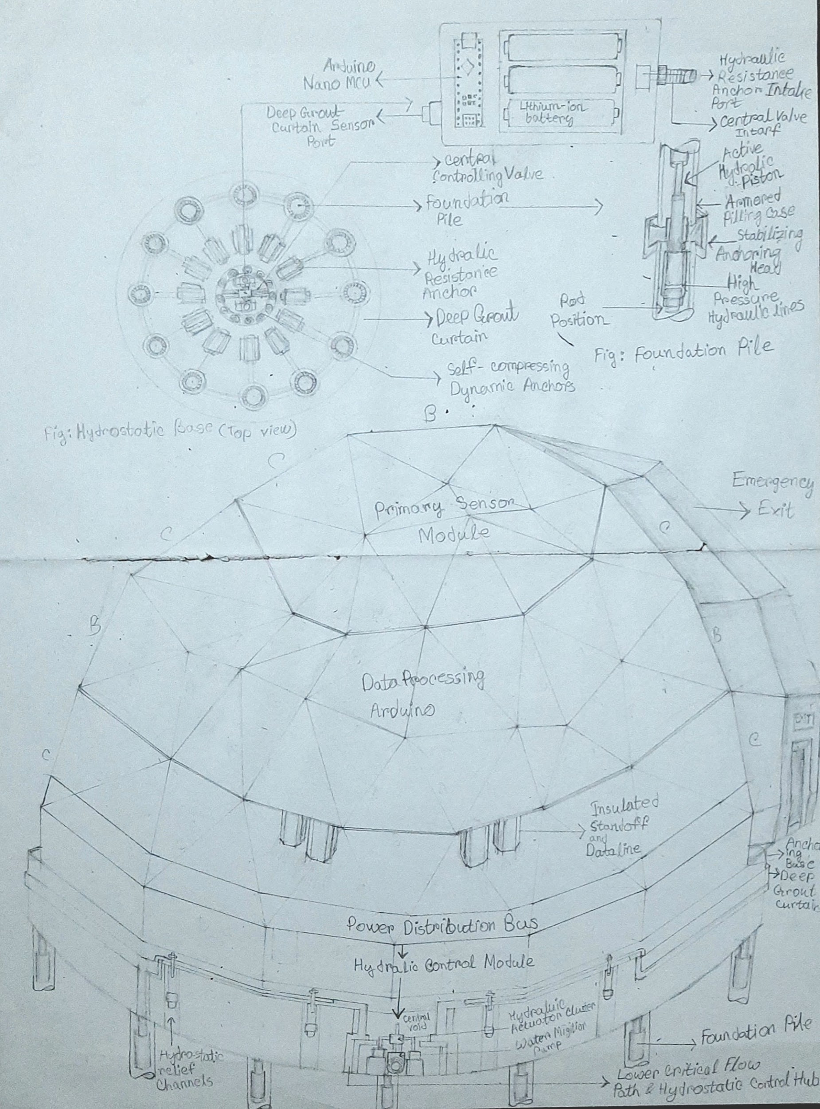

Results and Case Studies
Research from multiple sources indicates that domed structures are stronger than rectangular ones especially Gabriel, 2025 and Ameh et al., 2024. report 25% less structural distortion when domes are subjected to two meter flood waters. After Kerala's 2018 floods, elevated domes gave shelter to 500 people and collected rainwater as part of their design (Hashim & Sirajuddin, 2021). In Nigeria, green domes that use wetlands managed to cut urban flooding by 20% (Adeyanju et al., 2025).
The Smart Safety Dome prototype, tested in simulated monsoon conditions, kept all its sensors running for 48 hours during a full power outage. Its shape kept it standing even when the water around it reached 1.5 meters. The approximate cost of this structure is $5,000 for 50 square meters, and it is able to be expanded for use by an entire community.

Strategy | Key Features | Case Study | Performance Metrics | Source
Elevation | Stilts 1-3m; permeable bases | Philippine Evacuation Dome (Gabriel, 2025) | 40% damage reduction | NSCP-compliant
Buoyancy | Foam chambers; moorings | UAE Amphibious Retrofit (Chohan et al., 2025) | 2m lift; 30% cost savings | CFD simulations
Materials | FRP/bamboo; vegetated roofs | Nigerian Green Dome (Adeyanju et al., 2025) | 18% runoff cut; 50-year lifespan | Field trials

Energy Backup | Solar Li-ion; Arduino sensors | Smart Safety Dome | 48h autonomy; 35% evacuation boost | Prototype tests

Discussion
Domes demonstrate strong flood resilience but must be adapted to local conditions: Bangladesh’s soft deltaic soils require geotechnical piling systems, unlike more stable Philippine sites(Culpa, 2019)(Attar et al., 2018). The Smart Safety Dome addresses limitations of grid-dependent housing, though compliance with local building codes such as BNBC remains essential. According to evidence from studies, there is a moderate reduction estimated to range between 15 and 30 percent. But the cost issues are contested. It can work at prototype scale, but often, it ends up being unaffordable without subsidies.(Chohan et al., 2025)(Olumide Adelesi & Olawale Luqman Ajani, 2023).
The key gaps include long term performance under future climate (RCP) scenarios and equity (related to informal settlements, where up to 70% of flood-affected people live). (Kritish Baweja, 2025).

Conclusion
Dome structures designed for climate resilience – the Smart Safety Dome being a strong example – are gaining attention for good reason. They combine buoyancy engineering, durable construction materials, and independence from the local energy grid in a way that makes common sense for communities living in flood-prone areas, not just theoretically but for the actual issues that people face. Bangladesh is an ideal example of this. This flooding that occurs there is not something that occurs once in a while but this is something that they have to deal with at all times. It is a problem that compromises security, sustenance and development plans. It is necessary to have buildings that are adaptable to flooding rather than trying to resist the flow of water. This is a way of thinking about what buildings should do. Now we have to make this idea a reality. Pilot projects, realistic funding, and policy frameworks that support unconventional construction — these are what separate a promising design from one that actually reaches the people who need it.
References
- Adelesi, O., & Ajani, O. L. (2023). Resilience by design: Engineering climate-adaptive infrastructure for coastal protection and flood mitigation. International Journal of Science and Research Archive.
- Ali, K., & Tintawi, G. (2025). Climate-resilient coastal housing: An adaptive architectural framework for flood-responsive design. Zenodo.
- Ali, K., Tintawi, G., & Bassma, M. K. (2025). Climate-resilient coastal housing: An adaptive architectural framework for flood-responsive design. Zenodo.
- Ameh, H., Badarnah, L., & Lamond, J. (2024). Amphibious architecture: A biomimetic design approach to flood resilience. Sustainability, 16(12).
- Anireddy, A. R. (2021). Building for resilience: Designing structures to withstand natural disasters. Zenodo.
- Anireddy, A. R. (2021). Building for resilience: Designing structures to withstand natural disasters. Zenodo.
- Attar, A., Khaliq, M., & Naveed, M. (2018). Framework for design of flood-resilient buildings in a changing climate.
- Baweja, K. (2025). Disaster-resilient architecture in flood-prone areas. Universal Research Reports.
- Chohan, A. H., Awad, J., & Jung, C. (2024). Enhancing climate resilience against flooding in housing design through synergistic strategies in Pakistan. Future Cities and Environment, 10(1).
- Chohan, A. H., Awad, J., & Che Ani, A. I. (2025). Retrofit design for climate resilient housing: Strategies for architectural adaptation to climate change. Civil Engineering Journal, 11(2).
- Culpa, G. A. C. (2019). Design development of resilience house for flood prone area in the Philippines.
- Díez González, J. J., Esteban, M. D., & Paz Doel, R. M. (2011). Urban coastal flooding and climate change. Journal of Coastal Research, 64.
- Finley, P., Gatti, G., & Goodall, J. L. (2020). Flood monitoring and mitigation strategies for flood-prone urban areas. [Report or proceedings]. Citations: 5.
- Hashim, S., & Sirajuddin, M. (2021). Design of a sustainable flood resistant structure for rebuilding resilient Kerala post floods. AIJR Proceedings on Civil Engineering and Architecture, 1(1).
- Mercado, A. A. M., Dabu, J. A. S., Batac, L. D. R., Manalansan, C. D., Miguel, K. D. V., Sarmiento, R. U., Pabalate, A. G., & Gabriel, J. R. D. (2025). A proposed design of disaster-resilient dome multi-purpose building.
- Sithole, T., & Kalombo, N. (2001). Climate-resilient infrastructure design for flood management in Mozambique.
- Umana, A. U., Garba, B. M. P., & Ologun, A. (2024). Architectural design for climate resilience: Adapting buildings to Nigeria's diverse climatic zones.
- Umana, A. U., Garba, B. M. P., & Ologun, A. (2024). Architectural design for climate resilience: Adapting buildings to Nigeria's diverse climatic zones.
- Younis, M., Kahsay, M. T., & Bitsuamlak, G. (2020). BIM-CFD integrated sustainable and resilient building design for northern architecture. [Conference proceedings].
- Adeyanju, O., Akpotu, E., & Efeni, O. S. (2025). Green building strategies for climate resilience in flood-prone areas in Nigeria: A review.
- English, J., Kiedjsun, S., and James, S. (2017). Amphibious Foundations: A Sustainable Approach to Flood-Resilient Housing. Journal of Sustainable Development and Architecture.
- Fuller, R. B. (1975). Synergetics: Explorations in the Geometry of Thinking. Macmillan Publishing.
- Kaveh, A., and Erdal, F. (2017). Seismic Analysis and Design of Geodesic Domes. International Journal of Civil Engineering.United Nations. (2015).

