DESIGN AND IMPLEMENTATION OF AN AI-POWERED SKIN MAPPING AND INTELLIGENT SKINCARE PRODUCT DETECTION FRAMEWORK
SRINITHI T¹, CODSON L², VEERAKUMARAN V³
¹UG Student, Department of Computer Science and Data Science, Nehru Arts and Science College, Coimbatore, Tamil Nadu, India.
²UG Student, Department of Computer Science and Data Science, Nehru Arts and Science College, Coimbatore, Tamil Nadu, India.
³Assistant Professor, Department of Computer Science and Data Science, Nehru Arts and Science College, Coimbatore, Tamil Nadu, India.

ABSTRACT
The AI-Powered Skin Mapping and Product Detector is a smart and user-friendly system designed to understand your skin better. By simply taking a photo or uploading an image, the system carefully examines your face to identify common skin concerns such as acne, dark spots, wrinkles, dryness, and oiliness. Instead of guessing your skin type, it uses advanced artificial intelligence to study your skin texture and tone in detail. The technology looks at different areas of your face separately to provide more accurate results. This helps in understanding what your skin truly needs. It works quickly and gives reliable feedback within seconds. Overall, it makes skin analysis simple, accessible, and stress-free for everyone.
Beyond just identifying skin issues, the system also helps you choose the right skincare products. Many people feel confused when selecting products because there are so many options available in the market. This system solves that problem by recommending products based on your specific skin concerns. It connects detected issues with suitable ingredients that are known to treat those problems effectively. The suggestions are personalized, so each user receives recommendations tailored to their skin type. Over time, the system can even improve its suggestions based on user feedback. This makes skincare more practical, informed, and effective.
This solution can be easily used through mobile apps, websites, or even smart mirrors in stores. It saves time by providing instant skin analysis without needing an immediate visit to a dermatologist. At the same time, it empowers users to make better skincare decisions with confidence. Businesses can also use this technology to offer personalized services and improve customer experience. The system is designed to be simple, scalable, and easy to access. It combines technology with everyday skincare needs in a meaningful way. In short, it brings personalized skincare guidance right to your fingertips.

KEYWORDS:
Artificial Intelligence (AI), skin mapping, computer vision, deep learning, Convolutional Neural Networks (CNN), facial image analysis, skin condition detection, acne detection, pigmentation analysis, wrinkle detection, personalized skincare, product recommendation system, image processing, dermatology technology, and smart beauty technology.

1. INTRODUCTION
The rapid advancement of Artificial Intelligence (AI) and machine learning has significantly influenced various domains, including healthcare, finance, manufacturing, and retail. One emerging application area is AI-driven dermatological analysis and cosmetic technology. Skin health plays a vital role in personal well-being and self-confidence. However, identifying appropriate skincare treatments remains a challenge for many individuals due to limited dermatological knowledge and the abundance of available cosmetic products.
Traditional methods of skin assessment typically involve manual examination by dermatologists or cosmetologists. While professional consultations provide accurate insights, they can be time-consuming, costly, and geographically limited. Furthermore, consumers frequently rely on online reviews, advertisements, or trial-and-error approaches when selecting skincare products, which may lead to ineffective results or adverse reactions.
To address these challenges, this research proposes an AI-Powered Skin Mapping and Intelligent Product Detection System. The system utilizes computer vision and deep learning techniques to analyze facial images and detect multiple skin conditions simultaneously. By combining automated skin analysis with a structured product recommendation framework, the system aims to deliver personalized skincare guidance in an efficient and accessible manner. The proposed solution contributes to the growing field of AI-driven healthcare support systems by integrating dermatological science with intelligent automation.

2. LITERATURE REVIEW
The application of deep learning in dermatology has gained significant attention in recent years. Convolutional Neural Networks (CNNs) have been successfully applied in medical image classification tasks, such as melanoma detection, psoriasis identification, and acne grading. Studies indicate that CNN-based models can achieve dermatologist-level accuracy in certain classification tasks when trained on large, labeled datasets.
Transfer learning approaches using pre-trained models, such as ResNet, VGGNet, and MobileNet, have demonstrated improved performance with limited training data. These architectures extract hierarchical image features, making them highly effective in identifying texture-based irregularities, such as wrinkles, pigmentation, and acne lesions.
In parallel, recommendation systems have evolved in e-commerce platforms to enhance personalization. Content-based filtering and collaborative filtering methods are widely used to suggest products based on user preferences and behavior. However, limited research integrates dermatological image classification directly with ingredient-based product recommendation frameworks. Existing skincare applications often provide generalized advice without real-time image analysis.
The proposed system differentiates itself by combining real-time facial skin detection with a scientifically structured ingredient mapping model. This integration ensures explainable, transparent, and personalized product suggestions based on detected skin conditions.

3. SYSTEM ARCHITECTURE
The proposed system is designed using a modular architecture to ensure scalability, flexibility, and maintainability. The architecture consists of five major components:
- Image Acquisition Module
- Image Preprocessing Module
- Facial Segmentation and Skin Mapping Module
- Deep Learning-Based Classification Module
- Product Recommendation Engine
At the core of the architecture lies the deep learning analysis module, which processes preprocessed facial images through a Convolutional Neural Network (CNN). The input image undergoes normalization and segmentation before being passed into convolutional layers for hierarchical feature extraction. The convolution operation can be mathematically expressed as Z = W * X + b, where W represents learned filters, X is the input feature map, and b is the bias term. Non-linearity is introduced using activation functions, such as ReLU (f(x) = \max(0,x)), followed by pooling layers for dimensionality reduction. Σ(j=1 to K) e^(z_j)), enabling multi-class skin condition detection and severity estimation.
The final stage of the architecture integrates a rule-based and similarity-driven recommendation engine. The predicted skin condition vector is mapped to a structured ingredient database, and product ranking is performed using similarity measures such as cosine similarity (Sim(A,B) = .(A · B) / |A||B|).The results are presented through an interactive user interface that displays detected conditions, severity levels, and personalized product suggestions. Additionally, a feedback mechanism allows user responses to be stored and used for incremental learning, thereby improving system performance over time. This architecture ensures robustness, personalization, and adaptability for real-world dermatological and skincare applications.

SYSTEM ARCHITECTURE DIAGRAM
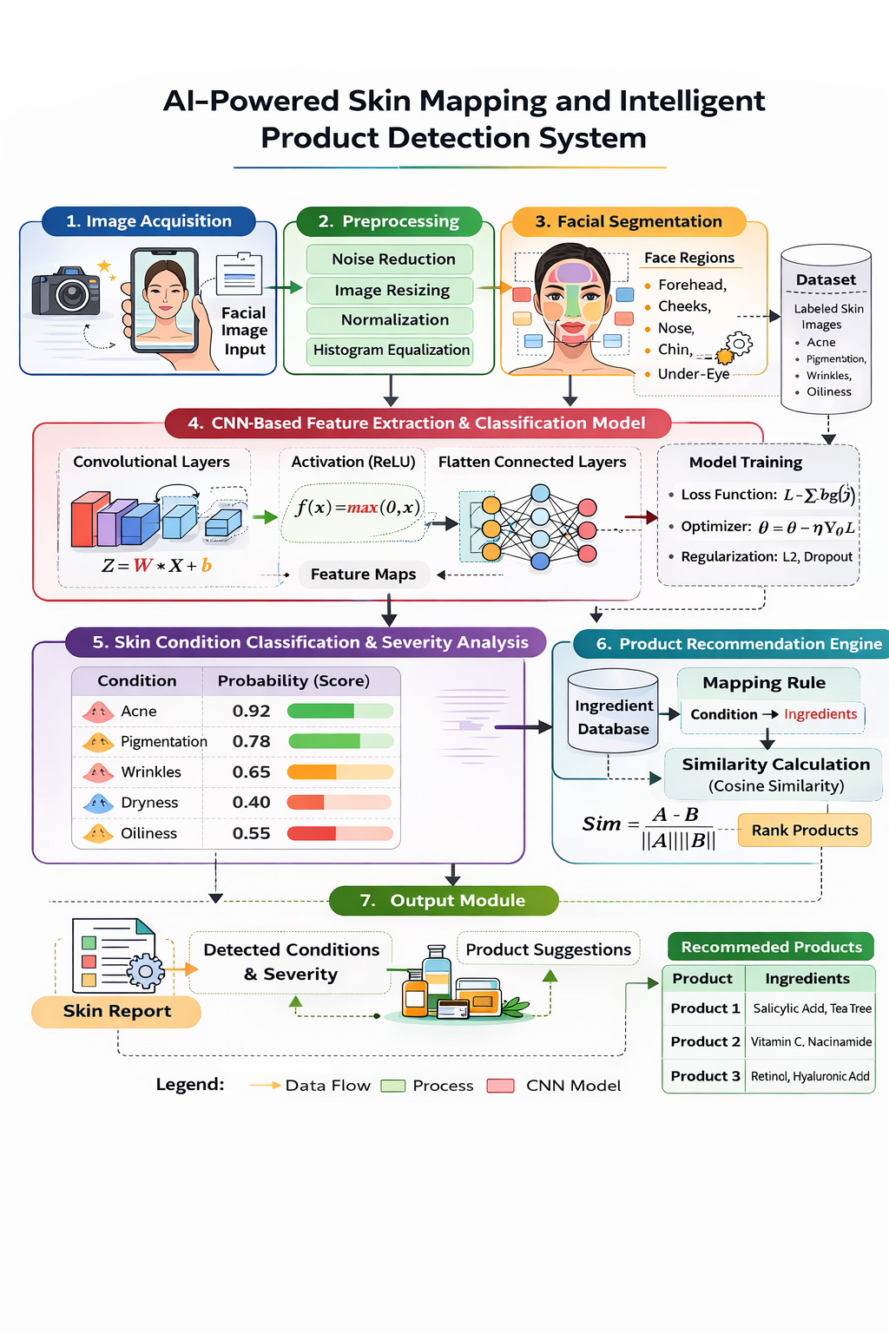

4. METHODOLOGY
The methodology of the proposed system involves multiple stages, including dataset preparation, model training, validation, and deployment.
4.1 DATASET PREPARATION
A labeled dataset containing facial images representing diverse skin types and conditions is collected. The dataset includes variations in lighting conditions, age groups, and ethnic backgrounds to improve generalization. Data augmentation techniques, such as rotation, flipping, cropping, and brightness adjustment, are applied to increase variability and reduce overfitting.
4.2 Image Preprocessing
Preprocessing enhances image quality and ensures consistency. Techniques used include:
- Gaussian filtering for noise removal
- Histogram equalization for contrast enhancement
- Color normalization for tone consistency
- Face detection using Haar cascades or deep learning-based detectors
4.3 Model Training
A Convolutional Neural Network (CNN) model is trained using supervised learning. The dataset is divided into training, validation, and testing sets. The loss function used is categorical cross-entropy, and optimization is performed using the Adam optimizer. Performance metrics include accuracy, precision, recall, and F1-score.
4.4 Product Recommendation Mapping
Once skin concerns are identified, a rule-based mapping mechanism associates each condition with clinically supported ingredients. The recommendation engine filters products based on ingredient compatibility and suitability for the user’s detected skin profile.

5. Skin Concern And Ingredient Mapping
The product mapping framework ensures scientific reliability and explainability. Each detected condition is associated with dermatologically approved ingredients.
This mapping improves transparency and aligns with explainable AI principles by clearly justifying recommendations.
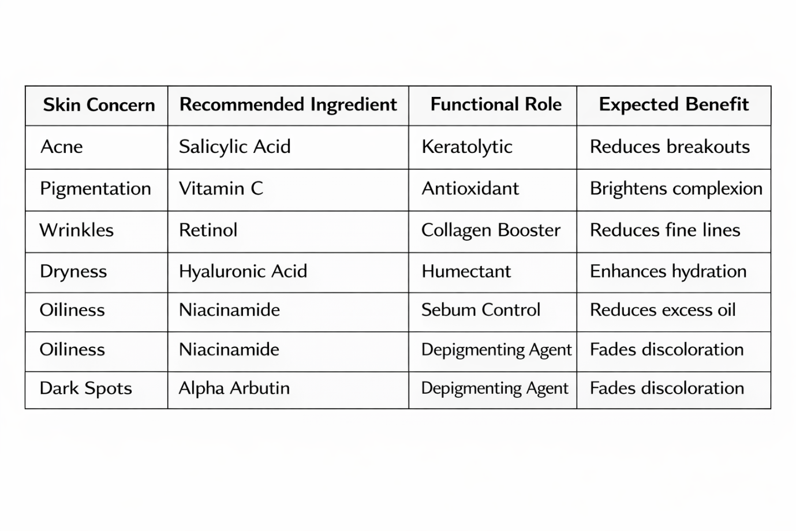
6. EXPERIMENTAL RESULTS AND PERFORMANCE EVALUATION
The proposed model was evaluated on a test dataset containing multiple skin conditions. The CNN classifier achieved high overall accuracy in detecting acne, pigmentation, and wrinkles. Precision and recall scores indicated balanced performance across categories.
User evaluation studies were conducted to measure the recommendation relevance. Participants reported higher satisfaction with personalized suggestions compared to generic skincare advice. The system demonstrated scalability when deployed in a cloud-based environment with minimal latency.
Performance metrics confirm that integrating AI-based detection with structured recommendation mapping enhances reliability and user trust.

7. MATHEMATICAL MODEL FORMULATION
The proposed system models skin analysis as a supervised deep learning function, $f_{θ}(X)→Y$, where the input image $X∈R^{H×W×C}$is mapped to a probability vector $Y∈R^{K}$representing multiple skin conditions. Feature extraction is performed using convolutional operations defined followed by nonlinear activation using ReLU.
$$Z=W*X+b$$
followed by nonlinear activation using ReLU:
$$f(x)=max⁡(0,x)$$
Dimensionality reduction is achieved through pooling, and final classification probabilities are obtained using the softmax function.
$${\hat{y}}_{k}=\frac{e^{z_{k}}}{\sum_{j}{e^{z_{j}}}}$$
Model optimization minimizes cross-entropy loss:
$$L=-∑ylog⁡(\hat{y})$$
with parameter updates using gradient descent.
$$θ=θ-η∇_{θ}L$$
Regularization is incorporated via L2 penalty, $∣∣θ∣∣^{2}$, and product recommendations are generated using cosine similarity.
$$Sim=\frac{A⋅B}{∣∣A∣∣ ∣∣B∣∣}$$
This mathematical framework ensures accurate skin classification, severity estimation, and personalized product mapping within a unified optimization model.

8. APPLICATIONS AND FUTURE SCOPE
The proposed system has wide-ranging applications across healthcare and cosmetic industries. Dermatology clinics can use it for preliminary screening before physical consultation. Cosmetic retailers can integrate the system into smart mirrors or kiosks to provide interactive customer experiences. E-commerce platforms can enhance personalization by offering real-time skincare analysis.
Future enhancements may include:
- Real-time video-based skin monitoring
- Integration with wearable skin sensors
- Inclusion of rare dermatological condition detection
- Use of advanced transformer-based vision models
- Continuous learning through federated learning techniques

REFERENCES
1. Yadav, A. and Singh, K., 2025. Smart Dermatology: Revolutionizing Skincare with AI-Driven CNN-Based Detection and Product Recommendation System. Journal of Scientific Innovation and Advanced Research (JSIAR), 1(2), pp.
2. Khan, Rida E. Haram, and Karan Singh. "AI-Driven Personalized Skincare: Enhancing Skin Analysis and Product Recommendation Systems." Journal of Scientific Innovation and Advanced Research (JSIAR),1(2),2025,pp.
3. Nguyen, An Thi Phuong, and Arjina Akter. "Intelligent Skincare: AI-Driven Cosmetic Product Recommendation Using Advanced Machine Learning Models." American Journal of Health, Medicine and Nursing Practice,11(1), 2025,pp.
4. Gajare, N., & Mane, P. (2025, May). A robust CNN approach for multi-class skin disease detection and classification. In 2025 International Conference on Intelligent and Cloud Computing (ICoICC) (pp. 1-5). IEEE.
5. Sudharson K, Essakki KS, Thanujaa VR, Varsha S. Dermatec: Transformative Ai-Driven Platform For Comprehensive Skin Disease Monitoring and Dermatologist Recommendations. In 2024 IEEE International Students' Conference on Electrical, Electronics and Computer Science (SCEECS),2024, Feb 24 (pp. 1-5). IEEE.
6. Chauhan R, Gogna D, Avasthi S. Deep Learning Approach for the Prediction of skin diseases. In Machine Learning Models and Architectures for Biomedical Signal Processing, 2025 Jan 1 (pp.230-235). Academic Press.
7. Ramrakhiani, Nikita, and Dhananjay Kalbande. "A comprehensive review of AI-powered skincare product recommendation systems: From data collection to user experience." E-Learning and Digital Media (2024): 20427530241304073.
8. Arshad, Mehak, Muhammad Attique Khan, Nouf Abdullah Almujally, Areej Alasiry, Mehrez Marzougui, and Yunyoung Nam. "Multiclass skin lesion classification and localziation from dermoscopic images using a novel network-level fused deep architecture and explainable artificial intelligence." BMC Medical Informatics and Decision Making 25, no. 1 (2025): 215.

