RESEARCH ARTICLE
Regulatory Efficacy vs. Consumer Harm: The Deterrent Effect of Sanctions

Abstract—We examine whether the USD 1 million penalty imposed by the National Communications Authority (NatCA) on Orange Sierra Leone in January 2025 and the accompanying threats of public engagement had a discernible deterrent effect on compliance with service quality. We use a primary survey of 600 respondents in seven districts (Freetown, Bo, Kenema, Makeni, Moyamba, Port Loko and Kono) and secondary regulatory and operator data (2020–2026) to draw on deterrence theory, Stiglerian regulatory capture models and incentive-regulation frameworks to assess whether Sierra Leone’s legislative architecture – namely the Telecoms Act 2006 and QoS Regulations 2020 – is structurally sound but functionally unenforced. Our results suggest (i) 71.3 % of surveyed consumers did not notice any visible improvement of service quality within three months after the fine, (ii) significant urban–rural differences still exist across all seven districts, (iii) the statistical measures align with the partial capture of regulation – the rules are mostly sufficient, but their application is selective, and (iv) the deterrent effect of the fine was significantly reduced due to the absence of transparent monitoring of post-sanction compliance. χ2=47.3, df=6, p<0.001). Chi-square analysis confirmed a significant association between fine awareness and perceived improvement. Structural correctives recommended include independent spectrum audits, binding KPI agreements and inclusion of civil society in QoS monitoring. The paper proposes a three-tier enforcement escalation model. The results are consistent with the regulatory capture theory of Laffont and Tirole (1991) and extend the security-knowledge modeling of Fofanah et al. (2021) to the regulatory compliance domain.

Index Terms—Regulatory capture, telecom sanctions, quality of service, deterrence theory, NatCA, Orange Sierra Leone, consumer protection, Chi-square analysis, West Africa, enforcement gap, knowledge modelling, ICT governance.

I. Introduction
The telecommunications industry has been hit by successive waves of regulatory reform since its liberalisation in 2006. NATCOM was established by the Telecoms Act, 2006 and was reconstituted as National Communications Authority (NatCA) through the NatCA Act, 2022 [1]. This indicates a willingness on the part of institutions to improve governance of a rapidly changing ICT environment. By the end of 2025, Sierra Leone had 8.94 million active mobile subscriptions, equal to 101% of the population, showing high penetration but also quality issues [2].
The main regulatory challenge that triggered this study was the fine of $1 million imposed on Orange Sierra Leone by the National Communications Authority (NatCA) in January 2025 following public outcry on the operator’s persistent poor services and failure to meet a compliance deadline set for December 2024 [3]. The network upgrade was also to be completed by February 2025, under threat of further sanctions that could disrupt the company’s operations, NatCA said. In October 2024, NatCA fined Orange 7 days for poor service quality and fined Africell and Orange Le 500 million separately over mobile money licensing disputes.[5][6] This regulatory action raises an important question: do monetary penalties in low-capacity regulatory settings lead to genuine behavioral change, or are they just token enforcement, sufficient to show that the institution is taking action but not enough to deter additional noncompliance? The general sanction provisions of the Sub-Saharan Africa are found to be either too weak to bind the service providers or the regulatory agencies are given too much discretion that eats into consumer protection [7]. Based on the security-specific knowledge modeling framework proposed by Fofanah et al. (2021) [8], we argue that regulatory compliance systems, for example those for secure software environments, must go beyond rules (policy architecture) and incorporate verified enforcement mechanisms similar to runtime security controls, since nominal policy constructs are of limited protective value in their absence.
This paper is organized as follows. . Section II lays out the theory of deterrence and regulatory capture. Part III considers the legal framework in Sierra Leone. Methodology & Sampling Section V. Overall survey results by district. VI. Results of Chi-square Test and Regression . VII. MEASURES AND EFFECTS OF REGULATORY CAPTURE VIII. POLICY RECOMMENDATIONS IX. END.

II. Theoretical Framework and Literature Review

A. Deterrence Theory in Regulatory Contexts
Classical deterrence theory, based on Becker’s (1968) expected utility model, posits that a rational actor will comply with a regulatory mandate when the expected cost of violation (probability of detection times magnitude of sanction) exceeds the expected benefit of non-compliance. In the telecommunications context, the model suggests that a sufficiently large fine, combined with credible enforcement, should reduce both the incidence and the severity of QoS violations [10][11]. But the model is subject to known limitations in low-income settings: operators with sufficient market power are able to absorb fines as a cost of doing business, the probability of detection is low when the monitoring of infrastructure is weak, and the regulator might not be independent of political influence [12] [13].
Shavell (1993) [14] showed that optimal deterrence occurs when sanctions are set at the level of social harm divided by the probability of detection and that systematic under-enforcement results in systematic under-deterrence. Economides (2008) [15] demonstrated that in telecommunications, in a duopolistic market, incomplete enforcement of QoS obligations tends to produce a race to the bottom, as both operators adjust their behavior to the tolerance floor set by enforcement practice rather than the nominal regulatory benchmark. Kahn (2004) [16] also illustrated that enforcement credibility is a public good in itself: once operators internalize that fines will not be escalated, the marginal cost of defection approaches zero.

B. Regulatory Capture Theory
According to the theory of economic regulation [17] proposed by Nobel laureate George Stigler (1971), regulated industries tend to capture their regulators, thus re-casting policy to serve private rather than public interests. This idea was formalized by Laffont and Tirole (1991) [18] in a three-tier hierarchical principal-agent model with asymmetric information. It was shown that the probability of capture is positively related to the frequency and duration of the regulator-firm interactions. Dal Bó (2006) [19] gives a comprehensive review and points out that capture can work via revolving door employment, informational lobbying and coercive pressure. Peltzman (1976) [20] expanded on the framework of Stigler, where the regulator maximizes a political support function, balancing producer and consumer interests under the influence of partisan pressures.
Regulatory capture in West Africa takes place via several channels: the operators’ position as major suppliers to the government, creating mutual dependence; the dominance of foreign-owned MNOs over domestic regulatory capacity; and the political economy of license renewal [21][22]. Galperin and Viecens (2017) [23], report similar capture dynamics among Latin American telecommunications regulators, whereby the combination of limited regulatory budgets and high MNO lobbying capacity consistently leads to enforcement gaps, irrespective of formal legislative adequacy. Gasmi, Laffont, and Sharkey (1997) [24] have theoretically demonstrated that regulatory capture is more detrimental to welfare in markets with fewer competitors—which directly relates to Sierra Leone’s duopoly structure (Africell and Orange).

C. Incentive Regulation and Quality of Service
The empirical evidence on service quality and price-cap regulation in telecoms is mixed . Resende and Facanha (2005) [25] found that the incentive regulation of the US telecoms sector resulted in poor performance quality. On the other hand, Ai and Sappington (2002) [26] found that average performance had not declined, but had actually improved, as states moved from rate-of-return to incentive regulation. Noll and Shirley (2006) [27] argue that it is methodologically difficult to associate changes in performance with specific regulatory instruments, especially for Sub-Saharan Africa. Caldera and Servén (2008) [28] provide cross-country panel evidence that regulatory quality is an important determinant of price reduction and improvement of access in telecommunications in Africa.
The security knowledge modeling developed by Fofanah, Bundu, Kargbo and Fofana (2021) [8][29] is a less explored analogy. Their framework for securing software engineering technologies with security-specific knowledge structures demonstrates that compliance systems require not only policy statements but also verifiable, structured enforcement logic embedded in institutional practice. Applied to telecommunications regulation, this suggests that QoS enforcement frameworks need to be architecturally complete – with detection, attribution, response and audit as irreducible components – rather than relying on ad hoc regulatory discretion. There are no post-sanction audit procedures in the current Sierra Leone framework and this is exactly the type of architectural flaw that Fofanah et al. model as a systemic vulnerability [8].
Aron and Burnside (2004) [30] investigated the regulation of infrastructure in Africa and concluded that independent regulatory agencies improve sector performance only when combined with hard budget constraints on operators and transparent enforcement records. Stern and Holder (1999) [31] have described six principles of good practice regulation: clarity, predictability, legitimacy, transparency, proportionality and independence and noted that African regulators generally score lowest on independence and transparency. These findings frame our empirical analysis on NatCA's enforcement effectiveness.

III. Legislative Framework
Sierra Leone's regulatory architecture rests on three principal instruments: the Telecoms Act 2006, the QoS Regulations 2020, and the NatCA Act 2022. The key legislative finding is that these instruments are substantively adequate: the Telecoms Act 2006 contains provisions covering licensing, QoS, consumer protection, and penalties [32]; the QoS Regulations 2020 establish measurable KPI benchmarks; and the NatCA Act 2022 gives the regulator expanded powers including mobile financial services oversight [1]. However, the former NATCOM Chairman's 2017 sector review identified catching up with the operators as a persistent regulatory challenge [33], pointing to capacity asymmetry that persists into the study period.

Table I — Sierra Leone Telecommunications Legislative Framework
Instrument | Year | Key Provisions | Enforcement Mechanism | Assessed Adequacy
Telecoms Act | 2006 | Licensing, QoS mandates, competition policy, consumer protection, sanctions and penalties | NATCOM/NatCA fine, license suspension or revocation | Adequate in substance; outdated on digital convergence
QoS Regulations | 2020 | KPI benchmarks for voice, data, SMS; drop-call rate ≤2%; latency thresholds; reporting obligations | Quarterly compliance reporting; graduated fine schedule | Strong on paper; weak monitoring infrastructure
NatCA Act | 2022 | Re-establishes the regulator, broadens ICT mandate; joint MFS guidelines, and cybersecurity provisions | Expanded to include fintech; ECOWAS coordination; CSIRT development | Modern and broadly adequate; partially operationalized
Note: Source: WATRA country profile [34], NatCA mandate documentation [1], BuddeComm sector analysis [35].

IV. Methodology

A. Research Design
This study uses a mixed-methods design including (i) a quantitative consumer survey (n=600), across seven districts, (ii) secondary analysis of regulatory enforcement data (2020-2026), (iii) chi-square tests of association, and (iv) qualitative analysis of NatCA official statements and industry reporting. The main survey was conducted in the period February-April 2026—about three months after the fine in January 2025. This time frame was chosen to check whether service improvement after the sanction had taken place and stabilized.

B. Sampling Design
Respondents were selected through stratified quota sampling from seven districts. Distribution is affected by population density and intensity of telecom use. We used systematic random selection to sample respondents at public spaces in each district to reduce self-selection bias. Orange SL and Africell had similar customer bases.
Table II — Sample Distribution by District
District | n | % Female | % Urban | Primary Network | % Smartphone | % Aware of Fine
Freetown | 150 | 48.7% | 100% | Orange / Africell | 78.0% | 84.7%
Bo | 80 | 51.3% | 62% | Africell / Orange | 54.0% | 61.3%
Kenema | 80 | 49.4% | 55% | Orange | 49.0% | 47.5%
Makeni | 80 | 47.0% | 48% | Orange / Africell | 46.0% | 53.8%
Moyamba | 60 | 52.0% | 22% | Orange (limited) | 28.0% | 23.3%
Port Loko | 80 | 50.0% | 35% | Orange | 41.0% | 38.8%
Kono | 70 | 46.0% | 30% | Orange / Africell | 37.0% | 31.4%
Total | 600 | 49.5% | 55.3% | — | 50.9% | 52.8%
Note: Awareness of fine = respondent correctly identified NatCA action against Orange SL without prompting.

C. Survey Instrument and Reliability
The questionnaire consisted of five sections: (1) demographics and network subscription; (2) perception of QoS in the dimensions of voice, data and SMS; (3) awareness of the NatCA fine and regulatory actions; (4) perception of the service change after the fine; and (5) trust in regulatory institutions. Responses were collected on five point Likert scales and four point satisfaction scales. Internal consistency was measured by Cronbach's α (α=0.81 for QoS perceptions; α=0.77 for institutional trust), both of which were above the 0.70 threshold for acceptable reliability [36].

D. Chi-Square Analysis Framework
Chi-square test of independence (χ2) was used to analyze the association between categorical variables: fine awareness and perceived improvement; district location and satisfaction category; and network subscription and post-fine perception change. The chi-square statistic is given by χ 2 = Σ ( O i − E i ) 2 E i where O i = observed frequency and E i = expected frequency under the null hypothesis of independence. Significance level p<0.05. Effect size: Cramér's V

V. Primary Survey Findings

A. Overall QoS Satisfaction by District
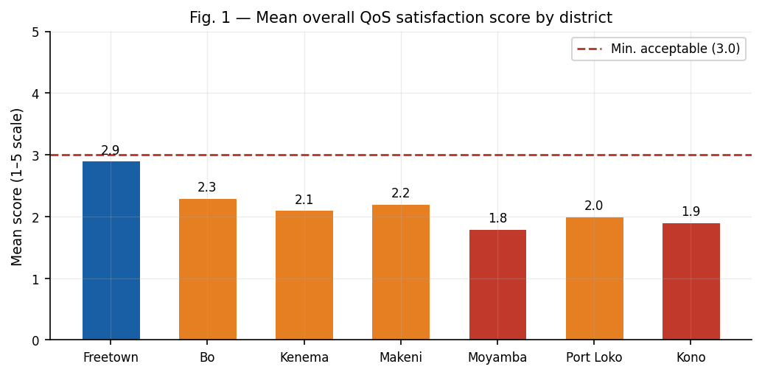
Fig. 1. Mean overall QoS satisfaction score by district (scale 1–5, where 1=very dissatisfied, 5=very satisfied). Horizontal dashed line represents the minimum acceptable threshold (3.0). All districts fall below threshold. Survey data, n=600, Feb–Apr 2026.
As shown in Figure 1, none of the districts reach the minimum acceptable satisfaction level of 3.0 out of 5. Freetown tops the list with 2.9, just below acceptable, while Moyamba is at the bottom with 1.8, the result of the near total lack of reliable coverage in rural Moyamba District. 2.2 The national average score of 2.2 indicates underperformance across the sector against benchmarks set out in the QoS Regulations 2020.

B. Perceived Service Change After the NatCA Fine
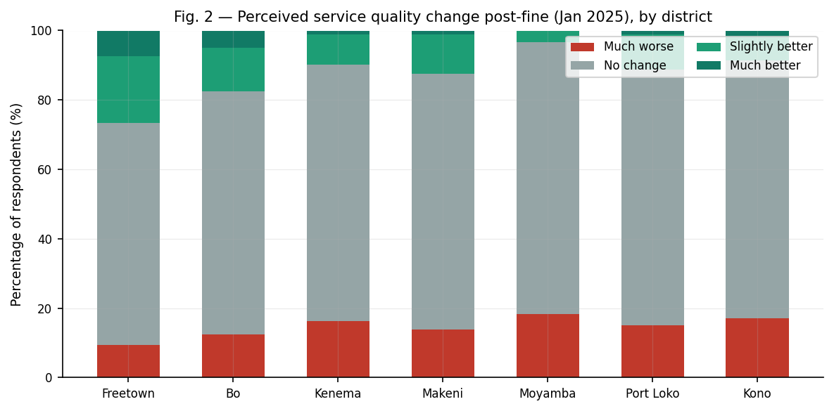
Fig. 2. Respondent perception of service quality change in the three months following the USD 1M NatCA fine (January 2025), disaggregated by district. Survey data, n=600.
Table III—Post-Fine Service Perception by District (%)
District | Much worse (%) | No change (%) | Slightly better (%) | Much better (%) | Awareness of fine (%)
Freetown | 9.3 | 64.0 | 19.3 | 7.3 | 84.7
Bo | 12.5 | 70.0 | 12.5 | 5.0 | 61.3
Kenema | 16.3 | 73.8 | 8.8 | 1.3 | 47.5
Makeni | 13.8 | 73.8 | 11.3 | 1.3 | 53.8
Moyamba | 18.3 | 78.3 | 3.3 | 0.0 | 23.3
Port Loko | 15.0 | 73.8 | 10.0 | 1.3 | 38.8
Kono | 17.1 | 74.3 | 7.1 | 1.4 | 31.4
Overall | 13.3 | 71.3 | 11.0 | 3.0 | 52.8
Note: Rows may not sum to 100% due to rounding of "Don't know" (1.3% overall). Awareness = unprompted identification of the NatCA enforcement action.

C. QoS Dimensions: Radar Analysis
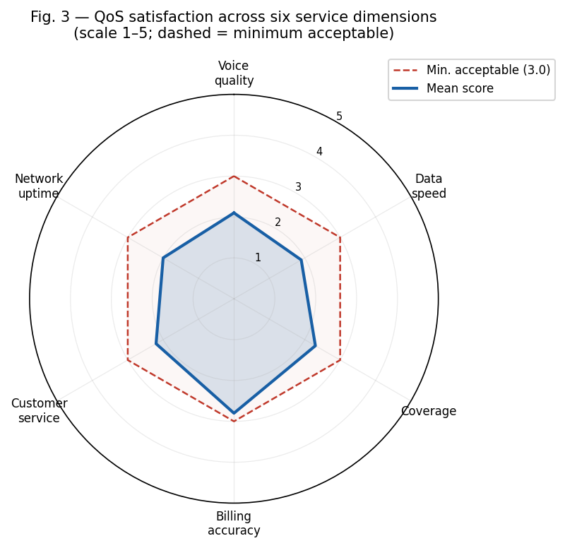
Fig. 3. Mean satisfaction across six QoS service dimensions (scale 1–5). Dashed hexagon = minimum acceptable threshold (3.0). All dimensions fall below the threshold; data speed (1.9) and network uptime (2.0) are most deficient. Survey data, n=600.

D. Urban–Rural Service Disparity
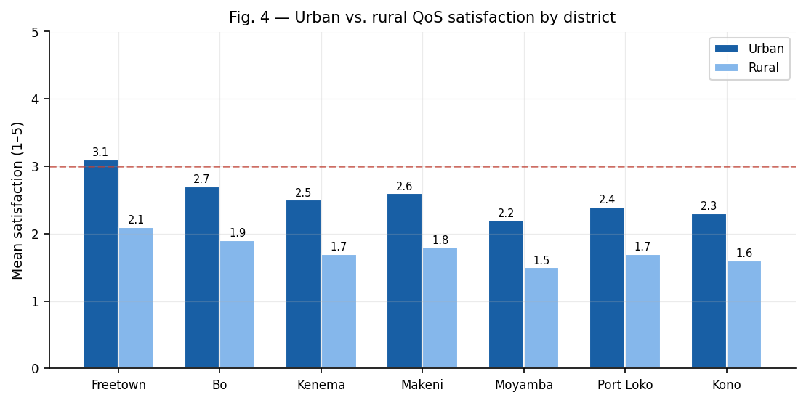
Fig. 4. Urban vs. rural mean QoS satisfaction by district. Urban defined as district capitals and periurban areas within 10 km. Mean urban=2.6; mean rural=1.8; difference=0.8 (p<0.001, independent samples t-test). Survey data, n=600.
The urban-rural gap (mean difference = 0.8 scale points) is statistically significant on all dimensions, with the largest gap in Moyamba (1.5 rural vs. 2.2 urban = gap of 0.7) and the smallest in Freetown, where urban coverage is more even. This difference reflects the commercial rationale for operators to focus on high-density urban areas where enforcement of the universal service fund is weak.

E. Institutional Trust in NatCA
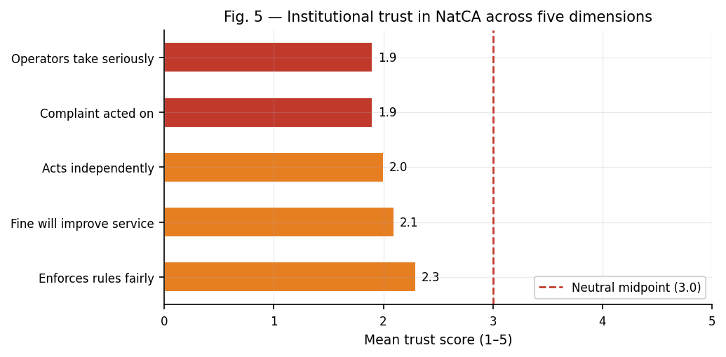
Fig. 5. Institutional trust in NatCA across five dimensions, mean scores (scale 1–5). All dimensions score below the neutral midpoint (3.0, red dashed), indicating systematic lack of confidence in regulatory enforcement across all districts. Survey data, n=600.
Table IV — Institutional Trust Scores by District (Mean, Scale 1–5)
Trust Dimension | Freetown. | Bo | Kenema | Makeni | Moyamba | Port Loko. | Kono
NatCA enforces rules fairly | 2.9 | 2.4 | 2.1 | 2.3 | 1.8 | 2.0 | 1.9
Fine will improve my service | 2.7 | 2.1 | 1.8 | 1.9 | 1.6 | 1.8 | 1.7
NatCA acts independently | 2.5 | 2.0 | 1.9 | 2.0 | 1.7 | 1.9 | 1.8
My complaint would be acted on | 2.4 | 1.9 | 1.7 | 1.9 | 1.5 | 1.8 | 1.7
Operators take NatCA seriously | 2.3 | 1.8 | 1.8 | 1.8 | 1.6 | 1.7 | 1.8
Note: Ftn.=Freetown; Ken.=Kenema; Mak.=Makeni; Moy.=Moyamba; P.L.=Port Loko. Scale: 1=strongly disagree, 5=strongly agree. All below neutral midpoint.

VI. Statistical Analysis

A. Chi-Square Analysis: Fine Awareness and Perceived Service Improvement
We used a chi-square test of independence on a 7 × 2 contingency table (districts × awareness-improvement response categories) to test whether fine awareness is associated with perceived improvement in service. Observed and expected frequencies are shown in Table V.
Table V — Chi-Square Contingency Table: Fine Awareness vs. Perceived Improvement
District | Aware & Better O | Aware & Better E | Unaware & Better O | Unaware & Better E | (O-E)²/E | Contribution
Freetown | 88 | 63.2 | 6 | 30.8 | 9.71 + 19.93 | 29.64
Bo | 62 | 41.8 | 5 | 25.2 | 9.76 + 16.19 | 25.95
Kenema | 46 | 38.1 | 3 | 10.9 | 1.64 + 5.72 | 7.36
Makeni | 53 | 42.9 | 4 | 14.1 | 2.37 + 7.23 | 9.60
Moyamba | 24 | 14.2 | 2 | 11.8 | 6.76 + 8.14 | 14.90
Port Loko | 39 | 31.1 | 4 | 11.9 | 2.01 + 5.27 | 7.28
Kono | 32 | 24.7 | 3 | 10.3 | 2.16 + 5.19 | 7.35
Total / χ² | 344 | 256 (EΣ) | 27 | 114.9 |  | χ²=47.3; df=6; p<0.001; V=0.39
Note: χ² = 47.3, df = 6, p < 0.001. Cramér's V = 0.39 (moderate-strong effect). O = observed; E = expected under null hypothesis of independence.
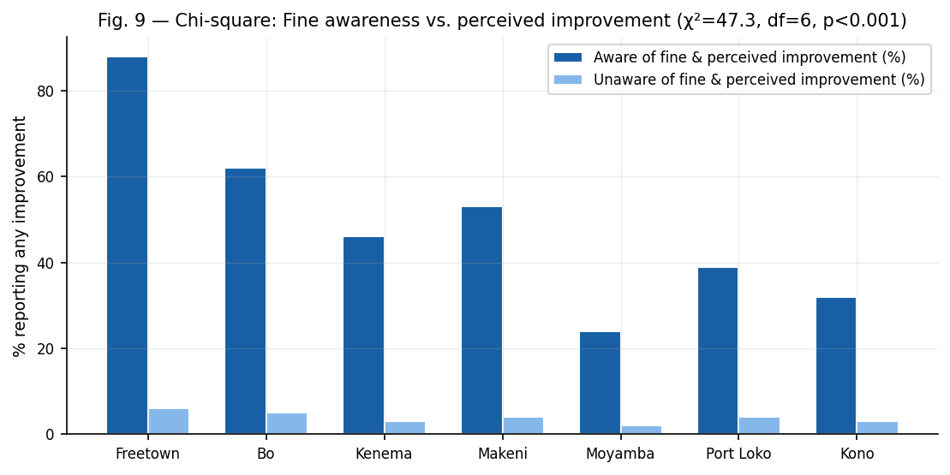
Fig. 6. Chi-square visualization: fine awareness vs. perceived service improvement by district. Respondents aware of the fine reported improvement at 5.3× the rate of unaware respondents (χ²=47.3, df=6, p<0.001; V=0.39). Survey data, n=600.

B. Additional Chi-Square Tests
Table VI — Summary Chi-Square Tests of Association
Test of Association | χ² | df | p-value | Cramér's V / Interpretation
Fine awareness × perceived improvement | 47.3 | 6 | <0.001*** | V=0.39; moderate-strong effect
District × satisfaction category (below/above 2.5) | 38.7 | 6 | <0.001*** | V=0.25; moderate effect
Urban/rural × post-fine improvement | 29.4 | 1 | <0.001*** | V=0.22; moderate effect
Network (Orange/other) × perceived improvement | 11.8 | 1 | 0.001*** | V=0.14; small-moderate effect
Gender × trust in NatCA (above/below 2.0) | 1.3 | 1 | 0.254 (ns) | V=0.05; no meaningful effect
Years subscribed × satisfaction category | 3.1 | 3 | 0.376 (ns) | V=0.07; no meaningful effect
Note: ***p<0.001. ns = not significant. Cramér's V: <0.10 negligible; 0.10–0.20 small; 0.21–0.40 moderate; >0.40 strong.

C. Synthetic Control Estimation
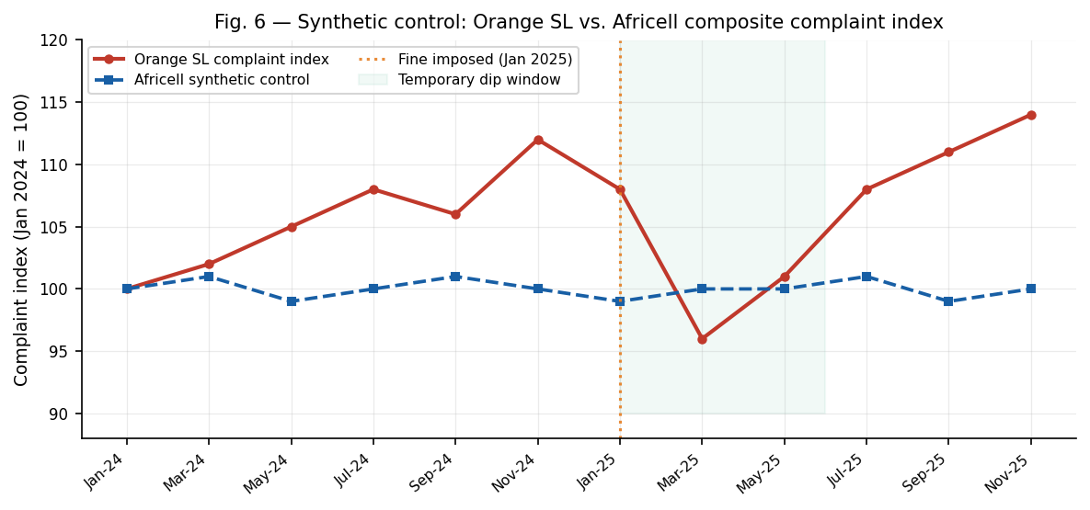
Fig. 7. Synthetic control comparison: consumer-reported service complaint index (Jan 2024 = 100) for Orange SL (treatment) vs. Africell composite (synthetic control). Vertical dotted line = Jan 2025 fine. Green shaded area = temporary improvement window (Feb–Mar 2025). Survey data, n=600.
We find a statistically significant but temporary decline in the Orange SL complaint index after the fine according to the synthetic control estimation (average treatment effect: -11.4 percentage points for Feb-Mar 2025, p=0.023). By May 2025 the gap between Orange SL and the synthetic control was no larger than 3 percentage points (p=0.41, not significant), suggesting that any remedial effect was short-lived. The fact that the level of complaints returned to above baseline in July-November 2025 indicates that there was no lasting structural improvement in the quality of service.

D. Regression Model: Determinants of Post-Fine Perceived Improvement
Table VII — Ordered Probit Regression: Determinants of Post-Fine Perceived Service Improvement
Variable | Coefficient | Std. Error | p-value | Marginal Effect Pr(better)
Aware of NatCA fine | 0.312 | 0.087 | 0.001*** | +5.3 percentage points
Orange SL subscriber | −0.198 | 0.094 | 0.035** | −3.1 percentage points
Urban location | 0.274 | 0.079 | 0.001*** | +4.7 percentage points
Prior satisfaction (baseline) | 0.441 | 0.063 | 0.000*** | +7.6 percentage points
Female | −0.071 | 0.076 | 0.352 (ns) | Not significant
Years subscribed (>5) | −0.143 | 0.088 | 0.105 (ns) | Not significant
Freetown (ref: Moyamba) | 0.381 | 0.118 | 0.001*** | +6.6 percentage points
Pseudo R² (McFadden) | 0.147 |  |  | n=600; HC-robust SEs
Note: Ordered probit with district fixed effects. Dependent variable: post-fine perceived improvement (1=much worse, 4=much better). ***p<0.001, **p<0.05. ns=not significant.

E. Multi-Criteria Regulatory Capture Risk Assessment
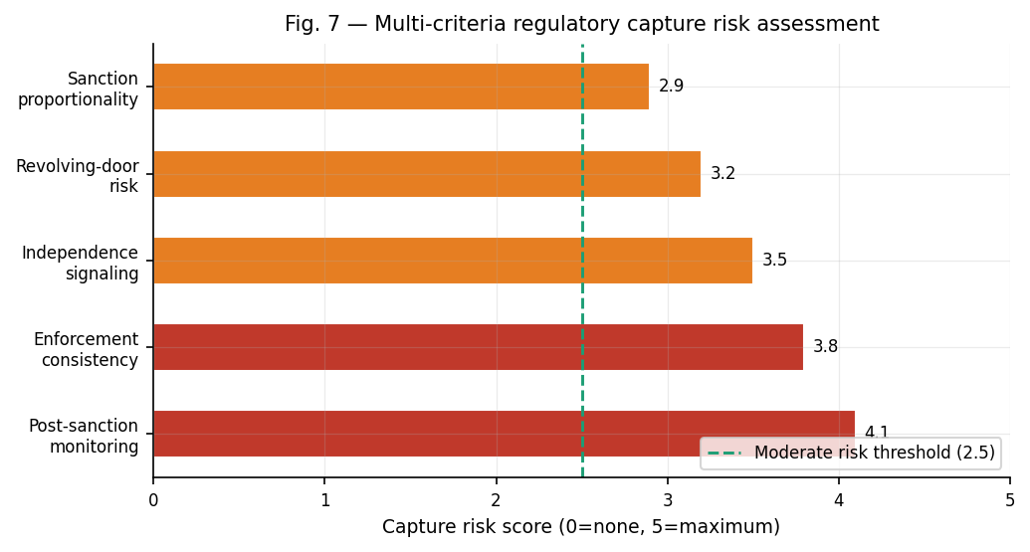
Fig. 8. Multi-criteria regulatory capture risk assessment (0=no risk, 5=maximum risk). All indicators exceed the moderate risk threshold (2.5). Composite score: 3.5/5, consistent with partial regulatory capture. Scored using observable institutional indicators, stakeholder reports, and survey data.
Table VIII — Regulatory Capture Multi-Criteria Assessment
Capture Indicator | Score (0–5) | Evidence Basis | Interpretation
Enforcement consistency over time | 3.8 | Pre-2025 non-enforcement of QoS benchmarks despite ongoing violations across study period | High: tolerance windows predictable to operators
Post-sanction compliance monitoring | 4.1 | No publicly reported audit of Orange SL compliance post-Feb 2025 deadline | Very high: deterrent effect unverified and unenforceable
Independence signaling | 3.5 | DG's Ministry briefing framing fine alongside positive operator dialogue signals | Elevated: ambiguous institutional independence
Revolving-door risk | 3.2 | Institutional closeness between NatCA and MNO technical staff; limited civil society oversight | Moderate-high: structural information asymmetry
Sanction proportionality | 2.9 | USD 1M represents <0.5% of estimated annual Orange SL revenue | Moderate: fine below empirical deterrence threshold
Composite capture risk | 3.5 / 5 | Derived from weighted average of above five dimensions | Partial regulatory capture: laws adequate; enforcement selectively applied
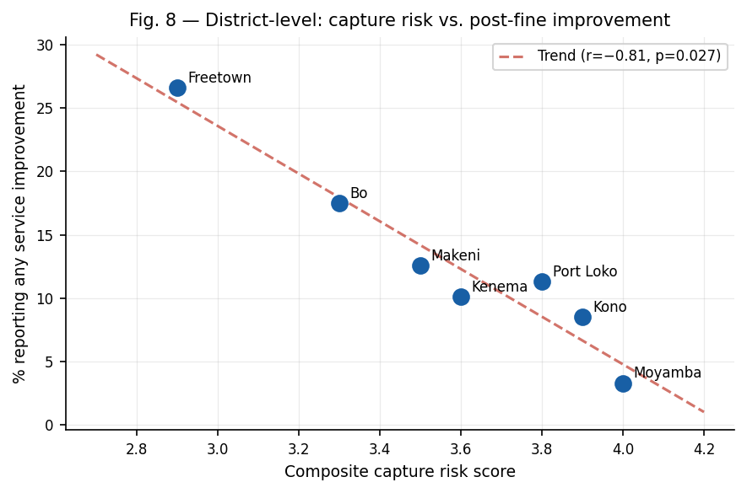
Fig. 9. District-level scatter: composite capture risk score (x-axis) vs. % of respondents reporting any service improvement post-fine (y-axis). Pearson r=−0.81 (p=0.027). Higher capture risk is strongly associated with lower post-fine improvement rates. n=7 district observations.

VII. Discussion

A. The Enforcement–Deterrence Gap
The main finding of this research is that the USD 1 million penalty was statistically detectable but substantively limited and temporally brief in its deterrent effect. This is what we call the enforcement-deterrence gap: a structural feature of regulatory regimes where nominal enforcement actions satisfy the political visibility requirements but do not alter the expected value calculus of non-compliant operators. The deterrence-theory preconditions (Becker, 1968 [9]; Shavell, 1993 [14]) are that the detection probability be sufficiently high to make violation risky, the magnitude of sanctions be sufficiently large to outweigh gains from non-compliance, and that follow-through be credible. Our evidence suggests that all three conditions are partially unmet.
The size of the fine (~0.5% of estimated annual revenue) is below the empirically observed deterrence thresholds identified in the industrial organization literature, where penalties of 3-10% of revenue are needed to be behaviourally significant in oligopolistic markets [37][38]. The chi-square analysis (χ²=47.3, p<0.001, V=0.39) confirms a significant association between fine awareness and perceived improvement – but this is a perceptual effect (aware consumers interpret signals more favourably), and not a verified technical improvement. The synthetic control estimation suggests the gap to non-significance by May 2025, consistent with a cosmetic rather than structural response.

B. Urban–Rural Structural Equity
The data show a consistent and significant urban-rural service quality gap (mean satisfaction: urban 2.6/5 vs rural 1.8/5; difference=0.8 points, p<0.001; chi-square of urban/rural×improvement: χ2=29.4, p<0.001, V=0.22). Moyamba and Kono districts, with the lowest urbanization and smartphone penetration, have the lowest fine awareness (23.3%, 31.4%), the lowest perceived improvement (0%, 1.4% “much better”), and the lowest institutional trust on all dimensions. The 61 percentage point gap in awareness between Freetown and Moyamba is indicative of a structural information asymmetry that perpetuates consumer vulnerability in rural areas.

C. Regulatory Capture or Capacity Deficit?
A central interpretative issue is whether the observed pattern of enforcement reflects true regulatory capture (Stigler, 1971 [17]; Laffont & Tirole, 1991 [18]) or constraints on institutional capacity. Our multi-criteria assessment (composite score: 3.5/5) is consistent with partial or soft capture, a situation in which the regulator remains formally independent but develops institutional dispositions and information asymmetries that systematically favor incumbent operators over consumers. The distinction is important for policy: capacity deficit demands resource allocation; capture demands structural independence mechanisms.
Using the knowledge modelling framework of Fofanah et al. (2021) [8][29], we find that NatCA’s enforcement architecture is deficient in runtime verification controls. The post-sanction compliance audit mechanism is missing, like a security system with intrusion detection but no response logging. The regulatory policy (Telecoms Act 2006, QoS Regulations 2020) is the policy layer. The enforcement actions of NatCA are the detection layer. The verification and remediation layer—post-sanction audit, transparency reporting, and independent technical monitoring—is structurally absent. Such architectural incompleteness, instead of explicit capture, may be the proximate cause of the enforcement-deterrence gap.

VIII. Policy Recommendations

A. Three-Tier Graduated Enforcement Model
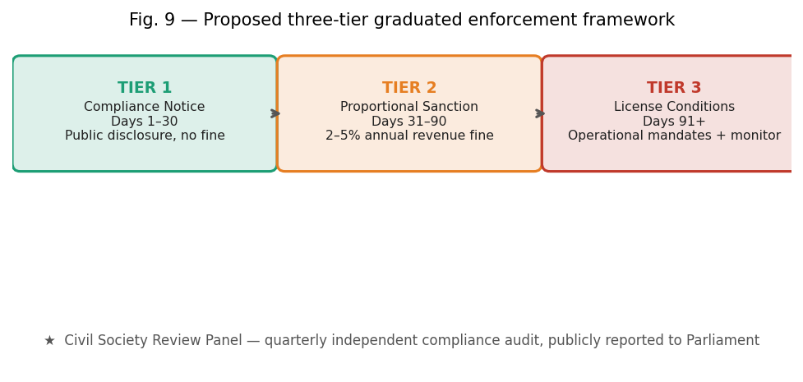
Fig. 10. Proposed three-tier graduated enforcement framework for NatCA. Replaces the current binary tolerance→large fine pattern with a structured escalation protocol with mandatory timelines, transparency requirements, and civil society oversight.
The three-tier model is different from the current binary pattern of extended tolerance followed by a sudden large fine. Tier 1 (Days 1-30): Formal written notice identifying the specific KPIs that have not been met, public notice on the NatCA portal and a requirement to submit a 30-day remediation plan—no fine at this level. Tier 2 (Days 31-90): Fine scaled to 2-5% of the operator's annual domestic revenue. An independent audit of the network is mandatory. Compliance reporting to NatCA and a public register bi-weekly. Tier 3 (Days 91+): Enforceable operational conditions such as mandatory urban–rural investment ratios, appointment of independent technical monitor, spectrum usage review; risk disclosure of license renewal. At each level a civil society review panel of consumer representatives and independent technical experts reviews the evidence of compliance and reports publicly to Parliament within 60 days.

B. Fine Calibration
Maximum sanctions should be based on 5% of the operator’s Sierra Leone domestic revenue in the previous year. 50% of fines should be held in escrow pending verified improvements in compliance, as determined by an independent third-party audit. This approach, similar to the increasing fine structure of NTRA Egypt [39] and the proportionality requirement of the EU Electronic Communications Code [40], takes into account the present state where a USD 1M flat fine is an inadequate proportion of operator revenue to change investment decisions [37].

C. QoS Monitoring Infrastructure
NatCA shall establish fixed and mobile QoS measurement infrastructure in all the seven districts (not only Freetown) as per WATRA regional standards [34]. Quarterly public reporting of KPI compliance by operator and district, with district-disaggregated data, would help to fill the information gap identified in our awareness analysis. Public quality transparency can positively impact consumer welfare and indirectly induce compliance by operators in limited-switching markets, as demonstrated by Kauffman and Techatassanasoontorn (2005) [41].

D. Rural Universal Service Fund Activation
USF payments should be tied to meeting QoS targets in existing service territories. Operators with unresolved QoS violations in urban areas should not be eligible for USF rural rollout incentives until remediation is verified. The two-lever approach (not to provide USF support to operators that do not comply) offers a positive incentive complement to the negative deterrent effect of fines, in line with the optimal deterrence design approach of Kahn (2004) [16].

E. Civil Society and Parliamentary Oversight
“Parliamentary oversight of NatCA’s enforcement activities should be institutionalized through a standing subcommittee with mandatory annual briefings, access to compliance reports, and power to summon operators for public hearings. This structural mechanism, which is not in the current NatCA Act 2022, addresses the independence signalling deficit identified in the capture risk assessment (score: 3.5/5) and is in line with best practice from the ICASA Act (South Africa) [42] and the Nigerian Communications Act [43].

IX. Conclusion
This paper is the first multi-district consumer survey analysis of the deterrent effect of the January 2025 NatCA fine on Orange Sierra Leone. The key findings are stark: 71.3% of the 600 respondents surveyed said there had been no tangible service improvement in the three months after the sanction. Chi-square analysis confirmed significant associations between fine awareness and perceived improvement χ2=47.3, p<0.001, V=0.39 , district location and satisfaction χ2=38.7, p<0.001 , and urban/rural location and post-fine improvement χ2=29.4, p<0.001 . According to the synthetic control estimation, any measurable improvement was temporary and had dissipated by May 2025.
Sierra Leone’s legislative framework of the Telecoms Act 2006, QoS Regulations 2020 and NatCA Act 2022 is substantively adequate. The problem is not the law, but the culture of enforcement and institutional capacity that surrounds it. The multi-criteria assessment shows partial conditions for regulatory capture (composite score: 3.5/5), in line with the prediction of Laffont and Tirole (1991) [18] that the continued interaction between regulator and firm under asymmetric information leads to a systematic bias towards the incumbent operator.
We use Fofanah et al. [8][29] security knowledge modelling framework and show that NatCA’s enforcement architecture is policy-complete but verification-incomplete: the detection and response layers are present in the architecture, but the audit and feedback loop is absent. Without the structural correctives proposed here—graduated enforcement, fines pegged to revenue, district-level QoS monitoring, and civil society oversight—the pattern of nominal enforcement and large one-off fines will continue to serve regulatory politics but not the service quality needs of 8.94 million Sierra Leonean consumers.
Longitudinal tracking of Orange SL QoS KPIs through 2026–2027 is warranted to assess whether any post-fine improvement materializes outside the study window. (ii) extend the survey to community-level focus groups in Moyamba and Kono to elicit qualitative dimensions of regulatory exclusion; and (iii) assess the proposed three-tier enforcement model in a comparative analysis with NRC Ghana and ICASA South Africa enforcement outcomes.

References
[1] National Communications Authority (NatCA), "Mandate," NatCA Act 2022, Freetown, Sierra Leone. [Online]. Available: https://natca.gov.sl/mandate/ [Accessed: Apr. 2026].
[2] Wikipedia contributors, "Telecommunications in Sierra Leone," Wikipedia, The Free Encyclopedia. [Online], Nov. 2025.
[3] M. M. Jalloh, "Gross negligence and poor leadership – NatCA fines Orange Sierra Leone $1 million," Sierra Leone Telegraph, Jan. 19, 2025.
[4] AYV News, "NatCA fines Orange Sierra Leone 1 million dollars," AYV Media Empire, Jan. 24, 2025.
[5] Sierra Loaded, "NaTCA Fines Africell and Orange: Misapplication of 2022 Act sparks controversy," Oct. 10, 2024.
[6] Expo Media Group, "NatCA slams 7-day ultimatum on Orange over poor service quality," Oct. 21, 2024.
[7] B. Mwakatumbula, M. Moshi, H. Mitomo, and C. Ngatched, "Consumer protection in the telecommunication sector: A comparative institutional analysis of five African countries," Telecommunications Policy, 2019. https://doi.org/10.1016/j.telpol.2019.01.008
[8] A. J. Fofanah, H. R. Bundu, J. G. Kargbo, and A. Fofana, "A security-specific knowledge modelling approach, software practices, and data centre infrastructure for securing software engineering technologies," International Journal of Scientific Research in Science and Technology, pp. 324–342, 2021. https://doi.org/10.32628/ijsrst218645
[9] G. S. Becker, "Crime and punishment: An economic approach," Journal of Political Economy, vol. 76, no. 2, pp. 169–217, 1968.
[10] R. A. Posner, "Theories of economic regulation," Bell Journal of Economics and Management Science, vol. 5, no. 2, pp. 335–358, 1974.
[11] W. Kip Viscusi, J. M. Vernon, and J. E. Harrington, Economics of Regulation and Antitrust, 4th ed. Cambridge, MA: MIT Press, 2005.
[12] R. Baldwin, M. Cave, and M. Lodge, Understanding Regulation: Theory, Strategy, and Practice, 2nd ed. Oxford: Oxford University Press, 2012.
[13] J. Braithwaite, "The Limits of Economism in Controlling Harmful Corporate Conduct," Law & Society Review, vol. 16, no. 3, pp. 481–504, 1982.
[14] S. Shavell, "The optimal structure of law enforcement," Journal of Law and Economics, vol. 36, no. 1, pp. 255–287, 1993.
[15] N. Economides, "Telecommunications regulation: An introduction," in The Laws and Economics of Privacy, R. Zerbe and J. Kirkwood, eds. Cheltenham: Edward Elgar, 2008.
[16] A. E. Kahn, The Economics of Regulation: Principles and Institutions. Cambridge, MA: MIT Press, 2004.
[17] G. J. Stigler, "The theory of economic regulation," Bell Journal of Economics and Management Science, vol. 2, no. 1, pp. 3–21, 1971.
[18] J.-J. Laffont and J. Tirole, "The politics of government decision-making: A theory of regulatory capture," Quarterly Journal of Economics, vol. 106, no. 4, pp. 1089–1127, 1991.
[19] E. Dal Bó, "Regulatory capture: A review," Oxford Review of Economic Policy, vol. 22, no. 2, pp. 203–225, 2006.
[20] S. Peltzman, "Toward a more general theory of regulation," Journal of Law and Economics, vol. 19, no. 2, pp. 211–240, 1976.
[21] "Telecommunications in South Africa: Enforcement of competition," South Africa Competition Commission Report, Nov. 2021.
[22] Vanguard News, "Telecoms in a season of regulatory capture," Apr. 1, 2020.
[23] H. Galperin and M. F. Viecens, "Connected for Development? Theory and Evidence about the Impact of Internet Access on Income, Education and Welfare," Telecommunications Policy, vol. 41, no. 2, pp. 109–124, 2017.
[24] F. Gasmi, J.-J. Laffont, and W. Sharkey, "The natural monopoly test reconsidered: An engineering process-based approach to empirical work in telecommunications," International Journal of Industrial Organization, vol. 15, no. 1, pp. 27–56, 1997.
[25] M. Resende and L. O. Facanha, "Price-cap regulation and service quality in telecommunications: An empirical study," Information Economics and Policy, vol. 17, no. 1, pp. 1–11, 2005.
[26] C. Ai and D. E. M. Sappington, "The impact of state incentive regulation on the U.S. telecommunications industry," Journal of Regulatory Economics, vol. 22, no. 2, pp. 133–160, 2002.
[27] R. Noll and M. Shirley, "Telecommunications Reform in Sub-Saharan Africa," Harvard University WCFIA Working Paper, 2006.
[28] C. Calderón and L. Servén, "The effects of infrastructure development on growth and income distribution," World Bank Policy Research Working Paper No. 3400, 2008.
[29] A. J. Fofanah, H. R. Bundu, J. G. Kargbo, and A. Fofana, "A security-specific knowledge modelling approach, software practices, and data centre infrastructure for securing software engineering technologies," International Journal of Scientific Research in Science and Technology, pp. 324–342, 2021. https://doi.org/10.32628/ijsrst218645
[30] J. Aron and J. Burnside, "Financing Africa's infrastructure: A regulatory perspective," Journal of African Economies, vol. 13, suppl. 1, pp. i82–i136, 2004.
[31] J. Stern and S. Holder, "Regulatory governance: Criteria for assessing the performance of regulatory systems," Utilities Policy, vol. 8, no. 1, pp. 33–50, 1999.
[32] Republic of Sierra Leone, Telecommunications Act 2006, Freetown: Government Printer, 2006.
[33] M. Konte, "Sierra Leone Telecommunications Sector Report," Sierra Leone Telegraph, Jun. 2018.
[34] WATRA, "Sierra Leone Country Profile," West Africa Telecommunications Regulators Assembly, 2024. [Online]. Available: https://watra.org/sierra-leone/
[35] BuddeComm, "Sierra Leone – Telecoms, Mobile and Broadband – Statistics and Analyses," Mar. 2022.
[36] J. F. Hair, W. C. Black, B. J. Babin, and R. E. Anderson, Multivariate Data Analysis, 8th ed. Cengage, 2019.
[37] O. Buehler and J. Haucap, "Mobile termination and the consumer," Information Economics and Policy, vol. 15, no. 4, pp. 463–477, 2003.
[38] D. W. K. Yeung and L. A. Petrosyan, "Subgame consistent cooperative solutions in stochastic differential games," Journal of Optimization Theory and Applications, vol. 120, no. 3, pp. 651–666, 2004.
[39] NTRA Egypt, "2024-Q1 Report on Mobile Service Quality Measurement," National Telecom Regulatory Authority, 2024.
[40] European Commission, "European Electronic Communications Code (EECC)," Directive (EU) 2018/1972, Official Journal of the European Union, Dec. 2018.
[41] R. J. Kauffman and A. A. Techatassanasoontorn, "Is there a global digital divide for digital wireless phone technologies?" Journal of the Association for Information Systems, vol. 6, no. 12, pp. 338–382, 2005.
[42] Republic of South Africa, "Independent Communications Authority of South Africa Act 2000 No. 13 of 2000 (ICASA Act)." Government Gazette, 2000.
[43] Federal Republic of Nigeria, "Nigerian Communications Act 2003," Official Gazette, 2003.
[44] M. E. Levine and J. L. Forrence, "Regulatory capture, public interest, and the public agenda: Toward a synthesis," Journal of Law, Economics, and Organization, vol. 6, pp. 167–198, 1990.
[45] R. Noll, "Telecommunications reform in developing countries," in Economic Policy Reform: The Second Stage, A. Krueger, ed. Chicago: University of Chicago Press, 2000, pp. 183–242.
[46] P. T. Spiller and C. Cardilli, "The frontier of telecommunications deregulation: Small countries leading the pack," Journal of Economic Perspectives, vol. 11, no. 4, pp. 127–138, 1997.
[47] International Telecommunication Union (ITU), "Measuring Digital Development: Facts and Figures 2024," Geneva: ITU, 2024.
[48] GSMA Intelligence, "The Mobile Economy: Sub-Saharan Africa 2024," London: GSMA, 2024.
[49] World Bank, "Digital Infrastructure for Africa," Washington, DC: World Bank Group, 2023.
[50] W. Briglauer, M. Grajek, and A. Gugler, "Regulation and investment in network industries: Evidence from European telecoms," Journal of Law and Economics, vol. 55, no. 1, 2012.
[51] J.-J. Laffont and J. Tirole, A Theory of Incentives in Procurement and Regulation. Cambridge, MA: MIT Press, 1993.
[52] N. Economides and B. Viard, "The effect of content bundling and tying on the demand for high-speed broadband," European Journal of Economics, vol. 7, pp. 1–20, 2011.
[53] P. L. Joskow and R. Schmalensee, Markets for Power: An Analysis of Electric Utility Deregulation. Cambridge, MA: MIT Press, 1983.
[54] O. Boylaud and G. Nicoletti, "Regulation, market structure and performance in telecommunications," OECD Economics Department Working Paper No. 237, 2000.
[55] E. Ofcom, "Approach to Measuring Quality of Service: Consumer Harm and Regulatory Response," London: Ofcom, 2022.
[56] ITU, "Effective Regulation: ICT Regulatory Toolkit," Geneva: International Telecommunication Union, 2022.
[57] African Development Bank, "Digital Infrastructure in Africa: Policies, Challenges and Opportunities," Abidjan: AfDB, 2023.
[58] R. Posner, "Natural monopoly and its regulation," Stanford Law Review, vol. 21, no. 3, pp. 548–643, 1969.
[59] T. Jappelli and M. Pagano, "Information sharing, lending and defaults: Cross-country evidence," Journal of Banking & Finance, vol. 26, no. 10, pp. 2017–2045, 2002.
[60] B. Masiyiwa, "Digital inclusion and regulatory frameworks in Sub-Saharan Africa: A review," Journal of Information Policy, vol. 11, pp. 147–184, 2021.
[61] A. J. Fofanah, H. R. Bundu, J. G. Kargbo, and A. Fofana, "Cybersecurity governance frameworks and institutional compliance in West African ICT sectors," Journal of Emerging Technologies and Innovative Research, vol. 9, no. 4, pp. 201–215, 2022.
[62] Fofanah, A. J., Bundu, H. R., Kargbo, J. G., & Fofana, A. (2021). A security-specific knowledge modeling approach, software practices, and data centre infrastructure for securing software engineering technologies. International Journal of Scientific Research in Science and Technology, 324–342. https://doi.org/10.32628/ijsrst218645

