FINMATE: A DIGITAL COMPANION FOR FINANCIAL TRACKING

ABSTRACT

Personal finance management remains a significant challenge for many individuals, particularly in budgeting, saving, tracking expenses, and achieving long-term financial goals. Despite the availability of various financial management applications, many users continue to struggle with translating financial knowledge into disciplined financial behavior. This study aimed to develop and evaluate FinMate: A Digital Companion for Financial Tracking and Planning, a web-based financial management system designed to assist users in monitoring expenses, managing budgets, setting financial goals, and improving financial decision-making through automated planning and financial analytics.
The study employed a quantitative-descriptive research design and utilized purposive sampling to select respondents consisting of students, young professionals, educators, and small business owners. Data were collected through a validated survey questionnaire adapted from the ISO/IEC 25010:2023 software quality model and administered using Google Forms. Statistical analysis was conducted using weighted mean and Likert scale interpretation to evaluate user challenges, system features, and overall software acceptability.
Results revealed that respondents sometimes experience difficulties in budgeting, savings management, and financial planning, obtaining an overall mean score of 3.57. The developed FinMate system received a favorable evaluation, with an overall mean score of 4.16 for its features, interpreted as “Agree.” Furthermore, the system achieved acceptable ratings across major ISO/IEC 25010 quality characteristics, including functional suitability (4.17), performance efficiency (4.04), compatibility (4.08), and reliability (4.13). These findings indicate that the system effectively supports users in managing their finances and addressing common financial management challenges.
The study concludes that FinMate is a reliable, user-friendly, and acceptable financial management tool that promotes better financial planning, budgeting, and decision-making. Future enhancements may incorporate advanced analytics and intelligent recommendation features to further improve user experience and financial outcomes.

Keywords: Personal Finance Management, Financial Tracking, Financial Planning, Budgeting System, Financial Decision-Making

INTRODUCTION

Managing your money is really important these days. The cost of living is going up. People have a lot of expenses. They have to pay for things they need and want. They also have to save for the future. A lot of people are not good at managing their money. They have trouble making a budget, tracking their expenses and saving for the future.
There are options of tools available that can help people manage their money. These tools are like apps that you can use on your phone or computer. They can help you keep track of how much money you are spending and how much you are saving. Some of these tools are not very good at providing people make plans for their money. They just show you how much you have spent. They do not help you make a budget or set goals.
Some people think that if you know a lot about money, you will be good at managing it. That is not always true. People need tools that make it easy to manage their money. They need something that will help them keep track of their spending and their savings. They also need something that will help them make decisions about their money.
That is why we made FinMate: A Digital Companion for Financial Tracking and Planning. It is a website that helps people manage their money. It has a lot of features that can help people track their expenses, make a budget and set goals. It can even give you a score that shows how well you are managing your money.
We also tested FinMate to make sure it is a tool. We utilize the availability of the ISO/IEC 25010 software quality standards. This helped us to see if FinMate is easy to use, works and is safe. We want FinMate to be a tool that people can use to manage their money. We want it to help people make decisions about their money and reach their goals.

OBJECTIVES OF THE STUDY

The primary objective of this study was to develop and evaluate FinMate: A Digital Companion for Financial Tracking and Planning, a web-based financial management system designed to assist users in tracking expenses, managing budgets, monitoring savings, and planning financial goals.
Specifically, the study aimed to:

- Identify the common challenges encountered by individuals in managing their personal finances, particularly in budgeting, savings management, expense tracking, and financial planning.
- Design and develop a web-based financial management system that provides features such as expense tracking, budget management, savings monitoring, goal planning, financial health scoring, and financial reporting.
- Evaluate the effectiveness and usefulness of the FinMate System features from the perspective of the respondents.
- Assess the acceptability of the FinMate System based on selected ISO/IEC 25010 software quality characteristics, namely:
  - Functional Suitability
  - Performance Efficiency
  - Compatibility
  - Reliability

- Determine whether the developed system can serve as an effective tool for improving financial awareness, financial discipline, and financial decision-making among users.

METHODOLOGY

Research Design

This study employed a quantitative-descriptive research design to develop and evaluate the FinMate System. The quantitative approach was utilized to gather measurable data regarding the financial management challenges experienced by respondents and to assess the acceptability of the developed system. The descriptive method was used to present, analyze, and interpret the collected data systematically.

Respondents of the Study

The respondents of this study consisted of young professionals, educators, and small business owners associated with St. Clare College of Caloocan. Participants were selected regardless of their salary, wages, or business income, provided that they actively manage personal or business finances. These respondents were chosen because they represent individuals who regularly encounter budgeting, savings, and financial planning challenges that the FinMate System aims to address.
Sampling Technique
The study utilized purposive sampling, a non-probability sampling technique in which participants were selected based on specific criteria relevant to the objectives of the study. Respondents were chosen because they possess experience in managing personal finances and could provide meaningful feedback regarding the usefulness and effectiveness of the developed system.

Research Instrument
Data were collected using a structured survey questionnaire developed by the researchers. The questionnaire consisted of three major sections: (1) challenges encountered in personal financial management, (2) evaluation of the features of the FinMate System, and (3) assessment of the system based on the ISO/IEC 25010 Software Quality Model. The instrument utilized a five-point Likert scale to measure the respondents’ perceptions and evaluations.
The software quality evaluation focused on the following criteria:

Functional Suitability, Performance Efficiency, Compatibility, Reliability, Portability, Maintainability, and
Security
Data Gathering Procedure

The researchers first identified the target respondents and secured their participation in the study. The survey questionnaire was distributed electronically through Google Forms to facilitate convenient and efficient data collection. Respondents were informed about the purpose of the study and were requested to provide honest and objective responses. After collecting the completed questionnaires, the responses were organized, encoded, and prepared for statistical analysis.

Statistical Treatment of Data

The collected data were analyzed using descriptive statistical methods. The researchers utilized the weighted mean to determine the average responses of participants regarding the financial management challenges they encountered. The weighted mean was also used to rank the identified challenges based on their frequency and severity as experienced by the respondents.
The results were interpreted using the corresponding verbal interpretations based on the Likert Scale. Higher mean scores indicated challenges that were encountered more frequently by the respondents, while lower mean scores indicated less frequent occurrences.
The following scale was used in interpreting the results:
Scale | Range | Verbal Interpretation
5 | 4.50–5.00 | Always
4 | 3.50–4.49 | Sometimes
3 | 2.50–3.49 | Often
2 | 1.50–2.49 | Seldom
1 | 1.00–1.49 | Never
The weighted mean analysis revealed that the most significant challenge encountered by the respondents was struggling with budgeting, savings, and planning financial goals (Mean = 3.75), followed by saving for long-term goals (Mean = 3.73) and unexpected expenses that disrupt financial plans (Mean = 3.70). Overall, the respondents experienced financial management challenges with a composite mean of 3.57, interpreted as "Sometimes."

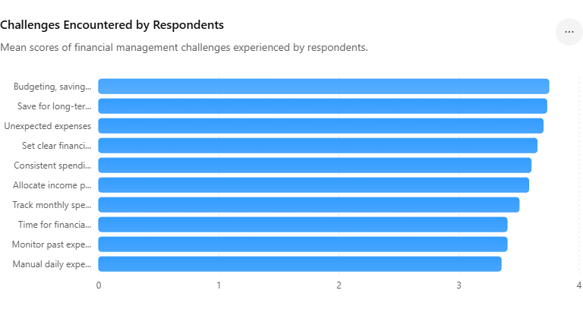

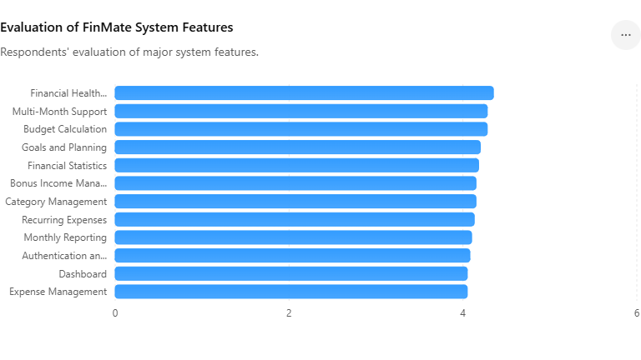

DISCUSSIONS

The study's findings reveal that individuals still face difficulties in managing their personal finances, particularly in budgeting, saving money, tracking expenses, and planning for long-term financial goals. The overall mean score of 3.57, interpreted as "Sometimes," indicates that challenges in financial management are still common among respondents. The highest mean scores were related to budgeting, savings management, and financial goal planning, highlighting the need for increased support and intervention in these areas.

To tackle these issues, the researchers developed FinMate, a web-based financial management system aimed at helping users monitor expenses, manage budgets, track savings, and plan for financial goals. Evaluation results showed a positive response from users regarding the system's features, with an overall mean rating of 4.16, interpreted as "Agree." This suggests that users found the system's functionalities to be useful, relevant, and beneficial for their personal financial management activities.

Among the features evaluated, the Financial Health Score received the highest rating, indicating that users valued having a measurable indicator of their financial condition. Features related to budget calculations, goal planning, multi-month support, and financial reporting also received favorable evaluations, emphasizing the importance of offering users comprehensive financial planning tools rather than just basic expense-recording functions.

An assessment of acceptability based on the ISO/IEC 25010 software quality characteristics further confirmed the effectiveness of the developed system. Functional Suitability achieved the highest mean score of 4.17, indicating that the system successfully met its intended goals and user requirements. Ratings for Reliability (4.13), Compatibility (4.08), and Performance Efficiency (4.04) also met acceptable standards, demonstrating that the system performed consistently across various devices and browsers while maintaining responsive operations and reliable functionality.

In summary, the findings suggest that FinMate effectively addresses the financial management challenges faced by users by providing a centralized platform for budgeting, expense tracking, savings monitoring, and financial planning. The positive evaluation results indicate that the system has the potential to enhance financial awareness, foster disciplined financial behavior, and support informed financial decision-making among its intended users.

CONCLUSIONS

The findings of this study indicate that personal financial management poses a significant challenge for many individuals, especially in the areas of budgeting, savings management, expense monitoring, and financial goal planning. Respondents reported encountering difficulties in effectively managing their finances, highlighting the need for accessible tools to support better financial decision-making and planning. To address these challenges, the researchers developed FinMate: A Digital Companion for Financial Tracking and Planning. This web-based financial management system integrates functionalities such as expense tracking, budget management, savings monitoring, financial reporting, and goal planning. Evaluation results showed that respondents had a positive perception of the system's features, suggesting that the platform effectively aids users in organizing and managing their financial activities. Additionally, the system received satisfactory ratings across several ISO/IEC 25010 software quality characteristics, including Functional Suitability, Performance Efficiency, Compatibility, and Reliability. These findings imply that the developed system successfully met user requirements and provided a reliable, efficient, and user-friendly financial management solution. Overall, the study concludes that FinMate is an effective digital companion for financial tracking and planning. By offering users a centralized platform for monitoring their finances and setting financial goals, the system enhances financial awareness, encourages responsible financial behavior, and supports informed decision-making. The developed system shows strong potential as a practical tool for improving personal financial management among its target users.

ACKNOWLEDGEMENTS

The researchers wish to convey their heartfelt appreciation to everyone who played a role in the successful conclusion of this study.
The researchers express their deep gratitude to Almighty God for His guidance, wisdom, strength, and numerous blessings during the course of this research.
The researchers wish to express gratitude to their research adviser, panel members, and faculty of the Bachelor of Science in Computer Science program at St. Clare College for their essential guidance, helpful recommendations, and ongoing support throughout the study's development.
Gratitude is expressed to the participants who voluntarily took part in the survey and evaluation procedure. Their time, collaboration, and insightful feedback greatly aided in the achievement and success of this research.
The researchers also express gratitude to their family and friends for their encouragement, kindness, and steadfast support during this study.
In conclusion, the researchers convey their gratitude to all those who, in various capacities, assisted in the achievement of this study titled "FinMate: A Digital Companion for Financial Tracking and Planning." Their help, encouragement, and backing enabled this project to be completed.

REFERENCE

Al-Qahtani, M., Siddiqui, A., & Ibrahim, R. (2024). Evaluating the portability of mobile financial applications: A quality-in-use perspective. International Journal of Pervasive Computing and Communications, 20(2), 145–163.
Analyn, M. (2024). Health financial resilience in individuals and households: A scoping review of components, strategies and outcomes. Journal of Economic Behavior & Organization, 30(15), 112–128.
Aris, N. M., Kim, J., & Chen, L. (2025). Scalability and performance efficiency in cloud-based financial applications: A multi-user load analysis. Journal of Systems and Software, 208(3), 111–126.
Ashraf, N., Karlan, D., & Yin, W. (2006). Female “empowerment” has increasingly become a policy goal … Impact of a commitment savings product in the Philippines. World Development.
Chaudhary, A., Tyagi, A., Sharawat, A., & Chauhan, G. (2025). A personal finance management web application. IJIRT, 11(12).
Chen, Y., & Wang, L. (2025). Responsive design and user retention in personal finance management systems: An empirical study. Journal of Interactive Design and Manufacturing, 19(1), 88–104.

AIJBM. (2025). Personal Finance Management Practices and Financial Stability of Government Tertiary Teachers in Calapan City. AIJBM Journal.
Bai, R. (2023). Impact of financial literacy, mental budgeting and self-control on financial wellbeing: Mediating impact of investment decision making. PLOS ONE, 18(11), e0294466. https://doi.org/10.1371/journal.pone.0294466
BEworks. (2021). How Behavioral Insights can unlock the full potential of personal finance apps. BEworks Blog.
Bhat, A., & Kumar, P. (2024). Web standards and browser compatibility: A quality assessment of financial SaaS platforms. Journal of Systems and Software Research, 15(2), 88–104.
Bitrián, P., Buil, I., & Catalán, S. (2021). Enhancing user engagement: The role of gamification in mobile apps. Journal of Business Research, 132, 170–185. https://doi.org/10.1016/j.jbusres.2021.04.028
Bitrián, P., Buil, I., & Catalán, S. (2021). Making finance fun: The gamification of personal financial management apps. International Journal of Bank Marketing, 39(7), 1310–1332. https://doi.org/10.1108/IJBM-02-2021-0074
Boncodin, E. T. (2004). Philippines-Australia Public Financial Management Program. Department of Foreign Affairs and Trade.
Brooks, D., Miller, P., & Zhang, Q. (2024). Cyber-resilience in personal finance applications: A longitudinal study of security features and user confidence. Journal of Cybersecurity and Privacy Research, 28(2), 115–130.
CHI EA. (2023). Evaluating Mobile Apps Targeting Personal Goals. ACM International Conference on Human Factors in Computing Systems Extended Abstracts.
Choowan, P., Daovisan, H., & Suwanwong, C. (2025). Effects of financial literacy and financial behavior on financial well-being: Meta-analytical review of experimental studies. International Journal of Financial Studies, 13(1), 1. https://doi.org/10.3390/ijfs13010001
Dimaunahan, D. S. F.(2025). Financial literacy and sustainable planning assessment among Filipino millennials. Acta Psychologica.
Dizon, A. J. L. (2024). Personal Financial Management Practices of Bank Employees: Basis for Financial Literacy Enhancement. Asia Pacific Journals.
Doroy, C. S. (2025). Insights from public school teachers in Philippines: Present bias, overconfidence, and loan dependency. Open Journal of Accounting, 14(3), … https://doi.org/10.4236/ojacct.2025.143006
French, D., McKillop, D., & Stewart, E. (2021). Personal finance apps and low-income households. Strategic Change, 30(4), 367–375. https://doi.org/10.1002/jsc.2430

