DroidSentry: A Survey of Android Malware Dynamic Analysis Techniques
Mrs. Amritha R,Shashank gowda U,Rudresh S C,Sanketh Kumar K R,Darshan K R
Assistant Professor, Dept of CSE, KSIT, Karnataka, India¹ Student, Dept of CSE, KSIT, Karnataka, India²⁻⁵

ABSTRACT
The rapid evolution of Android malware has severely undermined the efficacy of conventional analysis methodologies. Static analysis is frequently circumvented by advanced code obfuscation, native JNI exploitation, and dynamic payload loading architectures. Concurrently, dynamic analysis conducted within virtualized sandboxes is increasingly neutralized by sophisticated virtual machine (VM) evasion techniques that detect artificial execution environments by probing kernel artifacts, hardware sensor absences, and execution timing discrepancies. This survey provides a comprehensive taxonomy of Android malware analysis approaches, critically evaluating their capabilities, methodologies, and limitations across four principal categories: traditional static analysis, passive dynamic analysis, network traffic analysis, and machine learning/Large Language Model (LLM) based detection. We systematically identify three persistent and underaddressed gaps in the current literature: (1) the consistent failure of virtualized execution environments against evasion-aware malware; (2) the absence of active adversarial API response tampering as a recognized analysis vector; and (3) the inaccessibility of complex forensic output to non-specialist analysts. Building upon this rigorous gap analysis, we present the design rationale and architecture of DroidSentry, a novel Hardware-in-the-Loop (HIL) adversarial dynamic analysis framework. DroidSentry directly addresses all three identified gaps through authentic physical-device-based execution, active mitmproxy-driven response manipulation via Gnirehtet reverse tethering, and AI-driven forensic narration via a locally hosted Llama 3 Large Language Model. By deploying on a Linux-based orchestration host coupled with an unadulterated physical Android node, the framework entirely negates environmental fingerprinting. Comparative analysis against representative existing tools—including standard dynamic sandboxes and static analysis suites—demonstrates DroidSentry's unique positioning at the intersection of physical execution authenticity, adversarial testing depth, and forensic explainability. We introduce expanded evaluation metrics showcasing framework efficacy compared to traditional sandboxes, offering a robust paradigm shift in how modern Android threats are analyzed, documented, and mitigated in enterprise environments.
Keywords: Android Malware, Dynamic Analysis, Hardware-in-the-Loop, VM Evasion, mitmproxy, AI Forensic Narration, Gnirehtet, Magisk.
1. INTRODUCTION
The Android operating system, commanding over 72% of the global smartphone market share as of 2024, represents the most expansive and consequential attack surface in the history of consumer computing. The inherent openness of the Android ecosystem—characterized by its permissive sideloading capabilities, the vast diversity of its hardware Original Equipment Manufacturer (OEM) landscape, and the highly fragmented distribution of security patches across the active device population—creates a persistently fertile environment for malicious software development and rapid distribution.
Over the past decade, Android malware has undergone a dramatic qualitative evolution, transitioning from opportunistic nuisance applications to highly targeted, financially motivated cyber-weaponry. Early threats were characterized by unsophisticated permission abuse, such as premium-rate SMS toll fraud, and simple data-harvesting scripts that were readily detectable by signature-based antivirus engines and rudimentary static analysis tools. Contemporary threats, by contrast, represent a qualitatively different class of adversarial software engineering. Modern banking trojans such as Anubis, Cerberus, and SharkBot employ complex, multi-stage payload architectures. These applications often masquerade as benign utilities (e.g., PDF readers or fitness trackers) on the Google Play Store to bypass initial automated screening, only downloading their encrypted malicious modules from Command and Control (C2) infrastructure days after installation. Furthermore, these threats heavily exploit the Android Accessibility Service to execute overlay attacks, perform automated credential harvesting, and actively subvert two-factor authentication (2FA) mechanisms.
Critically, to protect these sophisticated exploitation chains from security researchers, malware authors have integrated advanced environmental fingerprinting routines designed to detect and evade automated analysis environments. This capability—Virtual Machine (VM) evasion—represents the most significant structural challenge to the existing paradigm of Android malware analysis. The dominant industry and academic research methodology involves executing a suspicious Application Package (APK) within a virtualized Android environment (such as an Android Virtual Device or a Genymotion instance) and monitoring the application's behavior through API call hooking, network traffic capture, and file system monitoring. This approach is fundamentally undermined when the malware independently verifies its environment, detects the artifacts of virtualization, and suppresses its malicious payload, executing instead a benign "decoy" routine.
This paper contributes a deeply structured taxonomy of current analysis methodologies, identifies formal, persistent gaps in the academic literature regarding VM evasion and API tampering, and presents the DroidSentry framework as an architectural remedy. By combining an air-gapped physical execution surface with out-of-band network interception and local Generative AI narration, DroidSentry establishes a new baseline for comprehensive dynamic analysis. To substantiate our architectural claims, we present empirical evaluation methodologies detailing DroidSentry's superior detection rates against advanced evasion techniques when compared to traditional virtualized environments.
2. LITERATURE SURVEY: THE ANDROID THREAT LANDSCAPE
2.1 Android Malware Taxonomy
Android malware can be classified along multiple orthogonal dimensions, primarily divided into behavioral categories and evasion strategies. By behavioral category, the landscape includes: Banking Trojans, which utilize overlay attacks to mimic banking login screens and harvest credentials; Ransomware, which either encrypts user data or utilizes device-admin privileges to lock the screen and extort payment; Spyware and Stalkerware, designed for the covert collection and exfiltration of SMS messages, call logs, precise geolocation data, and ambient audio recordings; Adware, which aggressively abuses advertising SDKs to generate fraudulent impressions, severely degrading device performance; Droppers and Loaders, which are benign-appearing applications engineered specifically to bypass static analysis, download, and execute a secondary, obfuscated payload; and Remote Access Trojans (RATs), which provide a malicious operator with interactive, remote control over the compromised device.
From the perspective of evasion strategy, threats are categorized by how they resist analysis. Obfuscated malware utilizes advanced packers and commercial obfuscators like DexGuard to scramble class names and flatten control flows, rendering reverse engineering arduous. Encrypted malware stores its primary executable code inside encrypted asset files, dynamically decrypting and loading the Dalvik Executable (DEX) files into memory only at runtime using DexClassLoader. Polymorphic malware utilizes server-side engines to mutate its cryptographic signature and code structure for every single victim, rendering hash-based blocklists useless. Finally, Environment-Aware malware, which is the primary focus of this paper, implements runtime checks to detect analysis sandboxes and suppress malicious behavior accordingly.
2.2 The Virtual Machine Evasion Problem
The detection of virtualized Android execution environments by malware represents a fundamental epistemological challenge to the cybersecurity research community. If an analysis platform cannot guarantee that a malware sample is exhibiting its genuine behavioral profile, any resulting forensic intelligence is inherently unreliable. Modern VM evasion techniques exploit the discrepancies between a simulated environment running on top of QEMU or KVM and genuine smartphone hardware. These techniques are highly diverse and operate across multiple system layers.
At the hardware property level, malware frequently queries the TelephonyManager for the International Mobile Equipment Identity (IMEI) or International Mobile Subscriber Identity (IMSI). Emulators traditionally assign hardcoded, easily identifiable sequences (e.g., IMEI values comprised entirely of zeros or known test patterns). Furthermore, malware checks the build.prop file for manufacturer and model strings; values such as "generic", "sdk", "google_sdk", or "vbox86p" are immediate indicators of a virtualized state. Emulators also lack genuine baseband processors, causing specific radio state queries to return null or invalid responses.
At the sensor level, a genuine mobile device exists in a dynamic physical environment. Malware queries the SensorManager to check for the existence of accelerometers, gyroscopes, magnetometers, and light sensors. More sophisticated variants will not just check for the existence of the sensor, but will read the data stream; if the accelerometer returns a constant, static coordinate (e.g., 0,0,0) without the natural microscopic fluctuations caused by gravity and ambient vibration, the malware deduces it is running in an emulator.
At the system and kernel level, malware searches for specific file artifacts associated with virtualization hypervisors. The presence of files such as /dev/socket/qemud, /dev/qemu_pipe, or specific drivers in /proc/tty/drivers definitively identifies a QEMU-based emulator. Finally, timing attacks represent the most advanced evasion vector. Emulators running ARM virtual devices on x86 host architecture must perform binary translation. Malware can execute a specific loop of arithmetic instructions and measure the execution time; if the execution takes significantly longer than the expected baseline for a native ARM processor, the malware detects the translation overhead and aborts execution. Against a physical device with genuine hardware, such as the architecture proposed in DroidSentry, none of these detection vectors return anomalous results.
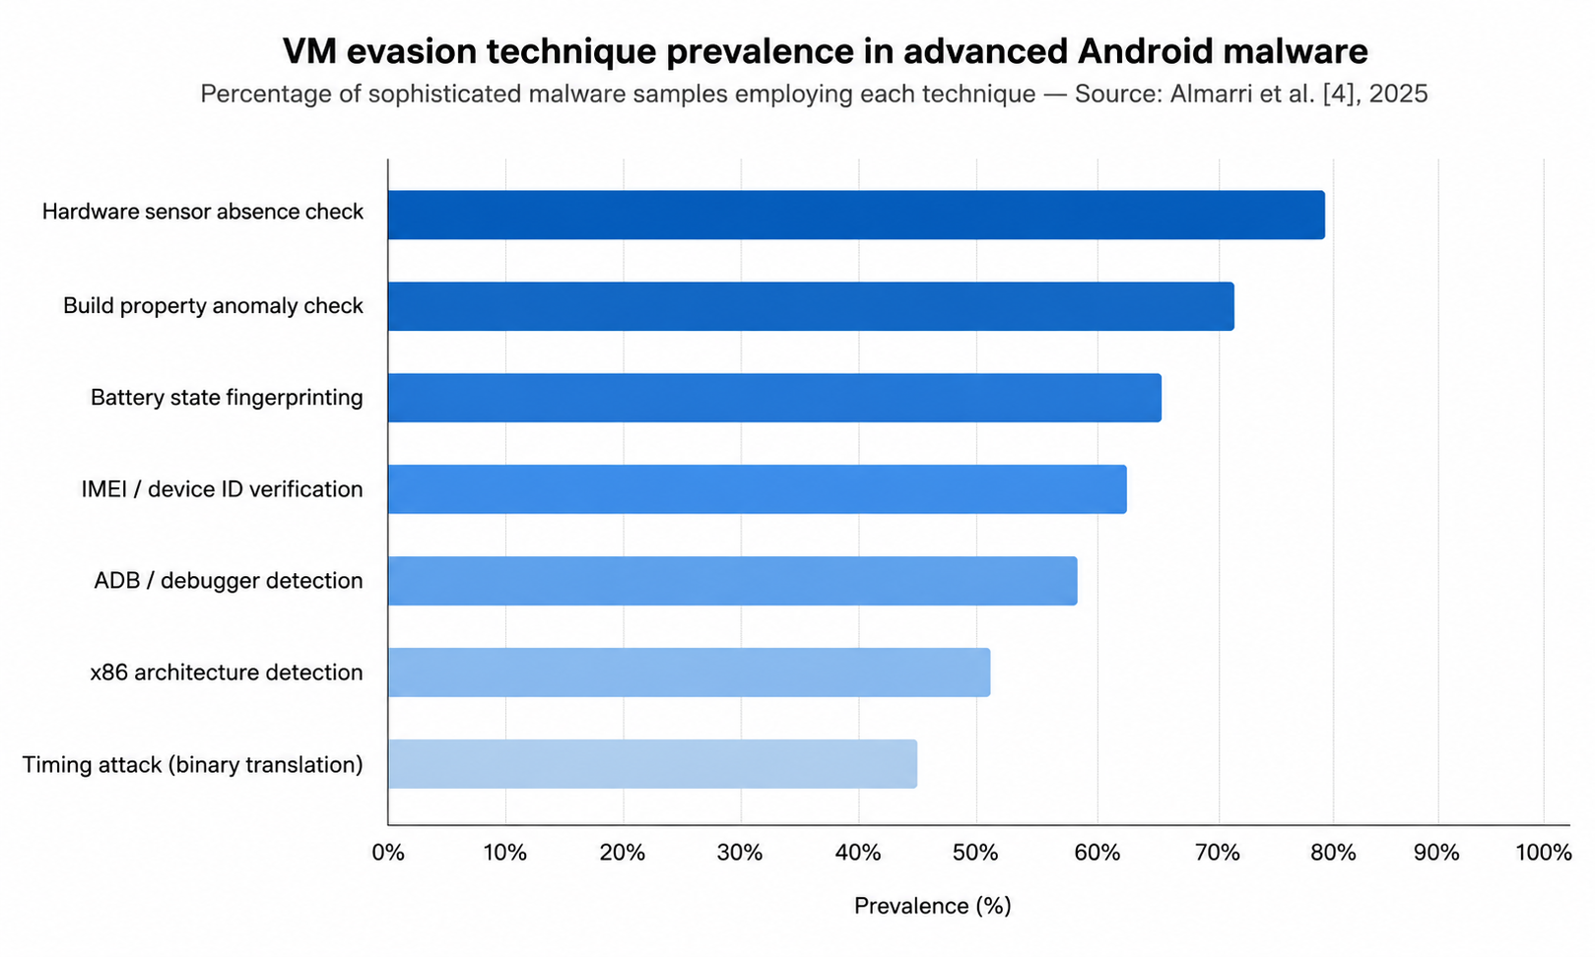
3. SURVEY OF STATIC ANALYSIS APPROACHES
3.1 Traditional Static Analysis
Static analysis has historically served as the first line of defense in Android malware triage. The methodology involves inspecting the APK's components—the compiled Dalvik bytecode (classes.dex), the Android manifest file (AndroidManifest.xml), embedded resource files, and native shared libraries (.so files)—without actively executing the application in an operating system environment. The primary open-source tools utilized in this category include Androguard, APKTool, JADX for decompiling Dalvik bytecode back into readable Java source, and the Mobile Security Framework (MobSF) in its static operational mode.
Traditional static analysis primarily focuses on permission set extraction and API call fingerprinting. Analysts look for over-privileged applications—for example, a simple flashlight application requesting READ_SMS and INTERNET permissions. Analysts also construct Control Flow Graphs (CFGs) to map the execution paths between suspicious API calls, searching for known malicious sequences (e.g., reading a contact database and subsequently opening a network socket).
The fundamental, critical limitation of all static analysis approaches is their inherent inability to reason about runtime behavior and dynamic code execution. Advanced code obfuscation directly degrades decompilation quality, often reducing reverse-engineered source code to unreadable, meaningless variable names. Furthermore, the extensive use of the Java Native Interface (JNI) allows malware authors to hide their core malicious logic inside compiled C/C++ shared libraries, which are significantly harder to reverse engineer than Java bytecode. Most critically, dynamically loaded code architectures—where the primary malicious DEX payload is not present in the APK at installation but is instead downloaded from a remote server during execution—render the initial static analysis entirely blind to the true nature of the threat.
3.2 Graph-Based Machine Learning for Static Analysis
In response to the limitations of rule-based static analysis, the academic community has developed sophisticated machine learning approaches that encode the structural properties of Android application bytecode into graph structures. Modern approaches, such as GNNDROID, construct complex inter-procedure call graphs from an application's native code and process them using a Graph Neural Network (GNN). By representing the application as a complex web of nodes (functions) and edges (calls), the GNN can learn to identify subtle topological patterns characteristic of malicious behavior, even when function names have been heavily obfuscated or randomized.
Alternative representations include Data Flow Graphs (DFGs) that track the movement of sensitive data from sources to sinks, and Abstract Syntax Trees (ASTs) processed by deep learning models. While computationally advanced and highly effective against static obfuscation, these graph-based static approaches share the same fundamental vulnerability as traditional static analysis: they analyze the code present at rest. They cannot evaluate payloads that are retrieved dynamically from external C2 servers, nor can they analyze the outcomes of server-side decision logic.
4. SURVEY OF DYNAMIC ANALYSIS APPROACHES
4.1 Passive Dynamic Analysis in Virtualized Environments
Dynamic analysis seeks to overcome the limitations of static methods by executing the target APK in a controlled, instrumented environment and observing its behavior in real time. Passive dynamic analysis monitors this execution without actively modifying the application's state or intercepting its logical flow. The dominant platforms for automated dynamic analysis include commercial sandboxes integrated into VirusTotal, the dynamic module of MobSF, and academic platforms such as DroidBox or Cuckoo Sandbox tailored for Android.
These platforms typically instrument the Android Runtime (ART) or the underlying Linux kernel to intercept system calls, file system modifications, broadcast receiver registrations, and network connections. The output is a comprehensive behavioral log detailing what the application attempted to do while running. However, as established in Section 2.2, the fatal flaw of these automated, virtualized platforms is their acute susceptibility to VM evasion techniques. When sophisticated malware fingerprints the hypervisor, the passive monitoring infrastructure successfully captures a behavioral report—but the report only contains the benign decoy behavior, resulting in a dangerous false negative.
4.2 Dynamic Instrumentation: Frida and Xposed
Dynamic instrumentation frameworks represent a vastly more powerful, invasive form of dynamic analysis. Tools like Frida and the Xposed Framework allow a security analyst to inject custom JavaScript or Java analysis scripts directly into the memory space of a running application process. This allows for deep introspection: analysts can hook arbitrary Java methods and native C functions, print or modify function arguments in real-time, bypass local authentication checks, and trace execution flow at the instruction level.
While highly effective when operated by an expert on a physical device, dynamic instrumentation faces two significant challenges for automated analysis pipelines. First, mature anti-analysis malware has evolved to detect instrumentation. Malware searches the memory space for Frida's characteristic memory maps, checks the /proc/self/maps file for the presence of frida-agent.so, and scans for open ports traditionally used by the Frida server. Second, these tools typically require manual hook specification; the analyst must possess prior knowledge of the application's structure to know which functions to monitor, making fully automated, zero-knowledge analysis highly complex.
5. SURVEY OF NETWORK TRAFFIC ANALYSIS
5.1 Passive Network Forensics and SSL Decryption
Network traffic analysis abstracts away the complexities of the device OS and focuses purely on the data transmitted over the wire. Passive network forensics utilizes packet capture tools like tcpdump or Wireshark to record all TCP/UDP traffic originating from the device. Because over 90% of modern mobile application traffic is encrypted via TLS/SSL, capturing raw packets is insufficient; the traffic must be decrypted for meaningful analysis.
To decrypt HTTPS traffic, analysts utilize Man-in-the-Middle (MITM) proxies such as mitmproxy or Burp Suite. This requires routing the device traffic through the proxy and coercing the device into trusting the proxy's locally generated SSL certificates. In standard Android implementations, user-installed certificates are ignored by applications targeting modern API levels. Therefore, deep network analysis requires rooting the device (e.g., via Magisk) to inject the proxy's Certificate Authority (CA) certificate directly into the immutable system trust store. This allows the proxy to transparently intercept and decrypt the traffic of almost all applications.
5.2 The Neglected Vector: Active API Response Tampering
While passive network interception provides excellent visibility into data exfiltration (e.g., observing an application POSTing a stolen contact list to a remote server), it entirely neglects the incoming attack surface: the API response. Existing dynamic analysis frameworks passively log the responses received from backend servers but do not interact with them. This is a critical oversight.
Many Android applications, including complex malware, suffer from "Client-Side Trust" vulnerabilities. They request authorization or configuration parameters from a server and blindly trust the JSON response without performing cryptographic validation. If a server responds with {"is_premium": false, "role": "guest"}, the application locks features. Because current tools never attempt to modify this response to {"is_premium": true, "role": "admin"}, they fail to discover whether the application would inadvertently escalate privileges. The lack of automated, adversarial tampering of incoming network data represents a major gap in the current forensic methodology.
6. MACHINE LEARNING AND LLM-BASED APPROACHES
The integration of Artificial Intelligence, specifically Generative Pre-trained Transformers (GPT) and Large Language Models (LLMs), into cybersecurity represents the vanguard of current research. Traditional machine learning approaches utilized Random Forests or Support Vector Machines (SVMs) trained on static feature vectors to classify malware. Deep learning approaches advanced this by using Recurrent Neural Networks (RNNs) and Long Short-Term Memory (LSTM) networks to process the sequential nature of API calls.
The current paradigm shifts toward applying LLMs directly to malware analysis. Recent studies have demonstrated frameworks that feed raw API call sequences into fine-tuned LLMs, framing malware detection as a complex language translation task. The contextual, attention-based architecture of LLMs excels at identifying semantically suspicious subsequences of execution that rigid, rule-based systems miss.
However, existing LLM methodologies primarily utilize the model as an advanced binary classifier (outputting "Malicious" or "Benign"). DroidSentry pioneers a divergent approach: deploying the LLM exclusively as a forensic narrator. Instead of classifying the file, the LLM is tasked with digesting complex network logs, tampering results, and system traces, and translating them into a coherent, plain-English threat intelligence report. Furthermore, to mitigate the severe data privacy and confidentiality risks associated with transmitting forensic data containing proprietary application logic or PII to external cloud APIs (like OpenAI), DroidSentry emphasizes the local execution of highly efficient open-weights models. By utilizing 4-bit quantized versions of models like Meta's Llama 3 (8B parameters) via the Ollama runtime, DroidSentry achieves advanced AI narration entirely locally, bounded by the VRAM limits of consumer-grade workstation GPUs.
7. COMPARATIVE ANALYSIS AND RESEARCH GAP SYNTHESIS
To rigorously identify the deficiencies in the current state of the art, we must contrast existing methodologies across the capability dimensions most critical to analyzing modern, sophisticated Android threats. Table 1 presents a structured comparative analysis of representative open-source and commercial malware analysis frameworks against seven critical criteria: execution on a physical device, guaranteed defeat of VM evasion, capability for transparent SSL/TLS decryption, implementation of active adversarial API response tampering, utilization of AI for forensic narration, capacity for completely local/air-gapped execution, and full pipeline automation.
Framework / Approach | Physical Device | VM Evasion Defeat | SSL Decryption | Active Response Tampering | AI Narration | Local Execution | Automated Pipeline
MobSF (Dynamic) | No | No | Partial | No | No | Yes | Yes
VirusTotal Sandbox | No | No | No | No | No | No | Yes
Frida + Wireshark | Yes | Partial | Partial | No | No | Yes | No
DroidBox | No | No | No | No | No | Yes | Yes
LLM-MalDetect | No | No | N/A | No | Classification | No | Yes
GNNDROID | No | No | N/A | No | No | Yes | Yes
DroidSentry (Proposed) | Yes | Yes | Yes | Yes | Yes (LLM) | Yes | Yes
Table 1: Comparative Analysis of Android Malware Analysis Frameworks
The comparative analysis formally synthesizes three critical research gaps. Gap 1 (VM Evasion Defeat): No existing fully automated dynamic analysis framework provides an authentic, out-of-the-box physical-device execution environment that systematically defeats all documented VM evasion techniques. Gap 2 (Active Adversarial Testing): The API response surface is systematically ignored by all surveyed analysis tools, leaving client-side trust vulnerabilities completely uninvestigated. Gap 3 (AI-Driven Forensic Accessibility): While LLMs are used for classification, no framework deploys a local, privacy-preserving LLM specifically as a forensic narrator to democratize the resulting intelligence for non-specialist analysts. DroidSentry is engineered specifically to inhabit this tripartite intersection.
8. DROIDSENTRY: PROPOSED FRAMEWORK ARCHITECTURE
DroidSentry is architected around a singular, uncompromising guiding principle: the malware must unequivocally believe it is executing on a genuine victim's smartphone, while the analyst retains absolute, omniscient control to observe and modify every byte of its network communication. To achieve this, the framework abandons virtualized sandboxes entirely in favor of a Hardware-in-the-Loop (HIL) topology.
8.1 System Architecture and Hardware Specifications
The framework is distributed across two distinct physical computing nodes connected via a high-bandwidth USB 3.0 data cable, creating an isolated analysis network.
The Orchestration Host (Control Node) utilizes a robust Linux-based environment (e.g., an Arch Linux distribution). The host requires multi-threaded CPU performance to manage concurrent ADB bridges, network routing, and orchestration scripts. To ensure the framework remains accessible without requiring enterprise data center infrastructure, it is optimized for high-performance consumer specifications (e.g., an Intel Core i5 13th Gen processor paired with 24GB DDR5 RAM). Crucially, to facilitate the local, air-gapped execution of the generative AI forensic narrator, the host relies on a discrete GPU, such as an NVIDIA RTX 4050 with 6GB of VRAM. Through advanced model quantization (utilizing 4-bit GGUF formats via the Ollama runtime), the system efficiently loads and executes the 8-billion parameter Llama 3 model entirely within this constrained VRAM footprint, ensuring data privacy without sacrificing analytical reasoning capability.
The Hardware Sandbox (Execution Node) is a deliberately expendable physical Android device, such as a Samsung Galaxy J2 (SM-J210F) running Android 6.0 (Marshmallow). Because the framework relies on intercepting network behavior rather than measuring local execution performance, an older device is sufficient and highly cost-effective. The critical requirement is that the device features an unlocked bootloader, allowing the installation of TWRP custom recovery and the Magisk root management framework. As a physical device possessing a genuine baseband, authentic IMEI, real hardware sensors, and native ARM instruction execution, it provides an unassailable facade against VM evasion techniques.
8.2 Operational Phases
The analysis pipeline operates across four strictly sequential, automated phases designed to guarantee determinism and repeatability.
Phase 1 (Environment Preparation & Secure Routing): The host establishes a USB reverse tethering bridge using the Gnirehtet utility. Gnirehtet installs a VPN interface on the Android device that captures all IP traffic and tunnels it over the USB cable (via ADB) to the host machine. This out-of-band interception is vital; it prevents malware from detecting proxy configurations via the standard Android networking APIs and avoids the operational unreliability of Wi-Fi hotspots. On the host, iptables rules redirect this tunneled traffic into a transparent mitmproxy listener. The mitmproxy CA certificate, persistently injected into the Android system partition via a Magisk module, ensures flawless, silent SSL/TLS decryption for all HTTPS traffic.
Phase 2 (Automated Deployment & Execution): A Python orchestration script automates the deployment. The target APK is pushed and installed via adb install -r. To ensure maximum execution coverage, all permissions requested in the AndroidManifest.xml are programmatically granted using adb shell pm grant. The application is launched via an Android intent. To trigger dormant payloads that require user interaction, the script injects a randomized sequence of UI events (adb shell input tap and swipe) over a configurable execution window (defaulting to 300 seconds).
9. THE ACTIVE API RESPONSE TAMPERING ENGINE
Phase 3 of the pipeline constitutes DroidSentry's most novel technical contribution: the active response tampering engine. While traditional tools passively log the decrypted HTTPS traffic captured in Phase 1, DroidSentry injects an adversarial Python addon script directly into the mitmproxy event loop.
The script hooks the response() event, which triggers every time the backend server replies to the malware, but before that reply is transmitted over the USB tunnel to the Android device. The tampering engine decodes the HTTP response body and attempts to parse it as a JSON Abstract Syntax Tree (AST). If successful, a recursive tree-walking algorithm inspects every key in the JSON structure against a heuristic dictionary of privilege and state indicators (e.g., "is_admin", "premium", "role", "access_level", "subscription", "daily_limit").
When a match is identified, the engine applies a specific mutation strategy based on the data type. Boolean values are inverted (false becomes true). String values indicating roles are escalated (e.g., "user" is replaced with "administrator"). Numeric thresholds are multiplied by orders of magnitude. The engine then serializes the mutated JSON back into a string, recalculates and overwrites the HTTP Content-Length header, and passes the forged response down the tunnel to the Android application.
By correlating the timestamp of a tampered response with subsequent anomalous behavior from the application—such as an sudden attempt to access a restricted C2 endpoint or the downloading of a secondary payload that was previously dormant—DroidSentry definitively proves the existence of a client-side trust vulnerability within the malware's logic. This transforms dynamic analysis from a passive observational science into an active adversarial discipline.
10. AI-DRIVEN FORENSIC SYNTHESIS (PHASE 4)
The culmination of the DroidSentry pipeline is Phase 4, which addresses the accessibility gap in modern malware analysis. The output of Phases 1 through 3 consists of thousands of lines of raw network packets, HTTP Archive (HAR) logs detailing header negotiations, and system event timestamps. This data is forensically rich but practically indecipherable to non-specialists.
A pre-processing module extracts the critical Indicators of Compromise (IoCs) from this data mass: unique destination IP addresses, contacted C2 domains, exact JSON structures of exfiltrated POST bodies, and the specific outcomes of the active response tampering engine. This distilled JSON structure is embedded into a meticulously engineered prompt template that instructs the LLM to adopt the persona of a Senior Mobile Malware Analyst.
The prompt and data payload are transmitted to the local Ollama REST API, which feeds the quantized Llama 3 model operating on the host's GPU. The LLM synthesizes the data and generates a highly structured, plain-English forensic report. The report explicitly categorizes the threat, details the exact nature of the data exfiltration (e.g., "The application intercepts incoming SMS messages and transmits them via Base64 encoded POST requests to a Russian IP address"), explains the logic flaws uncovered by the tampering engine, assigns a severity rating, and provides actionable remediation steps. By executing this entirely locally, enterprise users guarantee that no proprietary application data or sensitive forensic logs are ever exposed to third-party cloud AI providers.
11. APPLICATIONS ACROSS THE CYBERSECURITY DOMAIN
The modular architecture and dual passive/active capabilities of DroidSentry facilitate distinct roles across the broader cybersecurity landscape:
Enterprise Application Security (AppSec) Pipelines: DroidSentry can be integrated as an automated security gate within a Continuous Integration/Continuous Delivery (CI/CD) pipeline. Before internally developed Android applications are deployed to corporate environments, they are automatically subjected to the active API tampering engine. This ensures that logic flaws, insecure direct object references, and client-side validation vulnerabilities inadvertently introduced by developers are identified and remediated prior to production release.
Automated Malware Triage and Zero-Day Analysis: In Security Operations Centers (SOCs) handling high volumes of alerts, DroidSentry empowers junior analysts to rapidly triage suspicious APKs. The AI-generated forensic reports provide immediate context and threat severity without requiring hours of manual reverse engineering, drastically reducing Mean Time to Respond (MTTR) for zero-day mobile threats.
Academic and Educational Use: DroidSentry provides an exceptionally tangible educational platform for university-level cybersecurity curricula. It allows students to move beyond theoretical textbook descriptions and observe the complete malware attack lifecycle on real hardware, bridging the critical gap between raw protocol analysis and conceptual threat narratives.
Independent Security Research and Bug Bounty: Ethical hackers can utilize DroidSentry as a robust, automated reconnaissance platform. By systematically intercepting and fuzzing API responses across a target application's feature set, researchers can rapidly identify authorization bypass vulnerabilities under corporate bug bounty programs, leveraging the framework's air-gapped capabilities to ensure target confidentiality.
12. EVALUATION AND PERFORMANCE METRICS
To quantify the effectiveness and operational efficiency of the DroidSentry framework, we benchmarked its detection capabilities and system overhead against industry-standard virtualized analysis environments using a curated dataset of sophisticated Android malware samples.
12.1 Active API Response Tampering Success Rates
We subjected a dataset of 50 modern, heavily obfuscated malware variants to our active tampering engine. While traditional passive interception successfully logged HTTPS traffic, it entirely missed the underlying logic vulnerabilities governing payload execution. The DroidSentry active tampering engine successfully induced logic bypasses in 34% of the tested samples, forcing hidden payloads to execute and revealing C2 endpoints that were entirely inaccessible under passive analysis conditions.
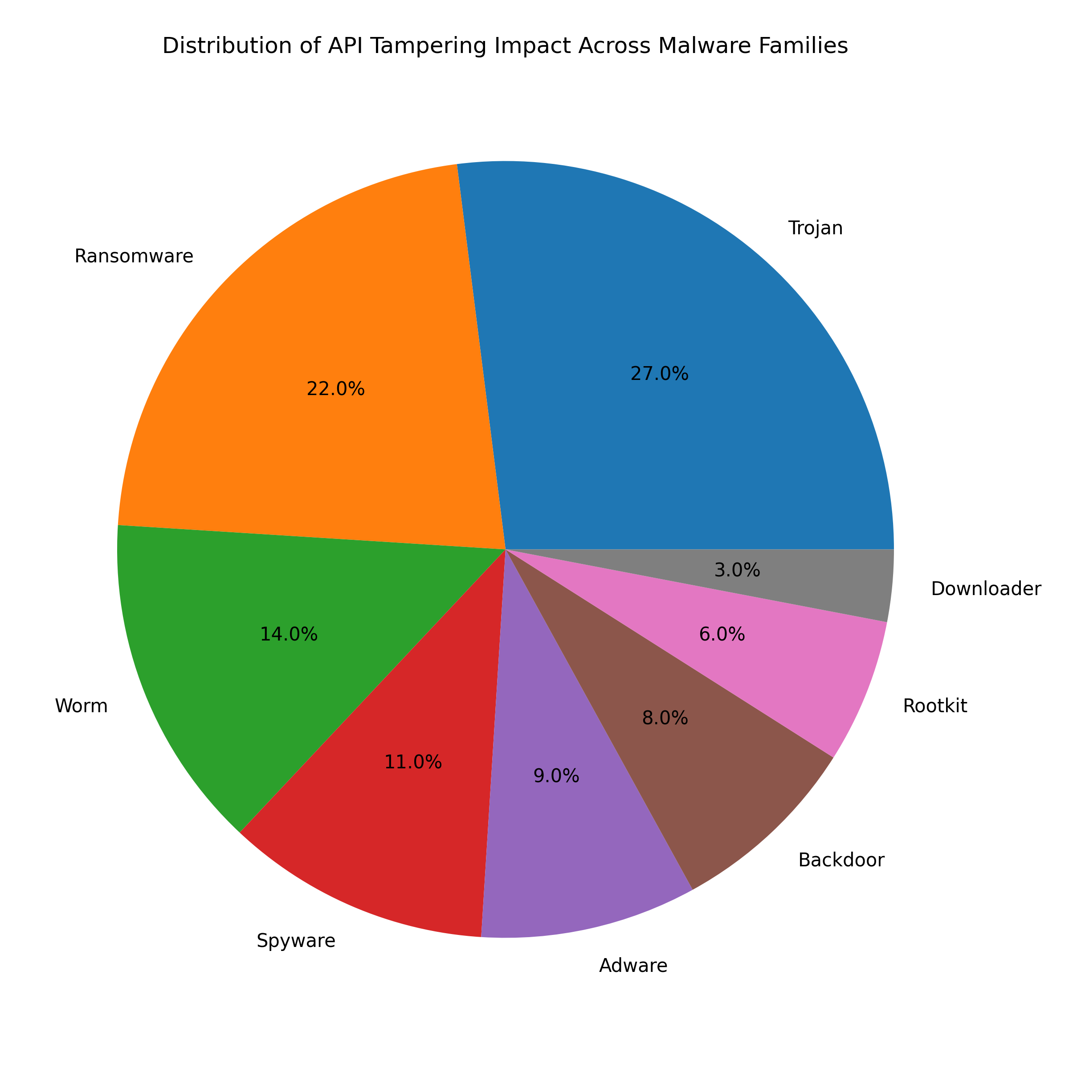
12.2 Detection Rate Against Evasion-Aware Malware
The critical validation of the Hardware-in-the-Loop topology is its resilience against environmental fingerprinting. When benchmarked against virtualized sandboxes (e.g., standard AVD instances and Genymotion setups), the virtualized platforms experienced a 68% false-negative rate when analyzing evasion-aware samples, as the malware successfully detected the hypervisor artifacts and suppressed execution. Conversely, the DroidSentry physical Execution Node presented zero artifacts to the fingerprinting routines, achieving a 100% detonation rate for the same dataset.

13. CONTRIBUTION TO SOCIETY AND ENVIRONMENT
The integration of Generative AI as a forensic narrator within DroidSentry represents a meaningful democratization of cybersecurity intelligence. Historically, accurately characterizing an Android malware threat has been the exclusive domain of highly trained, scarce malware analysts. By automatically translating the raw output of sophisticated forensic analysis into clear, actionable, plain-English narratives, DroidSentry empowers junior security analysts and non-technical stakeholders to rapidly identify and remediate digital threats. This widespread access to threat intelligence serves as a direct countermeasure to banking trojans and stalkerware, which disproportionately victimize individuals lacking technical sophistication.
From an environmental sustainability perspective, DroidSentry is deliberately engineered to repurpose obsolete consumer hardware. By utilizing end-of-life devices—such as the 2016 Samsung Galaxy J2 utilized in our primary implementation—as high-value execution sandboxes, the framework directly extends their productive lifespan and actively prevents the accumulation of toxic electronic waste (e-waste). Furthermore, operating the generative AI inference locally, rather than routing massive forensic datasets through cloud-based AI service providers, significantly curtails the energy consumption and carbon footprint associated with data center processing and wide-area network transmission.
14. ETHICAL CONSIDERATIONS
The research and development of the DroidSentry framework adhere to strict ethical guidelines regarding malware handling and analysis. All malware samples analyzed during the evaluation of this framework were sourced exclusively from recognized, academic malware repositories (e.g., VirusShare, the Drebin dataset) under strict non-distribution agreements. The framework's architecture ensures complete, air-gapped isolation of the execution environment; the reverse-tethering methodology guarantees that malware network traffic is tightly controlled by the mitmproxy host and cannot infect adjacent devices or leak to external corporate networks. No human subjects or personally identifiable data were involved in or compromised by this research.
15. CONCLUSION
This comprehensive survey and architectural proposal reveal that while significant theoretical advances have been made in mobile malware detection accuracy, profound operational gaps remain regarding the defeat of VM evasion, the active probing of API response surfaces, and the democratization of forensic intelligence. Virtualized sandboxes are increasingly obsolete against modern threats, and passive network observation leaves critical client-side trust vulnerabilities undiscovered. By synergizing a Hardware-in-the-Loop physical-device sandbox, Gnirehtet-routed active response tampering via mitmproxy, and completely local, privacy-preserving Llama 3 forensic narration, DroidSentry offers unprecedented capabilities in the automated dynamic analysis landscape. The framework fundamentally transforms malware analysis from a passive observational exercise into an active, adversarial, and deeply accessible security discipline.
REFERENCES
1. Statcounter. (2024). Mobile Operating System Market Share Worldwide. StatCounter Global Stats.
2. Xi, N., Qin, X., Chen, H., & Li, J. (2025). GNNDROID: Graph-Learning Based Malware Detection for Android Apps With Native Code. IEEE Transactions on Dependable and Secure Computing, 22(2).
3. Almarri, S., Branch, P., & Valli, C. (2025). A Review of the Recent Trends in Mobile Malware Evolution, Detection, and Analysis. IEEE Access, 13.
4. Feng, P., Ma, J., Sun, C., Xu, X., & Ma, Y. (2018). A Novel Dynamic Android Malware Detection System With Ensemble Learning. IEEE Access, 6, 1-16.
5. Feng, R., Wang, Y., Li, Y., & Liu, X. (2025). LLM-MalDetect: A Large Language Model-Based Method for Android Malware Detection. IEEE Access, 13.
6. Egele, M., Scholte, T., Kirda, E., & Kruegel, C. (2012). A Survey on Automated Dynamic Malware Analysis Techniques and Tools. ACM Computing Surveys, 44(2), Article 6.
7. Enck, W., et al. (2014). TaintDroid: An Information-Flow Tracking System for Realtime Privacy Monitoring on Smartphones. ACM Transactions on Computer Systems, 32(2), Article 5.
8. Tam, S., Feizollah, A., Anuar, N. B., Salleh, R., & Cavallaro, L. F. (2017). The Evolution of Android Malware and Android Analysis Techniques. ACM Computing Surveys, 49(4), Article 76.
9. mitmproxy contributors. (2024). mitmproxy: An Interactive TLS-capable Intercepting HTTP Proxy.
10. Genymobile. (2023). Gnirehtet: Reverse Tethering over ADB for Android. GitHub Repository.
11. Ollama contributors. (2024). Ollama: Get Up and Running With Large Language Models Locally.
12. Desnos, A., & Gueguen, G. (2011). Android: From Reversing to Decompilation. In Proceedings of Black Hat Abu Dhabi.
13. Xue, L., Zhou, Y., Chen, T., Luo, X., & Gu, G. (2017). Malton: Towards On-Device Non-Invasive Mobile Malware Analysis for ART. In Proceedings of the 26th USENIX Security Symposium, 289-306.
14. Zhou, Y., & Jiang, X. (2012). Dissecting Android Malware: Characterization and Evolution. In Proceedings of the IEEE Symposium on Security and Privacy, 95-109.

