Language Learning Strategies, Language Attitude, and Language Exposure: A Structural Equation Modeling Study of Motivation in Language Learning
Arturo T. Fernandez, Marilou Limpot
College of Teacher Education, Professional Schools, University of Mindanao, Davao City, Philippines College of Teacher Education, Professional Schools, University of Mindanao, Davao City, Philippines arturo.fernandez@umindanao.edu.ph, +639666949204
uoliramtopmil@gmail.com, +639514495628
ORCID ID: 0009-0004-0861-8101

ABSTRACT
This study aimed to determine the levels of language learning strategies, language attitude, and language exposure, and to examine their relationships and influence on motivation in language learning using Structural Equation Modeling (SEM). A quantitative, descriptive-correlational research design was employed. Results revealed that language learning strategies, language attitude, language exposure, and motivation in language learning were all at a very high level. Pearson correlation analysis showed significant and strong relationships among the three variables and motivation in language learning (p <
.01). Regression analysis further indicated that language learning strategies and language exposure had positive and significant effects on motivation, while language attitude demonstrated a significant effect depending on the direction of the relationship. Among the three generated models, Model 3 exhibited the best goodness-of-fit indices based on the criteria for CMIN/DF, GFI, CFI, NFI, TLI, RMSEA, and P-close, indicating that the structural relationships among variables were statistically sound and empirically supported. The findings suggest that motivation in language learning is shaped by the interaction of cognitive, affective, and environmental factors. Therefore, strengthening effective learning strategies, fostering positive language attitudes, and increasing meaningful language exposure are essential in enhancing students’ motivation and overall language learning outcomes.
Keywords: Language Learning Strategies; Language Attitude; Language Exposure; Language Learning Motivation; Structural Equation Modeling (SEM); Education

INTRODUCTION
The lack of motivation in language learning is a significant barrier that may result in failure among students despite their efforts. When students do not understand the importance of studying a language they are currently learning or fail to see a clear personal goal, they easily lose interest (Dörnyei & Ushioda, 2013). Because of this, it becomes a challenge for language teachers and researchers to develop effective strategies to sustain students’ interest and perseverance in their learning.
Motivation is an important factor in successful language learning because it drives learners to continue striving to achieve higher levels of proficiency. According to Dörnyei (135–136), learners with high motivation are less likely to give up and are more likely to achieve positive results. Strategies in language learning are also closely related to motivation in learning a language through participation and active engagement in the learning process (Vygotsky, 23–33; Johnson & Johnson, 125–133). In terms of attitude, strategies for managing attitudes also play a role in language learning. According to Horwitz et al. (125–132) and MacIntyre & Gardner (283–305), learners who experience reduced anxiety in language learning and have positive attitudes are more motivated to use the language. Finally, exposure to language is an important strategy that positively affects motivation in language learning. According to Dörnyei (141–145), learners who are frequently exposed to the language through media, immersion, and social interaction become more interested and engaged in using the language.
While many studies recognize the important role of language learning strategies, attitudes, and language exposure in shaping language learning motivation (Dörnyei, 2001; Gardner & Lambert, 1972; Oxford,

1990; Noels et al., 2000; Pelayo & Napil, 2025), there is still limited and localized literature examining the relationships among these factors, particularly in the context of senior high school students enrolled in Filipino subjects in Region XI. Because of this, there remains a need for studies that determine how strategies, attitudes, and exposure influence students’ motivation in learning Filipino.
According to the Socio-Educational Model of Gardner and Lambert (1972), motivation in language learning is divided into two main types: integrative and instrumental motivation. Integrative motivation refers to a learner’s desire to become part of the target language community, while instrumental motivation focuses on practical goals such as obtaining a job or passing examinations. The model highlights that motivation is not only a personal interest but is also deeply connected to social context and learning goals. In the study of Noels et al. (2000), the role of self-determination theory in language learning was also recognized, where intrinsic motivation—based on personal interest—is considered more powerful than extrinsic motivation. Figure 1 shows conceptual framework of the comprehensive structural model of motivation in language learning.

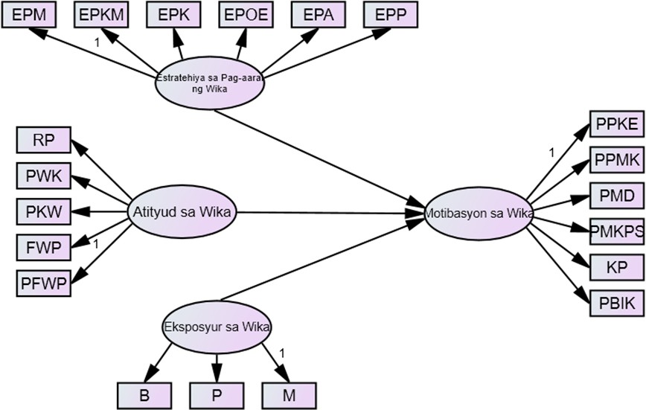

Figure 1. Conceptual Model Showing the Direct Relationship among Latent Exogenous Variables
This study aims to design the most appropriate model of learners’ motivation in language learning. Specifically, it seeks to determine the levels of language learning strategies among senior high school students in terms of memory strategies, cognitive strategies, metacognitive strategies, compensatory strategies, organizational strategies, affective strategies, and social strategies. It also aims to determine the level of attitude toward language learning among senior high school students in terms of cultural realism, respect for language and culture, the perceived importance and value of language, Filipino posture toward the global language (FWP), anxiety, positive attitude, and the level of language exposure of senior high school students in their homes, schools, and media.
Furthermore, the study aims to determine the level of learners’ motivation through integrative and instrumental motivation. It also seeks to examine the significant relationships between language learning strategies and motivation, attitude and motivation, and language exposure and motivation. In addition, the study investigates the combined influence of language learning strategies, attitude toward language, and language exposure on learners’ motivation. Finally, it aims to identify the most appropriate model of motivation in language learning among senior high school students.

This study aims to explore and explain the relationships among strategies, attitudes, and exposure to language in shaping students’ motivation in language learning. Through the development of a structural model, the study is expected to contribute significantly to the field of education, particularly in the teaching and learning of the Filipino language. Moreover, it supports the attainment of SDG 4: Quality Education, which emphasizes inclusive and equitable quality education for all.

METHOD
In this study, the researcher selected Senior High School students from public schools as respondents. A total of 450 students from various public secondary schools in Region XI served as participants. The required sample size was determined using the Raosoft sample size calculator to ensure adequate and appropriate data (Adam, 90–97). The respondents were chosen through stratified random sampling, where samples were drawn from different strata of the population involved in the study using Raosoft. This method was employed to ensure proper representation, particularly since the population was assumed to be heterogeneous (Parsons 1–11; Yıldız, Akdoğu, Demir, & Gelbal 795–824).
The study utilized survey questionnaires adapted from various previous studies developed by different researchers and modified to suit the current research context. The questionnaires were revised to ensure contextualization in terms of content, the appropriateness of the most relevant items, and proper alignment with the meaning of the statements or questions from the original instruments to make them clear, comprehensive, and meaningful to the respondents. The instrument underwent content validation and pilot testing.
The research instrument consisted of four parts. First, language learning strategies were adapted from the study of Cwagdan, Curto, H., and Rivera, E. (2018), which included 50 items divided into eight systems. Second, attitude toward language was adapted from the study of Marefat, F., and Paktazian, M. (2017), which contained 28 items divided into five systems. Third, language exposure was adapted from the study of Magno, Carlo F., Hilto, Moises E., Lajom, Jennifer E., Regodon, Joanne A., and Buangan, Kaye (2009), consisting of 20 items divided into three systems. Finally, motivation in language learning was adapted from the study of Jämielä Dastmardi (2008), which comprised two parts with a total of 25 items.Ang pag-aaral na ito ay gumamit ng disenyo na non-experimental kwantitatib na pag-aaral, na gumamit ng Structural Equation Model.
This approach is considered the most appropriate method for the study because it enables the collection of various types of data to measure the strategies, attitudes, and exposure of learners in Filipino. The researcher used confirmatory factor analysis (CFA), regression models, and complex path models to determine the most suitable and best-fitting model of motivation in language learning. These statistical techniques allow for the identification of the model that best explains communicative competence (Ullman & Bentler, 73–84). The goodness-of-fit statistics for the alternative models were analyzed using Analysis of Moment Structures (AMOS). In determining the best-fitting model, all relevant fit indices must meet the required criteria and standards.
Chi Square/Degree of Freedom (CMIN/DF)
0 < value < 2
P Value
>.05
Normative Fit Index (NFI)
>.95
Comparative Fit Index (CFI)
>.95

Goodness of Fit Index (GFI)
>.95
Tucker-Lewis Index
>.95
Root Mean Square Error of Approximation (RMSEA)
<.05
P-close
<.50

RESULTS AND DISCUSSION

Level of Language Learning Strategies among Senior High School Students
Table 1 presents the overall level of language learning strategies, which yielded a mean score of 4.36 (M = 4.36, SD = 0.33). This indicates a very high and consistent use of language learning strategies among the students in their language learning process. The low standard deviation suggests that the responses of the participants were closely clustered around the mean, reflecting relatively uniform perceptions and practices in the use of strategies.
These findings imply that students possess a strong foundation in applying appropriate strategies to enhance their language skills. The results further suggest that senior high school students are actively and effectively utilizing various strategies to support their learning and improve their proficiency in the language.

Indicators SD Mean Descriptive
Level
Memory Strategies | 0.32 | 4.40 Very High
Cognitive and Metacognitive Strategies | 0.36 | 4.35 Very High
Compensation Strategies | 0.36 | 4.37 Very High
Organization and Evaluation Strategies | 0.35 | 4.33 Very High
Affective Strategies | 0.37 | 4.31 Very High
Social Learning Strategies | 0.32 | 4.41 Very High
Total | 0.33 | 4.36 Very High

Table 1. Level of Language Learning Strategies Level of Attitude toward Language among Senior High School Students
Table 2 shows that the overall level of attitude toward language among the participants is Very High (M
= 4.36, SD = 0.73). This indicates that the students hold positive and strong perceptions and appreciation of the language. The moderate standard deviation suggests slight variation in the respondents’ answers; however, their attitudes remain generally high and relatively consistent. These findings imply that students recognize the important role of language in their identity, experiences, and social interactions.

Indicators SD Mean Descriptive Level
Cultural Realism | 0.71 | 4.40 Very High
Respect for Language and Culture | 0.74 | 4.34 Very High
Valuing the Importance of Language | 0.75 | 4.33 Very High
Filipino as the National Language | 0.72 | 4.38 Very High
Appreciation of FWL | 0.74 | 4.34 Very High

Total 0.73 4.36 Very High

Table 2. Level of Attitude toward Language
Level of Language Exposure among Senior High School Students
Table 3 shows that the overall level of language exposure among the participants is Very High (M = 4.35, SD = 0.33). This indicates that students are frequently exposed to the language in various contexts of their daily lives. The low standard deviation suggests that the respondents’ experiences with using and hearing the language are relatively similar. In such a situation, opportunities for the continuous development of their language skills become stronger and more sustained.
\

Indicators SD Mean Descriptive
Level

Home |  | 0.35 | 4.35 Very High
Friends |  | 0.40 | 4.40 Very High
School |  | 0.40 | 4.29 Very High
Media |  | 0.34 | 4.36 Very High
 | Total | 0.33 | 4.35 Very High

Table 3. Level of Language Exposure

Level of Motivation in Language Learning among Senior High School Students
Table 4 presents the level of motivation in language learning based on two dimensions: integrative motivation and instrumental motivation. The results show that integrative motivation has a mean of 4.36 (SD = 0.33), while instrumental motivation has a mean of 4.38 (SD = 0.33). Both dimensions fall under the descriptive level of “Very High.” The overall mean of 4.37 (SD = 0.32) indicates that the participants demonstrate a very high level of motivation in language learning. The low standard deviation further suggests that the responses of the participants are relatively consistent and closely clustered around the mean.

Indicators | SD | Mean | Descriptive Level
Integrative Motivation | 0.33 | 4.36 | Very High
Instrumental Motivation | 0.33 | 4.38 | Very High
Total | 0.32 | 4.37 | Very High

Significant Influence of Language Learning Strategies, Attitude toward Language, and Language Exposure on Motivation in Language Learning among Senior High School Students

Table 5 presents the overall influence of language learning strategies, attitude toward language, and language exposure on students’ motivation in language learning using multiple regression analysis. The results show that language learning strategies (B = .845, β = .880, p = .000) and language exposure (B
= .762, β = .802, p = .000) have a positive and significant combined influence on motivation in language

learning. This indicates that as students increase their use of appropriate language learning strategies and experience greater exposure to the language, their level of motivation also increases. The findings further support the idea that students who apply effective language learning strategies tend to develop greater active participation and stronger interest in language learning (Oxford, 2017).

Pagganyak sa Pagkatuto sa Wika
(Variables) |  | B | β | t | Sig.
Constant |  | .189 |  | 2.817 | .006
Estratehiya sa Pag-aaral ng |  | .845 | .880 | 6.905 | .000
Wikat
Atityud sa Wika |  | -.647 | -.706 | -6.238 | .000
Eksposyur Wika | sa | .762 | .802 | 13.309 | .000
R | .982
R2 | .965
∆R | .964
F | 1,366.482
ρ | .000

Table 5. Significant Influence of Language Learning Strategies, Attitude toward Language, and Language Exposure on Motivation in Language Learning
Summary of Goodness of Fit Measures of the Three Generated Models
Table 9 presents the goodness-of-fit measures of the three proposed models used to determine which model best fits the data. Based on the results, both Model 1 and Model 2 did not meet most of the fit indices. Their CMIN/DF values (6.173 and 4.774) exceeded the recommended value of 2, and their GFI, CFI, NFI, and TLI were below the acceptable threshold of .95.These findings indicate that the two models did not adequately represent the relationships among the variables and therefore require revision or modification to achieve a better fit with the data.
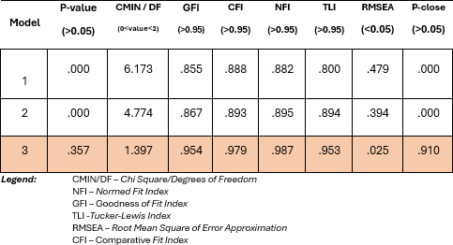

Table 6. Summary of Goodness of Fit Measures of the Three Generated Models Regression Weights of the 3 Generated Models
Table 7 presents the regression weights of the three developed models that examine the relationships among the exogenous variables—language learning strategies, attitude toward language, and language exposure—and the endogenous variable. In Model 1, language learning strategies (.050**) and language exposure (1.689**) show positive and significant effects, while attitude toward language (-4.162***) shows a negative but significant influence. This indicates that increased use of language learning

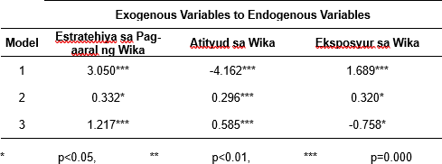
strategies and greater language exposure lead to higher levels of the outcome variable, whereas an unfavorable attitude may result in a negative effect on the outcome.

Table 7. Regression Weights of the 3 Generated Models Best-Fitting Model of Motivation in Language Learning
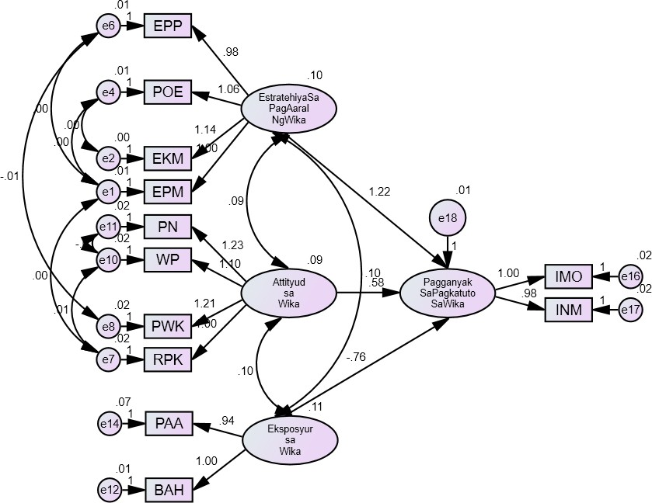
Figure 2 presents the most appropriate and best-fitting model based on the goodness-of-fit measures shown in the table. The CMIN/DF value falls within the recommended threshold (< 2), indicating a strong alignment between the proposed model and the actual data. Furthermore, the values of NFI, CFI, GFI, and TLI exceed the acceptable criterion of .95, suggesting that the model structure effectively represents the relationships among the variables. The low RMSEA value (< .05) and an acceptable p- value (> .05) indicate minimal model error and a strong fit with the data. According to Hu and Bentler, such results demonstrate that the model has strong empirical support in structural equation modeling.

Figure 2. Best Fit Model CONCLUSION AND RECOMMENDATION
Based on the goodness-of-fit measures, Developed Model 3 demonstrates the best fit to the data, highlighting the structural relationships among strategies, attitude, and language exposure as predictors of motivation in language learning, with strong empirical support. The model shows that motivation in language learning, as the endogenous variable, is directly influenced by the exogenous variables and reflects the overall learning experiences of students in language learning. Through the use of structural equation modeling, the study clearly explains the relationships among these factors and how they collectively influence students’ motivation (Schreiber et al., 323–338).

In this regard, it is recommended that teachers continue using communication-based and active learning strategies to sustain students’ high motivation. It is also important to strengthen students’ positive attitudes toward language by integrating culture into instruction. Moreover, the use of media and technology can serve as effective tools to broaden students’ language exposure and enhance their interest in learning.
Future researchers are encouraged to examine additional variables such as language anxiety, self- efficacy, and academic performance to gain a deeper understanding of motivation in language learning. Expanding the study to other educational levels may also help determine whether the developed model is applicable in different contexts. Ultimately, educational programs should continue to be designed and implemented to further strengthen students’ motivation and competence in language learning.

REFERENCES
Cawagdan–Cuarto, H., & Rivera, E. (2018). Influence of Language Learning Strategies to the English Proficiency Test Performance of College Students. JPAIR Multidisciplinary Research, 32(1), 149–
163. https://doi.org/10.7719/jpair.v32i1.580
Dörnyei, Zoltán, and Ema Ushioda. “Teaching and Researching Motivation.” Routledge, 2013. DOI: https://doi.org/10.4324/9781315833750
Dörnyei, Zoltán. Motivational strategies in the language classroom. Vol. 10. Cambridge: Cambridge University Press, 2001.
Gardner, R. C., & Lambert, W. E. (1972). Attitudes and Motivation in Second Language Learning.
Rowley, MA: Newbury House.
Horwitz, E. K., Horwitz, M. B., & Cope, J. (1986). Foreign language classroom anxiety. Modern Language Journal, 70(2), 125–132.
Johnson, D. W., & Johnson, R. T. (1999). Learning together and alone: Cooperative, competitive, and individualistic learning (5th ed.). Boston: Allyn & Bacon.
MacIntyre, P. D., & Gardner, R. C. (1994). The subtle effects of language anxiety on cognitive processing in the second language. Language Learning, 44(2), 283–305.
Magno, Carlo & Filho, Moisies & Lajom, Jennifer & Regodon, Joanne & Bunagan, Kay. (2009). Assessing the Level of English Language Exposure of Taiwanese College Students in Taiwan and the Philippines.
Marefat, Fahimeh, and Maryam Pakzadian. "Attitudes towards English as an International Language (EIL) in Iran: Development and validation of a new model and questionnaire." Iranian Journal of Applied Language Studies 9.1 (2017): 127-154
Noels, K. A., Pelletier, L. G., Clément, R., & Vallerand, R. J. (2000). Why are you learning a second language? Motivational orientations and self-determination theory. Language Learning, 50(1), 57– 85.
Oxford, Rebecca L. “Teaching and Researching Language Learning Strategies.” Routledge, 2017. DOI: https://doi.org/10.4324/9781315719146
Oxford, Rebecca L. Language Learning Strategies: What Every Teacher Should Know. Newbury House, 1990
Pelayre, G. N., & Napil, M. C. (2025). Exposure, Language Learning and Reading Strategies: A Structural Model for Grammatical Competence. Asian Journal of Advanced Research and Reports, 19 (5), 278–293. https://doi.org/10.9734/ajarr/2025/v19i51018
Schreiber, James B., et al. “Reporting Structural Equation Modeling and Confirmatory Factor Analysis Results: A Review.” The Journal of Educational Research, vol. 99, no. 6, 2006, pp. 323–338. DOI: https://doi.org/10.3200/JOER.99.6.323-338
Ullman, Jodie B., and Peter M. Bentler. "Structural equation modeling." Handbook of Psychology, Second Edition 2 (2012). 661.
Vygotsky, L. S. (1978). Mind in society: The development of higher psychological processes.
Cambridge, MA: Harvard University Press.

