A Comprehensive Review on Herbal Medicines with Therapeutics and Their Contemporary Pharmacological Importance

Abstract
Herbal medicines have been used for centuries as a natural approach for the prevention and treatment of various diseases. They are derived from plants and contain bioactive compounds that provide therapeutic effects. In recent years, herbal medicine has gained global attention due to increased interest in natural therapies, fewer side effects, and cultural acceptance. This review article discusses the history, classification, advantages, limitations, mechanisms of action, applications, and future prospects of herbal medicines.
Introduction:
Herbal medicine refers to the use of plant-derived materials such as leaves, roots, seeds, flowers, and bark for medicinal purposes. Traditional systems like Ayurveda, Traditional Chinese Medicine (TCM), Siddha, and Unani have relied heavily on herbs for healthcare management. According to the World Health Organization (WHO), a large proportion of the global population depends on herbal remedies for primary healthcare. Modern pharmaceutical research has also identified many plant compounds that are now used in conventional medicine.
History of Herbal Medicines
The use of medicinal plants dates back thousands of years. Ancient civilizations including Egyptians, Indians, Greeks, and Chinese documented herbal remedies in their medical texts.
Some important historical developments include:
* Ayurveda (India): Uses herbs like Ashwagandha, Tulsi, and Turmeric.
* Traditional Chinese Medicine: Employs Ginseng and Ginger.
* Greek Medicine: Hippocrates described medicinal properties of plants.
* Unani Medicine: Integrated herbal preparations for holistic healing.
Classification of Herbal Medicines
Herbal medicines can be classified based on their uses and origin:
1. Based on Therapeutic Action:
* Analgesics (pain relief)
* Anti-inflammatory agents
* Antimicrobial agents
* Antioxidants
* Immunomodulators
2. Based on Plant Parts Used:
* Leaves (Neem)
* Roots (Ginseng)
* Bark (Cinnamon)
* Seeds (Fenugreek)
* Flowers (Chamomile)
3. Based on Preparation:
* Decoctions
* Infusions
* Powders
* Capsules
* Essential oils
Common Herbal Medicines and Their Uses:
Herbal Plant | Scientific Name | Major Uses
Turmeric | Curcuma longa | Anti-inflammatory, antioxidant
Neem | Azadirachta indica | Antibacterial, skin disorders
Tulsi | Ocimum sanctum | Respiratory disorders, immunity
Ashwagandha | Withania somnifera | Stress reduction, adaptogen
Aloe vera | Aloe barbadensis | Wound healing, skin care
Ginger | Zingiber officinale | Nausea, digestion

Common Medicinal Plants:
Aloe Vera:
Two substances from Aloe vera a clear gel and its yellow latex – are used to manufacture commercial products. Aloe gel typically is used to make topical medications for skin conditions, such as burns, wounds, frostbite, rashes, psoriasis, cold sores, and dry skin. Aloe latex is used individually or manufactured as a product with other ingredients to be ingested for relief of constipation. Aloe latex may be obtained in a dried form called resin or as "aloe dried juice". There is conflicting evidence regarding whether Aloe vera is effective as a treatment for wounds or burns Topical use of aloe products may, according to some evidence, relieve symptoms of certain skin disorders, such as psoriasis, acne, or rashes, but may also cause an allergic reaction in some people and was connected in a 1991 trial with significantly delayed healing of obstetric sutures (Fu Y et al.2018 and Zhao, 2013). On the other hand, Aloe vera compared favourably to silver sulfadiazine in treating second- and third-degree burns in a 2022 meta-analysis and a 2023 review found it an effective basis for medical hydrogels. Aloe vera gel is used commercially as an ingredient in yogurts, beverages, and some desserts, but at high or prolonged doses, ingesting aloe latex or whole leaf extract can be toxic. Use of topical aloe vera in small amounts is likely to be safe. (Fig .1) (World Health Organization (WHO). Traditional Medicine Strategy).
Basil:
Basil is a tender, fragrant herb belonging to the mint family (Lamiaceae). It is widely used in cooking and traditional medicine and has dozens of varieties, each with its own unique flavor profile (Fu Y et al.2018 and Zhao, 2013).
Popular Varieties & Uses:
- Sweet / Genovese Basil: The most common variety used in Western cooking; it has large, sweet, peppery leaves and is the primary ingredient in pesto.
- Thai Basil: Features purple stems and a distinct licorice-anise flavor, ideal for Southeast Asian stir-fries and curries.
- Holy Basil (Tulsi): Has a spicy, clove-like flavor and is primarily used in herbal teas and Ayurvedic medicine (Fig.1).

Lemon Balm:
Lemon balm (Melissa officinalis) is a perennial herbaceous plant in the mint family. It grows to a maximum height of 1 m (3+¹⁄₂ ft). The species is native to south-central Europe, the Mediterranean, Central Asia, and Iran. It is naturalized worldwide. It grows easily from seed in rich, moist soil. Lemon balm grows vigorously from seed or vegetative fragments in temperate zones (Fu Y et al.2018 and Zhao, 2013). Key producing countries such as Hungary, Egypt, Ireland, and Italy cultivate a variety of cultivars for hand-harvested leaves and low-yield essential oils. It is used in Carmelite Water, as an ornamental plant, in perfumes and toothpaste, as a raw or cooked herb in various foods and teas, and aromatic essential oils (Fig.1).
Marigold:
The florets are edible. They are often included in salads for their colour or added to dishes as a garnish in lieu of saffron. While the leaves are also edible, they are generally not considered palatable, though historically they have been incorporated into potherb and salads. Additionally, the plant is utilized for making tea, Flowers were used in ancient Greek, Roman, Middle Eastern, and Indian cultures as a medicinal herb, as well as a dye for fabrics, foods, and cosmetics. Many of these uses persist today. They are also used to make an oil that is widely used in skin products (Fu Y et al.2018 and Zhao, 2013). Marigold leaves can also be made into a poultice that is believed to help scratches and shallow cuts to heal faster and to prevent infection. It has also been used in eye drops. Plant extracts are also widely used in cosmetics, presumably due to presence of compounds such as saponins, resins, and essential oils (Petitet, 2012). The flowers are a rich source of lutein, containing 29.8 mg/100g. (Fig.1)
Potential pharmacology:
Plant pharmacological studies have suggested that Calendula extracts may have anti-viral, anti-genotoxic, and anti-inflammatory properties in vitro.
Peppermint: Fresh or dried peppermint leaves are often used alone in peppermint tea or with other herbs in herbal teas (tisanes, infusions). Peppermint is used for flavouring ice cream, candy, fruit preserves, alcoholic beverages, chewing gum, toothpaste, and some shampoos, soaps, and skin care products (Petitet, 2012). Menthol activates cold-sensitive TRPM8 receptors in the skin and mucosal tissues, and is the primary source of the cooling sensation that follows the topical application of peppermint oil. (Fig.1).
Lavender: The pharmacology of the lavender plant (Lavandula angustifolia) centers primarily on its volatile essential oils, which exert powerful anxiolytic, sedative, anti-inflammatory, and neuroprotective effects (Petitet, 2012). Its primary therapeutic mechanism involves modulating neurotransmitter pathways in the central nervous system, mimicking standard clinical pharmaceutical actions (Fig.1) (Harborne JB. Phytochemical Methods).
Rosemary: There are a few different ways to use rosemary. A person can use the herb in cooking or make rosemary tea by steeping the herb in hot water and then drinking it. Rosemary essential oil can also be used by inhaling it, also known as aromatherapy, or applying it topically to the skin. To inhale, a person can put a few drops of the oil into an oil dispenser or a bowl of hot water before inhaling the steam. (Dori et al. 2020 and Petitet, 2012). Essential oils are highly concentrated, so it is best to dilute a few drops with a carrier oil, such as coconut or almond oil, before applying it to the skin. A person should never ingest essential oils. While research suggests there are health benefits, the FDA doesn’t monitor or regulate the purity or quality of essential oils (Kokate CK. Pharmacognosy). It’s important to talk with a healthcare professional before using essential oils and research the quality of a brand’s products. Always do a patch test before trying a new essential oil (Fig.1).
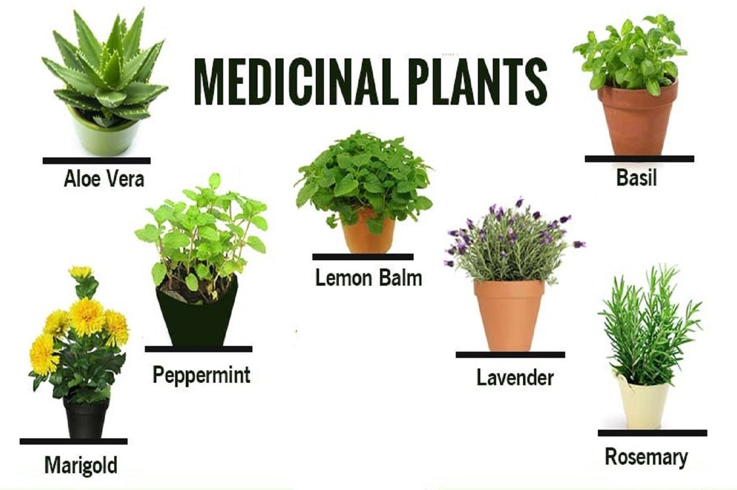
Fig:1 Photograph showing the different medicinal plants.
Mechanism of Action:

Herbal medicines contain phytochemicals such as alkaloids, flavonoids, tannins, glycosides, and terpenoids. These compounds exert therapeutic effects through:
* Antioxidant activity
* Modulation of immune responses
* Enzyme inhibition
* Antimicrobial effects
* Hormonal regulation
For example, curcumin from turmeric reduces inflammation by inhibiting inflammatory mediators.
Advantages of Herbal Medicines
1. Natural and culturally accepted
2. Easily available and cost-effective
3. Lower incidence of adverse effects
4. Suitable for chronic disease management
5. Rich source of bioactive compounds
Limitations and Risks
Despite their benefits, herbal medicines also have certain limitations:
* Lack of standardization
* Variation in active ingredients
* Possible contamination
* Drug-herb interactions
* Limited clinical evidence for some products
Improper dosage and self-medication may also lead to toxicity.
Role in Modern Healthcare:
Modern medicine increasingly incorporates herbal products into healthcare systems. Herbal formulations are widely used in:
* Nutraceuticals
* Cosmetic products
* Functional foods
* Alternative and complementary medicine
Research in pharmacognosy and phytochemistry continues to discover new therapeutic agents
Future Prospects:
The future of herbal medicine lies in:
* Scientific validation through clinical trials
* Standardization of herbal products
* Development of novel drug formulations
* Integration with conventional medicine
* Sustainable cultivation of medicinal plants
Biotechnology and nanotechnology may further improve the efficacy and safety of herbal formulations.
Herbal drugs and their preparations:
Traditional medicinal herbal drugs encompass various plant parts such as aerial parts, flowers, fruits, leaves, seeds, stems, and subterranean components like roots, bulbs, tubers, and rhizomes (Fu Y et al.2018 and Zhao, 2013). These materials exist in divers forms, including raw, fresh, dried, and extracts, with occasional use of entire dried plants (Fig.2) (Dori et al. 2020 and Petitet, 2012). They hold significant global importance in international trade, featuring noteworthy clinical, economic, health, and pharmaceutical value. The escalating recognition of their worth, whether justified or not, is contributing to a steady expansion of their market. However, comprehensive data concerning the quality, safety, and efficacy of numerous plants, their extracts, preparations, and active compounds remain limited. (Sahoo 2010) Ensuring their quality is of paramount importance to guarantee their safety and effectiveness (Petitet, 2012).
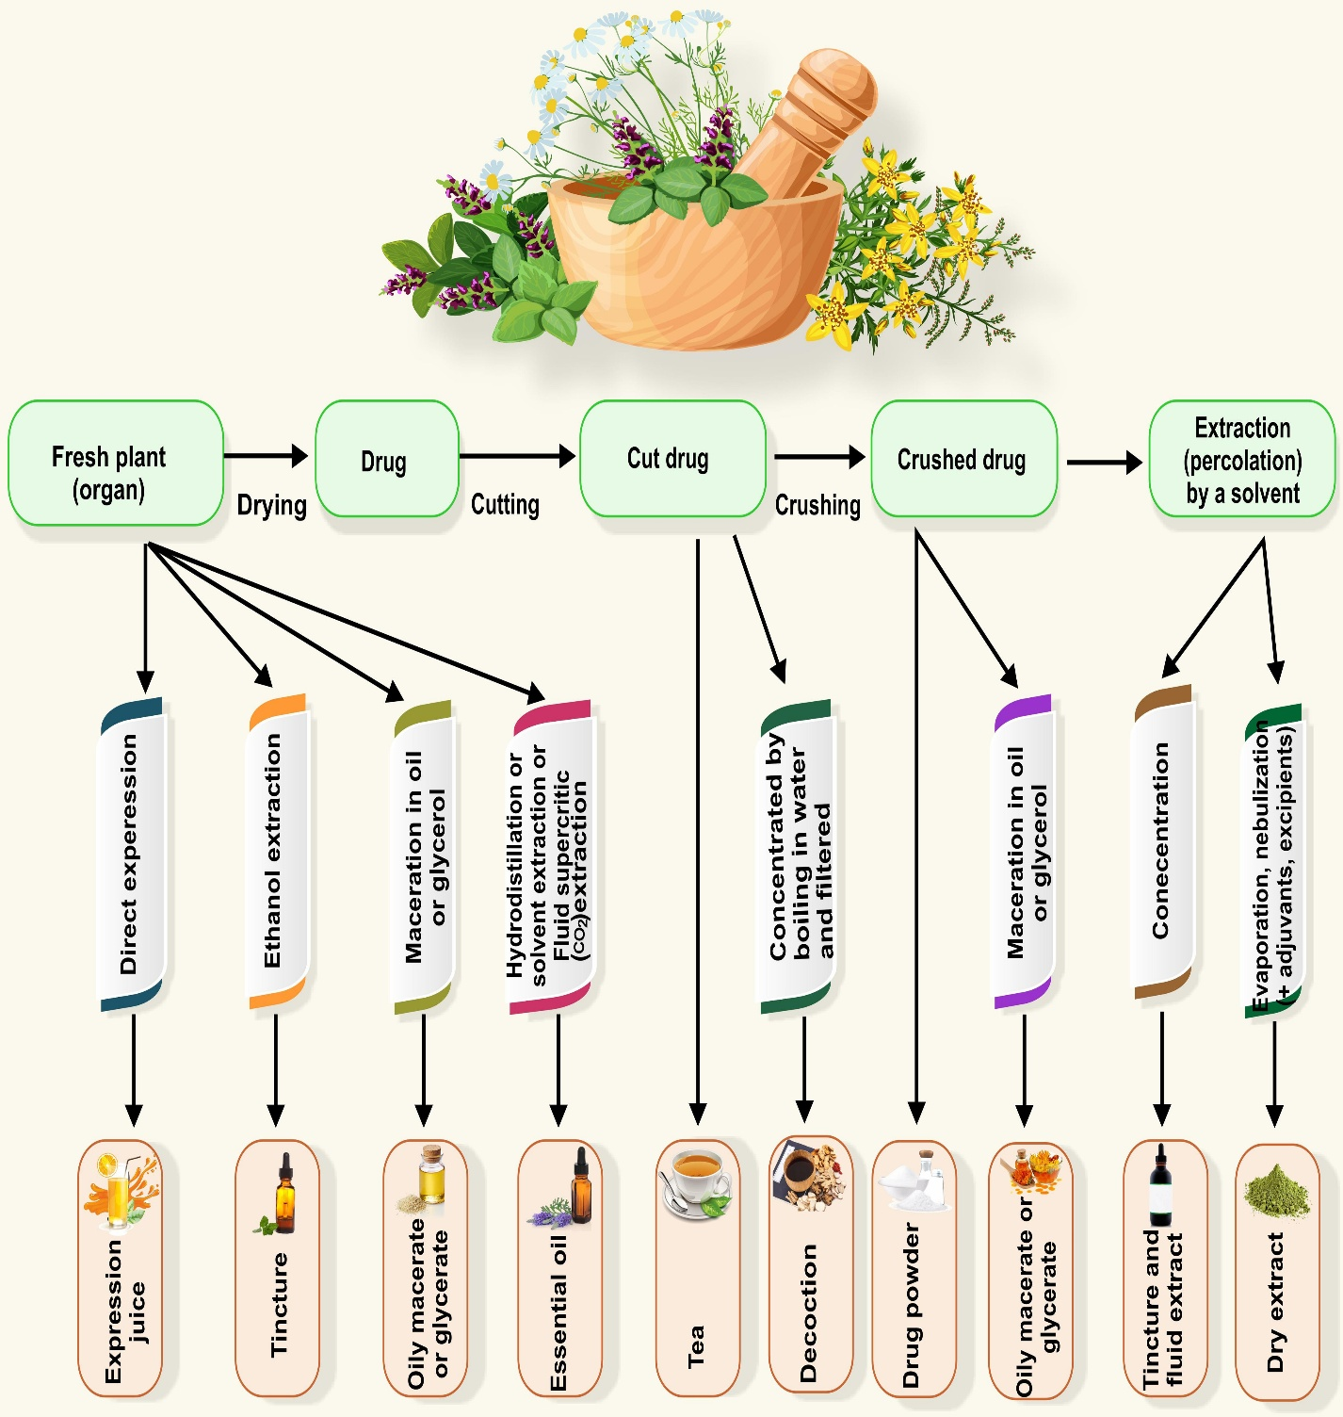
Fig:2 Schematic diagram showing the major types of herbal preparation.
Conclusion
Herbal medicines remain an important component of global healthcare systems. Their therapeutic potential, cultural significance, and natural origin make them valuable alternatives and complements to synthetic drugs. However, scientific evaluation, quality control, and proper regulation are essential to ensure their safe and effective use. Continued research and integration with evidence-based medicine can enhance the future role of herbal medicines in healthcare.

References:
1. World Health Organization (WHO). Traditional Medicine Strategy.
2. Kokate CK. Pharmacognosy.
3. Trease and Evans. Pharmacognosy and Phytochemistry.
4. Sharma PV. Dravyaguna Vigyan.
5. Harborne JB. Phytochemical Methods.
6-Fu Y, Yang JC, Cunningham AB, Towns AM, Zhang Y, Yang HY, et al. (2018) A billion cups: The diversity, traditional uses, safety issues and potential of Chinese herbal teas. J Ethnopharmacol 222:217-228
7-Zhao J, Deng JW, Chen YW, Li SP. (2013) Advanced phytochemical analysis of herbal tea in China. J Chromatogr A 1313:2-23
8-Dori D, Méda N, Gbaguidi FA, Quetin-Leclercq J, Semdé R. (2020) Wholesale distribution and delivery of plant-based medicinal products through the pharmaceutical system of Burkina Faso]. Ann Pharm Fr ;78(2):179-188
9-Petitet F. (2012) Interactions pharmacocinétiques entre préparation à base de plantes et médicament: une revue de l’importance Clinique. Phytothérapie 10(3):170-182
10-Sahoo N, Manchikanti P, Dey S. (2010) Herbal drugs: standards and regulation. Fitoterapia ;81(6):462-471

