Reconceptualising Teaching Excellence in Higher Education: The A³–A⁴ Model for Faculty Development and Pedagogical Practice
Dr. M. Ramjee
Professor, Department of Information Technology & Computer Applications, Andhra University college of Engineering, Andhra University, Visakhapatnam -530 003, A.P, India

Abstract

Teaching excellence in contemporary higher education requires a balanced integration of disciplinary expertise, continuous academic development, and effective pedagogical practice. While influential frameworks such as Bloom’s Taxonomy, Shulman’s Pedagogical Content Knowledge (PCK), and Outcome-Based Education (OBE) address important dimensions of teaching, they tend to focus on specific elements rather than the holistic professional development of teachers. This paper proposes the A³–A⁴ Model of Teaching Excellence, a conceptual framework organized around three interrelated dimensions—Acquire, Advance, and Apply (A³)—each supported by four equally weighted attributes (A⁴). Developed through systematic theoretical synthesis, the model integrates cognitive, constructivist, experiential, and outcome-based learning perspectives. It argues that sustainable teaching excellence emerges when professional competence, academic growth, and pedagogical application evolve in balance. By foregrounding the teacher’s developmental trajectory, the A³–A⁴ model addresses fragmentation in existing literature and offers a scalable framework for faculty development, teacher education, and institutional quality assurance.

Keywords: Teaching Excellence; Faculty Development; Conceptual Framework; Outcome-Based Education; Professional Growth

1. Introduction
Teaching in higher education has undergone significant transformation in response to globalization, digitalization, massification of education, and evolving expectations of graduates. Contemporary higher education teachers are no longer viewed solely as transmitters of disciplinary knowledge; rather, they are expected to function as reflective practitioners, curriculum designers, researchers, and mentors who continuously adapt to diverse learner needs and institutional demands. Consequently, teaching excellence is increasingly conceptualized as a complex and multidimensional construct.
Research in higher education has increasingly problematized the notion of teaching excellence, questioning managerial, metric-driven, and performative interpretations that reduce teaching to measurable outputs (e.g., Biggs & Tang, 2011; UNESCO, 2015). Scholars argue for more holistic and developmental perspectives that recognize teaching as a situated, evolving professional practice rather than a static set of competencies.

A range of influential frameworks has shaped understandings of teaching and learning in higher education. Bloom’s Taxonomy has provided a systematic structure for articulating cognitive learning objectives, Shulman’s Pedagogical Content Knowledge (PCK) has highlighted the importance of integrating subject expertise with pedagogy, and Outcome-Based Education (OBE) has foregrounded alignment between learning outcomes, instruction, and assessment. While these frameworks have made enduring contributions to educational theory and practice, they tend to address specific aspects of teaching rather than the holistic professional development of educators.

This theoretical fragmentation points to a continuing need for integrative models that place the teacher at the center of educational quality. In particular, there is limited conceptual guidance on how teachers acquire foundational competencies, advance academically and professionally, and apply their expertise effectively in classroom practice as part of a coherent developmental process. Addressing this gap, the present paper proposes the A³–A⁴ Model of Teaching Excellence, a teacher-centered conceptual framework that integrates professional competence, academic advancement, and pedagogical application.

The A³–A⁴ model conceptualizes teaching excellence as a balanced progression across three interrelated dimensions—Acquire, Advance, and Apply—each supported by four equally weighted attributes. By synthesizing established educational theories into a simple and symmetrical structure, the model aims to offer conceptual clarity, practical usability, and relevance for faculty development, reflective practice, and institutional quality enhancement in higher education.

2. Research Design and Conceptual Development Methodology

This study adopts a conceptual and theory-synthesis research design. Rather than empirical data collection, the model was developed through an integrative review and analytical synthesis of established educational theories and professional teaching standards. Core theoretical constructs were identified through an examination of seminal literature on cognitive learning, pedagogical knowledge, professional development, and learner-centered education.

The development of the A³–A⁴ framework followed three stages. First, recurring dimensions of effective teaching were identified across major theoretical traditions, including Bloom’s cognitive taxonomy, Shulman’s PCK, constructivist learning theory, experiential learning theory, and OBE. Second, these dimensions were clustered into three macro-level professional functions—competence acquisition, academic advancement, and pedagogical application—resulting in the A³ structure. Third, each macro- dimension was analytically decomposed into four foundational attributes, selected based on frequency of occurrence in the literature, conceptual distinctiveness, and practical relevance. Equal weighting was intentionally assigned to each attribute to reinforce the principle of balanced professional development.

As a conceptual framework, the A³–A⁴ model is intended to serve as a foundation for subsequent empirical testing and contextual adaptation, rather than as a definitive measurement instrument.

3. Theoretical Foundations

Bloom’s Taxonomy
Bloom’s Taxonomy classifies cognitive learning objectives across hierarchical levels, ranging from remembering and understanding to analyzing, evaluating, and creating (Bloom et al., 1956; Anderson & Krathwohl, 2001). It provides a foundation for aligning learning outcomes, instructional strategies, and assessment practices. The developmental logic of Bloom’s taxonomy conceptually aligns with the Acquire–Advance–Apply progression proposed in the A³–A⁴ model.

Shulman’s Pedagogical Content Knowledge
Shulman’s concept of Pedagogical Content Knowledge (PCK) emphasizes that effective teaching requires an integration of subject matter expertise and pedagogical skill (Shulman, 1986, 1987). PCK

highlights the teacher’s capacity to transform disciplinary knowledge into forms that are accessible and meaningful to learners, a principle reflected throughout the A³–A⁴ framework.

Outcome-Based Education
Outcome-Based Education focuses on clearly defined learning outcomes and the alignment of teaching strategies and assessments with those outcomes (Spady, 1994). OBE underscores accountability and learner achievement, informing the application-oriented dimension of the proposed model.

Constructivist and Experiential Learning Theories
Constructivist theory posits that learners actively construct knowledge through engagement with content and context (Vygotsky, 1978; Piaget, 1970). Experiential learning further emphasizes learning through experience, reflection, and application (Kolb, 1984). Together, these theories reinforce the importance of active, authentic, and applied teaching practices within the A³–A⁴ framework.

4. Conceptual Framework of the A³–A⁴ Model
The A³–A⁴ model is guided by two core principles: progression and balance. Progression reflects the developmental nature of teaching excellence, while balance emphasizes the equal importance of complementary professional attributes. The three macro-dimensions—Acquire, Advance, and Apply— are interdependent rather than strictly linear.
Each macro-dimension is supported by four micro-dimensions (A⁴), visually conceptualized as the four corners of a square to symbolize symmetry and interdependence. Overemphasis on any single attribute may weaken overall teaching effectiveness, whereas balanced development strengthens professional practice.

While the A³–A⁴ model presents a structured and balanced representation of teaching excellence, it is not intended as a prescriptive checklist. Rather, it should be interpreted as a reflective framework that can be adapted to disciplinary, cultural, and institutional contexts.

The aim of the A³–A⁴ model is not to replace existing frameworks, but to offer a meta-conceptual lens that integrates them around the professional development of teachers in higher education.

Acquire: Foundational Professional Competence
The Acquire dimension represents the foundational competencies that shape a teacher’s professional identity.

- Authority: Deep disciplinary knowledge and conceptual clarity that establish academic credibility.
- Articulation: The ability to communicate complex ideas clearly and accessibly, transforming expert knowledge into learner-friendly forms.
- Accountability: Ethical responsibility, fairness, transparency, and professional integrity in teaching practice.
- Adaptability: Flexibility and creativity in responding to learner diversity, curricular change, and evolving educational contexts.
Together, these attributes define the essential professional grounding required for effective teaching.

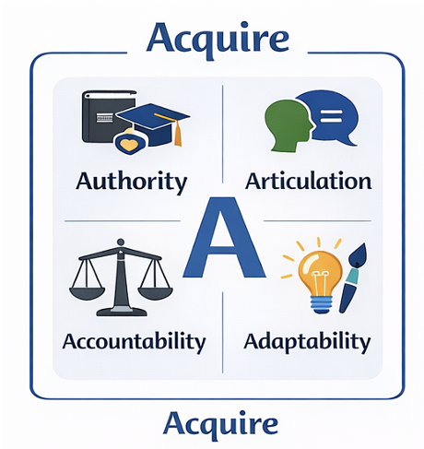

Advance: Continuous Academic and Professional Growth
The Advance dimension emphasizes sustained academic engagement beyond routine instructional practice.

- Assured Teaching: Consistent, reflective, and high-quality instructional practice informed by experience and feedback.
- Authorship: Scholarly writing and dissemination that contribute to disciplinary and pedagogical knowledge.
- Academic Advancement: Pursuit of higher qualifications, certifications, and professional recognition.
- Active Research: Continuous engagement in inquiry and investigation to maintain research- informed teaching.
This dimension ensures that teaching practice evolves alongside disciplinary and pedagogical advancements.

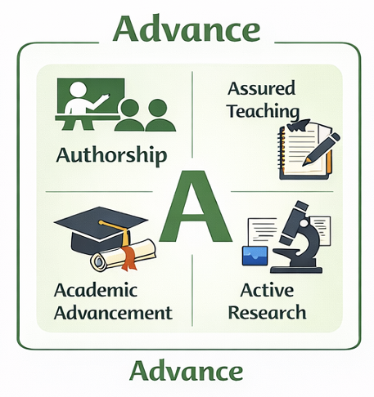

Apply: Pedagogical Implementation and Classroom Practice
The Apply dimension focuses on translating competence and academic growth into effective learning experiences.

- Authentic Aids: Real-world examples, case studies, and contextual materials that connect theory with practice.
- Active Learning Aids: Activities and strategies that promote student engagement, problem- solving, and collaboration.
- Audio-Digital Aids: ICT and audio-visual resources that support multimodal and accessible learning.
- Analog Visual Aids: Traditional tools such as boards, charts, and models that remain pedagogically inclusive and effective.
The balanced integration of traditional and digital aids reinforces inclusive and learner-centered pedagogy.

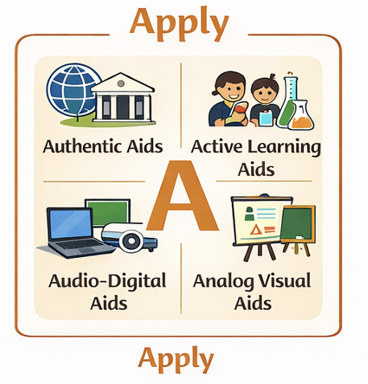

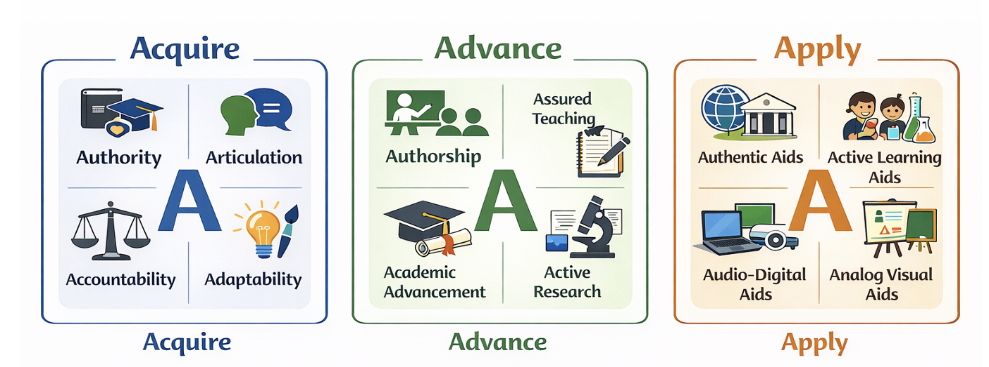

Contribution to Literature
This study contributes to the existing literature on teaching and teacher development by proposing an integrative, teacher-centric framework that complements and extends established educational theories and models. While prior frameworks have significantly informed instructional design, learning outcomes, and pedagogical knowledge, they often address teaching excellence in a fragmented manner. The A³–A⁴ Model addresses this limitation by offering a balanced, holistic, and scalable structure focused explicitly on the professional growth of educators.

Table 1 presents a comparative analysis of the proposed A³–A⁴ Model with prominent frameworks in educational research, namely Bloom’s Taxonomy, Shulman’s Pedagogical Content Knowledge (PCK), and Outcome-Based Education (OBE).

Table 1. Comparison of A³–A⁴ Model with Established Educational Frameworks

Dimension | Bloom’s Taxonomy | Shulman’s PCK | Outcome-Based  Education (OBE) | A³–A⁴ Model (Proposed)
Primary Focus | Learner cognitive processes | Integration of content & pedagogy | Achievement of predefined learning outcomes | Holistic teacher development
Unit of Analysis | Student learning levels | Teacher knowledge base | Curriculum and assessment alignment | Teacher professional competence
Scope | Cognitive domain (revised versions  include affective/  psychomotor) | Instructional  transformation  of content | System-level  instructional  design | Personal, academic, and  pedagogical  growth
Structural Nature | Hierarchical (progressive levels) | Integrative (content + pedagogy) | Outcome-driven alignment | Balanced and symmetrical (Acquire– Advance–Apply)
Treatment of Teaching Practice | Indirect | Central | Instrumental | Central and continuous
Research &  Professional  Growth | Implicit | Limited | Minimal | Explicitly  embedded  (Advance  dimension)
Practical Applicability | Lesson planning & assessment | Classroom instruction | Accreditation & accountability | Faculty development, mentoring, QA

Unlike Bloom’s Taxonomy, which primarily categorizes student cognitive outcomes, the A³–A⁴ Model foregrounds the teacher as the central agent of educational quality. In contrast to Shulman’s PCK, which focuses on the transformation of content for instruction, the proposed model extends teacher competence to include ethical grounding, adaptability, research engagement, and professional advancement. Compared to OBE, which emphasizes measurable learner outcomes, the A³–A⁴ Model integrates outcome alignment within a broader framework of sustained teacher development.

By synthesizing insights from cognitive theory, pedagogical knowledge, outcome orientation, and constructivist principles, the A³–A⁴ Model offers a novel contribution: a geometrically balanced, easily operationalizable framework that supports reflective teaching practice, faculty development initiatives, and institutional quality assurance. This integrative positioning distinguishes the model from existing frameworks and establishes its relevance for contemporary higher education systems.

The A³–A⁴ model conceptually integrates key insights from established educational theories into a single, coherent framework. Unlike technology- or outcome-specific models, it foregrounds the holistic professional development of teachers. By emphasizing balance across competence, academic growth, and application, the model addresses limitations associated with fragmented or overly narrow teaching frameworks.

Unlike performance-oriented models of teaching excellence that emphasize metrics and standardization, the A³–A⁴ framework foregrounds professional judgement, reflective practice, and academic identity formation The geometric representation of the model enhances conceptual clarity and practical usability, particularly for faculty development and self-reflection. While similar in intent to competency-based and PCK-oriented models, the A³–A⁴ framework contributes originality through its symmetrical structure and explicit progression across professional dimensions.

Implications for Teacher Education and Institutional Practice
The A³–A⁴ model has practical implications for teacher education curricula, faculty development programs, mentoring systems, and institutional quality assurance. It can inform professional portfolios, accreditation criteria, and reflective teaching practices. Its simplicity allows for easy adoption, while its theoretical grounding supports long-term professional growth.

Future Research Directions
Future research should focus on empirically validating the A³–A⁴ model across diverse educational contexts. Quantitative studies may operationalize the A³ and A⁴ dimensions using structured instruments and analyze them through factor analysis or structural equation modelling. Qualitative approaches, including interviews, classroom observations, and reflective portfolios, may further explore how the model shapes pedagogical decision-making. Discipline-specific adaptations and alignment with OBE and accreditation frameworks also warrant investigation.

Conclusion
This paper has proposed the A³–A⁴ Model of Teaching Excellence as a conceptual framework for understanding and supporting the professional development of teachers in higher education. By organizing teaching excellence around the interrelated dimensions of Acquire, Advance, and Apply, and by assigning equal importance to four supporting attributes within each dimension, the model foregrounds balance, progression, and integration in professional practice.

Unlike frameworks that focus primarily on student learning outcomes, pedagogical knowledge, or institutional accountability, the A³–A⁴ model positions the teacher as the central agent of educational quality. Its teacher-centered orientation highlights the importance of foundational competence, continuous academic growth, and thoughtful pedagogical application as mutually reinforcing elements of effective teaching.

The conceptual clarity and geometric symmetry of the model make it particularly suitable for reflective practice, faculty development initiatives, and institutional quality assurance processes. While the framework is not presented as an empirically validated intervention, it offers a coherent and adaptable lens through which educators and institutions can examine and support teaching excellence.

By synthesizing insights from cognitive, constructivist, experiential, and outcome-based learning theories, the A³–A⁴ Model contributes to ongoing scholarly conversations about teaching professionalism in higher education. Future empirical research can further test, refine, and contextualize the model, strengthening its relevance and applicability across diverse educational settings.

In doing so, the paper responds to contemporary calls in higher education research to reclaim teaching excellence as an intellectually grounded and professionally meaningful practice.

Declaration

No funding was received

References
Bloom, B. S., Engelhart, M. D., Furst, E. J., Hill, W. H., & Krathwohl, D. R. (1956).
Taxonomy of educational objectives: The classification of educational goals. Handbook I: Cognitive domain. New York, NY: Longman.
Anderson, L. W., & Krathwohl, D. R. (Eds.). (2001). A taxonomy for learning, teaching, and assessing: A revision of Bloom’s taxonomy of educational objectives. New York, NY: Longman.
Shulman, L. S. (1986).
Those who understand: Knowledge growth in teaching. Educational Researcher, 15(2), 4–14.
Shulman, L. S. (1987).
Knowledge and teaching: Foundations of the new reform. Harvard Educational Review, 57(1), 1–22.
Spady, W. G. (1994).
Outcome-based education: Critical issues and answers. Arlington, VA: American Association of School Administrators.
Vygotsky, L. S. (1978). Mind in society: The development of higher psychological processes. Cambridge, MA: Harvard University Press.
Piaget, J. (1970). Science of education and the psychology of the child. New York, NY: Orion Press.
Kolb, D. A. (1984).
Experiential learning: Experience as the source of learning and development. Englewood Cliffs, NJ: Prentice Hall.

Biggs, J., & Tang, C. (2011).
Teaching for quality learning at university (4th ed.). Maidenhead, UK: Open University Press.
Felder, R. M., & Brent, R. (2005).
Understanding student differences. Journal of Engineering Education, 94(1), 57–72.
Prince, M. (2004).
Does active learning work? A review of the research. Journal of Engineering Education, 93(3), 223–231.
Mishra, P., & Koehler, M. J. (2006).
Technological pedagogical content knowledge: A framework for teacher knowledge. Teachers College Record, 108(6), 1017–1054.
UNESCO. (2015).
Rethinking education: Towards a global common good? Paris: UNESCO Publishing.

