REVIEW ON ANALYTICAL METHOD DEVELOPMENT AND VALIDATION OF EMPAGLIFLOZIN
Lalit Bhoye, Dr. Uday A. Deokate, Vijay Lokhande, Muskan Mulla, Vaishnavi Punase, Govind Kokani
Department of Pharmaceutical Chemistry, Government College of Pharmacy, Karad.
ABSTRACT: Antidiabetic drugs manage diabetes mellitus by lowering blood glucose levels and are mainly classified into oral hypoglycemic agents and insulin formulations. Empagliflozin is an oral hypoglycemic drug belonging to the class of SGLT2 inhibitors. It acts on transporters in the proximal tubules of the kidneys to reduce blood glucose by promoting glucose excretion in the urine (glucosuria). It includes information on the development of various analytical techniques, including UV spectrophotometry, HPLC, HPTLC, and QbD-based HPLC methods, which can be utilized for further investigation and analysis of empagliflozin.
Keywords: Empagliflozin, RP-HPLC, UV Spectroscopy, HPTLC, QbD.
INTRODUCTION
Diabetes is a chronic metabolic disorder characterized by elevated blood glucose levels, which can lead to serious damage to the heart, blood vessels, eyes, kidneys, and nerves over time. The most common form is type 2 diabetes, which typically affects adults and occurs when the body becomes resistant to insulin or fails to produce sufficient amounts of it. Over the past three decades, the incidence of type 2 diabetes has risen markedly across nations with diverse income levels. Type 1 diabetes, formerly known as juvenile or insulin-dependent diabetes, is a chronic condition where the pancreas produces insufficient or no insulin. For people living with diabetes, access to affordable treatment options like insulin is vital for their survival (World Health organization About diabetes, January (2024).
SGLT2 Inhibitors
SGLT2 inhibitors are a class of oral medications used to treat diabetes. They are commonly prescribed to individuals with type 2 diabetes. FDA-approved oral prescription medications known as sodium-glucose cotransporter-2 (SGLT2) inhibitors are used in conjunction with diet and exercise to lower blood sugar levels in adults with type 2 diabetes (Saedi, E Gheini, MR Faiz, F Arami (2016).
Empagliflozin is a C-glycosyl compound featuring a beta-glucosyl residue with a (4-chloro-3-{4-[(3S)-tetrahydrofuran-3-yloxy]benzyl}phenyl) group attached at the anomeric center. PubChem was discovered and developed by Boehringer-Ingelheim. Approved by the FDA in 2014, it is available in four formulations: Jardiance (empagliflozin), Glyxambi (empagliflozin and linagliptin), Synjardy (empagliflozin and metformin), and Synjardy XR (empagliflozin and extended-release metformin) (www.sciencedirect.com, 2024).
Examples of SGLT2 inhibitors include remogliflozin etabonate, canagliflozin, dapagliflozin, bexaglifloxin, empagliflozin, and ertugliflozin.
Chemistry of Empagliflozin
The chemical structure of empagliflozin is 4-(1-chloro-4-(β-D-glucopyranos-1-yl)-2-[4-((S)-tetrahydrofuran-3-yloxy)benzyl]phenyl) (Rx List Empaglifozin, January, 2024). [Fig. 2] Its chemical formula is C23H27ClO7. It is a novel molecule with a molecular weight of 450. 91 g/mol. The partition coefficient (log P) is 1.7, while the dissociation constant is 12.57. The substance appears white and has a melting point of 151–153°^{C}.

Figure 1. Structure of Empagliflozin
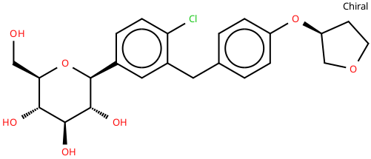
Reported Analytical method
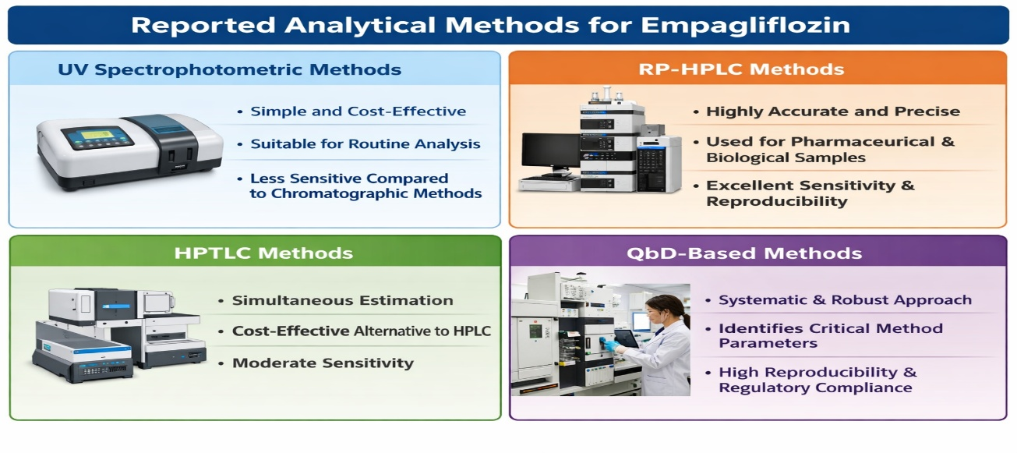
Comparative Discussion
Among various analytical techniques, RP-HPLC methods are the most widely used because of their high sensitivity, accuracy, and precision. Although UV spectrophotometric methods are simple and cost-effective, they lack sensitivity. While HPTLC methods offer a favourable balance between cost and performance, they lack the precision of HPLC. QbD-based approaches significantly enhance method robustness and reliability by employing systematic optimization.
Table 1.
Method | Sensitivity | Accuracy | Cost | Time Consumption | Applicability | Remark
UV | Low | Moderate | Low | Fast | Routine analysis | Simple Method
RP-HPLC | High | High | Moderate | Moderate | Bulk & plasma analysis | Most preferred method
HPTLC | Moderate | Moderate | Low- Moderate | Moderate | Multiple sample analysis | Economical alternative
QbD-based HPLC | Very high | Very high | High | Moderate | Advanced analytical studies | Highly robust and reliable

Reported Methods for Assessment of Empagliflozin

Sr. No. | Title | Description | Ref.  No.
UV-Spectrophotometric Method
1. | Development and validation of simple UV Spectrophotometric method for the determination of Empagliflozin | Solvent: Water: Methanol (9.0:1.0%v/v)  Wavelength: 224 nm  Linearity: 1.0–3.0 μg/mL  R2: 0.998 | (Patil Sushil D., Chaure Sayali K, 2017)
2. | Method development and validation of Empagliflozin in bulk and pharmaceutical dosage form using UV spectroscopy | Solvent: Ethanol and Water  Wavelength: 223 nm  Linearity: 1-30μg/mL  R2: 0.997 | (Benazir Shaik Bima, Archana Jorige, 2021)
Reverse Phase High Performance Liquid Chromatography (RP-HPLC)
3. | New validated RP- method for the estimation of empagliflozin in human plasma | Stationary phase: C18 column (250 mm × 4.6 mm, 5 µm)  Mobile phase: methanol and acetonitrile, 50:50% v/v  Linearity: 50-150 μg/ml  Flowrate: 1.0 ml/min | (N. Padmaja, 2018)
4. | RP-HPLC method for quantification of Empagliflozin in pharmaceutical formulation | Stationary phase: C18G column (250 x 4.6 mm, 5μm)  Mobile Phase: Methanol :Water (70: 30% v/v)  Linearity: 10–90 μg/mL  Flowrate: 1 mL/min | (Siridevi Mounika P, 2019)
5. | Development and validation of stability Indicating RP-HPLC method for Empagliflozin | Stationary phase: Phenomenex C18 column (250 x 4.6 mm, 5μm)  Mobile Phase: Methanol: Water (70: 30% v/v)  Linearity: 2–14 μg/mL  Flowrate: 1.0 mL/min | (Patil Sushil D, Dr. Amurutkar Sunil V, 2016)
6. | Empagliflozin: HPLC based analytical method development and application to pharmaceutical raw material and dosage form | Stationary phase: C18 column (250 x 4.6 mm, 5μm)  Mobile Phase: Water: Acetonitrile (70:30 %v/v):0.1% Trifluoroacetic acid solution (pH 4.8)  Linearity: 0.025-30 μg mL  Flow rate: 1.0 mL/ min | (Anas M. Hanif, Rabia Bushra, 2021)
7. | A new simple method development, validation and forced degradation studies of Empagliflozin by using RP-HPLC | Stationary phase: Develosil ODS HG-5 RP C18 column (150 x 4.6mm,5µm)  Mobile Phase: Water : Acetonitrile (45:55%v/v) Phosphate Buffer (pH 2.8)  Linearity: 0–50 µg/mL Flow rate: 1.0 mL/ min | (Rao Knv, V Shirisha 2019).
High-Performance Thin Layer Chromatography (HPTLC)
8. | A novel validated stability indicating method for quantification of Empagliflozin in bulk and marketed formulation by HPTLC applying experimental design approach. | Stationary phase: Aluminum plate that had previously been coated with silica gel  Mobile Phase: Ammonium acetate (2%): Triethylamine : Isopropyl alcohol (4:1:5 %v/v/v)  Detection: 237 nm | (Manojkumar Munde, Nilesh Kulkarn, 2023).
Quality by Design(QbD)
9. | The application of quality by design in the development of the liquid chromatography method to determine Empagliflozin in the presence of its organic impurities | Stationary phase: C18 column (250x 4.6mm, 5µm)  Mobile phase: Acetonitrile :water (72:28%v/v) Detection: 230 nm | (Joanna Wittchckind Manoel, 2020).

CONCLUSION
This review examines various analytical methods developed for estimating empagliflozin. Among these, RP-HPLC and QbD-based methods are the most reliable and widely accepted because of their superior sensitivity, precision, and robustness. Future studies should prioritize the development of analytical methods that are both environmentally sustainable and cost-efficient without compromising their high performance.
REFERENCES
- Anas M. Hanif, Rabia Bushra (2021). Empagliflozin: HPLC based analytical method development and application to pharmaceutical raw material and dosage form. Pak J. Pharm Sci, 3, 1081-1087.
- Benazir Shaik Bima, Archana Jorige (2021). Method development and validation of Empagliflozin in bulk and pharmaceutical dosage form using UV spectroscopy. Asian J. of Pharm. Analysis, 11, 123-126.
- https://www.sciencedirect.com/science/article/abs/pii/B9780323906449000603
- Joanna Wittchckind Manoel, Martin Steppe (2020). The application of quality by design in the development of the lSiquid chromatography method to determine Empagliflozin in the presence of its organic impurities. Royal soci. of chem, 10, 7313-7320.
- Manojkumar Munde, Nilesh Kulkarni (2023). A novel validated stability indicating method for quantification of Empagliflozin in bulk and marketed formulation by hptlc applying experimental design approach. Indian Drugs, 60, 66-75.
- N. Padmaja, Tegene Desalegn (2018). New validated RP-HPLC method for the estimation of empagliflozin in human plasma. IJPSR, Vol. 9(11), 4885-4889.
- Patil Sushil D., Chaure Sayali K (2017). Development and Validation of Simple UV Spectrophotometric Method for the Determination of Empagliflozin. Asian J. of Pharm. Analysis, 7, 18-22.
- Patil Sushil D., Dr. Amurutkar Sunil V (2016). Development and Validation of Stability Indicating RP-HPLC Method for Empagliflozin. Asian J. of Pharm. and Tech, 6, 201-206.
- Pub chem, Empagliflozin, January (2024). https://pubchem.ncbi.nlm.nih.gov /compound/Empagliflozin
- Rao Knv, V Shirisha (2019). A New Simple Method Development, Validation and Forced Degradation Studies of Empagliflozin by Using RP-HPLC. Int. J. of Pharm. and science, 9, 25-35.
- Rx List Empaglifozin, January (2024). www.rxlist.com/jardiance-drug.htm#description
- Saedi, E Gheini, MR; Faiz, F Arami (2016). Diabetes mellitus and cognitive impairments. World Journal of Diabetes, 7(17), 412–22.
- Science direct SGLT 2 inhibitor, January (2024). https://www.sciencedirect.com/science /article/abs/pii/B9780323906449000603
- Siridevi Mounika P, Kumar Hemant T (2019). RP-HPLC Method for Quantification of Empagliflozin in Pharmaceutical Formulation. Asian J. of Pharm. and Tech, 9, 208-211.
- World Health organization About diabetes, January (2024).

