AI-Powered Cosmetic Biotechnology: Emerging Innovations, Sustainable Business Strategies, and Digital Commerce Transformation

Abstract
Artificial Intelligence (AI) is revolutionizing cosmetic biotechnology by integrating advanced machine learning, biotechnology innovation, predictive analytics, and digital commerce systems to develop personalized and sustainable cosmetic solutions. AI-powered technologies such as intelligent skin diagnostics, ingredient optimization algorithms, virtual beauty assistants, and predictive consumer behavior models are improving product innovation, operational efficiency, and customer engagement. Biotechnology innovations including plant stem cells, microbial fermentation, peptides, and bio engineered cosmetic ingredients are contributing organizations create safer and eco-friendly skincare products.
The integration of AI with digital commerce platforms has significantly transformed cosmetic marketing and customer experiences through recommendation systems, augmented reality applications, virtual try-on systems, and personalized advertisements. AI also supports sustainable manufacturing by reducing production wastage, optimizing resource utilization, and improving recyclable packaging strategies.
This study examines the role of Artificial Intelligence in cosmetic biotechnology and analyzes emerging innovations, sustainable business strategies, and digital commerce transformation within the global cosmetic industry. The study it so highlights major challenges and future opportunities associated with AI-powered cosmetic biotechnology.
Keywords
Artificial Intelligence, Cosmetic Biotechnology, Sustainable Business Development, Digital Commerce, Personalized Cosmetics, Biotechnology Innovation

1. INTRODUCTION
Artificial Intelligence has become one of the most influential technologies transforming modern industries. The cosmetic and beauty industries has experienced rapid technological advancement due to increasing consumer demand for personalized skincare products, sustainable cosmetic manufacturing, and advanced digital shopping experiences. Cosmetic biotechnology combines biological science, biotechnology, and cosmetic product development to create innovative skincare and beauty solutions. The integration of AI technologies with cosmetic biotechnology has improved product innovation, customer engagement, ingredient analysis, and sustainable manufacturing operations (Kapoor and Sharma, 2022).
Traditional cosmetic product development required long laboratory testing cycles and extensive experimentation procedures. However, AI-powered systems allow cosmetic companies to analyze large biological datasets, identify effective cosmetic ingredients, and predict product performance within shorter time periods. Machine learning algorithms study skin conditions, environmental factors, customer lifestyles, and purchasing behavior to recommend personalized skincare routines (Lee and Kim, 2021).
Biotechnology innovations are also playing major roles in the cosmetic industries . Modern biotechnology techniques involve microbial fermentation, algae extracts, peptides, plant stem cells, and bioengineered compounds to produce safe and sustainable cosmetic products. Consumers increasingly prefer eco-friendly and ethically produced skincare products, encouraging cosmetic companies to invest in biotechnology-based formulations (Chen and Roberts, 2021).
Digital transformation has further accelerated cosmetic industry growth. AI-powered recommendation systems, beauty chatbots, virtual try-on applications, and augmented reality tools are improving online customer experiences and increasing digital sales performance (Johnson and Allen, 2022). Sustainability has become another major focus area because cosmetic companies face increasing pressure to reduce plastic waste, improve energy efficiency, and adopt recyclable packaging systems. AI technologies support sustainable business practices through optimized manufacturing systems, waste reduction techniques, and intelligent supply chain management (Green and Foster, 2023).

2. OBJECTIVE
1. To study the role of Artificial Intelligence in cosmetic biotechnology.
2. To examine emerging innovations in AI-based cosmetic product development.
3. To analyze sustainable business strategies in cosmetic industries.
4. To understand the impact of AI on digital commerce transformation.
5. To identify challenges and future opportunities in AI-powered cosmetic biotechnology.
3. LITERATURE REVIEW
Explained that Artificial Intelligence improves cosmetic product innovation, customer targeting, and personalized skincare systems. highlighted the role of computer vision technology in AI-based skin diagnostics studied biotechnology innovations and explained how microbial fermentation and bioengineered ingredients improve sustainability and cosmetic safety. found that AI-powered digital commerce systems improve customer engagement and online cosmetic sales through recommendation engines and virtual try-on technologies. concluded that sustainable packaging systems and AI-supported supply chains reduce operational wastage and environmental impact in cosmetic industries.
4. RESEARCH & METHODOLOGY
This study is based on secondary research methodology. Data has been collected from academic journals, Google Scholar articles, business reports, cosmetic industry publications, and scholarly databases related to Artificial Intelligence, biotechnology, sustainability, and digital commerce. it includes analysis of AI applications in skincare systems, biotechnology innovation, sustainable manufacturing practices, customer analytics, and digital marketing technologies approach is descriptive and analytical in nature.
- RESULTS & DISCUSSION
AI in Cosmetic Biotechnology
Artificial Intelligence significantly improved cosmetics biotechnology by enabling intelligent skincare systems and personalized beauty solutions. AI-powered skin analysis applications use computer vision technology to identify wrinkles, acne, pigmentation, hydration levels, and skin sensitivity. These systems provide customized skincare recommendations according to individual customer needs (Lee and Kim, 2021). Machine learning algorithms also help researchers analyze large biological datasets and identify suitable ingredient formulations for cosmetic products.
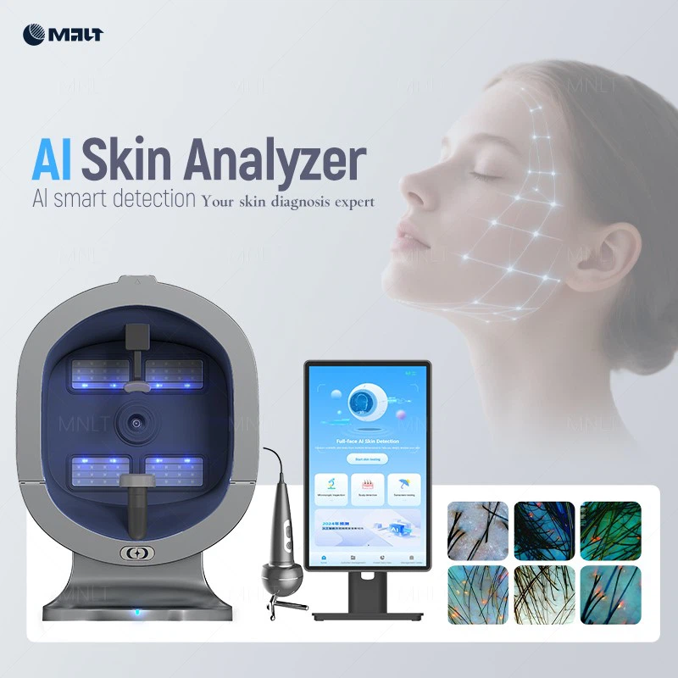
Figure 1: AI-Based Skin Analysis for Personalized Cosmetic Recommendations
Emerging Innovations in Cosmetic Industry
AI-based beauty platforms recommend customized skincare routines according to customer skin type, age, environmental conditions, and lifestyle factors. Augmented reality applications contributing customers to virtually test cosmetic products before purchasing them online. AI-powered chatbots provide skincare guidance and product recommendations, improving customer interaction’s and satisfaction. Predictive analytics systems analyze market trends and customer reviews to identify future beauty product demands.
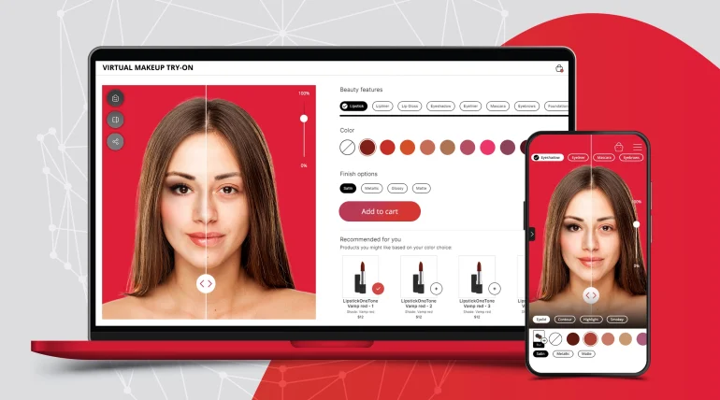
Figure 2: Augmented Reality-Based Virtual Makeup Try-On Technology
Table 1: Comparison Between Traditional and AI-Powered Cosmetic Systems
Traditional Cosmetic Industry | AI-Powered Cosmetic Industry
Manual skin testing | AI-based skin analysis
Generic skincare products | Personalized skincare solutions
Longer testing cycles | Faster AI-driven testing
High production wastage | Optimized resource utilization
Traditional marketing methods | AI-targeted digital marketing
Limited customer interaction | AI chatbots and beauty assistants

Sustainable Business Strategies
AI technologies support sustainable manufacturing by optimizing production processes, reducing raw material wastage, improving inventory management, and increasing energy efficiency. Cosmetic companies are increasingly adopting recyclable and biodegradable packaging materials to reduce environmental pollution.
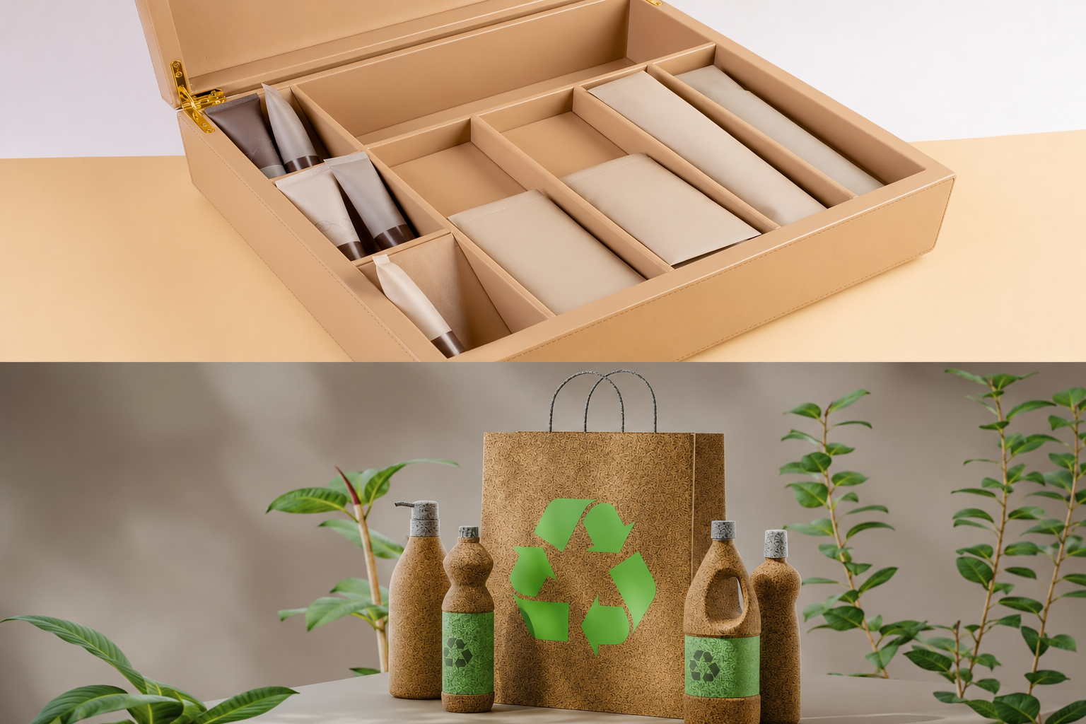
Figure 3: Sustainable and Eco-Friendly Cosmetic Packaging Solutions

Table 2: Sustainable AI Strategies in Cosmetic Industry
Sustainable Strategy | AI Contribution | Business Outcome
Eco-friendly packaging | Packaging optimization | Reduced plastic waste
Smart manufacturing | Resource monitoring | Lower production cost
AI supply chain | Demand forecasting | Reduced carbon emissions
Predictive maintenance | Machine efficiency | Reduced operational waste
Consumer analytics | Personalized marketing | Higher customer engagement

Case Study: L'Oréal AI Technology
L'Oréal introduced AI-powered skincare diagnostic systems that analyze customer skin conditions through smartphone cameras and computer vision technology. These systems study wrinkles, pores, pigmentation, and hydration levels to recommend personalized cosmetic products. The implementation of AI technology has improved customer engagement and digital beauty consultation efficiency.
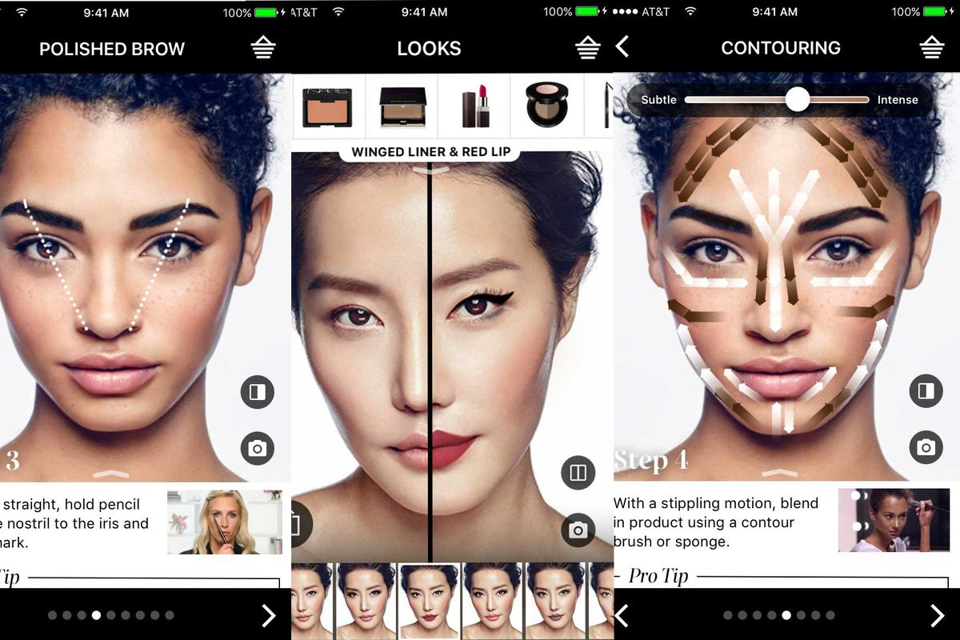
Figure 4: AI-Powered Smart Skincare Diagnostic System by L'Oréal

Case Study: Sephora Virtual Artist
Sephora introduced augmented reality-based virtual try-on systems that allow customers to digitally test makeup products before online purchase. This technology improved online shopping confidence, customer engagement, and sales performance.
Challenges
Major challenges associated with AI-powered cosmetic biotechnology include high implementation costs, cybersecurity concerns, data privacy risks, ethical issues, and lack of technical expertise in smaller cosmetic businesses.
Future Opportunities
Future advancements in Artificial Intelligence and biotechnology may lead to DNA-based personalized cosmetics, wearable skincare monitoring devices, robotic manufacturing systems, and blockchain-supported cosmetic supply chains. The integration of AI with biotechnology is expected to improve sustainability, transparency, and customer personalization in the global cosmetic industry.

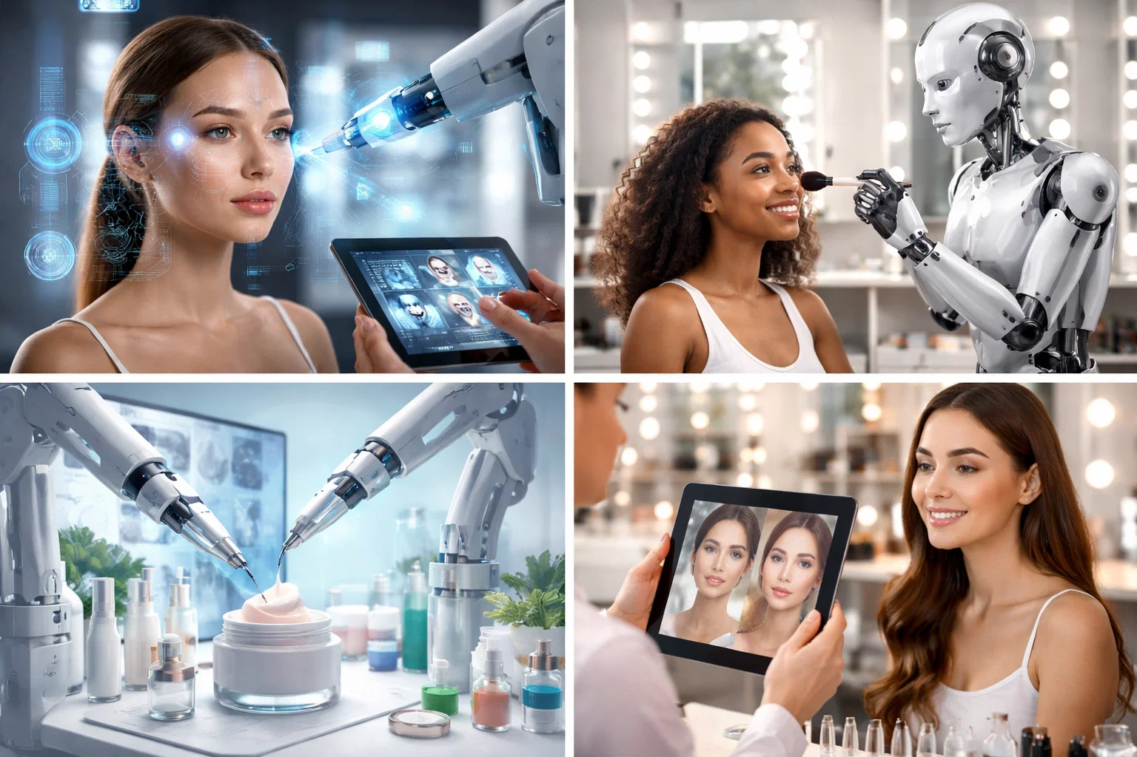
Figure 5: Future Integration of AI, Biotechnology, and Digital Cosmetic Commerce

6. CONCLUSION
The study concludes that AI-powered cosmetic biotechnology has significantly transformed product innovation, sustainability practices, and digital commerce operations within the cosmetic industry. Artificial Intelligence technologies such as machine learning, predictive analytics, computer vision, and augmented reality are helping cosmetic companies develop personalized skincare systems and improve customer experiences.
The findings suggest that sustainable business strategies supported by AI technologies are reducing environmental impact through optimized manufacturing systems, recyclable packaging solutions, and efficient supply chain management. AI-powered digital commerce systems are strengthening customer engagement through recommendation engines, beauty chatbots, and virtual try-on technologies.
Although challenges related to implementation cost and cybersecurity remain important concerns, future technological advancements are expected to further strengthen the role of Artificial Intelligence in cosmetic biotechnology. Therefore, the integration of Artificial Intelligence with cosmetic biotechnology can be considered a transformative approach for building future-ready, sustainable, and consumer-centric cosmetic industries.
7. REFERENCE
[1] Kapoor R, Sharma V. Artificial Intelligence in Cosmetic Industry. International Journal of Advanced Research, 12(3), PP.45-52 (2022).
[2] Lee H, Kim J. AI-Based Personalized Skincare Systems. Journal of Cosmetic Biotechnology, 9(2), PP.101-109 (2021).
[3] Brown T, Wilson P. Sustainable Business Strategies in Cosmetic Manufacturing. Business and Sustainability Review, 14(1), PP.88-97 (2023).
[4] Singh A, Verma N. Digital Commerce Transformation through Artificial Intelligence. International Journal of Digital Marketing, 8(4), PP.55-63 (2022).
[5] Chen Y, Roberts M. Biotechnology Innovations in the Beauty Industry. Cosmetic Science and Technology Journal, 11(5), PP.70-82 (2021).
[6] Patil S, Deshmukh R. AI Applications in Consumer Behavior Analysis. International Journal of Business Analytics, 6(3), PP.33-41 (2020).
[7] Green M, Foster L. Sustainable Packaging Technologies in Cosmetic Industry. Environmental Management Review, 10(1), PP.14-23 (2023).
[8] Johnson K, Allen B. Artificial Intelligence and E-Commerce Innovation. Global Digital Business Journal, 7(2), PP.90-102 (2022).
[9] Kumar P, Sharma D. Machine Learning in Product Development and Quality Management. Journal of Emerging Technologies, 5(2), PP.122-130 (2021).
[10] World Economic Forum. Artificial Intelligence and Future Business Transformation. Geneva Publications, PP.56-68 (2023).

