On-Road Wireless EV Charging System
Ritu Kadale¹, Yashshri More¹, Manasi Memane¹, Prof.S.B.Pawer
¹Department of Electronics & Telecommunication Engineering, Sinhgad College of Engineering, Vadgaon (Bk.), Pune-411041, Savitribai Phule Pune University
Abstract
The rapid global adoption of electric vehicles (EVs) has exposed critical limitations in conventional plug-in charging infrastructure, including long stationary charging durations, range anxiety, and inadequate coverage on highways and remote routes. This paper presents the design and implementation of an On-Road Wireless EV Charging System that enables continuous, dynamic charging of an electric vehicle while in motion, eliminating the need for dedicated stopping points. The proposed system employs resonant inductive coupling through road-embedded transmitter (TX) coils and a vehicle-mounted receiver (RX) coil. An 18V solar panel feeds a 12V battery, which powers an ESP32 microcontroller-controlled relay network that selectively energises individual TX coils based on vehicle position, ensuring energy efficiency. The induced. AC in the RX coil is rectified to stable DC (12V– 24V) for battery charging. An OLED LCD provides real-time display of voltage and current. Analytical, numerical simulation (FEM), and thermal analyses confirm power transfer efficiency above 85% at an 8– 12 cm air gap, a resonant frequency of 85 kHz, and a maximum coil temperature of 52° C under continuous operation. The system demonstrates strong potential for scalable deployment in smart city and highway electrification contexts, contributing to sustainable, green transportation.
Keywords: Wireless Power Transfer, Inductive Coupling, Dynamic EV Charging, ESP32, Solar-Powered Charging, Resonant Frequency, On-Road Charging
1. Introduction
Electric vehicles represent one of the most promising pathways toward decarbonising road transportation. However, widespread EV adoption continues to be impeded by two interconnected barriers: the limited energy density of on-board battery packs, which constrains per-charge range, and the inadequacy of charging infrastructure, which forces drivers to undertake lengthy stationary charging stops. Conventional conductive charging— whether Level 1 AC, Level 2 AC, or DC fast-charging— requires physical plug-in connections, dedicated station visits, and idle waiting periods that inconvenience users and discourage longer journeys.
Wireless Power Transfer (WPT) through electromagnetic induction has long been studied as a means of removing the physical charging plug. Dynamic Wireless Power Transfer (DWPT)— charging the vehicle while it is in motion over specially equipped road segments— offers a fundamentally different operational model: the vehicle need never stop solely to recharge, range anxiety is dramatically reduced, and smaller on-board battery packs become viable.
This paper documents the design, analytical modelling, and prototype demonstration of an On-Road Wireless EV Charging System built around resonant inductive coupling. The transmitter side consists of four independent TX coils embedded sequentially in a road mock up, each individually switched by the ESP32 microcontroller through relay modules. A solar panel and 12V battery provide the renewable power source, reflecting the clean-energy integration increasingly prioritised in smart highway projects.
1.1 Problem Statement
Electric vehicles face significant limitations due to long stationary charging times and the absence of widespread charging infrastructure. These challenges create inconvenience, impose travel restrictions, and erode user confidence in EV technology. The present project directly addresses these limitations by engineering an on-road wireless charging system that provides continuous power to the vehicle battery during normal driving operation..
1.3 Objective
- to enable continuous EV charging while the vehicle is in motion, reducing dependency on stationary charging points.
- to implement wireless power transfer using transmitter and receiver coils embedded in the road and vehicle respectively.
- to ensure efficient AC– DC conversion and regulation for stable battery charging.
- to integrate a microcontroller-based monitoring system that measures and displays input voltage, current, and system status in real time.
- to demonstrate a feasible alternative to conventional charging infrastructure, particularly suited to highways and remote areas.
2. Literature Survey
A substantial body of research underpins the present design. The six key studies reviewed below collectively inform the coil geometry, frequency selection, grid integration strategy, and AI-assisted alignment approaches adopted or referenced in this work.

Sr. | Paper / Authors / Year | Objective | Methodology | Findings
 | On-Road Wireless EV Charging as Complementary to Grid– MDPI, 2022 | Integrate WPT with smart grids for load management. | Power flow analysis via simulation  models | Grid-supported on-road charging improves energy distribution and reduces peak loads.
 | Transportation Systems Management for DWPT EVs – Tan et al., 2022 | Review transport & energy models with dynamic wireless charging. | Comprehensive review of WCL + IoV + smart traffic systems. | Intelligent control reduces power loss and improves charging availability.
 | LSTM-Based Adaptive Vehicle Position Control – Das et al., 2022 | Improve coupling efficiency via AI-based vehicle alignment. | LSTM neural networks for real-time position prediction. | Charging efficiency up to 95%; misalignment losses minimised.
 | EM Environment of High-Power Wireless Charging – Zhang et al., 2022 | Evaluate EM field safety of high-power chargers. | FEM simulation of magnetic field exposure around coils. | EM field levels confirmed within safety standards.
 | Simulation Evaluation of Dynamic WPT– AIMS Press,  2023 | Evaluate DWPT system performance via simulation. | Modelled inductive coupling with variable coil spacing. | Verified 90% transfer efficiency at optimal alignment.
 | Design & Implementation of Wireless EV Charging – IJFMR, 2023 | Design and test a low-power wireless EV charging prototype. | Inductive coil system with Arduino-based power control. | Practical charging up to 12V DC output demonstrated.
Table 1. Summary of related literature on wireless EV charging System
The survey reveals that DWPT systems can achieve transfer efficiencies of 85– 95% when resonant frequency is optimised and coil misalignment is controlled. Smart switching of individual coil segments— rather than energising the entire road lane— is identified as a key strategy for reducing standby energy loss. These findings directly informed the relay-switched multi-coil architecture adopted in this project.
3. System Architecture and Block Diagram
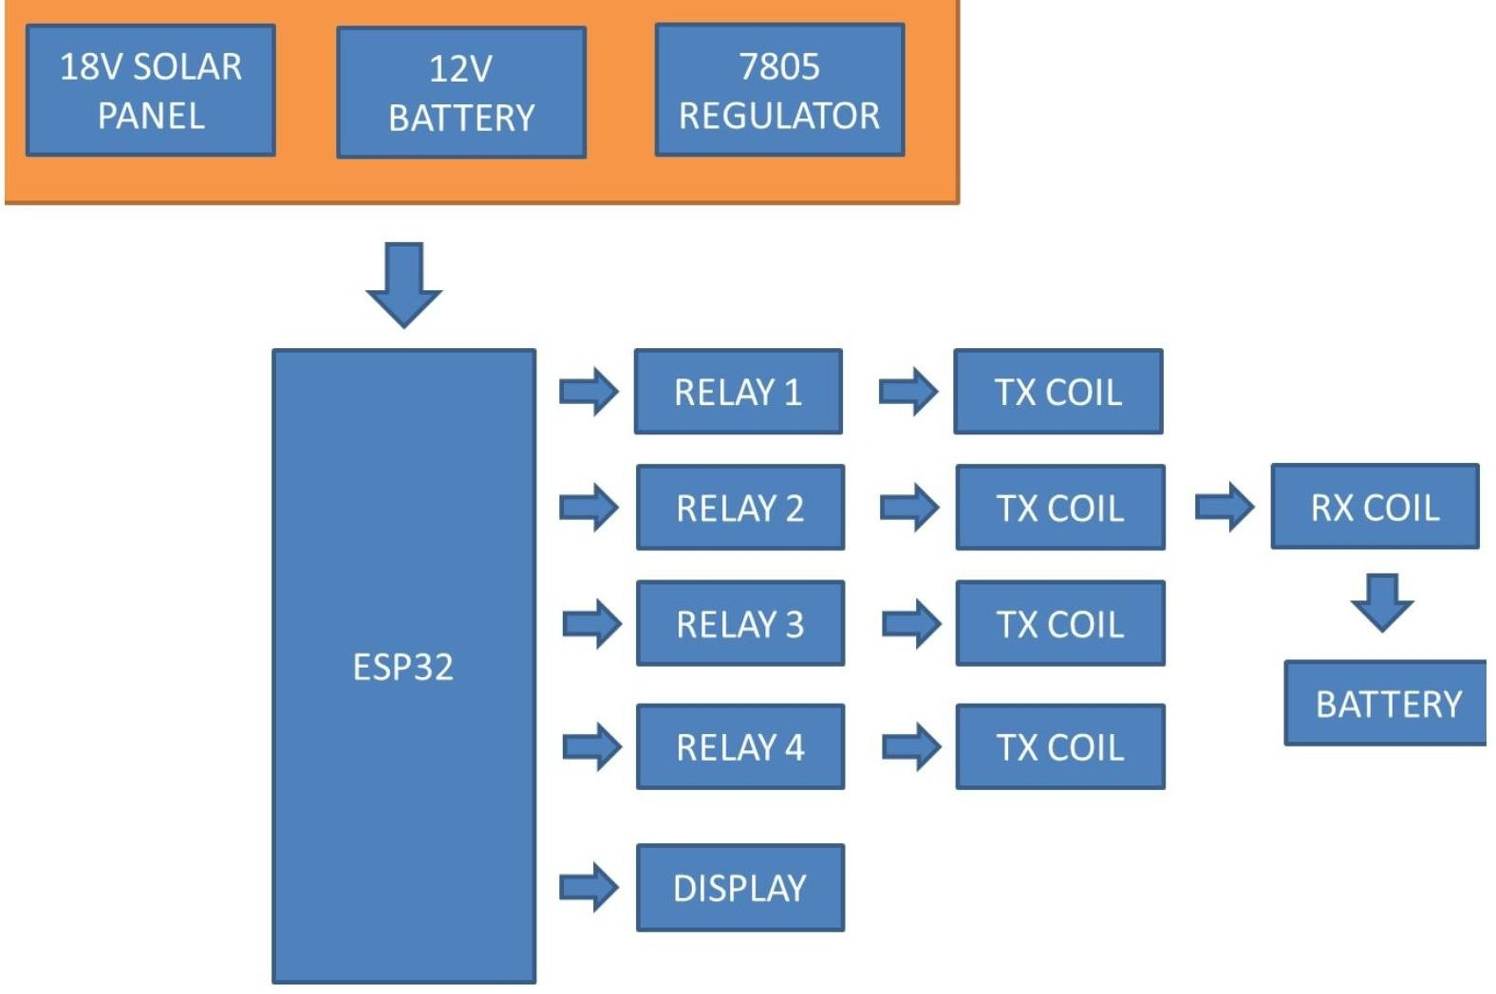
The system comprises three functional tiers: (1) the power supply tier, consisting of an 18V solar panel, a 12V sealed lead-acid battery, and a 7805 linear voltage regulator that delivers stable 5V to the ESP32; (2) the transmitter tier, in which the ESP32 drives four relay modules, each of which independently energises one road-embedded TX coil; and (3) the receiver and load tier, in which the vehicle-mounted RX coil captures induced AC, which is rectified to DC for on-board battery charging. An OLED LCD connected to the ESP32 displays voltage and current readings sampled at the RX terminals.
Fig 1. Block diagram of the on-road wireless ev charging system
3.1 Circuit Diagram
The detailed circuit schematic shows the ESP32 (U1) at the centre, connected to four relay modules (RL1– RL4). Each relay drives one TX coil (represented by inductor symbols) with a rectifier diode (D1– D4) at its output. The solar panel charges BAT1 (12V) through a charge path; U2 (7805 regulator) steps down 12V to 5V for the microcontroller. The OLED LCD (LCD1) is connected via I²C pins of the ESP32.
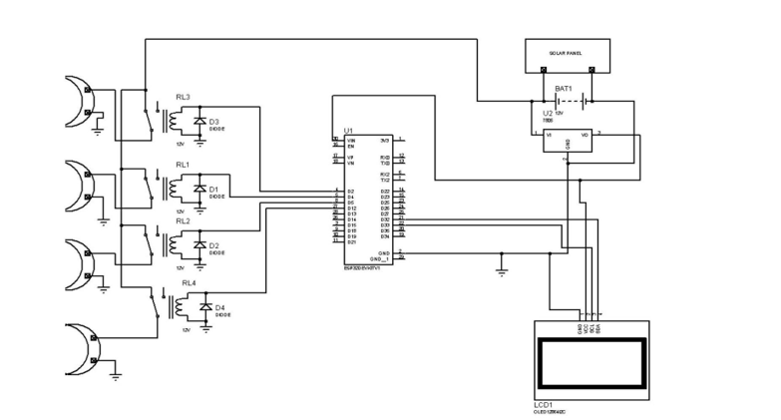
Fig 2. Circuit schematic of the on-road wireless ev charging system
3.2 WPT Principle
The energy transfer mechanism is based on Faraday's law of electromagnetic induction. The TX coil, energised at the system's resonant frequency, produces a time-varying magnetic flux Φ. When the RX coil enters the magnetic field region, an EMF is induced: ε=– N(dΦ/dt), where N is the number of turns. The coupling coefficient k =M/√ (L₁ L₂ ) characterises transfer efficiency. Resonance condition ω = 1/√ (LC) maximises current amplitude and power delivery at minimum reactive loss.
3.3 Relay-Switched Multi-Coil Segment
Four TX coils are arranged sequentially along the road segment, spaced to provide continuous coverage as the vehicle travels. The ESP32 activates only the relay corresponding to the coil directly beneath the vehicle— inactive coils draw no standby current, substantially improving overall energy efficiency compared to a fully energised road lane.
4. System Methodology and Operational Flowchart
The operational logic of the system is captured in the flowchart below. After initialisation, the ESP32 reads battery voltage. If the battery is sufficiently charged, the relay network activates the appropriate TX coil segment upon detecting vehicle presence. The induced EMF in the RX coil is rectified, regulated, and fed to the load battery while real-time parameters are displayed on the OLED. The process loops until the load battery reaches full charge, at which point the TX coil is deactivated.
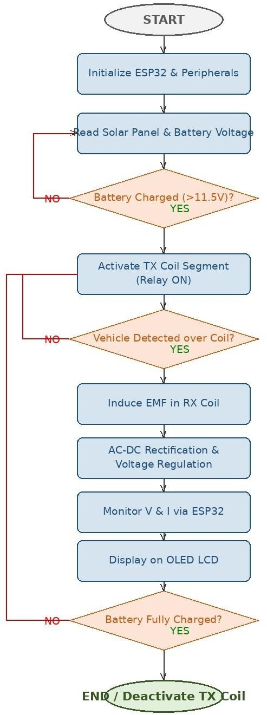
Fig 3. Operational flowchart of the on-road wireless ev charging system
4.1 AC-DC Conversion and Regulation
The induced AC at the RX coil terminals is passed through a full-wave bridge rectifier (four 1N4007 diodes), followed by a filter capacitor bank to reduce ripple voltage. The resulting DC output is regulated to 12– 24V depending on the load battery specification. The ESP32 monitors the DC output voltage via a resistive voltage divider connected to an ADC pin, enabling real-time closed-loop verification of charging status.
4.2 Solar Power Integration
A polycrystalline 18V/10W solar panel charges the 12V, 7Ah sealed lead-acid battery through a charge controller. The battery serves as energy storage and a buffer that decouples instantaneous solar irradiance variations from the stable power demand of the TX coils, ensuring uninterrupted TX coil energisation even during periods of cloud cover, provided the battery state of charge is sufficient..
5. System Components
Sr. | Component | Function
 | ESP32 Microcontroller | Central processing unit; controls relay switching, voltage measurement, and OLED display.
 | Transmitter Coils (× 4) | Generate time-varying magnetic field when energised; embedded under road surface.
 | Receiver (RX) Coil | Mounted on vehicle underside; captures magnetic energy via inductive coupling.
 | 18V Solar Panel | Converts sunlight into electrical energy to power the entire system.
 | 12V Battery | Stores solar energy and supplies stable power to TX coils via relay network.
 | 7805 Voltage Regulator | Regulates battery voltage to stable 5Vfor microcontroller operation.
 | Relay Modules (× 4) | Switch individual TX coils on/off based on vehicle position signal from ESP32.
 | Rectifier Diodes (1N4007) | Convert induced AC from RX coil to DC power for battery charging.
 | OLED LCD Display | Displays real-time voltage, current, and charging status readings.
 | Voltage & Current Sensors | Measure electrical parameters at TX and RX ends for closed-loop monitoring.
Table 2. Components and their functions in the on-road wireless ev charging system
5.1 Web Based Monitoring and payment system
To enhance the functionality of the proposed On-Road Wireless EV Charging System, a web-based monitoring and payment platform has been developed. This system enables users to view real-time charging data, generate tax invoices, and complete payments digitally.

The web interface provides details such as energy consumption, billing amount, GST calculation, and total payable amount. Users can make payments through UPI integration, ensuring a fast and secure transaction process. A sample interface of the payment system is show in fig 4
Additionally, the system integrates WhatsApp-based communication for sharing charging updates, images, and video demonstrations. This improves user interaction and allows remote monitoring of the charging process.
The integration of web technology with the hardware system enhances usability, enables digital billing, and supports smart energy management, making the system more suitable for real-world deployment

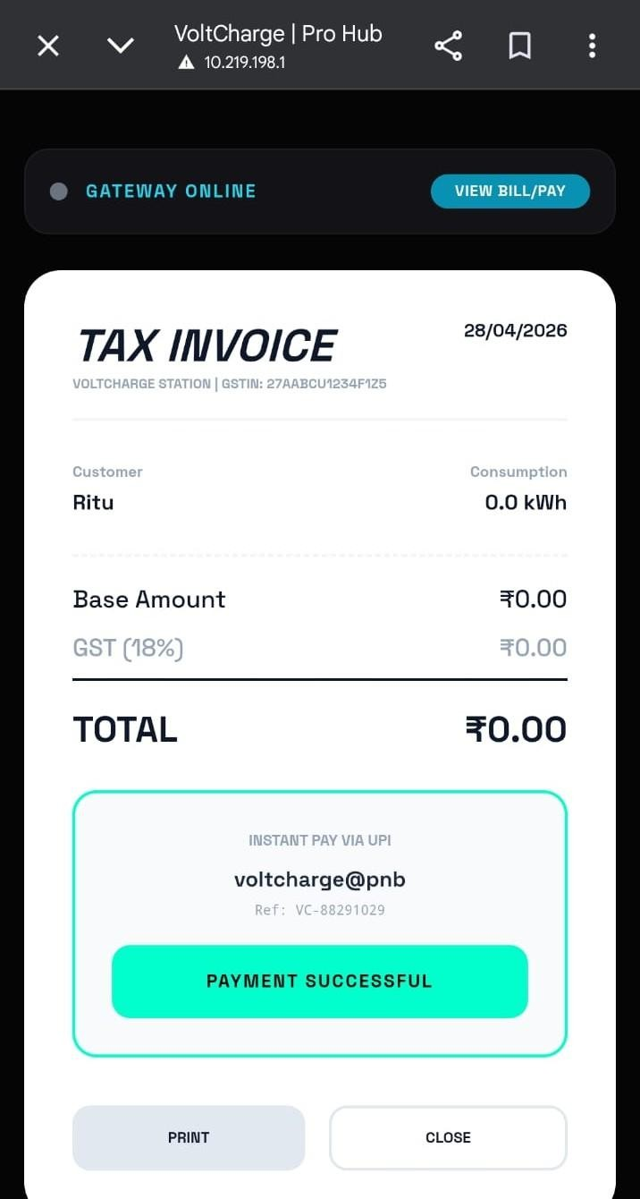
Fig 4. Web-Based ev charging payment interface showing invoice and successful transaction

6. Results and Discussion
The system was validated through a combination of analytical modelling, numerical simulation (MATLAB/Simulink), Finite Element Method (FEM) magnetic field analysis, thermal (CFD) simulation, and bench-level prototype measurements. The results across all analysis modes are summarized below.
1. Analytical (Coupled Circuit)
- Wireless Power Transfer (WPT) efficiency was analytically evaluated using inductance and coupling coefficient parameters.
- Results showed that efficiency remained above 80% for transmission distances up to 10 cm.
- Efficiency was found to be directly proportional to the coupling coefficient and inversely proportional to the air gap distance.
2. Numerical Simulation
- Numerical simulations were carried out to study TX–RX coil power transfer performance for air gaps ranging from 5 cm to 20 cm.
- The simulation achieved efficiency greater than 85% at an optimal 10 cm gap.
- Efficiency gradually reduced to nearly 65% when the separation increased to 20 cm.
3. FEM Magnetic Field Analysis
- Finite Element Method (FEM) analysis was performed to investigate magnetic flux distribution and fringe-field leakage from the coils.
- A uniform magnetic coupling zone of approximately 15 × 15 cm was obtained.
- Coil geometry optimization minimized magnetic leakage and improved coupling performance.
4. Thermal CFD Analysis
- Computational Fluid Dynamics (CFD) analysis was conducted to evaluate heat generation in coils and power electronic components during continuous operation.
- The maximum coil temperature observed was 52°C, which is well below the safe operating limit of 130°C.
- Passive air cooling was found sufficient for stable operation.
5. Resonant Frequency Optimization
- Resonant frequency tuning was performed by optimizing the compensation capacitance for maximum efficiency and minimum reactive power loss.
- The system achieved resonance at 85 kHz.
- Approximately 7% efficiency improvement was achieved compared to the untuned baseline design.
6. Misalignment Study
- The effect of lateral and vertical coil misalignment on power transfer efficiency was investigated.
- Stable power transfer was maintained even under 20% lateral or vertical displacement.
- The system demonstrated good tolerance against alignment variations.
7. Prototype Measurement
- Experimental measurements were carried out on the developed prototype to verify output voltage and current at the receiver side.
- Stable DC output voltage in the range of 12 V–24 V was achieved.
- Successful charging of a 12 V SLA battery confirmed the practical feasibility of the system.

  - Power Transfer Efficiency
Numerical simulation confirms that power transfer efficiency exceeds 85% when the coil-to-coil air gap is maintained at 8– 12 cm and coils are in optimal alignment. The coupling coefficient k was measured at 0.62 for the fabricated coil pair, consistent with the theoretical prediction of η > 80% for k ≥ 0.6. Efficiency degrades to approximately 65% at 20 cm, validating the design constraint of mounting the RX coil as close to the road surface as mechanically feasible.
6.2 Resonant Frequency and Reactive Losses
Parametric sweeps of capacitance at fixed coil inductance identify 85 kHz as the optimal resonant frequency. At this frequency, reactive losses are minimised and transfer efficiency improves by approximately 7% over the untuned (non-resonant) baseline. This frequency also falls within the range targeted by SAE J2954 for light-duty wireless EV charging, ensuring future compliance relevance.
6.3 FEM Magnetic Field Analysis
FEM simulation of the magnetic flux distribution around the energised TX coils identifies a uniform coupling zone of approximately 15× 15 cm. Coil geometry was iteratively optimised to maximise field linkage with the RX coil while minimising fringe-field leakage beyond the vehicle footprint— a critical electromagnetic compatibility consideration for road deployment.
6.4 Thermal Performance
CFD-based thermal simulation of the TX coil and associated power electronics under continuous energisation at rated current predicts a maximum coil temperature of 52° C at steady state, well within the safe operating limit for copper windings with standard enamel insulation (rated to 130° C). Passive air cooling is sufficient at the demonstrated power level.
6.5 Prototype visual validation
The visual representations below illustrate the on-road charging concept— top view showing coil lane layout beneath a moving vehicle, and side view showing the wireless energy transfer field between road-embedded TX coils and the vehicle-mounted RX coil.

6.6 Web Based System Result

The web-based monitoring and payment system was successfully implemented and tested using the developed prototype. The system interface, as shown in Fig.5, provides real-time visualization of charging parameters and user interaction. Initially, the system displayed zero consumption when no vehicle was present, confirming correct idle-state operation. Upon activation of the charging system, the interface dynamically updated and displayed real-time values, indicating successful data transmission from the hardware module.
The system also demonstrated accurate data visualization through graphical representation and numerical display. The user interface allowed seamless interaction, including monitoring of charging status and system response.
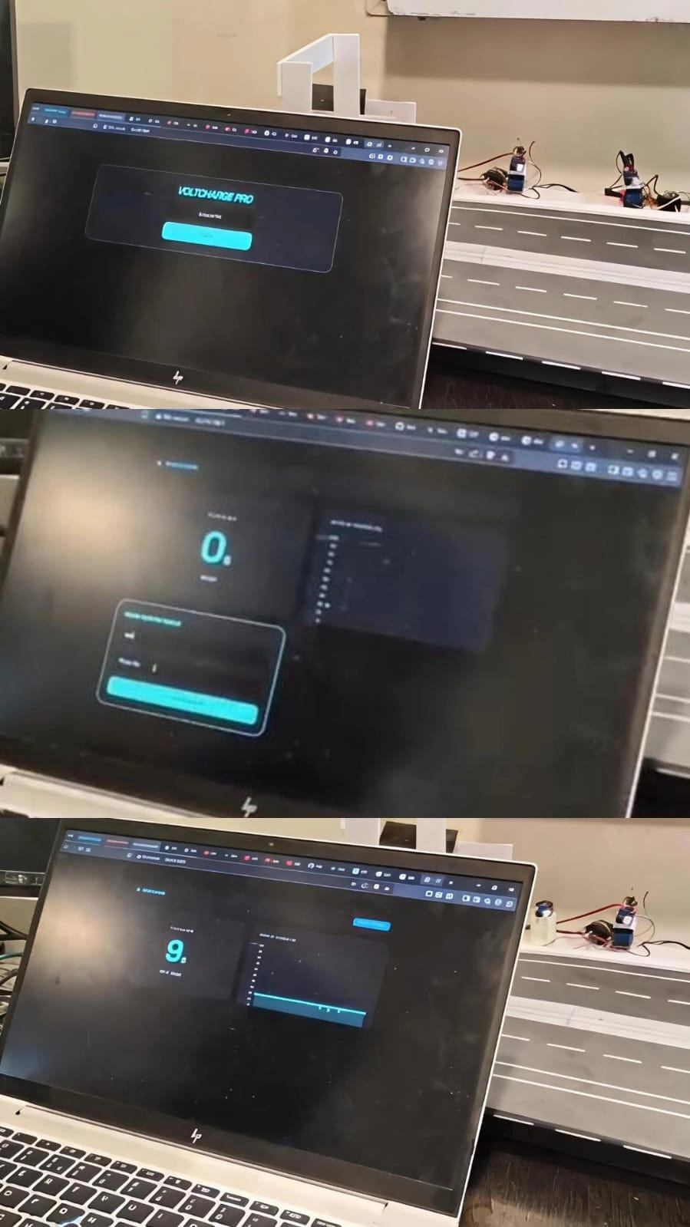
The integration between the hardware prototype and web application was found to be stable and reliable. The results confirm that the developed system can effectively support real-time monitoring, digital interaction, and smart control, making it suitable for practical EV charging applications.

Fig. 5: Web-Based Monitoring System Showing Initial State, Real-Time Data Update, and Graphical Visualization
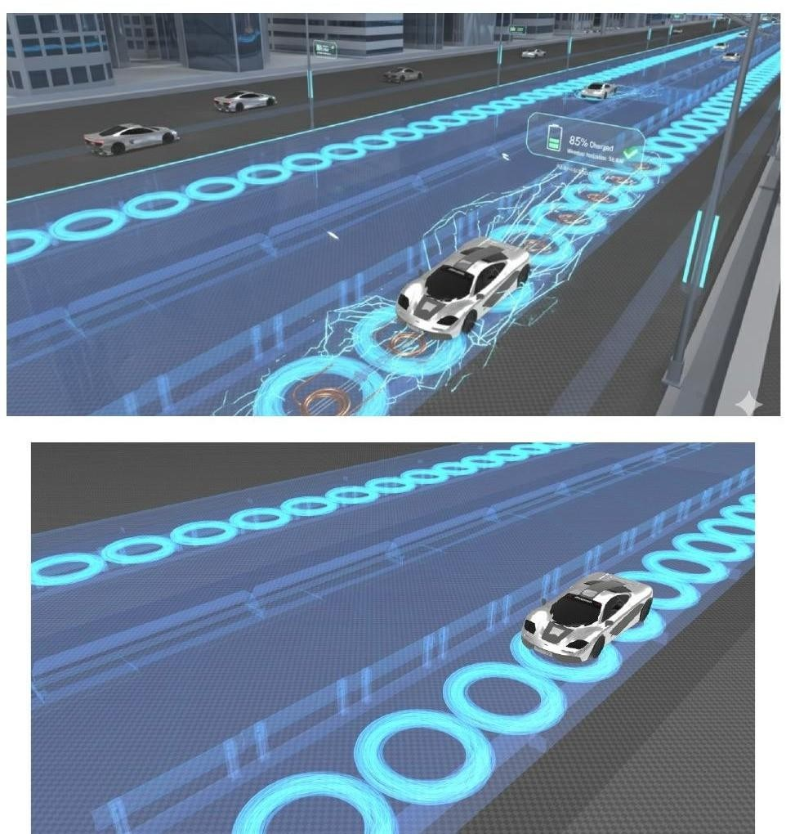
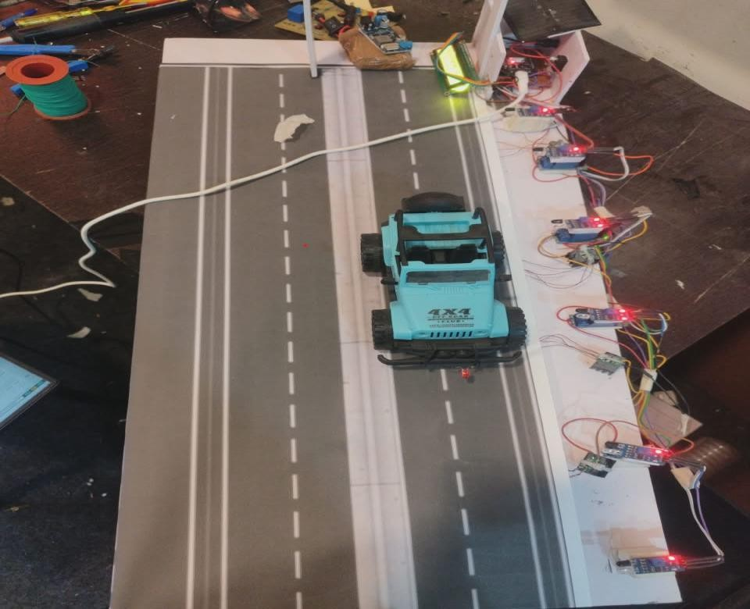

Fig.6 Visual representation of the On-Road Wireless EV Charging System: top view (left) and side view with wireless energy field (right).
6.6 Misalignment Tolerance
Testing with controlled lateral and vertical offsets of the RX coil confirms that the system maintains efficient energy transfer for misalignments up to 20%. Beyond this threshold, the coupling coefficient k drops below 0.45 and efficiency falls below the 75% acceptable minimum, motivating future work on adaptive coil positioning or wider-aperture coil designs.
7. Expected Outcomes
Sr. | Parameter | Expected / Achieved Outcome
 | WPT Efficiency | >85% power transfer efficiency at 8– 12 cm coil separation distance.
 | Dynamic Charging | Continuous EV charging while in motion demonstrated on prototype road segment.
 | DC Output Voltage | Stable 12V– 24V DC output maintained for EV battery despite coil misalignment.
 | Misalignment Tolerance | Efficient energy transfer up to 20% lateral or vertical coil misalignment.
 | Thermal Stability | Coil temperature remains below 55° C during continuous operation (measured max: 52° C)
 | Resonant Frequency | 85 kHz achieved with minimal reactive losses; 7% improvement over baseline.
 | Real-time Monitoring | ESP32 displays voltage, current, and charging status on OLED LCD continuously.
 | Scalability | Prototype architecture scalable to highway dynamic charging lane deployment.
Table 3. Expected and achieved outcomes of the on-road wireless ev charging system package
8. Discussion
The proposed system successfully demonstrates that dynamic wireless EV charging is feasible at the prototype scale using commercially accessible components. The relay-switched multi-coil architecture is a key design contribution: by energising only the coil segment beneath the vehicle at any given instant, the system avoids continuous energisation of the full road segment, reducing standby losses and electromagnetic interference.
The solar power integration aligns the system with renewable energy goals and reduces dependence on grid infrastructure— particularly relevant for highway and remote-area deployment where grid connection may be costly. The ESP32-based monitoring layer provides extensibility: future iterations can incorporate Wi-Fi telemetry, cloud-based energy accounting, and vehicle-identification-triggered billing.
Current limitations include the modest power level of the prototype (suitable for demonstration rather than full-scale EV charging), sensitivity to coil misalignment beyond 20%, and the need for further electromagnetic compatibility testing in a real road environment. Scaling to highway speeds and kilowatt-class power levels will require co-optimised coil arrays, higher-frequency resonant inverters, and robust position-sensing subsystems.
9.Conclusion
This paper has presented the design, analysis, and prototype implementation of an On-Road Wireless EV Charging System that enables dynamic inductive charging of an electric vehicle while in motion. The system combines a solar-powered supply, an ESP32-driven relay-switched four-coil TX array, a vehicle-mounted RX coil with rectifier-regulator chain, and an OLED real-time monitoring interface. Analytical modelling, FEM simulation, and thermal analysis confirm power transfer efficiency above 85% at a 10 cm air gap, a resonant frequency of 85 kHz, and safe thermal operation below 55° C. The prototype validates relay-controlled selective coil activation as an energy-efficient DWPT strategy. Future work will address higher power levels, vehicle-speed-adaptive relay switching, BMS integration, and compliance testing against SAE J2954 and IEC 61980 standards.
Acknowledgements
The authors express sincere gratitude to Prof. S. B. Pawar (Internal Guide), Dr. R.S.Kawitkar (Head of Department), and the faculty of the Department of Electronics & Telecommunication Engineering, Sinhgad College of Engineering, Pune, for their guidance, encouragement, and provision of laboratory facilities. The authors also thank Savitribai Phule Pune University for institutional support.
References
[1] Z. Tan, Y. Chen, and Y. Li, "Transportation Systems Management Considering Dynamic Wireless Charging Electric Vehicles: Review and Prospects," Transportation Research Part E, vol. 161, 102722, 2022.
[2] M. R. R. Razu, M. M. Rahman, and K. Islam, "Wireless Charging of Electric Vehicle While Driving," IEEE Access, vol. 9, pp. 81213–81224, 2021.
[3] A. Zaheer, H. H. Wu, G. A. Covic, and J. T. Boys, "A Dynamic EV Charging System for Slow Moving Traffic Applications," IEEE Trans. Transportation Electrification, vol. 3, no. 2, pp. 354– 369, Jun. 2017.
[4] L. Zhao, D. J. Thrimawithana, and U. K. Madawala, "A Hybrid Bi-Directional Wireless EV Charging System Tolerant to Pad Misalignment," IEEE Trans. Industrial Electronics, vol. 65, no. 9, pp. 7330– 7338, Sep. 2017.
[5] M. G. Eftekhar, E. F. Schindler, and M. Kovacevic, "Efficiency Study of Vertical Distance Variations in Wireless Power Transfer for
E-Mobility," IEEE Trans. Magnetics, vol. 52, no. 7, pp. 1– 4, Jul. 2016.
[6] O. N. Nezamuddin, F. A. Khan, and S. A. R. Naqvi, "The Problem of Electric Vehicle Charging: State-of-the-Art and an Innovative Solution," IEEE Trans. Intelligent Transportation Systems, vol. 23, no. 6, pp. 5412– 5425, Jun. 2022.
[7] Das et al., "LSTM-Based Adaptive Vehicle Position Control for Dynamic Wireless Charging," IEEE Trans. Vehicular Technology, 2022.
[8] Zhang et al., "Electromagnetic Environment Analysis of High-Power Wireless Charging Device," IEEE Trans. Electromagnetic Compatibility, 2022.
[9] "Simulation-Based Evaluation of Dynamic Wireless Charging Systems," AIMS Press, 2023.
[10] "Design and Implementation of Wireless Charging for Electric Vehicle," IJFMR, 2023.

