"Transforming Life through Welding: An International Model Integrating Prison Rehabilitation and Skill Development for Sustainable Nation Building"

Abstract:
Globally, over 12 million people are incarcerated, with India accounting for nearly 600,000 prisoners of whom 56–60% are youth aged 18-35 years and about 50,000 are women. This demographic presents a significant opportunity for skill-based rehabilitation. Concurrently, India’s fabrication and shipbuilding sectors face a shortage of qualified welding personnel’s, with a projected demand of 12,000-15,000 professionals by 2026-30. Existing prison training programs have shown limited success due to non-standardized curricula and weak industry alignment. To address this gap, the "Transforming life through welding" initiative was developed as an international model integrating prison rehabilitation with skill development for Sustainable nation-building. The program was Implemented at the Industrial Skill Development Training Centre, Central Prison, Chennai (TN) India, designed 240 hours of training in MMAW Process (3F/3G) aligned with ISO 9606-1 standards with NSQF Level; 3.5-4 Skill competency. The curriculum combined 60% practicals, 30% theoretical, and 10% life-skill and behavioral transformation modules. Quantitative assessment revealed that 60% of participants achieved WPQ validated through NDT/DT testing. Behavioral evaluation indicated a 40% improvement in discipline, a 50% enhancement in technical competency, and a 75% rise in self-confidence. Certified inmates contributed to in-prison fabrication and maintenance work, generating income to support their families. A post-employment facilitation cell was established to assist with reintegration and job placement after release. Key success factors included sustainable VR/AR-based welding simulator training (reduction in training costs & Energy), exposure to engineering drawings and basic electrical practices, life-skill mentoring. Despite infrastructure constraints, the model proved scalable and sustainable, demonstrating how structured welding education can serve as a transformative tool for rehabilitation, employability, and social reintegration with a targeted goal on “Viksit Bharat 2047: Empowering India through skill development. This initiative establishes a replicable global framework of social engineering, illustrating that through welding, lives can be rebuilt, families strengthened, and nations empowered.
Keywords:
Welding Education, Prison Rehabilitation, Skill Development, Industrial Workforce, ISO 9606, Welder Qualification, WPQ, Social Reintegration, Nation Building, PPE.

I. Introduction
The rehabilitation of prisoners through structured skill development has emerged as a critical global priority; both as a social responsibility and an economic necessity. Around the world, correctional Professional institutions are increasingly shifting focus from punitive confinement to transformative reformation, enabling inmates to rebuild their lives through vocational and technical education. In India, however, prisons have traditionally functioned as detention facilities rather than centers of rehabilitation. This has resulted in limited reintegration opportunities for released inmates, perpetuating cycles of unemployment, marginalization, and re-offending. The absence of standardized vocational programs aligned with industry needs further widens this gap, leaving a vast pool of untapped human potential within the prison system. Meanwhile, India’s industrial ecosystem; particularly fabrication, infrastructure, and shipbuilding sectors, faces an acute shortage of certified welders and fabrication specialists. The projected demand for 12,000-15,000 skilled welding professionals by 2026–2030 underscores an urgent need for a sustainable skill aligns with international quality standards. This study presents an innovative and reformative model titled “Transforming prisoners’ life through welding”, which integrates vocational welding skill training within the prison system as a pathway to social rehabilitation, workforce empowerment, and sustainable nation building. By aligning with ISO 9606-1 Standard and NSQF Min. 3.5 to Max. 4, Level of skilled technician competency, this initiative bridges the gap between incarceration and employability, turning confinement into an opportunity for constructive transformation.
- Aim
The primary aim of this study is to develop and implement a structured, skill-based rehabilitation model that transforms prison inmates into certified and employable welding professionals. The initiative seeks to utilize standardized welding education as a tool for behavioral reform, technical competency building, and social reintegration within correctional facilities. Mainly a targeted goal on “Viksit Bharat 2047; Empowering India through Skill development. It includes goals for inclusive Country growth, innovation, sustainability, and prosperity, with initiatives focusing on Skill education and technology.
- Goal

The goal of the initiative is to establish a sustainable and replicable framework for Prison-based skill development aligned with international welding standards, such as Integrated Management System (IMS) with performance qualification as per ISO 9606-1 (ISO3834) welding standard and NSQF Level 3.5-4 Skill competency.

II. Objectives

The objectives of this study are fourfold. First, to design and implement a structured 240-hour welding training program aligned with ISO 9606-1 Standard. and NSQF Level-3.5-4 Competency, integrating 60% practical, 30% theoretical, and 10% life-skill components to ensure a balanced learning experience. Second, to enhance behavioral and professional competencies by fostering discipline, teamwork, self-confidence, and a sense of responsibility among inmates through continuous mentoring and life-skill development initiatives. Third, to assess and certify trainee performance through Non-Destructive Testing (NDT) and Destructive Testing (DT) qualification methods, ensuring compliance with international welding standards and industrial readiness. Finally, to establish a sustainable rehabilitation model by linking trained inmates with CSR and industry partners for post-release employment, thereby promoting economic empowerment, social reintegration, and contributing to the development of a skilled national workforce.

III. Literature Review
Across the world, numerous studies and initiatives have demonstrated the transformative potential of technical and vocational education within correctional facilities. Internationally recognized frameworks emphasize that education and skills training are central to prisoner rehabilitation and social reintegration. The United Nations standard minimum rules for the treatment of prisoners (Nelson Mandela Rules & Guidelines adopted 2015) specifically advocate for structured vocational and educational programs that empower inmates to reintegrate into mainstream society as productive citizens. Empirical evidence from developed nations such as Norway, Japan, and Canada highlight that employment-oriented correctional training programs significantly reduce recidivism rates; by as much as 43%, while enhancing social stability and post-release employability. These models demonstrate that well-designed skill training not only equips inmates with technical competencies but also fosters discipline, self-worth, and a sense of responsibility. In the Indian context, however, earlier rehabilitation efforts driven by NGOs and CSR or Government based initiatives have remained fragmented, often lacking standardized curricula, industry linkages, and certification alignment with recognized national or international frameworks. The absence of ISO-compliant welding qualification systems and limited integration of the National Skills Qualification Framework (NSQF) have restricted trained inmates from securing formal employment opportunities upon release. The present study seeks to address these systemic gaps by introducing a standardized, internationally bench-marked training model that aligns prison-based skill development with EN/ISO 9606-1 welder qualification standards and NSQF Level; 3.5-4 competency. Through this alignment, establishes a essential framework for sustainable rehabilitation and industrial workforce development within correctional ecosystems.

IV. Narrative Analysis for the Interpretation of Qualitative Findings:
The Narrative analysis of this study on “Transforming Life Through Welding”, highlights the socio-economic and psychological challenges faced within the prison system and its limited contribution to rehabilitation. The investigation research revealed that the overall running cost of prisons, including expenditure on food, clothing, welfare, infrastructure, police administrative salaries, and legal or judicial expenses; continues to rise significantly.
However, these financial inputs do not yield meaningful outcomes in terms of behavioral improvement, mental health stability, or post-release reintegration of prisoners. During imprisonment, prisoners often show poor attitudinal change and discipline due to the lack of structured rehabilitation programs.
Their families face emotional and economic hardship, leading to disrupted education and social exclusion. Consequently, many prisoners struggle to regain a sense of citizenship and responsibility because of persistent social stigma”.
According to the National Crime Record Bureau, the statistical data (Figure No. 1) indicates that the majority of prison expenditure was allocated to food (62.1%), followed by welfare activities (22%) and vocational education (8.8%). Smaller proportions were spent on clothing (4%), medical care (1.6%), and other miscellaneous expenses (1.4%). This reveals that while basic needs dominate the expenditure, relatively limited funds are directed toward skill development and rehabilitation initiatives such as vocational education.
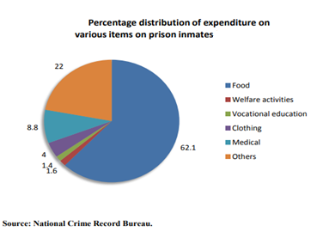
Figure No:1. Expenditure on running prisons in India (pie chart)
There is limited motivation and sustainable support for prisoners, with minimal industry or professional engagement. This highlights the urgent need for a skill-based rehabilitation model promoting behavioral change, economic empowerment, and social reintegration.
“Transforming Life Through Welding” emphasizes how welding skills can open new opportunities, ensure stable careers, and inspire personal growth.

The following criteria present the observations from narrative analysis:
Sl. NO. | OBSERVED CRITERIA | KEY FINDINGS / OBSERVATIONS | INTERPRETATION / IMPACT
1 | Economic Cost of Prison Management | High expenditure on prison operations including food, welfare, staff salary, and legal systems - without measurable improvement in prisoner outcomes; | Indicates inefficient use of government resources and lack of performance-based reform measures.
2 | Skill Development and Training Initiatives | No structured or continuous vocational or technical programs found. | Absence of skill-based rehabilitation leads to unemployment and re-offending risk post-release.
3 | Attitude and Behavioral Development | Prisoners show minimal improvement in personal discipline, teamwork / individual responsibility. | Demonstrates poor behavioral reformation and lack of moral or civic guidance.
4 | Mental and Emotional Well-being | Prisoners experience mental stress, hopelessness, and low morale due to isolation and lack of counseling. | Weak psychological support system; increases vulnerability to violence and depression.
5 | Family and Social Impact | Families suffer financially and emotionally; children’s education interrupted; social stigma persists. | Highlights secondary victimization of families and community alienation.
6 | Institutional and Administrative Support | Minimal engagement from NGOs or welfare departments; limited long-term rehabilitation planning. | Lack of coordination between correctional institutions and social organizations.
7 | Citizenship and Responsibility Awareness | Prisoners are not guided toward regaining citizenship identity or civic responsibility. | Reduces potential for social reintegration and productive citizenship.
8 | Public and Policy Perception | Society views prisoners as offenders rather than potential contributors. | Need for awareness campaigns and positive social inclusion frameworks.
9 | Future and Motivation Level | Prisoners express deep worry about post-release life, Employability, and society acceptance. | Urgent requirement for structured re-entry through industrial skill initiatives such as “Life through Welding.”
10 | Prisoners Life Change and Output | Represents a model of rehabilitation through skill empowerment, promoting both individual transformation and collective peace within society. | The project fosters a strong sense of social responsibility, discipline & human values, also reduction in criminal behavior, Re-integrated into society as skilled workers.
Table No:1, Observed Criteria and Findings from Narrative Analysis
Summary of Interpretation: Despite significant investments, India’s prison system struggles to achieve true reformation and reintegration. Introducing industry-linked skill programs like welding training can transform imprisonment into productive learning and sustainable rehabilitation.

V. Methodology
The Qualitative methodology emphasized skill competency enhancement, behavioral transformation, and social reintegration, ensuring that each participant acquired not only trade-specific proficiency but also the discipline, responsibility, and ethical awareness required for sustainable rehabilitation and future employability.
The “Transforming Life through Welding” initiative was implemented as a collaborative framework led by Shri. Chandran Subramani, Hon. Welding Skill Development Coordinator, Sothern Regional cum Examiner (IIW–India) at Chennai, in association with the Tamilnadu Central Prison (Puzhal) and TN State Prison Authorities, Chennai District. The initiative was structured under a comprehensive skill development course design, syllabus and overall infrastructure (facilities with requirements) provided free of cost, this framework integrating technical training, behavioral development.
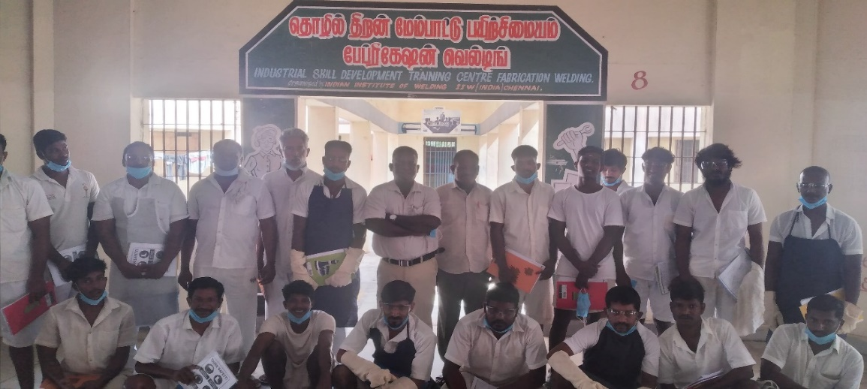
✅P1: Photographic Evidence of the Initiated “Industrial Skill Development Training Centre”
The program was systematically designed to transform inmates into Certified Welding Inspector (CWI)/ International Welding Technologist (IWT) through a standards-based training model aligned with both national and international qualification systems.
A. Program Design:
The training curriculum was meticulously structured to ensure technical rigor, behavioral development, and industry readiness. The program had a total duration of 192 hours, focused on the Shielded Metal Arc Welding (SMAW) process, specifically in 3F and 3G welding positions. Further to be developed training Modules of GMAW (MIG, MAG, FCAW) with GTAW (TIG) welding process with different welding positions. All training modules were aligned with the ISO9606-1 qualification framework, ensuring global recognition of welding competence. The curriculum was structured to ensure a balanced blend of technical and personal development 60% practical training in welding techniques, 30% theoretical learning on fundamentals and PPE safety, and 10% life skills and attitude development focusing on discipline, teamwork, and communication. This integrated approach equipped trainees with both professional competence and personal discipline, supporting their smooth reintegration into the workforce.
B. Assessment and Evaluation:
A comprehensive multi-stage assessment system was developed to ensure both technical and behavioral competencies were objectively evaluated.
Technical Evaluation: Each participant’s welding performance was tested through Destructive Testing (DT) and Non-Destructive Testing (NDT) methods, including visual inspection, bend tests & radio-graphic examination, in accordance with EN/ISO.
Behavioral Assessment: Pre- and post-training surveys were conducted to measure improvements in discipline, confidence, and workplace behavior.
Performance Monitoring: Individual progress was tracked through daily performance logs, trainers’ evaluation reports, and assess periodic reviews conducted by certified welding inspectors - CWI / IWT qualified welding examiner. This evaluation framework ensured data-driven validation of training effectiveness and performance.
C. Supporting Components:
To enhance the learning experience and bridge the technology gap within correctional environments, several supporting elements were integrated:
VR/AR-based Simulation Practice: Provided a risk-free digital environment for trainees to visualize weld techniques, arc behavior, and defect correction before live practice.
Electrical and Blueprint Fundamentals: Introduced basic electrical circuit knowledge and engineering drawing to improve understanding of fabrication systems.
Personality Development and Soft Skills Training: Focused on confidence-building, self-awareness, and employability enhancement through motivation sessions.
Industry Partnership: Collaboration with MSME industry partners ensured post-release employment facilitation for qualified trainees.
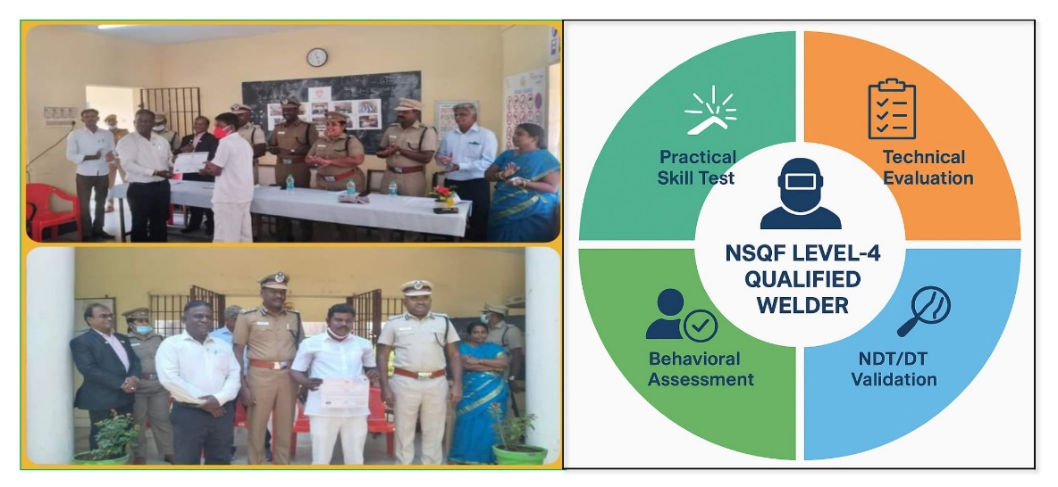
✅P2: Photographic Evidence of “Best Welder” Awarded (ISO 5817 Stringent Level Qualified)
The “Transforming Life Through Welding” program yielded significant results in both technical and behavioral dimensions, demonstrating the transformative potential of structured vocational training within correctional environments. A total of 100 inmates participated in the training program. Out of these, 60 participants (60%) successfully achieved ISO 9606-1 structural steel welder qualification, verified through destructive and non-destructive testing (DT/NDT) methods under certified inspection supervision. The remaining trainees completed partial training modules and continued with internal prison-based welding assignments for further practice and evaluation.
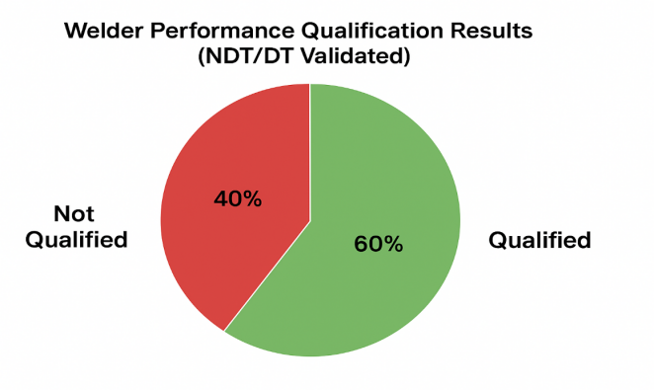
Figure No:2. Final Result for Welder Performance (Pie Chart)
A. Performance Improvement Analysis: Quantitative analysis indicated measurable enhancement in multiple performance Indicator:
Performance Indicator | Pre-Training Baseline | Post-Training Improvement
Discipline and Work Ethic | Low level to Moderate | +40% improvement
Technical Competence | Basic level to Un-skilled | +50% improvement
Confidence & Self-Motivation | Low level to Moderate | +75% improvement
Table No:2, Recorded Performance Improvement
The data reflect that a progressive correlation exists between technical proficiency and behavioral stability. Participants who demonstrated higher welding performance scores also showed greater self-discipline, focus, and teamwork capability. This correlation validates that technical engagement fosters psychological transformation, contributing to long-term adaptability and social reintegration.
B. Employment and Reintegration Outcomes
Following certification, qualified inmates were engaged in in-prison fabrication, repair, and maintenance activities, contributing to facility operations while generating income to support their families. A Post-release Employment Facilitation Cell was established within the prison training center to coordinate placement opportunities with CSR and industry partners. Early outcomes indicated that trained welders received favorable consideration from fabrication and shipbuilding industries seeking certified manpower.
These findings affirm that standardized welding training within correctional facilities can serve as an effective bridge between incarceration and employability, promoting both individual rehabilitation and industrial workforce development.

VI. Discussion
The outcomes of this initiative clearly validate that structured welding skill development within correctional environments serves as a powerful instrument for both employability enhancement and moral reformation. by integrating internationally recognized standards such as ISO 9606-1 and the NSQF Level 3.5-4 framework, the program effectively bridged the gap between incarceration and industrial readiness. The results demonstrate that when inmates are trained under industry-grade conditions, they can evolve into competent, disciplined, and socially responsible professionals. This transformation extends beyond technical skill acquisition; it promotes self-confidence, work ethics, and a constructive mindset, all of which are crucial for successful reintegration into society. Nevertheless, the implementation of the program encountered several operational challenges, including limited infrastructure availability, administrative clearance delays, and constraints in tool and equipment maintenance. Despite these limitations, the initiative’s success was largely attributed to the collaborative partnership model involving CSR sponsors, prison authorities, and certified welding instructors, which ensured continuous resource support, quality assurance, and program sustainability. Overall, the findings underscore that industry-integrated rehabilitation models, when supported by standardized training systems and cross-sector collaboration, can play a transformative role in reducing recidivism, enhancing national skill capacity, and advancing the vision of inclusive nation building through skill-based reform.

VII. Challenges and Observations:
The implementation of the “Transforming Life through Welding” initiative revealed several critical challenges within the prison environment. Internal support from prison officials was limited, and coordination between administrative and training units remained weak. The establishment of structured rules and regulations for fabrication and welding training within prison premises was identified as essential but has not yet been formalized. In addition, insufficient internal resources; including tools, consumables, and safety equipment, restricted the effectiveness of skill practice and learning outcomes. The procurement and safe custody of external training materials also presented logistical and security challenges, further slowing overall progress. At the initial stage, many prisoners exhibited low motivation and indifference toward welding activities, primarily due to negative attitudes and limited awareness of skill-based opportunities. It was further observed that a considerable portion of the prison population showed low levels of physical fitness and reduced work efficiency. Despite these constraints, the narrative findings indicate that many prisoners possess strong technical aptitude and learning potential. Once engaged in training, they demonstrated the ability to grasp welding concepts quickly and perform assigned tasks with growing competence. The introduction of a monthly stipend and work-based incentives notably improved participation levels and fostered a sense of dignity, purpose, and social value within the prison community. These findings suggest that, with structured management support, adequate material provision, and consistent motivational reinforcement, the Transforming Life through Welding” model can evolve into a sustainable and replicable framework for rehabilitation and social reintegration.

VIII. Recommendations / Improvements Activity;
Based on the outcomes of this study, several key recommendations are proposed to strengthen and expand the impact of prison-based welding skill development programs at both national and international levels.
National Replication and Policy Integration: The success of this model underscores the need for its nationwide replication under the frameworks of the National Skill Development Corporation (NSDC) and the Directorate General of Training and Employment (DGTE). Establishing Welding Skill Development Units within major prisons across India can create a standardized and scalable rehabilitation ecosystem aligned with the National Skills Qualification Framework (NSQF).
Standardization through International Frameworks: To ensure global recognition and employability, future programs should align with international quality benchmarks such as ISO 3834 (Weld Quality Management System) and ISO 9606-1 (Welder Qualification Testing). This alignment will ensure that inmates receive certifications equivalent to those required in fabrication industries and shipbuilding sectors worldwide.
Integration with Industry 5.0 and Digital Learning Tools: The adoption of Industry 5.0 technologies, including Virtual Reality (VR) and Augmented Reality (AR) simulation platforms, is recommended to enhance digital literacy and practical understanding among trainees. These tools can replicate real-time welding conditions and provide immersive learning experiences, improving training efficiency and safety.
Sustainability and Employment Linkages: Establishing a centralized “Prison Skill Employment Cell” under the Ministry of Skill Development & Entrepreneurship (MSDE) will help connect trained inmates with industry employment opportunities. This cell can serve as a coordination hub between correctional institutions, industry associations, and CSR sponsors to ensure continuous engagement and placement support.
Social Reintegration and Economic Empowerment: To ensure long-term rehabilitation, mechanisms for microfinance, entrepreneurship training, and self-employment support should be introduced for released inmates. Partnerships with public and private banks, NGOs, and industrial clusters can facilitate small-scale fabrication units or welding service enterprises operated by certified ex-inmates.

Global Collaboration and Knowledge Exchange: The model can be adapted internationally through collaboration with global bodies such as the International Labour Organization (ILO) and UNESCO - UNEVOC. Establishing cross-country exchange programs will allow sharing of best practices in prison-based vocational rehabilitation, thereby promoting inclusive global workforce development. Also, to be collaborate with International Institute of Welding (iiw).
Collaboration and Strategic Activation: It is the right time to collaborate with IIW-India and State and Central Government skill development bodies, along with the relevant Sector Skill Councils, to establish a governing body & technical committee and a mission targeted mainly a targeted goal on “Viksit Bharat 2047;

This strategic collaboration will help standardize training frameworks, ensure quality certification, and implement a nationwide rehabilitation program aimed at transforming prisoners into skilled professionals. The initiative will effectively promote social reintegration, dignified livelihood opportunities, and contribute to industrial manpower development across key sectors.
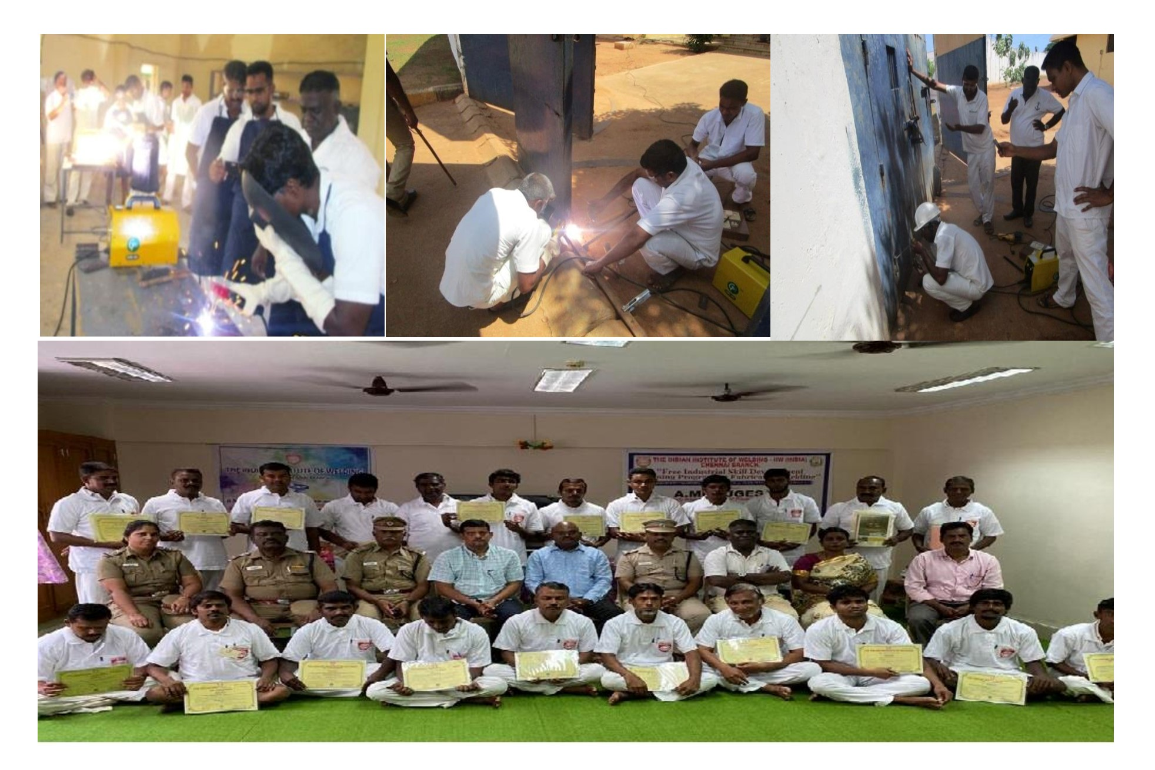
✅P:3. Photographic Evidence of the Welding Training, Assignment & Validation

Training Plan and Benefits: The Project-focused skill development training program is designed to fulfill the requirements. The initiative aims to build a skilled and certified workforce capable of meeting industrial and national standards.

Recommended Employment Phase (Pre-release & Post-release): Upon successful completion of training and assessment, certified candidates will be offered one of the following employment opportunities:
- Prison Maintenance & Fabrication Work (Pre-release); Engaging in internal maintenance and small-scale fabrication within the facility.
- External Camp Work (Pre-release); Participation in on-site fabrication, Manufacturing and shipbuilding yard projects.
- National Employment (Post-release); Placement in domestic industries manpower supporting after prison tenure.
- Overseas Employment (Post-release); Opportunity for international placement based on performance and valid international skills certification.
- Self-Employment (Post-release): Supporting government initiatives under the MSME (Micro, Small, and Medium Enterprises) scheme, including free registration and loan facilities, also guiding startup for innovation projects.

Training Benefits; During the training period, participants receive attractive stipends and access to welfare support programs, ensuring sustained motivation and active engagement throughout the training-to-employment transition. Additionally, monthly performance-based award with rewards and a special annual paid holiday (for family visits) provision are offered to recognize dedication and continuous improvement.

Proposed NSQF-Aligned Training Modules (India):
NSQF Level | Designation / Role | Competency Description | Qualification Focus
Level 1 | Welding Helper / Unskilled Assistant (Foundation level) | Basic understanding of welding tools, materials handling, PPE | Foundational knowledge and safety practices.
Level 2 | Basic Operational Welding Skills (Basic Level) | Performs simple welding operations under supervision. (1F/1G) | Practical exposure to basic welding processes.
Level 3 | Welding Assistant / Supporting Technician (Standard Level) | Supports skilled welders in preparation, alignment, and inspection activities. (2F/2G) | Process familiarity and teamwork competence.
Level 3.5 | Qualified Welder (Intermediate Level) | Certified skilled welders in preparation and welding quality inspection activities. (3F/3G) | individuals can perform routine welding tasks independently.
Level 4 | Independent Certified Welder (Expert Level) | Performs independent welding tasks as per ISO 9606-1 qualification standard. (6G) | Performance qualification and professional certification.
Level 5 | Welding Supervisor/CWI Inspector / Coordinator (Supervisory Level) | Oversees welding operations, ensures quality compliance as per the standards. (CWI, TOT syllabus) | Supervisory skills and inspection, weld quality management systems.
Table no:3 NSQF structured Training Levels and Qualification modular system
This structured training levels and qualification modular system ensures progressive skill enhancement, leading to sustainable employability and rehabilitation through globally recognized welding Standards.
Proposed for Phase Implementation:
Analysis of state-wise prisoner populations highlights the need for the immediate introduction of structured skill development and rehabilitation programs in prisons with the highest inmate strength. The proposed “Transforming Life Through Welding” initiative aims to convert incarceration into a platform for skill empowerment, socio-economic reintegration, and reduced recidivism through vocational welding training and personnel counseling.
Priority states for phased implementation include Uttar Pradesh (≈20,000), Maharashtra (≈10,000), Andhra Pradesh (≈9,000), Tamil Nadu (≈8,500), West Bengal (≈8,000), Madhya Pradesh (≈7,500), Bihar (≈7,000), Punjab (≈6,750), Haryana (≈6,500), and Karnataka (≈6,000).
These ten states collectively represent a major share of India’s prison population and are identified as key focal regions for launching the “Transforming prisoners’ life through welding” skill-based rehabilitation phase model.
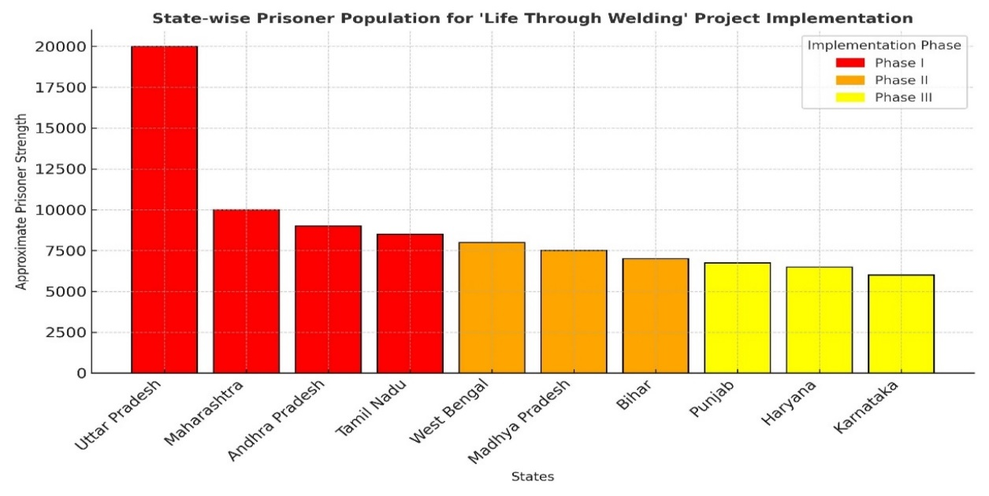Figure 3. State-wise Prisoner Population Indicating Phase-wise Implementation (Bar Chart)
Summary of Interpretation: The chart illustrates that Uttar Pradesh (Indian state) leads with the highest inmate strength, followed by Maharashtra, Andhra Pradesh, and Tamil Nadu; forming the Phase-I priority cluster. These states together represent a substantial proportion of India’s total prison population and hence are ideal for launching the “Transforming Life through Welding” initiative focusing on welding skill training and behavioral rehabilitation.
Module Proposed for the Title of Welders performance qualification Assessment:
Module Code | Course Title | Duration | Total Hours | Structure | Process/Qualification | Enrolment Group
WPT-1 (Intern. Expert) | Certified International Welding Expert | 3 Months | 480 Hrs | (400 Practical + 80 Theory) | SMAW, GMAW, GTAW, FCAW - 6G (NSQF-4) | Qualified “Standard level” Qualification,
WPT-2 (STD.) | Certified Structural ARC Welder (SMAW) | 45 Days | 280 Hrs | 240 Practical + 40 Theory | SMAW - 3G/3F (NSQF-3) | Qualified “Basic level” Qualification,
WPT-3 (STD.) | Certified Structural MIG Welder (GMAW) | 45 Days | 280 Hrs | 240 Practical + 40 Theory | GMAW - 3G/3F (NSQF-3) | Qualified “Basic level” Qualification,
WPT-4 (STD.) | Certified Structural TIG Welder (GTAW) | 45 Days | 280 Hrs | 240 Practical + 40 Theory | GTAW - 3G/3F (NSQF-3) | Qualified “Basic level” Qualification,
WPT-5 (Expert) | Certified Pipe Welder (SMAW + GMAW) | 45 Days | 280 Hrs | 240 Practical + 40 Theory | SMAW & GMAW 6G (NSQF-4) | Qualified “Standard level” Qualification,
WPT-6 (Expert) | Certified Pipe Welder (SMAW + GTAW) | 45 Days | 280 Hrs | 240 Practical + 40 Theory | SMAW & GTAW 6G (NSQF-4) | Qualified “Standard level” Qualification,
WPT-7 (Expert) | Certified Pipe Welder (GTAW + SMAW) | 45 Days | 280 Hrs | 240 Practical + 40 Theory | GTAW & SMAW 6G (NSQF-4) | Qualified “Standard level” Qualification,
WPT-8 (Basic) | Certified Brazing Technician (Brazer) | 45 Days | 280 Hrs | 240 Practical + 40 Theory | OAG Weld & Braze 2F/2G (NSQF-3) | Skilled/Un-skilled/ Counseling selection
WPT-9 (Basic) | Certified Welder - Basic (SMAW) | 45 Days | 280 Hrs | 260 Practical + 20 Theory (Foundation) | SMAW 2F/1G (NSQF-2) | Skilled/Un-skilled/ Counseling selection
WPT-10 (Basic) | Certified Welder- Basic (GMAW) | 45 Days | 280 Hrs | 260 Practical + 20 Theory (Foundation) | GMAW 2F/1G (NSQF-2) | Skilled/Un-skilled/ Counseling selection
WPT-11 (Basic) | Certified Welder - Basic (GTAW) | 45 Days | 280 Hrs | 260 Practical + 20 Theory (Foundation) | GTAW 2F/1G (NSQF-2) | Skilled/Un-skilled/ Counseling selection
WPT-12 (Fdn.) | Welding Assistance (Foundation) | 45 Days | 280 Hrs | 260 Practical + 20 Theory (Foundation) | Basic Joint / Gas cutting, (NSQF-1) | Skilled/Un-skilled/ Counseling selection
Table no: 4, NSQF with Welding Standard (structured qualification modular)

IX. Conclusion
The initiative “Transforming Life through Welding” conclusively demonstrates that skill-based correctional education is not merely a tool for rehabilitation, but a strategic instrument for national development. By embedding Integrated management system and ISO 9606-1 (Requirements of ISO3834 WQM) welder performance qualification standards within NSQF-aligned training frameworks, this model transforms correctional institutions into centers of structured technical excellence, producing globally competitive and industry-ready welding professionals. The incorporation of AI-based monitoring under CCTV supervision, along with Sustainable welding Training VR/AR-enabled welding simulations (Using cost saving & energy) and digital performance analytics, enhances training effectiveness monitoring systems and discipline, and productivity, resulting in measurable improvements in employability, self-confidence, and social reintegration. Aligned with the national vision of Viksit Bharat 2047, this initiative directly advances India’s objectives of inclusive growth, innovation-led development, sustainability, and workforce transformation. It addresses critical skilled manpower shortages while redefining prisons as engines of human capital generation rather than centers of isolation. By harmonizing advanced digital technologies with a human-centric approach under Industry 5.0 principles, this research establishes a replicable and scalable framework for dignified rehabilitation. Transforming prisoners into professionals is not merely social reform; it is nation-building in action. Skill progress is measured using software-based weld quality analytics, simulation logs, and performance dashboards rather than biological tracking. aligned with Industry 5.0 principles, this human-centered and technology-driven model redefines prisoner reformation through dignity, discipline, and innovation. It effectively bridges social transformation with industrial advancement, addressing skilled manpower shortages while promoting inclusive growth. Ultimately, the initiative stands as a replicable global framework of social engineering, proving that through the power of welding, lives can be rebuilt, families restored, and nations strengthened.

References:
- NSDC: Skill India Mission - Transforming Workforce Development in India, Govt. Report,2022.
- Author; Chandran Subramani; “Emerging Strategies for Skill Development and Standardization of ISO 3834 Standard by Weld Quality Management (WQM) Approach”. URL;https://www.doi-ds.org/doilink/02.2023-88146716/UIJIR
- Author; Chandran Subramani; “Up-Skilling India for Defense and Marine Sector Development, URL:https://www.ijnrd.org/viewpaperforall?paper=IJNRD2307461
- Ministry of Skill Development & Entrepreneurship (MSDE), National Skill Gap Report, 2022.
- International Institute of Welding (IIW), ISO 9606-1 Std. for Welder Qualification Testing.
- National Crime Records Bureau (NCRB), Prison Statistics India 2023.
- ISO 9606-1:2023, Qualification Testing of Welders - Fusion Welding.
- NSDC, “National Skills Qualification Framework (NSQF) Level Descriptors, 2022
- Author; Joe labriola: Post- prison Employment Quality and Future Criminal Justice Contact, URL;https://www.jstor.org/stable/10.7758/rsf.2020.6.1.07?seq=1
- IIW Guidelines for the Implementation of Education, Training and Qualification in Welding.
------------

