PROJECT FINTASTIC: AN INTERVENTION ON SOCIAL SKILLS FOR FISHMONGERS

ARLYN C. TABINAS

A DISSERTATION PRESENTED TO THE GRADUATE SCHOOL CENTRAL BICOL STATE UNIVERSITY OF AGRICULTURE PILI, CAMARINES SUR IN PARTIAL FULFILLMENT
OF THE REQUIREMENTS FOR THE DEGREE IN

DOCTOR OF PHILOSOPHY IN DEVELOPMENT EDUCATION

JUNE 2025
i

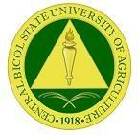
ii
CENTRAL BICOL STATE UNIVERSITY OF AGRICULTURE
San Jose, Pili, Camarines Sur GRADUATE SCHOOL

DOCTOR OF PHILOSOPHY IN DEVELOPMENT EDUCATION

ARLYN C. TABINAS

PROJECT FINTASTIC: AN INTERVENTION ON SOCIAL SKILLS FOR FISHMONGERS

CHRISTOPHER B. DACER, Ph.D.

JUNE 2025

No portion of this dissertation can be copied by any means without the written consent of the authors. Any portion of this dissertation
can only be accessed within the bounds of ethical standards.

ARLYN C. TABINAS

CHRISTOPHER B. DACER, Ph.D.

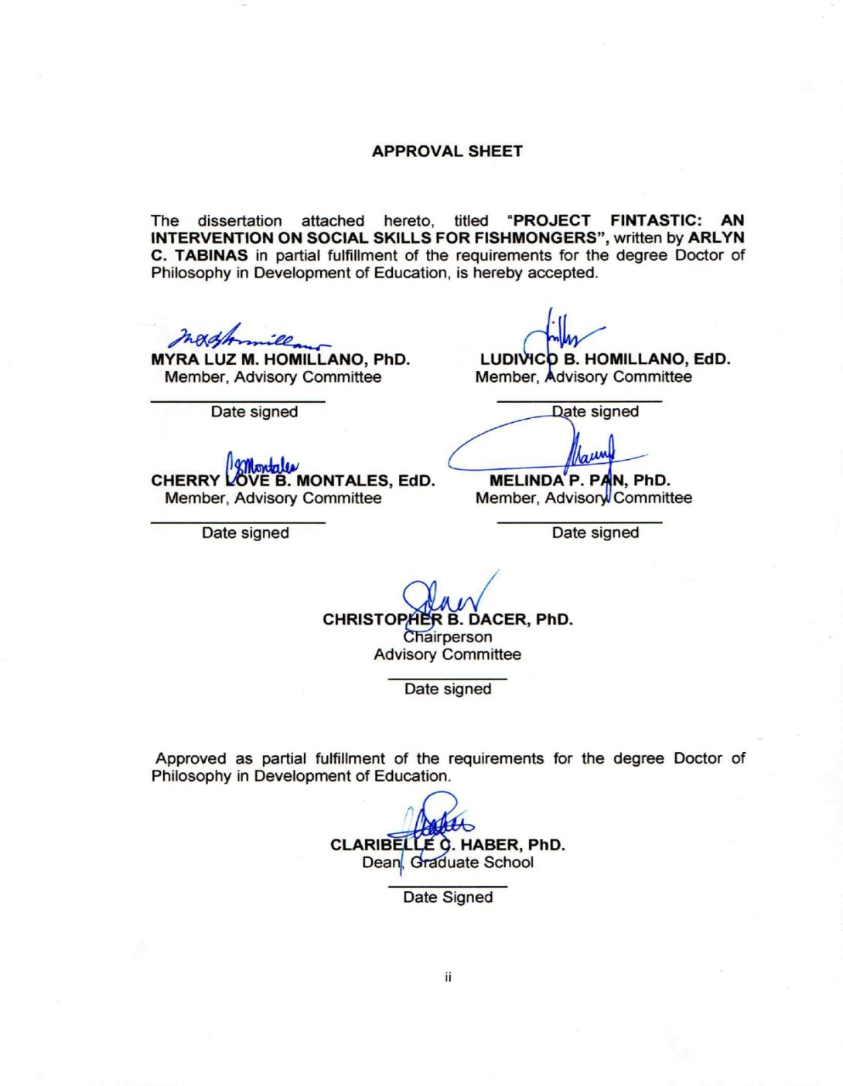

The dissertation attached hereto, titled “PROJECT FINTASTIC: AN INTERVENTION ON SOCIAL SKILLS FOR FISHMONGERS”, written by ARLYN
C. TABINAS in partial fulfillment of the requirements for the degree Doctor of Philosophy in Development of Education, is hereby accepted.

MYRA LUZ M. HOMILLANO, Ph.D. DR. LUDIVICO B. HOMILLANO, EdD.
Member, Advisory Committee Member, Advisory Committee

Date signed Date signed

CHERRY LOVE B. MONTALES, EdD. MELINDA P. PAN, Ph.D.
Member, Advisory Committee Member, Advisory Committee

Date signed Date signed

CHRISTOPHER B. DACER, Ph.D.
Chairperson Advisory Committee

Date signed

Approved as partial fulfillment of the requirements for the degree in Doctor of Philosophy in Development of Education.

CLARIBELLE C. HABER, Ph.D.
Dean, Graduate School

Date Signed

Research Author


Arlyn C. Tabinas was born on April 6, 1982, in Basud, Camarines Norte, and currently resides in Happy Homes Fairview II, Magang, Daet, Camarines Norte. She is the eldest child of Ricardo S. Coderes and Francisca Rejuso. She completed her primary education at Mantagbac Elementary School in 1995 and her secondary education at Moreno Integrated School in 1999. In 2004, she earned a Bachelor of Secondary Education, majoring in English, from Camarines Norte State College. She later pursued and completed her master’s in management, majoring in Educational Planning and Management, at the same institution. She is now married to Helfred L. Tabinas and gifted with two wonderful children, Yani, 9 years old, and Symont, 14. Currently, she serves as the Head Teacher of the English Department at Camarines Norte National High School, where she also teaches Grade 10 classes due to staffing shortages.

ACKNOWLEDGMENT

The researcher wishes to convey her heartfelt appreciation to all individuals and institutions who contributed to the success of this study. First and foremost, gratitude is extended to the Central Bicol State University of Agriculture for providing the necessary expertise, resources, and support to guide this research endeavor. Special thanks is given to Dr. Christopher B. Dacer, the research adviser, for his unwavering guidance, patience, and expertise, which were instrumental in refining this work.
She expresses her profound thanks to the well-versed panel, who have helped her research succeed with their priceless suggestions, constructive responses, and consistent encouragement. Your sharing of knowledge and precious advice not only altered the course of this paper for the better but also changed her academic life by strengthening her dedication and sense of purpose. Special thanks are given to the school heads of Camarines Norte National
High School, Francisco D. Torrero, SSP II, and Wilson Angel H. Villarin, ASP II, for granting permission to conduct this study during her free time and for providing access to the School Improvement Plan.
The researcher is also thankful to the fishmongers who participated in the seminar workshop and eagerly shared their insights, which significantly enhanced the relevance and impact of this research. Also, to the Mercedes Local Government Unit (LGU) for their invaluable assistance in organizing the seminar and research activities. The researcher thanks the Pandawan administrator for

coordinating and facilitating the fishmongers' participation in the program, and the Guest Speaker for sharing her wisdom with the fishmongers.
The researcher expresses deep thanks to her colleagues and friends who were the mainstay during the study. Their consistent dedication, smart recommendations, and constant support were, to be honest, priceless. The kindness, tolerance, and unshakeable support in her work are deeply felt by the researcher.
The researcher is deeply grateful to her friends and classmates, THE CLOUD 9, as they call it, whose unwavering support and friendship made this academic journey not just easier but also more fulfilling. Your genuine care for each other’s well-being and encouragement during the tough times created an environment of shared determination and camaraderie. Whether through thoughtful advice, shared experiences, or just being there when it mattered, your kindness has made a lasting impact on both the researcher’s heart and this work. A very particular and heartfelt thank you goes to her husband for the untiring support, to her children for their encouragement, and to her parents for love and caregiving support while she was away conducting research and attending classes. Special thanks are extended to her sister and her family for their quiet but
persistent support.

Above all, the researcher offers her deepest gratitude to the Almighty for divine guidance, wisdom, and strength, leading her to where she is meant to be.

ARLYN CODERES TABINAS

Abstract

Tabinas, A.C. (2025). Project Fintastic: An Intervention on Social Skills for Fishmongers. (Unpublished Dissertation). Central Bicol State University of Agriculture-Pili.

Christopher B. Dacer

Keywords: social skills, fishmongers, lifelong learning, intervention

This study investigated the social communication skills of fishmongers in Mercedes, Camarines Norte, and assessed the effectiveness of a structured intervention aimed at enhancing their verbal, non-verbal, and collaborative abilities. Given the vital role of communication in customer engagement, business success, and economic resilience, the study sought to identify existing skill gaps and implement a learning program tailored to the fishmongers' needs.
Descriptive design was used, integrating both quantitative and qualitative data collected through surveys, a Social Skills Self-Assessment, a Training Needs Assessment (TNA), and Focus Group Discussions (FGDs) with 32 small-scale fish vendors. The intervention featured seminar-workshops focused on active listening, understanding social cues, and building effective teamwork. Pre- and post-training assessments were used to evaluate changes in participants’ social communication skills.
Findings showed that most fishmongers had limited formal education, and training, yet demonstrated a strong desire to improve their communication abilities. Post-intervention results indicated notable improvements in verbal fluency, non-

verbal responsiveness, and collaborative behaviors, which translated into enhanced customer satisfaction, increased confidence in conflict resolution, and improved sales outcomes.
The study concluded that strengthening the social communication skills of fishmongers fostered individual empowerment and contributed to the achievement of Sustainable Development Goals (SDGs), particularly those related to quality education (SDG 4) and decent work and economic growth (SDG 8). It was recommended that continued implementation of such community-based interventions and greater policy support to promote sustainable livelihood opportunities within the local fishing sector.

TABLE OF CONTENTS

TITLE PAGE i

CERTIFICATION OF APPROVAL SHEET ii
RESEARCH AUTHOR iii
ACKNOWLEDGEMENT iv
ABSTRACT vi
TABLE OF CONTENTS viii
LIST OF TABLES vi
LIST OF FIGURES vii
CHAPTER PAGE
- INTRODUCTION 1
Statement of the Problem 7
Objectives of the Study 8
Significance of the Study 9
Scope and Limitations of the Study 11
Theoretical Framework 12
Conceptual Framework 15
Definition of Term 18
- METHODOLOGY 20
Research Design 20
Locale of the Study 21
Respondents of the Study 21
Ethical Considerations 24
Project Fintastic 25
Research Instrument 25
Data Gathering Procedures 27
Statistical Treatment of Data 28
- RESULTS AND DISCUSSION 30
Socio–Demographic Profile of the Respondents 30
Needs of the Fishmongers in Terms of Social Skills 36
Project Conducted to Address the Needs of 41
Fishmongers in Social Skills
Social Skills of Fishmongers After the Implementation 43
of the Project
.
Recommendations Drawn from Fishmongers 55
To Improve the Project
- SUMMARY, FINDINGS, CONCLUSION, AND RECOMMENDATIONS 57
Summary 57
Findings 58
Conclusions 63
Recommendations 65
BIBLIOGRAPHY 69
APPENDICES 72

LIST OF TABLES
Table Title Page

  - Interpretation of the Level of Social Skills 21
  - Socio-Demographic Profile of the 31
Respondents during the Training Needs Assessment
  - Socio–Demographic Profile of the 34
Respondents during the Post Assessment
  - Needs of the Fishmongers in terms 36
of verbal communication or active listening (verbal na komunikasyon or aktibong pakikinig)
  - Needs of the Fishmongers in terms of non - 39
verbal communication (di - berbal na komunikasyon or mga sosyal na palantadaan at kagandahan asal)
  - Assessed Needs of the Fishmongers in terms 40
of collaboration (Pakikipagtulungan)
  - Level of social skills in terms of verbal skills 44
(active listening) of the participants/respondents based
on the Social Skills Self–Assessment survey.
  - Level of social skills in terms of non-verbal skills 45
(social cues, behaviors) of the participants/respondents based on the Social Skills Self–Assessment survey.
  - Level of social skills in terms of collaboration 46
skills (pakikipagtulungan) of the participants/respondents based on the Social Skills Self–Assessment survey
  - Summary of the level of social skills of the 48
participants/respondents based on the Social Skills Self–Assessment Survey

LIST OF FIGURES
Figure Title Page

- Theoretical Paradigm of the Study 14

- Conceptual Paradigm of the Study 17

LIST OF APPENDICES
Appendix | Page
A Approved Letter – Request to Conduct the Study | 72
B Approved Letter – Request for Survey Questionnaire | 73
Validation
C Sample Survey Questionnaire | 74
D Project Proposal for the Fishmongers | 73
E Approved letter to invite the guest speaker | 83
F Attendance of the Participants to the activity | 84
G Certification of the Editor | 85
E Certification of the Statistician | 86

CHAPTER I INTRODUCTION
Surrounded by the Indian and Pacific Oceans and bordered by various seas, bays, and straits, Southeast Asia had a significant fishing industry. Countries like Indonesia, the Philippines, Thailand, and Vietnam were among the top global producers of fish and seafood, which significantly contributed to their countries’ economy and food security.
In this sector, fishmongers were a common and important part of the local economy, as in the Philippines. From bustling metropolitan markets to quiet rural towns, these sellers provided an essential food source while contributing considerably to their regions' economic viability. Their success relied not only on the availability of fresh fish but also on their ability to communicate effectively to establish connections with consumers, suppliers, and fellow vendors. However, these fishmongers, who were frequently the backbone of local markets, relied significantly on their interpersonal skills to attract consumers, negotiate pricing, and develop long-term connections with buyers. As stated in one article by Workbed (2023), entitled Fishmongers: Key Skills, Qualifications and Career Path, being one who specialized in handling and selling fish, a fishmonger also had to have excellent customer and communication skills, an ability to work well in a team and collaborate with colleagues, and the skills to handle customer inquiries and complaints. This was because, in their role as vendors, fishmongers were required to negotiate rates, respond to customer inquiries, resolve disputes, sustain connections, and build loyalty among themselves and business partners.
1

The article What are Social Skills? Definitions and Examples by Herrity (2024) defined social skills as those that were “used to communicate with others daily in a variety of ways, including verbal, nonverbal, written, and visual.” This definition was particularly relevant to fishmongers, whose livelihood depended not only on the quality of their products but also on their ability to interact effectively with customers, suppliers, and fellow vendors. Their daily work involved using verbal communication to promote and sell fish, nonverbal cues to express friendliness and trustworthiness, and even visual communication through the display of their goods. Enhancing these social skills could significantly improve their customer relations, increase sales, and strengthen their role in the marketplace.
The importance of social skills as a quality of a vendor was further emphasized in the study of Otto et al. (2019), entitled Do Social Skills Shape Career Success in the Psychology Profession, which stated that, like any other profession, fishmongers also benefited from having strong social skills that could enhance their work performance and, at the same time, their customer relations. In the same way, with social skills, one could be successful with others, regardless of the nature of the relationship, thus affecting every aspect of one’s life (CatholicEdCare, 2024), entitled Why Developing Social Skills is Important for Young Children, including that of the fishmonger. Zamler’s (2023) study, Developing Social Skills as a Means of Success for the Entrepreneur, mentioned that a person engaged in business, such as a fishmonger, had to have the ability to communicate with people while also identifying opportunities, and that a person

with a high level of social skills had an advantage in developing relationships with others and creating opportunities. Additionally, PwC’s 2024 report on upskilling in Southeast Asia showed that investments in workforce development, especially in digital and sustainability skills, could boost the region’s GDP by 4% and create up to 676,000 new jobs by 2030, with the Philippines positioned to benefit significantly. This finding supported the study’s emphasis on providing targeted projects to fishmongers to enhance their economic participation and resilience. Research conducted by WorldFish (2023) on women fish retailers in Egypt demonstrated that targeted skills training, including teamwork and marketing, significantly boosted confidence, collaboration, and economic outcomes among fish vendors. This paralleled the objectives of the present study, which sought to empower fishmongers in Mercedes through structured social skills programs.
Furthermore, Business Fights Poverty (2024), referencing the 2030 Agenda for Sustainable Development adopted by all United Nations (UN) members in 2015, highlighted that education and skills development were central to achieving the Sustainable Development Goals (SDGs), equipping individuals to improve their lives and adapt to changing economic environments. This reinforced the study’s focus on lifelong learning as a pathway to supporting SDG 4 (Quality Education) and SDG 8 (Decent Work and Economic Growth).
A recent study highly relevant to research on social skills across different occupational groups was titled A Social Cognitive Career Theory Study of Agricultural Mechanical Trade Workers by Rebecca Black, P. Nancey Hoare, Nicole McDonald, and Peter McIlveen, published in the Journal of Career

Assessment in 2024. The study explored how mechanical trade workers in agriculture—such as agricultural mechanics, technicians, and service technicians—developed self-efficacy, outcome expectations, and satisfaction in their careers, using the Social Cognitive Career Theory as a framework. Through qualitative interviews, the authors found that social and contextual supports like organizational backing, coworker relationships, and mentorship played a significant role in career satisfaction and overcoming workplace challenges. This research was important for the present study because it demonstrated how the same theoretical approach could be applied to different respondent groups (engineers, mechanics, farmers) to understand the interplay between social skills, vocational development, and workplace outcomes in agricultural and technical fields.
The study titled Stakeholder Collaboration for Small Business Growth in Developing Economies: Evidence from Agricultural Enterprises (Adekunle et al., 2020) illustrated how bringing together diverse stakeholders—such as government agencies, NGOs, cooperatives, and academic institutions—created a supportive network that provided small-scale producers with essential resources, technical training, and market access. This collaboration not only boosted productivity and decision-making but also built resilience and sustainability for small businesses facing environmental and social challenges. Relating to the study, both emphasized that social skills and stakeholder collaboration were fundamental drivers of resilience, efficiency, and inclusive growth, highlighting the human

dimension of cooperation as vital for thriving in complex environments like fishmongers in the fish markets.
Having said all these, it became apparent that the social skills of fishmongers needed to be improved to help them become more productive and motivated at work, as the number one providers of fish products in the market. Hence, offering Project Fintastic to these vendors promoted inclusive, equitable, and lifelong learning. Also, by providing them with better business practices, the project advanced SDG 8: Decent Work and Economic Growth, which promoted long-term economic growth and decent employment (United Nations, 2024). Schools had a fundamental social responsibility to their stakeholders, especially to parents, by actively supporting them through programs that developed their skills and helped improve their life situations. As teachers, this responsibility was particularly significant in communities like Mercedes, Camarines Norte, where many fishmongers were also parents of students attending public schools. The School Improvement Plan (SIP) of Camarines Norte National High School recognized parents as vital stakeholders, outlining a comprehensive five-year roadmap that included strategies and actions to enhance educational quality and foster continuous improvement. This plan aimed for academic excellence and prioritized positive school culture and sustained engagement with families (DM No. 152, s. 2023).
Research underscored that effective family-school-community partnerships were a shared responsibility, requiring schools to engage families in meaningful ways and provide them with the tools needed to be active partners in their

children’s education. The study enhanced the social skills (verbal, non-verbal, and collaborative skills) of fishmongers in Mercedes, Camarines Norte, through targeted seminar workshops as part of the project. The data-gathering process involved a structured social skills program, post-seminar workshop assessments, and follow-up evaluations to measure the impact of the seminar workshops.
Hence, the study, titled Project Fintastic: An Intervention on Social Skills, was conducted to determine the needs of the fishmongers relevant to their social lives and to develop a program that could help them enhance their social lives and eventually sell their fish products confidently to business partners and consumers in the market and community. The study focused on the fishmongers of Mercedes, Camarines Norte, since it had the greatest number of fishmongers in the province, thus making the place an important base for the province’s fishing sector.
The Mercedes Fish Port, one of the largest in Luzon, was well-known for its distinctive "bulungan" (whispered) commerce, in which buyers and sellers engaged in a lively and secretive bidding process. The town's economy mainly depended on its fishing sector, which had a sizable fleet that supplied much of the region's seafood. This sector generated significant employment opportunities for locals, from fishermen to vendors, thus boosting the local economy. Taken together, these studies demonstrated that social and communication skills were critical for enhancing the productivity, confidence, and economic resilience of individuals in the fisheries sector. The study, titled Project Fintastic: An Intervention on Social Skills, built on this foundation by addressing the specific needs of fishmongers in Mercedes, Camarines Norte. Through structured seminar

workshops, they enhanced their verbal, nonverbal, and collaborative social skills to improve commercial transactions, foster stronger relationships with business partners and consumers, and ultimately support community well-being. Mercedes, with its large fish port known for the distinctive "bulungan" (whispered) commerce, represented a vital base for the province’s fishing sector. The town’s economy depended heavily on fishing, providing employment for fishermen to vendors and boosting the local economy. By focusing on this unique environment, the study contributed to the existing body of knowledge by identifying the social skills that influenced commercial success and developing tailored interventions to improve fishmongers’ economic resilience. This, in turn, had the potential to positively impact local market dynamics and community welfare, aligning with broader sustainable development objectives.

Statement of the problem

Generally, it sought to explore the social skills of the fishmongers in Mercedes, Camarines Norte.
Specifically, it sought to answer the following questions:

- What is the socio-economic demographic profile of fishmongers in terms of
  - Age
  - Sex
  - Educational attainment
  - No. of family members

  - Length of years in fish mongering
  - Annual income
  - Attendance to training conducted by relevant government agencies
- What are the needs of fishmongers in terms of social skills?
  - verbal (active listening)

  - non-verbal (social cues, manners)

  - collaboration

- What project can be conducted to address the needs of fishmongers in social skills?
- How do the social skills of fishmongers change after the implementation of the project?
- What recommendations can be drawn from fishmongers to improve the project?

Objectives of the study
The study aimed to explore the social skills of the fishmongers in Mercedes, Camarines Norte. Specifically, the study aimed to:
- Determine the socio-economic demographic profile of fishmongers in terms of:
  - Age

  - Sex

  - Educational attainment

  - Number of family members

  - Length of years in fish mongering
  - Annual income
  - Attendance at training conducted by relevant government agencies
- Identify the needs of fishmongers in terms of social skills, specifically:

  - Verbal skills (active listening)

  - Non-verbal skills (social cues, manners)

  - Collaboration skills

- Develop a project that addresses the identified needs of fishmongers regarding social skills.
- Assess the social skills of fishmongers after the implementation of the project.
- Gather recommendations from fishmongers for the improvement of the project.

Significance of the Study

In finding out the needs of the fishmongers about their social skills and implementing a program to help them enhance their social skills (verbal, non- verbal, and collaborative skills), a body of information can be very useful in helping these people become more efficient and effective in conducting business. Hence, the results of this study were deemed beneficial to the following:
Fishmongers: Considering that their primary source of income was the selling of fish and required interaction with a lot of people from different walks of

life, the project implemented can help them improve their ability to transact with others and successfully sell their fish products.
Local Government Unit: The municipality of Mercedes and the barangays will benefit from this study as the basis for future programs and activities to alleviate the form of living conditions of the fisher folks.
Educational Institutions: CBSUA - Calabanga Campus, Camarines Norte State Colleges, College of Fisheries, and other colleges offering agricultural programs can use the findings of this study to develop curriculum and training programs focused on enhancing the social and communication skills of fishmongers through Project FINTASTIC.
Government Agencies and other stakeholders: DTI, DOLE, DA, and Young Farmers Training that provide business development services, such as training and consultancy, can use the study’s findings to create targeted interventions for fishmongers. These services include workshops, mentoring, and resources aimed at enhancing vendors’ social and communication skills, ultimately leading to better business outcomes.
Consumers: Consumers benefit from improved interactions and services provided by fishmongers who have enhanced their social and communication skills. Better communication can lead to more transparent transactions, higher- quality products, and a more enjoyable shopping experience, fostering trust and loyalty between vendors and consumers.
Researcher: This study may also provide an opportunity to contribute to the existing body of knowledge on the role of social and communication skills in

small-scale business successes. It allowed exploration of a unique context— fishmongers in a local market setting—which can yield valuable insights and potentially uncover new theoretical frameworks.
Policymakers: The results and findings of the study provided empirical evidence that can guide the formulation of policies aimed at supporting small-scale vendors. The insights gained from this research can help develop targeted interventions that address the specific needs of fishmongers, such as access to training programs, financial support, and market infrastructure improvements. By leveraging the findings of this study, policymakers can create a more inclusive and supportive business environment that fosters the growth and sustainability of small-scale enterprises in the community/locality.

Scope and Limitations of the Study

This study explored the social skills of fishmongers in Mercedes, Camarines Norte, and involved 32 small-scale fish brokers as participants, providing a comprehensive overview of their current status and needs. Also, the study focused solely on social skills and does not cover other potential areas of need, such as financial management or technical skills in fish mongering.
Finally, this study examined the project's effectiveness in enhancing the participants' social skills, which are focused on verbal skills (active listening, non– verbal skills (social cues and manners), and collaboration. And assessed such social skills after the implementation of the said project.

Theoretical Framework
The researcher carefully considered different theories to better support the problems posed in this study.
Piaget's theory on social skills stated that individuals were expected to be mentally or physically prepared to face the realities of the world, so one’s social skills had to be developed even at the early stages of life. This was considered relevant to this study since, as Piaget pointed out, social skills were important and had to be developed even at an early age. They were necessary for interacting with people, especially fishmongers, who needed to interact with many people from different walks of life.
Barnett Pearce’s theory on communication management of meaning emphasized the importance of giving meaning to a context, and cultural norms, social roles, and situational dynamics influenced communication. Through this theory, the process of communication was considered, which was not entirely dependent on the transmission of information but also involved the co-creation and navigation of shared realities. It explained how fishmongers contextualized their experiences and how that showed up in their interactions with others and business dealings.
Cognitive dissonance theory by Leonard Festinger discussed the psychological tension that one could experience in cases of inconsistencies in behavior, beliefs, or attitudes. By recognizing this dissonance, an individual tried to reduce conflict by rationalizing, changing, or modifying their behaviors. In cases where fishmongers promoted their products and interacted with potential

clients/customers who found themselves in a conflicting situation, their manner of interaction and relationship could also be affected, which ultimately prejudiced a successful transaction.
Lastly, according to Vygotsky’s Sociocultural Theory, social skills were learned through interactions with more knowledgeable others. In this study, teachers were considered key figures in the community who could serve as role models for fishmongers by guiding and developing their social skills, which could be passed on to their children, as parents were identified as one of the stakeholders of the school. Likewise, teachers’ role was emphasized in the Code of Ethics for Professional Teachers (2023), not just as facilitators of learning but also as those responsible for initiating extension activities with community programs that promoted the moral, social, educational, economic, and civic betterment of the people.

Social Skills of Fishmongers
Cognitive Dissonance Theory Leonard Festinger (1957)
Explains how individuals feel discomfort when their thoughts, beliefs, or behaviors are inconsistent.
Socio-cultural theory
Lev Vygotsky (1920)
Learning social skill is not entirely up to the learner but to also those that surrounds them.

Social Skills Development
Jean Piaget (1920)
He stated that social interactions play a crucial role in cognitive development.

Communication Management of Meaning Theory Barnett Pearce (2000)
Giving meaning to a context and factors affecting communication.

Figure 1. The Theoretical Framework of the Study

Conceptual Framework

The conceptual framework for this study provided a structured approach to describing the socio-demographic profile and social skills of the fishmongers of Mercedes, Camarines Norte. It also provided a glimpse into the exploration of the effectiveness of an intervention to develop their social skills. The framework highlighted the relationship between the socio-economic demographic characteristics of fishmongers and their social communication skills, emphasizing the role of community projects in enhancing these skills. It began by identifying the training needs of the participants to develop an intervention that catered to the fishmongers' needs in terms of their social communication skills. This was followed by acknowledging that the fishmongers’ background factors— such as age, education, gender, and experience—influenced their existing social communication abilities. These socio-economic demographic characteristics provided the context within which communication skills were developed and expressed.
At the core of the framework were social communication skills, which were divided into three interrelated components: verbal, non-verbal, and collaborative skills. Verbal skills involved spoken language and the ability to convey messages clearly, while non-verbal skills included body language, facial expressions, and other forms of unspoken communication. Collaborative skills referred to the capacity to work effectively with others, fostering teamwork and mutual understanding. These three interrelated components were considered important factors in developing quality relationships with others and creating a peaceful

working environment. Hence, together, these skills formed a comprehensive set of abilities essential for effective interaction in the fishmongers’ professional environment.
The framework further suggested that these social communication skills could be enhanced through targeted training programs. By designing programs like Fintastic: Lifelong Learning Intervention for Fishmongers that took into account the socio-economic demographic background of the fishmongers, such projects more effectively developed verbal, non-verbal, and collaborative communication abilities. Providing these kinds of programs truly enhanced an individual's ability to communicate with others more positively and collaboratively.

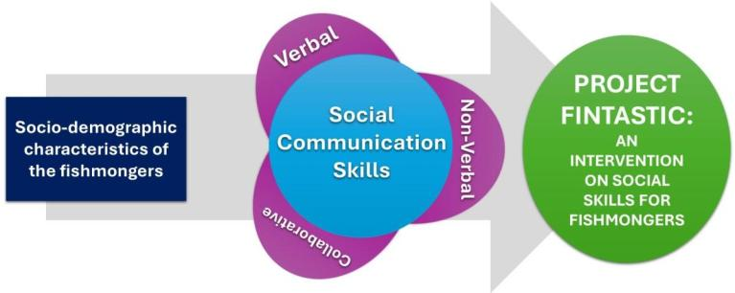

Figure 2. Conceptual Framework of the Study

Definition of Terms

The terms used in the study were conceptually and operationally defined to promote precision, consistency, and clarity in the conceptualization, measurement, and interpretation of key concepts and variables, thereby enhancing the credibility, validity, and impact of the research study.
Collaborative Skills. A competency to work with others with joint objectives in most work environments. This skill includes communication, emotional intelligence, respect, and conflict resolution.
Fishmongers. A person who sells fish. They are responsible for acquiring, preparing, and serving fish to patrons.
Fish Mongering: The practice of selling fish and seafood, typically in a market setting. This includes activities such as sourcing, handling, displaying, and selling fish to customers.
Non-Verbal Skills: The ability to communicate without the use of spoken language. This includes understanding and using body language, facial expressions, gestures, eye contact, and other social cues to convey messages and emotions.
Social skills. Capabilities that provide appropriate interaction and communication with others. They consist of cooperation, empathy, cooperation, and the capacity to establish and preserve relationships in addition to verbal and nonverbal communication abilities.

Verbal Skills. The ability to effectively communicate using spoken language. This includes active listening, clear articulation, appropriate tone, and the ability to convey information and ideas effectively.

CHAPTER II METHODOLOGY
This chapter presented the research design and methodology employed in the study. It also discusses Research Design, Population and Sampling Design, Data Gathering Procedure, and the Statistical Treatment of Data employed in data analysis to interpret the pertinent information gathered.

Research Design

The primary purpose of this study was to determine the social skills needs of fishmongers in Mercedes, Camarines Norte, and implement a project to enhance these skills while assessing its effectiveness. To address the research objectives, the study used a descriptive and evaluative research design considering that the researcher described both the socio – demographic profile of the participants and their training needs and at the same time evaluate the effectiveness of the Fintastic Project given to the participants as an intervention in helping them improve their social skills in terms of verbal, non – verbal and collaboration.
Descriptive-quantitative methods were applied to objectives 1 and 2, while descriptive-qualitative methods were used for objectives 4 and 5. This design allowed for both numerical assessment and deeper exploration of participants' experiences and needs.
20

The study employed both descriptive quantitative and qualitative research methods to comprehensively evaluate the effectiveness of the project on social skills among fishmongers in Mercedes, Camarines Norte.
The quantitative component involved collecting socio-economic demographic data and administering a Social Skills Self-Assessment Test to the participants. This allowed the researcher to objectively measure changes and improvements in social skills as a result of the project. On the other hand, the qualitative component consisted of conducting a Training Needs Assessment (TNA) through interviews and Focus Group Discussions (FGDs). These qualitative methods enabled the researcher to triangulate the data and gain deeper insights into the fishmongers’ perceived training needs, experiences, and the practical impact of the seminar on their daily work and income. By combining these two approaches, the study not only described the specific social skills needs of the fishmongers but also validated the quantitative self-assessment results with rich, qualitative feedback from the participants. This comprehensive methodology ensured a more accurate and holistic understanding of the seminar workshop’s effectiveness.

Locale of the Study

The participants during the needs assessment and the participants in the Project Fintastic and the conducted focused group discussion were all from the municipality of Mercedes, Camarines Norte. This place was chosen as where the

participants considering that the major source of income of the residents there is fish-related, e.g., fishing, selling fish, both fresh and dried, and the like.
In addition, Mercedes, Camarines Norte is a 2nd-class coastal municipality located in the Bicol Region of the Philippines, with geographic coordinates approximately at 14°06′33″N latitude and 123°00′39″E longitude. It covers an area of about 173.69 square kilometers and had a population of 55,334 as of the 2020 census. The municipality comprises 26 barangays, including both urban and rural communities, with San Roque being the most populous. Mercedes has a mixed economy with fishing as a major livelihood, supported by its coastal location along San Miguel Bay and the Philippine Sea. The poverty incidence stood at around 22.41% in 2021, reflecting socio-economic challenges typical of rural municipalities. The local government is headed by Mayor Alexander Pajarillo, and the municipality is known for its cooperative efforts and community activities involving fishmongers and fishermen, often facilitated by the Municipal Agriculture Office and local market administrators.
As previously stated, the socio-economic activities in Mercedes center largely on fishing and fish marketing, with fishmongers playing a vital role in the local economy. Data gathering efforts such as interviews, seminar workshops, and focus group discussions have been conducted in selected barangays to support these stakeholders. And as evidence of such support, the Municipal Agriculture Office of the said municipality has even openly accommodated the researcher in the conduct of the Project Finstatic with their resident fishmongers as participants.

The Project was then held at the same municipality so that participants could easily attend without having to go to a different and unfamiliar place, and at the same time ensure that the place of implementation would be accessible for them without further hassle on their part or incurring unnecessary expenses.
Lastly, the focus group discussion was also conducted within the same community to ensure that participants would be more at ease in answering the questions and be free to express whatever was on their minds and feelings.

Participants of the Study

The participants of this study were small-scale fishmongers from Mercedes, Camarines Norte, who were selected to provide a representative perspective on the training needs and social skills development within their community.
For the Training Needs Assessment (TNA) and the Focus Group Discussion (FGD), eight fishmongers were purposively chosen based on their experience and professional profiles, ensuring that they could accurately represent the broader group of 44 registered small-scale fishmongers in the municipality, as recorded by the Municipal Agriculture Office. These individuals were considered seasoned vendors with substantial experience in fish selling, making their insights particularly valuable for identifying relevant training needs.
For the Training Needs Assessment (TNA) and Focus Group Discussion (FGD), eight fishmongers were carefully chosen not just for their years of experience, but for the valuable perspectives they bring to the table. These

individuals were selected from the 44 registered small-scale fishmongers in the municipality, based on records from the Municipal Agriculture Office. Each of them has spent many years—some more than a decade—selling fish and navigating the day-to-day realities of the trade.
These fishmongers were more than just vendors; they were familiar faces in their communities, known for their dedication, resilience, and deep knowledge of the market. They’ve seen how the business has changed over time, adjusted to customer needs, and dealt with challenges like supply issues, competition, and price fluctuations. Some of them were even leaders in their local vendor associations, trusted by their peers and often looked to for advice.
What makes them truly representative was not just their experience, but their willingness to share what they know and to speak up about what they—and others like them—need to improve their livelihoods. They understand the skills that matter most in their line of work and can identify what kind of support or training would make a real difference. Their stories, struggles, and successes provided meaningful insights that reflect the wider experiences of fishmongers in the community.
By listening to these eight individuals, the study was able to gather honest, grounded input that can help shape better programs—ones that speak to the real needs of fish vendors and support them in building a more secure and sustainable future.

The sample size was determined using the Slovin formula, to wit: n = N / (1
+ Ne²), where n is the sample size, N is the population, and e is the margin of error. This formula is normally used to compute the sample size of a given population and thereby determine the needed sample participants for a research study.
This was to ensure that the participants were representative of the entire population, certified by a statistician/professor from Camarines Norte State College, Main Campus. This approach ensured both the qualitative and quantitative phases of the research were grounded in a well-defined and appropriately sampled population, enhancing the reliability and validity of the study’s findings.
For the implementation of the seminar-workshop, a larger group of 32 fishmongers was randomly selected from the same population of 44 registered fishmongers. The selection process and sample size were determined using the Slovin formula to ensure that the participants were statistically representative of the entire population. This careful approach to respondent selection helped guarantee that the findings and outcomes of the study were both reliable and generalizable to the community of fishmongers in Mercedes, Camarines Norte.

Ethical Considerations

To protect the participants and for ethical research considerations, this study's activities involving them adhered to the ethical principles of the Central Bicol State University of Agriculture’s Academic Research Council. Furthermore, the participants consent to participate in the study was obtained before the

implementation of the project and the gathering of data. Participants were also informed that they could opt to leave anytime if they found the project inconvenient or overstepping their boundaries.

Development of Project FINTASTIC

Project FINTASTIC was a community-based intervention aimed at improving the social skills of 32 fishmongers in Mercedes, Camarines Norte. Based on a Training Needs Analysis, the project identified strong demand for training in customer interaction and moderate interest in teamwork strategies. Through two structured workshops—focused on verbal and non-verbal skills, active listening, and collaborative business strategies—the project sought to enhance the fishmongers’ ability to engage with customers, work more effectively with peers, and boost sales. Plotted last February 2025, the initiative promoted stronger customer satisfaction, improved business operations, and community support.

Research Instrument

In this study, several research instruments were carefully designed and utilized to gather both quantitative and qualitative data, ensuring a comprehensive assessment of the fishmongers’ social skills and the effectiveness of the intervention.
The primary quantitative instrument was the Training Needs Assessment (TNA) questionnaire, which consisted of three main sections and a total of twenty questions. The first section focused on collecting the socio-economic demographic

profiles of the participants and selecting the options that best described their backgrounds. This section also included an open-ended question regarding specific training topics of interest, allowing for personalized responses. The second section assessed the participants’ current skills and knowledge, prompting them to identify both their existing competencies and the areas they felt needed improvement. This helped the researcher pinpoint strengths to build upon as well as gaps that required targeted training. The third section addressed developmental interventions, where participants indicated the degree of priority (low, moderate, or high) they assigned to various proposed interventions by checking the appropriate boxes.
Another key quantitative instrument was the Social Skills Self-Assessment Test. This tool was adapted from existing validated questionnaires and modified to align with the specific objectives of the study. The test comprised fifteen items, with five questions each targeting three core areas of social skills: verbal, non-verbal, and collaboration skills. Participants responded by checking the box that corresponded to their level of agreement with each statement, providing an objective measure of their social skills before and after the intervention. For the qualitative aspect, the researcher developed an interview outline for Focus Group Discussions (FGDs). This outline included eight open-ended questions designed to elicit in-depth feedback on the impact of the seminar workshop, particularly regarding its influence on participants’ work practices and income. The FGD guide facilitated the collection of rich, descriptive data that complemented the quantitative findings and allowed for triangulation of results.

To ensure clarity and inclusivity, both the Social Skills Self-Assessment Test and the FGD interview outline were prepared in English and translated into Tagalog/Filipino. The TNA questionnaire was administered through interviews, during which participants also provided their written socio-economic demographic information. The Social Skills Self-Assessment Test was administered several days after the seminar-workshop, followed by the FGDs.
Overall, the combination of structured questionnaires, self-assessment tests, and guided interviews enabled the researcher to collect robust and multi- dimensional data, providing a solid foundation for evaluating both the needs and the progress of the fishmongers in developing essential social skills. To interpret the social skills of the participants, Table 1 below was provided. The Social Skills Rating System (SSRS) was a multi-rater assessment tool used to measure social skills in children and adolescents. The SSRS was developed by Gresham and Elliott (1990) and was one of the most widely used measures of social skills.

Table 1. Interpretation of the Level of Social Skills

MEAN | DESCRIPTIVE INTERPRETATION
1.00 – 1.80 | Needs Improvement in Social Skills
1.81 – 2.60 | Low Social Skills
2.61 – 3.40 | Moderate Social skills
3.41 – 4.20 | High Social Skills
4.21 – 5.00 | Very High Social Skills

Data Gathering Procedures

The data collection process began with the administration of the TNA through interviews, during which participants also provided their written socio- economic demographic information. Following the initial assessment, a seminar workshop was conducted to address the identified training needs, focusing on enhancing the fishmongers’ social skills. Originally planned as a two-day event, the seminar was condensed into a single full-day session due to weather conditions and the participants’ availability, maximizing attendance and minimizing disruption to their livelihoods. The session was facilitated by a resource speaker and supported by local authorities, who helped coordinate logistics and secure the necessary permissions. To encourage participation, attendees were provided with tokens of appreciation.
After the workshop, the Social Skills Self-Assessment Test was administered to the participants to objectively measure any changes in their social skills. Subsequently, a Focus Group Discussion was conducted using a prepared interview outline with eight questions, primarily exploring the impact of the seminar workshop on the fishmongers’ work and income.

Statistical Treatment of Data

The data collected from the study were systematically tabulated and subjected to statistical analysis using techniques recommended by a professional statistician to ensure accuracy and reliability in interpreting the results. To address
the first specific objective, frequency distribution was employed to determine the

number of participants according to their socio-economic demographic profiles, such as age, gender, and years of experience. This approach provided a clear overview of the composition of the study participants. Additionally, percentages were calculated to interpret the proportion of participants within each socio- economic demographic category, offering a more nuanced understanding of the distribution and representation of various groups within the sample.
For the qualitative data gathered from Focus Group Discussions (FGDs), thematic analysis was utilized. This involved carefully reviewing and coding the participants’ responses to identify recurring themes, patterns, and key insights regarding their experiences and perceptions of the seminar workshop’s effectiveness. By combining quantitative statistical techniques with qualitative thematic analysis, the study was able to present a comprehensive and in-depth interpretation of the data, ensuring that both measurable outcomes and personal experiences were thoroughly analyzed and accurately reflected in the findings.

CHAPTER III RESULTS AND DISCUSSION
This chapter presented and discussed the findings gathered from the conducted survey, highlighting key insights and patterns based on the participants' answers.

Socio-economic and Demographic Profile of the Fishmongers

Table 2 presented the socio-economic demographic profile of the participants in terms of their age, sex, educational attainment, number of family members, and length of years of fishmongering for the training needs assessment. Age. As per the data during the needs assessment stage of the study, only eight
(8) participants were asked to participate. Out of these 8 participants, 50% (4

participants) were between 41 to 45 years old, while 37.5% (3 participants) were

within 61 to 65 years old.

Gender. As to the data in terms of sex, there were more female fishmongers than male fishmongers, with 62.5% being female and 37.5% being male.
Educational Attainment. The data showed that most of the participants finished high school (63%), while some went to college (36%). No one had only elementary education or vocational training. Overall, the group’s education level was moderate.
31

Table 2. Socio-economic Demographic Profile of the Participants

Respondent’s Profile | NEEDS ASSESSMENT
Respondent’s Profile | Frequency | Percentage
Age
21 – 35 y/o | 0 | 0
36 – 50 y/o | 4 | 50%
51 – 65 y/o | 4 | 50%
66 y/o above | 0 | 0
Gender
Male | 3 | 37.5%
Female | 5 | 62.5%
Educational Attainment
Elementary Level
High School Level | 5 | 63%
College Level | 3 | 36%
Vocational Course
Family Members
1 – 4 | 2 | 25%
5 – 8 | 4 | 50%
9 – above | 2 | 25%
Length of years of fishmongering
1 – 4 | 2 | 25%
5 – 8 | 1 | 12.5%
9 – 10 | 4 | 50%
More than 10 years | 1 | 12.5%
Annual Income
Less than P1,000/daily
P1,000.00 – P2,000.00/daily
P1,000.00 – P5,000.00 monthly
P6,000.00 – P10,000.00/monthly | 2 | 25%
P11,000.00 –  P15,000.00/monthly | 3 | 38%
P100,000.00/monthly
Di pare pareho/depende | 3 | 38%
Attendance at Training
Livelihood Training (food processing/fish selling) | 1 | 13%
DOLE, DTI, DA, Young Farmers Training | 1 | 13%
Personality Development Training | 0 | 0
None | 6 | 75%

Length of Years in Fishmongering. Half of the participants had been fishmongers for 9–10 years, while the rest had either worked for 7–8 years or over
10 years. This mix of experience levels showed that most had a substantial background in the trade. The presence of both seasoned and newer vendors suggested opportunities for shared learning, with experienced fishmongers guiding newcomers and fresh perspectives contributing to growth.
Annual Income. The data presented the annual income levels of the participants. It showed that 25% earned between P6,000 to P10,000 monthly, while 38% had a monthly income ranging from P11,000 to P15,000. Another 38% stated that their income was not fixed and depended on various factors such as sales or season. No participants were recorded earning in the lower daily income brackets or the highest monthly bracket of P100,000. This indicated that most participants either earned a modest and steady income or relied on irregular sources of income. The results suggested a need to support those with unstable earnings by offering opportunities that could help improve and stabilize their financial situation.
Attendance at Training. The data showed that only 13% of fishmongers had attended livelihood training (e.g., food processing or fish selling), and another 13% had participated in programs offered by government agencies like DOLE, DTI, DA, or the Young Farmers Training. Notably, none of the participants had undergone personality development training, while a significant 75% had not attended any training at all. This highlighted a major gap in access to or awareness of skill-building opportunities, particularly in areas related to personal and social

development. These findings supported the relevance of implementing Project FINTASTIC TALK, as it addressed the critical need for training that enhanced communication and interpersonal skills among fishmongers. Table 2.1 showed the socio-economic demographic profiles of the participants after the project was conducted or during the post-assessment.
Age. The data showed that the largest group of participants fell within the 51 to 65-year-old age range, making up 40.63% of the sample. This was followed by those aged 21 to 35 years old, who comprised 31.25% of the participants. Participants aged 36 to 50 years old accounted for 25%, while only a small portion, 3.12%, were 66 years old and above. This suggested that the sample was mostly composed of middle-aged to older adults, with fewer younger and senior participants.
Gender. The data revealed that the majority of participants were female, comprising 78.13% of the sample, while males made up only 21.86%. This indicated a significant gender imbalance among the participants, with females being the dominant group in the study.
Educational Attainment. Nearly half of the participants (46.88%) had reached only the elementary level of education, making this the most common educational background in the group. About a third (31.25%) had completed high school, while a smaller portion (15.63%) had attained a college education. Only 6.24% had finished a vocational course. This suggested that the majority of participants had relatively low educational attainment, with few having pursued higher or specialized education.

Table 2.a. Socio - economic Profile of the Participants

Respondent’s Profile | POST ASSESSMENT
Respondent’s Profile | Frequency | Percentage
Age
21 – 35 y/o | 10 | 31.25%
36 – 50 y/o | 8 | 25%
51 – 65 y/o | 13 | 40.63%
66 y/o above | 1 | 3.12%
Gender
Male | 7 | 21.86%
Female | 25 | 78.13%
Educational Attainment
Elementary Level | 15 | 46.88%
High School Level | 10 | 31.25%
College Level | 5 | 15.63%
Vocational Course | 2 | 6.24%
Family Members
1 – 4 | 10 | 31.25%
5 – 8 | 21 | 65.63%
9 – above | 1 | 3.12%
Length of Years of Fishmongering
1 – 4 | 10 | 31.25%
5 – 8 | 6 | 18.75%
9 – 10 | 4 | 12.5%
More than 10 years | 12 | 37.5%
Annual Income
Less than P1,000/daily | 5 | 15.63%
P1,000.00 – P2,000.00/daily | 3 | 9.38%
P1,000.00 – P5,000.00 monthly | 6 | 18.75%
P6,000.00 – P10,000.00/monthly | 2 | 6.25%
P11,000.00 –  P15,000.00/monthly | 1 | 3.12%
P100,000.00/monthly | 1 | 3.12%
Di pare pareho/depende | 14 | 43.76%
Attendance at Training
Livelihood Training (food processing/fish selling) | 4 | 12.5%
DOLE, DTI, DA, Young Farmers Training | 3 | 9.38%
Personality Development Training | 0 | 0
None | 25 | 78.13%

Family Members. Most participants came from medium-sized families, with 65.63% reporting 5 to 8 family members. About a third (31.25%) had smaller families of 1 to 4 members, while only a small fraction (3.12%) belonged to large families with 9 or more members. This indicated that medium-sized households were typical among the participants.
Length of Years of Fishmongering. When it came to experience in fishmongering, 37.5% of participants had been in the business for more than 10 years, indicating a significant portion with long-term experience. About 31.25% had worked as fishmongers for 1 to 4 years, 18.75% for 5 to 8 years, and 12.5% for 9 to 10 years. This showed a diverse range of experience levels, but with a notable concentration of long-term practitioners in the group.
Annual Income. The data showed that most of the participants had low or irregular income. The largest group, 43.76%, said their earnings were not the same every day and depended on sales or other factors. About 15.63% earned less than P1,000 daily, while 9.38% made between P1,000 to P2,000 daily. Around 18.75% earned only P1,000 to P5,000 monthly, showing that many were in the low-income group. A few earned between P6,000 to P15,000 monthly, while only one respondent reported a high monthly income of P100,000. Overall, the results showed that most participants struggled with low or uncertain earnings, which may have been reflected in their fish selling.
Attendance to Training. The data revealed that a majority of the participants (78.13%) had never attended any formal training, indicating a significant gap in access to or awareness of development opportunities among

fishmongers. Only a small portion had participated in livelihood-related training: 12.5% in food processing or fish selling, and 9.38% in government-initiated programs such as those by DOLE, DTI, DA, or the Young Farmers Training. Notably, none of the participants had undergone personality development training, which could have helped enhance social skills.

Needs of Fishmongers in Terms of Social Skills

Table 3 to 3.b presented the assessed needs of the participants as gathered during the focus group discussion with 8 chosen fishmonger representatives.

Table 3: Needs of the Fishmongers in terms of verbal communication or active listening (berbal na komunikasyon o aktibong pakikinig)
Statements | No. | Rank
Asking follow-up questions to show engagement. (Pagtatanong ng mga kasunod na tanong upang ipakita ang pakikilahok.) | 8 | 1.5
Asking follow-up questions to show engagement. (Pagtatanong ng mga kasunod na tanong upang ipakita ang pakikilahok.) | 8 | 1.5
Understanding and clarifying customer inquiries and concerns. (Pag-unawa at paglilinaw sa mga tanong at alalahanin ng mamimili.) | 6 | 3
Summarizing or paraphrasing to confirm understanding. (Pagbubuod o pagsasaayos ng sinabi upang matiyak ang pagkakaunawa.) | 5 | 4
Avoiding interruptions and giving full attention while others speak. (Pag-iwas sa pagsingit at pagbibigay ng buong atensyon habang may nagsasalita.) | 4 | 5

Table 3 presented the needs of the participants in terms of verbal skills (active listening). As per the table, it could be seen that most areas of verbal skills

were marked by the participants as skills they wished to develop or improve within themselves. However, both responding appropriately and respectfully in conversations (pagtugon nang naaayon at may paggalang sa pag-uusap) and asking follow-up questions to show engagement (pagtatanong ng mga kasunod na tanong upang ipakita ang pakikilahok) received the highest number of participants, each having a rank of 1.5. This was followed by understanding and clarifying customer inquiries and concerns (pag-unawa at paglilinaw sa mga tanong at alalahanin ng pamimili), which ranked 3rd. In 4th place was summarizing or paraphrasing to confirm understanding (pagbubuod o pagsasaayos ng sinabi upang matiyak ang pagkakaunawa). On the other hand, avoiding interruption and giving full attention while others speak (pag-iwas sa pagsingit at pagbibigay ng buong atensyon habang may nagsasalita) fell under the 5th rank.
These findings indicated that participants felt they were not skilled enough to respond appropriately and respectfully in conversations with their customers and, at the same time, in asking follow-up questions to ensure they could capture the customers’ attention and interests. In addition, it seemed that the participants considered avoiding interruptions and giving full attention while others speak to be their least needed skill, although they still regarded it as an important aspect of social skills.
In an article written by Roy (2024) entitled Politeness Pays Off: Boosting Customer Experience with Courtesy, it was emphasized that being courteous to a client was an essential component of service interaction and was sometimes even the hallmark of a good brand. According to the same article, being courteous—

such as talking to a customer appropriately and respectfully and asking the correct questions at the right time—could help business owners de-escalate thorny conversations, improve customer satisfaction, and increase referrals and lifetime value, among others.
Interacting with customers, talking, and dealing with them were inherent in the job description of a fishmonger; therefore, learning and mastering such social skills, specifically verbal skills focused on responding appropriately and respectfully to customers, was a must. For this reason, it was not surprising that this came out as one of the needed skills that the participants felt should be improved. Table 3.a presented the needs of the participants in terms of non-verbal skills. Both demonstrating polite and respectful behavior and observing others’ body language and adjusting behavior accordingly ranked 1.5 each and were revealed as the top two most needed skills by the participants. This was followed by using gestures and posture to reflect openness and respect, which ranked 3rd. In rank 4.5 were maintaining appropriate eye contact during interactions (pagpapanatili ng angkop na pagtingin sa mata habang nakikipag-ugnayan) and maintaining cleanliness and professional appearance in public interactions (pagpapanatili ng kalinisan at propesyonal na anyo sa publiko).
As discussed in the article entitled Is Body Language Important in Negotiations? (Scotwork Limited, 2025), although verbal communication was important in negotiation, reading someone’s intentions, feelings, and reactions through their body language was equally important. This was because non-verbal cues or body language could give inaudible signals, such as posture, gesture, and

facial expression, which might show how the person truly felt and thought. It also helped in building rapport and trust by maintaining eye contact, adopting an open stance, and making welcoming gestures. Controlling perception could also be influenced by one’s body language since it could build one’s credibility and affect bargaining skills and abilities as perceived by others.

Table 3.a. Needs of the Fishmongers in terms of non - verbal communication or the di - berbal na komunikasyon and mga sosyal na palantadaan at kagandahan asal

Statements | No. | Rank
Demonstrating polite and respectful behavior (e.g., greetings, expressions of gratitude).  (Pagpapakita ng magalang at marespeto na pag-uugali (hal. pagbati, pagpapasalamat). | 8 | 1.5
Observing others’ body language and adjusting behavior accordingly. (Pagmamasid sa kilos ng katawan ng iba at pag- aangkop ng sariling kilos batay dito.) | 8 | 1.5
Using gestures and posture that reflect openness and respect. (Paggamit ng mga kilos at tindig na nagpapakita ng pagiging bukas at may respeto.) | 5 | 3
Maintaining appropriate eye contact during interactions. (Pagpapanatili ng angkop na pagtingin sa mata habang nakikipag-ugnayan.) | 4 | 4.5
Maintaining cleanliness and professional appearance in public interactions. (Pagpapanatili ng kalinisan at  propesyonal na anyo sa harap ng publiko.) | 4 | 4.5

Considering the importance of non–verbal cues, such as being polite and respectful and understanding body language, in negotiation, which is part and parcel of a fishmonger’s nature of work, it is not surprising that they see these aspects of non–verbal skills as an important skill in their work that must be improved or developed.

The needs of the fishmongers in terms of collaboration skills were shown in Table 3.b.

Table 3.b. Needs of the Fishmongers in terms of collaboration or Pakikipagtulungan.
Statements | No. | Rank
Participating in partnerships or agreements that support better profit and family income.  (Pakikilahok sa mga kasunduan o pakikipag-partner na tumutulong sa mas mataas na kita at kabuhayan ng pamilya.) | 8 | 1
Communicating ideas and needs clearly in a team setting. (Maayos na pagpapahayag ng mga ideya at pangangailangan sa loob ng grupo.) | 5 | 2.5
Respecting the opinions and contributions of other group members. (Paggalang sa mga opinyon at ambag ng ibang kasapi ng grupo.) | 5 | 2.5
Coordinating with local organizations or cooperatives to improve services. (Pakikipag-ugnayan sa mga lokal na organisasyon o kooperatiba upang mapabuti ang serbisyo.) | 3 | 4.5
Building relationships with institutions (e.g., stores, restaurants, markets) to expand product distribution. (Pagbuo ng ugnayan sa mga institusyon (hal. tindahan, kainan, palengke) upang mapalawak ang distribusyon ng produkto.) | 3 | 4.5

Based on this table, it was laid down that in collaboration, participating in partnerships or agreements that support better profit and family income came first in rank in terms of skills that needed to be improved and developed. On the other hand, the areas of communicating ideas and needs clearly in a team setting and respecting opinions and contributions of other group members both came in at rank 2.5.

This was followed by the statements coordinating with local organizations or cooperatives to improve services (pakikipag-ugnayan sa mga lokal na organisasyon o kooperatiba upang mapabuti ang serbisyo) and building relationships with institutions (e.g., stores, restaurants, markets) to expand product distribution (pagbuo ng ugnayan sa mga institusyon), which were both considered by the participants as needed but were in the 4th rank.
Collaboration skills may have been taken by the participants as the least important aspect of social skills that they needed. Nevertheless, the participants still viewed participating in partnerships or agreements that can help achieve better profits and family income as important. This only meant that fishmongers considered collaboration valuable not only in terms of supporting their business management but, more importantly, in helping them increase their income— considering that their main reason for venturing into such a business was to earn more so that they could provide more for their families.

Project Conducted to Address the Needs of Fishmongers in Social Skills

Initially, a Training Needs Assessment was conducted for the participating fishmongers to accurately identify their training needs. Based on the said needs assessment, the project titled Project FINTASTIC TALK was designed to address deficiencies in verbal, non-verbal, and collaborative communication among fishmongers.
Project FINTASTIC was a community-based intervention aimed at improving the social skills of 32 fishmongers in Mercedes, Camarines Norte. Based

on the Training Needs Analysis, the project identified a strong demand for training in customer interaction and a moderate interest in teamwork strategies. Through two structured workshops—focused on verbal and non-verbal skills, active listening, and collaborative business strategies—the project sought to enhance the fishmongers’ ability to engage with customers, work more effectively with peers, and boost sales.
In implementing the project, the researcher collaborated with the then Municipal Agriculture Office to identify possible fishmongers who could participate. Once approved and identified, letters of invitation were sent through the Barangay Captains of the targeted barangays for proper coordination and information dissemination. A date and venue were set to avoid confusion and ensure the attendance of the targeted participants.
A resource speaker was also invited to run the workshop to ensure impartiality on the part of the researcher and to guarantee that the program would be delivered by someone with greater expertise on the topic.
On the day of the implementation, a preliminary program was first held, followed by the talk proper of the resource speaker on the topic of social skills, specifically focusing on verbal skills, non-verbal skills, and collaboration. During the discussion, participants were also asked to share their own experiences and thoughts on the topics presented.
After an in-depth discussion, participants were asked to demonstrate what they had learned. They were paired with others and given scenarios in which they

acted out their possible reactions. Following the performance, a closing program was conducted. Several days after the workshop, the Self-Assessment of Social Skills was administered to the participants. At the same time, the researcher conducted a focused group discussion with selected participants.
Participants were given simple tokens as a gesture of appreciation for their heartfelt participation in Project FINTASTIC.

Social Skills of Fishmongers After the Implementation of the Project.

The succeeding tables (Tables 4 to 4.3) presented the data that answered SOP 4 of this study, which assessed the social skills of the fishmongers after the implementation of the project. Following these tables were the results of the focus group discussion conducted to further determine and triangulate the effectiveness of the said project on the participants. Table 4 presented the mean results of the social skills using the self-assessment as a basis were presented.
According to the table, although all statements were interpreted as reflecting very high social skills, the statement “I actively listen to customers to understand their needs and preferences” received the highest mean of 4.75, while the statement “I listen attentively without interrupting the customer” had the lowest mean of 4.34. Taken together, it could be seen that the social skills of the participants in terms of verbal skills were considered Very High Social Skills, with an overall mean of 4.52.
This data meant that the participants’ social skills in terms of verbal skills, particularly active listening, were at a very high level. It showed that they could communicate effectively with their customers by truly listening to their needs and

providing them with relevant information about the products they sold. This could be attributed to the training they received on social skills.

Table 4. Level of social skills in terms of verbal skills (active listening) of the participants based on the Social Skills Self–Assessment survey.
STATEMENT | MEAN | DESCRIPTIVE  INTERPRETATION
I actively listen to customers to understand their needs and preferences. (Aktibong nakikinig ako sa mga mamimili upang maunawaan ang kanilang mga pangangailangan at kagustuhan.) | 4.75 | Very High Social Skills
I repeat back key points to ensure the customer feels heard. (Inuulit ko ang mga pangunahing punto upang matiyak na narinig  ang mamimili). | 4.56 | Very High Social Skills
I ask clarifying questions when I’m unsure of the customer’s needs. (Nagtatanong ako ng mga naglilinaw na katanungan kapag hindi ako sigurado sa mga pangangailangan ng  mamimili). | 4.47 | Very High Social Skills
I provide clear and concise information to customers about the fish we sell. (Nagbibigay ako ng malinaw at maikling impormasyon sa mga mamimili tungkol sa mga isdang tinitinda  namin.) | 4.50 | Very High Social Skills
I listen attentively without interrupting the  customer. (Nakikinig ako nang mabuti nang hindi iniistorbo ang mamimili.) | 4.34 | Very High Social skills
Overall mean | 4.52 | Very High Social Skills
Legend: 1.00 – 1.80: Needs Improvement on social skills; 1.81 – 2.60: Low social skills; 2.61 – 3.40: Moderate Social Skills; 3.41 – 4.20: High social skills; 4.21 – 5.00: Very High Social
Skills

Table 4.a presented the social skills of the participants/respondents in terms of their non-verbal skills, which were manifested through social cues or manners. This was based on the self-assessment answered by the participants.
It was revealed in Table 4.a that the statement “I am mindful of my tone of

voice to ensure it is friendly and welcoming” had the highest mean of 4.68, while

the statement “I can sense when a customer needs reassurance and respond appropriately” had the lowest mean of 4.21. However, the overall social skills of the participants in terms of non-verbal skills were still considered at the highest level, with an overall mean of 4.42.

Table 4.a. Level of social skills in terms of non-verbal skills (social cues, behaviors) of the participants based on the Social Skills Self–Assessment survey
STATEMENT | MEAN | DESCRIPTIVE INTERPRETATION
I make eye contact and smile when interacting with customers. (Nakikipag-eye contact at ngumingiti ako kapag nakikipag- ugnayan sa mga mamimili.) | 4.53 | Very High Social Skills
I pay attention to the customer's body language to gauge their needs. (Pinapansin ko ang galaw ng katawan ng mamimili upang malaman ang kanilang mga pangangailangan.) | 4.25 | Very High Social Skills
I use polite gestures and maintain a respectful posture. (Gumagamit ako ng magalang na kilos at pinapanatili ang marespeto na tindig.) | 4.41 | Very High Social Skills
I can sense when a customer needs reassurance and respond appropriately. (Nararamdaman ko kung kailan kailangan ng katiyakan ng mamimili at tumutugon nang  naaayon.) | 4.21 | Very High Social Skills
I am mindful of my tone of voice to ensure it is friendly and welcoming. (Pinapanatili ko ang malumanay na tono ng boses upang matiyak  na ito ay magiliw at malugod.) | 4.68 | Very High Social Skills
Overall Mean | 4.42 | Very High Social  skills
Legend: 1.00 – 1.80 : Needs Improvement on social skills; 1.81 – 2.60: Low social skills; 2.61 – 3.40: Moderate Social Skills; 3.41 – 4.20: High social skills; 4.21 – 5.00: Very High Social Skills

This data implied that the participants were now able to interact with their customers and colleagues more confidently by being aware of their behaviors and the social cues being presented to them.
The level of social skills of the participants in terms of their ability to collaborate is laid down in Table 4.b, which was taken from the self–assessment made by them after the conduct of the training.

Table 4.b. Level of social skills in terms of collaboration skills (pakikipagtulungan) of the participants based on the Social Skills Self– Assessment survey.

 | STATEMENT | MEAN | DESCRIPTIVE INTERPRETATION
 | I communicate effectively with my colleagues to coordinate tasks. (Epektibong nakikipag-ugnayan ako sa aking mga kasamahan upang maisaayos ang mga gawain.) | 4.44 | Very High Social Skills
 | I offer help to my colleagues when they are struggling with their tasks. (Nag-aalok ako ng tulong sa aking mga kasamahan kapag nahihirapan sila sa kanilang mga gawain.) | 4.28 | Very High Social Skills
 | I can delegate tasks efficiently when the stall is busy. (Maayos akong nakakapag-atas ng  mga gawain kapag abala ang tindahan.) | 4.16 | High Social Skills
 | I participate in team discussions to improve our customer service. (Nakikilahok ako sa mga talakayan ng koponan upang mapabuti  ang aming serbisyo sa mamimili.) | 4.19 | High Social Skills
 | I am open to feedback from my team members to improve our collaboration. (Bukás ako sa mga puna mula sa aking mga kasamahan upang mapabuti ang aming  pakikipagtulungan.) | 4.41 | Very High Social skills
 | Overall Mean | 4.30 | Very High Social  skills
Legend: 1.00 – 1.80 : Needs Improvement on social skills; 1.81 – 2.60: Low social skills; 2.61 – 3.40: Moderate Social Skills; 3.41 – 4.20: High social skills; 4.21 – 5.00: Very High Social Skills

The table showed the diversity in the level of social skills of the participants. Although only three statements were found to be at a very high level of social skills, the statement “I communicate effectively with my colleagues to coordinate tasks” had the highest mean of 4.44, with a descriptive interpretation of Very High Social Skills. The other two statements that were at the high social skills level had means of 4.16 and 4.19. These were “I can delegate tasks efficiently when the stall is busy” and “I participate in team discussions to improve our customer service”, respectively.
Despite having two statements at the high social skill level, it was still revealed that the overall social skills of the participants in terms of collaboration were at a very high social skill level, with a total mean of 4.30.
This information provided an idea that although fishmongers had already gained the confidence to effectively communicate with and help their colleagues and to accept feedback, they were still somewhat hesitant to offer help to colleagues who were struggling with their tasks or to delegate their own tasks at the stall to others. This could probably be because, although they were colleagues, they remained competitors in terms of attracting possible customers to buy their fish products.
Table 4.c. also summarized the level of social skills of the participants. It showed that overall, the social skills of the participants were at a very high level (mean: 4.41). However, in analyzing the three aspects of social skills, it appeared that verbal skills had the highest mean of 4.52, while collaboration had the lowest, with a mean of 4.30.

Table 4.c. Summary of the level of social skills of the participants based on the Social Skills Self–Assessment Survey

ASPECTS OF SOCIAL SKILLS | MEAN | DESCRIPTIVE INTERPRETATION
Verbal skills (active listening) | 4.52 | Very High Social Skills
Non–verbal skills (social cues, manners) | 4.42 | Very High Social Skills
Collaboration | 4.30 | Very High Social Skills
TOTAL SOCIAL SKILLS | 4.41 | Very High Social Skills
Legend: 1.00 – 1.80: Needs Improvement on social skills; 1.81 – 2.60: Low social skills; 2.61 – 3.40: Moderate Social Skills; 3.41 – 4.20: High social skills; 4.21 – 5.00: Very High Social Skills

This result indicated that indeed, after the conduct of the training on social skills, the participants had gained confidence, particularly in actively listening to the needs of their customers. Despite collaboration being the lowest among the three areas, it was still notable that participants could now interact and communicate more effectively with their fellow fishmongers, making it easier for them to collaborate on team tasks.
Furthermore, this result served as concrete evidence that there truly existed a need to provide fishmongers with opportunities to improve themselves so that they could become more effective in selling their fish products and more socially relevant in dealing with their colleagues. Also, given the fact that the FINTASTIC Project had been proven effective, continuing these kinds of activities and interventions for fishmongers could be very useful and beneficial to them.

Results of the Focus Group Discussion
In trying to verify the effect of the training on the social skills of the participants, the researcher also conducted a focus group discussion (FGD) with some of the

participants. The answers of the participants to the self–assessment were triangulated with their answers during the focused group discussion.
The first question asked by the researcher in the FGD was how the seminar- workshop influenced their daily interactions with customers. By analyzing the answers of the participants, certain key themes were discovered, to wit: awareness, friendly and good listener, and calm and patient, as shown in the table below.
These themes were taken from the following statements of the participants: For awareness: Almost all of the participants said, “Naging aware kami ulit sa mga tamang pag-aasikaso sa customer” (We became aware again of the right way of treating our customers), and “Dapat ginagamit ang charm” (Charm must also be used). However, for friendly and good listener, a little less than half of the participants claimed, “Magaling na akong magsalestalk” (I could do sales talk better now), “Mas magiliw na akong bumati sa mga parokyano” (I greeted my constant customers more cheerfully), and “Nakakatulong ang pagngiti at magandang pagbati” (Smiling and greeting them properly helped).
As for being calm and patient, most participants answered, “Mas nagiging mahinahon na akong makipag-usap, lalo na kapag may reklamo ang customer” (I spoke in a calm manner, especially when a customer voiced out complaints), and “Medyo mahaba na ang pasensya ko” (I had become more patient).
Taking into consideration the answers of the participants, it gave the impression that indeed the seminar-workshop on social skills conducted had a positive influence on their daily interactions with their customers.

As a follow-up question, participants were also asked which social skills taught during the seminar-workshop were most useful in their line of business. The answers of the participants gave the themes active listening and effective communication.
These themes were apparent in the following statements of the participants: “Ang pakikinig sa pangangailangan ng mamimili bago mag-alok ng paninda” (Listening to the needs of the buyers before offering my product) was shared by more than half of the participants as the social skill that they considered most useful in their business. For some participants, “Ang pagiging pasensyoso ma’am maski nakakasura na minsan” (Being patient even if it was annoying at
times).

While for others, “Ang tamang pagbati sa customer, kasi mas naging magaan ang pakikipag-usap” (The proper way of greeting the customer because it helped make conversations easier). For the minority of the participants, “Ang paggamit ng tamang tono ng boses at pananalita para maging magalang at maayos ang usapan” (The proper use of voice tone and manner of speaking to be respectful and to deal properly).
Based on these statements, the participants confirmed that the seminar- workshop on social skills given to them, especially the topics on active listening and effective communication, was useful in their field of work and helped them increase their income.
Participants were also asked if they noticed any improvement in customer satisfaction after applying the social skills they learned. With this question, the

participants gave positive feedback, which served as the theme taken from their answers. The following were some of the statements that supported this theme:
It was shared by the majority of the participants that, “Mas madalas silang nakangiti” (They smiled more often).
“May ilan na nagrerekomenda ng paninda ko sa kanilang mga kaibigan” (Some recommended my fish products to their friends) was claimed by 4 out of 10 participants as the improvement they saw in their customers.
“Hindi na sila gaanong tumatawad kasi alam nilang maganda ang kalidad ng tinda ko” (They no longer asked for discounts because they knew I sold quality products) were the answers of a little more than half of the participants.
As stated, the positive responses of the participants pointed to the customer satisfaction of the fishmongers and, eventually, to an increased income on their part.
To gauge the impact of the seminar-workshop and customer interaction on the participants, the researcher initially asked them how the seminar helped them improve their ability to greet, negotiate, and engage with customers. To this question, the participants answered and provided the themes of becoming respectful, effective sales talk and increased sales, and happier.

As evidence of these themes, some of the statements were hereby stated: Becoming respectful: Half of the participants stated, “Naaraman ko po ang tamang paraan ng pagbati para maging mas madali ang pakikipag-usap” (I became aware of the right way of greeting to make the conversation easy), while

the other half said, “Natutunan kong gamitin ang tamang tono ng boses para hindi magmukhang suplada”, “Naging magalang ako sa pagsagot kahit minsan mainit ang ulo” (I learned to use the proper tone of voice so I did not appear snobbish; I became respectful in responding even if the customer was sometimes irritable).
Effective sales talk and increased sales: 60% of the participants said, “Dae na ako nasusupog makipagtawadan” (I no longer felt shy negotiating), “Alam ko na kung paano mag-alok ng produkto” (I already knew how to offer my fish products), “Napansin ko mas madaling makabenta ngayon” (I noticed that selling was easier these days), and “Mas napapansin ko na ngayon ang body language ng customer at alam ko kung paano mag-adjust” (I noticed more easily the body language of the customer and knew how to adjust).
Happier: About 37% of the participants claimed, “Mas naging masaya ang pakikipag-usap sa customer” (It was more fun dealing with customers) and “Ang simpleng pagbati at pangungumusta pala ay may malaking epekto” (A simple greeting and showing care had a big effect).
It seemed that through the seminar, the participants learned the importance of using the proper tone in selling while still being respectful to their customers, which helped them become effective fish sellers and happier in their work. When asked if the participants felt more confident in handling customer complaints and resolving conflicts after the seminar-workshop, 90% of the participants shared the following, which gave rise to the themes of calmness, patience, and bravery:

“Dae na ako masyadong natataranta kapag may reklamo lalo na kung mayaman ang customer” (I no longer got anxious when a customer complained, especially if the customer looked rich).
“Mas kalmado na ako sa pag-ayos ng problema” (I was calmer in solving problems).
“Natutunan kong huwag agad magalit at unawain muna ang reklamo” (I learned not to get angry right away and to understand the complaint first).
“Mas madali kong nauunawaan kung ano ang tunay na isyu ng customer”
(I more easily understood the real issue of the customer).
“Hindi na ako kinakabahan kapag may nagtatanong na customer” (I no longer felt nervous when a customer asked questions).
“Natutunan kong gawing oportunidad ang reklamo para mapabuti ang serbisyo ko” (I learned to turn complaints into opportunities to improve my service). These statements provided a picture of fishmongers who were more confident and braver in handling customer complaints or issues. Being aware of how to handle such situations helped them feel more confident.
Other than a change in behavior, an increase in sales or customers was also asked.
To answer this question, the themes that emerged were increased sales and customers and competitiveness.
To substantiate these themes, the following were a few of the statements made by almost all of the participants:
“Oo, medyo naggulpi” (Yes, it slightly increased).

“Napansin kong mas mabilis akong nakakabenta ngayon” (I noticed that I could sell faster these days).
“Dumami ang bumibili ng maramihan dahil tiwala silang maganda ang produkto ko” (More customers bought in bulk because they trusted that I sold quality products).
“May mga bagong customers na lumapit dahil narinig nilang magaling na akong kumbinsihin sila” (New customers came because they heard I was good at convincing them).
“Mas naging competitive ako sa ibang tindero ng isda” (I became more competitive with other fish sellers).
These statements implied that through the seminar conducted, these fishmongers were able to improve their selling skills, which may have led to increased sales, additional customers, and greater competitiveness.
Following the focus group discussion, both the researcher and a colleague observed that the participants responded confidently and without hesitation. This suggested that the seminar-workshop was beneficial, even within its limited timeframe. However, the impact of the seminar-workshop was not all positive. When asked what challenges they still faced when applying the social skills learned in the seminar, all participants gave a consistent theme of having difficult customers, as appeared in some of their statements, such as the following:
“Paano harapin ang mahirap na customer” (How to face a difficult customer).
“Pag masungit ang customer” (When the customer was grumpy).

“Magkontrol ng pagka-inis” (To control myself when annoyed).
Apparently, despite the seminar-workshop on social skills that they attended, the fishmongers still found it difficult to handle customers who were grumpy or challenging.

Recommendations Drawn from Fishmongers to Improve the Project

Lastly, participants were also asked what aspect of the seminar-workshop they think needs improvement or further explanation; they unanimously requested another seminar-workshop, but in a bigger venue.
Considering that participants still want another seminar-workshop, suggested that aside from the seminar being useful to them, they felt the need to improve themselves, since it eventually helped them also become effective fishmongers.
On the other hand, taking into consideration this recommendation of the participants, it appears that they are also very much in need of a training or seminar that can best help them improve their livelihood at the same time providing them an opportunity to become more competent fish sellers. In these types of seminars, it is also best that they be given not only to a certain number of fishmongers, but may also include fishermen, since they work hand in hand in this type of business. Further, conducting such a seminar in a place where these possible participants are more familiar and comfortable may be a plus factor.

CHAPTER IV

Summary, Findings, Conclusions, and Recommendations

This chapter provided a summary of the study, along with its findings, conclusions, and possible recommendations.

Summary

This study explored the social skills of fishmongers in Mercedes, Camarines Norte, to answer several specific questions. These included identifying the socio- economic demographic profile of the participants in terms of age, sex, educational attainment, number of family members, length of years in fishmongering, annual income, and attendance at training conducted by relevant government agencies. Additionally, the study sought to determine the needs of fishmongers concerning social skills, specifically verbal skills such as active listening, non-verbal skills like understanding social cues and manners, and collaboration. Another objective was to identify potential projects that could address these needs, assess the social skills of fishmongers after the implementation of such a project, and gather recommendations from the fishmongers to enhance future initiatives.
To answer these questions, the researcher employed both quantitative and qualitative research methods. The needs of the participants were identified through a Training Needs Assessment (TNA), which served as the basis for conducting a seminar workshop on social skills. A speaker was invited to discuss the concept of social skills and how they can be developed. The impact of this seminar workshop
57

was evaluated using a Social Skills Self-Test and a Focus Group Discussion (FGD) to determine any improvements and gather further insights from the participants.

Findings

The findings of this study show that the socio-economic demographic profile of the participants is between the age range of 21 years old to 75 years, but the majority of them (31.25%) are between 51 – 55 years old, while 78.13% are female and only 21.86% are male. Further, the highest educational attainment of the participants is a college graduate, but this comprises only 9.38% since the majority, or 43.75%, are merely elementary graduates. When it comes to some family members, 43.75% of them have a family with 5 – 6 members, but in terms of the number of years working as fishmongers, the longest period with the greatest number of participants is more than 10 years with 37.5% followed by 3 – 4 years with 18.75%.
It was also found that 43.75% of the participants have no fixed monthly income as it varies according to season and availability of fish products, although 18.75% are earning between P1,000.00 – P5,000.00 a month. Likewise, 78.13% of them have not received or attended any training conducted by any relevant government agencies.

The findings indicate that all fishmongers surveyed possess strong technical skills essential to their trade, including selecting and sorting fresh fish, identifying various fish species, managing customer relationships, and handling pricing and labeling. This demonstrates a solid foundation in the practical and

operational aspects of their work, reflecting their competence and experience in these areas. However, a notable portion of the participants (25%) identified communication skills-particularly in customer interaction and relationship management areas, where improvement is needed, while some were uncertain about specific gaps.
Further analysis reveals that while fishmongers are confident in their technical expertise, they face challenges in effectively communicating and engaging with customers and colleagues. This gap in social skills may hinder their ability to foster stronger customer relationships and collaborate efficiently within their teams. Therefore, it is clear that targeted training programs focusing on verbal communication, active listening, and understanding social cues would be beneficial. Enhancing these interpersonal skills is vital, as they play a significant role in improving customer satisfaction, teamwork, and ultimately, the overall success and reputation of the fishmongers in their community.

During the Training Needs Assessment (TNA) stage, the researcher found that among the three aspects of social skills, verbal communication emerged as the area with the highest perceived need for improvement among the participants, followed by non-verbal communication
Under the verbal skills, responding appropriately and respectfully in conversations and asking follow–up questions to show engagement ranked 1.5, respectively, giving it the status of being most needed. While avoiding interruptions and giving full attention to those who speak ranked 5 the least needed by the participants.

As for non–verbal communication skills, the areas of demonstrating polite and respectful behaviors and observing others’ body language and adjusting behavior accordingly were found to be most needed, being in rank 1.5 each. Maintaining appropriate eye contact during interactions and maintaining cleanliness and professional appearance in public interactions were the least needed by the participants.
The findings on collaboration skills reveal that the highest-ranked skill among participants was "Participating in partnerships or agreements that support better profit and family income," indicating that fishmongers place strong importance on collaborative efforts that directly enhance their livelihood. In contrast, the lowest-ranked skill was "Building relationships with institutions (e.g., stores, restaurants, markets) to expand product distribution," suggesting that participants may need further support and training in establishing external connections that can help widen their market reach and improve long-term business sustainability.
So, using these data as a basis, a seminar workshop on social skills development focused on verbal skills (active listening), non–verbal skills (social cues and manners), and collaboration was conducted with them as the participants. All three topics were still included during the seminar workshop because the results gave an impression that despite not being chosen by most of the participants as needed skills, the researcher still on the opinion that discussing them during the seminar workshop would not hurt them in anyway but instead can still help them become a better fishmonger and help them increase their income.

However, although all those topics were still covered in the seminar workshop on social skills, emphasis and considerable allowance were given to those topics that were identified as the most important during the needs assessment survey.

Project Fintastic was conceptualized to address the gaps identified during the participants’ training needs assessment. This two-day seminar-workshop focused on enhancing the social and communication skills of fishmongers, with expert speakers leading the discussions and interactive sessions. The project was made possible through the approval and support of the Local Government Unit (LGU) and the assistance of the Municipal Agriculture Office (MAO), particularly in coordinating and gathering the participants. The workshop was conducted at the recommended venue—a daycare center classroom—which provided a suitable space for learning and engagement. A total of 32 participants attended and actively took part in the activities. To show appreciation for their involvement, the researcher provided refreshments (merienda) and a small grocery pack as a token of gratitude

As a result of the Social Skills Self – Assessment test, the level of social skills of the participants in terms of their verbal skills (active listening) is on the very high level, each of the statement having a mean between 4.34 to 4.75 and a total mean of 4.52. This positive result is supported by the responses during the FGD which gives rise to the themes active listening (“ang pakikinig sa pangangailangan ng mamimili bago mag – alok ng paninda,, “ang pagiging pasensyoso ma’am maski nakakasura na minsan” and “natutu akong huwag magalit agad magalit at

unawain muna ang reklamo), and effective communications(“ang tamang pagbati sa customer, kasi mas nagiging magaan ang pakikipag – usap”, and “alam ko na kung paano mag alok ng produkto”)
The level of social skills in terms of the non – verbal skills (social cues and manners) of the participants was also at very high level with a total mean of 4.42. This was also evident during the FGD with the themes becoming respectful (“ang paggamit ng tamang tono ng boses at pananalita para maging magalang at maayos ang usapan”, and “natutu akong huwag magalit at unawain muna ang reklamo”), happier (“mas naging masaya ang pakikipag – usap” and “ang simpleng pagbati pala at pangungumusta ay may malaking epekto”)
The collaboration skills of the participants are also on a very high level, but some areas were rated as merely high social skills. The result is shown in the statements of the participants when asked about how they were dealing with the customers and any challenges they experienced.
Although they claimed that there was an increase in sale (“napansin ko mas mabilis akong nakakabenta ngaun”, dumami ang bumibili ng maramihan dahil tiwala silang Maganda ang produkto ko”) and that they were able to confidently deal with customers and colleagues (“hindi na ako kinakabahan kapag may nagtatanong ng customer”, “mas kalmado na ako sap ag ayos ng problema” and “dae na ako masyadong natataranta kapag may reklamo”), they still find it challenging to deal with customers who are “masungit” or “mahidap na customer".

Participants were also asked what aspect of the seminar workshop they think needs improvement or further explanation; they unanimously requested another seminar workshop, but in a bigger venue.
Considering that participants still want another seminar workshop, suggests that aside from the seminar being useful to them, they felt the need to improve themselves, since it eventually helped them also become effective fishmongers.

Conclusions
In conclusion, it can be said that the socio-economic demographic profile of the participants varies but the majority are between the ages 51 – 60 years, mostly female, have a family member of 5 -6, are elementary graduates, been working as fishmongers for almost 10 years and has not attended any training from relevant government agencies.
Fishmongers are confident in their knowledge about the technical side of selling fish, essential to their trade, including selecting and sorting fresh fish, identifying various fish species, managing customer relationships, and handling pricing and labeling when asked about their current skills and knowledge. This demonstrates a solid foundation in the practical and operational aspects of their work, reflecting their competence and experience in these areas.
With the use of the TNA, the need to conduct a seminar workshop on Social Skills Development with a focus on active listening has been rated as a high degree of priority, while avoiding interruptions and giving full attention to those who speak ranked 5 the least needed by the participants. For non-verbal communication

skills, the most needed were demonstrating respectful behavior and adjusting to others’ body language, both ranked 1.5. The least needed were maintaining eye contact and a professional appearance during interactions. On collaboration skills, participants prioritized partnerships that improve profit and family income, while the lowest ranked was building ties with institutions, indicating a need for support in expanding market connections.
Project Fintastic serves as a valuable foundation for fishmongers seeking to improve their social skills, which are essential for building stronger relationships with customers and increasing their income potential. By participating in the project’s interactive activities, respondents gain practical knowledge and confidence that can be applied in their daily market interactions.
In the future, fishmongers can continue using the lessons learned from Project Fintastic to adapt to changing customer expectations, resolve conflicts more effectively, and promote their products with greater impact. The skills developed through this project will not only enhance their professional image but also contribute to the long-term sustainability of their livelihood in an increasingly competitive market.
The seminar workshop on social skills development has helped the participants to gain confidence to deal and interact with their customers and colleagues, which may eventually lead to an increase in sales and profit.
And lastly, the participants, primarily fishmongers from Mercedes, Camarines Norte, expressed strong interest in conducting another seminar- workshop in a larger venue, demonstrating how valuable and relevant they found

the initial session to their personal and professional growth. Their enthusiasm signifies a continued desire to further develop their communication and social skills. In light of this, a follow-up seminar is proposed to be organized by the researcher in collaboration with the Municipal Agriculture Office, the Office of the Municipal Mayor, the Sangguniang Bayan, the Public Employment Service Office (PESO), and local cooperatives. The activity will be intended for a wider group of fish vendors, market sellers, and other small-scale entrepreneurs. It is recommended to take place at a larger venue, such as the Mercedes Sports Complex or the Municipal Training Hall, to accommodate more participants comfortably. This collective support and ongoing interest highlight the positive impact of the workshop and its potential to further uplift the skills and confidence of local fishmongers in their day-to-day trade.
This study highlights how education, when grounded in real community needs, can empower small-scale fishmongers and improve their livelihoods. It reinforces the core philosophy of the Ph.D. in Development of Education—that meaningful learning goes beyond classrooms and must address everyday challenges. By identifying practical training needs, the study shows how education can be a tool for social and economic development at the grassroots level.

Recommendations

All in all, it can be said that the exploration of the social skills of the fishmongers of Mercedes, Camarines Norte, is quite educational and inspiring, considering that the researcher was able to personally witness the status of the participants herein. It was also fulfilling knowing that the development intervention

given to them was not put to waste since it has helped them in their daily activities and their line of work. However, to further refine this study and its findings, the researcher would like to make the following recommendations:
- In the determination of the socio-economic demographic profile of fishmongers, considering that most of the participants are female, did not finish elementary education at the least and are even lacking of trainings, either relating to their personal growth or to improve their business skills and are even in the fish selling business for a minimum of 10 years already, it is then recommended that a regular training be given to them to help them improve themselves better and eventually give them enough knowledge and skills to improve their selling skills and increase income. These programs should be spearheaded by the Local Government Unit (LGU) in partnership with concerned government agencies such as the Department of Trade and Industry (DTI), Technical Education and Skills Development Authority (TESDA), and the Bureau of Fisheries and Aquatic Resources (BFAR) to ensure relevance, sustainability, and accessibility of the interventions.
- In line with the identifying the needs of fishmongers in terms of social skills, the results of the study have showed that there was indeed a need to conduct training on social skills to boost the participants capacity to sell their product and become a better member of their community, however, it was also revealed that these participants are yet to be aware of their behavior as affecting their ability to sell their fish product. For this it is highly

recommended, especially for the agency in charge of these sector like the BFAR, LGU, DOLE, and for future researchers as well, to provide these fishmongers the opportunity to provide intervention or activities where they can be able to become more aware of their behavior and thoughts which may be of great help for them in making them more capacitated and well- mannered fishmongers in the market.
- In developing a project that addresses the identified needs of fishmongers regarding social skills, Project Fintastic should be continued and expanded to reach more fishmongers in nearby barangays. Follow-up seminar- workshops should be conducted to reinforce and deepen the skills acquired, particularly in communication, customer service, and basic business management. Collaboration with the Local Government Unit (LGU), the Municipal Agriculture Office (MAO), and potential non-governmental partners should be strengthened to sustain the program’s impact. Additionally, implementing a system to monitor the long-term effects of the training and providing incentives such as certificates or livelihood kits may further encourage participation and promote sustained growth among fishmongers.
- Relating to assessing the social skills of fishmongers after the implementation of the project, the implementation of Project Fintastic, where a talk on social skills was conducted, may have helped the participants to improve their social skills in terms of verbal, non-verbal, and communication, but such a project is still far from perfection, as it may need

further innovation and improvement. Hence, it is recommended that a more thorough training on social skills be provided to ensure that the fishmonger’s social skills continuously improve until they become part of their daily lives. Admittedly, the training on Social Skills may not have catered to the needs of the entire fishmonger’s population. The future implementors of the Project Fintastic may try to pursue a training that is more inclined to improving the livelihood of the fishmongers and that of the fishing community as well. An example of this might be training on preserving fish or developing other products that are basically made of fish and other sea products to be provided by the LGU and other concerned agencies.
- To support the continuous improvement of the project based on the recommendations of the fishmongers, it is advisable to conduct another seminar-workshop focusing on the same topic. This activity should be spearheaded by the Municipal Agriculture Office in collaboration with other key government agencies such as the Public Employment Service Office (PESO), the Office of the Municipal Mayor, and the Sangguniang Bayan. With their understanding of the study’s outcomes, these agencies can also coordinate with non-governmental organizations to strengthen the initiative. Furthermore, conducting the event in a more spacious venue, such as the Mercedes Sports Complex or the Municipal Training Hall, is recommended to accommodate a larger number of participants and ensure a more comfortable and effective learning environment.

Bibliography

Alnakhli, H., & Inyang, E. (2021). The Role of Salespeople in Value Co-Creation and Its Impact on Sales Performance. Journal of Business-to-Business Marketing, 28(4), 347-
367. https://doi.org/10.1080/1051712X.2021.2012079
Bureau of Fisheries and Aquatic Resources. (2023, October). Philippine Fisheries Profile 2022. Fisheries Planning and Economics Division, Bureau of Fisheries and Aquatic Resources. https://www.bfar.da.gov.ph/wp- content/uploads/2024/02/2022-Philippine-Fisheries-Profile.pdf

Cadiz, A. P., Sanchez, B. G., & Evangelista, E. V. (2024). Exploring the vulnerability of small-scale fisherfolks in selected barangays. Journal of Environmental Science and Sustainable Development, 7(1), 496–
511. https://doi.org/10.7454/jessd.v7i1.1235
Christensen, J. (2024, November 21). Lessons from fishmongers: How FISH! principles transform work and lifework. LinkedIn.

EarlyEdCare (2024). Why Developing Social Skills is Important for Young Children. https://www.catholicearlyedcare.qld.edu.au/why-developing-social-skills-is- important-for-young- children/#:~:text=Social%20skills%20help%20children%20to,as%20good
%20overall%20mental%20health

Ervik, H., Østern, T. P., & Strømme, A. (2022). A narrative inquiry into fishermen’s experience-based knowledge. Journal for Research in Arts and Sports Education, 6(4), 43–58. https://doi.org/10.23865/jased.v6.3287

Gender Participation in the Fisheries Sector of Lake Taal, Philippines Maria Theresa M. Mutia*, Myleen L. Magistrado, Michelle Joy L. Fermaran, Myla C. Muyot National Fisheries Research and Development Institute- National Freshwater Fisheries Research and Development Center, Butong, Taal Batanga

Gresham, F. M., & Elliott, S. N. (1990). Social Skills Rating System manual. Circle Pines, MN: American Guidance Service.
Herrity, J. (2024). What are Social Skills? Definition and Examples. https://www.indeed.com/career-advice/career-development/social-skills

Mutia, M. T. (2020). Gender Participation in the Fisheries Sector of Lake Taal, Philippines. The Philippine Journal of Fisheries.
Otto, K., Roe, R., Sobiraj, S., Mabunda, M. B., Vasquez, M.E.G. & Schaladitz, S. (2019). Do Social Skills Shape Career Success in the Psychology Profession?. https://doi.org/10.1026/0932-4089/a000293

Piaget, J. (1977). Development of thought: Equilibration of cognitive structures.
Viking Press.
PhilAtlas. (n.d.). PhilAtlas: Geographic and administrative divisions of the Philippines. Retrieved May 16, 2025, from https://www.philatlas.com

Rane, N., Achari, A., & Choudhary, S. P. (2023). Enhancing customer loyalty through quality of service: Effective strategies to improve customer satisfaction, experience, relationship, and engagement. International Research Journal of Modernization in Engineering Technology and Science, 5(5), 427-452. https://doi.org/10.56726/IRJMETS38104

Roy, S. (2024, April 24). Politeness pays off: Boosting customer experience with courtesy. CX Today. Retrieved from https://www.cxtoday.com/loyalty-management/politeness-pays-off-boosting-customer-experience-with- courtesy/

Santos, R. B., & Rivera, F. C. (2022). Demographic trends in small-scale fisheries value chain: A comparative study of three Philippine coastal provinces. Marine Policy, 135, 104802.
Scotwork Limited. (2025). Is body language important in negotiations? Scotwork. Retrieved from https://www.scotwork.com/ph/negotiation-insights/is-body- language-important-in-negotiation/

Šostar, M., & Haripriya, C. (2022). IMPORTANCE OF NONVERBAL
COMMUNICATION IN SALES.

Tian, H. L., & Logendran, T. (2023). The Role of Communication Skills in Persuading Customers to Purchase Products. EDUCATUM Journal of Social Sciences, 9(1), 47-61. https://doi.org/10.37134/ejoss.vol9.1.5.2023

United Nations. (2024). Transforming our world: The 2030 agenda for sustainable development. https://sdgs.un.org/2030agenda

Vygotsky, L. S. (1978). Mind in society: The development of higher psychological processes. Harvard University Press.

Workbed (2023). Fishmonger: Key Skills, Qualifications and Career Path. https://www.un.org/sustainabledevelopment/sustainable-development- goals/
Zamler, G. (2024). Developing Social Skills as a Means of Success for the Entrepreneur https://www.tomorrowsuccess.com/social- skills.html#:~:text=The%20entrepreneur%20has%20to%20be,to%20creat e%20relationships%20and%20opportunities.

Zhang, H., & Yang, M. (2025). Does farmers’ participation in skills training improve their livelihood capital? An empirical study from China. Agriculture, 15(7), Article 679. https://doi.org/10.3390/agriculture15070679
APPENDIX A

APPROVED LETTER TO THE MUNICIPAL MAYOR TO CONDUCT THE ACTIVITY

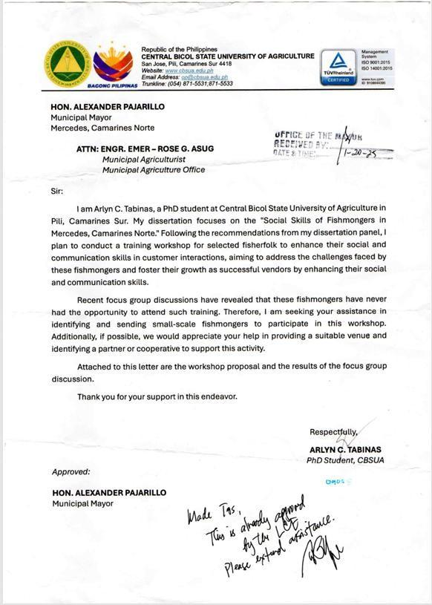
APPENDIX B

APPROVED LETTER – REQUEST FOR SURVEY QUESTIONNAIRE VALIDATION


 | Republic of the Philippines  CENTRAL BICOL STATE UNIVERSITY OF AGRICULTURE  San Jose, Pili, Camarines Sur 4418  Website: www.cbsua.edu.ph  Email Address: op@cbsua.edu.ph  Trunkline: (054) 871-5531;871-5533

IVY DENICE M. ABOGADO
Registered Guidance Counselor Daet, Camarines Norte

Madam:

Greetings of Peace!

The undersigned is presently writing a dissertation entitled “Social Skills of Fishmongers in Mercedes, Camarines Norte”. The study seeks to explore the social skills of the fishmongers in Mercedes, Camarines Norte, and conduct a project that will help them to improve their social skills. I likewise intend to distribute copies of the survey questionnaire to the identified participants. An interview will also be conducted to look into the effects of the activity.

Given this, I would like to seek your approval to validate my survey questionnaire for the participants.

I anticipate your positive response to this humble request. Your most valuable support will contribute to the success of the study.
Thank you very much.

Respectfully yours,

ARLYN C. TABINAS (sgd.)
Researcher Noted:
CHRISTOPHER C. DACER, PhD. (sgd.)
Adviser

CHERRY LOVE MONTALES, PhD. (sgd.)
GAC member Approved:
IVY DENICE M. ABOGADO (sgd.)
Registered Guidance Counselo

APPENDIX C

SAMPLE SURVEY QUESTIONNAIRE
 | Republic of the Philippines  CENTRAL BICOL STATE UNIVERSITY OF AGRICULTURE  San Jose, Pili, Camarines Sur 4418  Website: www.cbsua.edu.ph  Email Address: op@cbsua.edu.ph  Trunkline: (054) 871-5531;871-5533

Dear Participants,
Greetings!
I am Arlyn Tabinas, currently conducting a study entitled “Social Skills of Fishmongers in Mercedes, Camarines Norte. The purpose of this study is to determine the needs of fishmongers and provide an intervention to help improve their social skills, particularly in communication, which will benefit both their personal lives and professional roles as fishmongers.
Please take a moment to complete this questionnaire. Your responses will be kept confidential and will only be used for research purposes. Rest assured, no harm or risks will come to you by participating.
Thank you very much.
THE RESEARCHER

Name:
- Socio - economic demographic Profile
  - I. Socio–Demographic Profile

Age:
21 – 25 y/o 51 – 55 y/o
26 – 30 y/o 56 – 60 y/o
31 – 35 y/o 61 – 65 y/o
36 – 40 y/o 66 – 70 y/o
41 – 45 y/o 71 – 75 y/o
46 – 50 y/o
    - Sex: Male Female

Educational Attainment:

Elementary Undergraduate College Undergraduate
Elementary Graduate College Graduate
High School Undergraduate Vocational Course
High School Graduate

Number of family members:
1 -2 5 – 6 9 - 10
3 – 4 7 – 8

Length of years as fishmongers
1 -2 years 5 – 6 years 9 – 10 years
3 – 4 years 7 – 8 years More than 10
years

Annual Income
Less than P1,000/daily P11,000.00 –
P15,000.00/monthly
P1,000.00 – P2,000.00/daily P100,000.00/monthly
P1,000.00 – P5,000.00 monthly Di pare –
pareho/depende
P6,000.00 – P10,000.00/monthly

Attendance to Training
Livelihood Training (food processing/fish selling)
DOLE, DTI, DA, Young Farmers Training
Personality Development Training
none

- Needs Assessment
Please check (✓) the skills you would like to improve or develop further. (Pakitsek (✓) ang mga kasanayang nais mong paghusayin o higit pang paunlarin)
- Berbal na Komunikasyon (Aktibong Pakikinig):
  - Understanding and clarifying customer inquiries and concerns. (Pag-unawa at paglilinaw sa mga tanong at alalahanin ng mamimili.)
  - Responding appropriately and respectfully in conversations. (Pagtugon nang naaayon at may paggalang sa pag-uusap.)
  - Avoiding interruptions and giving full attention while others speak. (Pag-iwas sa pagsingit

at pagbibigay ng buong atensyon habang may nagsasalita.)
  - Asking follow-up questions to show engagement. (Pagtatanong ng mga kasunod na tanong upang ipakita ang pakikilahok.)
  - Summarizing or paraphrasing to confirm understanding. (Pagbubuod o pagsasaayos ng sinabi upang matiyak ang pagkakaunawa.)

- Non-Verbal Communication (Social Cues and Manners) Di-Berbal na Komunikasyon (Mga Sosyal na Palatandaan at Kagandahang Asal):
  - Maintaining appropriate eye contact during interactions. (Pagpapanatili ng angkop na pagtingin sa mata habang nakikipag-ugnayan.)
  - Using gestures and posture that reflect openness and respect. (Paggamit ng mga kilos at tindig na nagpapakita ng pagiging bukas at may respeto.)
  - Demonstrating polite and respectful behavior (e.g., greetings, expressions of gratitude). (Pagpapakita ng magalang at marespeto na pag-uugali (hal. pagbati, pagpapasalamat).
  - Observing others’ body language and adjusting behavior accordingly. (Pagmamasid sa kilos ng katawan ng iba at pag-aangkop ng sariling kilos batay dito.)
  - Maintaining cleanliness and professional appearance in public interactions. (Pagpapanatili ng kalinisan at propesyonal na anyo sa harap ng publiko.)

- Collaboration (Pakikipagtulungan)
  - Communicating ideas and needs clearly in a team setting. (Maayos na pagpapahayag ng mga ideya at pangangailangan sa loob ng grupo.)
  - Respecting the opinions and contributions of other group members. (Paggalang sa mga opinyon at ambag ng ibang kasapi ng grupo.)
  - Coordinating with local organizations or cooperatives to improve services. (Pakikipag- ugnayan sa mga lokal na organisasyon o kooperatiba upang mapabuti ang serbisyo.)
  - Building relationships with institutions (e.g., stores, restaurants, markets) to expand product distribution. (Pagbuo ng ugnayan sa mga institusyon (hal. tindahan, kainan, palengke) upang mapalawak ang distribusyon ng produkto.)
  - Participating in partnerships or agreements that support better profit and family income. (Pakikilahok sa mga kasunduan o pakikipag-partner na tumutulong sa mas mataas na kita at kabuhayan ng pamilya.)

- Social Skills Self-Assessment (Pagsusuri sa Sariling Kasanayan sa Pakikipagkapwa)
Directions: Read each statement and indicate your level of agreement. There are no right or wrong answers. Please be honest in your responses.
- – Strongly Disagree
- – Disagree
- – Neutral

- – Agree
- – Strongly Agree

Statements on Verbal Skills | 1 | 2 | 3 | 4 | 5
I actively listen to customers to understand their needs and preferences.
(Aktibong nakikinig ako sa mga mamimili upang maunawaan ang
kanilang mga pangangailangan at kagustuhan.)
I repeat back key points to ensure the customer feels heard.
(Inuulit ko ang mga pangunahing punto upang matiyak na naririnig ang mamimili.)
I ask clarifying questions when I’m unsure of the customer’s needs.
(Nagtatanong ako ng mga paglilinaw na katanungan kapag hindi ako sigurado sa mga pangangailangan ng mamimili.)
I provide clear and concise information to customers about the fish we sell.
(Nagbibigay ako ng malinaw at maikling impormasyon sa mga mamimili tungkol sa mga isdang tinitinda namin.)
Statements on Non-Verbal Skills
I listen attentively without interrupting the customer.
(Nakikinig ako nang mabuti nang hindi iniistorbo ang mamimili.)
I make eye contact and smile when interacting with customers. (Nakikipag-eye contact at ngumingiti ako kapag nakikipag-ugnayan sa mga mamimili.)
I pay attention to the customer’s body language to gauge their
needs.
(Pinapansin ko ang galaw ng katawan ng mamimili upang malaman ang kanilang mga pangangailangan.)
I use polite gestures and maintain a respectful posture.
(Gumagamit ako ng magalang na kilos at pinapanatili ang marespeto na tindig.)
I can sense when a customer needs reassurance and respond appropriately.
(Nararamdaman ko kung kailan kailangan ng katiyakan ng mamimili
at tumutugon nang naaayon.)
I am mindful of my tone of voice to ensure it is friendly and welcoming.
(Pinapanatili ko ang malumanay na tono ng boses upang matiyak na ito ay magiliw at malugod.)
Statements on Collaboration Skills
I communicate effectively with my colleagues to coordinate tasks.
(Epektibong nakikipag-ugnayan ako sa aking mga kasamahan upang maisaayos ang mga Gawain).

Statements on Verbal Skills | 1 | 2 | 3 | 4 | 5
I offer to help my colleagues when they are struggling with their tasks.
(Nag-aalok ako ng tulong sa aking mga kasamahan kapag
nahihirapan sila sa kanilang mga awain.)
I can delegate tasks efficiently when the stall is busy.
(Maayos akong nakakapag-atas ng mga awain kapag abala ang tindahan.)
I participate in team discussions to improve customer service.
(Nakikilahok ako sa mga talakayan ng koponan upang mapabuti ang aming serbisyo sa mamimili.)
I am open to feedback from my team members to improve our collaboration.
(Bukas ako sa mga puna mula sa aking mga kasamahan upang
mapabuti ang aming pakikipagtulungan.)

- Project Evaluation
Please answer the following questions briefly and clearly.
- How would you rate the effectiveness of the communication skills training? Why? (Paano mo iraranggo ang bisa ng pagsasanay sa kasanayan sa komunikasyon? Bakit?)

- What aspects of the project did you find most beneficial? Why?
(Anong aspeto ng proyekto ang nakita mong pinaka-may pakinabang? Bakit?)

- Are there any areas of the project that you think need improvement? Why? (Mayroon bang mga bahagi ng proyekto na sa tingin mo ay kailangan pagbutihin? Bakit?)

- How do you feel about the team-building activities?
(Ano ang iyong naramdaman tungkol sa aktibidad ng pagkakabuo ng koponan?)

- Do you have any suggestions for future training sessions? What are these? (Mayroon ka bang mga mungkahi para sa mga susunod na sesyon ng pagsasanay? Ano-ano ang mga iyon?)

APPENDIX D

APPROVED PROPOSAL FOR THE PROJECT FINTASTIC

   | 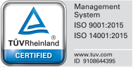  Republic of the Philippines  CENTRAL BICOL STATE UNIVERSITY OF AGRICULTURE  San Jose, Pili, Camarines Sur 4418  Website: www.cbsua.edu.ph  Email Address: op@cbsua.edu.ph  Trunkline: (054) 871-5531;871-5533

PROJECT FINTASTIC TALK

PROPONENT OFFICE:
ARLYN C. TABINAS, Head Teacher III, Camarines Norte National High School
PROGRAM NAME:
Project FINTASTIC TALK: Enhancing Social Communication Skills for Fishmongers

AMOUNT REQUESTED:
PhP 10,000.00
(Solicitation, donation)

Rationale:

The Training Needs Analysis (TNA) revealed a high demand among fishmongers in Mercedes, Camarines Norte, for workshops on social skills focusing on verbal, non-verbal, and collaboration skills. Effective communication is essential for improving customer relations and business success. Additionally, there is a moderate interest in collaborative strategies workshops, highlighting the importance of teamwork in enhancing business operations.

PROPOSED ACTIVITIES FOR SY 2024-2025
Project FINTASTIC: Enhancing Social Communication Skills for Fishmongers

A.1. Date of Conduct:  February 4, 2025, Customer Interaction Workshops  February 11, 2025, Collaborative Strategies Workshops | A.2. Duration of Activity  2-Day Activity
A.3. Venue/Platform:  Municipality of Mercedes | A.4. Target Participants  32 fishmongers in Mercedes, Camarines Norte
A.5. Activity Rationale:

The workshops address the needs for improved customer interaction and collaboration among fishmongers. By enhancing these skills, fishmongers can better serve their customers, increase sales, and foster a more cooperative business environment.
A.6. Objectives:

- To improve the verbal and non-verbal communication skills of fishmongers.
- To enhance active listening skills to better understand customer needs.
- To develop effective strategies for teamwork and collaboration among fishmongers.
- To increase customer satisfaction and loyalty through improved service interactions.
A.7. Expected Output:

- Improved customer service and communication skills among fishmongers.
- Better understanding and application of collaborative strategies in business operations.
- Increased customer satisfaction and higher sales.
- Stronger community ties and support among fishmongers.

A.8. Methodology:

Date | Time | Activity | Venue | Persons Involved | Facilitators
Feb. 4, 2025 | 8:00-9:00 | Registration/Preliminaries | Municipality of Mercedes | Invited speakers | The researcher
 | 9:00-10:00 | Introduction to Customer Interaction:  Overview of customer service principles.  Importance of effective communication in business.
 | 10:00 – 12:00 | Active Listening Skills:  Techniques for active listening.  Role-playing exercises to practice listening and responding to customers' needs.  Verbal Communication:  Effective verbal communication strategies.  Handling customer inquiries and complaints professionally.  Non-Verbal Communication:  Understanding and using body language.  Maintaining a positive demeanor through facial expressions and posture.  A mini-session or segment under verbal communication that discusses building confidence in interacting with different types of customers.
Feb. 11, 2025 | 8:00-9:00 | Management of Learning | Municipality of Mercedes | Invited speakers | The researcher
 | 9:00 – 10:00 | There will be a segment on how to give and receive feedback, both from customers and colleagues, to reinforce active listening and collaboration as a review of the previous discussions.  Collaborative Strategies:  Importance of collaboration in the workplace.  Clear communication strategies for teamwork.  Methods for sharing and delegating tasks.  Techniques for resolving conflicts within the team.
 | 10:00 – 11:00 | Practical Sessions:  Simulated customer interactions and team activities.  Feedback and improvement tips from trainers.  There will be a follow-up mechanism or simple survey to assess how fishmongers apply what they learned, ensuring lasting impact and refinement.

A.9. Budgetary Requirement:
Quantity | Unit | Item | Unit Price | Total Amount
 |  | Snack  Token  Cert  Miscellaneous |  | 5000  3000  1000  1000
Grand Total |  |  |  | 10000

Prepared by:

ARLYN C. TABINAS (sgd.)
Proponent

Noted:
CHRISTOPHER B. DACER (sgd.)
Dissertation Adviser

Approved:

ALEXANDER PAJARILLO (sgd.)
Municipal Mayor – Mercedes

APPENDIX E
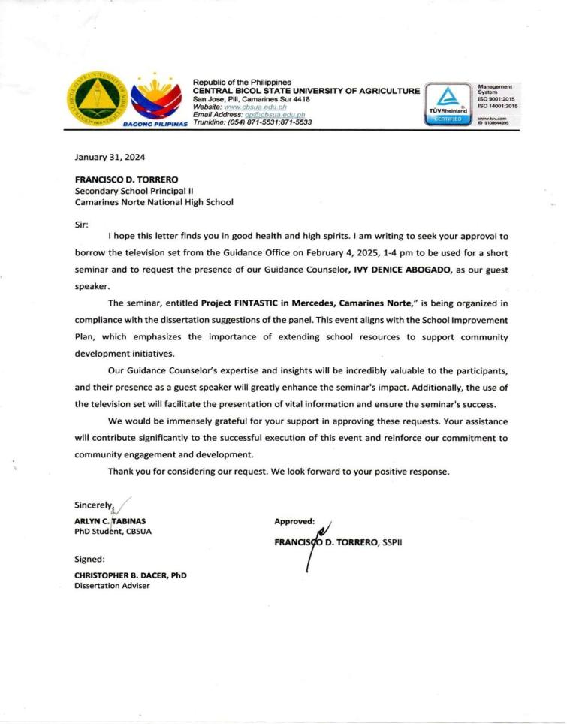
APPROVED LETTER – REQUEST TO INVITE THE GUEST SPEAKER FROM THE OFFICE OF THE SCHOOL PRINCIPAL

APPENDIX F
ATTENDANCE OF THE PARTICIPANTS TO THE CONDUCTED ACTIVITY
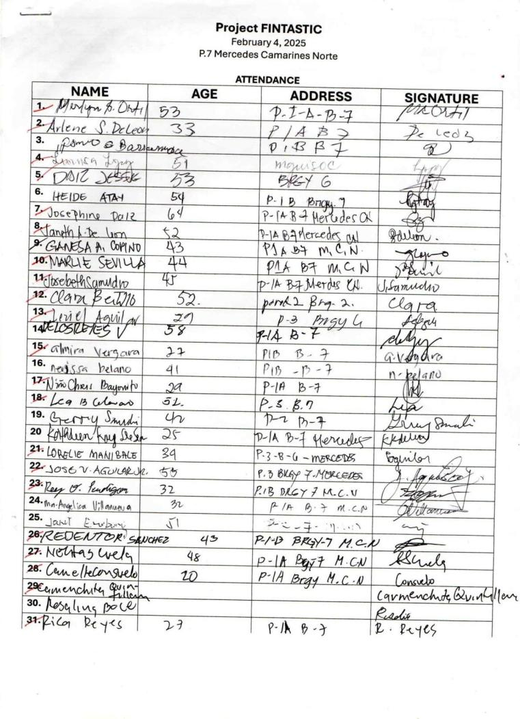
APPENDIX F CERTIFICATION OF THE EDITOR

CERTIFICATION

This is to certify that the Dissertation entitled “PROJECT FINTASTIC: AN INTERVENTION ON SOCIAL SKILLS FOR FISHMONGERS”, prepared and submitted by ARLYN C. TABINAS in partial fulfillment of the requirements for the degree of Doctor of Philosophy (Development of Education) has been edited by the undersigned.

This certification is hereby issued upon the request of Ms. Tabinas.

Issued this of May 2025 at Central Bicol State University of Agriculture, Pili, Camarines Sur.

IMARI MERYL S. ROXAS
Editor

APPENDIX F
CERTIFICATION OF THE STATISTICIAN

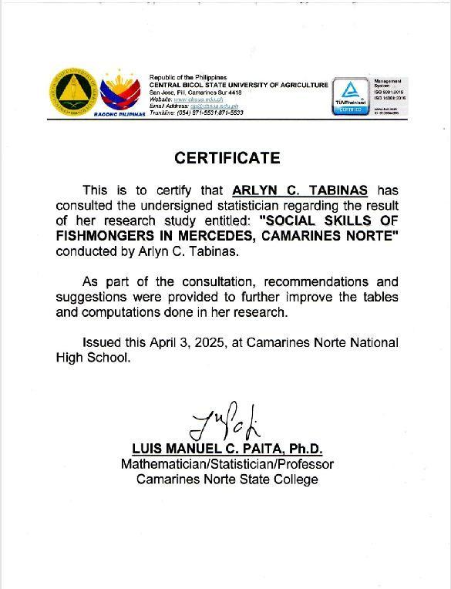

APPENDIX G

PHOTO DOCUMENTATION

During the Training Needs Assessment

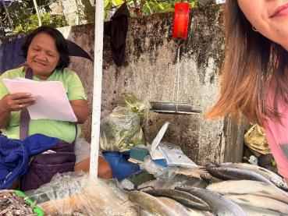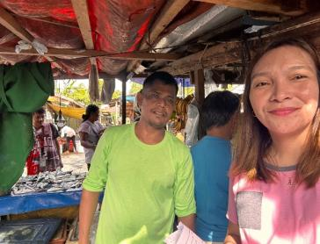

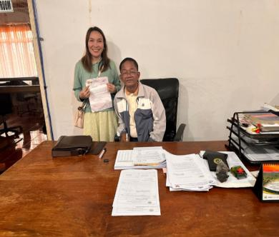
Formally signed the request letter to the Municipal Administrator, seeking approval to conduct the seminar-workshop on behalf of the mayor, paving the way for meaningful community engagement and learning

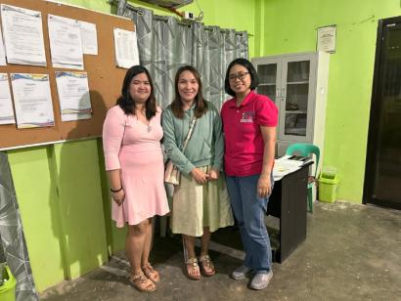

Coordination meeting with the Municipal Agriculture Officer of the municipality of Mercedes.

THE SEMINAR–WORKSHOP PROPER

