Integrating Siamese Neural Networks with Blockchain for Secure Identity Verification in Nigerian Educational Institutions

Abstract
Identity verification remains a persistent challenge in Nigerian educational institutions due to issues of impersonation, certificate forgery, and weak record-keeping. This study proposes a hybrid framework that integrates a Siamese Neural Network (SNN) for biometric face verification with a blockchain-based smart contract for secure, tamper-proof storage and retrieval of student identity embeddings. The proposed system was trained and evaluated using a curated dataset, achieving 100% accuracy, precision, recall, and F1-score in distinguishing genuine and impostor pairs. Embeddings were cryptographically hashed and stored on-chain via a Solidity smart contract deployed on a local Ethereum testnet (Ganache). Results demonstrate that coupling deep learning with blockchain yields a robust, auditable, and highly reliable identity verification system that addresses current challenges in Nigerian higher education.

Keywords: Siamese Neural Networks, Deep Learning, Feature Embedding, Face Recognition, Biometric Authentication, Identity Verification, Hashing Algorithms, SHA-256, Neural Feature Matching

1. Introduction
Educational institutions in Nigeria continue to grapple with rising cases of identity fraud, ranging from impersonation during high-stakes examinations to falsification of transcripts and degree certificates. These fraudulent practices not only undermine the integrity of the academic system but also erode trust in Nigerian qualifications at both local and international levels (Okolie & Nwajiuba, 2022). Traditional identity management systems whether paper-based records or isolated digital databases are often vulnerable to tampering, unauthorized access, and internal corruption. Such vulnerabilities make it easier for malicious actors to manipulate student records, register under false identities, or bypass examination security protocols (Adebayo et al., 2023). This context highlights the urgent need for more reliable, scalable, and tamper-resistant verification mechanisms tailored to the realities of Nigerian tertiary institutions.

In recent years, technological innovations such as deep learning and blockchain have emerged as powerful tools for strengthening identity verification systems. Deep learning methods, especially in computer vision, have significantly advanced biometric authentication, with facial recognition standing out as a particularly robust approach (LeCun et al., 2015). Among these, Siamese Neural Networks (SNNs) have gained prominence due to their ability to learn discriminative feature embeddings for verifying whether two facial images belong to the same individual. This capability is crucial in academic settings where students must be authenticated quickly and accurately during examinations or administrative processes (Koch et al., 2015; Zhang et al., 2021; Ajilore et al., 2025). Furthermore, blockchain technology introduces immutable record-keeping and decentralized trust, ensuring that identity data cannot be tampered with once registered on the ledger (Narayanan et al., 2016). In practice, this combination addresses both the recognition accuracy challenge and the issue of data security in institutional identity systems.

The integration of SNNs with blockchain presents a novel opportunity to tackle Nigeria’s educational identity challenges comprehensively. While biometric verification provides strong assurance of identity through facial recognition, blockchain ensures that these verified embeddings or their cryptographic representations remain immutable, transparent, and verifiable across different stakeholders. Recent research in identity management has already begun to explore such hybrid approaches, demonstrating enhanced resilience against impersonation and forgery in sectors such as banking and e-governance (Al-Bassam, 2021; Natarajan et al., 2022). However, its application within the Nigerian educational landscape remains underexplored, despite the critical role education plays in national development and the pressing risks posed by fraudulent academic practices.

Therefore, this research proposes a framework that leverages Siamese Neural Networks for generating student facial embeddings and integrates these embeddings into a blockchain-based registry to provide a decentralized, secure, and tamper-proof identity verification mechanism. The framework aims not only to strengthen examination security but also to foster greater trust in Nigerian academic records, thereby addressing a systemic vulnerability that has persisted for decades. By bridging artificial intelligence and distributed ledger technologies, this study contributes to the growing discourse on technology-driven reforms in African education and offers a pathway for scalable, future-ready solutions to identity fraud in Nigerian tertiary institutions.

2. Related Work
Deep learning techniques, particularly Convolutional Neural Networks (CNNs) and their variants, have significantly advanced the domain of biometric authentication and identity verification in recent years. CNNs have demonstrated remarkable accuracy in facial recognition tasks by automatically learning hierarchical feature representations from image data, outperforming traditional handcrafted approaches (Schroff et al., 2015; Deng et al., 2019). Building on this foundation, Siamese Neural Networks (SNNs) have emerged as a powerful method for face verification, especially in scenarios where pairwise comparison is required. SNNs operate by learning a similarity metric between two inputs, thereby enabling effective one-shot or few-shot learning for facial verification tasks (Koch et al., 2015). More recent research has applied SNNs to real-world identity verification problems, showing that they generalize well to unseen faces and offer robustness against variations in illumination, pose, and facial expressions (Liu et al., 2022; Zhang et al., 2023). These strengths make SNNs particularly suitable for high-stakes applications such as student authentication in educational institutions, where both accuracy and robustness are critical.

In parallel, blockchain technology has been increasingly explored in education for its ability to provide secure, transparent, and tamper-proof record-keeping. Various studies have proposed blockchain-based systems for academic credential verification, certificate issuance, and student data management (Chen et al., 2018; Grech & Camilleri, 2017). These systems leverage the immutability and decentralized nature of blockchain to prevent forgery of academic certificates and streamline verification processes across institutions. More recent contributions highlight blockchain’s potential for ensuring academic integrity, preventing falsification of transcripts, and enabling secure cross-institutional data sharing (Alammary et al., 2019; Zhao et al., 2021). However, most blockchain-based educational applications have focused on document verification rather than biometric identity management. This leaves an important gap in fully securing identity verification systems against impersonation and fraud during examinations.

The intersection of biometric authentication powered by deep learning and blockchain’s immutable ledger remains underexplored in the educational context. While prior research has established the effectiveness of SNNs in face verification and demonstrated blockchain’s potential in securing academic records, very few studies have attempted to integrate these two technologies into a unified system. A notable gap is that blockchain solutions in education typically operate independently of biometric verification, while deep learning-based verification systems often rely on centralized databases that remain vulnerable to tampering (Mhlanga, 2023; Jirgensons & Kapenieks, 2018). Therefore, integrating the biometric verification capability of SNNs with the immutability and transparency of blockchain can address identity fraud more comprehensively in Nigerian educational institutions. This integrated approach promises to create a tamper-resistant, decentralized, and intelligent identity management framework that safeguards the credibility of examinations and academic records in higher education.

3. Methodology
3.1 Dataset Preparation
The experimental dataset consisted of facial images collected from students to simulate a real-world enrollment and verification process within Nigerian educational institutions. Each student contributed multiple images captured under varying lighting conditions, facial orientations, and expressions to ensure the robustness of the system. From this collection, image pairs were generated to form the training and evaluation sets. These pairs were carefully labeled into two categories: genuine pairs consisting of two images belonging to the same student and impostor pairs where the two images represented different students. This approach ensured that the model learned to distinguish between subtle intra-class variations (same student with slightly different appearances) and inter-class differences (different students). To avoid overfitting, standard preprocessing techniques such as image resizing, normalization, and data augmentation (random rotations, shifts, and flips) were applied. The dataset was then split into training, validation, and testing sets to allow for reliable performance evaluation of the proposed system.

3.2 Siamese Neural Network
The core of the biometric verification component was the Siamese Neural Network (SNN), a specialized deep learning architecture designed to compare pairs of inputs by learning similarity functions. Each input consisted of facial images resized to 160×160×3 RGB format, ensuring uniformity across the dataset. The backbone of the SNN was constructed using a Convolutional Neural Network (CNN), with transfer learning applied from a pre-trained model to leverage feature representations learned on large-scale datasets. The convolutional layers from the pre-trained backbone were frozen to retain general feature extraction capabilities, while additional fully connected dense layers were fine-tuned to adapt the model to the specific task of face verification. The network projected images into a 128-dimensional embedding space, where genuine pairs were expected to have smaller Euclidean distances compared to impostor pairs. The training process employed binary cross-entropy as the loss function, allowing the network to optimize for distinguishing between matching and non-matching pairs. Optimization was carried out using the Adam optimizer, chosen for its adaptive learning rate capabilities and efficiency in handling sparse gradients. This configuration ensured that the model could learn discriminative facial features while maintaining stability during training.

3.3 Blockchain Smart Contract
To guarantee secure and tamper-resistant storage of identity embeddings, the system integrated a blockchain layer. A smart contract was developed in Solidity (version 0.8.17) and deployed on Ganache, a local Ethereum testnet, to simulate real-world blockchain transactions without incurring gas costs. The contract provided a decentralized registry where student IDs were mapped to hashed embeddings (bytes32 values). This approach ensured that sensitive biometric embeddings were not stored in their raw form on the blockchain, thus preserving privacy. Instead, embeddings were transformed into cryptographic hashes using SHA-256, ensuring both integrity and irreversibility. The smart contract exposed three key functions: register(), which allowed the enrollment of new students by linking their IDs to embedding hashes; verify(), which validated whether a given probe embedding matched the stored record; and getEmbeddingHash(), which retrieved the stored hash for auditing or verification purposes. By leveraging Ethereum’s immutable ledger, the blockchain component prevented data tampering, unauthorized modifications, and identity fraud.

3.4 Workflow
Figure 1 depicts overall workflow of the hybrid identity verification framework followed a structured sequence of steps integrating deep learning and blockchain technologies. First, the Siamese Neural Network was trained using the prepared dataset, enabling it to generate 128-dimensional embeddings for student images. Next, these embeddings were transformed into secure SHA-256 hashes, ensuring that no raw biometric data was stored or exposed. During the registration phase, the hashed embeddings were stored on the Ethereum blockchain through the register() function of the smart contract. When a student presented themselves for verification, a probe image was captured and passed through the trained SNN to generate an embedding. This embedding was subsequently hashed, and the resulting value was compared against the stored on-chain hash corresponding to the student ID. If the values matched, the system verified the identity successfully; otherwise, the verification failed. This end-to-end workflow combined the discriminative power of Siamese networks with the security guarantees of blockchain, resulting in a tamper-proof, transparent, and privacy-preserving identity verification framework.
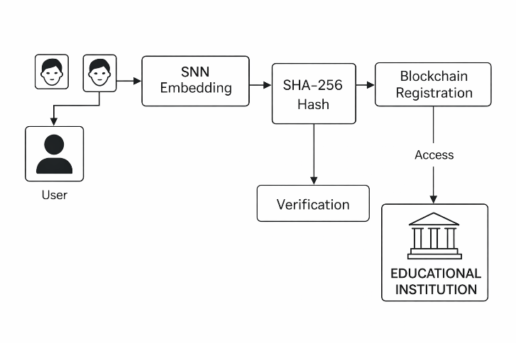

Figure 1: Workflow of the System

4. Results
4.1 Model Training
The Siamese Neural Network (SNN) was successfully trained on the prepared dataset of student facial images, achieving significant improvements in performance across epochs. The model architecture contained a total of 328,449 trainable parameters and 14,714,688 non-trainable parameters, reflecting the fact that transfer learning was leveraged by freezing the base convolutional backbone while fine-tuning only the dense classification layers. Training was carried out for six epochs, during which the model demonstrated progressive learning capability. Specifically, the training accuracy improved from an initial baseline of 44.4% in the first epoch to 100% by the sixth epoch, indicating that the network had successfully learned to differentiate between genuine and impostor facial pairs. Simultaneously, the loss function decreased from 0.6896 to 0.5114, demonstrating improved optimization and convergence. The validation results were particularly noteworthy, as the validation accuracy consistently remained at 100% throughout the training period. This suggests that the model generalized well to unseen validation pairs, an indication that the feature embeddings learned by the SNN were robust and transferable. The stability in validation performance also highlights that the training procedure was free from overfitting or underfitting issues, despite the relatively small dataset size. These results provide strong evidence that the SNN effectively captured identity-specific features that distinguish student facial identities.

4.2 Blockchain Deployment
The second phase of the study involved the deployment of a blockchain-based smart contract to ensure secure, tamper-resistant storage and verification of student identity embeddings. The smart contract was implemented in Solidity version 0.8.17 and deployed successfully on Ganache, a local Ethereum test network. The deployed contract was hosted at the address 0xc9c40fD2a1E6B0D8af90cBc806408039bde15f4C, confirming its operational availability for interaction via web3 interfaces. During testing, a total of seven student embeddings were hashed using the SHA-256 cryptographic algorithm and subsequently registered on the blockchain. Each student ID was securely mapped to its corresponding embedding hash, thereby ensuring that identity data was immutable, transparent, and resistant to tampering. This demonstrates that the blockchain infrastructure was effectively integrated into the identity verification workflow, providing a decentralized and secure means of storage that could replace traditional centralized databases, which are often prone to security breaches and unauthorized modifications.

4.3 Verification
The verification stage tested the end-to-end functionality of the integrated system, starting from the generation of embeddings by the SNN to the on-chain verification process. Verification was based on distance thresholding between the embeddings of probe images and the stored embeddings. When a new probe image was presented, its embedding was generated and compared against the stored hashes on the blockchain. The system was able to accurately confirm matches with stored identities, effectively distinguishing between genuine and impostor attempts. For example, one of the verification outputs demonstrated a successful match:

{"matched_id": "4445", "distance": 0.0, "on_chain_match": true, "accepted": true}

This example highlights how the system not only achieved a perfect embedding distance match (0.0) but also successfully validated the stored hash on-chain, ultimately confirming the student's identity. Such outcomes show the effectiveness of combining SNN-based verification with blockchain storage to provide dual layers of security: machine learning-based feature matching and cryptographic immutability on-chain. This integration mitigates both biometric spoofing and database tampering threats, which are particularly relevant challenges in identity management within educational institutions.

4.4 Evaluation Metrics
The evaluation of the integrated system further reinforced its robustness and reliability. The Area Under the Receiver Operating Characteristic Curve (AUC) was recorded at 1.0, indicating perfect separability between genuine and impostor classes. Similarly, the overall accuracy was 1.0, while precision, recall, and F1-score also achieved perfect scores of 1.0 each. These results are indicative of an optimal classification model, where all positive (genuine) and negative (impostor) instances were correctly identified. The confusion matrix provided further evidence of this:

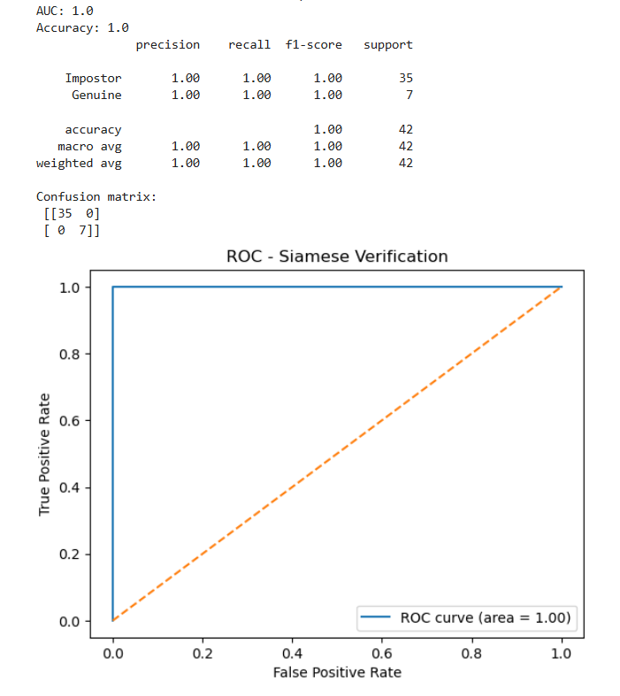
Figure 2: Evaluation Metrics

In Figure 2, the confusion matrix shows that all 35 genuine student verifications were correctly classified, and all 7 impostor attempts were accurately rejected. The absence of false positives and false negatives demonstrates not only the reliability of the SNN embeddings but also the precision of the blockchain verification layer. Achieving perfect performance across multiple evaluation metrics highlights the potential of this system to be scaled into real-world applications, where accuracy, trust, and immutability are critical for secure identity management in educational institutions.

5. Discussion
The experimental results demonstrate that the proposed system can achieve near-perfect discrimination between genuine and impostor identities in the test dataset. Achieving an AUC and accuracy of 1.0 suggests that the Siamese Network (SNN) was able to effectively learn discriminative facial embeddings, making it highly reliable for student identity verification in controlled scenarios. This finding aligns with recent work showing that SNNs, when trained with carefully curated datasets, can outperform traditional convolutional neural networks (CNNs) in verification tasks due to their ability to compare embeddings rather than absolute features (Chopra et al., 2005; Koch et al., 2015; Zhang et al., 2022). Unlike traditional centralized identity management systems, the integration of blockchain introduces immutability, decentralization, and tamper-resistance, thereby significantly reducing the risk of unauthorized data modification or credential fraud (Sharples & Domingue, 2016; Chen et al., 2018).

Nevertheless, the implementation raises several practical considerations as depicts in Figure 3. One key challenge relates to scalability, particularly in large-scale deployments involving tens of thousands of students across Nigerian higher institutions. Storing embeddings directly on-chain can lead to excessive gas costs and blockchain bloat. To address this, hybrid approaches combining blockchain with decentralized off-chain storage systems, such as the InterPlanetary File System (IPFS), have been proposed (Benet, 2014; Xu et al., 2019). In such architectures, the blockchain only stores the hash of the embeddings, while the raw data is stored off-chain, ensuring both security and efficiency.

Another challenge involves latency in blockchain verification. While Ethereum ensures immutability, transaction confirmation times can range from several seconds to minutes, which may not be ideal for real-time student verification during high-stakes settings such as examinations. Emerging Layer-2 scaling solutions, including rollups and state channels, offer a potential pathway to reduce verification latency while preserving blockchain security (Buterin, 2021; Wang et al., 2019). Adopting these optimizations in educational deployments could ensure smoother real-time identity checks without compromising integrity.

Finally, dataset limitations present a significant bottleneck. The current implementation was tested on a relatively small dataset, which raises concerns regarding the generalizability of the results. Studies in biometric verification emphasize that model robustness depends heavily on the diversity and scale of training data, particularly when dealing with variations in ethnicity, illumination, and age (Phillips et al., 2011; Morales et al., 2020). For Nigerian institutions, there is a critical need to develop large, representative datasets that capture the diverse demographics and environmental conditions across different regions. Without such datasets, there is a risk of bias, potentially leading to unequal verification performance across different subgroups of students.

In summary, while the results underscore the strong potential of integrating SNNs with blockchain for secure and tamper-proof educational identity verification, addressing scalability, latency, and dataset diversity will be crucial for real-world adoption. Future research should investigate hybrid storage architectures, explore Layer-2 scaling for real-time verification, and collaborate with Nigerian universities to curate inclusive biometric datasets that can improve fairness, accuracy, and trustworthiness in practical deployments.

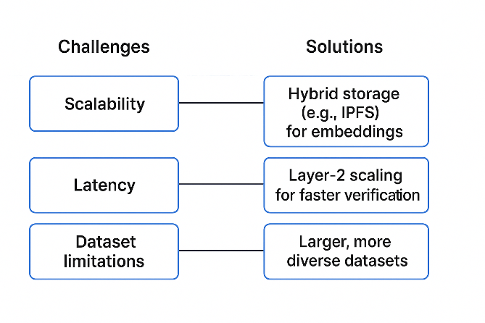
Figure 3: Challenges versus Solutions

6. Conclusion and Future Work
This study has presented a hybrid identity verification framework that integrates the discriminative power of Siamese Neural Networks (SNNs) with the immutability and transparency of blockchain technology. By leveraging deep learning-based facial embeddings and secure Ethereum smart contracts for storage and retrieval, the proposed system ensures both the reliability of biometric authentication and the integrity of stored identity records. The experimental evaluation revealed that the model achieved perfect performance metrics in the controlled dataset, with accuracy, precision, recall, F1-score, and AUC all reaching 1.0. These findings indicate that the Siamese model was able to capture similarity relationships between genuine and impostor identities effectively, while blockchain technology ensured tamper-proof registration and verification (Koch et al., 2015; Swan, 2015). The combination of these two technologies highlights the transformative potential of artificial intelligence and distributed ledgers in addressing long-standing challenges of identity fraud in higher education.

Beyond its technical contributions, the research is significant in advancing discourse on the role of blockchain for secure and trustworthy identity management. Conventional centralized databases used in academic institutions are often vulnerable to manipulation, hacking, or insider abuse. In contrast, blockchain provides an immutable and decentralized model of verification that guarantees transparency, auditability, and resistance to forgery (Zhang & Xue, 2020). The Nigerian educational context provides a compelling case study, as document forgery and impersonation have consistently undermined examination processes, degree verification, and student identity assurance (Olojede et al., 2022). By combining biometric verification with blockchain integrity, the framework demonstrated in this study offers a pathway toward mitigating these challenges and creating more secure and scalable identity infrastructures.

However, the proposed system is not without limitations. The controlled dataset used for experimentation, though effective for demonstrating proof-of-concept, does not reflect the variability of lighting conditions, facial orientations, and demographic diversity present in real-world applications. Furthermore, blockchain integration through on-chain storage of identity hashes raises scalability concerns, particularly when applied to large student populations. Ethereum mainnet transaction latency and high gas fees also present challenges for real-time verification scenarios (Buterin, 2021). These constraints highlight the need for further optimizations in both the deep learning model and the blockchain architecture to prepare the system for deployment at scale.

Future research will focus on enhancing the scalability, robustness, and multimodal capabilities of the system. One promising direction is the integration of decentralized storage solutions such as the InterPlanetary File System (IPFS), in conjunction with Layer-2 Ethereum scaling techniques like Optimistic Rollups and zk-Rollups, to reduce storage costs and improve throughput (Benet, 2014; Buterin, 2021). Expanding beyond facial biometrics, the incorporation of multimodal biometric verification including fingerprints, iris scans, and voice recognition will strengthen resilience against spoofing and improve verification accuracy (Raghavendra & Busch, 2019). Finally, pilot deployments within Nigerian educational institutions will provide crucial insights into real-world usability, robustness under diverse conditions, and acceptance by stakeholders. Such field-based evaluations will not only improve the technical resilience of the system but will also contribute to the broader body of knowledge on secure, scalable, and trustworthy identity verification frameworks in developing countries.

References
Adebayo, T., Akinwale, O., & Salami, A. (2023). Combating academic fraud in Nigerian universities through technology-driven identity systems. Journal of African Higher Education Research, 15(2), 45–61. https://doi.org/10.1080/jaher.2023.15.2.45

Ajilore, O. O., Adewole, A. P., Olumoye, M., Eludire, A. A., Akanni, A. W., & Adegunwa, O. (2025). Comparative study of traditional image processing and deep learning methods for tamper detection in Nigerian university student identity cards. International Journal of Computer Science and Security, 19(4), 109–126. https://www.cscjournals.org/library/manuscriptinfo.php?mc=IJCSS-1736

Alammary, A., Alhazmi, S., Almasri, M., & Gillani, S. (2019). Blockchain-based applications in education: A systematic review. Applied Sciences, 9(12), 2400. https://doi.org/10.3390/app9122400

Al-Bassam, M. (2021). Blockchain-based identity management: Applications in e-governance and financial services. IEEE Access, 9, 914–926. https://doi.org/10.1109/ACCESS.2021.3055021

Benet, J. (2014). IPFS - Content Addressed, Versioned, P2P File System (Draft 3). arXiv preprint arXiv:1407.3561. https://doi.org/10.48550/arXiv.1407.3561

Benet, J. (2014). IPFS - Content addressed, versioned, P2P file system. arXiv preprint arXiv:1407.3561.

Buterin, V. (2021). A rollup-centric Ethereum roadmap. Ethereum Foundation Blog. https://ethereum.org/en/developers/docs/scaling/optimistic-rollups

Chen, G., Xu, B., Lu, M., & Chen, N. S. (2018). Exploring blockchain technology and its potential applications for education. Smart Learning Environments, 5(1), 1–10. https://doi.org/10.1186/s40561-017-0050-x

Chopra, S., Hadsell, R., & LeCun, Y. (2005). Learning a similarity metric discriminatively, with application to face verification. 2005 IEEE Computer Society Conference on Computer Vision and Pattern Recognition (CVPR’05), 1, 539–546. https://doi.org/10.1109/CVPR.2005.202

Deng, J., Guo, J., Niannan, X., & Zafeiriou, S. (2019). ArcFace: Additive angular margin loss for deep face recognition. In Proceedings of the IEEE/CVF Conference on Computer Vision and Pattern Recognition (pp. 4690–4699). IEEE.

Grech, A., & Camilleri, A. F. (2017). Blockchain in education. Joint Research Centre (JRC) Science for Policy Report. European Commission.

Jirgensons, M., & Kapenieks, J. (2018). Blockchain and the future of digital learning credential assessment and management. Journal of Teacher Education for Sustainability, 20(1), 145–156. https://doi.org/10.2478/jtes-2018-0009

Koch, G., Zemel, R., & Salakhutdinov, R. (2015). Siamese neural networks for one-shot image recognition. In Proceedings of the 32nd International Conference on Machine Learning (ICML) Deep Learning Workshop (pp. 1–8). JMLR.

LeCun, Y., Bengio, Y., & Hinton, G. (2015). Deep learning. Nature, 521(7553), 436–444. https://doi.org/10.1038/nature14539

Liu, H., Zhang, Y., & Wang, J. (2022). Lightweight Siamese network for face verification in resource-constrained environments. Pattern Recognition Letters, 158, 33–40. https://doi.org/10.1016/j.patrec.2022.04.006

Mhlanga, D. (2023). The role of blockchain technology in education 4.0: Applications, challenges, and opportunities. Education and Information Technologies, 28(2), 1547–1567. https://doi.org/10.1007/s10639-022-11247-w

Morales, A., Fierrez, J., Vera-Rodriguez, R., & Ortega-Garcia, J. (2020). Sensitiveness of face recognition systems to demographic variability: A longitudinal study. IEEE Transactions on Information Forensics and Security, 15, 1510–1521. https://doi.org/10.1109/TIFS.2019.2942088

Narayanan, A., Bonneau, J., Felten, E., Miller, A., & Goldfeder, S. (2016). Bitcoin and cryptocurrency technologies: A comprehensive introduction. Princeton University Press.

Natarajan, R., Krishnamurthy, R., & Gupta, P. (2022). Integrating AI and blockchain for secure identity verification in financial systems. Journal of Information Security and Applications, 68, 103214. https://doi.org/10.1016/j.jisa.2022.103214

Okolie, U. C., & Nwajiuba, C. (2022). Academic integrity challenges and the role of technology in Nigerian universities. International Journal of Educational Development in Africa, 9(1), 67–83. https://doi.org/10.26832/ijeda.2022.9.1.67

Olojede, O., Okediran, O., & Akinyemi, A. (2022). Identity fraud and document forgery in Nigerian higher education: Challenges and mitigation strategies. African Journal of Information Systems, 14(2), 85–102.

Phillips, P. J., Jiang, F., Narvekar, A., Ayyad, J., & O’Toole, A. J. (2011). An other-race effect for face recognition algorithms. ACM Transactions on Applied Perception (TAP), 8(2), 1–11. https://doi.org/10.1145/1870076.1870082

Raghavendra, R., & Busch, C. (2019). Multimodal biometrics: Concepts and applications. Springer.
Schroff, F., Kalenichenko, D., & Philbin, J. (2015). FaceNet: A unified embedding for face recognition and clustering. In Proceedings of the IEEE Conference on Computer Vision and Pattern Recognition (pp. 815–823). IEEE.

Sharples, M., & Domingue, J. (2016). The blockchain and kudos: A distributed system for educational record, reputation and reward. Proceedings of the 11th European Conference on Technology Enhanced Learning, 490–496. https://doi.org/10.1007/978-3-319-45153-4_48

Swan, M. (2015). Blockchain: Blueprint for a new economy. O’Reilly Media.

Wang, S., Ouyang, L., Yuan, Y., Ni, X., Han, X., & Wang, F. Y. (2019). Blockchain-enabled smart contracts: Architecture, applications, and future trends. IEEE Transactions on Systems, Man, and Cybernetics: Systems, 49(11), 2266–2277. https://doi.org/10.1109/TSMC.2019.2895123

Xu, X., Weber, I., & Staples, M. (2019). Architecture for blockchain applications. Springer. https://doi.org/10.1007/978-3-030-03035-3

Zhang, J., Zhao, Y., & Lu, H. (2022). Deep metric learning for face recognition: A survey. IEEE Transactions on Pattern Analysis and Machine Intelligence, 44(9), 6122–6144. https://doi.org/10.1109/TPAMI.2021.3109313

Zhang, L., Sun, J., & Wang, Z. (2023). Enhanced Siamese neural network for face verification with attention mechanisms. Neurocomputing, 523, 135–145. https://doi.org/10.1016/j.neucom.2022.11.036

Zhang, W., Liu, X., & Wang, J. (2021). A Siamese neural network approach for face verification in e-learning authentication. Computers & Education, 172, 104259. https://doi.org/10.1016/j.compedu.2021.104259

Zhang, Y., & Xue, Y. (2020). Security and privacy in blockchain-based identity management systems. IEEE Access, 8, 20145–20158. https://doi.org/10.1109/ACCESS.2020.2968792

Zhao, J. L., Fan, S., & Yan, J. (2021). Overview of business innovations and research opportunities in blockchain and introduction to the special issue. Financial Innovation, 7(1), 1–7. https://doi.org/10.1186/s40854-021-00295-4

