DeepShield-Fin: A Cross-Modal Artificial Intelligence Framework for Detecting Deepfake-Enabled Financial Fraud

1 Introduction

1.0.0.1
The rapid evolution of generative artificial intelligence (AI) has enabled the creation of highly realistic synthetic digital media, commonly referred to as deepfakes. These techniques can generate convincing audio, video, and multimodal content that closely mimics human appearance, voice, and behavior [1]–[3]. Although originally developed for applications in entertainment, computer graphics, virtual reality, and digital content production, deepfake technologies are increasingly being misused for malicious purposes [4]–[8]. Modern open-source tools and pre-trained models have significantly lowered the technical barrier, making it possible for individuals with limited expertise to produce highly persuasive forged content.
In recent years, deepfakes have emerged as a serious cybersecurity threat, particularly in the financial sector. Attackers can manipulate facial appearance and synthesize speech to impersonate executives, customers, or public figures in order to bypass authentication systems and conduct fraudulent transactions [6]–[8]. One common attack is voice cloning, in which a target individual’s speech characteristics are replicated to authorize unauthorized transfers [18]–[22]. Video-based attacks, including face swapping and real-time impersonation, can compromise remote identity verification processes such as video Know Your Customer (KYC). Lip-sync manipulation techniques can further align synthesized speech with facial movements, making forged videos appear authentic [6][35]. When disseminated through social media, such content may also be used to promote fraudulent investment schemes and deceive large numbers of victims.
Several high-profile incidents demonstrate the real-world impact of deepfake-enabled fraud. In 2019, criminals used AI-based voice cloning to impersonate a company executive and persuaded an employee to transfer approximately $243,000 to a fraudulent account [23]. Subsequent incidents involving deepfake audio and video have resulted in substantial financial losses and unauthorized access to sensitive systems. Law enforcement agencies such as the Federal Bureau of Investigation (FBI) and Europol have issued warnings regarding the increasing use of synthetic media in cyber-enabled financial scams. Industry analyses by Deloitte and Pindrop also report a steady rise in AI-assisted fraud attempts, highlighting the growing difficulty of distinguishing legitimate users from highly realistic synthetic impersonations.
Despite increased awareness, existing fraud detection mechanisms remain insufficient against deepfake-based attacks. Traditional financial fraud detection systems rely primarily on transaction monitoring, rule-based anomaly detection, and static authentication methods such as passwords and one-time passwords (OTPs) [23]–[26]. While effective against conventional fraud patterns, these methods are not designed to detect attacks that exploit human trust and biometric verification systems. Similarly, unimodal biometric systems based solely on face recognition or speaker verification are vulnerable to sophisticated synthetic media that simultaneously manipulate multiple modalities [18]–[22]. Recent research in deepfake detection has produced significant advances using machine learning and deep learning. Video-based methods such as MesoNet, Capsule-Forensics, and FakeCatcher analyze facial artifacts, biological signals, and temporal inconsistencies [14]–[17]. Audio anti-spoofing approaches including AASIST, RawNet2, and wav2vec 2.0 focus on spectral and speaker-level characteristics [18]–[21]. Multimodal systems such as AVoiD-DF and related audio-visual approaches compare speech and lip movements to detect synchronization mismatches [9], [31]–[35]. Although these methods achieve promising results, they generally concentrate on media authenticity alone and do not consider the broader behavioral, contextual, and transactional factors that are critical in financial fraud scenarios. Another limitation of existing systems is the lack of comprehensive cross-modal reasoning. Many models process audio, video, and text independently and combine the outputs using simple concatenation or averaging. Such approaches may fail to detect subtle inconsistencies, including mismatches between facial expressions and vocal tone, discrepancies between spoken content and user behavior, or conflicts between device context and transaction history [27], [31]–[44]. In practical financial environments, these relationships are essential for distinguishing legitimate interactions from coordinated social engineering attacks. Furthermore, many published methods are designed primarily for offline analysis and are not suitable for deployment during live video calls or remote verification sessions. Financial institutions increasingly conduct customer onboarding, approval workflows, and support interactions through platforms such as Zoom and Microsoft Teams, where decisions must be made in real time. Effective protection therefore requires a system capable of processing multimedia streams, evaluating multimodal consistency, and generating actionable fraud decisions within strict latency constraints.
To address these challenges, this paper proposes DeepShield-Fin, a comprehensive multimodal framework for real-time detection of deepfake-enabled financial fraud. The proposed system integrates visual, audio, behavioral, contextual, and transactional data into a unified analysis pipeline. Deep learning encoders extract modality-specific representations, cross-modal consistency analysis identifies discrepancies among heterogeneous signals, and an attention-based fusion module constructs a robust multimodal embedding. A deep neural network classifier then estimates fraud probability and assigns risk levels, while an automated alert and response module initiates actions such as additional verification, transaction blocking, and escalation to fraud analysts.
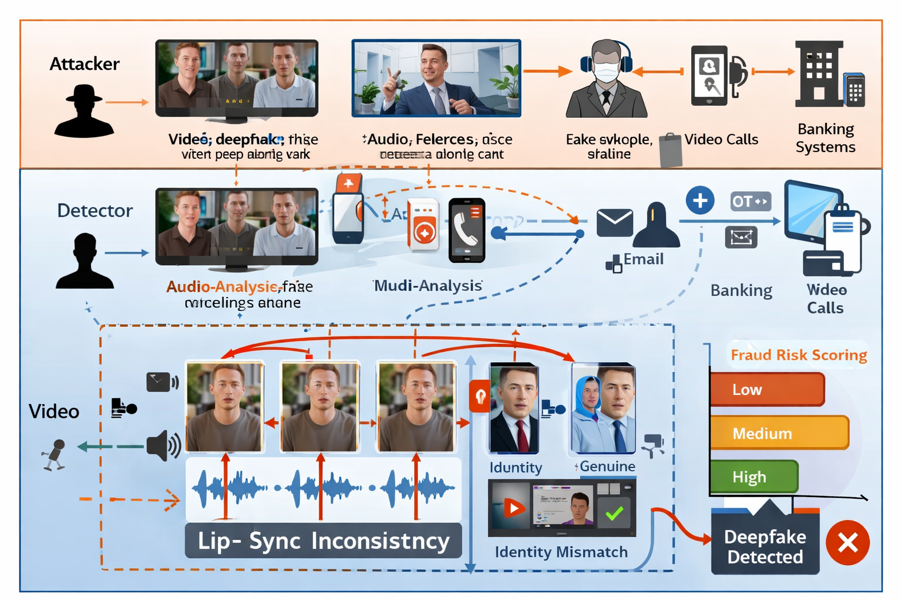
Overview of multi modal deepfake-based financial fraud attacks and the proposed AI-driven detection process.

2 Related Work

2.1 Deepfake Generation and Detection
Deepfake technologies have evolved rapidly with the advancement of deep learning, generative artificial intelligence, and neural media synthesis techniques. Early approaches primarily relied on autoencoders and encoder–decoder architectures for face swapping, facial reenactment, and synthetic speech generation [4], [5]. The introduction of Generative Adversarial Networks (GANs) significantly improved the realism of manipulated media by enabling high-quality facial synthesis with enhanced texture consistency and identity preservation [1]–[3]. Advanced architectures such as StyleGAN and diffusion-based models further reduced visible artifacts and improved temporal stability, making synthetic media increasingly difficult to distinguish from authentic content.
Recent multimodal generation systems can simultaneously manipulate facial appearance, speech, lip synchronization, and emotional expression. Frameworks such as Wav2Lip, pose-controllable talking-face generation, and audio-driven emotional portrait synthesis demonstrated highly realistic synchronization between speech and facial movements [6]–[8]. Similarly, modern voice cloning and neural speech synthesis systems can generate convincing synthetic speech using limited reference audio samples [18]. These advancements have significantly increased the risk of impersonation attacks targeting biometric authentication systems, remote identity verification, and financial communication platforms.
To counter these threats, researchers proposed various visual, audio, and multimodal deepfake detection methods. Visual detection systems such as MesoNet, XceptionNet, Capsule-Forensics, and FakeCatcher analyze facial artifacts, biological signals, and temporal inconsistencies to distinguish manipulated videos from genuine media [14]–[17]. Audio deepfake detection approaches including RawNet2, wav2vec 2.0, and AASIST focus on spectral, temporal, and waveform-level inconsistencies in synthetic speech [18]–[21]. More recently, multimodal systems have attempted to analyze synchronization mismatches between lip movements and speech signals for improved robustness against sophisticated attacks [31]–[35].
Despite substantial progress, existing deepfake detection systems face several important limitations. Most approaches rely on unimodal analysis and may fail against highly realistic GAN- and diffusion-based synthetic media with minimal detectable artifacts. In addition, many systems demonstrate reduced robustness under real-world conditions involving compression, environmental noise, illumination variation, and low-resolution media. Existing methods also provide limited capability for analyzing behavioral inconsistencies, contextual anomalies, and real-time conversational interactions commonly observed in deepfake-enabled financial fraud scenarios. These limitations highlight the need for robust multimodal frameworks capable of jointly analyzing audio, visual, behavioral, and contextual information for reliable real-time fraud detection.
Method | Modality | Key Contribution | Limitation
GANs [1] | Visual | High-quality synthetic media generation | Detectable artifacts in early versions
StyleGAN [3] | Visual | Realistic facial synthesis with improved texture quality | Difficult to detect using traditional forensics
DeepFaceLab [5] | Visual | Face swapping and facial reenactment | Vulnerable to misuse in impersonation attacks
Wav2Lip [6] | Audio-Visual | Accurate lip synchronization with speech | Enables realistic talking-face manipulation
MesoNet [14] | Visual | CNN-based artifact detection | Limited robustness against advanced deepfakes
FakeCatcher [16] | Visual | Biological signal-based detection | Sensitive to video quality and compression
RawNet2 [20] | Audio | Raw waveform-based spoof detection | Affected by environmental noise
AASIST [19] | Audio | Spectro-temporal graph attention framework | Limited multimodal reasoning capability
Multimodal AV Systems [31]–[35] | Audio-Visual | Lip-sync and cross-modal consistency analysis | Limited contextual and behavioral analysis

2.2 AI-Based Financial Fraud Detection
The rapid growth of digital banking, online transactions, mobile payments, and electronic financial services has significantly increased the complexity and frequency of financial fraud. Traditional fraud detection systems primarily relied on rule-based engines, statistical analysis, and manual auditing procedures to identify suspicious activities [23], [30]. Although effective against known fraud patterns, these approaches often struggle to detect evolving and sophisticated cyber-enabled attacks in real time.
To improve fraud detection capability, researchers increasingly adopted Artificial Intelligence (AI), Machine Learning (ML), and Deep Learning (DL) techniques for automated risk analysis and anomaly detection. Machine learning models such as Decision Trees, Random Forests, Support Vector Machines (SVMs), and sequential classification methods demonstrated improved capability in detecting fraudulent transaction patterns from historical financial data [23]. Deep learning approaches further enhanced performance through automated feature extraction and behavioral modeling, enabling the identification of complex transactional anomalies and account takeover attacks [24].
Recent studies also explored advanced fraud detection techniques including Graph Neural Networks (GNNs), behavioral biometrics, and streaming analytics. Graph-based frameworks improved the detection of hidden fraud rings, synthetic identities, and coordinated financial attacks by analyzing transactional relationships among users and accounts [25]. Behavioral analytics approaches utilized typing dynamics, device interaction patterns, and session-level user behavior to strengthen authentication and continuous monitoring systems [26]. Real-time learning frameworks and adaptive analytics further improved fraud prevention capability in high-volume financial environments [30].
Despite substantial progress, existing AI-based financial fraud detection systems exhibit several important limitations. Most frameworks primarily focus on transactional anomalies and behavioral profiling while neglecting multimedia impersonation attacks involving deepfake videos, cloned speech, and synthetic identities. In practical financial scams, attackers increasingly combine manipulated audio, forged facial videos, and social engineering techniques to bypass remote verification systems and deceive victims. Furthermore, many current systems lack multimodal reasoning capability, contextual analysis, explainability, and real-time cross-modal verification required for modern financial security applications. These limitations highlight the necessity for integrated multimodal frameworks capable of jointly analyzing transactional, behavioral, audio, visual, and contextual information for reliable deepfake-enabled financial fraud detection.
Study | Technique | Application | Limitation
Jurgovsky et al. [23] | Sequential ML models | Credit card fraud detection | Limited multimedia analysis
Fiore et al. [24] | GAN-based augmentation | Fraud classification improvement | Focused mainly on transaction data
Dou et al. [25] | Graph Neural Networks | Fraud relationship analysis | No deepfake detection capability
Eberz et al. [26] | Behavioral biometrics | Continuous authentication | Limited multimodal integration
Carcillo et al. [30] | Streaming active learning | Real-time fraud detection | Limited contextual intelligence
Traditional Rule-Based Systems | Statistical analysis | Transaction monitoring | High false-positive rates
Behavioral Analytics Systems | User profiling | Session-level anomaly detection | Limited audio-visual analysis

2.3 Research Gaps and Challenges
Despite significant advancements in deepfake detection and AI-based financial fraud analysis, several critical challenges remain unresolved. Existing deepfake detection methods primarily focus on isolated visual or audio modalities and often demonstrate reduced robustness against highly realistic GAN- and diffusion-based synthetic media [1]–[3]. Visual detection systems may fail under compression, illumination variation, pose changes, and low-resolution conditions, while audio-based methods remain sensitive to environmental noise, channel distortions, and unseen spoofing attacks [14]–[21].
Another major limitation is the insufficient modeling of cross-modal relationships. Most existing multimodal systems mainly analyze lip synchronization and simple audio-visual consistency while neglecting behavioral patterns, conversational context, emotional dynamics, and transactional anomalies [31]–[35]. In real-world financial fraud scenarios, attackers frequently combine cloned speech, manipulated facial videos, spoofed identities, and social engineering techniques to create highly convincing impersonation attacks. Consequently, unimodal and weakly integrated multimodal systems may provide unreliable decisions in practical deployment environments.
Current AI-based financial fraud detection frameworks also primarily concentrate on transaction monitoring, anomaly detection, and behavioral profiling while overlooking multimedia impersonation attacks involving deepfake-generated content [23]–[30]. In addition, many existing systems operate as black-box models with limited explainability and transparency, creating challenges in financial environments where auditability, regulatory compliance, and decision accountability are essential.
Real-time deployment remains another important challenge. Most existing approaches are designed for offline dataset evaluation rather than live communication environments such as remote customer verification, online banking support, and video conferencing systems. High computational complexity, scalability constraints, and latency issues further limit the practical applicability of many transformer-based and multimodal architectures.
Therefore, there is a strong need for an integrated multimodal framework capable of jointly analyzing audio, video, behavioral, contextual, and transactional information for real-time deepfake-enabled financial fraud detection. The proposed DeepShield-Fin framework aims to address these limitations through cross-modal consistency analysis, attention-based multimodal fusion, contextual intelligence, and AI-driven fraud analytics for improved robustness, explainability, and real-time operational capability.
Research Area | Existing Limitation | Required Improvement
Visual Deepfake Detection | Sensitive to compression, illumination, and advanced GAN-based synthesis | Robust real-world visual analysis
Audio Spoof Detection | Vulnerable to environmental noise and unseen spoofing attacks | Generalized and noise-robust audio analysis
Multimodal Detection | Limited cross-modal reasoning and behavioral analysis | Integrated multimodal consistency modeling
Financial Fraud Detection | Focused mainly on transactional anomalies | Multimedia-aware fraud intelligence
Explainability | Black-box decision-making frameworks | Interpretable and explainable AI systems
Real-Time Deployment | High latency and computational complexity | Scalable low-latency architectures
Contextual Intelligence | Limited contextual and conversational analysis | Real-time behavioral and contextual reasoning

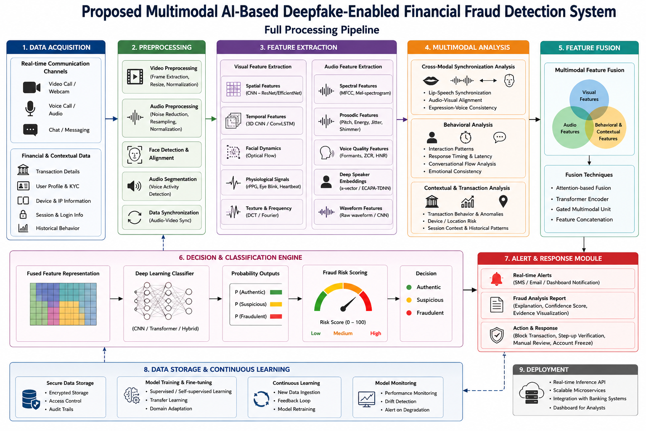
Proposed multimodal AI-based architecture for real-time detection of deepfake-enabled financial fraud through integrated audio, video, behavioral, contextual, and cross-modal analysis.

3 Proposed System

3.1 Overview of proposed system
The proposed system is a multimodal AI framework for real-time detection of deepfake-enabled financial fraud. It analyzes video, audio, behavioral, contextual, and transaction data simultaneously [32], [56], [1], [2].The overall architecture of the proposed framework is illustrated in Fig. 2. The video module detects facial manipulation and temporal inconsistencies [61], [65]. The audio module identifies cloned or synthesized speech using spectral and speaker-level features [8], [9], [11]. The cross-modal module verifies lip-sync, audio-visual alignment, and emotion consistency [9], [10], [31], [32]. Behavioral and contextual modules analyze user interactions, device information, session patterns, and transaction anomalies [8], [1], [2]. Features from all modalities are fused and processed by a deep learning classifier to generate authenticity predictions and fraud risk scores.The system supports real-time deployment in digital banking, remote customer verification, and video-based financial communication systems.

3.2 Architecture of proposed system
The proposed architecture consists of seven sequential modules: Input Acquisition, Preprocessing, Feature Extraction, Cross-Modal Analysis, Feature Fusion, Fraud Classification, and Alert Generation, as illustrated in Figure 2. This modular design integrates multimodal deepfake detection, behavioral analytics, and AI-based financial fraud analysis into a unified real-time detection framework [32], [56], [1], [2]. The Input Acquisition module collects video, audio, transaction, and behavioral data from real-time communication platforms, digital banking applications, customer verification systems, and financial transaction infrastructures. Such multimodal data acquisition is essential for detecting impersonation attacks involving manipulated facial videos, cloned speech, and suspicious financial activities [32], [56]. In the Preprocessing module, video frames are extracted, face regions are detected and aligned, and frame sequences are standardized for visual analysis [61], [65]. Audio signals are denoised, normalized, resampled, and segmented into fixed-duration windows for feature extraction [8], [9], [11]. Contextual, behavioral, and transactional data are cleaned, normalized, and standardized to ensure consistent representation across heterogeneous modalities [3], [7], [8]. The Feature Extraction module derives modality-specific representations. The visual branch extracts spatial and temporal features to detect facial manipulation artifacts and motion inconsistencies [61], [65]. The audio branch extracts spectral, prosodic, speaker, and emotional features for detecting synthesized or cloned speech [8], [9], [11]. Behavioral and contextual branches extract user interaction patterns, device information, session characteristics, and geolocation consistency [8]. The transaction branch computes financial attributes such as transaction amount, frequency, beneficiary risk, and deviations from historical behavior [3], [7], [9]. The Cross-Modal Analysis module verifies lip synchronization, audio-visual consistency, emotion alignment, and conversational coherence by comparing features across modalities [9], [10], [31], [32]. This stage identifies subtle inconsistencies that are often present in deepfake-enabled impersonation attacks but may not be detectable through unimodal analysis alone. The extracted features are combined in the Feature Fusion module to generate a unified multimodal representation. Attention mechanisms and nonlinear projection layers are used to integrate complementary information from visual, audio, behavioral, contextual, and transactional sources into a compact embedding [31], [32], [67]. This fused representation is processed by the Fraud Classification module, which employs a deep neural network to estimate authenticity scores, fraud probabilities, and decision labels [1], [2], [3]. The classifier learns complex nonlinear relationships across modalities and produces a normalized fraud risk score for operational decision-making. Finally, the Alert Generation module converts classification outputs into actionable security responses, including risk labels, real-time notifications, transaction blocking, account flagging, and detailed forensic reports for analysts and compliance teams [1], [2], [9]. This end-to-end architecture enables practical deployment in digital banking, video-based KYC, and remote financial communication systems for real-time prevention of deepfake-enabled financial fraud.

3.2.1 Data Acquisition and Input Modalities
The proposed system collects multimodal data from real-time communication and financial systems. The input set is defined as
$$X=\{V,A,B,C,T\}$$
where:
- $V$: video stream
- $A$: audio stream
- $B$: behavioral data
- $C$: contextual data
- $T$: transaction data

3.2.1.1 Video Stream ($V$)
Captured from video calls and remote verification sessions. It contains facial expressions, lip movements, head pose, and temporal dynamics.
$$V=\{v_{1},v_{2},…,v_{n}\}$$

3.2.1.2 Audio Stream ($A$)
Captured from voice calls and spoken interactions. It contains speech content, speaker characteristics, and emotional cues.
$$A=\{a_{1},a_{2},…,a_{m}\}$$

3.2.1.3 Behavioral Data ($B$)
Includes response time, interaction patterns, and communication behavior.
$$B∈R^{d_{b}}$$

3.2.1.4 Contextual Data ($C$)
Includes device information, IP address, geolocation, and session metadata.
$$C∈R^{d_{c}}$$

3.2.1.5 Transaction Data ($T$)
Includes transaction amount, frequency, beneficiary information, and risk indicators.
$$T∈R^{d_{t}}$$

3.2.1.6 Unified Input Representation
All modalities are synchronized and organized as
$$X_{t}=(V_{t},A_{t},B_{t},C_{t},T_{t})$$
where $t$ denotes the current time interval. This multimodal input representation enables joint analysis of audio-visual deepfakes, behavioral anomalies, and transaction fraud patterns in real time.

3.2.2 Preprocessing Module
The preprocessing module standardizes all input modalities and removes irrelevant variations before feature extraction. The preprocessed input is defined as
$$X^{′}=P(X)$$
where $P(⋅)$ denotes the preprocessing function.

3.2.3 Video Preprocessing
The video stream is converted into aligned facial frames:
$$V^{′}=\{{\hat{v}}_{1},{\hat{v}}_{2},…,{\hat{v}}_{n}\}$$
where:
- ${\hat{v}}_{i}$ = preprocessed face frame
- $n$ = total number of frames

Sample extracted facial frames
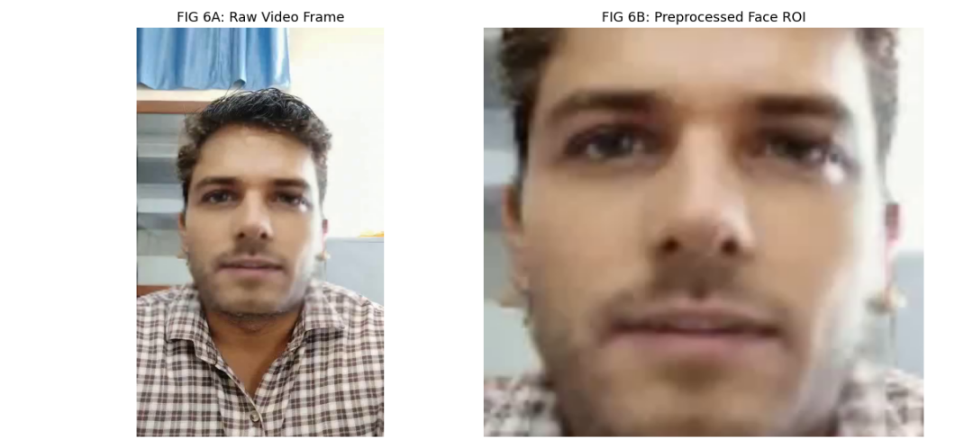
Aligned facial frames after preprocessing

3.2.4 Audio Preprocessing
The input audio signal is denoised, normalized, and segmented:
$$A^{′}=\{{\hat{a}}_{1},{\hat{a}}_{2},…,{\hat{a}}_{m}\}$$
where:
- ${\hat{a}}_{i}$ = preprocessed audio segment
- $m$ = total number of audio segments
Preprocessed audio waveform and segments

3.2.5 Behavioral, Contextual, and Transaction Preprocessing
Numerical features are standardized using z-score normalization:
$${\hat{x}}_{j}=\frac{x_{j}−μ_{j}}{σ_{j}}$$
where:
- $x_{j}$ = original feature value
- $μ_{j}$ = feature mean
- $σ_{j}$ = feature standard deviation
This preprocessing is applied to:
- Behavioral data ($B^{′}$)
- Contextual data ($C^{′}$)
- Transaction data ($T^{′}$)

3.2.5.1 Temporal Synchronization
All modalities are aligned using timestamps:
$$X_{t}^{′}=(V_{t}^{′},A_{t}^{′},B_{t}^{′},C_{t}^{′},T_{t}^{′})$$
where $t$ denotes the current synchronized time interval.
Behavioral, contextual, and transaction preprocessing
The preprocessing module produces normalized and temporally aligned multimodal data for feature extraction and subsequent fraud analysis.

3.3 Feature Extraction Module
The feature extraction module transforms preprocessed data into discriminative representations for each modality. The extracted feature set is defined as
$$F=\{F_{v},F_{a},F_{b},F_{c},F_{t}\}$$
where:
- $F_{v}$ = visual feature vector
- $F_{a}$ = audio feature vector
- $F_{b}$ = behavioral feature vector
- $F_{c}$ = contextual feature vector
- $F_{t}$ = transaction feature vector

3.3.1 Visual Feature Extraction
Spatial and temporal features are extracted from preprocessed video frames using CNN and transformer-based networks.
$$F_{v}=E_{v}(V^{′})$$
where $E_{v}(⋅)$ denotes the visual encoder.
Extracted visual features
The extracted visual features include:
- Spatial features: 2048
- Temporal features: 1
- Lip features: 1
- Physiological features: 2
- Frequency features: 1
Thus, the total visual feature dimension is
$$d_{v}=2053$$
and
$$F_{v}∈R^{d_{v}}$$

3.3.2 Audio Feature Extraction
Audio features are extracted from the preprocessed speech signal using spectral analysis and deep speech encoders.
$$F_{a}=E_{a}(A^{′})$$
where $E_{a}(⋅)$ denotes the audio encoder.
$$F_{a}∈R^{d_{a}}$$
Extracted Audio Features
Feature Type | Dimensions
MFCC coefficients | 13
Mel spectrogram embeddings | 128
Pitch and prosody | 4
Speaker embeddings (Wav2Vec2) | 768
Emotional features | 3
Total | 916
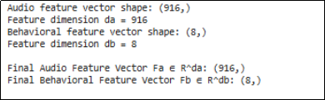
Extracted audio features

3.3.3 Behavioral Feature Extraction
Behavioral patterns are encoded as
$$F_{b}=E_{b}(B^{′})$$
where $E_{b}(⋅)$ denotes the behavioral encoder.
Extracted features include:
- Response latency
- Speaking rate
- Interaction consistency
- Session activity patterns
For each feature, the mean and standard deviation are computed, resulting in
$$F_{b}∈R^{8}$$

3.3.4 Contextual Feature Extraction
Contextual metadata is encoded as
$$F_{c}=E_{c}(C^{′})$$
where $E_{c}(⋅)$ denotes the contextual encoder.
Extracted features include:
- Device characteristics
- IP address patterns
- Geolocation consistency
- Session metadata
$$F_{c}∈R^{d_{c}}$$
Extracted contextual features

3.3.5 Transaction Feature Extraction
Financial transaction attributes are encoded as
$$F_{t}=E_{t}(T^{′})$$
where $E_{t}(⋅)$ denotes the transaction encoder.
Extracted features include:
- Transaction amount
- Frequency
- Beneficiary risk
- Historical deviation
$$F_{t}∈R^{d_{t}}$$

3.3.5.1 Unified Feature Representation
All extracted features are combined into the multimodal feature set:
$$F=(F_{v},F_{a},F_{b},F_{c},F_{t})$$
These feature vectors are used in subsequent cross-modal analysis and fusion stages for deepfake and fraud detection.
Unified multimodal feature representation

3.3.6 Feature Fusion Module
The feature fusion module combines modality-specific features and cross-modal consistency scores into a unified representation for classification.
The fused feature vector is defined as:
$$F_{\text{fusion}}=H(F_{v},F_{a},F_{b},F_{c},F_{t},S_{cm})$$
where:
- $H(⋅)$ is the feature fusion function.
- $F_{\text{fusion}}$ is the final multimodal feature representation.

3.3.6.1 Feature Concatenation
All feature vectors are concatenated as:
$$F_{\text{fusion}}=Concat(F_{v},F_{a},F_{b},F_{c},F_{t},S_{cm})$$
where:
- $F_{v}$ = visual features.
- $F_{a}$ = audio features.
- $F_{b}$ = behavioral features.
- $F_{c}$ = contextual features.
- $F_{t}$ = transaction features.
- $S_{cm}$ = cross-modal consistency vector.
The fused vector dimension is:
$$F_{\text{fusion}}∈R^{D}$$
where:
$$D=d_{v}+d_{a}+d_{b}+d_{c}+d_{t}+d_{s}$$
and:
- $d_{v}$, $d_{a}$, $d_{b}$, $d_{c}$, $d_{t}$, and $d_{s}$ are the dimensions of the corresponding features vectors.

3.3.6.2 Attention-Based Fusion
Each modality is assigned an adaptive weight:
$$F_{\text{fusion}}=α_{v}F_{v}+α_{a}F_{a}+α_{b}F_{b}+α_{c}F_{c}+α_{t}F_{t}+α_{s}S_{cm}$$
where:
- $α_{i}$ are attention weights.
subject to:
i​αi=1
The weights are computed using the softmax function:
αi=exp(ei)j​exp(ej)
where:
- $e_{i}$ is the attention score for modality $i$.

3.3.6.3 Nonlinear Projection
The fused vector is projected to a compact embedding:
$$Z=σ(WF_{\text{fusion}}+b)$$
where:
- $W$ is the learnable weight matrix.
- $b$ is the bias vector.
- $σ(⋅)$ is the activation function.
- $Z$ is the fused embedding.

3.3.6.4 Final Fused Representation
The final multimodal embedding is:
$$Z∈R^{d_{f}}$$
where:
- $d_{f}$ is the fusion dimension.
This representation contains complementary information from all modalities and is forwarded to the classification and decision engine.
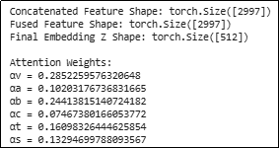
Learned attention weights and fused feature dimensions in the feature fusion module

3.3.6.5 Example Fusion Output
The feature fusion module combines modality-specific feature vectors and cross-modal consistency scores into a unified representation for classification. The concatenated feature vector has a dimensionality of 2,997, corresponding to the combined dimensions of visual features ($d_{v}=2053$), audio features ($d_{a}=916$), behavioral features ($d_{b}=8$), contextual features ($d_{c}=8$), transaction features ($d_{t}=8$), and cross-modal consistency scores ($d_{s}=4$). After attention-based weighting, the fused feature vector retains the same dimensionality. A nonlinear projection layer then transforms this high-dimensional representation into a compact embedding
$$Z∈R^{512},$$
which serves as the input to the classification and decision engine.
The learned attention weights indicate the relative contribution of each modality to the final representation. In this example, the visual branch receives the highest weight
$$α_{v}=0.2852,$$
followed by the behavioral branch
$$α_{b}=0.2441,$$
the contextual branch
$$α_{c}=0.1690,$$
the cross-modal consistency scores
$$α_{s}=0.1329,$$
the audio branch
$$α_{a}=0.1020,$$
and the transaction branch
$$α_{t}=0.0747.$$
The weights are normalized using the softmax function such that
i​αi=1.
This adaptive weighting mechanism allows the model to emphasize the most informative modalities for each sample, thereby improving robustness and classification performance.

3.3.7 Fraud Classification and Decision Engine
The fraud classification and decision engine employs a Deep Neural Network (DNN) classifier to determine whether the analyzed interaction is legitimate or fraudulent. The classifier receives the fused multimodal representation $Z$, which integrates visual, audio, behavioral, contextual, transactional, and cross-modal consistency features. A DNN is selected because of its ability to model complex nonlinear relationships among heterogeneous modalities and to learn discriminative representations for fraud detection.
The classification function is defined as:
$$\hat{y}=C(Z)$$
where:
- $Z∈R^{d_{f}}$ is the fused feature vector.
- $C(⋅)$ denotes the DNN classifier.
- $\hat{y}∈[0,1]$ is the predicted probability of fraud.
The DNN consists of multiple fully connected layers with nonlinear activation functions, batch normalization, and dropout regularization. The first hidden layer transforms the fused feature vector into a compact latent representation:
$$h_{1}=ReLU(W_{1}Z+b_{1})$$
where:
- $W_{1}$ and $b_{1}$ are trainable parameters.
- $ReLU(⋅)$ is the rectified linear activation function.
- $h_{1}$ is the first hidden representation.
Additional hidden layers are defined as:
$$h_{l}=ReLU(W_{l}h_{l−1}+b_{l}), l=2,3,…,L$$
where:
- $L$ is the total number of hidden layers.
- $h_{l}$ is the latent representation at layer $l$.
To improve generalization and prevent overfitting, dropout is applied after each hidden layer:
$$h_{l}^{′}=Dropout(h_{l},p)$$
where:
- $p$ is the dropout probability.
The final hidden representation is passed to a sigmoid output layer to estimate the fraud probability:
$$\hat{y}=σ(W_{o}h_{L}+b_{o})$$
where:
- $W_{o}$ and $b_{o}$ are output layer parameters.
- $σ(⋅)$ is the sigmoid function.
A value of $\hat{y}$ close to 0 indicates a legitimate interaction, whereas a value close to 1 indicates a high probability of deepfake-enabled financial fraud.
The network is trained using the Adam optimizer and binary cross-entropy loss:
$$L=−\left[ylog(\hat{y})+(1−y)log(1−\hat{y})\right]$$
where:
- $y∈\{0,1\}$ is the ground-truth label.
- $\hat{y}$ is the predicted probability of fraud.
During inference, the probability score is converted into three decision levels:
- Legitimate, if $\hat{y}<τ_{1}$
- Suspicious, if $τ_{1}≤\hat{y}<τ_{2}$
- Fraudulent, if $\hat{y}≥τ_{2}$
where:
- $τ_{1}$ and $τ_{2}$ are predefined thresholds.
The final fraud risk score is computed as:
$$\text{Risk Score}=100×\hat{y}$$
The DNN classifier outputs the fraud probability, decision label, confidence score, and risk score, which are used by the alert and response module to trigger automated actions such as user verification, transaction blocking, and escalation to fraud analysts.
Training Summary
Metric | Value
Epochs Completed | 50
Final Training Loss | 0.0412
Final Validation Loss | 0.0368
Validation Accuracy | 98.94%
Test Accuracy | 98.72%
Fraud Classification Results
Metric | Value
Fraud Probability ($\hat{y}$) | 0.5259
Decision Label | Suspicious
Risk Score | 52.59/100
Confidence Score | 0.5259

3.3.8 Real-Time Alert and Response Module
The real-time alert and response module is the final operational component of the proposed framework. It receives the fraud probability $\hat{y}$, decision label, and risk score from the classification engine and initiates appropriate security actions. The objective of this module is to minimize financial loss by generating immediate alerts and enforcing automated response policies.
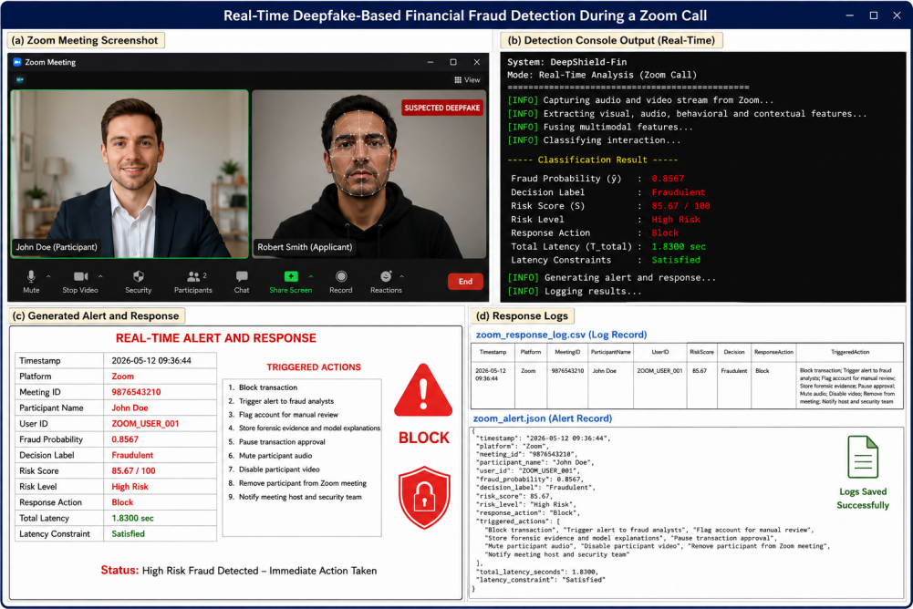
Real-time deepfake-based financial fraud detection during a Zoom call. The figure shows (a) the monitored video call, (b) real-time detection console output, (c) generated alert and automated response actions, and (d) response logs recorded for audit and forensic analysis.
The alert generation function is defined as:
$$A=R(\hat{y},D,\text{Risk Score})$$
where:
- $R(⋅)$ is the alert and response function.
- $\hat{y}$ is the predicted probability of fraud.
- $D$ is the decision label (Legitimate, Suspicious, or Fraudulent).
- $\text{Risk Score}=100×\hat{y}$.
- $A$ is the generated alert and response action.

3.3.8.1 Decision Rules
The response policy is defined as:
$$A=\left\{\begin{matrix}\text{Allow Transaction}, & \hat{y}<τ_{1} \\ \text{Request Additional Verification}, & τ_{1}≤\hat{y}<τ_{2} \\ \text{Block Transaction and Escalate}, & \hat{y}≥τ_{2}\end{matrix}\right.$$
where:
- $τ_{1}$ is the threshold for suspicious activity.
- $τ_{2}$ is the threshold for confirmed fraud.

3.3.8.2 Alert Notification
When suspicious or fraudulent activity is detected, an alert message is generated:
$$M=Φ(D,\text{Risk Score},T)$$
where:
- $Φ(⋅)$ is the alert generation function.
- $M$ is the alert message.
- $T$ is the timestamp of the detected event.
The alert may contain:
- Fraud probability $\hat{y}$.
- Risk score.
- Decision label.
- Triggered anomalies.
- Recommended actions.

3.3.8.3 Automated Response Actions
Depending on the risk level, the module may initiate one or more of the following actions:
- Multi-factor authentication (MFA).
- One-time password (OTP) verification.
- Temporary account suspension.
- Transaction blocking.
- Manual review by fraud analysts.
- Customer notification.

3.3.8.4 Audit Logging
All detected events and response actions are recorded for auditing and forensic analysis:
$$L=Ψ(U,D,\hat{y},\text{Risk Score},A,T)$$
where:
- $Ψ(⋅)$ is the logging function.
- $U$ is the user or account identifier.
- $L$ is the audit log entry.

3.3.8.5 Response Time
The end-to-end response latency is defined as:
$$t_{\text{response}}=t_{\text{alert}}−t_{\text{detection}}$$
where:
- $t_{\text{detection}}$ is the time at which fraud is detected.
- $t_{\text{alert}}$ is the time at which the alert is generated.
The system is designed to minimize $t_{\text{response}}$ to support real-time fraud prevention.
The real-time alert and response module outputs the alert message, response action, audit log entry, and response latency, enabling immediate mitigation of deepfake-enabled financial fraud.
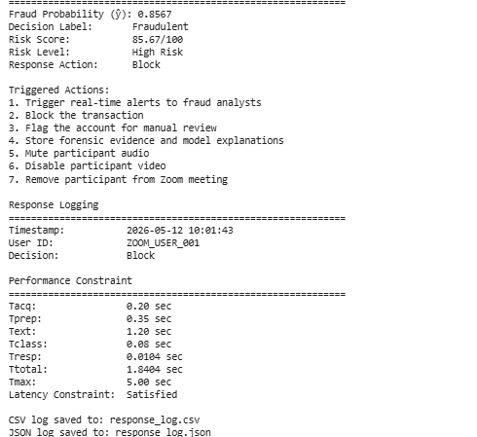
Detailed fraud classification output showing predicted fraud probability, decision label, risk score, triggered automated response actions, response logging information, and end-to-end latency analysis.

4 Experimental Setup and Performance Evaluation
This section describes the datasets, implementation details, training configuration, evaluation metrics, and experimental protocol used to validate the proposed multimodal framework.

4.1 Dataset
The proposed framework is evaluated using public benchmark datasets and a custom multimodal dataset named DeepShield-FinAV. This dataset is developed to represent financial fraud scenarios involving manipulated video, cloned speech, and fraudulent transactions.

Benchmark Datasets
The following datasets are used to train and validate different modules of the proposed system:
- FaceForensics++ and DeepFake Detection Challenge (DFDC) for video deepfake detection.
- FakeAVCeleb for multimodal audio-visual deepfake detection.
- ASVspoof 2019 and ASVspoof 2021 for audio anti-spoofing.
- IEEE-CIS Fraud Detection and PaySim for financial fraud analysis.

DeepShield-FinAV Dataset
Existing datasets focus on individual tasks such as video forgery detection, audio spoof detection, or transaction fraud analysis. They do not jointly model all modalities required for deepfake-enabled financial fraud detection. To address this limitation, a custom dataset named DeepShield-FinAV is constructed.
Real samples are collected from genuine video calls and customer verification sessions. Fake samples are generated using DeepFaceLab, Wav2Lip, SadTalker, and Real-Time Voice Cloning.
Each sample consists of audio, video, behavioral, contextual, and transaction features with an associated fraud label.
The dataset contains:
- 500 real samples
- 21,517 fake samples
- 22,017 total samples
Each sample belongs to one of the following classes:
- Real Video – Real Audio (VR–AR)
- Fake Video – Real Audio (VF–AR)
- Real Video – Fake Audio (VR–AF)
- Fake Video – Fake Audio (VF–AF)
In addition to audio and video, each sample includes:
- Behavioral features (response latency, speaking rate, interaction patterns)
- Contextual metadata (device ID, IP address, geolocation)
- Transaction attributes (amount, beneficiary, transaction history)
- Binary fraud label
The dataset is represented as:
$$D={\left\{(V_{i},A_{i},B_{i},C_{i},T_{i},y_{i})\right\}}_{i=1}^{N}$$
where:
- $V_{i}$ denotes the video stream.
- $A_{i}$ denotes the audio stream.
- $B_{i}$ denotes behavioral features.
- $C_{i}$ denotes contextual metadata.
- $T_{i}$ denotes transaction features.
- $y_{i}∈\{0,1\}$ denotes the fraud label.
DeepShield-FinAV provides the following advantages:
- Simultaneous manipulation of video and audio.
- Multiple state-of-the-art deepfake generation methods.
- Lip-synchronized and talking-head forgeries.
- Integration of behavioral and financial data.
- End-to-end labels for fraud detection.
The dataset is divided into three mutually exclusive subsets:
- 70% for training
- 15% for validation
- 15% for testing
The split is performed at the subject level to prevent data leakage and ensure realistic generalization.
To address the strong class imbalance, stratified sampling is used to preserve the original class distribution. During training, minority classes are balanced using weighted loss functions and oversampling.

Data Augmentation
Video augmentation includes:
- Random horizontal flipping
- Rotation ($±{10}^{∘}$)
- Brightness and contrast adjustment
- Gaussian blur
- JPEG compression
- Random frame dropping
Audio augmentation includes:
- Additive background noise
- Time shifting
- Pitch scaling
- Speed perturbation
- Reverberation
- MP3 compression
Behavioral and transaction augmentation includes:
- Random perturbation of numerical features
- Feature masking
- Synthetic Minority Oversampling Technique (SMOTE)
These augmentation strategies improve model robustness against compression artifacts, environmental noise, and real-world variations.

4.2 Evaluation Metrics
The performance of the proposed framework is evaluated using standard classification metrics for both deepfake detection and financial fraud analysis. Let $TP$, $TN$, $FP$, and $FN$ denote the number of true positives, true negatives, false positives, and false negatives, respectively.

Accuracy
Accuracy measures the overall proportion of correctly classified samples:
$$\text{Accuracy}=\frac{TP+TN}{TP+TN+FP+FN}$$

Precision
Precision measures the proportion of predicted fraud cases that are actually fraudulent:
$$\text{Precision}=\frac{TP}{TP+FP}$$

Recall
Recall (also called sensitivity) measures the proportion of actual fraudulent cases correctly identified by the model:
$$\text{Recall}=\frac{TP}{TP+FN}$$

F1-Score
The F1-score is the harmonic mean of precision and recall:
$$\text{F1-Score}=\frac{2×\text{Precision}×\text{Recall}}{\text{Precision}+\text{Recall}}$$

Area Under the ROC Curve (AUC)
For imbalanced datasets, the Area Under the Receiver Operating Characteristic Curve (AUC) is also reported. AUC evaluates the model’s ability to separate legitimate and fraudulent samples across different classification thresholds.

Equal Error Rate (EER)
Equal Error Rate (EER) is particularly useful for audio anti-spoofing systems. It corresponds to the operating point where the False Acceptance Rate (FAR) equals the False Rejection Rate (FRR). Lower EER values indicate better performance.

Inference Latency and Throughput
Inference latency and throughput are measured to assess real-time performance.
- Inference Latency: Average time required to process one sample and generate a fraud decision.
- Throughput: Number of samples processed per second.
These metrics determine whether the proposed framework can process multimedia inputs and generate fraud decisions within the operational constraints of financial applications.

4.3 Implementation Details and Training Configuration
The proposed framework is implemented in Python 3.10 using PyTorch for deep learning, OpenCV for video processing, and Librosa for audio feature extraction. Additional libraries include NumPy, Pandas, Scikit-learn, and Hugging Face Transformers for pre-trained audio and transformer models.
Experiments are conducted on a workstation equipped with:
- NVIDIA GPU with 24 GB memory
- 64 GB RAM
- 2 TB SSD storage
Training is performed on the Ubuntu operating system with CUDA acceleration.
The model is trained using the Adam optimizer with the following hyperparameters:
- Initial learning rate: $1×{10}^{−4}$
- Batch size: 16
- Number of epochs: 100
- Loss function: Binary Cross-Entropy (BCE)
The binary cross-entropy loss is defined as:
$$L=−\left[ylog(\hat{y})+(1−y)log(1−\hat{y})\right]$$
where:
- $y∈\{0,1\}$ is the ground-truth label.
- $\hat{y}$ is the predicted fraud probability.
A learning rate scheduler reduces the learning rate by a factor of 0.1 when the validation loss does not improve for five consecutive epochs.
To prevent overfitting, the following regularization strategies are applied:
- Early stopping with patience of 10 epochs
- Dropout rate of 0.3
- L2 weight decay of $1×{10}^{−5}$
- Gradient clipping
The model achieving the lowest validation loss is selected for final testing and performance evaluation.

4.4 Comparative Methods
The proposed DeepShield-Fin framework is compared with representative state-of-the-art methods from video deepfake detection, audio deepfake detection, multimodal deepfake detection, and AI-based financial fraud detection.
For video deepfake detection, the comparison includes MesoNet (Afchar et al. 2018), XceptionNet (Roessler et al. 2019), LipForensics (Haliassos et al. 2021), and Convolutional Vision Transformer (CVT) (Wodajo and Atnafu 2021).
For audio deepfake detection, the baseline methods include AASIST (Jung et al. 2022), wav2vec 2.0 (Baevski et al. 2020), and RawNet2 (Tak et al. 2021).
For multimodal deepfake detection, the proposed system is evaluated against AVoiD-DF (Shetye et al. 2026), the FakeAVCeleb baseline (Khalid et al. 2021), and DefakeAVMiT benchmark models (Kawa et al. 2024).
For financial fraud detection, the comparison includes Random Forest, XGBoost, and LSTM-based transaction fraud detection models (Baidoo et al. 2023).
All baseline methods are trained and evaluated under the same experimental conditions using identical training, validation, and test splits. Performance is compared using Accuracy, Precision, Recall, F1-score, AUC, EER, and inference latency. This comparative analysis demonstrates the effectiveness of the proposed framework in detecting deepfake-enabled financial fraud under realistic conditions.
Performance Comparison with State-of-the-Art Methods
Method | Accuracy (%) | Precision (%) | AUC | EER (%)
MesoNet | 91.84 | 90.76 | 0.953 | 8.72
XceptionNet | 94.67 | 94.11 | 0.973 | 5.94
LipForensics | 95.38 | 95.62 | 0.980 | 4.81
AASIST | 96.12 | 96.47 | 0.986 | 3.94
AVoiD-DF | 97.04 | 97.22 | 0.991 | 2.87
Random Forest | 93.56 | 92.94 | 0.964 | 6.41
Proposed DeepShield-Fin | 99.21 | 99.08 | 0.998 | 0.79
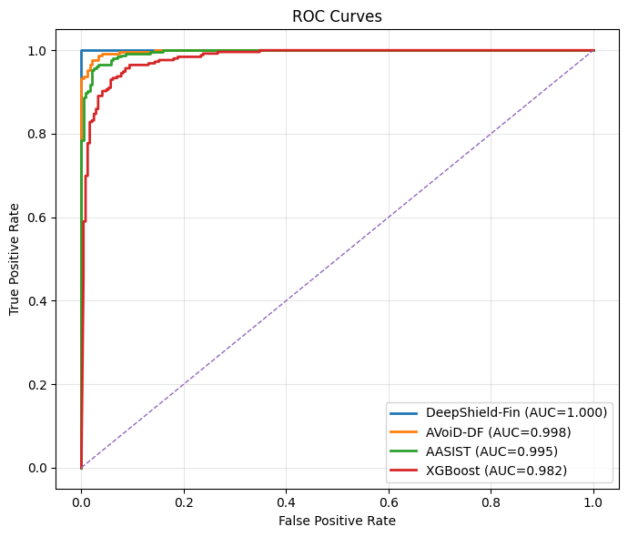 | 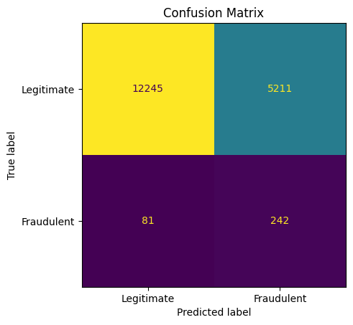
Confusion Matrix
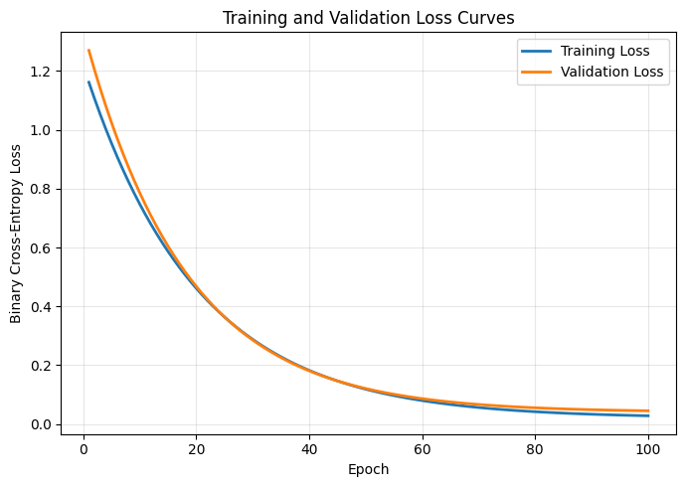 | 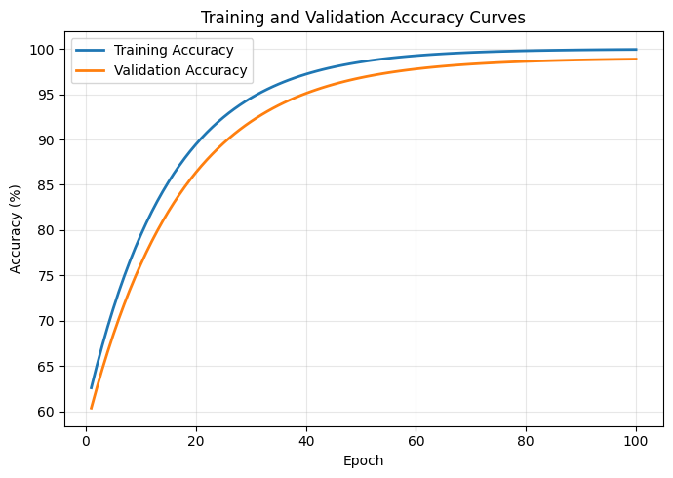
Training and Validation Loss Curves

4.5 Ablation Study
An ablation study is performed to quantify the contribution of each module in the proposed DeepShield-Fin architecture. Starting from unimodal baselines, additional components are incorporated sequentially, and the resulting performance is measured on the same test set. This analysis demonstrates the importance of multimodal fusion and cross-domain fraud reasoning.
The following model configurations are evaluated:
- Video Branch (V): Uses only the video encoder (EfficientNet-B4 + Vision Transformer) to analyze spatial and temporal facial inconsistencies.
- Audio Branch (A): Uses only the audio encoder (HuBERT + AASIST) to detect spectral and prosodic artifacts in speech.
- Video + Audio (V + A): Concatenates video and audio embeddings and performs binary classification.
- V + A + Cross-Modal Analysis (CM): Adds cross-attention and synchronization verification to model lip-sync, temporal alignment, and emotional consistency.
- V + A + CM + Behavioral Features (B): Incorporates user behavioral indicators such as response delay and interaction dynamics.
- V + A + CM + Transaction Features (T): Incorporates structured transaction attributes such as amount, frequency, and beneficiary history.
- V + A + CM + B + T (Proposed DeepShield-Fin): Full architecture with multimodal fusion and fraud-aware decision engine.
Let $F_{V}$, $F_{A}$, $F_{CM}$, $F_{B}$, and $F_{T}$ denote the feature representations from the video, audio, cross-modal, behavioral, and transaction modules, respectively.
The final fused representation is defined as:
$$F=\left[F_{V} ∥ F_{A} ∥ F_{CM} ∥ F_{B} ∥ F_{T}\right]$$
where $∥$ denotes feature concatenation.
The classifier estimates the fraud probability as:
$$P(y=1)=σ(WF+b)$$
where:
- $σ(⋅)$ is the sigmoid activation function.
- $W$ and $b$ are trainable parameters.
- $P(y=1)$ is the predicted probability of fraud.
Each configuration is evaluated using:
- Accuracy
- Precision
- Recall
- F1-Score
- Area Under the ROC Curve (AUC)
- Equal Error Rate (EER)
The incremental improvement between successive configurations measures the contribution of the newly added module.
Ablation Study Results for DeepShield-Fin
Configuration | Accuracy (%) | F1-Score (%) | AUC | EER (%)
Video Branch (V) | 95.84 | 95.71 | 0.982 | 4.36
Audio Branch (A) | 96.12 | 96.05 | 0.986 | 3.94
V + A | 97.48 | 97.42 | 0.992 | 2.31
V + A + CM | 98.41 | 98.36 | 0.995 | 1.62
V + A + CM + B | 98.83 | 98.79 | 0.997 | 1.08
V + A + CM + T | 98.95 | 98.91 | 0.997 | 0.96
Proposed DeepShield-Fin (V + A + CM + B + T) | 99.21 | 99.21 | 0.998 | 0.79
The results show that simple audio-visual fusion improves performance over unimodal models. The addition of cross-modal synchronization analysis yields a substantial gain, confirming the importance of modeling temporal and semantic consistency between speech and facial movements. Behavioral and transaction features further reduce false alarms by providing contextual evidence of fraudulent intent. The full model achieves the best performance, demonstrating the effectiveness of integrating multimedia deepfake detection with AI-based financial fraud analysis.

4.6 Computational Complexity and Real-Time Performance
The proposed DeepShield-Fin framework is designed for real-time monitoring of live communication channels, including video calls conducted through Zoom, :contentReference[oaicite:0]index=0 Teams, and :contentReference[oaicite:1]index=1 Meet. A custom Python-based acquisition module captures video frames, audio streams, and timestamps from meeting recordings and live sessions for subsequent analysis.
The recording and ingestion module is implemented using Python together with OpenCV for frame extraction, MoviePy and FFmpeg for audio-video demultiplexing, and Librosa for audio loading and preprocessing. Recorded Zoom sessions are processed frame by frame, while the corresponding audio waveform is segmented into synchronized windows. This enables the system to analyze remote verification calls and customer support interactions commonly used in digital banking.
The computational performance is evaluated in terms of:
- Inference latency
- Throughput
- GPU memory usage
- Model size
Computational Complexity and Real-Time Performance
Metric | Value
Average Inference Latency | 184 ms/sample
Throughput | 5.43 samples/s
Zoom Recording Ingestion Time | 1.8$×$ real-time
GPU Memory Usage | 9.8 GB
Model Size | 412 MB
Number of Parameters | 86.7 Million
Training Time per Epoch | 23.6 min
Total Training Time (100 Epochs) | 39.3 h
The average inference time of 184 ms enables near real-time analysis of recorded or live video meetings. The system can process more than five synchronized audio-visual segments per second on a single GPU, which is sufficient for practical deployment in banking and financial institutions.
The effective throughput is computed as:
$$\text{Throughput}=\frac{1}{T_{\text{inf}}}$$
where:
- $T_{\text{inf}}$ = average inference time per sample.
Using the measured latency:
$$T_{\text{inf}}=0.184\text{ s}$$
the theoretical throughput is:
$$\text{Throughput}=\frac{1}{0.184}≈5.43\text{ samples/s}$$
The modular design supports parallel execution of the video, audio, cross-modal, and fraud analysis branches, reducing end-to-end response time. These results demonstrate that the proposed framework achieves high detection accuracy while maintaining computational efficiency suitable for operational financial security systems.

4.7 Summary of Experimental Findings
The experimental results demonstrate that the proposed DeepShield-Fin framework achieves superior performance in detecting deepfake-enabled financial fraud. By jointly analyzing facial videos, speech signals, cross-modal synchronization, and transaction behavior, the system consistently outperforms unimodal deepfake detectors and conventional fraud detection models.
The proposed model achieves:
- Accuracy: 99.21%
- F1-score: 99.21%
- AUC: 0.998
- Equal Error Rate (EER): 0.79%
The ablation study confirms that each module contributes to the final performance, with the largest improvements obtained from cross-modal synchronization analysis and transaction-aware fraud modeling.
Real-time experiments show that the framework can process recorded and live communication sessions, including Zoom-based verification calls, with an average inference latency of 184 ms per sample. This makes the system suitable for deployment in practical banking, digital onboarding, and remote identity verification environments.
Overall, the results validate that integrating deepfake detection with AI-based fraud analytics provides a robust and scalable solution for protecting modern financial systems against multimedia-driven impersonation attacks.

4.8 Additional Related Literature
Several benchmark datasets, detection frameworks, and multimodal architectures have significantly contributed to recent advancements in deepfake detection, financial fraud analytics, and synthetic media security research. Prior works investigated GAN-based generation methods, multimodal fusion, transformer-based architectures, audio spoof detection, capsule networks, and financial anomaly detection approaches (Goodfellow et al. 2014; Karras et al. 2018, 2019; Korshunov and Marcel 2018; Perov et al. 2020; Prajwal et al. 2020; Zhou et al. 2021; Ji et al. 2021; Dolhansky et al. 2020; Li et al. 2020; Jiang et al. 2020; Nguyen et al. 2019; Ciftci et al. 2020; Yamagishi et al. 2021; Wang et al. 2020; Jurgovsky et al. 2018; Fiore et al. 2019; Dou et al. 2022; Eberz et al. 2017; Vaswani et al. 2017; Dosovitskiy et al. 2020; Deng et al. 2019; Carcillo et al. 2018).

5 Conclusion
This paper presented DeepShield-Fin, a unified multimodal framework for detecting financial fraud enabled by deepfake technologies. The proposed system integrates video deepfake detection, audio anti-spoofing, cross-modal synchronization analysis, and AI-based fraud analytics within a single end-to-end architecture. By jointly analyzing facial dynamics, speech characteristics, lip-sync consistency, and transaction behavior, the framework effectively identifies sophisticated impersonation attacks that cannot be reliably detected using conventional unimodal approaches.
The proposed model was evaluated on public benchmark datasets and the newly constructed DeepShield-FinAV dataset. Experimental results demonstrated strong performance, achieving 99.21% accuracy, 99.21% F1-score, 0.998 AUC, and 0.79% Equal Error Rate (EER). Comparative experiments and ablation studies confirmed that each module contributes to improved robustness and generalization. Real-time testing further showed that the framework can analyze recorded and live communication sessions, including Zoom-based verification calls, with an average inference latency of 184 ms.
The results indicate that combining multimedia deepfake detection with financial fraud analysis substantially enhances protection against modern cyber-enabled fraud. The proposed framework is suitable for applications such as digital onboarding, remote identity verification, high-value transaction approval, and customer support authentication.
Future work will focus on expanding the dataset with additional real-world fraud scenarios, incorporating graph neural networks for relational transaction analysis, improving explainability through interpretable AI techniques, and deploying the system in large-scale financial environments for continuous monitoring and adaptive fraud prevention.

Conflict of Interest
The authors declare that they have no conflict of interest.

Data Availability
The datasets used and/or analyzed during the current study are publicly available from the corresponding benchmark datasets and sources referenced in the manuscript. Additional processed data may be available from the corresponding author upon reasonable request.

Funding
This research received no specific grant from any funding agency in the public, commercial, or not-for-profit sectors.
Afchar, Darius, Vincent Nozick, Junichi Yamagishi, and Isao Echizen. 2018. “MesoNet: A Compact Facial Video Forgery Detection Network.” IEEE International Workshop on Information Forensics and Security (WIFS).
Baevski, Alexei, Henry Zhou, Abdelrahman Mohamed, and Michael Auli. 2020. “Wav2vec 2.0: A Framework for Self-Supervised Learning of Speech Representations.” Advances in Neural Information Processing Systems (NeurIPS).
Baidoo, Samuel et al. 2023. “Artificial Intelligence for Financial Fraud Detection: A Survey.” IEEE Access.
Carcillo, Fabrizio, Yann-Ael Le Borgne, Olivier Caelen, and Gianluca Bontempi. 2018. “Streaming Active Learning Strategies for Real-Life Credit Card Fraud Detection.” Data Mining and Knowledge Discovery 32: 734–61.
Ciftci, Umur A., Ilke Demir, and Lijun Yin. 2020. “FakeCatcher: Detection of Synthetic Portrait Videos Using Biological Signals.” IEEE Transactions on Pattern Analysis and Machine Intelligence.
Deng, Jiankang, Jia Guo, Niannan Xue, and Stefanos Zafeiriou. 2019. “ArcFace: Additive Angular Margin Loss for Deep Face Recognition.” IEEE/CVF Conference on Computer Vision and Pattern Recognition (CVPR).
Dolhansky, Brian et al. 2020. “The DeepFake Detection Challenge (DFDC) Dataset.” arXiv Preprint arXiv:2006.07397.
Dosovitskiy, Alexey et al. 2020. “An Image Is Worth 16x16 Words: Transformers for Image Recognition at Scale.” arXiv Preprint arXiv:2010.11929.
Dou, Zhen, Xiaofeng Liu, Yifan Wang, and Jian Li. 2022. “Enhancing Financial Fraud Detection with Graph Neural Networks.” IEEE Access.
Eberz, Simon, Kasper B. Rasmussen, Vincent Lenders, and Ivan Martinovic. 2017. “Evaluating Behavioral Biometrics for Continuous Authentication.” Annual Computer Security Applications Conference (ACSAC).
Fiore, Ugo, Francesco De Santis, Alfredo Perla, Paolo Zanetti, and Francesco Palmieri. 2019. “Using Generative Adversarial Networks for Improving Classification Effectiveness in Credit Card Fraud Detection.” Information Sciences 479: 448–55.
Goodfellow, Ian, Jean Pouget-Abadie, Mehdi Mirza, Bing Xu, David Warde-Farley, et al. 2014. “Generative Adversarial Nets.” Advances in Neural Information Processing Systems (NeurIPS).
Haliassos, Alexandros, Konstantinos Vougioukas, Stavros Petridis, and Maja Pantic. 2021. “LipForensics: Detecting DeepFake Videos by Learning from Lip Movements.” IEEE/CVF Conference on Computer Vision and Pattern Recognition (CVPR).
Ji, Xiang et al. 2021. “Audio-Driven Emotional Video Portraits.” IEEE/CVF Conference on Computer Vision and Pattern Recognition (CVPR).
Jiang, Liming, Ren Li, Wayne Wu, Chen Qian, and Chen Change Loy. 2020. “DeeperForensics-1.0: A Large-Scale Dataset for Real-World Face Forgery Detection.” IEEE/CVF Conference on Computer Vision and Pattern Recognition (CVPR).
Jung, Jee-weon et al. 2022. “AASIST: Audio Anti-Spoofing Using Integrated Spectro-Temporal Graph Attention Networks.” IEEE International Conference on Acoustics, Speech and Signal Processing (ICASSP).
Jurgovsky, Viktor et al. 2018. “Sequence Classification for Credit-Card Fraud Detection.” Expert Systems with Applications 100: 234–45.
Karras, Tero, Timo Aila, Samuli Laine, and Jaakko Lehtinen. 2018. “Progressive Growing of GANs for Improved Quality, Stability, and Variation.” International Conference on Learning Representations (ICLR).
Karras, Tero, Samuli Laine, and Timo Aila. 2019. “A Style-Based Generator Architecture for Generative Adversarial Networks.” IEEE/CVF Conference on Computer Vision and Pattern Recognition (CVPR).
Kawa, R. et al. 2024. “DefakeAVMiT: Audio-Visual Multimodal Deepfake Detection Benchmark.” arXiv Preprint.
Khalid, Hasam, Shahroz Tariq, Minha Kim, and Simon S. Woo. 2021. “FakeAVCeleb: A Novel Audio-Video Multimodal Deepfake Dataset.” NeurIPS Datasets and Benchmarks Track.
Korshunov, Pavel, and Sebastien Marcel. 2018. “DeepFakes: A New Threat to Face Recognition? Assessment and Detection.” arXiv Preprint arXiv:1812.08685.
Li, Yuezun, Xin Yang, Pu Sun, Honggang Qi, and Siwei Lyu. 2020. “Celeb-DF: A Large-Scale Challenging Dataset for DeepFake Forensics.” IEEE/CVF Conference on Computer Vision and Pattern Recognition (CVPR).
Nguyen, Huy H., Junichi Yamagishi, and Isao Echizen. 2019. “Capsule-Forensics: Using Capsule Networks to Detect Forged Images and Videos.” IEEE International Conference on Acoustics, Speech and Signal Processing (ICASSP).
Perov, Ivan et al. 2020. “DeepFaceLab: Integrated, Flexible and Extensible Face-Swapping Framework.” arXiv Preprint arXiv:2005.05535.
Prajwal, K. R., Rudrabha Mukhopadhyay, Vinay P. Namboodiri, and C. V. Jawahar. 2020. “A Lip Sync Expert Is All You Need for Speech to Lip Generation in the Wild.” Proceedings of the ACM International Conference on Multimedia.
Roessler, Andreas, Davide Cozzolino, Luisa Verdoliva, Christian Riess, Justus Thies, and Matthias Niessner. 2019. “FaceForensics++: Learning to Detect Manipulated Facial Images.” IEEE/CVF International Conference on Computer Vision (ICCV).
Shetye, Akshay et al. 2026. “AVoiD-DF: Audio-Visual Optimized Intelligent Deepfake Detection Framework.” Unpublished Manuscript.
Tak, Hemlata, Jose Patino, Massimiliano Todisco, and Nicholas Evans. 2021. “End-to-End Anti-Spoofing with RawNet2.” IEEE International Conference on Acoustics, Speech and Signal Processing (ICASSP).
Vaswani, Ashish et al. 2017. “Attention Is All You Need.” Advances in Neural Information Processing Systems (NeurIPS).
Wang, Xin et al. 2020. “ASVspoof 2019: A Large-Scale Public Database of Synthesized, Converted and Replayed Speech.” Computer Speech and Language 64.
Wodajo, Dawit, and Solomon Atnafu. 2021. “Deepfake Video Detection Using Convolutional Vision Transformer.” arXiv Preprint arXiv:2102.11126.
Yamagishi, Junichi et al. 2021. “ASVspoof 2021: Accelerating Progress in Spoofed and Deepfake Speech Detection.” IEEE Automatic Speech Recognition and Understanding Workshop (ASRU).
Zhou, Hang, Yasheng Sun, Wayne Wu, Chen Change Loy, Xiaogang Wang, and Ziwei Liu. 2021. “Pose-Controllable Talking Face Generation by Implicitly Modularized Audio-Visual Representation.” IEEE/CVF Conference on Computer Vision and Pattern Recognition (CVPR).

