Modeling the Economic Impact of Muguka Addiction: A Deterministic Approach that Integrates Health Cost Analysis

ABSTRACT
Muguka, a variant of miraa (khat), significantly influences the socio-economic dynamics of regions where it is widely cultivated and consumed. Despite its economic importance, addiction to Muguka has led to substantial health and economic challenges, yet limited research has quantified these impacts comprehensively. To address this gap, this study develops a deterministic compartmental model that integrates health costs to analyze the dynamics of Muguka addiction. The aim is to quantify and evaluate the economic and health consequences of Muguka addiction, providing insights for effective public health interventions. The methodology involves formulating a system of ordinary differential equations (ODEs) to capture the dynamics of addiction and health costs across defined compartments. Key aspects of the analysis include deriving the reproduction number, examining equilibrium points and their stability, and performing sensitivity analysis to explore how changes in critical parameters influence addiction prevalence and associated costs. Numerical simulations are employed to assess health cost dynamics and to design optimal, cost-effective control strategies. The findings reveal that Muguka addiction imposes significant economic burdens, including substantial income loss and escalating healthcare costs. The model provides policymakers and public health officials with a valuable tool for designing targeted interventions to mitigate the adverse effects of Muguka addiction.
Keywords: Muguka addiction; deterministic modeling; health costs; economic impact; sensitivity analysis

INTRODUCTION
Muguka, a variant of the khat plant (Catha edulis), is a stimulant commonly used in parts of East Africa, particularly in Kenya. Unlike traditional khat, Muguka consists of smaller, more potent leaves and is often favored for its stronger stimulating effects. The leaves of the Muguka plant are chewed to release cathinone, an amphetamine-like stimulant that produces feelings of euphoria, increased alertness, and hyperactivity. The cultivation and sale of Muguka provide substantial income for farmers and traders, contributing to the livelihoods of many households. In regions like Meru County in Kenya, Muguka cultivation has become a major economic activity, even outpacing other agricultural products in profitability [13]
However, these economic benefits are counterbalanced by several drawbacks. The focus on Muguka cultivation often leads to the neglect of other essential food crops, which can compromise local food security. Additionally, the income generated from Muguka trade is not always reinvested in sustainable activities. Instead, users may spend a significant portion of their earnings on the drug, perpetuating a cycle of poverty [11]. Furthermore, the financial gains are unequally distributed: middlemen and traders capture a larger share of the profits compared to the farmers who grow the plant. This disparity can lead to social tensions and exacerbate existing inequalities within communities [10]
The social implications of Muguka use are profound and multifaceted. Muguka is often consumed in group settings, fostering a sense of community among users. However, its use is also associated with negative social consequences. Prolonged use of Muguka can lead to social isolation, as users may prioritize the drug over familial and social responsibilities [7]. Muguka use has also been linked to increased crime rates and social unrest. The stimulant effects of Muguka can lead to aggressive behavior and impaired judgment, contributing to domestic violence and other criminal activities. Moreover, the presence of widespread Muguka use in communities can strain social services and law enforcement resources as they contend with the related social issues [12]
Muguka consumption poses significant health risks, both physical and mental. Physically, Muguka use can lead to dental problems, gastrointestinal disorders, and cardiovascular issues. Short-term effects include increased heart rate, elevated blood pressure, and hyperactivity, while long-term use can precipitate more severe problems such as cardiomyopathies, digestive tract ulcers, and tooth decay. The active ingredient in Muguka, cathinone, has stimulant properties similar to amphetamines, which can overwork the cardiovascular system and lead to complications like hypertension and heart disease [14]. Mentally, chronic Muguka use is associated with psychiatric disorders including anxiety, depression, and psychosis. Dependence on the drug can result in withdrawal symptoms and exacerbation of mental health issues. Studies have shown that Muguka users are at higher risk of developing mental health disorders compared to non-users [8]. Cognitive functions and emotional well-being are also impaired: users often experience memory deficits, reduced concentration, poor decision-making, mood swings, aggression, and social withdrawal. These cognitive and emotional impairments hinder personal development and strain social relationships [14]
The public health implications of widespread Muguka use are significant. Communities with high rates of Muguka abuse face increased healthcare burdens due to the drug’s health impacts. Public health systems may struggle to address the needs of Muguka users, leading to strained resources and inadequate care. Moreover, the communal aspect of Muguka consumption (e.g., gathering in close quarters to chew) can facilitate the spread of infectious diseases, adding another layer of public health concern [12]. Healthcare systems thus face substantial challenges in addressing Muguka’s health impacts. The legal status and cultural acceptance of Muguka complicate efforts to regulate its use and mitigate its risks. Policymakers must balance respect for cultural practices with the need to implement effective public health strategies. This balance requires comprehensive policies that include public education, accessible healthcare and rehabilitation services, and community engagement to reduce the adverse health effects of Muguka [11]. Although Muguka’s physiological and psychological effects mirror those of other potent stimulants such as cocaine and methamphetamine, its cultural acceptability and legal status often downplay its dangers, complicating efforts to curb its use [5]. This underscores the need for targeted interventions to address the under-recognized risks of Muguka abuse in affected regions.
In summary, Muguka addiction is a serious socio-economic burden, exacerbating healthcare costs and reducing productivity in affected communities. Effective intervention requires an understanding of the interplay between addiction dynamics and economic factors. To this end, we develop a mathematical model that quantifies addiction prevalence, evaluates the impact of interventions, and predicts the economic burdens of Muguka use through an explicit health cost function.

MATHEMATICAL FORMULATION
This section introduces a deterministic compartmental model to study the economic impact of Muguka addiction by incorporating health costs into the population dynamics. The model tracks the progression of individuals through four stages: addiction and its control while quantifying the associated economic implications (such as healthcare costs). The population is divided into four compartments: Susceptible (S) individuals who have never used Muguka (but could potentially initiate use), Addicted (A) individuals who are actively using/abusing Muguka, Treatment (T) for individuals undergoing treatment or rehabilitation for Muguka addiction, and Recovered (R) individuals who have successfully overcome addiction (assumed to have temporarily or permanently quit Muguka). Key model parameters include those governing the rates of addiction initiation, treatment entry, recovery, relapse, and Muguka-related health complications, as well as per-capita cost coefficients for addicted and treated individuals (defined in the next section). Table 1 lists the state variables and their meanings, and Table 2 summarizes the model parameters and baseline values.
The model is structured as a system of ODEs representing the transitions between these compartments (Figure 1 illustrates the flow between compartments). We assume an open population with recruitment (e.g. immigration or maturation into adulthood) feeding into the susceptible class and natural mortality affecting all classes equally. The following were the key
Table 1: State Variables
Variables | Description
 | Susceptible population not using Muguka
 | Individuals who are actively using/abusing Muguka
$$T$$ | Individuals undergoing treatment or rehabilitation for Muguka addiction
$$R$$ | Individuals who have successfully overcome addiction

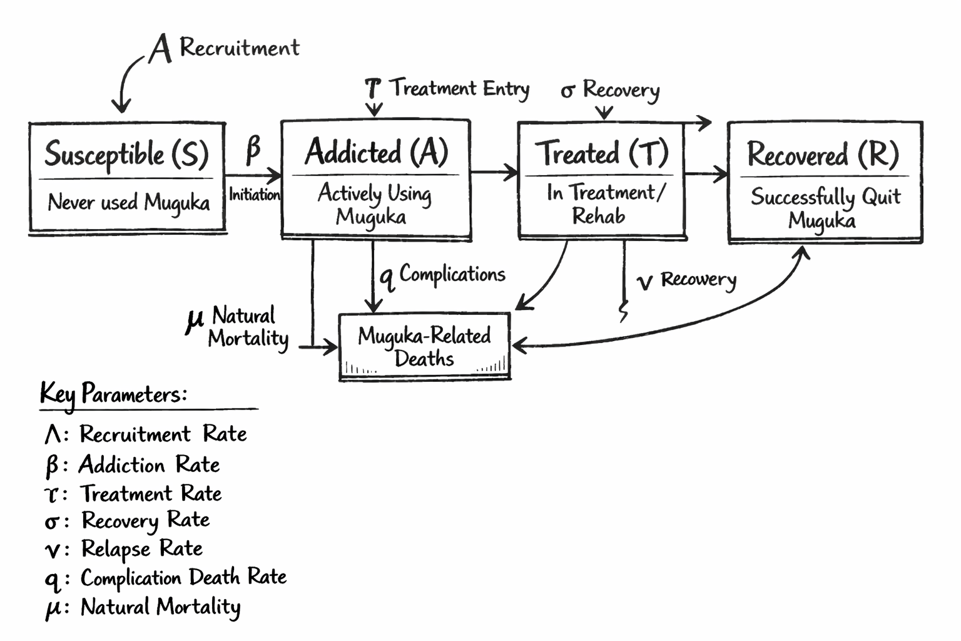
Figure 1: Model flow diagram dynamics

Model assumptions:
- The total population $N\left(t\right)$ at time $t$ is subdivided into four compartments based on Muguka use status: Susceptible $S\left(t\right)$, Addicted $A\left(t\right)$, in Treatment $T\left(t\right)$, and Recovered $R\left(t\right)$.
- New Muguka addictions occur through interactions between susceptible and addicted individuals (i.e., contact with addicted persons encourages non-users to start using).
- Health-related costs accrue only from addicted and treatment populations (i.e., only active users and those in treatment incur direct health and social costs in the model).
- There is a constant inflow of new susceptible individuals (through birth or immigration) to the population. This “recruitment” replenishes the susceptible class.
- Intervention programs (such as awareness campaigns or rehabilitation efforts) increase the rate at which addicts seek treatment and successfully recover (and thereby leave the addicted compartment).
Using these assumptions, we construct the flow diagram and ODE system for the model. The compartments and transition rates are defined as follows. Let $S\left(t\right)$, $A\left(t\right)$, $T\left(t\right)$, and $R\left(t\right)$ denote the number of individuals in each compartment at time $t$. The model includes the following transition processes: susceptible individuals become addicted through effective contact with addicts; addicted individuals may undergo treatment or may be removed due to severe health complications (including Muguka-related mortality); individuals in treatment may either recover or (due to failure/relapse) return to the addicted class; recovered individuals are those who have overcome addiction, but they may relapse back to addiction. Natural death applies to all compartments at a constant rate. The resulting system of ODEs is:
$$\begin{matrix}\frac{dS}{dt} & =Λ - \frac{β S A}{N} - μ S, \\ \frac{dA}{dt} & =\frac{β S A}{N} + ν R - α A - q A - μ A, \\ \frac{dT}{dt} & =α A - τ T - μ T, \\ \frac{dR}{dt} & =τ T - ν R - μ R ,\end{matrix}$$
All parameters are non-negative. In this model, the total population $N\left(t\right)=S\left(t\right)+A\left(t\right)+T\left(t\right)+R\left(t\right)$ is not constant, due to the recruitment $Λ$ and drug-related removals $qA$. However, under reasonable conditions the population will remain bounded. The model variables and parameters can be calibrated from epidemiological and socio-economic data on Muguka use (for example, estimating $β$ from survey data on peer influence and initiation, $α$ and $τ$ from treatment program statistics, etc.).

MODEL ANALYSIS

POSITIVITY AND BOUNDEDNESS OF SOLUTIONS
Given non-negative initial conditions $S\left(0\right)$, $A\left(0\right)$, $T\left(0\right)$, $R\left(0\right)$, the system’s trajectories remain non-negative for all future times, which is crucial since the variables represent population counts. This can be verified by standard arguments showing that each equation prevents the corresponding state from becoming negative if it starts non-negative (for instance, $dS/dt$ at $S=0$ is $Λ>0$, pushing $S$ positive). The population $N\left(t\right)$ is bounded above by a carrying capacity determined by the balance of inflow $Λ$ and outflow $μ$. Specifically, in the absence of addiction ($A=T=R=0$), the susceptible population tends to the equilibrium $S=Λ/μ$. With addiction present, total population may decline due to the additional removals $qA$, but solutions remain bounded for all $t≥0$. These properties ensure the model dynamics are epidemiologically and demographically well-posed (solutions stay in the feasible region $S,A,T,R≥0$ and $N<∞$ for all time).

EQUILIBRIUM POINTS
To determine the equilibrium points of the system, we set all time derivatives to zero ($dS/dt=dA/dt=dT/dt=dR/dt=0$). Solving the resulting algebraic equations yields the equilibrium populations $S^{*},A^{*},T^{*},R^{*}$. Two important equilibrium scenarios are of interest:
Muguka-Free Equilibrium (MFE): This equilibrium corresponds to the absence of active addiction in the population. Setting $A^{*}=T^{*}=R^{*}=0$, the equations simplify and yield a nonzero susceptible population at steady state. From the first equation, $0=Λ-μS^{*}$ (since $A^{*}=0$), giving $S^{*}=Λ/μ$. The other equations are satisfied by $A^{*}=T^{*}=R^{*}=0$. Thus, the Muguka-free equilibrium is
- $\left(S^{*},A^{*},T^{*},R^{*}\right)=\left(\frac{Λ}{μ}, 0, 0, 0\right).$
This scenario represents a stable society with a constant population $Λ/μ$ in which no one is using Muguka.
Muguka Endemic Equilibrium (MEE): This is a situation where Muguka addiction persists in the population at steady state, so all compartments are potentially nonzero. Solving the full equilibrium equations for $S^{*},A^{*},T^{*},R^{*}$ in terms of the model parameters is algebraically involved. However, the endemic equilibrium can be expressed in closed form by a sequence of substitutions. From the $S$-equation at equilibrium: $0=Λ-\frac{βS^{*}A^{*}}{N^{*}}-μS^{*}$. At the endemic equilibrium, typically $N^{*}=Λ/μ$ (meaning the inflow balances total outflow in the long term), so one can solve for $S^{*}$ in terms of $A^{*}$. Similarly, the equilibrium conditions for $A,T,R$ can be manipulated. In general, the endemic equilibrium will exist only if the system’s parameters satisfy a threshold condition (related to the reproduction number exceeding 1, discussed below). For brevity, we do not reproduce the full expressions for $A^{*},T^{*},R^{*}$ here, but they can be obtained by algebraic elimination. These equilibrium values depend on a complex interplay of parameters $β,α,τ,ν,q,$ etc. When it exists, the endemic equilibrium is denoted
- $\left(S^{*},A^{*},T^{*},R^{*}\right)=\left(\tilde{S}, \tilde{A}, \tilde{T}, \tilde{R}\right),$
with all components $\tilde{S},\tilde{A},\tilde{T},\tilde{R}>0$. This equilibrium forms the basis for analyzing the long-term burden of Muguka addiction in the population.

LOCAL STABILITY ANALYSIS
We assess the local stability of the equilibrium points by examining the Jacobian matrix of the system. The Jacobian $J$ is a 4×4 matrix of partial derivatives $J_{ij}=∂f_{i}/∂x_{j}$ (where $f_{i}$ is the right-hand side of the $i$th ODE and $x_{j}∈\{S,A,T,R\}$). Evaluating $J$ at an equilibrium and analyzing its eigenvalues reveals whether that equilibrium is stable (eigenvalues with negative real parts) or unstable (any eigenvalue with a positive real part).
At the Muguka-Free Equilibrium $\left(Λ/μ,0,0,0\right)$, the Jacobian takes a block triangular form due to the absence of addicts and patients. The eigenvalues in this case are found to be $-μ$ (with multiplicity three for the $S,T,R$ directions) and $β S^{*}-\left(α+q+μ\right)$ for the $A$ direction (since the linearized growth of $A$ when rare is driven by $βS^{*}-\left(α+q+μ\right)$). Here $S^{*}=Λ/μ$ is the susceptible population at MFE. The sign of the eigenvalue associated with the addicted class determines the stability of the MFE. If $βS^{*}<α+q+μ$, then all eigenvalues are negative and the MFE is locally asymptotically stable (addiction cannot invade). Conversely, if $βS^{*}>α+q+μ$, the eigenvalue for the addicted class becomes positive, making the MFE unstable and indicating that an invasion of addiction can occur from rarity. This condition leads naturally to the definition of a threshold parameter for the system.

BASIC REPRODUCTION NUMBER $R_{0}$
The basic reproduction number, denoted $R_{0}$, is a critical threshold that predicts whether an addiction (or disease) can establish itself in a fully susceptible population. In the context of our model, $R_{0}$ represents the average number of secondary new addicts generated by one “addicted” individual introduced into an entirely susceptible population. Using the next-generation matrix approach[1], we derive:
$$R_{0} = \frac{β Λ}{μ \left(α+q+μ\right)} ,$$
which encapsulates the balance between the addiction transmission potential (numerator) and the removal rates of an addict (denominator). Intuitively, $β Λ/μ$ is the inflow-adjusted effective contact rate (since $Λ/μ$ represents the size of a susceptible population at equilibrium in the absence of addiction), while $α+q+μ$ is the combined rate at which an addict leaves the addictive state (either by treatment, drug-induced exit, or natural death). If $R_{0}<1$, each addict generates less than one new addict on average, and the addiction will die out (making the Muguka-free equilibrium stable). If $R_{0}>1$, addiction can persist and spread, leading to an endemic equilibrium where Muguka use remains present in the population [2][3]. In our model, $R_{0}>1$ is the condition for the existence of the non-trivial endemic equilibrium (MEE). These results align with the stability analysis above: $R_{0}-1$ has the same sign as the critical eigenvalue at the MFE.

STABILITY OF THE ENDEMIC EQUILIBRIUM
When $R_{0}>1$, the model admits the endemic equilibrium $\left(\tilde{S},\tilde{A},\tilde{T},\tilde{R}\right)$. The local stability of this Muguka-endemic equilibrium can be analyzed by evaluating the Jacobian at that point. The computation is more involved because all compartments have nonzero values. However, by applying the Ruth-Hurwitz criteria or numerical eigenvalue computation, one can check that the endemic equilibrium is locally asymptotically stable whenever it exists (provided model parameters remain in a biologically realistic range). In simpler terms, if $R_{0}>1$, the system will tend toward the endemic state of persistent Muguka use, and small perturbations around that state will die out, keeping the system near the endemic equilibrium [4].

HEALTH COST ANALYSIS
An important contribution of this model is the incorporation of a health cost function that quantifies the economic burden of Muguka addiction over time [5][6]. We define the total health-related cost at time $t$ as:
$$C\left(t\right)=c_{1} A\left(t\right) + c_{2} T\left(t\right),$$
where $A\left(t\right)$ is the number of addicted individuals, $T\left(t\right)$ is the number of individuals in treatment at time $t$, $c_{1}$ is the per capita cost associated with an addicted individual, and $c_{2}$ is the per capita cost for an individual in treatment [7]. The parameter $c_{1}$ represents various direct and indirect costs due to addiction (lost productivity, healthcare utilization, criminal justice costs, etc.), while $c_{2}$ represents the costs of providing treatment and rehabilitation (medical care, counseling, facilities, etc.) for one individual [8]. This function $C\left(t\right)$ thus captures the total economic burden (per unit time) attributable to Muguka addiction at time $t$.
Using the ODE system, we can derive an expression for the rate of change of the cost function. Differentiating $C\left(t\right)$ and substituting the model equations for $dA/dt$ and $dT/dt$ gives:
$$\frac{dC}{dt} = c_{1} \frac{βSA}{N} + c_{1} νR - c_{1} \left(α+q+μ\right)A + c_{2} αA - c_{2} \left(τ+μ\right)T .$$
This result shows how changes in the addicted and treatment populations influence the evolution of the health cost[9][10]. The terms on the right-hand side have intuitive interpretations: the term $c_{1}\left(βSA/N\right)$ increases cost as new individuals become addicted; $c_{1}νR$ increases cost as relapses add back to the addicted population; the term $-c_{1}\left(α+q+μ\right)A$ represents cost reductions when addicts leave the addicted compartment (either by going into treatment, dying from complications, or natural death); $c_{2}αA$ increases cost when addicts enter treatment (increasing the treatment population); finally, $-c_{2}\left(τ+μ\right)T$ represents cost reductions as treated individuals either recover (and leave treatment) or die naturally. By setting $dC/dt=0$ and substituting the equilibrium conditions, one can determine the steady-state cost at equilibrium.
At the Muguka-Free Equilibrium, $A^{*}=0$ and $T^{*}=0$, so naturally $C=0$ in the absence of addiction, there is no associated cost [11]. At the endemic equilibrium, where $A=\tilde{A}$ and $T=\tilde{T}$ are constants, the health cost stabilizes at
$$C^{*}=c_{1} \tilde{A}+c_{2} \tilde{T}.$$
The values $\tilde{A}$ and $\tilde{T}$ depend on all model parameters, meaning the equilibrium cost burden $C^{*}$ is a function of the model’s rates [12]. For example, a higher transmission rate $β$ will generally increase $\tilde{A}$ and thus raise $C^{*}$; a higher treatment success rate $τ$ will reduce $\tilde{A}$ (by moving people to recovery faster) and thereby reduce the long-term cost; changes in $c_{1}$ or $c_{2}$ directly scale the cost contributions of addicts and patients, respectively [13][14]. We examine these relationships in a sensitivity analysis below.
SENSITIVITY ANALYSIS
To understand which factors influence the health cost the most, we performed a sensitivity analysis on key parameters[14]. In each case, we vary one parameter and observe the effect on the cost function $C\left(t\right)$ (either on its peak value or long-term level), while holding other parameters at baseline values (see Table 2). The findings can be summarized as follows:
Cost per Addict vs. per Treatment ($c_{1}$ and $c_{2}$): Increasing the cost coefficient for addiction $c_{1}$leads to a directly proportional rise in total cost $C\left(t\right)$ at any given prevalence of addiction. A larger $c_{1}$ means each addicted individual imposes a higher economic burden, which raises both the peak and cumulative cost of an outbreak of addiction [14]. Similarly, increasing $c_{2}$ (cost per person in treatment) raises the portion of cost due to treatment programs. Higher $c_{2}$ would reflect more expensive or intensive treatment efforts, increasing total costs especially if a large fraction of addicts enter treatment. In practice, a higher $c_{1}$emphasizes the need for preventive measures (since addiction is very costly), whereas a higher $c_{2}$highlights the economic impact of investing in recovery programs.
Treatment-Seeking Rate (α): This is the rate at which addicts voluntarily enter treatment. A higher α means addicts are moving to treatment faster. In the short term, raising α can increase T(t) and thus $C\left(t\right)$ (because more individuals are incurring treatment costs) [15]. However, because treatment removes individuals from the addicted pool, a sufficiently large α will eventually lead to a lower number of active addicts $A\left(t\right)$, which can reduce long-term costs. Our model suggests there may be an initial cost surge when scaling up treatment programs, followed by a reduction in the overall addiction prevalence and a subsequent decline in total costs as the epidemic of addiction is brought under control.
Addiction Transmission Rate (β): This “contact rate” determines how quickly susceptible individuals become addicted through interactions with addicts. As expected, a higher β dramatically increases the spread of addiction [13]. When β is large, the model predicts a rapid rise in $A\left(t\right),$leading to a higher and earlier peak in the health cost C(t). Faster addiction spread means that more individuals succumb before interventions can take effect, significantly raising the total burden. This result underlines the importance of preventive programs (education, awareness, restrictions on Muguka availability) in reducing effective contact rates and thereby mitigating the growth of addiction cases.
Recovery Rate (τ): This is the rate at which individuals in treatment successfully recover (i.e., leave the T compartment for R). Increasing τ means treatment is more effective or faster, so individuals spend less time in treatment and more quickly become recovered [13]. A higher τ tends to reduce the number of active addicts $A\left(t\right)$ (because treatment success removes people from the addictive cycle) and also reduces T(t) (since people do not stay in treatment as long). Both effects act to lower the health cost $C\left(t\right)$ over time. Thus, improving the efficacy of treatment programs (higher recovery rate) can substantially decrease the long-term economic burden of Muguka addiction by curbing the population of addicts and the duration of costly interventions.
In addition to the above, we note that other parameters like the relapse rate $ν$ and the complication removal rate q can influence the dynamics and cost, even though they were not explicitly varied in the four cases above. For instance, a higher relapse rate \nu means recovered individuals are more likely to fall back into addiction, which can sustain higher A(t) and costs for longer. Conversely, a higher Muguka-related death rate q will tend to remove addicts faster (reducing $A\left(t\right),$but it also means more loss of life and productivity; its net effect on C(t) depends on how one accounts for the cost of fatalities (our $C\left(t\right)$captures ongoing costs, not the implicit cost of lost life years). Generally, reducing $ν$(through better aftercare to prevent relapse) will lower long-term addiction prevalence and costs, while reducing q (through better healthcare for addicts) will keep addicts alive longer, potentially increasing $C\left(t\right)$ unless coupled with effective treatment to move them into recovery. A full multi-parameter sensitivity analysis could quantify these effects, but qualitatively our model suggests that the most influential parameters on total cost are those directly affecting the number of active addicts (such as β, τ, ν and the unit cost parameters $c_{1}$, $c_{2}$.
To solidify these insights, we conducted numerical simulations of the model, illustrating how $C\left(t\right)$ changes over time under variations in specific parameters. We used baseline parameter values estimated for the Muguka context (see Table 2 for values, e.g. $β=0.35$, $α=0.0005$, $τ=0.79$, $ν=0.45$, $q=0.065$, $μ=0.0655$, and $λ=0.0075,)$ and a total initial population of 1030 individuals (with $S\left(0\right)=900, A\left(0\right)=100, T\left(0\right)=20, R\left(0\right)=10$ as an illustrative scenario). We then varied one parameter at a time (doubling or halving its baseline value) and computed the trajectories of $S\left(t\right)$, $A\left(t\right),$ $T\left(t\right),$ $R\left(t\right)$ and the resulting cost $C\left(t\right)$. The system was solved numerically using a 4th-order Runge-Kutta method (via MATLAB’s ode45 solver) over a time horizon of 100 units (interpreted roughly as months or years). The results are shown in Figures 2- 6. Each figure displays the health cost $C\left(t\right)$ curves for three different values (low, baseline, high) of the indicated parameter, holding all other parameters at their baseline values.
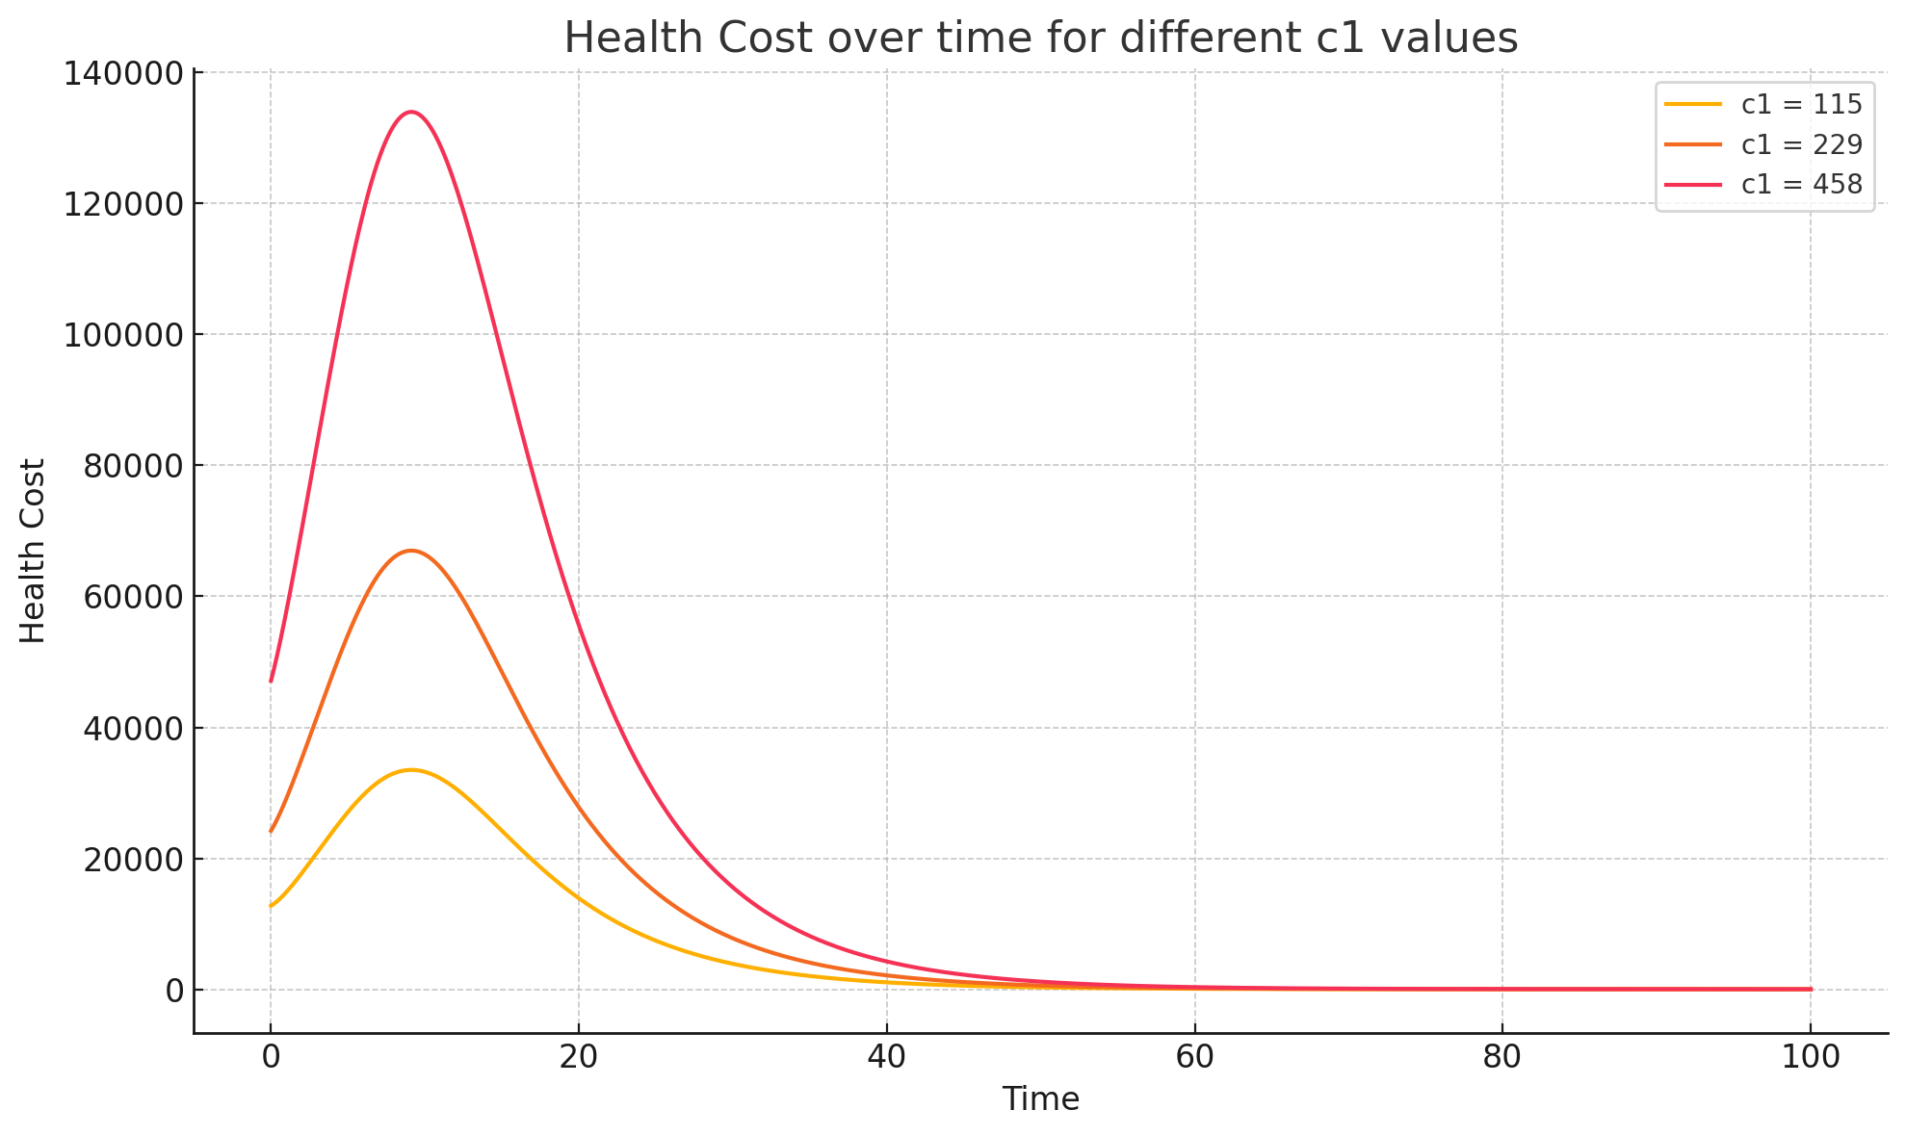
Figure 2: Health cost C(t) over time for different values of the per-addict cost parameter $c_{1}$
A higher $c_{1}$ (red curve, doubled from baseline) results in a proportionally higher total cost at every time point, including a much larger peak cost, since each addicted individual contributes more to the cost. Conversely, a lower $c_{1}$ (yellow curve, half of baseline) scales down the overall cost. Importantly, varying $c_{1}$does not change the timing or duration of the addiction outbreak – only the monetary magnitude of costs because $c_{1}$ does not feed back into the infection dynamics.

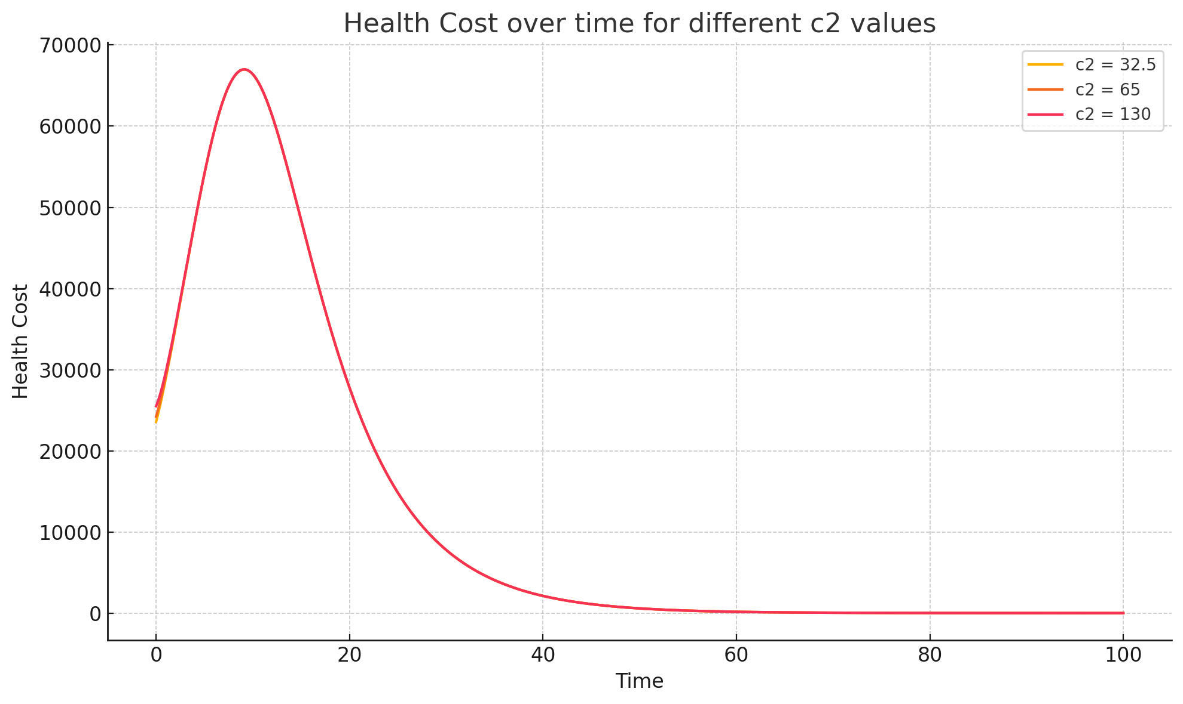
Figure 3: Health cost $C\left(t\right)$ for different values of the per-treatment cost parameter $c_{2}$
In this simulation, the curves for low $c_{2}$ (yellow, half baseline) and high $c_{2}$ (red, double baseline) almost overlap with the baseline case (orange). This indicates that within the given parameter range, variations in $c_{2}$ have a relatively minor impact on total costs compared to $c_{1}$. The reason is that, in this scenario, the majority of costs are driven by addicted individuals ($c_{1}A$ term) rather than the treatment population ($c_{2}T$ term), since not all addicts seek treatment (baseline α is low). Thus, even significantly increasing treatment spending per person does not dramatically raise overall costs unless a large fraction of addicts enter treatment.
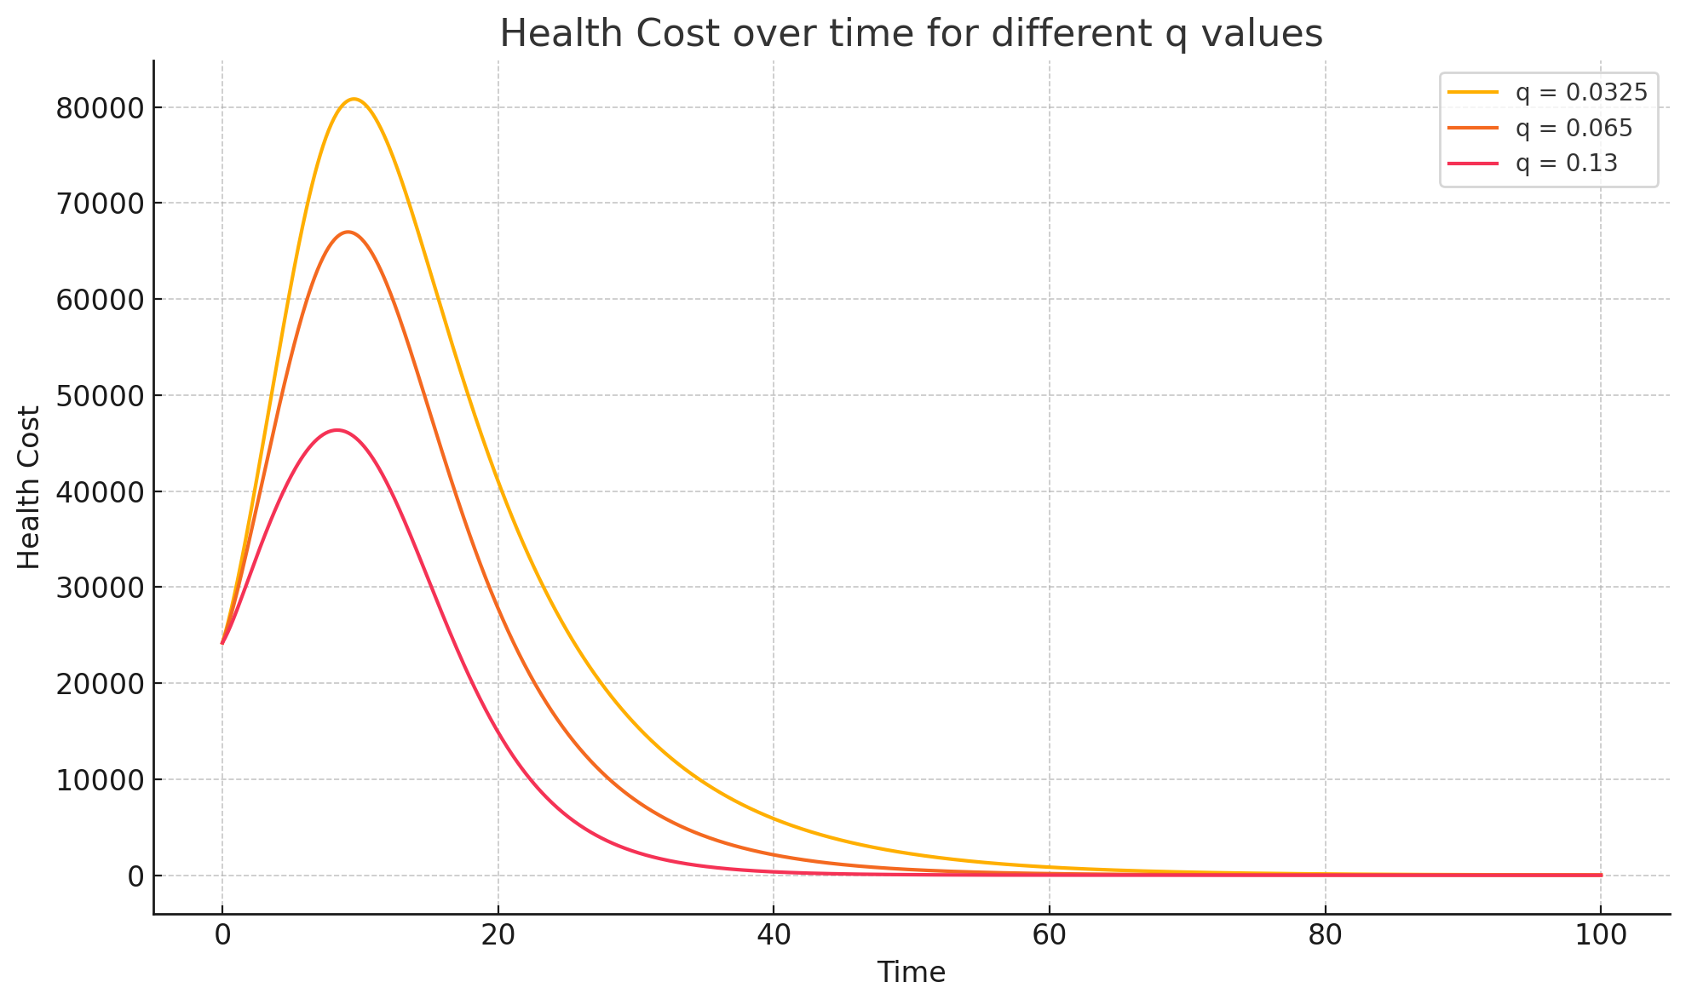
Figure 4: Health cost $C\left(t\right)$ for different values of the complication removal rate q (Muguka-related death/exit rate of addicts)
A lower q (yellow curve, half baseline) means addicts have fewer fatal complications, so they remain in A longer; this leads to a larger and later peaking cost curve, as the addicted population persists. A higher q (red curve, double baseline) hastens the removal of addicts, resulting in a smaller peak in $C\left(t\right)$ and a quicker decline (the outbreak “burns out” faster). However, a high q also implies more severe health outcomes (more deaths), which is socially undesirable despite reducing ongoing costs. This trade-off highlights that simply increasing q (e.g., through lack of medical support) is not a viable control strategy – it lowers costs at the expense of higher mortality.
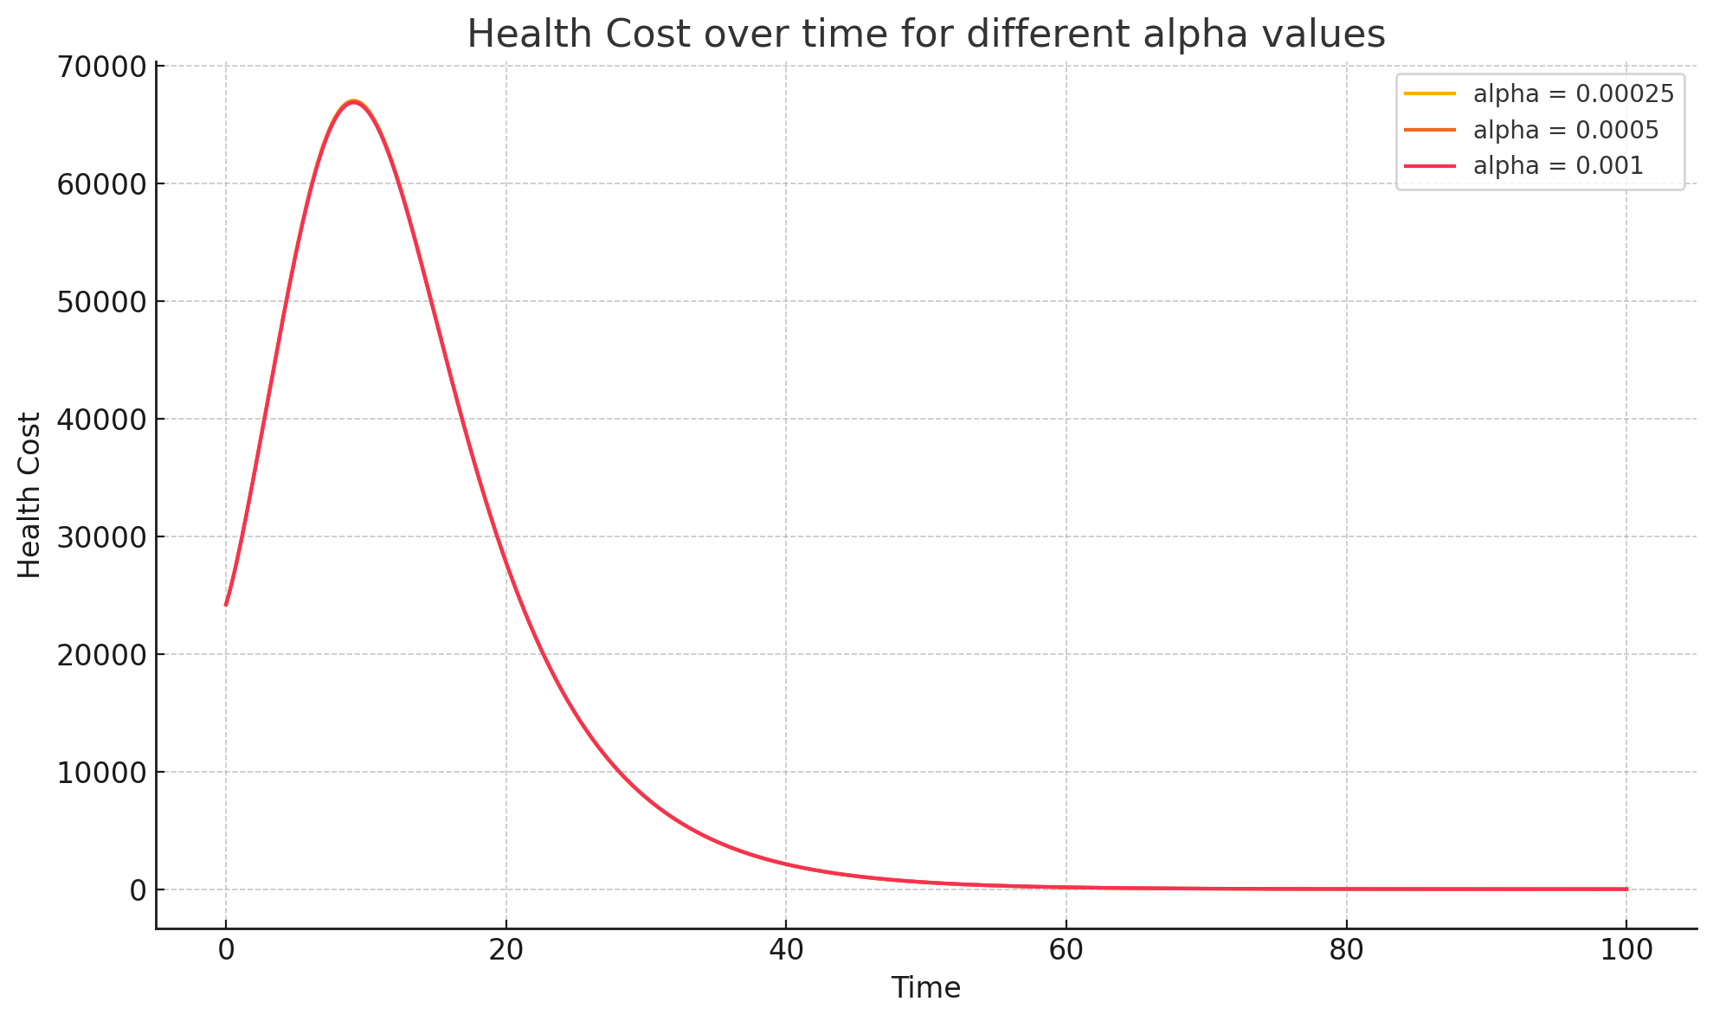
Figure 5: Health cost $C\left(t\right)$ for different values of the treatment-seeking rate α

The curves for half baseline α (yellow) and double α (red) lie almost on top of the baseline curve (orange), indicating minimal impact. This suggests that in our baseline scenario, the voluntary treatment rate is so low that even doubling it does little to change the course of the addiction epidemic or its cost. Most addicts are not entering treatment in either case, so the dynamics (dominated by β, q, ν remain essentially the same. Only when α is increased by an order of magnitude or more would we begin to see a noticeable effect (earlier and higher T(t) leading to slightly lower A(t) later). Thus, while encouraging treatment is important, other parameters like β or τ have a more immediate influence on cost in this model.

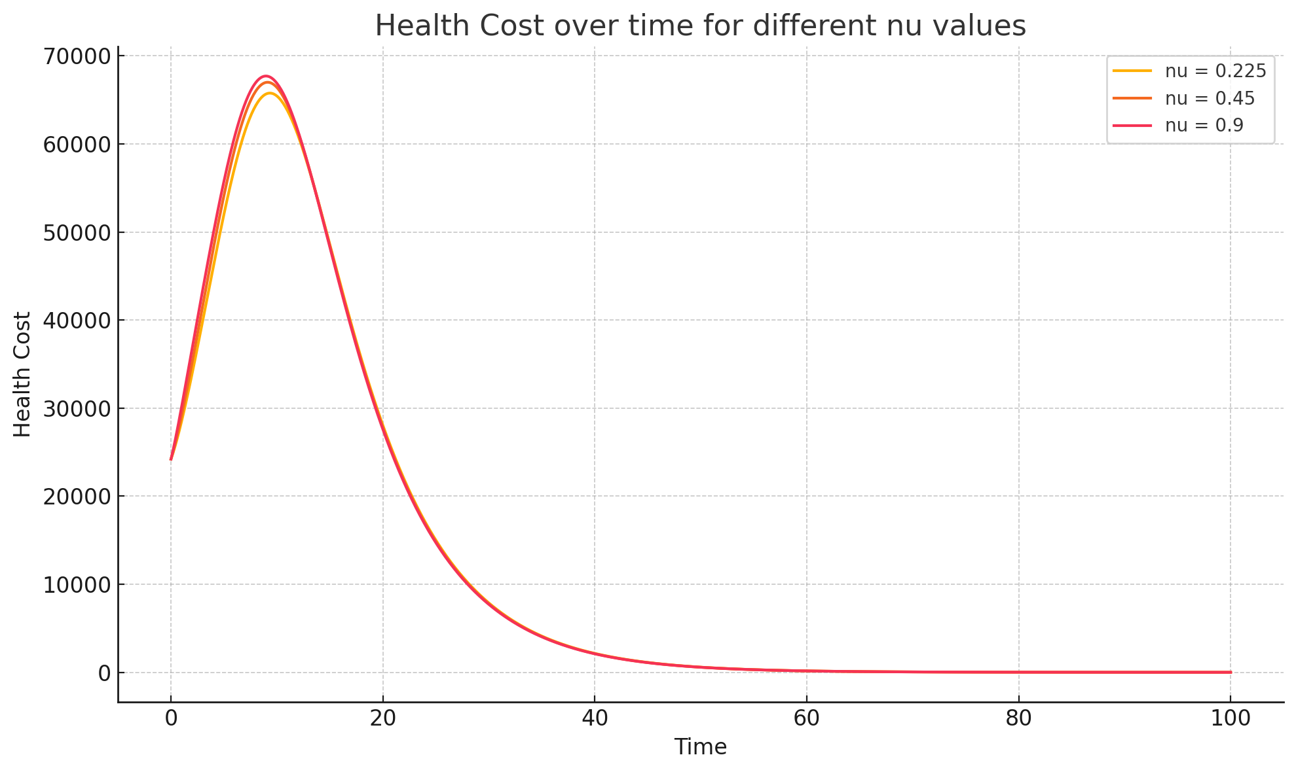
Figure 6: Health cost $C\left(t\right)$ for different values of the relapse rate $ν$.
A higher relapse rate (red curve, $ν$ doubled to 0.9) means many recovered individuals fall back into addiction, which sustains a larger addicted population and leads to a slightly higher and later-peaking cost curve. A lower relapse rate (yellow curve, $ν$ halved to 0.225) allows more recovered individuals to remain drug-free, which helps the addicted population decline faster after the initial peak, resulting in a somewhat lower overall cost. The differences, however, are not as dramatic as with β or q variations, because even the baseline relapse rate is moderate and a significant portion of addicts are continuously present due to other factors. Nonetheless, this demonstrates that improving long-term recovery (reducing relapse) has a tangible benefit in reducing the sustained economic burden of addiction.
These simulation results align with the earlier sensitivity analysis and reinforce key insights: preventing the spread of addiction (lowering β) and improving recovery (increasing τ, or equivalently reducing ν are crucial for reducing the magnitude and duration of the Muguka addiction burden. Direct costs ($c_{1}$, $c_{2}$) scale the economic impact but do not change the underlying epidemic trajectory, while the rate of seeking treatment ($α$) has limited effect unless it is made substantially large or paired with effective treatment (high $τ$).

CONCLUSION
In this study, we developed a mathematical model for Muguka addiction that integrates epidemiological dynamics with a health cost analysis. The model captures the transitions of individuals through susceptibility, addiction, treatment, and recovery, while explicitly accounting for the economic costs associated with addiction and intervention efforts. Our analysis yielded several important findings. First, the model’s basic reproduction number $R_{0}$ provides a threshold criterion for the persistence of Muguka use: if $R_{0}<1$, the addiction will eventually die out, whereas if $R_{0}>1$, Muguka addiction can invade the population and reach an endemic equilibrium. For plausible parameter estimates in Kenya, $R_{0}$ is well above 1, indicating that Muguka use has the potential to remain endemic without effective interventions. Second, the Muguka-free equilibrium was shown to be locally stable when $R_{0}<1$, and conversely, when $R_{0}>1$, a unique endemic equilibrium exists and is stable, meaning the system will gravitate toward a persistent level of addiction in the long run. These theoretical results highlight the need for reducing transmission potential (e.g., through awareness and prevention) to push $R_{0}$ below unity if eradication is desired.
From a socio-economic perspective, the incorporation of the health cost function $C\left(t\right)=c_{1}A\left(t\right)+c_{2}T\left(t\right)$ allowed us to estimate the economic burden of Muguka addiction over time. The model simulations indicate that, even with moderate parameter values, the costs can escalate rapidly as addiction spreads, reflecting lost productivity and increased healthcare and enforcement expenses. The cost tends to peak when the number of active addicts is highest and then decline as either interventions take effect or a significant portion of the population succumbs to addiction and related removals. For example, using notional cost values (per addict and per patient) appropriate to the Kenyan context, our simulations showed a potential cost peak on the order of tens of thousands of cost units (which could correspond to US dollars or Kenyan shillings in the appropriate scale) within months of an uncontrolled spread. Such costs underscore the urgency for public health action.
Based on our model findings, we can offer several policy insights and optimal control considerations for mitigating the impact of Muguka addiction:
Prevention Programs: Curbing the initiation of Muguka use is crucial. Public awareness campaigns, restrictions on Muguka access (especially for youth), and community-based interventions should aim to reduce the effective contact rate $β$. Lowering β directly reduces $R_{0}$ and prevents new addictions, providing the most cost-effective long-term control of the problem. Our model suggests that prevention has a multiplicative benefit by avoiding both the health harms and the economic costs associated with each averted case of addiction.
Enhanced Treatment and Aftercare: Strengthening the treatment infrastructure (increasing α) and improving treatment efficacy (increasing $τ$ and reducing relapse ν are vital. This includes expanding access to rehabilitation centers, improving the quality of counseling and medical management for addiction, and providing support systems for those in recovery to prevent relapse. Efficient treatment drives down the number of active addicts (cutting $c_{1}A$ costs) and ensures that recovering individuals do not revert to costly addiction cycles. While our model showed that simply increasing treatment uptake α without high success can have limited immediate effects, combining it with high success rates and low relapse yields substantial reductions in long-term costs.
Resource Allocation: Policymakers need to balance investments between preventive and treatment measures. In our cost formulation, $c_{1}$ and $c_{2}$ symbolically represent spending on prevention vs. treatment per individual. A balanced approach is necessary for cost-effectiveness [15]. For instance, if $c_{2}$ (treatment cost) is very high relative to $c_{1}$, it may indicate that resources are heavily skewed towards treating existing addicts, whereas increasing funding for prevention could lower the number of new addicts and reduce future costs. On the other hand, under-investment in treatment ($c_{2}$ too low) could lead to persistently high addiction prevalence and societal costs. An optimal control strategy would involve determining the mix of prevention and treatment investment that minimizes the total cost $C\left(t\right)$ over a multi-year horizon.
In conclusion, the deterministic model presented here provides a framework for understanding and quantifying the complex dynamics of Muguka addiction and its economic impact. The integration of health cost analysis into the addiction model is a novel step that reveals how different intervention strategies might “pay off” in economic terms. While the model is a simplification of reality, it offers valuable qualitative guidance: aggressive prevention to reduce initiation, combined with effective treatment to shorten addiction duration, is likely to yield the greatest benefit both in health and economic outcomes. Future work could extend this model by incorporating additional complexities such as stochastic effects, age structure, or more detailed economic feedback. Nonetheless, even in its current form, the model is a useful tool for policymakers. It highlights the importance of curbing the Muguka menace not just for the health and social well-being of the community, but also to avert significant economic losses associated with addiction.
REFERNCES
1. Al-Motarreb, A., Baker, K., & Broadley, K. J. (2002). Khat: Pharmacological and medical aspects and its social use in Yemen. Phytotherapy Research, 16(5), 403–413.
2. Beckerleg, S. (2008). Ethnic identity and development: Khat and social change in Africa. Palgrave Macmillan.
3. Brauer, F., Castillo-Chavez, C., & Feng, Z. (2019). Mathematical Models in Epidemiology. Springer.
4. Carrier, N. (2007). Kenyan Khat: The social life of a stimulant. Brill.
5. Dhadphale, M., & Omolo, O. E. (1988). Psychiatric morbidity among khat chewers. East African Medical Journal, 65(6), 355–359.
6. Ferguson, N. M., Laydon, D., Nedjati-Gilani, G., Imai, N., Ainslie, K., Baguelin, M., ... & Ghani, A. C. (2020). Impact of non-pharmaceutical interventions (NPIs) to reduce COVID-19 mortality and healthcare demand. Imperial College COVID-19 Response Team – Report 9.
7. Gikonyo, W. (2018). Social implications of khat chewing in Kenya. African Journal of Drug & Alcohol Studies, 17(2), 123–135.
8. Kassim, S., & Croucher, R. (2006). Khat addiction: Historical and socio-medical perspectives. Advances in Psychiatric Treatment, 12(6), 456–463.
9. Klein, A. (2013). Khat and the informal globalization of a psychoactive commodity. In L. T. King & L. C.
10. H. Hui (Eds.), Globalisation and Crime (pp. 201–214). Cambridge University Press.
11. Kimani, S. (2019). Economic implications of Muguka farming in Kenya. Journal of Agricultural Economics and Development, 8(3), 45–52.
12. Mwenda, J. (2017). The economic impact of khat farming in Meru County. Meru University of Science and Technology Journal, 5(1), 89–105.
13. Njoroge, P. (2020). Crime and khat use in Kenya: An analysis of socio-economic factors. Kenya Institute for Public Policy Research and Analysis, 6(4), 103–119.
14. Nyaga, J. (2018). The role of Muguka in the local economy of Eastern Kenya. African Economic Research Consortium, 27(4), 77–90.
15. Odenwald, M., Klein, A., Warfa, N., & Bhui, K. (2017). The stimulant khat – another door in the wall? A call for overcoming the barriers. Global Mental Health, 4(2), e20.

