Geotechnical Evaluation of the Effects of NaCl-induced Salinity on the shear strength parameters of coastal soils in Ikot Abasi, Nigeria

ABSTRACT
Saltwater intrusion is a major environmental factor affecting the engineering behavior of coastal soils because dissolved salts, such as sodium chloride (NaCl), alter the soil’s physicochemical properties, presenting challenges that affect infrastructure stability and environmental management. This study investigated the effects of NaCl intrusion on the shear strength parameters of coastal soils in Ikot Abasi Local Government Area. Laboratory tests, including unconsolidated undrained (UU) triaxial, direct shear, Atterberg limit, and compaction tests were performed. Samples were collected from four locations within the coastal area, and labeled as Points A, B, C, D for easy identification. According to the Unified Soil Classification System (USCS), the soils at Points A, B, and C were classified as clayey sand (SC), while Point D was classified as well-graded sand with silt (SW-SM). Points A, B, and C exhibited cohesive behavior, whereas Point D behaved as a non-cohesive material. The Atterberg limit results indicated that Points A, B, and C exhibited low to intermediate plasticity, whereas Point D was non-plastic. The liquid limit (LL) values ranged from 27.8% to 36.2%, and the plasticity index (PI) values ranged from 12.2% to 13.5%, indicating moderate plasticity. MDD values for the soils ranged from 1.7 g/cm3 to 1.7 g/cm3. OMC values ranged from 15% to 20.8%. NaCl dissolved in distilled water was used to simulate saltwater intrusion. Results from the direct shear test conducted on the soil at Point D showed a progressive reduction in angle of internal friction from 31.33⁰ to 24.86⁰ as the NaCl concentration increased from 0 to 55 g/L. Results of triaxial tests showed an increase in soil cohesion from 28 to 34 kPa for Point A, 20 to 24 kPa for Point B, and 23 to 27.4 kPa for Point C as the NaCl concentration increased. Conversely, increasing NaCl concentration resulted in a decline in the angle of internal friction. The findings demonstrate that increasing NaCl-induced salinity alters the shear strength behavior of coastal soils by increasing cohesion while reducing the angle of internal friction.
Keywords:
Coastal Soils, Sodium Chloride, Shear Strength, Saltwater, Friction angle, Cohesion.

INTRODUCTION

Ikot Abasi is a coastal region in Nigeria that lies between latitudes 4.500278°–4.666944° N and longitudes 7.500278°–7.650278° E. It is situated near a break in the mangrove swamp and rainforest in the Eastern Niger Delta, with approximately 20–30% of its total area covered by water. The terrain is relatively flat, comprising alluvial plains, rolling sandy plains, and beach ridge sands as the major physiographic units (Akankpo et al., 2020). According to the base map of Akwa Ibom State produced by the Nigerian Geological Survey Agency (2006), the geology of Ikot Abasi Local Government Area is predominantly Coastal Plain Sands, with prolific groundwater potential and weak aquifer protectivity in most places. The groundwater in the area has been reported to be contaminated by saltwater and elevated concentrations of dissolved ions exceeding WHO recommendations, with Na⁺ and Cl⁻ as the predominant salt ions (Charles, 2024; Etesin et al., 2023). Rapid population growth has intensified the demand for land for agricultural and infrastructural development, making the development and utilization of coastal and swampy terrains increasingly inevitable. However, these terrains often exhibit poor engineering characteristics, including high compressibility, low bearing capacity, high plasticity, low strength, and low hydraulic conductivity (Yin et al., 2021; Azevedo et al., 2024). Furthermore, climate change and sea-level rise have increased flooding and saltwater intrusion, thereby affecting the mechanical and physicochemical properties of soils and reducing agricultural productivity (Abam, 2016; Truc et al., 2019; Geng et al., 2022). Saltwater intrusion has become a global environmental and geotechnical challenge, driven by sea-level rise, groundwater over-extraction, and anthropogenic activities (Werner & Simmons, 2009; Barlow & Reichard, 2010). Saline soils, containing more than 0.3% salt, may exhibit expansion, corrosion, and collapsibility, making them unsuitable for engineering construction (Xu, 2024; Shen et al., 2024). Saltwater alters soil composition, hydraulic conductivity, compression index, water retention, and strength characteristics, thereby influencing the safety and performance of engineering structures such as embankments, road subgrades, building foundations, and retaining walls (Zhang et al., 2024; Shen et al., 2024).
Although several studies have investigated the influence of salinity on soil properties, their findings remain inconsistent. Otoko (2014) reported that Atlantic Ocean water could serve as a stabilizing agent, increasing friction angle, compaction characteristics, and unconfined compressive strength compared with freshwater. Similarly, sodium chloride has been shown to reduce swelling potential, decrease liquid and plastic limits, lower the free swell index, and improve maximum dry density (Kady et al., 2020; Kady et al., 2022; Rahil et al., 2019). Conversely, other studies have shown that salinity disperses clay particles, reduces liquid limit, plasticity index, cohesion, angle of internal friction, and load-bearing capacity (Johny et al., 2024; Abu-Zeid & Abd El-Aal, 2017). Similarly, while some researchers reported that salinity enhances cohesion through flocculation of fine particles (Ajalloeian et al., 2013; Sen et al., 2017; Shen et al., 2024), others observed that salt ions weaken quartz wettability and contribute to soil weakening under seasonal groundwater salinity and tidal fluctuations (Min et al., 2016; Ketabchi et al., 2016). Despite the rapid industrialization, urbanization, population growth, and infrastructure development in Ikot Abasi, there is limited understanding of how the presence of NaCl influences the shear strength parameters of the coastal soils in this area.
This study employed a laboratory simulation with the aim of providing meaningful insights into the impact of NaCl on the shear strength parameters of coastal soils and the geotechnical implications for infrastructure founded on these soils, with particular emphasis on soils within the premises of the Federal University of Technology premises at Ikot Abasi Local Government Area and its environs. By conducting laboratory tests on soil samples collected from the field and interpreting the laboratory results, the study seeks to improve understanding of the effects of NaCl-induced salinity on soil shear strength properties, which are critical geotechnical parameters for sustainable infrastructure development and engineering applications in the study area.

MATERIALS AND METHODS

Study Area
The coastal area used in this study is located within the premises of the Federal University of Technology, which is in Ikot Abasi Local Government Area in Akwa Ibom State, Nigeria. It is relatively flat, low-lying, prone to flooding during the rainy season, low water infiltration rate, and the soil is characterized as sandy-clay.

Soil Sampling
Samples were obtained from four points within the university premises, and each point was at-least 500 m apart. The samples were obtained at a depth of 1.5 m from the surface after clearing off shrubs and vegetation, this depth was chosen as the average foundation depth (2.5 meters max.) within the university premises. The materials collected from each of the four points were labeled as Points A, B, C, and D for easy identification.

Materials
The materials used in this study included soil samples collected from the study site, sodium chloride (NaCl), distilled water for preparing NaCl solutions, and various laboratory equipment, including sieve apparatus, a hydrometer, Atterberg limit apparatus, a compaction mold, a triaxial testing apparatus, and a direct shear apparatus.
Method
The methodology used involved both laboratory tests and data analysis to evaluate the influence of NaCl-induced salinity intrusion on the shear-strength properties of coastal soils. All tests were conducted in accordance with relevant ASTM and AASHTO standards, and the results are presented clearly and systematically.
Laboratory tests were designed to simulate the effects of NaCl-induced salinity intrusion on the soil samples. Sodium chloride (NaCl) was used and its concentration was expressed in gram per liter (g/L). Salt solutions were prepared by dissolving NaCl in distilled water at concentrations of 35, 45, and 55 g/L. These solutions were mixed with the soil samples, and the resulting changes in shear-strength properties were compared with those obtained using distilled water only (0 g/L). Clay activity was determined using the clay fraction (< 2 μm) obtained from hydrometer analysis. Soil classification was carried out in accordance with ASTM D2487.
The direct shear test was conducted to evaluate the shear strength characteristics of the non-cohesive soil under drained conditions in accordance with ASTM D3080/D3080M. Soil specimens treated with NaCl solutions at concentrations of 0, 35, 45, and 55 g/L were thoroughly mixed and allowed to equilibrate for 24 h before testing to ensure uniform salt distribution. The specimens were prepared at the target density and placed in the shear box apparatus. Normal stresses of 70, 140, and 210 kPa were applied, followed by shear loading at a constant displacement rate until failure. During the test, horizontal displacement, vertical displacement, and shear load were continuously recorded. The peak shear stress corresponding to each applied normal stress was determined and used to construct the Mohr–Coulomb failure envelope. The angle of internal friction was obtained from the slope of the linear failure envelope. The variation in shear strength parameters with increasing NaCl concentration was subsequently analyzed to evaluate the influence of salinity on the mechanical behavior of the non-cohesive soil.
The Unconsolidated Undrained (UU) triaxial compression test was conducted to evaluate the shear strength characteristics of the soil specimens under total stress conditions in accordance with ASTM D2850. Soil specimens prepared with NaCl solutions at concentrations of 0, 35, 45, and 55 g/L were sealed and allowed to equilibrate for 24 h prior to testing to ensure uniform moisture and salt distribution. Three specimens were tested for each salinity level under confining pressures of 70, 140, and 210 kPa. Each specimen was enclosed in a rubber membrane, mounted in the triaxial cell, and subjected to the designated confining pressure. No drainage was permitted, and no consolidation stage was allowed, axial loading was applied immediately after the confining pressure was reached. The specimens were sheared at a constant strain rate until failure, which was taken as the peak deviator stress developed during loading. The confining pressure, representing the minor principal stress (σ₃), and the corresponding deviator stress (σ_{d}) at failure were used to determine the major principal stress (σ₁) at failure using Equation (1). Subsequently, the center and radius of each Mohr circle were calculated using Equations (2) and (3), respectively. Mohr circles corresponding to the different confining pressures were plotted, and a common tangent was drawn to establish the Mohr–Coulomb failure envelope. The values of cohesion and angle of internal friction were obtained as the intercept and the slope of the Mohr-Coulomb failure envelope, respectively. Equation (4) shows the shear strength relationship

$σ_{1} = σ_{3}+ σd$ Equation (1)
$Centre of Mohr circle = \frac{σ_{1} + σ_{3}}{2}$ Equation (2) $Radius of Mohr circle = \frac{σ_{1}- σ_{3}}{2}$ Equation (3)
$ɽ= c+ σ_{n}tan$ φ Equation (4)

σ₁ = Major Principal stress (kPa)
σ₃ = Minor Principal stress or confining pressure (kPa)
ɽ = Shear stress at failure (kPa)
φ = Angle of internal friction (º)
c = Cohesion (kPa)
Quality Control
Relevant ASTM and AASHTO testing procedures were meticulously followed to ensure the accuracy, reliability and producibility of the results.

RESULTS AND DISCUSSION

Engineering and Physicochemical Properties of the Soils
Salinity and pH tests were conducted on the samples to determine their chemical characteristics in the natural state, with the results presented in Table 1. The results indicate low salinity, chloride, and sulphate levels in the soil. However, the physicochemical properties suggest that the soils are typical of a coastal or deltaic environment and may be influenced by seawater intrusion or groundwater interaction. Soil sample A recorded a high turbidity value of 93.5 NTU, which may be attributed to poor drainage or the presence of fine-grained particles such as silt and clay. This high turbidity may reduce soil permeability and make the soil more susceptible to swelling, shrinkage, and strength loss under wet conditions.

Table 1: Physicochemical Properties of the soils.
S/N | LOCATION | pH | Turbidity (NTU) | Salinity (ppt) | Chloride (ppm) | Sulphate (ppm)
1 | Point A | 7.8 | 93.5 | 0.084 | 0.300 | 0.332
2 | Point B | 7.7 | 88.7 | 0.102 | 0.400 | 0.538
3 | Point C | 6.7 | 59.7 | 0.120 | 0.500 | 1.443
4 | Point D | 8.9 | 59.7 | 0.102 | 0.400 | 1.615

Soil Classification
A summary of the engineering properties of the natural soils is presented in Table 2, while the grain-size distribution curves are shown in Figure 1. According to the American Association of State Highway and Transportation Officials (AASHTO) soil classification system, the soil samples from Points A and C were classified as A-6, while the soil sample from Point B was classified as A-2-6. The A-6 classification indicates that the soils from Points A and C contain a relatively high proportion of clay. The soil sample from Point D was also classified as A-2-4, indicating that it is more granular. Similarly, under the Unified Soil Classification System (USCS), the soil samples from Points A, B, and C were classified as clayey sand (SC), while the soil sample from Point D was classified as well-graded sand with silt (SW-SM).
Table 2: Summary of the engineering properties of soil samples used in this study.
S/N | Soil Property | Point A | Point B | Point C | Point D
1 | Natural water Moisture, % | 9.2 | 4.8 | 4.3 | 1.0
2 | Bulk Density (g/cm³) | 1.77 | 1.85 | 1.82 | 2.03
3 | Liquid Limit % | 29.3 | 27.8 | 36.2 | Non-Plastic
4 | Plastic Limit % | 17.1 | 14.3 | 23.3 | Non-Plastic
5 | Plasticity Index % | 12.2 | 13.5 | 12.9 | Non-Plastic
6 | Linear Shrinkage | 8.5 | 12.1 | 7.9 | Non-Plastic
7 | Maximum Dry Density (g/cm³) | 1.51 | 1.60 | 1.61 | 1.70
8 | Optimum Moisture Content (%) | 20.8 | 15.1 | 15.0 | 15.0
10 | Bulk Unit Weight (KN/m³) | 17.4 | 18.1 | 17.9 | 19.9
11 | % finer than 4.75mm sieve | 100 | 100 | 100 | 100
12 | % finer than 1.18mm sieve | 98.8 | 99.2 | 97.6 | 96.0
13 | % finer than 425µm sieve | 88.0 | 88.8 | 82.4 | 53.4
14 | % finer than 75µm sieve | 39.8 | 27.2 | 38.6 | 11.4
11 | Sand Content % | 60.2 | 72.8 | 61.4 | 88.6
12 | Silt % | 23.4 | 11.97 | 18.28 | 8.96
13 | Clay Content % | 16.4 | 15.23 | 20.32 | 2.44
14 | Activity (A) | 0.732 | 0.886 | 0.635 | N/A
15 | AASHTO | A-6(1) | A-2-6(0) | A-6(1) | A-2-4
16 | USCS | SC | SC | SC | SW-SM

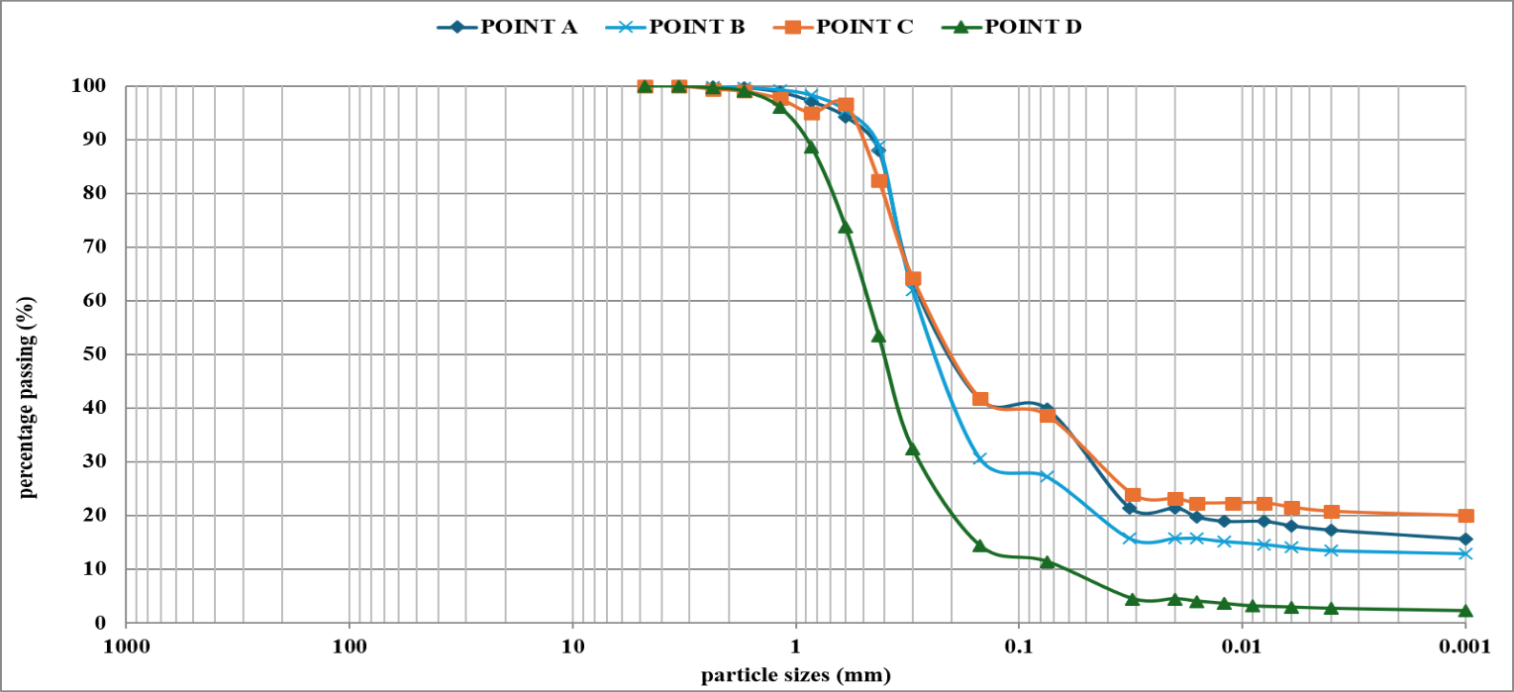
Figure 1: Particle size distribution curve of soil samples

Atterberg Limits
Table 2 present the results of the Atterberg limit tests conducted on the soil samples. The Atterberg limit results indicate that the soils from Points A, B, and C exhibit low to intermediate plasticity, whereas the soil from Point D is non-plastic, reflecting marked variations in their engineering behavior and fines composition. The liquid limit (LL) values ranged from 27.8% to 36.2%, with the highest value recorded at Point C (36.2%), while Point D exhibited no measurable liquid limit due to its non-plastic nature. Similarly, the plastic limit (PL) varied between 14.3% and 23.3%, with Point C recording the highest value (23.3%). The plasticity index (PI) values range from 12.2% to 13.5%, with Point B exhibiting the highest PI (13.5%) and the lowest at Point A (12.2%), indicating moderate plasticity. According to the Casagrande plasticity chart shown in Figure 2, the LL values (<50%) and moderate PI values suggest that the soils from Points A, B, and C are low-plasticity materials, consistent with their Unified Soil Classification System (USCS) classification. Furthermore, the relatively moderate LL and PI values indicate limited volume change potential and moderate compressibility, suggesting that these soils are unlikely to undergo excessive shrink–swell behavior under normal moisture fluctuations. This interpretation is further supported by the activity (A) values of 0.732, 0.886, and 0.635 for Points A, B, and C, respectively, all of which are less than unity, suggesting inactive to normal clays dominated by relatively stable clay minerals such as kaolinite rather than highly expansive minerals like montmorillonite. The linear shrinkage (LS) values ranged from 7.9% to 12.1%, with Point B recording the highest shrinkage (12.1%), and Point C the lowest (7.9%), suggesting that Point B possesses a slightly greater tendency for volumetric contraction upon drying despite having a liquid limit lower than Point C. The observed plasticity characteristics correspond closely with the particle-size distribution, Point C, which contains the highest clay content (20.32%), also exhibited the highest liquid limit and plastic limit, whereas Point B, despite having a lower clay fraction (15.23%), recorded the highest plasticity index. In contrast, Point D, characterized by a high sand content (88.6%), very low clay fraction (2.44%), and non-plastic behavior, exhibited no measurable Atterberg limits or shrinkage, confirming the predominance of coarse-grained particles and the absence of cohesive clay minerals.
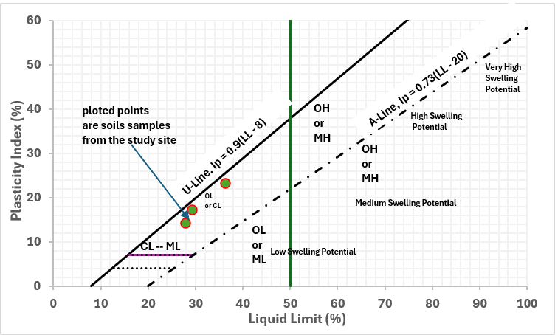
Figure 2: Casagrande plasticity chart showing soil samples domains

Compaction Characteristics
The compaction characteristics of the soils obtained from the four sampling points exhibit distinct responses to moisture addition, reflecting differences in particle-size distribution, plasticity characteristics, and soil mineralogy. As shown in Figure 3 and Table 2, Point D attained the highest dry density (MDD) of 1.70 g/cm³ at an Optimum Moisture Content (OMC) of 15.0%, and Point A had the lowest MDD of 1.51 g/cm³ at the highest OMC of 20.8%. Point D consistently exhibited the highest dry densities over the entire moisture range, indicating superior compactability. This behavior is attributed to its non-plastic nature. Point A recorded the lowest MDD and the highest OMC, indicating a comparatively poorer compaction response. This can be explained by its relatively higher plasticity index (12.2%), appreciable clay content, and lower sand fraction.
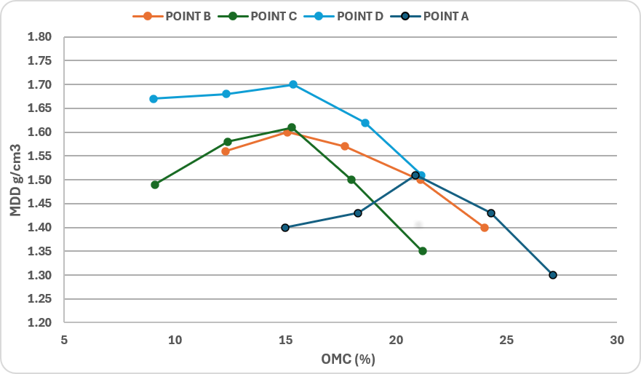
Figure 3: Plot of MDD Vs OMC fir the tested soil samples

Shear Strength Parameters
Influence of NaCl Variation on the Angle of Internal Friction of Non-Cohesive Soil
Direct shear tests were conducted on the soil from Point D to evaluate the influence of NaCl on the shear strength characteristics of a non-plastic soil at that location. The normal stress values were plotted against the corresponding shear stress values obtained at different NaCl concentrations as shown in Figure 4. The plot demonstrates that the tested coastal soil exhibits Mohr–Coulomb behavior, with shear strength increasing linearly with normal stress under all conditions. However, increasing NaCl concentration reduces the slope of the failure envelope, indicating a decline in the angle of internal friction from approximately 31.3° to 24.9° as shown in Figure 5. This observation is consistent with the findings of Shen et al. (2024), who reported that increasing salinity reduces the angle of internal friction of soils. The intercepts are approximately at the origin, suggesting that the soil behaves predominantly as a frictional material.
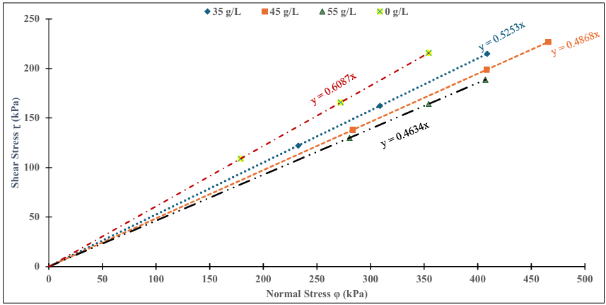
Figure 4: Mohr–Coulomb failure envelopes of the soil sample at Point D.
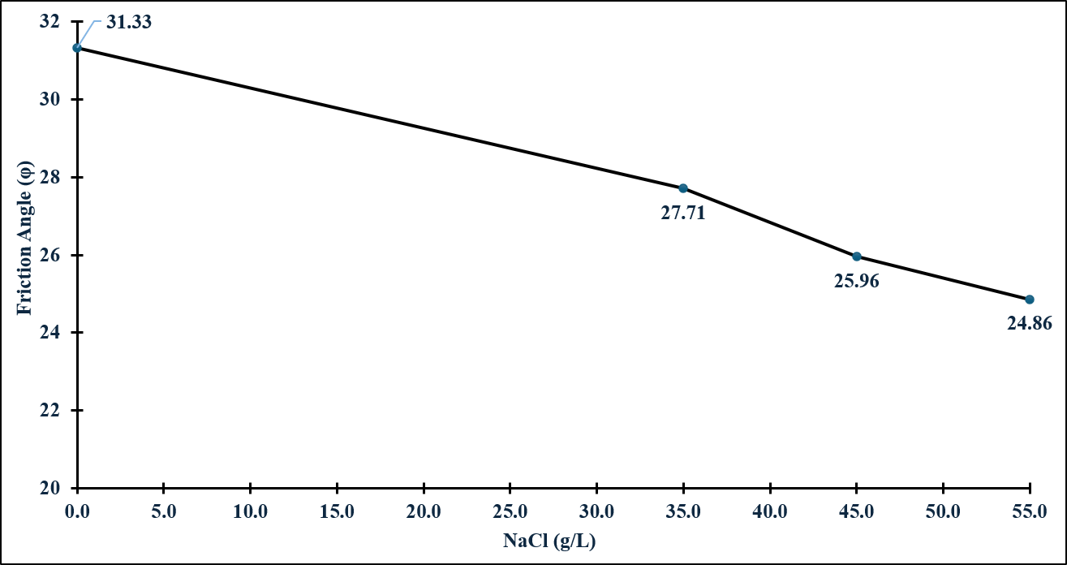
Figure 5: Variation of angle of internal friction of the soil at Point D.
Influence of Salinity Variation on Cohesion and the Angle of Internal Friction of Cohesive soils
To evaluate the influence of NaCl intrusion on the shear-strength parameters of the cohesive soils, Unconsolidated Undrained (UU) triaxial compression tests were conducted on samples obtained from Points A, B, and C, and the Mohr–Coulomb failure criterion was used to determine the shear-strength parameters. Figure 6 to 8 present the plotting of Mohr’s circle and Mohr-Coulomb failure envelopes for the soil samples at varying NaCl concentrations of 0, 35, 45, 55 g/L. The graphs show a progressive increase in soil cohesion as NaCl concentration increases. The progressive outward expansion of the Mohr circles with increasing confining pressure indicates the expected increase in shear resistance under higher confinement. The failure envelopes remain approximately linear for all salinity levels, confirming that the soil behavior conforms satisfactorily to the Mohr–Coulomb failure criterion. A comparison of the envelope equations shows that the slope decreases slightly as salt concentration increases. For the soil sample from Point A, the slope decreases from 0.3449 for the untreated soil to 0.3161 at 55 g/L NaCl concentration, indicating a gradual reduction in the angle of internal friction from 19.03⁰ to 17.54⁰. However, the intercept increases from 28 kPa to 34 kPa, suggesting a corresponding increase in soil cohesion. The same trend was observed for the soils at Point B where the angle of internal friction moved from 19⁰ to 18.42⁰, while cohesion increased from 20 kPa to 24 kPa. Similarly, at Point C, the angle of internal friction decreased from 22.9⁰ to 21.4⁰, while cohesion increased from 23 kPa to 27.4 kPa. This behavior suggests that salt intrusion promotes physicochemical interactions between dissolved ions and clay particles, resulting in particle flocculation and stronger interparticle bonding while simultaneously reducing frictional resistance. This agrees with Shen et al. (2024), who reported that at higher salt concentration (2% and above) soil cohesion increases with an increase in salt concentration. They attributed this behavior to the saturation of the pore solution and the cementation effect of precipitated salt crystals, which enhanced the bonding strength between clay particles. Table 3 presents the values of cohesion and the angle of internal friction obtained from Mohr-Coulomb failure envelope.
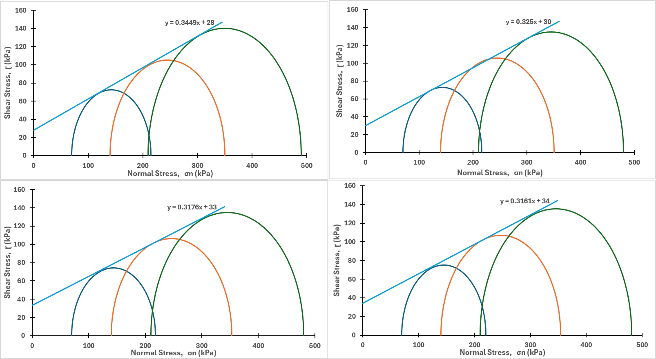Figure 6: Mohr’s circle with failure envelope at different NaCl concentration for soil at Point A.
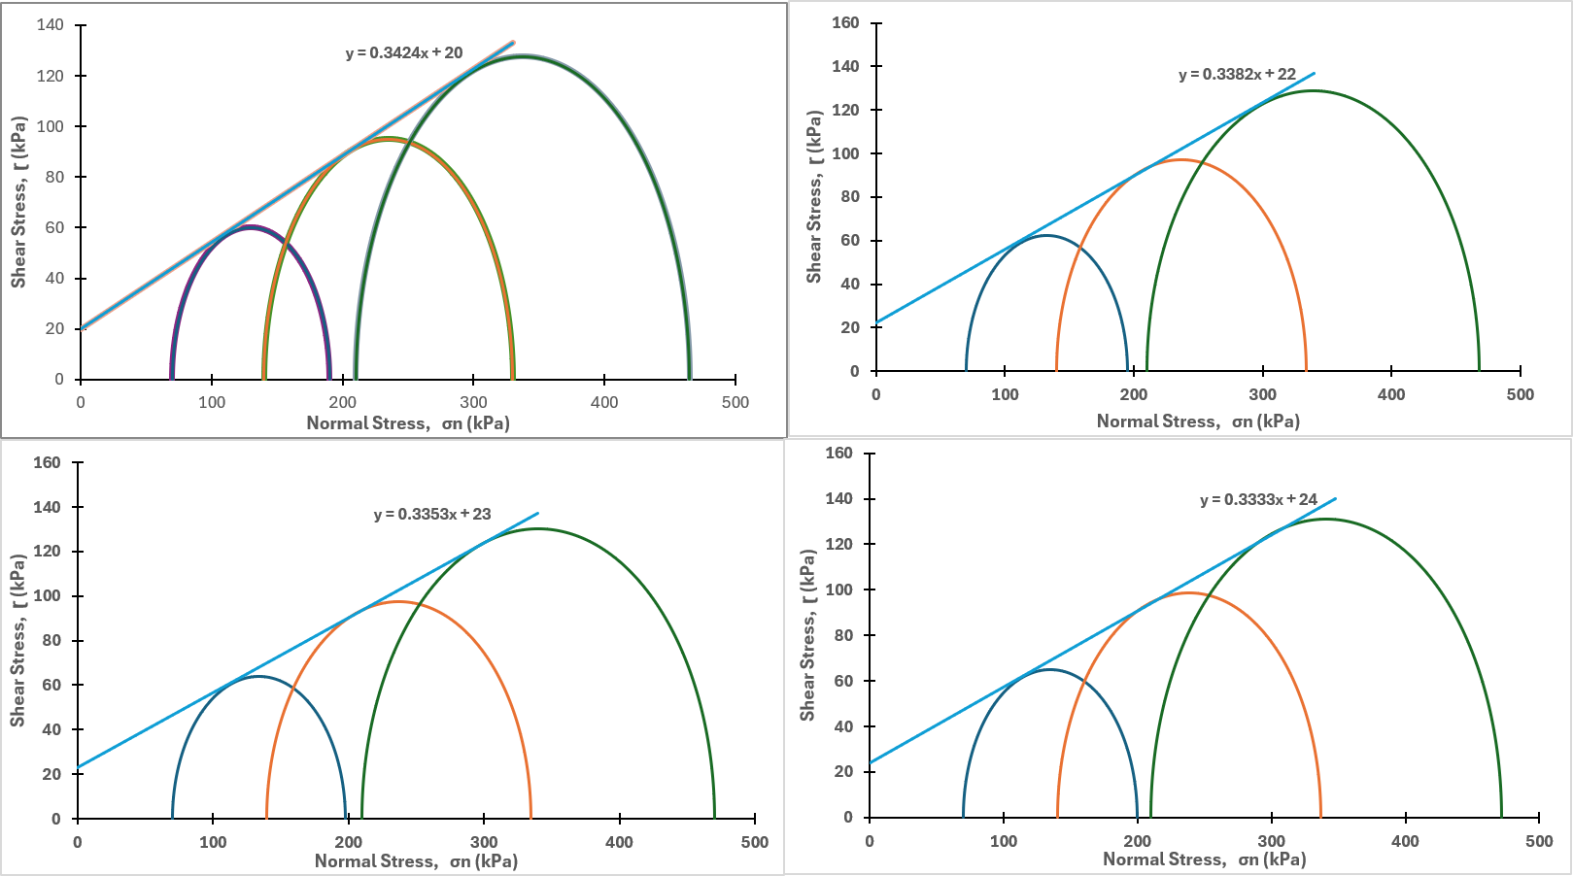
Figure 7: Mohr’s circle with failure envelope at different NaCl concentration for soil at Point B.
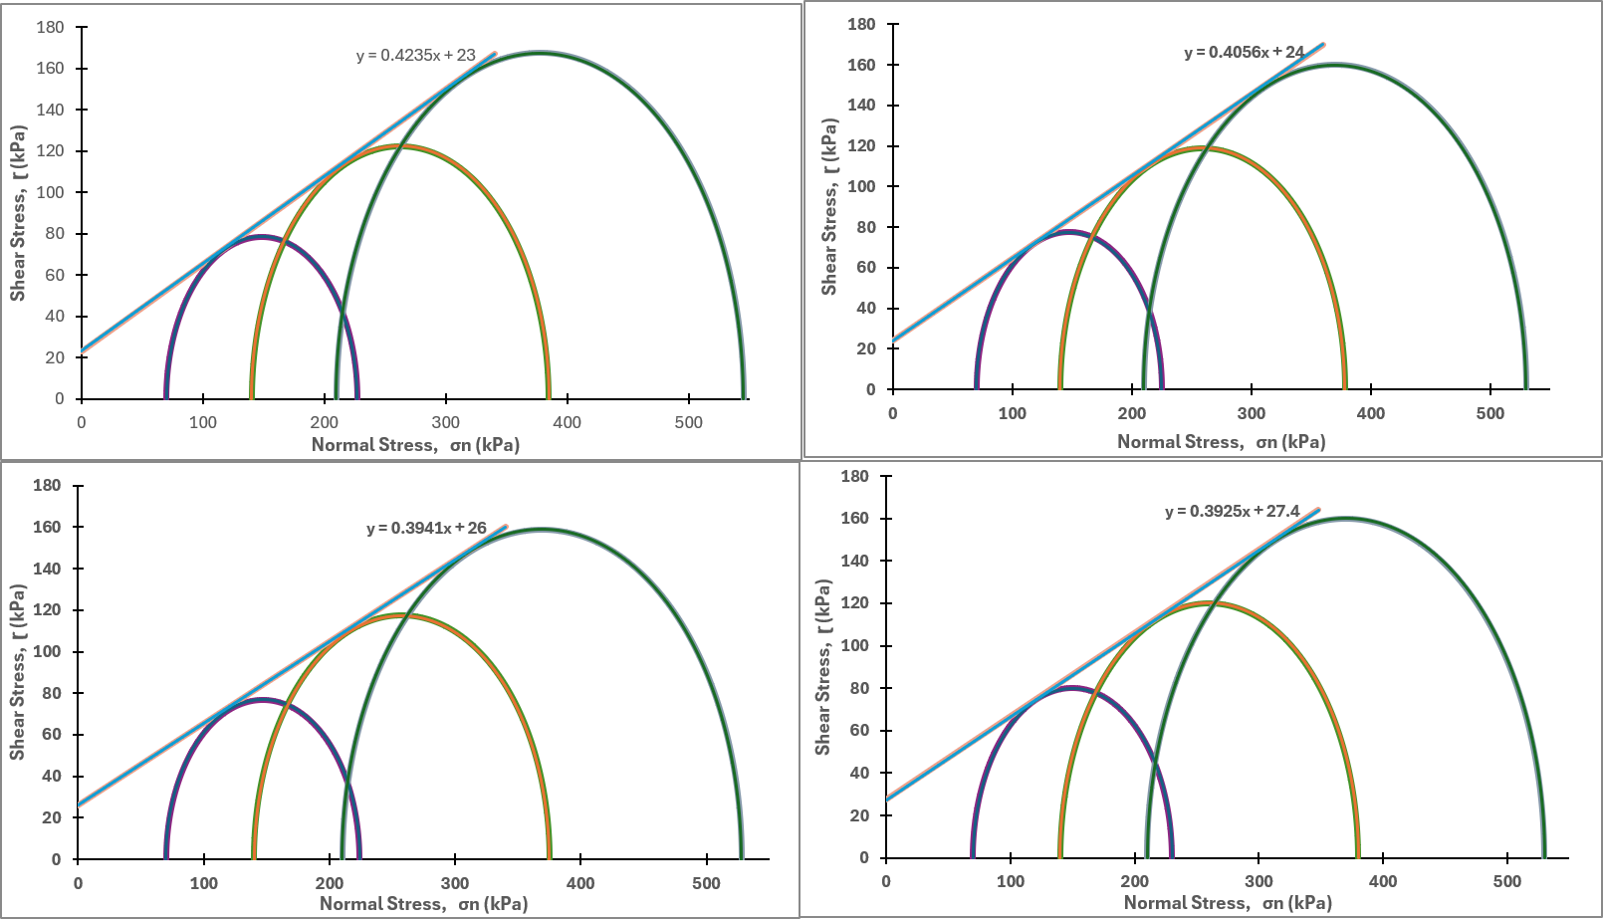
Figure 8: Mohr’s circle with failure envelope at different NaCl concentration for soil at Point C.
Table 3: Summary of cohesion (C) and angle of internal frictional (ϕ) of the soils
Location | Shear strength Parameters |  |  | 0 g/L | 35 g/L | 45 g/L | 55 g/L
Point A |  | C (kPa) |  | 28 | 30 | 33 | 34
 |  | ϕ (º) |  | 19.03 | 18 | 17.62 | 17.54
Point B |  | C (kPa) |  | 20 | 22 | 23 | 24
 |  | ϕ (º) |  | 19 | 18.69 | 18.54 | 18.42
Point C |  | C (kPa) |  | 23 | 24 | 26 | 27.4
 |  | ϕ (º) |  | 22.9 | 22.08 | 21.51 | 21.4

CONCLUSIONS
This study investigated the influence of NaCl intrusion on the shear-strength properties of coastal soils within the Federal University of Technology premises in Ikot Abasi, Nigeria. Four sample locations were used and the sampling locations were designated as Points A, B, C, and D. Soils from Points A, B, and C were cohesive soils classified as clayey sand (SC). The soil from Point D behaved as a non-cohesive soil and classified as well graded sand with silt (SW-SM). The Atterberg limit results indicated that the soils from Points A, B, and C exhibited low to intermediate plasticity, whereas the soil from Point D was non-plastic. The liquid limit (LL) values ranged from 27.8% to 36.2%, with the highest value recorded at Point C (36.2%); the plasticity index (PI) values ranged from 12.2% to 13.5%, indicating moderate plasticity. MDD values for the tested soils ranged from 1.55 g/cm³ to 1.7 g/cm³. OMC values ranged from 15% to 20.8%. The direct shear and triaxial test results showed that NaCl-induced salinity influences soil shear strength parameters, namely cohesion and angle of internal friction. While the test results showed a decline in the angle of internal friction values with increasing NaCl concentration across all test points, soil cohesion increased with salt concentration. These results demonstrate that increasing NaCl-induced salinity alters the shear-strength behavior of coastal soils by increasing cohesion and reducing the angle of internal friction. The findings suggest that the engineering behavior of coastal soils may be adversely influenced by NaCl-induced salinity and should therefore be considered in the design of foundations and pavement subgrades in coastal environments.
STUDY LIMITATIONS
This This study was limited to the laboratory simulation of saltwater intrusion using sodium chloride (NaCl) solution and to soil samples collected from depths not exceeding 2 m due to financial constraints. Consequently, the findings may not fully represent the behavior of coastal soils exposed to the complex ionic composition of natural seawater or deeper subsurface conditions. Further research is recommended to investigate the influence of natural saltwater intrusion on the shear-strength properties of coastal soils at greater depths. Future studies should also evaluate the long-term effects of salinity, conduct field-scale investigations to validate the laboratory findings, and develop numerical models capable of simulating the effects of salinity on soil behavior and geotechnical performance under realistic environmental conditions.
LIST OF ABBREVIATIONS:
FUTIA = Federal University of Technology, Ikot Abasi
AASHTO = American Association of State Highway and Transport Officials.
OMC = Optimum Moisture Content
MDD = Maximum Dry Density
NaCl = Sodium Chloride
PPM = Parts per Million
ASTM = American Society for Testing and Materials.
NTU = Nephelometric Turbidity Units
PH = Potential of Hydrogen
SC = Clayey sand
SW-SM = Well graded sand with silt
N/A = Not applicable
PI = Plasticity index
PL = Plastic limit

AUTHOR CONTRIBUTION:
All authors were involved in the conception and design, data collection, analysis and interpretation of results, drafting of the manuscript, review, and approval of the final version of the manuscript.

FUNDING
This project was financially supported by Tertiary Education Trust fund (TETfund) Institution-Based Research (IBR) for the Federal University of Technology, Ikot abasi.

CONFLICT OF INTEREST
The authors declare they have no conflict of interest, financial or otherwise.

REFERENCES
- Abam, T.K.S (2016). Engineering Geology of the Niger Delta, Journal of Earth Sciences and Geotechnical Engineering. Scienpress Ltd, 6(3), 65-89.
- Abu-Zeid, M. M., & Abd-El-Aal, A. K., (2017). Effect of salinity of groundwater on the geotechnical properties of some Egyptian clay. Egyptian Journal of Petroleum, 26(3), 643-648. https://doi.org/10.1016/j.ejpe.2016.09.003.
- Ajalloeian, R., Mansouri, H., & Sadeghpour, A. H. (2013). Effect of saline water on geotechnical properties of fine-grained soil. Electronic Journal of Geotechnical Engineering. 18, 1419-1435.
- Akankpo, A. O., Essien, I. E., Umoren, E. B., & Dan, A. P. (2020). Groundwater Quality Mapping in Ikot Abasi Using Geographic Information System (GIS). British Journal of Environmental Sciences, 8(2), 57-68.
- Azevedo, G. F., Moura, A.S., Filho, F.C.S., Leme, R.F., Gonçalves, D.R.L., & Cunha, R.P. (2024). Geotechnical Engineering Challenges to Meet Current and Emerging Needs of Society, (1st Edition). CRC Press. https://doi.org/10.1201/9781003431749-544
- Barlow, P.M., & Reichard, E.G. (2010). Saltwater intrusion in coastal regions of North America. Hydrogeology Journal. 18, 247-260. https://doi.org/10.1007/s10040-009-0514-3.
- Charles, Kennedy (2024). Seismic Characterization of Subsurface Soils at Ikot Abasi, Nigeria through Integrated Geotechnical Investigations. Research Square. https://doi.org/10.21203/rs.3.rs-4337324/v1.
- Etesin, U., George, N., Joseph, O., & Akpan, Itohowo. (2023). Source identification and variation in the chemical composition of rainwater in the coastal and industrial areas: a case study of Ikot Abasi, south-eastern Nigeria. Earth science Malaysia, 7, 66-74. https://doi.org/10.26480/esmy.01.2023.66.74.
- Geng, W., Han, W., Yin, J., & Lu, Z. (2022). Salinity effects on the strength and morphological indices of soft marine clay. Scientific Report, 12, 17563. https://doi.org/10.1038/s41598-022-22627-w
- Gillen, M. N., Messerschmidt, T., & Kirwan, M. L. (2021). Biophysical controls of marsh soil shear strength along an estuarine salinity gradient. Earth Surface Dynamics, 9, 413–421.
- Johny, R., Rency, M., Abraham, B., & Sridharan, A. (2024). Effect of salinity on geotechnical properties of soft marine clay. Geomechanics and Geoengineering. 19. 1-15. https://doi.org/10.1080/17486025.2024.2338842.
- Kady, A., Bakr, M., & Gad, S. (2020). Evaluation Of Salt Water Effect on The Physical Properties and Compaction Characteristics of Expansive Soil. International Journal of Civil Engineering and Technology, 11(11), 49-64. https://doi.org/10.34218/IJCIET.11.11.2020.005.
- Kady, A., Bakr, M., & Gad, S. (2022). Experimental Study on Behavioral Parameters of Expansive Soil Treated with Salt Water. Journal of Al-Azhar University Engineering Sector, 17(65), 1221-1240. https://doi.org/10.21608/auej.2022.265712.
- Li, M., Chai, S., Du, H., & Wang, C. (2016). Effect of chlorine salt on the physical and mechanical properties of inshore saline soil treated with lime, Soils and Foundations. Science Direct, 56(3), 327-335, https://doi.org/10.1016/j.sandf.2016.04.001.
- Nigerian Geological Survey Agency, (2006). Geological and Mineral Map of Akwa-Ibom State, Nigeria. https://ngsa.gov.ng/publications-of-ngsa/
- Otoko, George (2014). The Effect of Salt Water on the Physical Properties, Compaction Characteristics and Unconfined Compressive Strength of a Clay, Clayey Sand and Base Course. European International Journal of Science and Technology, 3, 9-16.
- Rahil, F., Al-Soudany, K., Abbas, N., & Hussein, L. (2019). Geotechnical Properties of Clayey Soils Induced by the Presence of Sodium Chloride. IOP Conference Series: Materials Science and Engineering, 518(2), Article 022064. https://doi.org/10.1088/1757-899X/518/2/022064.
- Sen, P., Dixit, M., & Chitra, R. (2017). Effect of Chemicals on Engineering Properties of Soil. International Journal for Research in Applied Science and Engineering Technology, 5(X), 1677-1688, http://doi.org/10.22214/ijraset.2017.10244
- Shen, J., Wang, Q., Chen, Y., Zhang, X., Han, Y., & Liu, Y. (2024). Experimental investigation into the salinity effect on the physio-mechanical properties of carbonate saline soil. Journal of Rock Mechanics and Geotechnical Engineering, 16(5), 1883-1895, https://doi.org/10.1016/j.jrmge.2023.09.024.
- Truc, N.N., Lena M., Mukunoki, T., & Do, D.M. (2019). Effect of saline intrusion on the properties of cohesive soils in the Red River Delta, Vietnam. Marine Georesources & Geotechnology, 30(1), 23-39. https://doi.org/10.1080/1064119X.2018.1550827
- Werner, A., & Simmons, C. (2009). Impact of Sea-Level Rise on Sea Water Intrusion in Coastal Aquifers. Ground water, 47, 197-204. https://doi.org/10.1111/j.1745-6584.2008.00535.x.
- Xu, Shuailing (2024). Influence of Xinjiang Saline Soil on Corrosion of X80 Pipeline Steel. Journal of Physics, Conference Series 2706 012086. https://doi.org/10.1088/1742-6596/2706/1/012086.
- Yin, J., Lu, Z., Geng, W., Han, W., & Hudu, A. A. (2021). Effect of porewater salinity on compression behaviors and hydraulic conductivity of soft marine clay. Marine Georesources & Geotechnology, 40(7), 813–822. https://doi.org/10.1080/1064119X.2021.1941451
- Zhang, Xiao, Yutao Zuo, Tiejun Wang, and Qiong Han (2024). Salinity Effects on Soil Structure and Hydraulic Properties: Implications for Pedotransfer Functions in Coastal Areas. Land, 13(12). https://doi.org/10.3390/land13122077

