CHAPTER I
INTRODUCTION

Background of the study
Indian almond is an unappreciated seed bear in the Talisay tree that mainly grows in tropical areas (Sarkar, 2020). Indian almond tree (Terminalia catappa), locally known as Talisay, remain underappreciated despite their abundance in tropical regions. The seeds are not commonly utilized for food despite their availability. This underutilization does not only represent a missed opportunity for nutritional and economic gain. The Talisay tree is commonly cultivated for shade and ornamental purposes, but its seeds—considered edible nuts—are often overlooked because of their hard shells and less appealing appearance. Considered as a source for fighting multiple diseases such as high blood pressure, cardiovascular disease, and atherosclerosis. Moreover, it is also a good source of vitamins like vitamin A, vitamin D, vitamin e, and vitamin K1 in making oil made of Indian almond. According to Ero et al. (2023), despite these attributes, there is limited public awareness and scientific literature highlighting their potential as a nutritious and sustainable food source. In the Philippines, where the Talisay tree thrives, its seeds are typically discarded as waste. This oversight not only reflects a missed opportunity for local communities to leverage a valuable resource, but also points to the need for more studies and advocacy regarding their use. Exploring nutritional value, health benefits, and practical applications of Talisay seeds can contribute to promoting food innovation and environmental sustainability. This study sought to address the knowledge gap by shedding light on the nutritional profile, health benefits, and possible applications of Talisay seeds. In doing so, it aimed to enhance awareness, encourage local utilization, and foster a more sustainable approach to food consumption. This study sought to explore the potential of Talisay (Indian Almond) seeds as ingredient for coco jam. Many consumers enjoy spreading various toppings on their bread due to the diverse flavors and textures they provide, enhancing the overall eating experience. The creamy texture and aromatic flavor of these spreads contribute to a more enjoyable and to a less dry experience when consuming bread. Given the wide range of flavor possibilities, bread has become a versatile staple that appeals to a broad audience. Consumers often prefer to experiment with different flavors rather than sticking to a single type, leading to an increased interest in innovative spreadable food items.
Spreadable food items encompass a variety of products that can be used on or between slices of bread or other substrates. The market offers numerous options, including cheese spreads, mayonnaise, jams, and jellies. Through investigating Talisay seeds for coco jam, this study aims to contribute to the growing trend of exploring underutilized resources while providing consumers with new flavor experiences. The findings may encourage greater acceptance and incorporation of ingredients into everyday food practices.
Statement of the Problem
This study seeks to explore the Consumer Acceptability of Talisay Seeds (Terminalia catappa) Coco Jam: A Sustainable and Innovative Product. The research will address the following questions:
- What is the profile of the respondents in terms of:
  - Age
  - Sex
  - Classifications
- What is the level of acceptability of the products formulated in terms of:
- Appearance
- Texture
- Aroma
- Taste
- What is the overall acceptability of Talisay Coco Jam?
Significance of the Study
This study will prove beneficial to the following:
The Researchers. The research team behind this study is interested in exploring new and sustainable food sources. Through focusing on untapped natural resources, specifically Talisay (Indian Almond) seeds, they aim to contribute to food innovation and sustainability while raising public awareness about the potential benefits of utilizing these underappreciated ingredients. Students. This study includes students who play a vital role in the research process. They will contribute to the exploration of Talisay (Indian Almond) seeds as an ingredient in food production. Through their involvement, these students will enhance their practical knowledge and understanding of how innovation can be applied to traditional food systems.
Teachers. The teachers involved in this study are essential as they provide guidance and mentorship throughout the research process. The valuable knowledge and insights from them are instrumental in ensuring the success of the study; helping students navigate the complexities of research while fostering a deeper understanding of the subject matter.
Entrepreneurs. This study aims to empower entrepreneurs in order to identify new ways to innovate and to develop unique products. By incorporating Talisay (Indian Almond) seeds into traditional coco jam, it is possible to create a distinctive sustainable food product which meets the growing consumer demand for healthier and more eco-friendly options.
Scope and Delimitation
This study was focused on Acceptability of Talisay Coco Jam. However, the research was limited to Eastern Visayas State University, Tanauan Campus, in Tanauan, Leyte. The respondents include students from the Bachelor of Science in Hospitality Management and Bachelor of Science in Industrial Technology. By concentrating on this specific demographic, the study aimed to gather insights that reflect both academic perspectives and practical applications within the context of food innovation. This targeted approach would help ensure that the findings are relevant and applicable to local culinary practices.
Definition of Terms
To ensure clarity, precision, and consistency in the interpretation of terms used in this study, the following terminologies were conceptually and operationally defined based on their relevance to the research:
Acceptability: The degree to which a product is found to be satisfactory, adequate, or suitable by consumers. It encompasses the overall approval and willingness of consumers to eat or purchase a product based on factors such as taste, appearance, texture, aroma, and perceived quality or value.
Aroma: The pleasant or distinctive smell produced by food or drink, typically due to the release of volatile organic compounds. It is a key component of flavor perception and plays a significant role in determining the overall sensory appeal and acceptability of a food product.
Coco Jam: A sweet, caramel-like spread made from coconut milk and sugar, popular in Southeast Asia, particularly in the Philippines and Malaysia. It is often used as a topping for bread, pancakes, or traditional desserts like suman and bibingka.
Consumer: An individual or entity that purchases goods or services for personal use rather than for resale or production.
Descriptive Design: A methodological approach used to systematically describe characteristics, behaviors, or phenomena without manipulating variables. It focuses on answering "what," "where," "when," and "how" questions through methods like surveys, observations, and case studies.
Eastern Visayas State University – Tanauan Campus: A satellite campus of Eastern Visayas State University (EVSU) located in Tanauan, Leyte, Philippines.
Flavor: The combined sensory experience of taste and smell that determines how food or beverages are perceived. It is influenced by factors such as ingredients, cooking methods, and individual taste preferences.
Kalamay: A sticky, sweet Filipino delicacy made from glutinous rice, coconut milk, and sugar, often flavored with pandan or latik (caramelized coconut curds). It is commonly sold in coconut shells or wrapped in banana leaves and is enjoyed as a snack or dessert.
Shelf-life: It refers to the length of time a product remains safe to consume and retains its desired sensory, chemical, and microbial qualities under specific storage conditions. For the Talisay Coco Jam, the estimated shelf-life was determined based on the properties of its ingredients (such as coconut milk, sugar, and Talisay seed) and standard preservation practices for similar jam-like products.
Spread: A soft, easily spreadable food product used to enhance the flavor of bread, crackers, or other foods.
Standard Deviation: This measures the amount of variation or dispersion in a set of data. This will indicate how consistent the respondents’ ratings were. A low standard deviation means that most responses were close to the average (weighted mean), suggesting a strong agreement among participants. Conversely, a high standard deviation would imply more varied opinions.
Sustainability: The practice of meeting present needs without compromising the ability of future generations to meet their own, balancing environmental, social, and economic factors. It focuses on responsible resource use, reducing waste, and promoting long-term ecological and human well-being.
Talisay Seed: It comes from the Talisay tree (Terminalia catappa), also known as the Indian almond or tropical almond tree. The seed, found inside the hard shell of its fruit, is edible, rich in oil, and has a nutty flavor similar to almonds.
Talisay Tree: It is also known as the Indian almond or tropical almond, is a large, fast-growing tree commonly found in tropical and coastal regions. It provides shade, has medicinal properties, and produces almond-like seeds that are edible and rich in nutrients.
Taste: The sensory perception of flavor in food, detected by the taste buds on the tongue, recognizing five basic tastes: sweet, sour, salty, bitter, and umami. It works together with smell and texture to create the overall eating experience.
Texture: A physical characteristic that affects food mouthfeel, such as crispiness, creaminess, chewiness, or smoothness. It affects the eating experience, influences perception, enjoyment, and overall appeal of a dish.
Weighted Mean: This is a statistical measure that represents the average score of a set of values, giving different weights to each value based on its frequency. It will be used to determine the average level of acceptability for each sensory attribute (appearance, texture, aroma, and taste) based on the responses of the participants. The higher the weighted mean, the more favorable the response, with values closer to 5 indicating higher acceptability.

CHAPTER II
REVIEW OF RELATED LITERATURE
This literature review examines the acceptability of Talisay coco jam, a Filipino spread. With growing concerns over environmental sustainability and food innovation, Talisay seeds emerge as a promising candidate due to their rich nutritional profile, which includes essential fatty acids, vitamins, and minerals. This review will synthesize relevant studies to highlight the benefits of Talisay seeds.
This review aims to identify key variables influencing consumer acceptance and address gaps in the current literature. The findings will not only contribute to the understanding of Talisay seeds as an ingredient, but will also emphasize the broader implications for sustainable practices in the food industry, ultimately setting the groundwork for further investigation into their potential applications in enhancing traditional food products like coco jam.
Foreign Literature
Nutritional and Antinutritional Evaluation
A study by N. N. E. Etamey et al., (2024) entitled “Nutritional and Antinutritional Evaluation of the Pulp Seed of Terminalia catappa I. Fruit and Physiochemical Properties of its Seed Oil” evaluated the pulp and seed of Terminalia catappa, revealing that the seeds possessed high oil content and favorable physicochemical properties. It emphasized the nutritional advantages of the seed oil, which is rich in essential fatty acids such as oleic and linoleic acids. These findings align with the present research which is focus on exploring the seed’s health benefits, particularly its potential to combat cardiovascular diseases, and justify its consideration as a viable edible oil source.
Local Literature
Evaluation of Nut By-product
In the study of Adlaon and Maghuyop (2022), which was published in the International Journal of Agronomy and Agricultural Research, they examined the sensory evaluation of several Talisay nut-based products including polvoron, glazed nuts, and sugar-coated nuts. Their research highlighted that products made with Talisay nuts received consistently high ratings for appearance, aroma, taste, and texture using hedonic scales. Particularly, Talisay nut polvoron and glazed nuts were “liked very much” by respondents, confirming that the seed’s unique nutty flavor and appealing aroma made it a favorable ingredient in sweet products. The study emphasized that sensory evaluation is essential in determining product acceptability, as it captures consumer perception that cannot be measured through chemical or instrumental means alone.
Incorporation in Cookies
On the other hand, Alingal and Gibertas (2023) conducted a study on the development of cookies using Talisay seed flour, published in the Cognizance Journal of Multidisciplinary Studies. Their research further supported the viability of Talisay seeds in baked goods, particularly when processed into flour and incorporated into cookies. The findings revealed that cookies made with sun-dried Talisay flour were “very much liked” by consumers in terms of taste, texture, and aroma. Importantly, the study also conducted a phytochemical and nutritional analysis of Talisay flour, showing that it is rich in protein (25.2%), fat (48.8%), and dietary fiber (12%). These results underscored the nutritional value and health potential of Talisay seeds as food ingredients.
Moreover, Alingal et al., (2023) stressed the importance of ingredient processing methods such as sun drying, dry roasting, and dehydration, which can affect the sensory characteristics of the final product. Among the treatments, sun drying preserved the most desirable qualities, yielding products closest to the control samples made with commercial flour. These findings suggest that processing method plays a vital role in determining the final sensory appeal and acceptability of Talisay-enriched food items.
Alternative Ingredient
Meanwhile, Tamiok, et.al., (2024) conducted a study entitled “Acceptability of Indian Almond Terminalia catappa as Bitter Chocolate” to determine the viability of Terminalia catappa (Indian almond) as an ingredient for bitter chocolate. The researchers used a quasi-experimental design, developing four formulations with varying proportions of Indian almond and native Philippine chocolate (Tableya). Sensory evaluation was conducted using attributes such as appearance, aroma, taste, and texture, evaluated by 30 respondents. The results showed that the formulation with 100% Indian almond (T3) had a dark appearance closest to commercial chocolate, while formulations with a mix of Indian almond and Tableya also received favorable scores for flavor.
The study included microbial analysis to ensure food safety. The findings revealed that all chocolate samples met acceptable microbial safety standards, with no harmful levels of pathogens such as E. coli or Salmonella. This confirmed the viability of Indian almond as a safe alternative ingredient. Additionally, the sensory evaluation showed significant differences in appearance and taste between formulations, with T3 rated the most visually similar to commercial chocolate, and formulations T2 and T3 rated as moderately bitter, a flavor associated with dark chocolate.
Despite the differences in sensory attributes, the level of acceptability for all formulations, including the control, did not vary significantly. Respondents generally liked the Indian almond chocolate formulations slightly, indicating its potential as a viable alternative ingredient. However, factors such as texture and aroma showed no statistically significant differences across formulations, suggesting the comparable sensory profile of Indian almond chocolate with traditional Tableya chocolate.
The research highlighted the potential of Indian almond as a sustainable and nutritious alternative to cocoa-based products. Its rich nutrient profile and sensory compatibility make it a valuable resource for innovative food applications. The findings supported the development of diverse chocolate products, providing consumers with options beyond conventional cocoa-based formulations.
In another study entitled “Terminalia catappa Linn Seed Yogurt with Honey Substitution for Food Security” by Damayanti A. et al., (2022) explored the potential of Terminalia catappa Linn (tropical almond) seeds as an ingredient for yogurt production, focusing on sustainability and nutritional value. The seeds underwent processes such as steaming, soaking, grinding, and filtering to extract their nutrients, which served as the base for yogurt. Honey was used as a natural sweetener and fermentation substrate, with varying concentrations (6%, 8%, and 10%) tested for their effect on protein content. Results showed that the yogurt met Indonesian National Standards for protein levels, with higher honey concentrations leading to increased protein content due to enhanced bacterial activity during fermentation.
The preparation methods used in the study highlight effective ways to process alternative ingredients for food products. The extraction of nutrients from tropical almond seeds ensured their suitability for fermentation, while the use of honey improved both the nutritional profile and functionality of the yogurt. These techniques were relevant to the use of Talisay (Indian almond) seeds, where similar processing methods can be applied to maximize their potential as an ingredient in sustainable food products.
Additionally, the study demonstrated that optimizing ingredient ratios, such as increasing honey concentration, significantly improved protein content. This finding was valuable for other studies, such as developing Talisay-based coco jam, where adjusting ingredient proportions could enhance nutritional value and product quality. The emphasis on ingredient interaction offers a clear direction for achieving both nutritional and consumer acceptance goals.
Lastly, the study highlighted the sustainability of using tropical almond seeds, which are abundant and underutilized, as a resource for food production. This aligns with the goal of utilizing Talisay seeds as a sustainable alternative ingredient, reducing reliance on conventional resources while promoting local and underused materials. Overall, the methodologies and findings from this research provide a practical guide for ensuring that alternative ingredient-based products are both sustainable and nutritionally beneficial.

Butter Product
Another study entitled, “Development of Talisay (Terminalia catappa) Butter” (2022) by D. Abaya, aimed on the development of butter product using Terminalia catappa (Talisay) seeds focusing on its acceptability in terms of sensory attributes such as appearance, texture, aroma, and taste. The study involved creating three formulations with varying proportions of Talisay nuts as the primary experimental variable. The formulations were evaluated by a panel of faculty and students through a sensory test using a 5-point Hedonic scale. Among the formulations, the one with the highest proportion of Talisay nuts (WF3) consistently received the highest ratings, indicating its strong sensory appeal. WF3 was found to have qualities most similar to commercial butter, particularly in texture and taste, achieving perfect scores in these categories.
The methodology involved sun-drying Talisay fruits, cracking the hard coat to extract the nuts, and preparing the formulations with other constant ingredients like sugar and oil. This ensured consistency across the products while varying the proportion of Talisay nuts. Sensory evaluation revealed that WF3’s higher Talisay nut content contributed significantly to its superior aroma and taste. Additionally, WF3 had the smoothest texture, closely mimicking the characteristics of commercially available butter. These results highlighted the importance of ingredient ratios in achieving desirable product qualities.
In addition to sensory evaluation, the study included a cost analysis of the butter formulations. While WF3 had the highest production cost due to its greater nut content, it also yielded a larger volume of product. This resulted in a lower cost per serving compared to other formulations, demonstrating its economic viability. The study concluded that Talisay butter could be a cost-effective and nutritious alternative to commercial butter, particularly for low-income families.
Abaya also emphasized the sustainability of utilizing Talisay nuts, a readily available and underutilized resource in the Philippines whereas through repurposing a material often considered waste, the study addressed environmental concerns while contributing to food innovation. The research suggested further exploration of the nutritive value, shelf life, and potential scalability of Talisay butter, paving the way for its marketability and broader applications in food products.
Flour Alternative
A study by P. B. Reyes and M. M. Gonzales in 2020 entitled “Isolation and Identification of Starch from Terminalia catappa (Talisay) Fruit: A Potential Substitute for Commercial Flour” investigated the potential of Terminalia catappa (Talisay) fruit starch as a substitute for commercial flour in baked products.
Their study identified and isolated starch from the fruit’s mesocarp through qualitative and quantitative methods, including iodine testing, colorimetric analysis, and direct acid hydrolysis. The results showed starch content ranging from 1.15% to 2.45% using colorimetry and up to 12% using acid hydrolysis.
The isolated starch was incorporated into commercial flour in varying proportions to produce crinkles, which were then subjected to sensory evaluation. Crinkles containing 75% Talisay starch were rated highly acceptable in terms of color, aroma, texture, and flavor, comparable to products made with pure commercial flour.
The study further emphasized the abundant availability and underutilization of Talisay fruit, which is often regarded as waste. Reyes and Gonzales demonstrated that Talisay fruit starch is a sustainable and cost-effective alternative to commercial flour. They highlighted the practicality of utilizing Talisay fruit as it requires minimal cultivation and collection costs, especially during its peak fruiting season. This approach does not only support sustainable food production, but also addresses solid waste management concerns, aligning with environmental and economic goals.
The findings of Reyes and Gonzales provided important insights into the broader applications of Terminalia catappa as a food resource. While their study focused on the mesocarp for starch extraction, their methods and findings open avenues for exploring other parts of the fruit, such as the seeds, which are rich in nutrients and may offer similar or complementary benefits. The process of isolating components, analyzing their chemical properties, and evaluating their acceptability through sensory tests creates a robust framework for future studies. Additionally, their work highlighted the importance of consumer acceptability in the development of alternative food products. By ensuring that products incorporating Talisay starch meet sensory standards similar to commercial alternatives, they demonstrated its potential for market adoption. This research underscored the versatility of Terminalia catappa, establishing it as a valuable resource for sustainable food innovations.
Nut Spread Product
An article by Carpio C. et al., (2022) entitled “TALISAY TREE (Terminalia catappa) NUT SPREAD” examined the acceptability of nut spread derived from Talisay (Terminalia catappa) seeds, employing experimental methods to assess its sensory attributes. The researchers utilized two formulations, one sweetened with granulated sugar and the other with muscovado sugar—and evaluated based on appearance, aroma, taste, texture, and general acceptability. Thirty respondents including nut spread vendors and consumers participated in sensory evaluations using a five-point Likert scale and a nine-point hedonic scale. Results indicated that both formulations were generally well-received, with the muscovado sugar formulation outperforming in terms of taste and aroma.
The preparation process for the Talisay nut spread was a critical component of the study. Seeds were roasted, ground, and blended with sweeteners and oil to achieve a smooth, spreadable texture. The roasting process enhanced the natural flavors of the Talisay nuts, while the choice of sweeteners influenced the product's appearance, with the muscovado sugar formulation yielding a darker, richer color. This systematic approach to processing provided a clear framework for optimizing the sensory attributes of Talisay-based food products, offering insights for similar innovations, including the development of spreads and jams.
Sensory evaluations revealed significant differences between the two formulations. The muscovado sugar formulation exhibited a stronger aroma and a more appealing taste, which were attributed to the sweetener’s natural properties. Texture, on the other hand, was rated consistently smooth across both formulations, suggesting that the base processing techniques were effective in achieving uniformity. These findings underscored the importance of ingredient selection in enhancing the overall acceptability of products made from Talisay seeds.
The study then concluded that both formulations of the Talisay nut spread were highly acceptable, with evaluators expressing a preference for the muscovado sugar formulation. This demonstrates the potential of Talisay seeds as a versatile ingredient in developing new food products. By leveraging such findings, similar research initiatives can explore additional applications of Talisay seeds, such as their integration into alternative recipes like coco jam, to expand their use in sustainable and locally sourced food innovations.
The methodological rigor and sensory insights from Carpio et al.’s study provided a valuable foundation for understanding consumer preferences and processing techniques. This can inform efforts to optimize the use of Talisay seeds in various food applications, ensuring a balance between sustainability and consumer satisfaction.
THEORETICAL FRAMEWORK
The study of Consumer Acceptability of Talisay Seeds (Terminalia catappa) Coco Jam: A Sustainable and Innovative Product builds on a new theoretical model designed to explore the Consumer Acceptability of Talisay Seeds (Terminalia catappa) Coco Jam: A Sustainable and Innovative Product. Thus, this theory integrates elements of sustainability, flavor perception, and consumer behavior to explain how consumers evaluate and adopt alternative ingredients in traditional food products. The presented model builds on the existing theories of food choice—such as the Food Choice Process Model and Flavor Theory—and adapts them to focus on sustainability and innovation in food systems.
There are three main dimensions that influence the acceptability of sustainable alternative ingredients like Talisay (Indian Almond) Seed, and these includes: Perceived Sustainability, Sensory and Functional Attributes, and Behavioral Factors.
Perceived Sustainability reflects on how consumers perceive the environmental, social, and economic sustainability of using Talisay (Indian Almond) Seed as an ingredient; these includes--the awareness of the ecological benefits of using Talisay, such as reduced reliance on coconut production or waste reduction, how efficiently the ingredient is sourced and processed, and of course, its compatibility with local traditions and ethical considerations.
Sensory and Functional Attributes delves on how well Talisay (Indian Almond) Seed performs in terms of sensory appeal and functionality in coco jam like its ability to complement or to enhance the traditional flavor profile of coco jam, its impact on the texture, consistency, and visual appeal of the final product, and health benefits associated and acquired with the ingredient.
Behavioral Factors incorporates psychological and social factors that influence consumer behavior: such as, openness to trying new ingredients in traditional recipes, influence of family, peers, or cultural norms on food choices, and lastly, confidence in preparing or consuming products made with Talisay (Indian Almond) Seed.
With the accordance to the abovementioned dimensions, the researchers then drew and integrated insights from established theories to provide and produce a substantial theoretical framework.
The Food Choice Process Model, developed by Furst et al., (n.d.) is focused on understanding how individual experiences and broader social influences shape food choices over time. This model is comprised of three main components: life course influences, social frameworks, and personal food systems. Life course influences refer to an individual’s past eating experiences and how these shape current preferences and behaviors. In the context of Talisay (Indian Almond) Seed, consumers' previous encounters with similar ingredients or flavors could significantly impact their willingness to try coco jam made with this alternative ingredient. If consumers have positive associations with tropical flavors or have previously enjoyed dishes containing Talisay (Indian Almond) Seed, they may be more inclined to accept it in new applications.
The social framework aspect highlights the importance of interpersonal relationships and cultural norms in shaping food choices. Family traditions and cultural practices often dictate what is considered acceptable or desirable in food consumption. For instance, if Talisay (Indian Almond) Seed is integrated into family recipes or endorsed by influential family members, its acceptance as an ingredient in coco jam could increase significantly. Additionally, personal food systems involve individual evaluations of various factors such as sensory perceptions (taste and texture), nutritional value, and convenience. If the Talisay (Indian Almond) Seed is perceived positively across these dimensions—especially if it offers unique sensory experiences while being nutritious—it could enhance its overall acceptability among consumers.
Flavor Theory, on the other hand, examines how sensory experiences—specifically taste and aroma—affect food preferences and acceptability. Flavor plays a pivotal role in determining whether consumers will embrace new ingredients like Talisay seed in traditional products such as coco jam. The unique flavor profile of Talisay seed must be compatible with consumer expectations for coco jam; if it complements or enhances the traditional coconut flavor without overpowering it, acceptance is likely to increase. Conducting sensory evaluations can provide empirical data on how well Talisay seed integrates into existing flavor profiles.
Additionally, Flavor Theory underscores the importance of sensory memory and past experiences in shaping preferences. If consumers have positive memories associated with similar flavors or ingredients from their cultural background or previous culinary experiences, they may be more open to trying coco jam made with Talisay seed. Furthermore, marketing strategies that highlight the sensory qualities—such as taste tests or recipe demonstrations—can effectively engage potential consumers by allowing them to experience the flavor firsthand before making a purchase decision. By focusing on flavor compatibility and sensory appeal, stakeholders can enhance the likelihood of acceptance for Talisay seed as a sustainable alternative ingredient in coco jam production. These theories collectively provide a comprehensive understanding of the factors influencing consumer acceptability of Talisay seed as an alternative ingredient for coco jam, guiding effective strategies for product development and marketing.

THEORETICAL FRAMEWORK
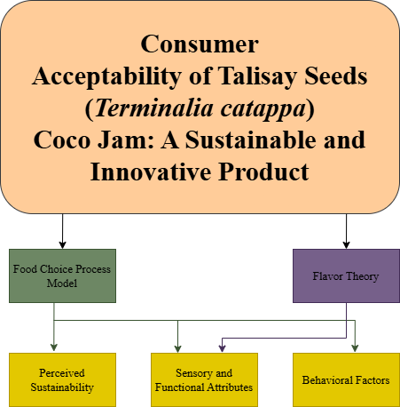
Figure 1. Theoretical Paradigm
CONCEPTUAL FRAMEWORK
OUTPUT
PROCESS
INPUT
Consumer Acceptability of Talisay Seeds (Terminalia catappa) Coco Jam: A Sustainable and Innovative Product
- Planning
- Preparation of the desired product.
- Finding/Selec-tion of Respondents
- Analysis and Verification of the Data Gathered.
- Talisay Seeds
- Tools, Equipment, and Ingredients.
- Survey Questionnaire

FEEDBACK

Figure 2. Conceptual Framework

CHAPTER III
METHODOLOGY

This chapter outlines the research methodology, including the geographical location of the study, the total number of participants, data sources, tools used for data collection, the questionnaire validation process, and the sampling method.
Research Design
The researchers employed a descriptive research design, which is suitable for this study as it aimed to assess the Consumer Acceptability of Talisay Seeds (Terminalia catappa) Coco Jam: A Sustainable and Innovative Product, focusing on attributes such as appearance, texture, aroma, and taste. Additionally, a survey questionnaire was utilized to collect data regarding the product's acceptability. This approach allowed for a comprehensive understanding of consumer perceptions and preferences, providing valuable insights that inform future product development and marketing strategies.
Research Procedure
The researchers employed a systematic approach which outlined the specific task would take to explore the Acceptability of Talisay Jam in food production. This included detailing the tools, equipment, and materials that will be utilized throughout the process, ensuring that each phase is clearly defined and replicable. By following a structured methodology, the study would be able to provide reliable insights into the acceptability and application of Talisay seeds in traditional recipes, ultimately contributing to food innovation and sustainability efforts.
Materials and Method
Tools, Equipment, and Ingredients
Food Weighing Scale
Food Processor
6 pcs Jar
2 cups of coconut milk
6 pcs/ 12g kalamay
½ kl brown sugar

Ingredients and Cost:
Table 1. Ingredients list their unit quantity, and price
List of Materials | Unit and Quantity | Price
- Kalamay | 6 pcs/12 grams | Php 15.00
- Brown Sugar | 500 grams | 50
- Talisay Seed | 50 grams. | -
- Coconut Milk | 4 cups | Php 60.00
- Jar | 3 pcs | Php 77.00
TOTAL | - | Php 202.00

Procedure:
- Crack the shell of the Talisay seed
- Wash the seed thoroughly
- In a heavy-bottomed saucepan, mix the coconut milk, kalamay, sugar together with Talisay seed paste and add a pinch of salt. Stir well until the sugar dissolves.
- Lower the heat to a simmer. Continue stirring frequently to prevent the mixture from sticking to the bottom and burning.
- Once the mixture reaches a thick, spreadable consistency (like jam) add the Talisay seeds and continue mixing for 1minute. Afterwards, remove it from the heat. The jam will thicken further as it cools.
- Transfer it into sterilized jars or containers. Seal tightly.
Shelf-life
Based on the ingredients and preparation process used—coconut milk, sugar (via kalamay), and Talisay seed —the Talisay Coco Jam resembled traditional coconut-based spreads or jams, which are relatively high in sugar. Sugar acted as a natural preservative by reducing water activity, which helped inhibit microbial growth. The estimated shelf-life of the product based on typical conditions are listed below:
Table 2. Shelf-life based on storage conditions
Storage Condition | Shelf-Life
Room Temperature (25–30°C) | 1–2 weeks (unopened, sterilized jar)
Refrigerated (4–8°C) | 1–2 months (opened or unopened)
Frozen (-18°C) | 3–4 months (best quality retention)

Storage Recommendations for Best Quality and Safety
- Before filling, jars should be sterilized by boiling in water for at least 10 minutes or using a hot oven (around 120°C for 15 minutes). Lids should also be sterilized, and the jam should be sealed while still hot to create a vacuum seal.
- Once opened, the jam should be kept in the refrigerator and consumed within 2–3 weeks for best quality.
- Always use a clean, dry spoon when scooping jam from the jar to prevent introducing bacteria or mold.
- Even under refrigeration, check regularly for signs of spoilage: off smell, mold, bubbling, or color change.
Research Locale
The study was conducted at Eastern Visayas State University Tanauan Campus, Tanauan Leyte. The location of the study is as shown below.

MAP

Research Respondents
Figure 3. Map of Eastern Visayas State University
The researchers selected thirty (30) respondents for the study who were students from Eastern Visayas State University, Tanauan Campus, specifically those who were enrolled in the Bachelor of Science in Hospitality Management and Bachelor of Science in Industrial Technology Major in Culinary Arts.
Research Instrument
The researchers constructed a survey questionnaire as an instrument to achieve the study's primary objective. The survey questionnaire was composed of three parts. Part 1 contained the respondent’s profile regarding age, sex, and classification. Part 2 was the level of acceptability of the products formulated in terms of appearance, texture, aroma, and taste. Participants selected the appropriate point on the scale that best describes their preferences. Part III contained the overall Acceptability. The sensory assessment and degree of acceptability scales were evaluated using a five-point Likert scale ranging from dislike very much (1) to like very much.
Ethical Guidelines
The study followed an ethical research guideline to ensure the protection of respondents’ rights, privacy, and respect of all participants. Written informed permission was acquired, describing the study's goal, benefits. Anonymization of identities and safe data storage ensured participant confidentiality. The survey ensured voluntary participation by giving respondents the option to answer or refuse without repercussions. The questionnaire was created intended to avoid sensitive or intrusive questions while establishing trust and transparency throughout the study process.

Data Gathering Procedure
For this study, the researchers obtained a letter from the research advisor, department head, and research course instructor to ask permission to survey the school premises. Upon approval of the letter the researchers conducted the survey at Eastern Visayas State University. The questionnaire included the age, and course program. Afterwards, validity and reliability study were done with 30 respondents which participated in the scale development study.
Method of Scoring
The data gathered were tabulated and interpreted to determine the Consumer Acceptability of Talisay Seeds (Terminalia catappa) Coco Jam: A Sustainable and Innovative Product. The ages of the respondents were categorized as follows: (M.d Emran Hossaim S.M Zabed Ahmed, 2016)

Table 3. Age Range and their description
Age Range | Description
19 – 21 | Early Adulthood
22 – 24 | Middle Adulthood
25 years old and above | Adult

To measure the acceptability level, the researcher used the following scale and interpretation.

Table 4. Mean Range and its respective qualitative description
Mean Range | Qualitative Description
4.21 – 5.00 | Highly Acceptable
3.41 – 4.20 | Acceptable
2.61 – 3.40 | Moderately Acceptable
1.81 – 2.60 | Less Acceptable
1.00 – 1.80 | Not Acceptable

Statistical Treatment of data
The data gathered from the respondents were carefully tabulated and organized. The data presented, analyze and interpreted with the use of percentage and weighted mean.
To determine the percentage of distribution of the respondents according to their profile, the following percentage distribution formula below were used.
Formula:
$$P=\frac{f}{n}×100$$
Where:
f = frequency of responses in each category.
n = total number of respondents.

To analyze the mean score of each item. The weighted mean formula below was used.

Formula:
$$\overline{Χ}= \frac{\sum{\left(f×x\right)}}{n}$$
Where:
f = frequency of each rating
x = scale point (1 to 5)
n = total number of respondents

The standard deviation was used to measure the variability or consistency of the respondents’ ratings.

SD= $\sqrt{\begin{aligned}∑{\left(x - \bar{x}\right)}^{2} \\ n\end{aligned}}$

Where:
$x=$ individual score
$\overline{x}=$ mean score
$n=$ total number of respondents

CHAPTER IV
PRESENTATION, ANALYSIS, AND INTERPRETATION OF DATA
This chapter provides the presentation, interpretation and analysis of data from the product tasting of Talisay Coco Jam conducted among respondents of the study.
Table 5. Age of the Respondents
Age Range | Frequency | Percentage
16- 18 | 4 | 13.33
19 - 21 | 13 | 43.33
22-25 | 13 | 43.33
Total: | 30 | 100

Figure 4. Visual Representation of the Age of the Respondents

Table 5 and figure 4 show the age distribution of the 30 respondents who took part in the sensory evaluation of Talisay Coco Jam. The responders of (43.33%) were between the ages of 19-21 and 22-24, which were considered early and middle adulthood. A lower proportion (13.33%) were aged 16 to 18, indicating late adolescence.
Table 6. Course Program of the Respondents
Course Program | Frequency | Percentage
BSHM | 16 | 53.33
BIndTech | 14 | 46.67
Total: | 30 | 100

Figure 5. Visual Representation of the Course Program of the Respondents

Table 6 and figure 5 show the responders based on their academic program. Out of 30 total participants, 16 (53.33%) were from the Bachelor of Science in Hospitality Management (BSHM) program, and 14 (46.67%) were from the Bachelor of Industrial Technology (BINDTECH) program. This almost even distribution guarantees a fair representation of opinions from students with relevant culinary arts and technical backgrounds, which improved the acceptance evaluation's validity.

Table 7. Sex Profile of the Respondents
Sex | Frequency | Percentage
Female | 17 | 56.66
Male | 13 | 43.33
Total: | 30 | 100

Figure 6. Visual Representation of the Sex Profile of the Respondents

Table 7 and figure 6 present the distribution of respondents according to sex. Out of the 30 individuals who participated in the sensory evaluation of Talisay Coco Jam, 17 were female (56.67%) and 13 were male (43.33%). This indicated a slightly higher representation of female respondents in the study. The balanced participation from both sexes ensures that the feedback reflected a range of perspectives and enhanced the reliability of the acceptability assessment across gender lines.

Table 8. Acceptability of Talisay (Terminalia catappa) Jam in terms of Appearance

Statement | Weighted Mean | Standard Deviation (SD) | Description
Appearance (Color, visual, appeal, and presentation of the jam) | 4.67 | 0.47 | Highly  Acceptable

Figure 7. Visualized Tally of the Respondents’ answers regarding the Product’s Appearance

Table 8 and figure 7 show that with a weighted mean of 4.67 and a standard deviation of 0.47, the look of the Talisay Coco Jam was judged extremely satisfactory. Respondents praised the product's visual attractiveness, particularly its color and uniformity. The comparatively low standard deviation suggested that it received continuous good comments on its look.

Table 9. Acceptability of Talisay (Terminalia catappa) Jam in terms of
Texture

Statement | Weighted Mean | Standard Deviation (SD) | Description
Texture (Mouthfeel and consistency of the jam.) | 4.20 | 0.41 | Acceptable

Figure 8. Visualized Tally of the Respondents’ answers regarding the Product’s Texture

Table 9 and figure 8 show that sensory evaluation of the coco jam suggested a generally positive response from the responders. The texture, which relates to the jam's mouthfeel and consistency, obtained a weighted mean score of 4.20 with a low standard deviation of 0.41, indicating that most assessors thought the texture was consistently satisfactory and pleasant. This means that the jam's consistency is smooth and appealing, meeting customer expectations.
Table 10. Acceptability of Talisay (Terminalia catappa) Jam in terms of Aroma

Statement | Weighted Mean | Standard Deviation (SD) | Description
Aroma (Fragrance and Smell of the product) | 4.70 | 0.53 | Highly Acceptable

Figure 9. Visualized Tally of the Respondents’ answers regarding the Product’s Aroma
Table 10 and figure 9 indicate that the aroma of the product had a weighted mean of 4.70 and a standard deviation of 0.53. This result suggested that many respondents thought the jam smelled good. Although responses vary significantly more than taste, the overall agreement indicated a high liking for the product's aroma.

Table 11. Acceptability of Talisay (Terminalia catappa) Jam in terms of
Taste

Statement | Weighted Mean | Standard Deviation (SD) | Description
Taste (Sweetness, balance of flavors, and overall palatability. | 4.80 | 0.40 | Highly Acceptable

,,

Figure 10. Visualized Tally of the Respondents’ answers regarding the Product’s Taste

Table 11 and figure 10 further indicate that the Talisay Coco Jam scored the highest rating for taste, with a weighted mean of 4.80 and a standard deviation of 0.40, suggesting that most respondents regarded the flavor to be very good. The low SD indicated a high level of agreement among the assessors, confirming that the product's flavor is its most appealing feature.
The overall acceptability of Talisay Coco Jam, based on the sensory evaluation conducted with 30 respondents from Eastern Visayas State University – Tanauan Campus, can be described as highly acceptable.
Taste received the highest rating with a weighted mean of 4.80, falling in the “Highly Acceptable” range. Taste is often the most decisive factor in overall product satisfaction, making this score particularly significant.
Aroma was also rated highly, with a mean of 4.70, indicating that the product's fragrance was very well received by participants.
Appearance followed with a mean of 4.67, suggesting that the visual presentation, including color and consistency, was visually appealing and attractive to consumers.
Texture, though slightly lower, still scored a mean of 4.20, which falls under the “Acceptable” range, indicating that the product’s consistency and mouthfeel were generally satisfactory, but could be improved slightly.
Considering the consistent high scores across all sensory attributes, especially taste, aroma, and appearance—the Talisay Coco Jam is deemed highly acceptable overall. The product demonstrated strong potential for consumer approval, particularly among young adults with culinary backgrounds. Its incorporation of Talisay seeds not only contributed to its unique and enjoyable flavor, but also aligned with current trends in sustainable and locally sourced food products.

Table 12. Overall Acceptability
Sensory Attributes | Weighted Mean | Description
Appearance | 4.67 | Highly Acceptable
Texture | 4.20 | Acceptable
Aroma | 4.70 | Highly Acceptable
Taste | 4.80 | Highly Acceptable
Overall Acceptability | 4.59 | Highly Acceptable
Figure 12. Overall Acceptability

The overall mean of 4.59 indicates that the Talisay Coco Jam is highly acceptable, with taste having the highest rating and texture having the lowest but still within the acceptable range.

CHAPTER V
SUMMARY, CONCLUSION, AND RECOMMENDATIONS
Summary
The study intended to assess Consumer Acceptability of Talisay Seeds (Terminalia catappa) Coco Jam: A Sustainable and Innovative Product. The study is set by having its locale and respondents from Eastern Visayas State University – Tanauan Campus. The objective of the study is to provide answers to the following questions:
- To determine the profile of the respondents in terms of:
  - Age
  - Sex
  - Classifications
- To determine the level of acceptability of the products formulated in terms of:
  - Appearance
  - Texture
  - Aroma
  - Taste
- To determine the overall acceptability of Talisay Coco Jam
Findings
The study sought to determine the acceptability of Talisay Coco Jam, a spreadable product incorporating Talisay (Terminalia catappa) seeds, among students of Eastern Visayas State University – Tanauan Campus. A total of 30 respondents participated in the sensory evaluation. The demographic profile revealed that the majority of respondents fell within the age range of 19 to 21 years old and 22 to 25. Specifically, Ages 19 to 21 and 22 to 25 were tied –both having 13 participants, the rest of the respondents then falls between 22 to 25 years of age. This age range indicates that the feedback primarily reflects the preferences and perceptions of young adults, most of whom are in their college years. In terms of gender, the sample consisted of 13 males and 17 females, suggesting a fairly balanced distribution, although slightly more females participated. Regarding their academic programs, 15 students were enrolled in the Bachelor of Science in Hospitality Management and the remaining 15 in the Bachelor of Industrial Technology major in Culinary Arts, ensuring that the responses came from individuals with relevant educational backgrounds and likely exposure to food and product evaluation.
In terms of sensory attributes, the results indicated a highly favorable reception of the product. For appearance, 19 respondents rated the product as “Very Much Acceptable,” and the remaining 11 rated it as “Acceptable.” This strong positive reception suggests that the visual presentation, including the color and uniformity of the jam, met or exceeded the expectations of most participants. The calculated weighted mean was 4.67, which falls under the “Highly Acceptable” category, indicating a strong consensus regarding the product’s visual appeal.
For texture, 24 respondents rated it as “Very Much Acceptable,” while 6 rated it as “Acceptable.” This resulted in a weighted mean of 4.20, which corresponds to the “Acceptable” category. While the rating is positive, it also suggests that there is slightly more room for improvement in terms of the product’s mouthfeel and consistency compared to the other sensory dimensions. The relatively lower mean (although still high) and low standard deviation imply that while the texture was well-received, it was not quite as exceptional as other attributes.
Regarding aroma, 22 respondents rated it “Very Much Acceptable,” 7 rated it “Acceptable,” and 1 rated it “Moderately Acceptable.” The weighted mean for aroma was 4.70, placing it under “Highly Acceptable.” This indicates that most respondents found the scent of the product appealing and pleasing, which is an important factor in consumer acceptability, especially for food products where aroma significantly influences perceived flavor.
The attribute that received the highest rating was taste, where 24 respondents rated it “Very Much Acceptable” and 6 as “Acceptable,” resulting in a weighted mean of 4.80. This high score indicates that the flavor of the jam, including its sweetness and the balance of ingredients, was well appreciated. Taste is often the most critical component in food acceptability, and the strong performance in this category indicates that the product is likely to succeed in a broader market.
Conclusion
Based on the data collected and analyzed from sensory evaluations, the study concluded that the Talisay Coco Jam is generally well accepted by the target population, which comprises young adult students from culinary and hospitality management programs. The findings revealed that the product scored “Highly Acceptable” in most sensory categories, particularly in taste, aroma, and appearance. These attributes are critical in determining a product's marketability and consumer preference, especially in the food industry where first impressions and flavor play a central role in consumer decision-making.
The data revealed that respondents found the product visually appealing, aromatic, and flavorful, which strongly supports the hypothesis that Talisay seed can be used successfully as a substitute or complementary ingredient in traditional coco jam. The slight decline in the score for texture, while still within the acceptable range, suggests that this area might benefit from slight refinement. Nonetheless, the jam’s consistency was still regarded positively, indicating it does not pose a barrier to consumer acceptance.
Furthermore, the favorable reception among respondents indicates a readiness of the younger demographic to embrace innovative, sustainable, and locally sourced food products. Given that the respondents are from academic programs focused on culinary and hospitality fields, their feedback carries added weight in evaluating the product’s potential for industry adoption and consumer market acceptance. These conclusions demonstrated that Talisay seeds, which are often overlooked and underutilized, hold considerable promise as ingredients for sustainable food innovations.
Recommendations
Based on the findings and conclusions of the study, several recommendations are proposed to further improve the product and support its potential for wider market adoption:
- While the texture of the Talisay Coco Jam was deemed acceptable, this aspect received the lowest rating among the four sensory parameters. Therefore, the researchers recommend revisiting the formulation and preparation method to achieve a more consistent and smoother texture. This might involve experimenting with different grinding or emulsifying techniques for the Talisay seed paste or adjusting cooking times and ingredient ratios.
- In order to ensure the broader applicability and generalizability of the findings, it is recommended that future research includes a larger and more diverse group of respondents beyond the university setting. Involving participants from different age groups, backgrounds, and regions can provide more comprehensive insights into market preferences and enhance the external validity of the results. Additionally, this could help identify consumer segments that are most receptive to the product.
- As a way to increase consumer interest and cater to diverse palates, it is recommended to develop flavored variants of Talisay Coco Jam. Some potential flavor enhancements could include Vanilla or cinnamon for aroma enhancement, Calamansi or lemon zest for a citrusy twist, Spicy or savory versions for gourmet markets.
- The product's unique selling proposition—its use of Talisay seeds, a sustainable and underutilized ingredient—should be emphasized in future brandings and marketing efforts. Marketing campaigns should highlight the health benefits, cultural relevance, and environmental advantages of using local ingredients like Talisay. Engaging storytelling, product demonstrations, and sampling could help foster consumer interest and acceptance.
- Future researchers and food entrepreneurs are encouraged to explore additional applications of Talisay seeds in various food products. Given the positive reception of this initial application in coco jam, it is likely that the seed's versatility and nutritional value can be harnessed in other forms, such as nut spreads, energy bars, baked goods, or beverages. This would not only promote sustainable food development but also help establish Talisay seeds as a mainstream food resource.
- Encourage sustainable sourcing by partnering with local communities to collect, process, and supply Talisay seeds. This not only supports the local economy, but also strengthens the sustainability narrative of the product—an appealing angle for modern consumers.

APPENDICES

Appendix A: Approval Letter for Survey Questionnaire



Appendix B: Request for Validation of Research Survey Questionnaire



Appendix C: Research Adviser Request



Appendix D: Survey Questionnaire

Survey Questionnaire

- Profile

Direction: Please Give the needed Information
Age: _________
Course Program: _________

- Level of Acceptability of Talisay Coco Jam
Direction: Please rate the product based on the following sensory attributes using the scale below.
5- Very Much Acceptable
4- Acceptable
3- Moderately Acceptable
2- Less Acceptable
- Not Acceptable

Sensory Attributes | 5-Very Much Acceptable | 4-Acceptable | 3 Moderately Acceptable | 2-Less Acceptable | 1-Not Acceptable
Texture (Mouthfeel and consistency of the jam)
Taste (Sweetness, balance of flavors, and overall palatability)
Aroma (Fragrance and smell of the product)
Appearance (Color, visual appeal, and presentation of the jam)

Part III: Overall Acceptability

Overall Acceptability | 5-Very Much Acceptable | 4-Acceptable | 3 Moderately Acceptable | 2-Less Acceptable | 1-Not Acceptable
How would you rate the overall acceptability of Talisay Coco Jam?

Appendix E. Certificate of Language

 | EASTERN VISAYAS STATE UNIVERSITY  Tacloban City
 | UNDERGRADUATE STUDENT RESEARCH MANUAL | Control No | EVSU-XXX-F13
 | UNDERGRADUATE STUDENT RESEARCH MANUAL | Revision No | 00
 | Subject:  CERTIFICATE OF LANGUAGE  EDITING | Date | JULY 10, 2024
 | Subject:  CERTIFICATE OF LANGUAGE  EDITING | Page | 1 of 1

Date: MAY 14, 2026

 | Business Plan |  | Feasibility Study
Paper Type: Thesis Capstone
Project
Name of Student Researcher(s): Student No:
- _______________________________________ _________
- ________________________________________ _________
- ________________________________________ _________
- ________________________________________ _________
- ________________________________________ _________

This is to certify that the paper entitled
“________________________________________________________________________
_________________________________________________________________________ ________________________________________________________________________,” has been edited for grammar, mechanics and language effectiveness.
Issued this 09th day of AUGUST (month) 2025 (year) at Eastern Visayas State University Tanauan (Campus)


Certified by:

__

_

RICAH JOYCE T. OÑAS
, LPT

__

_

____

Language Editor
(Contact details of Language Editor)
Note: For Contracted Language Editor use only

Appendix F: Documentation

DOCUMENTATION

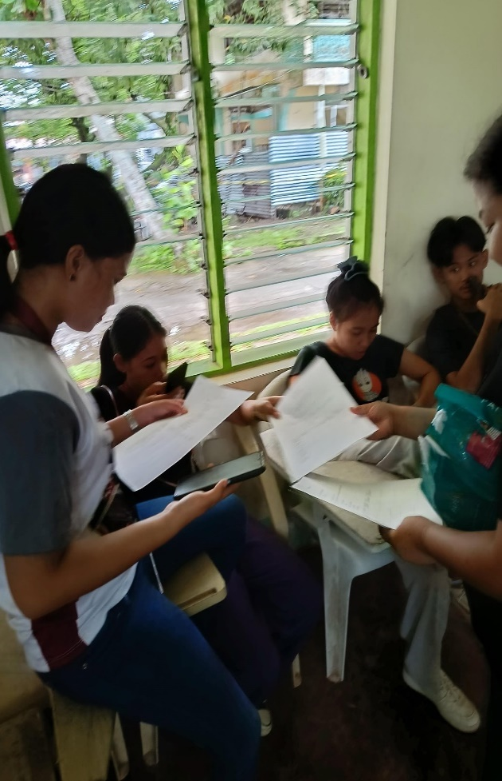

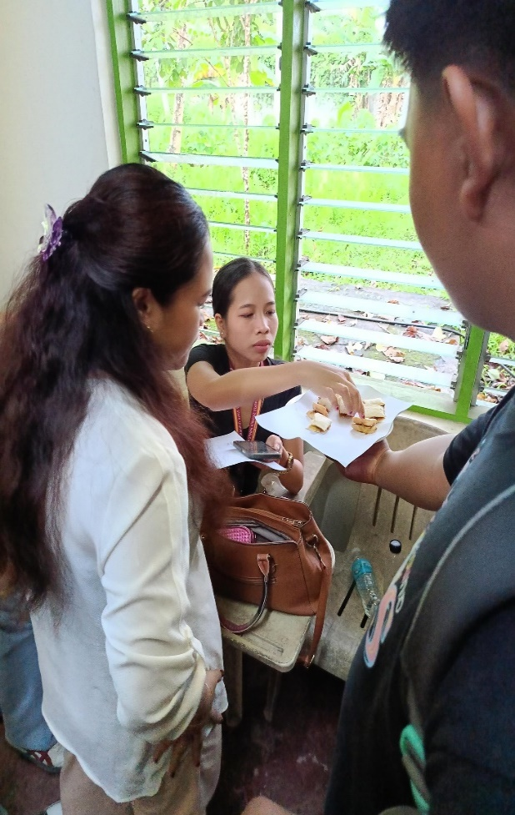


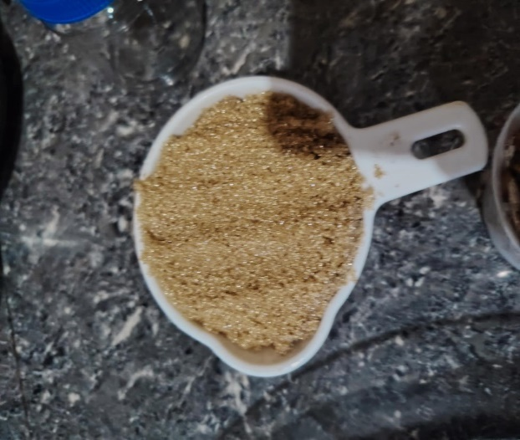
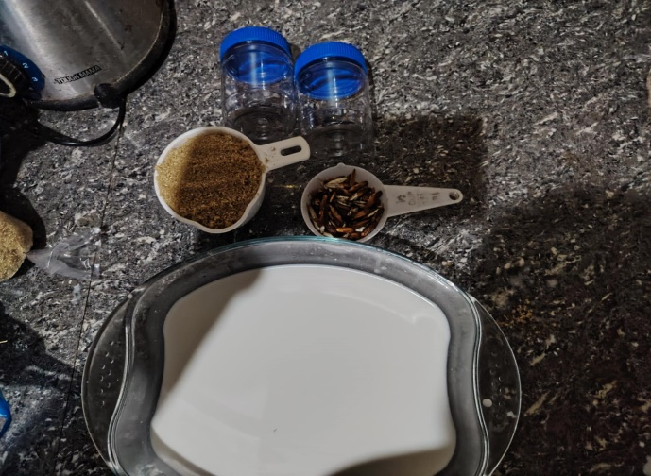


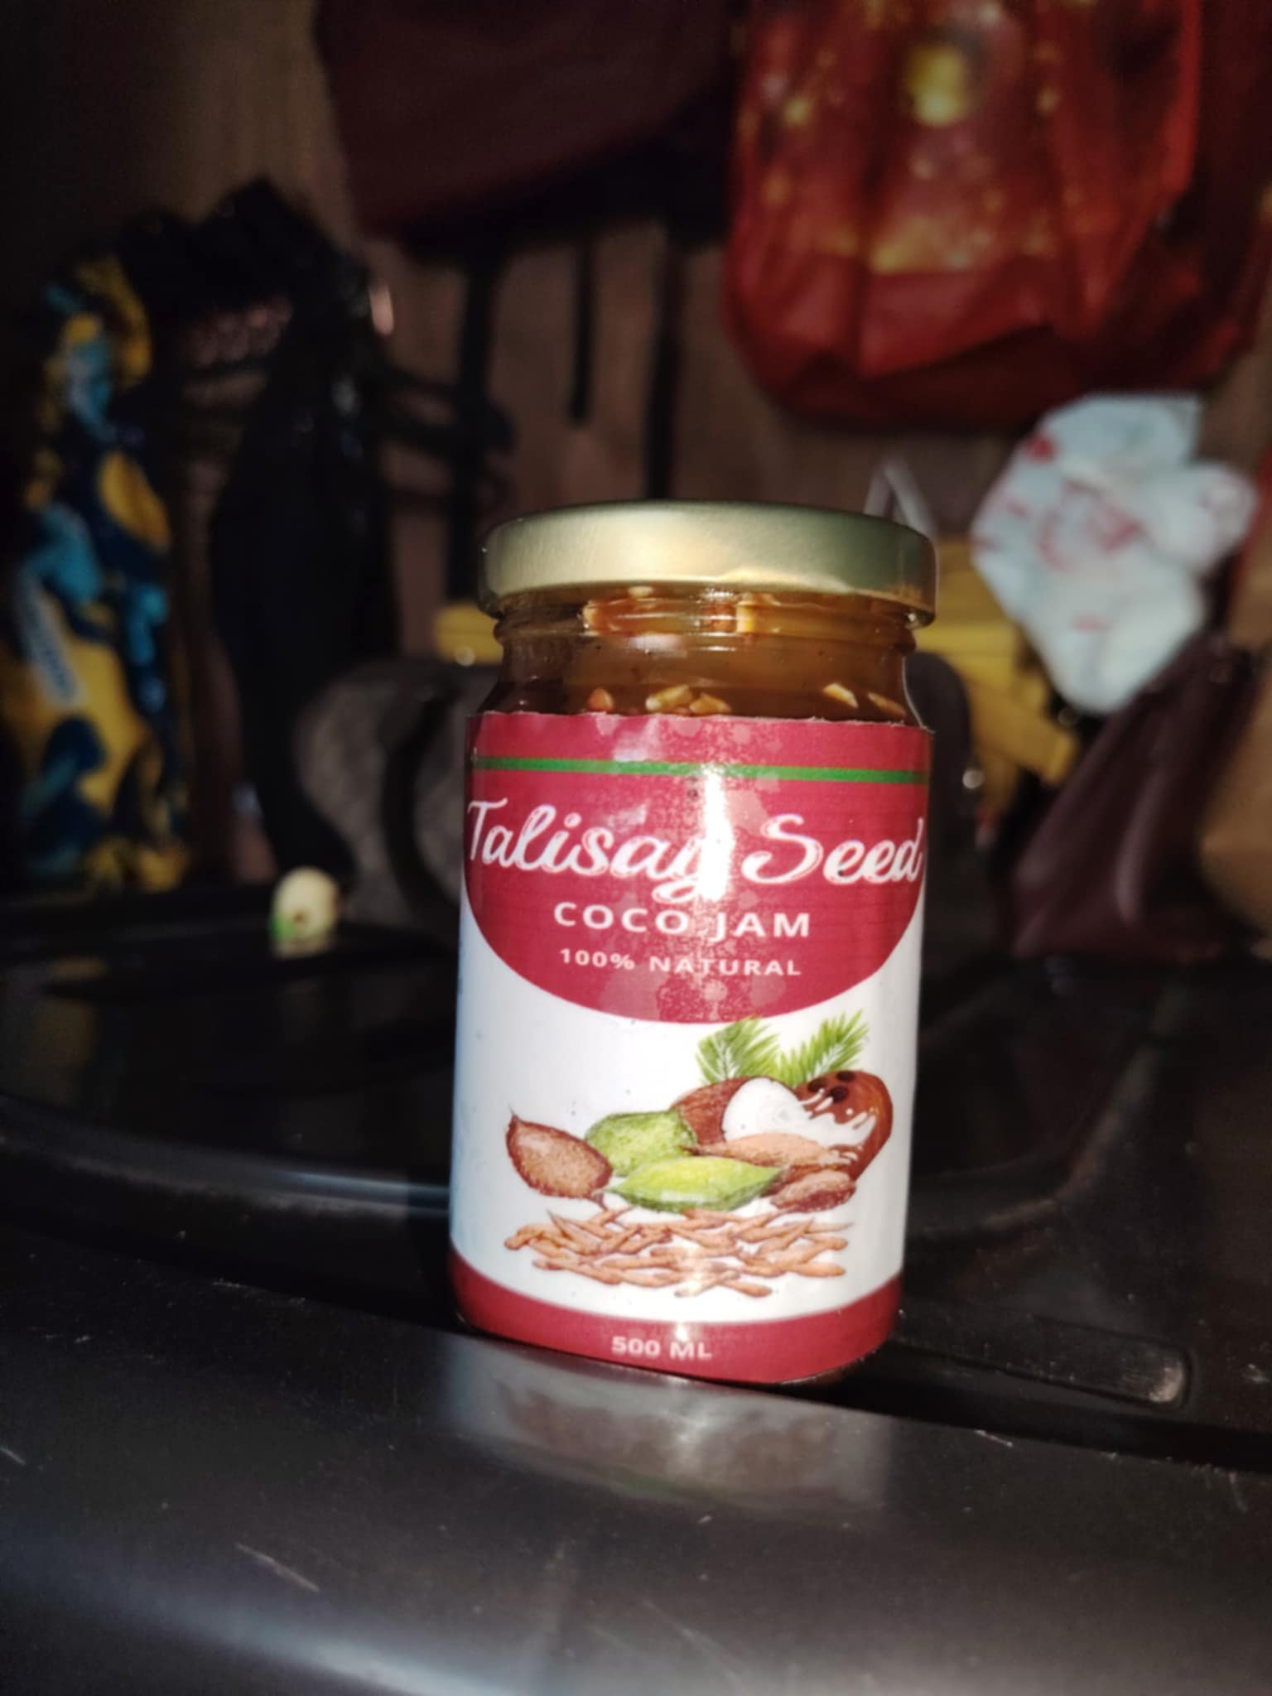

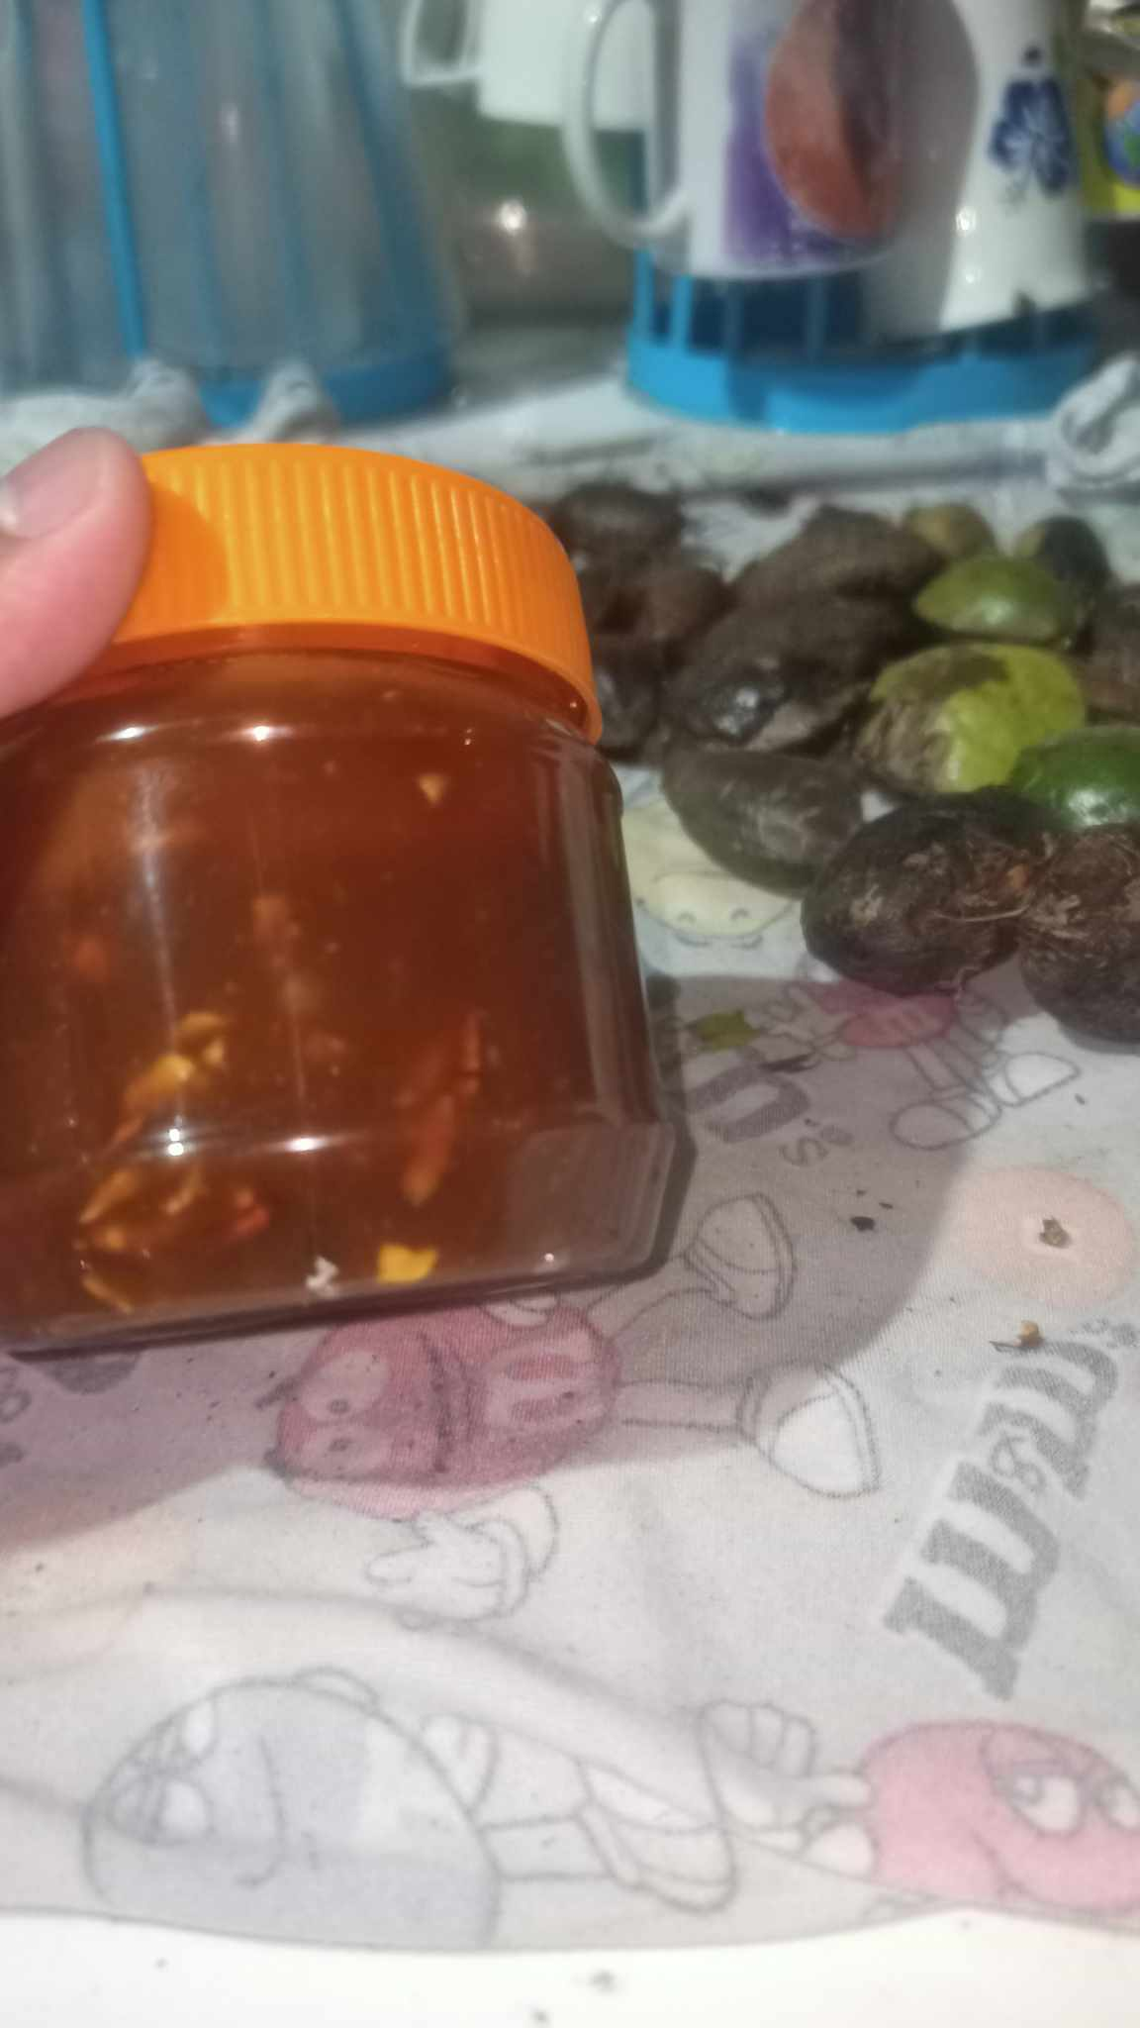

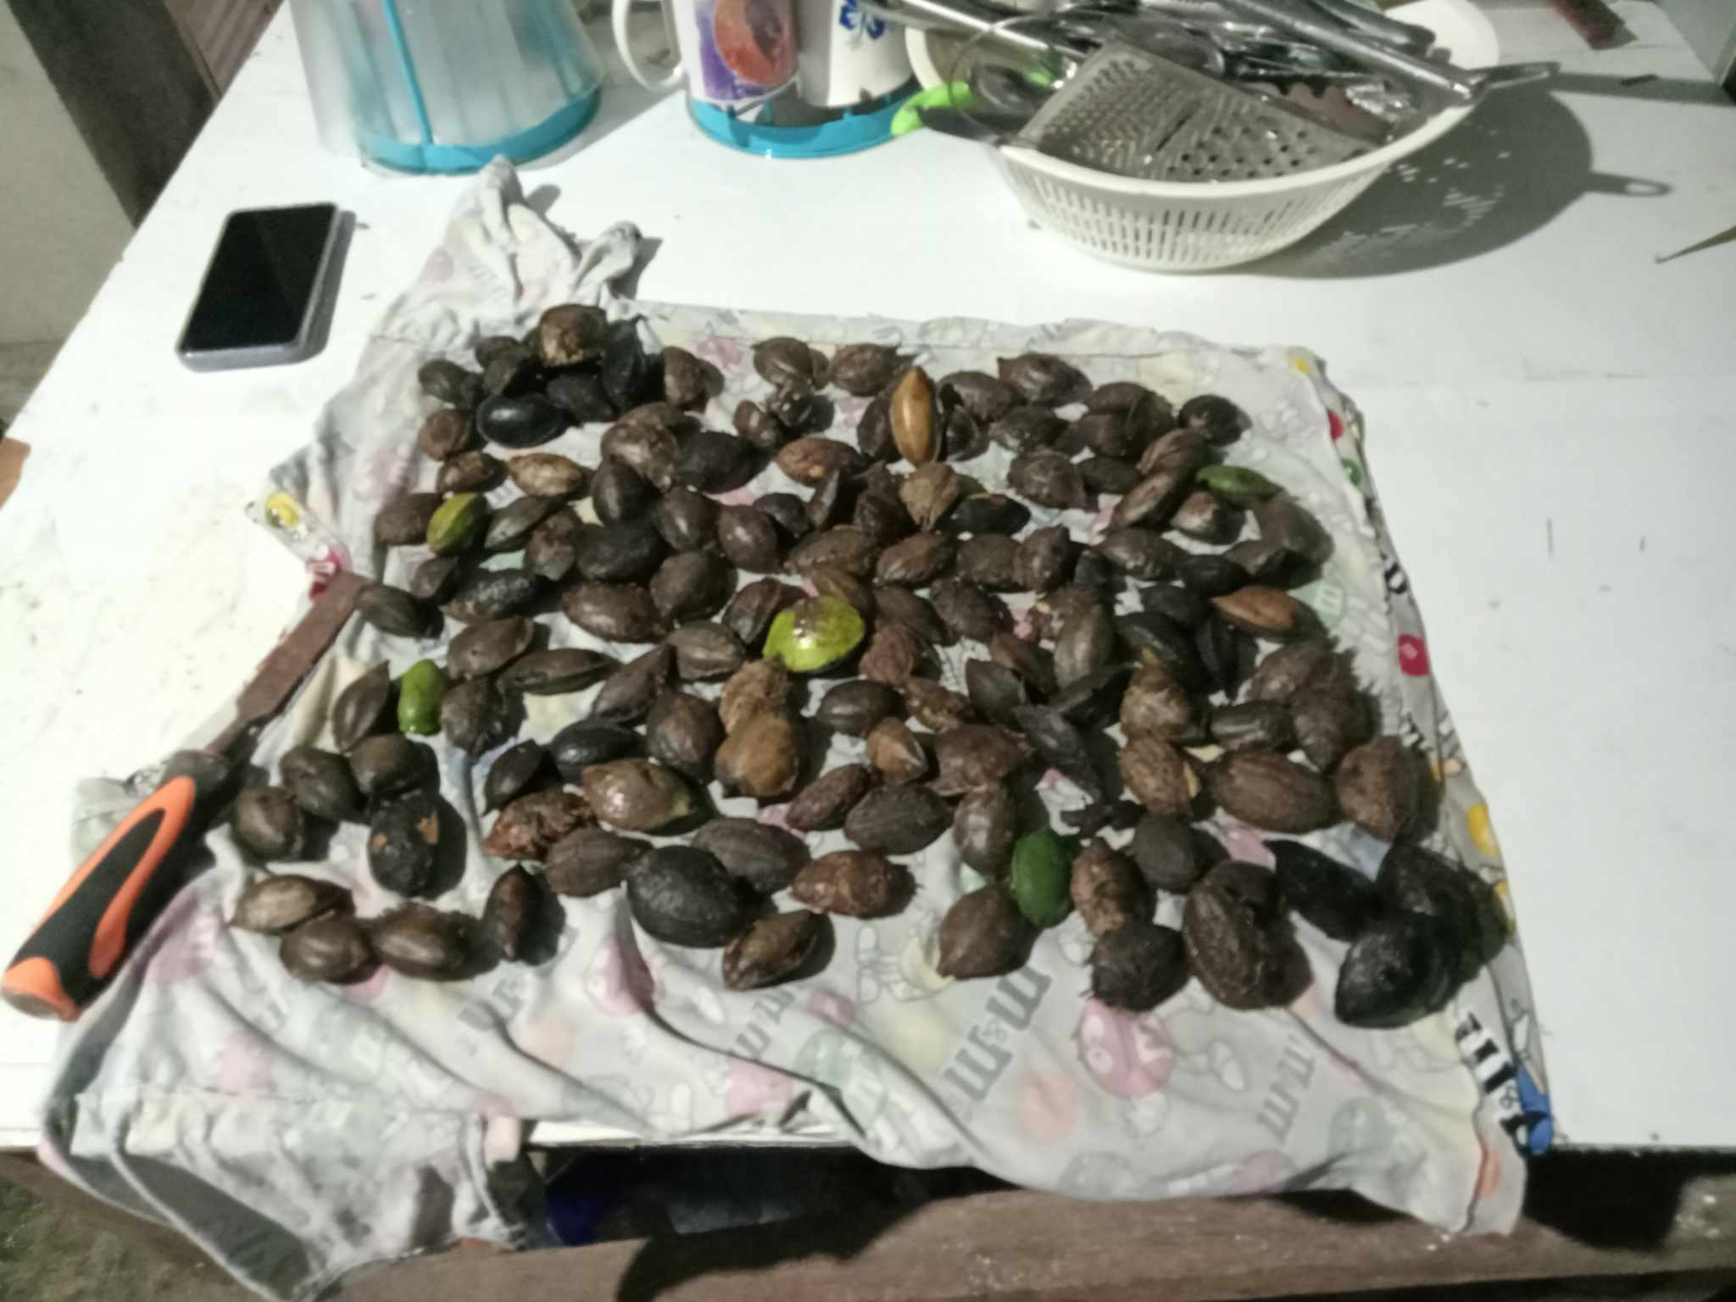



Appendix G: Curriculum Vitae


CURRICULUM VITAE

Name: Mary Rose C. Catan
Address: Brgy. Canramos, Tanauan, Leyte
Cellphone Number: 0936-207-4340
Email: ashecatan6@gmail.com

PERSONAL DATA
Nationality: Filipino
Religion: Roman Catholic
Sex: Female
Marital Status: Single
Date of Birth: March 11, 2004
Place of Birth: Canramos, Tanauan, Leyte

EDUCATIONAL BACKGROUND

Tertiary:
Eastern Visayas State University – Tanauan Campus
Tanauan, Leyte
2022 – Present
Secondary:
Tanauan National High School
Tanauan, Leyte
2016 – 2022
Primary:
Tanauan II Central School
Tanauan, Leyte
2010 – 2016


CURRICULUM VITAE

Name: Roniel O. Lastimado
Address: Brgy. Capangihan Tolosa, Leyte
Cellphone Number: 09918270281
Email: lastimadoroniel1@gmail.com
PERSONAL DATA
Nationality: Filipino
Religion: Roman Catholic
Sex: Male
Marital Status: Single
Date of Birth: October 17, 2003
Place of birth: Caritas Pampangga
EDUCATIONAL BACKGROUND
Tertiary:
Eastern Visayas State University -Tanauan Campus
Tanauan Leyte
2022 - Present
Secondary:
Tolosa National High School
Tolosa Leyte
2016 - 2022
Primary:
Capangihan Elemantary School
Tolosa Leyte
2010 - 2016


CURRICULUM VITAE

Name: Reciel Batulan Miranda
Address: Cabuynan Tanauan, Leyte
Cellphone Number: 09050349524
Email: recielmiranda29@gmail.com

PERSONAL DATA
Nationality: Filipino
Religion: Born Again Christian
Sex: Female
Marital Status: Single
Date of Birth: January 29, 2003
Place of Birth: Tanauan, Leyte

EDUCATIONAL BACKGROUND
Tertiary:
Eastern Visayas State University – Tanauan Campus
Tanauan, Leyte
Secondary:
Tanauan School of Craftsmanship and Home Industry
Canramos Tanauan, Leyte
2017-2021
Primary:
Cabuynan Elementary School
Cabuyan Tanauan, Leyte
2009-2016

CURRICULUM VITAE

Name: Lelan Mark R. Go
Address: Brgy. Aslum, Julita Leyte
Cellphone No: 09105780618
Email: golelan34@gmail.com
PERSONAL DATA
Nationality: Filipino
Religion: Roman Catholic
Sex: Male
Marital Status: Single
Date of Birth: May 10, 2004
Place of birth: Julita Leyte

EDUCATIONAL BACKGROUND
Tertiary: Eastern Visayas State University -Tanauan Campus
Tanauan Leyte
2022 - Present
Secondary: Tolosa National High School
Tolosa Leyte
2016 - 2022
Primary: Aslum Elementary School Tabon-Tabon Leyte
2010 – 2016


CURRICULUM VITAE

Name: Janine Banola
Address: Brgy. Santo Nino Tanauan Leyte
Cellphone No: 09940151828
Email: janinebanola19@gmail.com
PERSONAL DATA
Nationality: Filipino
Religion: Roman Catholic
Sex: Female
Marital Status: Single
Date of Birth: Decemeber, 22 2003
Place of birth: Albay
EDUCATIONAL BACKGROUND
Tertiary: Eastern Visayas State University -Tanauan Campus
Tanauan Leyte
2022 - Present
Secondary: Tanauan National Highschool
Tanauan Leyte
2016 - 2022
Primary: Santo Nino De Tanauan Leyte School For Basic ducation Inc
2010 - 2016

REFERENCES
‌Abaya, D. (2022, July 17). Development of Talisay (Terminalia catappa) Butter
[Review of Development of Talisay (Terminalia catappa) Butter]. Https://Etcor.org/Book-Publications; ETCOR Educational Research Center. https://etcor.org/storage/iJOINED/Vol.%20I(3),%2039-44.pdf
Biego, G. H. M., Konan, A. G., Douati, T. E., & Kouadio, L. P. (2012). Physicochemical
quality of kernels from Terminalia catappa L. and sensory evaluation of the concocted kernels. Sustainable Agriculture Research, 1(2), 1–6. https://doi.org/10.5539/sar.v1n2p1
Carpio Chrishamay C, Ann, Novie, Ma., Vhince, M., Sanogal Joylyn C, Marie,
Rojannie, M., & Venecio Zoe M. (2022). Talisay Tree (Terminalia Catapa) Nut Spread. IC-ITECHS, 3(1), 127–137. https://jurnal.stiki.ac.id/IC-ITECHS/article/view/782
Christian, A., & Mark E. Ukhun. (2006). Nutritional Potential of the Nut of Tropical
Almond (Terminalia Catappia L.). Pakistan Journal of Nutrition, 5(4), 334–336. https://doi.org/10.3923/pjn.2006.334.336
‌Damayanti, A., Bahlawan, Z. A. S., Putri, A., Salwa, D. F., & Nurjaya, N. (2022).
Terminalia catappa Linn Seed Yogurt with Honey Substitution for Food Security. IOP Conference Series: Earth and Environmental Science, 1105(1), 012033. https://doi.org/10.1088/1755-1315/1105/1/012033Hamed Taherdoost. Validity and Reliability of the Research Instrument; How to Test the Validation of a Questionnaire/Survey in a Research. International Journal of Academic Research in Management (IJARM), 2016, 5. hal-02546799⟩
Janporn, S., Ho, C.-T., Chavasit, V., Pan, M.-H., Chittrakorn, S., Ruttarattanamongkol,
K., & Weerawatanakorn, M. (2015). Physicochemical properties of Terminalia catappa seed oil as a novel dietary lipid source. Journal of Food and Drug Analysis, 23(2), 201–209. https://doi.org/10.1016/j.jfda.2014.06.007
‌Madel Tamiok, Nilnilsen Makiling, & Goles, C. (2024). Acceptability of Indian Almond
Terminalia catappa as Bitter Chocolate. EDUCATUM Journal of Science, Mathematics and Technology, 11(2), 72–83. https://doi.org/10.37134/ejsmt.vol11.2.8.2024
Ntube, N., Bassey, C. I., & Ogugua, V. N. (2022). Nutritional and antinutritional
evaluation of the pulp and seed of Terminalia catappa L. (tropical almond) fruit and physicochemical properties of its seed oil. International Journal of Biological and Chemical Sciences, 16(5), 2251–2264.
Reyes, P., & Gonzales, M. (2020). Isolation and Identification of Starch from Terminalia
catappa (Talisay) Fruit: A Potential Substitute for Commercial Flour. https://research.lpubatangas.edu.ph/wp-content/uploads/2020/06/Reyes-and-Gonzales-Test-Engineering.pdf
Thomson, L., & Evans, B. (2006). Terminalia catappa (tropical almond).
https://www.doc-developpement-durable.org/file/Culture/ArbresFruitiers/FICHES_ARBRES/badamier/Terminalia%20catappa.pdf
‌‌Singh, M., Parmar, F., & Solanki, H. (2023). TROPICAL ALMOND: THE VALUABLE
TREE. Vidya: A Journal of Gujarat University, 2(2), 348–353. https://doi.org/10.47413/vidya.v2i2.290
S. Samarasinghe, Chandimala, U. R., & D. Gunathilake. (2022). Development of a
Plant-based Milk Using Tropical Almond (Terminalia catappa L.) Nuts. Annual Research Session Faculty of Technology, Eastern University of Sri Lanka. https://www.researchgate.net/publication/368788862_Development_of_a_Plant-based_Milk_Using_Tropical_Almond_Terminalia_catappa_L_Nut

