Title Page
Case Report
Removal of Retained Broken Distal Femoral Nail Using a Corkscrew in a Resource-Constrained Setting. A Case Report.
Okwara, Blasius Okechukwu^{1,2}, Duru, Ndubuisi Ebere³, Eze, Chinonso Blessing⁴, Ugbala, Amaechi^{5,6}, Jacob, Joy Nkeiruka⁷, Obiako, Benjamin Chukwudi^{2,3}, Okwara, Anulika Perpetua O⁸, Okonkwo, Chukwuebuka Augustine¹
Running Title: Corkscrew Technique for Broken Femoral Nail Removal.

¹Department of Orthopaedics and Trauma, University of Nigeria Teaching Hospital, Ituku/Ozalla, Enugu, Nigeria.
²Department of Surgery, Godfrey Okoye University, Enugu, Nigeria.
³Department of Orthopaedics, National Orthopaedic Hospital, Enugu, Nigeria.
⁴Department of Plastic and Reconstructive Surgery, National Orthopaedic Hospital, Enugu, Nigeria.
⁵Division of Plastic Surgery, Department of Surgery, Alex Ekwueme University Teaching Hospital, Abakaliki, Ebonyi State, Nigeria,
⁶Department of Surgery, Alex Ekwueme University, Ndufu-Alaike, Ikwo, Ebonyi State, Nigeria,
⁷Department of Nursing Sciences, Southern Delta University, Ozoro, Delta State, Nigeria.
⁸Department of Nursing Services, National Orthopaedic Hospital, Enugu, Nigeria.

Authors Affiliation
Dr. Okwara, Blasius Okechukwu (PhD/FWACS)
Consultant Orthopaedic Surgeon/Senior Lecturer.
Department of Orthopaedics and Trauma, University of Nigeria Teaching Hospital, Ituku/Ozalla, Enugu, Nigeria/Department of Surgery, Godfrey Okoye University, Enugu, Nigeria.
blasiusokwara@yahoo.com
+2348035460636.

DR. Duru, Ndubuisi Ebere (FWACS)
Chief Consultant Orthopaedic Surgeon.
Department of Orthopaedics, National Orthopaedic Hospital, Enugu, Nigeria.
drneduru@yahoo.com
+2348033354924.
Dr. Eze Chinonso Blessing (FWACS)
Department of Plastic and Reconstructive Surgery, National Orthopaedic Hospital, Enugu, Nigeria.
ezerium1@gmail.com
+2348061131525
Dr. Ugbala, Amaechi (FWACS)
Consultant Plastic Surgeon/Lecturer 1
Division of Plastic Surgery, Department of Surgery, Alex Ekwueme University Teaching Hospital, Abakaliki, Ebonyi State, Nigeria/Department of Surgery, Alex Ekwueme University, Ndufu-Alaike, Ikwo, Ebonyi State, Nigeria.
ugbala.amaechi@gmail.com
+2348068178841.

Dr. Jacob, Joy Nkeiruka (PhD)
Lecturer 1
Department of Nursing Sciences, Southern Delta University, Ozoro, Delta State, Nigeria.
Joyjacob716@gmail.com
+2348133031220

Dr. Obiako, Benjamin Chukwudi (FWACS)
Consultant Orthopaedic Surgeon/Lecturer 1
Department of Surgery, Godfrey Okoye University, Enugu, Nigeria/ Department of Orthopaedics, National Orthopaedic Hospital, Enugu, Nigeria.
benjaminobiako@yahoo.com
+234806791179.
Mrs. Okwara, Anulika Perpetua (BNSc)
Assistant Chief Nursing Officer (Perioperative Nurse)
Department of Nursing Services, National Orthopaedic Hospital, Enugu, Nigeria.
blasiusokwara@gmail.com
+2348037738267.

Dr. Okonkwo, Chukwuebuka Augustine (MWACS)
Department of Orthopaedics and Trauma, University of Nigeria Teaching Hospital, Ituku/Ozalla, Enugu, Nigeria.
chuksokons@gmail.com
+2348038345165

Corresponding Author
Dr. Okwara, Blasius Okechukwu.
Department of Orthopaedics and Trauma, University of Nigeria Teaching Hospital, Ituku/Ozalla, Enugu, Nigeria/Department of Surgery, Godfrey Okoye University, Enugu, Nigeria.
blasiusokwara@yahoo.com
+2348035460636.

Abstract
Background:
Implant failure following intramedullary nailing of femoral shaft fractures, though uncommon, presents a significant surgical challenge, particularly when the distal fragment of a broken nail is retained within the medullary canal. Conventional extraction techniques are often technically demanding, may require specialized instruments, and can increase operative morbidity. This challenge is further amplified in resource-constrained settings where advanced tools may not be readily available.
Case Presentation:
We report the case of a 56-year-old male who presented with a 7-month history of right thigh pain, deformity, and abnormal mobility following previous surgical interventions for femoral shaft fracture. Radiographic evaluation revealed atrophic nonunion with broken intramedullary implants (Kuntscher nail and Rush pin). During surgery, conventional extraction techniques successfully removed the proximal components; however, the distal fragment proved difficult to retrieve. A corkscrew device, obtained from a hip arthroplasty set, was introduced into the lumen of the retained nail fragment, achieving secure purchase and enabling controlled extraction. This was followed by exchange intramedullary nailing and bone grafting.
Intervention:
Minimally invasive extraction of the retained distal nail fragment using a corkscrew technique, followed by definitive fixation with interlocking intramedullary nailing and autologous bone grafting.
Outcome:
Postoperative recovery was uneventful. The patient commenced early mobilization and progressed from non-weight bearing to full weight bearing by 12 weeks. Follow-up radiographs demonstrated satisfactory callus formation, and the patient reported resolution of pain, restoration of limb length, and return to functional ambulation.
Conclusion:
The corkscrew extraction technique is a simple, cost-effective, and minimally invasive method for removing retained distal fragments of broken intramedullary femoral nails. It is particularly valuable in resource-limited settings and should be considered a reliable alternative when conventional extraction methods fail.
Keywords: Intramedullary nail, femoral shaft fracture, implant failure, nonunion, corkscrew technique, resource-limited setting.
Introduction
Intramedullary nailing is widely regarded as the gold standard for the management of femoral shaft fractures due to its biomechanical stability and favourable healing outcomes (Brumback & Virkus, 2000). However, complications such as implant failure, including nail breakage, may occur, particularly in cases of delayed union, nonunion, or excessive mechanical stress (Wu, 1996; Mauffrey et al., 2016). Removal of a broken intramedullary nail, especially the distal fragment, is technically demanding due to limited access, bone ingrowth, and the absence of an accessible proximal end (Brewster et al., 1995; Hak & McElvany, 2008).
Various techniques have been described for the extraction of retained nail fragments, including the use of hooks, guide wires, custom extraction devices, and open surgical approaches (Whalley & Thomas, 2009). Many of these methods require specialized equipment or extensive surgical exposure, which may increase intraoperative risks such as blood loss, infection, and iatrogenic fracture (Hak & McElvany, 2008; Zhang et al., 2021).
The corkscrew extraction technique has emerged as a simple and reproducible method. By engaging the inner lumen of the broken nail fragment, the corkscrew provides firm anchorage, enabling controlled removal without extensive cortical disruption (Middleton & McNab, 1980; Sharma & Mahajan, 2013). This work discusses the principles, advantages, and clinical implications of using a corkscrew for the removal of broken intramedullary femoral nails.
Reporting Guideline
This case report was prepared in accordance with the CARE (CAse REport) guidelines.

Case Summary
A case of a 56-year-old male trader who presented with a 7-month history of right thigh pain. The pain was dull in nature, intermittent, non-radiating, associated with deformity, abnormal movement at the mid-thigh and abnormal gait. Pain worsens on walking over a long period of time and relieved by rest. He was ambulating with the aid of a walking stick.
He was involved in a road traffic accident about 7 years ago and sustained a closed right femoral shaft fracture. Initially he presented to a traditional bonesetter who managed him for 2 years with topical application of native medications, massaging and splinting.
He developed symptoms of non-union; deformity, abnormal movement and occasional pain at the right mid-thigh, hence, he presented to a private specialist hospital, where open reduction and internal fixation with intramedullary (Kuntschar) nail was done. He developed pain and abnormal movement at the fracture site 3 years post-surgery. X-ray of the affected limb revealed non-united femoral shaft fracture with implant failure. He presented to the same surgeon, who repeated the surgery, this time by inserting a rush pin inside the broken K-nail. Symptoms of pain, abnormal movement and abnormal gait persisted necessitating an X-ray of the affected thigh which revealed broken implants and non-union of the femoral shaft. He presented to our facility for expert care.
There was no history of prolonged use of steroids. There was no deformity or pain on the contra lateral limb. A known hypertensive diagnosed about 5 years prior to his presentation to our facility. He has been compliant with his medication. No history of alcohol or tobacco ingestion.
Examination revealed; a middle-aged man in no painful distress with stable vital signs. Musculoskeletal revealed limb length discrepancy with shortening of about 5 cm on the right lower limb. Real length and apparent length of right and left lower limbs were 76 and 79cm and 81 and 84cm respectively. The right femoral length was 37cm whereas left femoral length was 42cm. The lengths of both tibiae were equal. There was a longitudinal lateral incision scar on the right thigh and gluteus. There was also abnormal mobility on the right mid-thigh, with power of grade 4 on the right hip and power of grade 5 on both flexors and extensors of the right knee and ankle. Sensation and distal pulsations were intact. There was slight limitation of right hip flexion, otherwise, there were full ranges of motion on the hip, knee and ankle. The left lower limb was essentially normal. No deformity or tenderness on the spine and paraspinal region. There was no abnormality detected in any other system.

The diagnosis of non-union right femur with retained broken distal intramedullary nails was made. Blood parameters were within the normal range and urinalysis was also normal. The radiograph of right femur revealed non-union with broken intramedullary nails (K-nail and rush pin) as seen in figure 1. The removal of the broken nails was done with difficulty encountered in the removal of the distal broken part of the nails. Atrophic non-union right femoral shaft with broken rush pin and K-nail was finding intraoperatively. There was no sign of bone infection. The Rush pin and proximal fragment of the K-nail were removed using conventional nail extractor. The removal of the distal fragment proved difficult using the conventional nail extractor, several attempts were made without any appreciable success, even guide wire was tried for some time with no success. We tried the removal of the distal fragment using corkscrew from hip arthroplasty set after failed attempt with conventional nail extractor and guide wire. The dimensions of the corkscrew were six inches length, with a corkscrew diameter of half inch and a handle diameter of three-quarter inch. The pointed end of the corkscrew was introduced to the hollow/central canal of the nail. It was screwed in until it was snugly fitted in the nail. The corkscrew was gently pulled out with the retained distal fragment of the K-nail removed in the process. Antegrade exchange nailing with 380 by 11mm interlocking nail was done. Locking was achieved with two proximal screws and one distal screw. Bone grafts were packed at the fracture site. The total operative time was about five hours. Post operatively he was placed on antibiotics, analgesics, deep venous thrombosis prophylaxis and physiotherapy. He commenced non-weight bearing ambulation by the first day post-surgery with a pair of axillary crutches. He was discharged home on the 10th day post-surgery.
First post operative visit (6 weeks); post-surgery. He had commenced partial weight bearing. There was no pain at operation site nor limb length discrepancy. On Second post operative visit (12 weeks) post-surgery; he was clinically stable with radiograph check revealed callus formation at the fracture site as seen in fig 2.1 and fig.2.2. He was asked to commence full weight bearing. Figure 2: Post-operative radiograph after successful extraction and re-nailing. He was followed up till one year after the surgery without any problem encountered clinically.

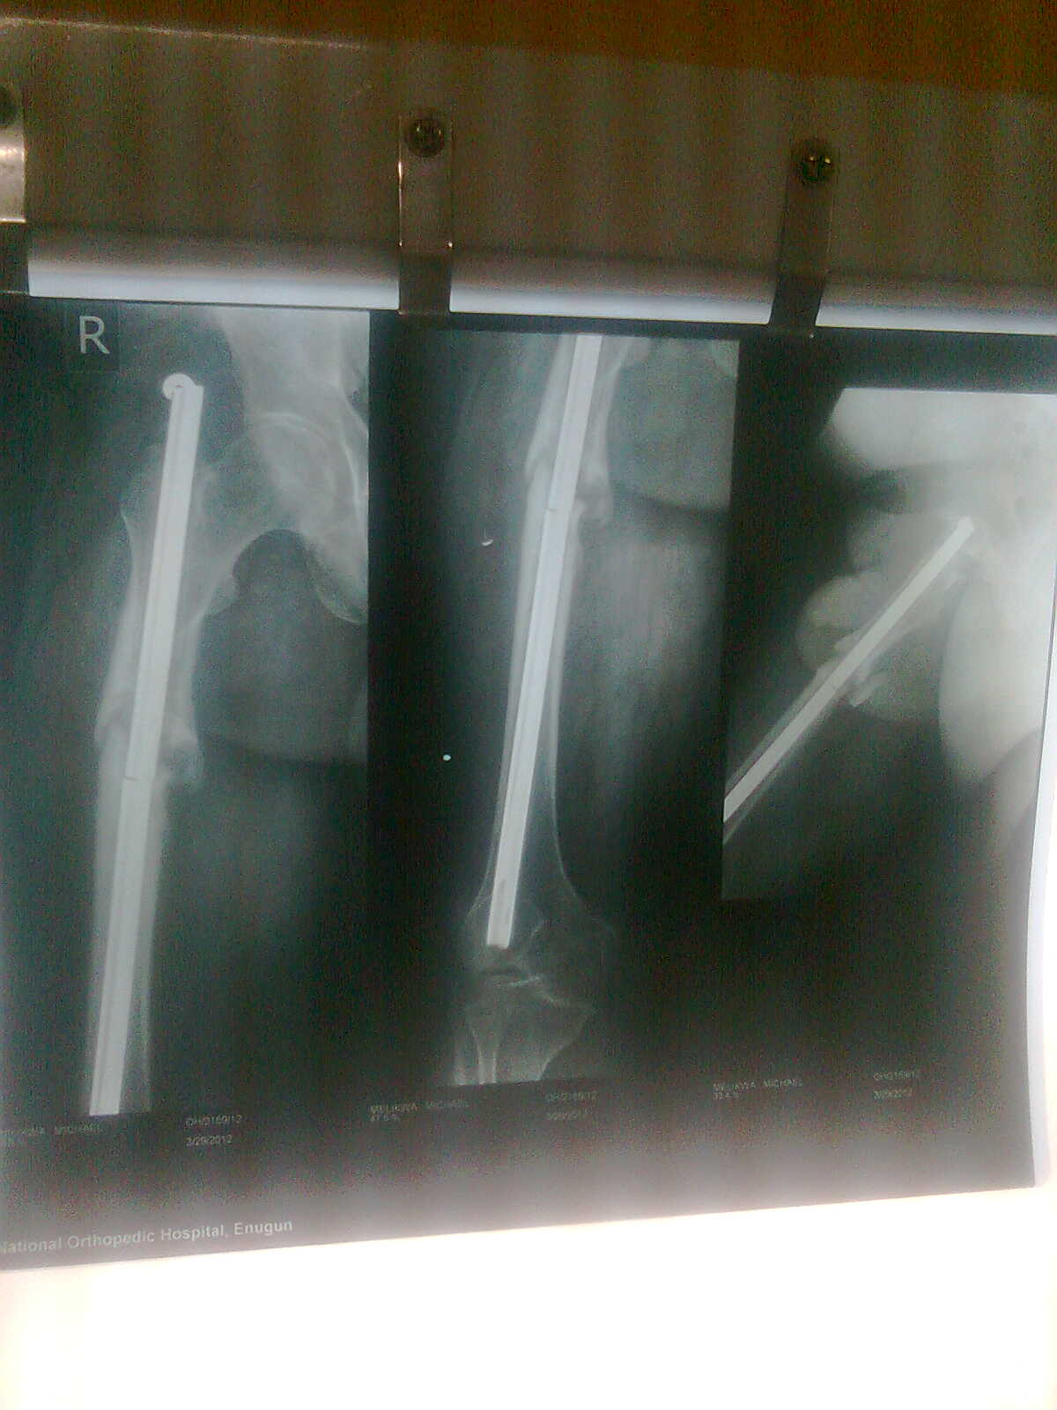
Figure 1: Pre-operative radiograph showing broken femoral nail.

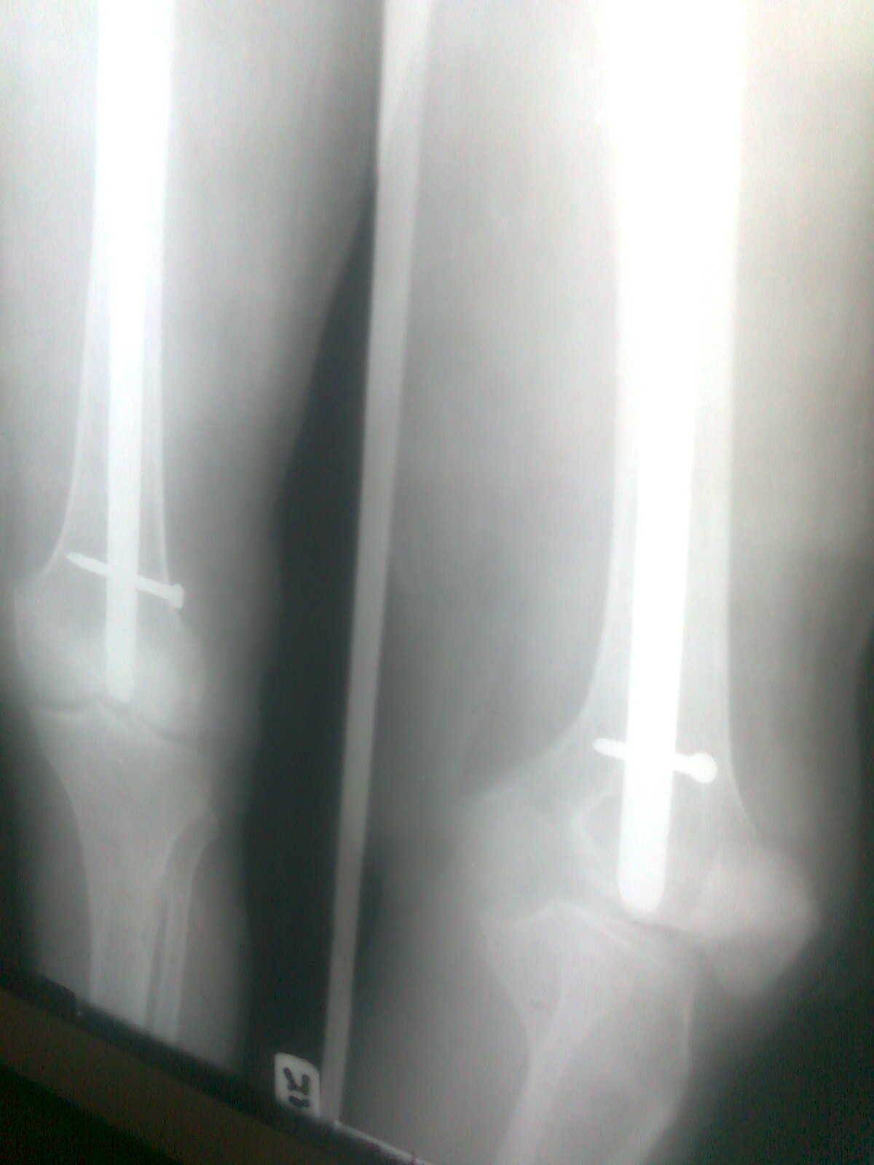
Figure 2.1: Post-operative radiograph after successful extraction and re-nailing. (distal femur)

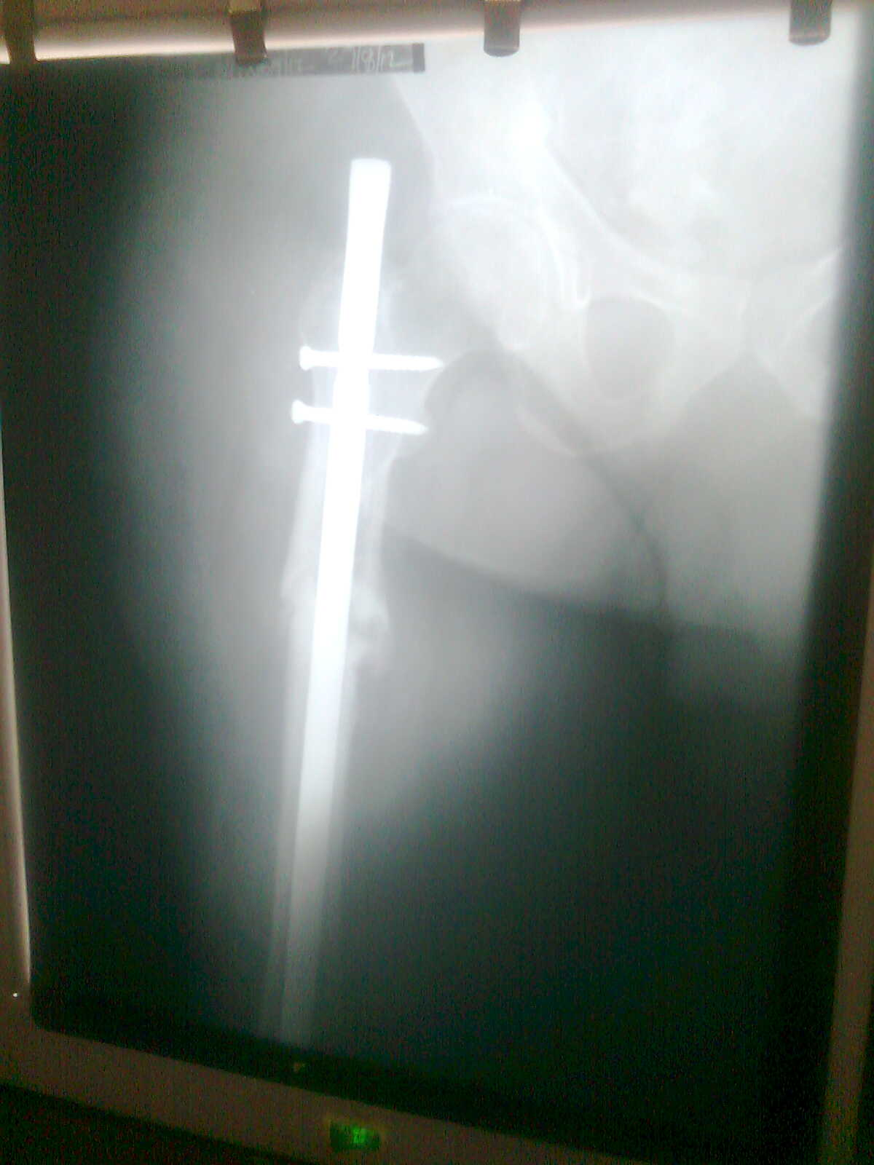
Figure 2.2: Post-operative radiograph after successful extraction and re-nailing (proximal femur).

Discussion
The management of broken intramedullary femoral nails remains a complex surgical problem, with the primary difficulty being the extraction of the distal fragment. Traditional methods, such as retrograde impaction or open retrieval, often involve significant surgical trauma and prolonged operative time (Whalley & Thomas, 2009; Mauffrey et al., 2016). In contrast, the corkscrew technique offers a minimally invasive solution that can be performed using readily available instruments.
The effectiveness of the corkscrew method lies in its ability to achieve secure engagement within the hollow canal of the nail fragment. Once inserted, rotational advancement allows the corkscrew to anchor firmly, enabling the surgeon to apply steady traction for extraction. This reduces reliance on forceful manipulation, thereby decreasing the risk of cortical damage or secondary fractures (Middleton & McNab, 1980; Sharma & Mahajan, 2013).
Another important advantage is the reduced need for fluoroscopic guidance compared to more complex techniques, which contributes to lower radiation exposure for both patient and surgical team (Kose et al., 2017). Additionally, the technique is cost-effective, as it does not require specialized or custom-made instruments, making it particularly suitable for resource-limited settings (Seyhan et al., 2018).
However, certain limitations should be acknowledged. The technique may be less effective in cases where the nail lumen is obstructed by bone ingrowth or debris. In such cases, preoperative planning and possible canal preparation may be necessary (Zhang et al., 2021). Furthermore, successful application depends on the compatibility between the corkscrew size and the internal diameter of the nail fragment (Brewster et al., 1995).
Overall, the corkscrew technique represents a practical and efficient approach for the removal of broken intramedullary femoral nails. Its simplicity, minimal invasiveness, and reproducibility make it a valuable option, particularly when conventional methods are unsuccessful or unavailable.

Patient’s Perspective
“I went through several surgeries and complications, and it was very difficult for me physically and emotionally. The constant pain at rest and when walking was very disturbing to me. Moreover, the deformity and shortening of my right lower limb was distressing and made me lose my appetite and confidence. When the doctors told me of removing the failed implant, I was sceptical, I was not sure if it would help, but within a few days, I noticed a big improvement, my two lower limbs were equal and I wasn’t feeling the terrible pain on my right thigh anymore and I started to feel better and more hopeful. I am grateful to the medical team for finding a solution despite limited resources, and I am happy to have recovered and returned to my normal life.”

Conclusion
The removal of a broken intramedullary femoral nail remains a technically demanding procedure. The corkscrew technique provides a simple, effective, and minimally invasive option for extracting the distal fragment, particularly when conventional methods fail. Careful patient selection, meticulous surgical technique, and preparedness to employ alternative strategies are essential for optimal outcomes. Future innovations in implant design and extraction may further improve the ease and safety of this challenging procedure.

Authors’ Contributions: OBO, and DNE conceptualized and designed the study. OBO, DNE and OBC were involved in data collection; All authors (OBO, DNE, ECB, UA, JNJ, OBC, OAP, OCA) were involved in writing and revising the manuscript for intellectual content. All authors read, approved the final manuscript, and agreed to be accountable for all aspects of the work.
Ethical approval: Not required for a case report
Informed consent: A written informed consent was obtained from the patient.

Declaration of Patient Consent:
The authors certify that they have obtained all appropriate patient consent forms. In these forms, the patient provided written consent and the patient also gave assent for the use of his images and other clinical information for publication. The patient understand that the patient’s name and initials will not be published, and all reasonable efforts will be made to ensure anonymity; however, complete anonymity cannot be guaranteed.
Declaration of Helsinki: The study was conducted according to the ethical principles of the Helsinki declaration of 1975, as revised in 2013.
Availability of research data: The authors are available and ready to supply any information on the case report upon request through the corresponding author
Funding: The authors did not receive any funding or financial support for this study.
Conflict of interest: The authors have no conflict of interest to declare.
Acknowledgement: We acknowledge the nurses and physiotherapists in the ward 3 of National Orthopaedic Hospital, Enugu and all the resident doctors whose diligence and hard work led to the successful management of this patient.

References
Brewster, N. T., Ashcroft, G. P., & Scotland, T. R. (1995). Extraction of broken intramedullary nails—An improvement in technique. Injury, 26(4), 286–287. https://doi.org/10.1016/0020-1383(95)00026-K
Brumback, R. J., & Virkus, W. W. (2000). Intramedullary nailing of the femur: Reamed versus nonreamed. Journal of the American Academy of Orthopaedic Surgeons, 8(2), 83–90. https://doi.org/10.5435/00124635-200003000-00002
Calori, G. M., Phillips, M., Jeetle, S., Tagliabue, L., & Giannoudis, P. V. (2019). Classification of non-union: Need for a new scoring system? Injury, 49(Suppl 2), S59–S63.
Elsoe, R., Larsen, P., Nielsen, N. P. H., Swenne, J., Rasmussen, S., & Østgaard, S. E. (2022). Population-based epidemiology of femoral shaft fractures. Injury, 53(1), 83–89. https://doi.org/10.1016/j.injury.2021.10.012
Giannoudis, P. V., Einhorn, T. A., Marsh, D., & Schmidmaier, G. (2017). The diamond concept—Open questions. Injury, 48(Suppl 1), S3–S5. https://doi.org/10.1016/S0020-1383(17)30194-1
Hak, D. J., & McElvany, M. (2008). Removal of broken hardware. Journal of the American Academy of Orthopaedic Surgeons, 16(2), 113–120. https://doi.org/10.5435/00124635-200802000-00006
Kose, O., Durakbasa, M. O., Islam, N. C., & Kilicaslan, O. F. (2017). A novel technique for removal of broken intramedullary nails. Acta Orthopaedica et Traumatologica Turcica, 51(3), 234–238. https://doi.org/10.1016/j.aott.2017.03.005
Mauffrey, C., Hak, D. J., Martin, M. P., & Hammerberg, E. M. (2016). Complications and management of intramedullary nailing of femoral shaft fractures. Journal of the American Academy of Orthopaedic Surgeons, 24(9), 645–653. https://doi.org/10.5435/JAAOS-D-15-00393
Mauffrey, C., Herbert, B., Young, H., Wilson, M. L., Hake, M., & Stahel, P. F. (2020). The role of intramedullary nailing in femoral shaft fractures. EFORT Open Reviews, 5(5), 239–247. https://doi.org/10.1302/2058-5241.5.190046
Metsemakers, W. J., Morgenstern, M., McNally, M. A., Moriarty, T. F., McFadyen, I., Scarborough, M., Athanasou, N. A., Ochsner, P. E., Kuehl, R., Raschke, M., & Verhofstad, M. H. J. (2018). Fracture-related infection: A consensus on definition. Injury, 49(3), 505–510. https://doi.org/10.1016/j.injury.2017.08.040
Middleton, R. G., & McNab, I. (1980). Extraction of broken femoral intramedullary nails using a corkscrew device. Clinical Orthopaedics and Related Research, 147, 150–153.
Seyhan, M., Unay, K., Sener, N., & Karatosun, V. (2018). Removal of broken intramedullary femoral nails: A technical note and review of literature. European Journal of Orthopaedic Surgery & Traumatology, 28(5), 935–942. https://doi.org/10.1007/s00590-018-2147-5
Sharma, A. J., & Mahajan, A. (2013). Simple technique for removal of distal broken femoral nail using a corkscrew. Orthopaedics & Traumatology: Surgery & Research, 99(3), 379–382. https://doi.org/10.1016/j.otsr.2012.11.012
Whalley, H., & Thomas, G. (2009). A review of techniques for the removal of broken intramedullary nails. Injury, 40(6), 595–599. https://doi.org/10.1016/j.injury.2008.10.030
Wu, C. C. (1996). Treatment of femoral shaft aseptic nonunion associated with broken nail. Journal of Trauma, 40(4), 633–638.
Zhang, Q., Gao, F., Zhou, D., & Ren, Y. (2021). Techniques and pitfalls in removal of broken intramedullary nails: A systematic review. BMC Musculoskeletal Disorders, 22, 1021.

