Design and Prototype Development of an IoT-Based Smart Safety Device for Real-Time Location Tracking and Emergency Alerts Using ESP32, GPS Module and Wi-Fi Communication

Abstract:
B. Prudhvi Kumar Reddy G. Swathi Student Student
Dept of CSE Dept of CSE
Lendi Institute of Lendi Institute of Engineering and Technology Engineering and Technology
boraprudhvikumar@gmail.com swathigulipalli24@gmail.com

Personal safety is a growing concern, especially for individuals who travel alone or require immediate assistance during emergencies. Many existing wearable safety solutions depend on smartphone connectivity or complex physiological sensors, which can lead to false triggers or fail in situations where users cannot access their phones. To address these limitations, this paper presents the design and implementation of a compact IoT-based smart safety wearable capable of real-time location tracking and emergency alert transmission.
The system is built around the ESP32 microcontroller, which handles device control, processing, and wireless communication. A GPS module with an external antenna provides accurate geolocation, ensuring consistent satellite lock and reliable coordinate acquisition. When the user presses the SOS button, the device retrieves the current latitude and longitude and transmits an emergency alert message containing a Google Maps location link through the TextBee API using WiFi connectivity. This approach eliminates dependency on GSM modules while maintaining fast and reliable message delivery in network-enabled environments.
In addition to emergency alerts, the device supports periodic location updates to a Django-based web server, where data is stored and displayed on an interactive tracking dashboard. This enables authorized users to monitor the wearer’s movement in real time and view their historical location trail. The system is powered by a 5V rechargeable battery, making it portable and suitable for continuous operation in daily use.
By integrating WiFi communication, GPS-based location tracking, and a robust cloud-backed monitoring platform, the proposed smart wearable provides an efficient, low-cost, and reliable solution for personal safety, emergency response, and real-time tracking applications.

Keywords: ESP32, GPS Module, IoT Wearable, Wi-Fi Communication, TextBee API, Real-Time Location Tracking, SOS Alert System, Web Application, Emergency Response, Personal Safety Device

INTRODUCTION


Personal safety has emerged as a significant concern in modern society, particularly for individuals who frequently travel alone for work, education, or daily activities. Vulnerable groups such as women, children, elderly individuals, and workers in remote or isolated locations are at higher risk during emergency situations. In such circumstances, the ability to seek immediate assistance becomes critical, as delays in communication can escalate the severity of the incident.
Fig 1: reported crimes against child in India and global wide

One of the major challenges during emergencies is the inability to contact others instantly. Individuals may be physically unable to use their smartphone due to panic, injury, or restricted movement. Additionally, smartphones may become inaccessible if they are misplaced, discharged, or locked at the moment of crisis. These factors significantly limit the reliability of conventional mobile-based safety solutions.
Another challenge is unreliable network connectivity. Rural areas, highways, hilly terrains, construction zones, and industrial sites often experience weak or fluctuating network signals. When connectivity is poor, emergency messages may fail to reach the intended recipients, preventing timely intervention. This also affects real-time location visibility for family members or guardians, making it difficult to track the individual's movements during critical situations. Due to these limitations, there is a growing need for a dedicated, reliable, and easy-to-use personal safety system that operates independently of smartphones, provides accurate location tracking, and ensures consistent communication. Such a solution must be compact, wearable, energyefficient, and capable of sending alerts with minimal user interaction during emergencies.

LITERATURE SURVEY
Personal safety wearables have gained considerable research attention due to increasing demand for reliable emergency communication and location-tracking systems. Various IoT-based approaches have been proposed, each employing different communication technologies, sensing

mechanisms, and tracking techniques. This section reviews the most relevant contributions, highlighting their strengths and limitations, and identifying the gap that motivates the proposed system.
GSM-based emergency alert devices are among the earliest solutions. In [1], a microcontroller is interfaced with a GPS receiver and a GSM modem to transmit the user’s coordinates via SMS when a panic button is pressed. Although such systems are simple and low-cost, they rely heavily on 2G networks, which have poor reliability, increasing phase-out, and limited data capabilities in many regions. Furthermore, GSM-based devices commonly lack mechanisms to buffer data during network outages, resulting in lost location information.
Wi-Fi-enabled safety devices have also been explored. In [2], the authors implemented an IoT wearable that transmits location data to a cloud server or mobile application using Wi-Fi. While this provides real-time tracking with a user-friendly interface, its dependency on Wi-Fi hotspots or smartphone tethering restricts its usability in outdoor or mobile scenarios where Wi-Fi is unavailable.
Sensor-based emergency detection systems, such as those in [3], employ accelerometers and motion sensors to identify falls, shocks, or abnormal human movement. These systems can trigger alerts automatically without user intervention. However, frequent false positives caused by normal body motions limit their reliability. In real-world deployments, automatic detection systems often require sophisticated filtering and calibration to avoid triggering unnecessary alarms.
Hybrid systems combining multiple sensors with cloud-based monitoring platforms have been proposed to enhance reliability. In [4], a wearable device is integrated with physiological sensors for continuous health and safety tracking. Although the system utilizes IoT connectivity for realtime monitoring, it assumes consistent network availability and does not address how emergency communication is maintained during temporary connectivity loss.
Long-range communication technologies have also been investigated. A LoRa-based safety device is introduced in [5], enabling low-power, long-range communication suitable for rural environments. However, LoRa requires access to a dedicated LoRaWAN gateway infrastructure, which is often unavailable in many regions, making deployment impractical for general-purpose urban or semi-urban users.
Smartphone-based safety applications have been developed as well. In [6], mobile apps enable users to share live location and send emergency alerts. Although these applications are widely accessible, they depend entirely on smartphone availability, battery life, and user interaction—factors that may fail during critical situations when the user cannot operate the device.
LTE-based and cloud-assisted tracking solutions, such as those in [7], offer improved coverage and lower latency compared to GSM. However, many of these systems focus on vehicle or asset tracking rather than compact, body-worn personal safety devices. Additionally, most implementations do not incorporate mechanisms to store and synchronize data after network restoration.
From the above studies, it is evident that although various IoT-based safety solutions exist, they suffer from limitations such as network dependency, smartphone reliance, false triggering from sensors, lack of data buffering, requirement for additional infrastructure, or limited communication range. These constraints highlight the need for a lightweight, independent, reliable, and user-operable wearable safety system that can provide real-time location tracking and emergency alerts without depending on GSM networks or smartphones.

The proposed system addresses these gaps by integrating an ESP32 microcontroller with a GPS module and Wi-Fi-based TextBee API communication, enabling reliable location reporting, low latency alerts, and operation independent of smartphones or GSM networks.
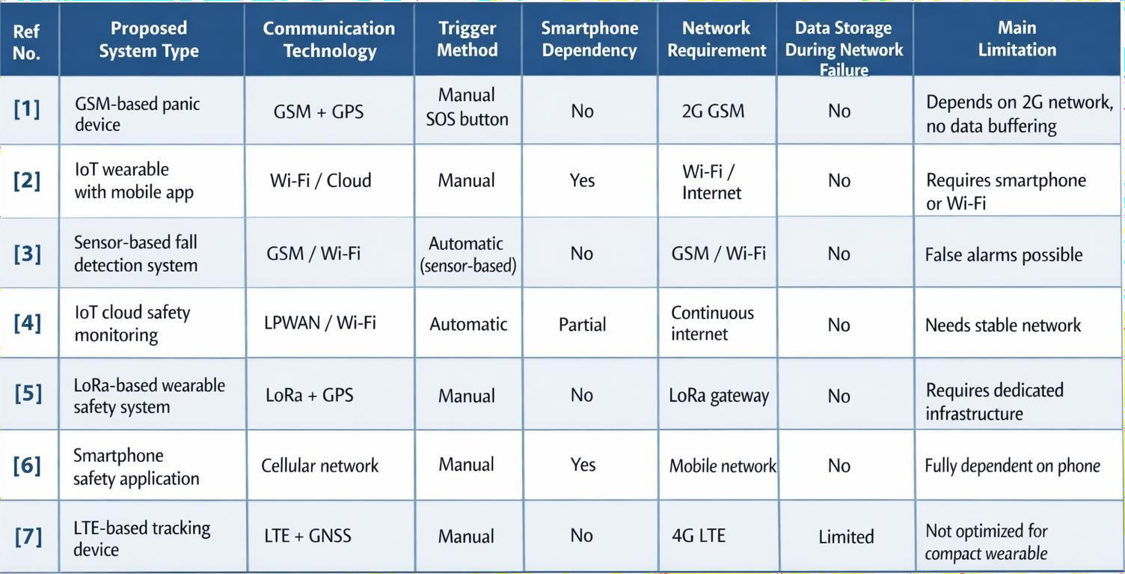
Fig 2: Comparison between the existing systems

PROPOSED SYSTEM
The literature survey highlights that existing personal safety solutions rely on GSM communication, smartphone-based applications, Wi-Fi-dependent devices, sensor-triggered systems, and longrange communication technologies such as LoRa. However, these approaches have several drawbacks. GSM-based devices face limited 2G coverage and higher power consumption, while Wi-Fi–only systems require continuous internet availability and often depend on a smartphone hotspot, reducing reliability in outdoor environments. Smartphone-based solutions can fail when the device is inaccessible, damaged, or has insufficient battery. Sensor-driven automatic alert systems frequently generate false alarms due to misinterpretation of normal motion patterns. Many previous systems also lack robust backend support for continuous web-based monitoring and historical tracking.
To overcome these limitations, this work proposes a compact IoT-based wearable safety device that provides reliable emergency alerts and real-time location tracking using ESP32, a dedicated GPS module, and WiFi-based communication integrated with the TextBee API. The ESP32 microcontroller serves as the main processing and control unit due to its low power consumption, integrated Wi-Fi capabilities, and high performance. A GPS module with an external antenna is used to obtain accurate geographical coordinates, ensuring stable satellite lock and reliable tracking.
The system includes a manual SOS button, allowing the user to trigger an emergency alert during critical situations. When activated, the ESP32 acquires the current latitude and longitude from the GPS module through serial communication. The device then transmits an emergency message containing a Google Maps location link via the TextBee API using WiFi connectivity. This approach eliminates dependency on GSM networks while providing fast and cost-effective message delivery. Beyond emergency alerts, the device supports periodic location updates to a Django-based

backend server using WiFi internet access. Each update is stored in a database and visualized through a secure web application. Authorized users can log in to monitor real-time location on an interactive map, view historical travel paths, and track recent device activity. This enhances remote monitoring capabilities compared to traditional SMS-only systems.
To ensure reliability in low-connectivity conditions, the system stores the last known location locally on the ESP32. When internet connectivity is restored, the device automatically synchronizes pending data with the server. This feature ensures that essential information is not lost, even in hilly or partially connected environments.
By integrating WiFi communication, GPS-based tracking, a cloud-backed web monitoring platform, and a simple user-operated SOS mechanism, the proposed system delivers a reliable, low-cost, and efficient wearable safety solution suitable for real-world emergency response and personal security applications.

System Design
The proposed smart safety wearable system is composed of four integrated subsystems: power management, processing and control, communication and positioning, and backend monitoring. A compact
3.7V Li-ion battery serves as the primary power source, regulated through a voltage regulator to provide a stable 3.3V supply to the ESP32 microcontroller and GPS module, while a charging circuit ensures safe battery charging and protection. The ESP32 functions as the core controller, managing system initialization, SOS button detection, GPS data retrieval, WiFi connectivity, periodic location updates, and emergency alert transmission. A NEO-6M GPS module with external antenna provides accurate real-time location data through UART communication. Instead of using GSM communication, the system utilizes the ESP32’s builtin WiFi module to transmit alerts through the TextBee API. When the SOS button is pressed, the ESP32 fetches the current coordinates, generates a Google Maps location link, and sends it as an emergency SMS to predefined contacts. In addition, the device periodically uploads location data to a Django-based backend server, where the coordinates are stored in a database and displayed through a secure web dashboard. Authorized users can access the dashboard to monitor live device location, movement history, and recent activity. During temporary WiFi unavailability, the device stores the last known location locally and synchronizes the data once connectivity is restored. By integrating GPS-based positioning, WiFi communication, and a web-enabled monitoring platform, the Smart Shield Band provides a compact, costeffective, and reliable prototype solution for personal safety and emergency response applications.

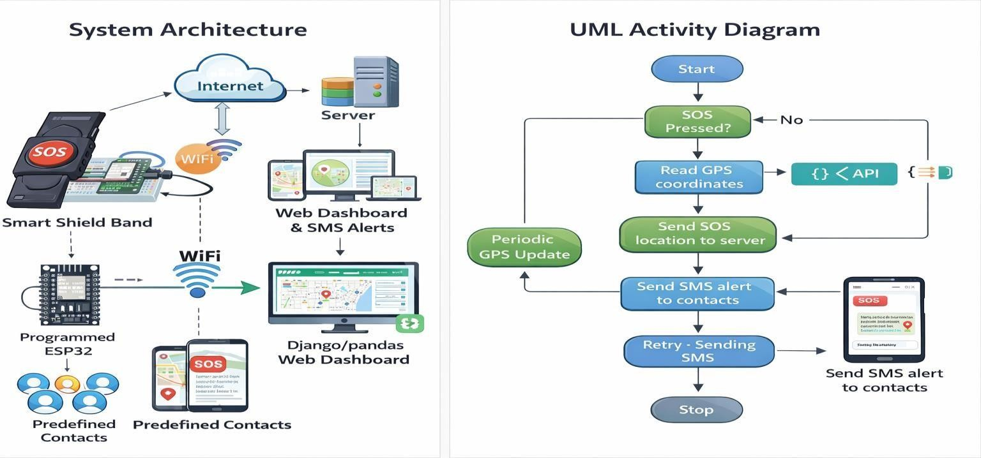

Hardware Implementation
The hardware implementation of the proposed Smart Shield Band is developed using a compact, low-power embedded design suitable for wearable applications. At the core of the system is the ESP32 microcontroller, which manages all major processing tasks including SOS event detection, GPS data acquisition, WiFi communication, periodic data transmission, and overall coordination of system functions. Real-time location tracking is achieved using a NEO-6M GPS module equipped with an external antenna to ensure reliable satellite reception. The ESP32 communicates with the GPS module through a UART interface to continuously retrieve geographic coordinates. A dedicated SOS push button is interfaced with the ESP32, allowing the user to trigger an emergency alert instantly with a single press. Upon activation, the controller reads the latest GPS coordinates, generates a Google Maps location link, and transmits the alert message to predefined contacts using the TextBee API through WiFi communication, thereby eliminating the need for GSM modules or SIM cards.
The entire device is powered by a 3.7V Li-ion battery, providing portability and enabling continuous wearable operation. A charging module is incorporated to ensure safe and efficient battery charging with protection features. A regulated 3.3V power supply is provided to the ESP32 and GPS module to maintain stable performance. Proper filtering and decoupling capacitors are included in the power circuit to minimize electrical noise and ensure reliable operation during GPS signal acquisition and WiFi data transmission.
All hardware components are assembled into a compact prototype enclosure, making the device lightweight, portable, and suitable for wearable usage. The implemented hardware prototype demonstrates the feasibility of a reliable IoT-based personal safety device capable of emergency alert communication and real-time location tracking using low-power embedded components.
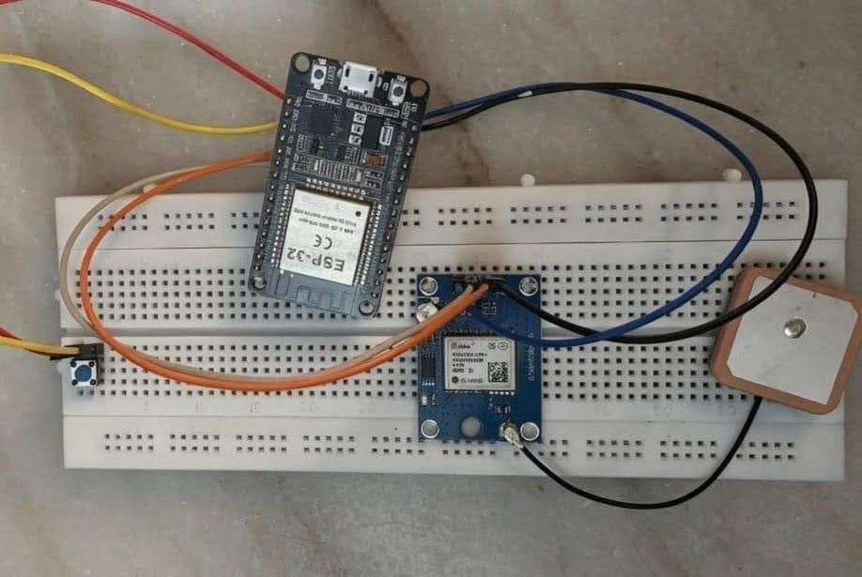

Software Implementation
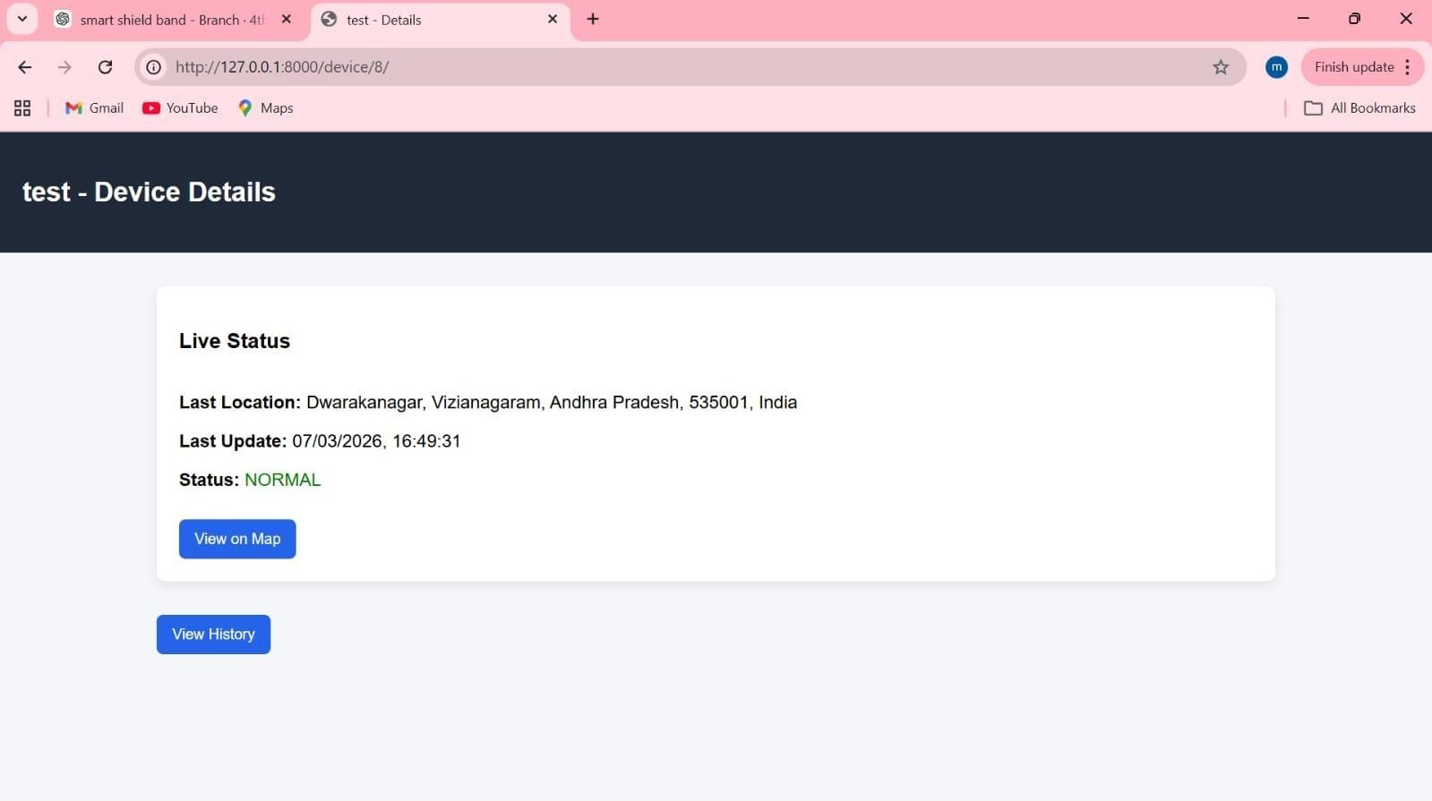
The software architecture of the proposed Smart Shield Band consists of two major components: the embedded firmware running on the ESP32 microcontroller and the backend web application developed using the Django framework. Together, these components enable emergency alert generation, periodic location tracking, and real-time remote monitoring.
The embedded firmware is responsible for managing all hardware operations, including communication with the GPS module, SOS button monitoring, WiFi connectivity, and message processing. The ESP32 communicates with the GPS module through a UART interface to continuously obtain real-time latitude and longitude coordinates. The firmware then formats this data into a structured output, including a Google Maps link that allows emergency contacts to quickly access the user's location.
For communication, the system uses the ESP32’s built-in WiFi instead of GSM or LTE networks. The firmware connects the device to a WiFi network and uses HTTP requests to interact with the TextBee API. When an SOS event is triggered, the ESP32 reads the current GPS coordinates, generates a location link, and sends an emergency SMS message through the TextBee API to predefined contacts. This approach ensures reliable alert delivery without requiring GSM modules, SIM cards, or cellular subscriptions.
During normal operation, the ESP32 also sends periodic location updates to the Django backend server using HTTP POST requests. These updates are stored in a database and used for continuous location tracking. To handle temporary WiFi failure, the firmware includes a fallback mechanism where it stores the most recent known location in memory and synchronizes the data automatically once connectivity is restored.

The backend web application, built using Django, receives incoming location data from the ESP32 device, validates and stores it in a structured database, and updates the user interface in real time. The secure web dashboard allows authorized users to log in, view the device’s live location, explore historical movement data, and monitor recent alerts and activities.
By integrating lightweight embedded firmware on the ESP32, GPS-based positioning, WiFi communication, and a robust Django backend, the software architecture delivers a reliable and efficient platform for personal safety monitoring and emergency response.

RESULTS
The emergency alert functionality of the proposed Smart Shield Band was successfully tested and validated using the ESP32 microcontroller, GPS module, and WiFi-based communication through the TextBee API. When the SOS button is pressed, the device immediately reads the user’s current geographic coordinates from the GPS module. The ESP32 then formats the data into a Google Maps link and sends an SMS alert to predefined emergency contacts using the TextBee messaging API.
The received SMS alerts, illustrated in the results section, contain a clickable Google Maps URL that allows the recipient to view the user’s live location instantly. This enables quick
decisionmaking and rapid response during emergency situations. Testing confirmed that SMS alerts are delivered within a short time after the SOS button is triggered, ensuring timely notification. Multiple alerts with updated location links can also be sent during extended
emergency scenarios, providing continuous tracking capability.
The successful transmission of location-enabled SMS alerts demonstrates the reliability and
effectiveness of the WiFi + TextBee communication approach. This method removes the need for GSM modules or SIM cards while still maintaining dependable delivery of emergency notifications. System testing also verified that the GPS module consistently provides accurate location coordinates under open-sky conditions.
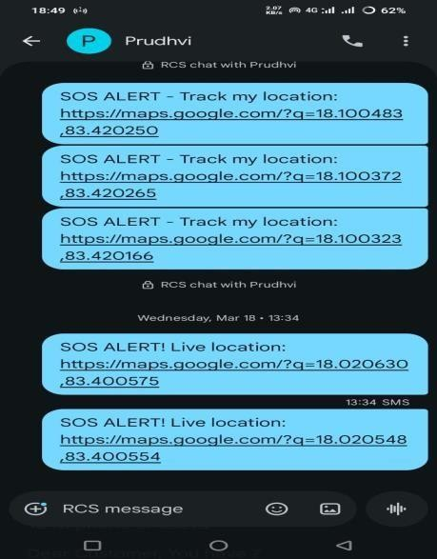
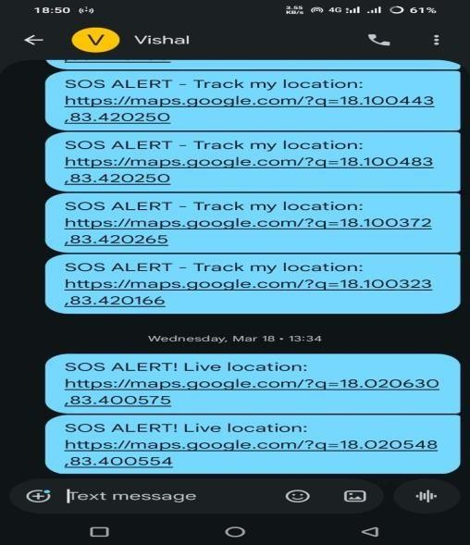
Overall, the results confirm that the Smart Shield Band prototype delivers accurate location information, timely emergency alerts, and stable real-time communication—making it suitable for practical use in personal safety and emergency response applications.

ss

CONCLUSION

This paper presented the design and prototype development of the Smart Shield Band, a wearable personal safety system that integrates real-time location tracking and emergency alert functionality. The system is built using an ESP32 microcontroller, an external GPS module for precise geographic positioning, and WiFi-based communication to transmit emergency notifications. By using the TextBee API, the device is able to deliver SMS alerts containing live Google Maps links to predefined contacts, ensuring quick and reliable access to the user’s location during critical situations.
The proposed system addresses key limitations found in traditional safety solutions, such as dependency on smartphones, unreliable GSM connectivity, and the absence of real-time tracking. The use of a standalone GPS module eliminates reliance on mobile phones for location services, while WiFi communication provides a cost-effective and API-driven mechanism for sending alerts without requiring a SIM card or GSM module. The successful system tests demonstrate accurate position acquisition, timely SMS delivery, and consistent periodic location updates to the backend server. The Django-based web platform further enhances the system by enabling real-time monitoring, location history visualization, and secure data management.
Overall, the Smart Shield Band prototype demonstrates a reliable, low-cost, and energy-efficient solution for personal safety applications. Its compact structure and lightweight hardware make it suitable for wearable use, particularly for individuals in vulnerable or high-risk environments. Future improvements may include integrating machine learning techniques for activity recognition and automatic emergency detection, enabling the system to trigger alerts without requiring manual input. Additional enhancements to the web interface—such as alert prioritization, intelligent data analytics, and user-specific notifications—can further increase system utility and effectiveness in real-time safety monitoring.

IEEE References

- A Smart friendly IoT device for women safety with GSM and GPS location tracking by N.Saranya, R. Aakash, K.Aakash , K.Marimuthu 2022.
- A Novel Privacy enabled Human Health and Safety Monitoring System using IoT with Smart Wearable Device by M.Tamilselvi 2024.
- An Automated Wearable Fall Detection System For Elderly People using Sensors by N.Anitha, Vishnu Vardan, Pradeep R, Nazeem A 2025.
- IoT Based Health Monitoring System with AI Powered Disease Prediction by Sarvesh Kumar Gupta, Dr. Savya Sachi, Vamsi Krishna Gottipati 2025.

- Safe Connect: A LoRa, GSM, and GPS-Based Women's Emergency Alert System by Bhushan Niwangune, Shivam Pujari, Tejas Khandage, Mrs.S.P.Hon 2025.

- AI-Powered Woman Safety Application with Real-Time Audio-Based Trigger and Emergency Alert System by Ilakkiya Jothi V P 2025S

- GPS Bracelet Device for Personal Safety and Emergency Situations with Whatsapp Communication by Macaria Hernandez-Chavez, Adrian Apolonio-Vera 2025
- Design and Implementation of Smart Safety Wearable Device Using IoT, in Proc. IEEE Int. Conf. Electronics and Communication Systems 2023.
- IoT-Based Women Safety Device with Real-Time Location Tracking, in Proc. IEEE Int. Conf. Smart Technologies for SmartNation,2022.

- Design of Smart Wearable Safety System Using GPS and GSM Modules in Proc. IEEE Int. Conf. Computing, Communication and Automation (ICCCA), 2021.

- Low-Cost IoT-Based Emergency Alert System for Personal Safety, in Proc. IEEE Int. Conf. Intelligent Computing and Control Systems (ICICCS), 2022.

- Wearable IoT Device for Real-Time Safety Monitoring and Emergency Alerts in Proc. IEEE Int. Conf. Smart Electronics and Communication (ICOSEC), 2023.

- Design and Development of GPS-Based Safety Device for Women Using Embedded Systems, in Proc. IEEE Int. Conf. Communication Systems and Network Technologies (CSNT),2022.

- IoT-Based Smart Safety System Using Cloud and Mobile Application, in Proc. IEEE Int. Conf. Advanced Computing and Communication Systems (ICACCS), 2023.

- Implementation of Smart Emergency Alert System Using IoT and Wireless Communication, in Proc. IEEE Int. Conf. Emerging Technologies (ICET),2021.

