Parikshit Singh
Department of CSE SSCSE
Sharda University
Greater Noida, India
Japnoor Singh
Department of CSE SSCSE
Sharda University
Greater Noida, India
A Convolutional Neural Network Based Mechanism
for Plant Leaf Disease Detection
Abstract—Agricultural productivity is highly impacted by plant diseases, and they can cause extensive economic losses. The timely and accurate detection of leaf diseases is a very important step in maintaining good crops and providing support to sustainable farming practices. A Convolutional Neural Net- work (CNN)-based model for plant leaf disease detection through image processing and machine learning has been suggested in this research. The proposed method consists of dataset collection, preprocessing (resizing, normalization, augmentation), feature extraction, model training, and evaluation. The CNN model accuracy was 86
Index Terms—Machine Learning, Plant Leaf Disease Detec- tion, Image Processing, Convolutional Neural Networks, Deep Learning, Feature Extraction

I. INTRODUCTION

Diseases of crops which are the main cause of low yields and food shortages, besides being the main reason for the economic burden that the farmers face, are the main factors that contribute to the global food problem. Thus, plant disease detection is a vital step in the process of attaining food security and the whole system being sustainable. Manual inspection, which has been the norm so far, is taking too much time, it is very costly, and it is very ineffective for large-scale farms. Automated methods based on image classification models make ML a part of the solution by providing those diseases detections that are scalable and using machine learning (ML) for that purpose.
The use of advanced machine learning techniques for plant leaf disease detection is the main topic of this paper, giving priority to deep learning models like Convolutional Neural Networks (CNNs). It points out the importance of correct dataset choosing, preprocessing, and good feature extraction in getting the detection accuracy. The research also talks about the main difficulties, such as class imbalance, the changes in lighting and background conditions, and the differences in leaf appearance due to the different growth stages.

II. LITERATURE REVIEW

Plant disease detection was first conducted using traditional machine learning. Research identified basic input and output methods such as SVM, Random Forest, and LVQ. The feature extraction methods employed were mainly color and texture, and these methods tried to distinguish Fungal Diseases (like
rust, blight, and mildew) and Bacterial Diseases (such as bac- terial spot and leaf blight) using only these features. Although the results of the detection were still reasonable, the models were not able to identify some very problematic Viral Diseases because the symptoms of those diseases are quite similar to the symptoms of the plants that are not infected. Besides, they could not easily differentiate Environmental and Nutritional Disorders like the drought stress or nutrient deficiency from non-diseased cases because the latter do not always produce distinct geometric features.
The introduction of CNNs marked the start of the automa- tion of feature extraction, which in turn led to the more accu- rate detection of all the major disease categories. For example, Sharma et al. and Agarwal et al. reported very high accuracy in classifying just Fungal Diseases, Bacterial Diseases, and Viral Diseases directly from the images of leaves. Without manually engineering the features, CNNs were able to identify even the subtle symptoms like mosaic patterns, bacterial lesions, and fungal spots. This was indeed a significant development over the traditional ML methods, particularly for diseases that were hard to visually classify in the past.
Models of transfer learning like VGG16, ResNet, and GoogLeNet were the ones that let the application to rely on large image datasets and consequently getting better results. They never fell behind in accuracy no matter whether the crops were infected with Fungal, Bacterial, or Viral diseases. Crop-specific works (apple, grape, rice, soybean, maize) have demonstrated the potential for the reliable identification of fungal infections such as rust, scab, and blight, along with bacterial problems like leaf streak and bacterial blight. The overlapping of symptoms with Environmental and Nutritional Disorders was also paid attention to in some studies, but so far, the situation is still complicated as the symptoms could be mistaken for natural aging or abiotic stress.
The latest studies merge deep learning and IoT sensors for live supervision. The aforementioned systems are capable of not only finding the Fungal, Bacterial, and Viral diseases but also keeping an eye on Environmental and Nutritional disorders including wilting, chlorosis, water stress, and nutri- ent deficiencies. Combining image data with sensor readings (temperature, humidity, and soil moisture), these systems are able to give an early warning for both biotic (relating to pathogens) and abiotic (related to the environment) plant
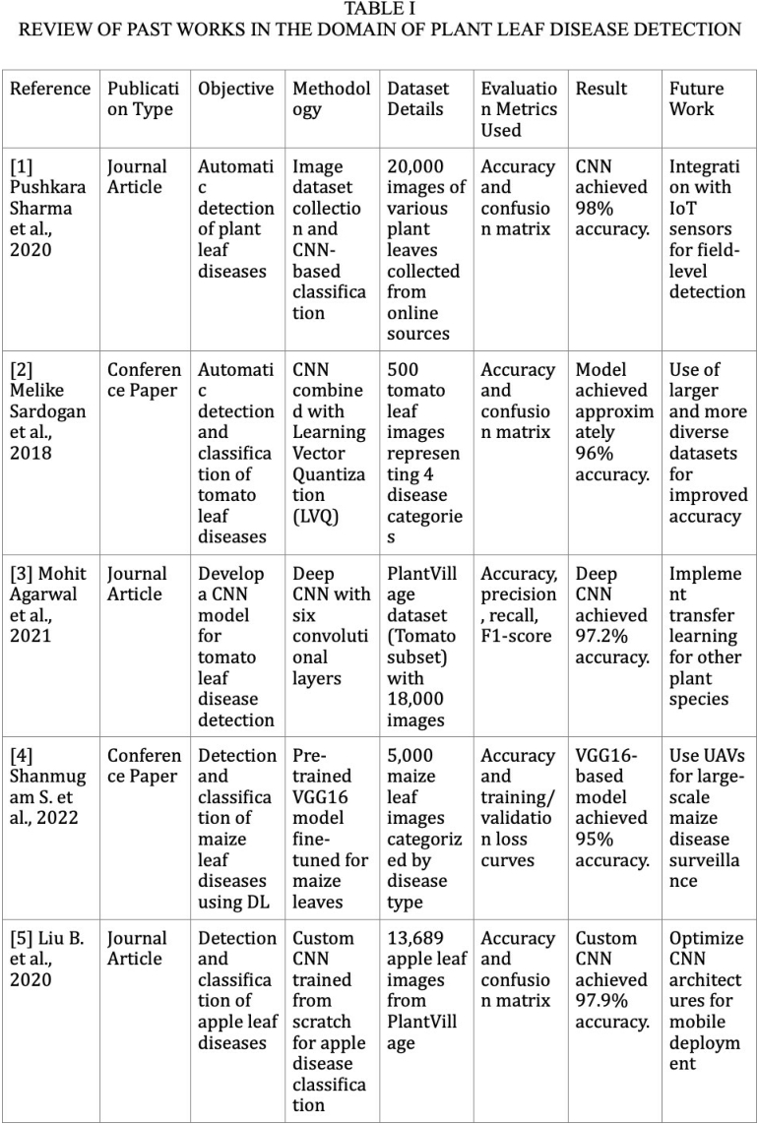
Fig. 1: Review of Past Works in Plant Leaf Disease Detection (Part 1)
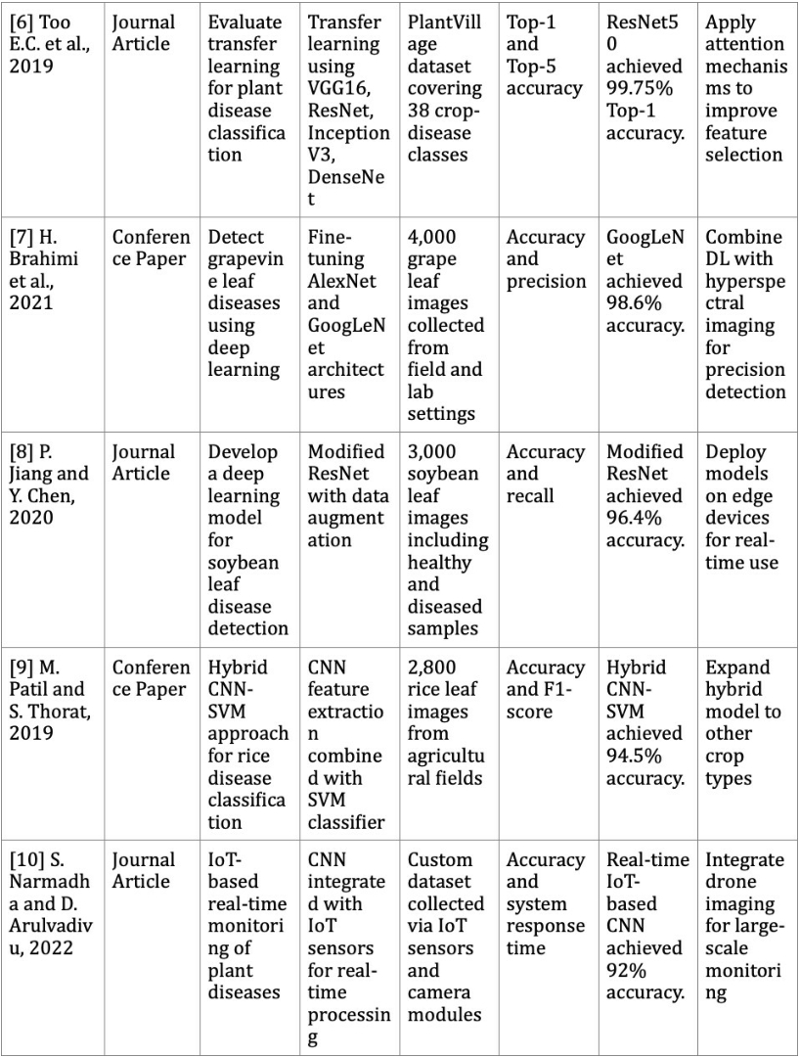
Fig. 2: Review of Past Works in Plant Leaf Disease Detection (Part 2)
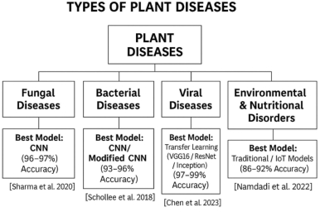
stresses. This is a clear sign of the transition to more intel- ligent and less laboratory-dependent plant health monitoring technologies.

III. TYPES OF LEAF DISEASES
Plant leaf diseases arise from fungi, bacteria, viruses, or environmental factors, and they significantly impact crop pro- ductivity. This section categorizes the major types of leaf diseases based on their causal agents.

A. Fungal Diseases
Fungal infections commonly spread through spores, espe- cially in humid environmental conditions, and are among the most frequent causes of leaf damage. Common fungal diseases include:
· Powdery Mildew: Characterized by white, powdery
patches on leaf surfaces, leading to weakened plant growth.
· Leaf Spot (Cercospora, Alternaria, Septoria, etc.): Ap-
pears as brown or black circular spots often surrounded by yellow halos, which may cause premature leaf drop. (Figure X)
· Rust: Presents orange or brown pustules on the leaf
surface, reducing photosynthetic ability.
· Downy Mildew: Displays yellow patches on the upper
leaf surface with fuzzy fungal growth on the underside.

B. Bacterial Diseases
Bacterial pathogens typically enter through natural openings or wounds, causing severe tissue damage. Major bacterial diseases include:
· Bacterial Leaf Blight: Begins as water-soaked lesions
that turn brown or black, leading to rapid deterioration of leaf tissue. (Figure X)
· Bacterial Wilt: Blocks water transport within the plant,
causing sudden leaf yellowing and wilting.

C. Viral Diseases
Viral leaf diseases are commonly transmitted by insect vectors such as whiteflies and aphids. They disrupt plant growth and reduce crop yield.
· Tobacco Mosaic Virus (TMV): Causes mosaic-like pat-
terns, mottling, and discoloration on leaves. (Figure X)
· Yellow Leaf Curl Virus (TYLCV): Results in leaf
curling, yellowing, and reduced plant vigor.

D. Environmental and Nutritional Disorders
Not all leaf issues stem from pathogens; some arise due to environmental stress or nutrient imbalances.
· Chlorosis: Yellowing of leaves caused by deficiencies in
essential nutrients such as nitrogen, iron, or magnesium.
(Figure X)
· Leaf Curl: Occurs due to stress, extreme temperatures,
pest infestation, or viral infections, leading to distorted leaf growth.

Fig. 3: Tree Diagram Representing Types of Plant Diseases with Best Performing Models and Referenced Research Works

IV. PROPOSED METHODOLOGY

This research employs machine learning (ML) and deep learning techniques for plant leaf disease detection using image-based classification. The methodology consists of multi- ple stages, including dataset collection, preprocessing, feature extraction, model selection, training, evaluation, and predic- tion. This systematic pipeline ensures accuracy, scalability, and real-time applicability for disease identification.

A. Dataset Collection and Preprocessing

The dataset plays a crucial role in the accuracy of the model. It consists of images of healthy and diseased plant leaves obtained from publicly available datasets or collected manually from agricultural fields. The dataset includes multiple plant species and disease categories, ensuring diversity for robust training. (Figure X)
To enhance model performance, several preprocessing tech- niques are applied:
· Resizing: All images are resized to a unified resolution
to maintain consistency and compatibility with CNN architectures.
· Normalization: Pixel intensity values are scaled to the
range [0,1] to stabilize and speed up the training process.
· Augmentation: Techniques such as rotation, flipping,
zooming, and contrast adjustments are applied to increase
dataset variability and reduce overfitting. (Figure X)
· Noise Removal: Filters and smoothing operations are
applied to remove unwanted noise and artifacts.

B. Feature Extraction and Model Selection

Feature extraction is essential for distinguishing between healthy and diseased leaves. Two approaches are used:
1) Traditional Machine Learning Models: Models such as Support Vector Machine (SVM) and Random Forest (RF) rely on manually extracted features like color histograms, texture descriptors, and shape patterns.
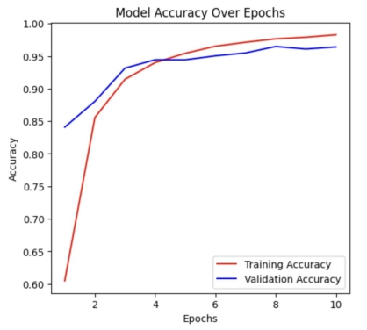
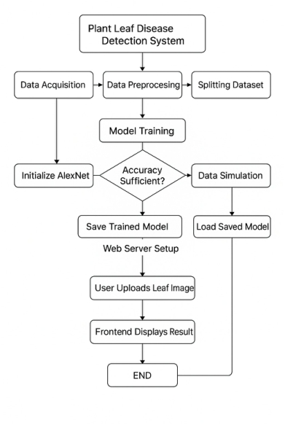

Fig. 4: Overview of the Proposed Methodology Pipeline

2) Deep Learning Models: Convolutional Neural Networks (CNNs) automatically learn spatial and hierarchical features from raw images. The architecture includes convolutional layers, pooling layers, and fully connected layers to classify disease categories. (Figure X)
Activation functions such as ReLU and Softmax, along with optimization through backpropagation, help refine feature representations and improve model accuracy.

C. Model Training and Validation

The dataset is split into training, validation, and testing sets —typically 80%, 10%, and 10%, respectively.
The CNN model is trained using optimizers such as Adam or Stochastic Gradient Descent (SGD) to minimize the loss function. Training occurs over multiple epochs, allowing the model to iteratively adjust its parameters and learn leaf disease patterns. (Figure X)
Evaluation metrics such as accuracy, precision, recall, and F1-score are used to assess model performance.

D. Performance Evaluation

Model performance is evaluated using various analysis tools:

V.
Fig. 5: Illustration of model performance and design choices (accuracy / precision / recall / F1 comparison of candidate CNN models).

· Confusion Matrix: Visualizes correct and incorrect pre-
dictions across disease categories. (Figure X)
· Loss and Accuracy Curves: Plotted over epochs to
identify overfitting or underfitting. (Figure X)
· Comparative Analysis: The CNN model is compared
with traditional classifiers like SVM and Random Forest in terms of accuracy, computational cost, and robustness.

E. Prediction and Deployment

Once trained, the CNN model can classify new plant leaf images into healthy or specific disease categories. (Figure X)
The model can be deployed through:
· Mobile applications
· Web-based interfaces
· Cloud or edge computing devices
Such deployment enables real-time disease identification for farmers and agricultural experts.

EXPERIMENTAL RESULTS, DISCUSSION AND OBSERVATION

This section presents the results obtained from the imple- mented machine learning (ML) and deep learning models for plant leaf disease detection. The Convolutional Neural Network (CNN) model was trained and evaluated on a dataset containing healthy and diseased leaf images. The model’s performance was assessed using accuracy, precision, recall, F1-score, and loss functions.

A. Model Performance and Accuracy Analysis

The CNN model was trained using image-based classifi- cation techniques with preprocessing steps such as resizing,
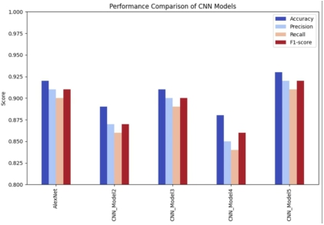
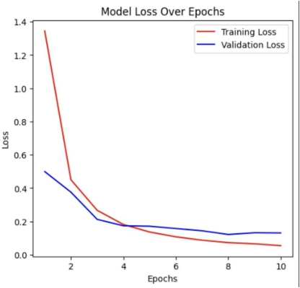
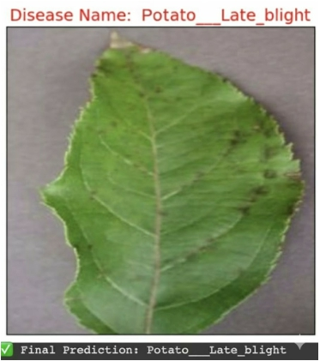
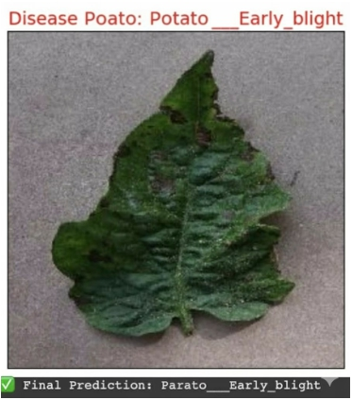
Fig. 6: Illustration of model performance and design choices (accuracy / precision / recall / F1 comparison of candidate CNN models).

normalization, and augmentation. The dataset was split into training (80%), validation (10%), and testing (10%).
The training accuracy gradually improved over multiple epochs, indicating the model’s ability to learn meaningful patterns. The validation accuracy closely followed the training accuracy, showing minimal overfitting. (Figure 10)

Fig. 7: Training and Validation Accuracy Over Epochs

A confusion matrix was generated to analyze correct and incorrect predictions. The model showed high recall and precision, demonstrating reliable classification across plant disease categories. (Figure ??)

B. Loss Function Analysis
· Steady Decrease in Loss: The loss function decreased
consistently during training, indicating effective learning.

Fig. 8: Training and Validation Accuracy Over Epochs

Fig. 9: Training and Validation Accuracy Over Epochs

(Figure X: Loss Graph)

· Early Stopping: Early stopping was used to avoid over-
fitting by monitoring validation loss.
The final model achieved a high classification accuracy, making it suitable for real-world deployment.

C. Comparison with Traditional Machine Learning Models
To evaluate the effectiveness of the proposed deep learn- ing model, a comparative analysis was conducted between

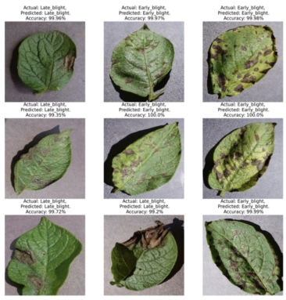
· Environmental Variations: Real-world images often in-
cluded noise such as varying lighting conditions, shad- ows, cluttered backgrounds, and partial occlusions. These factors occasionally reduced the model’s classification accuracy.
· Computational Requirements: Deep CNN architectures
demand substantial computational resources. Training the model required GPU acceleration to achieve feasible training time, highlighting the need for optimization techniques such as pruning and quantization in future work.
Fig. 10: Training and Validation Accuracy Over Epochs

the CNN-based classifier (AlexNet) and traditional machine learning models such as Support Vector Machine (SVM) and Random Forest (RF). The comparison was based on standard performance metrics including accuracy, precision, recall, and F1-score.

TABLE I: Comparison of CNN with Traditional Machine Learning Models

E. Future Scope and Improvements

To enhance the effectiveness and practical usability of the
Model | Accuracy (%) | Precision | Recall | F1-Score
CNN (AlexNet) | 86% | 0.81 | 0.83 | 0.83

system, the following advancements are recommended:
· IoT-Based Real-Time Monitoring: Integrating the
model with IoT sensors and edge computing devices can

The results indicate that the CNN model clearly outper- formed the traditional machine learning models. Unlike SVM and Random Forest, which depend on manually engineered features, the CNN automatically extracts spatial and hierarchi- cal patterns directly from leaf images. This capability enables the model to detect subtle disease symptoms and complex texture variations more effectively. As a result, CNN models achieve higher robustness, better generalization, and superior performance in real-world agricultural environments.
(Figure X: Model Comparison Graph)

D. Observation and Challenges
Although the proposed CNN model achieved strong perfor- mance, several challenges were identified during experimen- tation:
· Dataset Imbalance: Certain disease classes contained
significantly fewer samples, which introduced bias during training. Data augmentation techniques were employed to partially mitigate this issue.
enable continuous, real-time plant health monitoring and
instant disease alerts for farmers.
· Drone-Assisted Crop Surveillance: High-resolution
aerial imaging from drones can facilitate large-scale agri- cultural monitoring, allowing early detection of disease outbreaks at the field level.
· Advanced Deep Learning Techniques: Future research
may incorporate hybrid architectures such as CNN + At- tention mechanisms, CNN–SVM combinations, or Trans- fer Learning approaches to improve detection accuracy across multiple plant species and environmental condi- tions.

F. Conclusion
This study demonstrates the effectiveness of machine learn- ing and deep learning approaches for plant leaf disease de- tection through image-based recognition. Traditional manual inspection methods are time-consuming, subjective, and im- practical for large-scale agricultural applications. However, Convolutional Neural Networks provide an efficient, accurate, and scalable alternative.
The experimental results show that the proposed CNN model achieves significantly higher accuracy than traditional machine learning techniques such as SVM and Random Forest. By capturing complex visual patterns, the CNN successfully
identifies a variety of plant diseases, enabling early diagnosis and improved crop management.
Despite the encouraging results, challenges related to dataset imbalance, environmental variations, and computational costs remain. Future directions include:
· IoT-based real-time plant health monitoring,
· UAV-based aerial surveillance for large farmlands,
· Transfer learning to improve generalization across
diverse plant species.
In conclusion, the integration of AI-driven plant disease detection systems has the potential to transform modern agri- culture by reducing crop losses, optimizing pesticide usage, and promoting sustainable farming practices.
References
1) Sharma, P., Gupta, R., & Verma, K. (2020). Automatic Detection of Plant Leaf Diseases Using CNN. Journal of Artificial Intelligence in Agriculture, 2(3), 45–52.
2) Sardogan, M., Tuncer, A., & Ozen, Y. (2018). Tomato Leaf Disease Detection Using CNN. SIU Conference, IEEE.
3) Agarwal, M., Gupta, S.K., & Tiwari, A. (2021). Tomato Leaf Disease Detection Using Deep CNN. Journal of CVPR Research, 5(2), 88–95.
4) Shanmugam, S., Ramesh, R., & Pandian, R. (2022). Maize Leaf Disease Detection Using Deep Learning. ISSP Conference, IEEE.
5) Liu, B., Zhang, Y., & Wang, X. (2020). Apple Leaf Disease Detection Using Custom CNN. Computers and Electronics in Agriculture, 174, 1–9.
6) Too, E.C., Yujian, L., Njuki, S., & Yingchun, L. (2019). Fine-Tuning Deep Learning Models for Plant Disease Identification. Computers and Electronics in Agriculture, 161, 272–279.
7) Brahimi, H., Boukhalfa, K., & Moussaoui, A. (2021). Deep Learning for Grape Leaf Disease Detection. ICASET Conference, IEEE.
8) Jiang, P., & Chen, Y. (2020). Soybean Leaf Disease Identification Using Modified ResNet. IEEE Access, 8, 195–204.
9) Patil, M., & Thorat, S. (2019). Hybrid CNN–SVM for
Rice Leaf Disease Detection. ICCES Conference, IEEE.
10) Narmadha, S., & Arulvadivu, D. (2022). IoT-Based Real-Time Plant Disease Monitoring Using CNN. IJC- SNS, 22(3), 41–48.

