The Role of Introversion, Extroversion, and Social Media Interaction in Students’ Impulsive Buying

ABSTRACT
The purpose of this study is to investigate the relationship between personality traits and impulsive buying tendency. Secondly, to explore the impact of social media interaction on the students’ buying behaviour. This study was conducted to students in Universiti Malaysia Pahang Al-Sultan Abdullah. In particularly, master students. The study is using a quantitative method. The respondents only need to answers and fill out the questions through Google Form. The questionnaire used a five-point Likert scale measurement. A total of 63 responses were gained, and the data was analysed using a SPSS (Statistical Package for Social Science) software. The findings indicate a positive relationship between social media interaction and impulsive buying tendency. However, the relationship was found to be weakly significant, suggesting that social media interaction has a limited influence on students’ impulsive buying tendencies. In addition, the findings reveal a positive relationship between personality traits and impulsive buying tendency, indicating that students’ behaviour, lifestyle, and habits may influence their purchasing decisions. Finally, this study provides several recommendations for future research related to impulsive buying behaviour among students.
Keywords: Personality Traits; Social Media Interaction; Impulsive Buying; Consumer Behavior; Students

INTRODUCTION

1.1 Introduction
This study examines the influence of personality traits, particularly introversion and extroversion, on social media interaction and impulsive buying tendency among master students. Social media was initially developed as a platform for communication, interaction, and relationship building. However, with the advancement of digital technology, it has evolved into a multifunctional platform that supports information sharing, video and voice calls, news updates, and the posting of photos and videos. Popular platforms such as TikTok, Facebook, Instagram, Twitter, and WhatsApp are widely used by Millennials and Generation Z in Malaysia. In recent years, social media has also become an important platform for purchasing products and services, transforming from a networking space into a digital business platform. This development has contributed to the growth of social commerce as an extension of e-commerce.
In line with current digital trends, social media is now widely used for marketing, advertising, and product promotion. Consumer engagement with social media content may influence buying tendencies, especially when users are exposed to product information, promotional offers, discounts, reviews, and price comparisons. Through social media platforms, consumers are able to evaluate products, communicate with sellers, and make purchasing decisions more conveniently. Online purchasing also differs from physical retail shopping because consumers can choose when and how to interact with sellers, which may create a more comfortable buying experience, particularly for individuals who prefer less direct communication.
Despite the increasing role of social media in consumer purchasing behaviour, there is still a need to better understand how personality traits influence social media interaction and impulsive buying tendency among students. Introverted and extroverted individuals may respond differently to online marketing content, seller interaction, and social media engagement. Therefore, this study aims to examine the relationship between personality traits, social media interaction, and impulsive buying tendency among master students. Specifically, it seeks to explore how social media interaction affects students’ buying behaviour and investigate the relationship between personality traits and buying tendency.
This study is expected to benefit business owners, marketers, students, and future researchers. For business owners and marketers, the findings may provide useful insights into how social media interaction and personality traits shape consumer buying tendencies, allowing them to design more effective digital marketing strategies. For students as consumers, this study may help explain how social media platforms influence their product evaluation, interaction, and purchasing decisions. Academically, the study may contribute to the literature on consumer behaviour, digital marketing, personality traits, and impulsive buying behaviour, while also serving as a useful reference for future research in online consumer behaviour.

2.0 LITERATURE REVIEW

2.1 Introduction
This chapter discusses the influence of personality traits and social media interaction on impulsive buying tendency among master students. Specifically, this chapter examines the two independent variables, namely personality traits and social media interaction, and their relationship with the dependent variable, which is impulsive buying tendency. The discussion is supported by previous literature to provide a clearer understanding of the key concepts and theoretical foundation of the study.

2.2 Social Media Interaction and Consumer Behaviour

2.2.1 Influence of Social Media on Impulsive Buying Tendency
Impulsive buying tendency refers to a spontaneous and unplanned desire to purchase a product after being exposed to certain stimuli. In the context of social media, this tendency may arise when consumers view attractive product content, promotions, influencer endorsements, or customer reviews. Social media has become a powerful platform that influences consumer behaviour because it allows users to interact with brands, sellers, influencers, and other consumers in real time.
Many brands use social media influencers and ambassadors to promote their products because these individuals are able to attract attention and shape consumer preferences. Younger consumers, particularly Millennials and Generation Z, are often considered highly responsive to this form of marketing strategy (Mileva, 2022). They are frequently exposed to product recommendations, promotional content, and lifestyle-based advertising through platforms such as TikTok, Instagram, Facebook, Twitter, and WhatsApp. As a result, social media interaction plays an important role in influencing consumers’ impulsive buying tendencies.

2.2.2 Influence of Social Media on Information Seeking
The continuous advancement of digital technology has contributed to the rapid growth of social media platforms. Platforms such as Facebook, TikTok, Instagram, Twitter, and WhatsApp are widely used in Malaysia for communication, information sharing, entertainment, and social networking. However, these platforms have also evolved into virtual shopping spaces that allow users to browse, compare, and purchase products at flexible times and locations.
This development has contributed to the growth of social commerce, where social interaction and commercial activities are integrated within digital platforms. According to Anindito and Handarkho (2021), social commerce allows users to share information, engage with promotional content, and participate in online social interaction related to products and services. From a marketing perspective, social media is considered an effective and low-cost promotional tool because it enables businesses to deliver messages quickly to a wide audience.
Barysevich (2020) reported that 71% of consumer buying decisions are influenced by social media. This indicates the significant role of social media interaction in shaping consumer decision making. In today’s digital lifestyle, many consumers are highly attached to their electronic devices and frequently rely on social media to obtain product information. Through comment sections, reviews, ratings, and user-generated content, consumers can immediately access feedback from other users. Positive or negative reviews may influence their perception of a product and affect their purchasing decision.
This process is closely related to social proof, where consumers rely on the opinions, recommendations, and experiences of others before making a purchase. When social proof is perceived as credible and transparent, consumers may develop stronger confidence in a product. Therefore, the greater the influence of social proof, the faster consumers may make buying decisions.

2.3 Personality Traits and Consumer Behaviour

2.3.1 Influence of Extraversion on Impulsive Buying Tendency
Personality traits play an important role in shaping individual behaviour, including consumer behaviour. Each individual may respond differently to similar situations due to differences in personality. In the context of online purchasing, personality traits may influence how consumers interact with sellers, respond to promotional content, and make buying decisions.
According to Indrajaya and Mahesha (2020), individuals with extraverted traits are generally sociable, active, expressive, and more likely to experience positive emotions. They tend to enjoy social interaction and are comfortable engaging with others, including in online environments. Extraverted individuals may also be more willing to seek information, communicate with sellers, participate in online discussions, and respond to promotional content.
In social media environments, extraverted consumers may be more exposed to marketing messages because they are actively involved in online interactions. Their high level of engagement may increase their tendency to respond positively to product promotions and recommendations. As a result, extraverted individuals may demonstrate lower resistance toward purchasing products, especially when they are influenced by social interaction, peer recommendations, or attractive marketing content.

2.3.2 Influence of Introversion on Impulsive Buying Tendency
In contrast, introverted individuals are often associated with reflective, reserved, and less socially expressive characteristics. They may prefer limited social interaction and tend to think carefully before making decisions. Holland (2021) suggested that introverted individuals may be more likely to overthink or evaluate their choices before taking action. This tendency may reduce the likelihood of immediate purchasing decisions.
However, social media may provide a more comfortable environment for introverted consumers compared to face-to-face interaction. Online platforms allow introverted individuals to browse products, communicate with sellers, and make decisions without the pressure of direct physical interaction. This may reduce social anxiety and provide greater flexibility in the buying process.
Past studies have found that personality traits influence the way individuals use social media (Zafar et al., 2020). Therefore, introversion and extroversion may affect users’ online behaviour, including how they engage with product information, respond to marketing content, and make purchasing decisions. Although introverted individuals may be more cautious, social media interaction may still influence their buying tendency by providing a less intimidating and more flexible shopping environment.

2.4 Impulsive Buying Tendency
Impulsive buying tendency refers to a consumer’s tendency to make sudden, spontaneous, and unplanned purchases. According to Zafar et al. (2020), impulsive buying tendency is an important factor in understanding unexpected buying behaviour. Consumers may be influenced by various external stimuli, including product images, promotional messages, reference groups, celebrity endorsements, influencer recommendations, discounts, and online reviews.
Environmental factors also play an important role in encouraging impulsive buying behaviour. In the context of social media, consumers are constantly exposed to persuasive content, attractive visuals, limited-time offers, and product recommendations. These elements may stimulate emotional responses and encourage consumers to make quick purchasing decisions.
Younger consumers are often more active in digital environments and are more likely to engage with e-commerce and social commerce platforms. Their buying decisions may differ based on demographic factors such as age, gender, and marital status. Compared to younger consumers, older generations may prefer additional communication and information before making a final purchasing decision (Palalic et al., 2020).
Advertising and promotional strategies are generally designed to attract consumers by appealing to their needs, wants, emotions, and interests. When consumers are exposed to marketing content that captures their attention, their impulsive buying tendency may increase. This strategy is particularly relevant in social commerce, where younger consumers are frequently targeted due to their active use of social media and their responsiveness to digital marketing content.

2.5 Theoretical Framework
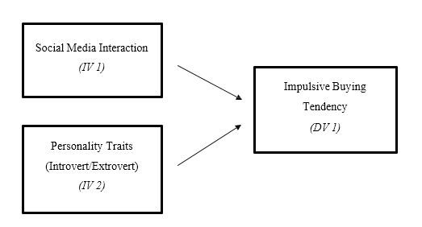

Figure 2-1 Independent and dependent variables

The theory is relevant to this paper, it will help to investigate the independent variable on which personality traits (Introversion-Extroversion) showed a certain type of behavior on social media interaction. An extrovert usually interacts with the customer service when they need extra information. While introverts display an opposite behavior, engage less or no communication at all (Itani et al., 2020). Past research mentioned that, customer-generated content, online ratings, blogs, comments, reviews, discussion, and community forums, is another form of engagement. Although the interaction is not direct, it can influence and persuade others’ emotions to make the purchase happen. Social exchange through social media can cater to someone's personality traits as they are not directly engaged in a traditional way. It is a fluid method for introverted people to engage more without being shy and feeling exposed (Baker, 2021).
Moreover, it analyzes the dependent variable; impulse buying tendency. The buying tendency and buying decision happened when social media was being fully utilized by the customer. They will display an act of buying tendency when the trends are fully blown. In current times, trends and viral products are fads. They come and go. People are interested in those things and love to enjoy a jiffy moment (Barysevich, 2020). Social engagement (direct/indirect) in social media is the targeted place to make quick decision making. A post that was seen will be recommended many times until we are ‘forced’ to make purchases. That is how algorithms work (Jarboe, 2022). It can read and understand our preference pattern and keep popping on our feed homepage. This type of marketing is the most effective in swaying the customer buying decision.

3.0 Research Methodology
3.1 Research Design
The first stage of the research process involves identifying the problem statement. This is followed by a review of relevant literature to establish the independent and dependent variables of the study. Based on the research objectives, this study aims to examine the issues highlighted in the problem statement, particularly the relationship between social media usage, personality traits, and buying tendency.
The variables will be measured using a structured questionnaire based on a Likert scale. The collected data will then be analysed to determine the relationship among the identified variables. Finally, the study will be concluded by integrating the findings and providing appropriate recommendations based on the results obtained.
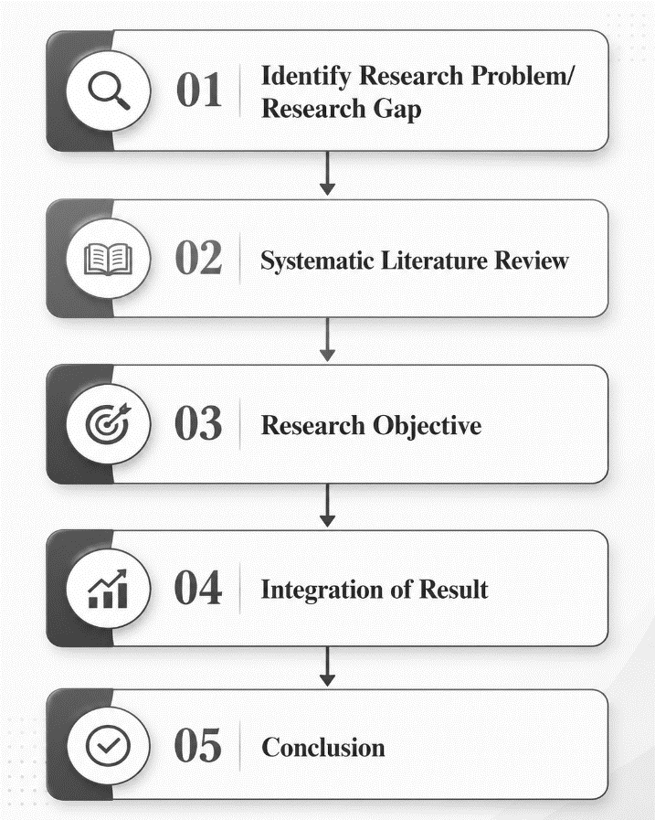

Figure 3-1 Research process and methodology (qualitative and quantitative)

3.3 Sampling Design

3.3.1 Target Population
The target population for this study consists of Universiti Malaysia Pahang Al-Sultan Abdullah students, specifically master students from the Pahang and Kuala Lumpur branches. The respondents include students from different levels of education, namely foundation, diploma, and degree programmes. The respondents are expected to be from various age groups, ranging from 20 years old to 36 years old and above. Students from different ethnic backgrounds are also included in this study.
Participation in this study is voluntary, and respondents are required to complete a structured questionnaire. The questionnaire is designed in English; therefore, respondents must have a basic understanding of the English language in order to answer the questions accurately. In developing the questionnaire, careful attention was given to ensure that all items are appropriate, clear, and free from offensive or sensitive wording.
The questionnaire items will be measured using a Likert scale. After the data collection process is completed, the responses will be analysed using the Statistical Package for the Social Sciences (SPSS). The results obtained from the analysis will be used to test the research hypotheses and determine the relationships among the variables in this study.

3.3.2 Sample Size
The sample size for this study is determined based on the sample size table developed by Krejcie and Morgan (1970). Based on the information obtained from master administrative staff, the total population of master students is approximately 14,000. According to Krejcie and Morgan’s sample size guideline, a population of this size requires a sample of approximately 370 respondents.
This sample size is considered appropriate to represent the population of master students and to ensure that the findings of the study are reliable and meaningful. A sufficient number of respondents will also help improve the accuracy of the statistical analysis and support the testing of the proposed hypotheses.
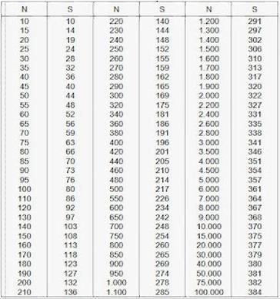

Figure 3-2 Sample size by Krejie & Morgan (1970)

    - Sample technique
For the sample technique, the potential respondent can be gained with the help of the master department/staff. An invitation to participants in the study will be sent through Whatsapp. The respondent will voluntarily answer the form without being subjected to force or any form of harm and blackmail. The link will be forwarded to their friend for a faster exposure and quick response once they finish answering it.
The method used for distributing the questionnaires is a non-probability sampling method. Due to time restrain, this method is the most suitable one. Plus, a convenient method is the best to distribute the question for the students in university. The respondent details will not be exposed to the public. They don't have to worry about a breach of confidentiality during answering the survey (Byju’s, 2021).
Futhermore, all the questionnaires will be answered through likert scales (McCombes, 2022). This method will make the respondent respond better and have accurate results. It is also a cost-effective method because the link can be shared through Whatsapp. This will help to lessen the cost without having to personally go to the Kuala Lumpur branch and distribute the questionnaire.
  - Research Instrument
Section | Construct | Section Details | No of Items
A | Demographics | This section will determine the population of the respondents | 7
B | Social Media Use | This section will evaluate the frequency of social media usage used by the students | 9
C | Introversion Scale | This section will determine the level of introversion in students | 12
D | Buying Tendency | This section aims to see the buying tendency behavior upon interaction in social media | 9
Table 3-1 Questionnaire design

    - Section A; Demographics
In section A, the 7 questions that will be asked is about the demographics of the respondents. The questions include age, gender, location, level of education, ethnicity, number of social media accounts, what kind of posy often shared on social media, the frequentness of social media used and the average of social media usage per day. These questions are asked in order. To identify the which category the respondent will suits the aim of the study and its variables.

Section B; Social Media Use
In section B, there is 9 questions that were asked. The respondent will ask regarding the usage of social media in their daily life. It also illustrates, the students’ lifestyle that were associate with social media like Instagram, Whatsapp, TikTok and Facebook. The questions also asked about the functions of social media for the students. For instance, uploading post, comments, reading news, exchange message, and making new friends. These questions will measure one of the independent variables; social media interaction.

Section C; Introversion Scale
In section C, there is 12 questions that were asked. These sections are to determine one of the independent variables; personality traits. The analysis will show the numbers (high or low) which explain whether the student have extrovert or introvert personality traits. The questions that were ask consist of students’ social engagement with other people in a big crowd or in familiar setting.

Section D; Buying Tendency
In section D, there is 9 questions that were asked. This section is to measure the dependent variable; impulse buying tendency. The questions consist of the reactions of students’ personality traits while using social media. The instant reaction of the marketers in social media would result in impulse buying tendency; high or low.

Data Analysis
The data will be interpreted using the IBM SPSS Statistic Version 29 Software. The systematic analysis will be shown how the data will be obtained from the respondent. There are a few methods analysis that will be used in the study.
Firstly, a descriptive analysis. This analysis will make the researcher understand the errors and identify correlations between the independent and dependent variables. The frequency of the data will show which questions indicates high score that show understanding and familiarization among the respondents (Gravetter, Wallnau, Forzano and Witnauer, 2020).
Second, reliability analysis. These tests will be measuring the understanding of the concept of the questions. The higher the score towards 1, it means it have a high reliability. Any numbers going downwards means the reliability became lessen and poor correlations (Middleton, 2019).
Third, Pearson correlation coefficient. This analysis is to measure the relationship between 2 variables. It will indicate the direction of the relationship, whether positive or negative (Turney, 2022). As previous analysis, number 1 score indicates the perfect score, while 0 means no correlations.
The last analysis would be Multiple Linear Regression Analysis. This is to investigate the independent variable on the dependent variable (Zikmund et al, 2013).. In this case, if there a significant relationship between social media and buying tendency and personality traits and buying tendency.

Pilot Study
Pilot study have been done to ensure the questions are free from error. These is important steps in the study, to determine the questionnaire is easily understand, no offensive words are included in the distribution (Zikmund et al, 2013). A total of 15 students have been receiving the questionnaire and giving the feedback.
Prior to that, the supervisor has reviewed the questionnaire to make sure they are appropriate to be answered by the students. After gain the feedback, some adjustments have been done to simplify the question to make it easier to understand. The result has showed a positive result for all the variables; social media interaction (0.693), personality traits (0.861) and impulse buying tendency (0.914). These indicates that the questions are reliable enough to used.
Below are the resulted of the pilot study.
Pilot study: Social Media Interaction
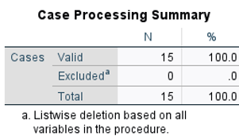
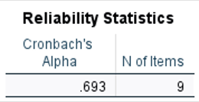

Figure 3-3 Result for Pilot study: Social Media Interaction

Pilot study: Personality Traits
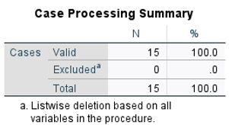
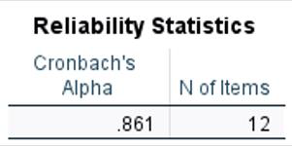

Figure 3-4 Result for Pilot study: Personality Traits

Pilot study: Impulsive Buying Tendency
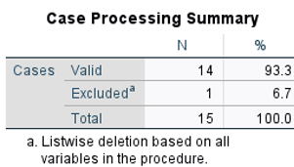
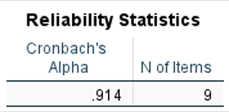

Figure 3-5 Result for Pilot study: Impulsive Buying Tendency

4.0 Analysis of Data

This chapter explains how the data is analysed and focuses on the creation and presentation of the questionnaire results. Google Forms is used to collect the survey responses, which are then analysed by IBM SPSS Statistics Version 29 software and turned into a table. Descriptive Analysis, Reliability Analysis, Pearson Correlation Coefficient, and Multiple Regression Analysis are among the types of analysis covered in this chapter. This chapter presents the results, which are prepared as tables and pie charts.

Demographic Profile

The questionnaire has been distributed through online medium (Whatsapp) as a mean to collect the data. Approximately, 63 respondence have answered the survey. Descriptive analysis is used to interpret data on respondents’ the general information which includes gender, age, ethnicity, level of education, and location.

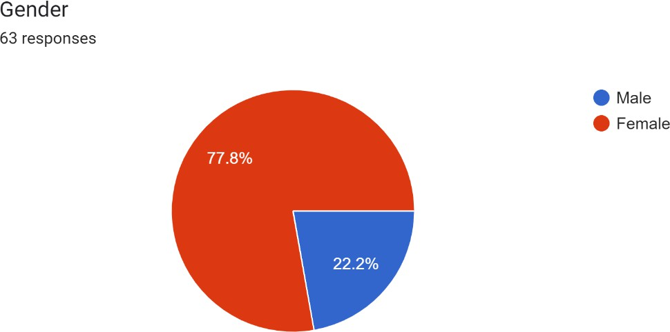

Figure 4-1 Respondents’ gender
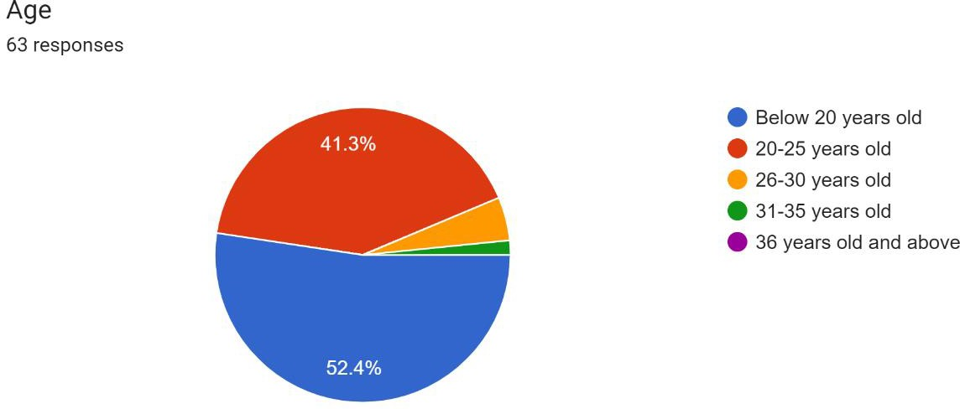

Figure 4-2 Respondents’ age

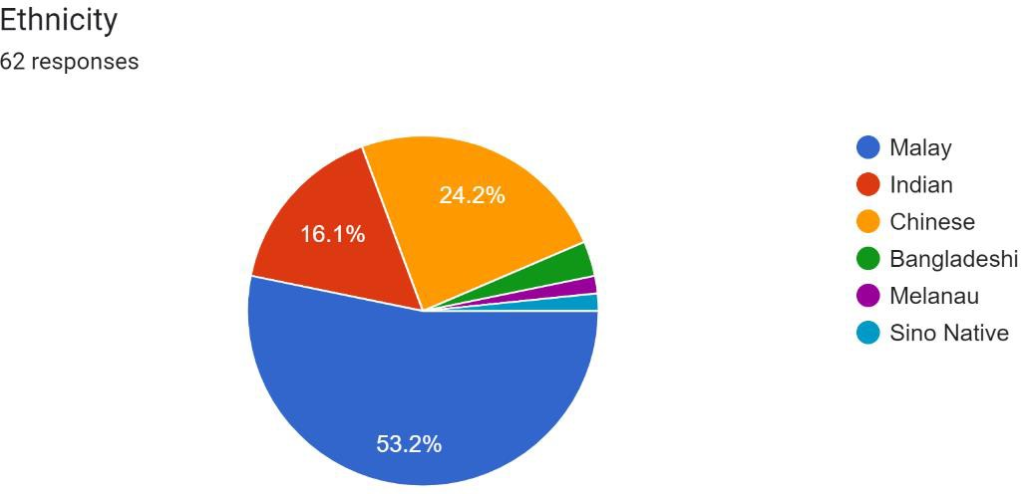

Figure 4-3 Respondents’ ethnicity

As shown in the above pie chart, a majority of the respondent are mainly from female at 77.8%, which equivalent to 49 respondence. While the male correspondence is at 22.2% which equivalent to only 14 participants. Only a total number of 63 responses were gathered from master students at Universiti Malaysia Pahang Al-Sultan Abdullah with a mixed of various ethinicity; Malay 53.2%, Indian 16.1%, Chinese, 24.2%, and others 6.4% (Bangledeshi, Melanau, and Sino Native).

The majority age that belongs to the respondent are below 20 years old at 52.4% (33 respondent), while the lowest numbers of age category would be 31-35 years old with a number of 1 person who answer the survey. These age category means the majority of the respondence came from a foundation background. As for the second major would be students in degree and the minority or zero response from the diploma has not been stated as they are unreachable during the semester breaks.

The student’s origin would be from two places; Kuala Lumpur and Pahang. In Kuantan, where the questions are easier to conduct due to the networking are receiving high number of respondence at 96.8% (61 respondence) followed by master KL at 3.2% (2 respondence).

Descriptive Analysis
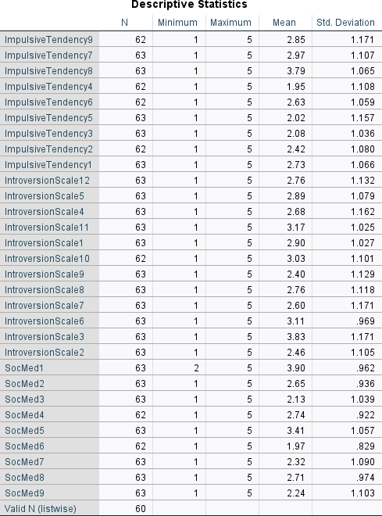

Figure 4-6 Descriptive Statistics (N, Min, Max, Mean, Std Variation)

In the survey, A 5 Likert point scale are being used to measure the descriptive statistic of the indicators of the variables. The data shown that the highest mean for impulse buying tendency would be at 3.79, 2.97, and followed by 2.85, respectively. As for standard deviation, the highest number would be 1.171, while the lowest would

be 1.036. To measure personality traits, these two numbers depict the highest mean 3.83 and 3.17 in the variable. As for standard deviation, the highest number would be 1.132, while the lowest would be 0.969. The highest social media score for social media standard deviation is 1.090, while the lowest is 0.969. The table showed highest means at 3.90 followed by 3.41.

The standard deviation for all of the variables is less than one. The data gathered can be considered appropriate for further investigation based on the low standard deviation number.

Reliability Analysis

    - Reliability Analysis; Social Media Interaction

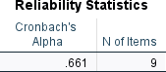

Figure 4-4 Reliability result for Social Media Interaction

This is the Cronbach's alpha for the independent variable; social media interaction. Through this exploration, the result is shown at 0.661 for a total of 9 items. It shows the result are moderately positive in nature.

Reliability Analysis; Personality Traits

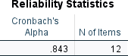

Figure 4-5 Reliability result for Personality Traits

As for the Personality trait’s reliability analysis, it showed slightly higher number compared to the previous analysis. As it is closer to number 1.0, it showed a variable has a strong reliability.

Reliability Analysis; Impulsive Buying Tendency

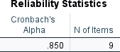

Figure 4-6 Reliability result for Impulsive Buying Tendency

Lastly, in impulsive buying tendency. The result shown a positive and strong reliability, as the previous results are in similar nature. As all of the results are showing consistency and high indications. This means the questions are ready to be used in further analysis.

Pearson’s Correlation Coefficient Analysis
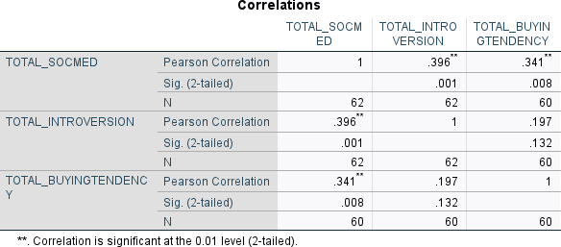

Figure 4-7 Pearson’s Correlation Coefficient Analysis
The Pearson correlation coefficient test are used to determine the strength between two or more quantitative variables (Pallant, 2011). The value will be between
-1 and +1. In this analysis, all the result are showed positive value. Social media have an absolute perfect correlation at +1, while personality traits and buying tendency are at +0.396 and +0.341 prospectively. Although the numbers are quite low, value are still positive. All of the variables showed a strong correlations coefficient especially between social media and buying tendency.

Multiple Regression Analysis

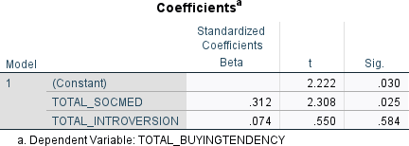

Figure 4-8 Result for Multiple Regression Analysis

Above is the Multiple regression analysis. The purpose if the analysis is to determine whether the construct of social media and personality traits could influence the buying tendency. The findings of the multiple regression analysis also revealed the percentage of total variance.
The findings showed that, independent variable personality traits have the highest significant value compared to social media, which is at 0.584 and 0.025 respectively. The indication of both independent variables is positively related to buying tendency which are the main indicator of this buying behavior. Hypotheses 1 (social media has a positive relationship with buying tendency) was accepted as the result showed a positive value in the analysis. Hypotheses 2 (Personality traits have a positive relationship with buying tendency) also accepted as the value at 0.584.

Hypothesis Testing

No. | Hypothesis | Supported/Rejected
H1 | Social Media has a positive  relationship with buying tendency. | Supported
H2 | Personality traits have a positive  relationship with buying tendency | Supported

Table 4-1 Hypothesis Testing
According to the above table, H1 are accepted because there are proved that there is a positive relationship between social media and buying tendency based on the analysis in Pearson’s Correlation Coefficient Analysis, at +1. H2 are also accepted because the value shown there is a positive relationship between personality traits and buying tendency, at +0.396 correlation.

Discussion

Chapter 5 discusses the outcome of this study which is the summary of the statistical analyses based on the result gathered from Chapter 4. Moreover, this chapter will also discuss the significant finding of this study, the limitation of the research, and recommendations for future research and analysis.

In this section, the explanation will focus more on the analysis of key findings in order to validate research goals and conclusions.

No. | Hypothesis | Significant | Conclusion
H1 | Social media interaction has a positive relationship with  impulse buying tendency | 0.025 | Supported
H2 | Personality traits have a positive relationship with  impulse buying tendency | 0.584 | Supported

Table 5-1 Discussion on findings

    - Relationship between social media interaction and impulse buying tendency
H1 indicates that social media interaction has a positive relationship with impulse buying tendency. The result showed the value is at t= 2.308, B= 0.312 p=0.025. Students with active interaction on social media are more incline to have impulse buying tendency to make online purchases. Hence, H1 is supported. Social media have a huge existing in students’ daily life. The direct involvement in social media is due to lifestyle, which, makes it harder for the students to block the temptation from making a buying decision. The interaction which consists of commentary, reviewed, promotion tools like pictures and video helps to heighten the impulsiveness of buying tendency in master students.

Relationship between personality traits and impulse buying tendency
H2 indicates that personality traits has a positive relationship with impulse buying tendency. The result showed the value is at t= 0.55, B= 0.074 p=0.584. Students who are more incline towards extrovert personality tend to have impulse buying tendency to make online purchases. Hence, H2 is supported. Extroverts are more upfront in communicating with a total stranger (marketers), this behavior reflect the communication style of extrovert people. The information seeking traits are predominant. While, introvert people tend to restraint themselves from communicating with the seller. Introvert are more satisfied when there is less communication occurred and pleased with the whatever information appear on social media.

Limitation of Study
There are a few limitations to this study, but they are acknowledged and taken into account. Yet, it will provide a platform for future research contributions. In order to investigate this and finally offer highly extensive results, the data should first and foremost be based on a larger sample size. Current data was collected on a time constraints. Next, there is none of the respondent from a diploma background due to the semester break. On account of that, there are unreachable and unresponsive on their Whatsapp. Moreover, some of the students are not interested to answer the questionnaire that was distributed to them. As the act of answering survey is a volunteered, some of the students choose not to answer as there is no implication affected on them.

Recommendation for Future Research
The recommendations are based on the previous limitation mentioned in 5.3. Since, there is a time constraint on to get a bigger sample size, the future research might want to choose a bigger population. For instance, focus on Undergraduates of whole UMPSA instead of master students only. A bigger crowd can answer it within short time as more respondence are within that category. Another point that future research needs to take consideration is making sure the availability of students to answering the survey. Students tend to socially unavailable when they are on their break. Although the question was distributed, it didn’t pique their interest to answer it.

Conclusion
The study that focuses on social media have illustrate that it is a powerful marketing channel for companies and marketers alike to attract their customers. Furthermore, the researcher's findings show that students use social media as a medium to interact with other people to gain more knowledge about the products. In present study, there is correlation between social media interaction and personality traits on impulse buying tendency. The variables were statistically analyzed and research objectives were successfully achieved. This chapter also includes a summary of the statistical analysis, explanations of the key findings, research limitations, and suggestions for additional research in the future.
References
Anindito, K., & Handarkho, Y. D. (2021). The impact of personality trait and social experience on youngsters’ intention to purchase impulsively from social commerce platforms. Young Consumers, 23(1), 53–71. https://doi.org/10.1108/yc-02-2021-1284
Baker, M. (2021, December 24). 10 Struggles Only Shy Introverts Will Understand. IntrovertDear.com. https://introvertdear.com/news/struggles-only-shy-introverts-will-understand/
Barysevich, A. (2020, November 20). How social media influence 71% consumer buying decisions. Search Engine Watch. https://www.searchenginewatch.com/2020/11/20/how-social-media-influence-71-consumer-buying-decisions/
Byju’s. (2021). Sampling Methods. https://byjus.com/maths/sampling-methods/ Cleave, P. (2021, January 18). Advantages Of Questionnaires In Online Research.
Smart Survey. https://www.smartsurvey.co.uk/blog/advantages-of-questionnaires-in-onlineresearch
Indrajaya, A., & Mahesha, G. (2020). He Effect Of Big Five Model (BFM) Personality Traits On Online Impulsive Buying: Evidence From Website User In Dki Jakarta Area. International Journal of Business, Economics and Law, Vol. 26–ISSN 2289-1552(Issue 1 (April)). http://repository.ipmi.ac.id/id/eprint/1375
Introversion Scale. (n.d.). https://www.jamescmccroskey.com/measures/introversion.htm

Itani, O. S., El Haddad, R., & Kalra, A. (2020). Exploring the role of extrovert-introvert customers’ personality prototype as a driver of customer engagement: Does relationship duration matter? Journal of Retailing and Consumer Services, 53, 101980. https://doi.org/10.1016/j.jretconser.2019.101980
Gravetter, F. J., Wallnau, L. B., Forzano, L. A. B., & Witnauer, J. E. (2020).
Essentials of statistics for the behavioral sciences. Cengage Learning.
Jarboe, G. (2022, November 8). A Guide To Social Media Algorithms & How They Work. Search Engine Journal. https://www.searchenginejournal.com/how-social-media-algorithms-work/380642/
Krejcie, R. V., & Morgan, D. W. (1970). Determining sample size for research activities. Educational and psychological measurement, 30(3), 607-610.
McCombes, S. (2019, September 19). Sampling Methods | Types, Techniques & Examples. Scribbr. https://www.scribbr.com/methodology/sampling-methods/
Mileva, G. (2022, November 23). The Biggest Social Shopping Trends To Shape Our Economy. Influencer Marketing Hub. https://influencermarketinghub.com/social-shopping-trends/
Palalic, R., Ramadani, V., Mariam Gilani, S., Gërguri-Rashiti, S., & Dana, L. (2020). Social media and consumer buying behavior decision: what entrepreneurs should know? Management Decision, 59(6), 1249–1270. https://doi.org/10.1108/md-10-2019-1461
Pallant, J. (2011). Survival manual. A step by step guide to data analysis using SPSS, 4, 4. Papasolomou, I. & Melanthiou, Y. (2012). Social media: Marketing public relations’ new best friend. Journal of promotion management, 18(3), 319-328. https://doi.org/10.1080/10496491.2012.696458
Seong-Kon, K. (2022, February 13). Understanding South Korea’s Generation MZ. The Star.
https://www.thestar.com.my/news/focus/2022/02/13/understanding-south-koreas-generation-mz
Turney, S. (2022, May 13). Pearson Correlation Coefficient (r) | Guide & Examples. Scribbr.https://www.scribbr.com/statistics/pearson-correlationcoefficient/#:~:text=The%20Pearson%20correlation%20coeffic ient%20(r,the%20rela tionship%20between%20two%20variables.&text=When%20one%20varia ble%20cha nges%2C%20the,changes%20in%20the%20same%20direction
Zafar, A. U., Qiu, J., Shahzad, M., Shen, J., Bhutto, T. A., & Irfan, M. (2020). Impulse buying in social commerce: bundle offer, top reviews, and emotional intelligence. Asia Pacific Journal of Marketing and Logistics, 33(4), 945–973. https://doi.org/10.1108/apjml-08-2019-0495
Zikmund, W. G., Babin, B. J., Carr, J. C., & Griffin, M. (2013). Business research methods. Cengage Learning.

