Machine Learning-Based Network Anomaly Detection System

ABSTRACT

Network security has become a critical concern due to the rapid growth of computer networks and internet-based services. Traditional Anomaly detection systems rely on predefined rules and signatures, which limits their ability to detect new and unknown cyberattacks. To overcome these limitations, this project proposes a Machine Learning-Based Network Anomaly Detection System that automatically learns patterns from historical network traffic data. The system uses Machine Learning algorithms such as Decision Tree, Logistic Regression, and Support Vector Machine (SVM) for analysis and prediction to automatically detect anomalies in network traffic. To improve detection performance and accuracy, an Ensemble Method is implemented, which combines the predictions of all three models. This hybrid approach helps in reducing individual model limitations and increases the overall reliability of the system. The system is designed to support a live monitoring dashboard, where network traffic is continuously analyzed and visualized. It displays the distribution of normal and attack traffic, allowing users to easily understand system behavior. The model is evaluated using performance metrics such as accuracy, and results show that the SVM and Ensemble models achieve higher accuracy compared to Logistic Regression, Decision Tree making them more effective for Anomaly detection.
Keywords: Network Security, Network Anomaly Detection System, Machine Learning Algorithms, Decision Tree, Logistic Regression, Support Vector Machine (SVM), Ensemble Model, Cyber Attack Detection, Network Traffic Classification, Real-Time Monitoring, Accuracy Evaluation.

INTRODUCTION
In today’s digital world, computer networks are widely used in areas like education, business, banking, and healthcare. With the rapid growth of the internet, the amount of data shared over networks has increased, which also raises security risks. Cyber attacks such as malware, phishing, and denial-of-service (DoS) can harm systems and steal important data. To protect networks, Network Anomaly Detection Systems (NADS) are used to monitor traffic and detect suspicious activities. Traditional systems are based on predefined rules and cannot detect new or unknown attacks effectively. They also produce false results and require manual effort.
1.1 Network Anomaly Detection
Network Anomaly Detection is the process of identifying unusual or abnormal patterns in network traffic that do not match normal behavior. These anomalies may indicate potential security threats such as cyberattacks, unauthorized access, or system misuse. In a normal network, data follows predictable patterns. When there is a sudden change or unexpected activity, it is considered an anomaly. Network anomaly detection systems monitor traffic continuously and analyze data to detect such irregular behavior.

1.2 Need for Cybersecurity in Networks
In today’s interconnected world, cybersecurity has become an essential requirement for protecting network systems and data. With the increasing dependency on digital platforms, networks are continuously exposed to various cyber threats that can compromise sensitive information and disrupt services. Cyber Attacks can target individuals, businesses, and government organizations, leading to data breaches, identity theft, and financial losses. As attackers use advanced techniques to exploit vulnerabilities, traditional security measures are no longer sufficient to handle these threats effectively.
1.3 EXISTING SYSTEM
The existing network intrusion detection systems primarily rely on signature-based and rule based techniques. These systems detect attacks by matching network traffic with predefined patterns stored in a database.
While effective for detecting known attacks, these systems have several drawbacks. They cannot identify new or unknown attacks and require continuous updates of signatures. They also depend on manual configuration and expert knowledge, making them less efficient.

1.4 PROPOSED SYSTEM
The proposed system is a Machine Learning-based Network Anomaly Detection System (NIDS) designed to provide an intelligent and automated solution for network security.
In this system, network traffic data is collected and preprocessed using techniques such as data cleaning, normalization, and feature selection. This ensures that the data is suitable for training machine learning models.
The system uses multiple supervised learning algorithms, including:
- Decision Tree
- Logistic Regression
- Support Vector Machine (SVM)
These models are trained on labeled datasets to classify network traffic as normal or malicious. The system can also use an ensemble approach to combine predictions from multiple models and improve accuracy.
The proposed system supports real-time detection and provides results through a graphical dashboard. The dashboard displays visualizations such as attack vs normal distribution, performance graphs, and prediction results.

- SYSTEM ARCHITECTURE
The system architecture of the proposed Machine Learning-Based Network Anomaly Detection System (NIDS) is designed to provide an efficient and automated solution for identifying malicious activities in network traffic. The architecture follows a structured workflow that includes data input, preprocessing, model training, testing, and real-time prediction with visualization. Initially, the system takes a dataset as input, which contains both network-related features such as packet size, protocol type, and encryption details, as well as user behavior features such as login attempts, session duration, and IP reputation score. This dataset forms the foundation for training and evaluating the machine learning models.
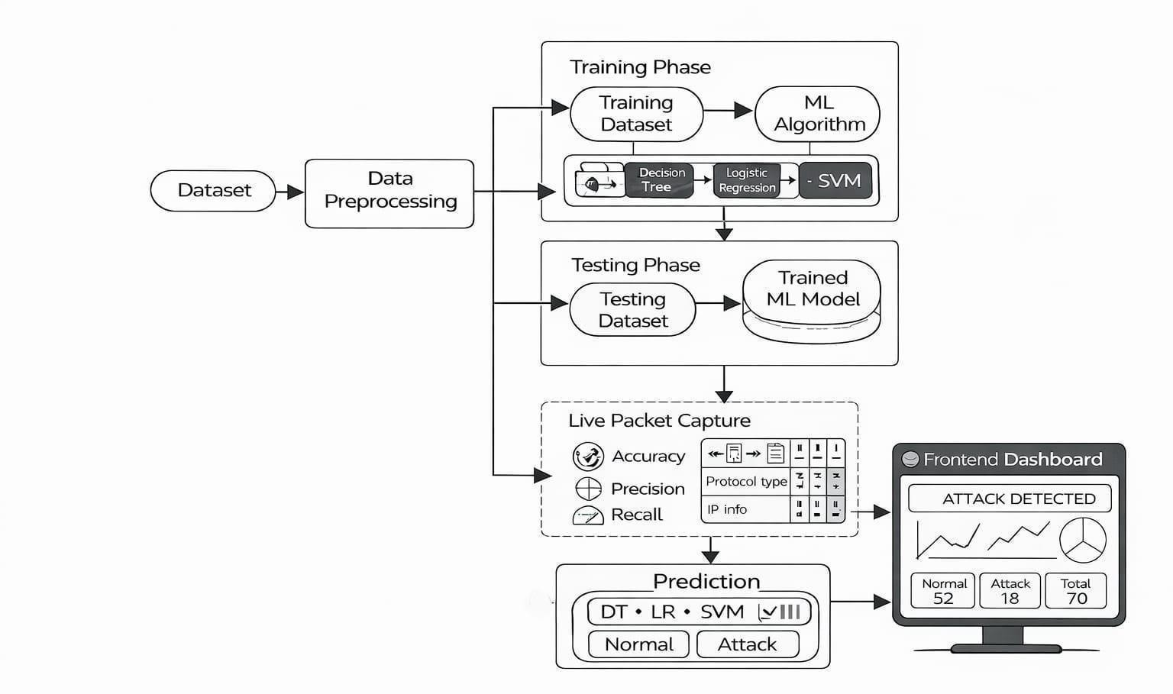

Figure- 2. System Architecture
After preprocessing, the system moves to the training phase. In this phase, the processed dataset is used to train multiple machine learning algorithms, including Decision Tree, Logistic Regression, and Support Vector Machine (SVM). These algorithms analyze the dataset and learn patterns that differentiate normal network behavior from malicious activity. As a result, a trained machine learning model is created.

2.1 Methodology and Algorithms
The methodology of the proposed system is based on a systematic machine learning approach for detecting network anomalies. The process begins with data collection, where a dataset containing network traffic and user behavior features is gathered. This dataset includes labeled instances of both normal and malicious activities, which are essential for supervised learning.

Algorithms Used
- Logistic Regression
- Decision Tree
- Support Vector Machine (SVM)
It is supervised machine learning algorithms are used to classify network traffic as either Normal (0) or Attack (1). Each algorithm learns patterns from historical network data but works in a different way.
Ensemble Method – Combines all models for better prediction

2.2 Logistic Regression:
Logistic Regression is a probability-based classification algorithm.
Logistic Regression is used to classify network traffic as Normal (0) or Attack (1). It takes input features like login attempts, failed logins, and packet size, and calculates the probability that the activity is malicious.
This helps in quickly identifying suspicious network behavior.
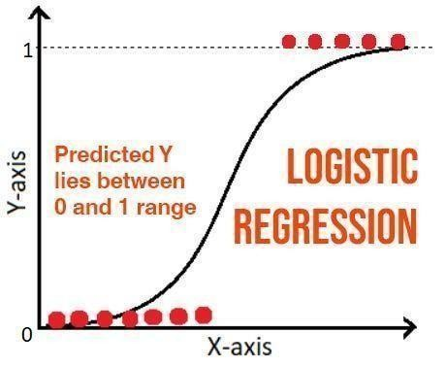
Figure- 2.2: Logistic Regression Algorithm

It works
This graph shows the Sigmoid (S-shaped) curve.
Output values are between 0 and 1.
If output > 0.5 → Attack
If output < 0.5 → Normal
It converts input into probability.
Example: If: login_attempts = 20 failed_logins = 15 unusual_time_access = 1
The model may calculate 0.85 probability of attack → Classified as Attack.

2.3 Decision Tree
Decision Tree is a rule-based classification algorithm.
The top node is called the root node, where the first condition is checked.
Based on True/False conditions, the data splits into branches.
Each branch leads to another condition or final decision.
Final outputs (Decision A / Decision B) represent Normal or Attack traffic.

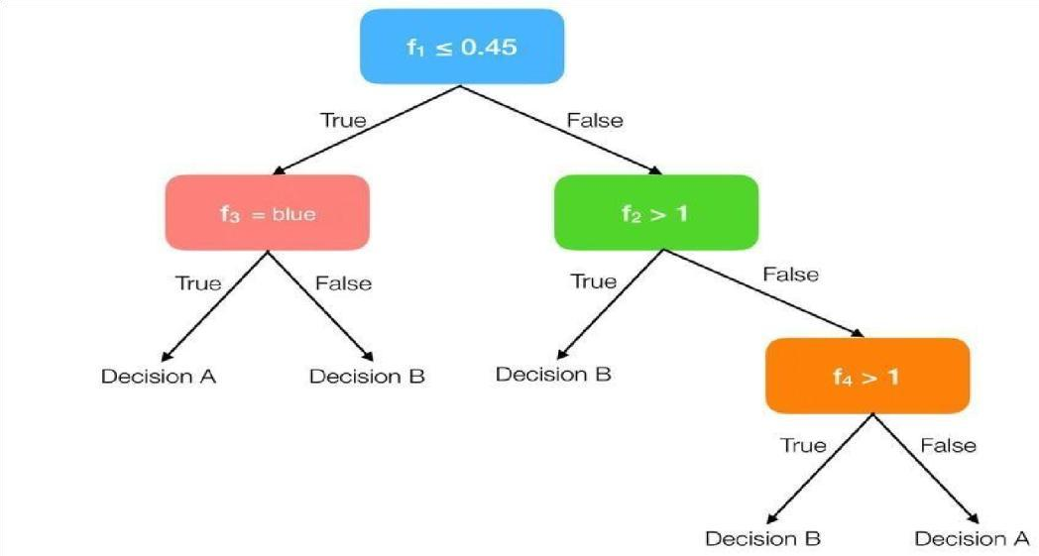
Figure- 2.3: Decision Tree Algorithm

It works
It creates decision rules based on feature values.
It splits data using conditions like:
If failed_ logins > 5 → Attack Else
→ Normal
It continues splitting until it reaches a final decision.
Example:
If:
failed_logins > 10
Ip_reputation_score < 30
Then → Attack

2.4 Support Vector Machine (SVM)
SVM is a boundary-based classification algorithm.
SVM is used to classify network traffic as Normal (0) or Attack (1) by creating a boundary (hyperplane) that separates the two classes.
Points near the boundary are called support vectors.
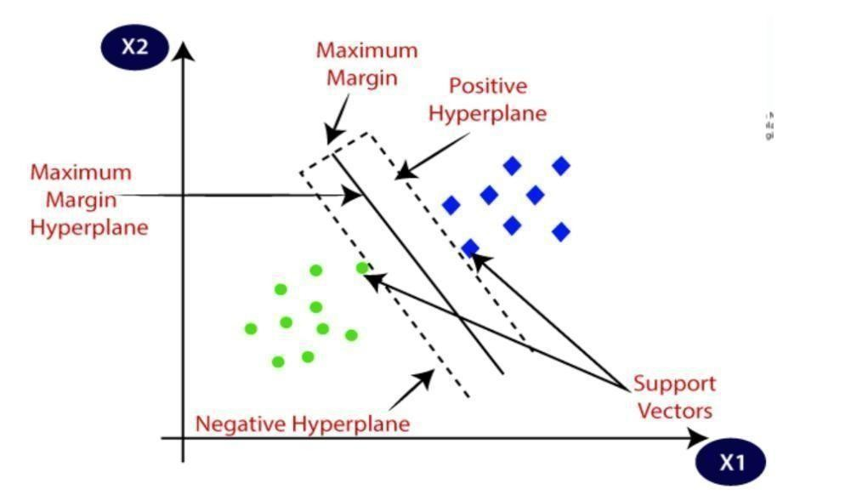
Figure- 2.4: Support Vector Machine Algorithm
It works
It places data points in a feature space.
It finds the best boundary that separates normal sessions from attack sessions.
It maximizes the distance between the two classes.
Example:
Normal sessions form one cluster, and attack sessions form another cluster.
SVM draws the best line separating them.

2.5 Ensemble Model
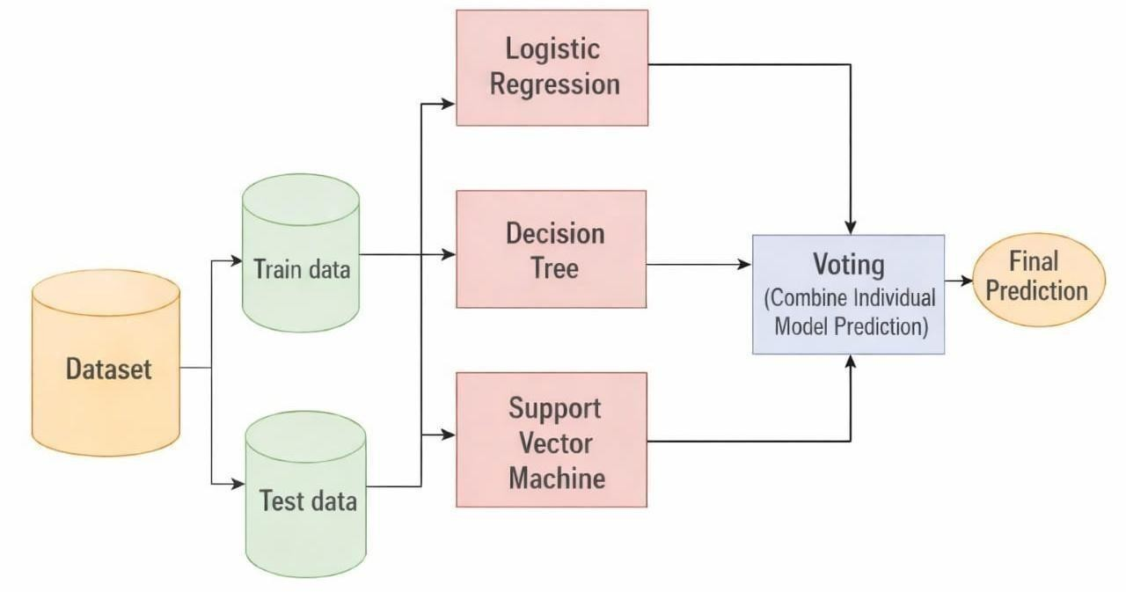
Figure- 2.5: Ensemble Model Architecture
To overcome this, the ensemble approach takes the predictions from all these models and combines them to make a final decision. This can be done using methods like majority voting, where the final output is the class predicted by most models. For example, if two models predict
“Attack” and one predicts “Normal,” the final result will be “Attack.”

2.6 System Working
The overall working of the system begins with input data, which is preprocessed and transformed into a suitable format. The processed data is then used to train machine learning models. After training, the models are evaluated using testing data to ensure accuracy.

3. DATASET DESCRIPTION

The Cybersecurity Intrusion Detection Dataset is used to identify cyber attacks by analyzing both network traffic and user behavior. Each record in the dataset represents a network activity or user session and contains several features that describe how the system is being used.
The dataset is labeled, meaning it clearly tells whether a particular activity is normal (0) or an attack (1) using the target variable attack_detected. This makes it suitable for supervised machine learning, where the model learns from existing data and predicts future outcomes.
The main purpose of using this dataset in our project is to train a system that can automatically detect suspicious activities based on patterns in the data. It helps in understanding how different features like login attempts, packet size, and IP reputation contribute to identifying cyber threats.

3.1 DATASET DETAILS:
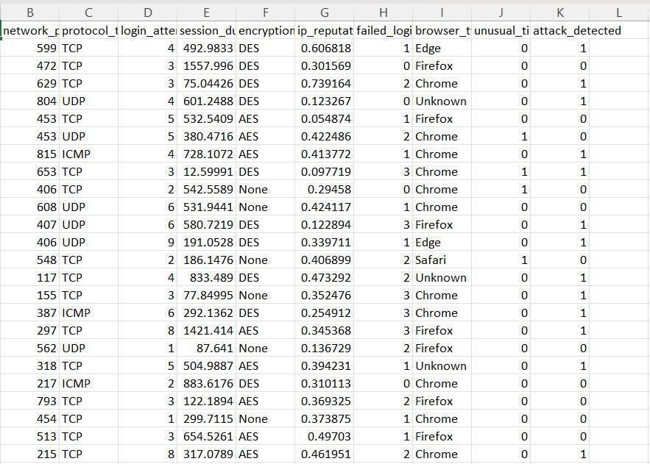

Figure 3. Dataset: cybersecurity intrusion data

The dataset contains two types of important features:

1. Network-Based Features
These describe technical details of network communication: network_packet_size → Size of data packets; abnormal size may indicate attack protocol_type → Type of communication (TCP, UDP, ICMP) encryption_used → Security level (AES strong,
DES weak, None risky)

2. User Behavior Features
These describe how users interact with the system: login_attempts → High attempts may indicate brute-force attack failed_logins → Many failures indicate hacking attempt session_duration → Long session may indicate unauthorized access unusual_time_access → Login at odd times is suspicious ip_reputation_score → High score means risky IP browser_type
→ Unknown browser may indicate bots

3. Target Variable attack_detected
- → Normal
- → Attack

Dataset Helps
- It contains both network data + user behavior data
- Helps system understand real attack patterns
- Improves accuracy of prediction
- Helps detect attacks automatically (no manual work)
- Supports real-time monitoring
- Helps identify suspicious users and activities early

4. IMPLEMENTATION
The implementation of the proposed Machine Learning-Based Network Anomaly Detection System (NADS) is carried out using Python by integrating machine learning techniques with real-time network traffic monitoring. The system is designed to capture live network packets, process the captured data, and classify it as normal or malicious using trained machine learning models.

4.1 Technologies Used

Python
Python is the primary programming language used in this project. It is a high-level language known for its simplicity and readability, which makes it easy for developers to write and understand code. Python is widely used in machine learning and data science because it provides powerful libraries and tools. In this project, Python is used for all major tasks such as data preprocessing, model training, evaluation, and real-time detection. It also supports file handling operations, which are useful for reading input datasets and writing output results. Additionally, Python can easily integrate with databases like SQLite, making it a flexible and efficient choice for developing the entire system.

Scikit-learn
Scikit-learn is a machine learning library in Python that is used to build and train models for classification tasks. In this project, Scikit-learn is used to implement supervised learning algorithms such as Logistic Regression, Decision Tree, and Support Vector Machine (SVM). These models are trained using historical network data to learn patterns of normal and attack traffic. After training, the models are used to predict whether new network data represents normal activity or a potential intrusion. Scikit-learn provides simple functions like fit() for training and predict() for making predictions. It also includes evaluation metrics such as accuracy, precision, recall, and F1-score, which help in measuring the performance of the models. Due to its ease of use and efficiency, Scikit-learn plays a key role in enabling intelligent detection in the system.

SQLite
SQLite is a lightweight database management system used in this project for storing data. It is a serverless database, which means it does not require installation or configuration and can be directly used with Python. In the Network Anomaly Detection System, SQLite is used to store network logs and prediction results, such as whether the traffic is normal or an attack. The database file is created locally and managed using Python’s built-in sqlite3 module. SQLite allows efficient storage and retrieval of data, making it suitable for real-time applications. It is fast, simple, and reliable, which makes it an ideal choice for this project.

4.2 Dataset Splitting
Once preprocessing is completed, the dataset is divided into training and testing sets. This step is essential for evaluating the performance of machine learning models.
In this project, the dataset is split using an 80:20 ratio, where 80% of the data is used for training and 20% is used for testing. The training dataset is used to train the machine learning models, while the testing dataset is used to evaluate how well the models perform on unseen data. The splitting process ensures that the model does not memorize the data and can generalize well to new inputs. It also helps in identifying overfitting and underfitting issues during model evaluation.

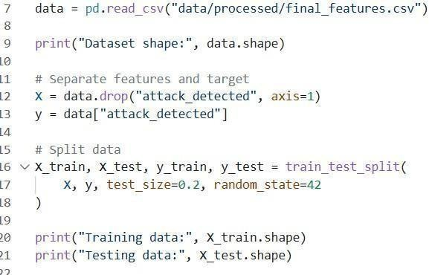
Figure: 4.2 Dataset Splitting

4.2.1 Model Training Implementation
In this stage, machine learning models are trained using the preprocessed training dataset. The models used in this project include Decision Tree, Logistic Regression, and Support Vector
Machine (SVM).
Each model is trained separately using labeled data, where the input features represent network and user behavior, and the output represents whether the activity is normal or an attack.
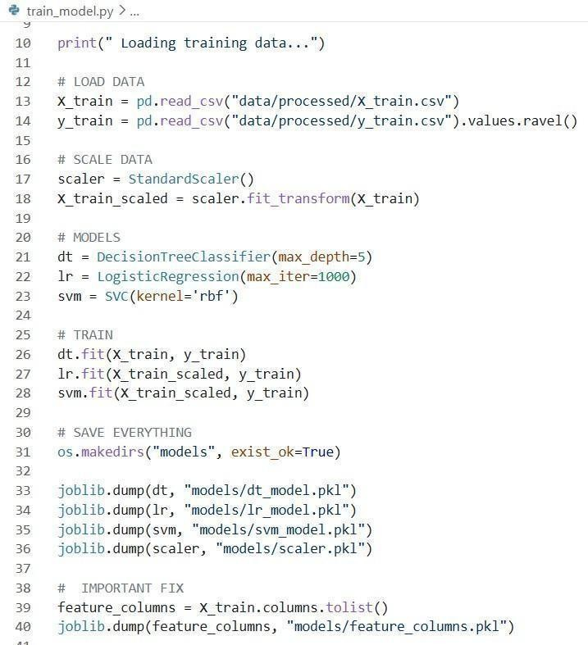
Figure:-4.2.1 Model Training Implementation

4.3 Data Preprocessing Implementation
Data preprocessing is a crucial stage in the implementation of the Machine Learning-Based Network Anomaly Detection System. The performance of machine learning models highly depends on the quality of the input data. In real-world scenarios, raw datasets are often incomplete, inconsistent, and unstructured. Therefore, preprocessing is required to clean and transform the data into a structured format suitable for model training.

4.3.1: Loading the Dataset
The preprocessing process begins with loading the dataset into the system using Python libraries such as Pandas. The dataset is stored in CSV format and is read into a DataFrame for further processing.
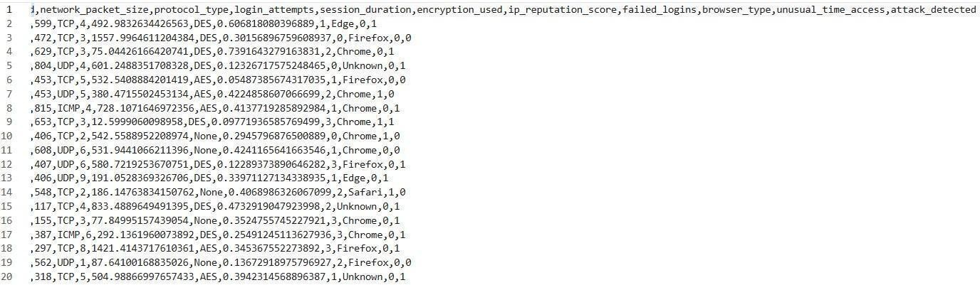
Figure: 4.3.1 Loading the Dataset

4.3.2: Removal of Duplicate Records
The dataset may contain duplicate entries, where the same network activity is recorded multiple times. These duplicate records can negatively impact the performance of the model by introducing bias and redundancy.
To improve data quality by removing redundancy and unnecessary information.
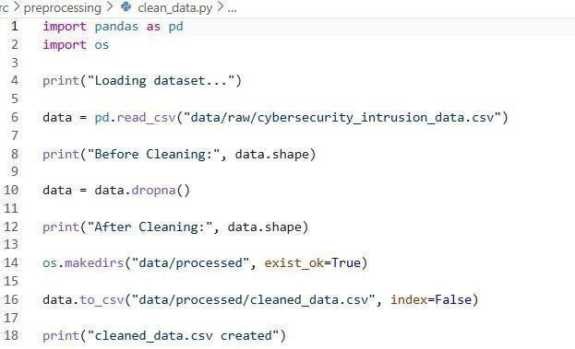

Figure:4.3.2 Removal of Duplicate Records

4.3.3: Encoding Categorical Features
The dataset contains several categorical features such as protocol type, encryption method, and browser type. These features are represented as text values, which cannot be directly processed by machine learning algorithms.
For example:
TCP → 0
UDP → 1
ICMP → 2 This conversion allows the machine learning model to interpret categorical information effectively.
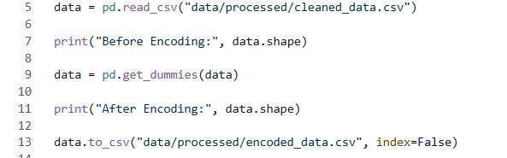
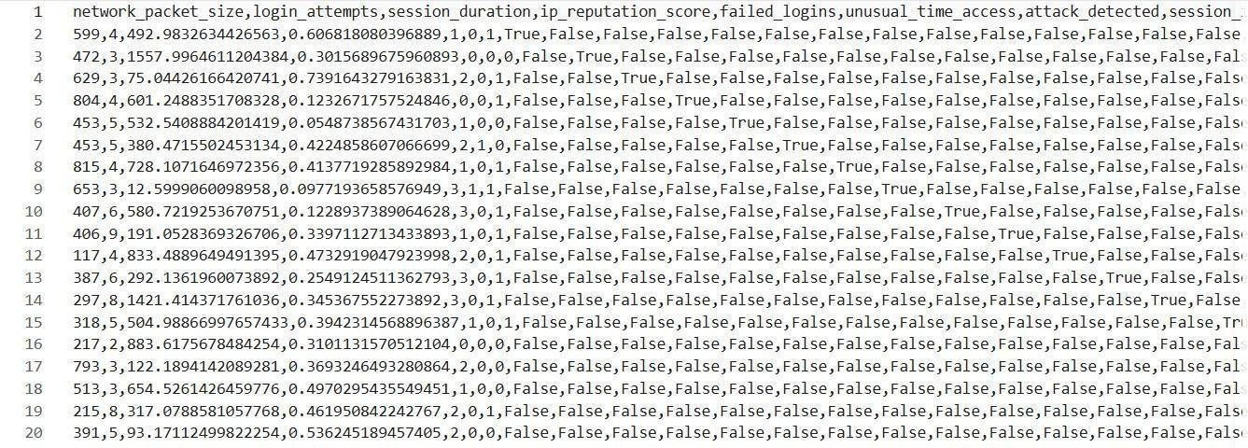
Figure: 4.3.3 Encoding Categorical Features

4.3.4: Feature Selection
The dataset may contain a large number of features, but not all features are equally important for prediction. Some features may be irrelevant or redundant and can increase computational complexity.
To select only relevant features and improve efficiency.
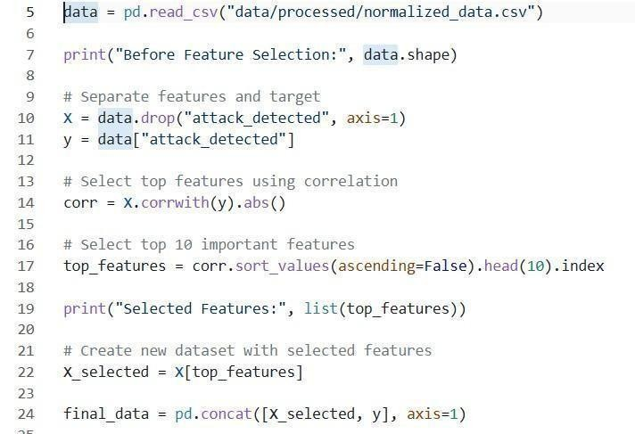

Figure:4.3.4 Feature Selection

4.4 Normalization
The dataset contains features with different ranges and units. For example, packet size values may be in hundreds or thousands, while IP reputation score values may range between 0 and 1. If these features are not scaled properly, features with larger values may dominate the model and affect its performance.
To standardize feature values and improve model accuracy.
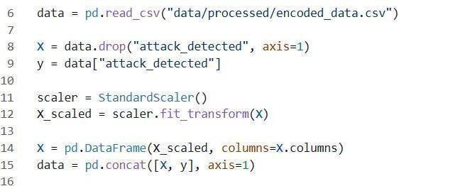
Figure:4.4 Normalization

4.5 Testing & Evaluation
After completing the model training phase, the next step is model testing. In this stage, the trained machine learning models are evaluated using a separate testing dataset that was not used during training. The purpose of testing is to determine how well the model performs on unseen data. The testing dataset contains input features along with actual labels indicating whether the network activity is normal or malicious. The trained models such as Decision Tree, Logistic Regression, and Support Vector Machine (SVM) are applied to the testing dataset. Each model generates predictions for the given inputs. The predicted results are then compared with the actual values to measure the correctness of the model. This process helps in identifying how accurately the model can classify network traffic.
Evaluation
To evaluate the performance of the machine learning models, several evaluation metrics are used. These metrics provide a clear understanding of how well the model is performing in detecting anomalies. Accuracy is used to measure the overall correctness of the model by calculating the percentage of correctly predicted instances. Precision indicates how many of the predicted attack instances are actually correct. It helps in reducing false alarms. Recall measures how many actual attack instances are correctly identified by the model. It is important for ensuring that no attacks are missed. F1-score is the harmonic mean of precision and recall. It provides a balanced evaluation of the model, especially when dealing with imbalanced data.
These metrics collectively help in selecting the best-performing model for real-time prediction.

4.5.1 CONFUSION MATRIX
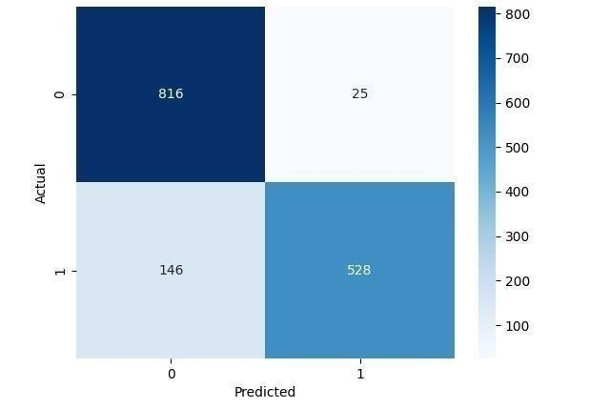
Figure: 4.5.1 Confusion Matrix
A confusion matrix is a performance evaluation tool that compares the actual values with the predicted values of the model.
From the confusion matrix:
True Negatives (TN) = 809 → Normal traffic correctly classified as normal
False Positives (FP) = 32 → Normal traffic incorrectly classified as attack
False Negatives (FN) = 157 → Attack traffic incorrectly classified as normal
True Positives (TP) = 517 → Attack traffic correctly classified as attack
This shows that the model performs well in identifying normal traffic, but there are some misclassifications in detecting attacks.

4.5.2 Performance Metrcis of The Model

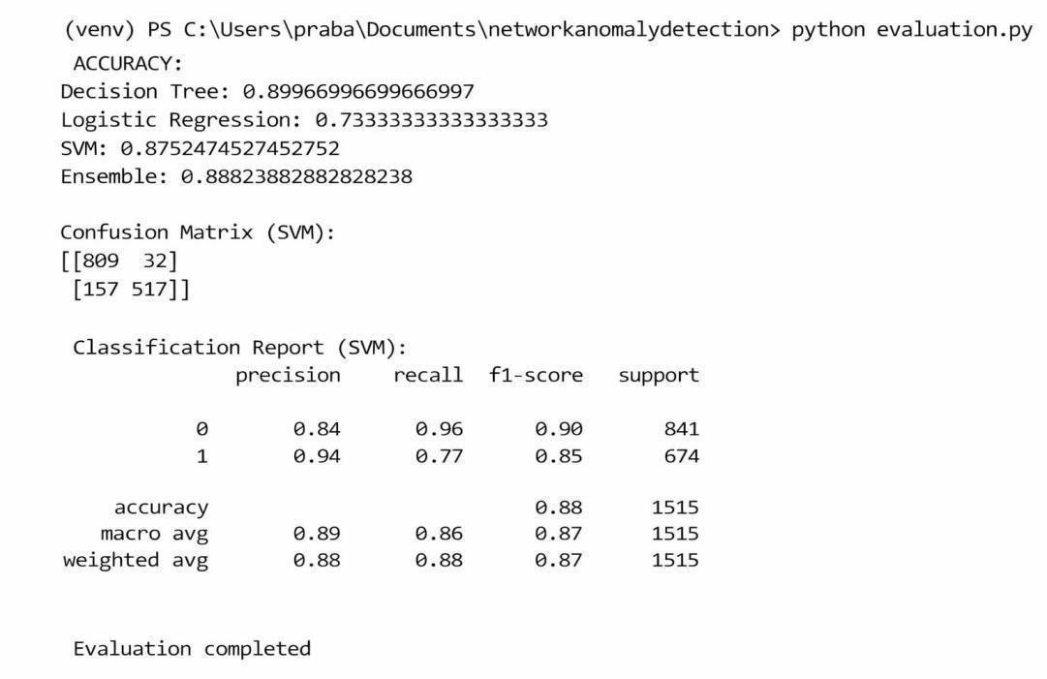

Figure:4.5.2 Performance Metrcis
The performance of different machine learning models is evaluated using accuracy:
Decision Tree: 89.96% (Highest accuracy)
Logistic Regression: 73.33% (Lowest performance)
SVM: 87.52% (Good performance)
Ensemble Model: 88.82% (Balanced performance)
The Decision Tree model achieved the highest accuracy, while the Ensemble method provided stable and reliable performance by combining multiple models.
Classification Report (SVM Model)
The classification report provides detailed evaluation metrics:
Class 0 (Normal Traffic):
Precision: 0.84
Recall: 0.96
F1-score: 0.90
Class 1 (Attack Traffic):
Precision: 0.94
Recall: 0.77
F1-score: 0.85
Overall Accuracy: 88%
The model has high recall for normal traffic, meaning it correctly identifies most normal instances. However, the recall for attack traffic is slightly lower, indicating some attacks are misclassified as normal.

Model Performance Comparison and Accuracy Analysis

Table:-
S.no | Models | Accuracy
1. | Decision Tree | 89.96% (Highest accuracy)
2. | Logistic Regression | 73.33% (Lowest performance)
3. | Support Vector Machine | 87.52% (Good performance)
4. | Ensemble Model | 88.82%

5. DEPLOYMENT
The deployment phase of the Network Anomaly Detection System involves integrating trained machine learning models with real-time network traffic monitoring. The system captures live network packets, processes them into structured features, and predicts whether the activity is normal or an attack.

5.1 MODEL LOADING AND INTEGRATION
The trained machine learning models such as Decision Tree, Logistic Regression, and SVM are saved as .pkl files in the models directory. These models are loaded during runtime and used for prediction.
The system does not retrain the model during deployment, which improves efficiency and reduces computation time.

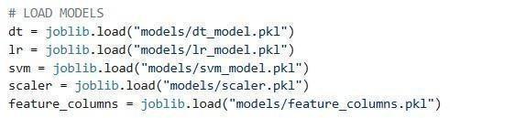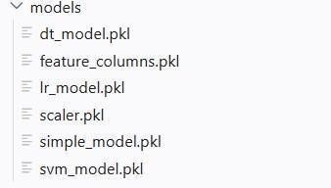

Figure:5.1 Model loading

5.2 Real-Time Network Traffic Capture
In addition to dataset-based testing, the system is designed to work with real-time network data.
The system captures live network packets using the Scapy library.
Scapy is used to monitor the network interface and capture incoming packets continuously. Each captured packet contains information such as packet size, protocol type, and other attributes.
This real-time packet capture enables the system to analyze actual network traffic instead of relying only on static datasets.

5.3 Feature Extraction from Packets
After capturing the network packets, the next step is feature extraction. In this stage, relevant features are extracted from each packet.
The extracted features include packet size, protocol type, and other required attributes. These features are converted into a structured format so that they can be used as input to the machine learning model.

5.4 Real-Time Prediction
The prediction is performed instantly, allowing the system to detect suspicious activities in real time. The output is displayed in a simple format such as “Normal Traffic” or “Attack Detected”.
This real-time prediction capability is the key functionality of the system.

5.5 DATABASE IMPLEMENTATION
The system uses a database to store network logs and prediction results. SQLite database (network_logs.db) is used for storing packet data, features, predictions, and timestamps.
This allows tracking of past network activity and improves analysis.
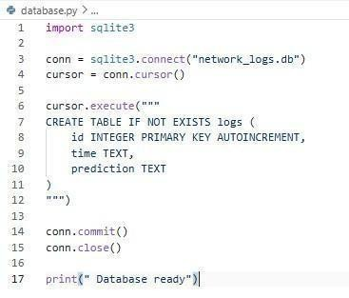
Figure: 5.5 Sqlite3 Database

5.6 Streamlit Dashboard
This app.py uses Streamlit to create a real-time dashboard for network Anomaly detection by fetching the latest data from a SQLite database. It displays metrics, logs, and visual graphs (pie chart and trend) to monitor attack vs normal traffic. It also shows alerts when any attack is detected, updating automatically every 2 seconds.
The app.py file acts as the main application that connects all components, including the trained model, data processing functions, and visualization dashboard. First, the trained model (saved as a .pkl file) is loaded into the application. This model is used to make predictions on new input data or live network traffic.
the following command is used in the terminal:
Figure:5.6 Command to Launch Streamlit Dashboard Application

6. OUTPUT SCREENS

6.1 Real-Time Prediction

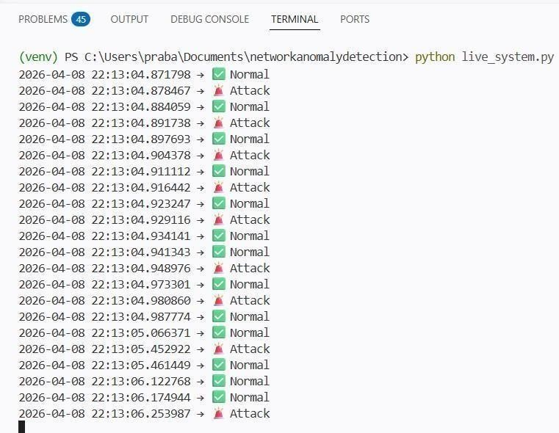

Figure: 6.1 Real-Time Running Prediction

The real-time output of the Network Anomaly Detection System (NADS) during execution. The system continuously processes incoming network data and classifies each instance as either
Normal or Attack.
Each row in the output contains:
A timestamp indicating when the data packet was processed
A prediction result showing whether the traffic is normal or malicious The results are visually represented using symbols:
Normal → Indicates safe and legitimate network activity
Attack → Indicates suspicious or malicious activity detected by the system
Working Process
As the system runs, it analyzes network traffic in real-time and immediately displays the prediction results in the terminal. For example:
At a given timestamp, if the model detects unusual patterns, it labels the traffic as Attack
If the behavior matches normal patterns, it labels it as Normal
This continuous monitoring helps in identifying threats instantly without delay.
Example Interpretation
From the output:
Some entries are marked as Normal, meaning the network traffic is safe
Several entries are marked as Attack, indicating potential Anomaly attempts

6.2 Network Anomaly Detection System (Live)
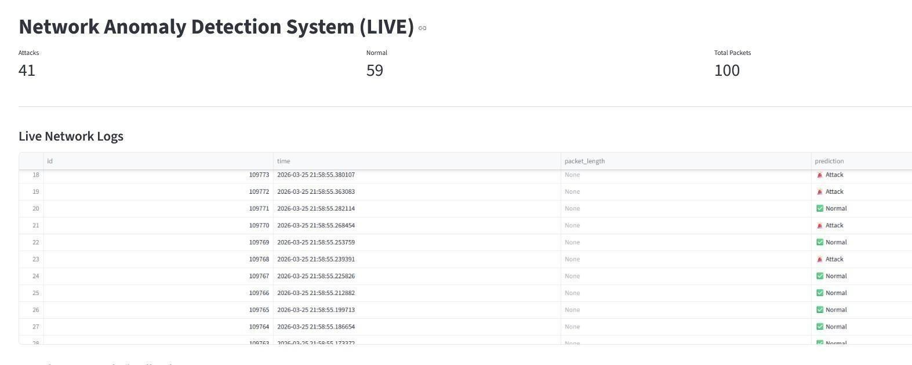
Fig no: 6.2 Network Anomaly Detection System (Live) Dashboard

Overall Dashboard
This dashboard shows real-time network monitoring results.
It displays how many packets are normal and how many are attacks.
Helps the user quickly understand network security status.

1. Top Statistics (Attacks / Normal / Total Packets)
Attacks (41): Number of malicious packets detected
Normal (59): Safe network traffic
Total Packets (100): Total analyzed data
Shows overall performance of the detection system

2. Live Network Logs Table
Displays real-time packet information
Columns include ID, Time, Packet Length, and Prediction
Each row represents one network packet

3. Prediction Column
Shows whether traffic is Attack or Normal
Attack is marked with a warning symbol
Normal is marked with a safe/green symbol
The dashboard continuously receives data from the live system, which captures network packets using Scapy. This data is processed and passed to the trained Machine Learning model, which classifies the traffic as Normal (0) or Attack (1). The results are instantly displayed on the dashboard, allowing users to observe network behavior in real time.

6.3 Attack Vs Normal Distribution
The pie chart visualization represents the overall distribution of network traffic. It clearly shows the proportion of normal and attack packets, where approximately 60% of the traffic is normal and 40% is identified as malicious. This graphical representation helps in quickly understanding
the overall network condition without analyzing detailed logs.
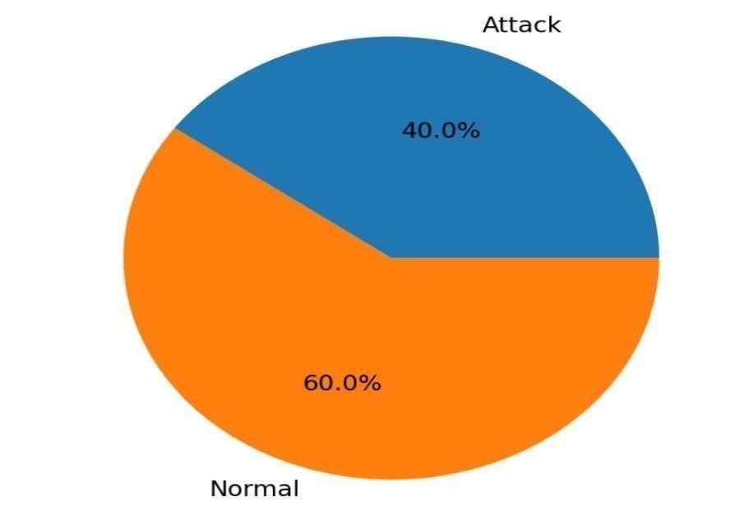

Fig no: 6.3 Pie Chart The
pie chart represents the distribution of network traffic.
It shows the percentage of normal and attack packets detected.
Helps users quickly understand overall network behavior.

6.4 Live Traffic Trend
The attack trend graph illustrates how intrusion activities vary over time. The x-axis represents time, while the y-axis indicates the level of attack activity. The graph shows fluctuations and peaks, highlighting periods of increased attack intensity. This helps in identifying patterns and understanding when the network is most vulnerable.
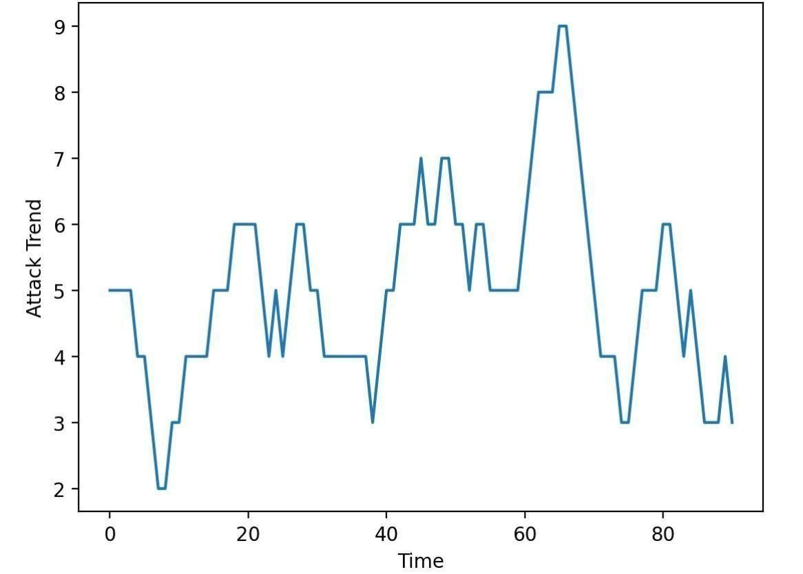

Fig no: 6.4 Attack Trend Graph
The graph shows how attack activity changes over time.
X-axis represents time, Y-axis represents attack intensity/trend.
Helps identify peaks and sudden increases in attacks.
Together, these outputs provide a complete6view of the system’s performance by combining real-time monitoring, statistical visualization, and temporal analysis. This enables efficient detection of intrusions, better decision-making, and improved network security management.

7. CONCLUSION
This project develops a Network Anomaly Detection System using Machine Learning and Scapy. It captures live network traffic, processes it, and uses Decision Tree, Logistic Regression, and SVM to classify data as normal or attack. The ensemble method improves accuracy, and results are shown in a real-time dashboard. Overall, it provides an efficient and simple solution for network security. A hybrid model is used to increase accuracy and reduce false positives. Performance is evaluated using metrics like accuracy, precision, and recall. The system is scalable, cost-effective, and efficient. It enhances network security by providing fast and automated intrusion detection. The system is designed to collect network traffic data, preprocess it, and analyze important features such as login attempts, session details, protocol type, and user behavior. Machine Learning algorithms including Logistic Regression, Decision Tree, and Support Vector Machine (SVM) are used to train the model. Each algorithm contributes differently to the detection process, and the use of an ensemble method further improves the overall accuracy and reliability of predictions. One of the key strengths of the system is its ability to perform real-time monitoring using packet capturing techniques. The Live System continuously analyzes incoming network traffic and classifies it as Normal (0) or Attack (1), providing instant results. The integration of a Streamlit dashboard allows users to visualize outputs through graphs, charts, and live updates, making the system easy to understand and us The project also ensures proper data management by storing detection results in a SQLite database, which helps in tracking, analysis, and future improvements. Compared to traditional systems, this solution reduces manual effort, increases detection speed, and provides better adaptability to new types of cyber threats.

REFERENCES
- Bovenzi, G.; Aceto, G.; Ciuonzo, D.; Persico, V.; Pescapé, A. A Hierarchical Hybrid
- Intrusion Detection Approach in IoT Scenarios. In Proceedings of the GLOBECOM 2020–2020 IEEE Global Communications Conference, Taipei, Taiwan, 7–11 December
2020; pp. 1–7.
- Nimbalkar, P.; Kshirsagar, D. Feature selection for intrusion detection system in Internet-of-Things (IoT). ICT Express 2021, 7, 77–181.
- Y. Zhou, G. Cheng, S. Jiang, and M. Dai, ‘Building an efficient intrusion detection system based on feature selection and ensemble classifier’, Comput. Networks, vol. 174, 2020.
- N. Acharya and S. Singh, ‘An IWD-based feature selection method for intrusion detection system’, Soft Comput., vol. 22, no. 13, pp. 4407–4416, 2018.
- M. Ring, S. Wunderlich, D. Scheuring, D. Landes, and A. Hotho, ‘A survey of networkbased intrusion detection data sets’, Comput. Secur., vol. 86, pp. 147–167, 2019.
- "NSL-KDD dataset," [Online]. Available: https://www.unb.ca/cic/datasets/nsl.html.
[Accessed 08 04 2019].
- Ullah, I.; Mahmoud, Q.H. A Scheme for Generating a Dataset for Anomalous Activity Detection in IoT Networks. In Advances in Artificial Intelligence; Goutte, C., Zhu, X., Eds.; Lecture Notes in Computer Science; Springer: Cham, Switzerland, 2020.
- Oreški, D.; Androcˇec, D. Genetic algorithm and artificial neural network for network forensic analytics. In Proceedings of the 2020 43rd International Convention on Information, Communication and Electronic Technology (MIPRO), Opatija, Croatia, 28 September–2 October 2020; pp. 1200–1205.
- Derhab, A.; Aldweesh, A.; Emam, A.Z.; Khan, F.A. Intrusion Detection System for Internet of Things Based on Temporal Convolution Neural Network and Efficient Feature Engineering. Wireless Commun. Mobile Comput. 2020, 2020, 6689134. [CrossRef]
- Anthi, E.; Williams, L.; Słowin´ska, M.; Theodorakopoulos, G.; Burnap, P. A supervised intrusion detection system for smart home iot devices. IEEE Internet Things J. 2019, 6, 9042–9053. [CrossRef]
- Injadat, M.; Moubayed, A.; Shami, A. Detecting Botnet Attacks in IoT Environments: An Optimized Machine Learning Approach. In Proceedings of the 2020 32nd International Conference on Microelectronics (ICM), Aqaba, Jordan, 14–17 December 2020; pp. 1–4.
- Sarhan, M.; Layeghy, S.; Moustafa, N.; Gallagher, M.; Portmann, M. Feature Extraction for Machine Learning-based Intrusion Detection in IoT Networks. arXiv 2021, arXiv:2108.12722v1.
- Lo, W.W.; Layeghy, S.; Sarhan, M.; Gallagher, M.; Portmann, M. E-GraphSAGE: A Graph Neural Network based Intrusion Detection System. arXiv 2021, arXiv:2103.16329.
- Sarhan, M.; Layeghy, S.; Portmann, M. Feature Analysis for ML-based IIoT Intrusion Detection. arXiv 2021, arXiv:2108.12732.
- Qaddoura, R.; Al-Zoubi, A.M.; Almomani, I.; Faris, H. A Multi-Stage Classification Approach for IoT Intrusion Detection Based on Clustering with Oversampling. Appl. Sci. 2021, 11, 3022. [CrossRef]
- Alkahtani, H.; Aldhyani, T.H. Intrusion Detection System to Advance Internet of Things Infrastructure-Based Deep Learning Algorithms. Complexity 2021, 2021, 5579851. [CrossRef]
- Islam, N.; Farhin, F.; Sultana, I.; Kaiser, M.S.; Rahman, M.S.; Mahmud, M.; Hosen, A.S.; Cho, G.H. Towards Machine Learning Based Intrusion Detection in IoT Networks. Comput. Mater. Contin. 2021, 69, 1801–1821. [CrossRef]
- Song, Y.; Hyun, S.; Cheong, Y.-G. Analysis of Autoencoders for Network Intrusion Detection. Sensors 2021, 21, 4294. [CrossRef] [PubMed]
- Hussein, A.Y.; Falcarin, P.; Sadiq, A.T. Enhancement performance of random forest algorithm via one hot encoding for IoT IDS. Period. Eng. Nat. Sci. 2021, 9, 579–591.

