AI-Based Personalized Study Planner with Adaptive Reward Allocation for Enhancing Learning Effectiveness

Keshamoni Keerthi B.Tech., Student, 22951A0577
Computer Science and Engineering Institute of Aeronautical Engineering Dundigal, Hyderabad, India keerthi.keshamoni04@gmail.com
Kunchapu Madhavi
B.Tech., Student, 22951A0596 Computer Science and Engineering Institute of Aeronautical Engineering Dundigal, Hyderabad, India 22951a0596@iare.ac.in

Mary Swarna Latha Gade
Dept. of Computer Science and Engineering Institute of Aeronautical Engineering
Dundigal, Hyderabad, India g.maryswarnalatha@iare.ac.in
R. Naga Pranav B.Tech, Student, 22951A05B6
Computer Science and Engineering Institute of Aeronautical Engineering Dundigal, Hyderabad, India 22951a05b6@iare.ac.in

Abstract— Students often face difficulties in organizing their study time because of increasing academic workload and the absence of effective planning strategies. Many existing study planning tools only provide basic scheduling features and do not adapt to individual learning behavior or offer motivation to maintain consistency. This research presents an AI-based personalized study planner with an adaptive reward allocation mechanism designed to improve learning effectiveness and student engagement. The proposed system is a web-based platform that creates customized study schedules based on subjects, exam deadlines, learning goals, and available study time. It monitors user activities such as task completion, study duration, and quiz performance to evaluate learning progress. A Learning Effectiveness Score (LES) is introduced to measure learning performance by combining factors like task difficulty, engagement level, and assessment results. According to this score, the system dynamically assigns reward points to motivate consistent study habits. The platform also includes a reward wallet where students can redeem earned points for educational resources. The system is implemented using Python, React, and MongoDB, enabling efficient scheduling, analytics, and real-time reward processing to support personalized and motivating learning environments.
Keywords—Artificial Intelligence, Personalized Learning, Study Planning System, Adaptive Reward Mechanism, Learning Effectiveness Score, Educational Data Analytics, Gamified Learning, Intelligent Tutoring Systems.

- INTRODUCTION
Effective study planning plays an important role in improving students’ academic performance and maintaining consistent learning habits. However, many students struggle to organize their study schedules due to increasing academic workload, multiple subjects, and limited time management skills. Without proper planning, students often experience irregular study patterns, reduced motivation, and difficulty in tracking their learning progress. In the digital learning era, technology-based solutions can help address these challenges by providing structured and personalized study support.
Traditional study planners and scheduling applications mainly focus on simple task management and calendar
based reminders. While these tools help students list their tasks and deadlines, they usually do not adapt to
individual learning behaviors, performance levels, or subject difficulty. As a result, these systems lack personalization and fail to encourage sustained learning motivation. In addition, most existing planners do not provide any reward or feedback mechanism that can reinforce positive learning behavior.

These Recent advancements in artificial intelligence (AI) have created new opportunities for developing intelligent educational systems that can support personalized learning experiences. AI-based systems are capable of analyzing user data, identifying learning patterns, and generating adaptive recommendations. Integrating AI into study planning can enable systems to automatically generate optimized study schedules based on factors such as academic goals, exam deadlines, subject difficulty, and available study time. This research proposes an AI-Based Personalized Study Planner with Adaptive Reward Allocation for Enhancing Learning Effectiveness. Artificial intelligence has increasingly been applied in educational environments to improve personalized learning experiences and academic planning systems [1], [6], [8], [19]. The proposed system generates customized study plans and continuously monitors user activities such as task completion, study duration, and assessment results. Previous research has shown that AI-based adaptive learning systems can analyze student behavior and generate personalized recommendations to improve learning outcomes [12], [19].

A key component of the system is the Learning Effectiveness Score (LES), which evaluates learning performance using metrics such as engagement level, task complexity, and quiz outcomes. Adaptive learning models and AI-driven decision systems have demonstrated the ability to analyze student engagement and performance to support more effective learning strategies [9], [15]. Based on this score, the system dynamically allocates reward points to encourage consistent and productive study habits, similar to gamified and AI-supported learning systems that motivate learners through incentives.
In addition to personalized planning, the system introduces a reward-based learning ecosystem where students can redeem earned points for educational resources available on the platform. Research indicates that integrating motivational strategies with AI-based learning environments can significantly improve student engagement and self-directed learning behavior [5], [9], [14],[19].

The proposed platform is implemented using Python, React, and MongoDB, enabling scalable and efficient management of study planning, performance tracking, and reward processing. AI-powered educational systems and intelligent scheduling frameworks have been widely explored in recent research for improving learning management and academic planning processes [3], [4], [13], [17]. By combining intelligent scheduling with adaptive reward mechanisms, the proposed system aims to enhance student motivation, improve study consistency, and support more effective learning practices. Such AI-driven adaptive learning environments are increasingly recognized as a promising direction for future digital education systems [16].

- LITERATURE SURVEY
Research in artificial intelligence (AI) for education has grown rapidly, especially in areas such as personalized learning, intelligent tutoring, and adaptive academic systems. Existing studies can be broadly grouped into key themes, including AI- supported gamification, data-driven decision- making, intelligent scheduling systems, adaptive learning platforms, and AI-enabled tutoring environments.
One prominent line of work investigates the use of AI in gamified learning environments. Researchers highlight that integrating AI techniques—such as adaptive learning models, automated evaluation systems, and intelligent tutoring—can significantly improve learner engagement and motivation. These systems are capable of delivering customized feedback and dynamically adjusting content based on individual student needs. However, concerns related to ethical usage, data protection continue to be major challenges.

Another important research direction focuses on the application of AI in forecasting and decision-making. By utilizing approaches like machine learning, predictive analytics, reinforcement learning, and optimization methods, these systems can process large volumes of data to enhance planning and strategic decisions. The findings suggest that such techniques improve efficiency, accuracy, and adaptability, making them relevant for applications like AI-based academic planning and study management systems.
A growing body of work also addresses intelligent scheduling solutions in education. These systems aim to generate personalized exam timetables and assignment schedules by analyzing student performance and workload.
Reinforcement learning techniques, particularly Proximal Policy Optimization (PPO) and Q-Learning, have proven effective in solving complex scheduling problems, with PPO often delivering better results. Furthermore, hybrid models that combine reinforcement learning with language models and explainable AI improve both adaptability and transparency, enabling students to better understand and manage their academic tasks.
In addition, AI-powered learning platforms have been widely explored for delivering personalized educational experiences. Studies using mixed research methods, including surveys and data analytics, show that such platforms can recommend relevant learning resources and improve user engagement. Similarly, experimental approaches using AI tools like conversational agents demonstrate enhanced academic performance, increased learning efficiency, and higher student satisfaction. Despite these advantages, issues such as system usability, user trust, and engagement levels still require attention.

The development of intelligent tutoring systems represents another key area of research. In particular, multi-agent AI systems have been proposed to provide dynamic and real time instructional support. These systems use technologies like natural language processing, cognitive modeling, and learning analytics to adapt teaching strategies based on learner behavior. While they offer improved personalization compared to traditional methods, challenges related to scalability, privacy, and performance evaluation remain unresolved.

AI technologies are also widely used to enhance digital learning environments through tools such as chatbots, virtual tutors, and automated feedback systems. These technologies enable continuous monitoring of student progress and facilitate the delivery of tailored educational content. Although they contribute to better learning outcomes and engagement, researchers emphasize the importance of addressing ethical concerns and ensuring responsible AI implementation. Another emerging trend involves AI-based decision-support systems designed to promote self-directed learning. These systems assist learners in selecting appropriate study materials and strategies based on their preferences and performance. Findings indicate that such tools improve learner independence, engagement, and overall efficiency, thereby strengthening personalized learning experiences.

Furthermore, some studies combine AI techniques with established motivational theories to enhance educational outcomes. By incorporating concepts such as self-determination and need-based motivation into AI models, these systems can monitor student participation, detect learning difficulties early, and support timely interventions. However, ensuring transparency, fairness, and ethical governance remains essential when applying these approaches.

Gap Analysis:
Although significant progress has been made, several limitations persist in current AI-based educational systems.
Key issues include concerns over data privacy, lack of transparency in AI decision-making, scalability challenges, and unequal access to technology. Moreover, many existing solutions address specific functionalities—such as tutoring, scheduling, or recommendation—without offering a unified system that integrates all these components effectively.

To overcome these limitations, the proposed work aims to develop an integrated AI-based educational framework that combines personalized scheduling, adaptive learning, and intelligent feedback mechanisms. The approach emphasizes improved usability, transparency, and accessibility while leveraging advanced AI techniques to enhance learning outcomes and provide a more holistic educational experience.

- RELATED WORK
Recent advancements in artificial intelligence (AI) have significantly influenced the development of intelligent educational systems, particularly in the areas of personalized learning, adaptive planning, and student engagement. Several studies have explored the application of AI techniques such as machine learning, reinforcement learning, and learning analytics to improve academic performance and optimize study processes.
A major body of research focuses on AI-driven personalized learning systems. These systems analyze student behavior, learning patterns, and performance data to generate customized learning recommendations and adaptive study content. Prior studies [1], [6], [8] demonstrate that AI-based adaptive learning environments can enhance student engagement, improve learning efficiency, and provide real-time feedback. However, many of these systems primarily focus on content delivery and lack integration with structured study planning and scheduling mechanisms.

Another important research direction involves intelligent scheduling and planning systems. Techniques such as reinforcement learning and optimization algorithms have been used to develop personalized timetables based on user preferences, workload, and performance [3], [4]. These systems effectively handle complex scheduling tasks and improve time management. Nevertheless, most existing scheduling solutions do not continuously adapt to student progress or incorporate motivational strategies to sustain long-term engagement.
Gamification and reward-based learning approaches have also been widely studied to enhance student motivation. Research shows that incorporating rewards, incentives, and feedback mechanisms into learning systems can significantly improve user engagement.

AI-supported gamified systems further enhance this by dynamically adjusting rewards based on user behavior. Despite these benefits, many implementations use static reward systems and do not consider comprehensive performance metrics for adaptive reward allocation.

In addition, AI-based decision-support systems have been proposed to assist learners in managing their study activities and selecting appropriate learning strategies [9], [15]. These systems improve learner autonomy and support self-directed learning. However, they often lack a unified framework that combines planning, monitoring, and motivation within a single platform.

- PROPOSED SYSTEM

- System Overview

The proposed solution is an AI-based personalized study planning system designed to assist students in organizing their academic activities while maintaining motivation through a dynamic reward mechanism. Artificial intelligence has increasingly been used to support personalized learning and adaptive educational environments that improve student engagement and performance [6], [8], [19]. The platform combines study schedule generation, performance tracking, and reward allocation within a single web-based learning environment.

The system functions as a closed-loop learning framework, where student activities are continuously monitored and analyzed in order to improve study recommendations and reward distribution. Adaptive learning platforms that analyze student behavior and performance have been widely explored in recent research for enhancing learning efficiency and personalization [12], [19]. The platform consists of several interconnected modules including user profile management, intelligent study plan generation, task monitoring, learning performance evaluation, reward allocation, and analytical visualization. The architecture follows a client–server model. The user interface is developed using React, while the server- side logic and AI components are implemented using Python. All system data, including study tasks, reward points, and performance metrics, are stored in a MongoDB database. Similar AI-based educational architectures have been proposed in previous research to support scalable and intelligent academic planning systems [3], [4], [13].

The proposed AI-based personalized study planner operates by first collecting user inputs such as subjects, goals, deadlines, and available study time through an interactive web interface. As the user follows the plan, the system continuously tracks activities including task completion, study duration, and assessment performance. This data is used to compute the Learning Effectiveness Score (LES), which reflects the user’s overall learning progress. Based on the LES, an adaptive reward mechanism dynamically assigns points to motivate consistent study behavior.

- System Architecture

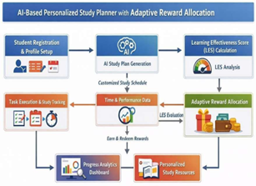

Fig 1. System architecture of the AI-based personalized study planner

Fig 1 shows the architecture of the proposed platform and it composes of multiple interconnected components that work together to deliver a customized learning experience. The architecture is designed to efficiently process user data, generate customized study plans, and provide real-time feedback and rewards.

- User Interface Layer

This layer enables interaction between users and the system. Students can create accounts, define study objectives, manage tasks, and monitor their learning progress through dashboards.

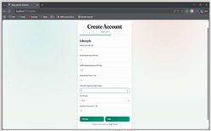
Fig 2: User Profile Setup – Lifestyle Information Collection

This figure represents the stage in the registration process where the system collects lifestyle-related information from the user. Details such as sleeping patterns, screen usage, social media activity, and physical exercises are recorded. These inputs help the AI component understand the user’s daily routine, allowing it to create a study plan that is more suitable, balanced, and aligned with individual habits.

- Application Logic Layer

The application layer handles the core functionality of the system, including request processing, study plan generation, reward computation, and performance monitoring. Backend systems for intelligent educational applications often rely on AI-driven logic to analyze learning behavior and generate adaptive responses [19].

- AI Planning module

The AI planning component generates individualized study schedules by analyzing various factors such as:

  - subject complexity
  - available study time
  - examination deadlines
  - previous academic performance
  - patterns of task completion

The figure, that is below presents the Study Planner interface of the proposed AI-driven personalized learning system. This component enables users to monitor their scheduled study activities by displaying subject-wise planned duration alongside the time already completed.

It also indicates the current status of each task, such as pending or completed, allowing students to effectively follow their daily learning progress. Additionally, a “Finalize Day” feature is included at the bottom of the interface, which triggers the evaluation of the user’s productivity level and assigns reward points based on their overall performance and task completion.

The Fig 3 below represents the workflow of the AI-Based Personalized Study Planner, showing how a user interacts with the system from start to finish. It begins with student registration or login, followed by profile creation where key details such as subjects, goals, exam dates, and available study time are provided. Based on this input, the system uses AI to generate a customized study plan tailored to the individual’s needs and priorities, ensuring efficient time management and structured learning.

Once the study plan is generated, the student proceeds with task execution. The system continuously tracks study activities, including time spent and performance in quizzes or assessments. This data is then used to calculate the Learning Effectiveness Score (LES), which reflects how effectively the student is progressing. The repeated tracking and scoring process helps maintain accuracy in evaluation.

Based on the calculated LES, the system allocates reward points through an adaptive mechanism designed to motivate consistent study habits. These points are stored in a reward wallet, which users can later use to redeem educational resources. Additionally, the system provides progress analytics, enabling students to monitor their improvement over time. Overall, the workflow highlights a continuous cycle of planning, monitoring, evaluation, and motivation, creating a comprehensive and engaging learning environment.

The AI-based planning module is responsible for generating personalized study schedules based on user inputs such as subjects, deadlines, goals, and available study time. It analyzes these factors to prioritize tasks and allocate time efficiently, ensuring balanced workload distribution.

- Learning Effectiveness Evaluation Module
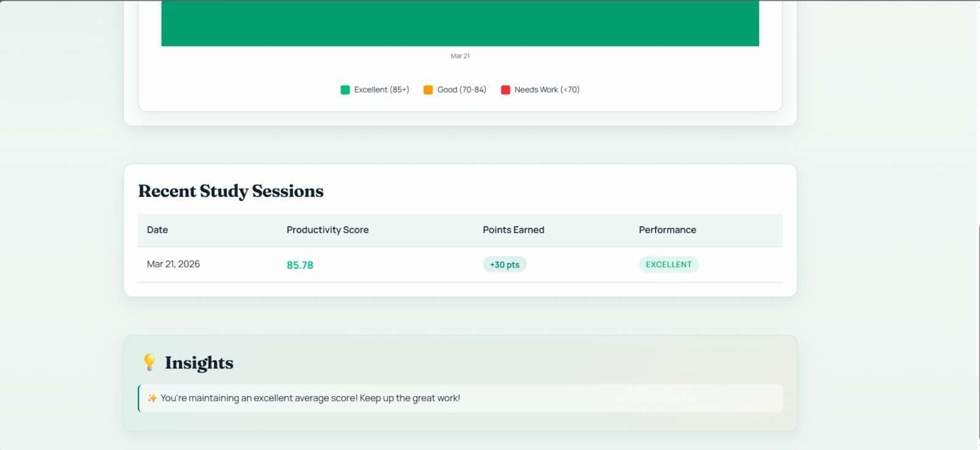

Fig.3: Learning Effectiveness Score (LES) and Performance Analytics Dashboard

This module evaluates the academic performance of the student by computing a Learning Effectiveness Score (LES). The score is derived from several performance indicators including task completion rate, study engagement, assessment outcomes, and task difficulty. Similar adaptive learning evaluation models have been explored in AI-based learning systems to monitor student performance and guide personalized learning recommendations [15], [19].
The figure shows the Learning Effectiveness Score (LES) dashboard of the AI-based personalized study planner. This interface presents a summary of recent study sessions, including the date, productivity score, reward points earned, and overall performance level. The system evaluates the student's study activities and assigns a productivity score, which is then used to allocate reward points. The dashboard also provides performance insights and feedback messages that help students understand their learning progress and maintain consistent study habits.

- Reward Management Module

The reward module dynamically assigns points based on the calculated LES value. Accumulated points are stored in a digital reward wallet, which allows students to redeem points for educational materials available on the platform. Gamification strategies and reward- based learning systems have been shown to increase student motivation and participation in educational environments [1], [10].

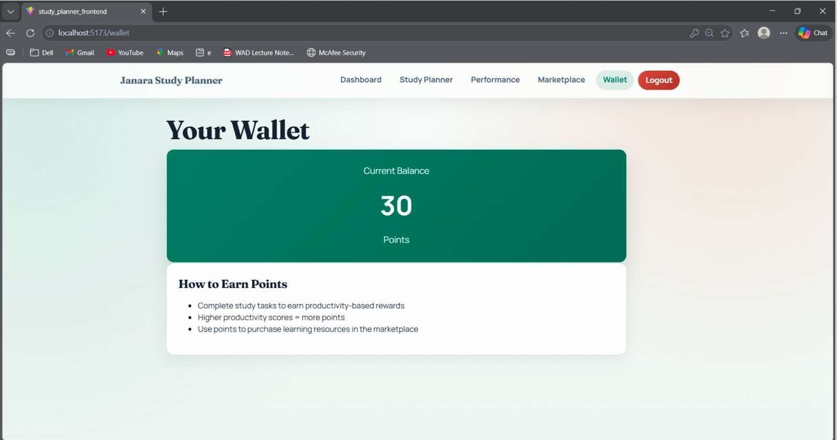
Fig.4: Reward Wallet Interface for Point Management and Redemption

The figure illustrates the reward wallet module of the AI-based personalized study planner system. This interface displays the current reward points accumulated by the user based on their study performance and productivity score. The wallet system allows students to track their earned points and understand how points are awarded through task completion and productivity levels. It also informs users that the accumulated points can be utilized to access or purchase educational resources available in the marketplace. This module acts as a motivational component by encouraging students to maintain consistent study habits in order to earn more rewards and improve their learning performance.

- Data Storage Layer

All system information, including user profiles, study schedules, task logs, assessment results, and reward points, is maintained in MongoDB. This database provides scalability and efficient retrieval of data required for real-time processing. Data-driven educational systems commonly rely on scalable databases to store large volumes of learning data and support real- time analytics [2], [19].

The intelligent study planning module generates customized schedules through the following procedure:
The student registers and creates an academic profile by entering subjects, exam dates, and study goals. The system analyzes the difficulty level of subjects along with available study time. Tasks are ranked according to urgency and complexity. Based on this analysis, the system generates a daily or weekly study schedule. Students complete assigned tasks while the system records study duration and progress.

Through this mechanism, each study plan is tailored according to the learner’s academic requirements and available time. Adaptive scheduling systems have been widely studied in AI-based learning environments to optimize academic planning and improve student productivity [4].

To measure student performance, the system calculates Learning Effectiveness Score (LES) that reflects the efficiency of the learning process. Learning analytics and performance evaluation techniques are commonly used in AI-driven education systems to measure student engagement and academic progress [9], [14].

- CONCLUSION

This research presented an AI-based personalized study planner that combines intelligent scheduling, performance evaluation, and an adaptive reward mechanism to enhance student learning effectiveness and motivation. The system generates
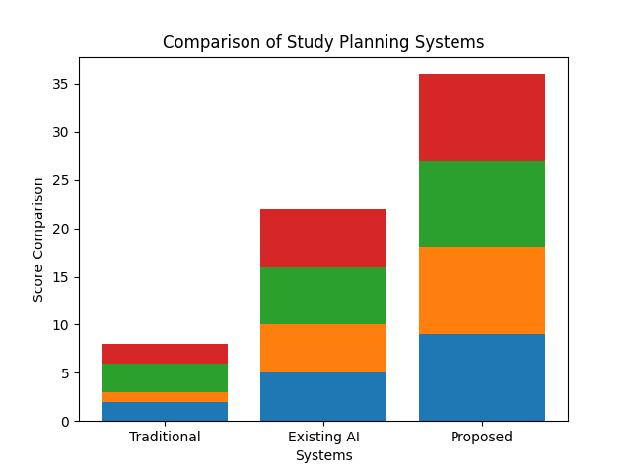
customized study schedules by analyzing subject difficulty, available study time, academic goals, and performance patterns, ensuring that each learner receives a structured and optimized study plan. A key contribution of this work is the Learning Effectiveness Score (LES), which evaluates student performance using parameters such as task completion, engagement level, assessment results, and task complexity, enabling the system to allocate rewards dynamically based on learning performance. The integration of a reward wallet and analytics dashboard further encourages consistent study behavior and allows students to monitor their academic progress through visual insights and performance feedback. The implementation of the system using React, Python, and MongoDB demonstrates the feasibility of developing a scalable and intelligent web-based learning platform. Overall, the proposed system shows how artificial intelligence and gamification techniques can be effectively combined to create a personalization.
Fig. 5: Bar graph showing comparison of existing and proposed system

- FUTURE SCOPE

The proposed system can be further developed by incorporating more advanced intelligent capabilities to enhance its effectiveness and adaptability. Future enhancements may involve the use of more sophisticated learning models that can better understand individual study patterns and predict performance trends with higher accuracy. The platform can also evolve by including interactive features such as AI-driven assistants that guide users in real time and provide contextual study suggestions. Expanding the reward mechanism into a more dynamic and personalized system, including elements like goal-based incentives and collaborative learning. Additionally, connecting the system with external educational platforms or institutional databases can enable a more comprehensive view of student progress.

REFERENCES
- Barone, M., Naeem, M., Ciaschi, M., Tretola, G., & Coronato, A. (2025). AI-Based Intelligent System for Personalized Examination Scheduling. Technologies, 13(11), 518.
- Khanna, Y., Manglik, I., & Revathi, D. A. (2025). AI-Augmented Assignment Management: A Hybrid RL-LLM Framework for Personalized Scheduling and Content Generation in Education. Available at SSRN 5853862.
- Khamis, R. (2024). AI-powered learning experience platforms: Investigating personalized learning in the workplace.
- Chen, X., Fu, M., & Li, H. (2026). Enhancing higher education through AI-driven personalized adaptive learning: Evidence from a ChatGPT- based strategy. International Journal of Instruction, 19(1), 579594.
- Gupta, N., & Heggond, S. (2026). Agentic artificial intelligencedriven tutoring: A multi-agent cognitive architecture for personalized adaptive learning in Education. International Journal of Applied Resilience and Sustainability, 2(2), 572-598.
- Frank, E. (2024). The Influence of artificial intelligence on education: Enhancing personalized learning experiences. EasyChair Preprint, 14675, 1-15.
- Umar, U., & Purwanto, M. B. (2025). AI and decision assistance for enhancing self-directed learning. ETERNAL (English Teaching Journal), 16(2), 457-465.
- Chineze, O. G., Nkechi, O. I., & Alordiah, C. O. (2025). Harnessing Artificial Intelligence and motivation theories for transformative educational leadership: a data-driven model for school management
and personalised learning. interdisciplinary journal of african & asian studies (IJAAS), 11(1).
- Umar, U., & Purwanto, M. B. (2025). AI and decision assistance for enhancing self-directed learning. ETERNAL (English Teaching Journal), 16(2), 457-465.
- Meylani, R. (2024). A critical glance at adaptive learning systems using artificial intelligence: A systematic review and qualitative synthesis of contemporary research literature. Batı Anadolu Eğitim Bilimleri Dergisi, 15(3), 3519-3547.
- Barone, M., Ciaschi, M., Ullah, Z., & Piccardi, A. (2024, September). Reinforcement learning based intelligent system for personalized exam schedule. In 2024 19th Conference on Computer Science and Intelligence Systems (FedCSIS) (pp. 549-553). IEEE.
- Okonji, N. N., & Igwe, E. A. (2025). Prospects and Challenges of Personalized Learning through Artificial IntelligenceDriven Adaptive Learning Systems in N. Journal of Education in Developing Areas, 33(1), 139-147.
- Li, P., & Ding, Z. (2025). Application of deep learning-based personalized learning path prediction and resource recommendation for inheriting scientist spirit in graduate education. Computer Science and Information Systems, (00), 43-43.
- Deepshikha, D. (2026, December). A systematic review on the future of educational assessment: AI-driven grading and personalised feedback in higher education. In Artificial Intelligence in Education (Vol. 2, No. 2, pp. 75-115). Emerald Publishing Limited.
- Khairullah, S. A., Harris, S., Hadi, H. J., Sandhu, R. A., Ahmad, N., & Alshara, M. A. (2025, February). Implementing artificial intelligence in academic and administrative processes through responsible strategic leadership in the higher education institutions. In Frontiers in Education (Vol. 10, p. 1548104). Frontiers Media SA.
- Abishev, N., Ramazanov, R., Abaideldanova, M., Chesnokova, K., & Baizhumayeva, A. (2025, July). Artificial intelligence model in the cognitive and learning activities of university subjects. In Frontiers in Education (Vol. 10, p. 1623170). Frontiers Media SA.
- Liu, H. (2025). Personalized learning support system for special education: a real-time feedback mechanism based on deep reinforcement learning. Frontiers in Psychology, 16, 1658698.
- Ifraheem, S., Rasheed, M., & Siddiqui, A. (2024). Transforming education through artificial intelligence: personalization, engagement and predictive analytics. Journal of Asian Development Studies, 13(2), 250266.
- Fedorka, P., Buchuk, R., Klymenko, M., Saibert, F., & Petrushyn, A. (2025). The use of adaptive artificial intelligence (AI) learning models in decision support systems for smart regions. J. Res. Innov. Technol.

