FINANCIAL ANALYSIS AND FINANCING STRATEGY OF ENVIRONMENTALLY FRIENDLY BATIK AS SUSTAINABLE TOURISM COMPETITIVENESS STRENGTHENING REGIONAL IDENTITY AND CREATIVE ECOTOURISM

ABSTRACT
Batik is an Indonesian cultural heritage recognized by UNESCO as Intangible Cultural Heritage since 2009. In the midst of modern industrial development, conventional batik production faces serious challenges related to environmental impacts from the use of synthetic chemical dyes. This community service program aims to develop environmentally friendly batik by integrating proper financial analysis and financing strategies for small and medium enterprise (SME) craftspeople, while linking it to the sustainable tourism ecosystem. The financial study encompasses investment feasibility analysis (Net Present Value/NPV, Internal Rate of Return/IRR, and Payback Period), social capital-based financing structures, and potential access to green financing from financial institutions. Activities were carried out at Tapak Dara Community Village, Meteseh Sub-district, Tembalang District, Semarang City in February 2026, involving at least 30 batik artisans. Expected outcomes include improved financial literacy among craftspeople, the development of bankable business models, at least 30% income growth, and the creation of high-value creative ecotourism packages. This program contributes to achieving the Sustainable Development Goals (SDGs), particularly Goal 8 (Decent Work and Economic Growth) and Goal 12 (Responsible Consumption and Production).

Keywords: financial analysis; green financing; environmentally friendly batik; sustainable tourism; creative ecotourism; SMES

A. INTRODUCTION
Indonesia possesses extraordinary cultural wealth, one of which is batik, recognized by UNESCO as Intangible Cultural Heritage on October 2, 2009. Beyond its high cultural value, batik is also a strategic economic commodity that supports the livelihoods of millions of craftspeople and micro, small, and medium enterprise (SME) actors across Indonesia. However, the sustainability of the batik industry faces two major interrelated challenges: environmental pressure from the use of synthetic chemical dyes and limited access to capital that hinders environmentally friendly product innovation.In terms of the environment, the textile industry, including batik, is estimated to contribute approximately 20% of global water pollution. Synthetic dyes contain hazardous chemical substances such as heavy metals, azo dyes, and carcinogenic compounds that not only pollute ecosystems but also threaten the health of craftspeople. Ironically, the transition to natural dyes, which are far more environmentally friendly, is hampered by economic factors: higher production costs, limited initial capital, and minimal access by craftspeople to alternative financing sources.
From a financial perspective, the majority of batik craftspeople operate as micro enterprises with very limited financing capacity. They do not yet have structured financial records, do not understand the concept of investment feasibility, and are unable to access formal financing schemes from banks or non-bank financial institutions. This situation creates a cycle of innovation poverty: without sufficient capital, craftspeople cannot transition to environmentally friendly technologies and materials; without high-value-added products, craftspeople cannot generate adequate cash flows to attract creditors.
On the other hand, the global tourism paradigm is shifting toward sustainable tourism. A Booking.com survey in 2021 showed that 83% of global travelers consider sustainable travel very important. Modern tourists are willing to pay a premium for environmentally friendly products and experiences, opening significant financial opportunities for batik craftspeople who are able to transform. Creative ecotourism based on environmentally friendly batik is therefore not merely a cultural preservation program, but a business strategy that is financially viable if supported by proper financial planning.
This community service program was developed in response to that gap. By integrating financial approaches including investment feasibility analysis, financing strategies, and strengthening financial literacy into the environmentally friendly batik development program, this program aims to create a business model that is not only ecological but also financially sustainable and competitive within the modern tourism ecosystem.

B. THEORETICAL FRAMEWORK

1. Environmentally Friendly Batik and Its Economic Value
Environmentally friendly batik refers to batik production practices that prioritize the use of renewable natural materials, such as indigo (nila), soga, turmeric, and morinda (mengkudu) as dyes. From an economic perspective, environmentally friendly batik products have a comparative advantage over conventional batik in several dimensions. First, product differentiation: the uniqueness of natural colors that cannot be replicated by synthetic dyes creates a premium aesthetic value. Second, sustainability value: the market segment of environmentally conscious tourists and consumers is willing to pay a premium price (green premium) for products with a low ecological footprint. Third, reduction of negative externalities: by switching to natural dyes, craftspeople avoid potential regulatory costs and environmental fines in the future.
Research shows that the use of natural dyes can reduce negative environmental impacts by up to 80%. Financially, the reduction of hazardous waste also means reduced waste management costs and legal risks, which in turn improves the long-term profitability of batik enterprises.

2. Investment Feasibility Analysis for Batik SMES
Investment feasibility analysis is a crucial financial instrument in business decision-making, particularly for SMEs with limited capital. The three main indicators commonly used are Net Present Value (NPV), Internal Rate of Return (IRR), and Payback Period. NPV measures the present value of the net cash flows generated by an investment; a positive NPV value indicates that the investment is financially viable. IRR is the discount rate that makes NPV equal to zero; the higher the IRR compared to the cost of capital, the more attractive the investment. Payback Period measures how long it takes for the initial investment to be recovered from operating cash flows. For batik craftspeople wishing to transition to natural dyes, investment feasibility analysis needs to consider the additional costs of procuring natural raw materials, training and capacity-building costs, the potential increase in product selling prices, and projected sales volume growth as the market for green products expands.

3. Green Financing as a Financing Solution
Green financing is a mechanism for channeling funds aimed at supporting projects or enterprises that have a positive impact on the environment. In Indonesia, green financing instruments are developing rapidly, encompassing environmentally oriented People’s Business Credit (Kredit Usaha Rakyat/KUR), green bonds, and environment-based Corporate Social Responsibility (CSR) programs. Bank Indonesia and the Financial Services Authority (Otoritas Jasa Keuangan/OJK) have issued regulations encouraging financial institutions to allocate credit portfolios to green sectors, including environment-based creative industries such as environmentally friendly batik.
For batik craftspeople, access to green financing opens opportunities to obtain capital at competitive interest rates while also receiving technical assistance from financing institutions. However, this access requires craftspeople to have credible financial reports, a structured business plan, and an understanding of the required environmental standards.

4. Sustainable Tourism and Revenue Potential
Sustainable tourism, as defined by the UNWTO, takes economic, social, and environmental impacts into balanced consideration. From a financial perspective, the development of batik-based creative ecotourism destinations has the potential to create multiple revenue streams for craftspeople: sales of premium batik products, income from educational tourist visits, batik workshop fees, and commissions from integrated tour packages. This diversification of income sources not only increases total income but also reduces financial risk stemming from dependence on a single sales channel.

5. SMES Financial Literacy and Its Impact on Competitiveness
Financial literacy refers to an individual’s ability to understand and use financial knowledge in business decision-making. Studies show that a high level of financial literacy is positively correlated with the ability of SMEs to survive, grow, and access formal financing. For batik craftspeople, improving financial literacy encompasses understanding simple financial record-keeping, production cost analysis, cash flow management, and pricing strategies that reflect the ecological and cultural value of their products.

6. Relationship with the SDGs
The development of environmentally friendly batik supported by appropriate financial strategies aligns with several SDG goals, particularly: Goal 8 (Decent Work and Economic Growth) through increased craftspeople’s income, Goal 12 (Responsible Consumption and Production) through the reduction of chemical waste, Goal 13 (Climate Action) through sustainable production practices, and Goal 17 (Partnerships for the Goals) through multi-stakeholder collaboration among universities, financial institutions, craftspeople, and tourism actors.

C. IMPLEMENTATION METHOD

1. Location and Time
This community service activity was carried out at the Tapak Dara Community Village, Meteseh Sub-district, Tembalang District, Semarang City on February 8, 2026, with a total budget of IDR 4,000,000 from internal university funding.

2. Program Targets
The direct target of this program is at least 30 batik craftspeople who are actively producing in local batik centers, particularly those interested in developing environmentally friendly batik products but constrained by capital and financial literacy issues. Indirect targets include local government as SME financing policymakers, financial institutions with the potential to become green financing partners, domestic and international tourists as the product market, and the younger generation as successors to sustainability-based batik enterprises.

3. Implementation Stages
The program implementation consists of five integrated stages. First, initial financial assessment: recording the craftspeople’s financial conditions, analyzing existing production cost structures, and identifying the gap between capital needs and available financing capacity. Second, technical training on natural dyes: covering extraction methods, processing, and application of dyes from local plants, accompanied by recalculation of the new cost of production. Third, assistance in preparing a business plan and simple bankable financial reports, including cash flow projections, NPV/IRR analysis, and premium pricing strategies. Fourth, strengthening access to financing through socialization of green financing schemes, environmentally oriented KUR, and relevant CSR programs from financial institutions. Fifth, development of creative ecotourism packages as a financially measurable income diversification strategy.

D. RESULTS AND DISCUSSION

1. Problem Identification
Based on the initial assessment conducted prior to program implementation, a number of key problems with dual dimensions environmental as well as financial were identified. From an environmental perspective, the majority of craftspeople still rely on synthetic chemical dyes as they are considered more affordable and practical. From a financial perspective, it was found that: (1) almost all craftspeople do not have adequate financial records; (2) craftspeople are unable to accurately calculate the cost of production, making it impossible to set selling prices that yield a reasonable profit margin; (3) craftspeople do not have access to formal financing institutions because they are not bankable; and (4) there is no planned income diversification strategy. This combination of financial limitations and environmental knowledge deficiencies creates a situation in which craftspeople are trapped in a cycle of low-cost yet low-value production, with no capacity to invest in innovation that could improve their competitiveness.

2. Financial Feasibility Analysis of Environmentally Friendly Batik
As part of the program, the implementation team conducted a simulation of investment feasibility analysis for the transition from chemical to natural dyes. Assuming an initial investment of IDR 2,500,000 per craftsperson for the procurement of natural raw materials, simple equipment, and training, along with a projected average selling price increase of 40% due to the premium value of environmentally friendly products, the simulation results show a positive NPV over a three-year horizon with an IRR of approximately 28–35%, exceeding the average cost of SME loan capital in Indonesia which ranges from 9–12% per year. The Payback Period is estimated at between 14 and 18 months, indicating that this investment is financially viable and attractive. This simulation serves as the basis for preparing a business plan that craftspeople can use to access financing schemes, both from the KUR program and from green financing schemes rolled out by national banks in accordance with the OJK Sustainable Finance Roadmap.

3. Recommended Financing Strategies
Based on the conditions and needs of the craftspeople, this program recommends three financing pathways that can be pursued in stages. First, social capital-based financing: utilizing group savings (arisan), craftspeople’s cooperatives, and community revolving funds as initial capital with low risk and without formal collateral. Second, Micro KUR (credit ceiling up to IDR 50 million): once craftspeople have structured financial reports as a result of program assistance, they can apply for KUR at a subsidized interest rate of 6% per year. Third, green financing from partner financial institutions: for craftspeople who have demonstrated good financial track records and hold environmentally friendly product certifications, access to green financing with lower interest rate incentives can be facilitated through the university’s partnership network with the banking sector.

4. Expected Outputs
This community service program targets multi-layered outputs. From a financial perspective: the preparation of simple financial reports for all participants, the formation of at least 3 business groups that are bankable and ready to access formal financing, and an average income increase of at least 30% for craftspeople within six months of the program. From a product and market perspective: at least 50 new environmentally friendly batik motifs/designs, a branding and packaging system that reflects ecological and premium values, and an integrated creative ecotourism package. From an academic perspective: publication in an accredited national journal, a replicable training module, and a documented environmentally friendly batik business model as a reference for green creative industry development.

5. Program Success Indicators
Program success is measured using quantifiable indicators:
- At least 80% of participants are able to independently apply natural dye techniques
- At least 80% of participants are able to prepare simple financial reports and calculate the cost of production
- At least 30% income increase for craftspeople within 6 months after the program
- Formation of at least 3 environmentally friendly batik business groups with written business plans and access to formal financing
- At least 50% increase in tourist visits to the batik center within one year
- At least 70% reduction in the use of synthetic chemical dyes among participants

6. Impact and Significance
This program delivers multi-layered, mutually reinforcing impacts. From a financial aspect, improved financial literacy and access to financing create a stronger foundation for craftspeople to innovate and grow without relying on their limited personal capital. From an environmental aspect, the reduction in chemical dye use directly reduces water and soil pollution. From a socio-cultural aspect, the program strengthens regional cultural identity through the preservation of natural dyeing techniques. From a tourism aspect, the creation of new creative ecotourism destinations opens new revenue streams that add economic value to the Meteseh-Tembalang area as a local wisdom-based tourist destination. On a macro level, the success of this program is expected to serve as a proof of concept for the development of green creative industries in Indonesia — demonstrating that environmental sustainability and economic growth are not contradictory, but can be achieved synergistically through sound financial planning and a commitment to sustainability values.

E. CONCLUSION
The community service program themed Financial Analysis and Financing Strategy of Environmentally Friendly Batik as Sustainable Tourism Competitiveness is a strategic effort that integrates three pillars synergistically: cultural heritage preservation, environmental protection, and strengthening SME financial capacity. The main findings of this program indicate that investment in environmentally friendly batik is financially feasible and attractive, with a positive NPV, an IRR exceeding the cost of capital, and a competitive Payback Period in the range of 14–18 months.
The key to successfully transforming batik craftspeople toward a sustainable business model lies in three main financial interventions: improving financial literacy so that craftspeople are able to manage and record cash flows in an orderly manner, preparing a bankable business plan as a prerequisite for accessing formal financing, and facilitating access to green financing schemes currently being continuously developed by the OJK and national banks. With a strong financial foundation, environmentally friendly batik becomes not only a lasting cultural product, but also a sustainable and inclusive economic empowerment instrument a tangible contribution to the achievement of the Sustainable Development Goals in Indonesia.
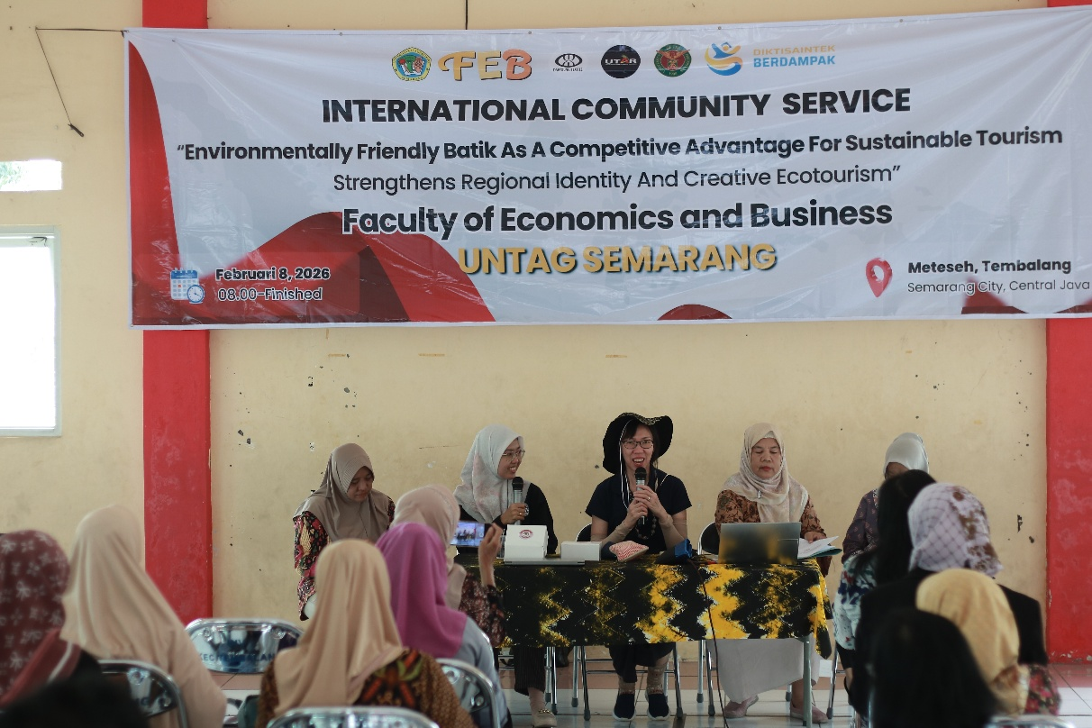
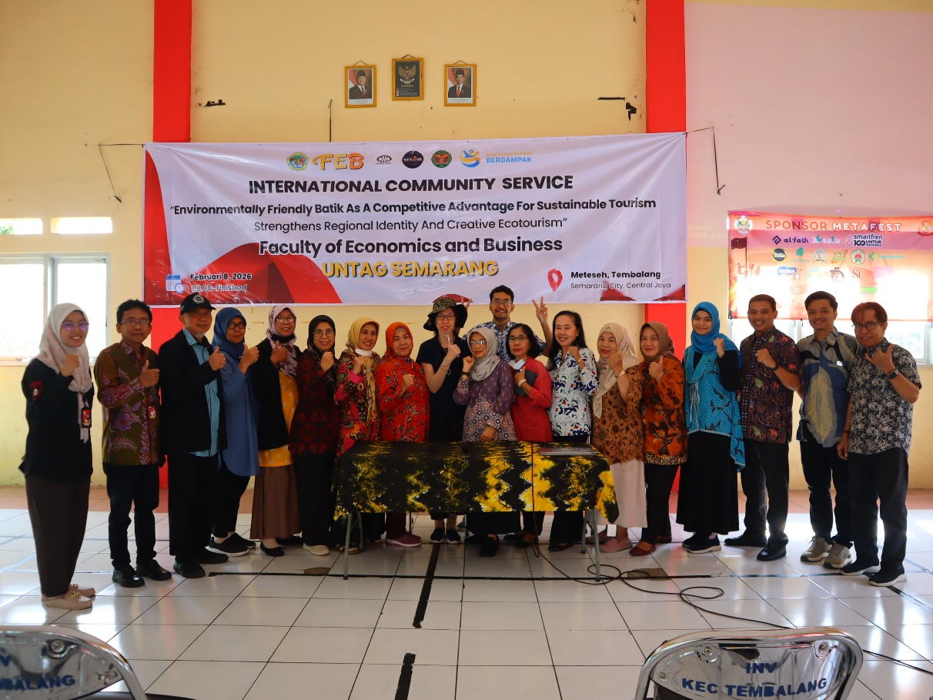

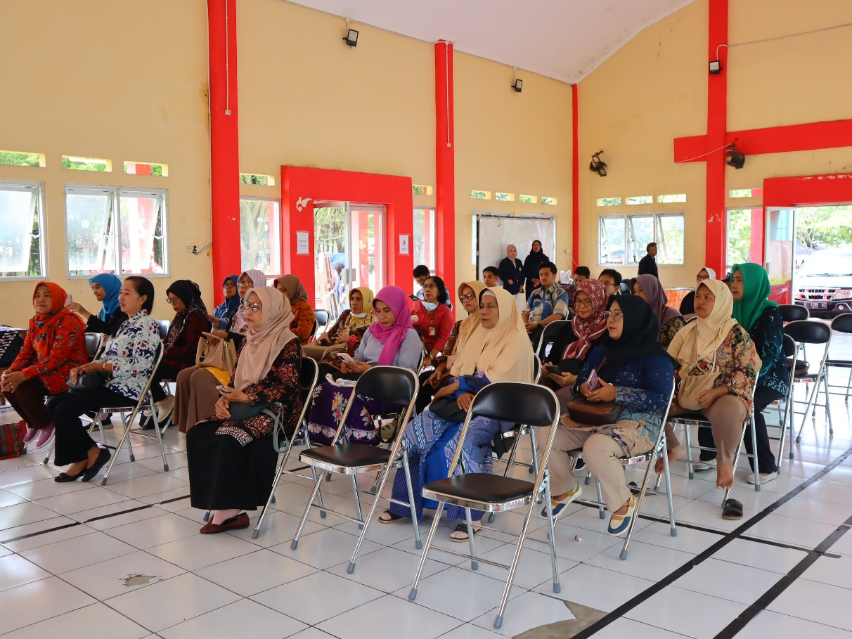

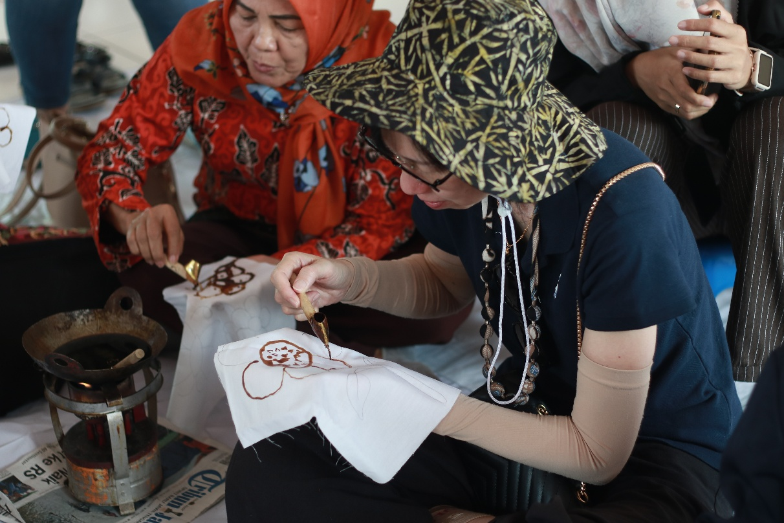
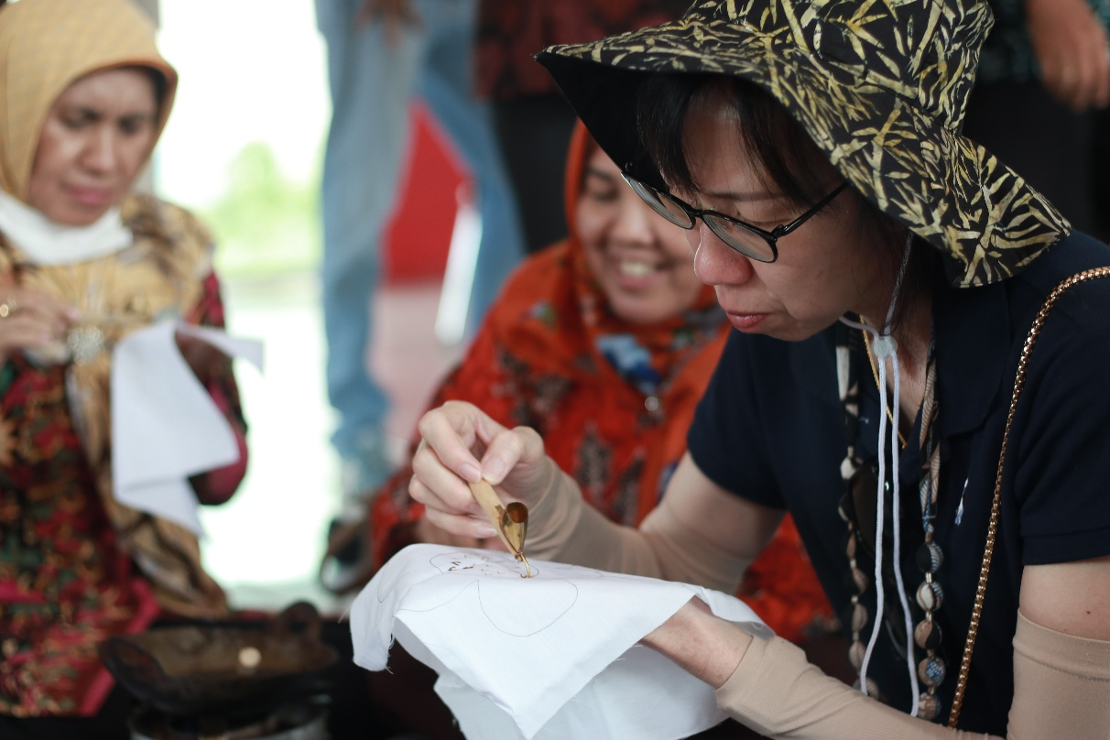
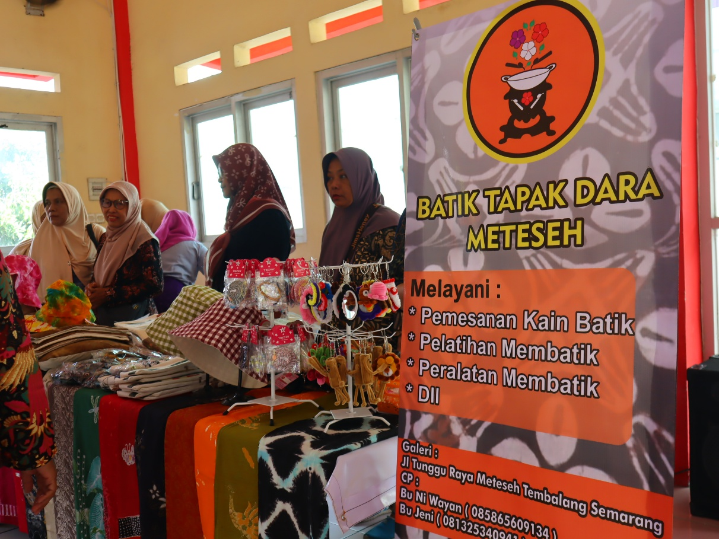

REFERENCES
Booking.com. (2021). Sustainable travel report 2021. Amsterdam: Booking.com.
Financial Services Authority (Otoritas Jasa Keuangan). (2021). Roadmap for sustainable finance in Indonesia 2021–2025. Jakarta: OJK.
Regulation of the Minister of Tourism Number 14 of 2016 concerning Guidelines for Sustainable Tourism Destinations.
Ross, S.A., Westerfield, R.W., & Jordan, B.D. (2019). Fundamentals of corporate finance (12th ed.). New York: McGraw-Hill Education.
UNESCO. (2009). Batik inscription. Intangible Cultural Heritage of Humanity. Paris: UNESCO.
United Nations. (2015). Transforming our world: The 2030 agenda for sustainable development. New York: United Nations.
UNWTO. (2021). Making tourism more sustainable: A guide for policy makers. Madrid: World Tourism Organization.
Law Number 5 of 2017 concerning Cultural Advancement (Undang-Undang Nomor 5 Tahun 2017 tentang Pemajuan Kebudayaan).
Law Number 32 of 2009 concerning Environmental Protection and Management (Undang-Undang Nomor 32 Tahun 2009 tentang Perlindungan dan Pengelolaan Lingkungan Hidup).

