SMART WASTE MANAGEMENT SYSTEM

Ms Ch Prabhavathi Ade Manasa Lingam Prashanth S Chinmai

Dept. of Computer Science and Engineering
Institute of Aeronautical Engineering
Dept. of Computer Science and Engineering
Institute of Aeronautical Engineering
Dept. of Computer Science and Engineering
Institute of Aeronautical Engineering
Dept. of Computer Science and Engineering
Institute of Aeronautical Engineering

Hyderabad, India Hyderabad, India Hyderabad, India Hyderabad, India

Abstract— Rapid urbanization and population growth have intensified challenges in municipal solid waste management, leading to overflowing bins, irregular waste collection, and severe environmental and public-health risks. Traditional waste management systems lack real-time monitoring, efficient routing, and transparent communication between citizens and municipal authorities. To address these issues, this research proposes a Smart Waste Management System integrating Internet of Things (IoT), GPS/GPRS-based vehicle tracking, RFID technology, cloud computing, and mobile applications. Smart bins equipped with sensors continuously monitor fill levels and transmit data to a cloud platform, enabling timely waste collection and efficient route optimization. RFID tags further automate verification of waste pickup events, while the mobile application facilitates user interaction by providing waste-tracking features, service requests, and complaint registration. The system ensures improved transparency, reduced operational costs, optimized collection cycles, and enhanced environmental sustainability. Experimental analysis demonstrates that the proposed framework significantly enhances efficiency and offers a scalable solution for smart city ecosystems.
Keywords— Smart Waste Management, Internet of Things (IoT), Smart Bins, RFID Technology, GPS/GPRS Tracking, Waste Collection Optimization, Cloud Computing, Mobile Application, Solid Waste Monitoring, Smart City Solutions.

- INTRODUCTION

The rapid growth of urban populations and the continuous expansion of metropolitan regions have placed immense pressure on existing waste management infrastructures. Traditional waste collection methods often rely on fixed schedules, manual monitoring, and outdated operational procedures, resulting in overflowing bins, unhygienic surroundings, inefficient resource usage, and increased environmental hazards. As cities move towards smarter and more sustainable ecosystems, waste management systems must evolve to incorporate automation, transparency, and real-time decision-making capabilities.

Smart Waste Management, empowered by emerging technologies such as the Internet of Things (IoT), RFID, GPS/GPRS tracking, cloud computing, and mobile applications, offers a transformative solution to these challenges. IoT-enabled smart bins can continuously monitor fill levels, detect anomalies, and communicate status information instantly to municipal authorities. GPS-enabled vehicle tracking enhances route optimization and ensures
timely waste collection, while RFID technology automates verification of bin servicing events. Furthermore, mobile and web-based platforms bridge the communication gap between citizens and municipal bodies by enabling real-time reporting, tracking, and service requests.

This research presents an integrated Smart Waste Management System designed to improve operational efficiency, reduce manual intervention, and promote cleanliness in urban environments. By leveraging sensor- based monitoring, automated data transmission, and user- centric applications, the proposed system contributes towards building cleaner, healthier, and more sustainable smart cities.

- LITERATURE SURVEY
The increasing complexity of urban waste generation and management has prompted extensive research into intelligent, technology-driven solutions capable of addressing long-standing inefficiencies in traditional waste collection systems. A comprehensive review of existing literature reveals that the integration of smart technologies— particularly the Internet of Things (IoT), wireless sensor networks (WSN), RFID, GPS/GPRS tracking, and cloud computing—has become a dominant approach toward developing smart waste management infrastructures.
Traditional waste management practices primarily rely on static schedules and manual monitoring, which frequently result in overflowing bins, delayed collection, inefficient route planning, and excessive fuel consumption. Shyam et al. (2017) introduced one of the earliest IoT-driven smart waste monitoring frameworks, utilizing ultrasonic sensors embedded in bins to record fill levels. Their system demonstrated how real-time information can significantly reduce unnecessary collection trips by municipal authorities and promote optimization of waste pickup routes.
Similarly, Folianto, Low, and Yeow (2015) proposed the SmartBin system, which integrates wireless sensors with cloud connectivity to report bin status automatically. Their work highlighted technical considerations such as battery consumption, communication range, and data accuracy— factors that influence the long-term sustainability of IoT- based waste solutions. The authors emphasized that stable and low-power communication protocols are crucial for large-scale smart city deployments.
Kurre’s (2016) contribution further explored IoT-based overflow detection systems. His model presented a simpler but practical solution for monitoring bin capacity and alerting

XXX-X-XXXX-XXXX-X/XX/$XX.00 ©20XX IEEE

authorities before spillage occurs. The system’s primary advantage lies in its straightforward architecture, which can be easily adopted by municipal corporations in developing nations with limited technical infrastructure. However, this solution lacked vehicle routing and user feedback components, representing a partial implementation of the broader waste management cycle.
Other researchers have explored more comprehensive systems. Kumar et al. (2017) developed an integrated IoT and RFID-enabled waste monitoring and clearance system that tracks the presence of collection vehicles using RFID tags. When coupled with GPS data, this method enables verification of whether the garbage truck has physically visited a specific location. Their system ensures accountability among waste collectors and provides transparent data for municipal authorities. Although highly effective, the integration of both RFID and GPS increases implementation costs and requires robust cloud infrastructure for seamless operation.
Vu and Swati Dewangan (2019) conducted a detailed survey on intelligent solid waste management systems and identified key research gaps in data processing, load balancing, energy management of IoT sensors, and citizen engagement. She argued that truly effective smart waste systems must incorporate both automated sensing mechanisms and interactive platforms that empower citizens to report issues, track waste services, and contribute to community cleanliness.
Several authors have emphasized using data analytics and prediction models to forecast waste generation patterns. Machine-learning-based waste prediction algorithms have shown promise in reducing operational costs by helping municipalities plan collection schedules dynamically. However, these advanced analytics systems require high- quality historical datasets that many developing nations currently lack.
Across the literature, common limitations are evident:
- Lack of integration: Many systems focus on smart bins alone without linking them to vehicle tracking or cloud analytics.
- Limited user engagement: Only a few studies incorporate mobile applications or citizen-reporting features.
- Scalability challenges: Large-scale deployment is hindered by high implementation costs, network reliability issues, and maintenance demands.
- Data management constraints: Cloud dependency and real-time processing require robust infrastructure that may not be present in all regions.
The present work addresses these gaps by proposing a holistic Smart Waste Management System integrating IoT-based smart bins, GPS/GPRS-enabled vehicle tracking, RFID- based bin servicing verification, cloud data management, and Android applications for both users and waste collectors. By combining multiple modern technologies in one framework, the proposed system enhances operational transparency, reduces manual intervention, optimizes waste collection routes, and strengthens communication between municipal authorities and citizens. This integrated approach aligns with emerging smart city initiatives and offers a scalable, efficient, and sustainable waste management model suitable for urban environments in developing countries.

- PROPOSED METHOD
The proposed Smart Waste Management System introduces an integrated technological framework that automates the monitoring, collection, and management of municipal solid waste through the use of IoT sensors, RFID technology, cloud infrastructure, GPS-based vehicle tracking, and mobile applications. The fundamental objective of the proposed method is to provide an end-to-end, intelligent waste management ecosystem that ensures timely waste collection, reduces operational inefficiencies, enhances transparency, and improves overall urban hygiene.

System Architecture

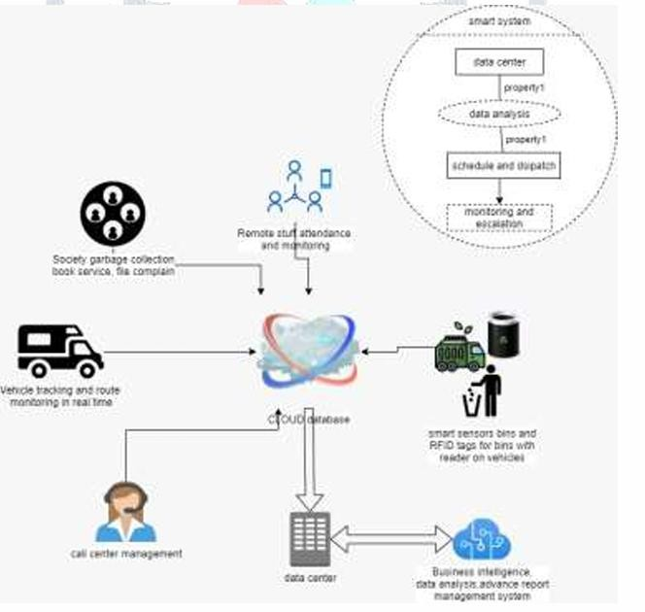
The system architecture of the proposed Smart Waste Management System is designed using a layered and modular approach to ensure scalability, robustness, and seamless communication between different components. The architecture consists of interconnected units such as smart bins, cloud services, mobile applications, vehicle tracking modules, and administrative control systems. Each layer of the architecture handles a specific set of responsibilities, enabling the system to function efficiently in real-time urban Waste management environments.

Hardware Architecture

The hardware architecture involves all physical components used in the system. Smart bins are equipped with ultrasonic sensors, microcontrollers, GSM/Wi-Fi modules, and RFID tags. The sensors detect the fill level, while the microcontroller processes this data and sends it to the cloud. Garbage collection vehicles are installed with GPS tracking devices and RFID readers to identify bins during collection. This combination ensures accurate data gathering, location tracking, and verification of waste pickup activities.

IoT Communication Architecture

The IoT communication architecture provides reliable data transfer between hardware devices and cloud platforms. Smart bins send sensor data through a wireless communication channel (Wi-Fi, GSM, or LoRa) to the cloud. The vehicle GPS module continuously transmits coordinates for real-time tracking. Communication protocols such as MQTT or HTTP are used to ensure efficient data transmission with low latency. This architecture ensures that all real-time data—bin fill levels, vehicle positions, and RFID scans—reach the cloud without delay.

Cloud Architecture

The cloud layer forms the backbone of the system by storing, analyzing, and distributing all incoming data. A scalable cloud platform such as AWS or Firebase is used to manage bin status updates, RFID logs, user complaints, pickup requests, and historical data. Cloud functions process this data, trigger alerts, and synchronize updates across the user and collector applications. This architecture also allows administrators to generate analytical reports for decision- making and future planning.

Software Application Architecture
The software architecture consists of three main applications: the User App, the Garbage Collector App, and the Admin Dashboard.
- The User App connects citizens with the system by providing real-time vehicle tracking, complaint submission, and waste pickup booking.
- The Garbage Collector App provides workers with alerts, optimized routes, RFID-based bin verification, and collection status updates.
- The Admin Dashboard offers centralized monitoring of all system components, including bin levels, vehicle routes, complaints, and collection logs.
These applications are developed using modern frameworks such as Flutter for apps and ReactJS for the dashboard, ensuring usability and responsiveness.
Integration Architecture
The integration architecture combines all modules into a single workflow. Sensor data from smart bins, RFID scans from vehicles, and user interactions from applications are unified in the cloud. The cloud then distributes processed information back to the respective interfaces. This ensures end-to-end synchronization between sensors, collectors, administrators, and users. The integration architecture guarantees that all elements of the system function cohesively and in real time.
RESULT
The implementation of the Smart Waste Management System demonstrated significant improvement in monitoring and collection efficiency. The smart bins accurately detected and transmitted fill levels to the cloud, enabling timely “bin full” alerts and preventing overflow. The RFID module successfully verified each waste pickup, ensuring proper accountability, while GPS tracking provided real-time
monitoring of garbage collection vehicles. Both the User and Garbage Collector applications operated smoothly, allowing citizens to track vehicles and submit complaints, and helping collectors receive optimized routes and alerts.
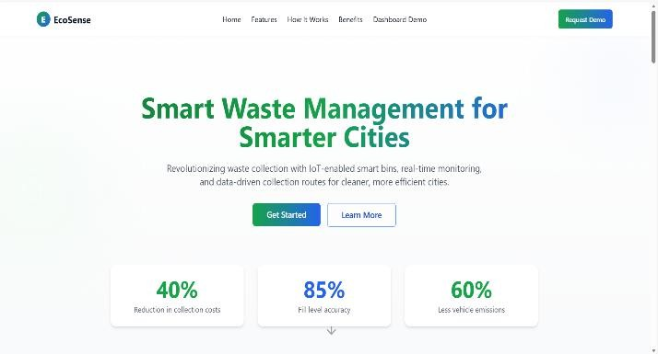
Fig.1 Home page
The home page displays the title “Smart Waste Management System” along with a clean dashboard that provides quick access to system status and key features.
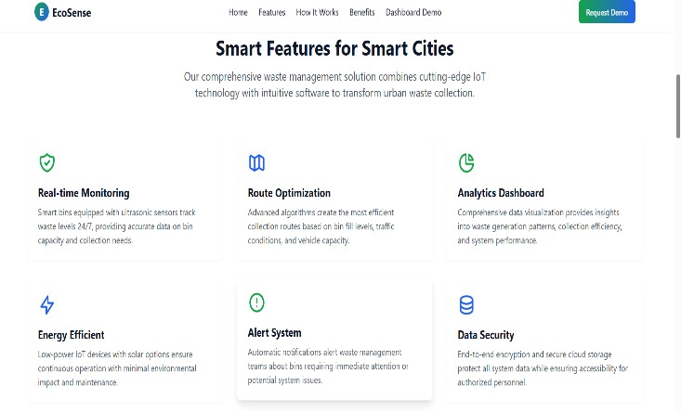
Fig.2.App Features

The features page showcases all the key functionalities of the app, including tracking, monitoring, complaints, and service options in a clear and user-friendly layout.
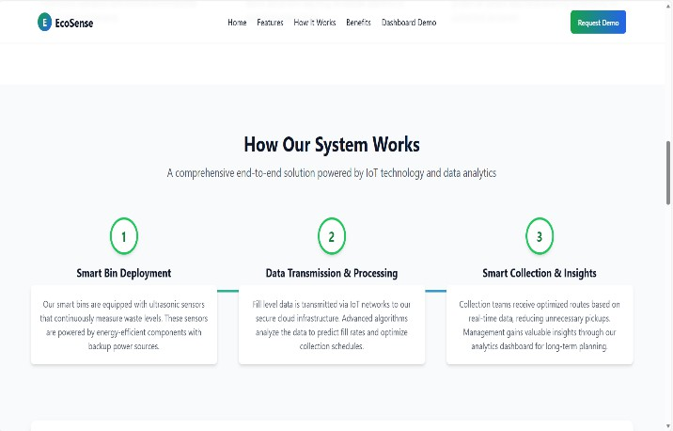
Fig.3.System Working
The “How the System Works” page provides a simple visual workflow explaining how smart bins, sensors, cloud systems, and collection vehicles interact in real time.


Fig.4.Request a Demo
The Request a Demo page allows users to interact with the system by submitting their details to experience the platform’s features firsthand.
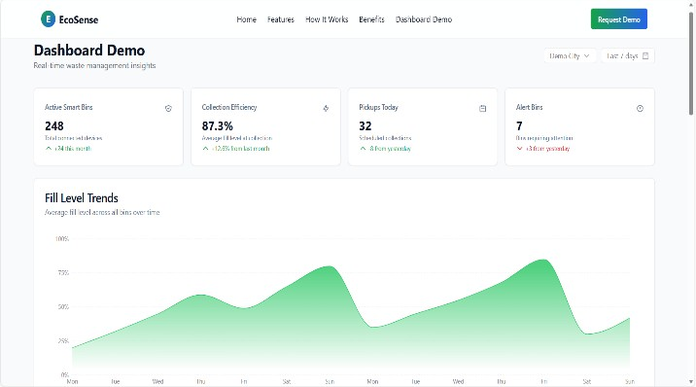
Fig.5. Bin Status Graph Page
The Bin Status Graph page visually presents real-time waste levels across different areas, helping users and admins monitor bin conditions at a glance.
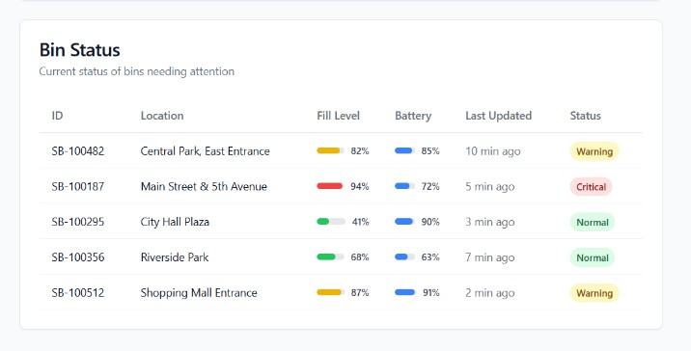
Fig.6.Bin Status
The Bin Status page displays the current fill levels of all smart bins, allowing users and admins to quickly identify which bins need immediate attention.
real-time data from sensors, GPS modules, and RFID readers must be continuously transmitted to the cloud. Any network disruption can delay alerts or interrupt communication between system components. The hardware components, such as ultrasonic sensors and RFID tags, require regular maintenance and calibration, and may malfunction due to environmental factors like dust, moisture, or physical damage. The initial installation cost of smart bins, tracking devices, and cloud infrastructure can be high, especially for large-scale deployment across cities. Additionally, the system’s performance may be affected by battery limitations in IoT devices, requiring periodic charging or replacement. User adoption can also be a challenge, as not all citizens may actively use the application or report complaints. Despite these constraints, the system remains a highly effective solution when properly maintained and supported.
CONCLUSION AND FUTURE SCOPE

The Smart Waste Management System presented in this research demonstrates how the integration of IoT sensors, RFID technology, GPS tracking, cloud computing, and mobile applications can significantly enhance the efficiency and transparency of urban waste management. The system successfully automates real-time monitoring of bin status, ensures verified waste collection through RFID, optimizes routes using GPS data, and improves communication between citizens, garbage collectors, and municipal authorities. By reducing manual interventions, preventing bin overflow, and providing accurate, timely information, the proposed system contributes to cleaner surroundings and more sustainable waste management practices. Overall, the implementation results show that the solution is effective, scalable, and capable of supporting smart city initiatives.

Despite its advantages, the system still has room for improvement, providing several opportunities for future enhancements. The integration of machine learning algorithms can enable predictive analysis to forecast waste generation trends, helping municipalities plan collection schedules more efficiently. Solar-powered sensor units may be incorporated to reduce the dependency on battery replacements. Expanding the communication infrastructure to include low-power networks like LoRaWAN can enhance system reliability in remote or low-connectivity areas.
Future work may also include adding automated robotic arms for waste handling, enhancing user engagement through reward-based cleanliness programs, and integrating environmental sensors to monitor air quality around waste collection points. With these advancements, the Smart Waste Management System can evolve into a fully autonomous, intelligent, and sustainable solution for modern cities.

Limitations
Although the Smart Waste Management System offers significant improvements over traditional waste collection methods, it also has certain limitations. The effectiveness of the system depends heavily on stable internet connectivity, as
Acknowledgment
I sincerely appreciate Ch Prabhavathi for her outstanding guidance and support. Her expertise in emerging technologies helped me choose an engaging topic and inspired me throughout my research journey. Her mentorship has significantly contributed to my academic growth.

REFERENCES

- g. shyam, s. s. manvi, and p. bharti, “smart waste management using internet of things (iot),” ieee computing and communications technologies (iccct), 2017, pp. 199–203. [Online]. Available: https://ieeexplore.ieee.org/
- v. k. kurre, “smart garbage collection bin overflow indicator using iot,” international research journal of engineering and technology (irjet), 2016.
[Online]. Available: https://www.irjet.net/
- f. folianto, y. s. low, and w. l. yeow, “smartbin: smart waste management system,” ieee intelligent sensors, sensor networks and information processing (issnip), 2015. [Online]. Available: https://ieeexplore.ieee.org/
- d. vu and g. kaddoum, “a waste city management system for smart city applications,” advances in wireless and optical communications, 2017.
[Online]. Available: https://ieeexplore.ieee.org/
- s. v. kumar, t. s. kumaran, a. k. kumar, and m. mathapati,
“smart garbage monitoring and clearance system using internet of things,” ieee smart technologies and management for computing, communication, controls, energy and materials, 2017.
[Online]. Available: https://ieeexplore.ieee.org/
- s. dewangan, “iot-enabled intelligent solid waste management system for smart cities: a survey,” 2019, issn 2249-7455. [Online]. Available: https://www.researchgate.net/
- o. m. amoo and r. l. fangbale, “renewable municipal solid waste pathways for energy generation and sustainable development,” international journal of energy and environmental engineering, vol. 4, no. 1, p.42, 2013. [Online]. Available: https://link.springer.com/
- m. arefin, m. rahman, and s. akter, “iot-based smart waste management system for smart cities,” international journal of advanced computer science and applications (ijacsa), vol. 12, no. 5, pp. 245–252, 2021.
[Online]. Available: https://thesai.org/
- r. khan, p. kumar, and s. tiwari, “internet of things-based
waste management system: a smart city approach,” journal of environmental management, vol. 298, p. 113465, 2021. [Online]. Available: https://www.sciencedirect.com/
- a. goutham and k. rajesh, “design and implementation of smart waste management system using wireless sensor networks,” international journal of engineering research & technology (ijert), vol. 9, no. 7, pp. 1–5, 2020.
[Online]. Available: https://www.ijert.org/
- m. al imam, h. chowdhury, and m. rahman, “real-time garbage monitoring system using ultrasonic sensor and gsm,” international conference on innovation in engineering and technology (iciest), pp. 89–94, 2019.
[Online]. Available: https://www.researchgate.net/
- s. sharmin, t. ahmed, and m. alam, “development of an automated solid waste collection system using iot,” international journal of scientific & technology research, vol. 9, no. 4, pp. 132–138, 2020.
[Online]. Available: https://www.ijstr.org/

