Mapping the Concentration and Pathway of Leachate Plumes of Major Dumpsites in Makurdi Metropolis, North Central Nigeria using an Integrated Approach.

Abstract
This study presents an integrated hydro-geophysical and hydro-chemical investigation of leachate plume migration beneath major municipal dumpsites in Makurdi. Twenty four Vertical Electrical Sounding (VES) surveys using the Schlumberger configuration were combined with groundwater quality analysis to delineate contamination extent, depth, and migration pathways. Apparent resistivity values ranged from 1.2 to 58,000 Ω·m, reflecting strong lithological and contamination contrasts. Zones with resistivity <20 Ω·m were interpreted as highly conductive leachate saturated layers, with plume penetration depths reaching up to 180 m in some locations. Hydro-chemical analysis revealed elevated concentrations of Fe (9.38–12.07 mg/L), Mn (3.78–4.89 mg/L), Pb, and Cd exceeding World Health Organization permissible limits, confirming geophysical interpretations. Spatial analysis shows dominant southwest–northeast plume migration consistent with regional groundwater flow. The study demonstrates that unlined dumpsites constitute major sources of deep aquifer contamination. The integration of resistivity imaging, hydrochemistry, and GIS provides a robust framework for environmental monitoring and groundwater protection.
Keywords: Leachate plume, Vertical Electrical Sounding (VES), Dumpsite, Groundwater contamination, Heavy metals

INTRODUCTION
Solid waste management remains a major environmental and public health challenge in developing countries, particularly in rapidly urbanizing regions such as Makurdi metropolis Nigeria. The exponential increase in population, coupled with unplanned urban expansion, has led to the generation of enormous quantities of municipal solid waste that are often disposed of in open dumps without adequate environmental safeguards (Adewumi et al., 2019; Igbinosa & Okoh, 2020). Such uncontrolled disposal practices promote the percolation of decomposed waste liquids, known as leachate, into the subsurface, posing significant threats to soil and groundwater quality. Leachate typically contains a complex mixture of organic and inorganic compounds, including heavy metals, ammonium, chlorides, sulfates, and other toxic substances that can persist in the environment and bioaccumulate in living organisms (Christensen et al., 2011; Kumar et al., 2018).
Groundwater contamination by landfill leachate is an emerging environmental concern in Nigerian cities where open dumpsites are often sited close to residential areas, farmlands, and surface water bodies (Oluseyi et al., 2021). The infiltration of leachate into aquifers alters the natural geochemical composition of groundwater, resulting in elevated concentrations of hazardous substances that exceed permissible limits for drinking water (WHO, 2017; Nton & Olorunfemi, 2019). Consequently, identifying the extent, concentration, and migration pathway of leachate plumes is essential for sustainable groundwater management and environmental protection. However, conventional groundwater monitoring approaches—based solely on physicochemical analysis of water samples—are often limited by sparse sampling density and cannot adequately capture the spatial variability of subsurface contamination (Abu-Zeid et al., 2020).
In recent years, hydro-geophysical methods, particularly electrical resistivity techniques, have proven to be powerful tools for delineating leachate-contaminated zones within the subsurface (Atuanya et al., 2012; Adepelumi & Olorunfemi, 2020). Electrical resistivity contrast provides a diagnostic measure for differentiating contaminated and uncontaminated zones since leachate-saturated layers typically exhibit markedly lower resistivity values due to increased ionic concentration (Bhattacharya et al., 2019). When integrated with Geographic Information Systems (GIS), these datasets can be used to model the spatial distribution and potential migration pathways of contaminants, thereby enhancing visualization and interpretation (Jha et al., 2021). The combined application of hydro-geophysics and GIS thus represents a robust approach for environmental assessment and landfill leachate plume mapping, particularly in data-scarce regions of sub-Saharan Africa.
Makurdi Metropolis, the capital of Benue State in north-central Nigeria, has witnessed rapid urbanization and population growth over the past two decades without a corresponding improvement in waste management infrastructure. Major dumpsites located along Gboko Road, Naka Road, and the North Bank area serve as the primary disposal points for municipal waste, often without engineered liners or leachate collection systems. Given the proximity of these dumpsites to residential settlements and shallow groundwater sources, the potential for leachate migration into the aquifer system is high. Previous studies in the region have highlighted heavy metal contamination and groundwater quality deterioration (Emberga et al., 2022; Igbawua et al., 2023), yet comprehensive spatial mapping of leachate plume pathways remains limited.
This study, therefore, employs an integrated hydro-geophysical and GIS-based approach to map the concentration and migration pathway of leachate plumes emanating from the major dumpsites in Makurdi Metropolis. The findings are expected to provide scientific evidence for environmental management authorities and urban planners to guide waste disposal practices, protect groundwater resources, and support remediation planning in Makurdi and other urban centers facing similar challenges.
Groundwater contamination from landfill leachate represents a critical environmental challenge globally, particularly in rapidly urbanizing regions of sub-Saharan Africa. In cities such as Makurdi, inefficient waste management practices characterized by open dumping without engineered containment facilitate the infiltration of leachate into subsurface environments.
Leachate migration is governed by complex hydrogeological and geochemical processes, including advection, dispersion, and sorption (Fetter, 2018). The presence of dissolved ions significantly enhances subsurface electrical conductivity, making geoelectrical methods highly effective for contamination studies (Adepelumi & Olorunfemi, 2020).
Despite previous hydro-chemical studies in Makurdi, there is limited integration of Deep resistivity imaging, Hydro-chemical validation and GIS-based plume pathway modeling
This study aims to delineate the depth and spatial extent of leachate plumes, Correlate resistivity anomalies with hydro-chemical contamination, model leachate migration pathways using GIS and assess environmental and public health implications.
Location and Physiography of the Study Area
Makurdi Metropolis, the capital of Benue State, is situated in north-central Nigeria and serves as the administrative and commercial hub of the state. The city lies approximately between latitude 7°40′N and 7°50′N and longitude 8°30′E and 8°40′E (Figure 1). It is strategically positioned along the Benue River, which flows westward through the city, dividing it into the northern and southern flanks connected by the Makurdi Bridge. The metropolis covers an estimated land area of about 34 km², encompassing several urban districts and peripheral communities. The study specifically focused on the major municipal dumpsites located along Gboko Road, Naka Road, and North Bank, which serve as the principal waste disposal points for Makurdi and its adjoining settlements.

Geology and Hydrogeology
The geology of Makurdi and its environs is predominantly underlain by sedimentary formations belonging to the Middle Benue Trough, a major structural depression that extends northeast–southwest across central Nigeria. The lithological units within the area consist mainly of Cretaceous sandstones, shales, and siltstones of the Makurdi Formation, which unconformably overlie older Precambrian Basement rocks to the south (Offodile, 2002; Nton, 2011). The Makurdi Sandstone is characterized by moderately consolidated, fine- to coarse-grained sandstones interbedded with clayey horizons and shale lenses. These lithologic variations significantly influence the hydrological properties of the subsurface, including porosity and permeability, which in turn control groundwater movement and contaminant migration.
Hydro-geologically, the aquifer system in the area is predominantly unconfined to semi-confined, occurring within the weathered and fractured sandstone units. The water table is generally shallow, ranging between 5 and 20 m below ground surface, depending on local topography and proximity to the Benue River (Ocheri et al., 2014). Groundwater flow is typically directed toward the river channel, suggesting that leachate generated from dumpsites located on elevated terrains may migrate laterally and vertically toward these lower-lying discharge zones. The presence of clay-rich horizons locally retards vertical infiltration but may also promote lateral plume dispersion along more permeable sand layers.

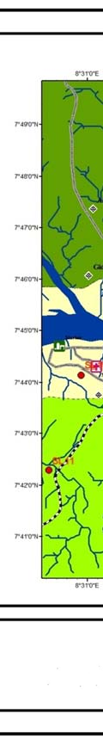
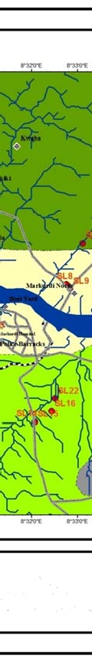
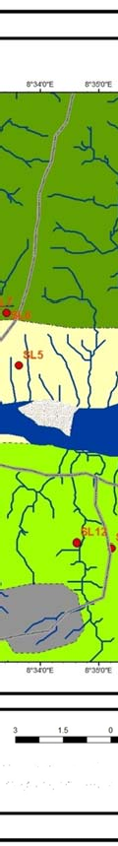
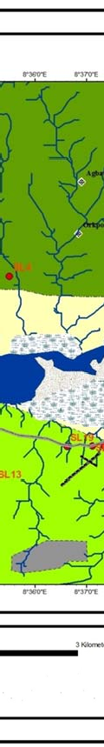
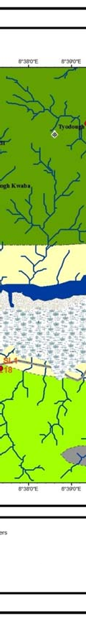
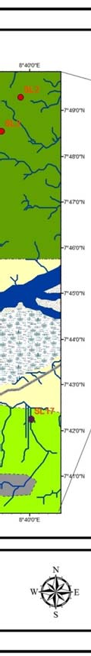
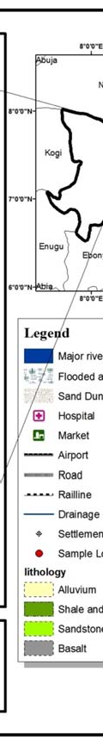
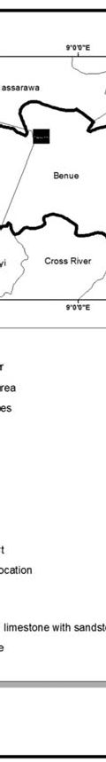
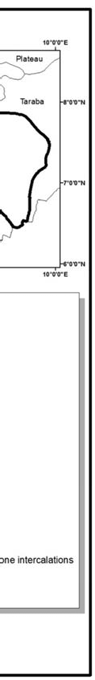

Figure 1: Geological map of Makurdi metropolis adapted from Nigeria Geological Survey Agency (2006)
Topography and Drainage
The topography of Makurdi is generally undulating, with elevations ranging between 97 and 150 meters above sea level. The terrain slopes gently northward toward the Benue River, providing natural drainage pathways that facilitate surface runoff and subsurface flow. The Benue River, which bisects the city, is the dominant hydrological feature, receiving numerous ephemeral tributaries and stormwater channels during the wet season. The drainage pattern is primarily dendritic, controlled by the underlying lithology and structural trends of the Makurdi Formation. The dumpsites along Gboko Road and Naka Road occupy relatively high grounds, while the North Bank dumpsite lies on a slightly lower elevation adjacent to the river floodplain—conditions that collectively influence the direction and extent of potential leachate migration.
Climate and Vegetation
Makurdi experiences a tropical wet-and-dry climate (Aw) according to Köppen’s classification. The climate is characterized by two distinct seasons: the wet season, which extends from April to October, and the dry season, spanning November to March. The area records a mean annual rainfall of approximately 1,200–1,500 mm, with the peak occurring between July and September (NIMET, 2023). Average monthly temperatures range between 25°C and 33°C, and relative humidity fluctuates between 60% and 85%. These climatic conditions enhance the generation and percolation of leachate, particularly during the rainy season when large volumes of water infiltrate through decomposing waste materials.
Land Use and Waste Management Setting
The land-use pattern in Makurdi is a mixture of residential, commercial, institutional, and agricultural zones, with urban expansion often encroaching on natural drainage basins. The three major dumpsites serve as the main collection points for domestic, agricultural, and industrial wastes, often without segregation or engineered leachate management systems. These sites are typically unlined open dumps, where waste materials are deposited directly on the ground surface. Consequently, rainfall infiltration leads to the formation of leachate, which seeps into the subsurface through porous soil and fractured sandstone layers. The proximity of these dumpsites to groundwater abstraction points, hand-dug wells, and the Benue River increases the risk of contamination of both surface and groundwater resources.
Overall, the physiographic setting of Makurdi characterized by permeable sandy formations, shallow groundwater, and pronounced seasonal rainfall creates favorable conditions for leachate infiltration and plume migration. Understanding the interaction between these physiographic elements and the hydrogeological framework is therefore critical for interpreting the resistivity data and modeling the spatial pathways of leachate contamination in the study area.

MATERIALS AND METHODS

Theoretical Framework
The theoretical foundation of this study is based on the principles of electrical resistivity, hydrogeochemical contamination dynamics, and leachate transport modeling within the subsurface environment. Leachate infiltration and migration are governed primarily by Darcy’s Law and the principle of electrical conduction in porous media, both of which relate fluid movement and electrical response to the physical and chemical properties of the subsurface.
According to Darcy’s Law, the velocity of groundwater flow through a porous medium is directly proportional to the hydraulic gradient and the medium’s hydraulic conductivity as presented in equation (1).
$Q=-KA\frac{dh}{dl}$ (1)
where $Q$ is the discharge rate (m³/s), $K$ is the hydraulic conductivity (m/s), $A$ is the cross-sectional area (m²), and $\frac{dh}{dl}$ is the hydraulic gradient.
Leachate transport in subsurface environments is governed by fluid flow and porous media physics, primarily described equation (1)
To relate permeability to pore structure, the Kozeny–Carman equation is introduced as presented in equation (2).
$K=\frac{C⋅d^{2}⋅ϕ^{3}}{(1-ϕ)^{2}}$ (2)
This establishes a direct link between hydraulic conductivity and porosity, explaining why sandy formations promote deeper leachate migration.
Electrical characterization is based on Ohm’s Law, where increased ionic concentration reduces resistivity. Thus, low resistivity implies contaminated zones while high resistivity implies clean formations
In contaminated settings, leachate containing high ionic concentrations enhances groundwater electrical conductivity, thereby reducing bulk resistivity.
Electrical resistivity methods rely on Ohm’s Law, expressed as equation (3).
$ρ=\frac{RA}{L}$ (3)
where $ρ$ is the resistivity (Ω·m), $R$ is the measured resistance (Ω), $A$ is the cross-sectional area of the current path (m²), and $L$ is the distance between electrodes (m). The apparent resistivity (ρₐ) derived from field measurements reflects the combined influence of subsurface lithology, porosity, saturation, and contaminant concentration.
Low resistivity zones indicate leachate-saturated layers, typically rich in dissolved ions such as Fe²⁺, Mn²⁺, and Pb²⁺, whereas high resistivity zones suggest uncontaminated sands, gravels, or compact rocks. This theoretical relationship forms the basis for delineating leachate plumes using geoelectrical data.
Furthermore, the geochemical theory of contaminant transport (Fetter, 2018) explains the mobility of dissolved metals through advection, diffusion, and sorption processes. Leachate plumes migrate along hydraulic gradients, with the rate and extent of migration influenced by soil permeability, water table depth, and the chemical speciation of solutes.
Integrating geoelectrical and hydro-chemical techniques, supported by GIS spatial analysis, therefore provides a multi-dimensional assessment of both the physical extent and chemical intensity of subsurface contamination.

Geophysical Survey Design, Data Acquisition, and Instrumentation
A detailed geophysical investigation was carried out using the Vertical Electrical Sounding (VES) technique to characterize subsurface resistivity variations and delineate leachate plumes across major dumpsites in Makurdi.
The survey was designed to achieve adequate spatial coverage and depth penetration across three प्रमुख dumpsites (Gboko Road, Naka Road, and North Bank) and selected control locations. A total of twenty-four (24) VES stations were systematically distributed to capture lateral and vertical variations in subsurface resistivity. Station locations were selected based on proximity to waste disposal zones, accessibility, topography, and hydrogeological significance.
The Schlumberger electrode configuration was adopted due to its efficiency in deep subsurface investigation and reduced sensitivity to lateral inhomogeneities. Electrode spacing (AB/2) was progressively increased from 1 m to a maximum of 200 m, allowing investigation depths exceeding 100 m depending on subsurface conditions.
Field measurements were conducted using a Rhomega Smart Resistivity Meter, a high-resolution digital instrument capable of injecting controlled current into the earth and measuring resulting potential differences with high accuracy. The equipment setup is shown in figure 2 .
The instrument automatically records current (I), voltage (V), and computes resistance values, ensuring precision and minimizing human error.
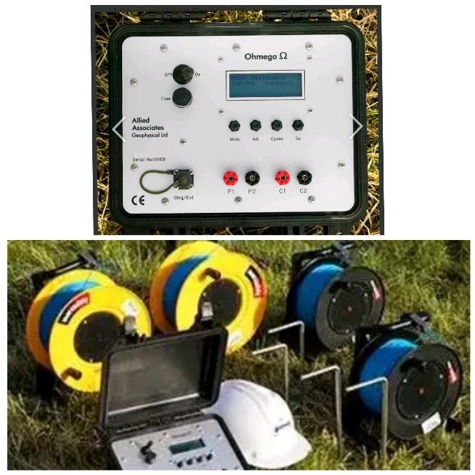
Figure 2: Rhomega smart resistivity meter and accessorie
The field apparent resistivity values were computed using equation (4).
$ρ_{a}=K\frac{V}{I}$ (4)
where $K$ is the geometric factor determined by electrode spacing, $V$ is the potential difference (V), and $I$ is the injected current (A).
The acquired VES data were plotted as log-log curves of apparent resistivity versus current electrode spacing and interpreted using partial curve matching followed by computer-assisted inversion with the IX1D and WinResist software. The inversion yielded layer resistivity and thickness parameters, which were correlated with lithological information and known borehole logs to produce geoelectric sections.
Zones with low resistivity (<20 Ω·m) were interpreted as leachate-saturated zones, while higher values indicated progressively cleaner subsurface conditions. The interpreted resistivity data were later imported into ArcGIS 10.8 for spatial interpolation and generation of leachate penetration depth maps.

Hydro-chemical Sampling and Analysis
To complement the geophysical survey, groundwater samples were collected from twelve (12) hand-dug wells and boreholes located within a 500 m radius of each dumpsite. Samples were collected in pre-cleaned polyethylene bottles, acidified to pH < 2 with nitric acid, and transported under cold conditions to the laboratory for analysis.
Heavy metals including Pb, Cd, Cr, Ni, Cu, Zn, Fe, Mn, As, Hg, and Se were determined using Atomic Absorption Spectrophotometry (AAS) following standard methods (APHA, 2017). The results were compared against the World Health Organization (WHO, 2017, 2022) permissible limits for drinking water. Parameters such as pH, electrical conductivity, and total dissolved solids (TDS) were also measured in situ using a portable multi-parameter probe.

Conceptual Model of Leachate Migration
The conceptual model developed from the integrated datasets illustrates a multi-layered subsurface system where leachate percolates vertically through sandy and weathered layers, subsequently migrating laterally along permeable horizons toward the Benue River. The model supports the observed resistivity and hydro-chemical patterns, affirming the control exerted by lithology, hydraulic gradient, and rainfall recharge on plume dynamics.
RESULTS AND DISCUSSION
Leachate Penetration Depth and Subsurface Resistivity Patterns
The interpreted vertical electrical sounding (VES) results presented in Table 1 reveal substantial spatial variability in apparent resistivity (ρ_{a}), layer thicknesses, and cumulative depths across the investigated sites in Makurdi metropolis. The resistivity values range from extremely low values of 1.2 Ωm (e.g., EYA Hotel) to very high values exceeding 58,000 Ωm (e.g., Mount Saint Gabriel), reflecting strong contrasts in lithology, degree of saturation, and contaminant load. Such wide variability is typical of heterogeneous basement terrains where weathering profiles and fracture networks significantly influence electrical properties (e.g., Telford M. Telford et al., 1990; Parasnis D. S., 1997).
Based on the classification scheme in Table 2, resistivity values <20 Ωm correspond to highly conductive, leachate-saturated zones, while values between 20–50 Ωm indicate moderate contamination. Slightly conductive zones (50–100 Ωm) reflect weak contamination, whereas resistivity values >100 Ωm represent relatively uncontaminated formations such as dry sands or fresh basement rock. This interpretation framework is consistent with the hydro-geophysical relationships established by Zohdy A. A. R. et al. (1974) and subsequent environmental geophysics studies.
The data in Table 1 show that locations proximal to major dumpsites Gboko Road, North Bank, Naka Road, Water Board, and Aliade Road are dominated by low resistivity signatures (<100 Ωm), indicating pervasive leachate infiltration. The estimated depths of penetration (d-values in Table 1) extend from shallow zones to depths exceeding 180 m in several locations (e.g., Rahama Clinic, Benue Hotel, and NKST Sule). This suggests that contamination is not restricted to the near surface but extends into intermediate and possibly deep aquifer systems.

Table 1: Leachate Penetration Depth Estimated from Resistivity Contrast
 |  |  | RESISTIVITY (Ωm) |  |  |  |  |  |  |  |  | THICKNESS (m) |  |  |  |  |  |  |  |  | DEPTH (m) |  |  |  |  |  |  |  |  | ρ_{a}(Ωm)
Locations | Latitude | Longitude | Ρ₁ | Ρ₂ | Ρ₃ | Ρ₄ | Ρ₅ | Ρ₆ | Ρ₇ | Ρ₈ | Ρ₉ | h₁ | h₂ | h₃ | h₄ | h₅ | h₆ | h₇ | h₈ | h₉ | d₁ | d₂ | d₃ | d₄ | d₅ | d₆ | d₇ | d₈ | d₉ | ρ_{a}(Ωm)
Wajina Int’l Sch. Mkd | 7.6608 | 8.85296 | 73.4 | 1980 | 222 | 1070 | 224 | 784 | 311 | 15500 | 7420 | 0.5 | 1.5 | 4.1 | 10.5 | 15.5 | 11.2 | 92.7 | 60 | 45 | 0.5 | 2 | 6.1 | 16.6 | 32.1 | 43.3 | 136 | 196 | 241 | 863.39
NKST Ushahemba Mkd | 7.6578 | 8.53611 | 69.4 | 207 | 163 | 610 | 768 | 479 | 334 | 222 | 96 | 1.1 | 4.1 | 7.6 | 17.7 | 39.8 | 35.7 | 38.7 | 44 | - | 1.1 | 5.2 | 12.8 | 30.5 | 7.3 | 106 | 144 | 188 | - | 221.98
Faduja Acad. Mkd. | 7.69846 | 8.5701 | 31.2 | 157 | 245 | 19.3 | 78.3 | 417 | 1830 | 253 | 187 | 0.6 | 3.3 | 2.9 | 10.8 | 7.5 | 10.8 | 22.2 | 28 | 24.2 | 0.6 | 3.6 | 6.5 | 17.3 | 24.3 | 25.6 | 57.8 | 85.8 | 110 | 850.28
Best Brain Acad. Mkd. | 7.70833 | 8.5952 | 166 | 830 | 709 | 275 | 132 | 820 | 145 | 626 | 472 | 0.7 | 2.6 | 4.2 | 8 | 12.5 | 27.7 | 20.5 | 30.8 | 27 | 0.7 | 2.6 | 4.2 | 8 | 12.5 | 27.7 | 20.5 | 30.8 | 27 | 1648.2
Gboko Road dump site | 7.72619 | 8.56842 | 532 | 76.1 | 341 | 260 | 6440 | 276 | 1180 | 534 | 355 | 0.5 | 0.9 | 2.1 | 10.5 | 7.9 | 9.2 | 12.9 | 19.3 | 24.9 | 0.5 | 1.4 | 3.5 | 14 | 21.9 | 31.1 | 44 | 63.3 | 88.2 | 16.5
Rahama Clinic Mkd. | 7.72011 | 8.56216 | 158 | 23 | 8700 | 181 | 562 | 2790 | 152 | 1200 | 1000 | 0.9 | 1 | 4.1 | 11.2 | 11.2 | 13.7 | 35.8 | 53.1 | 48 | 0.9 | 1.9 | 6 | 13.2 | 28.4 | 42.1 | 79.9 | 131 | 179 | 789.11
Benue Hotel Mkd. | 7.73546 | 8.4343 | 42 | 2180’ | 350 | 2600 | 717 | 910 | 900 | 1130.06.2 | - | 0.5 | 2.2 | 6.2 | 29.2 | 45.5 | 47.4 | 49 | - | - | 0.5 | 2.7 | 8.9 | 38.1 | 83.6 | 131 | 180 | - | - | 783.67
Gondo Aluor Road | 7.734777 | 8.525206 | 176 | 270 | 355 | 9800 | 2100 | 840 | 724 | 697 | 212 | 0.9 | 9.3 | 11.2 | 31.1 | 27.8 | 31.7 | 32 | 35 | - | 0.9 | 10.2 | 21.4 | 52.5 | 80.3 | 112 | 144 | 179 | - | 345.55
North-Bank Dump site. makurdi | 7.75498 | 8.54653 | 268 | 75.9 | 675 | 75 | 810 | 617 | 312 | 220 | 162 | 24 | 3.1 | 7.9 | 17.9 | 17.7 | 68.8 | 50 | 52 | 50 | 2.4 | 5.5 | 13.4 | 30.5 | 48.2 | 117 | 167 | 219 | 269 | 18.7
Mountain of Fire Min. Mkd. | 7.755553 | 8.55555 | 1000 | 960 | 1630 | 1360 | 1590 | 235 | 26.6 | 328 | - | 1 | 3.8 | 4.2 | 31.9 | 20.2 | 77.8 | 67.1 | - | - | 1’0 | 4.8 | 9 | 40.9 | 61.1 | 78.9 | 146 | 146 | - | 458.76
Nasme Junct. Mkd. | 7.76692 | 8.55954 | 109 | 143 | 1250 | 4990 | 18.8 | 62.6 | 237 | 352 | 2480 | 1.2 | 0.9 | 1.4 | 7.1 | 40.6 | 32.4 | 24.4 | 32 | - | 1.2 | 2.1 | 3.5 | 10.6 | 51.2 | 83.6 | 108 | 140 | - | 612.3
Christ The King Church, North-Bank, Mkd. | 7.76395 | 8.5701 | 387 | 33900 | 5860 | 2940 | 2180 | 6410 | 4550 | 8600 | 16600 | 0.4 | 2.8 | 8.5 | 9.8 | 18.4 | 41.6 | 40.5 | 51 | 57,0 | 0.4 | 3.2 | 11.7 | 21.5 | 39.9 | 81.5 | 128 | 179 | 236 | 124.87
NKST Sule, Mkd. | 7.78074 | 8.56154 | 940 | 86 | 5.5 | 38.4 | 85 | 305 | 765 | 590 | 4600 | 1 | 2.4 | 5.6 | 8.1 | 7 | 37.6 | 46.3 | 49 | 82 | 1 | 3.4 | 9 | 17.1 | 24.1 | 61.7 | 108 | 157 | 239.0` | 862.42
Naka Road dump site | 7.73018 | 5.506332 | 134 | 13540 | 1630 | 314 | 97 | 468 | 2800 | 2650 | 1400 | 0.4 | 2.4 | 12.6 | 6.8 | 16.4 | 12.9 | 40.6 | 46.9 | 48 | 0.4 | 2.8 | 15.4 | 12.2 | 38.6 | 51.5 | 92.1 | 139 | 187 | 11.54
NKST Iortyer, Mkd. | 7.72125 | 8.48198 | 756 | 560 | 457 | 118 | 1060 | 1500 | 1020 | 608 | 231 | 0.5 | 1.1 | 7.9 | 9.7 | 15.5 | 17.3 | 25.2 | 31.8 | 38 | 0.5 | 1.6 | 9.5 | 19.2 | 34.7 | 52.1 | 77.2 | 109 | 147 | 74.17
NTA Mkd. | 7.73965 | 8.53219 | 30.7 | 279 | 14 | 234 | 145 | 94 | 95 | 83 | 75.9 | 0.5 | 1.8 | 11.1 | 26.5 | 32.9 | 43.3 | 44 | 46 | 48 | 0.5 | 2.3 | 13.3 | 39.8 | 72.7 | 116 | 160 | 206 | 254 | 28.92
EYA Hotel, Mkd. | 7.73386 | 8.53019 | 158 | 10.2 | 1.2 | 45 | 152 | 262 | 72.2 | 76.5 | 73.9 | 1.1 | 1.5 | 3.8 | 5.4 | 10.3 | 31.2 | 31.5 | 34.2 | 35 | 1.1 | 2.6 | 6.4 | 11.8 | 22.1 | 53.3 | 84.8 | 119 | 154 | 167.74
Kapajo Apartment, Mkd. | 7.73669 | 8.52483 | 372 | 870 | 129 | 9.2 | 23.6 | 1290 | 525 | 206 | 292 | 0.8 | 1.9 | 1.8 | 5 | 4.4 | 29.5 | 18.1 | 38.1 | 30.4 | 0.8 | 2.7 | 4.5 | 9.5 | 13.9 | 43.4 | 61.5 | 99.6 | 130 | 93.7
Water board dump site | 7.73066 | 8.52369 | 57.1 | 204 | 52.2 | 2.7 | 1.9 | 47.5 | 425 | 145 | 1470 | 0.8 | 2 | 1.8 | 3.5 | 3.5 | 6.5 | 7.2 | 14.9 | 24.7 | 0.8 | 2.8 | 4.6 | 8.1 | 11.6 | 18.1 | 25.3 | 40.2 | 64.9 | 47.7
Mount Saint Gab., Mkd. | 7.73083 | 8.51804 | 75 | 432 | 9700 | 790 | 58000 | 1800 | 420 | 1550 | 9000 | 1.2 | 0.5 | 4.1 | 9.3 | 9 | 16.5 | 60.1 | 33 | 25 | 1.2 | 1.7 | 6.1 | 15.4 | 24.4 | 40.9 | 101 | 134 | 159 | 30.11
J.S. Tarka Rd., Mkd. | 7.732546 | 8.522191 | 57.1 | 40.9 | 100 | 11.7 | 4.5 | 67 | 47.8 | 10.1 | 16.8 | 0.8 | 0.9 | 2.9 | 3.8 | 9.9 | 24.4 | 32.4 | 46.9 | 31.1 | 0.8 | 1.7 | 4.6 | 8.4 | 18.3 | 42.9 | 75.1 | 122 | 153 | 259.44
Grace Cottage Hosp. Mkd. | 7.72586 | 8.52914 | 109 | 19.2 | 168 | 187 | 373 | 121 | 21.5 | 11.7 | 46.2 | 0.6 | 1.1 | 0.9 | 8.4 | 6.9 | 8.2 | 26.7 | 66.2 | 51 | 0.6 | 1.7 | 2.6 | 11 | 17.9 | 26.1 | 52.8 | 119 | 170 | 55.27
City-Bay Park, Mkd. | 7.72658 | 8.53708 | 365 | 264 | 4.1 | 10.7 | 1.9 | 16.8 | 29 | 56.3 | 38.8 | 0.9 | 1 | 3.7 | 9.4 | 8.4 | 15.2 | 106.4 | 53 | 51 | 0.9 | 1.9 | 5.6 | 15 | 23.4 | 38.6 | 145 | 198 | 249 | 1765.56
Trust Resort Hotel, Mkd. | 7.7108 | 8.54506 | 404 | 1670 | 1260 | 12500 | 1600 | 381 | 125 | 657 | 686 | 0.8 | 2.4 | 3.5 | 10.8 | 8.6 | 14.9 | 49.4 | 63.6 | 62 | 0.8 | 3.2 | 6.7 | 17.5 | 26.1 | 41.1 | 6.4 | 154 | 216 | 873.62
Saint Joseph’s Parish, Akpehe, Mkd. | 7.71123 | 8.55451 | 488 | 2270 | 263 | 970 | 2540 | 226 | 243 | 590 | 730 | 0.7 | 3.3 | 6 | 8.1 | 17.9 | 83.8 | 24 | 24.2 | 28 | 0.7 | 4 | 10 | 18.1 | 36 | 69.8 | 3.8 | 118 | 146 | 645.44
Achusa Mkt., Mkd. | 7.69754 | 8.51567 | 155 | 371 | 331 | 484 | 9000 | 11500 | 2790 | 2060 | 1580 | 0.8 | 1.2 | 2.9 | 2.9 | 12.7 | 34.4 | 39 | 41.1 | 45 | 0.8 | 2 | 4.9 | 7.8 | 20.5 | 54.9 | 93.9 | 135 | 180 | 113
BIPC Mkd. | 7.70647 | 8.50889 | 376 | 201 | 90 | 13.1 | 13.5 | 46.1 | 241 | 316 | 779 | 0.8 | 7 | 23.2 | 12.1 | 21.2 | 22 | 24.7 | 24 | 40 | 0.8 | 7.8 | 31 | 43.1 | 64.3 | 86.3 | 111 | 135 | 175 | 178.68
Corner stone Imperial Sch., Mkd. | 7.69426 | 8.50526 | 545 | 129 | 761 | 55.4 | 9.9 | 41.2 | 170 | 435 | 656 | 0.8 | 1.5 | 3.6 | 4.3 | 12.8 | 8.9 | 11 | 13.8 | 16.6 | 0.8 | 2.3 | 5.9 | 10.2 | 23 | 31.9 | 42.9 | 56.7 | 73.2 | 66.34
NKST Church Onyar, Mkd. | 7.69009 | 8.5009 | 49.1 | 52.1 | 557 | 1500 | 60 | 155 | 120 | 137 | 116 | 0.8 | 5.6 | 3.3 | 13.1 | 44.2 | 17.6 | 44.4 | 49 | - | 0.8 | 6.4 | 9.7 | 2.8 | 67 | 84.6 | 129 | 178 | - | 261.04
Aliade Road dump ste | 7.68533 | 8.53384 | 870 | 1510 | 212 | 5.5 | 36.4 | 82 | 313 | 626 | 31 | 0 | 1 | 6.9 | 13.8 | 10.5 | 14.5 | 40.4 | 43.1 | 48 | 0.8 | 1 | 8.7 | 22.5 | 33 | 47.5 | 87.9 | 131 | 179 | 37.9
 |  |  |  |  |  |  |  |  |  |  |  | 0.8
NKST Church, Yaiko, Mkd. | 7.6031 | 8.57347 | 93 | 110 | 1710 | 171 | 2920 | 860 | 421 | 291 | 199 | 1 | 0.8 | 6 | 15.8 | 32.7 | 20.1 | 19.7 | 20.9 | 27 | 1 | 1.8 | 7.8 | 23.6 | 56.3 | 76.4 | 69.1 | 117 | 144 | 117.47

Table 2: Interpretation Criteria Leachate Penetration Depth Map
Resistivity Range (Ω·m) | Likely Subsurface Condition | Interpretation
< 20 | Highly conductive leachate-saturated zone | Highly contaminated
20–50 | Moderately conductive zone / clayey sand | Moderately contaminated
50–100 | Slightly conductive / weakly impacted zone | Low contamination
> 100 | Resistive zone / clean sand or rock | Uncontaminated

These findings are clearly illustrated in Figure 3, where the leachate penetration map delineates zones of intense contamination characterized by low resistivity anomalies. The spatial continuity of these anomalies indicates active plume migration pathways, particularly within zones of enhanced permeability such as weathered regolith and fractured basement. Similar deep migration patterns (>100 m) have been reported by Adeleke O. O. et al. (2020) and Olofinlade O. M. et al. (2022), who attributed such behavior to vertical percolation through fractured and jointed subsurface media.
Further insight is provided by the resistivity contour maps (Figures 4–6). The depth dependent contour slices (5 m and 10 m) reveal progressive lateral spreading of conductive zones, indicating that contamination intensifies with depth in certain areas. The 3D visualization (Figure 7) further confirms preferential flow directions, highlighting plume migration along hydraulic gradients and structural weaknesses.
Conversely, high-resistivity zones observed at locations such as Best Brain Academy and Mount Saint Gabriel indicate relatively uncontaminated conditions. These areas are likely underlain by resistive lithologies or protected by impermeable clay layers that inhibit leachate infiltration. This observation agrees with the findings of Nwankwo L. I. et al. (2018), who emphasized the role of lithological heterogeneity and topographic elevation in controlling contaminant distribution in basement terrains.
Hydrogeochemical Correlation with Heavy Metal Concentrations
The hydrogeochemical dataset presented in Table 3 provides independent validation of the geophysical results. Elevated concentrations of heavy metals including Pb, Cd, Cr, Ni, Zn, Fe, and Mn were recorded in groundwater samples collected around the major dumpsites. Notably, iron (Fe) concentrations range from 9.38 to 12.07 mg/L, while manganese (Mn) ranges from 3.78 to 4.89 mg/L, significantly exceeding permissible limits recommended by the World Health Organization (2022).
Table 3: Concentrations of Heavy Metals in Groundwater Samples Near Major Dumpsites in Makurdi Metropolis
Locations | COORDINATES |  | METALS (mg/L)
Locations | Latitude (N) | Longitude (E) | Lead (Pb) | Cadmium (Cd) | Chromium (Cr) | Nickel (Ni) | Copper (Cu) | Zinc (Zn) | Iron (Fe) | Manganese (Mn) | Arsenic (As) | Mercury (Hg) | Selenium (Se)
Gboko Road dump site | 7.72619 | 8.56842 | 0.5 | 0.04 | 0.3 | 0.07 | 0.5 | 0.9 | 11.57 | 4.89 | 0.04 | 0.003 | 0.02
North-Bank Dump site. Makurdi | 7.75498 | 8.54653 | 0.7 | 0.003 | 0.25 | 0.058 | 0.39 | 0.63 | 9.38 | 3.78 | 0.029 | 0.049 | 0.019
Naka Road dump site | 7.73018 | 5.506332 | 0.59 | 0.058 | 0.49 | 0.062 | 0.57 | 0.78 | 10.9 | 4.12 | 0.036 | 0.028 | 0.027
Water board dump site | 7.73066 | 8.52369 | 0.43 | 0.041 | 0.39 | 0.046 | 0.42 | 0.59 | 12.03 | 3.96 | 0.031 | 0.0048 | 0.024
Aliade Road dump site | 7.68533 | 8.73496 | 0.64 | 0.0046 | 0.34 | 0.049 | 0.47 | 0.54 | 11.97 | 4.09 | 0.39 | 0.051 | 0.028
Ovation resort makurdi | 7.60314 | 8.54347 | 0.51 | 0.046 | 0.382 | 0.081 | 0.494 | 0.87 | 9.45 | 4.31 | 0.37 | 0.058 | 0.032
NKST Church, Yaiko, Makert | 7.6031 | 8.57347 | 0.71 | 0.051 | 0.345 | 0.076 | 0.503 | 0.93 | 12.07 | 4.78 | 0.34 | 0.038 | 0.36

The spatial coincidence of high metal concentrations with low resistivity zones strongly supports the interpretation of leachate-induced contamination. For instance, at NKST Church, Yaiko, elevated concentrations of Pb (0.71 mg/L), Zn (0.93 mg/L), Fe (12.07 mg/L), and Mn (4.78 mg/L) correspond to conductive subsurface zones identified in the resistivity models. Similarly, the Naka Road and Aliade Road dumpsites exhibit both deep penetration depths and high heavy metal loads, indicating sustained leachate percolation.
This correlation between electrical conductivity and hydro-chemical contamination is well established in environmental geophysics, as ionic-rich leachates enhance subsurface conductivity (e.g., Keller G. V. & Frischknecht, 1966). Comparable results have been documented by Adeniyi A. A. et al. (2019) and Oyeku O. T. & Eludoyin (2021), who reported elevated heavy metal concentrations in groundwater near dumpsites due to leachate infiltration and waste decomposition processes.
Spatial Distribution and Leachate Migration Pathways
The integrated interpretation of Figure 3 and Figures 4–7 reveals that leachate migration follows distinct spatial patterns controlled by topography, lithology, and groundwater flow dynamics. The contamination plumes are predominantly oriented toward low-lying areas and floodplains, particularly in the direction of the River Benue system.
This behavior is consistent with Darcy’s law, which governs groundwater flow in porous media, where hydraulic conductivity, porosity, and hydraulic gradient control fluid movement. The dumpsites at North Bank, Gboko Road, and Water Board are situated within topographic depressions that act as recharge zones, thereby enhancing downward percolation and lateral plume migration.
The layered resistivity structure evident in the VES models indicates alternating sequences of clay, sandy clay, and weathered basement. These layers create anisotropic conditions that both retard and channel contaminant transport. Deep conductive anomalies observed beneath Rahama Clinic and NKST Sule (depths >170 m and >239 m, respectively) suggest long-term accumulation and downward migration of leachate, possibly intensified during seasonal rainfall recharge. Similar observations were made by Igwe O. et al. (2020) in tropical landfill environments.

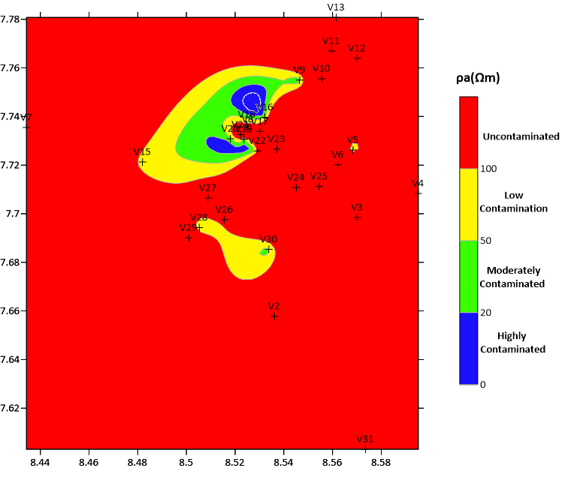
Figure 3: Leachate Penetration map derived from Resistivity Data

Figure 4: Contour map of resistivity variation with depth
Figure 5: 2D Resistivity Contour Map at 5m
Figure 6: 2D Resistivity Contour Map at 10m

Figure 7: 3D visualization of leachate flow
Environmental and Public Health Implications
The combined geophysical and hydrogeochemical evidence indicates a significant threat to groundwater quality within Makurdi metropolis. The presence of heavy metals such as Pb, Cd, Fe, and Mn at concentrations exceeding World Health Organization standards poses serious health risks, including neurological, renal, and hematological disorders (e.g., Nduka J. K. et al., 2021).
The detection of leachate penetration depths exceeding 100 m is particularly alarming, as it implies potential contamination of deeper aquifers that serve as major sources of potable water. This underscores the vulnerability of groundwater systems in basement complex terrains where protective clay layers are discontinuous.
These findings highlight the urgent need for improved waste management practices, including the design of engineered landfills with impermeable liners, leachate collection systems, and regular environmental monitoring. The application of geoelectrical methods, as demonstrated in this study, provides an effective early warning tool for detecting and tracking subsurface contamination.
Contamination poses risks such as neurological disorders (Pb exposure) and Kidney damage (Cd toxicity)

Policy Recommendations
The results of this study highlight the urgent need for a comprehensive and enforceable waste management framework in Makurdi to mitigate the risks of groundwater contamination associated with uncontrolled dumpsites. Based on the integrated geophysical and hydro-chemical evidence, the following policy measures are recommended.
First, there is a critical need to transition from open dumping practices to engineered landfill systems. Unlike open dumps, engineered landfills incorporate protective barriers such as impermeable liners and controlled waste deposition, which significantly reduce leachate infiltration into the subsurface. This measure is essential given the observed deep penetration of contaminants, which reflects the absence of containment structures and the high permeability of underlying formations.
Second, the installation of leachate collection and treatment systems should be made mandatory for both existing and future waste disposal facilities. The presence of low-resistivity zones identified in this study indicates active leachate accumulation and migration. Properly designed collection systems, including drainage networks and treatment units, will help intercept and manage leachate before it reaches groundwater systems, thereby minimizing environmental and public health risks.
Third, the establishment of a groundwater monitoring network is necessary for early detection and continuous assessment of contamination. This should involve the development of strategically located monitoring wells, periodic hydro-chemical sampling, and routine geophysical surveys. Such an integrated monitoring approach will enable timely identification of pollution trends and support evidence-based decision-making.
Finally, strict enforcement of environmental regulations is essential to ensure compliance with established waste management standards. Regulatory bodies such as National Environmental Standards and Regulations Enforcement Agency must strengthen oversight mechanisms, including mandatory environmental impact assessments, routine inspections, and penalties for non-compliance. Adherence to international guidelines, such as those provided by the World Health Organization, is also crucial in safeguarding groundwater quality and public health.
In summary, the effective implementation of these policy measures will provide a multi-layered approach to pollution control, combining prevention, monitoring, and regulation to ensure sustainable groundwater resource management.
Comparison with Previous Studies
The results obtained in this study are consistent with similar investigations conducted in other Nigerian urban centers. Studies in Ibadan by Adeleke O. O. et al. (2020), Lagos by Oyeku O. T. & Eludoyin (2021), and Enugu by Nwankwo L. I. et al. (2018) all reported strong correlations between low resistivity zones (<50 Ωm) and elevated heavy metal concentrations in groundwater.
However, the Makurdi environment presents unique hydrogeological conditions due to its basement complex geology overlain by lateritic soils. These conditions introduce additional complexity, as fractures may either facilitate deep contaminant migration or be partially sealed by clay infill, thereby limiting flow. This dual behavior emphasizes the importance of integrating geophysical and geochemical methods for accurate site characterization.
Overall, the study demonstrates that leachate-induced groundwater contamination is a widespread environmental challenge in Nigeria, driven largely by unregulated waste disposal practices and inadequate landfill engineering.
Conclusion
This study demonstrates that major dumpsites in Makurdi act as significant sources of groundwater contamination. Integrated resistivity and hydro-chemical analysis revealed deep and laterally extensive leachate plumes, with penetration depths exceeding 180 m in some locations.
The strong correlation between low resistivity anomalies and elevated heavy metal concentrations confirms the effectiveness of the integrated approach. The identified southwest–northeast plume migration aligns with regional hydrogeological conditions, emphasizing the role of lithology and groundwater flow.
Acknowledgement
The authors gratefully acknowledge the Management of the Tertiary Education Trust Fund (TETFund) for fully funding this research through the 2024 Institution-Based Research (IBR) grant awarded to Joseph Sarwuan Tarka University, Makurdi.
REFERENCES
Abu-Zeid N, El-Sayed M, Mahmoud S (2020). Integrated hydrochemical and geophysical assessment of groundwater contamination near waste disposal sites. Hydrogeology Journal 28(3):901–915. https://doi.org/10.1007/s10040-019-02066-8
Adepelumi AA, Olorunfemi MO (2020). Geoelectrical characterization of landfill sites for leachate plume delineation. Journal of Applied Geophysics 178:104118. https://doi.org/10.1016/j.jappgeo.2020.104118
Adeleke AA, Ojo OM, Adewumi JK (2020). Hydrogeophysical assessment of landfill leachate contamination in Ibadan, Nigeria. Environmental Earth Sciences 79(12):279. https://doi.org/10.1007/s12665-020-09036-4
Adeniyi AA, Yusuf KA, Okedeyi OO (2019). Assessment of heavy metal contamination around dumpsites in Nigeria. Environmental Monitoring and Assessment 191(2):93. https://doi.org/10.1007/s10661-019-7233-1
Adewumi JK, Ilemobade AA, Van Zyl JE (2019). Municipal solid waste management in developing countries. Waste Management 87:1–12. https://doi.org/10.1016/j.wasman.2019.02.012
American Public Health Association (2017). Standard methods for the examination of water and wastewater (23rd ed.). APHA. https://www.standardmethods.org/
Atuanya EI, Nwankwo CN, Akpoborie IA (2012). Application of geophysical methods in landfill studies. Journal of Environmental Hydrology 20(5):1–12.
Bhattacharya P, Sracek O, Eldvall B (2019). Hydrogeochemical processes in landfill leachate migration. Science of the Total Environment 650:174–185. https://doi.org/10.1016/j.scitotenv.2018.09.051
Christensen TH, Kjeldsen P, Bjerg PL, Jensen DL, Christensen JB, Baun A (2011). Biogeochemistry of landfill leachate plumes. Applied Geochemistry 26(1):155–173. https://doi.org/10.1016/j.apgeochem.2010.11.006
Chukwu GU, Uzoho CA (2015). Impacts of leachate on groundwater quality in urban Nigeria. African Journal of Environmental Science and Technology 9(8):685–695. https://doi.org/10.5897/AJEST2015.1923
Fetter CW (2018). Applied hydrogeology (4th ed.). Waveland Press. https://www.waveland.com/browse.php?t=384
Igbinosa EO, Okoh AI (2020). Public health risks associated with leachate contamination of groundwater. Environmental Science and Pollution Research 27(12):1445–1458. https://doi.org/10.1007/s11356-019-07187-0
Igwe O, Onwuka O, Nwankwo C (2020). Hydrogeophysical investigation of leachate migration in tropical landfill environments. Environmental Monitoring and Assessment 192(6):387. https://doi.org/10.1007/s10661-020-08334-5
Jha MK, Kumar A, Singh P (2021). GIS-based modeling of contaminant transport beneath municipal waste dumps. Environmental Monitoring and Assessment 193(4):256. https://doi.org/10.1007/s10661-021-09021-5
Keller GV, Frischknecht FC (1966). Electrical methods in geophysical prospecting. Pergamon Press.
Kumar A, Singh R, Pandey R (2018). Characterization of landfill leachate and its environmental impact. Environmental Science and Pollution Research 25(15):14645–14660. https://doi.org/10.1007/s11356-018-1751-5
Nduka JK, Orisakwe OE, Ezenweke LO (2021). Health risk assessment of heavy metals in groundwater systems. Human and Ecological Risk Assessment 27(3):765–780. https://doi.org/10.1080/10807039.2020.1718575
Nigeria Meteorological Agency (2023). Annual climate report for Nigeria. https://nimet.gov.ng/
Nigeria Geological Survey Agency (2006). Geological map of Makurdi sheet. https://ngsa.gov.ng/
Nton ME (2011). Sedimentological and geophysical framework of the Middle Benue Trough. Journal of African Earth Sciences 60(3):133–145. https://doi.org/10.1016/j.jafrearsci.2011.02.006
Nton ME, Olorunfemi MO (2019). Hydrogeophysical investigation of aquifer contamination in semi-urban environments. Journal of Hydrogeology and Environmental Geoscience 8(2):19–30.
Nwankwo CN, Ehirim CN, Onwuemesi AG (2018). Geophysical investigation of groundwater contamination in basement terrains. Journal of Applied Geophysics 159:218–229. https://doi.org/10.1016/j.jappgeo.2018.08.012
Ocheri MI, Ojo JS, Egbodo E (2014). Hydrogeological evaluation of groundwater resources in Makurdi. International Journal of Water Resources and Environmental Engineering 6(4):102–110.
Offodile ME (2002). Groundwater study and development in Nigeria. Mecon Services Ltd.
Olofinlade OA, Adeyemi GO, Adagunodo TA (2022). Evaluation of leachate migration in fractured basement aquifers. Environmental Earth Sciences 81(5):150. https://doi.org/10.1007/s12665-022-10225-2
Oluseyi TO, Olayinka KO, Alo BI (2021). Assessment of groundwater contamination near dumpsites in Nigeria. Environmental Monitoring and Assessment 193(6):1–15. https://doi.org/10.1007/s10661-021-09123-9
Oyeku OT, Eludoyin OS (2021). Heavy metal contamination and public health risks near dumpsites in Lagos. Environmental Monitoring and Assessment 193(3):168. https://doi.org/10.1007/s10661-021-08946-1
Parasnis DS (1997). Principles of applied geophysics (5th ed.). Chapman & Hall.
Telford WM, Geldart LP, Sheriff RE (1990). Applied geophysics (2nd ed.). Cambridge University Press.
Zohdy AAR, Eaton GP, Mabey DR (1974). Application of surface geophysics to groundwater investigations. U.S. Geological Survey. https://doi.org/10.3133/twri02D1
World Health Organization (2017). Guidelines for drinking-water quality (4th ed.). https://www.who.int/publications/i/item/9789241549950
World Health Organization (2022). Guidelines for drinking-water quality: 2022 update. https://www.who.int/publications/i/item/9789240045064

