A Framework for Addressing Academic Integrity Challenges in the Era of Artificial Intelligence in South African Universities

Abstract
Artificial intelligence (AI) is quickly becoming ubiquitous across all sectors, including higher education, and AI, specifically generative AI, is an example of how advancing technologies will revolutionize the way we teach, the way we learn, and how we assess learning. In South Africa, the emergence of AI in higher education presents many potential benefits as well as significant risks for organizations committed to preserving academic integrity, such as AI-enabled plagiarism, ambiguity in authorship and the use of unreliable detection tools, and a lack of policy development. Systemic inequality in the education system and a global digital divide result in a lack of access to technology and/or inadequate skills development to effectively use devices connected to the internet; therefore, the lack of national oversight on the use of AI and other new technological applications creates an additional layer of complexity around these issues in South Africa.
This research employs a conceptual approach to synthesise recent literature to develop a multi-dimensional framework that is influenced by ethics, policy, pedagogy, and technology. Rather than focusing solely on the punitive detection of AI-related academic misconduct, the study provides a framework for a perspective of "cautious optimism" by emphasizing the importance of AI literacy, ethical transparency, adaptive institutional policies, and the redesigning of assessments and assignments. Furthermore, this research contributes to the ongoing discourse regarding practical, context-specific solutions to assist South African higher education institutions in ensuring academic integrity in an age of AI.

Keywords: Academic integrity, artificial intelligence, higher education, South Africa higher education, plagiarism, ethics, AI-giarism.

- Introduction and Background
Artificial Intelligence (AI) is a very fast-moving field that is rapidly changing higher education by changing the way students’ access, create, and engage with knowledge and disrupting traditional academic integrity and ethical principles of honesty, trust, fairness, respect, and responsibility. The new generation of advanced, large language models (LLMs) like Claude and Google Gemini has raised the growing concern about academic dishonesty with plagiarism, authorship, and intellectual rights because academic institutions are seeing a growing number of students submit AI-generated work as if it were their own. In South Africa this challenge is exacerbated; for example, the University of South Africa has reported a dramatic increase in AI-assisted academic dishonesty due to systemic issues that have not yet been addressed with revisions to the existing academic policies and assessment practices.
Moreover, it is important to recognise that conventional plagiarism detection tools, such as Turnitin, are increasingly losing their effectiveness. AI-generated content is technically original but does not adequately reflect either real academic or creative work shown through rigorous independent study. As we work to find more trustworthy ways to assure academic integrity and the need to understand the limits of AI-generated content in e-learning. AI Content currently utilises 26% of E-Learning tasks while 75% of students are worried about using AI for E-Learning due to concerns regarding academic integrity. This data indicates some of the risks associated with AI in academic integrity for higher educational environments. These can be assessed in a contextual manner. The ethical use of AI in higher education requires a contextually dependent framework.
1.1 Conceptualising Academic Integrity in the AI Era
Academic integrity has been targeted at fighting academic dishonesty in the form of plagiarism and the promotion of originality in writing. Academic dishonesty has been complicated by the presence of AI in education; students who use AI technology to generate written products without properly citing their source(s) have been referred to as committing “AI-giarism” (Nwozor2025). Recent studies also indicate that AI has caused confusion regarding collaboration vs. authorship (Chan, 2025). Furthermore, AI technology has progressed so far that it is getting harder to tell the difference between an academic paper written by a human student and a paper written by an AI application (Amirjalili et al., 2024)
1.1.1. Digital Inequality:
Digital inequality might worsen academic inequality since access to the internet, reliable devices, cheap data, stable electricity and digital skills are all essential prerequisites for using AI approaches. “Unequal access to these resources affects learners’ digital engagement,” the OECD said. UN concerns: 2.6bn to be cut off from internet in 2024 as ‘AI divide’ looms Students from distant places or with limited affluence will be at a disadvantage since they will need consistent internet connectivity and up-to-date technology (Miah, 2024). Affordable connectivity and digital skills are essential for inclusive AI usage, but free access and support may help create equality. Such support is not sufficient unless the data costs and connectivity issues are addressed. “Universities will have to develop AI policies to ensure equitable access and provide
1.2.2. Policy Gaps
With the emergence of generative AI (artificial intelligence) to identify holes in the South African higher education policies, several universities have started to establish some policy framework connected to AI; however, the execution is uneven among institutions (Jin et al. 2025). For example, there are numerous universities still creating their academic integrity standards that do not even include AI features. Therefore, openness, privacy and ethical use of AI are only suggestions and not formalised as legally obligatory assertions. Thus, the uncertainties around how AI will be used, what disclosures will be required around AI usage, and how universities will assess AI will remain unclear (Kaya‐Kasikci et al. 2025). Recent data captured in research papers on universities in South Africa have shown considerable discrepancies in preparation and governance techniques (Smith, 2025).
1.2.3. Barriers to Effective Use of Language
Second language South African students in higher education speak English at a variety of levels, and thus their communication will also vary. Joubert and Sibanda (2022) refer to academic integrity as the behaviours expected of students by their educational institutions and their service providers. While a fluent second language speaker may struggle with the subtlety of academic integrity because of their status as second language learners, there are also many systemic barriers that limit these students’ ability to communicate effectively in an academic environment. In fact, language barriers are one of several factors that contribute to an increased rate of breach of academic integrity standards among disadvantaged students compared with their peers who consider themselves non-disadvantaged (Pagaling et al., 2022). Some students may not be able to grasp what is expected of them in the specific academic settings in which they are enrolled because they lack the prior frame of reference, which is typically required by academic institutions. Many disadvantaged students have a different understanding of both ownership and authorship of knowledge from what is typically required in academic institutions, due to their cultural backgrounds; therefore, they will face another barrier to meeting academic integrity standards (Marnewick, 2023).
1.2.4. AI and Academic Misconduct/Academic Integrity in Higher Education
According to Mabena (2026), the use of artificial intelligence could facilitate students’ opportunistic use of technology to cheat on university assessments; this might further undermine existing assessment tools at South African universities. Numerous South African students view the utilisation of AI-based programming and writing assistance tools as an appropriate means of achieving academic success and they participate in class projects (Ateeq et al., 2024). Studies conducted outside of South Africa confirm this trend. While technologies to detect [AI-generated] writing and institutional policies that will help teachers to detect such writing are being developed, there are still uncertainties for teachers on their implementation of assessment practices and academic quality (Guadu et al., 2025; Nwokocha & Morkel, 2025).
To help educators promote the ethical use of AI and limit academic dishonesty in their classrooms, educational materials are available to help them do so (Tan and Maravilla, 2024). In South Africa, schools have established many guideline expectations based on the fact that there are many instances of students using AI to commit academic dishonesty; however, many educators do not believe the tests they use to detect academic dishonesty are adequate to solve the larger ethical dilemmas that arise from the misuse of AI (Muringa, 2025; Nwokocha and Morkel, 2025). These larger ethical issues pertain to preparing students for ethical participation in a digitally driven society. There are limitations in existing detection and policy systems for AI misuse.
1.3. Pedagogical and Ethical Implications
Since AI has grown in influence within post-secondary education institutions, educators need to look critically at the ways they will teach with this new technology and the ethical aspect of new forms. Failure to engage with how students research and utilise AI in higher education could create a civil disconnect from how current academic knowledge is produced. There have been numerous discussions surrounding AI, ChatGPT, and other new tools that relate to academic integrity, but there are also many potential opportunities for educators to implement new methods to teach students as it relates to technology and the integration of technology within a pedagogy (Smith et al., 2024; Chan, 2023). Therefore, many schools are developing guidelines to ethically integrate technology into academic integrity and to understand better the overall effects of AI on society (Smith et al., 2024; Chan, 2023).
1.4. Institutional Actions Taken
Institutions are moving toward the adoption of assessment practices that include an emphasis on authenticity, critical thinking and student literacy in AI to help reduce academic dishonesty through assessments. Students will increasingly be expected to disclose their use of AI and to participate in some form of training on AI literacy and capabilities. Universities are using AI technologies that will help monitor how students interact with generative AIs, and they are also developing proctors and using AI detection systems (Chan 2023).
1.4.1Creating Policies About AI
Generative AI has changed the way that writers and creators produce work. These systems can generate high-quality work at the request of users, either by producing large-scale outputs or answers in real time. One impact of this technology is how it can affect academic integrity. Even if a student uses AI-generated content to produce their work, there is no guarantee that the generated content will be free from errors, be biased, or contain unoriginal content. In addition, universities need to have clear policies on what is acceptable as AI use in the classroom, in learning settings, and for assessments. Institutions of higher education around the world are developing frameworks to address misconduct using AI and to encourage the responsible use of AI; these frameworks seek to support both the newness of AI technology and the preservation of academic integrity (Chan 2023; Smith et al. 2024).
1.4.2. Creating Guiding Principles for Ethical Use
Universities need to promote responsible use of AI in education and to encourage students to take the insights generated from an AI and use them to produce their own academic work. To do so, institutions need to establish ethical guidelines that will define the limits for the use of AI and support student learning and innovation. Increasing the level of AI literacy among staff and students will also facilitate critical engagement with AI-generated content and better comprehend misinformation, bias, and deepfake technologies (Smith et al. 2024).
1.4.3. Improving Education About Academic Integrity
Educators need to provide students with an educational opportunity that will help develop their ethical awareness and the development of their academic abilities. In South Africa, the advent of generative AI tools creates challenges to academic integrity in higher education institutions. These challenges disproportionately impact students from disadvantaged educational contexts as well as students with language-related barriers. Transparency, digital literacies and critical engagement with AI technologies can enhance institutions’ capacity to promote academic integrity and to facilitate responsible adoption of AI (Smith et al., 2024).
1.4.4. Redesign Assessments to Enhance Higher-Order Thinking
Artificial intelligence has redefined higher education and raised the effectiveness of traditional assessment practices into question. While the growing use of AI-assisted writing and computational aids allows many traditional plagiarism-detection practices to be ineffective, a change in assessment design is required to promote higher-order thinking, critical analysis and problem-solving. Heathen (2026) notes that practical, oral or reflective forms of formation can be a way for students to show they genuinely understand while reducing the chances of academic dishonesty assisted by AI.
1.4.5. Use of Continuous Assessment Models versus Single Submission Assessment Models
The use of continuous formative assessment methods is used to support ongoing student engagement and ongoing opportunities for providing support and feedback. These methods decrease reliance on high-stakes (or single submission) assessments and allow for deeper learning and increased support for students of varying linguistic and educational backgrounds. Furthermore, the overall use of continuous formative assessment can help to address institutions’ concerns of academic integrity on the use of generative AI technologies (Khoo & Kang, 2022).
The emergence of generative AI creates both challenges and opportunities for higher education institutions in South Africa. Although generative AI technologies promote academic dishonesty and complicate the detection of traditional academic dishonesty, they also provide opportunities for assessment redesign and strengthening the practice of student learning. To meet these challenges, higher education institutions will need to implement an integrated, coordinated and multi-faceted response to academic integrity and responsible use of AI - this will include developing policies that are inclusive for all institutions, creating ethical guidelines to govern the use of AI and reskilling the way assessments are conducted based on AI technologies and using technology as a solution. In order for institutions to continue to maintain academic integrity and support students in using AI in a responsible manner, all institutional responses will be essential (Smith et al, 2024; Chan, 2023; Perkins & Roe, 2024).
The rapidly evolving technology of generative artificial intelligence will pose tremendous challenges to higher education institutions in relation to the protection of academic integrity in South Africa; new generative AI technologies, like ChatGPT, mean that institutions must develop new governance policies, reassess current assessment systems and develop new ethical standards, creating new and innovative ways to enhance student success. The evolution of the responsible use of generative AI at universities is not only an opportunity for institutions to improve access to education, but also to build the digital literacy of students and to equip them for success in the workplace of tomorrow (Smith et al., 2024; Chan, 2023; Perkins & Roe 2024)
2. Research methodology
This study has adopted a systematic literature review (SLR) guided by the PRISMA framework to develop a framework for addressing academic integrity challenges associated with Artificial Intelligence (AI) in South African universities. The PRISMA approach is appropriate because it provides a systematic and transparent process for identifying, screening, evaluating and synthesising literature while improving methodological rigour and reducing selection bias. Literature was searched from databases including Scopus, Web of Science, ERIC, ProQuest Education, ScienceDirect, and Google Scholar, covering publications from 2019 to date to capture developments related to AI, generative AI, and academic integrity in higher education. Search terms included combinations of keywords such as 'academic integrity', 'artificial intelligence', 'generative AI', 'ChatGPT', 'higher education' and 'South African universities'. The review process followed the PRISMA phases of identification, screening, eligibility and inclusion, supported by a PRISMA flow diagram.
The review has included peer-reviewed empirical studies, systematic reviews, policy documents and conceptual papers focusing on AI, academic integrity and higher education contexts, while excluding studies outside educational environments or lacking theoretical relevance. Data extracted from selected studies included publication information, study design, AI applications, academic integrity challenges and proposed interventions. Thematic analysis will be employed to synthesise findings and identify key themes related to assessment redesign, AI governance, ethical frameworks, academic integrity education and AI literacy development These themes will inform the development of the proposed framework for mitigating AI-related academic integrity challenges in South African universities.
Figure 01. Prisma diagram
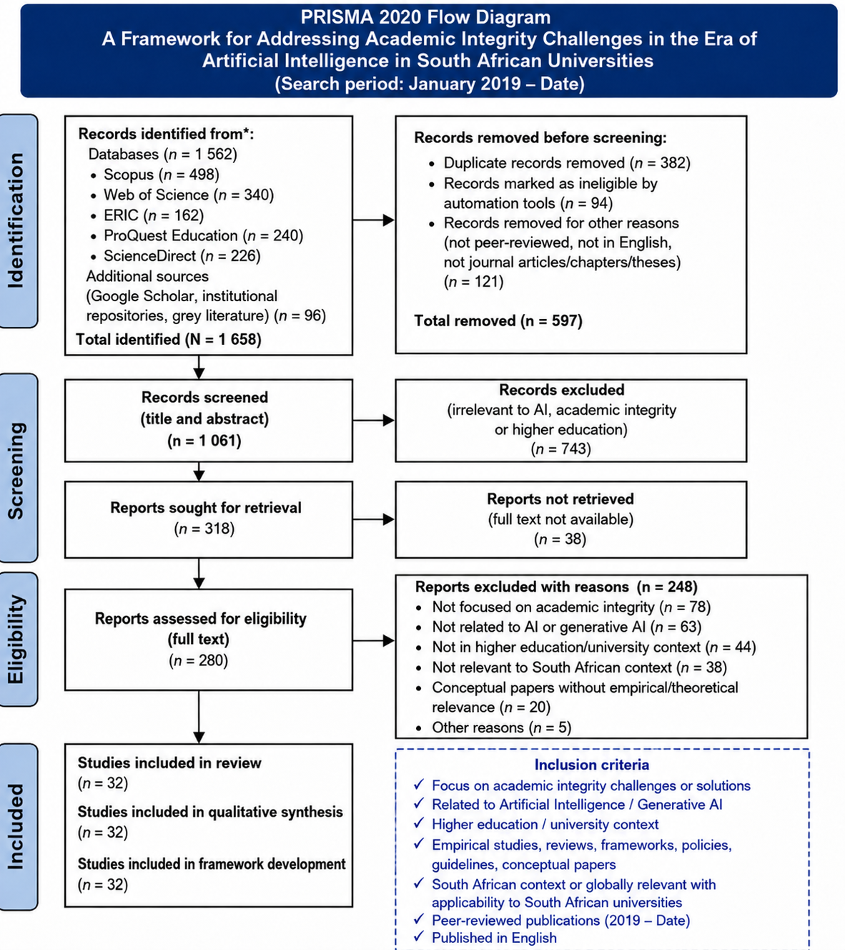
3.Framework modelling

3.1. Model Specification
The study can model academic integrity challenges as a function of AI use, institutional policy, digital literacy, assessment design, ethical awareness and monitoring systems.
$$AIC_{it}=β_{0}+β_{1}AIU_{it}+β_{2}AIP_{it}+β_{3}DIL_{it}+β_{4}EAW_{it}+β_{5}ASD_{it}+β_{6}IMS_{it}+β_{7}INS_{it}+ε_{it}$$
Where:
AIC = Academic Integrity Challenges
AIU = Student use of AI tools
AIP = Institutional AI policy clarity
DIL = Digital and AI literacy
EAW = Ethical awareness
ASD = Assessment design quality
IMS = Integrity monitoring systems
INS = Institutional support
ε = Error term
The model fits the South African context because universities are increasingly developing AI guidelines and academic integrity frameworks, while AI misuse in assessments is becoming a policy concern.
3.2. Expanded Model with Moderating Variable
Because policy may reduce the negative effect of AI misuse, include an interaction term:
$$AIC_{it}=β_{0}+β_{1}AIU_{it}+β_{2}AIP_{it}+β_{3}(AIU_{it}×AIP_{it})+β_{4}DIL_{it}+β_{5}EAW_{it}+β_{6}ASD_{it}+β_{7}IMS_{it}+ε_{it}$$
The interaction term AIU × AIP tests whether clear AI policies weaken the relationship between AI use and academic integrity problems.
Table 01. Expected Signs
Variable | Expected Sign | Interpretation
AIU | + | Higher unauthorised AI use may increase integrity challenges
AIP | − | Clear AI policies may reduce misconduct
DIL | − | Higher AI literacy may encourage responsible AI use
EAW | − | Ethical awareness may reduce dishonest behaviour
ASD | − | Authentic assessment design may reduce AI-enabled cheating
IMS | − | Monitoring systems may discourage misconduct
INS | − | Institutional support may improve compliance

3.3. Recommended estimation method
Use Ordinary Least Squares regression if the dependent variable is measured as a continuous index.
Use logistic regression if the dependent variable is binary, for example:
$$AIC_{i}=\left\{\begin{matrix}1 & \text{if student engaged in AI-related academic misconduct} \\ 0 & \text{otherwise}\end{matrix}\right.$$
Then the model becomes:
$$Pr(AIC_{i}=1)=\frac{1}{1+e^{-(β_{0}+β_{1}AIU_{i}+β_{2}AIP_{i}+β_{3}DIL_{i}+β_{4}EAW_{i}+β_{5}ASD_{i}+ε_{i})}}$$

4. Conclusion
This proposed framework specifically addresses the gaps identified in literature by indicating that AI (Artificial Intelligence) cannot be successfully integrated into Higher Education only using Technology. As existing studies have shown, in order for AI to be effectively adopted within institutions, there are many factors that must be present to successfully enable adoption of AI. Beyond having the necessary Technology tools available, organisations need to have the institutional readiness, governance structure, ethical considerations, digital competencies, and stakeholder engagement to adopt AI within their institutions. If organisations focus only on the Technology component of AI adoption, there is a high likelihood that implementation strategies are developed and implemented without consideration for the local context, human factors or educational outcomes. Therefore, this framework takes a holistic perspective on the development and integration of Technology infrastructure, Policy developments, AI Literacy, Academic Integrity mechanisms, and Institutional Support systems. According to current studies, the integration of artificial intelligence into organizations is an extremely multifaceted process that requires a multitude of both technological resources and support of the pedagogical and ethical principles behind artificial intelligence.
Considering the South African Higher Education context, this framework is particularly relevant as AI is being adopted within an environment of continuing inequality, and access to Technology through digital technologies, uneven digital infrastructure and digital Literacy is at different levels between students and educators. There continues to be significant disparities between Institutions and students with regards to access to internet connectivity, digital equipment and Technology support systems, despite the increasing digitalisation of Education. If not managed properly, these inequalities have the potential to continue and further reinforce the existing educational disadvantage caused by unequal access to Technology and will require an intentional effort to avoid replicating past discriminatory practices. The framework is thus aimed at integrating AI into education and ensuring that all students from all backgrounds have equitable access to the tools and technologies benefiting from this integration by providing institutional capacity development and improving digital literacy so that AI technologies can be used by all types of students, and do not create or increase the existing gap in education.
According to research conducted by the United Nations Educational, Scientific and Cultural Organization (UNESCO), ethical and inclusive implementation of AI should focus primarily on accessibility, fairness, and participation in the implementation of AI technologies to reduce the existing disparity between developed and developing countries. This is confirmed in the literature about the digital transformation in education, which states that when using technology in education, socio-economic conditions and inequalities in the communities where students live should be taken into account to ensure that students who are vulnerable or have limited access to technology do not face further exclusion from using technology in education (Czerniewicz & Brown 2018:94). It is also important to note that the emphasis of the proposed framework has been changed from that of a traditional framework that has used punitive approaches to investigate, detect and penalise students for any form of non-compliance with the use of AI.
Historically, the methods used by educators and institutions to respond to emerging technologies in education have been primarily focused on establishing control through mechanisms such as detection systems for plagiarism and developing strict rules around AI technologies to prevent students from misusing these technologies. Although these measures are important, they do not consider the larger educational impact of integrating AI when the methods of developing students' skills to use these technologies are limited to punitive measures. Thus, rather than taking a punitive approach to the implementation of AI in education, the proposed framework has taken a developmental approach by building competencies and providing appropriate training for educators and students to develop AI literacy, ethical and responsible use of technology, and developing critical thinking skills. The developmental approach to AI is consistent with the view of AI as an educational tool or resource and suggests that AI should be used as such if students and educators are provided with the necessary guidance, training and capacity to use AI ethically and responsibly, and not be solely prohibited from using AI. In summary, to enhance technological capabilities of post-secondary education institutions and governments, this proposed framework provides an integrated governance model to:
- improve technological capability;
- enhance institutional governance;
- build ethical/inclusive capability related to AI use; and
provide a means for supporting/implementing/integrating AI technologies across post-secondary education institutions in South Africa, as well as helping worldwide governing bodies (not limited to) by promoting ethical, inclusive, sustainable implementation of AI in education.

References
Amirjalili, F., Neysani, M., & Nikbakht, A. (2024). Exploring the boundaries of authorship: A comparative analysis of AI-generated text and human academic writing in English literature. Frontiers in Education. frontiersin.org
Ateeq, A., Alzoraiki, M., Milhem, M., & Ateeq, R. A. (2024). Artificial intelligence in education: implications for academic integrity and the shift toward holistic assessment. Frontiers in Education, 9. https://doi.org/10.3389/feduc.2024.1470979 Cited by: 138
Benuyenah, V. (2026). Commentary: Academic integrity challenges among non-native English-speaking students in higher education. Journal of Research in Innovative Teaching & Learning, 19(1), 211–215.
Chan, C. K. Y. (2023). A comprehensive AI policy education framework for university teaching and learning. International journal of educational technology in higher education, 20(1), 38.
Chan, C. K. Y. (2025). Students' perceptions of 'AI-giarism': Investigating changes in understandings of academic misconduct. Education and Information Technologies. springer.com
Czerniewicz, L., & Brown, C. (2018). THE HABITUS AND TECHNOLOGICAL PRACTICES OF RURAL STUDENTS. Crossing the Bridge of the Digital Divide: A Walk with Global Leaders, 163.
Eaton, S. E., & Hughes, J. C. (2022). Academic integrity in Canada. Ethics and Integrity in Educational Contexts, 1.
Grassini, S. (2023). Shaping the future of education: Exploring the effects of generative artificial intelligence on pedagogical methods and academic integrity. Education Sciences, 13(7), 692–704.
Guadu, B. et al. (2025). As cited in Generative artificial intelligence and the crisis of research integrity: Implications for knowledge production in higher education. Journal of Public Administration and Development Alternatives, 11(1).
Heathen, T. S. (2026). Artificial Intelligence and Academic Honesty: Challenges in the Digital Classroom.
Jin, Y., Yan, L., Echeverria, V., Gašević, D., & Martinez-Maldonado, R. (2025). Generative AI in higher education: A global perspective of institutional adoption policies and guidelines. Computers and Education: Artificial Intelligence, 8, 100348. sciencedirect.com
Joubert, M. & Sibanda, B. (2022). Whose language is it anyway? Students' sense of belonging and role of English for higher education in the multilingual, South African context. South African Journal of Higher Education. journals.co.za
Kaya‐Kasikci, S., Glass, C. R., Camero, E. C., & Minaeva, E. (2025). University Positioning in AI Policies: Comparative Insights from National Policies and Non‐State Actor Influences in China, the European Union, India, Russia, and the United States. Higher Education Quarterly, 79(4), e70062. wiley.com
Khoo, E., & Kang, S. (2022). Proactive learner empowerment: towards a transformative academic integrity approach for English language learners. International Journal for Educational Integrity, 18(1), 24.
Mabena, A. (2026). As cited in Generative artificial intelligence and the crisis of research integrity: Implications for knowledge production in higher education. Journal of Public Administration and Development Alternatives, 11(1).
Marnewick, C. (2023). Student experiences of project-based learning in agile project management education. Project Leadership and Society. sciencedirect.com
Miah, M. (2024). Digital inequality: the digital divide and educational outcomes. ACET J. Comput. Educ. Res, 17, 1-10.
Nwokocha, C., & Morkel, V. (2025). As cited in Generative artificial intelligence and the crisis of research integrity: Implications for knowledge production in higher education. Journal of Public Administration and Development Alternatives, 11(1).
Nwozor, A. (2025). Artificial intelligence (AI) and academic honesty-dishonesty nexus: Trends and preventive measures. AI and ethics, academic integrity and the future of quality assurance in higher education, 27(3). researchgate.net
Pagaling, R., Eaton, S. E., & McDermott, B. (2022). Academic Integrity: Considerations for Accessibility, Equity, and Inclusion. Online Submission. ed.gov
Perkins, M., & Roe, J. (2024). The use of Generative AI in qualitative analysis: Inductive thematic analysis with ChatGPT. Journal of Applied Learning & Teaching, 7(1), 390-395.
Smith, G., Taylor, M., & van Wyk, L. (2024). Ethical integration of technology and the digital literacy framework in South African universities. South African Journal of Higher Education, 38(2), 204–222.
Smith, L. (2025). Leveraging emerging technologies to enhance public accountability in South African higher education. South African Journal of Higher Education. journals.co.za
Tan, M. J. T., & Maravilla, N. M. A. T. (2024). Shaping integrity: why generative artificial intelligence does not have to undermine education. Frontiers in artificial intelligence, 7, 1471224.

