STUDENTS’ PERCEPTIONS OF DIGITAL TOOLS IN TEACHING AND LEARNING FINE AND APPLIED ARTS

Abstract
This study investigates the perceptions of undergraduate students regarding the use of digital tools in the teaching and learning of Fine and Applied Arts at Adeyemi Federal University of Education, Ondo. Against the backdrop of the post-COVID-19 pandemic, it examines how studio-based art students integrate such tools in their coursework. A descriptive survey design was employed, using an online questionnaire administered via Google Forms to undergraduate students from 100-level to 400-level. The instrument captured the students' familiarity with digital tools, their frequency and purpose of use, perceived benefits for creativity and understanding, and the various challenges associated with access and instructional support. Descriptive statistics were used to summarise patterns of device ownership, tool usage, and perceptions across academic levels. The findings indicate that most of the respondents use personal digital devices and show readiness for greater digital integration, particularly where such tools support visualisation, experimentation, and flexible access to learning resources. However, limited infrastructure, unstable internet connectivity, and varied lecturer competence constrain effective adoption. The study recommends strategic ICT infrastructure investment, targeted staff development, and curriculum review as crucial interventions in the alignment of Fine and Applied Arts education in Nigeria with contemporary digital practices and the enhancement of students’ learning experiences.
Keywords: Art curriculum development, digital tools, fine arts education, student perceptions, Nigeria.
- Introduction
The global shift to digital learning, accelerated by the COVID-19 pandemic, has emphasised the need to understand Fine and Applied Arts students' perceptions of digital tools, particularly as studio-based programmes adapted to digital strategies. The integration of digital tools in Fine and Applied Arts has revolutionised the way students and educators approach creative processes, enabling new forms of expression and learning. As digital tools such as graphic design software, 3D modelling programs, and virtual platforms become integral to the curriculum, the traditional boundaries of artistic education are expanding. This transformation has been highlighted by Manovich (2016), who examined how the intersection of art and technology has enabled hybrid forms of creativity, blending the digital with the physical in innovative ways. By embracing this shift, educators would not only have enhanced technical proficiency but also would have fostered collaboration and critical thinking, making technology a vital component of modern arts education.
However, Ajayi and Luckay (2023) report that Fine and Applied Arts departments in Nigeria face serious challenges regarding technology resources, device access, and pedagogical approaches. There is considerable variation in technology availability across institutions, which unevenly shapes students’ learning experiences. Many students struggle to access computers and other digital devices, limiting their capacity to complete assignments, engage with digital art practices, and build portfolios suitable for contemporary creative industries. In addition, teaching in many programmes remains heavily oriented toward traditional studio methods, with insufficient emphasis on digital skills and tools. To prepare students for the current art world, it is imperative to integrate modern technology more systematically and to strengthen both infrastructural support and pedagogical practices in these departments.
This study, therefore, responds to the growing need for digital tools in art practice that Nigerian universities are not yet adequately meeting. It identifies a clear gap between the demand for contemporary digital technologies in Fine and Applied Arts and the limited resources, skills, and pedagogical support available to use them effectively. This gap risks constraining students’ and emerging artists’ ability to fully leverage digital technologies in their creative and professional work.
A key problem addressed by this study is the limited empirical evidence on how art students in Nigeria perceive digital tools in both studio-based and theory-based courses. Most existing research on digital tools in education focuses on general education or STEM fields and is predominantly situated in Global North contexts, with little attention to Fine and Applied Arts in sub-Saharan Africa. Consequently, there is a scarcity of context-specific, discipline-focused evidence on how Nigerian art students access devices, become familiar with digital tools, and perceive their impact on creativity and learning outcomes.
This study addresses that gap by providing contextual, discipline-specific evidence on device access, tool familiarity, and perceived impact on creativity and learning outcomes among undergraduate Fine and Applied Arts students in Nigeria. By exploring students’ perceptions, the findings contribute to scholarly discussions in art education about how digital platforms can enhance instruction, critique, documentation, and portfolio development in Nigerian higher education.
Accordingly, this study examines undergraduate students’ perceptions of digital tools in the teaching and learning of Fine and Applied Arts at Adeyemi Federal University of Education, Ondo. Specifically, it addresses the following research questions:
- How familiar are students with digital tools relevant to their studies?
- How frequently and easily do students utilise these tools in their educational practices?
- What benefits do students perceive from using digital tools in their art education?
- What infrastructural or pedagogical challenges do students encounter in the adoption of digital tools?
- To what extent do students feel prepared for increased integration of digital tools in their coursework?
The main objectives of the study are to:
- assess students’ familiarity with digital tools relevant to their studies;
- gauge the frequency and ease of their use of these tools in educational practices;
- identify perceived benefits, such as enhanced creativity or efficiency in producing artworks;
- document infrastructural or pedagogical barriers that may hinder effective digital tool integration; and
- evaluate students’ readiness to embrace greater digital integration in their art education.
These objectives are justified by the increasing role of digital media in education and the creative industries; understanding student perceptions and experiences can inform curriculum development, support services, staff training, and ICT infrastructure investments within the department and similar contexts.
The study focuses on undergraduate students in the Department of Fine and Applied Arts at Adeyemi Federal University of Education, Ondo, who are currently enrolled and have completed at least one art course involving digital tools. It examines digital tools specifically used for teaching and learning in Fine and Applied Arts, rather than all possible technologies. By exploring students’ views, the findings aim to contribute to ongoing scholarly discussions in art education about how digital platforms can enhance instruction, critique, documentation, and portfolio development. Ultimately, the results are intended to guide curriculum revision, teacher training needs, and strategic investments in ICT infrastructure, thereby improving student engagement, teaching quality, and the overall digital learning landscape in Nigerian art education
- Brief History of Digital Tools in Education and in Fine and Applied Arts
The use of digital tools in education began in the 1960s with computers for administrative tasks, but it expanded significantly in the 1970s and 1980s with the advent of personal computers and early computer-assisted instruction (Amhag et al., 2019; Jeng & Zaini, 2025; Jingying, 2025). The 1990s saw a shift with the internet and multimedia technology introducing educational software that included video and audio, enhancing the learning experience for students. Tools like Adobe Photoshop and Macromedia Flash became accessible for creating digital art and animations, particularly in Fine and Applied Arts (Poiasok & Bespartochna, 2025; Wachowiak, 2022).
In the early 2000s, technology such as smartboards, digital projectors, and online platforms like Blackboard transformed classrooms, enabling virtual collaboration and enhancing teaching methods (Haleem et al., 2022; Kalyani, 2024). In arts education, tools like AutoCAD and 3D modelling programs expanded design learning, fostering creativity and technical skill ((Ling & Gao, 2025; Okotubu, 2024).
In the 2010s, tools like Google Drive and online courses made arts education more accessible, allowing people from different backgrounds to learn about digital art (Paul et al., 2023; Al-Samarraie & Saeed, 2018). Today, new technologies like AI, augmented reality, and 3D printing are changing how we teach Fine and Applied Arts, encouraging more creativity and exploration (Al-Ansi et al., 2023; Al-Samarraie & Saeed, 2018).
The evolution of digital tools in education reflects advancements that have transformed teaching and learning in Fine and Applied Arts. As technology continues to develop, it is essential for educators to adapt and integrate these tools effectively, fostering creativity in future generations of artists.
As posited by Chen (2023), the COVID-19 pandemic prompted a significant shift towards digital learning across various educational programmes, including those that rely heavily on studio-based activities, such as art, design, and performing arts. This transition brought both challenges and opportunities for students and educators.
One major challenge in art education is keeping hands-on, interactive activities that studio-based programmes need. According to Singh et al. (2021), many students find it hard to adjust to the lack of direct interaction and feedback that physical studios provide. Creative education often relies on in-person discussions and peer reviews, which are hard to recreate online.
However, moving to digital platforms has pushed educators to find new teaching methods. Virtual tools and software have become more important, allowing for fresh ways to collaborate and be creative. This shift has led teachers to integrate technology into their lessons more deeply, which might improve learning even after the pandemic. While the move to online learning has created challenges for studio-based programmes, it has also sparked innovation and a rethink of traditional teaching methods (Mulenga & Shilongo, 2024). The long-term effects of this change will continue to emerge as schools adjust to new educational needs.
- Methodology
  - Research design
This study adopted a descriptive survey design to investigate students’ perceptions of digital tools in the teaching and learning of Fine and Applied Arts. The design was considered appropriate for obtaining self-reported information on access to devices, familiarity with educational tools, and perceived impact on learning experiences across academic levels.
  - Population and sampling
The target population comprised undergraduate students in the Department of Fine and Applied Arts from 100-level to 400-level. A convenience sampling strategy was employed, leveraging departmental communication channels and class WhatsApp groups to reach participants efficiently. The intended sample size was 40–100 respondents to support robust descriptive analysis; however, at this preliminary stage, valid responses were obtained from 107 students, representing an initial pilot sample. These data are used here to illustrate emerging patterns and to refine the research instrument and procedures for subsequent large-scale data collection.
  - Research instrument
Data were collected using a structured questionnaire developed by the researcher and administered via Google Forms. The instrument comprised five sections, namely, demographics, access and familiarity, learning experience, benefits and challenges, and readiness.
- Demographics addressed academic level and specialisation;
- Access and familiarity dealt with device ownership and knowledge of digital tools;
- Learning experience used five Likert-scale items to capture engagement, ease of use, lecturer support, creativity, and understanding;
- Benefits and challenges utilised multiple-response lists to elucidate responses about perceived advantages and obstacles; and
- Readiness explored the willingness to see greater integration of digital tools with a 1–5 readiness scale.
Items were phrased concisely to enhance clarity and completion rates.
  - Data collection procedure and ethics
The questionnaire link was distributed to students through departmental channels and class WhatsApp groups. Data collection took place over three days, allowing participants to respond at their convenience using mobile phones, tablets, or computers. Ethical considerations were strictly observed, ensuring that participation was voluntary, informed consent was obtained electronically before accessing the instrument, anonymity was assured, and responses were used solely for research purposes. No personally identifiable information was collected, and participants were informed of their right to withdraw at any time without penalty.
  - Data preparation
Responses from Google Forms were exported as a comma-separated values (CSV) file for analysis. The dataset was screened for completeness and accuracy, including verification of the CSV structure, removal of duplicate records, and inspection of missing values. Variables with more than 5% missingness were excluded from analysis, while minor gaps in otherwise complete cases were handled through appropriate imputation procedures. Categorical variables were standardised (e.g., device types and tool categories), and Likert-scale items were converted to numeric codes following a consistent ordering. Variable names were harmonised and assigned descriptive labels, and the final de-identified dataset, named cleaned_art_education_dataset.csv, was checked to ensure compliance with ethical requirements regarding anonymity and consent.
  - Data analysis
Data analysis focused on descriptive statistics and graphical summaries to characterise patterns of device usage, familiarity with digital tools, and perceived learning experiences. Frequency distributions and percentages were computed for device types such as laptops, tablets, and smartphones, categories of educational tools like learning management systems, productivity applications, and reported challenges such as poor internet connectivity and high device costs. Mean scores and standard deviations were calculated for the five Likert-scale constructs like engagement, ease of use, creativity, understanding, and lecturer support, and compared across academic levels (100–400 level). To enhance ease of result interpretation, several visualisations were produced, including a pie chart of devices used for academic work and bar charts comparing mean perception scores by level and summarising the prevalence of specific benefits and challenges.
  - A pie chart illustrating the distribution of devices used for academic work. Each segment of the pie represents the proportion of users for each type of device (see Fig. 1).
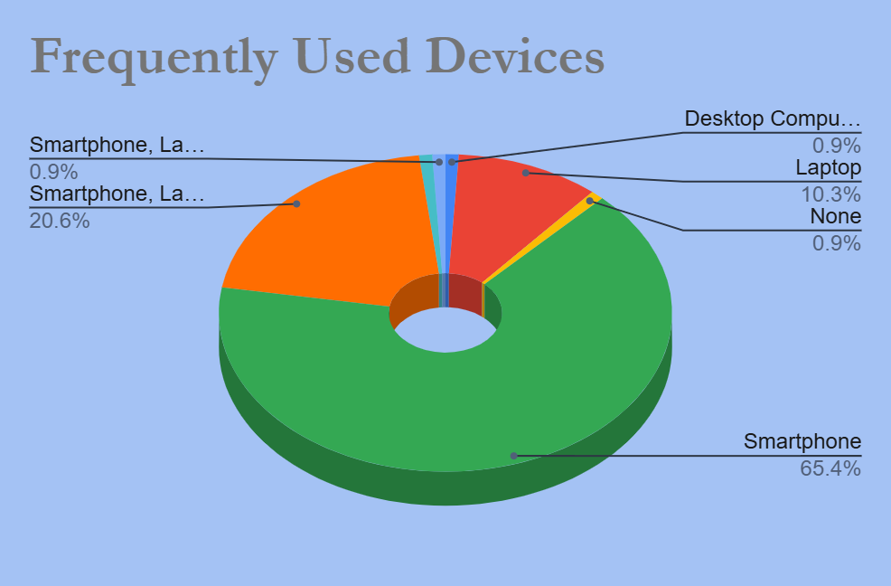
Fig. 1: Frequently used devices by Arts students
  - A grouped column chart (Fig. 2) displaying the average scores across the measures of engagement, ease of use, creativity, understanding, and lecturer support, presented for the total sample and segmented by academic level.
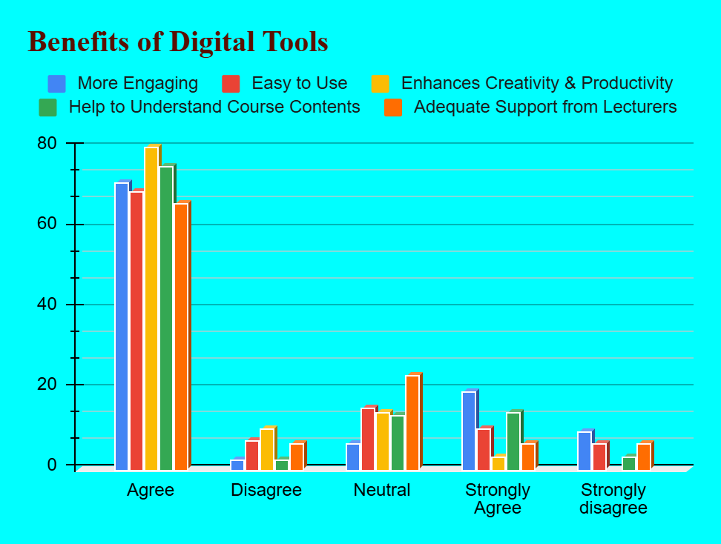
Fig. 2: Benefits of digital tools to Arts students.
  - A bar chart, shown in Fig. 3, depicted the perceptions of students on their readiness to use digital tools.
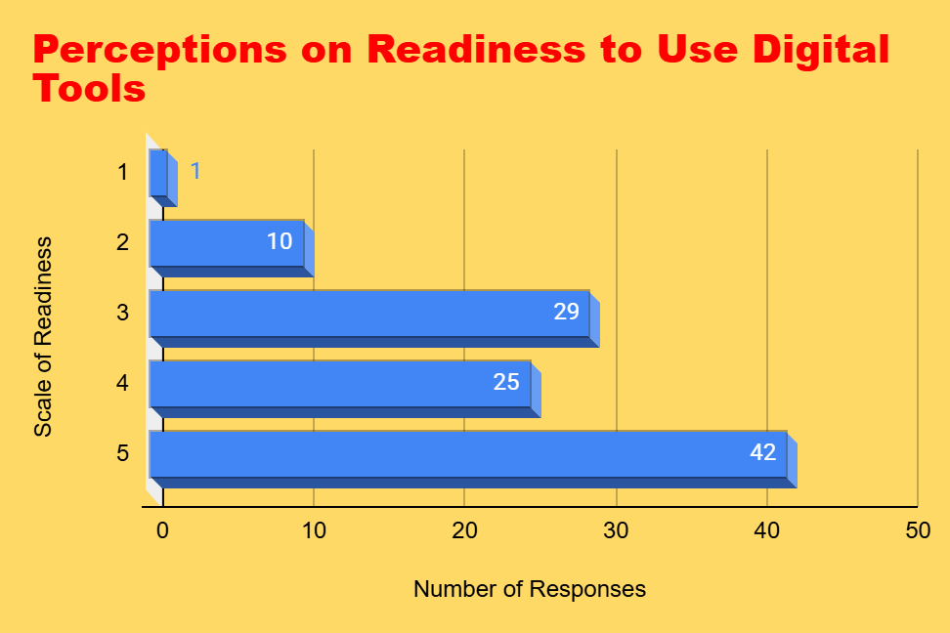
Fig. 3: Perceptions of students’ readiness to use digital tools
  - A bar chart that illustrated the counts of significant challenges reported by participants, such as poor internet connectivity, the high cost of devices, and insufficient training (see Fig. 4).
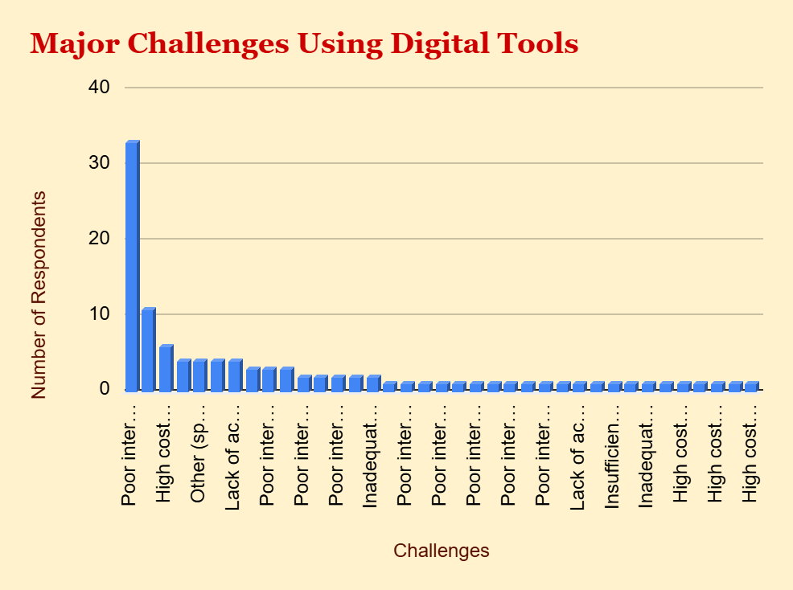
Fig. 4: Challenges faced by Arts students in the use of digital tools
- Discussion of Findings
The findings of this study reveal that undergraduate students in the Department of Fine and Applied Arts at Adeyemi Federal University of Education are generally familiar with basic digital devices, particularly smartphones, but have more limited access to computers and specialised art software. Most respondents reported using digital tools primarily for coursework documentation, image editing, and research, while fewer reported using them for advanced creative practices such as digital illustration, 3D modelling, or digital portfolio development. Students perceived multiple benefits of digital tools, including enhanced creativity, easier documentation of artworks, and greater flexibility in accessing learning materials. However, these benefits were moderated by significant infrastructural and pedagogical challenges, including unstable internet connectivity, high cost of devices and software, and limited lecturer competence in digital pedagogies. Students expressed a positive readiness to embrace greater digital integration, provided that institutional support is strengthened.
These patterns align with broader literature on digital learning in art and design education. Chen (2023) notes that the COVID-19 pandemic accelerated the adoption of digital tools across studio-based programmes, creating both challenges and opportunities for creativity and flexibility. Similarly, this study finds that students value digital tools for enhancing creativity and enabling flexible access to resources, consistent with reports that virtual platforms can foster new forms of collaboration and creative experimentation. The emphasis students place on digital documentation and portfolio development also resonates with Global North studies highlighting the centrality of digital portfolios in contemporary art education and professional practice.
However, some findings contrast with existing literature. In many studies from the Global North, students typically report reliable access to institutional computers, high-speed internet, and a range of professional software, with challenges centred more on pedagogical adaptation than on basic access. In contrast, Nigerian Fine and Applied Arts students in this study identified device access and infrastructure as primary constraints. This aligns with Ajayi and Luckay (2023), who report serious technology resource deficits in Nigerian Fine and Applied Arts departments, including uneven technology availability across institutions and limited emphasis on digital skills in teaching. The present study extends this evidence by focusing specifically on students’ perceptions in a Nigerian university context, rather than general education or STEM contexts, which dominate the literature.
The context matters for several reasons. First, Fine and Applied Arts education in Nigeria remains heavily studio-based and traditionally oriented, with many lecturers relying on conventional methods and giving limited attention to digital skills. This contrasts with many international contexts where digital tools are more systematically integrated into art curricula from early stages. Second, infrastructural constraints in Nigeria, such as unreliable electricity, limited broadband coverage, and high import costs for devices and software, shape students’ experiences in ways that are less pronounced in Global North settings. These contextual factors help explain why, despite positive perceptions and readiness, students’ actual use of advanced digital tools remains constrained.
The finding that students perceive digital tools as enhancing creativity, yet face barriers to advanced use, supports Singh et al.’s (2021) observation that creative education relies heavily on in-person interaction and studio feedback, which are difficult to replicate online. In this study, students appear to view digital tools as complementary to, rather than a replacement for, traditional studio practice, using them to support documentation, research, and preliminary design while still relying on physical studios for core creative work. This hybrid orientation may reflect both the potential of digital tools and the limitations of the current institutional context.
All things considered, the study provides discipline-specific, context-specific evidence about how Nigerian Fine and Applied Arts students use devices, familiarise themselves with digital tools, and assess their influence on learning outcomes and creativity. This addresses a gap in the literature, which is primarily composed of STEM or general education studies from the Global North, and offers a basis for curricular and policy interventions specific to art education in Nigeria.
  - Discussion of Anomalies or Unexpected Findings
A few unexpected findings emerged from the study that call for further discussion. There was a noticeable disparity in the reported difficulties; although the majority of participants cited inadequate internet as a major problem, a sizable percentage of students also reported having adequate access but struggling with device costs, which was less expected given the growing affordability of technology. Furthermore, a small subset of undergraduate students with smartphones reported high engagement scores, contradicting the idea that device type directly correlates with app proficiency, even though cross-tabulations indicated that laptop ownership was linked to higher familiarity with complex academic tools.
The combination of analysis and visual aids has enhanced understanding of how device usage and familiarity with tools influence students' engagement. It also offered detailed insights that can inform future educational policies and support strategies.
  - Limitations of the study and future research
This study is limited by its focus on a single institution and its relatively small initial sample, which restricts the generalisability of the findings. Future research should replicate this study across multiple Nigerian universities and include larger, more diverse samples to examine variations by region, institution type, and specialisation. Longitudinal studies could also track how students’ perceptions and digital competencies evolve over their programme and into their professional practice.
- CONCLUSION
This study examined undergraduate students’ perceptions of digital tools in the teaching and learning of Fine and Applied Arts at Adeyemi Federal University of Education, Ondo. The findings indicate that students are positively disposed to digital tools and perceive them as beneficial for creativity, documentation, and flexible access to learning materials. However, their use of digital tools is constrained by limited access to devices and computers, unstable internet connectivity, high costs of software and hardware, and insufficient lecturer competence in digital pedagogies. Despite these challenges, students express a strong readiness for greater digital integration in their coursework.
The results have clear implications for curriculum design, lecturer training, and institutional infrastructure in Fine and Applied Arts departments. First, the curriculum should explicitly incorporate digital competencies as core learning outcomes, including skills in digital image editing, portfolio development, documentation, and basic design software. Digital tools should not be treated as optional add-ons but as integral components of studio and theory courses, aligned with contemporary creative industry demands.
Second, lecturer training programmes are needed to build capacity in digital pedagogies. Many instructors in Fine and Applied Arts are accustomed to traditional studio methods and may lack confidence or expertise in using digital tools for teaching, critique, and assessment. Targeted professional development, workshops, and communities of practice can help lecturers integrate digital tools effectively into studio instruction, online critique sessions, and portfolio reviews.
Third, institutional infrastructure must be strengthened to support digital learning. This includes providing campus computer labs with reliable high-speed internet, subsidised or loan schemes for devices, access to affordable or open-source art software, and sustained technical support. Without such investments, the potential of digital tools to enhance creativity and learning will remain unrealised for many students.
In conclusion, strategic investment in ICT infrastructure, deliberate curriculum reform, and sustained staff development are essential to align Fine and Applied Arts education in Nigeria with contemporary digital practices. By addressing these areas, Nigerian universities can better prepare art students to utilise digital technologies in their creative work and to compete effectively in the global creative economy.

REFERENCES
Ajayi, N. O., & Luckay, M. B. (2023). Trends and challenges of higher education in Nigeria: Fine and applied arts technological literacy. Journal of Education, (92), 228–247. https://doi.org/10.17159/2520-9868/i92a13
Al-Ansi, A. M., Jaboob, M., Garad, A., & Al-Ansi, A. (2023). Analyzing augmented reality (AR) and virtual reality (VR) recent development in education. Social Sciences & Humanities Open, 8(1), 100532. https://doi.org/10.1016/j.ssaho.2023.100532
Al-Samarraie, H., & Saeed, N. (2018). A systematic review of cloud computing tools for collaborative learning: Opportunities and challenges to the blended-learning environment. Computers & Education, 124, 77–91. https://doi.org/10.1016/j.compedu.2018.05.016
Amhag, L., Hellström, L., & Stigmar, M. (2019). Teacher Educators’ Use of Digital Tools and Needs for Digital Competence in Higher Education. Journal of Digital Learning in Teacher Education, 35(4), 203–220. https://doi.org/10.1080/21532974.2019.1646169
Chen, L.-H. (2023). Moving Forward: International Students’ Perspectives of Online Learning Experience During the Pandemic. International Journal of Educational Research Open, 5, 100276. https://doi.org/10.1016/j.ijedro.2023.100276
Haleem, A., Javaid, M., Qadri, M. A., & Suman, R. (2022). Understanding the role of digital technologies in education: A review. Sustainable Operations and Computers, 3, 275–285. https://doi.org/10.1016/j.susoc.2022.05.004
Jeng, C. M., & Zaini, M. H. (2025). The Level of Use of Digital Technology for Teaching and Learning Purposes among SJKC Teachers in Seberang Perai Tengah District. International Journal of Academic Research in Progressive Education and Development, 14(2), Article 2. https://doi.org/10.6007/IJARPED/v14-i2/25261
Jingying, E. (2025). The Application of AI-Generated Art in Traditional Fine Arts Education and Research on Aesthetic Perception. Journal of Sociology and Education, 1(7). https://doi.org/10.63887/jse.2025.1.7.51
Kalyani, undefined D. L. K. (2024). The Role of Technology in Education: Enhancing Learning Outcomes and 21st Century Skills. International Journal of Scientific Research in Modern Science and Technology, 3(4), 05–10. https://doi.org/10.59828/ijsrmst.v3i4.199
Ling, J., & Gao, M. (2025). Research on Improving Creativity and Practical Skills of Art Education by Computer-Aided Design: International Journal of Information and Communication Technology Education, 21(1), 1–17. https://doi.org/10.4018/IJICTE.385438
Manovich, L. (2016). Theories of Software Culture. Bloomsbury Publishing.
Mulenga, R., & Shilongo, H. (2024). Hybrid and Blended Learning Models: Innovations, Challenges, and Future Directions in Education. Acta Pedagogia Asiana, 4(1), 1–13. https://doi.org/10.53623/apga.v4i1.495
Okotubu, J. O. (2024). Effect of AutoCAD Software Package on Creative Ability and Academic Achievement of Technical Drawing Students Technical Colleges in Delta State. KWASU International Journal of Education (KIJE), 7(1), 37–47. https://kije.com.ng/index.php/KIJE/article/view/83
Paul, P. K., Chatterjee, R., & S, A. P. (2023). Cloud Computing and its Impact in Education, Teaching and Research-A Scientific Review. Emergence and Research in Interdisciplinary Management and Information Technology, 01–26. https://doi.org/10.5281/zenodo.8078784
Poiasok, T., & Bespartochna, О. (2025). Digital Infrastructure of the Educational Environment for the Professional Training of Future Economists. Educological Discourse, 50(3), 115–124. https://doi.org/10.28925/2312-5829/2025.3.11
Singh, J., Steele, K., & Singh, L. (2021). Combining the Best of Online and Face-to-Face Learning: Hybrid and Blended Learning Approach for COVID-19, Post Vaccine, & Post-Pandemic World. Journal of Educational Technology Systems, 50(2), 140–171. https://doi.org/10.1177/00472395211047865
Wachowiak, M. P. (2022). Early 1990s – 2004 – the “Era of the Internet”. https://ecampusontario.pressbooks.pub/nudh1/chapter/early-1990s-2004-the-era-of-the-internet/

